Photoactive Bifunctional Degraders: Precision
Tools to Regulate Protein Stability

Cyrille S. Kounde and Edward W. Tate*
Department of Chemistry, Imperial College London, Molecular Sciences Research Hub, White City Campus, Wood Lane, London W12 0BZ, United Kingdom.

ABSTRACT

Targeted protein degradation with bifunctional degraders is positioned as a remarkable game-changing strategy to control cellular protein levels and promises a new therapeutic modality in drug discovery. Light activation of a degrader to achieve exquisite spatiotemporal control over protein stability in cells has attracted the interest of multiple research groups, with recent reports demonstrating optical control of proteolysis with chimeric molecules bearing photolabile or photoswitchable motifs. In this context of targeted proteolysis research spurring the emergence of innovative tools, we examine the design, synthesis, and properties of light-activated degraders. The significant impact of this approach in regulating disease-relevant protein levels in a light-dependent manner is highlighted with key examples, and future developments to fully harness the potential of light-induced protein degradation with photoactive bifunctional molecules are discussed.

1. INTRODUCTION
Protein expression levels within a cell are regulated by both pre- and post-translational mechanisms which maintain a fine balance between protein synthesis and protein degradation.¹ The ubiquitin-proteasome system (UPS), a key regulator of this balance, operates by tagging proteins with a polyubiquitin chain marking them for destruction at the proteasome.² Due to its involvement in several cellular processes such as cell cycle control, DNA repair, gene transcription and apoptosis, dysregulation of the UPS is associated with multiple human pathologies including neurodegenerative diseases and cancers,³ and pharmacological modulation of the UPS has been pursued extensively in drug discovery.⁴
In the last decade, targeted protein degradation (TPD) has emerged as an innovative approach to exploit the central ubiquitin-tagging mechanism of the UPS to deplete intracellular protein levels.⁵ TPD relies on the ability of molecular glues or heterobifunctional molecules to bring a target protein and an E3 ligase into close proximity in a ternary complex, leading to small molecule-directed ubiquitination and proteasomal degradation of the target protein.^{6,7} While molecular glues are single agents which mode of action involves a conformational change of the E3 ligase resulting in the recruitment of neosubstrates,⁸ bifunctional molecules require two distinct ligands joined together by a linker, whereby the first ligand binds to the target protein and the second ligand recruits the E3 ubiquitin ligase (Figure 1A). Because of their double-headed chemical structure, these compounds were first named proteolysis targeting chimeras (PROTACs).⁹ They are now established as powerful tools to regulate intracellular protein levels and the first two PROTACs targeting the androgen receptor (ARV-110) and the estrogen receptor (ARV-471) recently entered clinical investigation for the treatment of metastatic castration-resistant prostate cancer or breast cancer, respectively.¹⁰

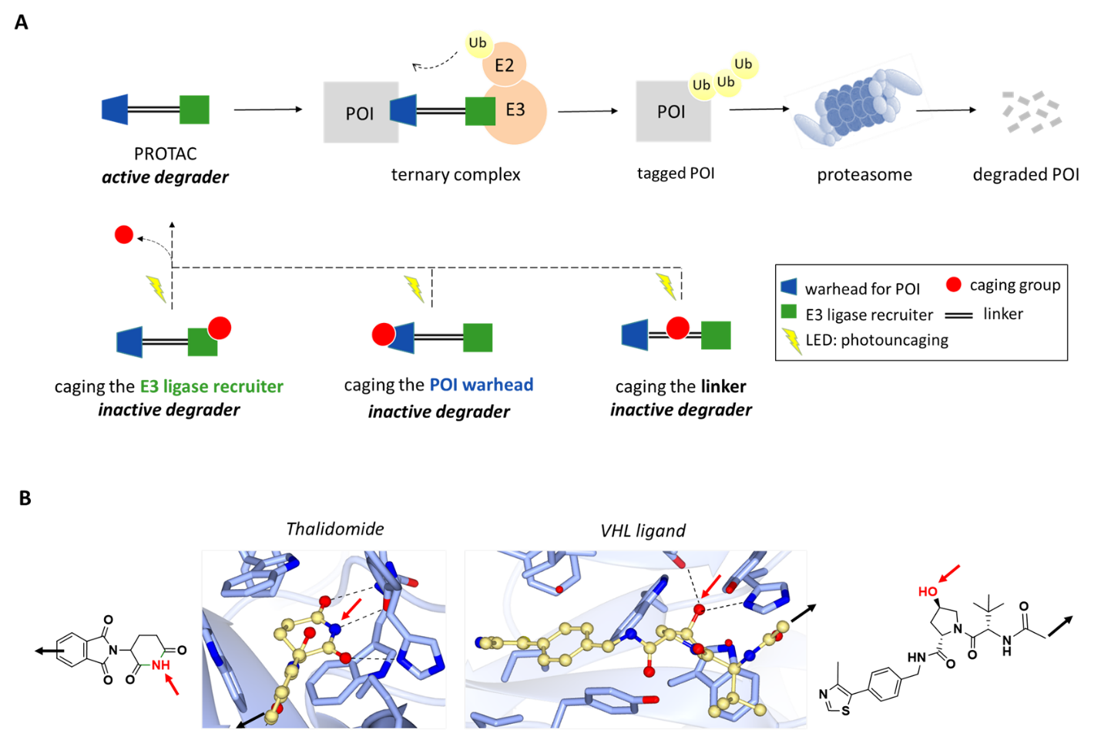

Figure 1. PROTAC mode of action and caging concept. (A) The PROTAC mediates the formation of a ternary complex between the protein of interest (POI) and an E3 ligase leading to post-translational modification of the POI with ubiquitin (Ub) and degradation within the proteasome catalytic unit. A caging group can be attached to the ligand recruiting the E3 ligase, to the warhead targeting the POI and potentially to the linker, with the purpose of generating an inactive degrader. Degradation should occur only after removal of the caging group in response to irradiation with the appropriate wavelength of light. (B) Crystal structure of Thalidomide bound to DDB1-CRBN E3 ubiquitin ligase (PDB: 4CI1)¹¹ (left); Crystal structure of VHL ligand bound to pVHL:EloB:EloC complex (PDB: 4W9H)¹² (right). Caging group attachment points and exit vectors for the linker appendage are identified by red and black arrows, respectively.

The simplicity and versatility of small molecule TPD over biological strategies (e.g. genetic or RNAi protein silencing) has attracted the interest of chemical biologists and drug discovery scientists alike.^{13,14} Key benefits of PROTAC-mediated proteolysis include action at the protein level independent of regulation at the RNA level,¹⁵ a reversible and catalytic mode of action,¹⁶ an enhanced pharmacodynamic effect linked to the removal of all functions of the target including scaffolding capabilities^{17,18} and the opportunity to degrade proteins lacking a classical ligand binding or enzyme active site.^{19,20} The latest research efforts around bifunctional degraders have mainly been directed towards expansion of the substrate scope and have provided novel degrading tools for a wide variety of biological targets.²¹ Likewise, ternary complex formation has been investigated in an attempt to identify rules that will better guide PROTAC design and optimization.^{22,23}
In view of the great opportunity that TPD offers in controlling protein abundance, we and others have envisioned to expand the breadth of PROTAC applications by turning them into light-activated precision tools. Since biological processes regulated by proteins in living organisms are temporally and spatially defined, harnessing light as a tool which also operates in time and space has become a reliable strategy to achieve precise control over many cellular functions.²⁴ In the case of bifunctional degraders, light would allow the non-invasive spatiotemporal control of proteolysis, greatly refining the study of protein degradation. Furthermore, with degraders now progressing into the clinic, it may become important to develop strategies to address their potential on- and off-target liabilities.²⁵ Tissue-selective delivery of PROTACs has been reported by conjugation to antibodies,^{26,27} and similarly the local application of light to deplete a disease-relevant protein in a tumor or other organ whilst sparing healthy tissue could improve PROTAC selectivity in vivo, and reduce potential toxicity.
Light-induced proteolysis was first explored using optogenetic methods^{28,29} and was later accomplished with small molecules in genetically modified mammalian cells, as reported by Delacour et al. in 2015.³⁰ The authors developed a photoactivatable version of the plant hormone auxin that promoted the degradation of an expressed target protein fused to an auxin-inducible degron (AID) sequence. Upon irradiation, the released auxin engaged the AID and recruited an E3 ligase for polyubiquitination and final proteasomal lysis of the fused construct. Although conditional degradation with light was achieved, the system required heterologous expression of a plant-derived protein in a mammalian cell to generate an artificial E3 ligase complex. In contrast, several recent reports have described light-induced protein degradation in mammalian cells without engineering the UPS system, by means of bifunctional degraders bearing photolabile or photoswitchable groups.^{31–37} Combining the attributes of light and PROTAC degradation has delivered promising results which have been highlighted in concurrent reports.^{38,39} In this miniperspective, we carefully review the design, properties, and applications of these novel precision tools as well as the associated challenges and photopharmacology prospects they bring to the table.

Whilst photoactive bifunctional degraders have been given diverse names and acronyms in the literature, the general terms “caged degrader” or “caged PROTAC”, and “(photo)switchable [degrader/PROTAC]”, will be used in this report for consistency and clarity.

2. CAGED DEGRADERS: IRREVERSIBLE ACTIVATION
The first strategy investigated to control PROTAC activity with light used a photosensitive appendage on one side of the bifunctional molecule to generate an inactive degrader (Figure 1A). Upon irradiation with UV light, an active degrader is irreversibly released to trigger the disposal of the studied protein. To qualify as suitable chemical tools for biological investigation, the designed caged molecules should be cell permeable, primarily inert as degraders and stable intracellularly before photolysis. Moreover, release of the active degrader should occur in high yield after a minimal irradiation time.⁴⁰

2.1 CAGING THE CHIMERA: HEADS OR TAILS?
The caged PROTACs reviewed here consist of a ligand for a specific target connected to one of the two most frequently used E3 ligase binders for Cereblon (CRBN) or von Hippel-Lindau (VHL) (Figure 1B). Since the binding modes of these E3 ligands for the respective ubiquitin ligase are well understood, notably through the -NH of the glutarimide group of thalidomide¹¹ and the hydroxyl group of the VHL ligand,¹² chemical functionalization with caging groups was mostly conducted on the E3 ligase recruiting part of the PROTAC (Figure 2).^{31–34}

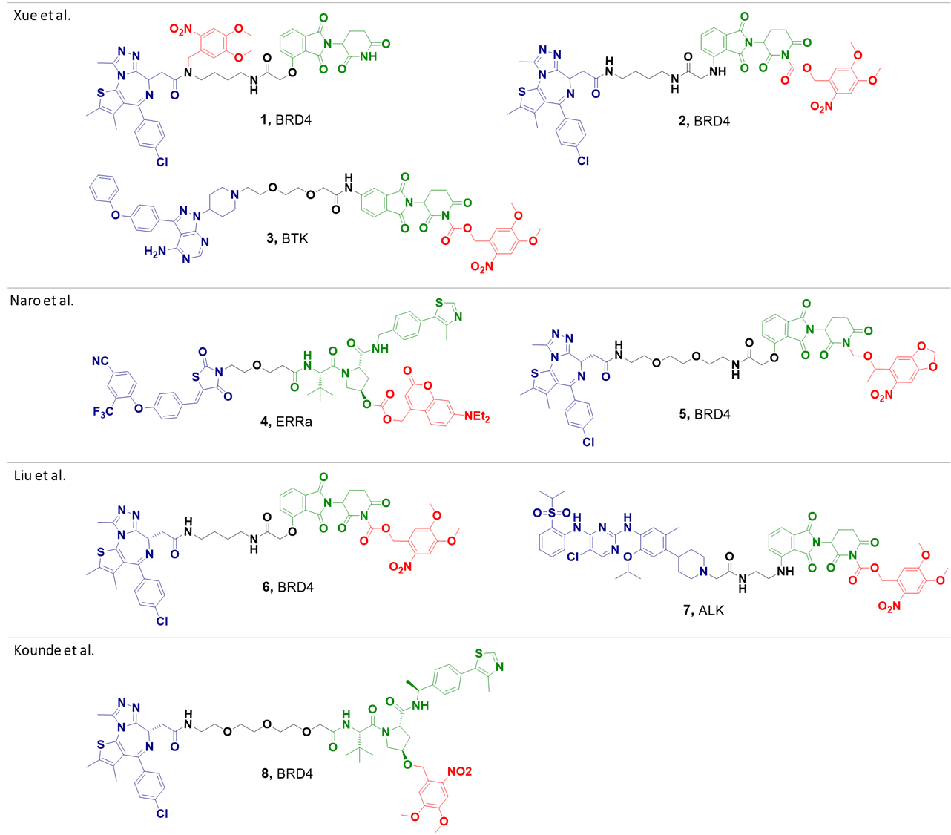
Figure 2. Structure of the reported caged PROTACs. Each caged degrader is made of a warhead (depicted in blue), a linker (black), an E3 ligase recruiter (green) and a photocleavable group (red). Compounds 1, 2, 5, 6 and 8 were designed to degrade Bromodomain-containing protein 4 (BRD4) upon irradiation. Compound 4 was designed to degrade the estrogen-related receptor alpha (ERRα) upon irradiation. Compounds 3 and 7 were designed to degrade Bruton tyrosine kinase (BTK) and anaplastic lymphoma kinase (ALK), respectively, upon irradiation.
This design relies on the ability of the caged moiety to prevent crucial binding interactions with the corresponding E3 ligase, thus precluding formation of the key ternary complex needed for ubiquitin transfer. Compounds 2-8 (Figure 2) demonstrated the versatility of the approach, and the range of targets degraded by these molecules following uncaging suggests that caging the E3 binder may deliver optical control of degradation for any functional PROTAC. However, such caged PROTACs may still interact with the target of interest via their warhead and may display activity in a binding, biochemical or cellular assay (vide infra). A caged degrader with attenuated or abolished pharmacological activity may be more advantageous, as it may leave the biological system unperturbed prior to irradiation. However, since degradation of a target protein often induces a greater pharmacodynamic response than its inhibition,⁴¹ a caged degrader with fully retained inhibitory activity against its target still represents a useful chemical tool provided its basal activity prior to irradiation is known or evaluated concurrently.
A second approach to generate a photoactivatable PROTAC is to install the caging group on the target-binding moiety of the degrader, in which case, ternary complex formation is impeded due to lack of target engagement (Figure 1A). The only reported example of this kind is caged molecule 1 which showed more than 100-fold loss in binding affinity against its target bromodomain-containing protein 4 (BRD4) compared to parent inhibitor JQ1.³¹ Unlike the first approach, this design leaves the E3 ligase recruiter of the PROTAC accessible and compound 1 bears a thalidomide ligand that can interact with the E3 ligase Cereblon.
With regards to E3 ligase-mediated off-target effects due to PROTAC binding, Winter et al. have shown that the uncaged PROTAC for compound 1, dBET1, recruits Cereblon for degradation of BRD2-4 without inducing knockdown of the nuclear factor IKZF3.⁴² Although Cereblon-induced effects were not expected for caged PROTAC 1, it is important to note that modulation of the E3 ligase partner can sometimes lead to unintentional degradation of novel protein substrates as demonstrated by the work of the Winter lab on phthalimide-based degraders.⁴³ In contrast, indirect modulation of secondary proteins with VHL E3 ligase recruiting PROTACs has not been reported to date, and direct interference with VHL HIF binding or hypoxia regulation generally requires compound concentrations far in excess of those required for degradation by a PROTAC.⁴⁴
Considering the importance of the linker in PROTAC mode of action,⁴⁵ a final option to generate a caged degrader would be to insert the photolabile group on the linker itself (Figure 1A), particularly if chemical functionalization is impractical on the ligands of the degrader. Such an approach would rely on an unfavorable conformation adopted by the caged linker via steric or stereoelectronic effects to adversely impact ternary complex formation, and could be enabled by structural data defining the linker orientation within the ternary complex formed by the parent PROTAC. Otherwise, the challenges of iterating caged linkers to identify a suitable inactive caged degrader suggest that functionalizing the warhead or the E3 ligase ligand with a caging group remains the most practical approach to obtain a caged PROTAC.

2.2 CAGING CHEMISTRY AND PHOTOCLEAVAGE
With most caged PROTACs bearing the photoactivatable group on the E3 ligase recruiting moiety, successful synthesis of the caged molecule is dependent on the chemistry that can be performed on the E3 ligase ligand. With the exception of compound 4, all reported caged degraders incorporated a 6-nitroveratryl derived group, also known as 4,5-dimethoxy-2-nitrobenzyl cage (DMNB) (Figure 2). DMNB is a frequently used photoprotecting group which can be activated using UV light with a maximum absorption at 365 nm,⁴⁶ and has been installed as a carbamate (compounds 2, 3, 6 and 7), an ether (compounds 5 and 8) or a N-alkylated functionality (compound 1). All final molecules were reported as stable intracellularly before irradiation as assessed by western blots.
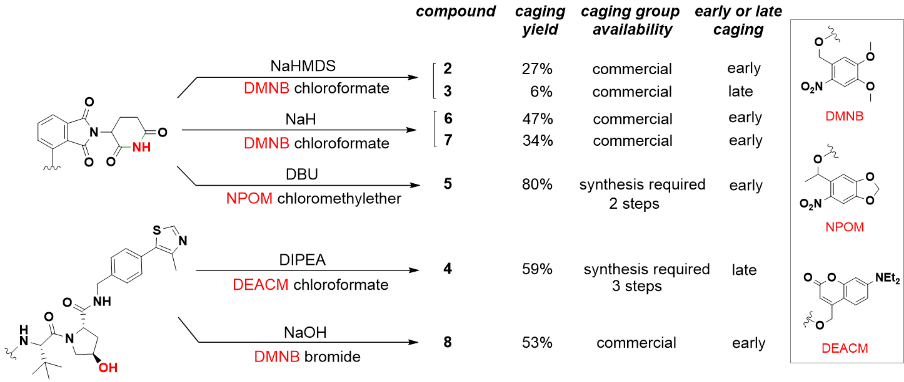

Figure 3. Chemical functionalization of E3 ligase ligands with photolabile groups. Varied strategies have been used to introduce the caging groups via acylation or alkylation with most groups installed relatively early in the synthesis as direct chemical modification of the parent PROTAC in the final step was not always feasible. The yield reported represents the yield of the caging step. “Early” caging refers to a synthetic route in which the caging group was not directly attached to the parent PROTAC as opposed to “late” caging. DBU = 1,8-Diazabicyclo[5.4.0]undec-7-ene, DEACM = diethylamino coumarin, DIPEA = N,N-Diisopropylethylamine, DMNB = 4,5-dimethoxy-2-nitrobenzyl, NaHMDS = Sodium bis(trimethylsilyl)amide, NPOM = 6-nitropiperonyloxymethyl.

While thalidomide and its derivatives could be efficiently alkylated on their imide portion (Figure 3, caged PROTAC 5), acylation to obtain a carbamate usually required a strong base and was achieved in moderate yields (Figure 3, caged PROTACs 2, 6, 7). Late stage chemistry was also attempted to insert the DMNB group directly on the parent PROTAC of 3 but it delivered the caged molecule in low yield. A final caging step is advantageous, since in theory, a small library of PROTACs could be turned into a set of caged degraders readily, provided the warhead for the POI does not interfere with the chemistry to be performed on the E3 ligand moiety. Comparable to the DMNB group, the diethylamino coumarin (DEACM) of 4 could be activated at 365 nm and also at the longer 405 nm wavelength.³²
The photouncaging properties of the final molecules were evaluated in solution before initiating cell work. Upon irradiation for less than 180 seconds, greater than 50% uncaged material was observed in solution for most compounds (caged PROTACs 1, 3, 4, 5 and 8). Interestingly, compound 2 failed to release any significant amount of active PROTAC after irradiation for 10 mins in phosphate buffered saline (PBS) solution and was eventually not tested in cells. On the contrary, compound 6 which was made from the same precursor PROTAC as 2 (dBET1) and carried an identical caging group underwent photolysis to release the active degrader, although a prolonged irradiation time was required to reach significant uncaging in solution (t_{1/2} = 58 mins, reported time to get 50% uncaging from a 1 mM solution of 6 as measured by UV-Vis). High efficiency in releasing the parent molecule upon irradiation (i.e. good quantum yield) is often a desired feature of a photocage, however, the catalytic mode of action of PROTACs may compensate for this limitation. Despite much slower cleavage kinetics than other caged PROTACs, compounds 6 and 7 did degrade their respective target upon irradiation, and within a concentration range close to their parent PROTAC.
For VHL-based caged degraders 4 and 8, the chemistry was performed on the hydroxyl group of the VHL ligand. Naro et al. synthesized a DEACM caging group before O-acylating the parent PROTAC at the final stage with a reasonable yield, whereas our group used phase transfer catalysis to successfully install the DMNB group early on via O-alkylation (Figure 3).

2.3 CAGED DEGRADERS IN ACTION
Bromodomain-containing protein 4 (BRD4)
Degradation of bromodomain and extra terminal (BET) proteins with PROTACs has been explored extensively,⁴⁷ and BETs are often used as targets to validate new assays and methodologies related to targeted protein degradation. BRD4 is also an important target in oncology due to its role in regulation of several genes associated with cell proliferation and maintenance of cell cycle.⁴⁸ Therefore, controlling BRD4 stability with light-activated degraders would provide a compelling way to modulate cancer cell proliferation in a spatiotemporal manner. BRD4 degraders such as dBET1, MZ1 or ARV-825 are well-validated chemical tools with potent cellular activity,^{42,44,49} and have shown promising pharmacodynamic effects in preclinical mouse models.^{50,51}
The BRD4-targeting caged PROTACs reviewed here are directly or closely related to dBET1 (compounds 1, 2, 5, 6) or MZ1 (compound 8). Consistent with their fast uncaging kinetics, caged compounds 1, 5 and 8 tested at 1 μM, achieved complete degradation of BRD4 in various cell lines following irradiation at 365 nm for 180 seconds or less. Depletion of BRD4 was generally more pronounced with longer irradiation times, and the kinetics of degradation were very similar to the parent PROTAC using equal concentrations of caged material. The observed knockdown was also confirmed to be E3 ligase- and proteasome-dependent for all compounds and the caged PROTACs 1, 5 and 6 negatively impacted cell survival upon irradiation (up to 39% reduction in cell viability for 5). Work in our laboratory demonstrated that treatment of HeLa cells with caged PROTAC 8 had a cytostatic effect prior to irradiation (an effect attributed to BRD4 inhibition by the free JQ1 warhead) but led to strong cytotoxicity post uncaging (Figure 4A). The consistent increase in toxicity observed upon photolysis of the caged degraders was not related to irradiation alone,³⁴ nor did the by-product generated during photoactivation affected BRD4 levels.³²
To take light-induced degradation with caged molecules one step further, Xue et al. have investigated the knockdown of BRD4 with compound 1 in a Zebrafish model, a widely used species in drug discovery and developmental biology.⁵² The high BRD4 expression levels during fish embryogenesis combined with the transparency of the embryos allowed the authors to look at light-induced phenotypes originating from BRD4 depletion (Figure 4B and 4C). While non-irradiated embryos treated with 1 developed a full yolk per the
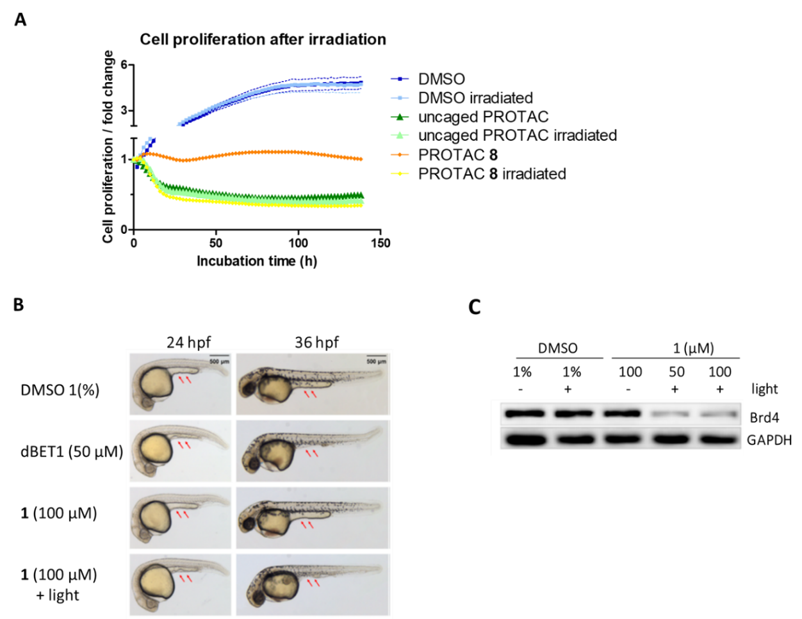
Figure 4. Effect of caged PROTACs on cell proliferation and in Zebrafish. (A) HeLa cells were treated with DMSO, caged PROTAC 8 (1 μM) or the uncaged parent PROTAC of 8 (1 μM) either without initial irradiation or with a 60-second irradiation time at 365 nm. Cell count was followed over 6 days. (B) Phenotype of zebrafish embryos treated with dBET1 and caged PROTAC 1 at 24 and 36 hours post-fertilization (hpf). (C) Expression of Brd4 protein in treated embryos examined by Western blot. Images adapted with permission from Ref. [31]. Copyright 2019 American Chemical Society.

DMSO control, embryos irradiated at 365 nm for 10 minutes fail to grow a yolk extension in presence of 1, analogous to treatment with dBET1.
This result represents the first use of light-activated degraders in a complex multicellular organism, and further highlights the important distinction between the pharmacological consequences of inhibition versus degradation.
Estrogen-related receptor alpha (ERRα)
In addition to BRD4, Naro et al. applied the photocaging strategy to a PROTAC targeting estrogen-related receptor alpha (ERRα), an orphan receptor with roles in metabolism, homeostasis, and breast cancer.⁵³ The parent PROTAC of 4 was reported by Bondeson et al. in 2015 and achieved significant reduction of ERRα receptor levels both in MCF-7 cells and in mice.¹⁶ The caged degrader 4 was unable to degrade ERRα in the same cell line until it was uncaged by UV light. The relevance of the approach was also highlighted by triggering estrogen receptor alpha (ERα) -dependent transcription (normally repressed in presence of ERRα) in MCF-7 cells transfected with a luciferase reporter gene. ERα-mediated transcription (monitored via the luciferase signal) was triggered by degradation of ERRα, which was in turn initiated upon uncaging of 4.
Bruton tyrosine kinase (BTK) and anaplastic lymphoma kinase (ALK)
Unsurprisingly given their attractiveness as therapeutic targets in cancer, several kinases have been targeted successfully with PROTACs. This includes cyclic dependent kinases (CDKs),⁵⁴ focal-adhesion kinase (FAK),⁵⁵ TANK-binding kinase (TBK),⁵⁶ and receptor tyrosine kinases (RTKs).¹⁷ Caged PROTAC 3, which is derived from MT-802, a potent Bruton tyrosine kinase (BTK) degrader developed by the Crews’ lab,⁵⁷ substantially decreased BTK levels in a dose-dependent manner only following irradiation at 365 nm. Likewise, 7 was designed by caging the anaplastic lymphoma kinase (ALK) degrader MS4078.⁵⁸ Photoirradiation of 7 strongly reduced cellular levels of oncogenic active ALK fusion proteins, EML4-ALK and NPM-ALK, in NCI-H2228 lung cancer cells and SU-DHL-1 lymphoma cells, respectively. To achieve an antiproliferative effect to the same extent as MS4078 on SU-DHL-1 cells, caged PROTAC 7 required activation by UV light.

3. PHOTOSWITCHABLE DEGRADERS: REVERSIBLE ACTIVATION
The examples above clearly demonstrate the potential of caged degraders as chemical tools to trigger target protein knockdown with timely precision. However, the caging strategy activates proteolysis in an irreversible manner, without the possibility to switch off the degradation event. Conversely, being able to trigger and halt protein degradation on demand would provide a subtle way to control cellular protein levels and associated biological functions. Astute structural modifications of bifunctional degraders with photoswitchable motifs has been devised to accomplish such reversible control.

3.1 PHOTOSWITCH DESIGN: AZOBENZENE AT THE FOREFRONT
Using geometrical isomerism to reversibly control biological processes has been exemplified extensively with azobenzene photoswitches,²⁴ and their chemical tractability and tunable properties also make them an appropriate choice for photoswitchable PROTACs.⁵⁹ It was hypothesized that incorporation of an azobenzene motif into a bifunctional molecule would allow for major changes in binary and ternary binding interactions to take place upon irradiation due to cis/trans isomerism. This change in configuration would then translate into a distinct degradation profile for each isomer (Figure 5A). As a consequence, turning proteolysis on or off would be feasible with a single molecule, simply by switching between the two geometrical isomers.
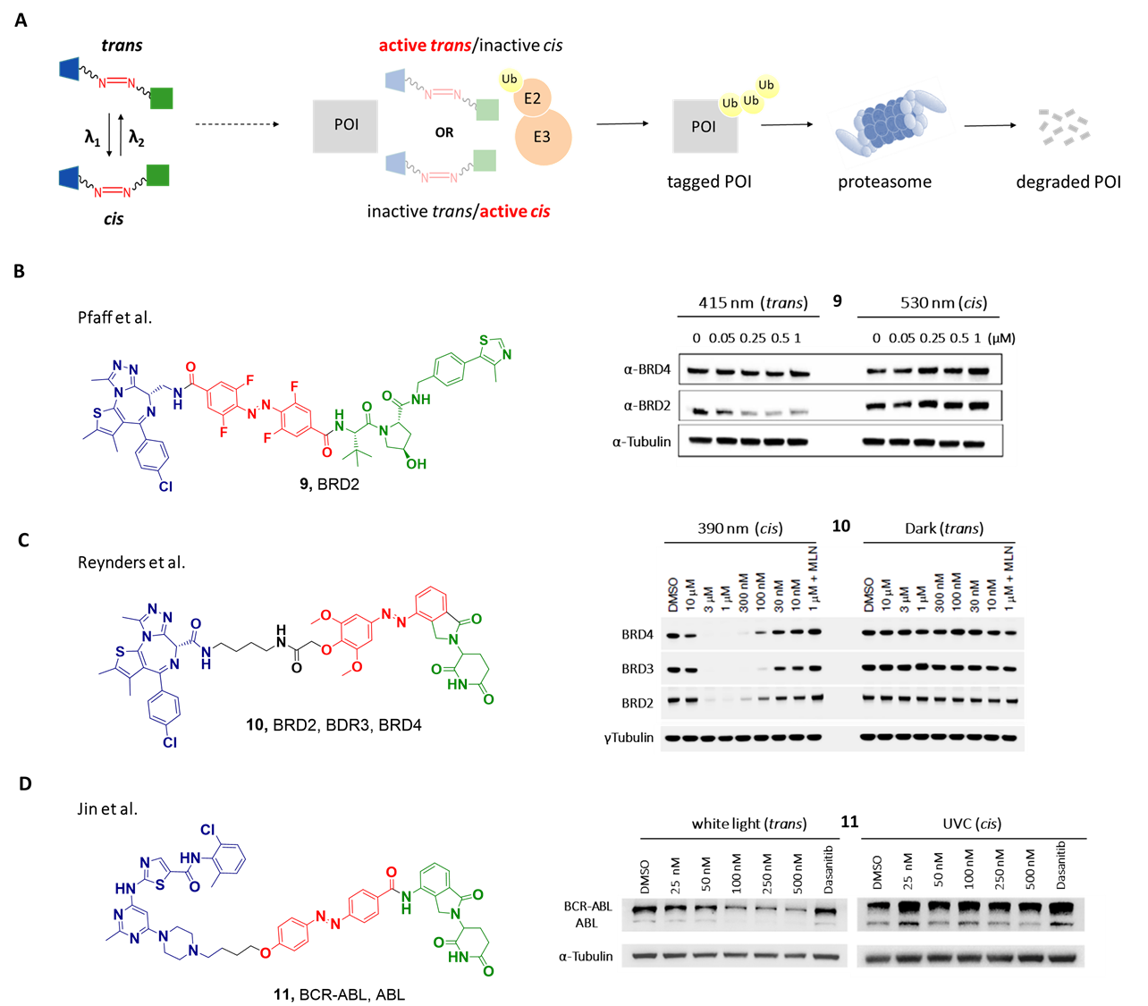
Figure 5. Photoswitchable degrader design, structures, and activity profiles. (A) The azobenzene motif delivers two geometrical isomers: the cis isomer can be obtained by irradiation of the trans isomer with a specific wavelength λ₁ and inversely, the trans isomer can be generated from the cis with either another wavelength λ₂ or by thermal relaxation. The difference in conformation between the two isomers affects binding interactions and allows degradation to occur with only one isomer (cis or trans) but not the other. (B) Structure of the reported photoswitchable PROTAC 9 (left). Each degrader is made of a warhead (depicted in blue), an E3 ligase recruiter (green) and a photoswitch (red) as part of the linker (black). Immunoblot analysis after treatment of Ramos cells with compound 9 (right). The trans isomer of 9 degraded BRD2 while the cis isomer did not affect BRD2 levels. Image adapted with permission from Ref.[35]. Copyright 2019 American Chemical Society. (C) Structure of the reported photoswitchable PROTAC 10 (left). Immunoblot analysis after treatment of RS4;11 cells with compound 10 (right). The cis isomer of 10 knocked down BRD2, BRD3 and BRD4 while the trans isomer did not degrade any BRD. Image adapted with permission from Ref.[36] Copyright 2020 AAAS. (D) Structure of the reported photoswitchable PROTAC 11 (left). Immunoblot analysis following treatment of K562 cells with compound 11 (right). The trans isomer of 11 was efficient in reducing levels of BCR-ABL and ABL while its cis counterpart showed no degradation activity. Image adapted with permission from Ref.[37]. Copyright 2020 American Chemical Society.

As previously mentioned, the linker that connects the two ligands of a PROTAC plays a critical role in a degrader’s efficacy.¹³ Parameters such as composition and length of the linker can have a profound impact on a degrader’s physicochemical properties as well as its conformation.⁶⁰ Taking this into account, the Carreira and Jian labs engineered the azobenzene switch as a central linker positioned between the E3 ligand and the warhead against the target protein (Figure 5B and 5D, compounds 9 and 11).^{35,37} Moreover, in their search for a bistable PROTAC which does not require continuous irradiation (i.e. thermodynamically stable as a trans isomer with a long cis thermal half-life), the Carreira lab incorporated into compound 9 an ortho-F₄-azobenzene motif reported to possess
Characteristics | 9 | 10 | 11
Photoswitch type | ortho-F4-azobenzene | azobenzene | azobenzene
Activity profile obtained | trans active / cis inactive | cis active / trans inactive | trans active / cis inactive
E3 ligand / E3 recruited | VH032 / VHL | lenalidomide / Cereblon | lenalidomide / Cereblon
Warhead / Protein degraded | JQ1 / BRD2 | JQ1 / BRD4 | Dasatinib / BCR-ABL
Isoform degradation profile | BRD4 not degraded | BRD4, BRD3 > BRD2 | ABL degraded
Main irradiation mode[a] | Single initial irradiation | Continuous pulse irradiation | Single initial irradiation
λ trans to cis / PSS[b] | 530 nm / 68% cis | 390 nm / >90% cis | UVC[c]
λ cis to trans / PSS[b] | 415 nm / 95% trans | >450 nm / >70% trans | White light[c]
cis half-life  thermal relaxation[d] | several days (37˚C, DMSO) | 8.8 h (37˚C, DMSO) | 10.3 h (25˚C)
photoswitch resistance | --- | multiple cycles tested | 5 cycles tested
In-cell activation and deactivation of degradation | achieved | achieved | achieved
Stability towards GSH reduction | stable | --- | stable

Table 1. Diverse characteristics and degradation profiles (cis vs trans) of photoswitchable degraders 9, 10 and 11. The type of photoswitch, E3 ligase ligand and warhead used can all affect degradation. [a] Varied light sources used in these studies; refer to original publications for details. [b] PSS = photostationary state, reported as percentage of cis at equilibrium after irradiation at λ. [c] wavelength not specified, no PSS data. [d] measured in the dark.

prolonged half-life.⁶¹ Bistable cis/trans isomers may prove beneficial to outcompete fast protein resynthesis (i.e. in the case of proteins with a high turnover), as higher concentrations of the desired isomer would be maintained without light stimulation contrary to fast relaxing switches.
In parallel, the Trauner lab investigated multiple positions for the azobenzene group and their most promising molecule adapted the phenyl ring of the E3 ligase ligand lenalidomide as an integral part of the photoswitch (Figure 5C, compound 10).³⁶ Synthesis of the highlighted tool compounds 9-11 was mainly achieved via conventional azo coupling to obtain the photoswitch followed by additional amide bond formation steps to reach several final molecules in a modular fashion. Key features are summarized in Table 1 and underscore the diversity in optical properties and degradation profiles that can be obtained using an azobenzene photoswitch.
Overall, the thermodynamically more stable trans isomer could be switched to its cis counterpart using UV or visible light and conversion was achieved with satisfactory to excellent photostationary state (PSS) ratios (68% cis for 9, above 90% cis for 10). Compound 9 was reported as bistable since thermal back isomerization from cis to trans was not observed after incubation at 37˚C for several days in solution. Although reasonable cis thermal half-lives were obtained for 10 and 11 (8.8 h and 10.3 h, respectively), the active cis isomer of 10 was mainly tested under continuous pulse irradiation to maximize the intracellular concentration of the active isomer over time. Apart from thermal relaxation, switching back to the trans isomer could also be realized for 9 and 10 with good PSS using another wavelength of light (Table 1). Lastly, in addition to favorable photochemical properties, these novel photoswitchable degraders demonstrated good stability after multiple irradiation cycles and could withstand glutathione without detectable reduction, suggesting they should be stable in cells.

3.2 TAMING THE CHIMERA: ON/OFF SWITCHING
With regard to degradation activity, the azobenzene photoswitch was generally well tolerated as an atypical linker. The two isomers from compound 9, based on pan-BET degrader ARV-771,⁶² displayed a different degradation profile towards BRD2 (trans active, cis inactive) while leaving BRD4 unaffected (Figure 5B).This selectivity towards BRD2 was partly attributed to the unusual inverse amide bond connecting JQ1 to the ortho-F₄-azobenzene moiety. In contrast, compound 10 showed an opposite activity profile with the cis isomer able to degrade BRD3, BRD4 and to a lesser extent BRD2, whereas the trans isomer was completely inactive towards all BRDs (Figure 5C). With the photoswitch embedded in the E3 ligase ligand, considerable changes in binary interactions (with Cereblon E3 ligase) but also in ternary complex formation would be expected upon isomerization of 10 and presumably lead to this distinctive degradation outcome. As for compound 11, its trans isomer degraded BCR-ABL fusion protein and ABL while its cis isomer did not affect the levels of those proteins (Figure 5D). It is worth noting that although the pairs of isomers of 9, 10 and 11 showed remarkably unique degradation profiles between cis and trans, many of the related compounds synthesized in the course of those studies did not exhibit a clearly differentiated effect. The extensive investigation from Trauner’s lab which reported a total of 19 photoswitchable degraders including 6 targeting the prolyl cis-trans isomerase FKBP12 suggests that linker length is one critical factor among several influencing the activity profile of the two geometrical isomers (Figure 6). Taken together, those results highlight the need for additional tools to guide the design of reversible light-activated degraders, and to better understand their mode of action.

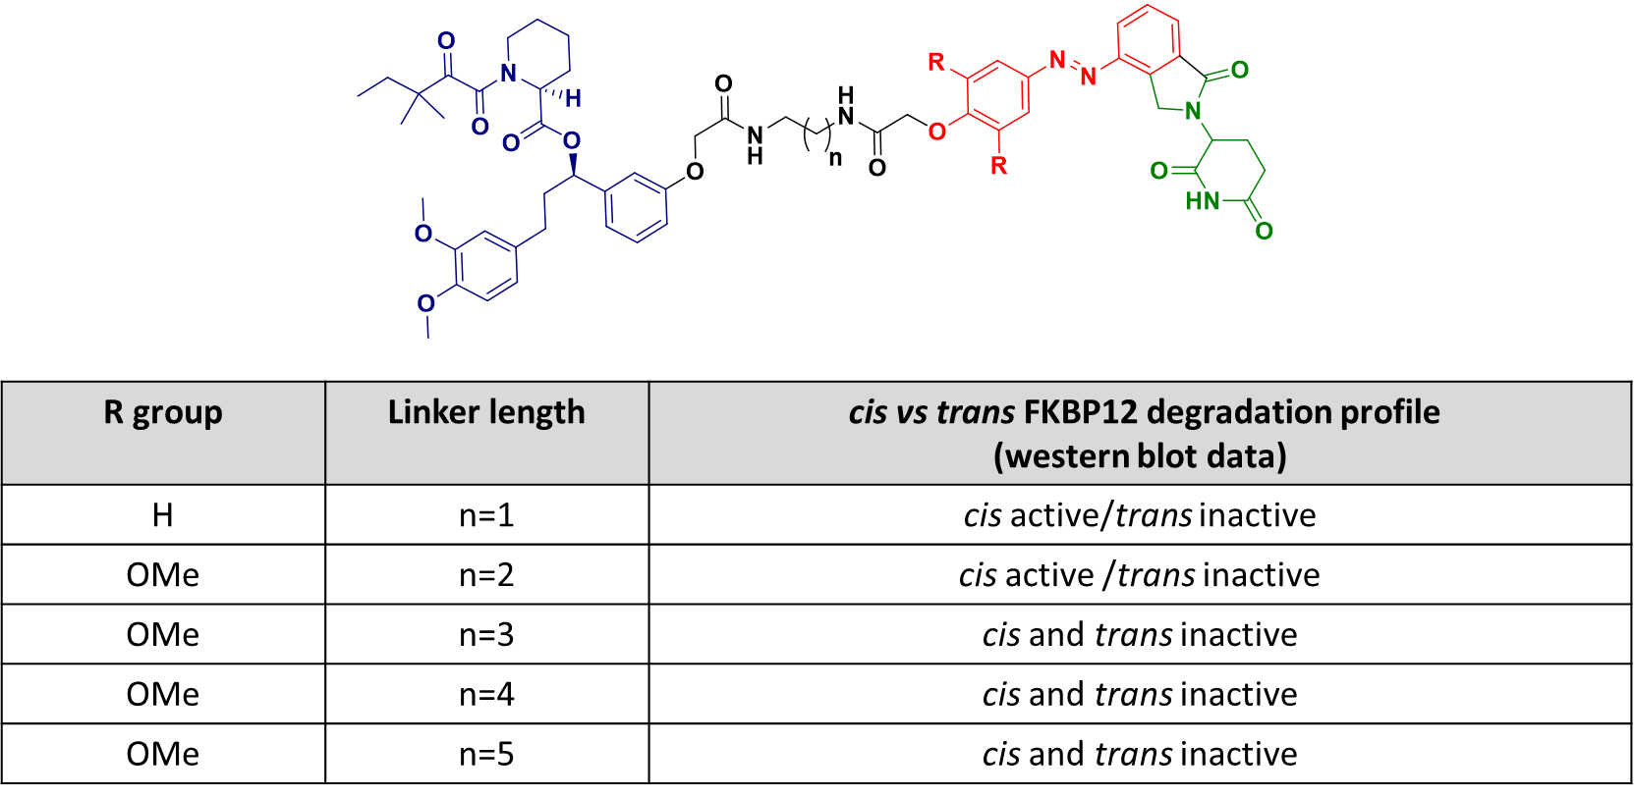

Figure 6. Influence of the linker length on FKBP12 photoswitchable PROTAC degradation profile. The warhead is depicted in blue, the E3 ligase recruiter in green and the photoswitch forming part of the black linker is depicted in red. RS4;11 cells were treated with various FKBP12 targeting photoswitchable compounds for 4 h at different concentrations. Cells were either irradiated with pulses of 390 nm light (cis) or kept the dark (trans).

Finally, reversible initiation or arrest of proteolysis upon photoisomerization was an important proof of concept result demonstrated with compounds 9, 10 and 11. In-cell bidirectional switching was achieved using two separate wavelengths and could also be accomplished via thermal relaxation in the case of 10. This two-way on/off mechanism, which is strictly dependent on the photoswitchable PROTAC configuration, undoubtedly represents an important milestone in the spatiotemporal control of protein stability with a small molecule. To further illustrate the benefit of this approach, the effect of photoswitchable degrader 10 on cell viability was correlated with degradation of BRDs by the cis isomer. 10 was seven times more toxic when irradiated at 390 nm (cis isomer) than when incubated in the dark (trans isomer).

4. SUMMARY AND OUTLOOK
Bifunctional degraders can be engineered into light-activated chemical tools with photocaging or photoswitchable functionalities, providing a compelling method for the spatiotemporal control of protein stability. Inherently, caged degraders can only switch on proteolysis via a relatively fast uncaging mechanism, mainly triggered by UV light, and which generates a by-product. As for photoswitchable degraders, their azobenzene motif allows isomerization within the visible wavelength range and offers a bidirectional on/off handle with a superior level of control, even though they may not deliver quantitative switching. Indeed, residual activity from small quantities of active isomer present in the PSS may compromise the pharmacological applications of switchable PROTACs and the stringency of switching required is likely to depend on the specific application. Furthermore, we note that PROTACs already present difficult profiles for oral delivery and balancing the physicochemical properties of two PROTAC isomers may present additional challenges of optimization.
Although bistable switchable degraders (such as compound 9) avoid the need for continuous irradiation, fast relaxing switches may find useful applications, particularly if sustained degradation can be attained after transient generation of the bioactive cis isomer and on- or off-target toxicities minimized by subsequent fast inactivation. A tight-binding PROTAC could be retained by its target proteins for a prolonged period in the cell, and thermal reversion may assist in taming extended pharmacodynamics. Decisions on optimal half-lives needed for the active isomer may ultimately depend on the target protein and specific applications pursued, and it remains unclear whether this automatic “switch off” characteristic would offer any benefit over tuning half-life through inactivation by metabolism or excretion.
We also note that caging of the E3 ligase component of a PROTAC (compounds 3-8) is straightforward, highly modular, and offers a mechanistically predictable outcome in switching on degradation upon photoirradiation. In comparison, the reports to date on photoswitchable degraders reveal that incorporation of a photoswitch into a bifunctional molecule can be explorative and identification of geometrical isomers with distinct degradation potency may require multiple synthetic iterations. More importantly, explanation of the observed structure-degradation profiles (which may also be target-dependent) has yet to be provided at a molecular level for photoswitchable degraders, and will certainly require a combination of biophysical and computational methods not only to understand the data a posteriori, but also to guide future design.
Selective and differential degradation of closely related proteins (i.e. proteins within a subfamily or isoforms) is another aspect worthy of investigation with photoswitchable degraders. This singular characteristic of PROTACs has mainly been described for kinase-targeting degraders,^{63,64} and the data from Pfaff et al. (BRD2 selective degradation with trans isomer of 9) encourages further exploitation of this feature with a photoswitch design. Differential degradation of structurally related proteins upon configurational change of the degrader could permit more precise targeting and study of protein function.
Equipped with the capacity to degrade proteins via a light-dependent mechanism and consequently modulate cellular functions, photoactive degraders have strong potential for development into the field of photopharmacology provided constraints associated with their physicochemical properties can be overcome.⁶⁵ The incorporation of lipophilic photolabile groups and the use of azobenzene units into degraders place these compounds into an undesired drug property space. Despite their high molecular weight and high lipophilicity, the caged and photoswitchable PROTACs reviewed here displayed sufficient cell permeability and stability to achieve controlled intracellular protein knockdown. We anticipate that the progression of such tool compounds in vivo (in animal models or in the clinic) will necessitate careful assessment and optimization of their pharmacokinetic properties while preserving their favorable photochemical features.⁶⁶
Finally, due to activating wavelengths within the UV-visible range, in vivo applications of photoactive PROTACs may be limited by light-induced cellular damage (if long irradiation times with UV light are needed) and poor tissue penetration of the incident light. Alongside sophisticated light-delivery methods,⁶⁷ strategies to develop photocaging groups and photoswitches activated in the red and near infrared regions are rapidly emerging.⁶⁸ Incorporation of these innovations in the design of novel photoactive bifunctional degraders will allow deeper in vivo exploration and manipulation of biological pathways, and may ultimately enable advances in precision medicine.

AUTHOR INFORMATION
Corresponding Author
Edward W. Tate: e-mail: e.tate@imperial.ac.uk
Author
Cyrille S. Kounde
NOTES
The authors declare the following competing financial interest(s): E.W.T. is a founder, Director, and shareholder of Myricx Pharma, Ltd.

BIOGRAPHIES
Cyrille Kounde completed his B.Sc. degree in biochemistry at Paris Diderot University and his M.Sc. in organic chemistry at Paris Descartes University. In 2006, he started his career in industry in the United Kingdom as a drug discovery scientist at Evotec Ltd then joined Novartis. He moved to Singapore in 2011 and worked on various medicinal chemistry projects related to neglected infectious diseases at the Novartis Institute for Tropical diseases (NITD). He is currently a PhD student in the group of Prof. Ed Tate at Imperial College London where he is investigating conditional activation of bifunctional degraders.
Ed Tate is Professor of Chemical Biology in the Department of Chemistry at Imperial College London, a Group Leader at the Francis Crick Institute, and Chief Scientific Officer of Myricx Pharma Ltd. He completed his B.Sc. degree in Chemistry at the University of Durham and undertook his Ph.D. in organic chemistry at the University of Cambridge under the guidance of Prof. Steve Ley. Following postdoctoral research at Ecole Polytechnique and the Pasteur Institute in Paris, he was awarded a BBSRC David Phillips Research Fellowship in 2006 at Imperial College London and was promoted to full Professor in 2014. His research encompasses the fields of chemical biology and chemical proteomics, with a focus on drug target discovery and validation.

ACKNOWLEDGEMENTS
We thank Dr Maria Maneiro, Dr Marcel Muelbaier and Dr John D. Harling for their critical evaluation of the draft manuscript. The authors acknowledge support from the Engineering and Physical Sciences Research Council (EPSRC) grant EP/R512540/1 and GlaxoSmithKline Research and Development Ltd.

ABBREVIATIONS
AID, auxin-inducible degron; BET, bromodomain and extra terminal; BRDs, bromodomain containing proteins; BTK, bruton tyrosine kinase; CRBN, cereblon; DDB1, DNA damage-binding protein 1; DEACM, diethylamino coumarin; DIPEA, N,N-Diisopropylethylamine; DMNB, 4,5-dimethoxy-2-nitrobenzyl; EloB, Elongin-B; EloC, Elongin-C; FAK, focal adhesion kinase; IKZF3, zinc finger protein Aiolos; LED, light-emitting diode; NaHMDS, sodium bis(trimethylsilyl)amide; NPOM, 6nitropiperonyloxymethyl; POI, protein of interest; PROTAC, proteolysis targeting chimera; PSS, photostationary state; RNAi, ribonucleic acid interference; RTK, receptor tyrosine kinase; TBK, TANK-binding kinase; TPD, targeted protein degradation; Ub, ubiquitin; UPS, ubiquitin-proteasome system; VHL, von Hippel Lindau

REFERENCES
(1) Alber, A. B.; Suter, D. M. Dynamics of Protein Synthesis and Degradation through the Cell Cycle. Cell Cycle 2019, 18 (8), 784–794.
(2) Hershko, A.; Ciechanover, A. The Ubiquitin System. Annu. Rev. Biochem. 1998, 67 (1), 425–479.
(3) Ciechanover, A. Intracellular Protein Degradation: From a Vague Idea Thru the Lysosome and the Ubiquitin-Proteasome System and onto Human Diseases and Drug Targeting. Cell Death Differ. 2005, 12 (9), 1178–1190.
(4) Nalepa, G.; Rolfe, M.; Harper, J. W. Drug Discovery in the Ubiquitin - Proteasome System. Nat. Rev. Drug Discov. 2006, 5 (7), 596–613.
(5) Pettersson, M.; Crews, C. M. PROteolysis TArgeting Chimeras (PROTACs) — Past, Present and Future. Drug Discov. Today Technol. 2019, 31, 15–27
(6) Che, Y.; Gilbert, A. M.; Shanmugasundaram, V.; Noe, M. C. Inducing Protein-Protein Interactions with Molecular Glues. Bioorganic Med. Chem. Lett. 2018, 28 (15), 2585–2592.
(7) Zhang, Y.; Loh, C.; Chen, J.; Mainolfi, N. Targeted Protein Degradation Mechanisms. Drug Discov. Today Technol. 2019, 31, 53–60.
(8) Fink, E. C.; Ebert, B. L. The Novel Mechanism of Lenalidomide Activity. Blood 2015, 126 (November), 2366–2370.
(9) Sakamoto, K. M.; Kim, K. B.; Kumagai, A.; Mercurio, F.; Crews, C. M.; Deshaies, R. J. Protacs: Chimeric Molecules That Target Proteins to the Skp1-Cullin-F Box Complex for Ubiquitination and Degradation. Proc. Natl. Acad. Sci. U. S. A. 2001, 98 (15), 8554–8559.
(10) Mullard, A. First Targeted Protein Degrader Hits the Clinic. Nat. Rev. Drug Discov. 2019, 18, 237.
(11) Fischer, E. S.; Böhm, K.; Lydeard, J. R.; Yang, H.; Stadler, M. B.; Cavadini, S.; Nagel, J.; Serluca, F.; Acker, V.; Lingaraju, G. M.; Tichkule, R. B.; Schebesta, M.; Forrester, W. C.; Schirle, M.; Hassiepen, U.; Ottl, J.; Hild, M.; Beckwith, Rohan E.J.; Harper, J. W.; Jenkins, J. L.; Thomä, N. H. Structure of the DDB1-CRBN E3 Ubiquitin Ligase in Complex with Thalidomide. Nature 2014, 512 (1), 49–53.
(12) Galdeano, C.; Gadd, M. S.; Soares, P.; Scaffidi, S.; Van Molle, I.; Birced, I.; Hewitt, S.; Dias, D. M.; Ciulli, A. Structure-Guided Design and Optimization of Small Molecules Targeting the Protein-Protein Interaction between the von Hippel-Lindau (VHL) E3 Ubiquitin Ligase and the Hypoxia Inducible Factor (HIF) Alpha Subunit with in Vitro Nanomolar Affinities. J. Med. Chem. 2014, 57 (20), 8657–8663.
(13) Churcher, I. Protac-Induced Protein Degradation in Drug Discovery: Breaking the Rules or Just Making New Ones? J. Med. Chem. 2018, 61 (2), 444–452.
(14) Cromm, P. M.; Crews, C. M. Targeted Protein Degradation: From Chemical Biology to Drug Discovery. Cell Chem. Biol. 2017, 24 (9), 1181–1190.
(15) Röth, S.; Fulcher, L. J.; Sapkota, G. P. Advances in Targeted Degradation of Endogenous Proteins. Cell. Mol. Life Sci. 2019, 76 (14), 2761–2777.
(16) Bondeson, D. P.; Mares, A.; Smith, I. E. D.; Ko, E.; Campos, S.; Miah, A. H.; Mulholland, K. E.; Routly, N.; Buckley, D. L.; Gustafson, J. L.; Zinn, N.; Grandi, P.; Shimamura, S.; Bergamini, G.; Faelth-Savitski, M.; Bantscheff, M.; Cox, C.; Gordon, D. A.; Willard, R. R.; Flanagan, J.J.; Casillas, L. N.; Votta, B. J.; Den Besten, W.; Famm, K.; Kruidenier, L.; Carter, P. S.; Harling, J. D.; Churcher, I.; Crews, C. M. Catalytic in Vivo Protein Knockdown by Small-Molecule PROTACs. Nat. Chem. Biol. 2015, 11 (8), 611–617.
(17) Burslem, G. M.; Smith, B. E.; Lai, A. C.; Jaime-Figueroa, S.; McQuaid, D. C.; Bondeson, D. P.; Toure, M.; Dong, H.; Qian, Y.; Wang, J.; Crew, A. P.; Hines, J.; Crews, C. M. The Advantages of Targeted Protein Degradation Over Inhibition: An RTK Case Study. Cell Chem. Biol. 2018, 25 (1), 67-77.
(18) Cromm, P. M.; Samarasinghe, K. T. G.; Hines, J.; Crews, C. M. Addressing Kinase-Independent Functions of Fak via PROTAC-Mediated Degradation. J. Am. Chem. Soc. 2018, 140 (49), 17019–17026.
(19) Tomoshige, S.; Nomura, S.; Ohgane, K.; Hashimoto, Y.; Ishikawa, M. Discovery of Small Molecules That Induce the Degradation of Huntingtin. Angew. Chemie - Int. Ed. 2017, 56 (38), 11530–11533.
(20) Zhou, H.; Bai, L.; Xu, R.; Zhao, Y.; Chen, J.; McEachern, D.; Chinnaswamy, K.; Wen, B.; Dai, L.; Kumar, P.; Yang, C. Y.; Liu, Z.; Wang, M.; Liu, L.; Meagher, J. L.; Yi, H.; Sun, D.; Stuckey, J. A.; Wang, S. Structure-Based Discovery of SD-36 as a Potent, Selective, and Efficacious PROTAC Degrader of STAT3 Protein. J. Med. Chem. 2019, 62 (24), 11280–11300.
(21) Verma, R.; Mohl, D.; Deshaies, R. J. Harnessing the Power of Proteolysis for Targeted Protein Inactivation. Mol. Cell 2020, 77 (3), 446–460.
(22) Riching, K. M.; Mahan, S.; Corona, C. R.; McDougall, M.; Vasta, J. D.; Robers, M. B.; Urh, M.; Daniels, D. L. Quantitative Live-Cell Kinetic Degradation and Mechanistic Profiling of PROTAC Mode of Action. ACS Chem. Biol. 2018, 13 (9), 2758–2770.
(23) Roy, M. J.; Winkler, S.; Hughes, S. J.; Whitworth, C.; Galant, M.; Farnaby, W.; Rumpel, K.; Ciulli, A. SPR-Measured Dissociation Kinetics of PROTAC Ternary Complexes Influence Target Degradation Rate. ACS Chem. Biol. 2019, 14 (3), 361–368.
(24) Ankenbruck, N.; Courtney, T.; Naro, Y.; Deiters, A. Optochemical Control of Biological Processes in Cells and Animals. Angew. Chemie - Int. Ed. 2018, 57 (11), 2768–2798.
(25) Moreau, K.; Coen, M.; Zhang, A. X.; Pachl, F.; Castaldi, M. P.; Dahl, G.; Boyd, H.; Scott, C.; Newham, P. Proteolysis-Targeting Chimeras in Drug Development: A Safety Perspective. Br. J. Pharmacol. 2020, 177 (8), 1709–1718.
(26) Maneiro, M.; Forte, N.; Shchepinova, M. M.; Kounde, C. S.; Chudasama, V.; Baker, J. R.; Tate, E. W. Antibody–PROTAC Conjugates Enable HER2-Dependent Targeted Protein Degradation of BRD4. ACS Chem. Biol. 2020, 15, (6), 1306–1312.
(27) Dragovich, P. S.; Adhikari, P.; Blake, R. A.; Blaquiere, N.; Chen, J.; Cheng, Y. X.; den Besten, W.; Han, J.; Hartman, S. J.; He, J.; M. He; Rei Ingalla, E.; Kamath, A.V.; Kleinheinz, T.; Lai, T.; Leipold, D.D.; Li, C.S.; Liu, Q.; Lu, J.; Lu, Y.; Meng, F.; Meng, L.; Ng, C.; Peng, K.; Lewis Phillips, G.; Pillow, T.H.; Rowntree, R.K.; Sadowsky, J.D.; Sampath, D.; Staben, L.; Staben, S.T.; Wai, J.; Wan, K.; Wang, X.; Wei, B.; Wertz, I.E.; Xin, J.; Xu, K.; Yao, H.; Zang, R.; Zhang, D.; Zhou, H.; Zhao, Y. Antibody-Mediated Delivery of Chimeric Protein Degraders Which Target Estrogen Receptor Alpha (ERα). Bioorganic Med. Chem. Lett. 2020, 30 (4), 126097.
(28) Bonger, K. M.; Rakhit, R.; Payumo, A. Y.; Chen, J. K.; Wandless, T. J. General Method for Regulating Protein Stability with Light. ACS Chem. Biol. 2014, 9 (1), 111–115.
(29) Renicke, C.; Schuster, D.; Usherenko, S.; Essen, L. O.; Taxis, C. A LOV2 Domain-Based Optogenetic Tool to Control Protein Degradation and Cellular Function. Chem. Biol. 2013, 20 (4), 619–626.
(30) Delacour, Q.; Li, C.; Plamont, M. A.; Billon-Denis, E.; Aujard, I.; Le Saux, T.; Jullien, L.; Gautier, A. Light-Activated Proteolysis for the Spatiotemporal Control of Proteins. ACS Chem. Biol. 2015, 10 (7), 1643–1647.
(31) Xue, G.; Wang, K.; Zhou, D.; Zhong, H.; Pan, Z. Light-Induced Protein Degradation with Photocaged PROTACs. J. Am. Chem. Soc. 2019, 141, (46), 18370–18374
(32) Naro, Y.; Darrah, K.; Deiters, A. Optical Control of Small Molecule-Induced Protein Degradation. J. Am. Chem. Soc. 2020, 142 (5), 2193–2197.
(33) Kounde, C. S.; Shchepinova, M. M.; Saunders, C. N.; Muelbaier, M.; Rackham, M. D.; Harling, J. D.; Tate, E. W. A Caged E3 Ligase Ligand for PROTAC-Mediated Protein Degradation with Light. Chem. Commun. 2020, 56 (41), 5532–5535.
(34) Liu, J.; Chen, H.; Ma, L.; He, Z.; Wang, D.; Liu, Y.; Lin, Q.; Zhang, T.; Gray, N.; Kaniskan, H. Ü.; Jin, J.; Wei, W. Light-Induced Control of Protein Destruction by Opto-PROTAC. Sci. Adv. 2020, 6 (8), 1–12.
(35) Pfaff, P.; Samarasinghe, K. T. G.; Crews, C. M.; Carreira, E. M. Reversible Spatiotemporal Control of Induced Protein Degradation by Bistable PhotoPROTACs. ACS Cent. Sci. 2019, 5, (10), 1682–1690.
(36) Reynders, M.; Matsuura, B. S.; Bérouti, M.; Simoneschi, D.; Marzio, A.; Pagano, M.; Trauner, D. PHOTACs Enable Optical Control of Protein Degradation. Sci. Adv. 2020, 6 (8) eaay5064.
(37) Jin, Y. H.; Lu, M. C.; Wang, Y.; Shan, W. X.; Wang, X. Y.; You, Q. D.; Jiang, Z. Y. Azo-Protac: Novel Light-Controlled Small-Molecule Tool for Protein Knockdown. J. Med. Chem. 2020, 63 (9), 4644–4654.
(38) Manna, D.; Verma, S. Controlling PROTACs With Light. ChemMedChem 2020, 1–5.
(39) Nalawansha, D. A.; Crews, C. M. PROTACs: An Emerging Therapeutic Modality in Precision Medicine. Cell Chem. Biol. 2020, 27, 998–1014.
(40) Mayer, G.; Hechel, A. Biologically Active Molecules with a “Light Switch.” Angew. Chemie - Int. Ed. 2006, 45 (30), 4900–4921.
(41) Dobrovolsky, D.; Wang, E. S.; Morrow, S.; Leahy, C.; Faust, T.; Nowak, R. P.; Donovan, K. A.; Yang, G.; Li, Z.; Fischer, E. S.; Treon, S. P.; Weinstock, D. M.; Gray, N.S. Bruton Tyrosine Kinase Degradation as a Therapeutic Strategy for Cancer. Blood 2019, 133 (9), 952–961.
(42) Winter, G. E.; Buckley, D. L.; Paulk, J.; Roberts, J. M.; Souza, A.; Dhe-Paganon, S.; Bradner, J. E. Phthalimide Conjugation as a Strategy for in Vivo Target Protein Degradation. Science (80). 2015, 348 (6241), 1376–1381.
(43) Ishoey, M.; Chorn, S.; Singh, N.; Jaeger, M. G.; Brand, M.; Paulk, J.; Bauer, S.; Erb, M. A.; Parapatics, K.; Müller, A. C.; Bennett, K. L.; Ecker, G. F.; Bradner, J. E.; Winter, G. E. Translation Termination Factor GSPT1 Is a Phenotypically Relevant Off-Target of Heterobifunctional Phthalimide Degraders. ACS Chem. Biol. 2018, 13 (3), 553–560.
(44) Zengerle, M.; Chan, K. H.; Ciulli, A. Selective Small Molecule Induced Degradation of the BET Bromodomain Protein BRD4. ACS Chem. Biol. 2015, 10 (8), 1770–1777.
(45) Donoghue, C.; Cubillos-Rojas, M.; Gutierrez-Prat, N.; Sanchez-Zarzalejo, C.; Verdaguer, X.; Riera, A.; Nebreda, A. R. Optimal Linker Length for Small Molecule PROTACs That Selectively Target P38α and P38β for Degradation. Eur. J. Med. Chem. 2020, 201, 112451.
(46) Klán, P.; Šolomek, T.; Bochet, C. G.; Blanc, A.; Givens, R.; Rubina, M.; Popik, V.; Kostikov, A.; Wirz, J. Photoremovable Protecting Groups in Chemistry and Biology: Reaction Mechanisms and Efficacy. Chem. Rev. 2013, 113 (1), 119–191.
(47) Yang, C. Y.; Qin, C.; Bai, L.; Wang, S. Small-Molecule PROTAC Degraders of the Bromodomain and Extra Terminal (BET) Proteins — A Review. Drug Discov. Today Technol. 2019, 31, 43–51.
(48) Zuber, J.; Shi, J.; Wang, E.; Rappaport, A. R.; Herrmann, H.; Sison, E. A.; Magoon, D.; Qi, J.; Blatt, K.; Wunderlich, M.; Taylor, M. J.; Johns, C.; Chicas, A.; Mulloy, J. C.; Kogan, S. C.; Brown, P.; Valent, P.; Bradner, J. E.; Lowe, S. W.;Vakoc, C. R. RNAi Screen Identifies Brd4 as a Therapeutic Target in Acute Myeloid Leukaemia. Nature 2011, 478 (7370), 524–528.
(49) Lu, J.; Qian, Y.; Altieri, M.; Dong, H.; Wang, J.; Raina, K.; Hines, J.; Winkler, J. D.; Crew, A. P.; Coleman, K.; Crews, C. M. Hijacking the E3 Ubiquitin Ligase Cereblon to Efficiently Target BRD4. Chem. Biol. 2015, 22 (6), 755–763.
(50) Noblejas-López, M. D. M.; Nieto-Jimenez, C.; Burgos, M.; Gómez-Juárez, M.; Montero, J. C.; Esparís-Ogando, A.; Pandiella, A.; Galán-Moya, E. M.; Ocaña, A. Activity of BET-Proteolysis Targeting Chimeric (PROTAC) Compounds in Triple Negative Breast Cancer. J. Exp. Clin. Cancer Res. 2019, 38 (1), 1–9.
(51) Sun, B.; Fiskus, W.; Qian, Y.; Rajapakshe, K.; Raina, K.; Coleman, K. G.; Crew, A. P.; Shen, A.; Saenz, D. T.; Mill, C. P.; Nowak, A. J.; Jain, N.; Zhang, L.; Wang, M.; Khoury, J. D.; Coarfa, C.; Crews, C. M.; Bhalla, K. N. BET Protein Proteolysis Targeting Chimera (PROTAC) Exerts Potent Lethal Activity against Mantle Cell Lymphoma Cells. Leukemia 2018, 32 (2), 343–352.
(52) Cassar, S.; Adatto, I.; Freeman, J. L.; Gamse, J. T.; Iturria, I.; Lawrence, C.; Muriana, A.; Peterson, R. T.; Van Cruchten, S.; Zon, L. I. Use of Zebrafish in Drug Discovery Toxicology. Chem. Res. Toxicol. 2020, 33 (1), 95–118.
(53) Berman, A. Y.; Manna, S.; Schwartz, N. S.; Katz, Y. E.; Sun, Y.; Behrmann, C. A.; Yu, J. J.; Plas, D. R.; Alayev, A.; Holz, M. K. ERRα Regulates the Growth of Triple-Negative Breast Cancer Cells via S6K1-Dependent Mechanism. Signal Transduct. Target. Ther. 2017, 2 (April), 1–9.
(54) Rana, S.; Bendjennat, M.; Kour, S.; King, H. M.; Kizhake, S.; Zahid, M.; Natarajan, A. Selective Degradation of CDK6 by a Palbociclib Based PROTAC. Bioorganic Med. Chem. Lett. 2019, 29 (11), 1375–1379.
(55) Popow, J.; Arnhof, H.; Bader, G.; Berger, H.; Ciulli, A.; Covini, D.; Dank, C.; Gmaschitz, T.; Greb, P.; Karolyi-Özguer, J.; Koegl, M.; McConnell, D. B.; Pearson, M.; Rieger, M.; Rinnenthal, J.; Roessler, V.; Schrenk, A.; Spina, M.; Steurer, S.; Trainor, N.; Traxler, E.; Wieshofer, C.; Zoephel, A.; Ettmayer, P. Highly Selective PTK2 Proteolysis Targeting Chimeras to Probe Focal Adhesion Kinase Scaffolding Functions. J. Med. Chem. 2019, 62 (5), 2508–2520.
(56) Crew, A. P.; Raina, K.; Dong, H.; Qian, Y.; Wang, J.; Vigil, D.; Serebrenik, Y. V.; Hamman, B. D.; Morgan, A.; Ferraro, C.; Siu, K.; Neklesa, T. K.; Winkler, J. D.; Coleman, K. G.; Crews, C. M. Identification and Characterization of von Hippel-Lindau-Recruiting Proteolysis Targeting Chimeras (PROTACs) of TANK-Binding Kinase 1. J. Med. Chem. 2018, 61 (2), 583–598.
(57) Buhimschi, A. D.; Armstrong, H. A.; Toure, M.; Jaime-Figueroa, S.; Chen, T. L.; Lehman, A. M.; Woyach, J. A.; Johnson, A. J.; Byrd, J. C.; Crews, C. M. Targeting the C481S Ibrutinib-Resistance Mutation in Bruton’s Tyrosine Kinase Using PROTAC-Mediated Degradation. Biochemistry 2018, 57 (26), 3564–3575.
(58) Zhang, C.; Han, X. R.; Yang, X.; Jiang, B.; Liu, J.; Xiong, Y.; Jin, J. Proteolysis Targeting Chimeras (PROTACs) of Anaplastic Lymphoma Kinase (ALK). Eur. J. Med. Chem. 2018, 151, 304–314.
(59) Beharry, A. A.; Woolley, G. A. Azobenzene Photoswitches for Biomolecules. Chem. Soc. Rev. 2011, 40 (8), 4422–4437.
(60) Gadd, M. S.; Testa, A.; Lucas, X.; Chan, K. H.; Chen, W.; Lamont, D. J.; Zengerle, M.; Ciulli, A. Structural Basis of PROTAC Cooperative Recognition for Selective Protein Degradation. Nat. Chem. Biol. 2017, 13 (5), 514–521.
(61) Bléger, D.; Schwarz, J.; Brouwer, A. M.; Hecht, S. o-Fluoroazobenzenes as Readily Synthesized Photoswitches Offering Nearly Quantitative Two-Way Isomerization with Visible Light. J. Am. Chem. Soc. 2012, 134 (51), 20597–20600.
(62) Raina, K.; Lu, J.; Qian, Y.; Altieri, M.; Gordon, D.; Rossi, A. M. K.; Wang, J.; Chen, X.; Dong, H.; Siu, K.; Winkler, J. D.; Crew, Andrew P.; Crews, C. M.; Coleman, K. G. PROTAC-Induced BET Protein Degradation as a Therapy for Castration-Resistant Prostate Cancer. Proc. Natl. Acad. Sci. U. S. A. 2016, 113 (26), 7124–7129.
(63) Huang, H. T.; Dobrovolsky, D.; Paulk, J.; Yang, G.; Weisberg, E. L.; Doctor, Z. M.; Buckley, D. L.; Cho, J. H.; Ko, E.; Jang, J.; Shi, K.; Choi, H. G.; Griffin, J. D.; Li, Y.; Treon, S. P.; Fischer, E. S.; Bradner, J. E.; Tan, L.; Gray, N. S. A Chemoproteomic Approach to Query the Degradable Kinome Using a Multi-Kinase Degrader. Cell Chem. Biol. 2018, 25 (1), 88-99.
(64) Bondeson, D. P.; Smith, B. E.; Burslem, G. M.; Buhimschi, A. D.; Hines, J.; Jaime-Figueroa, S.; Wang, J.; Hamman, B. D.; Ishchenko, A.; Crews, C. M. Lessons in PROTAC Design from Selective Degradation with a Promiscuous Warhead. Cell Chem. Biol. 2018, 25 (1), 78-87.
(65) Chamberlain, P. P.; Hamann, L. G. Development of Targeted Protein Degradation Therapeutics. Nat. Chem. Biol. 2019, 15 (10), 937–944.
(66) Fuchter, M. J. On the Promise of Photopharmacology Using Photoswitches: A Medicinal Chemist’s Perspective. J. Med. Chem. 2020, 63, (20), 11436–11447.
(67) Morstein, J.; Trauner, D. New Players in Phototherapy: Photopharmacology and Bio-Integrated Optoelectronics. Curr. Opin. Chem. Biol. 2019, 50, 145–151.
(68) Konrad, D. B.; Savasci, G.; Allmendinger, L.; Trauner, D.; Ochsenfeld, C.; Ali, A. M. Computational Design and Synthesis of a Deeply Red-Shifted and Bistable Azobenzene. J. Am. Chem. Soc. 2020, 142 (14), 6538–6547.

Table of Contents graphic
