Long Chain Alkylated Nanocellulose and LDPE-based Composite Materials with Improved Dispersion and Surface Polarity

Ahmad Aljaber,^{a)} Koon-Yang Lee,^{b)} George J.P. Britovsek^{a)}*

- Department of Chemistry, Imperial College London, Molecular Sciences Research Hub, White City Campus, 82 Wood Lane, W12 0BZ, United Kingdom.
- Department of Aeronautics, Imperial College London, Exhibition Road, South Kensington Campus, London SW7 2AZ, United Kingdom.

Materials 2
Synthesis 2
Synthesis of NFC-CS₂-Na 2
Synthesis of NFC-CS₂-C₆₆ 2
Extrusion of LDPE/ NFC-g-C₆₆ 3
Characterisation 3
Solid State NMR analysis 3
IR spectroscopy 3
Raman Spectroscopy 5
Thermogravimetrical Analysis (TGA) 5
PXRD analysis 8
DSC Analysis 9
Contact angle measurements 11
Mechanical properties 11
References 12

Materials
Nanocellulose (NFC) was provided by VTT Technical Research Centre Finland (Espoo, Finland) and was produced by grinding bleached birch kraft pulp (provided by Finnish pulp mill) using a Masuko supermass collider (Masuko Sangyo Co., Kawaguchi, Japan). Prior to grinding, the pulp was soaked in water overnight and dispersed using a high-shear mixer (Dispermix, Ystral GmbH, Germany) for 10 min. at 2000 rpm. This pulp suspension was then passed through the Masuko grinder six times to produce the aqueous nanocellulose gel with the final composition of approximately 2 wt.% NFC in water. Further details can be found here.[1]
Long chain alkyl iodides were prepared according to a previously reported procedure.[2]. LDPE (SABIC N0W2021) was donated by Sabic. All other reagents have been obtained commercially and were used as received.

Synthesis

Synthesis of NFC-CS₂-Na
60 g of NFC suspended in water (1.8 wt%) was stirred in 300 mL NaOH solution (18 wt% NaOH) overnight at room temperature. The resulting NFC-Na was filtered over a glass filter, washed with 1 L of water, and kept moist. The NFC-Na was stirred in 300 ml of water, and 2.4 g of CS₂ was added. The reaction mixture was stirred overnight after which it turned orange. The resulting NFC-CS₂-Na was filtered over a glass filter, washed with 1 L of water, and kept moist for further synthesis. For analytical purposes, it can be dried under vacuum overnight, but if it is to be used for further synthesis, it should be kept moist. The IR spectrum of NFC-CS₂-Na shows distinct signals that confirm the xanthate functionality with vibrational bands at 1060 cm⁻¹ for C=S (Figure S1.[3, 4]

Synthesis of NFC-CS₂-C₆₆
0.15 g of the moist NFC-g-CS₂-Na (1 equiv.) was dissolved in 30 ml of water, and 3.2 g of PE-I (average chain length C₆₆H₁₃₃-I (5 equiv.)) was dissolved in THF at 70 °C. The two solutions were mixed and 0.12 mL of trioctylmethylammonium chloride (Aliquat336) (0.42 equiv.) was added. The reaction was kept stirring overnight at 70 °C. The product was then filtered over filter paper and washed with 500 ml water, 200 ml hot toluene, and 100 ml methanol. The product was dried in a vacuum oven at 40 °C overnight, resulting in white powder. ¹³C NMR (150 MHz, solid-state CP-NMR) δ 14.1, 32.80, 62.57, 75.80, 87.51, and 105.1 ppm.

Extrusion of LDPE/ NFC-g-C₆₆
The extrusion of 10 g of LDPE (SABIC N0W2021) with 0.15 g of NFC-g-CS₂-C₆₆H₁₃₃ was carried out using a co-rotating twin-screw extruder (Eurolab XL, Thermo Fisher Scientific, Karlsruhe, Germany). The two materials where first mixed in a container and then fed into the extruder. The feeding zone of the extruder, the four subsequent zones, and the die temperatures were set to 130 °C during the fabrication of the LDPE/NFC-g-CS₂-C₆₆H₁₃₃ blends. The extrusions were processed at a speed of 15 rpm for the first cycle, 30 rpm for the second cycle, and 50 rpm for the third cycle. After each cycle, the molten extrudate was left to recrystallize under air and was then pelletized into 2 mm granules using a cutter (Haake VariCut, Thermo Fisher Scientific, Karlsruhe, Germany), mixed in a container, and fed into the extruder for the next cycle.

Characterisation

Solid State NMR analysis
Solid-state ¹³C CP-MAS (cross-polarization magic angle spinning at 12kHz) NMR spectroscopy measurements were carried out at 298K using a Bruker AV600 spectrometer at Queen Mary University, London, UK.

IR spectroscopy
IR spectra have been recorded using an Agilent Technologies Cary 630 FTIR spectrometer, measured by averaging 16 scans at a resolution of 4 cm⁻¹ with an optical range of 4000–400 cm⁻¹. Figure S1 displays the FTIR spectra for NFC before and after xanthation. The vibrational bands at 3050-3400 cm⁻¹ correspond to stretching and bending modes of OH groups, at 2895 cm⁻¹ for CH stretch, at 1640 cm⁻¹ for absorbed water in NFC, at 1420 cm⁻¹ for CH₂ asymmetric bending in NFC, and at 1300-1350 cm⁻¹ for C-H and C-O bending. The strong signals from 1000-1200 cm⁻¹ in NFC are associated with C-O stretches and the peak at 895 cm⁻¹ has been associated with the C-O-C glycosidic bond stretch, and 1160 cm⁻¹ for C-O-C asymmetric stretching.[5] The FTIR spectrum of NFC-CS₂-Na showed distinct signals that confirm the xanthation functionality with vibrational bands at 1060 cm⁻¹ for C=S. [3, 4]
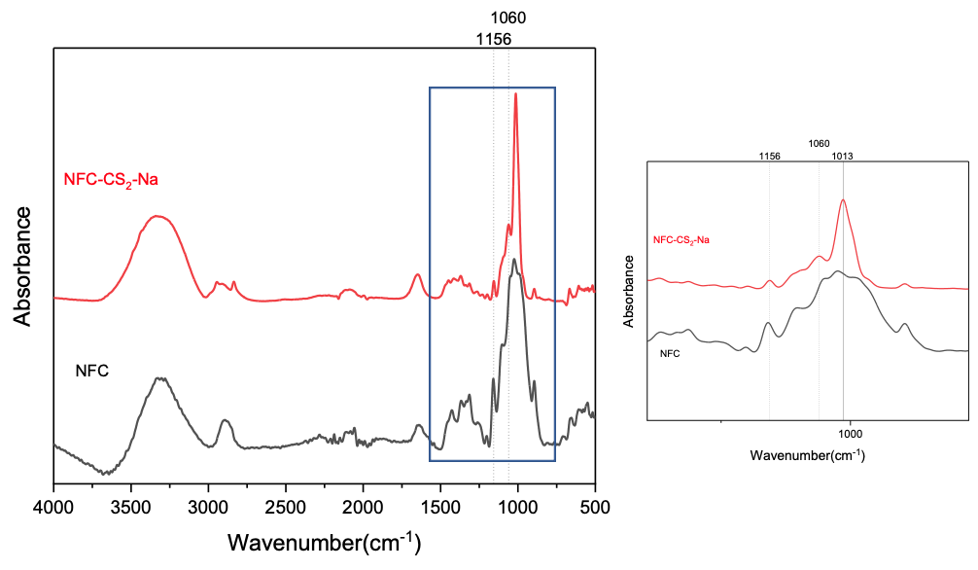
Figure S1. FTIR spectroscopy analysis of NFC and NFC xanthate sodium salt.
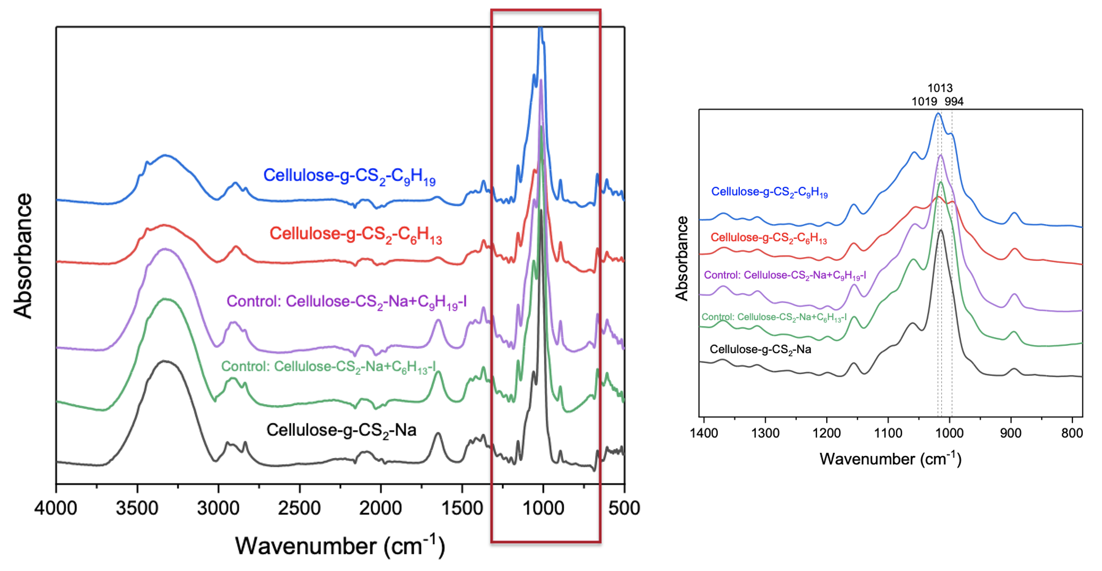
Figure S2. FTIR spectroscopy analysis of NFC-CS₂-Na, NFC-CS₂-C₉H₁₉ and NFC-CS₂-C₆H₁₃ as well as controls where NFC-CS₂-Na has been blended with C₉H₁₉I and C₆H₁₃I.

Raman Spectroscopy
Raman measurements were carried out using Renishaw inVia micro-Raman (100–1800 cm⁻¹), using a 50 mW 532 nm laser at 10% power output. Since S-C vibrational signals are weak in FTIR spectroscopy due to the close match in their electronegativity, Raman measurements were carried out to provide additional evidence. Figure S3 shows the Raman analysis for NFC, NFC-CS₂-Na, NFC-CS₂-C₉H₁₉, and NFC-CS₂-C₁₈H₃₇. Raman analysis shows signals at 576 cm⁻¹, 421 cm⁻¹, and 353 cm⁻¹ associated with C-S Stretch, 1145 cm⁻¹ for C-S and C-C stretch, 1265 cm⁻¹ for C=S + C-C stretch, 1094 cm⁻¹ for C-O stretch, and 1462 cm⁻¹ is associated with CH₂ bending.[4] Raman analysis helped to confirm the presence of C-S signals, but did not provide strong evidence for the covalent grafting of the alkyl chains into the NFC surface.
Figure S3. Raman analysis for NFC, NFC-CS₂-Na, NFC-CS₂-C₉H₁₉, and NFC-CS₂-C₁₈H₃₇.

Thermogravimetrical Analysis (TGA)
Thermal degradation measurements were carried out using Mettler Toledo TGA instrument. 5-10 mg samples were used for each measurement. The temperature was ramped up to 750 °C at a rate of 10 °C/ min under an air or nitrogen atmosphere. Thermogravimetric analysis coupled with mass spectrometry (TGA-MS) was carried out using a Mettler Toledo TGA/DSC instrument combined with a Hiden HPR-20 QIC EGA mass spectrometer under N₂. The temperature was ramped up to 750 °C at a rate of 10 °C/ min under a nitrogen atmosphere.

Figure S4. 1st Derivative of the TGA analyses of several alkylated celluloses.

Figure S5. TGA-MS analysis of NFC-CS₂-C₁₈.
Figure S6. TGA analysis of NFC-g-C₆₆, C₆₆H₁₃₃-I and a mixture of C₆₆H₁₃₃-I and NFC-Na.

PXRD analysis
Powder X-ray diffraction (PXRD) measurements were carried out using Malvern Panalytical X'Pert PRO diffractometer. The XRD instrument operates at 40 kV and 40 mA, with CuKa ($λ=0.1542 nm)$ radiation, at a scan rate of 0.085°/s and step size of 0.0334°. The diffraction angle was varied between 5° and 60°.
Figure S7. PXRD analysis for NFC, NFC-CS₂-Na, NFC-CS₂-C₆₆H₁₃₃, and C₆₆H₁₃₃-I

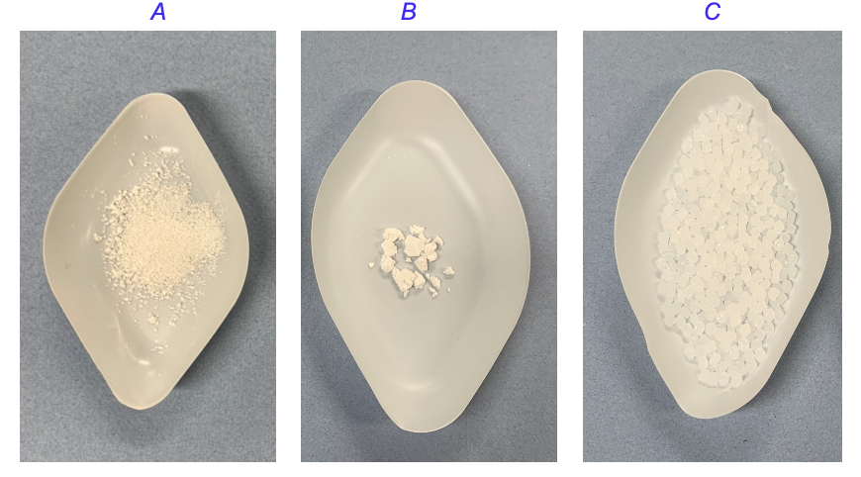
Figure S8. Morphology of A) NFC-CS₂-C₆₆, B) unmodified NFC (freeze dried), and C) LDPE.

DSC Analysis
Differential scanning calorimetry (DSC) measurements were performed using a Perkin Elmer DSC 4000 and a sample mass of approximately 2-4 mg under a nitrogen atmosphere with a heating cycle of 10 ˚C/min from 0 to 200 ˚C and followed by a cooling cycle at the same rate from 200 to 0 ˚C. Then the samples were reheated at the same rate for a second heating cycle to 200 ˚C. The data was processed using the Trios software.

DSC analysis was carried out in the temperature range from 0-200 ˚C in order to determine any changes to the crystallinity and the melting/crystallisation temperature upon incorporation of alkylated NFC. The crystallinity was determined from the heat of fusion associated with the LDPE melting process and normalized to the heat of fusion of 100% crystalline polyethylene, defined as:
$Crystallinity (χc) (\%)=\frac{∆H_{m} }{∆H_{0}* w}*100$

Where $∆H_{m}$is the heat of fusion (J/g), $∆H_{0}$is the heat of fusion of 100% crystalline PE (293 J/g), and w is the weight fraction of PE in the nanocomposite.

Table S1. Thermal characterization of the nanocomposite LDPE materials with grafted NFC using the first heating cycle in the DSC measurements.
 | First heating cycle after extrusion
Sample | T_{c} (°C) | ∆H_{c(}J/g) | T_{m} (°C) | ∆H_{m}(J/g) | χ_{c} (%)
LDPE | 96.6 | 83.4 | 109.3 | 85.7 | 29.2
LDPE-NFC-0.5 | 96.7 | 84.2 | 109.8 | 101.3 | 34.7
LDPE-NFC-1.5 | 97.1 | 78.7 | 109.7 | 95.5 | 33.1
LDPE-NFC-CS₂-C₆-0.5 | 97.4 | 78.7 | 109.6 | 100.6 | 34.5
LDPE-NFC-CS₂-C₆-1.5 | 97.1 | 87.5 | 109.9 | 85.9 | 29.8
LDPE-NFC-CS₂-C₉-0.5 | 96.8 | 87.2 | 110.3 | 104.1 | 35.7
LDPE-NFC-CS₂-C₉-1.5 | 97.1 | 88.7 | 110.4 | 105.7 | 36.6
LDPE-NFC-CS₂-C₁₈-0.5 | 96.3 | 88.9 | 109.6 | 103.4 | 35.5
LDPE-NFC-CS₂-C₁₈-1.5 | 96.9 | 86.7 | 110.2 | 100.7 | 34.9
LDPE-NFC-CS₂-C₆₆-0.5 | 96.7 | 84.9 | 109.9 | 100.9 | 34.6
LDPE-NFC-CS₂-C₆₆-1.5 | 97.3 | 97.3 | 109.3 | 103.7 | 35.9

Table S2. Thermal characterization of the moulded nanocomposite materials used for mechanical analysis obtained using the first heating cycle in the DSC measurements.
 | First heating cycle after moulding
Sample | T_{m} (°C) | ∆H_{m} (J/g) | χ_{c} (%) | Change in χ_{c} (%)
LDPE | 110.8 | 96.7 | 33.0 | 0.0
LDPE-NFC-1.5 | 109.5 | 95.5 | 33.1 | 0.3
LDPE-NFC-CS₂- C₁₈-1.5 | 108.1 | 96.4 | 33.4 | 1.2
LDPE-NFC-CS₂-C₆₆-1.5 | 108.4 | 97.6 | 33.8 | 2.5

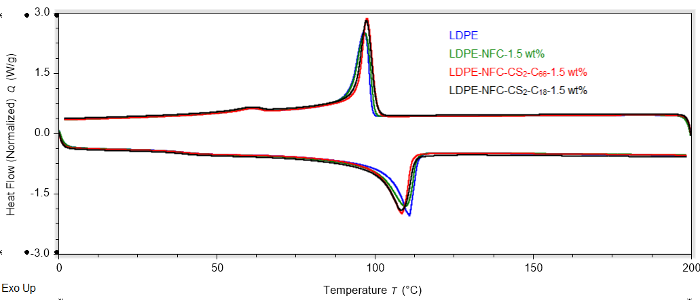
Figure S9. DSC measurements for LDPE and different LDPE nanocomposite materials at 1.5 wt% loadings (first heating cycle after moulding).

Contact angle measurements
LDPE and LDPE composite materials were first hot-pressed (4122 CE, Carver Inc., Wabach, USA) at 170 °C at 4 tons of weight for 10 minutes, resulting in a polymer film of approximately 0.5 mm. The LDPE and LDPE composite films were affixed on a microglass using double-sided tape. Contact angle measurements were carried out using water and dimethyl formamide (DMF) following the sessile drop method and analyzed using Krüss ADVANCE (version 1.9.0.8). Each measurement was carried out three times, and the average was taken.

Mechanical properties
The compounded nanocomposite materials were pelletised into 2 mm granules using Haake VariCut (Thermo Fischer Scientific, Karlsruhe, Germany). The moulding of the nanocomposite materials was carried out using a Haake Minijet Pro injection moulder (Thermo Fischer Scientific, Karlsruhe, Germany) (dog-bone mould, 6.5 cm length, 1 cm gauge length, 3 mm thickness). Tensile tests of LDPE and LDPE nanocomposites were carried out using a universal testing machine (Instron 5960, High Wycombe, UK), according to ASTM D638-14. The machine is equipped with a 10 kN load cell integrated with a crosshead speed of 1 mm min⁻¹ equal to a strain rate of 0.1% s⁻¹. All measurements were performed at room temperature (20 °C) and an average of five samples was taken.

References

[1] V. Vilchez, E. Dieckmann, T. Tammelin, C. Cheeseman, K.-Y. Lee, Upcycling Poultry Feathers with (Nano)cellulose: Sustainable Composites Derived from Nonwoven Whole Feather Preforms, ACS Sustainable Chemistry & Engineering, 8 (2020) 14263-14267.
[2] R. von Goetze, A. Aljaber, K.-Y. Lee, G. Hill, C. Wallis, G.J.P. Britovsek, Towards degradable polyethylene: end-functionalised polyethylene (PE-X) and PE-I/LDPE blends from iron-catalysed chain growth of ZnEt2 with ethylene, Polymer Chemistry, 13 (2022) 6377-6385.
[3] L.H. Little, G.W. Poling, J. Leja, Infrared Spectra of Xanthate Compounds: Ii. Assignment of Vibrational Frequencies, Can. J. Chem., 39 (1961) 745-754.
[4] N.B. Colthup, L.P. Powell, Vibrational analysis of alkyl xanthates, Spectrochimica Acta Part A: Molecular Spectroscopy, 43 (1987) 317-322.
[5] M. Makarem, C.M. Lee, K. Kafle, S. Huang, I. Chae, H. Yang, J.D. Kubicki, S.H. Kim, Probing cellulose structures with vibrational spectroscopy, Cellulose, 26 (2019) 35-79.

