The Metabolic Fate and Effects of 2-Bromophenol in Male Sprague-Dawley Rats

Kyrillos N. Adesina-Georgiadis^{1,4}, Nicola Gray^{1,2}, Robert S. Plumb¹, David F. Thompson³, Elaine Holmes¹, Jeremy K. Nicholson^{1*} Ian D. Wilson^{1*}

¹Department of Surgery and Cancer, Faculty of Medicine, Imperial College London, South Kensington Campus, London, SW7 2AZ, United Kingdom
² Department of Food and Nutritional Sciences, University of Reading, Reading, RG6 6AP, United Kingdom
³ Chemical and Physical Sciences, University of Keele, Staffordshire ST5 5BG, United Kingdom
⁴ Institute of Medical and Biomedical Education, St George’s, University of London, London, SW17 0RE, United Kingdom

*Corresponding Authors: j.nicholson@imperial.ac.uk Tel +4420 7594 3195 and i.wilson@imperial.ac.uk Tel: +4420 7594 3195

Abstract
1. The metabolic fate and urinary excretion of 2-bromophenol, a phenolic metabolite of bromobenzene, was investigated in male Sprague Dawley rats following single intraperitoneal doses at either 0, 100 or 200 mg/kg.
2. Urine was collected for seven days and samples analysed using ¹H NMR spectroscopy, inductively coupled plasma (ICP)MS, and UPLC-MS.
3. ¹H NMR spectroscopy of the urine samples showed that, at these doses, 2-bromophenol had little effect on endogenous metabolite profiles, supporting histopathology and clinical chemistry data which showed no changes associated with the administration of 2-bromophenol at these doses.
4. The use of ICP-MS provided a means for the selective detection and quantification of bromine-containing species and showed that between 15 and 30% of the dose was excreted via the urine over the 7 days of the study for both the 100 and 200 mg doses respectively.
6. The bulk of the excretion of Br-containing material had occurred by 8 hr post administration. UPLC-MS of urine revealed a number of metabolites of 2-bromophenol, with 2-bromophenol glucuronide and 2-bromophenol sulphate identified as the major species. A number of minor hydroxylated metabolites were also detected as their glucuronide, sulphate or O-methyl conjugates. There was no evidence for the production of reactive metabolites.
Keywords. 2-Bromobenzene, metabolism, nephrotoxicity, metabonomics.

Introduction
The compound 2-bromophenol is a metabolite of bromobenzene, a well-known nephro- and hepatotoxin, which has been used as a solvent, fire retardant and a component of motor oils. Following ingestion bromobenzene is metabolised in the liver to a range of oxidised metabolites including 2-bromophenol and 2-bromohydroxyquinone (Lau et al., 1984a). Both 2-bromophenol and 2-bromohydroxyquinone are readily transported from the liver to the kidneys, and the reaction of the latter with glutathione produces various mono-and di-substituted conjugates (Parke and Piotrowski, 1996). The accumulation of these conjugates, in addition to the depletion of the local glutathione pool, is thought to be the cause of renal toxicity (Lau et al,1984b). In addition to 2-bromohydroxyquinone it has been shown, following i.p. administration (at doses from 1.28 mmol/kg upwards), that 2-bromophenol is also a nephrotoxin in the rat (Lau et al,1984b). In a subsequent study Bruchajzer et al (2002) observed changes in the composition of the urine, and changes in glutathione concentrations in the kidney, of rats administered the compound, including increased protein excretion and elevated epithelial cell content, which they considered as being due to kidney damage. However, they also observed variability in the concentrations of ‘classic markers of nephrotoxicity’ such as creatinine.
Here, as part of a study undertaken by the Consortium of Metabonomic Toxicology (COMET) (Lindon et al., 2005), metabolite profiling has been performed on rat urine to identify changes in endogenous metabolites and also define the excretion and composition of 2-bromophenol-related material excreted following a single i.p. dose of either 0, 100 or 200 mg/kg (0, 0.58 and 1.16 mmol/kg repectively) of 2-bromphenol. In order to achieve these aims urine was analysed using proton nuclear magnetic resonance (¹H NMR) spectroscopy, bromine-detected inductively couple plasma (ICP) mass spectrometry (MS) and ultra (high) performance liquid chromatography-MS (U(H)PLC-MS) to characterise the effects of 2-bromphenol on urinary composition and determine the metabolic fate of the compound itself.

Materials and Methods
Solvents & chemicals
HPLC grade methanol (MeOH) was purchased from Fisher Scientific Leicestershire, UK). Ultra-pure water (18 MΩ @ 25 ºC) was produced in-house using an ELGA (Marlow, UK) water purification system. 3-(trimethylsilyl)-[2,2,3,3,-2H4]-propionic acid (TSP) 3-[2,2,3,3-2H4] trimethylsilyl propionate sodium salt (TSP), ammonium acetate, potassium bromide, sodium dihydrogen phosphate and disodium hydrogen phosphate were purchased from Sigma-Aldrich Company, Ltd (Gillingham, UK). NMR-grade deuterium oxide (²H₂O) was obtained from Goss Scientific Instruments (Nantwich, UK).
Optima grade LC-MS water was purchased from Fluka (Leicester, UK). Acetonitrile (LC-MS grade), formic acid (LC-MS grade), ammonium acetate (LC-MS grade), leucine enkephalin acetate salt hydrate and sodium formate solution were purchased from Sigma Aldrich (Gillingham, UK).

Study conduct
Urine and serum samples were collected after the intraperitoneal (IP) administration (as performed by Lau et al 1984) of 2-bromophenol as a single dose of either 0, 100 or 200 mg/kg (0, 0.58 and 1.16 mmol/kg repectively) to male Sprague-Dawley (Crl:CD(SD)IGS BR) rats supplied by Charles River Ltd. The 30 rats (6-8 wks of age) used in the study were randomly assigned to groups (10 animals/group) and housed 1 rat per metabolism cage from 48h before dosing. Purina chow 5002 and drinking water were available ad libitum. Environmental controls were set at 21±2°C and 55±10% relative humidity with 12 hr light and dark cycles + 1hr. Two groups of animals (10 per group) were dosed with 2-bromophenol at either 100 (numbers 11-20) or 200 (number 21-30) mg/kg in corn oil. A further 10 rats (numbers 1-10) acted as controls and were dosed with corn oil). These doses corresponded to 0, 0.58 and 1.16 mmol/kg. Rats were housed in metabolism cages and urine was collected for metabolite profiling and clinical analysis. Urine was collected into labelled tubes maintained at (-2 to +4ºC) containing sodium azide (1 ml of 1% solution) and stored frozen at -40ºC or lower until analysed. Urine was collected into tubes over a period of 8 days which includes a 1 day baseline collection. Urine samples were collected at 16 hours pre-dose, at time of dosing (0) and at 8, 24, 48 72, 120, 144 and 168 hrs post dose, with a total of 230 samples collected. Urine was centrifuged at 500g for 10 min to remove particulates. Urine volume, pH and osmolality were determined and samples stored at -70ºC. Clinical observations were performed daily before dosing, as soon as practicable after dosing, at a reasonable time after dosing, and once daily thereafter and to ensure that the animals suffered no pain or distress. Body weights were recorded daily. Clinical chemistry was performed on study day 2, 24 hours after treatment (all rats); study day 3, 48 hours after treatment (group A); and on study day 8, 168 hours after treatment (group B) with creatinine, potassium, glucose and protein concentrations measured (see Table S1).
Five animals from each group were sacrificed euthanized (by CO2 inhalation) on study day 3 and five were sacrificed on study day 8. Kidneys were removed, preserved in 10% buffered formol saline, processed through to paraffin wax, sectioned, stained with haematoxylin and eosin, and examined histopathologically. Samples were stored at -40 °C prior to analysis.
The study was subject to all relevant national regulations governing the conduct of animal studies and the specific protocols described in this paper were reviewed and approved by the local Departmental Review to ensure that they adhered to the principals of minimising animal suffering.
¹H NMR spectroscopy
Before ¹H NMR spectroscopy urine samples were centrifuged at 12000 g for 5 min at 4ºC to remove particulates and 250 μL of sample aliquoted into 2 mL cryo-vials and diluted 1:2 with phosphate buffer. A quality control mixture containing 10 μL of each sample was also prepared. Each urine sample was centrifuged at 12000g at 4 °C for 5 min and subsequently 500 μL was transferred into 96-well plates using a Bruker (Bruker, Rheinstetten, Germany) Sample Track system and a Liquid Handler 215 preparation robot. ¹H NMR spectroscopy was performed at a field strength of 14.1 T (1H 600.29 MHz) on a Bruker spectrometer using a 5 mm broadband inverse configuration probe with a z axis magnetic field-gradient capability. The spectrometer was equipped with a Bruker Sample Jet system set to 5mm shuttle mode with a cooling rack of refrigerated tubes at 6 °C and controlled via a Bruker Avance III console. The ¹H NMR spectra of the urine were measured using one-dimensional (1D) nuclear Overhauser enhancement spectroscopy, with a solvent suppression sequence following the front end pulse train of the noesy pulse sequence (NOESY-preset, noesypr1d) (Nicholson et al, 1995, Beckonert et al 2007). The data were acquired using Topspin 3.2 and run under automation by IconNMR (Bruker, Rheinstetten, Germany).
¹H NMR Spectral Data Analysis
After phasing to correct for first and zero-order errors, and baseline correction to account for distortions of the base values, the ¹H NMR spectral data were imported to MATLAB R2012b (Natick, Massachusetts, U.S.A.) using the Metaspectra program script, using a resolution of 0.00055. The data were then aligned using Recursive Segment-Wise Peak Alignment (RSPA) (Veselkov et al., 2008) and normalised by Probabilistic Quotient to account for, and exclude, systematic sources of bias within samples which were not due to biological processes or environment. Statistical Recouping of Variables (SRV) (Blaise et al., 2009) was then used for peak detection, and the integrated dataset was exported to SIMCA-P+ 13.0.2 software for multivariate analysis using Principal Component Analysis (PCA) and Orthogonal Projection to Latent Structures (OPLS) where appropriate. Models were constructed using all observations, with dosing group as the discriminating variable. Each feature of interest was then tested for significance using a modified Multiple Analysis of Variance (MANOVA) and the p values corrected for multiple testing using Benjamini-Yekutielli correction. Metabolite assignment was then performed.
ICP-MS-Based Total Bromine Analysis
The determination of total bromine in the samples was performed by flow injection analysis (FIA) with direct infusion of samples into the ICP-MS at 0.5 mL/min using 5 µL of sample/standard. For the purposes of quantification aqueous calibration standards were produced using potassium bromide over the concentration range 5 to 25 µg/mL using ultra-pure water. Samples were infused directly into a NexION 300D ICP-MS (PerkinElmer SCIEX, Shelton, CT USA) using a Waters Alliance 2695 HPLC system (Waters Corporation, Milford, MA) with the samples maintained at 4⁰ C within the sample compartment of the autosampler. For determination of total bromine both calibration standards and urine samples were injected into a flowing stream of a 90:10 v/v mixture of 0.1 % (v/v) nitric acid in methanol (prepared using the HPLC systems solvent mixing capability). The analysis time for the FIA was 2 minutes/sample. The concentration of bromine was determined operating the ICP-MS in standard mode (Table 1). A cooled spray chamber was used to reduce the solvent loading into the plasma. Oxygen was introduced into the sample stream to reduce the build-up of carbon on the sampler cone.
ICP-MS Data Processing/Analysis
All data were collected using NexION 1.5 software (PerkinElmer SCIEX, Shelton, CT USA), peak area integration was carried out using Analyst 1.4.2 (AB Sciex UK Ltd, Cheshire UK). Statistical analysis was carried out using Microsoft Excel 2010.
U(H)PLC-MS Sample Analysis
A 150 µL aliquot of urine was mixed with 300 µL water to dilute the salt concentration before protein removal via precipitation with acetonitrile (1:2 v/v). These samples were vortexed and left at -20 °C overnight, then centrifuged for 5 min at 12 000 g at 4 °C before 50 µL of sample was taken and added to 150 µL water in 350 µL 96-well plates (Waters Corporation, Milford, USA) and were stored at -20°C until analysis. Prior to analysis the sample order was randomised using the Microsoft Excel random number generator function. A pooled quality control (QC) sample was prepared (Gika et al. 2008) by combining 100 µL of each sample and diluting 1:4. Immediately before analysis the plates were centrifuged at 1700 g and then placed into the autosampler at 4 °C. Reversed-phase gradient liquid chromatography was performed on an Acquity UPLC system (Waters Ltd, Elstree, UK) coupled to a Synapt G2 triple quadrupole dual time-of-flight mass spectrometer (Waters MS technologies, Ltd., Manchester). UPLC-MS was performed by injecting 2 µL of sample onto a Waters HSS T3 1.8 µm, 2.1 x 100 mm UPLC column, maintained at 40 °C, at a flow rate of performed at 0.5 mL/min. Linear gradient elution was performed using mobile phases composed of 0.1 % formic acid in water (solvent A) and 0.1 % formic acid in acetonitrile (solvent B). The starting composition was 1 % B, held for 1.0 min, increasing to 15 % at 3.0 min, 50 % at 6.0 min, 95 % at 9.0 min, returning to 1 % B at 10 min, and followed by a 2 min re-equilibration step prior to the next injection (total cycle time 12 min). Mass spectrometry was performed with electrospray ionisation operated in both positive (ESI+) and negative ion modes (ESI-) The instrument was operated in sensitivity mode and set to acquire data over the m/z range 50 – 1200 with a scan time of 0.1 s. All mass spectral data were collected in centroid mode using the MSe data acquisition function. For mass accuracy, leucine encephalin (MW = 555.62) was used as a lock mass at a concentration of 200 pg/uL (in 1:1 v/v CH₃CN:H₂O, 0.1 % formic acid) infused at a flow rate of 20 µL/min via a lock spray interface. The data were collected using MassLynx V 4.1 software (Waters Corporation, Milford, USA).
UPLC-MS Data Analysis
Each UPLC-MS data set was pre-processed using Transomics (Non Linear Dynamics, UK). The ion intensities for each peak detected were then normalised, within each sample, to the median peak intensity in that sample. The resulting peak marker tables, comprising m/z, RT and normalised intensity values for each variable in every sample, were exported to SIMCA-P+ 13.0.2 software (Umetrics, Umea, Sweden) for multivariate analysis using Principal Component Analysis (PCA) and Orthogonal Projection to Latent Structures (OPLS) where appropriate. Models were constructed using all observations, with the dosing group as the discriminating variable. Bromine-containing metabolites were detected using the specific bromine isotope pattern. Each peak of interest was then tested for significance using a modified Multiple Analysis of Variance (MANOVA) and the p values corrected for multiple testing using Benjamini-Yekutielli correction. Metabolite assignment was then performed.

Results and Discussion
Clinical Pathology
None of the animals in the study exhibited any major adverse clinical signs attributable to treatment with 2-bromophenol although weight loss was seen in all groups, particularly animals in the high dose group, during the first 24 hours following administration. Recovery from weight loss occurred in all groups from Day 2 although this was at a slightly lower rate for the high dose group in comparison with the control and low dose animals. By Day 8, body weights were similar for all three groups. The high dose group showed mild clinical signs, including transient tremors, slight laboured respiration and inactivity; however these effects were minor and the animals had recovered by days 2-3 post dose.
As the administration of bromophenol has previously been associated with nephrotoxicity, characterised by necrotic damage to the proximal tubule cells, clinical chemistry (see Table S1) and histopathology of the kidneys were performed. It was expected, based on the previous study of Lau et al (1984a), that the high dose would cause changes in the kidney but no mortality.
Urinalysis showed statistically significant decreases in urinary osmolality, creatinine, potassium and glucose for the high dose animals between 0 and 8 hours after dosing on Day 1. However, there was no consistent pattern of variation in organ weight data to indicate an effect of treatment with 2-bromophenol and no macroscopic changes that could be attributed to the administration with the compound were noted at either 48 or 168 hours after dosing. Overall the clinical chemistry of the urine showed no trends and all animals were within the normal ranges for each test. The overall results of the clinical chemistry are summarised in Table S1 in supplementary information.
Histopathological examination of the kidneys identified no overall effect of 2-bromophenol administration. Some general mild nephropathy was present in the kidneys of all animals (dosed and control). This was not considered severe enough to cause any symptoms, although two low dose group animals did show signs of minimal localised inflammation. Two animals out of ten from the high dose group showed evidence of slight tubular regeneration, characterized by pale basophilic epithelial cells and necrotic cellular debris within the lumen of the proximal tubules but the remaining animals in this group showed no evidence of kidney damage. One control and one high dose animal showed signs of hyaline droplet formation indicative of a low level background of tubular damage in the test animals. Overall, there were no differences between the kidney tissues of any of the groups.
¹H NMR Spectroscopic Analysis of Urine
¹H NMR spectroscopy of urine provides a rapid means of assessing major biochemical changes in the kidney resulting from drug and xenobiotic induced toxicity (e.g. see Nicholson and Wilson 1990, Coen et al 2008). The effects of 2-bromophenol administration on endogenous metabolite profiles were investigated via the use of both unsupervised and supervised methods of multivariate statistical analysis of the ¹H NMR spectral data. Principal components analysis (PCA), an unsupervised method, showed a general separation of the high, 200 mg/kg, dosed animals from the other two groups, but very little differentiation of the 100mg/kg dose group from the controls (Supplementary data Figure S1). In the high dose group the maximal response was detected at 48hrs post dose. When models were constructed using only observations from this time point, increased amounts of hippurate (3.96/7.56/7.84 ppm, p = 7 x 10-17/3.78 x 10-18/6.16 x 10-17), aminohippurate (6.87ppm, p = 1.49 x 10-17) and 3-methylhistamine (2.84 ppm, p = 2.29 x 10-20) were observed compared to control and low dose groups. This is illustrated in the S plot, derived from the OPLS model constructed from these data, shown in Figure 1. Hippurate is a generally ubiquitous component of urine and its utility as a potential biomarker in metabonomic studies has been reviewed by Lees et al. (2013). In the rat the kidney represents the main route of excretion for hippurate and, if there is impaired renal function, has been seen to accumulate in the serum (Niwa, 1996) coupled with a reduction of urinary concentrations (Bairaktari et al., 2001). As a result it might be expected that, if 2-bromophenol were a nephrotoxin, urinary concentrations would fall, rather than increase as observed here.
Examination of the spectra from both l00 and 200 mg/kg dose groups did not reveal any significant contribution from 2-bromophenol, or its metabolites, at any time point.
ICP-MS Analysis of Urine
¹H NMR spectroscopy had not detected any signals other than those of the normally present endogenous compounds. Therefore both bromine-detected ICP-MS (and subsequently) U(H)PLC-MS) was performed on the urine samples to determine if any 2-bromophenol-related material had been excreted in the urine and thereby confirm exposure of the kidney to it, or its metabolites. The sensitive and quantitative nature of ICPMS for bromine enabled the ready determination of the total concentrations of 2-bromophenol-related compounds in the urine. The results of Br-detected ICP-MS clearly showed that, for both 100 and 200 mg doses, between ca. 15 and 30% of the administered bromine was excreted in the urine over the first 48 hours of dosing, the bulk of it in the first 8 hours. There was however, wide inter animal variation with, at both doses, mean excretion, up to 48 hrs post dose, of ca. 15%. The excretion of Br in the urine of the 100 mg/kg dose illustrating the time course of excretion for each animal is shown in Figure 2a and the cumulative excretion is provided in Figure 2b. Essentially similar profiles were seen for the 200 mg/kg dose (data not shown).

U(H)PLC-MS Analysis
Untargeted reversed-phase U(H)PLC-MS, in both positive and negative ESI modes, was performed on the urine samples to determine changes in endogenous metabolite profiles and characterise the metabolites of 2-bromopenol excreted in the urine. After data processing with Transomics Software the extracted metabolic signatures, defined by retention time and m/z ratio, were analysed using multivariate statistical methods as performed on the ¹H NMR spectroscopic data. The positive ESI data showed no separation by either dose group or time points on PCA, indicating minimal perturbation of the endogenous metabolites following 2-bromophenol administration, and no further analysis of these data was undertaken. In the case of the negative ESI data the PCA analysis showed a good, apparently dose-dependent, separation between the control and dosed groups. Initial PCA modelling of the negative ESI dataset revealed distribution patterns within the models which indicated both dose and time-dependent effects (Figure 3). By constructing models with observations from each time point separately, maximal “response” was identified for the high dose group at 8 hours post dose, with a diminishing effect at 24 hours, after which time the metabolic profiles of the animals returned to ‘normal’.
Furthermore, no doubt due to as a result of the greater sensitivity of MS analysis compared to ¹H NMR spectroscopy for some analytes, more subtle differences were detected leading to some differentiation between the low dose and control classes which were undetected by ¹H NMR spectroscopy. Subsequent OPLS modelling (Figure 4, lower) of the 8 hour time point provided very strong models (R2 = 0.99, Q2 = 0.71). On investigation the separations was seen to be largely due to the presence of brominated metabolites of 2-bromophenol of m/z 252.93 and 348.97 respectively. Analysis of the MS data identified these discriminating ions as a direct sulfate and glucuronide conjugates of 2-bromohenol respectively (Figure 4 upper). The mass spectra for each of these metabolites showed the distinctive 1:1 isotope pattern characteristic of bromine and, due to fragmentation in the ion source, appropriate losses of 80 and 176 Da, diagnostic of the sulphate and glucuronic acid moieties respectively. An ion consistent with a 2-bromophenol glucuronide dimer (m/z 718.94), with the similar retention time to the glucuronide, was also seen. However, this was likely an artefact resulting from in source dimerization. Due to poor ionisation under these U(H)PLC-MS conditions we were unable to detect 2-bromophenol itself (either as the pure standard or in urine samples). These data are summarized in Table 2.
Clearly, the presence of bromine, with ⁷⁹Br and ⁸¹Br isotopes present at a ratio of approximately 1:1 provides a characteristic and very distinctive isotope pattern in the mass spectra. We therefore searched the U(HP)LC-MS data specifically for ions with this isotopic signature in order to highlight the presence of other metabolites of 2-bromophenol. A typical example is illustrated in Figure 5 (upper) where the negative ESI data from the analysis of an 0-8 hr urine sample from a high dose animal has been used to generate an “isotopogram” . This was done by extracting all of the ions containing an isotopic pattern with a mass difference of 2 Da at a ratio of 1:1, thereby showing only ions containing the bromine isotopes. This selective (“bromatogram”) trace highlights 6 bromine-containing peaks, for which spectra are provided in Figure 5 (lower). Based on the fragmentation patterns seen in the mass spectra the first 3 eluting peaks corresponded to a hydroxylated 2-bromophenol metabolite conjugated to glucuronic acid (tentatively assigned as hydroxy 2-bromophenol glucuronide (peak 1)) and two sulphated mono-hydroxylated metabolites (peaks 2 and 3), one of which presumably corresponds to hydroxy 2-bromophenol sulfate whilst the other is sulfated at the alternative hydroxyl group. The major signals detected (peaks 4 and 5) corresponded to the previously identified 2-bromophenol sulfate and glucuronide metabolites respectively. The MS/MS spectrum of the sixth peak contained the characteristic sulphate 80Da loss, plus the addition of oxygen and a methyl group leading to the tentative assignment of this compound as 2-hydroxy(3-methoxy)bromophenol sulphate (although the alternative configuration of 2-methoxy-, 3-sulfate is clearly possible). The methylation of vicinal aromatic diols by catechol-O-methyltransferase is well known (Huotari et al, 2002) and conjugation with a methyl group, which would increase the lipophilicity of the compound, is also consistent with the increased retention time of this metabolite compared to the mono-sulfate. Glutathione conjugates and related mercapturates and cysteinyl conjugates are one of the major indications of potential toxicity via reactive metabolites, and have been detected as a result of the metabolism of 2-bromohydroxyquinone. In previous studies (e.g., Bruchajzer et al, 2002) changes in glutathione concentrations in the kidney were seen when 2-bromophenol was administered to the rat, even in the absence of evidence of major renal effects. Glutathione conjugates of 2-bromohydroquinone have been shown to form in vitro by rat liver microsomes, and to be nephrotoxic following intravenous administration to the rat (Monks et al 1985). The possibility of reactive metabolite production and subsequent detoxication to form glutathione conjugates was considered and the MS data were carefully searched for evidence of metabolites indicative of this. However, we were unable to detect any evidence of the presence of glutathione conjugates, nor were cysteinyl or mercapturic acids detected in the urine. This suggests that, at these doses and in this strain of rat, does not produce reactive intermediates from 2-bromophenol following I.P. administration.
To investigate any potential changes in endogenous metabolites that had been masked by the presence of the 2-bromophenol metabolites the ions for the sulphate and glucuronide conjugates were removed from the MS data which enabled the identification of hippurate, and citrate as being elevated in the 2-bromophenol dose groups
The lack of any significant changes in endogenous metabolites, or metabolic markers of nephrotoxicity, at either dose level, despite the clear evidence from ICP- and U(H)PLC-MS of urinary excretion, and therefore organ exposure to 2-bromophenol-related metabolites, supports the absence of kidney damage indicated by ¹H NMR-based metabonomic phenotyping, clinical chemistry and histopathology. The overall conclusion from this study with respect to nephrotoxicity was therefore that, after the administration of either 100 or 200 mg/kg, 2-bromophenol is not a potent nephrotoxin in the rat at these doses.

Acknowledgements. The authors would like to thank the Consortium for Metabonomic Toxicology for provision of samples and histopathology data, and Peter Webborn for useful discussions. K.N. Adesina-Georgiadis was supported by a CASE studentship from the BBSRC and AstraZeneca.
Declaration of interest. The authors report no declaration of interest.
ORCID Numbers
Nicola Gray - 0000-0002-0094-5245 Kyrillos N. Adesina-Georgiadis - 0000-0001-9003-5431 Robert S. Plumb - 0000-0002-1380-9285 David Thompson, - 0000-0002-2834-0109
Elaine Holmes - 0000-0002-0556-8389
Jeremy K. Nicholson, - 0000-0002-8123-8349
Ian D. Wilson, - 0000-0002-8558-7394

References:
Bairaktari E, Liamis G, Tsolas O, Elisaf, M. (2001). Partially reversible renal tubular damage in patients with obstructive jaundice. Hepatology 33: 1365-1369.
Blaise BJ, Shintu, L, Elena BND, Emsley L, Dumas M.-E, Toulhoat P. (2009). Statistical Recoupling Prior to Significance Testing in Nuclear Magnetic Resonance Based Metabonomics. Anall Chem. 81: 6242-6251.

Beckonert O, Keun HC, Ebbels TMD, Bundy JG, Holmes E, Lindon JC, Nicholson JK. (2007). Metabolic profiling, metabolomic and metabonomic procedures for NMR spectroscopy of urine, plasma, serum and tissue extracts. Nat Protoc. 2: 2692-2703.

Bruchajzer E, Szymanska JA, Piotrowski JK. (2002). Acute and subacute nephrotoxicity of 2-bromophenol in rats. Toxicology Letters 5, 245–252.

Coen M, Holmes E, Lindon JC, Nicholson JK. (2008). NMR-based metabolic profiling and metabonomic approaches to problems in molecular toxicology. Chem Res Toxicol. 21: 9-27.

Gika HG, Theodoridis GA, Wingate JE, Wilson, ID. (2005). Within-Day Reproducibility of an HPLC-MS-Based Method for Metabonomic Analysis: Application to Human Urine. J Proteome Res 6: 3291–3303.

Huotari M, Gogos JA, Karayiorgou M, Koponen I, Forsberg M, Raasmaja A. (2002). Brain catecholamine metabolism in catechol-O-methyltransferase (COMT)-deficient mice. Eur J Neurosci 15, 246–256.

Lau SS, Monks TJ, Greene KE, Gillette JR. (1984a). The role of ortho-bromophenol in the nephrotoxicity of bromobenzene in rats. Toxicol Appl Pharmacol 72:539-549.

Lau SS, Monks TJ, Gillette JR. (1984b). Identification of 2-bromohyrdoquinone as a metabolite of bromobenzene and o-bromophenol: Implications for bromobenzene-induced nephrotoxicity. J Pharmacol Expt Ther. 230: 360-366.

Lees H J, Swann JR, Wilson I D, Nicholson J, Holmes, E. (2013). Hippurate: The Natural History of a Mammalian-Microbial Cometabolite. J Proteome Res 12: 1527−1546.

Lindon JC, Keun HC, Ebbels, TM, Pearce J.M, Holmes E, Nicholson, JK. (2005). The Consortium for Metabonomic Toxicology (COMET): aims, activities and achievements. Pharmacogenomics 6: 691–699.

Monks TJ, Lau SS, Highet RJ, Gillette J.R. (1985). Glutathione conjugates of 2-bromohydroquinone are nephrotoxic. Drug Metab Dispos 13: 553–559.

Nicholson J.K and Wilson I.D. (1989) High resolution proton magnetic resonance spectroscopy of biological fluids. Progr Nuclear Magn Res Spectros 21: 449-501.

Jeremy K. Nicholson, Peta J. D. Foxall, Manfred. Spraul, R. Duncan. Farrant, John C. Lindon (1995). 750 MHz 1H and 1H-13C NMR Spectroscopy of Human Blood Plasma.
Analytical Chemistry 67: 793-811.

Niwa T. (1996). Organic acids and the uremic syndrome: protein metabolite hypothesis in the progression of chronic renal failure. Seminars on Nephrology 16: 167 −182.

Parke DV, Piotrowski JK. (1996). Glutathione: its role in the detoxication of reactive oxygen and environmental chemicals. Acta Toxicologica 4: 1–13.

Rush GF, Newton JF, Maita K, Kuo C-H, Hook JB. (1984). Nephrotoxicity of phenolic bromobenzene metabolites in the mouse. Toxicology 30:259-272.

Stonehouse J, and Keeler J. (1995). A Convenient and Accurate Method for the Measurement of the Values of Spin-Spin Coupling-Constants. J. Magn Res, A 112: 43-57.

Veselkov KA, Lindon JC, Ebbels TMD, Crockford D, Volynkin VV, Holmes E, Davies DB, Nicholson JK. (2008). Recursive Segment-Wise Peak Alignment of Biological ¹H NMR Spectra for Improved Metabolic Biomarker Recovery. Anal Chem 81: 56-66.

Tables
Table 1. Operating parameters of the PerkinElmer NexION 300D ICP-MS (*Oxygen introduced into the sample stream at the base of the torch).

Sample introduction
 | Micromist 149597 concentric nebuliser
 | ESI PC³ Cooled quartz cyclonic spray chamber
 | Quartz sample injector
Operating parameters
Plasma power | 1600 W
Plasma gas (Ar) flow | 18.0 L/min
Auxiliary gas (Ar) flow | 1.2 L/min
Nebuliser gas (Ar) flow | 1.14 L/min
DRC oxygen flow | 0.6 mL/min
Oxygen flow* | 0.01 L/min
Sample uptake rate | 0.5 mL/min

Table 2 Metabolites of 2-Bromophenol identified by UPLC-MS in Negative Ion ESI
Metabolite | Measured Mass (Da) | Retention Time (min) | Formula | Isotopogram peak number
Hydroxy 2-bromophenol glucuronide | 362.97 | 3.01 | C₁₂H₁₅O₉ | 1
Hydroxy 2-bromophenol sulfate | 268.89 | 3.09 | C₆H₇O₅BrS | 2
Hydroxy 2-bromophenol sulfate | 268.89 | 3.39 | C₆H₇O₅BrS | 3
2-bromophenol sulfate | 252.90 | 4.47 | C₆H₆O₄BrS | 4
2-bromophenol glucuronide | 348.98 | 4.43 | C₁₂H₁₄O₈ | 5
2-bromophenol glucuronide dimer | 718.94 | 4.46 | -- | 5
Hydroxy (3-methoxy) 2-bromophenol sulphate | 282.91 | 5.14 | C₇H₈O₅BrS | 6

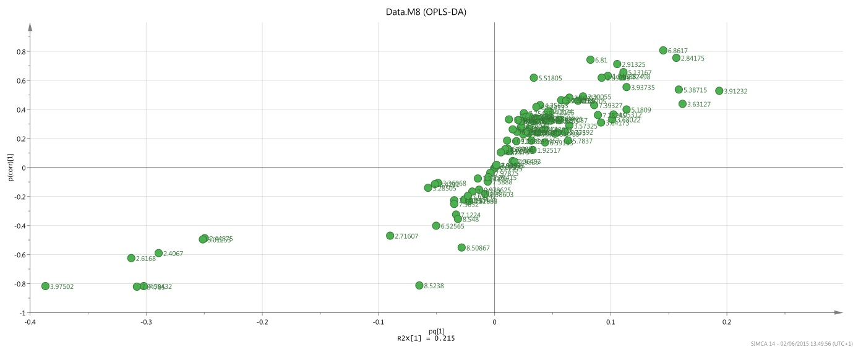
Figure 1. An S plot derived from the OPLS model of the ¹H NMR spectroscopic data, comparing high dose and control groups at 8 hours post dose. The data points in the bottom left quadrant of the plot, and therefore highly abundant in the treatment group, represent hippurate (3.96/7.56/7.84 ppm, p = 7 x 10-17/3.78 x 10-18/6.16 x 10-17), aminohippurate (6.87 ppm, p = 1.49 x 10-17) and N-acetylhistamine (2.84 ppm, p = 2.29 x 10-20).

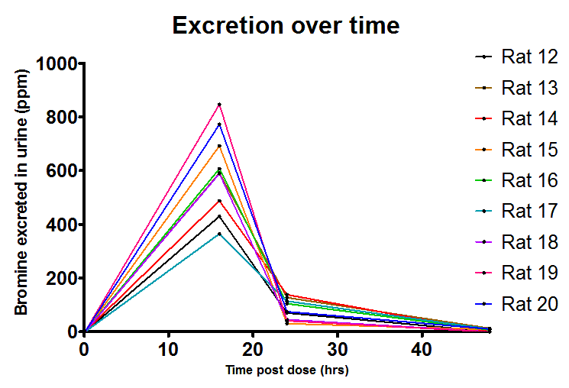
A
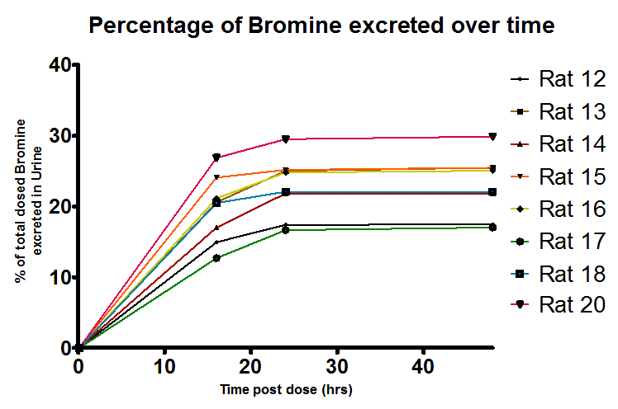
B
Figure 2. Determination of total bromine in rat urine by ICP-MS after I.P. administration to the rat administered at 100 mg/kg of 2-bromophenol by flow injection analysis. (A) Time course of excretion of Br and (B) Cumulative excretion of Br by individual animals.
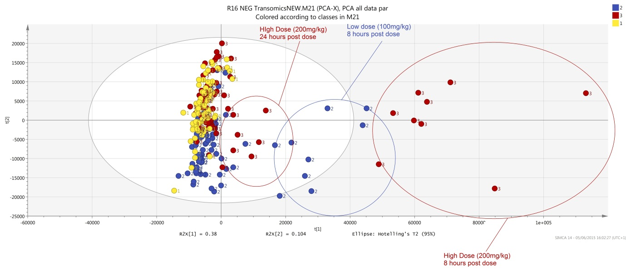

Figure 3. PCA scores plot of the model comparing dose groups, acquired by negative mode ionisation, with observations highlighted by time point. There is good separation between the groups and the distance the samples deviate from the controls seems to be dose and time dependant. The x and y axes represent PC 1 and 2 respectively an account for 95% of the total variance.

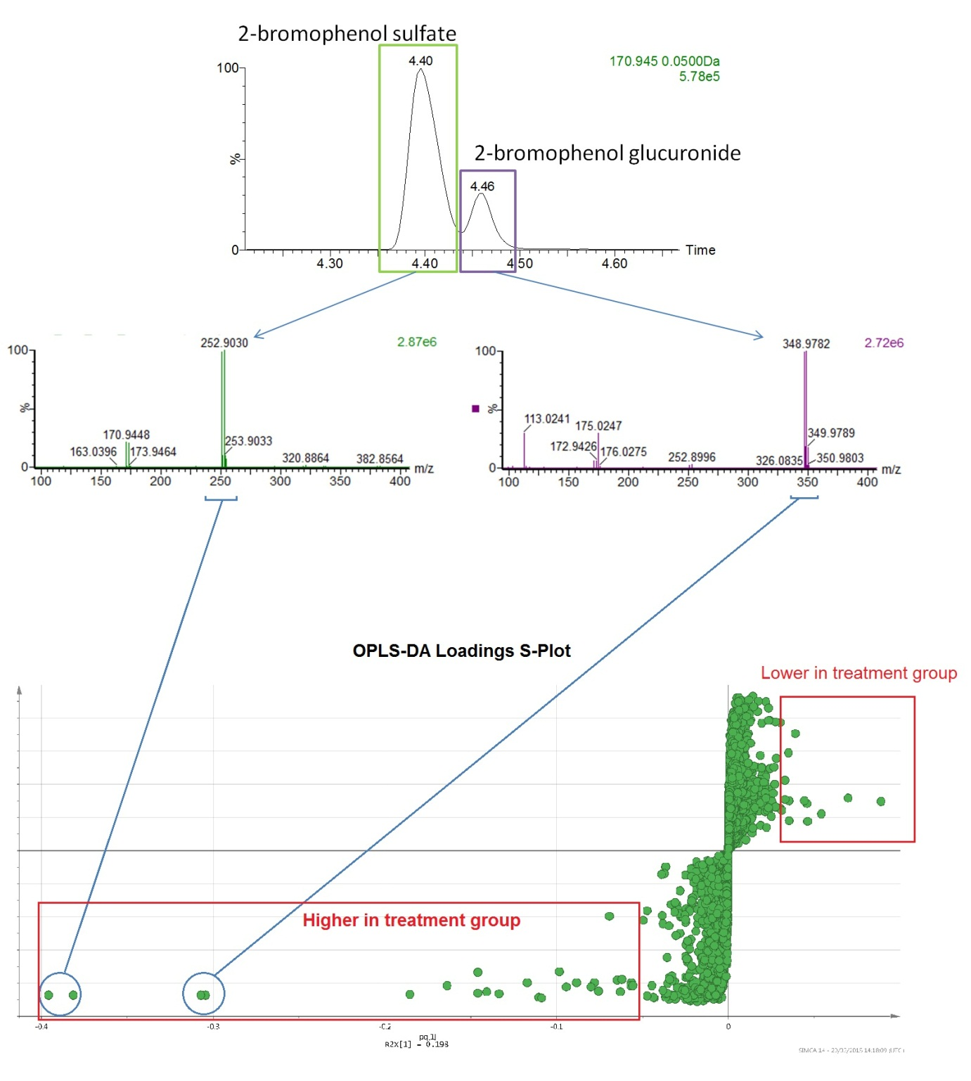
Figure 4. Composite plot highlighting and identifying the two most prominent 2-bromophenol metabolites derived from the S plot derived from the UPLC-MS data. Inspection of the S-plot (bottom) derived from the OPLS model comparing low dose and controls shows the ions influencing discrimination relate due to to 2-bromophenol sulphate (m/z 252.9) and 2-bromophenol glucuronide (m/z 348.97) in the lower left hand quadrant as highly influenctial in the discrimination of control from high dose urines. The chromatographic peak extraction (top) and the related mass spectra (middle) are also provided.

Figure 5. Isotopogram (top) and the related mass spectra (bottom). The chromatographic peaks are numbered and match up to the numbered mass spectra.

