An Accessible Method for DFT Calculation of ¹¹B NMR Shifts of Organoboron Compounds

Henry S. Rzepa,*ª Sergey Arkhipenko,^{b} Emily Wan,^{b} Marco T. Sabatini,^{c} Valerija Karaluka,^{c} Andrew Whiting,^{b} and Tom D. Sheppard^{c}

- Department of Chemistry, Imperial College London, South Kensington Campus, London, SW7 2AZ, UK. Email: rzepa@imperial.ac.uk
- Department of Chemistry, Durham University, Science Site, South Road, Durham, DH1 3LE, UK.
- Department of Chemistry, University College London, Gordon Street, London, WC1H 0AJ, UK.
Electronic Supplementary Information (ESI) available,¹⁶ including FAIR data for NMR spectra, computational data and synthetic procedures.
_______________________________________________________________________
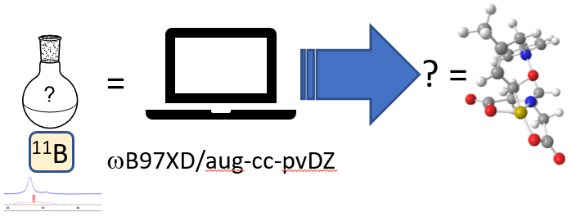
Abstract: The study of boron-mediated reactions in organic synthesis and reactions of organoboron compounds is greatly facilitated by the use of ¹¹B NMR. However, the identification and characterisation of reaction intermediates in often complex systems is far from trivial, as ¹¹B NMR does not provide any detailed structural information. Greater insight into the structures present in such systems can be obtained by using DFT chemical shift calculations to support or exclude proposed reaction intermediates. In this article, we report a rapid and accessible approach to the calculation of ¹¹B NMR shifts that is applicable to a wide range of organoboron compounds.
___________________________________________________________________________
Introduction
Organoboron compounds are widely used in organic synthesis as important reagents for a range of transition-metal catalysed processes, and they can also serve as useful precursors to a variety of organic compounds through regioselective and stereoselective conversion of the boron atom into other functional groups. Furthermore, boron compounds themselves have found many applications in recent years as catalysts for industrially important reactions such as direct amidation, and as radical precursors. As a consequence of the importance of boron in organic chemistry, there has been considerable interest in elucidating the mechanisms of these reactions. In many cases, complex reaction pathways are involved, where both the nature and the role of the boron species in the key steps can be hard to determine. Direct NMR analysis of real or simulated reaction mixtures can serve to provide insights into the boron species present, but accurate identification of the groups attached to boron is non-trivial due to the lack of detailed structural information that can be obtained from ¹¹B NMR data. As part of our ongoing interest in the study of boron-mediated reactions in organic chemistry, we required a reliable method for predicting the ¹¹B NMR shifts of organoboron compounds so that the presence of proposed reaction intermediates could be supported or excluded. Whilst DFT calculation of ¹¹B NMR chemical shifts of organoboron compounds has been employed in several mechanistic studies, to the best of our knowledge there has been no detailed evaluation of a DFT method using a structurally diverse set of organoboron compounds covering a wide range of chemical shift values. In this article, we describe a convenient method for DFT calculation of ¹¹B chemical shifts that is widely applicable, and which we believe will prove useful for helping to establish the likely structure of unknown intermediates in boron-mediated chemical reactions.

Computational procedures.
Many DFT-based methods for structure determinations based on ¹³C and ¹H NMR nuclei have been reported in the last decade. A typical example was the use of such methods for structure reassignments in obtusallenes, where the mPW1PW91 functional and the aug-cc-pVDZ basis set using a self-consistent reaction field correction for solvation and full optimization of the molecular geometry resulted in ¹³C shift predictions for carbon in a wide variety of environments with a mean deviation from the observed values of 1-2 ppm. More recently, it has become customary to use functionals which also include dispersion energy corrections leading to better geometric predictions for non-rigid molecules. For ¹¹B shifts, we have evaluated two well-tested examples of such functionals; ωB97XD, for which a second-generation dispersion correction is implict and the older B3LYP procedure augmented with an explicit third generation dispersion correction (B3LYP-GD3BJ). For evaluation of these functionals, the relatively fast aug-cc-pVDZ basis with an included continuum solvation correction was used for ¹¹B predictions relative to the computed shielding of BF₃.OEt₂ as the reference compound, and employing the Gaussian 09 and 16 programs. The use of the relatively modest aug-cc-pVDZ basis set (compared to larger triple-ζ bases) has the direct advantage of allowing the geometries of a wide range of molecules containing up to about 125 atoms to be fully optimized and the shieldings computed with reasonable computer resources. Typically systems with < 50 atoms will complete in a few hours, whilst molecules with up to 125 atoms may take 2-4 days on 16-64 processor systems. Basis sets have also been developed specifically for use in nuclear shielding calculations. Here we also assessed the relatively recent double-ζ aug-pcSseg-1 basis,¹⁴ which is both modestly larger than aug-cc-pVDZ in terms of basis functions, and computationally 2-3 times slower for the overall calculation. It is recognised that ¹H NMR shieldings are sensitive to the Boltzmann conformer populations and we also evaluated this sensitivity of ¹¹B shifts for one system where they might be expected to be maximal. To facilitate this, preliminary minimisation of conformer geometries was undertaken using the Avogadro program (V1.1) employing the relatively crude UFF force field to pre-optimize the geometry prior to application of the full DFT procedure. An exhaustive search for the global conformational minimum for the structures reported here was not undertaken, but this could also be added to future refinements of this procedure. All the computational data and experimentally recorded ¹¹B data is available via a managed data repository.

Results and Discussion

Table 1. Observed and Calculated ¹¹B NMR shifts for a range of boron compounds.†
Entry | Structure | δ_{obs} | δ_{calc (ωB97XD/}  _{aug-cc-pvDZ)} | δ_{calc (B3LYP+GD3BJ/}  _{aug-cc-pvDZ)} | δ_{calc (ωB97XD/}  _{aug-pcSseg-1)} | Calc DOI | Expt  DOI‡
1ª | (THF)₃LiBH₄ | -41.8 | -43.8 | -45.5 | -49.0 | 1929, 3675 3825 | cr7n3h
2ª | H₃BNH₃ | -22 | -24.7 | -23.7 | -27.1 | 3894 3895 3896 | ck62
3 | H₃BNEt₃ | -14 | -17.4 | -18.3 | -19.0 | 3817, 3715 3775
4^{c} |  | -2.6 | -5.6 | -2.0 | -8.5 | 3733, 3740 3867 | f88f6n
5 |  | 2⁶ | -1.5 | -1.3 | -3.4 | 1884, 3700 3849 | chxq
6 |  | 6.4¹⁷ | 4.5 | 5.5 | 3.3 | 753, 3698 3847 | cmm8
7^{b} |  | 10.1 | 9.1 | 9.5 | 8.1 | 3741, 3704 3928 | f7j7tt
8 |  | 10.7²¹ | 8.3 | 9.0 | 7.6 | 3920, 3706 3846 | ckzz
9 |  | 12.4¹⁷ | 10.9 | 12.1 | 11.3 | 940, 3689 3818 | cmm9
10 | B(OCH₂CF₃)₃ | 17 | 15.7 (16.5) | 15.2 | 17.4 | 1617, 3708 3816 | ckz2
11 | B(OPh)₃ | 16.4 | 14.6 | 14.2 | 15.7 | 3877 3893 3898 | ck94
12 | B(OMe)₃ | 19* | 17.1 | 16.7 | 19.2 | 1616, 3714 3815 | ckz7
13^{c} |  | 19.7²⁰ | 17.3 | 19.6 | 17.2 | 3735, 3739 3866 | f88f6n
14 |  | 24* | 21.8 | 21.3 | 21.7 | 1619, 3692 3814 | ckz8
15 | B(NMe₂)₃ | 27* | 26.5 | 26.0 | 26.7 | 1618, 3693 3776 | ckz9
16 |  | 28.3¹⁷ | 26.7 | 26.9 | 31.0 | 755, 3755 3793 | cmnb
17 |  | 28.4¹⁷ | 26.7 | 26.1 | 26.7 | 824 3754 3860 | dvfzcf
18^{d} | DanB-BPin | 28.5 | 29.9 | 29.5 | 31.2 | 3073, 3921 3929 | f2p9wj
18^{d} | DanB-BPin | 25.2²³ | 26.5 | 26.4 | 26.0 | 3073, 3921 3929 | f2p9wj
19^{c} |  | 28.9 | 27.5 | 27.1 | 27.6 | 3930, 3931 3932 | bz2sz8
20 | CatBH | 29* | 26.8 | 25.9 | 29.2 | 3879 3878 3880 | f2d8f8
21 |  | 29.1§ | 27.0 | 26.8 | 27.2 | 3732. 3707 3865 | cmnc
22 |  | 29.8¹⁷ | 29.1 | 28.7 | 28.7 | 757 3872 3873 | cmnd
23 | B₂Pin₂ | 30.1* | 28.2 | 28.0 | 29.7 | 3069, 3709 3863 | ck2b
24e | B₂Cat₂ | 30.7 | 28.5 | 28.0 | 30.2 | 3068, 3712 3862 | d6v9wb
25^{f} |  | 30.7 | 29.2 | 29.3 | 31.2 | 3936, 3935 3934 | fxfs7h
26 |  | 30.9 | 30.6 | 30.2 | 30.2 | 3826, 3876, 3864 | f98mz3
26 |  | 28.7²⁷ | 28.6 | 28.2 | 28.1 | 3826, 3876, 3864 | f98mz3
27 |  | 33¹⁷ | 31.0 | 30.9 | 32.5 | 1876, 3699 3820 | bz2sz8 cmnf
28 |  | 36 | 34.4 | 34.4 | 35.2 | 3176, 3687 3868 | ckz4
29e | BBr₃ | 40.5 | 63.3 | 68.5 | 71.3 | 3066, 3685 3812 | ckz5
30 |  | 42.2¹⁷ | 40.2 | 40.3 | 41.3 | 942, 3691 3819 | cmng
31 |  | 43.2 | 44.5 | 44.1 | 45.1 | 949, 3701 3850 | b3h65j
32 |  | 43.5¹⁷ | 41.2 | 41.7 | 42.8 | 943, 3690 3778 | cmnh
33 | Ph₂BO^{i}Pr | 44.8¹⁷ | 43.0 | 43.1 | 43.8 | 934, 3696 3794 | d6bsbf
34 | Ph₂BOH | 45.7¹⁷ | 43.4 | 43.8 | 45.0 | 719, 3695 3777 | cmn2
35^{g} | BCl₃ | 46.4 | 48.6 | 49.2 | 52.7 | 3067, 3697 3798 | cppdj4
36 |  | 50.2 | 47.8 | 49.0 | 50.1 | 939, 3694 3813 | ckz6
37^{h} | Et₃B | 86.5 | 82.7 | 85.5 | 88.2 | 1917, 3663 3771 | dbc9jq ck95
Abbreviations: Pin = Pinacolato; Dan = naphthalene-1,8-diaminato; Cat = Catecholato; †Data obtained in CDCl₃ unless otherwise stated: ªTHF; ^{b}Acetone; ^{c}Benzene; ^{d}MeOH; ^{e}CH₂Cl₂^{; f}D₂O; ^{g}PhMe; ^{h}Neat. *NMR spectrum collected in this work using a commercial sample. §Novel compound, see experimental section for details. FAIR data for these calculations referenced against BF₃.OEt₂ are available¹⁶ with individual entries resolved as e.g. https://doi.org/10.14469/hpc/1929 ‡Short DOI resolved as e.g. https://doi.org/cr7n3h

Evaluation of three different DFT methods (Table 1) using 37 organoboron compounds from the literature, as well as more structurally complex compounds isolated as part of our mechanistic study into boron-catalysed direct amidation,^{6,} revealed that calculations were accurate and consistent over a wide range of chemical shifts (-42 to +87 ppm). The regression analyses including all 39 sets of chemical shifts are shown in Table 2. Excluding compounds BBr₃ and BCl₃ (Entries 29 and 35), for which the errors in the calculated chemical shifts can be directly attributed to spin-orbit coupling effects,⁸ reduces the standard deviations significantly. We conclude that for the ωB97XD/aug-cc-pvDZ method, the remaining systematic error can be simply attributed to the computed value for the reference compound BF₃.OEt₂ and that a correction of +1.83 ppm to the calculated shift can be applied. There is also little difference between the two functionals, with ωB97XD being the slightly more accurate. At the ωB97XD/aug-pcSseg-1 basis set level, the systematic errors are relatively large for the first five entries; if these are also excluded the regression improves, but is still inferior to the ωB97XD/aug-cc-pvDZ method. There is therefore no substantial advantage in using such a basis set; rather these are really designed to facilitate extrapolation to complete basis set limits (CBS), which due to the sizes of many of the molecules reported here is not feasible. Because ¹¹B peaks tend to be broad, the measured shifts themselves are likely to be accurate to only ±1ppm, resulting from effects such as variation in phasing, concentration, solvent and reference procedures used. Given this variation, an accuracy of 1-2 ppm for the predicted shifts is sufficiently useful, and we suggest it can be considered a useful adjunct for identifying unknown boron species in solution. At this stage trying to achieve further reductions in the predictive ¹¹B shift errors by systematic variation in the density functional used or optimising the basis set was not attempted; rather we consider these results as a benchmark that further work should strive to improve upon.

Table 2. Regression analysis for ¹¹B NMR shifts.

Method | Regression slope with standard error. | Regression intercept with standard error.
ωB97XD/aug-cc-pvDZ | 1.032 ± 0.031 | -1.79 ± 1.01
ωB97XD/aug-cc-pvDZ | 1.007 ± 0.009ª | -1.83 ± 0.30
B3LYP+GD3BJ/aug-cc-pvDZ | 1.046 ± 0.036 | -1.77 ± 1.20
B3LYP+GD3BJ/aug-cc-pvDZ | 1.016 ± 0.009ª | -1.87 ± 0.30
ωB97XD/aug-pcSseg-1 | 1.113 ± 0.039 | -3.03 ± 1.28
ωB97XD/aug-pcSseg-1 | 1.079 ± 0.011ª | -3.13 ± 0.36
ωB97XD/aug-pcSseg-1 | 1.043 ± 0.016^{b} | -1.83 ± 0.53
ª Excluding BCl₃ and BBr₃. ^{b} Excluding BCl₃ and BBr₃ and entries 1-5.
Specific examples
- Entry 10, B(OCH₂CF₃)₃, was selected for conformational exploration, since the orientation of the C-CF₃ bond with respect to the B-O bond should be expected to exhibit a maximal electronic effect. The variation between 15.7 (all anti conformer) and 16.3-16.5 ppm (all gauche conformers of higher energy) for the ¹¹B shift is <1 ppm, which is less than the accuracy of the calculated predictions.
- Entry 9 contains an eight-membered ring which can exist in at least two conformations, one a boat with a transannular B-N interaction (1.72 Å, Figure 1a) and an alternate chair conformation in which the transannular interaction is absent (Figure 1b) for which the calculated free energy ΔG₂₉₈ is 6.1 kcal/mol higher indicating no significant Boltzmann population of this form. The calculated ¹¹B shifts in these forms differ substantially, 10.9 ppm for the former and 34.0 ppm for the latter, despite the relatively long B-N bond in the first. A search of the Cambridge structural database for tetracoordinate boron containing one attached carbon, two oxygens and one nitrogen produces a histogram of distances (Figure 2) ranging from 1.54 to 1.76 Å, which in turn suggests that ¹¹B shifts may be useful diagnostics for strength of the B-N interaction in such systems. The B-N bond length for the compound in entry 9 is at the top end of the range indicated by the crystal structure bond length distribution, suggesting a relatively weak interaction which is reflected in the relatively high ¹¹B chemical shift compared to the compounds shown in entries 7-8.
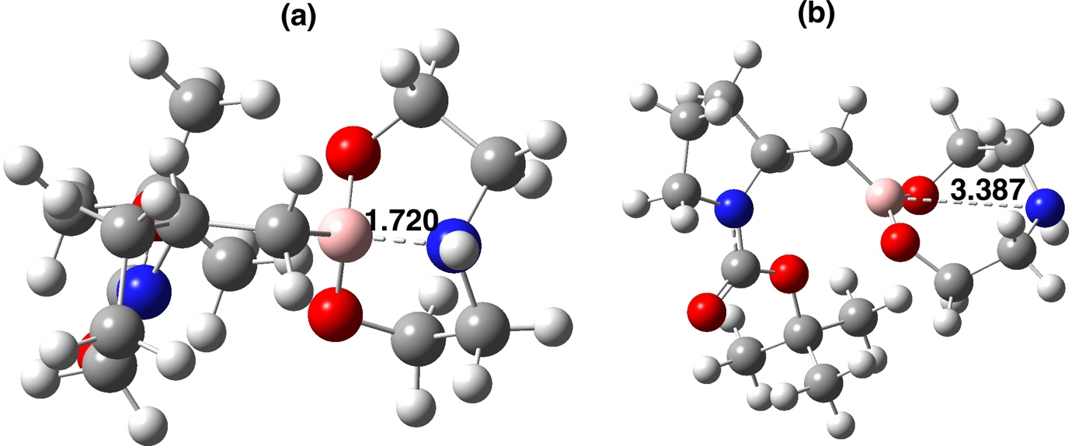
Figure 1. Calculated structures at the wB97XD/aug-cc-pVDZ/SCRF=chloroform level for system 8 as (a) a boat conformation and (b) a chair conformation, with the length of the B-N interaction shown, in Å.

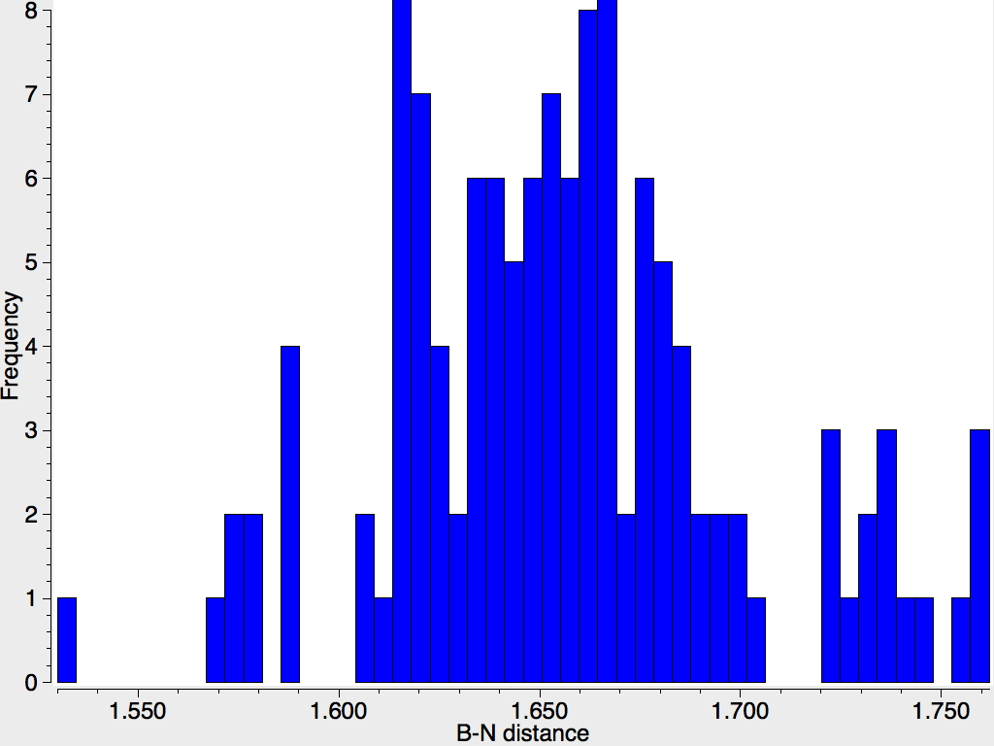
Figure 2. A crystal structure search for tetracoordinate B with B-C, two B-O and one B-N interactions, using the February 2018 version of the CSD database.

- During our recent study of the mechanism of boron-catalysed direct amidation reactions, we evaluated the reactivity of simple acyloxyboron compounds with amines (Scheme 1). Mandelic acid derivative 1 was synthesised as reported previously,³⁰ and reacted with benzylamine in CDCl₃ solution to give a new species in the ¹¹B NMR, which we proposed was the amine adduct 2. DFT predictions of the chemical shifts of both 1 and the amine adduct 2 were in good agreement with the proposed structures, which supports our hypothesis that trigonal acyloxyboron compounds react readily with amines at the boron atom. There was no evidence for reaction at the carbonyl group and subsequent amide formation. This serves as an illustration of the utility of this DFT method for identifying unknown species in solution.

Scheme 1. Reaction of mandelic acid boronates 1 with benzylamine to give adducts 2. The DFT calculated ¹¹B chemical shifts (shown in parentheses) are ωB97XD/aug-cc-pvdz/scrf=chloroform, including the reference correction of +1.8 ppm. Data in the sub-collection at DOI: 10.14469/hpc/3900

Summary

¹¹B NMR spectroscopy is widely used as a tool for investigating the role of organoboron reagents in organic reaction mechanisms, but accurately identifying the structure of unknown organoboron species is non-trivial. We have evaluated a simple “one-pot” procedure for estimating the ¹¹B chemical shift of putative species in solution using a standard quantum chemical program, enabling predictions with better than 2 ppm accuracy and providing a tool for assisting with probing the mechanistic pathways of organoboron mediated reactions.

Experimental Section.
General methods. All starting materials and solvents were obtained commercially from standard chemical suppliers and were used as received unless otherwise stated. NMR spectra were recorded using a Bruker Avance-400 MHz spectrometer at frequencies of 400, 101, 128 and 376 MHz for ¹H, ¹³C, ¹¹B and ¹⁹F respectively. NMR experiments were run in CDCl₃ unless otherwise stated and the data is reported as follows: chemical shift (δ, ppm), multiplicity, spin-spin coupling constants (J, Hz), integration and assignment, where possible. H_{na} and H_{nb} denote diastereotopic protons; H_{n} and H_{n’} (or equivalently, C_{n} and C_{n’}), denote rotamers. Aromatic carbons next to boron atom are not reported in ¹³C NMR. Mass spectra were obtained using ASAP (LCT Premier XE), ESI (TQD mass spectrometer with Acquity UPLC photodiode array detector) or EI (Shimadzu QP-2010-Ultra) techniques. Accurate mass values were measured on QtoF Premier mass spectrometer. IR spectra were obtained using FT1600 series or PerkinElmer UATR Two spectrometers. Elemental analysis was performed using an Exeter Analytical E-440 Elemental Analyser. Melting points were determined using an Electrothermal apparatus and were uncorrected.

4,9-Dimethoxy-1H,3H-naphtho[1,8-cd][1,2,6]oxadiborinine-1,3-diol (Entry 21)
n-Butyllithium (0.289 mL, 0.723 mmol) was added to a solution of 1,8-dibromo-2,7-dimethoxynaphthalene (0.100 g, 0.289 mmol) in dry THF (4 mL) under argon at -78 °C. The mixture was stirred for 30 minutes. Trimethyl borate (0.071 mL, 0.636 mmol) was then added quickly and the mixture slowly warmed to r.t. The mixture was stirred for 30 min, quenched with 20 % HCl (2 mL) and left to stir for 15 min. The product was extracted with EtOAc (3 x 4 mL), washed with brine (3 x 4 mL), dried (MgSO₄) and the solvent removed in vacuo. The compound was recrystallised from CH₂Cl₂ – Et₂O to give the product as a white solid (10.2 mg, 14 %): ¹H NMR (600 MHz, CDCl₃): 7.96 (2H, d, J 9.1), 7.35 (2H, s), 7.19 (2H, d, J 9.0), 4.07 (6H, s); ¹³C NMR (150 MHz, CDCl₃): 165.4. 144.0. 134.4. 123.7. 110.1. 56.2; ¹¹B NMR (CDCl₃): 29.8; m/z (ES+): 259.3 [M+H+]; HRMS: Calcd for C₁₂H₁₃¹⁰B₂O₅ 257.1022, found 257.1017.
Crystal data for 4,9-dimethoxy-1H,3H-naphtho[1,8-cd][1,2,6]oxadiborinine-1,3-diol (Entry 21): C₁₂H₁₂B₂O₅, M = 257.84, orthorhombic, space group P bca, a = 12.4294(6), b = 12.3804(6)), c = 15.3932(7) Å, U = 2368.7(2) Å³, F(000) = 1072.0, Z = 8, D_{c} = 1.446 mg m⁻³, μ = 0.108 mm⁻¹ ( Mo-Kα, λ = 0.71073 Å), T = 120(1)K. 46156 reflections were collected on a Bruker D8Venture diffractometer (ω-scan, 1°/frame) yielding 3142 unique data (R_{merg} = 0.0562). The structure was solved by direct method and refined by full-matrix least squares on F² for all data using SHELXTL and OLEX2 software. All non-hydrogen atoms were refined with anisotropic displacement parameters, H-atoms were located on the difference map and refined isotropically. Final wR₂(F²) = 0.1122 for all data (220 refined parameters), conventional R (F) = 0.0419 for 2297 reflections with I ≥ 2σ, GOF = 1.034. Crystallographic data for the structure have been deposited with the Cambridge Crystallographic Data Centre as supplementary publication CCDC-1834774.

Supporting Information: Computational full data files are available via a data repository,¹⁶ with these files containing details of calculations; also included are crystallographic and NMR data for 4,9-dimethoxy-1H,3H-naphtho[1,8-cd][1,2,6]oxadiborinine-1,3-diol, and all ¹¹B NMR spectra collected in this work (in Mpublish format).¹⁶

Acknowledgements
We thank Durham University for Doctoral Fellowship funding (SA), GlaxoSmithKline and UCL Chemistry for supporting a PhD studentship (MTS), and Pfizer for providing an EPSRC CASE award (VK). We thank Andrei Batsanov and Dmitry Yufit for solving the X-Ray crystal structure of 4,9-Dimethoxy-1H,3H-naphtho[1,8-cd][1,2,6]oxadiborinine-1,3-diol.

References

a) Lennox, A. J. J.; Lloyd-Jones, G. C. Selection of boron reagents for Suzuki–Miyaura coupling. Chem. Soc. Rev. 2014, 43, 412; b) Miyaura, N.; Suzuki, A. Palladium-catalyzed cross-coupling reactions of organoboron compounds. Chem. Rev. 1995, 95, 2457; c) Lam, P. Y. S. in Synthetic Methods in Drug Discovery: Vol. 1, Ch. 7, Royal Society of Chemistry (2016).
Hall, D. G. in Boronic Acids: Preparation and Applications in Organic Synthesis, Medicine and Materials: Vol. 1, Ch. 1, Structure, properties, and preparation of boronic acid derivatives: overview of their reactions and applications. Wiley (2011) (Ed. D. G. Hall).
Payette, J. N.; Yamamoto, H. in Boronic Acids: Preparation and Applications in Organic Synthesis, Medicine and Materials: Vol. 2, Ch. 12, Borate and boronic acid derivatives as catalysts in organic synthesis. Wiley (2011) (Ed. D. G. Hall).
a) Zhang, L.; Jiao, L. Pyridine-catalyzed radical borylation of aryl halides. J. Am. Chem. Soc. 2017, 139, 607; b) Atack, T.C.; Cook, S. P. Manganese-catalyzed borylation of unactivated alkyl chlorides. J. Am. Chem. Soc. 2016, 138, 6139; c) Seiple, I. B.; Su, S.; Rodriguez, R. A.; Gianatassio, R.; Fujiwara, Y.; Sobel, A. L.; Baran, P. S. Direct C−H arylation of electron-deficient heterocycles with arylboronic Acids. J. Am. Chem. Soc. 2010, 132, 13194; d) Lima, F.; Sharma, U. K.; Grunenberg, L.; Saha, D.; Johannsen, S.; Sedelmeier, J.; Van der Eycken, E. V.; Ley, S. V. A Lewis base catalysis approach for the photoredox activation of boronic acids and esters. Angew. Chem. Int. Ed. 2017, 56, 15136.
Mechanism studies: a) Cox, P. A.; Reid, M.; Leach, A. G.; Campbell, A. D.; King, E. J.; Lloyd-Jones, G. C. Base-catalyzed aryl-B(OH)2 protodeboronation revisited: from concerted proton transfer to liberation of a transient aryl anion. J. Am. Chem. Soc. 2017, 139, 13156; b) Molloy, J. J.; Seath, C. P.; West, M. J.; McLaughlin, C.; Fazakerley, N. J.; Kennedy, A. R.; Nelson, D. J.; Watson, A. J. B. Interrogating Pd(II) anion metathesis using a bifunctional chemical probe: A transmetalation switch. J. Am. Chem. Soc. 2018, 140, 126; c) Vantourout, J. C.; Miras, H. N.; Isidro-Llobet, A.; Sproules S.; Watson, A. J. B. Spectroscopic studies of the Chan–Lam amination: A mechanism-inspired solution to boronic ester reactivity. J. Am. Chem. Soc. 2017, 139, 4769; d) J. J. Molloy, J. J.; Clohessy, T. A.; Irving, C.; Anderson, N. A.; Lloyd-Jones, G. C.; Watson, A. J. A. Chemoselective oxidation of aryl organoboron systems enabled by boronic acid-selective phase transfer. Chem. Sci. 2017, 8, 1551; e) Zhang, L.; Jiao, L. Super electron donors derived from diboron. Chem. Sci. 2018, 9, 2711; f) Bagutski, V.; Del Grosso, A.; Ayuso Carrillo, J.; Cade, I. A.; Helm, M. D.; Lawson, J. R.; Singleton, P. J.; Solomon, S. A.; Marcelli, T. A.; Ingleson, M. J. Mechanistic studies into amine-mediated electrophilic arene borylation and its application in MIDA boronate synthesis. J. Am. Chem. Soc. 2013, 135, 474; g) Cox, P. A.; Leach, A. G.; Campbell, A. D.; Lloyd-Jones, G. C. Protodeboronation of heteroaromatic, vinyl, and cyclopropyl boronic acids: pH–rate profiles, autocatalysis, and disproportionation. J. Am. Chem. Soc. 2016, 138, 9145.
Arkhipenko, S. Y.; Sabatini, M. T.; Batsanov, A. S.; Karaluka, V.; Sheppard, T. D.; Rzepa, H. S.; Whiting, A. Mechanistic insights into boron-catalysed direct amidation reactions. Chem. Sci. 2018, 9, 1058.
a) Wrackmeyer, B. The B–N Bond in some aminoboranes and an iminoborane, studied by ¹¹B and ¹⁵N NMR spectroscopy and DFT methods. Z. Anorg. Allg. Chem. 2015, 641, 2525; b) Oh, S.-W.; Weiss, J. W. E.; Kerneghan, P. A.; Korobkov, I.; Maly, K. E.; Bryce, D. L. Solid-state 11B and 13C NMR, IR, and X-ray crystallographic characterization of selected arylboronic acids and their catechol cyclic esters. Magn. Reson. Chem. 2012, 50, 388; c) Wrackmeyer, B. Organoboranes and tetraorganoborates studied by ¹¹B and ¹³C NMR spectroscopy and DFT calculations. Z. Naturforsch 2015, 70, 421 d) Bagno, A.; Kantlehner, W.; Kress, R.; Saielli, G.; Stoyanov, E. Fries rearrangement of aryl formates: A mechanistic study by means of ¹H, ²H, and ¹¹B NMR spectroscopy and DFT calculations. J. Org. Chem. 2006, 71, 9331.
Braddock, D. C.; Rzepa, H. S. Structural reassignment of obtusallenes V, VI, and VII by GIAO-based density functional prediction. J. Nat. Prod., 2008, 71, 728.
Chai, J. -D.; Head-Gordon, M. Long-range corrected hybrid density functionals with damped atom–atom dispersion corrections. Phys. Chem. Chem. Phys. 2008, 10, 6615.
Grimme, S.; Ehrlich, S.; Goerigk, L. Effect of the damping function in dispersion corrected density functional theory. J. Comp. Chem. 2011, 32, 1456.
Kendall, R. A.; Dunning, Jr., T. H.; Harrison, R. J. Electron affinities of the first‐row atoms revisited. Systematic basis sets and wave functions. J. Chem. Phys. 1992, 96, 6796.
Gaussian 16, Revision A.03, Frisch, M. J.; Trucks, G. W.; Schlegel, H. B.; Scuseria, G. E.; Robb, M. A.; Cheeseman, J. R.; Scalmani, G.; Barone, V.; Petersson, G. A.; Nakatsuji, H.; Li, X.; Caricato, M.; Marenich, A. V.; Bloino, J.; Janesko, B. G.; Gomperts, R.; Mennucci, B.; Hratchian, H. P.; Ortiz, J. V.; Izmaylov, A. F.; Sonnenberg, J. L.; Williams-Young, D.; Ding, F.; Lipparini, F.; Egidi, F.; Goings, J.; Peng, B.; Petrone, A.; Henderson, T.; Ranasinghe, D.; Zakrzewski, V. G.; Gao, J.; Rega, N.; Zheng, G.; Liang, W.; Hada, M.; Ehara, M.; Toyota, K.; Fukuda, R.; Hasegawa, J.; Ishida, M.; Nakajima, T.; Honda, Y.; Kitao, O.; Nakai, H.; Vreven, T.; Throssell, K.; Montgomery, J. A., Jr.; Peralta, J. E.; Ogliaro, F.; Bearpark, M. J.; Heyd, J. J.; Brothers, E. N.; Kudin, K. N.; Staroverov, V. N.; Keith, T. A.; Kobayashi, R.; Normand, J.; Raghavachari, K.; Rendell, A. P.; Burant, J. C.; Iyengar, S. S.; Tomasi, J.; Cossi, M.; Millam, J. M.; Klene, M.; Adamo, C.; Cammi, R.; Ochterski, J. W.; Martin, R. L.; Morokuma, K.; Farkas, O.; Foresman, J. B.; Fox, D. J. Gaussian, Inc., Wallingford CT, 2016.
Grimme, S.; Bannwarth, C.; Dohm, S.; Hansen, A.; Pisarek, J.; Pracht, P.; Seibert, J.; Neese, F. Fully automated quantum‐chemistry‐based computation of spin–spin‐coupled nuclear magnetic resonance spectra. Angew. Chem. Int. Ed. 2017, 56, 14763.
Jensen, F. Basis set convergence of nuclear magnetic shielding constants calculated by density functional methods. J. Chem. Theory Comput. 2008, 4, 719-727 and Segmented contracted basis sets optimized for nuclear magnetic shielding. 2015, 11, 132-138.
Hanwell, M. D.; Curtis, D. E.; Lonie, D. C.; Vandermeersch, T.; Zurek, E.; Hutchison, G. R. Avogadro: an advanced semantic chemical editor, visualization, and analysis platform. J. Cheminformatics 2012, 4:17.
H. S. Rzepa, S. Arkhipenko, E. Wang, M. T. Sabatini, V. Karaluka, A. Whiting, T. D. Sheppard, Imperial College Research Computing Services Data Repository, 2016, DOI: 10.14469/hpc/3702 and collections therein.
Brown, H. C.; Choi, Y. M.; Narasimhan, S. Addition compounds of alkali metal hydrides. 22. Convenient procedures for the preparation of lithium borohydride from sodium borohydride and borane-dimethyl sulfide in simple ether solvents. Inorg. Chem. 1982, 21, 3657.
Ramachandran, P. V.; Drolet, M. P.; Kulkarni, A. S. A non-dissociative open-flask hydroboration with ammonia borane: ready synthesis of ammonia–trialkylboranes and aminodialkylboranes. Chem. Commun. 2016, 52, 11897.
Heitsch, C. W. The Nuclear Magnetic Resonance Spectra of Some Boron Complexes. Inorg. Chem. 1965, 4, 1019.
Gellrich, U.; Diskin-Posner, Y.; Shimon, L. J. W.; Milstein, D. Reversible Aromaticity Transfer in a Bora-Cycle: Boron–Ligand Cooperation. J. Am. Chem. Soc. 2016, 138, 13307.
Eberlin, L.; Carboni, B.; Whiting, A. Regioisomeric and Substituent Effects upon the Outcome of the Reaction of 1-Borodienes with Nitrosoarene Compounds. J. Org. Chem. 2015, 80, 6574.
Sabatini, M. T.; Boulton, L. T.; Sheppard, T. D. Borate esters: Simple catalysts for the sustainable synthesis of complex amides. Sci. Adv. 2017, 3, e1701028.
Cid, J.; Carbó, J. J.; Fernández, E. A clear-cut example of selective Bpin-Bdan activation and precise Bdan transfer on boron conjugate addition. Chem. Eur. J. 2014, 20, 3616.
Kawachi, A.; Nagae, S.; Onoue, Y.; Harada, O.; Yamamoto, Y. ortho-Magnesiation of boron-substituted benzenes by using (TMP)₂ Mg. Chem. Eur. J. 2011, 17, 8005.
Coombs, D. N.; Aldridge, S.; Wiltshire, G.; Kays, D. L.; Bresner, C.; Ooi, L. Complementary anion binding by bidentate boron-containing Lewis acids. J. Organomet. Chem. 2005, 690, 2725.
Arnold, K.; Batsanov, A. S.; Davies, B.; Grosjean, C.; Schütz, T.; Whiting, A.; Zawatzky, K. The first example of enamine–Lewis acid cooperative bifunctional catalysis: application to the asymmetric aldol reaction. Chem. Commun. 2008, 3879.
Noda, H.; Furutachi, M.; Asada, Y.; Shibasaki, M.; Kumagai, N. Unique physicochemical and catalytic properties dictated by the B₃NO₂ ring system. Nature Chem. 2017, 9, 571.
Paetzold P. I.; Scheibitz, W.; Scholl, E. Darstellung und Eigenschaften von 1.3.2-Dioxaborolandionen-(4.5). Z. Naturforsch. B 1971, 26, 646.
Hatano, M.; Goto, Y.; Izumiseki, A.; Akakura, M.; Ishihara, K. Boron Tribromide-Assisted Chiral Phosphoric Acid Catalyst for a Highly Enantioselective Diels–Alder Reaction of 1,2-Dihydropyridines. J. Am. Chem. Soc. 2015, 137, 13472.
Brown, N. M. D.; Favidson, F.; Wilson, J. W. Dimesitylboryl compounds. Part II. Nitrogen derivatives. J. Organomet. Chem. 1980, 192, 133.
Del Grosso, A.; Pritchard, R. G.; Muryn, C. A.; Ingleson, M. J. Chelate Restrained Boron Cations for Intermolecular Electrophilic Arene Borylation. Organometallics 2010, 29, 241.
Kahlert, J.; Bohling, L.; Brockhinke, A.; Stammler, H.-G.; Neumann, B.; Rendina, L. M.; Low, P. J.; Weber, L.; Fox, M. A. Syntheses and reductions of C-dimesitylboryl-1,2-dicarba-closo-dodecaboranes. Dalton Trans. 2015, 44, 9766.
Toporcer, L. H.; Dessy, R. E.; Green, S. I. E. The Preparation and Properties of Some Tetracoordinate Boron Compounds. The Pseudo-Metal Ion Concept. Inorg. Chem. 1965, 4, 1649.
S. Arkhipenko, S. Y. (2017) Approaches to Novel B-N Chemistry at the Boundary of Frustrated Lewis Pairs and Bifunctional Catalysis. PhD Thesis, Durham University; available at Durham E-Theses Online: DOI: 10.15128/et0012213
C. R. Groom, I. J. Bruno, M. P. Lightfoot and S. C. Ward. The Cambridge Structural Database. Acta Cryst. 2016, 72, 171.

