Logging disturbance shifts net primary productivity and its allocation in Bornean tropical forests
Running head: NPP and disturbance in tropical forest
Terhi Riutta¹*, Yadvinder Malhi¹, Kho Lip Khoon^{1,2}, Toby Richard Marthews^{3,1}, Walter Huaraca Huasco⁴, MinSheng Khoo⁵, Sylvester Tan⁶, Edgar C. Turner⁷, Glen Reynolds⁸, Sabine Both⁹, David F.R.P. Burslem⁹, Yit Arn Teh⁹, Charles S. Vairappan¹⁰, Noreen Majalap¹¹ & Robert M. Ewers⁵
¹ University of Oxford, School of Geography and the Environment, Environmental Change Institute, South Parks Road, Oxford, OX1 3QY, UK
² Tropical Peat Research Institute, Biological Research Division, Malaysian Palm Oil Board, 6, Persiaran Institusi, Bandar Baru Bangi, 43000, Kajang, Selangor, Malaysia
³ Centre for Ecology & Hydrology, Maclean Building, Wallingford OX10 8BB, UK
⁴ Universidad Nacional de San Antonio Abad del Cusco, Peru
⁵ Imperial College London, Department of Life Sciences, Silwood Park Campus, Buckhurst Road, Ascot, SL5 7PY, UK
⁶ Center for Tropical Forest Science, Smithsonian Institution, Washington, D.C. 20013-7012, USA
⁷ University of Cambridge, Insect Ecology Group, University Museum of Zoology, Downing Street, Cambridge, CB2 3EJ, UK
⁸ The Royal Society South East Asia Rainforest Research Partnership, Danum Valley Field Centre, PO Box 60282, 91112 Lahad Datu, Sabah, Malaysia
⁹ University of Aberdeen, School of Biological Sciences, Cruickshank Building, St Machar Drive, Aberdeen, AB24 3UU, UK
¹⁰Universiti Malaysia Sabah, Institute for Tropical Biology and Conservation, 88450 Kota Kinabalu, Malaysia
¹¹ Forest Research Centre, Sabah Forestry Department, P. O. Box 1407, 90715 Sandakan, Sabah, Malaysia

* Corresponding author: terhi.riutta@ouce.ox.ac.uk; Tel.: +44 (0)1865 285171, Fax: +44 (0)1865 275885
Keywords: allocation, carbon, land use, logging, net primary productivity, tree census, SAFE Project, GEM
Type of paper: Original research (Primary research article)

ABSTRACT
Tropical forests play a major role in the carbon cycle of the terrestrial biosphere. Recent field studies have provided detailed descriptions of the carbon cycle of mature tropical forests, but logged or secondary forests have received much less attention. Here we report the first measures of total net primary productivity (NPP) and its allocation along a disturbance gradient from old-growth forests to moderately and heavily logged forests in Malaysian Borneo. We measured the main NPP components (woody, fine root and canopy NPP) in old-growth (n=6) and logged (n=5) 1 ha forest plots. Overall, the total NPP did not differ between old-growth and logged forest (13.5 ± 0.5 and 15.7 ± 1.5 Mg C ha⁻¹ year⁻¹, respectively). However, logged forests allocated a significantly higher fraction into woody NPP at the expense of the canopy NPP (30% and 50% into woody and canopy NPP, respectively, in old-growth forest vs. 20% and 60% in logged forest). When controlling for local stand structure, NPP in logged forest stands was 41% higher, and woody NPP was 150% higher than in old-growth stands with similar basal area, but this was offset by structure effects (higher gap frequency and absence of large trees in logged forest). This pattern was not driven by species turnover: the average woody NPP of all species groups within logged forest (pioneers, non-pioneers, species unique to logged plots and species shared with old-growth plots) was similar. Hence, below a threshold of very heavy disturbance, logged forests can exhibit higher NPP and higher allocation to wood; such shifts in carbon cycling persist for decades after the logging event. Our results demonstrate that high-intensity logging can cause profound shifts in carbon production and allocation in tropical forests.
Given that the majority of tropical forest biome has experienced some degree of logging, our results demonstrate that logging can cause substantial shifts in carbon production and allocation in tropical forests.
INTRODUCTION
The tropical forest biome plays a dual role in the global carbon budget. On the one hand, it forms a large terrestrial carbon sink of approximately 1.0±0.5 Pg C yr⁻¹ (Pan et al., 2011), accounting for 40% of the global land C sink (Malhi, 2010; Ciais et al., 2013). On the other hand, carbon emissions from tropical forest degradation and deforestation, 1.1±0.8 Pg C yr⁻¹, make up >90% of the total emission from land use and land use change, which currently account for 12% of all anthropogenic carbon dioxide emissions (Ciais et al., 2013) .
Today, approximately 75% (1713 M ha) of the original, pre-industrial tropical forest area remains (FAO, 2015; Keenan et al., 2015). Of this extant tropical forest area, only 30% is relatively undisturbed (Potapov et al., 2008). The remaining area has been modified by humans, mostly through selective logging. Hence, the most pervasive aspect of global change in tropical forests is may be neither deforestation nor climate change, but the increasing transformation (approximately 12 M ha year⁻¹; FAO, 2015) of high biomass, slow-turnover, old-growth forests into lower biomass, higher turnover post-disturbance forests (Malhi et al., 2014). Selective logging changes the forest carbon cycle by altering forest structure, dynamics, composition, and microclimate. As a result, the functioning of the ecosystem may be substantially altered. Standing carbon stocks, and the amount of metabolically active tissue decrease, while necromass may increases. Gaps left by the removed and dying trees make the physical environment more exposed, altering radiation, temperature, humidity, and soil moisture regimes (Hardwick et al., 2015). In addition to the changes in microclimate, logging operations cause soil disturbance, loss of top soil and soil compaction, especially around logging roads, skid trails and logging platforms, which may cover up to 25% of logged forest areas (Yamada et al., 2014). Competition both above- and below-ground is reduced and resource availability (e.g. light in gaps, extra nutrients from logging residue and decomposing necromass) increases. The selective removal of large, commercially valuable canopy trees that dominate the aboveground carbon stock (Sist et al., 2014) changes the size, age structure, and species composition of the forest. The colonisation of gaps by pioneer species further alters community composition (Sist & Nguyen-The, 2002), especially if dominant canopy species, and therefore their seed source, have been removed. Typically, the community shifts from slow-growing, conservative, shade-tolerant species towards fast-growing, acquisitive, light-demanding species (Bischoff et al., 2005; Carreno-Rocabado et al., 2012; Saner et al., 2012). In the shorter term, logging decreases primary productivity and increases heterotrophic respiration (Huang & Asner, 2010). As the forest starts to recover, however, the woody biomass accumulation rate in logged forest may be several times higher than in old-growth forest (Blanc et al., 2009; Berry et al., 2010).
Almost all studies of biomass production and recovery in logged forests focus only on above-ground woody biomass (e.g. Blanc et al., 2009; Huang & Asner, 2010; Berenguer et al., 2014). Although wood production is a significant proportion of net primary production (NPP; typically 39% ±10% in old-growth tropical forests; see Malhi et al., 2011), it is by no means the only fate of fixed carbon, as photosynthesis also leads to the production of leaves, roots, flowers, fruits, and other ecosystem components. A more complete understanding of biomass production can be attained through an organ-specific assessment of NPP.
NPP is the amount of carbon assimilated through photosynthesis that is converted into new tissues, root exudates, and volatile organic compounds. In old-growth tropical forests, plants use approximately 60-70% of gross primary productivity (GPP) on their own metabolism, releasing the assimilated CO₂ back to the atmosphere through autotrophic respiration (Chambers et al., 2004; Malhi et al., 2009; Malhi, 2012; Anderson‐Teixeira et al., 2016). Thus, the carbon use efficiency (proportion of GPP converted to NPP) is estimated to be about 30-40% in old-growth forests, but may be substantially higher in post-disturbance forests where rapid growth and resource acquisition is prioritised over maintenance and defence. A pan-tropical analysis of NPP allocation into canopy, woody, and fine root NPP (which, together, account for ~90% of the total NPP) indicates roughly equal partitioning into these three components in old-growth forests, but site-specific variation is considerable (Malhi et al., 2011).
In recent years, there have been an increasing number of studies of above- and below-ground NPP in tropical old-growth forest sites (e.g. Clark et al., 2001; Aragão et al., 2009; Malhi et al., 2011; Malhi et al., 2015). However, as far is we are aware, there has been no assessment of above- and below-ground NPP for tropical logged forests; the most comprehensive synthesis of the existing empirical data on tropical forest carbon stocks and fluxes to date contains no estimates of total NPP for logged forests and only one estimate of total NPP for a naturally regenerating secondary forest (Anderson‐Teixeira et al., 2016). Given that the area of logged and human-modified forest exceeds that of old-growth forests (FAO, 2015), quantifying the carbon dynamics of logged forests is essential for understanding the carbon balance of the tropical forest biome.
In this study we present the first quantification of total net primary productivity and its allocation into woody, canopy and fine root NPP along a disturbance gradient from old-growth to heavily logged forest. Specifically, we addressed the following questions:
- How do total NPP and its allocation to canopy, woody and fine root components vary along a disturbance gradient from old-growth to heavily logged forests?
- Are the high woody growth rates reported for logged forests the result of an increase in NPP or a shift in allocation in favour of woody production, or some combination of these two factors?
- To what extent are the shifts in NPP along the disturbance gradient determined by species turnover, in particular, the presence of pioneer species?
- What is the relative contribution of shifts in tree carbon budgets (changes in productivity and allocation) vs. changes in stand density and structure (gaps, reduced number of large trees) in determining the net change in NPP and its allocation between logged and old-growth forests?

MATERIALS AND METHODS
Study sites
The study sites were located in Malaysian Borneo, in the states of Sarawak and Sabah. This area is a global hotspot of logging and forest conversion. By 2009, 28% of the original forest area of Sabah and Sarawak had been converted to plantations, predominantly oil palm, and 72% of the remaining forest area had been selectively logged (Bryan et al., 2013). Climate in the region is moist tropical, with an annual daily mean temperature of 26.7°C (Walsh & Newbery, 1999). Annual precipitation is approximately 2600-2700 mm (Walsh & Newbery, 1999; Kumagai & Porporato, 2012). There are no distinct dry and wet seasons, but approximately 12% of months receive lower precipitation, with rainfall of <100 mm month⁻¹ (Walsh & Newbery, 1999). The area experiences severe droughts linked to El Niño events approximately every ten years, with some evidence that the drought frequency is increasing (Walsh & Newbery, 1999; Malhi & Wright, 2004; Katayama et al., 2009).
Five plots formed a disturbance gradient from heavily to moderately logged forest sites, located in Kalabakan Forest Reserve, Sabah (Table 1). Six plots were located in old-growth forest (two in Danum Valley Conservation Area, Sabah; two in Maliau Basin Conservation Area, Sabah; and two in Lambir Hills National Park, Sarawak), where there was no evidence of logging or human disturbance of vegetation (apart from indirectly through heavy defaunation in Lambir; Harrison et al., 2013) (for a map of the sites, see Fig. S1). All plots had a planimetric area of 1 ha, divided into 25 subplots of 20 m × 20 m. The logged plots in Kalabakan Forest Reserve and the old-growth plots in Maliau are part of the Stability of Altered Forest Ecosystem (SAFE) Project, a large-scale forest fragmentation experiment (Ewers et al., 2011; www.safeprojet.net).

Table 1. Characteristics of the study plots. The logged plots are ranked from most to the least intensively logged. Mean of individual subplots ±1 SE. Plot codes are as designated in the forestplots.net database.
Plot name and plot code | Plot location | Disturbance | Soil type; topography | Basal area of trees >10 cm DBH (m² ha⁻¹)¹ | Mean canopy gap fraction (%) | Number of big trees (DBH >50 cm) ha⁻¹ | Pioneer tree species (% of basal area)
B South  (SAF-01) | SAFE Project, Sabah (4.732°, 117.619°) | Heavily logged | Clay; mostly flat with a moderate slope on one edge | 6.81±1.00 | 15.0±2.14 | 1 | 28.1±4.3
B North  (SAF-02) | SAFE Project, Sabah (4.739°, 117.617°) | Heavily logged | Clay; undulating | 11.1±1.81 | 13.4±1.51 | 0 | 57.2±5.8
Tower  (SAF-05) | SAFE Project, Sabah (4.716°, 117.609°) | Heavily logged | Clay; undulating | 13.9±1.70 | 12.2±2.07 | 6 | 34.5±6.6
LF  (SAF-04) | SAFE Project, Sabah  (4.765°, 117.700°) | Moderately logged | Partly sandy loam, partly clay; flat | 19.3±1.70 | 12.8±1.03 | 11 | 6.9±2.2
E  (SAF-03) | SAFE Project, Sabah (4.691°, 117.588°) | Moderately logged | Clay; steep slope | 19.6±1.88 | 11.2±1.29 | 10 | 21.5±5.0
Danum Carbon 1  (DAN-04) | Danum Valley Conservation Area  (4.951°, 117.796°) | Old-growth | Clay; steep slope | 32.0±3.30 | 10.5±1.00 | 34 | 0.7±1.0
Danum Carbon 2  (DAN-05) | Danum Valley Conservation Area  (4.953°, 117.793°) | Old-growth | Clay; flat | 30.6±3.37 | 11.3±1.5 | 26 | 0.1±0.0
Belian  (MAL-01) | Maliau Basin Conservation Area, Sabah  (4.747°, 116.970°) | Old-growth | Clay; undulating | 41.6±3.59 | 8.70±0.62 | 47 | 0.2±0.3
Seraya  (MAL-02) | Maliau Basin Conservation Area, Sabah  (4.754°, 116.950°) | Old-growth | Clay; moderate slope | 34.7±2.74 | 7.04±0.55 | 56 | 1.7±1.2
Lambir Clay  (LAM-07) | Lambir Hills National Park, Sarawak  (4.183°  114.022°) | Old-growth | Clay; valley | 31.8±3.85 | 10.5±0.45 | 35 | 0.1±0.3
Lambir Sand  (LAM-06) | Lambir Hills National Park, Sarawak  (4.188°  114.019°) | Old-growth | Sandy loam; undulating with steep slopes | 41.1±2.45 | 9.52±0.22 | 46 | 0.3±1.0

The forests in the region are extremely species rich. Lambir has the highest recorded tree species diversity in the Paleotropics (Lee et al., 2002). In all plots, Euphorbiaceae and Dipterocarpaceae were the most species-rich families among trees ≥ 10 cm dbh, with the Dipterocarpaceae dominating in overall biomass. In the old-growth plots, the most common genera were the Dipterocarps Shorea and Parashorea in Maliau and Shorea and Dryobalanops in Lambir, while in the logged plots the most common genera were Macaranga (Euphorbiaceae), Shorea (Diptocarpaceae) and Syzygium (Myrtaceae). On average 46% (range: 27% to 58%) of the basal area in the logged plots comprised of species that were also found in old-growth plots (Table S1). The basal area proportion of pioneer species in the logged plots ranged from 7% to 57% (Table 1, Table S1).
In the SAFE Project area, the forest had been selectively logged two (SAF-03, SAF-04) or four (SAF-01, SAF-02, SAF-05) times. The first round of logging took place in the mid-1970s, followed by one to three repeated rounds during 1990-2008. Approximately 113 m³ ha⁻¹ of timber was removed during the first rotation and an additional cumulative volume of 37 to 66 m³ ha⁻¹ during the subsequent rotations, which is similar to the mean extracted volume of 152 m³ ha⁻¹ within a larger, 220 000 ha area in Sabah (Fisher et al., 2011; Struebig et al., 2013). Converted to biomass, this sums to approximately 46 to 54 Mg C ha⁻¹ extracted during the 30-year period. However, total biomass lost was several times higher, due to collateral damage, increased mortality after the logging (Pearson et al., 2014; Shenkin et al., 2015), and abandonment of some of the felled trees in the forest (data not available for SAFE, but in Indonesian Borneo typically 25% of the stems; Griscom et al., 2014). As the area is earmarked for conversion to oil palm plantation in 2015-2017 (Ewers et al., 2011), the prescribed logging rotation of sixty years was not followed, and repeated rounds of logging have left parts of the area highly degraded (Reynolds et al., 2011) (the plots themselves, except SAF-05 Plot, will not be converted, but will remain inside forest fragments). The logging targeted – but was not limited to – medium-density hardwoods (genera Dryobalanops and Dipterocarpus) and lighter hardwoods (Shorea and Parashorea). There was a high level of small-scale spatial variation in logging intensity, due to differeences in topography, proximity to roads, and available timber, which created a gradient from heavily to moderately logged sites. Pre-logging biomass of the plots was obtained from digitised forest inventory maps from the 1970s (Natural Forest Research Programme of the Forest Research Centre, Sabah Forestry Department) (Fig. 1). In addition, to describe the change in forest structure and composition, we used four metrics to characterise the level of disturbance within each plot: basal area, canopy gap fraction (estimated from hemispherical photos), number of stems >50 cm diameter and pioneer proportion (Table 1, Table S1).
The soils in the plots in Sabah are orthic Acrisols or Ultisols and the soil in the plots in Sarawak are humult Ultisols or udult Ultisols (for a comprehensive description of the soil types, see Marsh & Greer, 1992; Sylvester et al., 2009; Kho et al., 2013; Naianr et al., 2015). There were no clear differences between sites (SAFE, Danum, Maliau and Lambir) or forest types (logged, old-growth) in soil nutrient concentrations or physical properties (Table S2, Fig. S2). Despite the geographic proximity of the logged plots, there was more variation in the soil characteristics among the logged plots than among the old-growth plots.

NPP estimates
The plots are part of the pan-tropical GEM (Global Ecosystems Monitoring) Intensive Carbon Plot network (http://gem.tropicalforests.ox.ac.uk/; Marthews et al., 2012) and the NPP data presented here complement recent NPP data reported for old-growth forests in Amazonia (Malhi et al 2015), the Andes (Malhi et al 2017) and Africa (Moore et al, in press). We quantified the following NPP components: woody NPP (stems, coarse roots and branches), canopy NPP (leaves, twigs and reproductive parts) and fine root NPP. NPP data for the SAFE and Maliau (Sabah) plots were collected in 2011-2014, over a 24 month period in each plot, and tree censuses were carried out at least twice. NPP data for the Lambir (Sarawak) plots were collected for 15 months during 2008-2010, and trees were censused every five years between 1992 and 2008; these Lambir NPP data have already been published elsewhere (Kho et al., 2013).

Woody NPP
Woody NPP was quantified as the sum of stem NPP, coarse root NPP and branch turnover NPP. All stems of trees and lianas >10 cm diameter at 1.3 m height (DBH) were tagged and the diameter was measured to the nearest millimetre. Measurement height was adjusted if the stem was not smooth at 1.3 m (buttresses, branching etc.). Small stems of trees and lianas of 2-10 cm DBH were tagged and measured in five subplots per plot in Sabah and in all subplots in Lambir. All plots were re-censused at least once. Stem height was estimated visually for all trees and calibrated against clinometer measurements for a subsample of 200 stems ranging from 6 to 63 m height. Height was not estimated during the recensus, as the change in height was considered too small to be detected reliably. Instead, a diameter to height relationship was estimated (exponential rise to maximum function, R² = 0.66 - 0.97, depending on the plot) and the height increment, as percentage change in height corresponding to the change in diameter, was derived from the curve for each stem.
Above-ground woody biomass was estimated using allometric equations for moist tropical forest, with diameter, height and wood density as inputs (Chave et al., 2005). Wood density for each species (or in the absence of species ID, average by genus or family) was derived from the global wood density database (Chave et al., 2009; Zanne et al., 2009) or from local measurements (Kho et al., 2013). We assumed a carbon content of 47.4% of dry biomass for all woody components (Martin & Thomas, 2011), a factor which includes volatile carbon content that is lost from oven-dried samples. Coarse root biomass was estimated using an allometric relationship between DBH and coarse root biomass (Eq. 1, Eq. 2), based on a root excavation study in a lowland dipterocarp forest in Pasoh Forest Reserve in Peninsular Malaysia (Niiyama et al., 2010):
Coarse root biomass (stems ≥ 2.5 cm DBH) = 0.023 × DBH^2.59 (Eq. 1)
Coarse root biomass (stems < 2.5 cm DBH) = 0.079 × DBH^1.04 (Eq. 2)
where coarse root biomass per stem is in kg and DBH in cm.
Stem and coarse root NPP were calculated as the increase in biomass in surviving trees between two subsequent censuses plus biomass of new recruits minus biomass loss through mortality. We assumed that stems that had died between censuses and new recruits that reached the DBH threshold between censuses did so, on average, in the middle of the census interval.
Branch turnover NPP was estimated in 25 quadrats of 2 m × 2 m in the plots in Sabah, and in four transects of 100 m × 1 m in the plots in Sarawak. All branches >2 cm diameter were collected every three to six months, weighed in the field and classified into five decay classes (Harmon et al., 1995). The first survey quantified the stock, rather than production of the new material. Sub-samples from each decay class in each quadrat were brought back to the laboratory to determine the dry mass and mean wood density of each class. The dry mass of the pieces belonging to classes 2-5 were converted to recently fallen (class 1) mass, using a conversion factor (Eq 3):
MassRF_class(i) = Mass_class(i) × Density_class1 / Density_class(i) (Eq. 3)
where the MassRF_class(i) is the mass in decay classes 2-5 converted into recently fallen mass, Mass_class(i) is the measured mass in decay classes 2-5, and Density_class1 and Density_class(i) is the wood density in decay class 1 and wood density in decay classes 2-5, respectively. In subsequent censuses any fallen branches from dead trees were excluded, as we were interested in the branch turnover term.

Canopy NPP
Fine litter fall (leaves; twigs, woody tissue and branches≤2 cm diameter; reproductive parts; undefined fine debris) was used as a proxy for canopy production. Litter was collected every 14 to 21 days from 50 cm × 50 cm litter traps, set 1 m above the ground (n=25 per plot), dried at 70°C until constant weight, and sorted into components. Litter carbon content was assumed to be 50%.

Fine root NPP
Fine root NPP was measured using cylindrical root in-growth cores of 12 cm diameter and 30 cm depth, made of wire mesh (n=16 per plot in Sabah, n=9 per plot in Sarawak). At the installation, all roots were extracted and the core was filled with the root free soil. The root mass at the first installation quantified the root stock rather than production. The cores were then harvested every three months, roots extracted, cleaned, dried (70°C until constant weight) and weighed. Roots in each core were searched in the forest for a fixed time (4×5 min or 4×10 min) and the total root mass in the sample was estimated from a cumulative root mass over time curve (Metcalfe et al., 2007; Kho et al., 2013), solved to 120 minutes. This method allows the root search time to be kept within a reasonable limit in the field while taking into account that a small fraction of roots is likely to remain unextracted. Root dry mass was converted into carbon by assuming a carbon content of 50%. Based on fine root mass in the top 30 cm soil layer, we estimated the fine root mass to 1 m depth by applying a correction factor of 1.125, derived from a root depth profile determined in Pasoh Forest Reserve in Peninsular Malaysia (Yoda, 1978; Kho et al., 2013).

Missing components of NPP
Somewhat inevitably, any estimate of NPP may be biased towards underestimation because it neglects several small NPP terms, such as NPP lost as volatile organic emissions, non-measured litter trapped in the canopy, NPP lost to herbivory, or dropped from understorey plants below the litter traps. At a site in central Amazonia, volatile emissions were found to be a minor component of the carbon budget (0.13±0.06 Mg C ha⁻¹ year⁻¹; Malhi et al., 2009). Kurokawa and Nakashizuka (2008) estimated a rate of leaf herbivory of 4.9% for Lambir, equivalent to 0.2-0.3 Mg C ha⁻¹ year⁻¹ (Kho et al., unpublished analysis). For below-ground NPP, the allocation to root exudates and to mycorrhizae is neglected, but can account for 5-10% of NPP in tropical forests (Doughty et al, in review). Kho et al. (unpublished analysis) estimate an allocation to mycorrhizae of 1.3-1.4 Mg C ha⁻¹ year⁻¹. These terms are challenging to measure, and here we focus on canopy, woody and fine root productivity, which are likely to account for over 85% of NPP, while recognising that these missing components do exist. The three missing terms above are likely to account for 10-13% of total NPP in Lambir (Kho et al., unpublished analysis), with transport to mycorrhizae being the most important.

Data analysis
The focus of this paper was to quantify the spatial variation in NPP (within and among plots, and between old-growth and logged forest) rather than to examine temporal trends. Therefore, all temporal replicates of each spatial replicate were pooled to derive a mean value for that sampling unit over the study period. These values were then used in the analyses.
The impact of logging disturbance on NPP was examined in two ways: by comparing the two forest types (old-growth and logged) by plot and by looking at the data along a finer scale disturbance gradient, wherein parts of each plot may belong to a different forest quality class. At the plot scale, the differences in total NPP and its components between forest types were tested using generalised least squares models, with forest type as a fixed factor and plot as a random factor. The models were run using R (R Core Team, 2014), with the package ‘nlme’ (Pinheiro et al., 2014). To test whether the relative allocation into the main NPP components (woody, canopy and fine root NPP) and canopy NPP allocation into different litter fractions (leaf, twigs, reproductive and undefined debris) differed between the forest types, we used a linear model for compositional data (Pawlowsky-Glahn & Buccianti, 2011), in the R package ‘compositions’ (van den Boogaart, 2008; van den Boogaart et al., 2014).
Along the disturbance gradient, differences in NPP and its allocation are influenced by factors of two different types: (i) a change in total NPP (which we will term ‘the productivity effect’) and/or shift in allocation patterns (‘the allocation effect’) in the plants; and (ii) changes in stand structure and density (‘the structure effect’). The structure effect may result from the reduction in the number of stems, particularly large stems, which may reduce overall NPP and also affect allocation patterns if allocation shows allometric relationships with tree size, and/or from an almost complete loss of stems and NPP in very open and degraded patches, such as old logging platforms. To assess the magnitude and relative importance of these effects, we conducted an analysis at sub-plot level, controlling for variation in stand basal area. At the subplot scale, basal area correlated with the mean and maximum diameter of stems >10 cm DBH (Fig. S3). At a similar basal area, both the mean and maximum diameter were slightly lower in logged forest than in old-growth forest (a difference of 1.2 cm, p=0.007 and 4.5 cm, p=0.047 for mean and maximum diameter, respectively). However, there was a large overlap in diameter distribution across the basal area range, compared to which the observed differences were small, indicating that at a similar basal area, the stand structure in the two forest types is comparable.
Variation in NPP along the disturbance gradient was partitioned into productivity effect, allocation effect and structure effect as follows. The total basal area range at subplot scale within the dataset (each 20 m × 20 m subplot forming one data point) was 0-102 m² ha⁻¹, and the overlapping basal area range for logged and old-growth forest was of 7-51 m² ha⁻¹. For the overlapping range, we assumed that the structure effect caused no variation in NPP between the forest types. Therefore, the difference in total NPP between the forest types within that range was used as an estimate for the productivity effect. The difference in total NPP at the non-overlapping basal area range (<7 m² ha⁻¹ or >51 m² ha⁻¹) was used as an estimate for the structure effect. At the NPP component (canopy, woody and fine root) scale, allocation effect had to be taken into account, in addition to the productivity and structure effects. The allocation effect was quantified by comparing the differences in NPP with observed allocation and assuming no difference in allocation (logged forest canopy, woody and fine root NPP recalculated, assuming the observed logged forest total NPP, but old-growth forest allocation pattern). In these analyses, old-growth forest was used as reference, against which the effects of logging were quantified. The area proportions of the overlapping and non-overlapping basal area zones were taken into account when calculating the overall importance of the productivity, allocation and structure effects.
NPP along the basal area gradient was modelled using a general additive mixed effects model (GAMM), with basal area of trees >10 cm DBH as an additive smoother and plot as a random effect. The data followed a gamma distribution (NPP values are non-negative, variance increases with increasing mean). The models were run using R packages ‘nlme’ (Pinheiro et al., 2014) and ‘mgcv’ (Wood, 2011), following the protocols outlined by Zuur et al. (2009). We compared models with a single overall smoother or a separate smoother by forest type, and the best model in each case was chosen using an information theoretic approach (Burnham and Anderson 2002) by comparing the possible models using Akaike’s Information Criterion (Akaike 1974), corrected for small sample sizes (AIC_{C}) (R package 'AICcmodavg'; Mazerolle, 2015).
To assess the extent to which the difference in logged forest and old-growth forest NPP were caused by tree species turnover, the species were classified into shared (present in both logged and old-growth plots) and unique (present in only one forest type) species and into pioneers and non-pioneers (Table S1). We then compared the woody NPP by these species groups (mixed effects model with the group as a fixed factor, diameter as a covariate and plot as a random effect), and the relationship between the pioneer basal area and pioneer woody NPP at each plot and subplot. The number of pioneer stems in the old-growth plots (n=11 for all six plots combined, <1% of the stems) was too small to be included in the analysis. Note that the canopy NPP and fine root NPP cannot be partitioned into species groups due to method constraints – several species contribute to the values derived from each spatial replicate (litter traps and root in-growth cores).

RESULTS
Carbon stocks and forest structure
Logged forest plots had much lower woody biomass (above-ground woody + coarse root biomass) than old-growth forest plots, 87±15 vs. 268±34 Mg C ha⁻¹, respectively (Fig. 1). In the moderately logged plots the smaller biomass was mainly due to the absence of large (>50 cm DBH) stems. However, in the most heavily logged plots the biomass was markedly lower across all diameter classes (Fig. 2; Fig. S4). In contrast, the mean pre-logging (1970s) biomass of the logged forest was similar to the current biomass in the old-growth forest (F_{1,9}=274.3, p=0.745). The partitioning of woody biomass between above and belowground components was similar in both forest types, with 20%±1.4% and 19% ±0.9% partitioned belowground in logged and old-growth forest, respectively.
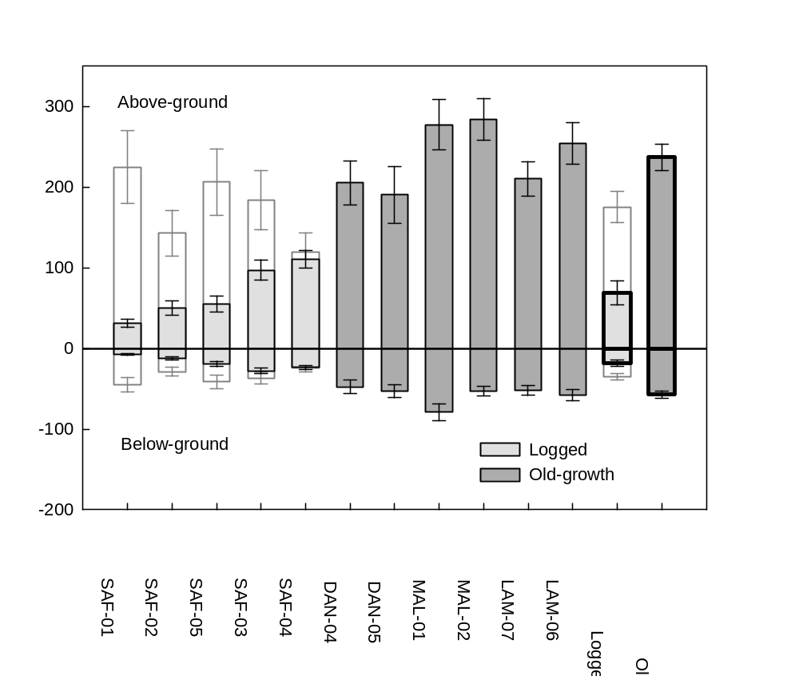
Figure 1. Above-ground woody biomass (positive values) and coarse root biomass (negative values) of living stems in logged and old-growth plots. Error bars are ±1 SE. The white bars for the logged plots denote the pre-logging biomass in the 1970s, obtained from historical records, ±20% uncertainty (below-ground stock estimated assuming the same allocation as post-logging).
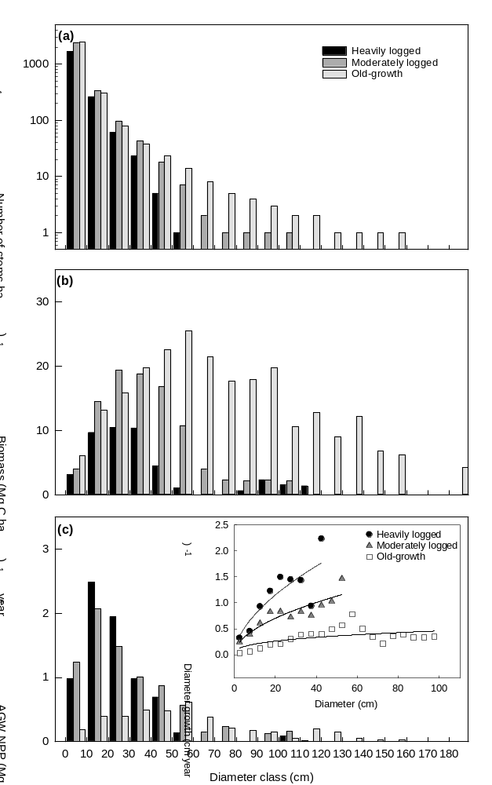
Figure 2. a) Diameter distribution, b) above-ground woody biomass, and c) above-ground woody net primary productivity (AGW NPP) by stem diameter class in heavily logged (SAF-01, SAF-02, SAF-05B South, B North, Tower), moderately logged (SAF-03, SAF-04) and old-growth (DAN-01, DAN-02, MLA-01, MLA-02, LAM-06, LAM-07 ) plots. Mean values are shown; for individual plots, see Fig. S4. Inset in (c): mean annual diameter growth by 5 cm diameter classes in the three forest types. Classes with n≥5 stems are shown.

Component and total net primary productivity
The logged forest plots had higher woody NPP than old-growth forest plots (F_{1,9} =11.35, p=0.008), owing to the higher woody NPP in the small and intermediate diameter classes (Fig. 2; Fig. 3b; Fig. S4). Individual trees across all diameter classes showed higher growth in the logged plots compared with the old-growth plots (Fig. 2c). However, in the logged plots the number of large trees, and thus their contribution to the plot level woody NPP, was small, (Fig. 2a, Fig. 2c). All species groups in the logged plots had a higher woody NPP per stem than the shared and unique non-pioneers in the old-growth plots (pair-wise comparison, all p-values <0.01), including those species that were found in both forest types (Fig. 4a). Within each forest type, all species groups had a similar woody NPP per stem (all p-values >0.05). At the plot and subplot scale, pioneer species contributed to the woody NPP proportionally to their basal area (Fig 4b).
Canopy NPP was lower in logged forest (F_{1,9} =24.91, p<0.001), while fine root NPP was similar in both forest types (F_{1,9} =0.832, p=0.385) (Fig. 3a,c). In logged forest, on average 87%±2.1% of the canopy NPP was allocated to leaves, 8.5%±1.4% to twigs and 1.7%±0.7% to reproductive parts, while 2.5%±0.2% of the sample mass was unidentified debris (most likely to be leaf material). The corresponding values in the old-growth forest were 78%±4.2% (leaves), 12%±1.9% (twigs), 1.7%±1.7% (reproductive) and 6.4%±1.3% (debris). The allocation of the canopy components into different fractions did not differ between the forest types (F_{2,9}=1.980, p=0.206 and F_{2,9}=3.337, p=0.088, with debris included and excluded, respectively).
Total NPP was similar in both forest types (F_{1,9}=1.791, p=0.214), on average 15.7±1.50 Mg C ha⁻¹ year⁻¹ in logged forest and 13.5±0.51 Mg C ha⁻¹ year⁻¹ in old-growth forest (Fig. 3d).
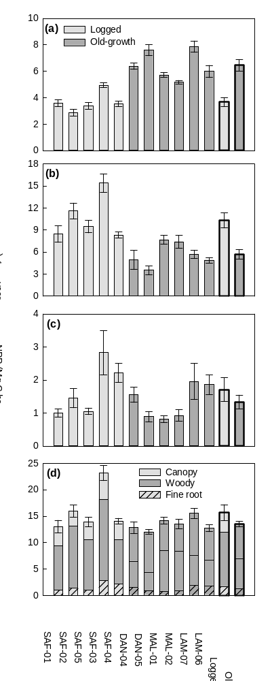
Figure 3. NPP by plot and forest type (logged plots in light grey, old-growth plots in dark grey), with the mean of both forest types shown in the two rightmost bars. Canopy (a,), woody (b), fine root (c) and total (d) net primary productivity (NPP). Error bars are ±1 SE.
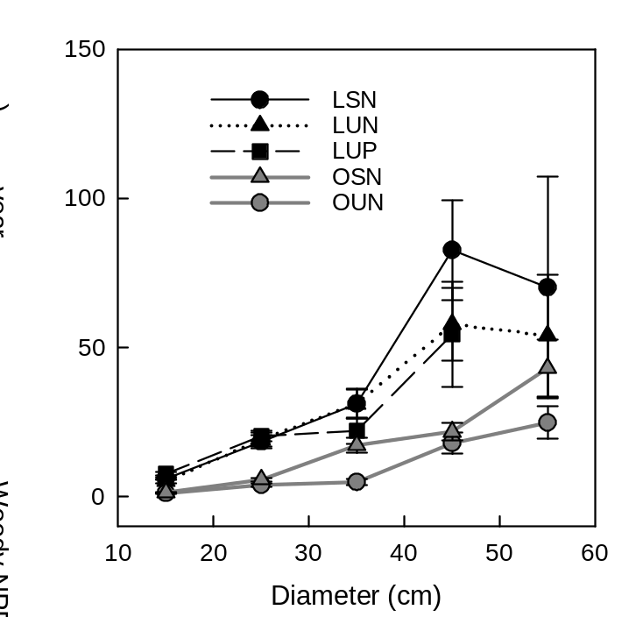
Figure 4. Average woody NPP (±1 SE) per stem by species groups across 10 cm diameter classes. Classes with n≥5 are shown. Species were classified into shared (found both in logged and old-growth plots) and unique (found only in one forest type) species and into pioneers and non-pioneers (Table S1). Species groups: LSN – logged, shared, non-pioneer; LUN – logged, unique, non-pioneer; LUP – logged, unique, pioneer; OSN – old-growth, shared, non-pioneer; OUN – old-growth, unique, non-pioneer.

NPP allocation to canopy, woody, and fine root NPP
At the plot scale, NPP allocation differed significantly between logged and old-growth plots (Fig. 3d, Fig. 5) (F_{2,8}=18.227, p=0.001). There was a clear shift in allocation from canopy to woody NPP in the logged forest (66%±2.2% allocated to woody NPP, 23%±1.6% to canopy NPP), compared with old-growth forest (42%±4.2% to woody NPP, 48%±3.6% to canopy NPP). Allocation to fine roots was similar in both forest types (11%±1.6% in logged, 10%±1.5% in old-growth forests).

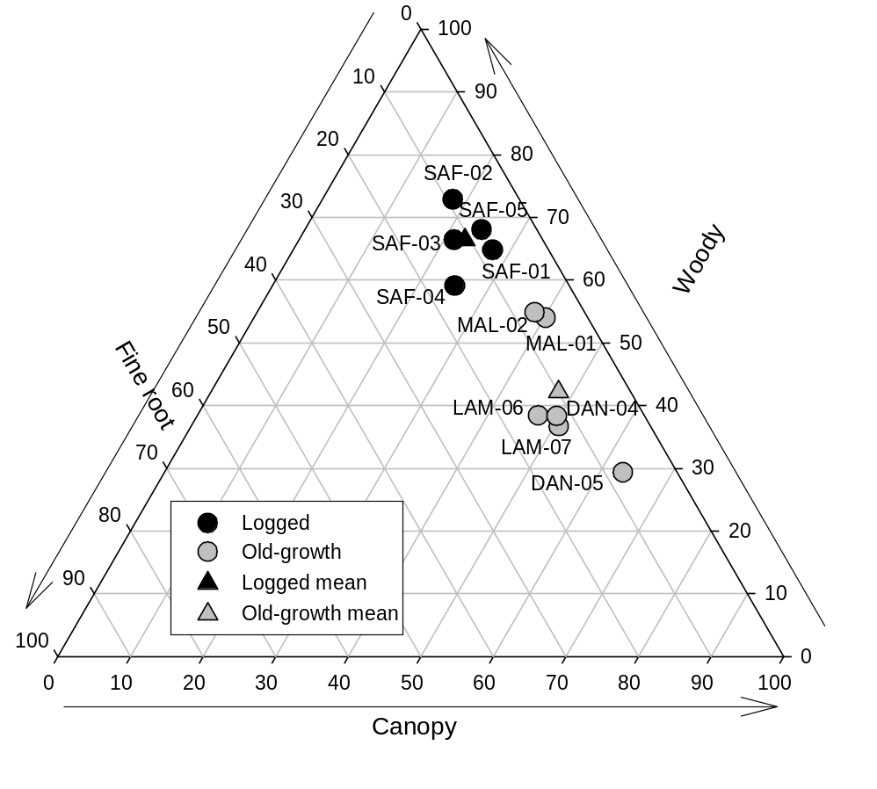
Figure 5. Relative allocation (% of total) of net primary productivity (NPP) into canopy, woody and fine root NPP. Large triangle: NPP allocation in individual plots, and mean by forest type. Small triangle: NPP allocation in different forest quality classes, class 1 denoting the most heavily disturbed and class 5 the least disturbed (old-growth) forest (see Table S2).

Productivity, allocation and structure effects
The patterns in NPP at the basal area range where logged and old-growth forest data overlap (thus, assuming that no difference in NPP between the two forest types was caused by structure effect) were used for distinguishing the productivity and allocation effects. When controlled for basal area within this range (7-51 m² ha⁻¹), total NPP was approximately 41% higher in logged forest than in old-growth forest when averaged across subplots (Fig. 6). In addition, the allocation to different NPP components differed between the forest types. At similar basal areas, logged forest had 150% higher woody NPP and 46% higher fine root NPP than old-growth forest. Canopy NPP, on the other hand, was 38% lower in logged forest.
The shapes of the basal area response curves illustrate structure effects (Fig. 6). These were particularly clear in logged forest, especially regarding canopy and woody NPP: canopy and woody NPP were low when basal area was small, and increased sharply and linearly with increasing basal area (though there is probably important herbaceous layer NPP in these gaps, which we do not account for). The threshold appeared at the basal area of approximately 10 m² ha⁻¹ for canopy and woody NPP (a threshold that may suggest canopy closure), after which the slope becomes less steep. As a result, total NPP in logged forest also followed this pattern. However, fine root NPP showed a more consistently linear relationship with basal area and no clear basal area threshold. The old-growth forest plots did not have subplots with low basal areas, and in these plots all responses were relatively linear, or in the case of the canopy NPP, showed little relationship with basal area. Hence, canopy NPP was relatively insensitive to forest structure above a threshold basal area of canopy closure in both logged and old-growth forests, while woody, fine root and total NPP showed a greater sensitivity to basal area in logged forests than in old-growth forests. Slopes of linear regressions when basal area >10 m² ha⁻¹ did not differ between logged and old-growth forest for canopy NPP (p=0.840), was borderline significant for woody NPP (p=0.053), and did differ for fine root NPP (p=0.028) and total NPP (p=0.022) (the results were similar when basal area threshold was increased to >20 m² ha⁻¹).
Figure 6. a) Canopy, b) woody, c) fine root and d) total net primary productivity (NPP) as a function of basal area of stems >10 cm diameter in logged and old-growth forest. The lines are cubic regression spline smoothers from general additive models and the grey bands are ± 95% confidence intervals. The inward and outward rugs on the x axes denote the distribution of the basal area data in logged and old-growth forest, respectively. To see plots with data points overlaid, see Fig. S5.

The relative importance of the productivity, allocation and structure effects on the variation in NPP between logged and old-growth forest is summarised in Figure 7. Compared with old-growth forest, the productivity effect increased the logged forest NPP by 31%. However, this effect was partly offset by the structure effect (logged forest plots having many subplots with very low basal area and no subplots with very high basal area; see data distribution rugs in Fig. 6), which lowered the logged forest NPP by 15%. The net effect was that NPP was only slightly (not significantly) higher in the logged forest at the 1 ha plot scale (Fig. 3d), although the difference between the two forest types within the overlapping basal area range was more marked. Woody NPP showed the largest difference between the forest types, being 83% higher in logged forest than in old-growth forest (Fig. 7) as a result of positive productivity and allocation effects. Canopy NPP, on the other hand, was smaller in logged forest, due to less allocation to canopy (allocation effect -61%). Fine root NPP was similar in both forest types (slightly higher in logged forest but not significant at the plot scale), with no evidence of increased allocation to fine roots in logged forest.
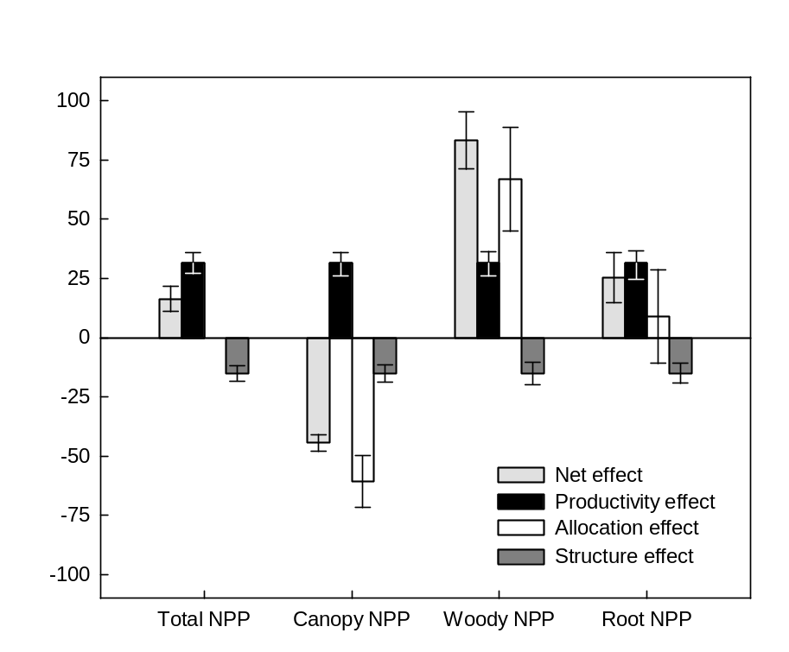
Figure 7. The percentage change in net primary productivity (NPP) in logged forest, compared with old-growth forest. The net effect is partitioned to productivity effect, allocation effect and structure effect, the sum of which equals the net effect. Error bars are ±1 SE.

DISCUSSION
NPP and its allocation along the disturbance gradient from old-growth to heavily logged forest
To our knowledge, these are the first comprehensive NPP estimates for human-modified tropical forests, describing all the main NPP components. In these forests, total NPP was similar in both forest types, although logged forests showed more variation, both within and among plots. In a previous publication, NPP estimates in the two plots in Lambir were put into pan-tropical context (see Table 3 in Kho et al., 2013), showing that NPP in Bornean old-growth forests is higher (this study: 13.5 Mg C ha⁻¹ year⁻¹, with SE of 0.519 Mg C ha⁻¹ year⁻¹) than the tropical average (11.2 ± 0.73 Mg C ha⁻¹ year⁻¹), but not exceptionally so.
Despite similar productivity in logged and old-growth forests, the legacy of logging was evident in the significantly reduced woody carbon stocks in logged forests. The absence of the largest trees contributed most to the lower carbon stocks in logged plots, but it is noteworthy that the carbon stock and the number of stems was lower even in the smallest diameter classes in the heavily logged plots compared with old-growth plots, which is similar to the pattern observed in Indonesian Borneo (Cannon et al., 1994). The logged plots had experienced on average a 50% reduction in their woody carbon stocks, comparable to results for logged forests elsewhere in Sabah (53%, Berry et al., 2010), Brazil (35-57%, Berenguer et al., 2014) and Africa (20-72%, Valentini et al., 2014; Cazolla Gatti et al., 2015). As the Yayasan Sabah Forest Management Area covers nearly a third of the forest area in Sabah (Fisher et al., 2011; Reynolds et al. 2011), these figures are also likely to be representitive of the wider area and are also in line with other parts of Borneo, where remaining basal area has been recorded as 14 m² ha⁻¹ (SD =7) and 18 m² ha⁻¹ (SD=10) in sparse and dense canopy fragments, respectively (Cannon et al., 1994).
Although the total NPP did not differ between forest types, there was a very clear difference in NPP allocation: logged forest allocated considerably more to woody NPP than to canopy NPP (66%±2.2% to woody, 23%±1.6% to canopy), compared with old-growth forests (42%±4.2% to woody, 48%±3.6% to canopy). A similar shift between canopy and woody allocation was reported when comparing young naturally regenerating regrowth forests with old intact forests (Anderson‐Teixeira et al., 2016). Since the results demonstrate a clear allocation shift between logged and old-growth forest, this highlights the importance of measuring all main NPP components, rather than using only one of them as a proxy for total NPP. In old-growth tropical forests, canopy NPP was found to be the best predictor of the total NPP both at Amazonian (Aragão et al., 2009; Girardin et al., 2010) and pan-tropical scales (Malhi et al., 2011), with allocation to canopy showing less variation than the allocation to other NPP components. Although this was the case for the old-growth plots in this study as well, the results from the logged plots of this study and from regrowth forests globally (Anderson‐Teixeira et al., 2016) show that disturbance can markedly change these patterns.
Allocation to fine roots was low in all sites, on average 10%±1.0%. This is consistent with reports from other sites in Asia (Hertel et al., 2009; Swamy et al., 2010; Kira et al., 2013), while allocation to fine roots is markedly higher in the Neo-tropical sites (global compilation by Malhi et al., 2011 and references therein). Allocation to fine roots was isometric, showing little variation across plots or along the disturbance gradient, with the exception of forest quality class 1, where the allocation to fine roots was considerably higher at approximately 33%. In those most disturbed zones with few or no trees, it is possible that the roots of the herbaceous vegetation contributed significantly to the fine root NPP. As the herbaceous layer was not included in the other NPP components, this may bias the NPP allocation estimates at small spatial scales. However, although the relative contribution of the herbaceous layer can be considerable in logging gaps, its contribution to absolute NPP at the plot scale is still likely to be small. Overall, we find no evidence of changes in relative investment in fine roots after logging, as might be expected if a flush of nutrients caused a decreased need for root foraging, or conversely if a surge in growth caused increased demand for nutrients. Results from old-growth forests in Amazonia also found little evidence for shifts in nutrient allocation towards roots in nutrient poor soils (Aragão et al., 2009; Malhi et al., 2015), suggesting little support for nutrient acquisition optimization models for predicting fine root NPP.
Higher woody growth rate in logged forest: Increase in NPP or shift in allocation?
Logged tropical forests typically have higher woody growth rates than old-growth forests: 50% higher stem growth rate and recruitment (Bischoff et al., 2005) and up to five times higher above ground biomass production (Berry et al., 2010) has been reported. This could be due to either increased NPP or a shift in allocation in favour of woody production. Our analysis shows that in these forests in Malaysia, the higher woody productivity is equally a result of both processes. Hence, trees grow faster in logged forests both because they have higher NPP, and because the invest more of their NPP in stem growth (at the expense of leaf growth) to compete for light.
The increased NPP could be caused by an increase in total canopy photosynthesis/gross primary productivity (GPP), and/or by an increase in the carbon use efficiency (CUE; the ratio NPP/GPP) in more disturbed sites. Studies in Amazonia show that more dynamic and disturbed forests appear to have a higher CUE, reflecting increased plant prioritisation in favour of NPP, rather than maintenance respiration (Malhi et al., 2015). In logged forests, the prioritisation in favour of rapid growth to reach canopy gaps is likely to lead to less proportional investment in maintenance and defence. It is also possible that the soil nutrient stocks are higher as a result of the logging residue, which may boost leaf nutrient content and maximum photosynthesis rates. However, as we find no consistent differences in soil nutrient status in the logged forests this latter effect is unlikely.
The observed shift in allocation in favour of woody production is also consistent with this functional shift. Post logging, the priority of successful trees is to grow crowns to capture now abundant within-forest light, to shade competitors and to avoid being shaded themselves (Chen et al., 2013). All these factors favour increased investment in stem growth. Allocation to leaves decreases when light availability increases – such as in logged forests that have gaps and recovering areas where the canopy is not yet fully closed (Poorter et al., 2012).

The roles of species turnover and pioneer species in logged forest NPP
In this study, the proportion of pioneers in the logged plots was high (on average, 30% of basal area, 33% of stems). However, the comparison by species groups showed that all species, not only pioneers, grew significantly faster in logged forest than in old-growth forest, indicating that the reduced competition and higher availability of light and nutrients were more important factors than species identity in explaining the difference in NPP between the forest types. Similarly, in a previous study in Malaysia, growth rate differences among tree species were shown to be much more strongly influenced by light interception index, crown illumination index and crown area than by wood density (King et al. 2015).

Relative contributions of productivity, allocation, and structure effects in determining the net change in NPP between logged and old-growth forests
The subplot-scale analysis showed that after reaching canopy closure, logged forests were considerably more productive than old-growth forests of similar basal area. Overall, the productivity effect increased the logged forest NPP by 31%, compared with the old-growth forest NPP. This is consistent with the well-documented age-related decline in forest productivity in temperate and boreal forests, where NPP shows a rapid increase in young stands, peaks in intermediate age classes and a slowly declines towards old stands (e.g. Gower et al., 1996; Ryan et al., 1997; Pregitzer & Euskirchen, 2004). The selectively logged forests of this study are not, however, directly comparable to chronosequence studies, due to their high within-plot variability, patchy structure and the mixture of old trees and new recruits. In this study, the growth of individual trees was highest in the most heavily logged plots across all diameter classes, including the largest (and, potentially, oldest) trees. This indicates that, in addition to age, the altered resource availability and growth strategies (investing in growth rather than in maintenance and defence) also contributed to the higher productivity.
However, the higher productivity rates in logged forests in this study applied only if the structure effect were not taken into account. The structure effect was strongest in the areas of most sparse tree cover (basal area <10 m² ha⁻¹). These areas may either be logging gaps, such as roads and landing sites, which regenerate slowly (Pinard et al., 2000), or tree fall gaps resulting from persistently higher mortality rates due to past logging. In these gaps, the NPP of individual trees, and thus the NPP per unit basal area, may be high due to abundant light, low belowground competition, and, typically, dominance of fast-growing pioneer species (Huang & Asner, 2010). However, such areas have low NPP per unit ground area because of the small number of trees — using a banking analogy, a small amount of capital earns only a small interest, even if the interest rate is high. The low NPP in the sparse tree cover areas largely counterbalanced the positive productivity effect, resulting in a similar average NPP in logged and old-growth forests at the 1-ha plot scale. The steep decline in NPP when basal area was <10 m² ha⁻¹ makes the area proportion of gaps one of the main factors affecting logged forest NPP. Based on high-resolution (30 m) remote sensing data, Bryan et al. (2013) classified 32% of the degraded forest area in Sabah as severely degraded. In our study, the proportion of very sparse tree cover areas (basal area <10 m² ha⁻¹) in the logged plots was similar (37%), indicating that the results are likely to be representative across the wider landscape.
Similar to total NPP, the component (canopy, woody and fine root) NPP in logged forest showed a positive productivity effect and negative structure effect. A similar productivity effect has been reported in other studies, where the magnitude of total NPP or GPP was the best predictor of the component NPP (Litton et al., 2007; Wolf et al., 2011). However, for the component NPP, potential allocation shifts must be taken into account to fully understand the differences between logged and old-growth forest. For logged forest canopy NPP, the negative allocation effect was stronger than the positive productivity effect, while logged forest woody NPP was increased as much by the positive allocation effect as by the positive productivity effect. This demonstrates that allocation effects may be equally or more important than changes in overall productivity and stand structure in determining the magnitude of woody growth, or root or canopy production.
The data presented here give new insights into how disturbance affects productivity and allocation. As logged forests become an increasingly prevalent part of the tropical forest biome, these shifts in productivity and allocation represent a profound human impact on the carbon cycling of the tropical biosphere, almost certainly more than impacts to date caused by atmospheric and climate change.

ACKNOWLEDGEMENTS
This study was part of the Stability of Altered Forest Ecosystem (SAFE) Project, funded by the Sime Darby Foundation, and the Biodiversity And Land-use Impacts on tropical ecosystem function (BALI) Project (NE/K016377/1) within the NERC Human-Modified Tropical Forests Programme. This paper is also a product of the Global Ecosystems Monitoring network (gem.tropicalforests.ox.ac.uk). We are grateful to Rostin Jantan and the other members of the SAFE Carbon Team and other SAFE research assistants, Alexander Karolus and the 50 ha plot team in Danum and Xyxtus Tan, Nasir Muhi, and Abilano Deres in Lambir for fieldwork assistance. We thank Bernadus Bala Ola and Dr Bill McDonald for the tree species identification. Dr. Reuben Nilus and Dr. Robert Ong at the Forest Research Centre, Sabah Forestry Department, kindly helped us access the historical forest inventory records. SAFE management team, Maliau Basin Management Committee, Royal Society South East Asia Rainforest Research Partnership (SEARRP), Sabah Foundation, Benta Wawasan, the State Secretary, Sabah Chief Minister’s Departments, Sabah Forestry Department and Forest Research Centre, Sabah Biodiversity Council, and the Economic Planning Unit are acknowledged for their support and access to the sites in Sabah. The sites in Lambir were supported by the Malaysian Palm Oil Board (MPOB) and Centre for Tropical Forest Science (CTFS) in collaboration with HSBC Climate Partnership. The 52-ha Long-Term Ecological Research Project in Lambir is a collaborative project of the Forest Department of Sarawak, Malaysia, the Center for Tropical Forest Science of the Smithsonian Tropical Research Institute, USA (under NSF awards DEB-9107247 and DEB-9629601), and Osaka City, Ehime & Kyoto Universities, Japan (under Monbusho grants 06041094, 08NP0901 and 09NP0901). The Danum 50 ha plot is a core project of the Southeast Asia Rainforest Research Partnership (SEARRP). We thank HSBC Malaysia and the University of Zurich for funding and the CTFS for support. YM is supported by the Jackson Foundation and European Research Council Advanced Investigator Grant, GEM-TRAIT (321131). This article is a contribution to Imperial College’s Grand Challenges in Ecosystems and the Environment Initiative.

REFERENCES
Anderson‐Teixeira KJ, Wang MM, McGarvey JC, LeBauer DS (2016) Carbon dynamics of mature and regrowth tropical forests derived from a pantropical database (TropForC‐db). Global Change Biology, 22, 1690-1709. doi:10.1111/gcb.13226
Aragão L, Malhi Y, Metcalfe D et al. (2009) Above-and below-ground net primary productivity across ten Amazonian forests on contrasting soils. Biogeosciences, 6, 2759-2778.
Berenguer E, Ferreira J, Gardner TA et al. (2014) A large-scale field assessment of carbon stocks in human-modified tropical forests. Global Change Biology, 20, 3713-3726. doi: 10.1111/gcb.12627
Berry NJ, Phillips OL, Lewis SL et al. (2010) The high value of logged tropical forests: Lessons from northern Borneo. Biodiversity and Conservation, 19, 985-997. doi: 10.1007/s10531-010-9779-z
Bischoff W, Newbery DM, Lingenfelder M, Schnaeckel R, Petol GH, Madani L, Ridsdale CE (2005) Secondary succession and dipterocarp recruitment in Bornean rain forest after logging. Forest Ecology and Management, 218, 174-192. doi:10.1016/j.foreco.2005.07.009
Blanc L, Echard M, Herault B, Bonal D, Marcon E, Chave J, Baraloto C (2009) Dynamics of aboveground carbon stocks in a selectively logged tropical forest. Ecological Applications, 19, 1397-1404. doi:10.1890/08-1572.1
Bryan JE, Shearman PL, Asner GP, Knapp DE, Aoro G, Lokes B (2013) Extreme differences in forest degradation in Borneo: Comparing practices in Sarawak, Sabah, and Brunei. PLoS ONE, 8. doi: 10.1371/journal.pone.0069679
Cannon CH, Peart DR, Leighton M, Kartawinata K (1994) The structure of lowland rainforest after selective logging in West Kalimantan, Indonesia. Forest Ecology and Management, 67, 49-68. http://dx.doi.org/10.1016/0378-1127(94)90007-8
Carreno-Rocabado G, Pena-Claros M, Bongers F, Alarcon A, Licona JC, Poorter L (2012) Effects of disturbance intensity on species and functional diversity in a tropical forest. Journal of Ecology, 100, 1453-1463. doi: 10.1111/j.1365-2745.2012.02015.x
Cazolla Gatti R, Castaldi S, Lindsell JA et al. (2015) The impact of selective logging and clearcutting on forest structure, tree diversity and above-ground biomass of African tropical forests. Ecological Research, 30, 119-132. doi: L10.1007/s11284-014-1217-3
Chambers JQ, Tribuzy ES, Toledo LC et al. (2004) Respiration from a tropical forest ecosystem: partitioning of sources and low carbon use efficiency. Ecological Applications, 14, 72-88. doi: 10.1890/01-6012
Chave J, Andalo C, Brown S et al. (2005) Tree allometry and improved estimation of carbon stocks and balance in tropical forests. Oecologia, 145, 87-99. doi: 10.1007/s00442-005-0100-x
Chave J, Coomes D, Jansen S, Lewis SL, Swenson NG, Zanne AE (2009) Towards a worldwide wood economics spectrum. Ecology Letters, 12, 351-366. doi: 10.1111/j.1461-0248.2009.01285.x
Chen G, Yang Y, Robinson D (2013) Allocation of gross primary production in forest ecosystems: allometric constraints and environmental responses. New Phytologist, 200, 1176-1186.
Ciais P, Sabine C, Bala G et al. (2013) Carbon and Other Biochemical Cycles. In: Climate Change 2013: The Physical Science Basis. Contribution of Working Group I to the Fifth Assessment Report of the Intergovernmental Panel on Climate Change. (eds Stocker TF, Qin D, Plattner G-K, Tignor M, Allen SK, Boschung J, Nauels A, Xia Y, Bex V, Midgley PM) . Cambridge, United Kingdom and New York, NY, USA, Cambridge University Press.
Clark DA, Brown S, Kicklighter DW, Chambers JQ, Thomlinson JR, Ni J (2001) Measuring net primary production in forests: Concepts and field methods. Ecological Applications, 11, 356-370.
Ewers RM, Didham RK, Fahrig L et al. (2011) A large-scale forest fragmentation experiment: the Stability of Altered Forest Ecosystems Project. Philosophical Transactions of the Royal Society B-Biological Sciences, 366, 3292-3302. doi: 10.1098/rstb.2011.0049
Fisher B, Edwards DP, Giam X, Wilcove DS (2011) The high costs of conserving Southeast Asia's lowland rainforests. Frontiers in Ecology and the Environment, 9, 329-334. doi: 10.1890/100079
FAO (2015) Global Forest Resources Assessment 2015. How are the world’s forests changing?. UN Food and Agriculture Organization, Rome.
Girardin CAJ, Malhi Y, Aragão LEOC et al. (2010) Net primary productivity allocation and cycling of carbon along a tropical forest elevational transect in the Peruvian Andes. Global Change Biology, 16, 3176-3192. doi: 10.1111/j.1365-2486.2010.02235.x
Gower ST, McMurtrie RE, Murty D (1996) Aboveground net primary production decline with stand age: potential causes. Trends in Ecology & Evolution, 11, 378-382.
Griscom B, Ellis P, Putz FE (2014) Carbon emissions performance of commercial logging in East Kalimantan, Indonesia. Global Change Biology, 20, 923-937.
Hardwick SR, Toumi R, Pfeifer M, Turner EC, Nilus R, Ewers RM (2015) The relationship between leaf area index and microclimate in tropical forest and oil palm plantation: forest disturbance drives changes in microclimate. Agricultural and Forest Meteorology, 201, 187-195.
Harmon ME, Whigham DF, Sexton J, Olmsted I (1995) Decomposition and mass of woody detritus in the dry tropical forests of the northeastern Yucatan Peninsula, Mexico. Biotropica, 27, 305-316.
Harrison RD, Tan S, Plotkin JB et al. (2013) Consequences of defaunation for a tropical tree community. Ecology Letters, 16, 687-694.
Hertel D, Moser G, Culmsee H, Erasmi S, Horna V, Schuldt B, Leuschner C (2009) Below-and above-ground biomass and net primary production in a paleotropical natural forest (Sulawesi, Indonesia) as compared to neotropical forests. Forest Ecology and Management, 258, 1904-1912.
Huang MY, Asner GP (2010) Long-term carbon loss and recovery following selective logging in Amazon forests. Global Biogeochemical Cycles, 24, GB3028. doi: 10.1029/2009gb003727
Katayama A, Kume T, Komatsu H et al. (2009) Effect of forest structure on the spatial variation in soil respiration in a Bornean tropical rainforest. Agricultural and Forest Meteorology, 149, 1666-1673.
Keenan RJ, Reams GA, Achard F, de Freitas JV, Grainger A, Lindquist E (2015) Dynamics of global forest area: results from the FAO Global Forest Resources Assessment 2015. Forest Ecology and Management, 352, 9-20.
Kho LK, Malhi Y, Tan SKS (2013) Annual budget and seasonal variation of aboveground and belowground net primary productivity in a lowland dipterocarp forest in Borneo. Journal of Geophysical Research-Biogeosciences, 118, 1282-1296. doi: 10.1002/jgrg.20109
King DA, Davies SJ, Supardi MNN, Tan S (2005) Tree growth is related to light interception and wood density in two mixed dipterocarp forests of Malaysia. Functional Ecology, 19, 445-453. doi: 10.1111/j.1365-2435.2005.00982.x
Kira T, Manokaran N, Appanah S (2013) NPP Tropical Forest: Pasoh, Malaysia, 1971-1973. Data set. Available on-line [http://www.daac.ornl.gov] from Oak Ridge National Laboratory Distributed Active Archive Center, Oak Ridge, Tennessee, U.S.A. doi:10.3334/ORNLDAAC/219.
Kumagai T, Porporato A (2012) Drought-induced mortality of a Bornean tropical rain forest amplified by climate change. Journal of Geophysical Research: Biogeosciences, 117, G02032. doi: 10.1029/2011jg001835
Kurokawa H, Nakashizuka T (2008) Leaf herbivory and decomposability in a Malaysian tropical rain forest. Ecology, 89, 2645-2656.
Lee HS, Davies SJ, LaFrankie JV et al. (2002) Floristic and structural diversity of mixed dipterocarp forest in Lambir Hills National Park, Sarawak, Malaysia. Journal of Tropical Forest Science, 14, 379-400.
Litton CM, Raich JW, Ryan MG (2007) Carbon allocation in forest ecosystems. Global Change Biology, 13, 2089-2109. doi: 10.1111/j.1365-2486.2007.01420.x
Malhi Y (2010) The carbon balance of tropical forest regions, 1990–2005. Current Opinion in Environmental Sustainability, 2, 237-244.
Malhi Y (2012) The productivity, metabolism and carbon cycle of tropical forest vegetation. Journal of Ecology, 100, 65-75. doi: 10.1111/j.1365-2745.2011.01916.x
Malhi Y, Aragão LEO, Metcalfe DB et al. (2009) Comprehensive assessment of carbon productivity, allocation and storage in three Amazonian forests. Global Change Biology, 15, 1255-1274.
Malhi Y, Doughty C, Galbraith D (2011) The allocation of ecosystem net primary productivity in tropical forests. Philosophical Transactions of the Royal Society B-Biological Sciences, 366, 3225-3245. doi: 10.1098/rstb.2011.0062
Malhi Y, Doughty CE, Goldsmith GR et al. (2015) The linkages between photosynthesis, productivity, growth and biomass in lowland Amazonian forests. Global Change Biology, 21, 2283-2295. doi: 10.1111/gcb.12859
Malhi Y, Gardner TA, Goldsmith GR, Silman MR, Zelazowski P (2014) Tropical Forests in the Anthropocene. Annual Review of Environment and Resources, 39, 125-159. doi:10.1146/annurev-environ-030713-155141
Malhi Y, Wright J (2004) Spatial patterns and recent trends in the climate of tropical rainforest regions. Philosophical Transactions of the Royal Society of London B: Biological Sciences, 359, 311-329.
Marsh CW, Greer AG (1992) Forest Land-Use in Sabah, Malaysia: An Introduction to Danum Valley. Philosophical Transactions: Biological Sciences, 335, 331-339. 10.2307/55620.
Marthews T, Metcalfe D, Malhi Y et al. (2012) Measuring tropical forest carbon allocation and cycling: a RAINFOR-GEM field manual for intensive census plots (v2. 2). Manual. Global Ecosystems Monitoring Network. Available from http:gem.tropicalforests.ox.ac.uk.
Martin AR, Thomas SC (2011) A reassessment of carbon content in tropical trees. PLoS ONE, 6, e23533.
Mazerolle MJ (2015) AICcmodavg: Model selection and multimodel inference based on (Q)AIC(c). R package version 2.0-3.
Metcalfe DB, Williams M, Aragão LEOC et al. (2007) A method for extracting plant roots from soil which facilitates rapid sample processing without compromising measurement accuracy. New Phytologist, 174, 697-703. doi: 10.1111/j.1469-8137.2007.02032.x
Nainar A, Bidin K, Walsh RP, Ewers RM, Reynolds G (2015) Variations in suspended sediment yield and dynamics in catchments of differing land-use in Sabah. Transactions on Science and Technology, 2, 1-19.
Niiyama K, Kajimoto T, Matsuura Y et al. (2010) Estimation of root biomass based on excavation of individual root systems in a primary dipterocarp forest in Pasoh Forest Reserve, Peninsular Malaysia. Journal of Tropical Ecology, 26, 271-284. doi:10.1017/S0266467410000040
Pan Y, Birdsey RA, Fang J et al. (2011) A large and persistent carbon sink in the world’s forests. Science, 333, 988-993. doi: 10.1126/science.1201609
Pawlowsky-Glahn V, Buccianti A (2011) Compositional Data Analysis - Theory and Applications. John Wiley & Sons.
Pearson TR, Brown S, Casarim FM (2014) Carbon emissions from tropical forest degradation caused by logging. Environmental Research Letters, 9, 034017.
Pfeifer M, Lefebvre V, Turner E et al. (2015) Deadwood biomass: an underestimated carbon stock in degraded tropical forests? Environmental Research Letters, 10, 044019.
Pinard M, Barker M, Tay J (2000) Soil disturbance and post-logging forest recovery on bulldozer paths in Sabah, Malaysia. Forest Ecology and Management, 130, 213-225.
Pinheiro J, Bates D, DebRoy S, D S, R Core team (2014) nlme: Linear and Nonlinear Mixed Effects Models. R package version 3.1-118.
Poorter H, Niklas KJ, Reich PB, Oleksyn J, Poot P, Mommer L (2012) Biomass allocation to leaves, stems and roots: meta-analyses of interspecific variation and environmental control. New Phytologist, 193, 30-50. doi: 10.1111/j.1469-8137.2011.03952.x
Potapov P, Yaroshenko A, Turubanova S et al. (2008) Mapping the world's intact forest landscapes by remote sensing. Ecology and Society, 13, 51.
Pregitzer KS, Euskirchen ES (2004) Carbon cycling and storage in world forests: biome patterns related to forest age. Global Change Biology, 10, 2052-2077.
R Core Team (2014) R: A language and environment for statistical computing. Vienna, Austria, R Foundation for Statistical Computing.
Reynolds G, Payne J, Sinun W, Mosigil G, Walsh RPD (2011) Changes in forest land use and management in Sabah, Malaysian Borneo, 1990–2010, with a focus on the Danum Valley region. Philosophical Transactions of the Royal Society B: Biological Sciences, 366, 3168-3176. doi: 10.1098/rstb.2011.0154
Ryan M, Binkley D, Fownes J (1997) Age-related decline in forest productivity. Adv. Ecol. Res, 27, 213-262.
Saner P, Loh YY, Ong RC, Hector A (2012) Carbon Stocks and Fluxes in Tropical Lowland Dipterocarp Rainforests in Sabah, Malaysian Borneo. PLoS ONE, 7, e29642. doi: 10.1371/journal.pone.0029642
Shenkin A, Bolker B, Pena-Claros M, Licona JC, Putz FE (2015) Fates of trees damaged by logging in Amazonian Bolivia. Forest Ecology and Management, 357, 50-59. doi: 10.1016/j.foreco.2015.08.009
Sist P, Mazzei L, Blanc L, Rutishauser E (2014) Large trees as key elements of carbon storage and dynamics after selective logging in the Eastern Amazon. Forest Ecology and Management, 318, 103-109. doi: 10.1016/j.foreco.2014.01.005
Sist P, Nguyen-The N (2002) Logging damage and the subsequent dynamics of a dipterocarp forest in East Kalimantan (1990-1996). Forest Ecology and Management, 165, 85- doi: 103. 10.1016/s0378-1127(01)00649-1
Struebig MJ, Turner A, Giles E, Lasmana F, Tollington S, Bernard H, Bell D (2013) Quantifying the biodiversity value of repeatedly logged rainforests: gradient and comparative approaches from Borneo. Advances in Ecological Research, 48, 183-224.
Swamy S, Dutt C, Murthy M, Mishra A, Bargali S (2010) Floristics and dry matter dynamics of tropical wet evergreen forests of Western Ghats, India. Current science, 99, 353-364.
Sylvester T, Yamakura T, Masako T et al. (2009) Review of soils on the 52 ha long term ecological research plot in mixed dipterocarp forest at Lambir, Sarawak, Malaysian Borneo. Tropics, 18, 61-86.
Valentini R, Arneth A, Bombelli A et al. (2014) A full greenhouse gases budget of Africa: synthesis, uncertainties, and vulnerabilities. Biogeosciences, 11, 381-407. doi: 10.5194/bg-11-381-2014
van den Boogaart KG (2008) “Compositions”: a unified R package to analyze compositional data. Computers & Geosciences, 34, 320.
van den Boogaart KG, Tolosana R, Bren M (2014) Compositions: Compositional Data Analysis. R package version 1.40-1.
Walsh RP, Newbery DM (1999) The ecoclimatology of Danum, Sabah, in the context of the world's rainforest regions, with particular reference to dry periods and their impact. Philosophical Transactions of the Royal Society B: Biological Sciences, 354, 1869-1883.
Wolf A, Field CB, Berry JA (2011) Allometric growth and allocation in forests: a perspective from FLUXNET. Ecological Applications, 21, 1546-1556.
Wood SN (2011) Fast stable restricted maximum likelihood and marginal likelihood estimation of semiparametric generalized linear models. Journal of the Royal Statistical Society: Series B (Statistical Methodology), 73, 3-36. doi: 10.1111/j.1467-9868.2010.00749.x
Yamada T, Niino M, Yoshida S, Hosaka T, Okuda T (2014) Impacts of logging road networks on dung beetles and small mammals in a Malaysian production forest: implications for biodiversity safeguards. Land, 3, 639-657.
Yoda K (1978) Organic carbon, nitrogen and mineral nutrient stock in the soils of Pasoh Forest. Malayan Nature Journal, 30, 229-251.
Zanne AE, Lopez-Gonzalez G, Coomes DA et al. (2009) Data from: Towards a worldwide wood economics spectrum. Dryad Digital Repository. doi:10.5061/dryad.234
Zuur AF, Ieno EN, Walker N, Saveliev AA, Smith GM (2009) Mixed effects models and extensions in ecology with R, Springer.

