Stress Fields and Geometrically Necessary Dislocation Density Distributions near the Head of a Blocked Slip Band
T. Benjamin Britton* and Angus J. Wilkinson
Department of Materials, University of Oxford, OX1 3PH, UK
*benjamin.britton@materials.ox.ac.uk

Abstract
We have examined the interaction of a blocked slip band and a grain boundary in deformed titanium using high resolution electron backscatter diffraction (HR-EBSD) and atomic force microscopy (AFM). From these observations, we have deduced the active dislocation types and assessed the dislocation reactions involved within a selected grain. Dislocation sources have been activated on a prism slip plane, producing a planar slip band and a pile up of dislocations in a near screw alignment at the grain boundary. This pile up has resulted in activation of plasticity in the neighbouring grain and left the boundary with a number of dislocations in a pile up. Examination of the elastic stress state ahead of the pile up reveals a characteristic ‘one over square root of distance’ dependence for the shear stress resolved on the active slip plane. This observation validates a dislocation mechanics model given by Eshelby, Frank and Nabarro in 1951 and not previously directly tested, despite its importance in underpinning our understanding of grain size strengthening, fracture initiation, short fatigue crack propagation, fatigue crack initiation and many more phenomena. The analysis also provides a method to measure the resistance to slip transfer of an individual grain boundary in a polycrystalline material. For the boundary and slip systems analysed here a Hall-Petch coefficient of K=0.41 MPa$\sqrt{m}$ was determined.

Introduction
The motion and interaction of dislocations with material microstructure are central to understanding plasticity, strengthening mechanisms and failure processes in metals. During plastic deformation, mechanical behaviour is controlled by movement of dislocations. In particular the pile-up of dislocations at hard obstacles, such as at grain boundaries, generates a back stress tending to suppress further activation of the dislocation source and a stress intensification ahead of the pile-up promoting grain boundary fracture, slip transfer or twin nucleation in to the neighbouring grain.
Theoretical work by Eshelby, Frank and Nabarro [1] produced an analytical solution to the pile-up of dislocations at a grain boundary, including the calculation of the resultant stress field on the slip plane projected into the neighbouring grain. They also showed that this stress field was well approximated by a ‘one over the square root of distance’ variation. The interaction of such a pile up with microstructure is ubiquitous in understanding mechanical properties of materials including the Hall-Petch effect of increasing strength with decrease in grain size [2-4], formation of Lüders bands [4], nucleation of deformation twins [5-7], cracks in fracture [7-9] and fatigue [10, 11], in the propagation of short fatigue cracks [12, 13] and in many more phenomena [14-16].
The configuration of dislocations near a grain boundary was imaged using transmission and high voltage electron microscopy, from bi-crystal regions of either post deformation or in-situ strained face centered cubic (FCC) polycrystalline samples by Shen et al. [17]. The morphology of the dislocation arrangement was input into a ‘dislocation stress analysis’ model, where forces were evaluated using Peach-Koeler equations, to successfully predict the preferred slip system in the neighbouring grain on which plasticity would activate. The authors directly compare micrographs obtained using in-situ observation and static post-test analysis and their micrographs demonstrate that post-test analysis produces a sharper observation of the local plasticity event (i.e. giving clear lines indicating the dislocations and a sharp interface at the grain boundary). In this forward modelling approach, the number and configuration of dislocations are known and but the form of the stress field is assumed.
Further work by Lee et al. [18] indicated the presence of a significant stress intensity ahead of a slip band grain boundary interaction in alpha titanium by the presence of significant bend contours in the neighbouring grain and in this case, no transmission occurred across the grain boundary and instead dislocations were accommodated in the grain boundary. Later there was a stress relief event from an ‘extended’ region of the boundary.
Livingstone and Chalmers initially presented a model which allows for slip transmission by conserving the geometric arrangement of atoms (i.e. Burgers vectors) on either side of the boundary and therefore selects the particular combinations of active slip systems in the transmitted grain [19]. Later work by Clark et al. [20] improved on their model by noting that accurate prediction of the transmitted slip system, observed with a transmission electron microscope (TEM), also required the local stress state at the boundary to be included (as well as any residual grain boundary dislocations). Once this criterion was added, they could successfully predict eleven out of thirteen in-situ bi-crystal experiments performed. For this study, the final two cases were not resolved due to the close alignment of two or more slip systems which rendered an ambiguous slip transfer case.
In summary, three conditions for slip transfer have been formulated initially for FCC systems [20] and later confirmed for hexagonally closed packed (HCP) systems (in likely order of importance attributed to their success of describing slip transfer by Shen et al. [17]) [21]:
- The magnitude of the Burgers vector of any grain boundary dislocations produced by the reaction should be minimised.
- The dislocation type produced as a result of the transfer should be on a slip system with maximum resolved shear stress.
- The angle between the grain boundary plane and the incoming and outgoing slip systems should be minimised.
Work by Shirokoff et. al [21] demonstrated with in-situ TEM straining of a Ti-4%Al sample that <a> type prism slip dislocations on two slip planes impinging on a random boundary generates an output of two <a> type prism dislocations on two different slip planes. In this case, the two outgoing slip planes activated successfully relieve the local stress concentration. In bulk samples, these rules for slip transfer can be combined with a simple Schmidt factor analysis to examine the formation of surface slip traces, for example as performed by Bridier et al. in Ti-6Al-4V [22].
In addition to this body of largely experimental work, there have been significant contributions from the modelling community. Recently, Kumar and colleagues [23] have proposed a 2D dislocation dynamics (DD) model which extends previous DD based work, assuming that the grain boundary is impenetrable, by nucleating a new source in the adjacent grain that follows the three criteria listed previously. Incorporation of these sources consistently resulted in softening, compared to hard boundaries with no associated sources.
At a smaller length scale, modelling of dislocation grain boundary interactions can be performed using atomistic simulations. In these cases, the choice of grain boundary plane is typically restricted yet detailed observation about the exact mechanism can be extracted. Jin et al. [24] indicate that in aluminium alloys, the precise chemistry of the alloy plays an important role in the interaction of a screw dislocation and a coherent twin boundary. For titanium, one could imagine that local chemical variations will also play a role, particularly when sort range order is modified by adding alloying additions such as Al.
At a larger length scale the inclusion of dislocation and grain boundary interactions has largely been avoided. Experimentally there are few accurate descriptions of the key factors involved which make it immensely difficult to incorporate slip transfer rules into finite element analysis (FEA) simulations instead these processes are essentially homogenised in these courser grain analyses. However, as ‘extreme value’ problems are thought to be key to the understanding of failure processes such as fatigue and furthermore computation power has significantly increased this is being revisited. Liu et al. presented a systematic simulation study of a bi-crystal in body centered cubic (BCC) iron using a 3D dislocation dynamics model and an FEA model to handle tractions and boundary conditions near the grain boundary [25]. From studies of this sort, it should be possible to infer rules to guide dislocation mediated finite element models of many crystals and grain boundaries. Balint et al. used a periodic ‘checkerboard’ grain structure with a directly coupled FEA and 2D DD simulation to examine Hall-Petch effects in greater detail [26]. In this study, grain boundaries were impenetrable to dislocations and a Hall-Petch scaling of the yield strength with respect to grain size was found and that the nature of the exponent was dictated by the blocking/transmission of dislocations which was studied by varying the misorientation between neighbouring grains and the number of active slip systems and source density.
Knowledge of the local stress state at the intersection of a slip band and grain boundary is required in order to predict slip transfer behaviour. Furthermore, much of our understanding of materials deformation behaviour rests upon the Eshelby, Frank and Nabarro model. Therefore it is surprising that experimental observation of the stress state ahead of the pile-up has not been reported in the literature yet. One potential cause of this absence is due to a lack of suitable tools with which to observe small changes in elastic strain in a moderately small length scale, smaller than can be observed using conventional X-ray or imaging techniques and larger than a TEM foil.
The emergence of high resolution electron backscatter diffraction (HR-EBSD) has provided a route by which we can map an elastic stress field on the surface of a well polished sample in the scanning electron microscope, therefore bridging this gap between X-ray and TEM methods. By comparing two or more EBSD patterns, using image correlation methods, Wilkinson et al. [27] presented an algorithm by which the full deviatoric elastic strain tensor and rigid body rotations can be measured with high precision (1x10⁻⁴ in strain and 1x10⁻⁴ rads in rotation). Similar algorithms have also been presented by other groups [28-30]. Recently, this method has been improved by utilising a statistical approach in solving for the strain and rotation tensors [31]; and the use of pattern remapping to improve measurement of small elastic strains in the presence of larger lattice rotations [32, 33] which is typical in plastically deformed metals.
Additional information describing the local dislocation content after plastic deformation events is also useful. Plastic strain gradients can be linked to the stored excess, or geometrically necessary, dislocation content using Nye’s dislocation tensor [34]. Nye’s dislocation tensor can be quantified by studying the local lattice rotation gradient, available through conventional EBSD [35, 36] and with higher sensitivity using high resolution EBSD [37, 38].
Work by several groups outlines the assumptions and kinematics involved [34, 39-45]. Briefly there are four significant factors to consider when converting lattice rotation measurements (or more formally their gradients) to dislocation content:
- In a sampled unit square, or cube, it is the net Burgers vector (i.e. the vector sum of all individual Burgers vectors) that will be measured. This separates dislocations into those which are ‘geometrically necessary’ (GNDs) and cause a closure failure of a Burgers circuit around the measurement area, and those which are ‘statistically stored’ (SSDs) and in combination cause no closure failure. Ascribing individual dislocations as GND or SSD is not unambiguously possible but the number densities can be unambiguously assigned. Therefore the sampling step size is important, as a smaller step size will consider more dislocations as GNDs and if the measurement grid is sufficiently small, only closely bound dipoles (or multipoles) will be difficult to observe.
- Measurement of dislocation content is limited by the angular resolution of the technique used. The lower bound sensitivity limit can be estimated by Equation 1, where $∆ρ$ is the sensitivity limit; $δ$ is the angular resolution of the technique; $b$ the Burgers vector length; $λ$the step size [42]. For a step size of 200nm in titanium with <a> Burgers vectors we estimate a sensitivity of ~1.5x10¹⁴ lines per m² for Hough based EBSD and ~1.7x10¹² lines per m² for HR-EBSD.
 | $$∆ρ=\frac{δ}{bλ}$$ | 1
- In addition to highlighting a link between angular resolution and GND resolution, Equation 1 also indicates that reducing the step size, in order to capture more dislocations as GNDs, will increase the noise level of the measured dislocation density significantly.
- Finally, the Nye tensor contains nine lattice curvature components including contributions from the elastic strain gradient terms and lattice rotation gradient terms (using Kroner’s analysis [43]). As EBSD data is only collected on the surface of the sample, only gradients in the $x_{1}$ and $x_{2}$ directions are measureable (focussed ion beam – scanning electron microscopy tomography could be used to extract the full curvature tensor [46], but this has not been performed with HR-EBSD yet). As Wilkinson and Randman note, use of Kroner’s form of the Nye tensor, would result in constraint using only three available curvature components [42]. However, if the elastic strain gradients are significantly smaller than the lattice rotation gradients then the elastic strain gradients may be ignored. Effectively, this results in use of six components of the original Nye tensor (five directly and one difference [42]). These can be mapped directly to the six measured lattice rotation gradients in the sample frame of reference. In most cases, there are many more than six possible GND types to consider and so the problem cannot be solved unambiguously.
For titanium, Britton et al. have presented a framework for this estimation, assuming that lattice curvature can be stored as the following types of dislocations :<a> screw, <a> edge on basal, prismatic, and pyramidal systems, <c+a> screw and <c+a> edge on pyramidal planes. Isotropic elasticity is used to weight the different line energies [39]. These dislocation types were chosen as most have been experimentally observed to be involved in deformation in the TEM [47, 48]. While this analysis only provides one likely lower bound solution (of many) to describe the storage of GNDs, it has been used to successfully evaluate the relative population of dislocation types in Ti-6Al-4V after rolling [49] and tensile deformation [50], and near indents in grade 1 (commercially pure)-Ti [37, 39].
In this paper we use HR-EBSD to measure the stress variation near the interaction of a slip band with a grain boundary in titanium and compare this with the form predicted by Eshelby et al [1]. We also use the measured lattice curvature to assess the GND density distribution in this region so as to gain insight into the slip transfer into the neighbouring grain.

Materials and Methods
Grade 1 commercially pure titanium was supplied by Timet UK ltd. The supplied composition is detailed in Table 1. A small tensile specimen was cut from the bar using electrical discharge machining. The long axis of the sample was parallel to the long axis of the bar. The sample was ground on silicon carbide papers up to 2500 grit and polished using a 50nm colloidal silica suspension with 20% by volume H₂O₂ in a vibratory polisher. Once a mirror finish was obtained using repeat steps of colloidal polishing and etching (1% HF: 10% HNO₃ in water) the sample was held in a vacuum at 830˚C for 24 hours to grow the grain size to ~350µm. After this heat treatment, the sample was repolished as before to remove any alpha case. The final gauge size of specimen was 14 x 3 x 0.5mm.
Element | Ti | Fe | O2 | N2 | C
Composition | Balance | 0.35wt% | 700ppm | 35ppm | 0.010wt%
Table 1: Composition of the as received grade 1 commercially pure titanium
The sample was deformed in tension to ~2.5% plastic strain measured using in-situ digital image correlation following a 3x4mm section of the gauge containing the area of interest patterned with carbon black particulates. After deformation, the gauge section was cut from the tensile sample using a low speed diamond saw and mounted for examination.
An EBSD map was captured of a 13x28 µm area with a 0.2 µm step size using a JEOL-6500F scanning electron microscope equipped with TSL/EDAX OIM v5. At each interrogation point a ~1000x1000 pixel EBSD pattern with intensities digitised to 12 bits was captured to disk for high resolution analysis offline.
For the offline HR-EBSD analysis, one point was selected from each grain either side of the grain boundary as a reference far field from the slip band (shown as a green cross in Figure 1A). The elastic strains at these reference points are unknown but are thought to be small compared to the elastic strains at the head of the dislocation pile-up.
The method described by Britton et al. [32] was employed using fifty 256x256 regions of interest (ROIs) for the image correlation analysis. A first pass of cross correlation was used to estimate a finite rotation matrix which was used to remap the test pattern to an orientation closer to that of the reference pattern using image interpolation within Matlab. A second pass of image correlation was used between the remapped test pattern and reference pattern to measure small lattice rotations and elastic strains. The finite rotation matrix used for back rotation of the test electron backscatter pattern (EBSP) was combined with the small lattice rotations and elastic strains measured in the second pass to calculate a finite deformation gradient tensor. The deformation gradient tensor was separated using a polar decomposition to produce a Green’s strain tensor and a finite rotation matrix for each point within the map. As the stress state and lattice rotation of the reference crystal is unknown, only variations in elastic strain, elastic stress and lattice rotation between test and reference for each crystal are presented here.
High resolution EBSD analysis provides two data quality metrics which can be used to screen suspect data. Mean angular error (MAE) describes a quantitative comparison of the measurement of image shifts for all fifty ROI and those expected from the best fit solution, chosen using a robust fitting scheme. Peak height (PH) describes how well the test and reference patterns correlate. It is normalised to one for autocorrelation (i.e. reference with reference). Variations in peak height can occur due to a change in brightness across the EBSP (i.e. shadowing at a surface step) or due to the presence of defects in the lattice or on the surface of the sample which blur or occlude the EBSD.
For this map, points with a mean angular error greater than 5x10⁻³ (first pass) and 1x10⁻³ (second pass) and a peak height less than 0.3 (first pass) have been discarded from later analysis as they are prone to large error [51]. Maps of these data quality metrics are presented in the supplementary data.
Stored dislocation content was recovered using the Nye tensor [34]. For the purposes of this map, the key components of the method will be described here (for a complete description of the mathematics involved please see the previous works of Britton et al. [39] and Wilkinson et al. [27]).
Measured finite lattice rotations (i.e. misorientation between reference pattern and each point within the map) were used to calculate the six available lattice curvatures; the remaining three are not accessible, as there is no information regarding the change in lattice rotation in the $x_{3}$ direction. This was performed by extracting a local kernel of up to nine pixels neighbouring each measurement point. Each pixel within the kernel must be of suitable quality and from the same grain as the central (measurement) pixel, if this is not met then the number of pixels in the kernel are reduced. If at least 3 pixels are within the kernel, forming at least an ‘L’ shaped motif (i.e. providing information regarding changes in lattice rotation in both the $x_{1}$ and $x_{2}$ directions) then the disorientation matrix between the central point and each neighbour is calculated. Each off-diagonal component from the disorientation matrices was paired with their counterpart and averaged, i.e. (ω_{ij} – ω_{ji})/2, leaving three terms (ω_{23,} ω₃₁ ω₁₂) which are approximately equal to components of the infinitesimal lattice rotation components. For each of these three terms, a plane was fitted to the points remaining in the kernel and using a least square minimisation the $x_{1}$ and $x_{2}$ gradients were extracted.
It has been shown by Pantleon et al. [44] and Wilkinson et al.[38] that Nye’s analysis can be applied in the sample frame with six lattice curvature components by solving Equation 2 for a vector of dislocation densities, $ρ$, with knowledge of the six curvature components, $\frac{∂ω_{jk}}{∂x_{i}}$ (provided that the lattice rotation gradients are significantly larger than the elastic strain gradients, as they are in this case) and the dyadic of the Burgers vector and line directions:
 | $$\left(\begin{matrix}b_{1}^{1}l_{1}^{1}-½b^{1}.l^{1} & . & b_{1}^{s}l_{1}^{s}-½b^{s}.l^{s} \\ b_{1}^{1}l_{2}^{1} & . & b_{1}^{s}l_{2}^{s} \\ b_{1}^{1}l_{3}^{1} & . & b_{1}^{s}l_{3}^{s} \\ b_{2}^{1}l_{1}^{1} & . & b_{2}^{s}l_{1}^{s} \\ b_{2}^{1}l_{2}^{1}-½b^{1}.l^{1} & . & b_{2}^{s}l_{2}^{s}-½b^{s}.l^{s} \\ b_{2}^{1}l_{3}^{1} & . & b_{2}^{s}l_{3}^{s}\end{matrix}\right)\left(\begin{matrix}ρ_{1} \\ . \\ ρ_{s}\end{matrix}\right)=\left(\begin{matrix}\frac{∂ω_{23}}{∂x_{1}} \\ \frac{∂ω_{31}}{∂x_{1}} \\ \frac{∂ω_{12}}{∂x_{1}} \\ \frac{∂ω_{23}}{∂x_{2}} \\ \frac{∂ω_{31}}{∂x_{2}} \\ \frac{∂ω_{12}}{∂x_{2}}\end{matrix}\right)$$ | 2

where $b_{i}^{s}$is the component of the s^{th} Burgers vector in the $x_{i}$^{th} direction and $l_{i}^{s}$is the component of the s^{th} line vector in the $x_{i}$^{th} direction.
For titanium there are potentially 33 slip systems (three <a> screw, three <a> basal, three <a> prism, six <a> pyramidal, six <c+a> screw, 12 <c+a> pyramidal) and therefore given that we have only six curvatures as inputs, Equation 2 is underdetermined. Therefore, it is only possible to estimate a lower bound solution using a minimisation scheme. Similar to Britton et al. [39], a solution has been chosen to minimise the total dislocation line energy, by adjusting the weighting factors, indicated in square brackets, for each slip system: <a> screw [0.0870], <a> edge [0.1243], <c+a> screw [0.3060] and <c+a> edge [0.4372]. To summarise our chosen algorithm, the solution provided by this route produces a lower bound solution (potentially one of many) which supports the measured values of the six available lattice curvature components and has minimal line energy.
In addition to this EBSD analysis, a topographic map of the same area was captured using a Pacific Nanotechnology Nano-R atomic force microscope (AFM) in contact mode.

Results

Conventional Hough based EBSD and AFM analysis
Conventional EBSD (see Figure 1A) shows the slip band running from the top grain and terminating at the grain boundary. The misorientation between the two grains is very close to being 30˚ rotation about a shared <c> axis. However the trace of the boundary plane on the sample surface is inclined at ~40˚ from the c axis making the boundary of mixed twist and tilt nature. Surface topography at the slip step, indicated in Figure 1B, has likely resulted in the decrease in image quality due to shadowing of the EBSP.
Slip line trace analysis for the upper grain indicates that the material slipped on one of the <a> prism planes and the AFM map and surface line trace confirm that the surface slip step is a result of <a> dislocations on the dark blue prism plane emerging at the crystal surface and the sense of slip is consistent with tensile deformation.
Assuming that the grain boundary plane runs vertically, into the specimen (given that the grain size is ~300µm) then from EBSD and AFM trace analysis, a schematic of the deformed volume can be constructed as shown in Figure 2.

High resolution EBSD analysis – stresses, strains and rotations
Measurement of the variation in lattice rotation tensor and the Green’s elastic strain tensor is presented in Figure 3. In the upper grain containing the slip band trace there is relatively little change in lattice rotation or elastic strain. In contrast, in the lower grain at the end of the slip band there are significant changes in lattice rotation and elastic strain.
Variations lattice rotation tensor indicates that rotations are confined to those about the vertical ($x_{2}$) axis. Looking down the slip band, towards the grain boundary, material has rotated clockwise into the plane of the surface (i.e. negative in the R₃₁ component).
Immediately below the slip band, the largest variations in the elastic strain tensor are in the ε₁₁ (tensile) and ε₃₃ (compressive) terms. The largest values of the strain terms are immediately adjacent to the intersection of the slip band and grain boundary. The magnitudes of these strains decreases significantly on moving further into the lower grain and are only significant within a few microns of the head of the slip band.
From these maps, a line scan has been extracted ahead of the slip for all six components of the elastic strain tensor. The position of the line scan is indicated in Figure 4A. These strains have been transformed into the $x_{1}^{r}$, $x_{2}^{r}$, $x_{3}^{r}$ coordinate frame shown in Figure 2 and formed by rotating by 45˚ about $x_{2}$ to resolve the strain tensor in the projected slip plane of the slip band (Figure 4B). This rotation reveals that the dominate strain variation is the shear strain on the slip plane, $ε_{31}^{r}$ as expected.
From these elastic strains, it is simple to calculate the elastic stress using elastic constants given by Fisher and Renkin in GPa as C₁₁ = 162.4, C₃₃ = 180.7, C₄₄ = 117, C₆₆ = 35.2, C₁₂ = 92.0, C₁₃ = 69.0 [52] and the crystal orientation measured by EBSD.
Figure 4C shows the variation in the shear stress along this line scan, using the anisotropic elastic constants and Hooke’s law to convert strain to stress (blue dot). This plot reveals the striking form of the stress state with a ‘one over square root of distance’ dependence consistent with the model posed by Eshelby, Frank and Nabarro [1].
Curve fitting of this data to the following model has been performed (red line in Figure 4C):
 | $$σ_{31}^{r}=A+K/{\sqrt{X+B}}$$ | 3
With K = 0.42 MPa$\sqrt{m}$, A = -121 MPa and B = 0.4µm. Parameters A and B have been included to allow for uncertainty in the grain boundary position (B) and far field elastic strain state due to the reference pattern problem (A).

High resolution EBSD analysis – geometrically necessary dislocations
Maps showing density distributions for six of the thirty three GND types are shown in Figure 5, together with a key indicating the directions of the Burgers vectors in the $x_{1}x_{3}$ cross section. Combinations of the Burgers vectors and line directions used in Equation 2 are reported in Table 2 and it should be noted that larger magnitudes in this table indicate that a given dislocation type should produce a more significant effect in the lattice rotation gradient component listed in the right hand column. The remaining twenty seven GND types have low density and typically represent less than one fifth of the total content.
Figure 5 shows that in the lower grain immediately below the slip band, most dislocations are positive <a₂> edge type on the prism plane and their storage is localised to the neighbourhood of the slip band/grain boundary interaction. The dislocation density decreases rapidly on moving further away from the boundary. Along this boundary, in the lower grain, dislocations of opposite Burgers vector are also detected. The next most populated dislocation type shares the same <a₂> Burgers vector but has a different line direction to give a screw dislocation. In reality the individual dislocations are most likely of <a₂> Burgers vector and have line directions close to the c axis though the screw dislocation contributions indicate a slight departure from this exact edge alignment.
 | Screw |  |  | Prism |  |  | Corresponding
 | <a₁> | <a₂> | <a₃> | <a₁> | <a₂> | <a₃> | rotation gradient
$$b_{1}l_{1}-½b.l$$ | 0.013 | 0.113 | -0.135 | -0.031 | 0.040 | -0.009 | $${∂ω_{23}}/{∂x_{1}}$$
$$b_{1}l_{2}$$ | 0.011 | 0.045 | 0.007 | 0.215 | -0.274 | 0.059 | $${∂ω_{31}}/{∂x_{1}}$$
$$b_{1}l_{3}$$ | -0.147 | 0.083 | 0.058 | -0.018 | 0.023 | -0.005 | $${∂ω_{12}}/{∂x_{1}}$$
$$b_{2}l_{1}$$ | 0.011 | 0.045 | 0.007 | -0.002 | 0.007 | -0.005 | $${∂ω_{23}}/{∂x_{2}}$$
$$b_{2}l_{2}-½b.l$$ | -0.147 | -0.140 | -0.144 | 0.014 | -0.047 | 0.033 | $${∂ω_{31}}/{∂x_{2}}$$
$$b_{2}l_{3}$$ | -0.010 | 0.014 | 0.032 | -0.001 | 0.004 | -0.003 | $${∂ω_{12}}/{∂x_{2}}$$
$$b_{3}l_{1}$$ | -0.147 | 0.083 | 0.058 | 0.028 | 0.013 | -0.041 | $${∂ω_{23}}/{∂x_{3}}$$
$$b_{3}l_{2}$$ | -0.010 | 0.014 | 0.032 | -0.196 | -0.087 | 0.283 | $${∂ω_{31}}/{∂x_{3}}$$
$$b_{3}l_{3}-½b.l$$ | -0.014 | -0.121 | 0.132 | 0.017 | 0.007 | -0.024 | $${∂ω_{12}}/{∂x_{3}}$$
Table 2: Components used in Nye’s analysis to recover individual dislocation densities for the six dislocation types shown in Figure 5 for the lower grain. [N.B. the final three components, involving$b_{3}$, are included for completeness and are not used in the calculation as they are related to the invisible three curvature components.]

Discussion
Analysis of the geometry of slip band and grain boundary interaction, seen in Figure 2, combined with evaluation of the stress field ahead of the slip band, seen in Figure 4, is consistent with a pile up of <a₃> screw dislocations in the upper grain at the grain boundary. During loading, the applied horizontal tensile stress resolves onto the <a₃> prism slip system with a Schmid factor very close to the maximum 0.5 and coupled with the low critical resolver shear stress for prism slip [53], leads to the slip geometry shown schematically in Figure 2.
In this crystal orientation, edge components of the dislocation loops formed on this <a₃> slip band will emerge from the sample surface and contribute to the step measured by AFM (Figure 1b). This step also reduces the quality of EBSPs produced making the slip band visible Figure 1a. The loops continue to expand until the lead dislocation becomes blocked by the grain boundary and the following dislocations form a pile up against the grain boundary. The large size of the two grains as seen on the sample surface suggests that the section is close to their equators and so the grain boundary is anticipated to be close to normal to the sample surface. This would mean that dislocations in the pile-up are close to screw alignment.
As deformation continues, the number of dislocations in the pile-up increases and as a result the stress ahead of the pile-up increases rapidly in the initial stages and subsequently more gradually. When the local stress ahead of the pile-up, either in the grain boundary region or in the neighbouring grain, is sufficiently large, then slip transfer will occur to reduce the magnitude of the stress associated with the dislocation pile up. Slip transfer will continue until the stresses are reduced sufficiently that the driving force is below the resistance offered by the boundary. As the externally driven deformation continues the driving force may build up until slip transfer is reactivated and again reduces the local stresses. Once significant slip transfer has taken place we expect the residual elastic stress state ahead of the pile-up is at the limit of the resistance to slip transfer of the grain boundary. It is likely that unloading of the sample will result in a slight relaxation of the pile-up, the extent of which could only be confirmed by an in-situ observation. The stress intensification observed in our experiment thus provides a lower limit on the resistance to slip transfer.
Figure 4 demonstrates that the stress field ahead of the slip band validates the model predicted by Eshelby, Frank and Nabarro [1]. The fact that the stress variation has the expected form suggests that there is little relaxation of the pile up. This has been quantified by the quality of the fit to Equation 3. In this equation, the constant A represents either an unknown strain contribution at the reference point or residual stress applied to the entirety of this grain (as the rest of the grain is fairly uniform, it is likely that the reference point chosen is not strain free).
The constant K is the stress intensity factor that describes resistance to slip transfer of this grain boundary which is equivalent to the dislocation locking parameter included in Hall-Petch [54] or other slip transfer studies [55-58]. Armstrong et al. report K from an analysis of the macroscopic yield points of titanium as 0.4 MPa$\sqrt{m}$ [54]. Our measurement of K = 0.41 MPa$\sqrt{m}$ agrees well with this value. Care must be taken in interpreting the value of K reported here, as the position of the grain boundary can significantly change the curve fitting process and could result in significant uncertainty in the measurement of K. Measurement of this value could be improved by using both a smaller step size, to measure the stress field even closer to the boundary, and a second alternative imaging method, to reveal more precisely the grain boundary location.
There are no observed changes in lattice rotation in the upper grain, shown in Figure 3, which is consistent with no measureable stored geometrically necessary dislocations in the upper grain associated with the slip band. In the lower grain, the <a₂> slip system shows a significant variation in stored dislocation content, with a positive lobe of prism edge dislocations stored immediately below the slip band and a negative lobe to the right. The presence of stored dislocations ahead of the slip band in the second grain indicates that plasticity has propagated into a small region of the lower grain where stresses are dominated by the localised stress field from the dislocation pile-up. The dislocations generated in the lower grain do not continue to slip for long distances because the Schmid factor for this system is relatively small and the stress thus falls to a low level away from the head of the pile-up.
The active slip system of the incoming dislocations in the upper grain has a Burgers vector, -<a₃>, which lies parallel to the maximum resolved shear stress (see Figure 2 and Figure 5). Conservation of the Burgers vector, <-a₃>, across the grain boundary would be best accommodated by a combination of <a₂> and -<a₃> in the lower grain or the generation of grain boundary dislocations (which are not easily observed with HR-EBSD). The presence of <a₂> dislocations in the lower grain ahead of the slip band presented in (Figure 5) is consistent with this argument. Furthermore, the <a₂> direction is most closely aligned both with the projected stress field ahead of the pile up and the macroscopic stress field, making it the most likely slip system to activate and enable slip transfer. These two observations support earlier work of Shirokoff et al. who note that the rules for slip transfer, originally developed for FCC materials, are applicable to HCP materials as well [21].
A lack of -<a₃> type dislocations in the lower grain is surprising at first. However we note that the dominate lattice curvature measured is $\frac{∂ω_{31}}{∂x_{1}}$ (see Figure 3) and that this curvature generated most efficiently by GNDs that have the largest absolute value of $b_{1}l_{2}$ which Table 2 shows is the observed <a₂> edge dislocation on the prism plane. Table 2 indicates that the -<a₃> type dislocations would show most strongly in $\frac{∂ω_{31}}{∂x_{3}}$ for edge dislocations on prism planes and in each of $\frac{∂ω_{31}}{∂x_{3}}$, $\frac{∂ω_{31}}{∂x_{3}}$ and $\frac{∂ω_{31}}{∂x_{3}}$ for -<a₃> screw dislocations. Our observations show that <a₃> screw dislocations are not present in detectable densities. However, our surface measurements do not allow the $\frac{∂ω_{31}}{∂x_{3}}$ rotation gradient to be probed. This could be achieved using either serial sectioning or analysis with 3D X-ray Laue synchrotron microscopy. In addition, we note that our analysis has only considered lattice rotation gradients, ignoring elastic strain gradient contributions. For this example, we note that the elastic strain gradients are an order of magnitude smaller than the lattice rotation gradients and therefore can be ignored (discussed in detail by Wilkinson and Randman [42]).
This observation has presented a chance to measure resistance to slip transfer of an individual grain boundary. Extending this analysis to other slip band/grain boundary interactions could result in a systematic evaluation of the grain boundary strengths, with regards to misorientation across the boundary and the grain boundary plane. Once a sufficient number of boundaries have been measured, it is hoped that it will be possible to inform metal processing routes to perform strength based grain boundary engineering. In addition, better understanding of stress fluctuations along the grain boundary indicated by Figure 3 should help improve the modelling of twin nucleation in HCP metals such as those proposed by Beyerlein and Tome in which stress fluctuations are a central but poorly understood part [5].

Summary
We have observed the effect of a pile up of screw dislocations at a grain boundary in commercially pure titanium. The deformation mechanism has been characterised with AFM and conventional EBSD to assess the active slip system. Analysis with HR-EBSD reveals that there is a stress field ahead of the dislocation pile up which varies as predicted by the model proposed by Eshelby, Frank and Nabarro. This stress field has been analysed to generate a stress intensity factor that describes the resistance to slip transfer of this individual grain boundary.

Acknowledgements
We gratefully acknowledge funding from the EPSRC (EP/E044778/1 and EP/H018921/1) and the supply of materials from Timet UK. We thank Prof Dave Rugg (Rolls-Royce) for continued discussions on the deformation of titanium.

References
[1] Eshelby JD, Frank FC, Nabarro FRN. The Equilibrium of Linear Arrays of Dislocations. Philos Mag 1951;42:351.
[2] Hall EO. The Deformation and Ageing of Mild Steel: III Discussion of Results. Proceedings of the Physical Society. Section B 1951;64.
[3] Petch NJ. The cleavage strength of polycrystals. Journal Iron Steel Institute 1953;174.
[4] Hall EO. Yield point phenomena in metals and alloys. London: Macmillan, 1970.
[5] Beyerlein IJ, Tome CN. A probabilistic twin nucleation model for HCP polycrystalline metals. P R Soc A 2010;466:2517.
[6] Bieler TR, Crimp MA, Yang Y, Wang L, Eisenlohr P, Mason DE, Liu W, Ice GE. Strain heterogeneity and damage nucleation at grain boundaries during monotonic deformation in commercial purity titanium. Journal of Microscopy-US 2009;61:45.
[7] Bieler TR, Eisenlohr P, Roters F, Kumar D, Mason DE, Crimp MA, Raabe D. The role of heterogeneous deformation on damage nucleation at grain boundaries in single phase metals. Int J Plasticity 2009;25:1655.
[8] Fedorov VA, Tyalin YI, Tyalina VA. On Crack Nucleation in Zinc upon Interaction of Basal and Pyramidal Dislocations. Crystallogr Rep+ 2010;55:71.
[9] Petch NJ. The Fracture of Metals. Progress in Metal Physics 1954;5:1.
[10] Dunne FPE, Rugg D. On the mechanisms of fatigue facet nucleation in titanium alloys. Fatigue Fract Eng M 2008;31:949.
[11] Sangid MD, Maier HJ, Sehitoglu H. The role of grain boundaries on fatigue crack initiation - An energy approach. Int J Plasticity 2011;27:801.
[12] Delosrios ER, Xin XJ, Navarro A. Modelling Microstructurally Sensitive Fatigue Short Crack-Growth. P Roy Soc Lond a Mat 1994;447:111.
[13] Wilkinson AJ. Modelling the effects of texture on the statistics of stage I fatigue crack growth. Philos Mag A 2001;81:841.
[14] Hall CL. Asymptotic expressions for the nearest and furthest dislocations in a pile-up against a grain boundary. Philos Mag 2010;90:3879.
[15] Mishin Y, Asta M, Li J. Atomistic modeling of interfaces and their impact on microstructure and properties. Acta Mater 2010;58:1117.
[16] Schouwenaars R, Seefeldt M, Van Houtte P. The stress field of an array of parallel dislocation pile-ups: Implications for grain boundary hardening and excess dislocation distributions. Acta Mater 2010;58:4344.
[17] Shen Z, Wagoner RH, Clark WAT. Dislocation and Grain Boundary Interactions in Metals. Acta Metallurgica 1988;36:3231.
[18] Lee TC, Robertson IM, Birnbaum HK. Tem Insitu Deformation Study of the Interaction of Lattice Dislocations with Grain-Boundaries in Metals. Philos Mag A 1990;62:131.
[19] Livingston JD, Chalmers B. Multiple Slip in Bicrystal Deformation. Acta Metallurgica 1957;5:322.
[20] Clark WAT, Wagoner RH, Shen ZY, Lee TC, Robertson IM, Birnbaum HK. On the Criteria for Slip Transmission Across Interfaces in Polycrystals. Scripta Materialia et Materialia 1992;26:203.
[21] Shirokoff J, Robertson IM, Birnbaum HK. The Slip Transfer Process through Grain-Boundaries in HCP Ti. Defect-Interface Interactions 1994;319:263.
[22] Bridier F, Villechaise P, Mendez J. Analysis of the different slip systems activated by tension in a alpha/beta titanium alloy in relation with local crystallographic orientation. Acta Mater 2005;53:555.
[23] Kumar R, Szekely F, Van der Giessen E. Modelling dislocation transmission across tilt grain boundaries in 2D. Comp Mater Sci 2010;49:46.
[24] Jin ZH, Gumbsch P, Ma E, Albe K, Lu K, Hahn H, Gleiter H. The interaction mechanism of screw dislocations with coherent twin boundaries in different face-centred cubic metals. Scripta Mater 2006;54:1163.
[25] Liu B, Raabe D, Eisenlohr P, Roters F, Arsenlis A, Hommes G. Dislocation interactions and low-angle grain boundary strengthening. Acta Mater 2011;59:7125.
[26] Balint DS, Deshpande VS, Needleman A, Van der Giessen E. Discrete dislocation plasticity analysis of the grain size dependence of the flow strength of polycrystals. Int J Plasticity 2008;24:2149.
[27] Wilkinson AJ, Meaden G, Dingley DJ. High-resolution elastic strain measurement from electron backscatter diffraction patterns: New levels of sensitivity. Ultramicroscopy 2006;106:307.
[28] Villert S, Maurice C, Wyon C, Fortunier R. Accuracy assessment of elastic strain measurement by EBSD. J Microsc-Oxford 2009;233:290.
[29] Bate PS, Knutsen RD, Brough I, Humphreys FJ. The characterization of low-angle boundaries by EBSD. J Microsc-Oxford 2005;220:36.
[30] Miyamoto G, Shibata A, Maki T, Furhara T. Precise measurement of strain accomodation in austenite matrix surrounding martensite in ferrous alloys by electron backscatter diffraction analysis. Acta Mater 2009;57:1120.
[31] Britton TB, Maurice C, Fortunier R, Driver JH, Day AP, Meaden G, Dingley DJ, Mingard K, Wilkinson AJ. Factors affecting the accuracy of high resolution electron backscatter diffraction when using simulated patterns. Ultramicroscopy 2010;110:1443.
[32] Britton TB, Wilkinson A. High resolution electron backscatter diffraction measurements of elastic strain variations in the presence of larger lattice rotations. Ultramicroscopy Available Online.
[33] Maurice C, Driver JH, Fortunier R. On solving the orientation gradient dependency of high angular resolution EBSD. Ultramicroscopy 2012.
[34] Nye JF. Some geometrical relations in dislocated crystals. Acta Metallurgica 1953;1:153.
[35] Pantleon W. Resolving the geometrically necessary dislocation content by conventional electron backscattering diffraction. Scripta Mater 2008;58:994.
[36] Demir E, Raabe D, Zaafarani N, Zaefferer S. Investigation of the indentation size effect through the measurement of the geometrically necessary dislocations beneath small indents of different depths using EBSD tomography. Acta Mater 2008.
[37] Wilkinson AJ, Clarke EE, Britton TB, Littlewood P, Karamched PS. High-resolution electron backscatter diffraction: an emerging tool for studying local deformation. J Strain Anal Eng 2010;45:365.
[38] Wilkinson AJ, Karamched PS, Britton TB. High Resolution EBSD - 3D Strain Tensors, and Geometrically Necessary Dislocation Distributions. Proceedings of the 31st Risoe International Symposium on Materials Science: Challenges in materials science and possibilities in 3D and 4D characterization techniques 2010.
[39] Britton TB, Liang H, Dunne FPE, Wilkinson AJ. The effect of crystal orientation on the indentation response of commercially pure titanium: experiments and simulations. P R Soc A 2010;466:695.
[40] Sun S, Adams BL, King WE. Observations of lattice curvature near the interface of a deformed aluminium bicrystal. Philos Mag A 2000;80:9.
[41] He W, Ma W, Pantleon W. Microstructure of individual grains in cold-rolled aluminium from orientation inhomogeneities resolved by electron backscattering diffraction. Mat Sci Eng a-Struct 2008;494:21.
[42] Wilkinson AJ, Randman D. Determination of elastic strain fields and geometrically necessary dislocation distributions near nanoindents using electron back scatter diffraction. Philos Mag 2010;90:1159.
[43] Kroner E. Der fundamentale zusammenhang zwischen versetzungsdichte und spannungsfunktionen. Z Phys 1955;142:463.
[44] Pantleon W, He W, Johansson TP, Gundlach C. Orientation inhomogeneities within individual grains in cold-rolled aluminium resolved by electron backscatter diffraction. Mat Sci Eng a-Struct 2008;483:668.
[45] Arsenlis A, Parks DM. Crystallographic aspects of geometrically-necessary and statistically-stored dislocation density. Acta Mater 1999;47:1597.
[46] Zaafarani N, Raabe D, Singh RN, Roters F, Zaefferer S. Three-dimensional investigation of the texture and microstructure below a nanoindent in a Cu single crystal using 3D EBSD and crystal plasticity finite element simulations. Acta Mater 2006;54:1863.
[47] Jones IP, Hutchinson WB. Stress-state dependence of slip in titanium-6Al-4V and other HCP metals. Acta Metallurgica 1981;29:951.
[48] Zaefferer S. A study of active deformation systems in titanium alloys: dependence on alloy composition and correlation with deformation texture. Mat Sci Eng a-Struct 2003;344:20.
[49] Britton TB, Birosca S, Preuss M, Wilkinson AJ. Electron backscatter diffraction study of dislocation content of a macrozone in hot-rolled Ti-6Al-4V alloy Scripta Mater 2010;62:639.
[50] Littlewood PD, Britton TB, Wilkinson AJ. Geometrically necessary dislocation density distributions in Ti-6Al-4V deformed in tension. Acta Mater 2011;59:6489.
[51] Britton TB, Wilkinson AJ. Measurement of Residual Elastic Strain and Lattice Rotations with High Resolution Electron Backscatter Diffraction. Ultramicroscopy 2011.
[52] Viswanathan GB, Lee E, Maher DM, Banerjee S, Fraser HL. Direct observations and analyses alpha phase of an alpha/beta Ti-alloy of dislocation substructures in the formed by nanoindentation. Acta Mater 2005;53:5101.
[53] Gong JC, Wilkinson AJ. Anisotropy in the plastic flow properties of single-crystal alpha titanium determined from micro-cantilever beams. Acta Mater 2009;57:5693.
[54] Armstrong R, Douthwaite RM, Codd I, Petch NJ. Plastic Deformation of Polycrystalline Aggregates. Philos Mag 1962;7:45.
[55] Soer WA, De Hosson JTM. Detection of grain-boundary resistance to slip transfer using nanoindentation. Mater Lett 2005;59:3192.
[56] Soer WA, Aifantis KE, De Hosson JTM. Incipient plasticity during nanoindentation at grain boundaries in body-centered cubic metals. Acta Mater 2005;53:4665.
[57] Britton TB, Randman D, Wilkinson AJ. Nanoindentation study of slip transfer phenomenon at grain boundaries. J Mater Res 2009;24:607.
[58] Wang MG, Ngan AHW. Indentation strain burst phenomenon induced by grain boundaries in niobium. J Mater Res 2004;19:2478.

Figure 1: (A) Conventional EBSD map showing combined image quality and normal direction inverse pole figure map with coloured crystal inserts and reference EBSPs; (B) Topographical AFM map with insert of surface line trace across the slip band. The tensile axis is horizontal.
Figure 2: Schematic showing morphology of grain boundary slip band interaction highlighting a pile up of screw dislocations at the grain boundary.
Figure 3: Variations in the finite lattice rotation tensor (R) and elastic (Green’s) strain tensor (ε) measured using high resolution electron backscatter diffraction. The slip band location is illustrated with a black dashed line which terminates at the grain boundary (which is unsolved due to overlapping diffraction patterns). [Colour scale for the lattice rotation matrix is 0 (±5x10⁻²) for the off diagonal terms and 1 ± (2.5x10⁻³) for the leading diagonal measured. Colour scale for the elastic strain tensor is in absolute strain measured. All maps are plotted with respect to the reference point for each grain (shown in Figure 1A).]
Figure 4: Assessment of elastic deformation field ahead of the slip band in a rotated reference frame. In this frame, $x_{2}^{r}$ points down the slip band; $x_{1}^{r}$ points 45˚ from the vertical axis, and $x_{3}^{r}$ points 45˚ from the horizontal axis (see Figure 2). This frame of reference highlights the stresses and strains with respect to the prismatic slip plane. (A) Spatial variation of elastic shear strain on slip plane (in upper grain) and projected slip plane (in lower grain); (B) Line traces of the rotated full strain tensor measured from the grain boundary to edge of the fielf of view (indicated by the line in A; (C) Line trace of the variation of the shear stress on the projected slip plane. The grain boundary distance (x axis) has been adjusted to best fit to Eshelby, Frank and Nabarro (1951) model allowing for an uncertainty in grain boundary position.
Figure 5: (left) calculated distributions of three <a> screw and three edge <a> on prism planes using Nye’s analysis; (right) schematic active slip system ‘wheel’ showing the projection of the <a> type slip systems and applied macroscopic stress state in the $x_{1}x_{3}$plane. [The circle is of unit length and the relative length of each vector indicates the projected length in this viewing plane].
Supplementary Figure 1: Mean angular error (MAE) and peak height (PH) quality from HR-EBSD analysis. First pass used to estimate a finite rotation matrix and the second pass is used to correct the estimation and to measure elastic strain. The mapped area is 13x28µm.
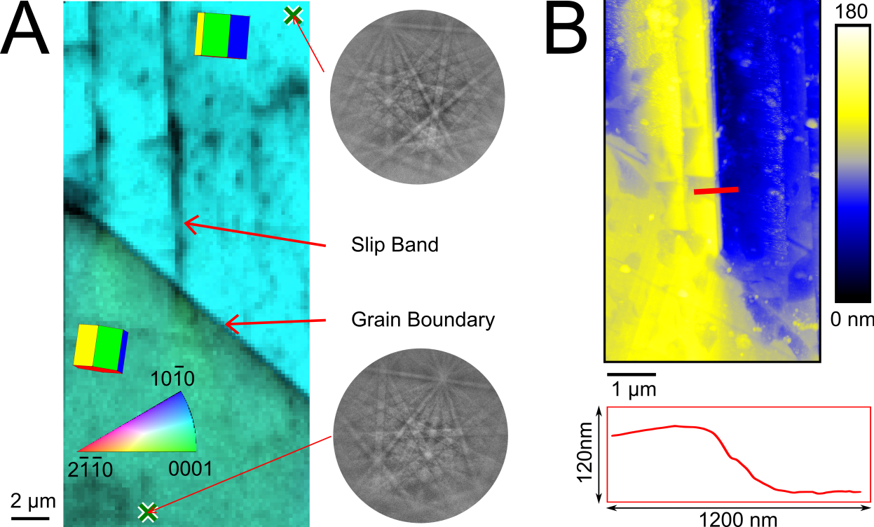
Figure 1

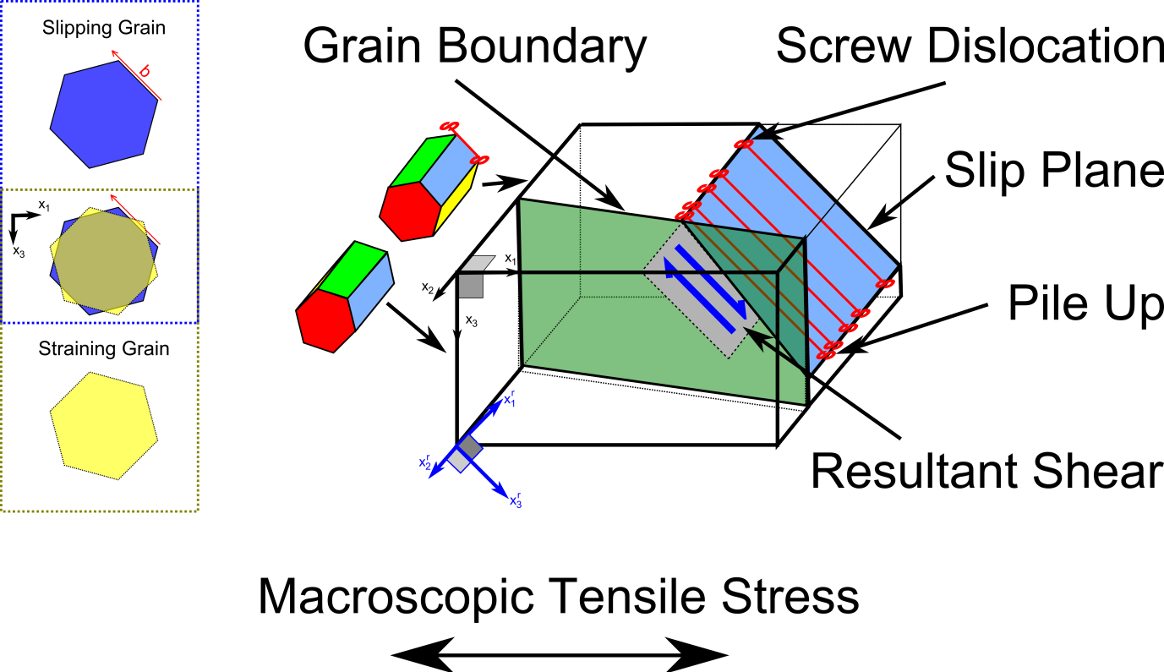
Figure 2

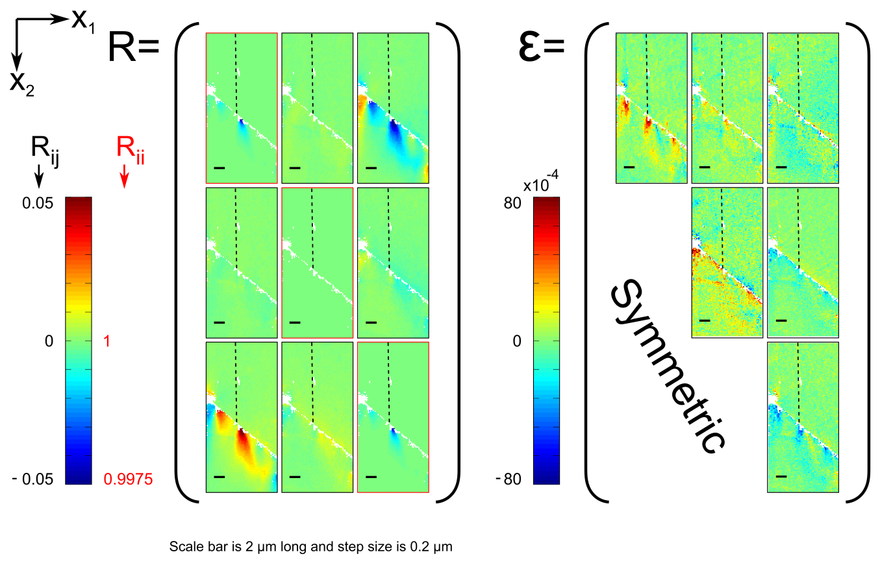
Figure 3

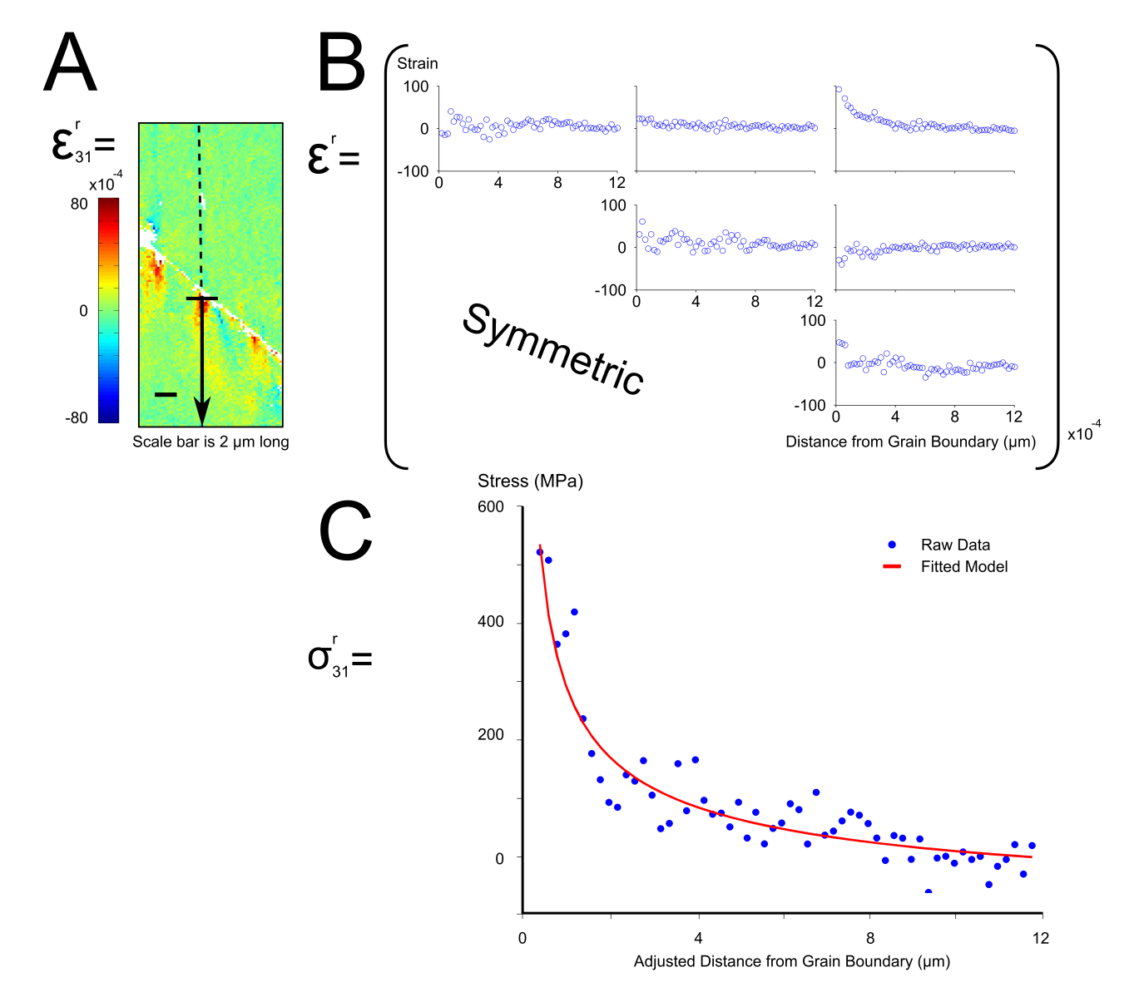
Figure 4

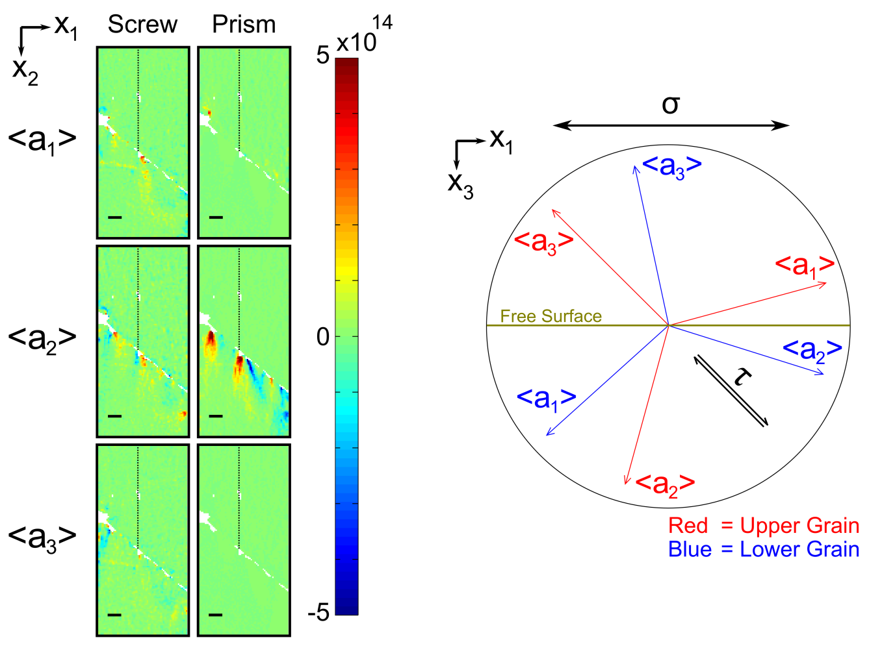
Figure 5

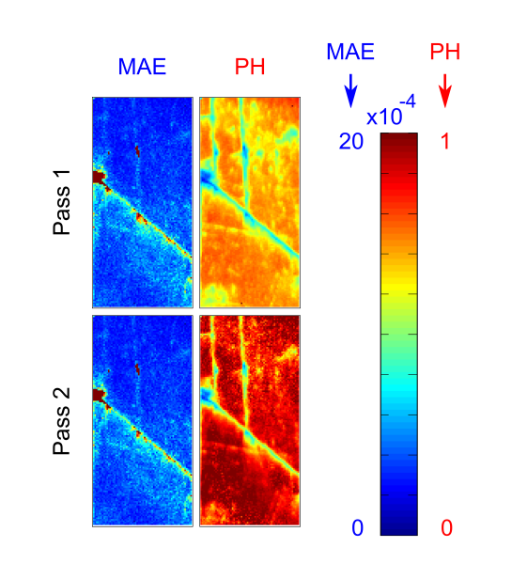
Supplementary Figure 1

