TITLE
The intensive care AI clinician learns optimal treatment strategies for sepsis.

AUTHORS
Matthieu Komorowski ^{1,2,3}, Leo Anthony Celi ^{3,4}, Omar Badawi ^{3,5,6} Anthony C. Gordon ¹*, A. Aldo Faisal ^{2,7,8}*

AFFILIATIONS
1- Department of Surgery and Cancer, Imperial College London, SW7 2AZ London, UK.
2- Department of Bioengineering, Imperial College London, SW7 2AZ London, UK.
3- Laboratory for Computational Physiology, Harvard-MIT Division of Health Sciences & Technology, Cambridge, Massachusetts, USA.
4- Beth Israel Deaconess Medical Center, Boston, Massachusetts, USA.
5- Department of eICU Research and Development, Philips Healthcare, Baltimore, Maryland, USA.
6- Department of Pharmacy Practice and Science, University of Maryland, School of Pharmacy, Baltimore, Maryland, USA.
7- Department of Computer Science, Imperial College London, SW7 2AZ London, UK.
8- MRC Clinical Sciences Centre, Faculty of Medicine, Imperial College London, Hammersmith Hospital Campus, Du Cane Road, W12 0NN London, UK.

INTRODUCTION
Sepsis is the third leading cause of death worldwide and the main cause of mortality in hospitals^{1–3}, but the best treatment strategy remains uncertain. In particular, evidence suggests that current practices in the administration of intravenous fluids and vasopressors are suboptimal and likely induce harm in a proportion of patients^{1,4–6}. To tackle this sequential decision-making problem, we developed a reinforcement learning agent, the artificial intelligence (AI) Clinician, which learns from data to predict patient dynamics given specific treatment decisions. Our agent extracted implicit knowledge from an amount of patient data that exceeds many-fold the life-time experience of human clinicians and learned optimal treatment by having analysed myriads of (mostly sub-optimal) treatment decisions. We demonstrate that the value of the AI Clinician’s selected treatment is on average reliably higher than the human clinicians. In a large validation cohort independent from the training data, mortality was lowest in patients where clinicians’ actual doses matched the AI policy. Our model provides individualized and clinically interpretable treatment decisions for sepsis that could improve patient outcomes.

MAIN TEXT
Sepsis is defined as severe infection leading to life-threatening acute organ dysfunction⁷. The management of intravenous fluids and vasopressors in sepsis is a key clinical challenge and a top research priority^{1,4}. Besides general guidelines such as the Surviving Sepsis Campaign, no tool currently exists to personalise treatment of sepsis and assist clinicians making decisions in real-time, at the patient level^{4–6}. As a consequence, clinical variability in sepsis treatment is extreme, with consistent evidence that suboptimal decisions lead to poorer outcomes^{8–10}.
We developed the AI Clinician, a computational model using reinforcement learning, able to dynamically suggest optimal treatments for adult patients with sepsis in the intensive care unit (ICU). Reinforcement learning is a category of artificial intelligence tools where a virtual agent learns from trial-and-error an optimized set of rules – a policy – that maximizes an expected return^{11,12}. Similarly, a clinician’s goal is to make therapeutic decisions in order to maximize a patient’s probability of a good outcome^{12,13}. Reinforcement learning has many desirable properties that may help medical decision-making. Their intrinsic design can handle sparse reward signals, which makes them well suited to overcome the complexity related to the heterogeneity of patient responses to medical interventions and the delayed indications of the efficacy of treatments¹¹. Importantly, these algorithms are able to infer optimal decisions from suboptimal training examples. Reinforcement learning has been successfully applied in the past to medical problems, such as diabetic retinopathy and mechanical ventilation in the ICU^{14,15}.
Our AI Clinician was built and validated on two large non-overlapping ICU databases, containing data routinely collected from adult patients in the U.S.A. The Medical Information Mart for Intensive Care version III (MIMIC-III)¹⁶ was used for model development and the eICU Research Institute Database (eRI) for model testing. In both datasets, we included adult patients fulfilling the international consensus sepsis-3 criteria⁷. After exclusion of non-eligible cases, we included 17,083 admissions (88.4% of eligible sepsis patients) from MIMIC-III from 5 separate ICUs in one tertiary teaching hospital and 79,073 admissions (73.6% of eligible sepsis patients) from 128 different hospitals from eRI (Supplementary Figure 1). Patient demographics and clinical characteristics are shown in Table 1 and Supplementary Table 1.
In both datasets, we extracted a set of 48 variables, including demographics, Elixhauser premorbid status¹⁷, vital signs, laboratory values, fluids and vasopressors received (Supplementary Table 2). Patients’ data were coded as multidimensional discrete time series with 4-hour time steps, and we included up to 72 hours of measurements per patient, around the estimated time of onset of sepsis. The total volume of intravenous fluids and maximum dose of vasopressors administered over each 4-hour period defined the medical treatments of interest. The model aims at optimizing patient mortality, so a reward was associated to survival and a penalty to death.
A Markov decision process (MDP) was used to model the patient environment and trajectories^{11,18}. The various elements of the model were defined using patient data time series from the training set (a random sample of 80% of MIMIC-III, see Figure 1). We deployed the AI Clinician to solve the MDP and predict outcomes of treatment strategies. First, we evaluated the actual treatments of clinicians, by analysing all the prescriptions and computing the average return of each treatment option, which can take values from -100 to +100 in our model. Then, the MDP was solved using policy iteration, which identified the treatments that maximised return, that is, the expected 90-day survival of patients in the MIMIC-III cohort¹¹. The resultant policy is referred to thereafter as the “AI policy”.
Evaluating the performance of this new AI policy using the trajectories of patients generated by another policy (the clinicians’ policy) is termed off-policy evaluation^{19–21}. It was crucial to obtain reliable estimates of the performance of this new policy without deploying it, since executing a bad policy would be dangerous for patients^{19,20}. Therefore, we implemented a type of high confidence off-policy evaluation (HCOPE) method (weighted importance sampling, WIS), and used bootstrapping to estimate the true distribution of the policy value in the MIMIC-III 20% validation set (Figure 2b, Supplementary Figure 1)^{20,21}. We built 500 different models using 500 different clustering solutions of the training data, and the selected final model maximised the 95% confidence lower bound of the AI policy²⁰. Figure 2a shows that this bound consistently exceeded the 95% confidence upper bound of the clinicians’ policy, provided that enough models were built. This model selection method maximizes the theoretical statistical safety of the new AI policy. The chosen AI policy was then tested on the independent eRI dataset.
Good model calibration was confirmed by plotting the relationship between the return of the clinicians’ policy and patients’ 90-day mortality (Figure 2c). In Figure 2d, we show the average return measured in survivors and non-survivors.
Figure 3a shows the distribution of the estimated value of the clinicians’ policy and the AI policy in the selected final model tested on the eRI cohort. Using bootstrapping with 2,000 resamplings, the median value of clinicians’ policy and the AI policy were estimated at 56.9 (interquartile range 54.7-58.8) and 84.5 (interquartile range 84.3-87.7), respectively. Figures 3b and 3c show the distribution of treatment doses according to clinicians’ and AI policies. On average, the AI Clinician recommended lower doses of intravenous fluids and higher doses of vasopressors, compared to clinicians’ actual treatments. While the proportion of time the eRI patients received vasopressors was only 17%, that would have been 30% if following the AI Clinician.
We further validated the model by analysing patient mortality when the dose actually administered corresponded to or differed from the dose suggested by the AI Clinician. Fifty eight percent of the time, the patients received a dose of vasopressor very close to the suggested dose, within 0.02 mcg/kg/min or 10% (whichever was smaller). For fluids, patients received the suggested dose approximately 36% of the time, within 10 mL/hour or 10%. These patients, who received doses similar to the doses recommended by the AI Clinician, had the lowest mortality. When the actual dose given was different from the suggested dose, clinicians gave more or less fluids in similar proportions, and less vasopressors 75% of the time. Giving more or less than the AI policy of either treatment was associated with increasing mortality rates, in a dose-dependent fashion. Figures 3d and 3e demonstrate this association, when the dose gap was averaged at the patient level. The median dose deficit in patients who received too little vasopressors was 0.13 mcg/kg/min (interquartile range 0.04-0.27 mcg/kg/min).
Using a random forest classification model, we gained some insight into the model representations and interpretability by estimating the relative importance of the model parameters for predicting the administration of both medications (Supplementary Figure 4). This confirmed that the decisions suggested by the AI Clinician were clinically interpretable and relied primarily on sensible clinical and biological parameters.
Here we demonstrate how reinforcement learning could be applied to solve a complex medical problem, and suggest individualized and clinically interpretable treatment strategies for sepsis. In an independent cohort, the patients that had received the treatments suggested by the AI Clinician had the lowest mortality rate.
When clinicians’ actual treatments varied from the AI Clinician’s suggested policy, this was most commonly to administer too little vasopressor. Early use of low-dose vasopressor has been suggested in sepsis^{4,5,8,9}. This may avoid administering excessive amounts of fluids, which has been linked with poorer outcome^{1,4,5,22}. Our results support this strategy but importantly allow the treatment to be individualized for each patient.
The vision is that this system would be used in real-time, with patient data coming from different streams being fed into electronic health record software fitted with our algorithm, which would suggest a course of action. Physicians will always need to make subjective clinical judgments about treatment strategies, but computational models can provide additional insight about optimal decisions, avoiding targeting short-term resuscitation goals and instead following trajectories towards longer-term survival^{23–25}. The reinforcement learning approach that we developed is agnostic to the data used and could in principle be applied to any data-rich clinical environment and many medical interventions. In the future, it is likely that as “-omic” technologies develop, this additional information will be added to the AI clinician to improve state definition and guide more therapies in selected patient groups.
There are limitations to our study. Although the datasets are large and used routinely collected clinical data, some sites and patients had to be excluded due to poor quality data recording or missing data. Due to differences between the two datasets, slightly different implementations of the sepsis-3 criteria were used, and hospital mortality was used in eRI instead of 90-day mortality. Finally, some laboratory values would not have been immediately available to clinicians to inform decision making but were available to the AI Clinician.
This work will clearly require prospective evaluation using real-time data and decision making in clinical trials and also testing in different healthcare settings, but if only a few percent reduction in mortality from sepsis could be achieved, this would represent several tens of thousands of lives saved annually, worldwide²⁶. In the last 10 to 15 years, attempts to develop novel treatments to reduce sepsis mortality have uniformly been unsuccessful^{27,28}. The use of computer decision support systems to better guide treatments and improve outcomes is therefore a much needed approach.

ACKNOWLEDGEMENTS
We are grateful for support from the National Institute of Health Research (NIHR) Comprehensive Biomedical Research Centre based at Imperial College Healthcare NHS Trust and Imperial College London. We are thankful to the Laboratory of Computational Physiology at the Massachusetts Institute of Technology and the eICU Research Institute for providing the data used in this research. MK and this project are funded by the Engineering and Physical Sciences Research Council and an Imperial College President’s PhD Scholarship. ACG is funded by an NIHR Research Professorship award (RP-2015-06-018). We are grateful to Finale Doshi-Velez and Omer Gottesman for their assistance with the methodology.

AUTHOR CONTRIBUTIONS
MK, ACG and AF conceived the overall study. MK and AF designed and conducted the experiments, and analysed the data. LAC and OB contributed to the experimental design and analyses. OB provided key input in extracting and processing data from the eRI. All authors contributed to the interpretation of the results and MK drafted the manuscript, which was reviewed, revised and approved by all authors.

COMPETING INTERESTS
The authors declare competing financial interests: ACG reports that outside of this work he has received speaker fees from Orion Corporation Orion Pharma and Amomed Pharma. He has consulted for Ferring Pharmaceuticals, Tenax Therapeutics, Baxter Healthcare, Bristol-Myers Squibb and GSK, and received grant support from Orion Corporation Orion Pharma, Tenax Therapeutics and HCA International with funds paid to his institution. LAC receives funding from Philips Healthcare. OB is an employee of Philips Healthcare. MK and AF do not have competing financial interests.

MATERIAL AND CORRESPONDENCE
Correspondence and requests for materials should be addressed to Anthony Gordon for clinical questions and A. Aldo Faisal for technical questions.
Anthony Gordon
anthony.gordon@imperial.ac.uk
Intensive Care Unit, Charing Cross Hospital, Fulham Palace Rd, London W6 8RF, UK
+44 (0)20 3313 0657

A. Aldo Faisal
a.faisal@imperial.ac.uk
Department of Bioengineering, Imperial College London, SW7 2AZ London, UK.
+44 (0)20 7594 6373

REFERENCES
1. Gotts, J. E. & Matthay, M. A. Sepsis: pathophysiology and clinical management. BMJ 353, i1585 (2016).
2. Torio, C. M. & Andrews, R. M. National Inpatient Hospital Costs: The Most Expensive Conditions by Payer, 2011: Statistical Brief #160. in Healthcare Cost and Utilization Project (HCUP) Statistical Briefs (Agency for Health Care Policy and Research (US), 2013).
3. Liu, V. et al. Hospital Deaths in Patients With Sepsis From 2 Independent Cohorts. JAMA 312, 90 (2014).
4. Byrne, L. & Haren, F. Fluid resuscitation in human sepsis: Time to rewrite history? Annals of Intensive Care 7, 4 (2017).
5. Marik, P. E. The demise of early goal-directed therapy for severe sepsis and septic shock. Acta Anaesthesiol Scand 59, 561–567 (2015).
6. Marik, P. & Bellomo, R. A rational approach to fluid therapy in sepsis. Br. J. Anaesth. 116, 339–349 (2016).
7. Singer M, Deutschman CS, Seymour C & et al. The third international consensus definitions for sepsis and septic shock (sepsis-3). JAMA 315, 801–810 (2016).
8. Waechter, J. et al. Interaction between fluids and vasoactive agents on mortality in septic shock: a multicenter, observational study. Crit. Care Med. 42, 2158–2168 (2014).
9. Bai, X. et al. Early versus delayed administration of norepinephrine in patients with septic shock. Crit Care 18, 532 (2014).
10. Marik, P. E., Linde-Zwirble, W. T., Bittner, E. A., Sahatjian, J. & Hansell, D. Fluid administration in severe sepsis and septic shock, patterns and outcomes: an analysis of a large national database. Intensive Care Med 43, 625–632 (2017).
11. Sutton, R. S. & Barto, A. G. Reinforcement Learning: An Introduction. (A Bradford Book, 1998).
12. Bennett, C. C. & Hauser, K. Artificial intelligence framework for simulating clinical decision-making: A Markov decision process approach. Artificial Intelligence in Medicine 57, 9–19 (2013).
13. Schaefer, A. J., Bailey, M. D., Shechter, S. M. & Roberts, M. S. Modeling Medical Treatment Using Markov Decision Processes. in Operations Research and Health Care (eds. Brandeau, M. L., Sainfort, F. & Pierskalla, W. P.) 593–612 (Springer US, 2005).
14. Gulshan, V. et al. Development and Validation of a Deep Learning Algorithm for Detection of Diabetic Retinopathy in Retinal Fundus Photographs. JAMA 316, 2402–2410 (2016).
15. Prasad, N., Cheng, L.-F., Chivers, C., Draugelis, M. & Engelhardt, B. E. A Reinforcement Learning Approach to Weaning of Mechanical Ventilation in Intensive Care Units. arXiv:1704.06300 [cs] (2017).
16. Johnson, A. E. W. et al. MIMIC-III, a freely accessible critical care database. Sci Data 3, 160035 (2016).
17. Elixhauser, A., Steiner, C., Harris, D. R. & Coffey, R. M. Comorbidity measures for use with administrative data. Med Care 36, 8–27 (1998).
18. Puterman, M. L. Markov Decision Processes: Discrete Stochastic Dynamic Programming. (Wiley, 1994).
19. Thomas, P. S., Theocharous, G. & Ghavamzadeh, M. High-Confidence Off-Policy Evaluation. in Twenty-Ninth AAAI Conference on Artificial Intelligence (2015).
20. Hanna, J. P., Stone, P. & Niekum, S. Bootstrapping with Models: Confidence Intervals for Off-Policy Evaluation. arXiv:1606.06126 [cs, stat] (2016).
21. Thomas, P., Theocharous, G. & Ghavamzadeh, M. High Confidence Policy Improvement. in PMLR 2380–2388 (2015).
22. Acheampong, A. & Vincent, J.-L. A positive fluid balance is an independent prognostic factor in patients with sepsis. Critical Care 19, 251 (2015).
23. Johnson, A. E. W. et al. Machine Learning and Decision Support in Critical Care. Proceedings of the IEEE 104, 444–466 (2016).
24. Vincent, J.-L. The Future of Critical Care Medicine: Integration and Personalization. Critical Care Medicine 44, 386–389 (2016).
25. Chen, J. H. & Asch, S. M. Machine Learning and Prediction in Medicine — Beyond the Peak of Inflated Expectations. New England Journal of Medicine 376, 2507–2509 (2017).
26. Fleischmann, C. et al. Assessment of Global Incidence and Mortality of Hospital-treated Sepsis. Current Estimates and Limitations. Am J Respir Crit Care Med 193, 259–272 (2015).
27. Gordon, A. C. et al. Levosimendan for the Prevention of Acute Organ Dysfunction in Sepsis. New England Journal of Medicine 375, 1638–1648 (2016).
28. Ranieri, V. M. et al. Drotrecogin Alfa (Activated) in Adults with Septic Shock. New England Journal of Medicine 366, 2055–2064 (2012).

FIGURES
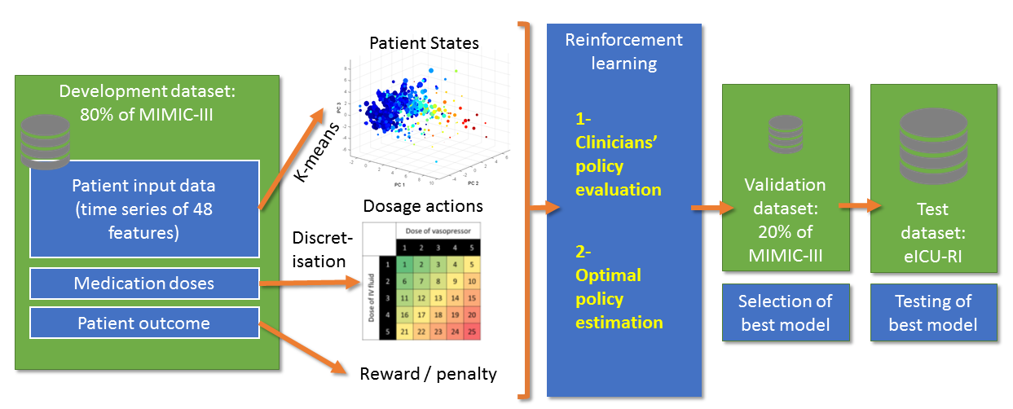
Figure 1: Data flow of the AI Clinician. Eighty percent of the MIMIC-III dataset was used to define the elements of the Markov decision process. Time series of patient data were clustered into finite patient states using k-means method. The dose of intravenous fluids and vasopressors were discretized into 25 possible actions. Patients’ survival at 90 days after ICU admission defined rewards. Reinforcement learning was used to evaluate the value of clinicians’ policy and estimate optimal treatment strategies, the AI policy. The remaining 20% MIMIC-III data was used to identify the best model among 500 candidates, which was then tested on an independent dataset from the eRI database.

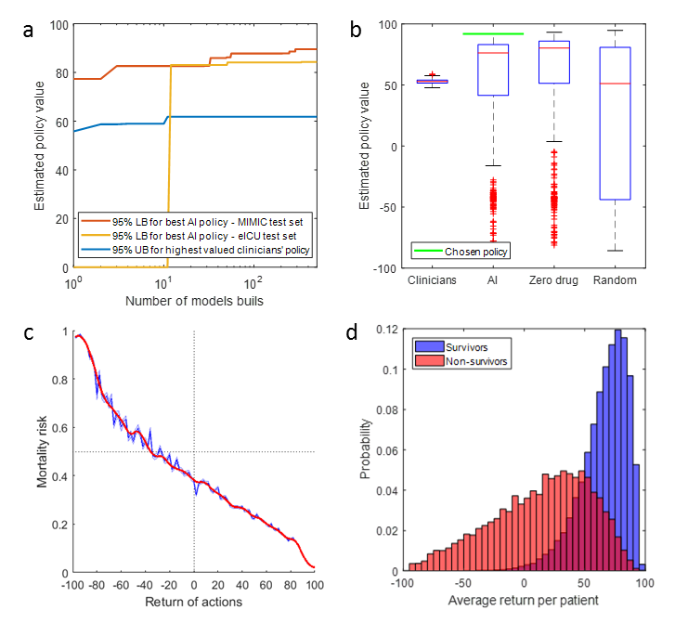
Figure 2. Selection of the best AI policy (a,b) and model calibration (c, d). a, evolution of the 95% lower bound (LB) of the best AI policy and 95% upper bound (UB) of highest valued clinicians’ policy during building of 500 models. After only a few models, a higher value for the AI policy than the clinicians’ treatment, within the accepted risk, is guaranteed. b, distribution of the estimated value of the clinicians’ actual treatments, the AI policy, a random policy and a zero-drug policy across the 500 models, in the MIMIC-III test set. The chosen AI policy maximises the 95% confidence lower bound. c, relationship between the return of clinicians’ treatments and patient 90-day mortality, in the MIMIC-III training set. Return of actions were sorted into 100 bins and the mean observed mortality was computed in each of these bins. Treatments with a low return were associated with a high risk of mortality, while treatments with a high return led to better survival rates. d, average return in survivors and non-survivors in the MIMIC-III training set. Figs. c and d were generated by bootstrapping in the training data with 2,000 resamplings.
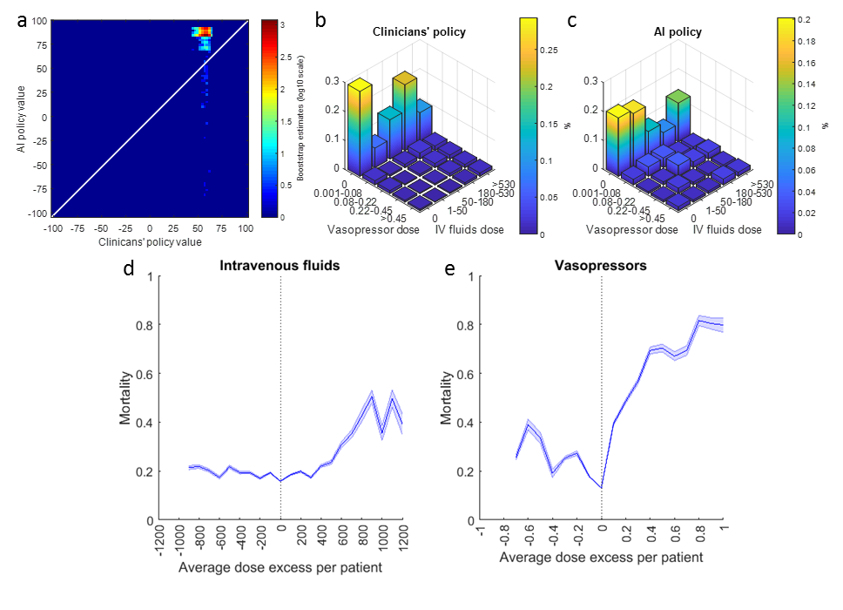
Figure 3. Comparison of clinicians and AI policies in eRI (a, b, c); Average dose excess received per patient of both drugs in eRI and corresponding mortality (d, e). a. distribution of the estimated value of the clinicians’ and the AI policy in the selected model, built by bootstrapping with 2,000 resamplings. b and c, Visualization of the clinicians’ and AI policies. All actions were aggregated over all time steps for the 5 dose bins of both medications. On average, patients were administered more intravenous fluid (b) and less vasopressor (c) medications than recommended by the AI policy. Vasopressor dose is in mcg/kg/min of norepinephrine equivalent and intravenous fluids dose is in mL / 4 hours. d and e, The dose excess refers to the difference between the given and suggested dose averaged over all time points per patient. The figure was generated by bootstrapping with 2,000 resamplings. In both plots, the smallest dose difference was associated with the best survival rates (vertical dotted line). The further away the dose received was from the suggested dose, the worse the outcome.

TABLE
 | MIMIC-III | eRI
Unique ICUs (N) | 5 | 128
Unique ICU admissions (N) | 17,083 | 79,073
Characteristics of hospitals, per number of ICU admissions. | Teaching tertiary hospital. | Non-teaching: 37,146 (47.0%)  Teaching: 29,388 (37.2%)  Unknown: 12,539 (15.9%)
Age, years (Mean, SD) | 64.4 (16.9) | 65.0 (16.7)
Male gender (N, %) | 9,604 (56.2%) | 40,949 (51.8%)
Premorbid status (N, %)  Hypertension  Diabetes  CHF  Cancer  COPD/RLD  CKD | 9,384 (54.9%)  4,902 (28.7%)  5,206 (30.5%)  1,803 (10.5%)  4,248 (28.7%)  3,087(18.1%) | 43,365 (54.8%)  25,290 (32.0%)  15,023 (19.0%)  11,807 (14.9%)  18,406 (23.3%)  14,553 (18.4%)
Primary ICD-9 diagnosis (N, %)  Sepsis, including pneumonia  Cardiovascular  Respiratory  Neurological  Renal  Others | 5,824 (34.1%)  5,270 (30.8%)  1,798 (10.5%)  1,590 (9.3%)  429 (2.5%)  2,172 (12.7%) | 41,396 (52.3%)  11,221 (14.2%)  9,127 (11.5%)  7,127 (9.0%)  1,454 (1.8%)  8,747 (11.1%)
Initial OASIS (Mean, SD) | 33.5 (8.8) | 34.8 (12.4)
Initial SOFA (Mean, SD) | 7.2 (3.2) | 6.4 (3.5)
Procedures during the 72h of data collection:  Mechanical ventilation (N, %)  Vasopressors (N, %)  Renal replacement therapy (N, %) | 9,362 (54.8%)  6,023 (35.3%)  1,488 (8.7%) | 39,115 (49.5%)  23,877 (30.2%)  6,071 (7.7%)
Length of stay, days (Median, IQR) | 3.1 (1.8 – 7) | 2.9 (1.7 – 5.6)
ICU mortality | 7.4% | 9.8%
Hospital mortality | 11.3% | 16.4%
90-day mortality | 18.9% | Not available
Table 1: Description of the datasets. CHF: Congestive Heart Failure; CKD: Chronic Kidney Disease; COPD: Chronic Obstructive Pulmonary Disease; ICD-9: International Classification of Diseases version 9; IQR: Interquartile Range; OASIS: Oxford Acute Severity of Illness Score; RLD: Restrictive Lung Disease; SD: Standard Deviation; SOFA: Sequential Organ Failure Assessment.

