Experimental study of moisture content effects on the transient gas and particle emissions from peat fires
Yuqi Huª, Eirik G. Christensenª, Hafiz M.F. Aminª, Thomas E. L. Smith^{b}, and Guillermo Rein^{a, *}
ª Department of Mechanical Engineering, Imperial College London, London SW7 2AZ, UK
^{b} Department of Geography and Environment, London School of Economics and Political Science,
London WC2A 2AE, UK.
* Corresponding author. Email: g.rein@imperial.ac.uk; Tel: +44 (0) 20 7594 7036
Abstract
Peat fires are an Earth-scale source of carbon emissions and the leading cause for regional air quality deterioration especially in Southeast Asia. The ignition and spread of peat fires are governed by moisture which acts as a significant energy sink. However, moisture effects on fire emissions are poorly understood. Here we present the first experimental work to investigate transient gas and particle emissions for a wide range of peat moisture content (MC); covering drying, smouldering, and flaming combustion. Peat samples conditioned to different MCs were burnt in a laboratory environment where a suite of diagnostics simultaneously measured mass loss rate, temperature profiles, real-time concentration of 20 gas species, and size-fractioned particle mass. It was found that MC, in addition to peat burning dynamics, also affects emissions. An increase in MC below a smouldering ignition threshold of 160% in dry basis led to a decrease in NH₃ and greenhouse gas emissions, including CO₂ and CH₄, throughout the ignition and spread of the fire. Smouldering wet peat was found to emit more coarse particles (between 2.5 to 10 μm) than dry peat especially from the ignition. In contrast, flaming peat was found to mainly emit soot particles less than 1 μm, and released 100% more fully oxidised gas species including CO₂, NO₂ and SO₂ than from smouldering. The examination of modified combustion efficiency reveals that it failed to recognise smouldering combustion, and differentiate between drying and flaming, thus is not suggested as a universal fire mode indicator. This work bridges the knowledge gap between peat MC and peat fire emissions, and provides a unique and comprehensive understanding to facilitate the development of improved haze mitigation technology.
Key words: wildfire; moisture; biomass; pollution; fire
- Introduction
Peatlands are formed from the accumulation of partially decayed vegetation in water-logged environments over centuries to millennia, and are vulnerable to smouldering fires: the slow, low-temperature, flameless burning of porous fuels, and the most persistent type of combustion [1, 2]. Peatland ecosystems only cover ~3% of the Earth’s land surface but are important terrestrial carbon pools, storing one-third of the world’s soil carbon [1, 3]. Smouldering peat fires are the largest fires on Earth (in terms of fuel consumption), they destroy soil and biological ecosystems irreversibly and release more than 100 trace gas species and different-sized particles to the atmosphere [2-7]. Carbon dioxide (CO₂), carbon monoxide (CO), methane (CH₄) and ammonia (NH₃) are found to be the four predominant gas species emitted from peat fires [8]. Among these species, CO₂ and CH₄ are significant long-lived greenhouse gases, while gases including CO, NH₃ and other non-methane organic compounds (NMOCs) impact atmospheric levels of CO₂ and CH₄ through photochemical processing [9]. On average, the annual carbon emissions from these fires are equivalent to ~15% of anthropogenic emissions, and create a positive feedback mechanism in the climate system [10, 11]. Furthermore, inhalation of deleterious emission species such as CO, SO₂ and particulate matter (PM) can lead to various adverse human physiological responses, predominantly to the respiratory and cardiovascular systems [3].
Smouldering combustion is sustained by the heat released when oxygen directly attacks the surface of a solid fuel, whereas flaming combustion dominates when the oxidation takes place in the gas phase [2]. Black smoke plumes generated from flaming fires (homogenous combustion chemistry) are strongly buoyant, the diffusion flames move fast on the ground surface with a short residence time. In contrast, smouldering fires (heterogeneous combustion chemistry) persistently release weakly buoyant smoke plumes that accumulate near the ground surface (Figure 1) [2, 3]. This white-grey smoke is rich in PM and can migrate long distances, causing regional haze and pose unresolved environmental and health crises, especially in Southeast Asia, Russia, and the USA [3, 11].
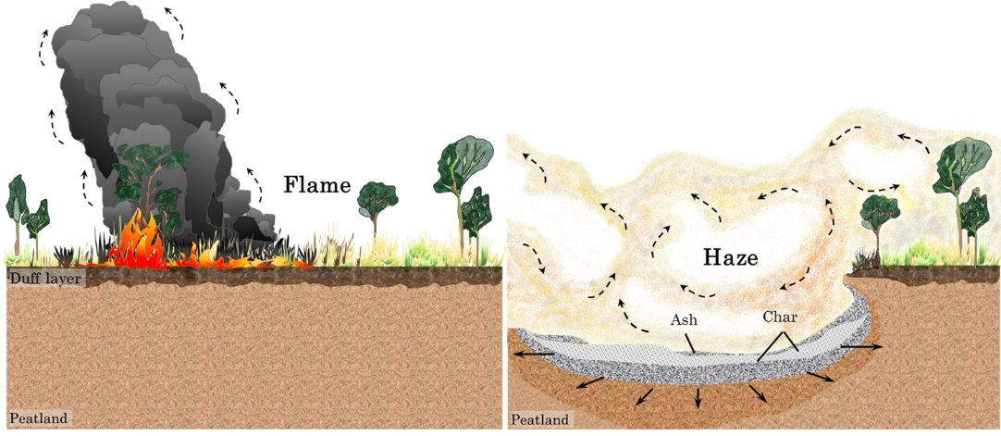
Figure 1 Schematics of a day-long peatland forest flaming fire (left), and the subsequent month-long smouldering peatland fire (right) [3].
Peat moisture content (MC) varies from 10 % under drought conditions up to > 300 % in flooded scenarios [12, 13]. Peat moisture serves as an energy sink during a fire, and is the single most important property governing the ignition and spread of smouldering fires [2]. Natural droughts (e.g. El Niño) or anthropogenic drainages (e.g. for agriculture) lower the water table in peatlands, reduces the MC of the peat, and increases the frequency and extent of peat fires [1]. Once ignited, peat can sustain a smouldering fire, propagating horizontally and vertically through deep layers [2, 14-17]. Preheating, drying, pyrolysis and oxidation are the sub-fronts forming the structure of a smouldering fire. Drying is not involved in chemical reactions and emits mainly water vapour [7, 18]. Most hydrocarbon (e.g., CH₄) emissions occur during peat pyrolysis, while CO, CO₂ and NH₃ are emitted by char oxidation [8]. Research investigating PM emissions from peat fire is limited to only a handful of studies (e.g., [19]), however the PM formation mechanism remains poorly understood [3].
Mass flux (mass flow rates per area of smouldering peat bed, g s⁻¹ m⁻²), and emission factor (EF, the mass of species emitted per mass of dry fuel consumed, g kg⁻¹) are used in the literature to quantify fire emissions. EFs are also widely used in atmospheric sciences to determine the impacts of fire in the context of global climate change [3]. Rein et al. [7] and Hadden [20] studied the mass flux and EFs from peat fires for CO₂ and CO. Hu et al. [8] recently found that the transient gas and particle emissions and their EFs are significantly dependent on combustion dynamics.
The aforementioned research consists of laboratory studies which simplify the vast complexity of natural peatland ecosystems, but provide vital insights into the general emission response to fire. Field studies provide invaluable data from landscape-scale fires [6, 19, 21] but are the most challenging to study due to landscape heterogeneity [15, 21]. Recent field studies have also suggested links between peat fire emissions, combustion dynamics, and peat composition (e.g. the effect of peat bulk density on CH₄ emissions during a fire [21], and changes in PM emissions as a fire ages [19]). Given that field campaigns are limited by the natural variability presented by the fires observed, field scientists stress the need for controlled laboratory studies to test hypotheses generated from limited field observations [19]. Fundamental understanding from laboratory-scale experiments can be extrapolated and applied to field-scales to provide context and a better understanding of field data. Research is therefore needed at all scales to advance the understanding of peat fire phenomena [15].
In this work, gas and particle emissions from smouldering peat were measured in the laboratory under different controlled moisture conditions. This allowed the effects of MC on the transient emissions to be investigated for the first time. This work also examined drying (i.e. without a source of ignition) and flaming peat, providing a unique and comprehensive understanding of the emission from different fire mechanisms.
- Experimental method
A commercially available temperate Irish sphagnum peat was used in this work, this peat has homogeneous properties and composition, and has been used in previous smouldering studies [8, 13, 14]. Elemental analysis (dry basis) shows that the mass fraction of C/H/N/S of this peat is 54.1/5.1/1.3/0.5 %, respectively. Peat samples were conditioned to different MCs values for a series of flaming, smouldering and drying experiments, following the same drying and rewetting protocol used in [8, 13- 15]: raw peat was firstly oven dried at 80 °C until no further mass loss was observed; next, the dry peat was rewetted with a corresponding amount of water to achieve the desired MCs. The sample was then mixed thoroughly and left sealed for at least 48 hours for moisture equilibrium. For smouldering peat experiments, samples targeted at nine different MCs were prepared: 0% (dry peat), 25%, 50%, 75%, 100%, 120%, 140%, 160% and 180%. An absolute 0 % MC peat is not possible as once dry peat finds air, it quickly absorbs the ambient moisture [14]. The actual MCs of the peat used in the smouldering experiments were determined by redrying and reweighting a subsample of 100 g taken from each sample [15] and were determined to be: 1.5 ± 0.9 % (dry peat); 26.7 ± 0.8 %; 54.5 ± 1.0 %; 78.2 ± 2.2 %; 103.0 ± 1.1 %; 125.4 ± 2.5 %; 142.9 ± 3.0 %; 158.7 ± 2.4 %; 177 ± 2.0 %. Dry peat samples were used for flaming experiments. The sample with a target MC of 180 % was used for drying experiments.
Measurements of the burning dynamics and the transient emissions were carried out on a comprehensive peat fire testing rig characterised in a previous study [8]. Two different open-top reactors (burning Reactor “A” and drying Reactor “B”) were used in this work (Figure 2). Both reactors have an inner dimension of 20 cm by 20 cm in cross section and 10 cm in depth, ensuring a constant peat volume in each experiment. Reactor A, used for both smouldering and flaming peat experiments, was built from 1.3 cm thick mineral fibre board with a coil heater buried 5 cm along one side of the reactor below the free surface [8, 14, 15]. A 1 mm thickness aluminium sheet was used to build the bottom wall of reactor B for drying experiments to facilitate heat conduction from a hot plate placed underneath.
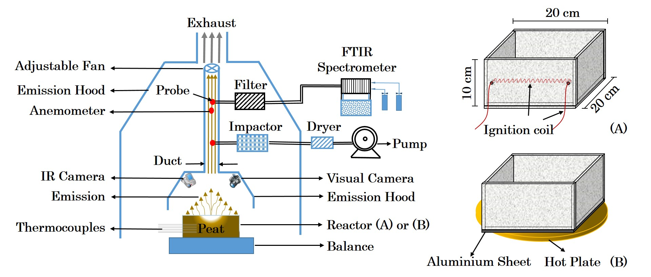
Figure 2 Schematic of the peat fire experiment set-up. Reactor A was used for all smouldering and flaming experiments; Reactor B was used for drying experiment.
The ignition of the smouldering peat was achieved by applying 100W of power to the coil for 30 minutes, following the same ignition protocol used in [8, 14- 16]. The extraction rate was set to 0.035 m³ s⁻¹ ± 2.5 % in smouldering experiments to ensure collecting all emissions while minimizing flow perturbations from open combustion [8].
The ignition coil for flaming experiments was kept on at all times to encourage pyrolysate emission for homogeneous gas-phase oxidation [2, 22]. The extraction rate for flaming peat was increased to 0.105 m³ s⁻¹ ± 2.0 %, because of the theory that transition from smouldering to flaming is enhanced by oxygen supply [2, 11]. After 20 min of the onset of the ignition attempt, surface peat glowing was observed, and a small pilot flame was used to ignite the fire smoke for 1 s. For the first time, successful and steady flaming peat was observed for ~5 min. This flaming phenomenon was observed under the same configuration for all repeated experiments.
Drying peat was attained by fixing the temperature of the hot plate to 95 ± 1 °C throughout the experiment. Table 1 provides a summary of the peat flaming, smouldering and drying experiments.
Table 1 Summary of the experimental configuration of peat flaming, smouldering and drying. Visual images (top view) of the experiments are shown. The reactors were 20 cm long and 20 cm wide, the peat was ignited at the left side of the reactor, and propagated from the left to the right.
 | Flaming | Smouldering | Drying
Peat moisture content | 0% (dry peat) | 0% - 180% | 180%
Emission extraction rate | 0.105 m³ s⁻¹ | 0.035 m³ s⁻¹ | 0.035 m³ s⁻¹
Ignition coil | 100 W, always on | 100 W for 30 min [8, 14] | n/a
Pilot flame | 1s, at 20 min | n/a | n/a
Hot plate | n/a | n/a | 95 °C, always on
Visual example | 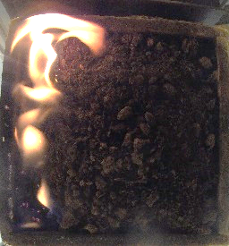 | 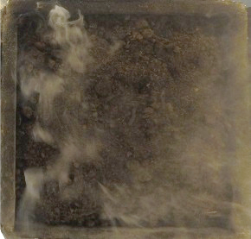 | 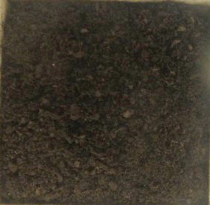

This work follows the same diagnostics configuration for measuring burning dynamics (mass loss, temperature profiles, visual and infrared images) and transient emissions (gas concentration, particle mass) used in [8]. 20 different gas species which are most abundant and important from the literature were measured using a Fourier-transform infrared spectroscopy (FTIR): CO₂, CO, CH₄, NH₃, acetylene (C₂H₂), ethylene (C₂H₄), ethane (C₂H₆), propylene (C₃H₆), propane (C₃H₈), butane (C₄H₁₀), methanol (CH₃OH), formaldehyde (CH₂O), nitric oxide (NO as NO_{x}), nitrogen dioxide (NO₂), hydrogen cyanide (HCN), acetic acid (CH₃COOH), acetaldehyde (C₂H₄O), formic acid (CH₂O₂), hydrogen chloride (HCl), and sulphur dioxide (SO₂). Species’ background concentrations were subtracted from the results.
Size-fractioned particles (D ≥ 10 µm; 2.5 µm ≤ D ≤ 10 µm; 1 µm ≤ D ≤ 2.5 µm; D ≤ 1 µm) were collected and weighted using a PM cascade impactor and a 0.01 mg resolution balance for 10 min after every 2 hrs [8]. Emitted masses of PM₁₀ (particle aerodynamic diameter ≤ 10 µm), PM_{2.5} (≤ 2.5 µm) and PM₁ (≤ 1 µm) were calculated from the mass gain of the size-fractioned particles. All experiments were repeated for 2-4 times.
- Results and discussion
  - Burning dynamics
3.1.1 Mass loss rate
Figure 3 shows the evolution of mass loss rate (MLR) from peat flaming, smouldering and drying. The MLR from the short flaming stage (0.057- 0.073 g s⁻¹) was on average 325% greater than that of smouldering peat. No visible smoke was seen from peat drying, and the MLR ranges from 0.003- 0.006 g s⁻¹ with an average of 0.004 g s⁻¹.
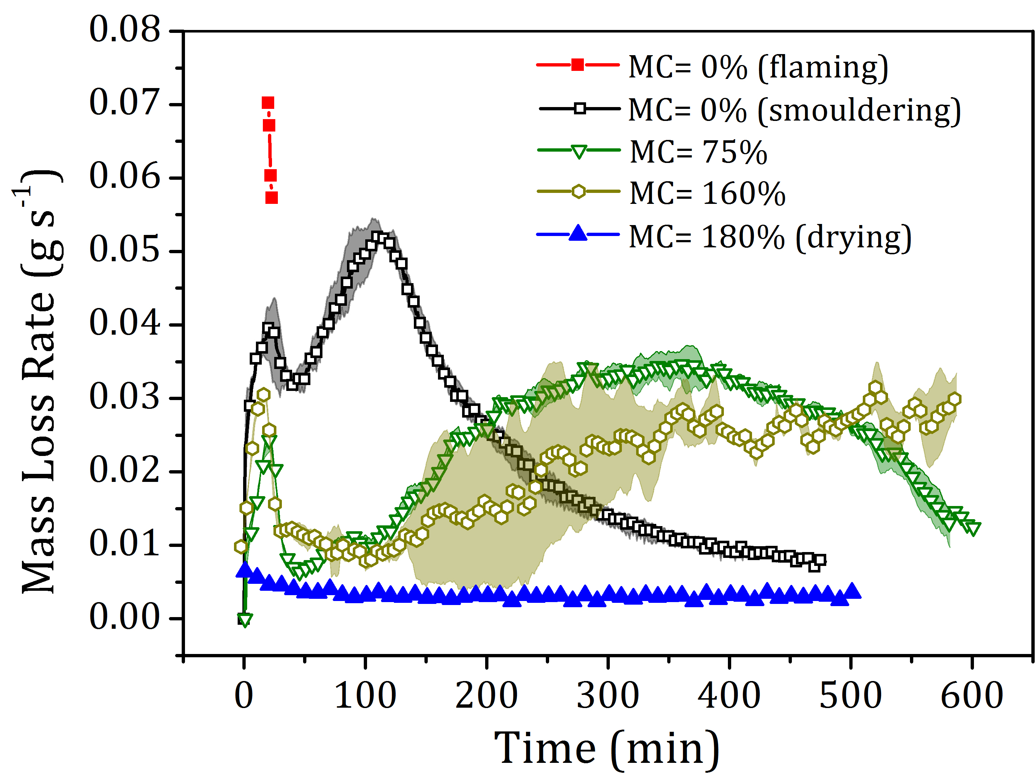
Figure 3 Evolution of mass loss rate measured during peat flaming, smouldering (at different MCs) and drying. Mass loss rate mean (line with symbol) and range (cloud) from the repeated experiments are shown.
Smouldering peat with MCs of 0%, 75% and 160% were chosen to represent the typical MLR trends exhibited within the whole MC range. Two general combustion stages were used to describe the evolution of a smouldering peat fire: ignition stage (first 30 min with coil heater on) and spread stage [8]. For peat with a MC < 160%, self-sustained smouldering determined from a steady increase of the MLR, was observed after the ignition stage for all repeats. When the MC was increased to 160%, two out of the four repeats failed to show ignition. None of the 180% MC peat sample was ignited. As a result, 160% is deemed as the critical MC in terms of smouldering thresholds, which is higher than the values of 110%, 135% and 150% reported in the literature [5, 14, 23].
Our data clearly show that MC significantly affects peat fire dynamics (Figure 4). This unique comparison of peak MLR of flaming, smouldering and drying peat intuitively revealed the dynamic difference among fire mechanisms. The MLR of flaming dry peat peaked at 0.073 g s⁻¹. Smouldering peat occurred within a large MC span, and it is found that with the increase of MC, the MLR peak value decreased. When the MC increased to 180%, the peak MLR (0.015 g s⁻¹) was recorded promptly after the ignition source was turned off, verifying the ignition failure at MC > 160%.
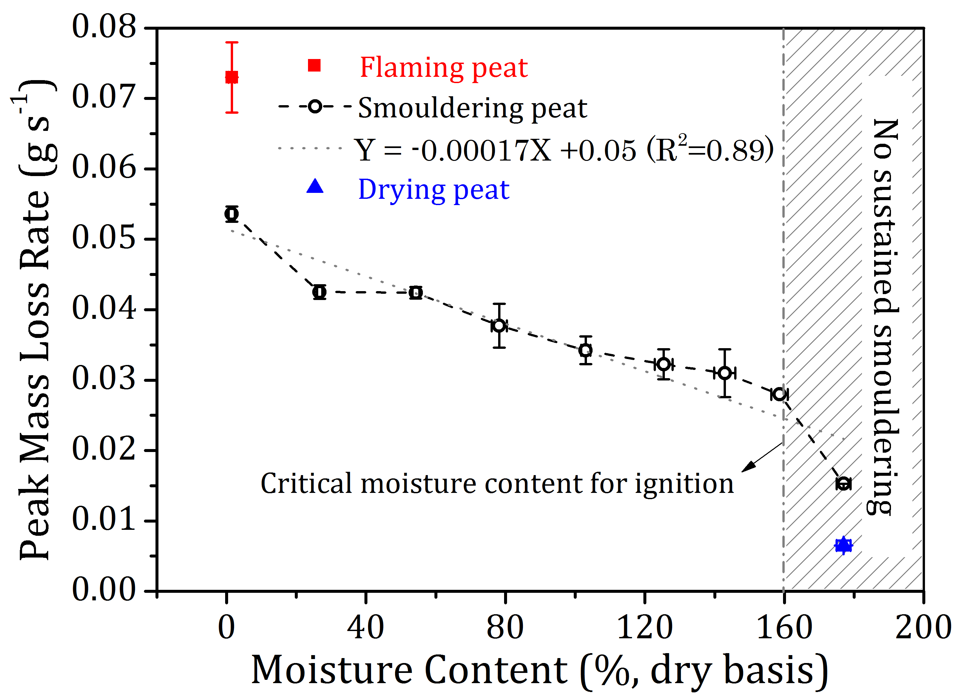
Figure 4 Peak mass loss rate for all peat fire experiments. 160% moisture content is the moisture content threshold for smouldering ignition. A linear regression was used to fit the mass loss rate data.
3.1.2 Spread rate
This work presents the first systematic investigation of the MC effects on smouldering spread rate which is controlled by the oxygen supply and heat transfer [2]. Temperature profiles of the experiments help interpret the spread of a peat fire. By tracking the drying front (100 °C) as a marker [8, 14], the lateral spread rate of smouldering peat across the reactor [14, 17] was studied and results are shown in Figure 5. This unique plot reveals that the spread rates at different depths have negative linear correlations with the peat MCs. For example, the spread rate at the top layer (2 cm below free surface) peat decreased ~75%, from 11.7 cm hr⁻¹ (dry peat) to 2.9 cm hr⁻¹ (75% MC peat). This decreasing trend of lateral spread rate as a function of MC corresponds with the finding of Santoso et al. [17] where spread rate gathered from different sources found in the literature were reviewed.
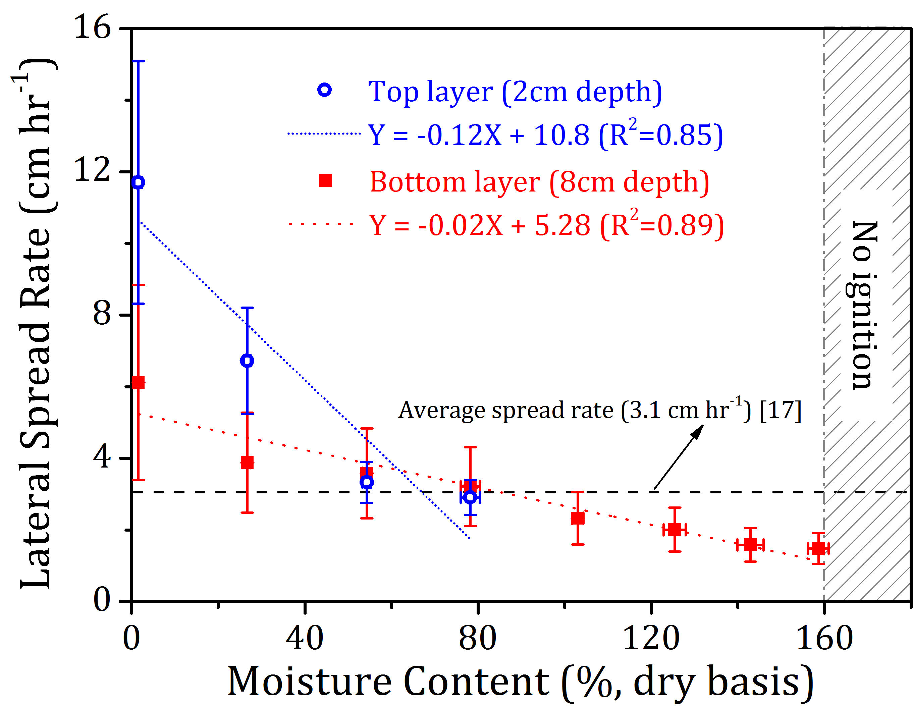
Figure 5 Lateral spread rate of smouldering peat fires under different moisture contents retrieved from the temperature profile. Average top and bottom layer peat spread rate and the error determined from uncertainty propagation are shown. A linear regression was used to fit the spread rate data.
Averaging all smouldering experiments, the mean lateral spread rate for smouldering peat is 3.02 ± 1.54 cm hr⁻¹, which is very close to the 3.1 ± 1.1 cm hr⁻¹ average spread rate reported in [17]. This confirms that peat fire is a slow yet complex combustion phenomenon, the large MC variability found in natural peat adds complexity when analysing its burning dynamics [1, 3, 11, 17].
Top layer lateral spread rate of the peat with MC larger than 75% was not included in this figure. This is because when the peat becomes wet (>50% MC), fire has been found to spread faster at a depth than at the free surface, leading to the formation and collapse of an overhang studied in Huang et al. [14]. The peat at the surface did not degrade into char (no in situ pyrolysis happening) [14] and was lower than 100 °C, thus was excluded for spread rate calculation.
  - Transient gas emissions
3.2.1 Gas concentration
Figure 6 shows the transient excess CO₂ concentrations of peat flaming, smouldering and drying experiments. Excess CO₂ concentrations from flaming peat ranged between 460 and 864 ppm. Smouldering peat with MC of 0%, 75% and 160% were selected to show the typical concentration trends exhibited within 0% and 180%. It is seen that CO₂ is mainly emitted during the spread stage of the peat fire [8], and the trends follows the evolutions of MLR with MC. With the increase of the MC, CO₂ concentration decreased. This decrease of the concentration with MC can be attributed to the decreased dry peat bulk density (dry peat/ total reactor volume) with MC [14]. For example, for 0% MC peat, the bulk density of net fuel available for burning was ~ 220 kg m⁻³, while this value decreased to ~102 kg m⁻³ for 160% MC peat. Only traceable amounts of excess CO₂ (< 5 ppm) was detected from peat drying. Full information of the other gas species’ transient concentration with MC is shown in Fig. S1.
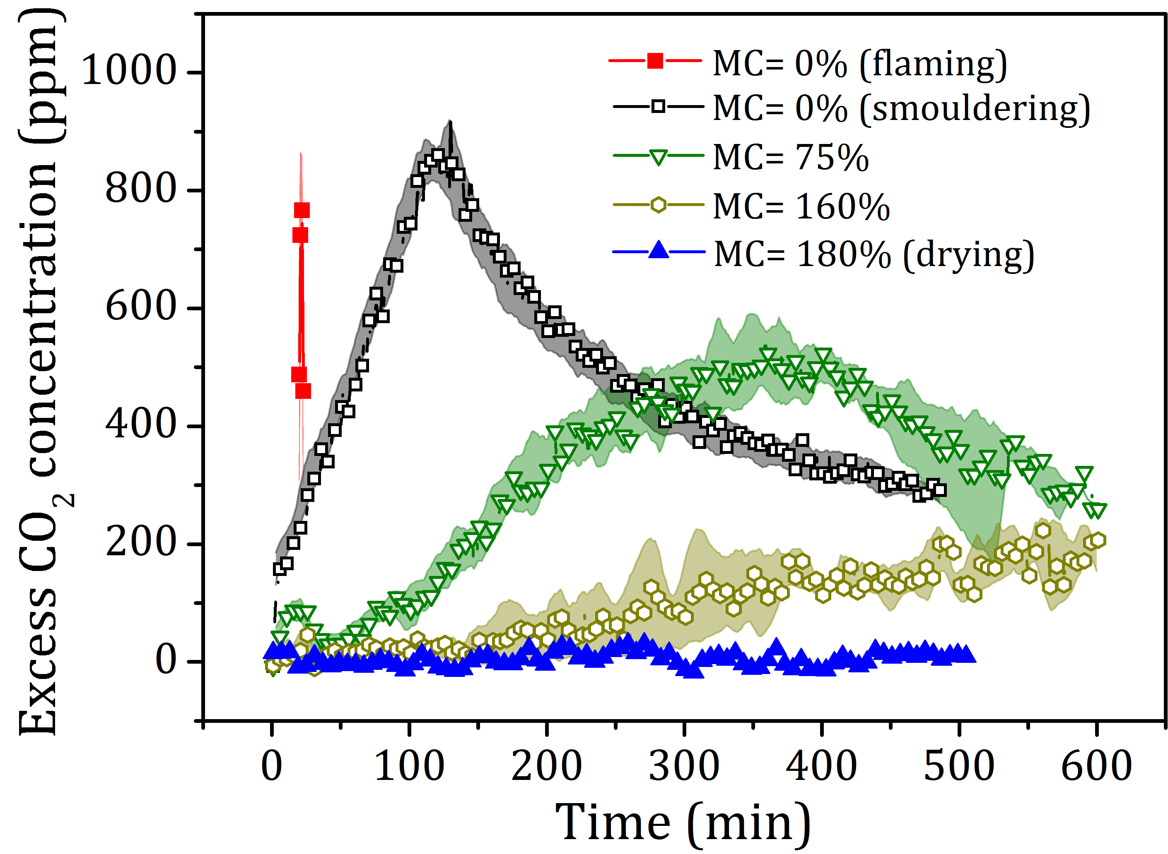
Figure 6 Evolutions of CO₂ concentration during the peat flaming, smouldering and drying. Concentration mean (line with symbol) and range (cloud, smoothed) are shown.
CO₂, CO, CH₄, NH₃ and HCN were selected as the main characteristic peat fire gas species analysed due to their prominent EFs and direct and indirect health effects [3, 8, 15]. For smouldering experiments, the moisture effects on the peak gas concentration across experiments were further examined under the ignition and spread stages.
Figure 7 shows the concentration peaks of CO₂ and CO from all peat fire experiments. Flaming peat and smouldering peat were found to have similar CO₂ concentration peaks, whereas flaming peat had a much lower CO concentration peak than that from smouldering peat. A 25% increase of the MC from dry peat led to a sharp 45% and 64% decrease of the CO₂ and CO peak concentrations from smouldering ignition stage, respectively. For the smouldering spread stage, CO₂ and CO concentrations from burning 160% MC peat decreased by 88% and 58% from those from dry peat, respectively. No CO was monitored from drying peat.
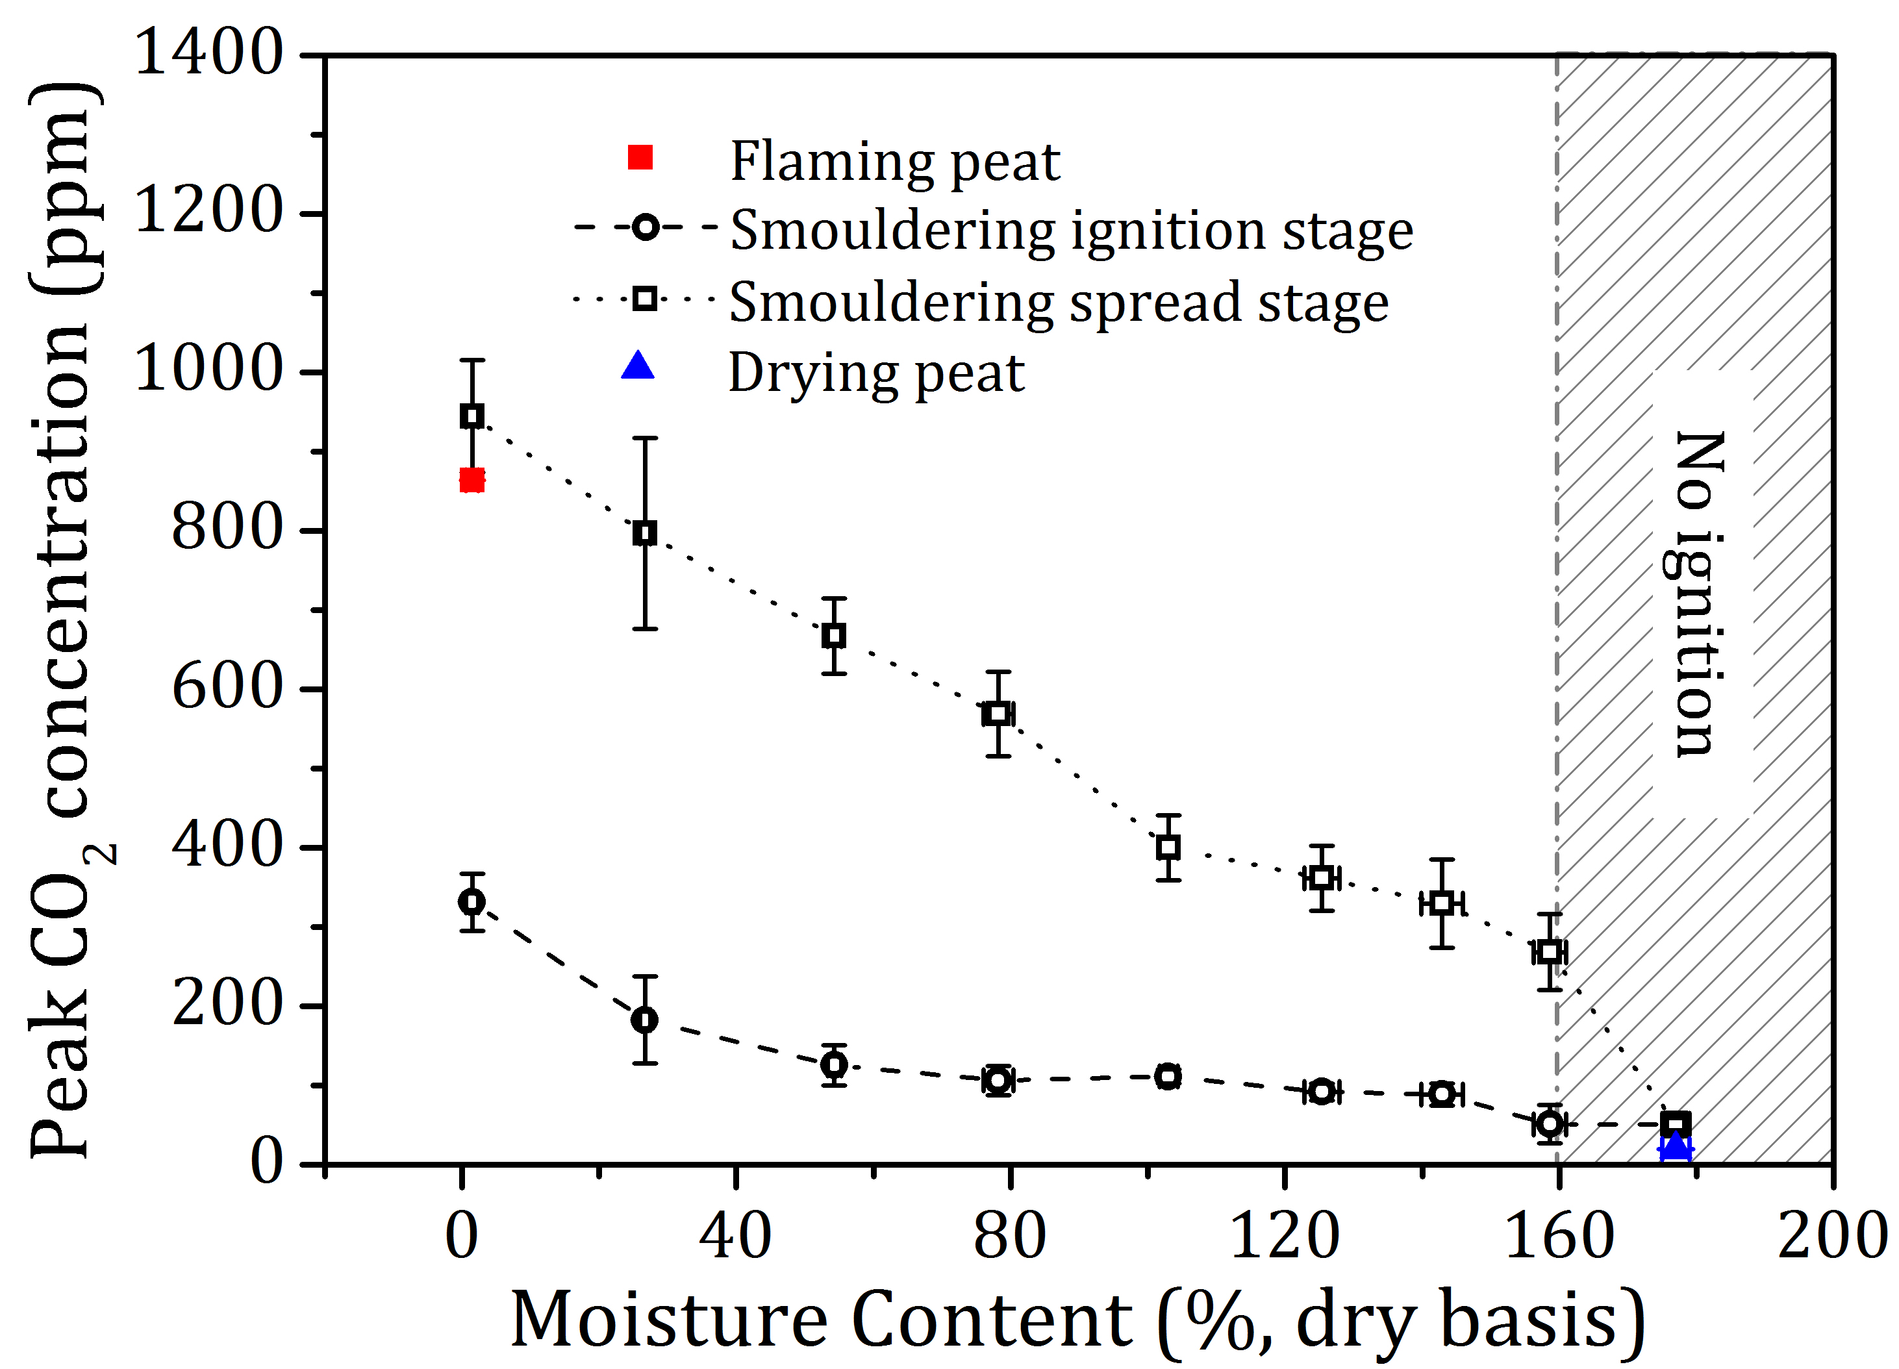
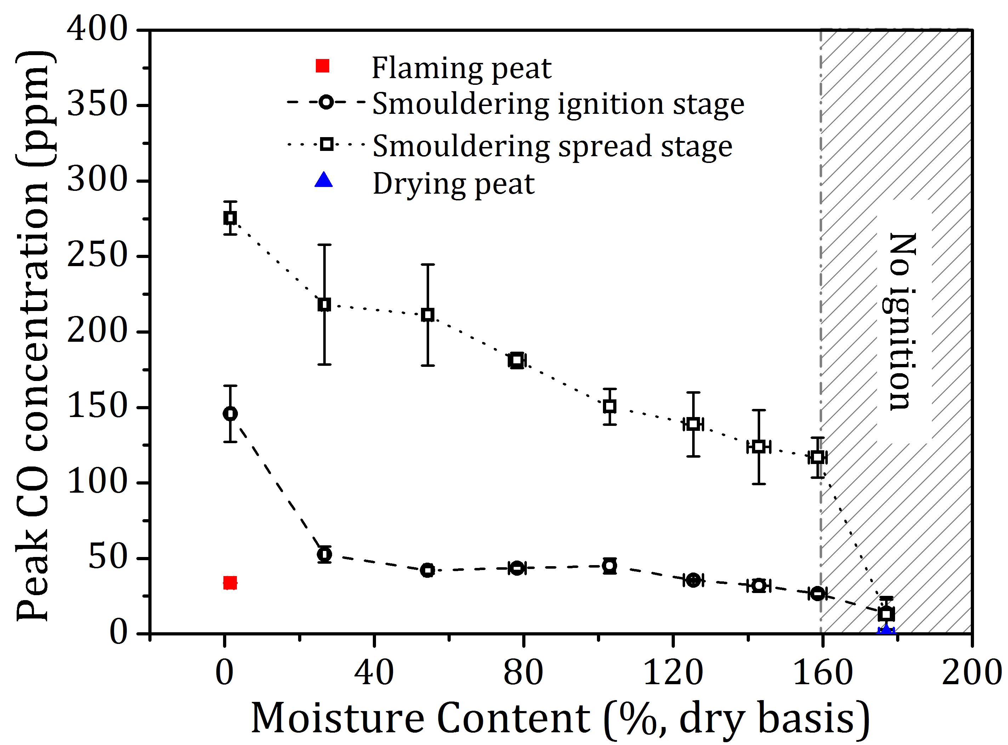
Figure 7 CO₂ (top) and CO (bottom) concentration peaks from peat flaming, smouldering and drying experiments.
Different from CO₂ and CO, outstanding CH₄ concentration peaks were found in ignition stage (Figure 8 (top)). For peat with MC < 140%, peak CH₄ concentrations exceeded those from flaming peat (8.3 ppm). A 25% increase of MC from dry peat led to a 52% decrease of the peak CH₄ concentration value. No CH₄ was detected from peat drying.
Contrasting with the results for CH₄, HCN concentration from smouldering ignition was traceable and insensitive to moisture with MC ≥ 25% (Figure 8 (bottom)). During the smouldering spread stage, HCN peak concentration stayed relatively constant (~ 0.5 ppm) with peat MC < 75% and decrease gradually when the MC > 75%. Negligible HCN (0.08 ppm) was detected from flaming peat, no HCN was found from peat drying.
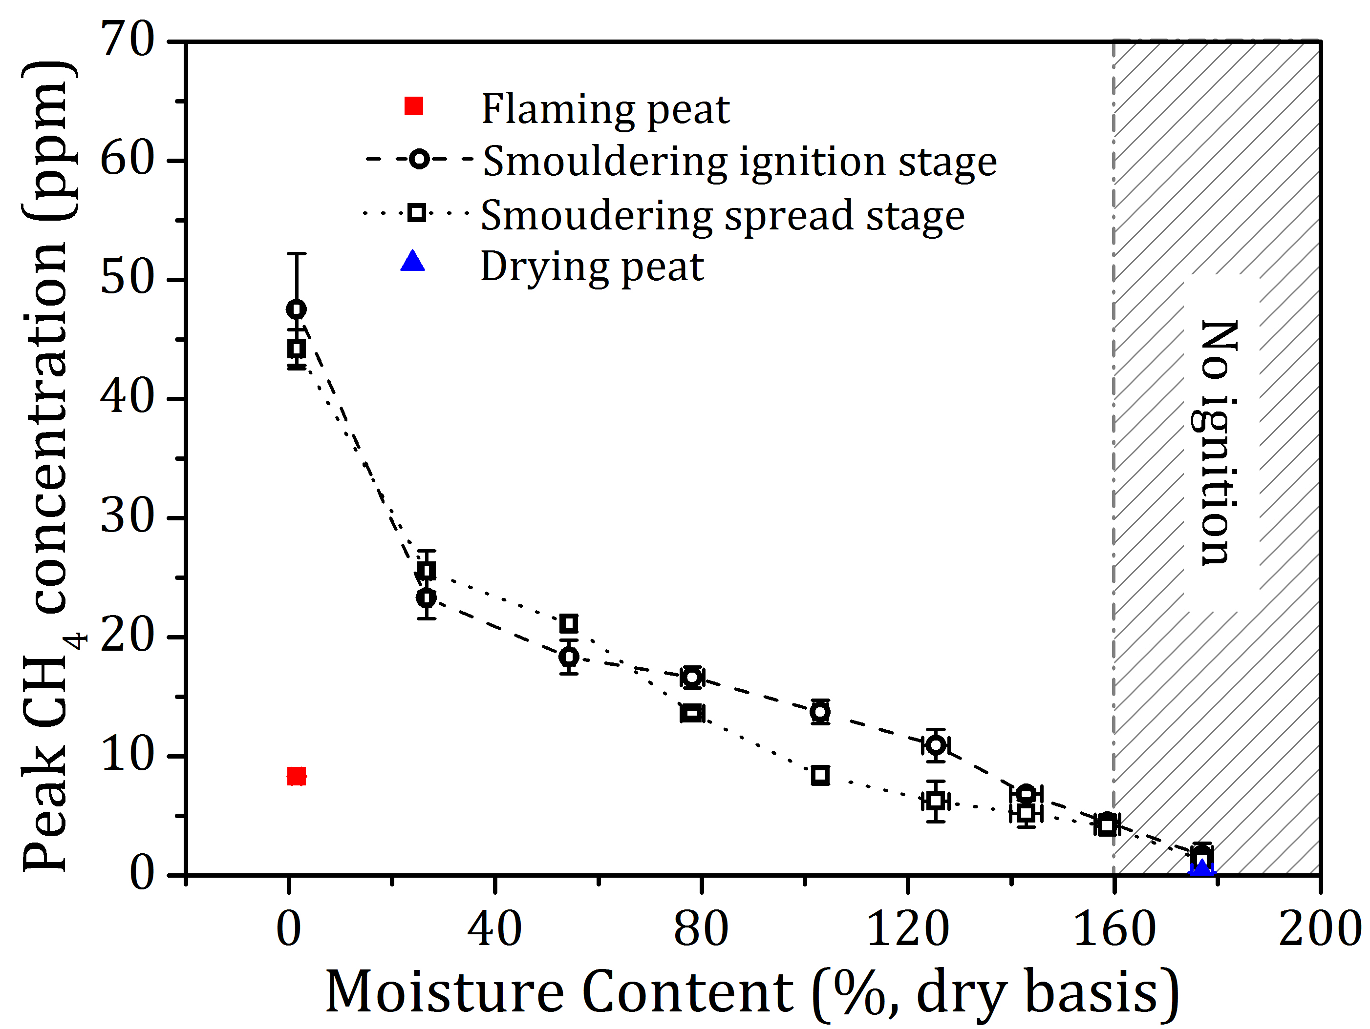
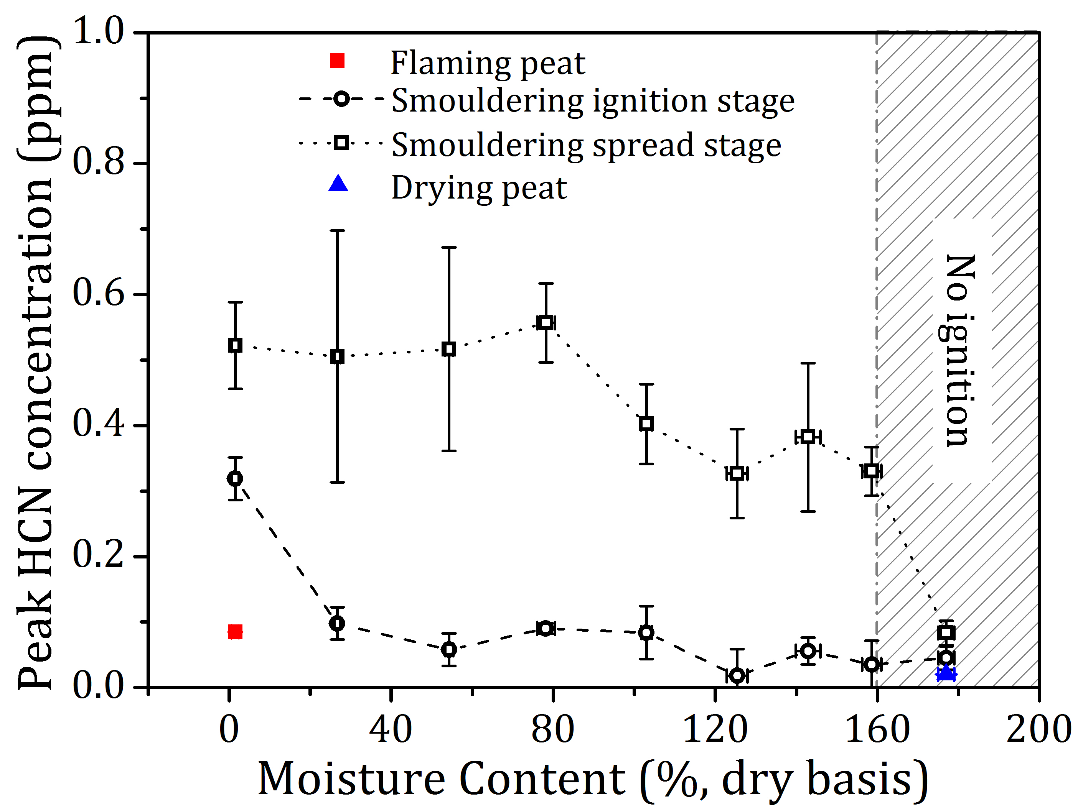
Figure 8 CH₄ (top) and HCN (bottom) concentration peaks from peat flaming, smouldering and drying experiments.
In [8], we proposed NH₃ as a candidate atmospheric marker for smouldering peat fires because of disproportionally larger emissions from smouldering over flaming peat combustion. Figure 9 shows peak NH₃ concentrations found in all experiments. At least 5.5 times higher NH₃ concentration were found during the smouldering spread stage than those from ignition stage (MC < 100%). Furthermore, NH₃ emissions from ignition are independent from the MC, verifying that NH₃ is not formed through pyrolysis but is a by-product of char oxidation [7, 8]. Only traceable NH₃ (0.56 ppm) was detected in flaming peat, no NH₃ was found from peat drying.
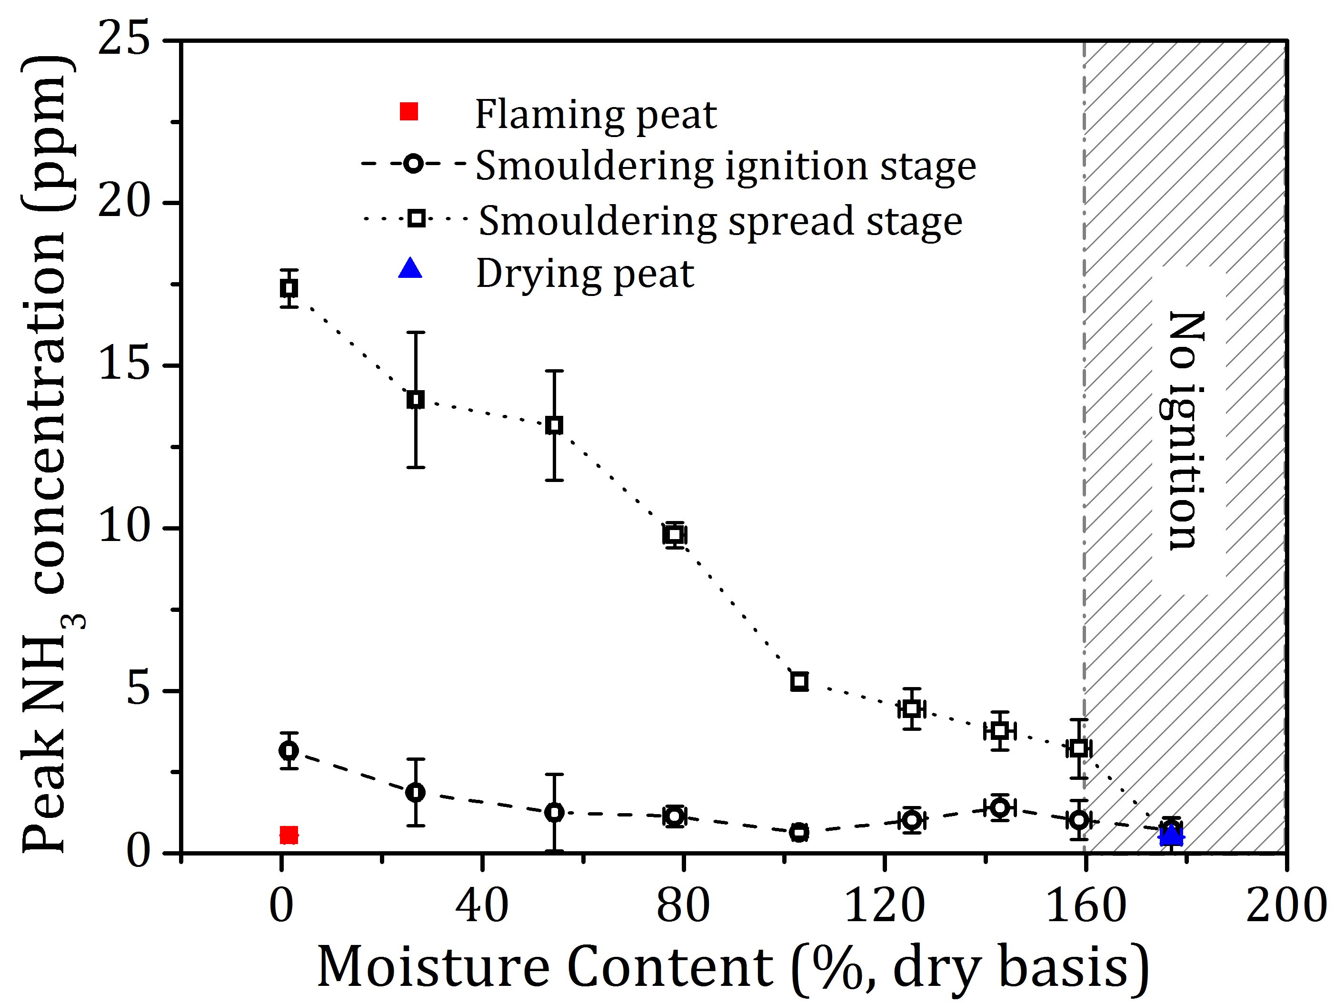
Figure 9 NH₃ concentration peaks from peat flaming, smouldering and drying experiments.
3.2.2 Mass flux and emission factors
Transient mass flux of all 20 gas species i (${\dot{m}}_{g,i}^{"}\left(t\right),$g s⁻¹ m⁻²) was calculated using Equation (1) [7, 8].
${\dot{m}}_{g,i}^{"}(t)=\frac{ρ_{i}[i](t)\dot{V}}{A}$ (1)
Where $ρ_{i}$ is the species density (ideal gas assumption, g kg⁻¹); $[i](t)$is the real-time excess concentration of the species i (ppm); $\dot{V}$ is the volumetric flow rate in the emissions duct (m³ s⁻¹); A is the surface area of the reactor (m²).
Fig. S2 covers the transient mass fluxes of CO₂, CO, CH₄, HCN and NH₃ found in all experiments. With an extraction rate of 0.105 m³ s⁻¹, flaming peat CO₂ mass flux reached 4.0 g s⁻¹ m⁻², distinctively larger than those from smouldering fires which ranges from 0.3 - 1.5 g s⁻¹ m⁻². This is because smouldering is an incomplete combustion process where large factions of carbon are emitted without being fully oxidised into CO₂ [2]. The mass flux of CH₄, an important greenhouse gas species, from the dry peat smouldering spread can reach up to 0.042 g s⁻¹ m⁻². The peak mass fluxes of deleterious CO, HCN and NH₃ found in smouldering peat fire emissions range from 0.08- 0.27 g s⁻¹ m⁻², 0.0002- 0.0004 g s⁻¹ m⁻², and 0.001- 0.01 mg s⁻¹ m⁻², respectively, posing acute respiratory and cardiovascular risks to the exposed population [3].
By assuming that the fraction of the moisture emission rate consistently corresponds to the MC of the peat, the transient EF calculated from a mass loss approach was validated [7, 8]. This work follows the best available moisture emission assumption and the EF mass loss approach (Equation (2)) to calculate the transient EF of different gas species i (${EF}_{m, i}\left(t\right)$, g kg⁻¹ dry mass combusted) .
${EF}_{m,i}(t)=\frac{{\dot{m}}_{g,i}^{"}(t)A}{\left(\frac{{\dot{m}}_{w}(t)}{1+φ_{ω}}\right)}$ (2)
Where ${\dot{m}}_{w}(t)$ is the transient MLR of the peat sample (g s⁻¹); $φ_{ω}$ is the MC of the peat sample in dry basis (%).
The transient EFs of CO₂, CH₄ and NH₃ from smouldering peat with MCs of 0%, 75% and 160% are shown in Figure 10 as examples of the trends exhibited in all MC ranges. It is seen that MC affected the EF evolutions of different gases: the transient EFs of CO₂, CH₄ and NH₃ decrease clearly with the increase of MC. An increase of 160% MC from dry peat led to 48%, 82%, and 84% decrease of the CO₂, CH₄ and NH₃ EFs, respectively. The decreasing CO₂ EF with MC contradicts the findings of [7] who found an increasing trend. The decreasing EF trend of CH₄ with MC is well explained by the theory that peat at low moisture smoulders with wider pyrolysis front, releasing a larger fraction of non-fully oxidised carbon species [7].
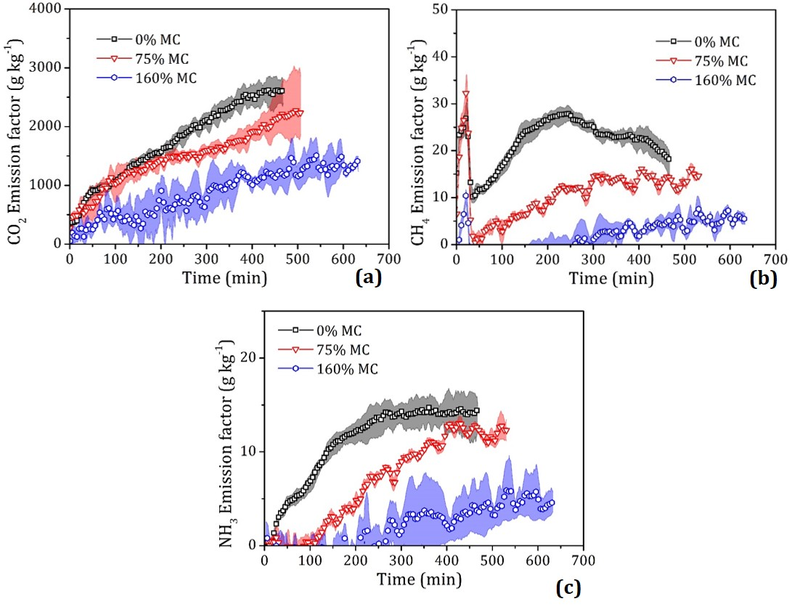
Figure 10 Transient CO₂ (a), CH₄ (b), and NH₃ (c) emission factor from smouldering peat fires with 0%, 75% and 160% targeted moisture contents. Emission factor mean (line with symbol) and range (cloud) from the repeated experiments are shown.
Wet peats (75% or 160% MC) were found to have generally higher CO and HCN EFs than from dry peat. The increasing CO EF with MC contradicts the findings of [7] who found that CO transient EFs are independent of the moisture. The increase of the MC has the potential to change the oxidation front as the porosity of the peat bed varies with MC affecting oxygen diffusion. Given that the EF evolutions varied among gas species, it is likely that the MCs not only affect the burning dynamics, but also affect the structure of the smouldering front, and the reaction chemistry. For example, the overall different EFs patterns between HCN and NH₃ could be explained by the availability of hydrogen radicals (H•) under different peat moisture conditions, as the H• was found to generate from the interactions of char and water, and is the key to determine chemical path forming HCN or NH₃ [24, 25].
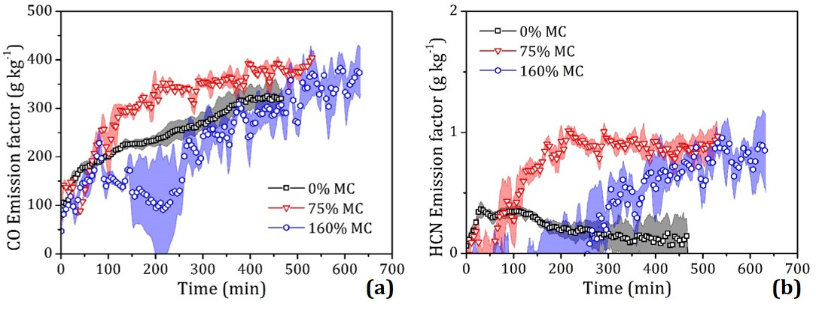
Figure 11 Transient CO (a), and HCN (b) emission factor from smouldering peat fires with 0%, 75% and 160% targeted moisture contents. Emission factor mean (line with symbol) and range (cloud) from the repeated experiments are shown.
Owing to our simultaneous measurement of the MLR and the transient emissions, this work is the first to characterise the flaming peat gas emissions. By comparing the EFs before and during the flaming stage, signals that are unique to peat gaseous pyrolysate oxidation were discovered: species including CO₂, C₂H₂, CH₂O, NO, NO₂, SO₂ and CH₃COOH experienced a distinct increase of the EF. For example, the EF of CO₂ increased ~513%, from 328.8 g kg⁻¹ (before flaming) to 2017.0 g kg⁻¹ (during flaming); NO increased ~ 156%, from 0.9 g kg⁻¹ to 2.3 g kg⁻¹. In contrast, a clear decrease of the species’ EFs including CO, CH₄, C₂H₆, C₃H₈ and C₄H₁₀ were observed during the flaming stage. For example, the EF of CO declined ~46%, from 78.0 g kg⁻¹ to 42.4 g kg⁻¹; CH₄ decreased ~70%, from 18.3 g kg⁻¹ to 5.5 g kg⁻¹. The other species showed inconspicuous difference of the transient EFs thus were deemed insensitive to changes in combustion regimes.
  - Transient particle emissions
Following the same calculation method used in [8], the transient EF of PM species $j$ (PM₁₀, PM_{2.5} and PM₁) from the experiments were determined (Equation (3)):
${EF}_{j}(t)=\frac{m_{j}(t)}{\frac{m_{w\left(t+∆t\right)-}m_{w\left(t\right)}}{\left(1+φ_{ω}\right)} }\frac{\dot{V}}{{\dot{V}}_{j}}$ (3)
Where$m_{j}(t)$ is the time-resolved mass of sampled PM (g); $m_{w\left(t+∆t\right)}$ and $m_{w\left(t\right)}$ are the mass of the wet peat before and after each PM measurement interval (g); $∆t$ is the single measurement time (10 min); $φ_{ω}$ is the MC of the peat sample in dry basis (%); $\dot{V}$ is the volumetric flow rate within the duct and ${\dot{V}}_{j}$ is the PM sampling flow rate within the impactor (0.0005 m³s⁻¹ ± 5.0%).
Transient PM₁₀, PM_{2.5} and PM₁ EFs from peat with MC of 0% and 75% were shown in Figure 12. Large amount of PM was detected during dry peat ignition stage, from which the PM₁₀, PM_{2.5} and PM₁ EFs stayed at 21.1 ± 4.7 g kg⁻¹, 6.55 ± 1.3 g kg⁻¹ and 0.48 ± 0.08 g kg⁻¹, respectively. In contrast, for wet peat with 75% MC, the corresponding EFs increased to 38.2 ± 8.4 g kg⁻¹, 32.1 ± 6.17 g kg⁻¹ and 11.86 ± 1.94 g kg⁻¹. Wet peat emits overall more particles from ignition, it is likely that moisture plays a role informing micro-scale PM from pyrolysis.
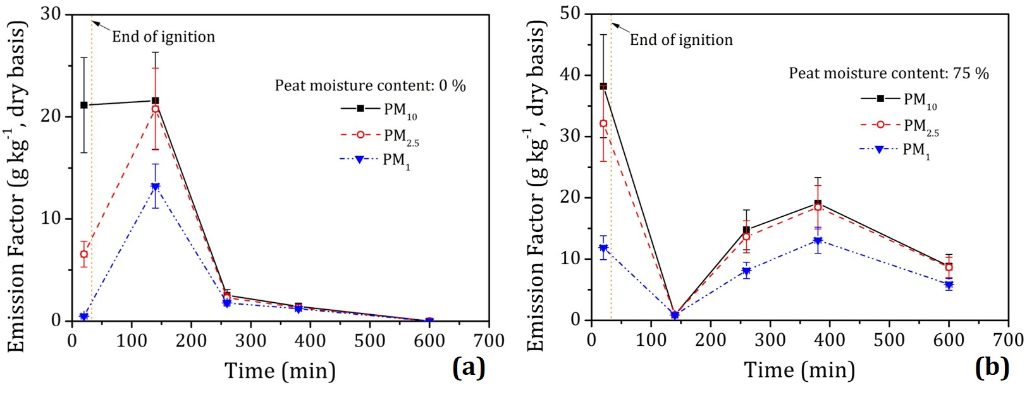
Figure 12 Transient PM₁₀, PM_{2.5} and PM₁ emission factor from smouldering peat fires ignition stage and spread stage with 0% (a) and 75% (b) targeted moisture contents. The error bars determined from uncertainty propagation detailed in [8] are shown.
The transient PM EFs followed the MLR evolutions within the smouldering spread stage. This similar trend was observed in Hu et al. [8] where the particle emissions from a peat sample with MC of 100% was measured. In addition, Roulston et al. [19] also showed a decline of PM EFs through time in both lab and field measurements. The peak PM₁₀ EF found in the spread stage of [8] and this study stayed below 25 g kg⁻¹. Although particle emissions are not the main carbon source from peat fire (compared with CO₂ emissions with the EF magnitude of 1000 g kg⁻¹), they pose direct and profound influence on the deterioration of air quality and human health [3].
60%- 70% of the particles emitted were found to be less than 1 μm (PM₁) from the smouldering spread stage: for dry peat and 75% MC peat, PM₁ takes up 69.7 ± 0.11% and 63.0 ± 0.06% of all the detectable particles, similar to the values reported in [8]. However, the mass fraction of PM₁ from dry peat ignition decreased to an extremely low 2.22%. This may be observed in Figure 13 (a) where the size-fractioned particles emitted from the ignition and spread stage of smouldering dry peat were shown. The particles were yellowish in colour and have negligible black carbon, which is characteristic for smouldering peat fires [3]. It is seen that the ignition stage generated far less PM₁ than those from the spread stage. However, particles in larger sizes (mainly in the range of 2.5 μm to 10 μm) emitted from the ignition stage outweigh those from spread stage.
Figure 13 Size-fractioned particulate matter samples (D ≤ 1 μm; 1 μm ≤ D ≤ 2.5 μm; 2.5 μm ≤ D ≤ 10 μm) collected during different experiments. The particles emitted from the ignition and spread stage from the smouldering dry peat are shown in (a); particles samples emitted from the flaming and smouldering peat are shown in (b).
Heat from the bright and intense peat flames initiated soot chemistry [11], for the first time, blackish sooty particles from flaming peat were collected and shown in Figure 13 (b). Flaming combustion regime changes the intrinsic particle formation and emission mechanism which led to totally different physical and chemical attributes. In this work, the EFs of size-fractioned flaming particles were reported: PM₁₀, PM_{2.5} and PM₁ EFs were slightly higher than those from smouldering spread stage, reaching 29.8 ± 6.6 g kg⁻¹, 29.3 ± 5.6 g kg⁻¹ and 27.8 ± 4.6 g kg⁻¹, respectively. Different from smouldering peat where PM₁ takes up less than 70%, PM₁ from flaming peat accounts for ~92% of the total particles. It is worth noting that C₂H₂, an indicative critical species in the soot formation process, experienced a distinct increase during flaming stage, linking the gas-phase chemistry to the soot formation steps [26]. Further analysis of the flaming PM will be carried out to better understand its emission mechanism. No PM was collected during peat drying.
  - Modified combustion efficiency
Modified combustion efficiency (MCE) is widely used in the literature to describe the combustion regimes (smouldering or flaming) of biomass burning [9, 20]. It is calculated from the excess mixing ratio ($∆$, the mole fraction of species in the smoke minus that from the background air) of CO₂ and CO (Equation (4)) [9, 27].
$MCE=\frac{∆CO_{2}}{∆CO+∆CO_{2}}$ (4)
There are discrepancies in terms of the use of MCE from the literature. Stockwell et al. [6] deemed that a high MCE ~0.99 stands for pure flaming, and a fire-averaged MCE between 0.75 and 0.84 designates pure biomass smouldering; Akagi et al [27] proposed that smouldering MCE is most often near 0.8, and an overall MCE near 0.9 suggests approximately equal amounts of flaming and smouldering. However, a review of the MCE used in wildfire research field shows that it is partially misunderstood and highly sensitive to unknown field variables [3]. A recent study found that MCE failed to capture the transient combustion dynamics of a smouldering peat fire [8]. In this work, the MCE calculated from peat flaming, smouldering and drying experiments was used to examine its applicability.
Figure 14 shows the transient MCE from all experiments. Here in this figure, the lower quartile (25th percentile), the median (50th percentile), upper quartile (75th percentile), and the mean of the transient MCEs of each experiment are shown in each diamond box. It was seen the flaming peat has a generally high MCE which ranges from 0.91 to 0.98 with an average of 0.96. For smouldering peat experiments, the mean MCE was found to decrease gradually from 0.79 (dry peat) to 0.67 (160% MC). The decrease of MCE with MC indicates a low heterogeneous combustion efficiency at high moisture conditions. However, the fire-averaged MCE of MC > 25% was found to stay below 0.75, the lower boundary of smouldering MCE as proposed in [6]. Furthermore, the interquartile ranges of the transient MCE for MC >50% stayed outside of this “smouldering boundary” proposed in [6]. When the MC was increased to 180%, the MCE mean (0.96) for an unsuccessfully ignited peat stayed close to the pure flaming MCE marker (0.99) proposed from [9, 27]. The drying peat, which entails no intense chemical reactions but mainly endothermic evaporation, presents a very high MCE (~1) throughout the experiments.
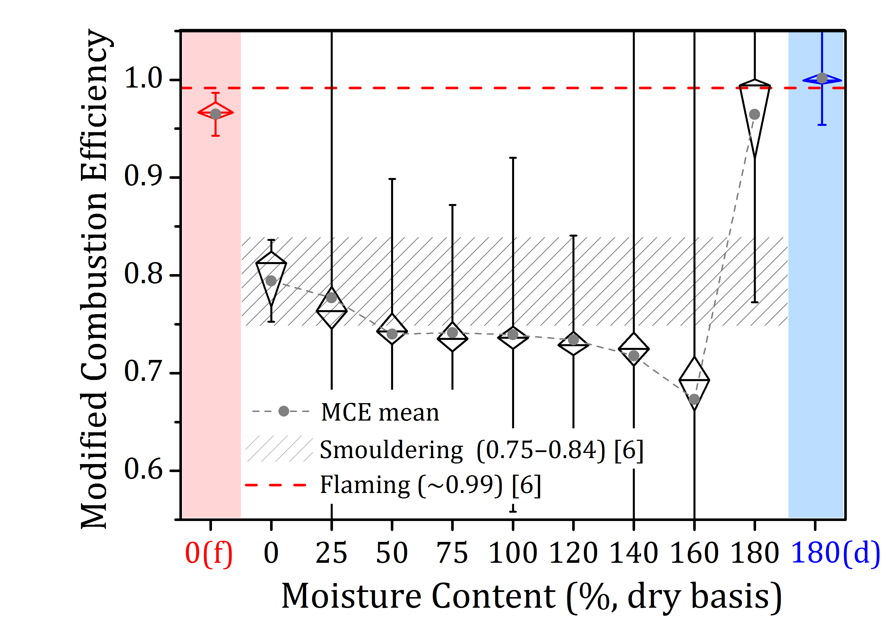
Figure 14 Boxplot of MCE from all peat fire experiments. Each box represents groups of transient MCE data through their lower quartile (25th percentile), the median (50th percentile), upper quartile (75th percentile). “0(f)” on the x-axis refers to flaming peat, “180(d)” refers to drying peat. The error bars show one standard deviation above and below the mean of the data.
Significant variations of the transient MCE were observed in all smouldering experiments of wet peats (one standard deviation above and below the MCE mean was shown as the error bars). This large variability was particularly intense within the ignition stage of a wet peat fire, which was also observed in a previous study [8]. Different natural-occurring fire stages integrate a development cycle of a peat fire, a fire-averaged MCE contradicts the burning dynamics driving the changes of transient MLR under different MCs. This single MCE value also failed to differentiate the chemical reaction pathways (drying, pyrolysis and oxidation) that forms different combustion regimes. This finding necessitates further studies investigating the complex dynamics of a peat fire.
- Conclusion
Controlled bench-scale experiments were carried out to investigate the mass loss, temperature profiles, real-time concentrations of 20 gas species, and size-fractioned particle mass from peat fire under different moisture conditions. For the first time, the combustion dynamics and transient emissions from flaming, smouldering and drying peat are reported.
Moisture was found to affect both the peat combustion dynamics and the fire reaction chemistry. Dry peat can sustain an intense flaming combustion, and emit more characteristic fully oxidised species (for example, CO₂, NO₂ and SO₂) than smouldering peat. It also generates soot particles less than 1µm. For smouldering peat, wet samples emitted less CO₂, CH₄ and NH₃ but more CO and HCN than those when dry. Furthermore, peat was found to favour the formation of particles in the range of 2.5 μm to 10 μm during ignition, while more particles smaller than 2.5 μm were released after the ignition. When the peat became wet enough (with a moisture content larger than 160%), smouldering cannot be sustained.
NH₃ emission from smouldering was found to be at least 600% larger than from flaming fire. As a result, NH₃ could be the best candidate for atmospheric detection of smouldering peat. Furthermore, NH₃ favours the formation of particulate sulphate and nitrate which is one of the most important mechanisms forming haze [28, 29]. Our laboratory finding shows that an increase of 160% moisture content can lead to 84% decrease of the NH₃ emission. This helps conclude that maintaining peatlands to a high moisture content could likely improve regional air pollution by limiting the NH₃ emissions in case of fire.
Modified combustion efficiency (MCE) failed to recognise smouldering wet peats. Subtle MCE differences were found between flaming and drying peat which have totally different dynamics. As a result, large uncertainty can be introduced in the use of fire-averaged MCE for identifying the combustion regime of a peat fire. This work advances the scientific understanding of peat fire, and has the potential to accelerate the development of mitigation strategy against this Earth-scale and unconventional source of emissions.
Acknowledgements
The research has been funded by the China Scholarship Council (CSC) and the European Research Council (ERC) Consolidator Grant HAZE (682587). The authors thank Muhammad Agung Santoso and Wuquan Cui for valuable discussions and help in the lab.
References
[1] M.R. Turetsky, B. Benscoter, S. Page, G. Rein, G.R. van der Werf, A. Watts, Global vulnerability of peatlands to fire and carbon loss, Nat. Geosci. 8 (2015) 11–14.
[2] G. Rein, Smouldering Combustion, in: M.J. Hurley, D.T. Gottuk, J.R.H. Jr., K. Harada, E.D. Kuligowski, M. Puchovsky, J.L. Torero, J.M.W. Jr., C.J. Wieczorek (Eds.), SFPE Handbook of Fire Protection Engineering, Springer, 2015.
[3] Y. Hu, N. Fernandez-Anez, T. E. Smith, G. Rein, Review of emissions from smouldering peat fires and their contribution to regional haze episodes, Int. J. Wildland Fire, 27 (2018) 293–312.
[4] S.E. Page, F. Siegert, J.O. Rieley, H.-D. V. Boehm, A. Jaya, S. Limin, The amount of carbon released from peat and forest fires in Indonesia during 1997, Nature 420 (2002) 61–65.
[5] G. Rein, N. Cleaver, C. Ashton, P. Pironi, J.L. Torero, The severity of smouldering peat fires and damage to the forest soil, Catena 74 (3) (2008) 304–309.
[6] C.E. Stockwell, T. Jayarathne, M.A. Cochrane, K.C. Ryan, E.I. Putra, B.H. Saharjo, A.D. Nurhayati, I. Albar, D.R. Blake, I.J. Simpson, E.A. Stone, Field measurements of trace gases and aerosols emitted by peat fires in central Kalimantan, Indonesia, during the 2015 El Niño, Atmospheric Chem. Phys 16 (2016), 11711–11732.
[7] G. Rein, S. Cohen, A. Simeoni, Carbon emissions from smouldering peat in shallow and strong fronts, Proc. Combust. Inst. 32 (2009) 2489–2496.
[8] Y. Hu, E. Christensen, F. Restuccia, G. Rein, Transient gas and particle emissions from smouldering combustion of peat, Proc. Combust. Inst. (2018), https://doi.org/10.1016/j.proci.2018.06.008.
[9] S. Urbanski Wildland fire emissions, carbon, and climate: emission factors, For. Ecol. Manage. 317 (2014), 51–60.
[10] U. Ballhorn, F. Siegert, M. Mason, S. Limin, Derivation of burn scar depths and estimation of carbon emissions with LIDAR in Indonesian peatlands, Proc. Natl. Acad. Sci. 106 (50) (2009) 21213–21218.
[11] G. Rein, Smouldering fires and natural fuels, in: C. Belcher (Ed.), Fire Phenomena and the Earth System, Wiley and Sons, 2013.
[12] X. Huang, G. Rein, H. Chen, Computational smouldering combustion: predicting the roles of moisture and inert contents in peat wildfires, Proc. Combust. Inst. 35 (3) (2015) 2673–2681.
[13] X. Huang, G. Rein, Downward spread of smouldering peat fire: the role of moisture, density and oxygen supply, Int. J. Wildland Fire 26 (2017), 907-918.
[14] X. Huang, F. Restuccia, M. Gramola, G. Rein, Experimental study of the formation and collapse of an overhang in the lateral spread of smouldering peat fires, Combust. Flame 168 (2016) 393-402.
[15] E. Christensen, Y. Hu, F. Restuccia, M. A. Santoso, X. Huang, G. Rein, Experimental Methods and Scales in Smouldering Wildfires, Chapter 19 in: ‘Fire effects on soils: State of the Art and Methods’, CSIRO, Australia, 2018.
[16] G. Rein, N. Cleaver, C. Ashton, P. Pironi, J.L. Torero, The severity of smouldering peat fires and damage to the forest soil, Catena 74 (3) (2008) 304–309.
[17] M.A. Santoso, X. Huang, N. Prat-Guitart, E. Christensen, Y. Hu, G. Rein, Smouldering Fires and Effects on the Soil: The State of the Art, Chapter 14 in: ‘Fire effects on soils: State of the Art and Methods’, Commonwealth Scientific and Industrial Research Organisation (CSIRO), Australia, 2018.
[18] A. Usup, Y. Hashimoto, H. Takahashi, H. Hayasaka, Combustion and thermal characteristics of peat fire in tropical peatland in central Kalimantan, Indonesia, Tropics 14 (2004) 1–19.
[19] C. Roulston, C. Paton-Walsh, T. E. L. Smith, É.-A. Guérette, S. Evers, C. M. Yule, G. Rein, G. R. Van der Werf, Fine particle emissions from tropical peat fires decrease rapidly with time since ignition, J Geophys Res Atmos 123 (2018) 5607–5617.
[20] R. Hadden, Smouldering and self-sustaining reactions in solids: an experimental approach, PhD thesis, The University of Edinburgh, Edinburgh, UK, 2011.
[21] T.E.L. Smith, S. Evers, C.M. Yule, J.Y. Gan, In situ tropical peatland fire emission factors and their variability, as determined by field measurements in Peninsula Malaysia. Global Biogeochem Cy, 32 (2018), 18-31.
[22] J. Yang, N. Liu, H. Chen, W. Gao, Smouldering and spontaneous transition to flaming over horizontal cellulosic insulation, Proc. Combust. Inst. (2018), https://doi.org/10.1016/j.proci.2018.05.054.
[23] W.H. Frandsen, The influence of moisture and mineral soil on the combustion limits of smouldering forest duff, Can. J. For. Res. 17 (1987) 1540-1544.
[24] Z. Xie, J. Feng, W. Zhao, K.C. Xie, K.C. Pratt, C.Z. Li, Formation of NO_{x} and SO_{x} precursors during the pyrolysis of coal and biomass, Part IV, Pyrolysis of a set of Australian and Chinese coals, Fuel 80 (2001) 2131-2138.
[25] F.J. Tian, J. Yu, L.J. McKenzie, J.I. Hayashi, C.Z. Li, Conversion of fuel-N into HCN and NH₃ during the pyrolysis and gasification in steam: a comparative study of coal and biomass, Energy & fuels, 21 (2007) 517-521.
[26] K.M. Leung, R.P. Lindstedt, W.P. Jones, A simplified reaction mechanism for soot formation in non-premixed flames, Combust. Flame 87 (1991) 289-305.
[27] S.K. Akagi, R.J. Yokelson, C. Wiedinmyer, M.J. Alvarado, J.S. Reid, T. Karl, J.D. Crounse, P.O. Wennberg, Emission factors for open and domestic biomass burning for use in atmospheric models, Atmospheric Chem. Phys. 11 (2011) 4039–4072.
[28] J. Plautz, Piercing the haze, Science, 6407 (2018) 1060-1063.
[29] X. Ye, Z. Ma, J. Zhang, H. Du, J. Chen, H. Chen, X. Yang, W. Gao, F. Geng, Important role of ammonia on haze formation in Shanghai, Environ. Res. Lett. 6 (2011) 024019.

Moisture content is defined as the mass of water divided by the mass of a dried peat sample (expressed as %).

