Steady-State Scratch Testing of Polymers

B.R.K. Blackman^{1*}, T. Hoult¹, Y. Patel¹, H. Steininger², & J. G. Williams^{1,3}
¹ Dept. Mechanical Engineering, Imperial College London, South Kensington Campus, London SW7 2AZ.
² BASF SE, Materials Physics and Analytics, 67056 Ludwigshafen, Germany.
³ AMME Dept. University of Sydney, Sydney, NSW, Australia

(*Corresponding author: +44 (0)20 75947196, email: b.blackman@imperial.ac.uk);
T. Hoult- email: tim.hoult@googlemail.com, Y. Patel- email: yatish.patel@imperial.ac.uk;
H. Steininger- email: helmut.steininger@basf.com, J. Williams-email: g.williams@imperial.ac.uk,

Abstract
The paper extends the notion of steady-state cutting of polymers with a sharp tool to scratching. The analysis assumes there is separation at the tool tip (fracture) and the removed layer undergoes plastic shear. Results are presented for three polymers: PMMA, PC and PBT. For the tougher polymer, PC, smooth scratches were obtained and the modified cutting analysis works well provided that the wear on the initially sharp tip is accounted for. For the more brittle polymers, PMMA and PBT, rougher scratches were obtained and this is consistent with the notion that the polymers exhibited micro-cracking ahead of the tool tip, which led to rough surfaces being generated. The results demonstrate that the fracture toughness and the yield stress are controlling parameters in the scratching process, and that a sufficiently high value of crack opening displacement COD (greater than about 10 μm) ensures that smooth scratches are obtained, as was the case for PC.

Keywords: steady-state scratching, orthogonal cutting, fracture toughness, friction, micro-cracking, damage.

1. Introduction
Thermoplastic polymers are increasingly finding application in a wide range of uses including automotive parts, consumer products and medical devices. In many demanding applications the fracture toughness and yield strength are important properties and a particular challenge has been to develop a toughness test for polymers that possess high toughness and low yield strength, as these materials are difficult to characterise with conventional tests. Such materials often violate the conditions of linear elastic fracture mechanics (LEFM) and an alternative approach is required. Previous research has focussed on the development of an orthogonal cutting test for polymers [1, 2], and this method has been shown to work well for tough polymers exhibiting high ductility. The analysis for orthogonal cutting involved the extension of conventional machining modelling [3] to include the toughness term, as advocated by Atkins [4]. The method has proved successful and a standard test is under development [5].

There are also a significant number of applications where the scratch resistance of the polymer is also important. Examples include the use of polymer layers in automotive clear coats (protecting the paint layers) and in touch screens for mobile devices. There is, therefore, the requirement to develop scratch tests and analyses for polymers that can measure scratch performance and allow the inter-relationship between scratch resistance and other key mechanical properties to be better understood. In the research reported here, the main objectives have been to extend the experimental approach and analysis adopted for the cutting of polymers to scratching. In the tests, a groove is formed on the surface of the flat specimen using a sharp scratching tool with a 90º angle. Such a test has been proposed for the determination of toughness [6] using initiation rather than steady-state scratching. It is not advocated here as a test for toughness measurement because of difficulties in defining the tool profile and the occurrence of micro-cracking, which have been observed to occur. However, the scratch data can be analysed in a similar way to orthogonal cutting data to obtain the toughness and yield strength, albeit to a lower accuracy. The objective has been to demonstrate that the scratching behaviour of polymers is controlled by the properties of toughness and yield strength, and this allows the possibility of controlling their scratch behaviour by the careful selection and manipulation of these material properties.

2. Analysis
The analysis of scratching used here is an extension of that used for steady-state orthogonal cutting using a sharp tool. In that process, there is separation at the tool tip (fracture) and the removed layer undergoes plastic shear along a shear plane, resulting in the off-cut chip [1, 2]. Fig. 1 (a and b) show the details of the scratching process with a tool of rake angle α and a profile giving a projected area A and a perimeter p. Resolving the forces on the shear plane on which there is a shear stress $\frac{σ_{Y}}{2}$ at an angle φ from the horizontal, gives: See Fig. 1b.
$$\left(F_{c}-pG_{c}\right)cosϕ-F_{t}sinϕ=\frac{σ_{Y}A}{2sinϕ}$$
i.e. $\frac{F_{c}}{p}-tanϕ\frac{F_{t}}{p}=\frac{σ_{Y}}{2}\frac{A}{p}\left(tanϕ+\frac{1}{tanϕ}\right)+G_{c}$ ………………………...……………………….1
(Here, $pG_{c}$ may be treated as a force because of the steady-state with the loads moving with the crack, and is equivalent to an energy balance.)
Fig 1a, Fig 1b.
The two material properties of yield strength, σ_{Y ,} and fracture toughness, G_{c}, may be found by performing a series of tests in which the cut depth h is varied, thus changing A and p, and then measuring the cutting force F_{c} and the transverse reaction F_{t}. In addition, φ is required and this may be determined directly from the chip height, h_{c}, see Fig. 2, from,

$tanϕ=\frac{\cos{α}}{{h_{c}}/h-sinα}$……………………………………………………………………………2

In orthogonal cutting, a surface layer of width b and thickness h is removed so that p = b and A = b·h giving:

$\frac{F_{c}}{b}-tanϕ\frac{F_{t}}{b}=\frac{σ_{Y}}{2}h\left(tanϕ+\frac{1}{tanϕ}\right)+G_{c}$………………………….………………………….3

and if h_{c} is measured on the offcut chip, tan φ can be determined using equation (2), and hence σ_{Y} and G_{c} are determined from the slope and Y-intercept of the linear plot of $\left(\frac{F_{c}}{b}-tanϕ\frac{F_{t}}{b}\right)$ versus $\left(\frac{h}{2}\left(tanϕ-\frac{1}{tanϕ}\right)\right)$. This is known as ‘Method 2’ in the proposed standard for finding G_{c} from cutting tests [5].
Fig 2.

In scratching tests, the dimensions of the chips are difficult to measure accurately, particularly at small h values, and so recourse is made here to what is known as ‘Method 1’ from [1, 2] in which φ is determined by minimizing the forces, i.e. the Merchant method [7] i.e.
$\frac{dFc}{dtanϕ}=\frac{dFt}{dtanϕ}=0$ and from equation 1
$-\frac{F_{t}}{p}=\frac{σ_{Y}}{2}\frac{A}{p}\left({1-cot}^{2}ϕ\right)$, and $\frac{Fc}{p}=σ_{Y}\frac{A}{p}cotϕ+G_{C}$..……………………………………4
i.e.
$$cot ϕ={\left(1+\frac{2}{σ_{Y}}\left(\frac{p}{A}\right)\frac{F_{t}}{p}\right)}^{\frac{1}{2}}$$
and
$\frac{F_{c}}{p}=σ_{Y}\frac{A}{p}{\left(1+\frac{2}{σ_{Y}}\left(\frac{p}{A}\right)\frac{F_{t}}{p}\right)}^{0.5}+G_{c}$………………………………………………………………5

Thus, if a set of F_{c} and F_{t} values are measured for a range of h, and hence A and p values, σ_{Y} and G_{c} may be determined numerically to minimize the standard deviations.

The geometry of the scratching tool used here is shown in Fig 2. It is a 90º angled sharp point but, in most cases, the initially sharp point wore away quickly to leave a flat tip of width 2Δ, with a length Δ having been worn away. The length Δ can be measured from the tool directly or from sectioning the resulting groove and measuring the profile. The geometric parameters are:
$p=2\sqrt{2}h+2∆$………………………………………………………………………………..6
and
$A=h\left(h+2∆\right)$………………………………………….……………………………….…….7

3. Materials and Methods
Tests using orthogonal cutting were first performed on the three materials used here, polybutylene terephthalate (PBT), polycarbonate (PC) and polymethyl methacrylate (PMMA). The materials were supplied as injection moulded sheets with nominal thickness of 6 mm which were then annealed to remove residual stresses. The tests were performed as described in [1, 2] and in accordance with a protocol developed by members of the Technical Committee 4 (TC4) on Polymers, Composites and Adhesives of the European Structural Integrity Society (ESIS) [5].

A sharp tool was used with a tip radius of approximately 5 μm and a rake angle α = 15º. Steady-state cutting was achieved for all three materials at a nominal speed of 40 mm/s using cut depths in the range 50 µm to 250 μm. The chip thickness values were measured and φ was determined using equation 2. The measured values of F_{c} and F_{t} were then used in equation 3 to determine G_{c} and σ_{Y} , i.e. by ‘Method 2’ in the protocol. G_{c} and σ_{Y} were also determined via ‘Method 1’, i.e. by minimising the forces, for comparison with the scratching tests, i.e. by using equations 4 and 5.

The scratch tests were performed using a modified version of the apparatus described by Wyeth [8]. Tests were carried out on the same annealed materials as tested in cutting using sharp tools with an initial tip radius of about 5 μm and rake angles α = -30°, -20°, -10°, 0° and 10°. These tools were manufactured by wire electrode discharge machining (EDM), as opposed to the ground tools used in previous work by the authors [1, 2]. This allowed the rake surface to be cut to provide the same projected area for each tool, a 90° triangular facet, whilst providing a 5° relief angle behind the edges of the tool. This relief angle is required to ensure that contact between tool and work-piece only occurs on the rake face.

In orthogonal cutting tests, an initial cut is performed to give a flat surface. In the scratch tests a flat bottomed groove was first cut in the surface to give the shaded profile, as shown in Fig. 3. This provided a smooth surface parallel to the axis of travel of the apparatus, meaning that any further scratches would be of constant depth. This procedure allowed for any errors in aligning the sample with the direction of stage travel, as well as any variation in flatness of the specimen.
Fig 3.
Sharp grooves were then cut into the specimens with the scratching tool. The specimens were nominally travelling at 40 mm/s during the formation of the scratch. A range of scratch depths from 50 µm – 300 μm was achieved. A Wyko NT9100 optical profiler was used to measure the scratch profile, using a green light filter for improved resolution of rough surfaces. In addition, a 20X objective was used with a demagnifier, resulting in an effective magnification of 11X. It is noted that lower power objectives will be incapable of resolving steep sided or rough scratches due to the reduction in numerical aperture of the optics system, but have the benefit of requiring fewer images to profile a large scratch. Profiles were generated of each scratch about its central region, and analysed using a LabVIEW virtual instrument that adjusted for any slope in the unscratched region, and calculated the average build up height and scratch depth for each test.

The grooves were formed by continuous chip formation for all materials and rake angles, with the exception of polycarbonate with a tool rake angle α = -30°. In this case, no grooves were formed and ploughing was the dominant mode of deformation. A degree of ploughing was observed in all tests, with some degree of material built up at the edges of the scratch. This build up was observed to increase as the tool rake angle decreased towards highly negative values.

Where scratch tests produced continuous material removal, the resulting chips were fragile and irregularly curled, unlike those observed during orthogonal cutting. Due to their size and fragility, especially for the more brittle PMMA and PBT specimens, the chips were difficult to handle and measure. Thus, in this case, analysis ‘Method 1’ of the cutting protocol was invoked in which φ is deduced from the Merchant method. This is done by choosing a σ_{Y} value and then, for each set of data, calculating the G_{c} values. The standard deviation (SD) of this G_{c} set is then computed. σ_{Y} is then changed and the process repeated and a new SD is calculated. Thus, the SD in Gc as a function of σ_{Y} can be computed and the minimum in the SD determined, thus giving the best fit G_{c} and σ_{Y} values. In addition, there were conditions under which rough surfaced grooves were produced with load variations and chatter. This behaviour is a series of unstable crack initiations and not the steady-state assumed here. Example force traces for each of the three materials are given in Fig. 4a, 4b and 4c. The data in these cases did not cover a sufficient thickness range to enable the calculation of G_{c} or σ_{Y} to the accuracies achieved in orthogonal cutting. This was due to inaccurate re-setting of the scratching tool after the initial flat bottom groove was cut, resulting in poor control of the applied scratch depth.
Fig 4a, 4b, 4c.
The presence of surface roughness would affect both the perimeter, p, and the area, A, of the groove. From the measured optical profiles and micrographs of the scratch tools, it was realised that the initially sharp steel tool soon became blunt, and this was confirmed in the groove profiles. The tool tips were examined and were generally found to lose about 35 μm from the tip, i.e. to have a 70 μm flat tip for the right-angles initial tips employed.

4. Results
Table 1 shows the orthogonal cutting results for the three materials. Method 2 is the more accurate in that φ is measured using the resulting chip thickness, and PC gives the best results with G_{c} of 2 kJm⁻² ± 6% and a constrained yield stress of 122 MPa. Smooth cutting occurred with no evidence of micro-cracking or surface roughness and the loads showed very small variations. A similar average value of G_{c} was measured for PMMA, i.e. 2 kJm⁻² but with a much greater scatter at ± 40% and a lower limit of 1.2 kJm⁻². There was some surface roughness present and varying loads (± 20%) suggesting micro-cracking. The higher yield stress of 240 MPa would enhance the brittle nature of the cutting. PBT had the lowest toughness at ~1.0 kJm⁻² and the same scatter as PMMA at ± 40% with a lower limit of 0.8 kJm⁻². The yield stress was similar to PC at 127 MPa. As in PMMA, these results suggest the occurrence of micro-cracking. The data from ‘Method 1’ are also shown in Table 1, as used in the scratch tests and shows good agreement with those of ‘Method 2’.
Table 1.
The profile data (p and A as a function of h) for the scratch tests are shown in Fig. 5a, b & c. Examples of the images from which the perimeter p and area A were obtained are given in Fig. 6a and b. In Fig. 5, the data are plotted in accordance with equations 6 and 7 i.e. p vs h and A/h vs h. The analysis would suggest that the former would have a slope of $2√2$and the latter a slope of unity. It is clear from the images in Fig. 6 that the groove is not sharp, and this is reflected in the plots given in Fig. 5 which show positive intercepts. The tools also show the blunting, as indicated in an example photograph given in Fig. 7 which shows about 35 μm had worn away. This was typical and, with this in mind, two lines have been drawn in the graphs in Fig. 5, each with the expected slope but with an intercept of 2Δ = 0 (a sharp tool) and an intercept of 2Δ = 70 μm (a blunt tool).
Fig 5a, 5b, 5c.
Fig 6a, 6b.
Fig 7.
The range of h values for each set of data for the rake angles used reflects the conditions for which it was possible to obtain steady-state scratching and sensibly constant forces. For PBT, there is a great deal of scatter which is particularly apparent in the area (A/h vs h) plots and rather limited ranges of h. The straight line fits provide reasonable bounds, although some perimeter data are beyond the lines. The values of σ_{Y} and G_{c} were then computed from equation 5 using p, A and the measured F_{c} and F_{t} values by varying σ_{Y} and minimising the SD in G_{c}, i.e. ‘Method 1’. The use of the measured flat, 2Δ = 70 μm provided a reasonable way of smoothing the data so the analysis was repeated using p and A computed from h and 2Δ = 75 μm from equations 6 and 7. This is referred to as the corrected analysis, as shown in Table 2. The resulting data are summarised in Table 2a for PBT. The results show considerable scatter, which is slightly improved by using the 2Δ smoothing, but the G_{c} values are all significantly greater than the cutting value with the exception of the α = -30° case. The scatter in A and p probably indicates micro-cracking which would give the higher values and is in accordance with the expectations from the cutting tests.
Table 2a, b, c
By contrast the PC data in Fig. 5b shows much less variation although the α = 10º tool was clearly sharp. The G_{c} and σ_{Y} data in Table 2b are much less scattered then for PBT and the results are similar to the cutting data but with larger scatter. The α = -30° tool gave only ploughing and no chips were formed and the α = -10º tests were not performed.

The PMMA data in Fig. 5c is, as expected, more scattered than PC and similar to PBT. The α = 10° and α = -10° results are over a very narrow range of h and go from a sharp to a blunt form which suggests tool wear occurred during the test. The results in Table 2c give very high SDs at these values, as do the α = -30° data. The α = 0° data were noticeably less scattered in p and A, and gave values of G_{c} via both the analysis using measured values and via the corrected analysis which agreed well with the cutting value. In all cases, the G_{c} values were high in accordance with the notion of micro-cracking having taken place.

5. Discussion
The steady-state orthogonal cutting procedure has been proposed as a test method for determining the fracture toughness of tough, low yield stress polymers where crack blunting can render conventional tests invalid [5]. This combination of high toughness and low yield strength results in these polymers cutting in a continuous manner with almost constant forces (F_{c} and F_{t}) and yields smooth chips. The orthogonal cutting method is not appropriate for polymers with low toughness and/or high yield stress as these materials behave well in LEFM tests and valid G_{c} results can be readily obtained using SENB specimens [9]. However, it has been applied to such materials [1,2] and gave sensible values, although with more scatter, mainly because of the occurrence of micro-cracking and the resulting generation of rough surfaces.

In the present work investigating the scratch test method, the objective was rather different in that it was to establish whether a scratch test equivalent to cutting would give some insight into which properties are important in developing scratch resistant materials. The PC studied here is satisfactory in cutting and, when scratch tests are performed, they conform well to the modified cutting analysis. Due account must be taken, however, of the inevitable wear of sharp tool tips. The data demonstrate that the fracture toughness and the yield stress are controlling parameters and that a fairly high value of the crack opening displacement COD $\left(δ = {G_{c}}/{σ_{Y}} = 17 μm\right)$ seems to ensure smooth scratches. The evaluation of the friction involved is avoided here by measuring the transverse force but does play a part. Values of the coefficient of friction can be estimated from:
$$μ=\frac{tan α+{F_{t}}/{F_{c}}}{1-tan α {F_{t}}/{F_{c}}}$$
Fig. 4 shows the μ values estimated for these force traces, i.e. 0.56, 0.31 and 0.29 respectively for PMMA, PC and PBT.

For the two more brittle materials (COD of 7 μm) gave quite different scratching behaviour than PC with rough grooves resulting from micro-cracking. This gave rise to large scatter in the data and high G_{c} values from the multiple cracks. However, the result is the same in that G_{c} and σ_{Y} are important and the low COD value gives brittle scratching with rough surfaces as opposed to the smooth scratches that were obtained in the more ductile material. The characterisation of these types in terms of scratch resistance and surface appearance will need further investigation.

The polymers studied here exhibited material removal through continuous chip formation for rake angles greater than -30°, but with an increasing degree of ploughing evident as the rake angle decreased. This is consistent with a proposed transition between cutting and rubbing in abrasion [10] and with the behaviour seen during orthogonal cutting with blunt tool radii [11].

It is not advocated here that scratch tests should be used to measure toughness as is suggested in [6]. In more ductile materials, orthogonal cutting is more accurate and, for more brittle materials, micro-cracking leads to large scatter and high values of toughness being determined. The constant depth scratching method presented here requires a greater number of samples than orthogonal cutting, as well as additional work in cutting the initial groove and in measuring the groove profile via profilometry or sectioning. However, if the goal is to measure scratch resistance, then scratch tests should obviously be performed. The methods used here, and their interpretation in terms of toughness and yield strength, should prove valuable in this endeavour.

6. Conclusions
A steady-state orthogonal cutting test and analysis for polymers has been extended to scratching with a sharp tool. The analysis assumes that there is separation at the tool tip (fracture) and the removed layer undergoes plastic shear along a shear plane. As in the cutting test, the scratch test described here requires a series of scratches to be performed cutting scratches of different depths and also using tools of various rake angles. The forces on the tool in the direction of scratching and in the transverse direction were measured and the shear plane angle was determined using Merchant’s force minimisation technique, because the scratch chips were difficult to recover and measure after the tests.
Scratch tests were performed on three polymers, PMMA, PBT and PC. In the tougher of the polymers (PC), smooth scratches were obtained whereas, for the two more brittle polymers (PMMA and PBT), discontinuous chips were formed which were associated with rougher scratch surfaces. It is proposed that this behaviour was due to the existence of micro-cracking ahead of the scratch tool in the two more brittle polymers. Analysis of the sectioned scratch profiles using an optical profiler and also microscopy of the tool tips showed that the tips wore down quickly during the experiments. The tips were shown to develop a worn profile with a flat on the tip of about 70 microns in width, associated with a loss of height on the tip of about 35 microns for the 90° angle tools used. The measured scratch data showed a transition from ‘sharp tool results’ to ‘blunt tool results’. The results suggest that a crack opening displacement of greater than about 10 microns is sufficient to give smooth scratching. It was possible to measure fracture toughness and yield strength from the scratch tests but the accuracy was lower and the scatter was greater than was obtained from orthogonal cutting. However, the scratching test does give useful insights into the mechanisms involved and the role of G_{c}, σ_{Y} and the roughness of the scratches. It is proposed that this additional insight is valuable in the development of more scratch resistant polymers.

References

- Patel Y, Blackman BRK, Williams JG; Measuring fracture toughness from machining tests; Proceedings of the Institution of Mechanical Engineers Part C - Journal of Mechanical Engineering Science;2009; 223; 2861-2869
- Williams JG, Patel Y, Blackman BRK; A fracture mechanics analysis of cutting and machining, Engineering Fracture Mechanics, 210; 77; 293-308
- Williams JG; The fracture mechanics of surface layer removal; International Journal of Fracture; 1970; 170, 37-48
- Atkins AG; Toughness and cutting: a new way of simultaneously determining ductile fracture toughness and strength; 2005; 72; 849-860
- Patel Y, Williams JG, Blackman BRK; Protocol for the toughness determination of polymers from cutting; European Structural Integrity Society (ESIS) TC4 Protocol, version April 2012.
- Akono AT, Ulm FJ; Scratch test model for the determination of fracture toughness; Engineering Fracture Mechanics; 2011; 78; 334-342
- Merchant ME; Mechanics of the Metal Cutting Process. I. Orthogonal Cutting and a Type 2 Chip; International Journal of Applied Physics; 1945; 16; 267-375
- Wyeth, DJ; An investigation into the mechanics of cutting using data from orthogonally cutting Nylon 66; International Journal of Machine Tools & Manufacture; 2008; 48; 896-904
- BS ISO 13586:2000; Plastics. Determination of fracture toughness (G_{IC} and K_{IC}). Linear elastic fracture mechanics (LEFM) approach
- Atkins, AG, Liu, JH; Toughness and the transition between cutting and rubbing in abrasive contacts; Wear; 2007; 262; 146-159
- Blackman BRK, Hoult TR, Patel Y, Williams JG; Tool sharpness as a factor in machining tests to determine fracture toughness; Engineering Fracture Mechanics; 101; 47-58

Tables

Table 1. Orthogonal cutting results for the three polymers investigated.

Material |  | σ_{Y} (MPa) | G_{c} (kJm⁻²) | COD  δ (μm)
PBT | Method 2 | 125 ± 7 | 1.05 ± 0.50 | 8
PBT | Method 1 | 134 | 0.79 ± 0.54 | 8
PC | Method 2 | 122 ± 1 | 2.03 ± 0.12 | 17
PC | Method 1 | 127 | 1.97 ± 0.15 | 17
PMMA | Method 2 | 240 ± 7 | 1.65 ± 0.58 | 7
PMMA | Method 1 | 239 | 2.58 ± 0.23 | 7

Note: Analysis method 1 uses equation 3; analysis method 2 uses equations 4 and 5.

Table 2. Scratch Test Results - values of σ_{y} and G_{c} determined via method 1.

- PBT
 | Rake | Measured perimeter |  | Corrected analysis |  | Orthogonal cutting  Method 1 |  | Orthogonal cutting  Method 2
 | Rake | σ_{Y} (MPa) | G_{c} (kJm⁻²) | σ_{Y} (MPa) | G_{c} (kJm⁻²) | σ_{Y} (MPa) | G_{c} (kJm⁻²) | σ_{Y} (MPa) | G_{c} (kJm⁻²)
* | 10° | 53.08 | 13.49 ± 3.77 | 47.7 | 10.87 ± 3.34 | 126.6 | 1.56 ± 0.42 | 126.9 | 1.30 ± 0.53
 | 0° | 60.62 | 8.82 ± 3.39 | 125.6 | 1.68 ± 2.70
 | -10° | 133.55 | 0.32 ± 2.16 | 95.2 | 2.43 ± 2.25
* | -20° | 46.63 | 9.47 ± 1.99 | 44.3 | 9.53 ± 2.07
 | -30° | 92.27 | 4.22 ± 1.59 | 112.7 | 0.98 ± 1.72

- PC
Rake | Measured perimeter |  | Corrected analysis |  | Orthogonal cutting |  | Orthogonal cutting  Method 2
Rake | σ_{Y} (MPa) | G_{c} (kJm⁻²) | σ_{Y} (MPa) | G_{c} (kJm⁻²) | σ_{Y} (MPa) | G_{c} (kJm⁻²) | σ_{Y} (MPa) | G_{c} (kJm⁻²)
10° | 136.32 | 3.72 ± 0.99 | 114.7 | 1.09 ± 0.72 | 123.3 | 2.17 ± 0.12 | 122.6 | 2.15 ± 0.13
0° | 163.99 | 1.72 ± 1.21 | 171.2 | 1.13 ± 1.29
-20° | 126.87 | 4.86 ± 1.79 | 145.2 | 2.83 ± 1.64

(c)PMMA
 | Rake | Measured perimeter |  | Corrected analysis |  | Orthogonal cutting  Method 1 |  | Orthogonal cutting  Method 2
 | Rake | σ_{Y} (MPa) | G_{c} (kJm⁻²) | σ_{Y} (MPa) | G_{c} (kJm⁻²) | σ_{Y} (MPa) | G_{c} (kJm⁻²) | σ_{Y} (MPa) | G_{c} (kJm⁻²)
* | 10° | 219.40 | 5.19 ± 2.35 | 180.3 | 5.02 ± 3.61 | 233.1 | 2.67 ± 0.60 | 238.5 | 1.94 ± 0.75
 | 0° | 204.09 | 1.91 ± 1.14 | 210.0 | 1.50 ± 0.91
* | -10° | 130.76 | 12.35 ± 8.21 | 100.6 | 16.13 ± 8.47
 | -20° | 162.35 | 6.73 ± 1.36 | 189.6 | 3.09 ± 1.09
* | -30° | 97.5 | 14.2 ± 10.20 | 129.4 | 12.3 ± 4.8

*Incomplete data sets due to load variations and scratch depth range arising from micro-cracking.

Fig. 1 Scratch tool geometry (a) View in scratch direction and (b) side view
Fig. 2 Geometry of the worn tool (for corrected analysis): Former tool angle 90°, worn tip approximated as flat.

Fig. 3 Initial groove cut prior to scratch testing to provide a flat surface

a. (PMMA): α = -10^{o,} μ = 0.56
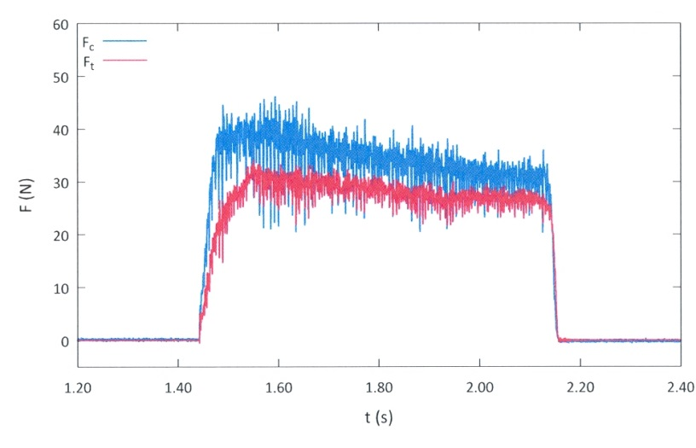

b. (PC): α = -10^{o,} μ = 0.31

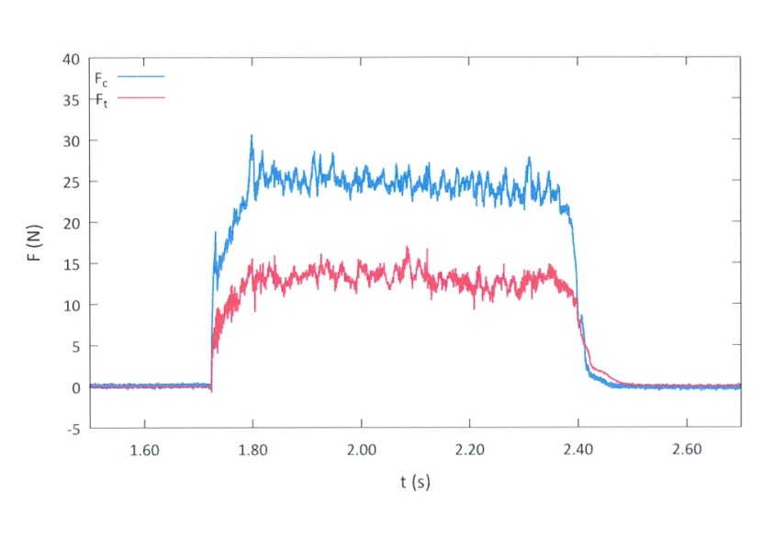
c. (PBT): α = -10^{o,} μ = 0.21

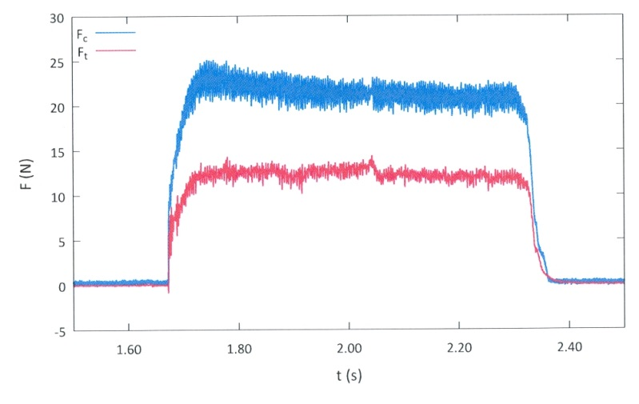

Fig. 4 Typical force traces for constant depth scratching at a rake angle of -10° for (a) PMMA, (b) PC and (c) PBT. µ denotes the coefficient of friction.

(a) PMMA

- PC

(c) PBT

Fig. 5 Perimeter, p, and area, A, data as a function of scratching depth, h, for various rake angles ranging from 10° to -30°. The two straight lines drawn indicate the expected situation for a sharp (intercept: 2Δ = 0) and a blunt (intercept: 2Δ = 70 μm) tool.

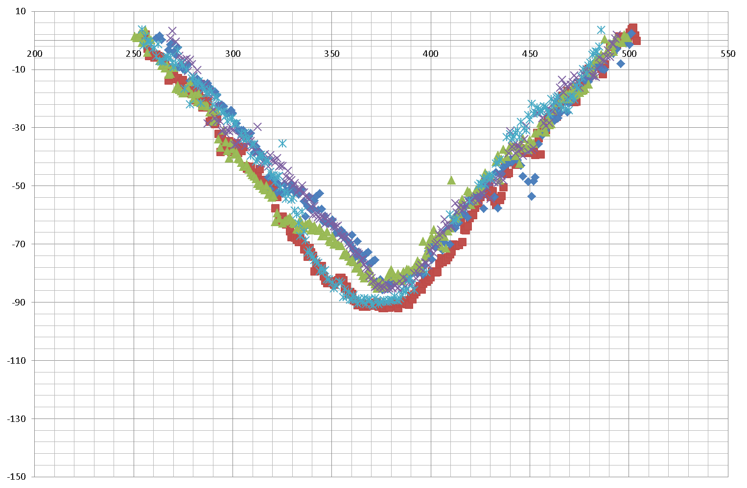

a) -30º rake angle

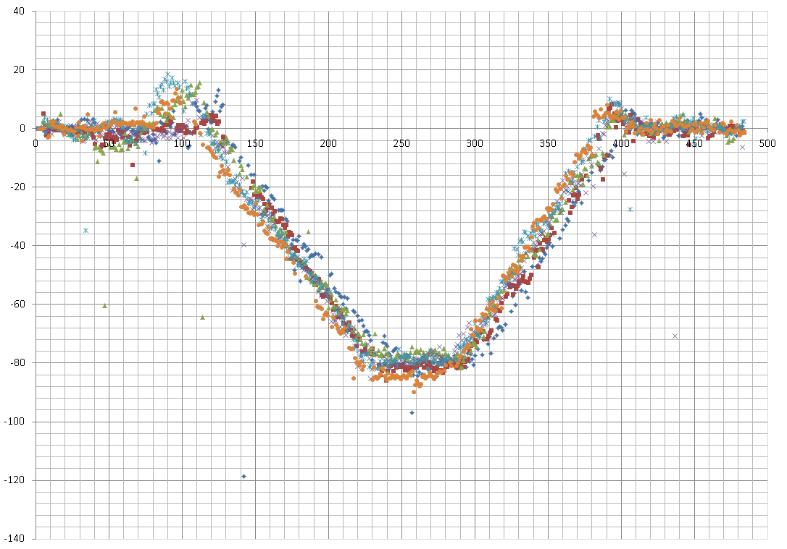
b) -20º rake angle

Fig. 6 Groove profiles at rake angles of (a) -30° and (b) -20°

Fig. 7 Profile of a worn 90° tool. An initially pointed tip became flat

