Effect of infill architecture on structural performance and sustainability of 3D-printed reinforced concrete columns
Vuong Nguyen-Van^{a,*}, Cheah Chun Jie^{b}, Y.X. Zhang^{c}, Hong S. Wong^{d}
ªCIRTECH Institute, HUTECH University, Ho Chi Minh City, Vietnam
^{b}School of Civil and Environmental Engineering, Nanyang Technological University, 50 Nanyang Avenue, Singapore 639798, Singapore
^{c}School of Mechanical and Mechatronic Engineering, Faculty of Engineering and Information Technology, University of Technology Sydney, 81 Broadway, Ultimo, NSW 2007, Australia
^{d}Centre for Infrastructure Materials, Department of Civil and Environmental Engineering, Imperial College London, London, SW7 2AZ, UK

*Corresponding author:
Email: nv.vuong@hutech.edu.vn

ABSTRACT
This study presents a holistic design-to-performance investigation of 3D-printed reinforced concrete (RC) columns featuring sinusoidal infill patterns, targeting both structural optimisation and sustainability. The primary contribution lies in the development and fabrication of functionally graded, lightweight RC columns using additive manufacturing, integrated with conventional reinforcement and cast mortar. Among four parametrically designed configurations (CS0 – non-peak sinusoidal infill, CS4 – 4-peak sinusoidal infill, CS8 – 8-peak sinusoidal infill, CS12 – 12-peak sinusoidal infill), the CS12 column is selected for physical fabrication and testing under uniaxial compression. The experimental results provide insights into load-bearing capacity and failure mechanisms, which are then used to calibrate a validated finite element model. The model enables an extensive parametric study comparing the four infill designs, focusing on structural efficiency, stress distribution, and damage progression. A cradle-to-gate life cycle assessment (LCA), conducted following the parametric analysis, quantifies the environmental impact of each configuration per unit mechanical strength. Results reveal that columns with CS8 and CS12 infill geometries achieve superior capacity-to-mass ratios and reduce global warming potential (GWP), demonstrating that infill architecture can be strategically tuned to optimise both performance and sustainability. This work advances digital concrete fabrication by providing a scalable framework for performance-driven and environmentally responsive column design.

Keywords: 3D printing of concrete; lightweight structural design; finite element analysis; sustainable construction materials; reinforced concrete columns.

Introduction
The emergence of digital concrete fabrication technologies marks a paradigm shift toward more efficient and digitally integrated building practices in the construction sector. 3D concrete printing (3DCP) has gained particular attention due to its direct layer extrusion capability from digital models without the need for traditional formwork [1-4]. This method offers enhanced control over the construction and design process, allowing for the creation of optimised and complex geometries that minimise material consumption while improving structural performance [5-9]. Furthermore, this approach supports sustainable construction by fostering the use of recycled and low-carbon concrete, shortening construction time, and reducing wastage and labour demands [10-14]. As more efforts have contributed to refining the long-term durability and mechanical performance of 3D-printed concrete elements, this technology presents a promising pathway toward more environmentally responsible and resilient infrastructure [15-19].
Reinforced concrete (RC) columns are critical load-bearing components that provide vertical support and ensure the integrity and stability of concrete infrastructure [20]. As such, there is growing interest in increasing the design flexibility and potential for sustainable construction of RC columns in digital fabrication and concrete automation [21]. However, applying 3DCP to fabricate RC columns poses notable challenges, including difficulties in integrating reinforcement into the layer-by-layer deposition process, maintaining consistent properties across complex geometries, and achieving sufficient structural integrity [1, 22]. Various strategies have been explored to address these challenges, such as developing novel printable mixtures with improved mechanical properties by incorporating fibres to replace traditional reinforcement, and using robotic systems for steel placement [23-25]. Given that ongoing research continues to resolve current limitations and key technical barriers, 3DCP holds considerable promise for transforming how RC columns are constructed and designed [26-28].
Infill architecture is a key design parameter of internal geometrical configurations for confinement effects (e.g. areas of varying density, cellular structures, and lattice patterns) in both conventional RC and increasingly in 3D-printed concrete structures [29-31]. Extensive research on confinement mechanisms, such as the fibre reinforced polymer (FRP)-based strengthening systems documented by Rousakis et al. [32, 33], has demonstrated that lateral restraint delays dilation, redistributes stresses, and enhances axial strength and ductility. In 3D concrete printing (3DCP), infill architecture refers to the internal structure of a 3D-printed concrete element, designed to optimise material usage, strength, and printing time, rather than printing a solid object [30, 34]. Unlike traditional solid RC components, strategic design of infill architectures in 3DCP enables researchers and engineers to optimise and tailor structural and mechanical performance (ductility, stiffness, load-bearing capacity), fabrication time, and weight while simultaneously enhancing sustainability and material efficiency [34-37]. Bos et al. revealed the potential of using lattice and cellular infill configurations in 3DCP to substantially reduce the amount of mortar required without compromising structural performance due to localised stress mitigation and optimised load distribution pathways [1]. Panda et al. also highlighted the influence of infill geometries in 3D-printed concrete samples on improving mechanical behaviours (improved post-peak ductility and compressive strength) [23]. Moreover, optimising infill patterns in 3DCP can reduce carbon footprint and embodied energy by minimising overall material usage and cement content [38, 39]. As such, infill architectures not only contribute to performance-based design but also align with sustainable construction practices by reducing environmental impact and promoting material efficiency.
Despite the emerging interest in infill architectures in 3D-printed concrete structures, current studies have predominantly focused on the mechanical performance and sustainability of plain printed concrete components (beams and walls), with limited attention to the effect of infill patterns on the structural behaviours of 3D-printed concrete columns [34, 40-42]. A significant gap remains in understanding how varying infill architectures affect the mechanical performance of 3D-printed reinforced concrete columns under loading. The mechanical behaviours of 3D-printed concrete elements with discrete and continuous reinforcement strategies have been investigated [43-45]. However, most existing work neglects the complex interactions between infill geometries, load transfer mechanisms, and reinforcement placement in 3D-printed columns, with assumptions of homogeneous or solid geometries [46-49]. Furthermore, a combination of 3D concrete printing, permanent formwork and casting with reinforcements, without any joints in the assembly, has been employed to fabricate reinforced concrete columns [50-52]. These studies revealed that the approach does not meet the requirements of conventional concrete columns because the 3D-printed concrete formworks were prone to breaking under loading, undermining the overall performance of the concrete columns. Addressing these gaps with the sustainability implications of adopting various infill strategies is important for optimising both environmental impact, mechanical performance, and structural integrity of 3D-printed reinforced concrete columns. This helps pave the way for their broader adoption in load-bearing applications and sustainable construction practices.
This paper investigates the development of lightweight, structurally efficient, and environmentally sustainable 3D-printed reinforced concrete (RC) columns through the strategic use of novel infill patterns. The central premise is that material usage can be reduced without compromising structural integrity by manipulating internal geometries, enabled by 3DCP, thereby achieving both structural optimisation and sustainability enhancement. This design approach addresses growing demands in the construction industry for low-carbon, resource-efficient building systems. The study adopts a multidisciplinary methodology that integrates experimental testing, finite element modelling (FEM), and life cycle assessment (LCA) to comprehensively evaluate the impact of various infill patterns on load-bearing performance, material efficiency, and carbon footprint. The FEM framework in this study is employed to simulate the structural response of the reinforced 3D-printed columns, providing deeper insight into stress distribution and deformation mechanisms and supporting the optimisation of infill pattern strategies in line with recent advances in FEM-based structural assessment [53]. The novelty of this research lies not only in the application of infill design to reinforced concrete columns (rarely explored in current literature) but also in the integrated framework combining physical experiments, numerical simulations, and environmental assessments. Furthermore, the incorporation of reinforcement into 3D-printed concrete columns with complex infill geometries represents a significant technical innovation. This holistic approach facilitates the development of next-generation structural components that align with global sustainability goals by reducing emissions, material waste, and structural mass. The size of the 3D-printed concrete column in this study is 270 mm in diameter and 700 mm in height. As demonstrated in some studies in the literature [41, 54], a single full-scale specimen is typically tested for large-scale structures, and reliability is ensured through detailed numerical-experimental calibration rather than statistical repetition.

Design of 3D-printed column and experiment programs

2.1 Design of 3D-printed column with different infill patterns
This section describes the design of 3D-printed reinforced concrete columns with different infill patterns. To optimise structural efficiency and material usage in 3D-printed lightweight concrete columns, four distinct cross-sectional designs are developed, as illustrated in Figure 1. These configurations incorporate varying degrees of internal infill complexity, targeting enhanced load transfer and reduced material consumption while maintaining structural integrity. The external geometry of all columns remains constant, with a concentric circular hollow core. The blue regions in the figure denote the 3D-printed components, while the grey regions represent the cast mortar infill. Each design is formulated to investigate the structural and sustainable impact of internal sinusoidal reinforcement patterns characterised by smooth, wave-like geometries connecting the inner and outer printed walls. These serve to enhance structural integrity by promoting uniform stress distribution, increasing mechanical interlocking with the cast mortar, and reducing material usage. In other words, the sinusoidal infill shape is selected because it provides a continuous, smooth, and fully printable geometry that satisfies the kinematic constraints of extrusion-based 3D concrete printing while ensuring consistent filament deposition without sharp corners or abrupt curvature changes. This sinusoidal shape was proven to be effective in bearing the load of lightweight 3D-printed concrete beams in the author’s previous work [34]. The three peak numbers (4, 8, and 12), therefore, serve as a systematic parametric set to evaluate how increasing the frequency of the sinusoidal waveform influences confinement efficiency and structural performance.
To be specific, the design in Figure 1a contains no sinusoidal infill (CS0 column), consisting solely of a printed ring shell and central hollow core with the annular space cast in mortar. This baseline design provides a comparison for evaluating the effect of added infill geometries. CS4 column incorporates a 4-peak sinusoidal pattern connecting the inner and outer walls of the printed structure (see Figure 1b). This design introduces moderate internal reinforcement, potentially improving stress distribution across the cross-section. Meanwhile, the design in Figure 1c features an 8-peak sinusoidal infill (CS8 column), increasing the frequency and connectivity of the internal printed filaments. This pattern aims to provide enhanced mechanical interlocking and improved resistance to localised deformation. The last concrete design (CS12 column) utilises a 12-peak sinusoidal pattern, offering the densest infill among all variations. This design maximises internal connectivity and support, potentially leading to higher structural performance while reducing the amount of cast mortar required. These geometries are generated parametrically to ensure consistency in outer dimensions and total volume. The integration of sinusoidal printed infill in CS4, CS8, and CS12 configurations introduces a novel architectural approach to achieving material efficiency and mechanical enhancement in the additive manufacturing of concrete columns.
The selection of the sinusoidal infill configurations with 4, 8, and 12 peaks is determined through a combination of fabrication constraints and structural considerations. Specifically, the minimum allowable spacing between adjacent peaks is governed by the geometric resolution of the printing system, defined by a 10 mm nozzle diameter and a 5 mm layer height, ensuring stable filament placement without overlap or deposition defects. Candidate infill patterns are first screened to satisfy these process limitations. Then, preliminary numerical assessments are conducted to eliminate configurations that either lacked sufficient confinement (too few peaks) or resulted in excessive material density with marginal structural benefit (too many peaks). The 4-, 8-, and 12-peak patterns are therefore selected as the most representative and mechanically meaningful variants, offering a progressive increase in internal connectivity and enabling a systematic evaluation of the influence of infill complexity on the structural performance of 3D-printed columns.
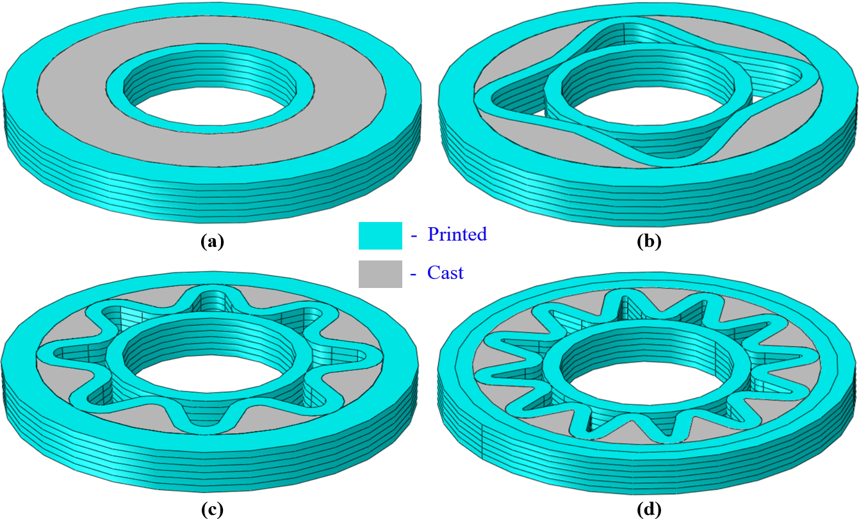
Figure 1. Different cross-sectional designs for 3D-printed lightweight concrete columns: (a) CS0 – column without sinusoidal infill, (b) CS4 – column with 4-peak sinusoidal infill, (c) CS8 – column with 8-peak sinusoidal infill, and (d) CS12 – column with 12-peak sinusoidal infill.
Among the proposed column designs, the CS12 configuration (featuring the most intricate internal geometry) is selected to illustrate the 3D concrete printing (3DCP) process and reinforcement integration. This approach ensures a consistent methodology applicable to all other designs (CS0, CS4, and CS8), while maximising structural interlocking and material efficiency. Figure 2 presents the configuration of the CS12 column, highlighting both the geometrical design of the 3D-printed portion and the post-printing reinforcement and assembly process. Herein, Figure 2a shows the detailed geometric and dimensional specifications of the printed part. The column section consists of three primary filament zones: outer filaments, inner filaments, and sinusoidal infill filaments. The external diameter of the column is 270 mm, including two concentric printed rings separated by a 120 mm annular infill zone. Each sinusoidal peak connects the inner and outer rings and contributes to mechanical interlocking and load distribution. The height of each printed layer is 5 mm, with the total layer count dictated by the column height. The outer ring width is 45 mm, and the inner ring has a diameter of 120 mm. Printed and cast zones are carefully delineated to allow seamless integration of reinforcement and cast mortar.
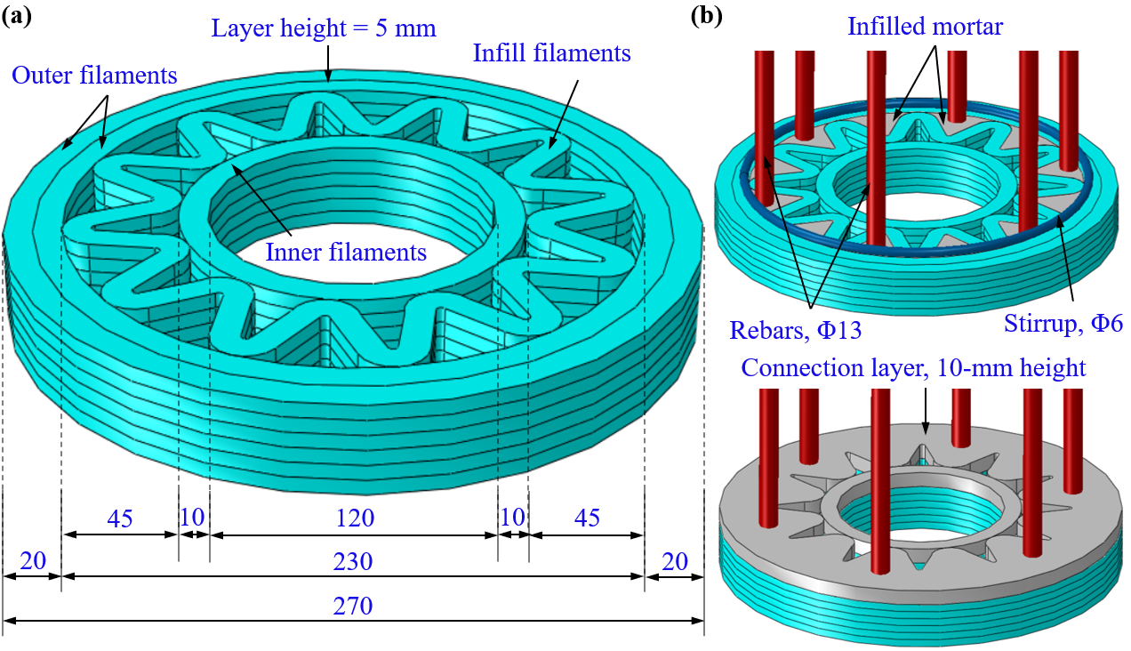
Figure 2. Configuration of the CS12 column (unit in mm): (a) detailed dimensions of the printed part and (b) reinforcement arrangements of the column with infilled mortar.
Figure 2b illustrates the structural reinforcement configuration and mortar infill strategy used after the printing phase. The reinforcement includes vertical steel rebars (Φ13 mm) strategically placed within the column’s annular space, supplemented by circular stirrups (Φ6 mm) to enhance lateral confinement. These reinforcements are embedded into the printed geometry through a designated 10-mm-high connection layer that ensures mechanical interlock between printed and cast mortar. After placing the reinforcement cage, the same mortar as used for printing is poured into the voids between the sinusoidal filaments to fully integrate the reinforcement and printed shell. This layered assembly approach promotes efficient construction sequencing and ensures the composite action between printed and cast elements. This hybrid method, combining additive manufacturing with traditional reinforcement and casting techniques, facilitates the fabrication of structurally robust, sustainable concrete columns. The modular nature of the process also enables adaptability for various design topologies, including CS0, CS4, and CS8, without altering the core fabrication workflow.

2.2 Experimental procedures

2.2.1 Low-carbon mix for 3D printing
A low-carbon mortar mix is developed by incorporating industrial by-products and advanced admixtures to ensure sustainability and printability in 3D-printed reinforced concrete columns in this study. The mortar design prioritises material circularity and performance suitable for extrusion-based 3D printing applications. The binder system consists of a ternary blend of ordinary Portland cement (OPC), ground granulated blast-furnace slag (GGBS), and silica fume (SF), formulated to reduce carbon emissions and enhance rheological behaviour. Specifically, the binder mix comprises 20 wt% OPC, 60 wt% GGBS, and 20 wt% SF. The chemical compositions of these materials are summarised in Table 1. The OPC primarily contains CaO (64.2%) and SiO₂ (21.3%), while GGBS exhibits a high content of CaO (39.9%), SiO₂ (33.5%), and Al₂O₃ (10.5%), contributing to the pozzolanic and latent hydraulic activity of the mix. SF, characterised by its ultrafine particle size and high SiO₂ content (94.6%), plays a critical role in enhancing the packing density and early strength development.
Table 1. Chemical composition of binders (% weight)
 | CaO | Al₂O₃ | SiO₂ | Fe₂O₃ | MgO | K₂O | Na₂O | SO₃ | TiO₂ | B₂O₃
OPC | 64.2 | 3.9 | 20.2 | 2.9 | 1.4 | 0.4 | 0.3 | 2.3 | 0.3 | -
SF | 0.3 | 0.4 | 94.6 | 0.1 | 0.2 | 0.2 | - | 0.8 | - | -
GGBS | 39.9 | 10.5 | 37.5 | 0.3 | 8.4 | 0.3 | - | 0.1 | 0.5 | 0.1

The final 3D printable mortar mix design is provided in Table 2, with component proportions in kg/m³. The mix design is based on the reference mix in the author's previous work, which has been proven to be printable [55]. The mix includes OPC, GGBS, and SF, with fine silica sand as fine aggregate. A low water-to-binder ratio (w/b) of 0.25 is employed, ensuring a balance between extrudability and buildability. The sand used has a mean particle size of 0.2 mm, and a sand-to-binder ratio of 0.4 is adopted based on preliminary trial mixes. To achieve the necessary flow characteristics for 3D printing, the mix is modified using chemical admixtures: a polycarboxylate-based high-range water-reducing agent (superplasticiser, SP) and a viscosity-modifying admixture (VMA). These are incorporated at 0.12% and 0.25% (by weight of binder), respectively. The SP enhanced flowability under shear, whereas the VMA improved shape stability and resistance to segregation during layer deposition [56].
Table 2. 3D printable mortar mix design (unit: kg/m³)
Cement | GGBS | Silica fume | Sand | Water | SP | VMA
167 | 503 | 167 | 335 | 209 | 1.0 | 2.1

This optimised formulation supports layer-by-layer construction while significantly reducing the carbon footprint compared to conventional cementitious systems. The synergy between mineral admixtures and chemical modifiers enables a robust, extrudable mortar suitable for fabricating complex geometries in 3D-printed structural elements [55]. The flow/spread diameter from the flow table tests is measured to evaluate the flowability of the printable mortar. The test is conducted following the ASTM 1437 [57]. The slump flow diameter is 154 mm, which still lies within the range (130 mm to 160 mm) recommended for 3D printable mortars [58].

2.2.2 Digital fabrication of reinforced concrete column
In this section, the 3D concrete printing (3DCP) and assembly process of the reinforced concrete column (CS12 column) are described. The reason for testing only CS12 is that it represents the largest deformation capacity and the most structurally complex geometry, and thus provides the most stringent case for validating the FEM framework. Figure 3 shows the 3DCP process for fabricating one segment of the CS12 column (column with 12-peak sinusoidal infill) using a gantry-based 3D concrete printer and a completed 3D-printed segment with a height of 200 mm. The mortar used for printing is prepared in a single batch using a 20 L Hobart mixer. The dry constituents (cement, silica fume, ground granulated blast-furnace slag (GGBS), and sand) are initially blended at a low speed of 120 rpm for two minutes to ensure uniform distribution. Subsequently, the superplasticiser (SP), previously dispersed in tap water, is introduced to the dry mix, followed by mixing at a higher speed of 360 rpm for three minutes to achieve a homogenous consistency. A viscosity-modifying agent (VMA) is then added, and the mixture is further blended at low speed for an additional two minutes. Once the mortar reaches the desired rheological properties, it is transferred into the extrusion barrel of the gantry 3D concrete printer. The geometry of the CS12 column, including its cross-sectional features, is designed using SolidWorks and exported as an STL file format for slicing via Simplify3D software. The resulting toolpath is compiled into a G-code dataset, based on defined printing parameters, to guide the printing operation. A circular nozzle with a diameter of 10 mm is utilised for extrusion, producing a filament with a width of 10 mm and a height of 5 mm. This configuration is selected to optimise inter-layer bonding and printed layer stability [2, 59]. During the printing process, the nozzle operates at a travel speed of 20 mm/s.
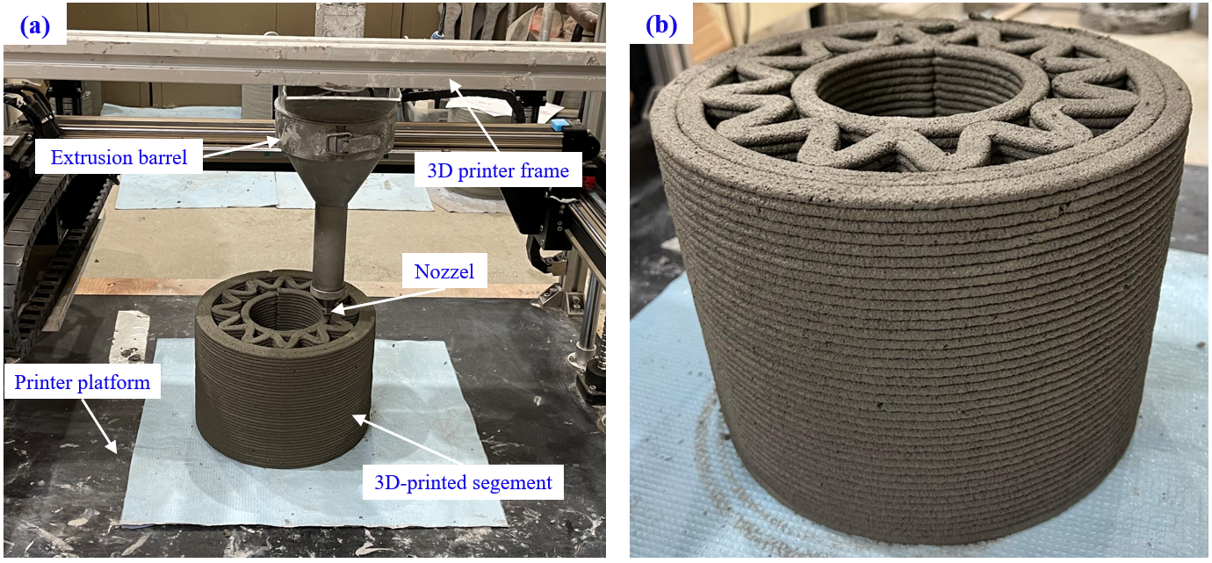
Figure 3. (a) 3D concrete printing process of one segment of the CS12 column and (b) 200 mm height of a 3D-printed concrete segment.
The segmentation strategy adopted for printing the CS12 column is based on the operational constraints of the printer, with a maximum build volume of 500 mm (length) × 400 mm (width) × 300 mm (height), and the need to accommodate both the longitudinal reinforcement bars and the transverse confinement reinforcement (stirrups) within the printed geometry. The printed segment depicted in Figure 3b illustrates a single 200 mm-high unit, highlighting the controlled layer deposition and the complex internal geometry achieved through this process. To ensure the structural performance and continuity of load transfer in the CS12 column, a robust reinforcement and assembly strategy is developed based on modular 3D-printed concrete segments. As illustrated in Figure 4, the assembly sequence and integration of reinforcement are critical to achieving structural integrity while accommodating the unique characteristics and tolerances inherent in the 3D printing process. In this regard, Figure 4a presents the 3D-printed concrete segments, including two 30 mm-height segments placed at two ends (one at the bottom and the other at the top) and three 200 mm-height segments placed in the middle (middle segments). These segments are fabricated individually using an extrusion-based additive manufacturing process and stacked to form the full column. Figure 4b shows the reinforcement mesh, comprising a prefabricated vertical cage assembled from high-strength steel rebars. Vertical bars are arranged uniformly around the circumference, connected by horizontal stirrups placed at regular intervals to resist shear and provide lateral stability. The reinforcement cage is dimensioned to meet structural requirements for vertical load-bearing and to maintain continuity across all segments. This prefabricated cage is designed to be centrally embedded within the 3D-printed shell during the post-casting phase.
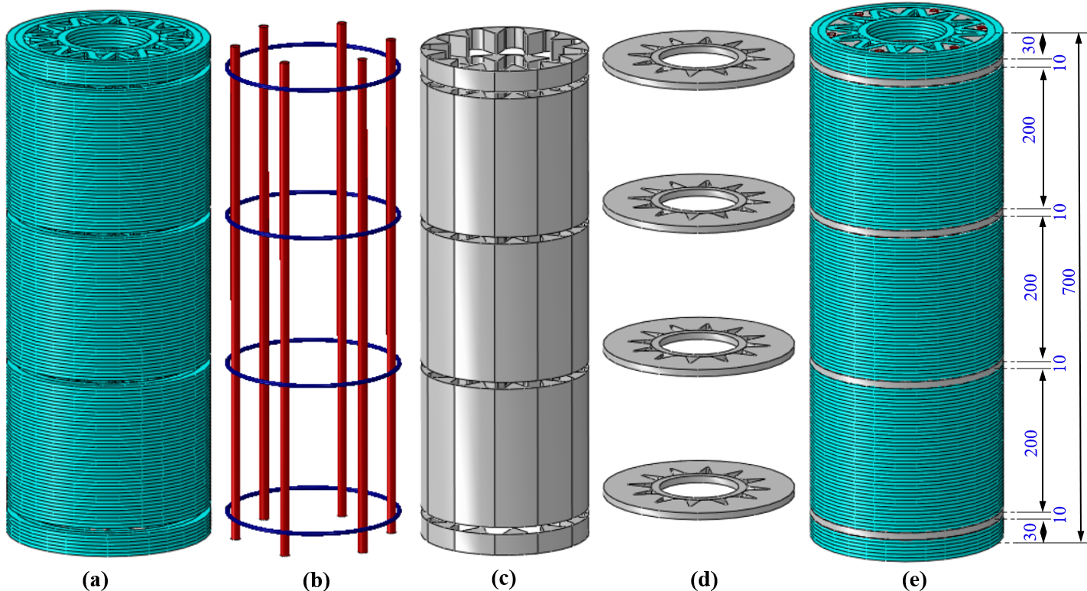
Figure 4. Composition of the CS12 column: (a) 3D-printed part, (b) reinforcement mesh, (c) infilled mortar, (d) connection layers, and (e) CS12 column after assembly.
Figure 4c depicts the mortar infill phase, wherein the same printable mortar is poured into the hollow core of each segment post-printing to encapsulate the reinforcement cage. This stage ensures full contact between the printed shell and the structural core, thereby improving composite action and axial load-carrying capacity. Figure 4d illustrates the incorporation of connection layers between segments. These layers serve as intersegmental joints, allowing precise alignment and vertical reinforcement continuity during assembly. The joints are formed by a combination of mechanical interlocking features and a high-bond mortar interface, which enhances shear transfer and interfacial adhesion. The intermodule connection zones are carefully designed to tolerate minor dimensional variations that may arise during the printing process, enabling accurate and reliable on-site installation. Figure 4e shows the final assembled CS12 column, consisting of five vertically stacked 3D-printed segments connected through joint interfaces. Each segment aligns accurately with the next to ensure structural verticality and dimensional consistency. The segmentation and reinforcement strategy facilitates modular transportation, ease of assembly, and ensures that the complete column meets structural performance criteria in terms of both load transfer and stability. This integrated reinforcement and assembly approach addresses the challenges of vertical reinforcement continuity, structural bonding between layers, and field constructability while leveraging the geometric flexibility of 3D concrete printing.
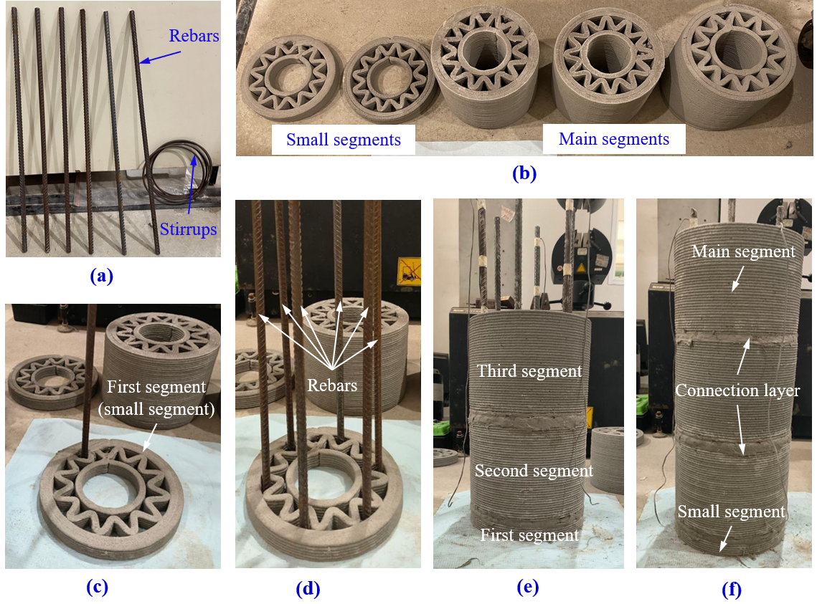
Figure 5. The assembly process of the CS12 column: (a) reinforcements (rebars and stirrups), (b) two small segments and three main segments; (c) and (d) positioning rebars on the first segment; (e) and (f) connecting main segments with small segments using mortars to complete the assembly process of the reinforced concrete column.
To fabricate the full-scale CS12 reinforced concrete column, five segments are printed, comprising two smaller end segments and three larger main segments, as shown in Figure 5b. The assembly process begins with the preparation of six vertical steel rebars and four circular stirrup rings (Figure 5a), which together form the internal reinforcement cage designed to meet structural continuity and load transfer requirements. As depicted in Figure 5c, the initial step of the assembly process involves placing the first (bottom) small segment on the assembly platform. The six longitudinal rebars are then inserted into pre-designed voids within this segment, precisely aligned in their designated positions (Figure 5d). These rebars extend vertically to accommodate the height of the entire column, ensuring uninterrupted vertical reinforcement throughout. Following this, the remaining segments (three additional main segments and one top small segment) are stacked sequentially from bottom to top (Figure 5e and Figure 5f). During this stage, fresh mortar (identical in composition to the 3D-printed mix) is used to fill the annular gaps between the extruded filament walls and the inserted reinforcement, as well as the intersegment connection layers. A vibration table is utilised during the grouting phase to ensure adequate compaction of the fresh mortar and to improve the interface quality between the cast mortar and the 3D-printed concrete. This step enhances both the mechanical performance and the durability of the assembled column by minimising voids and promoting full encapsulation of the reinforcement. Upon completion of the assembly, the column is subjected to air curing for 28 days under ambient laboratory conditions (22°C). Following the curing period, the column is transported to a universal testing machine for axial compressive load testing to evaluate its structural performance under uniaxial stress. This step-by-step assembly process demonstrates the feasibility of integrating reinforcement within a 3D concrete printing workflow while maintaining structural functionality and geometric accuracy through hybrid digital and manual construction techniques.

2.2.3 Large scale structural testing of 3D printed CS12 column under compression loading
This section describes the large-scale structural testing of the hardened state of the CS12 column (with 12-peak sinusoidal infill) under compression loading. The uniaxial compression test is conducted using a high-capacity 5,000 kN servo-hydraulic-controlled testing machine to evaluate the axial load-bearing capacity and failure mechanisms of the fully assembled 3D-printed reinforced concrete column. Both the schematic and actual test setups are shown in Figure 6, illustrating the instrumentation layout and boundary conditions employed during testing. The test is carried out under displacement-controlled loading with a constant rate of 0.2 mm/min, which enables a stable load application and facilitates observation of the post-peak response. The CS12 column is axially loaded between a reaction beam and a strong floor, with the actuator placed at the base to apply the compressive force vertically. The actuator is programmed to terminate the test once the axial load has dropped to approximately 25% of the peak load, indicating substantial structural degradation and crack propagation in the specimen. To capture the full-field deformation behaviour, a comprehensive instrumentation system is installed, which includes linear variable differential transformers (LVDTs) placed in both horizontal and vertical directions to continuously measure axial and lateral expansion. Two axial LVDTs are mounted at the top of the actuator to record the vertical displacement with high precision, while horizontal LVDTs, fixed perpendicular to the column axis at the middle, are used to track lateral dilation of the column under increasing compressive stress.
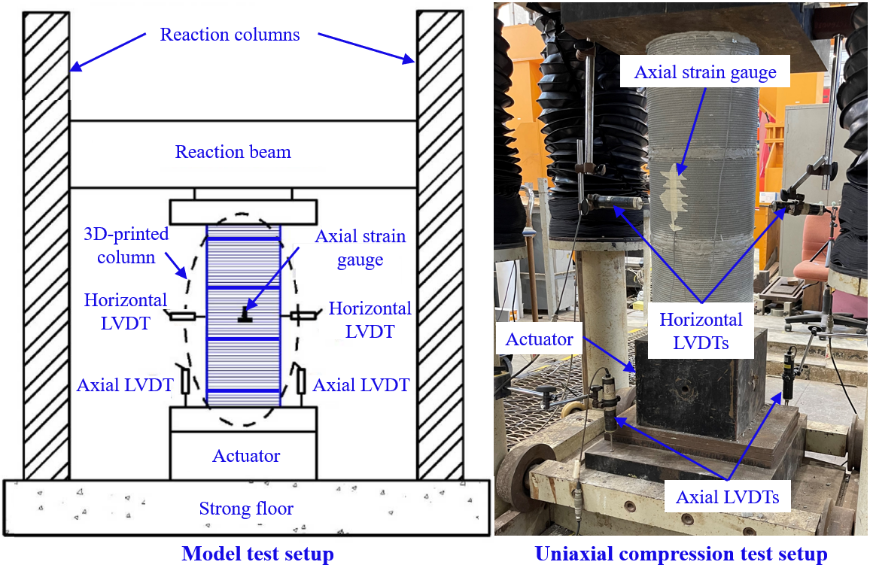
Figure 6. Uniaxial compression test setup of CS12 column (with 12-peak sinusoidal infill).
Additionally, electrical resistance strain gauges are affixed to the column surface at mid-height in both the axial and lateral directions to monitor strain development during the elastic and early inelastic stages. These strain gauges provide valuable data for assessing the stiffness characteristics and yield behaviour of the columns. As the axial load approaches and surpasses the peak value, surface cracks become visible, marking the onset of structural fracturing in the post-peak regime. Beyond this point, strain gauge readings become unreliable due to cracking and spalling. Thus, LVDTs are primarily relied upon for continued displacement measurements during the post-peak stage. This carefully instrumented setup allows for high-fidelity assessment of both pre-peak elastic behaviour and post-peak failure progression, supporting a detailed structural characterisation of the printed column’s load response, ductility, and failure mode.
In addition, the mechanical properties of the 3D-printed mortar are evaluated through compressive and direct tensile tests after 28 days of air curing under controlled laboratory conditions (22 ± 2°C, relative humidity ~60%). Three cube specimens (50 mm × 50 mm × 50 mm) are tested for compressive strength in accordance with ASTM C109/C109M [60], using a loading rate of 50 kN/min. For tensile strength, three dogbone-shaped specimens are tested under displacement control at 0.2 mm/min. The average compressive and tensile strengths are determined from the peak loads, providing essential input for assessing the structural performance of all four printed concrete columns through numerical investigation at a later stage. The results are listed in Section 4.1.

Numerical simulation
To complement the experimental work and overcome the limitations of physical testing, a finite element (FE) modelling framework is developed to simulate the structural behaviour of 3D-printed concrete columns with various infill patterns. Due to the high cost and complexity of experimentally testing large-scale or multiple design variations, only one representative column is fabricated and tested. The validated FE model serves as a reliable surrogate for physical experiments, enabling a broader exploration of design parameters without incurring the significant time, cost, and material demands of full-scale testing. Once validated, this numerical model is employed to conduct a comprehensive parametric study, systematically investigating how different sinusoidal infill patterns influence both the structural performance and environmental impact of the columns. This modelling approach ensures a robust, resource-efficient evaluation of design options and supports the development of optimised, lightweight, and sustainable 3D-printed concrete structures.
A comprehensive three-dimensional finite element analysis (FEA) is performed using ABAQUS/Explicit to simulate the structural performance of the 3D-printed reinforced concrete columns under uniaxial compression. The CS12 column (column with 12-peak sinusoidal infill) configuration (featuring the most complex internal geometry) is modelled, and the load-deformation behaviour and failure mechanisms from numerical modelling are compared with experimental results to validate the numerical model. As shown in Figure 7a, the finite element model comprises a vertically assembled column with alternating layers of printed components, cast mortar infill, and interlayer connection zones. The bottom of the column is fully restrained using an encastre boundary condition applied at Reference Point 2, while a 5 mm downward displacement is imposed at the top (Reference Point 1) to simulate quasi-static axial compression, consistent with experimental loading protocols.
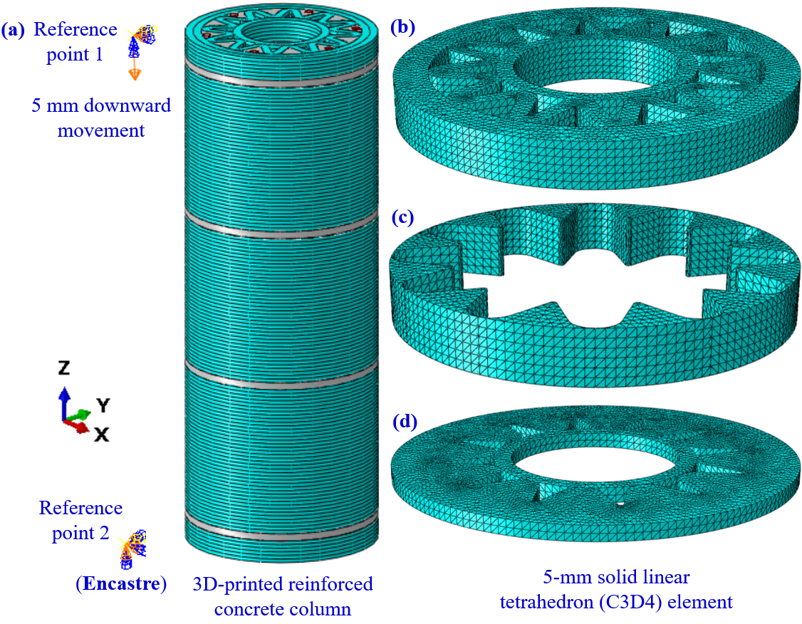
Figure 7. (a) Finite element model of CS12 column (with 12-peak sinusoidal infill), and mesh size of different components: (b) printed part, (c) infilled part, and (d) connection layer.
To accurately capture the geometrical intricacies and layer-wise construction features, all components are discretised using 5-mm linear tetrahedral solid elements (C3D4). The mesh size is selected based on a mesh sensitivity study, which balances numerical accuracy and computational efficiency. Four mesh densities (2.5 mm, 5 mm, 7.5 mm, and 10 mm) are evaluated by comparing their predicted peak axial loads versus time and computational times against the reference fine mesh (2.5 mm). The coarsest mesh (10 mm) produces a peak load deviation of approximately 13.1%, although it reduced computation time by 85%. A 7.5-mm mesh yielded a 6% deviation with a 56% reduction in runtime. The 5-mm mesh produces a peak load of 1676 kN, corresponding to only 2.8% deviation from the reference solution (1628 kN) while still achieving a 45% reduction in computational time. This level of accuracy is sufficient for structural-scale modelling of RC columns where global response dominates local stress variations [34]. Based on these results, the 5-mm element size is identified as the optimal choice that ensures mesh-independent predictions without excessive computational cost.
For modelling simplicity, the printed mortar is assumed to be homogeneous and isotropic, neglecting the potential anisotropy introduced by the layer-by-layer deposition process (see Figure 7b). Although the printing process can induce anisotropic characteristics due to filament orientation and interlayer bonding, a homogeneous isotropic model was adopted for the printed mortar without fibres to simplify the simulation while preserving the focus on macro-level structural performance [61, 62]. This assumption enables efficient computation while reasonably capturing global response characteristics. The cast mortar infill, occupying the spaces between printed filaments, is modelled using the same C3D4 elements as the printed components. Tie constraints are implemented at the printed-cast interface, simulating full bond and no relative slip to ensure proper integration with the printed parts (see Figure 7c). For the 10-mm-thick connection layers (see Figure 7d), these layers that connect adjacent printed units and facilitate vertical load transfer are also discretised using C3D4 elements. General surface-based contact interactions are applied between the top and bottom faces of these layers and the adjacent parts, incorporating hard contact in the normal direction and penalty-based frictional behaviour in the tangential direction. Furthermore, the rebars and stirrups are modelled using eight-node continuum solid elements (C3D8R) and embedded into mortar parts. Additionally, general contact is defined throughout the assembly to ensure realistic interaction among components, and tie constraints are used at critical interfaces (i.e, between the cast mortar and printed shell) to simulate full bonding conditions. This FEA approach provides a robust numerical framework for evaluating the load-bearing capacity and deformation characteristics of 3D-printed reinforced concrete columns with complex internal geometries.
It is noted that the mortar is modelled as a homogeneous and isotropic material. This assumption is justified by the fabrication method used in this study, where only the outer shell is printed, while the core and inter-segment joints are cast and mechanically compacted, significantly minimising interlayer discontinuities. Because the columns are tested under predominant axial compression, the influence of layer-induced anisotropy is expected to be limited. Nevertheless, future work will investigate anisotropic constitutive formulations and interlayer bond characterisation for scenarios involving flexure, shear, or tensile interface failures.

Results and discussion

4.1 Material models
The material models and the detailed material properties used in the finite element model are described in this section. Both experimental results and data obtained from material suppliers are used, ensuring a realistic representation of material behaviour under loading. The mechanical properties of the 3D printable mortar are summarised in Table 3. The mechanical properties of the steel reinforcement and stirrups were provided by the material supplier, which include the nominal yield strength, ultimate strength, density, Poisson's ratio, and elastic modulus. For the mortar, the compressive strength, elastic modulus, and density were determined experimentally through uniaxial compression tests on three hardened samples, from which the mean values and corresponding deviations were derived and subsequently used in the constitutive material model. These experimentally based inputs ensured that the finite element model was calibrated using the actual material behaviour of the tested columns.
Table 3. Mechanical properties and characteristics of mortar and steel
Materials | Young’s modulus (GPa) | Density, (kg/m³) | Poisson’s ratio | Compressive strength (MPa) | Yield strength (MPa) | Ultimate strength (MPa)
Mortar | 21.659 ± 0.68 | 2346 ± 54 | 0.18 | 60.49 ± 1.52 | - | -
Rebar* | 212 | 7850 | 0.27 | - | 555 | 641
Stirrup* | 230 | 7850 | 0.28 | - | 411 | 556
*Provided by the material supplier
Young’s modulus and Poisson’s ratio are used to define the linear material (elastic) behaviour of the concrete domain in the finite element model. The Simplified Cement Damage Plasticity (SCDP) model is adopted to simulate the nonlinear behaviour of the mortar under compression and tension. This model is a modified version of the classical Concrete Damaged Plasticity (CDP) framework in ABAQUS, tailored to better capture the brittle failure modes typically observed in high-strength printable mortars [63, 64]. According to the SCDP model [65], the damage parameters under compression (D_{c}) are determined by using Eq. (1):
$$\begin{aligned}D_{c}=1-\frac{σ_{c}}{σ_{cu}},\#\left(1\right)\end{aligned}$$
while Eq. (2) is used to obtain the tension damage parameters (D_{t}):
$$\begin{aligned}D_{t}=1-\frac{σ_{t}}{σ_{tu}}. \#\left(2\right)\end{aligned}$$
In the above equations, $σ_{cu}$ and $σ_{tu}$ are the maximum compressive and tensile stresses, respectively.
Table 4. Material properties used for the simplified cement damage plasticity (SCDP) model
Dilation angle | Potential eccentricity | Biaxial/uniaxial strength ratio, f_{b0}​/f_{c0} |  | Shape factor, K_{c} | Viscosity parameter
31 | 0.1 | 1.16 |  | 0.67 | 0
Compressive properties |  |  | Tensile properties
Yield stress (MPa) | Inelastic strain (%) | Damage parameter ( D_{c}) | Yield stress, (MPa) | Tensile strain (%) | Damage parameter (D_{t})
19.99 | 0.00 | 0.00 | 2.87 | 0 | 0
31.31 | 0.04 | 0.00 | 0.29 | 0.53 | 0.90
44.29 | 0.08 | 0.00
56.34 | 0.13 | 0.00
60.49 | 0.19 | 0.00
43.27 | 0.27 | 0.04
29.81 | 0.36 | 0.28
20.05 | 0.79 | 0.51
15.16 | 1.21 | 0.67
10.94 | 1.75 | 0.82

In this regard, the stress-strain relationships are defined using tabulated input for compressive and tensile behaviour. In compression, a set of yield stresses with corresponding inelastic strains and damage parameters is assigned, as seen in Table 4. Peak compressive stress occurred at 60.49 MPa, accompanied by a damage parameter (D_{c}) of 0.29, followed by a softening behaviour. In tension, a maximum tensile strength of 2.87 MPa is recorded, with post-peak degradation defined via the damage variable, D_{t}, and tensile strain. This damage-based approach captures both stiffness degradation and irreversible strain accumulation, enabling accurate simulation of cracking, crushing, and post-peak softening observed in the printed mortar under load. The mechanical properties of the longitudinal rebars (Φ13 mm) and stirrups (Φ6 mm) are provided by the supplier and are listed in Table 3. The steel reinforcement is assumed to exhibit elastic-perfectly plastic behaviour. Both rebar and stirrup are modelled as linearly elastic until yielding, followed by perfectly plastic behaviour without strain hardening. Poisson’s ratios are taken as 0.27 and 0.28 for rebars and stirrups, respectively. These parameters are used to define embedded elements in the finite element model to simulate internal reinforcement with full bond to the surrounding mortar. This combined material modelling strategy (utilising damage plasticity for concrete and idealised elastoplasticity for steel) enables the finite element model to capture both the pre-peak stiffness and post-peak degradation responses observed during uniaxial compression experiments.

4.2 Numerical model validation
A thorough validation is conducted against experimental results to ensure the reliability and accuracy of the developed finite element (FE) model for subsequent numerical investigations in this section. This process involves comparing key response characteristics obtained from both the simulation and the experiment of the CS12 column (column with 12-peak sinusoidal infill). In particular, the compressive load-strain behaviour and corresponding damage patterns under uniaxial compression are examined in detail. Several representative stages during the loading process are selected to capture the progressive failure mechanisms and material degradation. By evaluating both global responses and local failure modes, the validity of the FE model is assessed, providing a robust foundation for further parametric and structural analyses in this study.

4.2.1 Damage patterns
Figure 8 presents a comparative analysis of the damage evolution in the CS12 column under uniaxial compression, highlighting experimental observations (left) and corresponding numerical simulations (right) at three critical loading stages, i.e. peak load, 15% reduction from peak load, and 50% reduction from peak load. The damage contours in the numerical model are visualised using a colour scale ranging from blue (no damage) to red (full material failure), enabling a qualitative and quantitative assessment of progressive damage in the printed concrete structure.
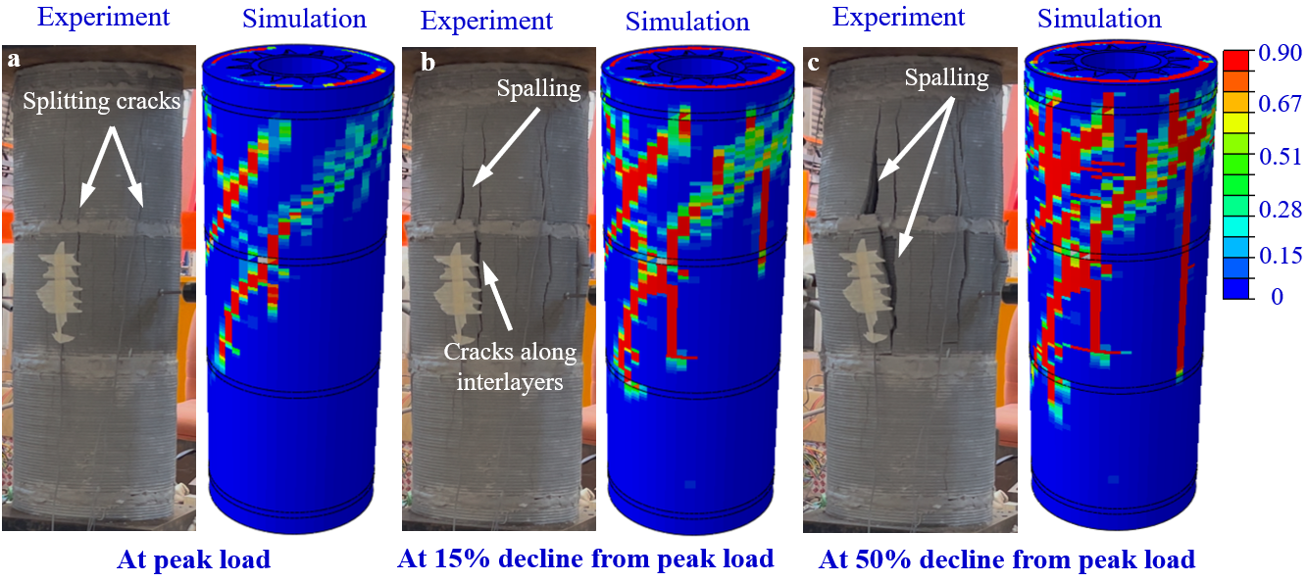
Figure 8. Comparison of damage patterns of experimental (left) and numerical (right) results at three loading stages (peak load, 15% and 50% decrease from peak load) of the CS12 column under compression test.
Firstly, at peak load (Figure 8a), the experimental column exhibits prominent vertical splitting cracks along the mid-height region, primarily due to tensile stresses induced by lateral dilation. These splitting cracks were well captured by the numerical model, which predicted localised damage bands aligned with the observed fracture orientation. The concentration of red and yellow zones in the simulation at this stage confirms the onset of severe material degradation, consistent with experimental evidence extracted from high-resolution video footage. Secondly, at 15% decline from peak load (Figure 8b), further damage development is evident in the form of spalling and cracks propagating along interlayer regions. These interfacial weaknesses, intrinsic to the layer-by-layer deposition process of 3D concrete printing, served as preferential paths for crack growth under compressive loading. The simulation results closely replicate this behaviour, with damage propagating along horizontal planes and intensifying in the mid-upper section of the column. The good agreement indicates that the numerical model effectively incorporates the anisotropic and heterogeneous nature of the printed material. Last but not least, at 50% decline from peak load (Figure 8c), extensive spalling and surface fragmentation are observed in the experiment, along with the coalescence of vertical and interfacial cracks. The simulation similarly shows wide zones of full damage, particularly in the upper segments of the column, validating the model’s capability to simulate severe post-peak degradation. However, slight differences in damage localisation and extent are observed between the two approaches. These discrepancies may be attributed to simplifications in the numerical model, such as idealised material homogeneity, perfect interface bonding assumptions, and limitations in replicating the exact boundary conditions and imperfections present in the printed specimen. Despite these minor differences, the overall correlation between the experimental and numerical results is strong, especially in terms of crack pattern evolution, damage localisation, and failure progression. The ability of the model to reproduce both the macro-scale failure modes and the interlayer-specific crack behaviour confirms its robustness for predicting the structural response of 3D-printed concrete columns under axial compression.

4.2.2 Load vs strain curves
To further validate the finite element (FE) model developed in this study, a detailed comparison between the experimental and numerical load–strain responses of the CS12 column is discussed. Specifically, Figure 9a shows the compressive load versus axial strain curves, while Figure 9b depicts the compressive load versus lateral strain behaviour. Three representative points along the loading path are used for comparative analysis: Point A_{e}/Aₛ at peak load, Point B_{e}/Bₛ at 15% decline from peak load, and Point C_{e}/Cₛ at 50% decline from peak load, where the subscripts “_{e}” and “ₛ” denote the experiment and simulation results, respectively.
The FE model demonstrates a strong correlation with the experimental results, accurately replicating the global deformation trends and post-peak softening behaviour of the 3D-printed column. The predicted peak load from the simulation is 1,529 kN, compared to 1,676 kN obtained from the experiment, representing a deviation of about 8.75%. This level of discrepancy is within an acceptable range (below 10%) for structural simulations of complex cementitious systems and confirms the model’s adequacy for further parametric investigations [66]. However, a noticeable difference is observed in the initial elastic region, where the slope of the simulated load-strain curve is lower than that of the experimental results. Several factors may contribute to this discrepancy. First, the experimental axial and lateral strains are derived from strain gauges and LVDTs, which may capture localised stiffness effects influenced by confinement, contact friction, or early microcrack formation. In contrast, the simulation assumes a homogenous and isotropic material behaviour without considering printing-induced anisotropy, pore structure, or interfacial imperfections, which can reduce the modelled stiffness of the printed mortar. Additionally, the FE model does not incorporate micro-level variability from the printing process, such as filament waviness, weak interlayer bonding, or small voids that influence early-stage stiffness. These simplifications may lead to an underestimation of stiffness in the elastic region.
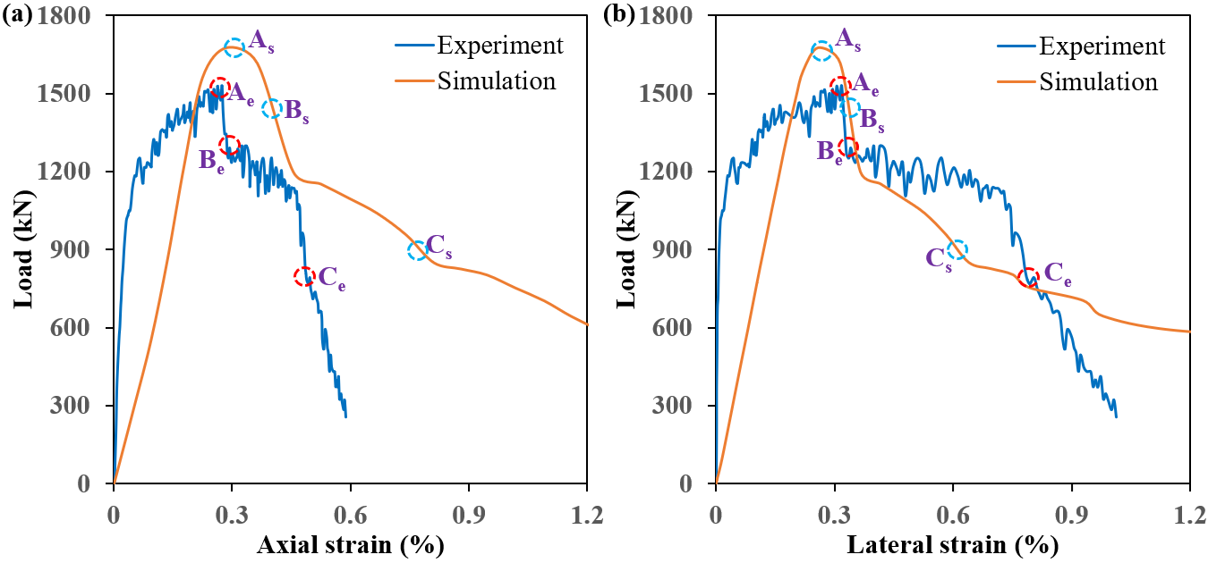
Figure 9. (a) Compressive load and axial strain curves and (b) compressive load and lateral strain curves of the CS12 column subjected to uniaxial compression load. (Point A_{e}/A_{s} – Experimental/numerical peak load; Point B_{e}/B_{s} – 15% decline from the peak of experimental/numerical compression load; Point C_{e}/C_{s} - 50% decline from the peak of experimental/numerical compression load).
Further comparisons of strain values at key loading points are shown in Figure 10. At peak load (Point A), the experimental and numerical axial strains are 0.27% and 0.28%, respectively, indicating close agreement. At later stages, the divergence becomes more pronounced, particularly at Point C, where the simulation predicts an axial strain of 0.81% versus 0.49% in the experiment. A similar trend is observed in the lateral strain values, where the simulation moderately underestimates or overestimates strain at various stages. At Point C, the lateral strain from the simulation is 0.70% compared to 0.80% in the experimental measurement. These disparities can be ascribed to several possible reasons, such as numerical assumptions of perfect body elements, neglect of printing-induced defects, measurement technique from LVDT and strain gauges, etc. Furthermore, the axial deformation was measured using mid-height LVDTs due to geometric constraints associated with the multi-segment printed assembly, which prevented installing long-gauge sensors directly between the loading platens. As highlighted in [67], platen-to-platen LVDTs offer higher fidelity, and the absence of this configuration may partly explain the slight discrepancy between the experimental and numerical stress-strain curves. Nevertheless, the measured pre-peak response was consistent with strain gauge data, confirming that the overall deformation trend was reliably captured to validate the FE model. The good agreement across the load-strain curves and the damage patterns confirms that the developed numerical model is suitable for subsequent numerical investigations and parametric studies in the following section.
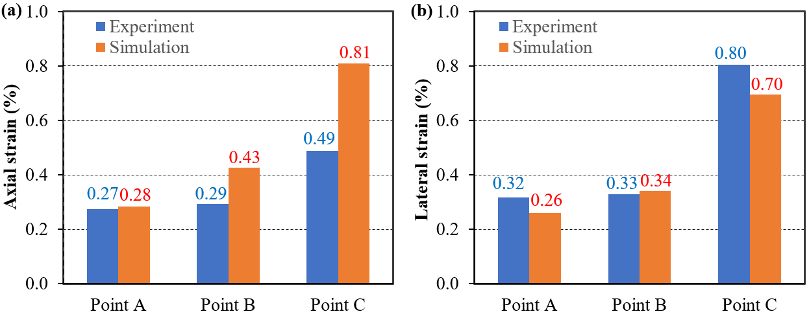
Figure 10. (a) Axial strain and (b) lateral strain at three locations (Points A, B, and C) on the load-strain curves of the CS12 column under compression.

4.3 Parametric studies: Effect of infill patterns
Following the validation of the finite element model, a comprehensive parametric study is performed to investigate the influence of different infill pattern designs on the structural and environmental performance of 3D-printed concrete columns. Four distinct infill configurations, i.e. CS0 (column without sinusoidal infill), CS4 (column with 4-peak sinusoidal infill), CS8 (column with 8-peak sinusoidal infill), and CS12 (column with 12-peak sinusoidal infill), are analysed to assess their effects on stress distribution within the concrete and reinforcement, peak compressive capacity and corresponding strain, as well as failure modes under axial loading. The third principal stress component (S33), representing the maximum compressive or tensile stress acting in the vertical direction, is extracted from the simulation results to investigate the influence of infill architectures on the structural performance of 3D-printed concrete columns under uniaxial compressive loading applied in the z-direction [34]. In this context, negative S33 values indicate compressive stresses, while positive values signify tensile stresses, in accordance with the sign convention used in continuum mechanics. Since the applied load is purely axial and aligned with the z-axis (see Figure 7), shear stress components are negligible, and the stress state is dominated by normal stresses, making principal stress (S33) an ideal metric for comparison. The parametric study examined four infill configurations (CS0, CS4, CS8, and CS12) selected to represent a progressive increase in sinusoidal peak frequency and internal confinement. CS0 serves as the solid reference column, while CS4, CS8, and CS12 introduce 4, 8, and 12 sinusoidal peaks along the circumference, respectively. These peak numbers were chosen based on practical printing constraints, including nozzle diameter and minimum curvature requirements, as well as preliminary FE simulations confirming that these geometries could be printed without loss of dimensional accuracy or path stability. By systematically varying the number of peaks, the study isolates the effect of geometric interlocking on confinement, stress redistribution, and axial strength, thereby providing a clear scope for understanding how infill complexity influences the structural performance of 3D-printed reinforced concrete columns.

4.3.1. Stress distribution
Figure 11 illustrates the S33 stress distribution in the concrete domain of four columns with varying infill topologies, CS0 (no infill), CS4 (4-peak sinusoidal infill), CS8 (8-peak sinusoidal infill), and CS12 (12-peak sinusoidal infill). Herein, the stress distribution from different viewpoints (front, back, top, and bottom) is compared. In the CS0 column (see Figure 11a), the stress field appears uniform and symmetric along the vertical axis, with peak compressive stresses (green colour) concentrated near the base and top sections. However, due to the lack of internal geometric variation, minimal confinement is observed in the core region, which may contribute to early localisation of damage.
As sinusoidal infills are introduced (CS4, CS8, CS12 columns), a clear evolution in stress distribution is observed. In CS4 column (see Figure 11b), compressive stress begins to localise around the sinusoidal undulations, particularly at regions where geometry causes stress intensification. Notably, tensile zones (red colour) emerge near the infill interfaces, suggesting stress reversal and potential cracking initiation sites. This effect is amplified in the CS12 column (see Figure 11d) and further intensified in the CS8 (Figure 11c), where the increase in sinusoidal peaks enhances internal confinement. However, more uniformly distributed compressive stress in the core and reduced concentrations of tensile stress are witnessed in the CS12 column than in the CS8 column. The stress distribution from the top and bottom views further confirms this pattern (more intricate sinusoidal geometries improve stress homogenisation across the column cross-section). This progression underscores the mechanical confinement effect introduced by the sinusoidal infill architecture. The undulating geometry likely redirects the load path, enabling more efficient stress redistribution and delaying localised failure [34]. As the sinusoidal density increases from CS4 to CS12, the minimum principal stress (maximum compressive value) becomes more evenly distributed, reflecting a more stable load-bearing response.
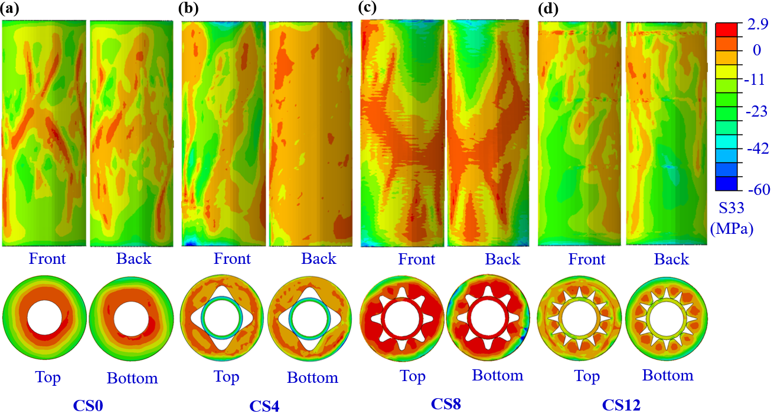
Figure 11. Principal stress (S33) distribution in four concrete columns from different viewpoints (front, back, top, and bottom): (a) CS0, (b) CS4, (c) CS8, and (d) CS12. (CS0 – column without sinusoidal infill, CS4 – column with 4-peak sinusoidal infill, CS8 – column with 8-peak sinusoidal infill, and CS12 – column with 12-peak sinusoidal infill)
Figure 12 displays the S33 stress distribution within the reinforcement cages of the four column configurations. In the CS0 column without sinusoidal infill (see Figure 12a), localised tensile stress (red colour) near the middle region of the column is observed in the longitudinal rebars, potentially indicating stress concentrations due to expansion effects. As sinusoidal infills are incorporated, the stress distribution in the rebars becomes more favourable. In CS4 and CS8 (see Figure 12b and Figure 12c), compressive stresses (represented by dark blue tones) are observed in the vertical rebars, especially at the mid-height of the column, suggesting improved stress transfer from the concrete to the steel through enhanced confinement. This trend reaches its peak in the CS12 column (Figure 12d), where the rebars are enveloped in an environment of high compressive stress and minimal tensile stress, indicating optimal interaction between concrete and reinforcement. The smoother transition of stress along the rebar length in CS12 reflects reduced stress discontinuities, likely contributing to improved ductility and energy absorption.
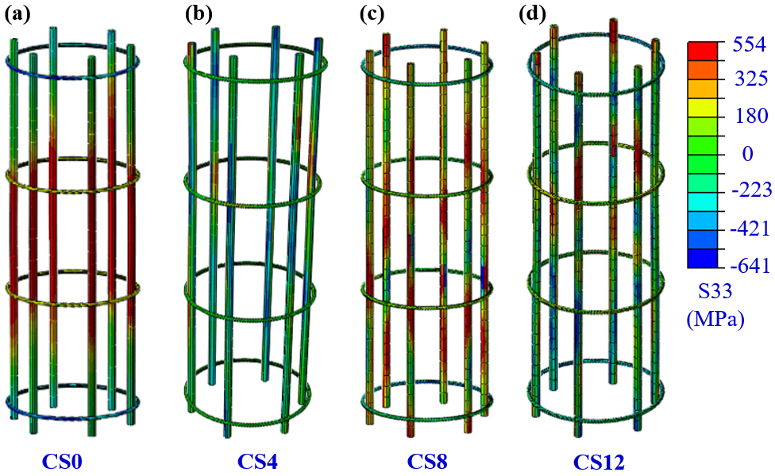
Figure 12. Principal stress (S33) distribution of reinforcement mesh in four concrete columns: (a) CS0, (b) CS4, (c) CS8, and (d) CS12. (CS0 – column without sinusoidal infill, CS4 – column with 4-peak sinusoidal infill, CS8 – column with 8-peak sinusoidal infill, and CS12 – column with 12-peak sinusoidal infill)
From a mechanistic standpoint, the sinusoidal infill pattern introduces geometric interlocking, promoting lateral restraint and suppressing radial expansion under axial compression. This confinement effect delays the onset of tensile cracking and redistributes the vertical load across a wider area, enhancing load capacity. The FE model captures these effects via the S33 stress field, showing the eigenvalues of the stress tensor representing the maximum compressive and tensile stresses a material point experiences. As the number of sinusoidal peaks increases, the columns exhibit a more desirable stress profile, dominated by compressive principal stresses and reduced tensile stress concentrations. This not only corroborates the superior mechanical stability of infilled columns but also validates the suitability of the developed FE model in capturing the intrinsic behaviour of complex 3D-printed cementitious composites.

4.3.2 Axial compressive capacity and strain at peak load
To evaluate the structural performance of 3D-printed concrete columns with various infill architectures, column load-bearing capacity and strain at peak load of four column types, i.e. CS0 (without sinusoidal infill), CS4 (4-peak infill), CS8 (8-peak infill), and CS12 (12-peak infill), are numerically investigated under axial compression loading. The numerical results, summarised in Table 5 and Figure 13, offer insights into the influence of internal geometry on compressive capacity, deformation characteristics, and construction efficiency.
The axial peak load gradually decreased with increasing infill complexity, from 1,994 kN in CS0 to 1,676 kN in CS12, largely due to the reduction in cross-sectional area. Despite the drop in absolute peak load value, the compressive capacity (load normalised by cross-sectional area) increased in CS4 and CS8 (45.68 MPa and 48.23 MPa, respectively), peaking in CS8, before slightly declining to 44.47 MPa in CS12. This trend indicates that columns with sinusoidal infills can compensate for reduced bulk material through improved mechanical efficiency, attributed to enhanced confinement and load redistribution. The improvement in compressive capacity from CS0 to CS8 demonstrates the benefit of strategic geometric interlocking offered by sinusoidal infill, which promotes more uniform stress distribution and delays failure. The marginal reduction observed in CS12 suggests that excessive geometric complexity may lead to stress concentrations or ineffective load transfer, outweighing the confinement benefit beyond a certain threshold.
Table 5. Cross-sectional area and compressive load of four concrete columns (CS0, CS4, CS8, and CS12) with percentage of printed and cast parts
Type of column | Cross-sectional area mm² | Axial peak load kN | Printed part  % | Cast part  %
CS0 | 47,316 | 1,994 | 46.2 | 53.8
CS4 | 40,440 | 1,888 | 71.5 | 28.5
CS8 | 40,795 | 1,968 | 76.5 | 23.5
CS12 | 37,609 | 1,676 | 85.7 | 14.3
Note: CS0 – column without sinusoidal infill, CS4 – column with 4-peak sinusoidal infill, CS8 – column with 8-peak sinusoidal infill, and CS12 – column with 12-peak sinusoidal infill
Axial and lateral strain values at peak load provide further insight into the deformability and confinement behaviour of the columns. As seen in Figure 13, CS0 exhibits the highest axial strain (0.76%) and lateral strain (0.51%), suggesting lower stiffness and limited confinement, typical of unconfined or weakly confined columns. In contrast, CS4 and CS8 show reduced axial strains of 0.52% and 0.36%, respectively, indicating greater resistance to axial deformation due to the confinement effect of the sinusoidal infill. Similarly, lateral strain decreases from 0.32% in CS4 to 0.30% in CS8, reflecting reduced transverse expansion and improved core confinement. The CS12 column, while maintaining relatively high compressive capacity (44.47 MPa), displays the lowest axial (0.28%) and lateral strain (0.26%) among all specimens. This suggests that CS12, with the highest printed content (85.7%), behaves in a more brittle and stiff manner, likely due to increased structural regularity and restriction in lateral deformation. These results collectively highlight the role of infill architecture in controlling both load-carrying capacity and strain development, where moderate sinusoidal complexity enhances ductility and strength, whereas excessive complexity may limit strain accommodation and lead to premature stiffness.
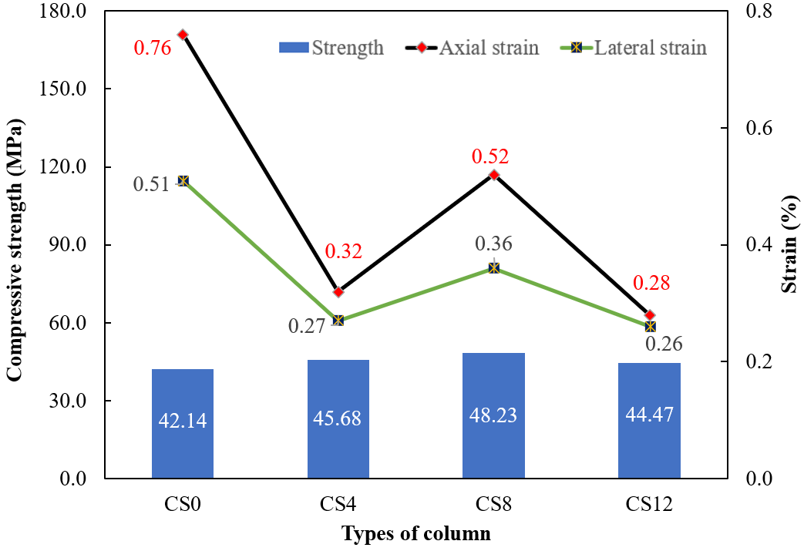
Figure 13. Compressive capacity, axial and lateral strain at peak load of four concrete columns (CS0, CS4, CS8, and CS12 columns).
From a construction point of view, a significant advantage of the sinusoidal infill design is the ability to maximise 3D-printed content while reducing the need for cast parts. As shown in Table 5, the percentage of printed material increased from 46.2% in CS0 to 85.7% in CS12, thereby reducing labour-intensive casting processes and enabling greater automation. Columns CS4, CS8, and CS12 demonstrate the potential of hybrid manufacturing strategies to balance structural performance with material efficiency. Additionally, the reduction in cross-sectional area with increasing infill complexity (from 47,316 mm² in CS0 to 37,609 mm² in CS12) represents material savings and reduced dead load, an essential consideration for sustainable construction. Notably, CS8 achieves the highest compressive capacity with a 13% smaller cross-section than CS0, exemplifying the effectiveness of structural optimisation via geometry rather than increased material usage.
In general, the comparison of compressive capacity and strain at peak underscores the critical role of sinusoidal infill design in modulating the mechanical behaviour of 3D-printed concrete columns. While CS0 relies on bulk material for strength, CS4 and CS8 achieve higher compressive performance through geometric confinement, reduced strain, and improved stress redistribution. CS12 shows diminishing returns due to excessive complexity. These findings validate the feasibility of tailored infill designs to enhance strength, reduce material consumption, and promote construction automation in advanced additive manufacturing of concrete structures.

4.3.3 Failure modes
Another parameter investigated in the parametric study is the failure modes of the 3D-printed concrete columns under uniaxial compression. Figure 14 illustrates the simulated damage distributions from multiple viewpoints (front, back, top, and bottom) for the four column types, i.e. CS0 (no infill), CS4 (4-peak infill), CS8 (8-peak infill), and CS12 (12-peak infill). The damage contour plots represent the scalar damage index (ranging from 0 to 0.9), with red regions indicating severe cracking or crushing, while blue colour represents no damage.
The CS0 column, which lacks any sinusoidal internal filaments, exhibits highly localised damage concentrated near the upper regions of the outer printed shell. The damage is limited in spatial extent, with relatively few zones reaching critical failure values. The top and bottom views further confirm minimal engagement of the internal volume in resisting the axial load. This behaviour reflects the limited capacity of the CS0 configuration to redistribute stress due to the absence of internal load paths, leading to premature crushing and low energy dissipation. On the other hand, in the CS4 design, the introduction of four sinusoidal printed filaments connecting the inner and outer walls results in more distributed diagonal cracking across both front and back views. The damage extends along the inclined directions, indicating that the infill contributes to shear resistance and helps to delay vertical splitting. The top and bottom views reveal partial engagement of the infill structure, though a significant portion of the cross-section remains structurally inactive. This configuration demonstrates an improved stress transfer mechanism compared to CS0, but still lacks sufficient redundancy in load-bearing paths. Furthermore, the CS8 column shows an even more distributed and intertwined damage pattern, forming an extensive network of diagonal and vertical cracks across the column height. Both the front and back views reveal widespread damage zones, indicating that more internal regions participate in resisting the compressive load. The top and bottom views also show significant engagement of the sinusoidal infill, with multiple damage initiation sites across the printed filaments. The failure pattern suggests that this architecture enhances both axial and lateral stiffness, enabling a more uniform load transfer and improved energy absorption during post-peak degradation. Moreover, the CS12 column also exhibits evenly distributed and extensive damage, especially along the front face and within the top view.
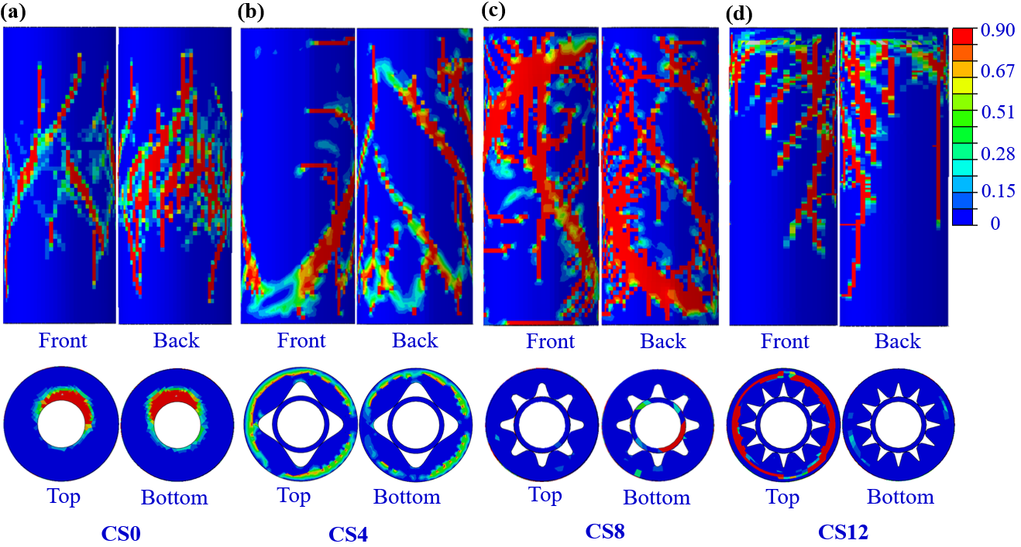
Figure 14. Failure modes in four concrete columns from different viewpoints (front, back, top, and bottom) under compression loading: (a) CS0, (b) CS4, (c) CS8, and (d) CS12.
Generally, the widespread nature of the damage in the columns with sinusoidal infills implies that the entire printed and cast matrix (including the infill filaments) actively participates in load redistribution. The fine spatial distribution of cracks reduces the likelihood of catastrophic brittle failure and indicates enhanced ductility. This behaviour reflects the intrinsic benefit of having multiple internal load paths and lateral bracing elements, which effectively confine the core and delay structural collapse. The column design with more peak sinusoidal infill patterns, therefore, demonstrates superior mechanical synergy between printed and cast components. In other words, the progressive enhancement of failure resistance from CS0 to CS12 can be directly attributed to the increasing number of sinusoidal infill peaks. As more internal filaments are introduced, the columns develop greater structural interconnectivity, allowing stress to be redistributed through redundant load paths. The observed trend aligns with the intrinsic mechanism of distributed damage, wherein more widespread failure zones indicate more material volume contributing to load bearing. Notably, the shift from localised damage in CS0 to global failure in CS12 suggests a transition from brittle to pseudo-ductile behaviour, as more internal regions absorb energy and deform before reaching peak stress. In addition, the presence of diagonal cracking in CS4 and CS8 highlights the role of sinusoidal filaments in controlling shear-induced damage propagation. These findings underline the importance of infill architecture optimisation in 3D-printed concrete structures—not only for enhancing mechanical performance, but also for ensuring more controlled and predictable failure mechanisms. Compared with conventional confinement methods such as multi-ply carbon fabric reinforced columns [68], which enhance axial strength through external material layers, the sinusoidal infill used in this study provides confinement through internal geometric interlocking. The improved strength and ductility observed in CS12, therefore, align with the confinement gains reported in the literature, but are achieved with significantly reduced material demand.
The enhanced performance of the CS8 configuration can be attributed to the optimisation of internal confinement and stress redistribution achieved by its eight-peak sinusoidal geometry. This layout provides a sufficient number of interlocking nodes to limit radial expansion while maintaining continuous load-transfer paths between the printed shell and the cast core. The resulting confinement effect leads to a more uniform compressive stress field and reduces the formation of localised stress concentrations at the peak-valley transitions. As shown in the stress contours and damage patterns (see Figure 11 and Figure 14), CS8 delays the onset of tensile cracking and distributes damage more evenly than CS4, while avoiding the overly thin curvature regions associated with higher-frequency patterns. These combined mechanisms explain the observed strength gain and structural stability, demonstrating that CS8 represents an effective balance between geometric complexity, confinement efficiency, and printability. Furthermore, it is important to note that the reduced ultimate load of CS12, relative to CS0 and CS8, is influenced not only by the smaller effective cross-sectional area but also by changes in its internal stress distribution and failure mode. The higher-frequency sinusoidal geometry produces thinner wall segments that undergo elevated compressive stresses, as confirmed in the FE stress contours. These localised stress concentrations lead to earlier onset of crushing and tensile cracking, which explains the more brittle post-peak behaviour observed for CS12. Thus, the performance of CS12 reflects a trade-off between enhanced geometric confinement and increased stress localisation, helping to explain why CS8 achieves a more favourable balance between strength, ductility, and material efficiency.

5. Life cycle assessment
In addition to structural performance, the environmental implications of each design are evaluated to identify configurations that offer both structural efficiency and reduced environmental impact. This investigation aims to provide valuable insights into the optimisation of 3D-printed concrete components for sustainable construction applications. A cradle-to-gate life cycle assessment (LCA) is conducted to holistically evaluate the sustainability of additively manufactured concrete columns. This approach accounts for all energy and material flows from raw material extraction to the finished product at the factory gate, excluding use-phase and end-of-life impacts. The system boundary encompasses concrete mix production, reinforcement integration, and the energy consumed during 3D printing, thereby allowing a comprehensive environmental comparison of columns with varying infill architectures. The life cycle inventory compiles comprehensive information on mixture proportions, reinforcement requirements, and the energy demand linked to the 3D-printing operation. The material volume for each column is determined by multiplying its cross-sectional area by the overall height, providing the total amount of printed material. To more accurately represent material consumption and environmental loads, the shares of 3D-printed and conventionally cast components are incorporated according to their respective percentages. Since each column design involves different ratios of printed and cast materials, their environmental contributions are allocated in proportion to these fractions. For this analysis, only the electricity consumed during the extrusion-based 3D concrete printing stage is included, ensuring that the influence of automated additive manufacturing is isolated. All columns are fabricated using a desktop mortar-extrusion printer rated at 0.6 kW. With a printing time of 5 hours per specimen, the electricity use per column is estimated at 3.0 kWh. Life cycle modelling is performed in SimaPro 9 using the CML-IA baseline (World, 1995) impact assessment method. A cradle-to-gate boundary is adopted, covering raw material acquisition, binder production, material mixing, and printing, with background inventories taken from the Ecoinvent 3.8 database.
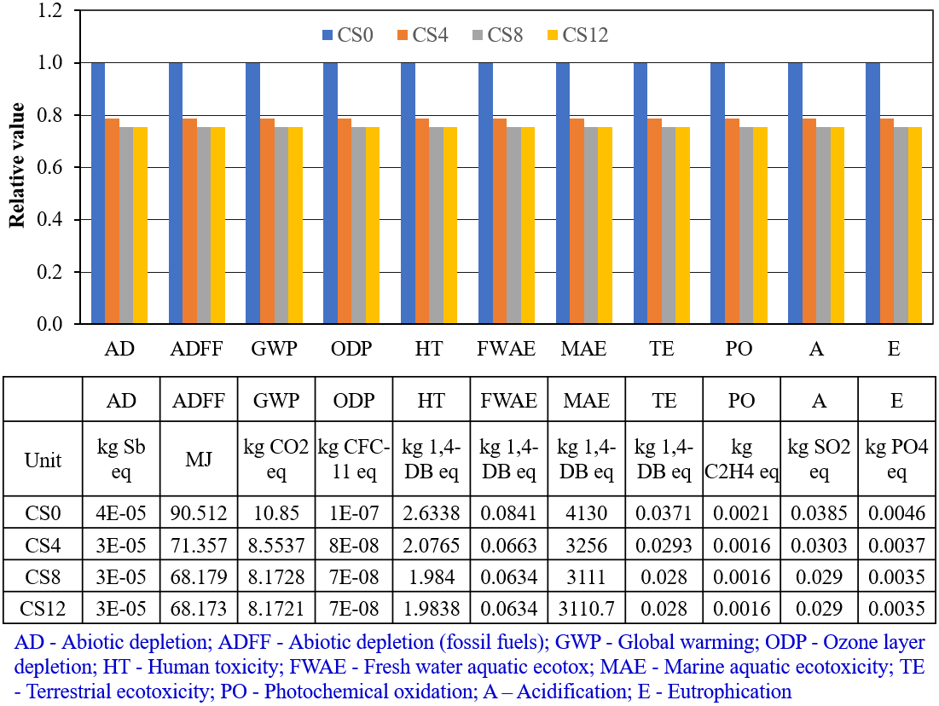
Figure 15. Environmental impact comparison of four concrete columns (CS0, CS4, CS8, and CS12) across eleven impact categories per MPa material. (CS0 – column without sinusoidal infill, CS4 – column with 4-peak sinusoidal infill, CS8 – column with 8-peak sinusoidal infill, and CS12 – column with 12-peak sinusoidal infill)
In the present study, the environmental impacts per 1 m³ material of the mix design listed in Table 2 were obtained first by using the LCA analysis. Then, the values were normalised by flexural strength in Figure 13 to enable a performance-based comparison. For example, the absolute carbon emissions (GWP) value of the conventional solid column (CS0), which represents a traditional RC configuration, exhibits a 457.219 kg CO₂-eq/m³. The incorporation of sinusoidal infills significantly reduces mortar volume demand and therefore lowers embodied emissions. Specifically, the GWP reductions are 16.9% for CS4 (390.750 kg CO₂-eq/m³), 16.0% for CS8 (394.184 kg CO₂-eq/m³), and 25.8% for CS12 (363.319 kg CO₂-eq/m³). These data confirm that CS12 provides the highest carbon reduction due to its largest decrease in mortar consumption. Furthermore, the printable mortar formulated in this work already demonstrates a substantial reduction in embodied emissions when compared to conventional OPC-based printable mortars reported in the literature [69]. For example, the GWP of typical printable mortars (~639 kg CO₂-eq/m³) is approximately 40% higher than the low-carbon mix used for CS0 in this study (457.219 kg CO₂-eq/m³). This improvement is primarily attributed to the high substitution levels of OPC with industrial by-products (GGBS and silica fume), which significantly decrease clinker-related emissions while maintaining adequate mechanical performance.
As illustrated in Figure 15, the environmental impact of the four column types—CS0 (no infill), CS4 (4-peak infill), CS8 (8-peak infill), and CS12 (12-peak infill)—is assessed across eleven midpoint impact categories normalised per MPa of mechanical strength. The data reveal that CS12 and CS8 consistently exhibit the lowest environmental impact across most categories, particularly in GWP (8.17 kg CO₂-eq/MPa) and ADFF (68.173 MJ/MPa), followed closely by CS4. These improvements are largely attributed to the high proportion of printed volume (85.7%), which minimises the need for cast segments that typically involve higher material overuse, formwork waste, and labour energy. The optimised infill geometry in CS8 and CS12 achieves better strength-to-mass ratios, thereby improving environmental performance per functional unit (MPa). In contrast, CS0—the reference column without sinusoidal infill—displays the highest environmental burdens, with GWP reaching 10.85 kg CO₂-eq/MPa and elevated values across acidification, eutrophication, and toxicity categories. This is primarily due to the larger cross-sectional area and the greater use of cast concrete (53.8%), which contributes to higher cement consumption, formwork use, and reduced automation potential. Interestingly, while CS4 shows modest improvements over CS0, it does not achieve the same level of efficiency as CS8 and CS12. This reflects the non-linear relationship between infill complexity and environmental performance, where moderate architectural intricacy does not fully capitalise on material efficiency and mechanical gains, but still incurs additional energy input due to increased print path length.
The LCA results underscore the dual benefit of optimised infill architecture, improving structural efficiency while reducing environmental impact. From a cleaner production perspective, 3D-printed elements such as CS12 and CS8 provide clear pathways toward material reduction through voided geometry and tailored strength placement, energy efficiency by decreasing overall printing and curing loads due to lower volume, and automation-enhanced sustainability, minimising the carbon footprint of manual casting processes. These findings validate the feasibility of using functionally graded infill strategies in the design of sustainable load-bearing components. More broadly, the results demonstrate how digital fabrication can integrate environmental and structural optimisation, aligning with the principles of the circular economy and sustainable construction. The cradle-to-gate LCA clearly demonstrates that columns with sinusoidal infill (especially CS8 and CS12) achieve superior environmental efficiency relative to conventional solid geometries (CS0). When normalised by mechanical performance, these printed designs yield notable reductions in global warming potential and resource depletion, confirming their value in low-carbon, digitally driven construction practices.
It is noted that the present assessment focuses exclusively on the mechanical performance and environmental impact of the proposed sinusoidal infill configurations. A comprehensive economic analysis, including printing time, labour requirements, and material and construction costs, is not included at this stage because these parameters are highly dependent on regional market conditions, project scale, and equipment-specific production rates, and therefore cannot be reliably generalised. The purpose of this study is to first establish the structural feasibility and sustainability potential of the infill patterns as a basis for future development. In subsequent work, a full performance-cost-environment evaluation will be conducted, enabling quantitative comparison between 3D-printed columns and traditional cast-in-place reinforced concrete alternatives.

6. Conclusions
This study introduced and validated a novel approach for designing and fabricating 3D-printed reinforced concrete (RC) columns with functionally graded sinusoidal infill patterns. By combining experimental testing, advanced numerical modelling, and cradle-to-gate life cycle assessment (LCA), the research provided a comprehensive evaluation of the mechanical and environmental performance of various infill configurations. The key findings and contributions are summarised as follows:
- Development and fabrication of infill-graded 3D-printed reinforced concrete (RC) columns: A hybrid construction method was successfully implemented to produce full-scale RC columns incorporating sinusoidal infill patterns and conventional steel reinforcement. The CS12 column, fabricated with a 12-peak infill, demonstrated the feasibility of integrating complex geometries and reinforcement through a layered assembly approach.
- Validation and application of numerical simulation for parametric design: A finite element model, calibrated against experimental data, effectively captured the structural response, damage progression, and failure mechanisms of the printed column. The validated model enabled a detailed parametric study of different infill geometries (CS0, CS4, CS8, CS12), revealing their influence on stress distribution, stiffness, and confinement behaviour.
- Structural optimisation through infill architecture: Among the designs, the CS8 column achieved the highest compressive capacity-to-material ratio due to effective internal confinement and stress redistribution, while the CS12 column provided the most uniform stress distribution and reduced deformation, highlighting a trade-off between strength, stiffness, and printing efficiency.
- Environmental benefits of printed infill design: The life cycle assessment demonstrated that the CS8 and CS12 columns substantially reduced environmental impacts, particularly global warming potential and fossil resource depletion, when normalised per MPa of strength. This confirms that sinusoidal infill architecture supports low-carbon, material-efficient construction strategies.
Overall, this study demonstrates that sinusoidal infill geometries can introduce an effective form of internal confinement, promoting favourable stress redistribution and delayed cracking under axial compression. The combined experimental-numerical approach confirms that the proposed FE framework is capable of capturing these global behaviours, thereby enabling systematic parametric investigation of alternative infill configurations. Nevertheless, the findings should be interpreted in light of certain limitations, including the single full-scale test configuration and the idealised representation of interlayer and interface behaviour in the numerical model. Future research will focus on quantifying micro-scale mechanisms (including mortar-steel bond behaviour, interface slip, and damage evolution) through cohesive interface modelling, small-scale bond tests, and DIC-based full-field strain measurements. Additional studies will also examine the economic viability and life-cycle cost performance of different infill geometries, as well as extend the numerical framework to incorporate calibrated traction-separation laws for printed interfaces. Finally, multi-objective optimisation of infill patterns using topology-based or machine-learning methods will be explored to further refine confinement efficiency and material usage.

Acknowledgments
The authors would like to sincerely thank the laboratory staff of the Construction Technology Laboratory, School of Civil and Environmental Engineering, Nanyang Technological University for their help and favourable conditions for the authors to successfully complete the experiments of this study.

References
[1] Freek Bos, Rob Wolfs, Zeeshan Ahmed, and T. Salet, "Additive manufacturing of concrete in construction: potentials and challenges of 3D concrete printing," Virtual and Physical Prototyping, vol. 11, no. 3, 2016, doi: https://doi.org/10.1080/17452759.2016.1209867.
[2] Vuong Nguyen-Van, Biranchi Panda, Guomin Zhang, Hung Nguyen-Xuan, and P. Tran, "Digital design computing and modelling for 3-D concrete printing," Automation in Construction, vol. 123, 2021, doi: https://doi.org/10.1016/j.autcon.2020.103529.
[3] Vuong Nguyen-Van, Shuai Li, Junli Liu, Kien Nguyen, and P. Tran, "Modelling of 3D concrete printing process: A perspective on material and structural simulations," Additive Manufacturing, vol. 61, 2023, doi: https://doi.org/10.1016/j.addma.2022.103333.
[4] Junli Liu, Vuong Nguyen-Van, Biranchi Panda, Kate Fox, Anton du Plessis, and P. Tran, "Additive Manufacturing of Sustainable Construction Materials and Form-finding Structures: A Review on Recent Progresses," 3D Printing and Additive Manufacturing, vol. 9, no. 1, 2022, doi: https://doi.org/10.1089/3dp.2020.0331.
[5] Haidong Tu, Zhenyun Wei, Alireza Bahrami, Nabil Ben Kahla, Ayaz Ahmad, and Y. O. Özkılıç, "Recent advancements and future trends in 3D concrete printing using waste materials," Developments in the Built Environment, vol. 16, 2023, doi: https://doi.org/10.1016/j.dibe.2023.100187.
[6] José Hernández Vargas, Andreas Sjölander, Helena Westerlind, and J. Silfwerbrand, "Internal topology optimisation of 3D printed concrete structures: a method for enhanced performance and material efficiency," Virtual and Physical Prototyping vol. 19, no. 1, 2024, doi: https://doi.org/10.1080/17452759.2024.2346290.
[7] Zicheng Zhuang, Fengming Xu, Junhong Ye, Nan Hu, Liming Jiang, and Y. Weng, "A comprehensive review of sustainable materials and toolpath optimization in 3D concrete printing," npj Materials Sustainability, vol. 2, 2024, doi: https://doi.org/10.1038/s44296-024-00017-9.
[8] Vuong Nguyen-Van, Junli Liu, Shuai Li, Guomin Zhang, H. Nguyen-Xuan, and P. Tran, "Modelling of 3D-printed bio-inspired Bouligand cementitious structures reinforced with steel fibres," Engineering Structures, vol. 274, 2023, doi: https://doi.org/10.1016/j.engstruct.2022.115123.
[9] Vuong Nguyen-Van, Niranjan Kumar Choudhry, Biranchi Panda, H. Nguyen-Xuan, and P. Tran, "Performance of concrete beam reinforced with 3D printed Bioinspired primitive scaffold subjected to three-point bending," Automation in Construction, vol. 134, 2022, doi: https://doi.org/10.1016/j.autcon.2021.104060.
[10] T. T. Le, S. A. Austin, S. Lim, R. A. Buswell, A. G. F. Gibb, and T. Thorpe, "Mix design and fresh properties for high-performance printing concrete," Materials and Structures vol. 45, pp. 1221–1232, 2012, doi: https://doi.org/10.1617/s11527-012-9828-z.
[11] Lukas Gebhard et al., "Enhancing structural efficiency with digital concrete – Principles, opportunities and case studies," Cement and Concrete Research, vol. 185, 2024, doi: https://doi.org/10.1016/j.cemconres.2024.107645.
[12] Robert J. Flatt and T. Wangler, "On sustainability and digital fabrication with concrete," Cement and Concrete Research, vol. 158, 2022, doi: https://doi.org/10.1016/j.cemconres.2022.106837.
[13] Junli Liu, Phuong Tran, Vuong Nguyen Van, Chamila Gunasekara, and S. Setunge, "3D printing of cementitious mortar with milled recycled carbon fibres: Influences of filament offset on mechanical properties," Cement and Concrete Composites, vol. 142, 2023, doi: https://doi.org/10.1016/j.cemconcomp.2023.105169.
[14] Vuong Nguyen-Van, Changlang Wu, Frank Vogel, Guomin Zhang, H. Nguyen-Xuan, and P. Tran, "Mechanical performance of fractal-like cementitious lightweight cellular structures: Numerical investigations," Composite Structures, vol. 269, 2021, doi: https://doi.org/10.1016/j.compstruct.2021.114050.
[15] Max Adaloudis and J. B. Roca, "Sustainability tradeoffs in the adoption of 3D Concrete Printing in the construction industry," Journal of Cleaner Production, vol. 307, 2021, doi: https://doi.org/10.1016/j.jclepro.2021.127201.
[16] Siyu Liu, Bing Lu, Hongliang Li, Zehua Pan, Jingjing Jiang, and S. Qian, "A comparative study on environmental performance of 3D printing and conventional casting of concrete products with industrial wastes," Chemosphere, vol. 298, 2022, doi: https://doi.org/10.1016/j.chemosphere.2022.134310.
[17] Guowei Ma, Richard Buswell, Wilson Ricardo Leal da Silva, Li Wang, Jie Xu, and S. Z. Jones, "Technology readiness: A global snapshot of 3D concrete printing and the frontiers for development," Cement and Concrete Research, vol. 156, 2022, doi: https://doi.org/10.1016/j.cemconres.2022.106774.
[18] Vuong Nguyen-Van, Junli Liu, Chenxi Peng, Guomin Zhang, H. Nguyen-Xuan, and P. Tran, "Dynamic responses of bioinspired plastic-reinforced cementitious beams," Cement and Concrete Composites, vol. 133, 2022, doi: https://doi.org/10.1016/j.cemconcomp.2022.104682.
[19] Niranjan Kumar Choudhry, Trung Kien Nguyen, Vuong Nguyen-Van, Biranchi Panda, and P. Tran, "Auxetic lattice reinforcement for tailored mechanical properties in cementitious composite: Experiments and modelling," Construction and Building Materials, vol. 438, 2024, doi: https://doi.org/10.1016/j.conbuildmat.2024.137252.
[20] David Darwin and C. Dolan, "Design of Concrete Structures 16e, 16th Edition," 2021, doi: 1259821242.
[21] Lukas Gebhard et al., "Towards efficient concrete structures with ultra-thin 3D printed formwork: exploring reinforcement strategies and optimisation," Virtual and Physical Prototyping vol. 17, no. 3, 2021, doi: https://doi.org/10.1080/17452759.2022.2041873.
[22] Viktor Mechtcherine et al., "Integrating reinforcement in digital fabrication with concrete: A review and classification framework," Cement and Concrete Composites, vol. 119, 2021, doi: https://doi.org/10.1016/j.cemconcomp.2021.103964.
[23] Biranchi Panda, Suvash Chandra Paul, Nisar Ahamed Noor Mohamed, Yi Wei Daniel Tay, and M. J. Tan, "Measurement of tensile bond strength of 3D printed geopolymer mortar," Measurement, vol. 113, pp. 108-116, 2018, doi: https://doi.org/10.1016/j.measurement.2017.08.051.
[24] Harald Kloft, Martin Empelmann, Norman Hack, Eric Herrmann, and D. Lowke, "Reinforcement strategies for 3D-concrete-printing," Civil Engineering Design, vol. 2, no. 4, 2020, doi: https://doi.org/10.1002/cend.202000022.
[25] Vuong Nguyen-Van, Phuong Tran, Junli Liu, Mien Van Tran, and Y. M. Xie, "Extended finite element multiscale modelling for crack propagation in 3D-printed fibre-reinforced concrete," Additive Manufacturing, vol. 81, 2024, doi: https://doi.org/10.1016/j.addma.2024.104019.
[26] Kathrin Dörfler et al., "Advancing construction in existing contexts: Prospects and barriers of 3d printing with mobile robots for building maintenance and repair," Cement and Concrete Research, vol. 186, 2024, doi: https://doi.org/10.1016/j.cemconres.2024.107656.
[27] Md. Aslam Hossain, Altynay Zhumabekova, Suvash Chandra Paul, and J. R. Kim, "A Review of 3D Printing in Construction and its Impact on the Labor Market," Sustainability, vol. 12, no. 20, 2020, doi: https://doi.org/10.3390/su12208492.
[28] Vuong Nguyen-Van, Chenxi Peng, Paul J. Hazell, Jaehong Lee, H. Nguyen-Xuan, and P. Tran, "Performance of meta concrete panels subjected to explosive load: Numerical investigations," Structural Concrete, 2023, doi: https://doi.org/10.1002/suco.202200749.
[29] Matthias Leschok et al., "3D printing facades: Design, fabrication, and assessment methods," Automation in Construction, vol. 152, 2023, doi: https://doi.org/10.1016/j.autcon.2023.104918.
[30] Bo Zhang, Wouter De Corte, Ticho Ooms, and R. Wan-Wendner, "Mechanical properties of particle-bed 3D printed concrete infill patterns," Additive Manufacturing, vol. 106, 2025, doi: https://doi.org/10.1016/j.addma.2025.104803.
[31] Vuong Nguyen-Van, Chenxi Peng, Phuong Tran, Sachini Wickramasinghe, Truong Do, and D. Ruan, "Mechanical and dynamic performance of 3D-printed continuous carbon fibre Onyx composites," Thin-Walled Structures, vol. 201, 2024, doi: https://doi.org/10.1016/j.tws.2024.111979.
[32] Theodoros C. Rousakis, Katerina B. Kouravelou, and T. K. Karachalios, "Effects of carbon nanotube enrichment of epoxy resins on hybrid FRP–FR confinement of concrete," Composites Part B: Engineering, vol. 57, pp. 210-218, 2014, doi: https://doi.org/10.1016/j.compositesb.2013.09.044.
[33] Theodoros C. Rousakis and I. S. Tourtouras, "RC columns of square section – Passive and active confinement with composite ropes," Composites Part B: Engineering, vol. 58, pp. 573-581, 2014, doi: https://doi.org/10.1016/j.compositesb.2013.11.011.
[34] Dhrutiman Dey, Vuong Nguyen-Van, H. Nguyen Xuan, Dodda Srinivas, Biranchi Panda, and P. Tran, "Flexural performance of 3D printed concrete structure with lattice infills," Developments in the Built Environment, vol. 16, 2023, doi: https://doi.org/10.1016/j.dibe.2023.100297.
[35] Patrick Bischof, Jaime Mata-Falcón, and W. Kaufmann, "Fostering innovative and sustainable mass-market construction using digital fabrication with concrete," Cement and Concrete Research, vol. 161, 2022, doi: https://doi.org/10.1016/j.cemconres.2022.106948.
[36] Anton du Plessis, Adewumi John Babafemi, Suvash Chandra Paul, Biranchi Panda, Jonathan Phuong Tran, and C. Broeckhoven, "Biomimicry for 3D concrete printing: A review and perspective," Additive Manufacturing, vol. 38, 2021, doi: https://doi.org/10.1016/j.addma.2020.101823.
[37] V. Nguyen-Van, "Mechanical evaluations of bioinspired TPMS cellular cementitious structures manufactured by 3D printing formwork " AIP Conference Proceedings, vol. 2428, no. 1, 2021, doi: https://doi.org/10.1063/5.0070708.
[38] Kirushnapillai Kopitha, Pathmanathan Rajeev, Jay Sanjayan, and Y. Elakneswaran, "CO2 sequestration and low carbon strategies in 3D printed concrete," Journal of Building Engineering, vol. 99, 2025, doi: https://doi.org/10.1016/j.jobe.2024.111653.
[39] Hamid Bayat and A. Kashani, "Reducing material and energy consumption in single-story buildings through 3D-printed wall designs," Energy and Buildings, vol. 333, 2025, doi: https://doi.org/10.1016/j.enbuild.2025.115497.
[40] Daniel Heras Murcia, Moneeb Genedy, and M. M. R. Taha, "Examining the significance of infill printing pattern on the anisotropy of 3D printed concrete," Construction and Building Materials, vol. 262, 2020, doi: https://doi.org/10.1016/j.conbuildmat.2020.120559.
[41] Lukas Gebhard, Jaime Mata-Falcón, Ana Anton, Benjamin Dillenburger, and W. Kaufmann, "Structural behaviour of 3D printed concrete beams with various reinforcement strategies," Engineering Structures, vol. 240, 2021, doi: https://doi.org/10.1016/j.engstruct.2021.112380.
[42] Ying Ma, Jiahao Mi, Xiaozhou Yang, Zhiguo Sun, and C. Liu, "Prediction model and sensitivity analysis of ultimate drift ratio for rectangular reinforced concrete columns failed in flexural-shear based on BP-Garson algorithm," Structures, vol. 60, 2024, doi: https://doi.org/10.1016/j.istruc.2023.105808.
[43] R.J.M. Wolfs, F.P. Bos, and T. A. M. Salet, "Hardened properties of 3D printed concrete: The influence of process parameters on interlayer adhesion," Cement and Concrete Research, vol. 119, pp. 132-140, 2019, doi: https://doi.org/10.1016/j.cemconres.2019.02.017.
[44] O. Geneidy, S. Kumarji, A. Dubor, and A. Sollazzo, "Simultaneous Reinforcement of Concrete While 3D Printing," Second RILEM International Conference on Concrete and Digital Fabrication, vol. 28, 2020, doi: https://doi.org/10.1007/978-3-030-49916-7_87.
[45] Dengjia Fang and C. Liu, "Mechanical characteristics and deformation calculation of steel diagrid structures in high-rise buildings," Journal of Building Engineering, vol. 42, 2021, doi: https://doi.org/10.1016/j.jobe.2021.103062.
[46] A. Perrot, D. Rangeard, and A. Pierre, "Structural built-up of cement-based materials used for 3D-printing extrusion techniques," Materials and Structures, vol. 49, pp. 1213–1220, 2016, doi: https://doi.org/10.1617/s11527-015-0571-0.
[47] Suvash Chandra Paul, Gideon P.A.G. van Zijl, Ming Jen Tan, and I. Gibson, "A review of 3D concrete printing systems and materials properties: current status and future research prospects," Rapid Prototyping Journal, vol. 24, no. 4, pp. 784-798, 2018, doi: https://doi.org/10.1108/RPJ-09-2016-0154.
[48] Chengqing Liu, Dengjia Fang, and L. Zhao, "Reflection on earthquake damage of buildings in 2015 Nepal earthquake and seismic measures for post-earthquake reconstruction," Structures, vol. 30, pp. 647-658, 2021, doi: https://doi.org/10.1016/j.istruc.2020.12.089.
[49] Puchang He, Ying Ma, and C. Liu, "Seismic resilience assessment of base-isolated structures with friction pendulum isolation bearings based on two-dimensional fragility," Journal of Building Engineering, vol. 103, 2025, doi: https://doi.org/10.1016/j.jobe.2025.112202.
[50] In-Hwan Yang, Quang-The Bui, Ji-Hun Park, and S.-T. Jeong, "A Feasibility Study on the Lateral Behavior of a 3D-Printed Column for Application in a Wind Turbine Tower," Energies, vol. 16, no. 20, 2023, doi: https://doi.org/10.3390/en16207218.
[51] Bing Liu et al., "Study on the compression performance of 3D printing concrete permanent formwork composite columns," Journal of Building Engineering, vol. 98, 2024, doi: https://doi.org/10.1016/j.jobe.2024.111245.
[52] Zhenbang Liu et al., "Axial performances of the steel rebar reinforced column confined by the steel cable reinforced 3D concrete printing permanent formwork," Virtual and Physical Prototyping vol. 19, no. 1, 2024, doi: https://doi.org/10.1080/17452759.2024.2382163.
[53] Shaise K. John, Alessio Cascardi, Salvatore Verre, and Y. Nadir, "RC-columns subjected to lateral cyclic force with different FRCM-strengthening schemes: experimental and numerical investigation," Bulletin of Earthquake Engineering vol. 23, pp. 1561–1590, 2025, doi: https://doi.org/10.1007/s10518-025-02100-5.
[54] Theo A. M. Salet, Zeeshan Y. Ahmed, Freek P. Bos, and H. L. M. Laagland, "Design of a 3D printed concrete bridge by testing," Virtual and Physical Prototyping vol. 13, no. 3, pp. 222-236, 2018, doi: https://doi.org/10.1080/17452759.2018.1476064.
[55] Vuong Nguyen-Van, Cheah Chun Jie, and N. S. Ha, "3D printable engineered cementitious composites for sustainable construction," Materials and Emerging Technologies for Sustainability, vol. 1, no. 1, 2025, doi: https://doi.org/10.1142/S3060932125500098.
[56] Tuani Zat, Sílvio Lisbôa Schuster, Ester Schmitt Duarte, Natália De Freitas Daudt, Robinson Carlos Dudley Cruz, and E. D. Rodríguez, "Rheological properties of high-performance concrete reinforced with microfibers and their effects on 3D printing process," Journal of Building Engineering, vol. 105, 2025, doi: https://doi.org/10.1016/j.jobe.2025.112406.
[57] A. C1437-20, "Standard Test Method for Flow of Hydraulic Cement Mortar," ASTM International, West Conshohocken, PA, 2020.
[58] Junhong Ye, Can Cui, Jiangtao Yu, Kequan Yu, and J. Xiao, "Fresh and anisotropic-mechanical properties of 3D printable ultra-high ductile concrete with crumb rubber," Composites Part B: Engineering, vol. 211, 2021, doi: https://doi.org/10.1016/j.compositesb.2021.108639.
[59] Vuong Nguyen-Van, H. Nguyen-Xuan, Biranchi Panda, and P. Tran, "3D concrete printing modelling of thin-walled structures," Structures, vol. 39, pp. 496-511, 2022, doi: https://doi.org/10.1016/j.istruc.2022.03.049.
[60] Standard Test Method for Compressive Strength of Hydraulic Cement Mortars (Using 2-in. or [50-mm] Cube Specimens), A. C109/C109M-20, 2020.
[61] S. Paudel, "Investigation of modelling approaches to study the structural performance of 3D printed plain wall under uniform axial compression," Advances in Structural Engineering, vol. 26, no. 10, 2023, doi: https://doi.org/10.1177/13694332231166566.
[62] Morteza Mohemmi, Vahid Sadeghian, Biranchi Panda, and S. Boyle, "Numerical Modeling of Lateral Resistance of 3D-Printed Concrete Walls," Fourth RILEM International Conference on Concrete and Digital Fabrication, pp. 457–464, 2024, doi: https://doi.org/10.1007/978-3-031-70031-6_53.
[63] Vuong Nguyen-Van, Phuong Tran, Ngoc San Ha, Yi Min Xie, and F. Aslani, "Blast resistance of 3D-printed Bouligand concrete panels reinforced with steel fibers: Numerical investigations," Composite Structures, vol. 348, 2024, doi: https://doi.org/10.1016/j.compstruct.2024.118481.
[64] Vuong Nguyen-Van, Chenxi Peng, Junli Liu, Phuong Tran, and H. Nguyen-Xuan, "13 - Performance evaluations of functionally graded porous structures," Machine Learning Aided Analysis, Design, and Additive Manufacturing of Functionally Graded Porous Composite Structures, pp. 315-346, 2024, doi: https://doi.org/10.1016/B978-0-443-15425-6.00007-9.
[65] Vuong Nguyen-Van, Phuong Tran, Chenxi Peng, Luong Pham, Guomin Zhang, and H. Nguyen-Xuan, "Bioinspired cellular cementitious structures for prefabricated construction: Hybrid design & performance evaluations," Automation in Construction, vol. 119, 2020, doi: https://doi.org/10.1016/j.autcon.2020.103324.
[66] Saif Aldabagh, Faroque Hossain, and M. S. Alam, "Refined deformation limit states for circular reinforced concrete bridge columns," Earthquake Engineering & Structural Dynamics, vol. 53, no. 1, pp. 348-365, 2023, doi: https://doi.org/10.1002/eqe.4023.
[67] T. C. Rousakis, "Hybrid Confinement of Concrete by Fiber-Reinforced Polymer Sheets and Fiber Ropes under Cyclic Axial Compressive Loading," Journal of Composites for Construction, vol. 17, no. 5, 2013, doi: https://doi.org/10.1061/(ASCE)CC.1943-5614.0000374.
[68] Alessio Cascardi, Salvatore Verre, Luciano Ombres, and M. A. Aiello, "Carbon Fabric Reinforced Cementitious Mortar confinement of concrete cylinders: the matrix effect for multi-ply wrapping," Composite Structures, vol. 332, 2024, doi: https://doi.org/10.1016/j.compstruct.2024.117919.
[69] Fei Teng, Fengming Xu, Minxin Yang, Jie Yu, Dong Zhang, and Y. Weng, "Development of sustainable strain-hardening cementitious composites containing diatomite for 3D printing," Journal of Building Engineering, vol. 103, 2025, doi: https://doi.org/10.1016/j.jobe.2025.112170.

