Supplementary information for: “Oligomeric ferrocene rings”
Michael S. Inkpen,ª Stefan Scheerer,^{b} Michael Linseis,^{b} Andrew J. P. White,ª Rainer F. Winter,^{b} Tim Albrechtª* and Nicholas J. Longª*

ª Department of Chemistry, Imperial College London, London, SW7 2AZ, UK
^{b} Fachbereich Chemie, Universität Konstanz, Universitätsstraße 10, D-78457 Konstanz, Germany
E-mail: n.long@imperial.ac.uk; t.albrecht@imperial.ac.uk

CONTENTS
1: EXPERIMENTAL
6: OXIDATIVE PURIFICATION OF STARTING MATERIALS
7: NMR AND MASS SPECTRA
16: ELECTROCHEMISTRY
22: CHARGE DELOCALIZATION IN RELATED FERROCENE MATERIALS
27: UV/VIS/NIR SPECTROSCOPY
31: X-RAY CRYSTALLOGRAPHY
34: REFERENCES
EXPERIMENTAL
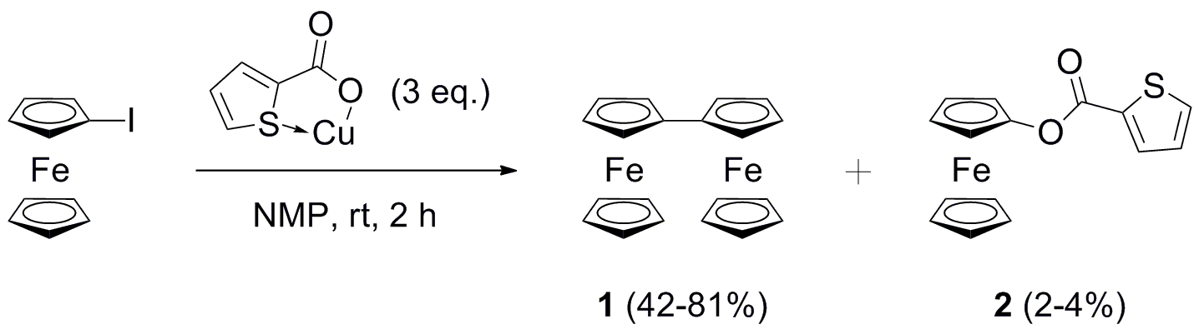
Supplementary Scheme 1. Synthesis of biferrocene (1) and ferrocenyl thiophene-2-carboxylate (2).

General conditions
All reactions were performed under an atmosphere of nitrogen. No special precautions were taken to exclude air or moisture during workup, unless otherwise stated. Ferrocenium BARF,¹ 1,1’-diacetylferrocenium hexafluoroantimonate,² CuTC³ and iodoferrocene^{4,5} were prepared via established routes, fc₁I₂, fc₂I₂ and fc₃I₂ were prepared as described in the SI, NMP (anhydrous, 99.5%, used without further purification) was from Sigma-Aldrich, all other reagents were commercially available and used as received. ¹H and ¹³C{¹H} NMR were recorded on a Bruker 400 MHz spectrometer and referenced to the residual solvent peaks of CDCl₃ at 7.26 and 77.16 ppm, respectively. Mass spectrometry analyses were conducted by Lisa Haigh of the Mass Spectrometry Service, Imperial College London using a Waters LCT Premier operating in ES+ mode (capillary voltage: 2 kV; sample cone voltage: 30 V; desolvation temperature: 350°C; source temperature: 120°C; cone gas flow [N₂]: 10 L/h; desolvation gas flow [N₂]: 400 L/h; MCP voltage: 2.1 kV) or a Micromass Micro MX ToF system operating in Reflectron mode using a 337 nm nitrogen laser (dihydroxy benzoic acid [DHB] used as matrix). Samples were diluted in appropriate solvent to an operating concentration of ~20 ng/μL and directly injected. For accurate mass, samples were referenced against Leucine Enkaphalin or Sulfadimethoxine (depending on mass). Microanalyses were carried out by Stephen Boyer of the Science Centre, London Metropolitan University using a Thermo Scientific (Carlo Erba) Flash 2000 Organic Elemental Analyser, configured for %CHN. Cyclic voltammograms were recorded under an atmosphere of argon in CH₂Cl₂/≤0.005 M NaBARF on a CHI760C potentiostat (CH Instruments, Austin, Texas) with a glassy carbon disc as working electrode (diameter = 2.5 mm), and Pt-wire as reference and counter electrodes respectively. Analyte solutions were between 0.1-1 mM. Potentials are reported relative to [Cp₂Fe]⁺/[Cp₂Fe], measured against internal [Cp₂Fe]⁺/[Cp₂Fe] or [Cp*₂Fe]⁺/[Cp*₂Fe] references, where appropriate.
UV/Vis/NIR spectroscopy on [cyclo[6]]^{n+} (n = 0, 1, 2)
1.40 mg of cyclo[6] was dissolved in 5 mL of 0.005 M DCM/TBA-BARF as starting solution. 0.9 mL aliquots of that solution were a) diluted with 0.9 mL of the supporting electrolyte solution, b) treated with 0.9 mL of Fc⁺ BARF– solution containing the oxidant at equal concentration as cyclo[6] (corresponding to 1 equiv. of the oxidizing agent), and c) treated with 0.9 mL of a solution of Fc⁺ BARF– solution containing twice the amount of Fc⁺ BARF– than that of cyclo[6] (corresponding to 2 equiv. of oxidant). The UV/Vis/NIR Data were recorded using a d=1 cm QS cuvette from HELLMA. For the generation of the [cyclo[6]]³⁺ 1,1'-diacetylferrocenium hexafluoroantimonate was used as an oxidizing agent. Immediately after addition of the oxidant the solution colour turned to an intense blue followed by instantaneous precipitation. UV/Vis/NIR spectra were recorded on a TIDAS fiberoptic diode array spectrometer (combined MCS UV/NIR and PGS NIR instrumentation) from j&m Analytik AG, Germany. The IR/NIR spectrum of [cyclo[6]]²⁺ was recorded on a Bruker TENSOR II spectrometer equipped with a liquid nitrogen cooled MCT detector system. The UV/Vis/NIR spectra are plotted against the molar extinction coefficient. Spectral deconvolution assuming Gaussian-shaped peaks of cyclo[6], [cyclo[6]]⁺ and [cyclo[6]]²⁺ on the wavenumber scale were performed with the ORIGIN program, version 2015, 92G.

Biferrocene (1) and ferrocenyl thiophene-2-carboxylate (2)
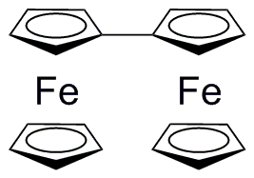Copper(I) thiophene-2-carboxylate (0.932 g, 4.90 mmol) was added to a solution of iodoferrocene (0.507 g, 1.63 mmol) in NMP (10 mL). After stirring at room temperature for 2 h, ethyl acetate was added (10 mL) and the mixture filtered through alumina (Brockmann activity V, 15% H₂O), rinsing with further ethyl acetate until the washings were colourless. This solution was washed with brine (3 x 100 mL), dried over MgSO₄ and filtered again through alumina (grade V). After concentration in vacuo, the crude material was purified using column chromatography (silica; n-hexane/CH₂Cl₂ [9:1→1:1 v/v]) eluting first a band comprising unreacted iodoferrocene and ferrocene. The subsequent band comprised 1 and 2, of which mixed fractions were combined and re-columned (silica; n-hexane/CH₂Cl₂ [4:1 v/v]). Solvent removal from selected combined fractions provided 1 as an orange crystalline solid (0.239 g, 81%). R_{f} (silica; n-hexane/CH₂Cl₂ [4:1 v/v]) = 0.27. ¹H NMR (400 MHz, CDCl₃): δ (ppm) 3.99 (s, 10H; Cp–H), 4.17 (pseudo-t, 4H; Cp–H), 4.35 (pseudo-t, 4H; Cp–H). ¹³C{¹H} NMR (101 MHz, CDCl₃): δ (ppm) 66.51 (4C; Cp-Cp, CH), 67.74 (4C; Cp-Cp, CH), 69.31 (10C; Cp-H, CH), 84.07 (2C; Cp-Cp, C). HR-MS ES+: m/z 370.0109 ([M]⁺ calc. for C₂₀H₁₈Fe₂: 370.0107).
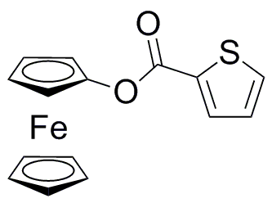Solvent removal from selected combined fractions provided 2 as an orange crystalline solid (0.008 g, 2%). R_{f} (silica; n-hexane/CH₂Cl₂ [4:1 v/v]) = 0.07. ¹H NMR (400 MHz, CDCl₃): δ (ppm) 4.00 (pseudo-t, 2H; Cp–H), 4.26 (s, 5H; Cp–H), 4.56 (pseudo-t, 2H; Cp–H), 7.16 (dt, J = 4.4, 1.4 Hz, 1H; C–H₍₃₎), 7.63 (dd, J = 5.0, 1.3 Hz, 1H; C–H), 7.89 (dd, J = 3.8, 1.4 Hz, 1H; C–H). ¹³C{¹H} NMR (100 MHz, CDCl₃): δ (ppm) 61.01 (2C; Cp-R, CH), 63.47 (2C; Cp-R, CH), 69.56 (5C; Cp, CH), 116.13 (1C; Cp, C–O), 128.09 (1C; C₄H₃S, CH), 133.22 (1C; C₄H₃S, CH), 133.32 (1C; C₄H₃S, C–CO₂Fc), 134.24 (1C; C₄H₃S, CH), 160.55 (1C; C=O). HR-MS ES+: m/z 311.9922 ([M]⁺ calc. for C₁₅H₁₂FeO₂S: 311.9907). (Found: C, 57.56; H, 3.94. Calc. for C₁₅H₁₂FeO₂S: C, 57.71; H, 3.87%).
1,1’-Diiodoferrocene (fc₁I₂), 1,1’’’-diiodobiferrocene (fc₂I₂)^{4,6} and 1,1’’’’’-diiodoterferrocene (fc₃I₂)⁷
A mixture of ferrocene (21.3 g, 114 mmol), n-hexane (200 mL) and TMEDA (37.7 mL, 251 mmol) was stirred in an oven-dried 1 L three-necked flask and cooled to 0 °C (ice-bath). 2.5 M ^{n}BuLi in hexanes (100 mL, 250 mmol) was added via cannula over 5 min, whereby the suspension was slowly raised to ambient temperature and stirred overnight. The resulting bright orange suspension (1,1′-dilithioferrocene–TMEDA) was cooled to −78 °C (acetone/dry ice) and a solution of I₂ (43.5 g, 171 mmol) in diethyl ether (240 mL) added. After warming to 0 °C, the reaction was quenched with water (100 mL) and stirred for a further 15 min. The mixture was filtered through sand, washed with brine (~100 mL), dried over MgSO₄, and filtered through Celite to provide a dark red slurry after solvent removal. Mono-, bi- and tri-nuclear ferrocene products were separated via repeated column chromatography (silica; eluting first with n-hexane/toluene [1:0→6:4 v/v], then CH₂Cl₂ to remove crystallized trinuclear and polynuclear materials).
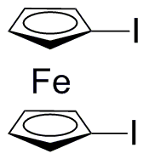Mononuclear ferrocene materials (ferrocene, iodoferrocene, fc₁I₂; R_{f} ≈ 0.7 on silica, n-hexane/toluene [6:4 v/v]⁸) were dissolved in n-hexane and washed (1 ‘wash’ = vigorous shaking for 2 min) with 0.5 M FeCl₃ (chemical oxidant, 9 x 200 mL).^{5,9,10} When ferrocene-containing contaminants had been removed (composition monitored by ¹H NMR spectroscopy between washings), the organic phase was extracted with water until the washings were colourless, dried over MgSO₄, filtered through Celite and solvent removed. The crude product was purified by column chromatography (silica; n-hexane), to provide pure fc₁I₂ as a dark orange oil (7.861 g, 16% based on ferrocene). ¹H NMR (400 MHz, CDCl₃): δ (ppm) 4.18 (pseudo-t, 4H; Cp–H), 4.38 (pseudo-t, 4H; Cp–H). ¹³C{¹H} NMR (101 MHz, CDCl₃): δ (ppm) 40.43 (2C; Cp-I, CI), 72.41 (2C; Cp-I, CI), 77.72 (2C; Cp-I, CI). HR-MS ES+: m/z 437.8075 ([M]⁺ calc. for C₁₀H₈FeI₂: 437.8065).
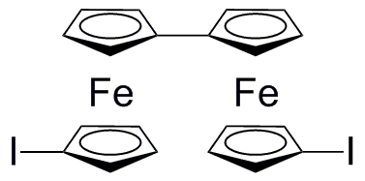Binuclear ferrocene materials (including fc₂I₂; R_{f} ≈ 0.5 on silica, n-hexane/toluene [6:4 v/v]⁸), were dissolved in CH₂Cl₂ and washed with 0.2 M FeCl₃ (chemical oxidant, 6 x 100 mL).^{5,9,10} The organic phase was pre-absorbed on silica and further purified via column chromatography (silica; CH₂Cl₂/n-hexane [0:1→3:7]) to provide pure fc₂I₂ as a dark red crystalline solid (2.427 g, 7%). ¹H NMR (400 MHz, CDCl₃): δ (ppm) 3.98 (pseudo-t, 4H; Cp–H), 4.16 (pseudo-t, 4H; Cp–H), 4.24 (pseudo-t, 4H; Cp–H), 4.35 (pseudo-t, 4H; Cp–H). ¹³C{¹H} NMR (100 MHz, CDCl₃): δ (ppm) 40.87 (2C; Cp-I, CI), 69.73 (4C; Cp-H, CH), 70.19 (4C; Cp-H, CH), 71.12 (4C; Cp-H, CH), 75.94 (4C; Cp-H, CH), 84.66 (2C; Cp-Cp, C). HR-MS ES+: m/z 621.8056 ([M]⁺ calc. for C₂₀H₁₆Fe₂I₂: 621.8040).
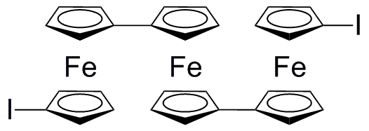Trinuclear ferrocene materials (including fc₃I₂; R_{f} ≈ 0.4 on silica, n-hexane/toluene [6:4 v/v]⁸) were dissolved in CH₂Cl₂ and washed with 0.2 M FeCl₃ (chemical oxidant, 1 x 200 mL).^{5,9,10} The black-red organic phase was pre-absorbed on silica and purified by column chromatography (silica; n-hexane/CH₂Cl₂ [8:2→8:3 v/v]). Selected fractions were combined and their dried residue recrystallized from CH₂Cl₂/n-hexane to provide fc₃I₂ as an orange-red crystalline solid (0.519 g, 2% based on ferrocene). ¹H NMR (400 MHz, CDCl₃): δ (ppm) 3.91 (pseudo-t, 4H; Cp–H), 4.06 (br pseudo-t, 4H; Cp–H), 4.10 (pseudo-t, 4H; Cp–H), 4.15 (br s, 12H; Cp–H). ¹³C{¹H} NMR (101 MHz, CDCl₃): δ (ppm) 40.86 (2C; Cp-I, CI), 67.91 (4C; Cp-H, CH), 69.16 (4C; Cp-H, CH), 69.39 (4C; Cp-H, CH), 70.13 (4C; Cp-H, CH), 70.88 (4C; Cp-H, CH), 75.79 (4C; Cp-H, CH), 83.25 (2C; Cp-Cp, C), 85.50 (2C; Cp-Cp, C). HR-MS ES+: m/z 805.8037 ([M]⁺ calc. for C₃₀H₂₄Fe₃I₂: 805.8016).
Cyclo[2]
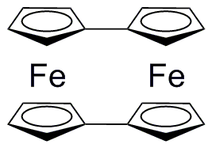Following the typical procedures described in the manuscript. R_{f} = 0.49 (silica, n-hexane/CH₂Cl₂ [6:4 v/v]). ¹H NMR (400 MHz, CDCl₃): δ (ppm) 3.89 (br pseudo-t, 8H; Cp–H), 5.41 (br pseudo-t, 8H; Cp–H). ¹³C{¹H} NMR (100 MHz, CDCl₃): δ (ppm) 66.19 (8C; Cp–H, CH), 68.97 (8C; Cp–H, CH), CR₃ resonance not observed due to low solubility of cyclo[2] in CDCl₃. HR-MS ES+: m/z 367.9934 ([M]⁺ calc. for C₂₀H₁₆Fe₂: 367.9951).

Cyclo[5]
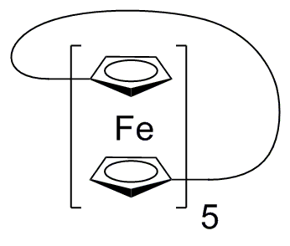Following the typical procedure described in the manuscript R_{f} = 0.33 (silica, n-hexane/CH₂Cl₂ [6:4 v/v]). ¹H NMR (400 MHz, CDCl₃): δ (ppm) 4.25 (pseudo-t, 20H; Cp–H), 4.42 (pseudo-t, 20H; Cp–H). ¹³C{¹H} NMR (100 MHz, CDCl₃): δ (ppm) 69.16 (20C; Cp–H, CH), 69.98 (20C; Cp–H, CH), 86.12 (10C; Cp-Cp, C). HR-MS ES+: m/z 919.9883 ([M]⁺ calc. for C₅₀H₄₀Fe₅: 919.9877).
Cyclo[6]
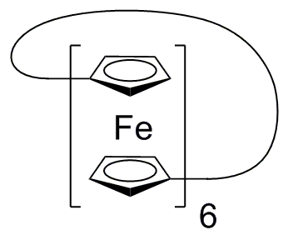Following the typical procedures described in the manuscript. R_{f} = 0.29 (silica, n-hexane/CH₂Cl₂ [6:4 v/v]). ¹H NMR (400 MHz, CDCl₃): δ (ppm) 4.15 (pseudo-t, 24H; Cp–H), 4.22 (pseudo-t, 24H; Cp–H). ¹³C{¹H} NMR (100 MHz, CDCl₃): δ (ppm) 68.90 (24C; Cp–H, CH), 69.55 (24C; Cp–H, CH), 85.09 (12C; Cp-Cp, C). HR-MS ES+: m/z 1103.9879 ([M]⁺ calc. for C₆₀H₄₈Fe₆: 1103.9852), 551.9860 ([M]²⁺). Crystals suitable for X-ray analysis were grown (a) from toluene solution at -20°C, (b) from evaporation of a benzene solution at room temperature – both solutions comprised 10% cyclo[2].
Cyclo[7]
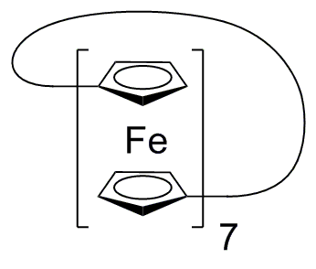Following the typical procedures described in the manuscript. R_{f} = 0.23 (silica, n-hexane/CH₂Cl₂ [6:4 v/v]). ¹H NMR (400 MHz, CDCl₃): δ (ppm) 4.13 (pseudo-t, 28H; Cp–H), 4.20 (pseudo-t, 28H; Cp–H). ¹³C{¹H}16 NMR (100 MHz, CDCl₃): δ (ppm) 68.91 (28C; Cp–H, CH), 69.39 (28C; Cp–H, CH), 85.05 (14C; Cp-Cp, C). HR-MS ES+: m/z 1287.9943 ([M]⁺ calc. for C₇₀H₅₆Fe₇: 1287.9828).
Cyclo[9]
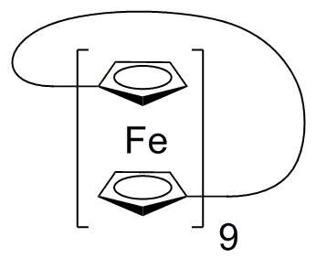Following the typical procedures described in the manuscript R_{f} = 0.18 (silica, n-hexane/CH₂Cl₂ [6:4 v/v]). ¹H NMR (400 MHz, CDCl₃): δ (ppm) 4.07 (pseudo-t, 36H; Cp–H), 4.15 (pseudo-t, 36H; Cp–H). ¹³C{¹H} NMR (100 MHz, CDCl₃): δ (ppm) 68.55 (36C; Cp–H, CH), 69.37 (36C; Cp–H, CH), 84.77 (18C; Cp-Cp, C). MS MALDI+: m/z 1656.3 ([M]⁺ calc. for C₉₀H₇₂Fe₉: 1655.9779).

OXIDATIVE PURIFICATION OF STARTING MATERIALS

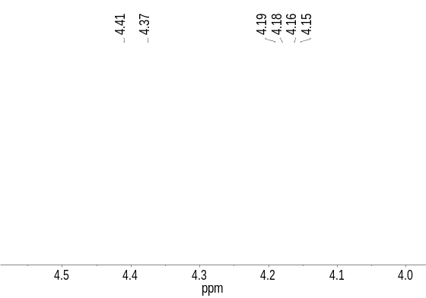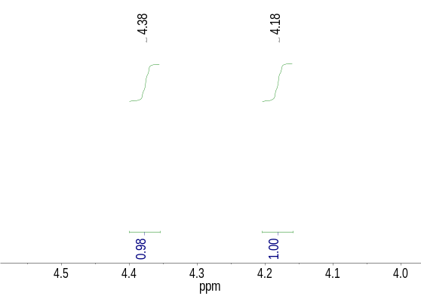
Supplementary Figure 1. ¹H NMR spectra before (left) and after (right) oxidative purification of fc₁I₂.

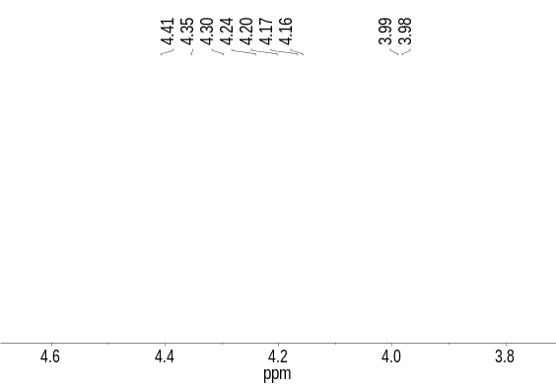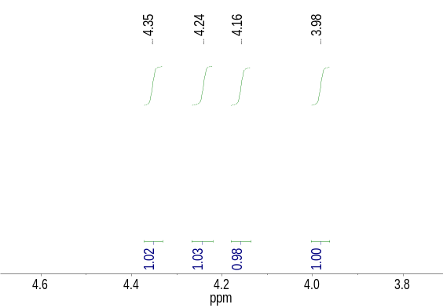
Supplementary Figure 2. ¹H NMR spectra before (left) and after (right) oxidative purification of fc₂I₂.

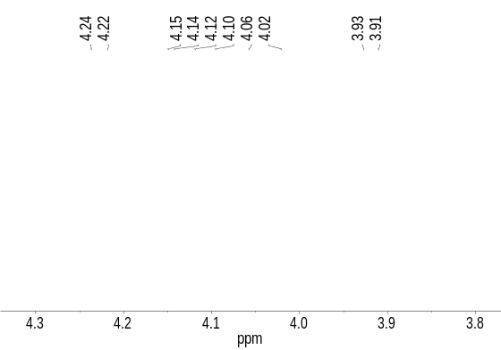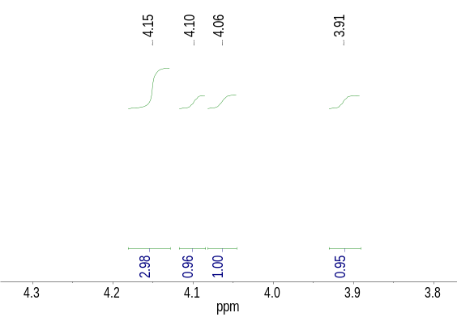
Supplementary Figure 3. ¹H NMR spectra before (left) and after (right) oxidative purification of fc₃I₂.

NMR AND MASS SPECTRA
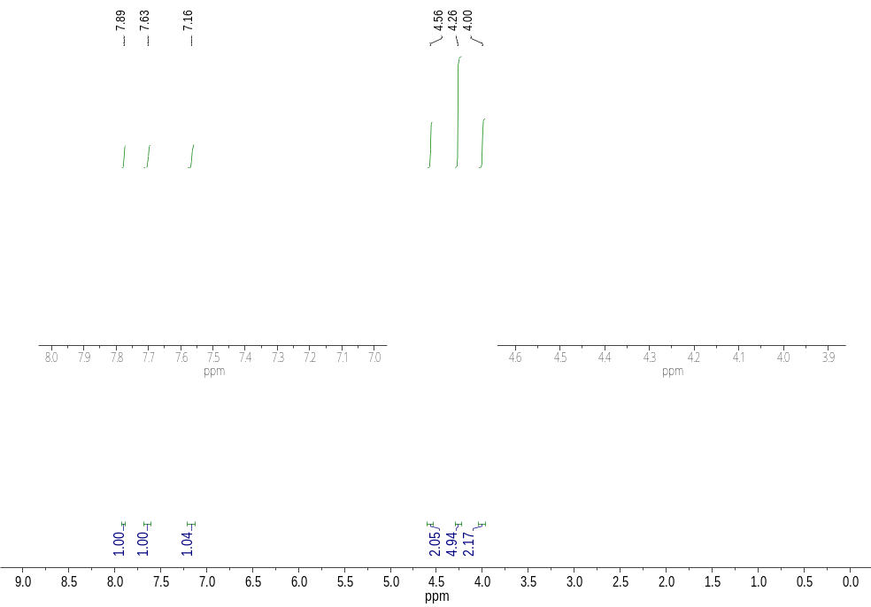
Supplementary Figure 4. ¹H NMR spectrum of 2 in CDCl₃.
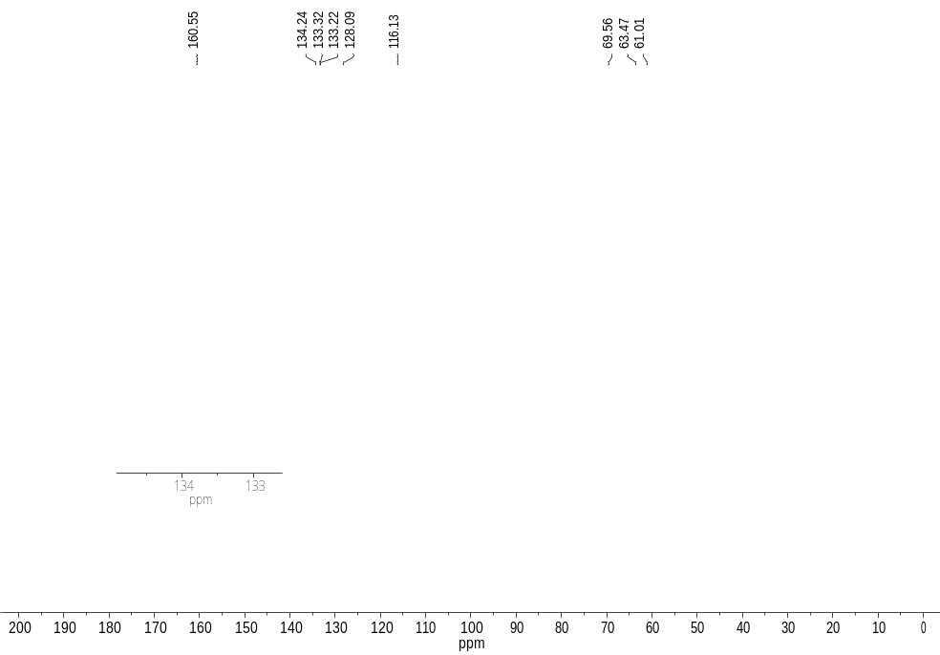
Supplementary Figure 5. ¹³C{¹H} NMR spectrum of 2 in CDCl₃.
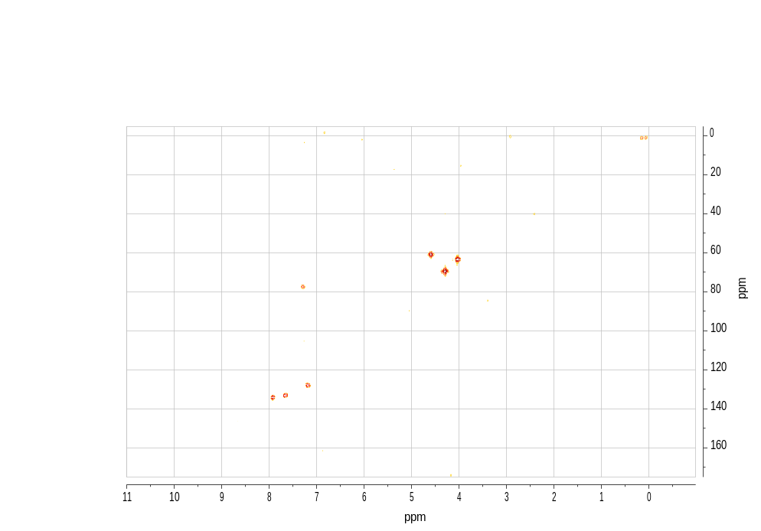
Supplementary Figure 6. 2D HMQC (¹H, ¹³C) NMR spectrum of 2 in CDCl₃.

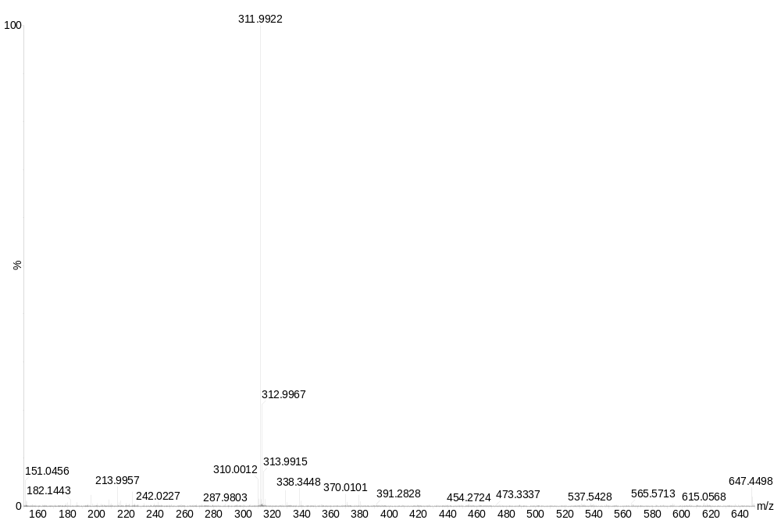
Supplementary Figure 7. Mass spectrum (ES+) of 2.
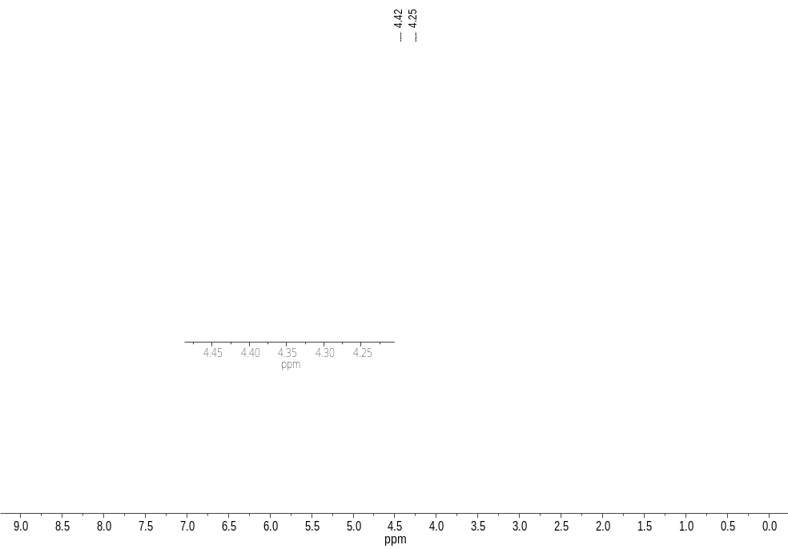
Supplementary Figure 8. ¹H NMR spectrum of cyclo[5] in CDCl₃.
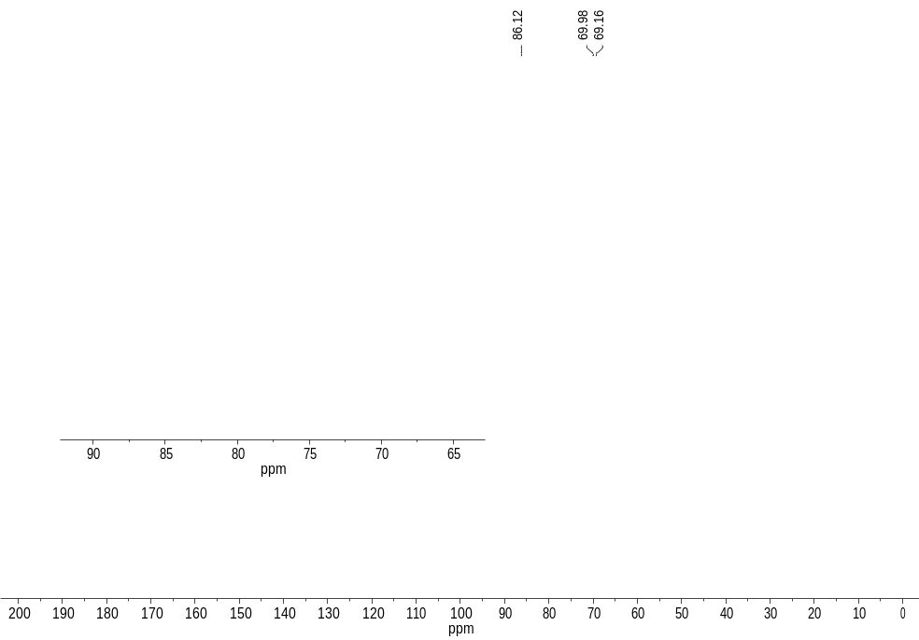
Supplementary Figure 9. ¹³C{¹H} NMR spectrum of cyclo[5] in CDCl₃.

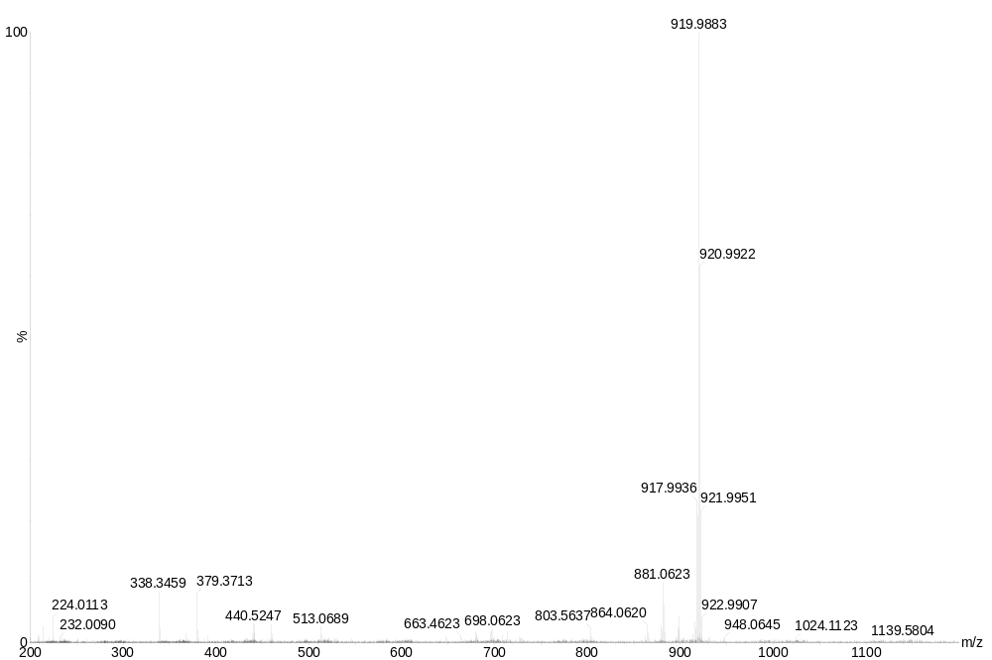
Supplementary Figure 10. Mass spectrum (ES+) of cyclo[5].

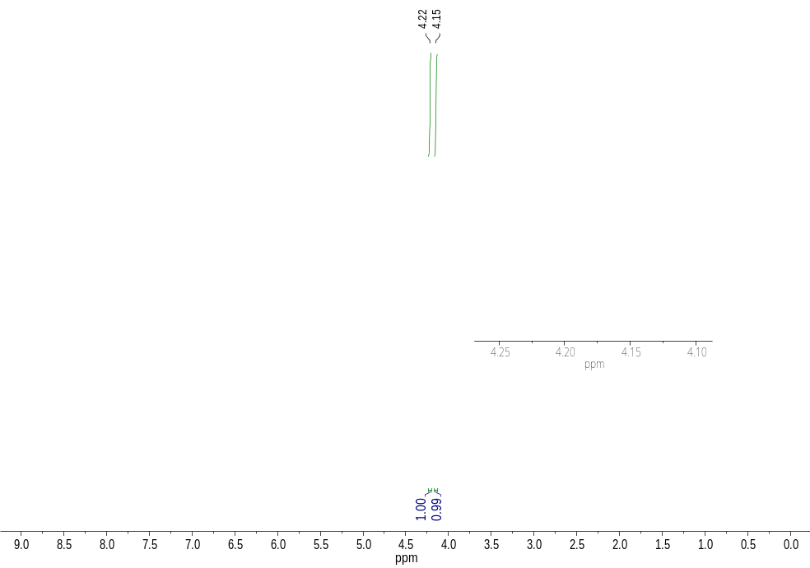
Supplementary Figure 11. ¹H NMR spectrum of cyclo[6] in CDCl₃.
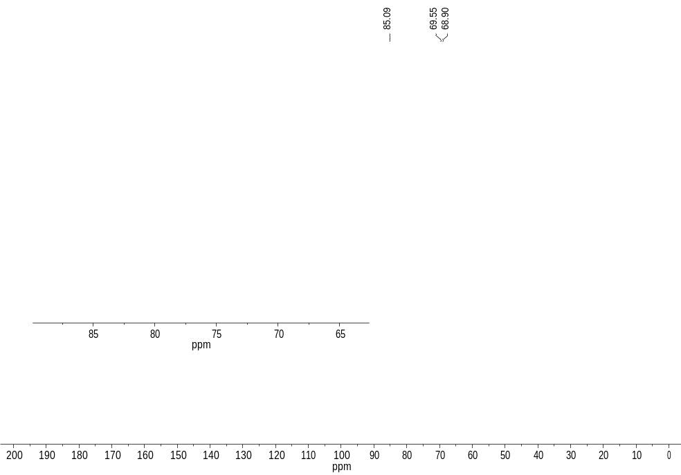
Supplementary Figure 12. ¹³C{¹H} NMR spectrum of cyclo[6] in CDCl₃.
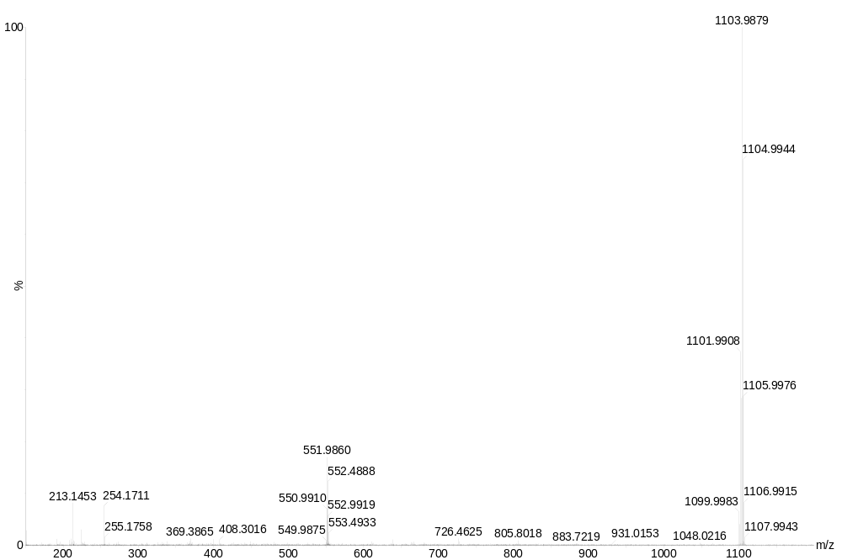
Supplementary Figure 13. Mass spectrum (ES+) of cyclo[6].

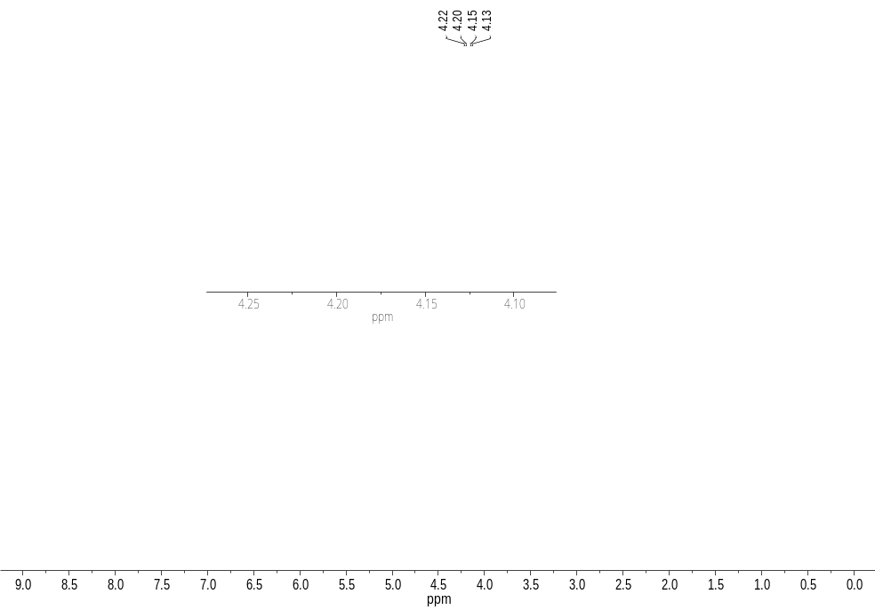
Supplementary Figure 14. ¹H NMR spectrum of a mixture of cyclo[2], cyclo[6] and cyclo[7] in CDCl₃.
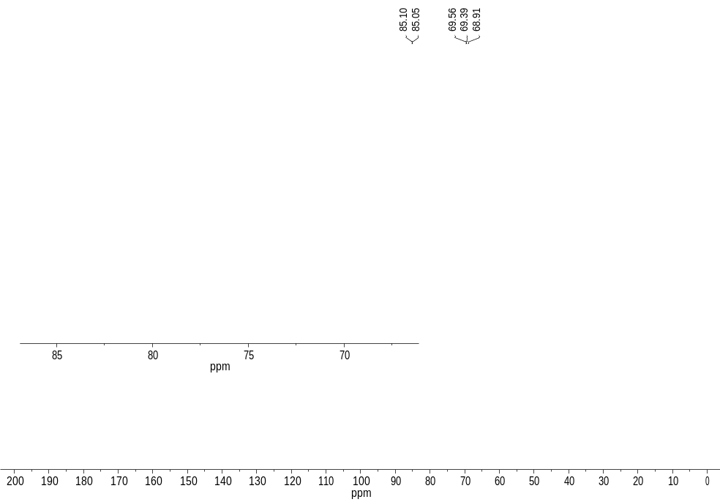
Supplementary Figure 15. ¹³C{¹H} NMR spectrum of a mixture of cyclo[2], cyclo[6] and cyclo[7] in CDCl₃.

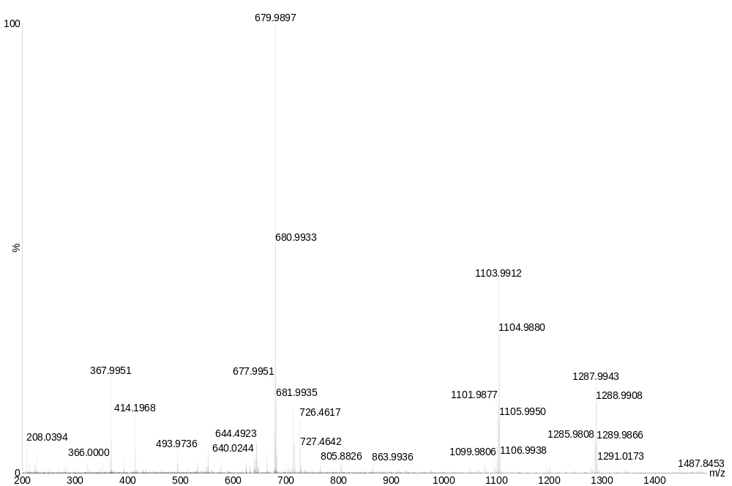
cyclo[7]
cyclo[6]
cyclo[2]
Supplementary Figure 16. Mass spectrum (ES+) of a mixture comprising cyclo[2], cyclo[6] and cyclo[7]. The peak at 679.9897 m/z likely corresponds to a minor impurity (fragment intensity not quantitative) of terferrocenyl thiophene-2-carboxylate ([M]⁺ calc. for C₃₅H₂₈Fe₃O₂S = 679.9858) which elutes closely during chromatographic separation of the cyclic products.
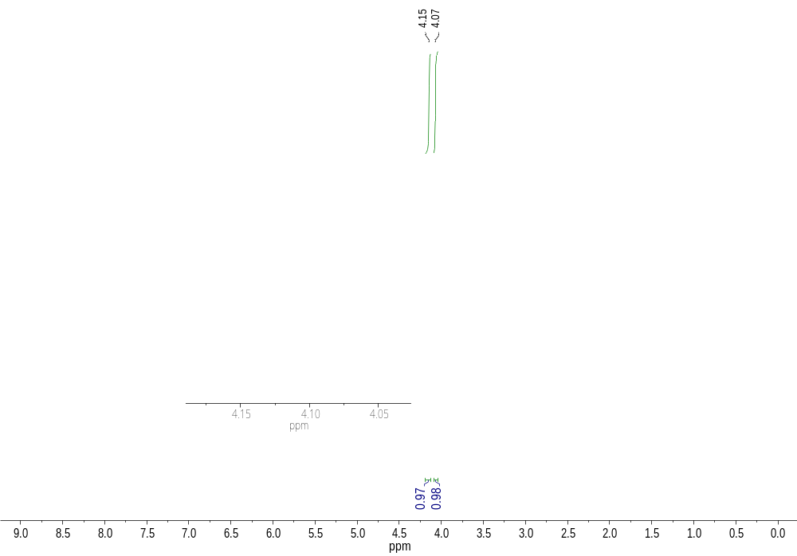
Supplementary Figure 17. ¹H NMR spectrum of cyclo[9] in CDCl₃.

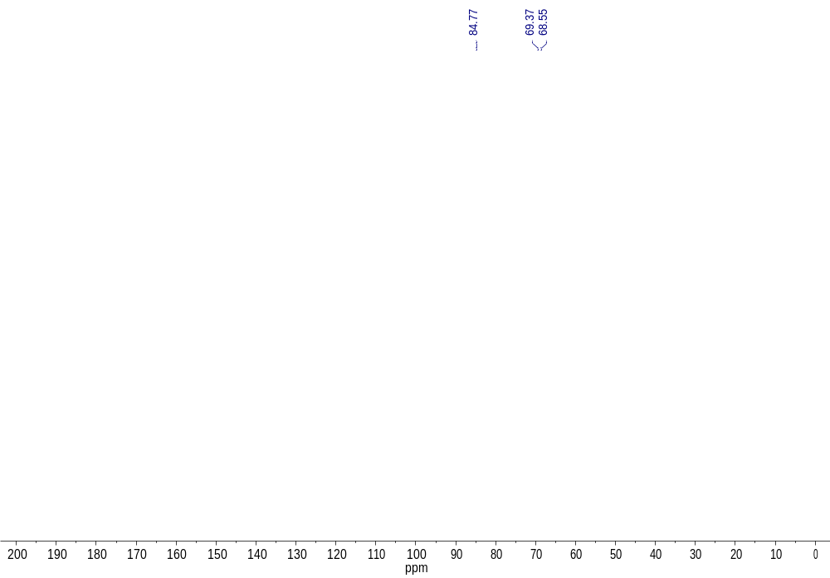
Supplementary Figure 18. ¹³C{¹H} NMR spectrum for cyclo[9] in CDCl₃.

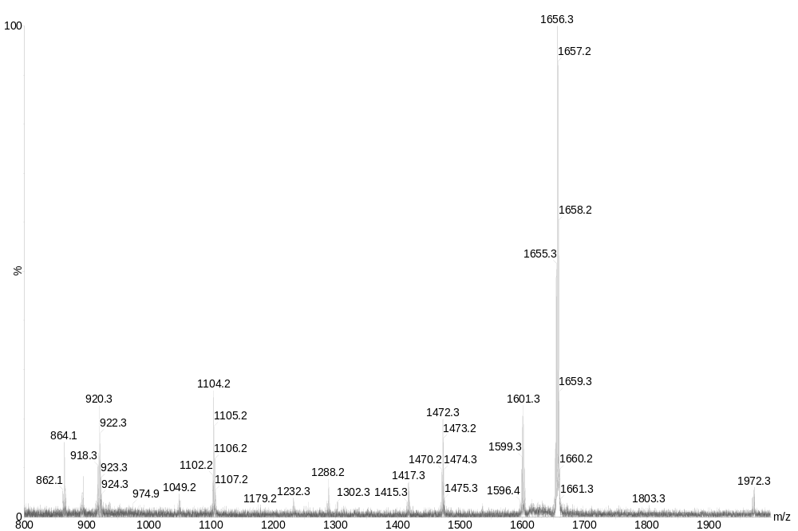
Supplementary Figure 19. Mass spectrum (MALDI+) for cyclo[9].

Variable-temperature experiments with cyclo[6]

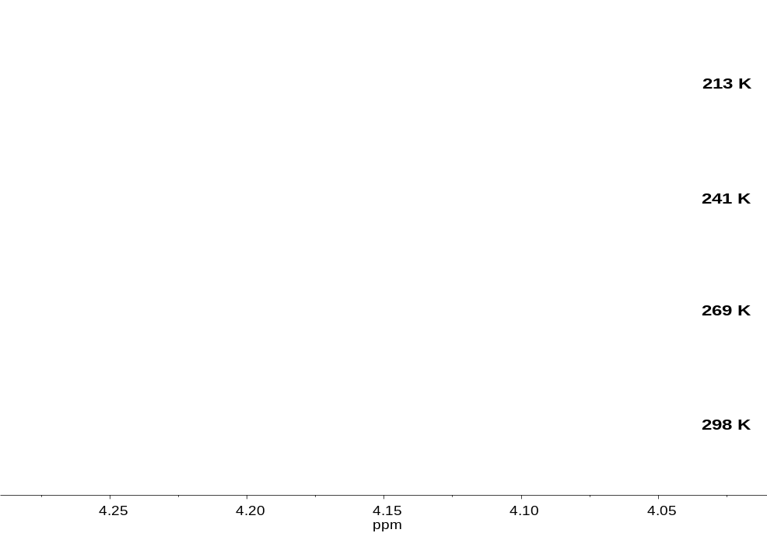
Supplementary Figure 20. Variable temperature ¹H NMR spectra for cyclo[6] in CD₂Cl₂ (213-298 K).

ELECTROCHEMISTRY
Experimental data
Supplementary Table 1. Equilibrium potentials (E_{x}) for oligomeric ferrocene rings.ª
 | E₁ | E₂ | E₃ | E₄ | E₅ | E₆ | E₇ | E₈ | E₉
cyclo[2]^{b} | -0.320 | 0.737 | - | - | - | - | - | - | -
cyclo[5]^{b} | -0.117 | 0.100 | 0.634 | (1.515) | (2.713) | - | - | - | -
cyclo[6]^{c} | -0.184 | -0.010 | 0.365 | 0.933 | (1.726) | (2.718) | - | - | -
cyclo[9]^{c} | -0.250 | -0.132 | 0.040 | 0.252 | 0.586 | 0.955 | (1.413) | (1.937) | (2.603)
ª Conditions: scan rate 0.1 V s⁻¹; working electrode, glassy carbon; reference and counter electrodes, Pt; electrolyte, CH₂Cl₂/NaBARF. All potentials in V, reported relative to [Cp₂Fe]⁺/[Cp₂Fe]. Equilibrium potentials obtained from DPV experiments, where E_{x} = E_{pa} + pulse height/2. Extrapolated data are enclosed in parentheses. ^{b} Measured with internal Cp₂Fe. ^{c} Measured with internal Cp*₂Fe (-0.624 V vs [Cp₂Fe]⁺/[Cp₂Fe]).

Supplementary Table 2. The difference in consecutive equilibrium potentials (ΔE_{(i-1)/i}) for oligomeric ferrocene rings.ª
 | ΔE_{1/2} | ΔE_{2/3} | ΔE_{3/4} | ΔE_{4/5} | ΔE_{5/6} | ΔE_{6/7} | ΔE_{7/8} | ΔE_{8/9}
cyclo[2] | 1.056 | - | - | - | - | - | - | -
cyclo[5] | 0.217 | 0.534 | (0.881) | (1.198) | - | - | - | -
cyclo[6] | 0.174 | 0.375 | 0.568 | (0.793) | (0.992) | - | - | -
cyclo[9] | 0.118 | 0.172 | 0.212 | 0.334 | 0.369 | (0.458) | (0.524) | (0.666)
ª ΔE_{(i-1)/i} = E_{i} – E_{i-1}. For conditions see Supplementary Table 1. Data based on extrapolated E_{x} values are enclosed in parentheses.

Supplementary Table 3. Electrochemical data for oligomeric ferrocene rings.ª
 | redox transition | E_{pa} | E_{pc} | ΔE | i_{pa}/i_{pc}
cyclo[2] | 0→1⁺  1⁺→2⁺ | -0.287  0.778 | -0.353  0.696 | 0.066  0.082 | 1.05  0.92
cyclo[5] | 0→1⁺  1⁺→2⁺  2⁺→3⁺ | -0.083  0.135  0.665 | -0.152  0.066  0.596 | 0.069  0.069  0.061 | 1.04  0.99  0.92
cyclo[6] | 0→1⁺  1⁺→2⁺  2⁺→3⁺  3⁺→4⁺ | -0.150  0.027  0.407  0.973 | -0.218  -0.047  0.324  0.894 | 0.068  0.073  0.083  0.079 | 1.05  0.89  0.94  0.87
cyclo[9]^{b} | 0→1⁺  1⁺→2⁺  2⁺→3⁺  3⁺→4⁺  4⁺→5⁺  5⁺→6⁺ | -0.275  -0.158  0.010  0.223  0.557  0.930 | -0.226  -0.107  0.071  0.282  0.615  0.981 | 0.049  0.051  0.061  0.059  0.058  0.051 | 1.09  0.93  1.00  0.99  0.94  0.80
ª Conditions: scan rate 0.1 V s⁻¹; working electrode, glassy carbon; reference and counter electrodes, Pt; electrolyte, CH₂Cl₂/NaBARF. All potentials in V, corrected for iR_{s} and reported relative to [Cp₂Fe]⁺/[Cp₂Fe]. Data taken from cyclic voltammetry experiments unless otherwise noted. ^{b} Data taken from differential pulse voltammetry experiments, where in the ideal case ΔE = E_{pc} – E_{pa} = pulse height (here, 0.05 V).

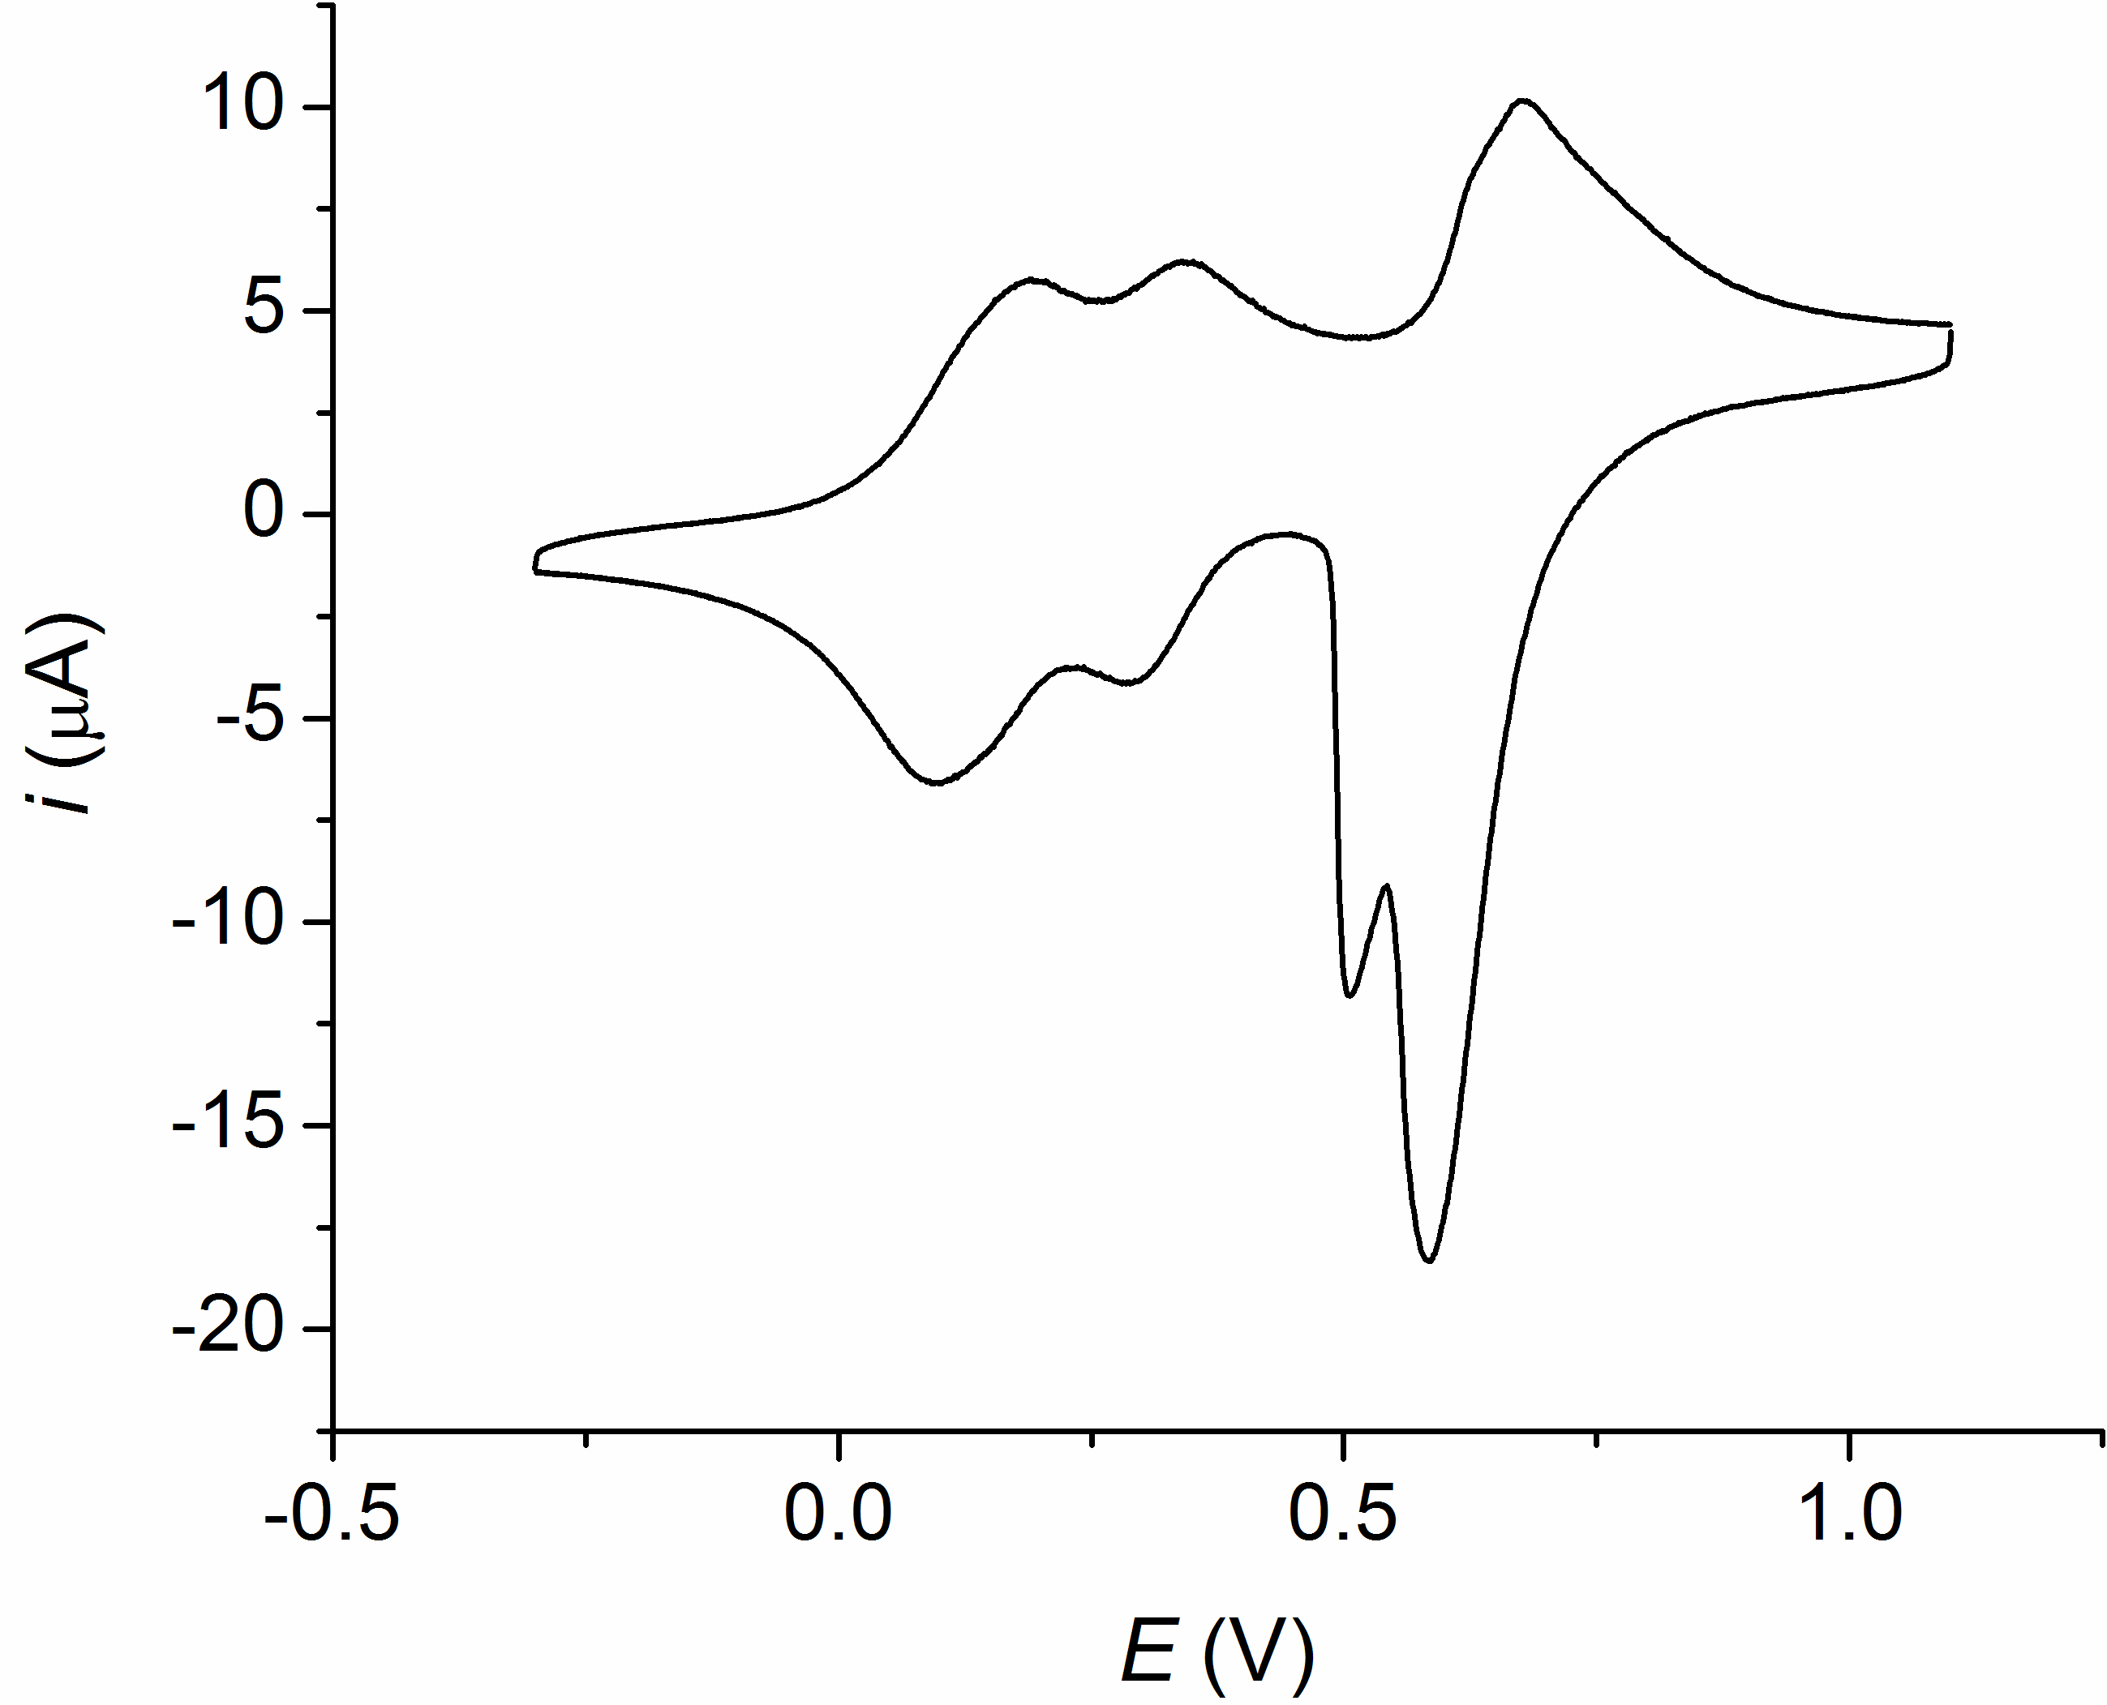
Supplementary Figure 21. Cyclic voltammogram for cyclo[6] in CH₂Cl₂/0.1 M NBu₄PF₆ (V vs Pt, V_{s} = 0.1 V s⁻¹).
Relationships between microscopic and macroscopic standard potentials
Following the methodology of Sokol et al.¹¹ (n = 4) and Richardson and Taube¹² (n = 2), we have derived relationships between the microscopic and macroscopic standard potentials of systems containing n = 2-9 equivalent and interacting redox centres. A generalized formula permits these relationships to be calculated for any n (see later). These may subsequently be used to calculate the Gibbs free energy of interaction (Δ_{int}G).
For 3 oxidized sites (n = 3) where each site can be reduced by one electron, eight species are possible (O_{x} = oxidized site, R_{x} = reduced site). These species are related as shown in Supplementary Scheme 2. It is notable that the number of species present in each oxidation state for different n follows the lines in Pascal’s Triangle (here for n = 3, 1-3-3-1; and for n = 2, 1-2-1; n = 4, 1-4-6-4-1; n = 5, 1-5-10-10-5-1, etc).

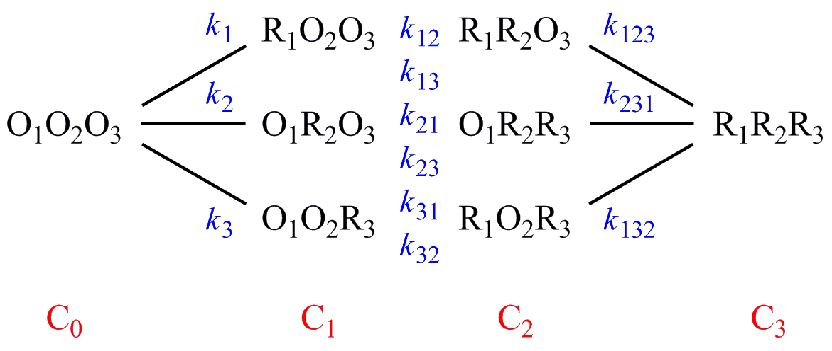
Supplementary Scheme 2. Relationship between species for a 3-centre system.

The last subscript digit of each microscopic equilibrium constant (k) indicates which site is undergoing reduction, whereas previous digits (where applicable) indicate which sites were reduced in the oxidized form of the redox couple (e.g. k₁₂ relates to the microscopic equilibrium R₁O₂O₃ ⇄ R₁R₂O₃). The microscopic equilibrium constants are related to the microscopic Nernst potentials (e⁰), by equations such as Supplementary Equation 1.

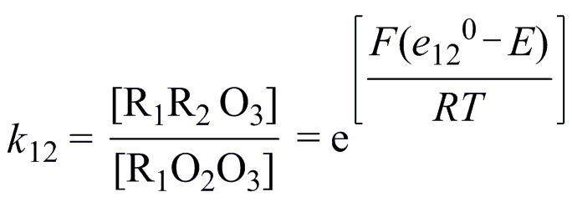
(1)

Where [R₁R₂O₃], [R₁O₂O₃], etc represent equilibrium concentrations at potential E, F = Faraday’s constant, R = gas constant and T = temperature. Macroscopic equilibrium constants (K) and macroscopic standard potentials (E⁰) are related by Supplementary Equation 2, where C_{i} = total concentration of all species in the same oxidation state.

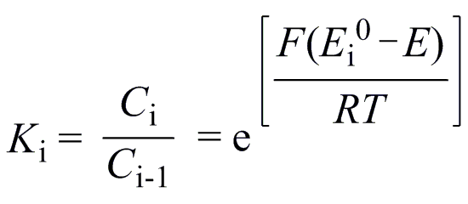
(2)

If it is assumed that all microscopic parameters at any stage of reduction are equal (e.g. k₁ = k₂ = k₃ = k) – as in the case of equivalent, interacting sites – the relationship between macroscopic and microscopic parameters can be determined as outlined in Supplementary Equations 3-5.

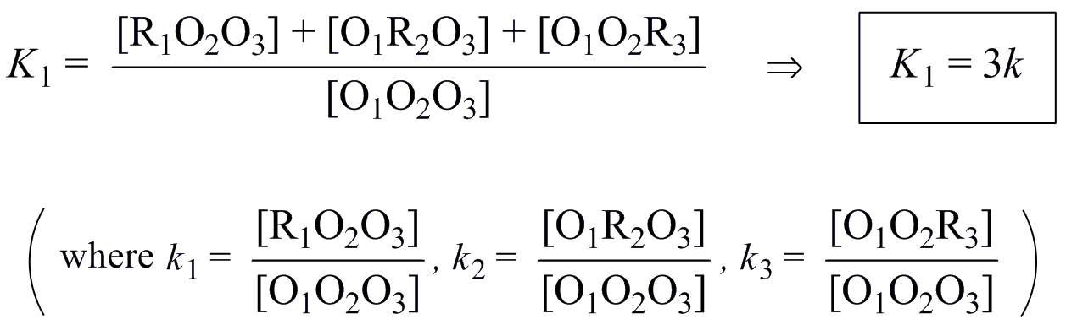
(3)

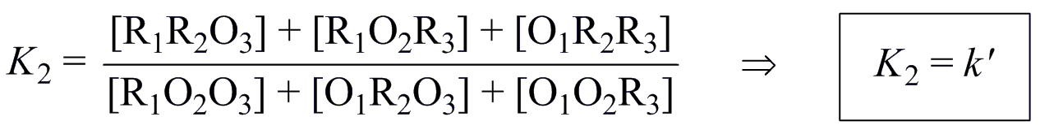
(4)

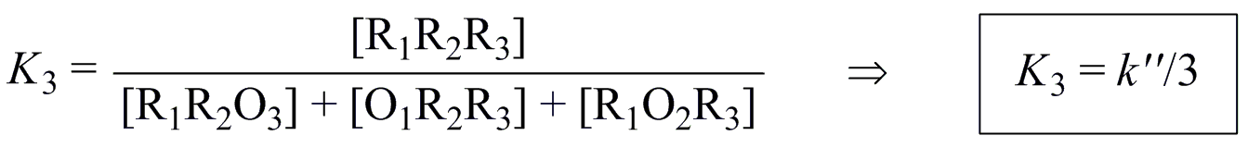
(5)

Using an identical methodology, we derived K₁-K₅ for a 5-centre system (not shown). With the relationships between microscopic and macroscopic parameters for n = 2-5 known, it proved possible to extrapolate relationships for n = 6-9 (Supplementary Table 4) based on the following observations. For K₁, k is always simply multiplied by n. For K_{x} (x > 1), the denominator is always x and the numerator increases by 1 with each corresponding change in n. So for K₄, the series is 1/4, 2/4, 3/4, 4/4, etc. Finally, for a given K_{x}, the number of primes on k increases as x-1. These observations can be consolidated into a generalized formula, allowing K_{x} to be determined for any values of x and n (Supplementary Equation 6, where x_{min} = n). Note that in the term k^{(x-1)}’, (x-1) is intended to indicate the number of primes.

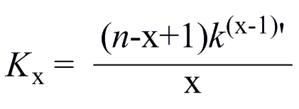
(6)
Supplementary Table 4. Relationships between microscopic (k) and macroscopic (K) standard potentials for molecules with n identical, strongly interacting redox sites.ª
K_{x} | n
K_{x} | 2^{b} | 3 | 4^{c} | 5 | 6 | 7 | 8 | 9
1 | 2k | 3k | 4k | 5k | 6k | 7k | 8k | 9k
2 | k’/2 | k’ | 3k’/2 | 2k’ | 5k’/2 | 3k’ | 7k’/2 | 4k’
3 | - | k’’/3 | 2k’’/3 | k’’ | 4k’’/3 | 5k’’/3 | 2k’’ | 7k’’/3
4 | - | - | k’’’/4 | k’’’/2 | 3k’’’/4 | k’’’ | 5k’’’/4 | 3k’’’/2
5 | - | - | - | k’’’’/5 | 2k’’’’/5 | 3k’’’’/5 | 4k’’’’/5 | k’’’’
6 | - | - | - | - | k’’’’’/6 | k’’’’’/3 | k’’’’’/2 | 2k’’’’’/3
7 | - | - | - | - | - | k⁶’/7 | 2k⁶’/7 | 3k⁶’/7
8 | - | - | - | - | - | - | k⁷’/8 | k⁷’/4
9 | - | - | - | - | - | - | - | k⁸’/9
ª Derived here for n = 3 (provided in full above) and n = 5 (not shown), extrapolated for n = 6-9. ^{b} From Richardson and Taube.¹² ^{c} From Sokol et al.¹¹

The difference in two standard reduction potentials corresponds to the ratio of macroscopic equilibrium constants as according to Supplementary Equation 7, in turn related to the Gibbs free energy of comproportionation (Δ_{co}G⁰) via Supplementary Equation 8.
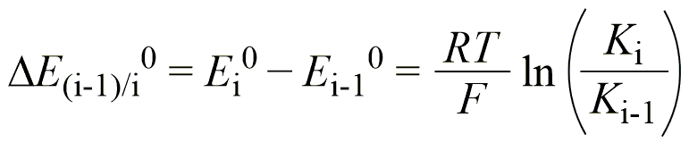
(7)

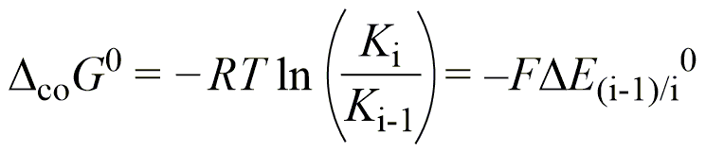
(8)

Taking the derived relationships between K and k (Supplementary Table 4) and experimentally determined ΔE_{i-1/i} (Supplementary Table 2), we calculated Δ_{int}G for each ΔE_{(i-1)/i} (Supplementary Table 5) using the method shown in the following example. Worked example – the relationship between ΔE_{1/2}⁰ and the microscopic equilibrium constants for a 5-centre system is provided by Supplementary Equation 9.
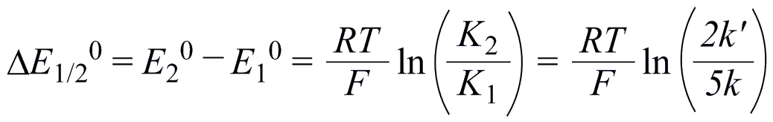
(9)

Where ΔE_{1/2} = 0.217 V at 25°C (Supplementary Table 2), k’/k = 11696 which corresponds to Δ_{int}G = –RT ln 11696 = -23.207 kJ mol⁻¹. Note that Δ_{int}G⁰ is related to Δ_{co}G⁰ by the statistical factor, in this case –(RT/F)ln (2/5).

Supplementary Table 5. Calculated Δ_{int}G for each ΔE_{i-1/i} for oligomeric ferrocene rings.ª
 | Δ_{int}G_{1/2} | Δ_{int}G_{2/3} | Δ_{int}G_{3/4} | Δ_{int}G_{4/5} | Δ_{int}G_{5/6} | Δ_{int}G_{6/7} | Δ_{int}G_{7/8} | Δ_{int}G_{8/9}
cyclo[2] | –105.419 | - | - | - | - | - | - | -
cyclo[5] | –23.207 | –53.240 | (–83.274) | (–113.307) | - | - | - | -
cyclo[6] | –18.957 | –37.739 | –56.229 | (–74.915) | (–93.551) | - | - | -
cyclo[9] | –13.394 | –17.931 | –21.550 | –33.231 | –36.608 | (–43.060) | (–49.233) | (–55.406)
ª Δ_{int}G_{i-1/i} = –(RT/F)ln (k^{[i-1]}’/k^{[i-2]}’). Extrapolated values are enclosed in parentheses.

Charge delocalization in related ferrocene materials
From the data presented in this study, it is apparent that charges in oxidized cyclo[n] materials are rapidly transferred between ferrocene sites, at least on the electrochemical timescale (0.1-1 s⁻¹). However, it is not yet possible to address several intriguing questions regarding charge delocalization at faster timescales (≥1-10⁷ s⁻¹). Key experiments to probe this – through utilization of IR spectroelectrochemistry, Mössbauer or electron paramagnetic resonance (EPR) spectroscopy – were inaccessible due to the limited quantities of cyclic materials currently available (<10 mg, at best). To provide additional insights, in this section we review previous investigations of charge transfer in analogous directly bonded, unsubstituted ferrocene materials (Supplementary Figure 22). For information regarding the study of additional substituted and indirectly covalently-bonded ferrocene-containing materials, please see a recent review by Santi et al.¹³ For information regarding other mixed-valence species and theoretical background, the reader is directed to several authoritative and thorough reviews on the subject.^{12,14-31}

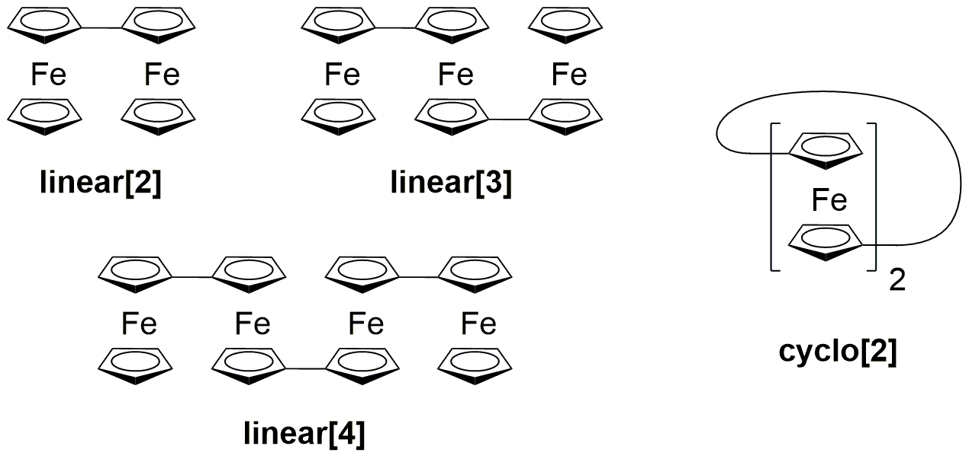
Supplementary Figure 22. Linear and cyclic analogues of the novel oligomeric ferrocene rings described in this work.

Intramolecular electron transfer was first observed in a singly charged biferrocene complex ([linear[2]]picrate) as early as 1970.^{32,33} UV/Vis/NIR spectroscopy showed the assigned intervalence charge transfer (IVCT) band to be somewhat broader than that reported just a year earlier for the Creutz-Taube ion ([Ru(NH₃)₅]₂(C₄H₄N₂)⁵⁺).³⁴ It was suggested that a contributing factor could be due to the multiple allowed Franck-Condon transitions in [linear[2]]⁺, given that the two Fe centres can be spaced at a range of distances from 3.8 Å (cis co-planar) to 5.1 Å (trans co-planar). There would be fewer allowed transitions in the Creutz-Taube ion as the Ru–Ru distance is fixed. Later,³⁵ it was also recognized that the energy of the IVCT band in [linear[2]]⁺ was lower than that observed for other contemporary mixed-valence systems (such as the aforementioned Creutz-Taube ion). This can be rationalized by considering that the optical Franck-Condon path for electron transfer proceeds via absorption of light by the mixed-valence complex [M₁^{II}M₂^{III}] (reactant), instantaneously forming the excited state [M₁^{III}M₂^{II}]* (product). For the reactant, the electron resides on M₁ and the nuclear configuration of the system (the complex and surrounding solvent) is in the equilibrium geometry for the reactant. For the product (excited state), the electron resides on M₂, yet the configuration of the involved nuclei remains in the equilibrium geometry for the reactant (a higher energy arrangement). For Robin and Day (RD) class II complexes,^{36,37} the energy of the IVCT transition is the energy change associated with the reconfiguration of involved nuclei from the equilibrium geometry of the reactant to the equilibrium geometry of the product (and is in this limit equal to the reorganization energy). It was proposed that the IVCT band/reorganization energy was lower for [linear[2]]⁺ than for other complexes because the structures of ferrocene and ferrocenium are comparable (in such materials the HOMO is of primarily metal character and non-bonding³⁸). Key features of the electronic spectra for this and several other compounds discussed in this section are collected in Supplementary Table 6.

Supplementary Table 6. Selected electronic spectral features reported for linear[n] and cyclo[n].
 | solvent | electrolyte/counter ion | λ_{max}, nm (ε)ª | ref
[ferrocenium]⁺ | CH₂Cl₂-CH₃CN 1:1 (v/v) | Bu₄NPF₆ (0.1 M) | 615 (208) | ³⁹
[linear[2]]⁺ | CH₂Cl₂-CH₃CN 1:1 (v/v)  CH₃CN  CH₃CN | Bu₄NPF₆ (0.1 M)  I₃–  picrate– | 546 (2230), ~680 (1250),^{b} 1900 (760)  542 (2030), ~700 (N/S),^{b} 1960 (541)  542 (1860), 700 (N/S),^{b} 1900 (551) | ³⁹  ⁴⁰  ^{32,40}
[cyclo[2]]⁺ | CH₃CN  CH₃CN  CH₃CN | PF₆–  I₃–  picrate– | 466 (1140), 594 (417), 1510 (1930)  471 (1110),^{b} 601 (583), 1470 (1710)  600 (370),^{b} 1550 (2100) | ⁴⁰  ⁴⁰  ⁴⁰⁻⁴²
[linear[3]]⁺ | CH₂Cl₂-CH₃CN 1:1 (v/v) | Bu₄NPF₆ (0.1 M) | 556 (3380), ~625 (3200),^{b} 1990 (1560) | ³⁹
[linear[3]]²⁺ | CH₂Cl₂-CH₃CN 1:1 (v/v) | Bu₄NPF₆ (0.1 M) | 540 (4470), ~690 (1800),^{b} 1670 (1080) | ³⁹
[linear[4]]²⁺ | CH₂Cl₂-CH₃CN 1:1 (v/v) | Bu₄NPF₆ (0.1 M) | 550 (4470), ~680 (2800),^{b} 1790 (1720) | ³⁹
ª Molar extinction coefficients in M⁻¹ cm⁻¹. ^{b} This band is a shoulder, with the λ_{max} value provided as an estimate only (N/S = not specified).

Ultimately, these and additional authors assigned [linear[2]]⁺ as RD class II, on the basis of UV/Vis/NIR^{32,33} spectra which revealed an IVCT band (not present in spectra of the isovalent states) as well as X-ray photoelectron^{35,43} and low temperature Mössbauer (78 K)⁴⁴ spectra that showed only a composite of features observed in isolated ferrocene/biferrocene (fully reduced) and [ferrocene]⁺/[biferrocene]²⁺ (fully oxidized) samples. This indicated that charge was localized at either one of the ferrocene moieties (integral oxidation states), rather than being delocalized over both sites (fractional oxidation states) – a key distinguishing factor between RD class II and class III. Though some evidence of rapid intramolecular charge transfer was initially reported for [linear[2]]picrate in Mössbauer measurements obtained at room temperature (298 K) – where changes in relative peak intensities and new absorptions prompted the suggestion that intramolecular electron transfer processes might be occurring at rates on the order of 10⁷ s⁻¹ – this was later dismissed (attributed to the presence of impurities).⁴⁰ The interpretation of the XPS spectrum of [linear[2]]picrate as proof of a valence-trapped state (i.e. showing separate Fe^{II} and Fe^{III} sites), was in this specific case also later called into question.⁴⁵ Subsequent studies have broadly upheld the assignment of [linear[2]]⁺ as RD class II, also investigating, for example, alternative techniques to study delocalization (e.g. spin-lattice relaxation times in NMR spectroscopy, g-tensor anisotropy in EPR spectroscopy, DFT),^{40,46-50} the effect of solvent and counter-ion on the intramolecular charge transfer process,^{48,49} and the effect of chemical substitution.⁵¹⁻⁵⁴ It is very interesting to note, for example, that whereas [linear[2]]I₃ and [1,1’’’-dichlorobiferrocene]I₃ exhibit a rate of intramolecular electron transfer slower than the Mössbauer timescale at room temperature, [linear[2]]X (where X = I₂Br– and Br₂I–) appear valence delocalized.^{48,55} Furthermore, [1,1’’’-dibromobiferrocene]I₃ and [1,1’’’-diiodobiferrocene]I₃ exhibit intramolecular charge transfer rates faster than can be observed using either Mössbauer or EPR techniques (>10¹⁰ s⁻¹).^{40,48,55-59} From these investigations it was concluded that the nature of crystal packing in the solid state can have a significant impact on the observed rates, as the former may induce an asymmetry in the vibronic states (e.g. lowering/raising the energy of Fe₁^{II}Fe₂^{III} relative to Fe₁^{III}Fe₂^{II}).⁴⁸ Though the thermal barrier to intramolecular charge transfer certainly persists in [linear[2]]⁺ (excluding the materials from RD class III status), solution NMR measurements have provided tantalising evidence for intramolecular charge transfer rates >10¹² s⁻¹ at room temperature.^{46,47,59} This is also in keeping with analyses using the PKS⁶⁰ model (arguably more appropriate than Hush’s model when treating delocalization systems, given that it takes into account vibronic coupling) which suggested that both [linear[2]]⁺ and [cyclo[2]]⁺ are actually RS class II/III borderline cases (though it was still considered that the latter exhibited a greater degree of interaction between the Fe centres).⁶¹
The first experimental reports of [cyclo[2]]⁺ were published back-to-back by Cowan and LeVanda⁴¹ and Mueller-Westerhoff and Eilbracht⁴² in 1972. Both sets of authors initially considered this complex must also be assigned to RD class II, but only on the basis of available UV/Vis/NIR spectral measurements. Notably, these showed a narrower IVCT band at higher energy than that of [linear[2]]⁺, which later was also shown to be broadly solvent independent (and actually comprised of at least two components, making the individual bands narrower still)^{62,63} – in keeping with a RD class III assignment. Subsequent investigations by these authors and Morrison et al. found that the Mössbauer spectrum of [cyclo[2]]⁺ actually showed only a single quadrupole-split doublet (instead of the two doublets previously observed in [linear[2]]picrate), indicating that the compound was indeed valence averaged with an intervalence electron transfer rate >10⁷ s⁻¹.⁶⁴⁻⁶⁶ Remarkably also, the doubly oxidized species ([cyclo[2]][I₃]₂) was found to be diamagnetic. This indicated a ground state with a net spin of 0 – plausibly due to antiferromagnetic coupling between the two Fe^{III} (S = ½) centres facilitated by the conjugated ligand framework, or the result of direct exchange (subsequent reports argue the former to be the most likely explanation).^{40,66-69} Further evidence of valence averaging in this compound was provided by XPS which showed only a single significant peak in the Fe(2p_{3/2}) spectrum (note that equivalence on the XPS timescale suggests a rate of electron exchange on the order of 10¹⁸ s⁻¹).^{45,64,69} In partial contradiction of this result, studies of cyclo[2], [cyclo[2]]PF₆, and [cyclo[2]][PF₆]₂ using IR spectroscopy showed features attributable to a ferrocene-type molecule in the spectrum of [cyclo[2]]PF₆,⁴⁰ an indication that (at least in this particular solid state arrangement) the compound was valence-trapped on the IR timescale (~10¹³ s⁻¹).
In contrast to linear[2] or cyclo[2], the linear series of unsubstituted 1,1’-oligoferrocenes, linear[n] (n >2), have been studied much less intensively. This is arguably due to challenges pertaining to their synthesis, solubility, electrochemical reversibility and stability in high oxidation states, not to mention the additional complexities introduced by the presence of multiple redox centres (enabling, at the very least, multiple possible intervalence charge transfer processes).^{39,70} Nonetheless, UV/Vis/NIR spectra for linear[n] (n = 2-4) complexes in different oxidation states ([linear[3]]⁺, [linear[3]]²⁺ and [linear[4]]²⁺) were reported by Brown et al. in 1974.³⁹ The authors found that IVCT bands in such 1,1’-polyferrocene ions appeared more intense than the IVCT band seen in [linear[2]]⁺ (Supplementary Table 6), and suggested that this could be explained by the existence of equivalent, weakly interacting (and so additive), optical transitions. To exemplify their point, they noted that [linear[3]]²⁺, or “(Fc-Fc-Fc)²⁺” would have the following two equivalent transitions:

(1) Fc⁺-Fc-Fc⁺ → (Fc⁺-Fc⁺-Fc)*
(2) Fc⁺-Fc-Fc⁺ → (Fc-Fc⁺-Fc⁺)*

The energies of the observed transitions, relative to one another, were also addressed by considering the IVCT band energy (E_{op}) to be the sum of the Franck-Condon energy (E_{FC}) and the difference in energy (E₀) between the equilibrium vibrational states of the product and reactant (E_{op} = E_{FC} + E₀, as proposed by Hush).^{36,39} It was argued that the similarity between E_{op} for [linear[2]]⁺ and [linear[3]]⁺ (1900 vs. 1990 nm) was reasonable given that E_{FC} could be considered comparable for both complexes (the optical transitions Fc-Fc-Fc⁺ → (Fc-Fc⁺-Fc)* and Fc-Fc⁺ → (Fc⁺-Fc)* were proposed to be similar in energy), and that E₀ ~ 0. The latter result was concluded after it was recognized that the associated reactant and product oxidation state isomers (Fc⁺-Fc-Fc and (Fc-Fc⁺-Fc)*, Fc-Fc⁺-Fc and (Fc⁺-Fc-Fc)*) must be similar in energy (impacted only by ferrocenyl substituent effects and a small statistical factor). Using a similar methodology, the increase in E_{op} going from [linear[3]]⁺ to [linear[3]]²⁺ (1990 vs. 1670 nm) was primarily attributed to a non-zero E₀ – the optical electron-transfer product would presumably be an energetically unfavourable oxidation state isomer (e.g. Fc⁺-Fc-Fc⁺ → (Fc⁺-Fc⁺-Fc)*). In passing, it is interesting to note that a similar argument was invoked to explain the trends in IVCT band features observed in a series of oligo(1,1’-dihexylferrocenylene)s – it was found that: (i) there was a shift to lower energies for a given oxidation state as the number of ferrocene units increases; and, (ii) the intensity of the IVCT band increased for a given compound as the oxidation state increased.⁷¹ To the best of our knowledge, the only other report considering the rate of intervalence electron transfer in unsubstituted linear[n] materials is a 1987 study by Dong and Hendrickson.⁷² Mössbauer spectroscopy measurements at 10 K and 300 K exhibited two quadrupole-split doublets, revealing [linear[3]][I₃]₂ was valence trapped on this experimental timescale (intervalence charge transfer rate <10⁷ s⁻¹).
Most studies point to the conclusion that rates of intervalence charge transfer are slower in [linear[2]]⁺ and [linear[3]]²⁺ (the most studied 1,1’-oligoferrocene) compared to [cyclo[2]]⁺. To us this suggests, perhaps unsurprisingly, that torsion angles between adjacent ferrocene units play a significant role in this context (note, we are not the first to make such an argument⁵¹). Given that every cyclic oligomer except cyclo[2] exhibits torsion angles >0° (see Shekurov et al.⁷³ and this work for X-ray crystal structures of cyclo[3] and cyclo[6], respectively), we consider that such cyclo[n] materials (n > 2) belong firmly within the RD class II regime. This hypothesis is further supported by UV/Vis/NIR spectroscopic analyses of [cyclo[6]]⁺ and [cyclo[6]]²⁺, conducted as part of the present study and discussed below. It should be reiterated however, that additional extensive and careful experiments are required to fully evaluate the many non-trivial questions regarding the precise rate of intervalence charge transfer within this new family of ferrocene materials.

UV/VIS/NIR SPECTROSCOPY
On chemical oxidation of cyclo[6] with one equiv. of ferrocenium BARF in 0.005 M CH₂Cl₂/TBA-BARF the solution colour changed from bright orange to a greyish blue-green (see Supplementary Figure 23(a) and (b)). A UV/Vis/NIR spectrum recorded from this solution showed the growth of a composite absorption band peaking at ca. 700 nm (for deconvoluted peak positions and extinction coefficients see Supplementary Table 7). Analogous features at ~600 nm are routinely observed in ferrocenium ions and various biferrocenium salts including [linear[2]]⁺ (see Supplementary Table 6) and have been assigned as the ²E_{2g}[(a_{1g})² (e_{2g})³] to ²A_{1g}[(a_{1g})¹(e_{2g})⁴] transition of the ferrocenium ion.^{33,74} Of particular relevance here is the observation of a rather broad band enveloping the entire NIR region from 1100 nm to 2000 nm, the low-energy limit of our Vis/NIR detector (Supplementary Figure 24). Based on a deconvolution on the wavenumber scale, the peak of this band lies most probably outside the detector range near 2700 nm (ca. 3700 cm⁻¹). When monitored in the IR/NIR region, the broad NIR band is resolved into two closely spaced transitions, with a weaker (ε ≈ 450 M⁻¹ cm⁻¹) broader (Δ_{1/2} = 3500 cm⁻¹) band at the high energy side and a more intense (ε ≈ 600 M⁻¹ cm⁻¹), less broad one (Δ_{1/2} = 2550 cm⁻¹) band at lower energy (Supplementary Figure 25). Similar observations of two closely spaced IVCT bands for the parent biferrocenium ion have been reported on an earlier occasion and have been ascribed as two separate IVCT transitions originating from the d_{x}²_{-y}² and d_{z}² Fe^{II} donor orbitals.^{75,76} The estimated extinction coefficients band widths are thus in the same range as those of ordinary biferrocenium ions (ca. 550 M⁻¹ cm⁻¹).³⁸ The former may be surprising considering the fact that in [cyclo[6]]⁺ two nearest-neighbour ferrocene donor sites are present instead of just one. Even more revealingly the extinction coefficient is significantly lower than that of 1560 M⁻¹ cm⁻¹ reported for the linear terferrocenium radical cation [linear[3]]⁺.³⁹ The rather low intensity of the IVCT bands may be related to the torsion of ferrocenyl/ferrocenium subunits imposed by forging the individual ferrocenylene subunits of [cyclo[6]]⁺ into a ring structure as it is evident from X-ray crystallography. Such torsions decrease the efficacy of intramolecular electron transfer along the Fe^{II}(d_{x}²_{-y}²)-C_{ipso}(π*)-C_{ipso}(π*)-Fe^{III}(d_{x}²_{-y}²) pathway.⁴⁸ (Note that a ΔE value of 0.174 V between the 0/+ and +/2+ couples translates into a value of 876 for the comproportionation constant K_{c} for [cyclo[6]]⁺, which in turn means that on addition of 1.0 equiv. of ferrocenium BARF the resulting solution should contain ~95% of [cyclo[6]]⁺ and ~2.5% each of cyclo[6] and [cyclo[6]]²⁺. For two redox sites the proportion of the complex in the mixed valence form at equilibrium is K_{c}^{1/2}/[2 + K_{c}^{1/2}], whereas for six redox sites this is √5K_{c}^{1/2}/[2√3 + √5K_{c}^{1/2}]. Given the difficulties inherent in working with such low quantities of compounds (1.4 mg of cyclo[6]) no efforts were made to correct the experimental spectrum of [cyclo[6]]⁺ for the minor quantities of its bordering redox forms).

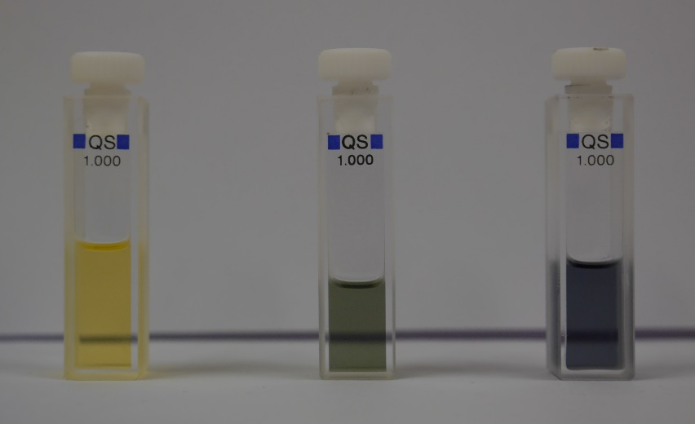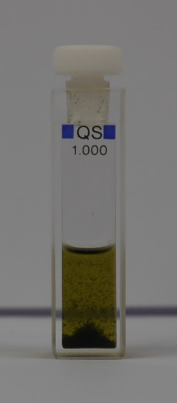
(a) (b) (c) (d)
Supplementary Figure 23. Photographs of [cyclo[6]]^{n+} solutions in CH₂Cl₂/0.005 M TBA-BARF, comprising: (a) no oxidant; (b) 1 eq. of ferrocenium BARF; (c) 2 eq. of ferrocenium BARF; (d) 3 eq. of 1,1'-diacetylferrocenium SbF₆.

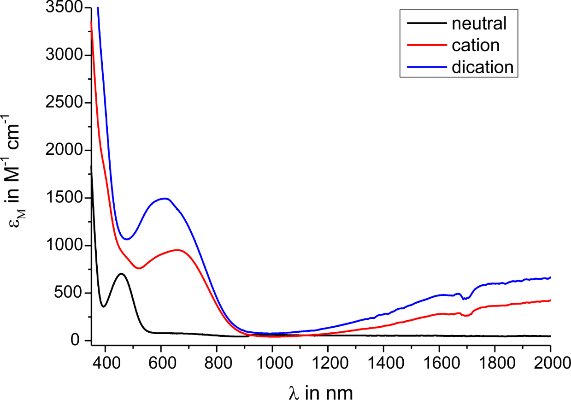
Supplementary Figure 24. UV/Vis/NIR spectra of [cyclo[6]]^{n+} (n = 0, 1, 2).
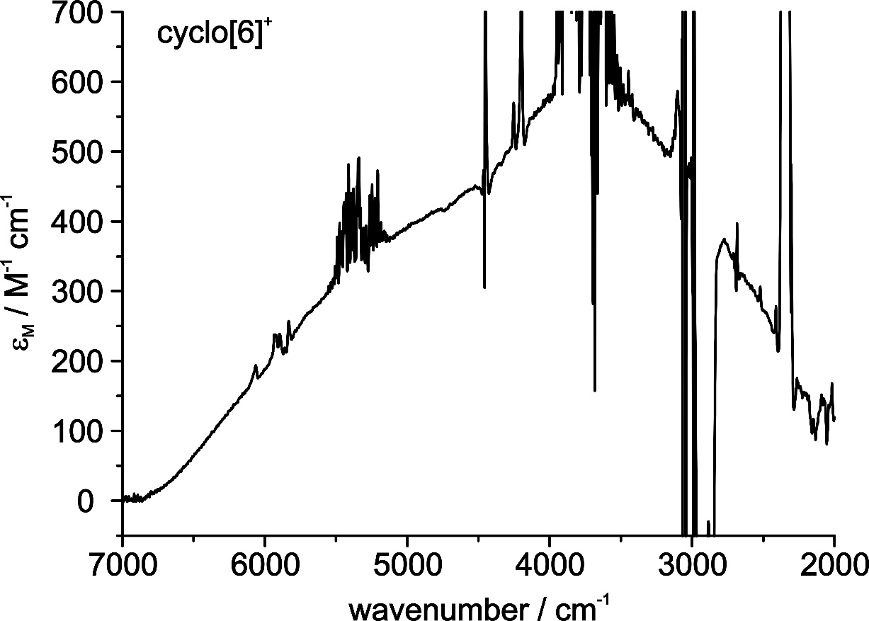
Supplementary Figure 25. NIR/IR spectrum of [cyclo[6]]⁺ showing the IVCT bands.

Addition of another equivalent of ferrocenium BARF affects further oxidation to [cyclo[6]]²⁺, which is accompanied by a further colour change to greyish-blue (Supplementary Figure 23(c)) and a further intensification and blue-shift of the typical ferrocenium-type ²E_{2g}[(a_{1g})² (e_{2g})³] to ²A_{1g}[(a_{1g})¹(e_{2g})⁴] transition as well as of the NIR bands (Supplementary Figure 24). Again the single broad peak observed with our Vis/NIR instrument (Supplementary Figure 24) could be resolved into two separate bands with our IR/NIR spectrometer, giving better sensitivity in the low-energy NIR range (Supplementary Figure 26). Both these observations match with the availability of two ferrocenium acceptor sites in [cyclo[6]]²⁺ as compared to only one such site in [cyclo[6]]⁺ and the doubling of the number of possible IVCT transitions from nearest-neighbour donor sites to four instead of two. The band positions, extinction coefficients and band half-widths (Δ_{1/2} = 3100 for the band at higher and ca. 2000 cm⁻¹ for the band at lower energy) were again estimated with the aid of spectral deconvolutions. It appears that the bands become less broad and their maxima are shifted to the blue by ca. 100 to 200 cm⁻¹ with respect to [cyclo[6]]⁺. Similar findings were already reported for oligo(1,1’-dihexylferrocenylene)s⁷¹ and for linear oligoferrocenes.³⁹ They were rationalized by destabilization of the product potential energy surfaces with increasing oxidation state, due to increased electrostatic repulsion when the charged sites move closer together. A similar reasoning can be administered here as the most stable ground state places the unipositive charges at maximum distance, i.e. at opposing rings in 1- and 4-position of the cycle (note that for an electronic transition a timescale of 10¹⁵ s⁻¹ applies where the charges have to be considered as localized). IVCT would bring them closer together, which is expected to result in a slight destabilization of the excited state potential hypersurface with respect to [cyclo[6]]⁺, where this is not the case.
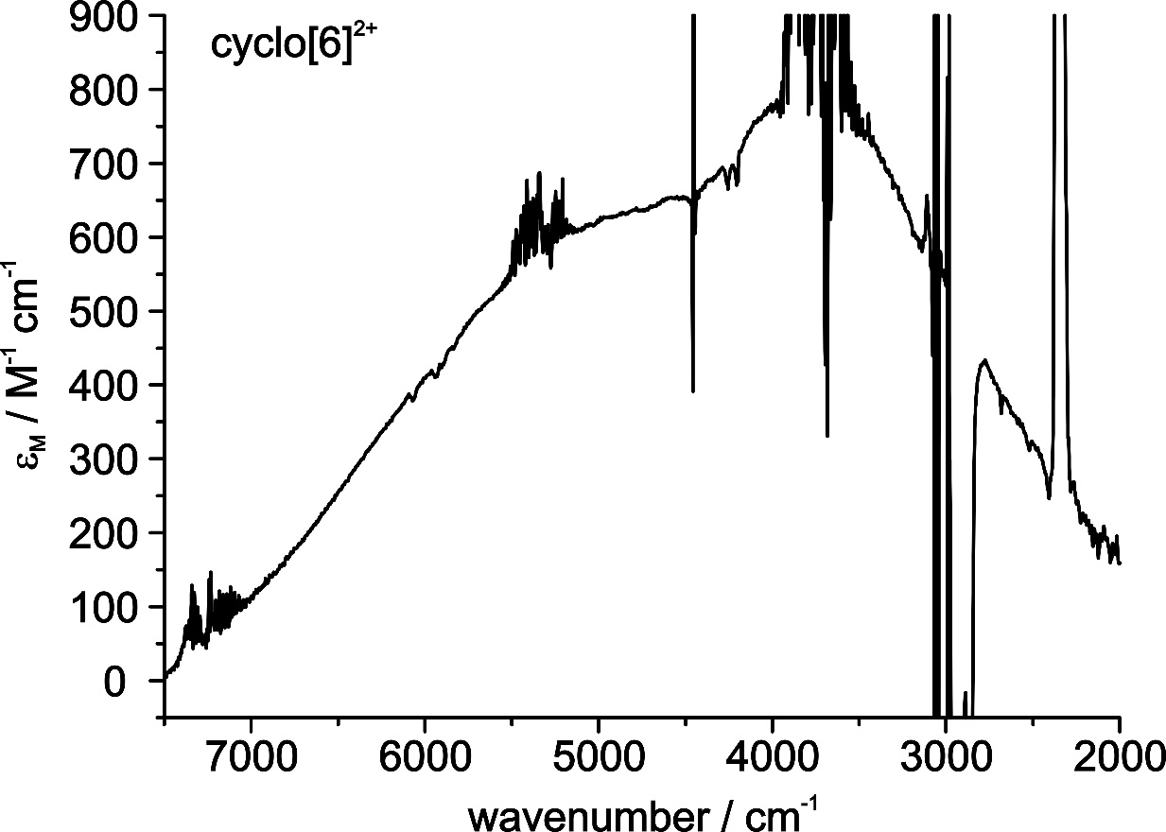
Supplementary Figure 26. NIR/IR spectrum of [cyclo[6]]²⁺ showing the IVCT bands.

Attempts to also access [cyclo[6]]³⁺ by addition of 3 equiv. of 1,1'-diacetylferrocenium SbF₆⁻ as oxidant to a solution of cyclo[6] in 0.005 M⁻¹ TBA-BARF resulted in a colour change to deep blue and the rapid deposition of a dark blue precipitate (see Supplementary Figure 23(d)).

Supplementary Table 7. UV/Vis/NIR spectral features for [cyclo[6]]^{n+} (n = 0, 1, 2).ª
 | _{max}, cm⁻¹ (ε) | λ_{max}, nm
cyclo[6] | 23622 (421), 21239 (571) | 423, 471
[cyclo[6]]⁺ | 24769 (886), 21564 (753), 16778 (840), 14303 (438), 13002 (173), 4630 (450), 3714 (600)^{b} | 404, 464, 596, 699, 769, 2160, 2692
[cyclo[6]]²⁺ | 25866 (2539), 21649 (669), 17565 (1337), 15008 (640), 13437 (412), 4840 (630), 3800 (790)^{b} | 387, 462, 569, 666, 744, 2066, 2640
ª Individual bands obtained from Gaussian deconvolution. Molar extinction coefficients in M⁻¹ cm⁻¹. ^{b} _{max}, λ_{max} and ε estimated from tail of Gaussian band.

X-RAY CRYSTALLOGRAPHY
The X-ray crystal structure of cyclo[6]-benzene
Crystal data for cyclo[6]-benzene: C₆₀H₄₈Fe₆·2(C₆H₆), M = 1260.30, monoclinic, C2/c (no. 15), a = 27.9340(9), b = 7.5162(3), c = 26.0371(7) Å, β = 95.548(3)°, V = 5441.0(3) Å³, Z = 4 [C_{i} symmetry], D_{c} = 1.539 g cm^{–3}, μ(Mo-Kα) = 1.603 mm^{–1}, T = 173 K, dark red blocky needles, Agilent Xcalibur 3E diffractometer; 5439 independent measured reflections (R_{int} = 0.0248), F² refinement,^{77,78} R₁(obs) = 0.0325, wR₂(all) = 0.0701, 4488 independent observed absorption-corrected reflections [|F_{o}| > 4σ(|F_{o}|), 2θ_{max} = 57°], 353 parameters. CCDC 1420914.
The cyclo[6] oligomer in the crystal structure of cyclo[6]-benzene was found to sit across a centre of symmetry. The unique included benzene solvent molecule in the structure of cyclo[6]-benzene was found to be disordered. Two orientations were identified of ca. 62 and 38% occupancy, their geometries were optimised, the thermal parameters of adjacent atoms were restrained to be similar, and only the non-hydrogen atoms of the major occupancy orientation were refined anisotropically (those of the minor occupancy orientation were refined isotropically).
The X-ray crystal structure of cyclo[6]-toluene
Crystal data for cyclo[6]-toluene: C₆₀H₄₈Fe₆·2(C₇H₈), M = 1288.35, triclinic, P-1 (no. 2), a = 7.4131(6), b = 13.2070(9), c = 14.5753(10) Å, α = 94.319(6), β = 99.791(6), γ = 98.987(6)°, V = 1381.31(18) Å³, Z = 1 [C_{i} symmetry], D_{c} = 1.549 g cm^{–3}, μ(Cu-Kα) = 12.647 mm^{–1}, T = 173 K, yellow needles, Agilent Xcalibur PX Ultra A diffractometer; 5238 independent measured reflections (R_{int} = 0.0458), F² refinement,^{77,78} R₁(obs) = 0.0375, wR₂(all) = 0.0922, 4274 independent observed absorption-corrected reflections [|F_{o}| > 4σ(|F_{o}|), 2θ_{max} = 148°], 368 parameters. CCDC 1420915.
The cyclo[6] oligomer in the crystal structure of cyclo[6]-toluene was found to sit across a centre of symmetry. The unique included toluene solvent molecule in the structure of cyclo[6]-toluene was found to be disordered. Two orientations were identified of ca. 60 and 40% occupancy, their geometries were optimised, the thermal parameters of adjacent atoms were restrained to be similar, and only the non-hydrogen atoms of the major occupancy orientation were refined anisotropically (those of the minor occupancy orientation were refined isotropically).
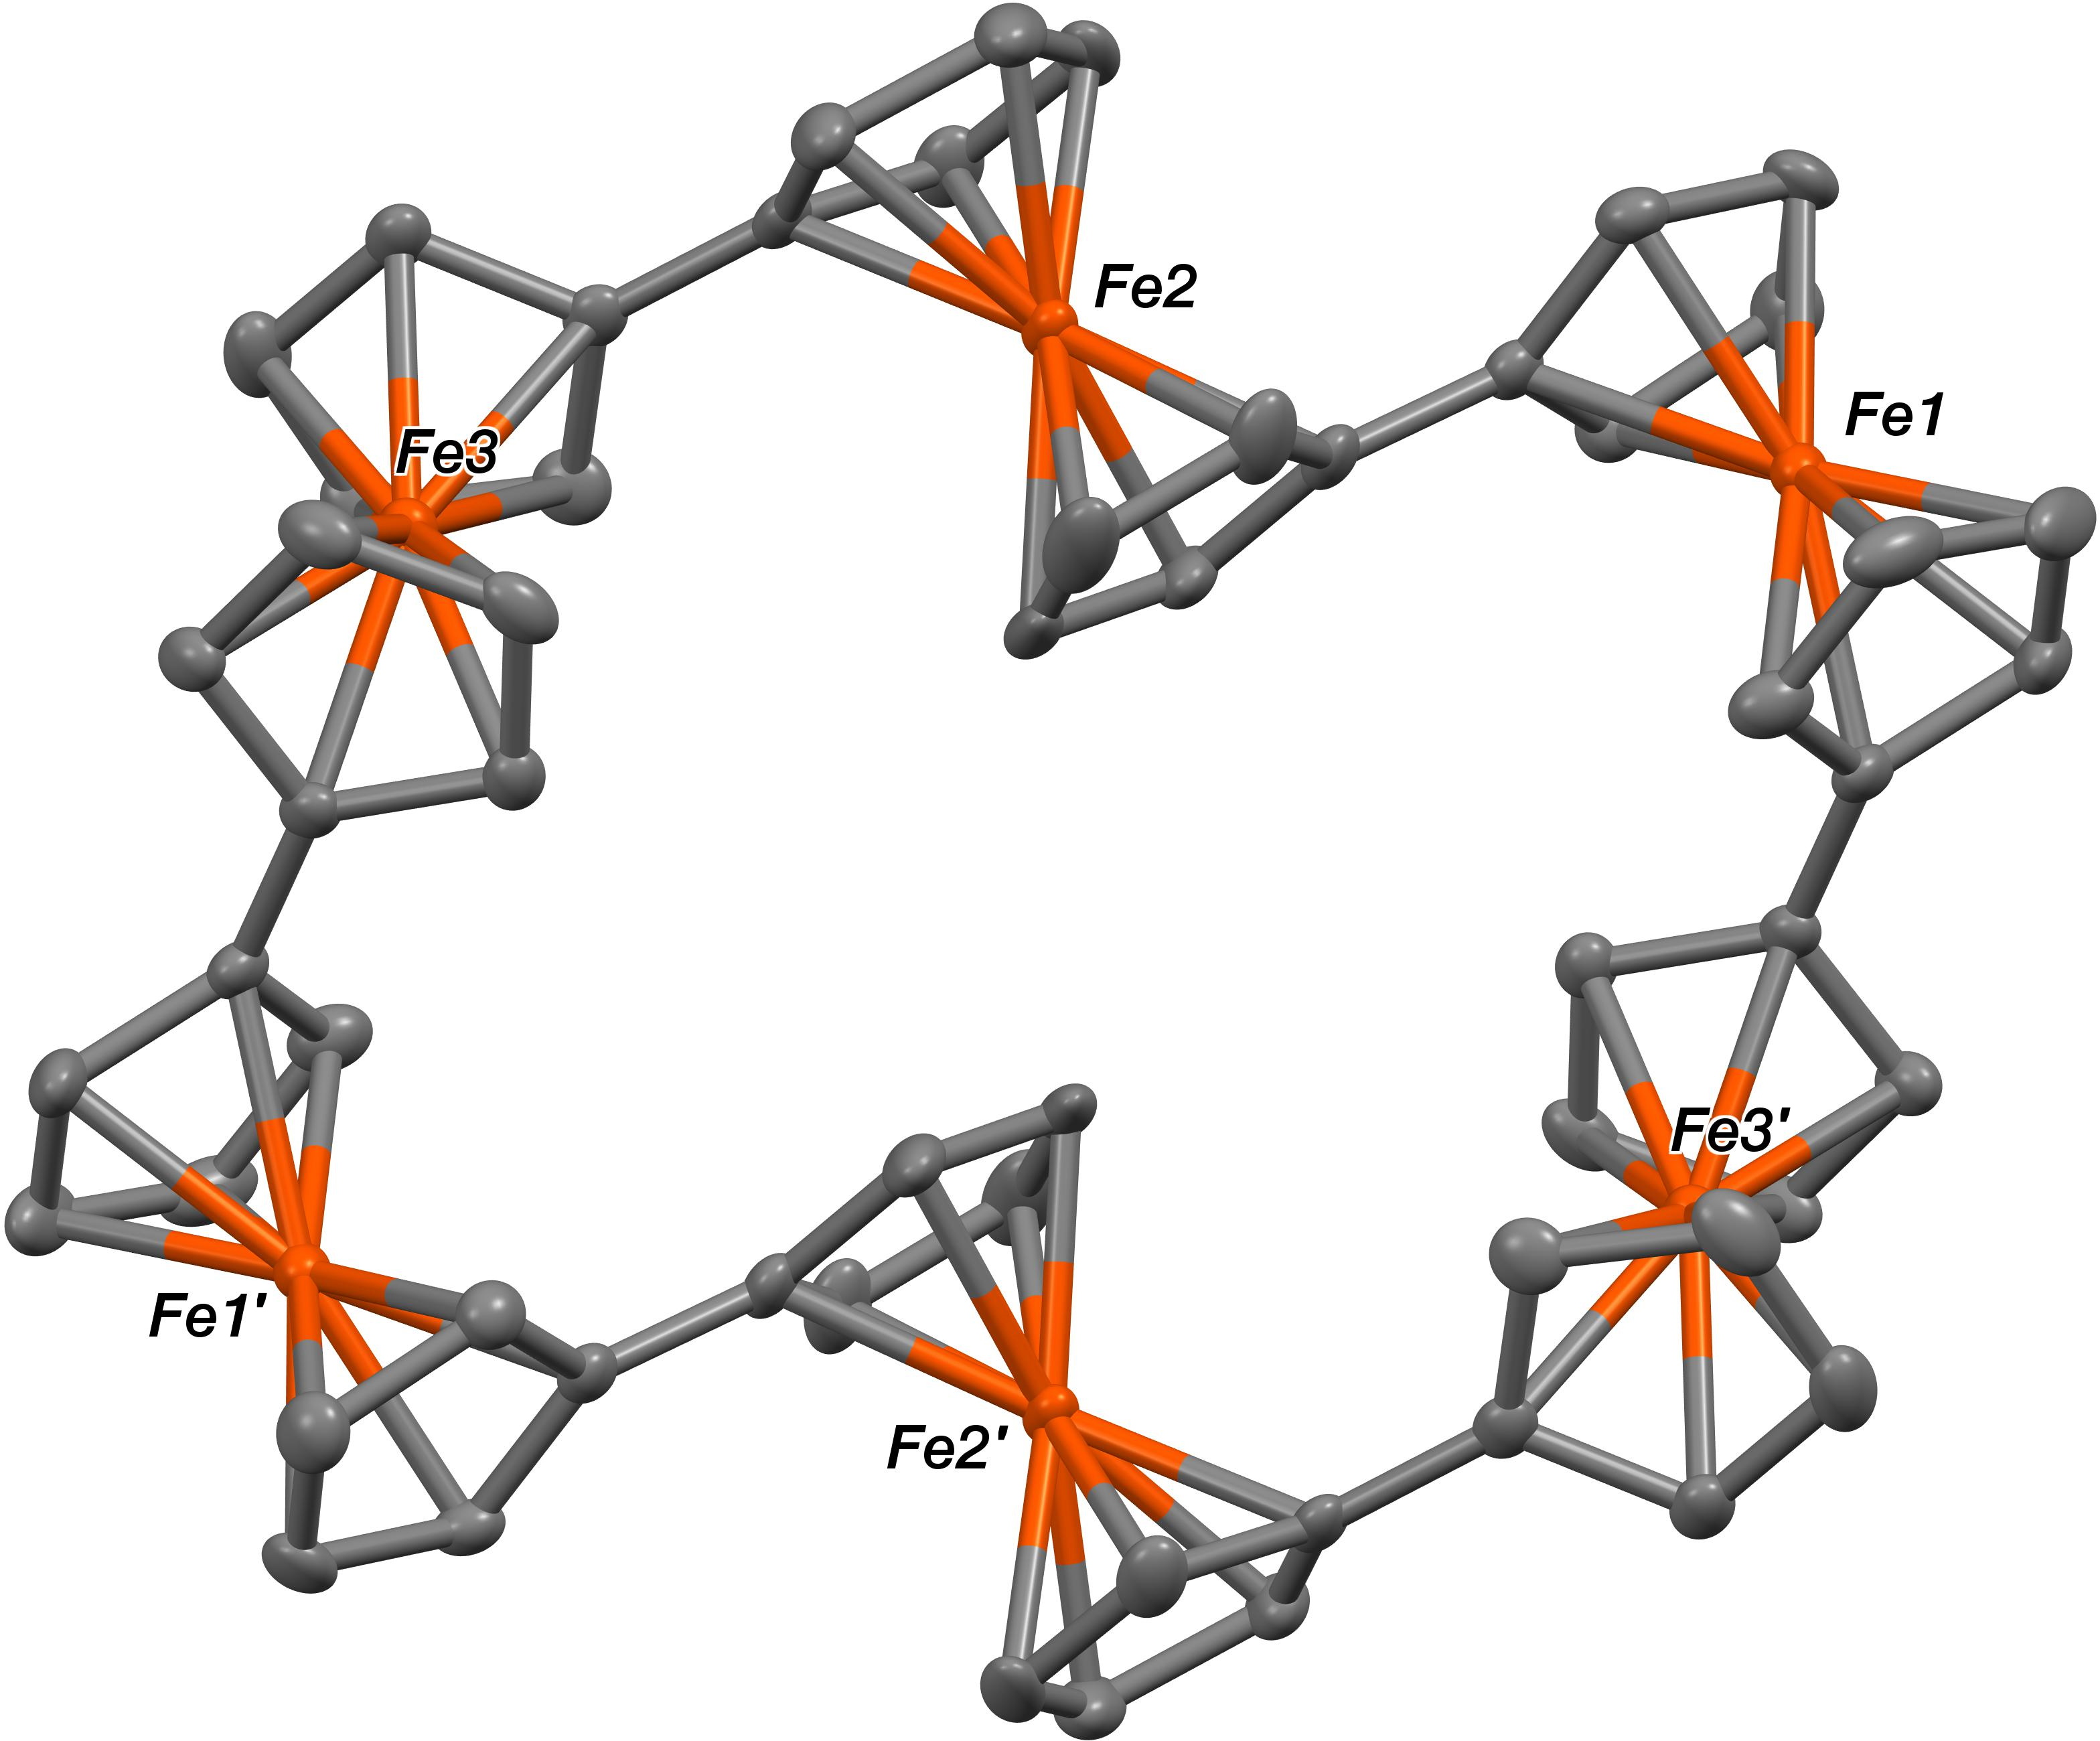
Supplementary Figure 27. The crystal structure of cyclo[6]-benzene (50% probability ellipsoids, benzene solvate removed for clarity).
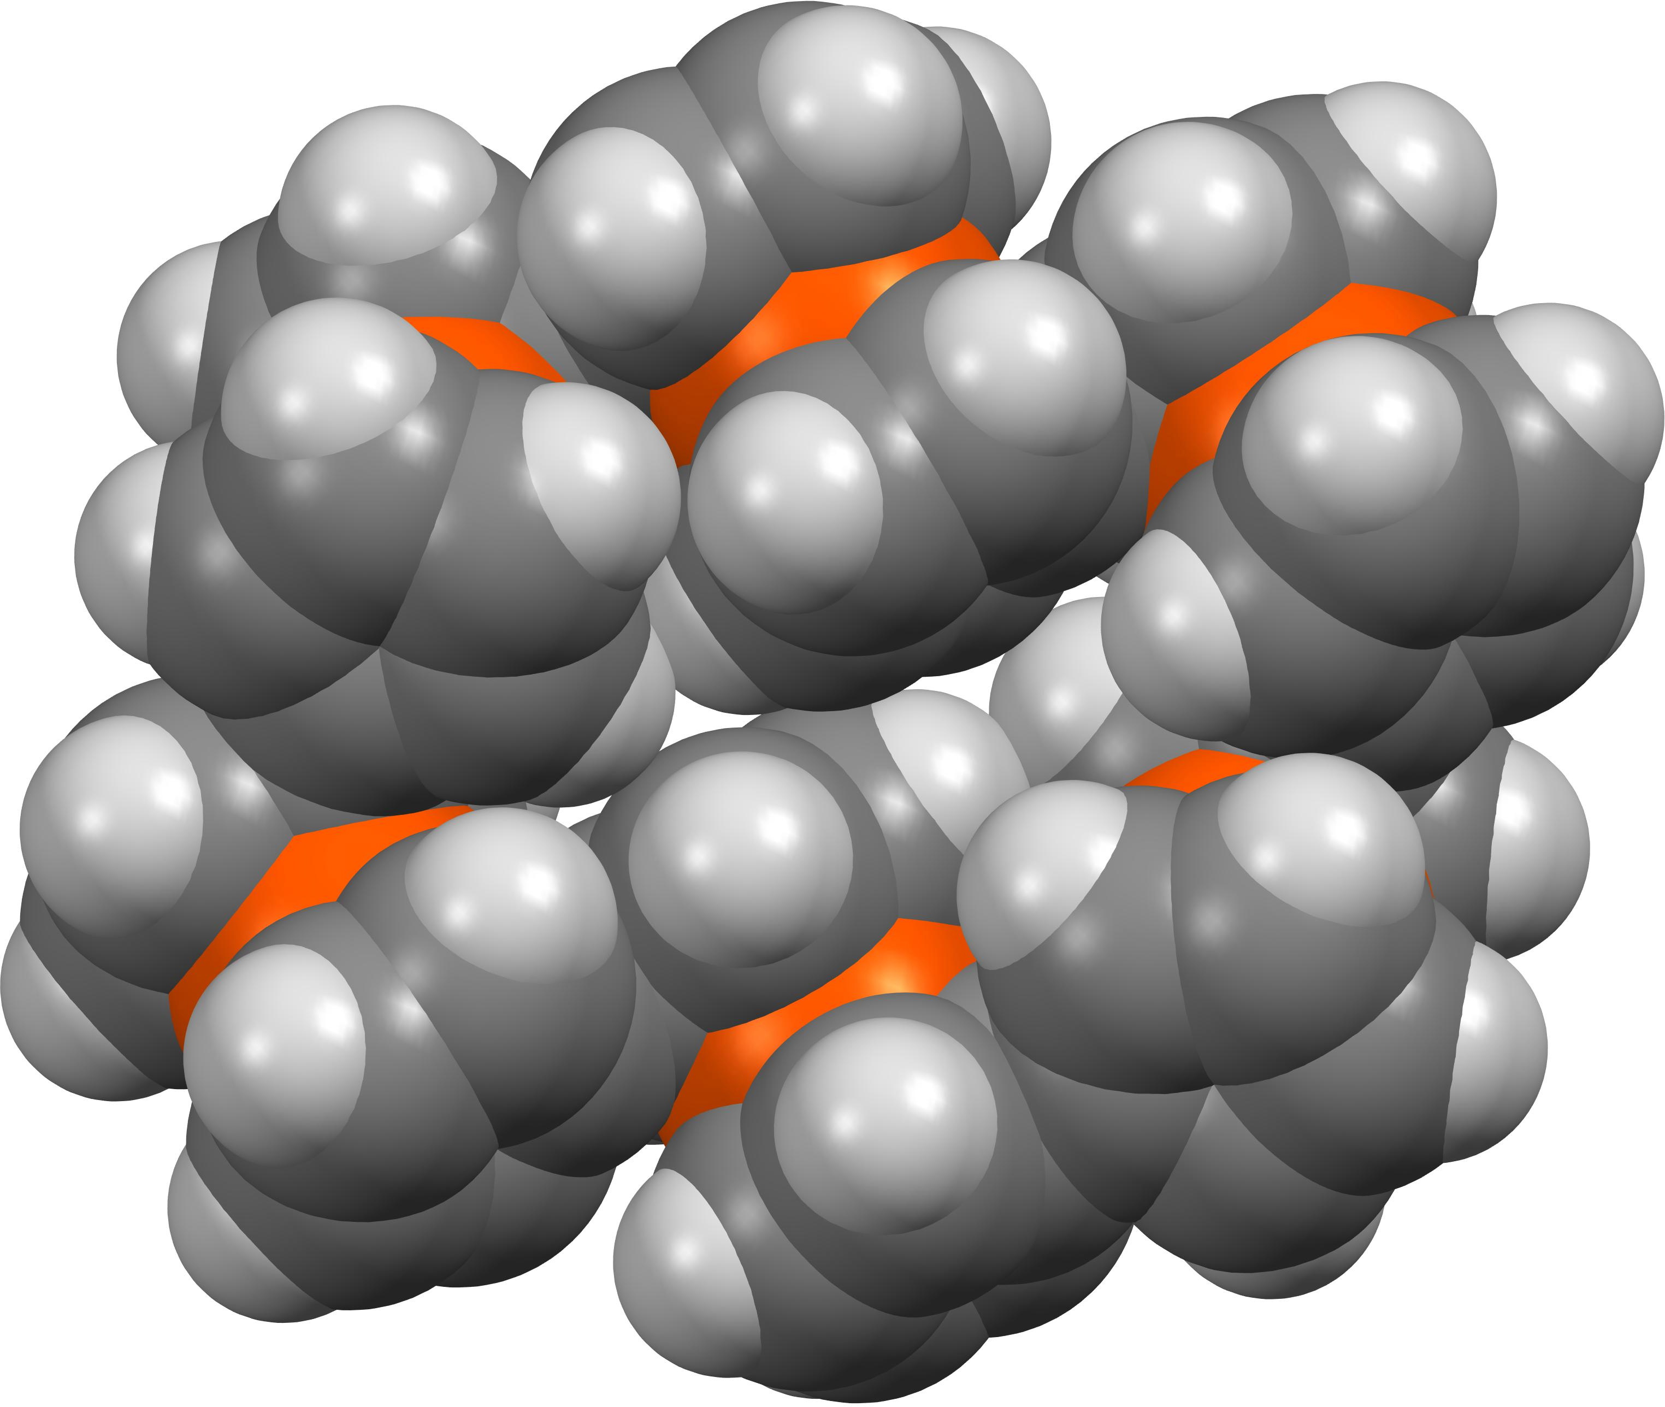
Supplementary Figure 28. Space filling representation of the crystal structure of cyclo[6]-benzene (benzene solvate removed for clarity.
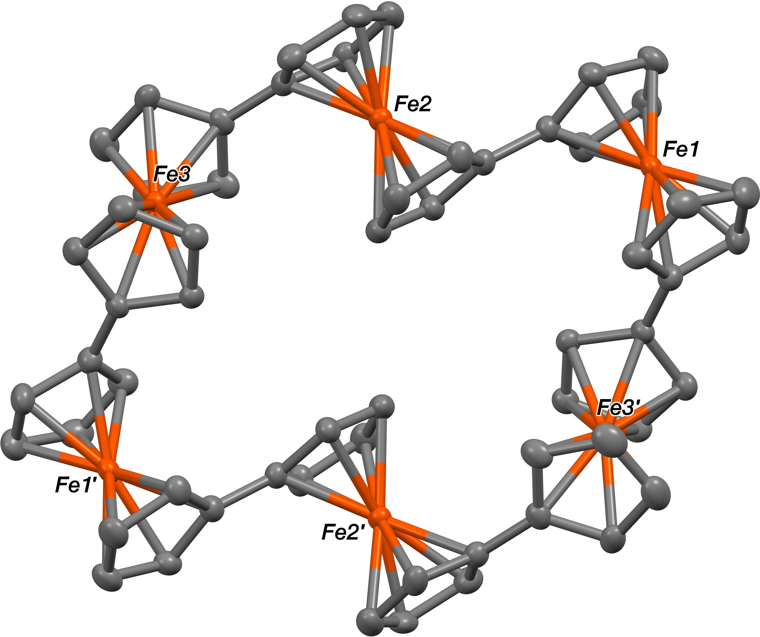
Supplementary Figure 29. The crystal structure of cyclo[6]-toluene (50% probability ellipsoids, toluene solvate removed for clarity).

REFERENCES
(1) Le Bras, J., Jiao, H., Meyer, W. E., Hampel, F. & Gladysz, J. A. Synthesis, crystal structure, and reactions of the 17-valence-electron rhenium methyl complex [(η⁵-C₅Me₅)Re(NO)(P(4-C₆H₄CH₃)₃)(CH₃)]⁺ B(3,5-C₆H₃(CF₃)₂)₄⁻: Experimental and computational bonding comparisons with 18-electron methyl and methylidene complexes. J. Organomet. Chem. 616, 54–66 (2000).
(2) de Bellefeuille, D. et al. X. Reversible double oxidation and protonation of the non-innocent bridge in a nickel(II) salophen complex. Inorg. Chem. 51, 12796–12804 (2012).
(3) Zhang, S., Zhang, D. & Liebeskind, L. S. Ambient temperature, Ullmann-like reductive coupling of aryl, heteroaryl, and alkenyl halides. J. Org. Chem. 62, 2312–2313 (1997).
(4) Kovar, R. F., Rausch, M. D. & Rosenberg, H. Convenient route to 1,1'-dihalogenated ferrocenes. Organomet. Chem. Synth. 1, 173–181 (1971).
(5) Inkpen, M. S., Du, S., Driver, M., Albrecht, T. & Long, N. J. Oxidative purification of halogenated ferrocenes. Dalton Trans. 42, 2813–2816 (2013).
(6) Colbert, M. C. B., Hodgson, D., Lewis, J., Raithby, P. R. & Long, N. J. Synthesis, characterization and electrochemical studies of 1',6'-bis(ethynyl)biferrocene and some metal complexes: Novel heterometallic compounds towards non-linear optics. Polyhedron 14, 2759–2766 (1995).
(7) Hore, L. -A. et al. Communication between Co₂(CO)₄dppm units via polyferrocenylalkyne linkages. Organometallics 19, 5039–5048 (2000).
(8) Roling, P. V. & Rausch, M. D. Formation of 1,1'-oligomeric ferrocenes from mixed Ullmann reactions of haloferrocenes. J. Org. Chem. 37, 729–732 (1972).
(9) Goeltz, J. C. & Kubiak, C. P. Facile purification of iodoferrocene. Organometallics 30, 3908–3910 (2011).
(10) Inkpen, M. S. et al. The unusual redox properties of fluoroferrocenes revealed through a comprehensive study of the haloferrocenes. Organometallics 34, 5461–5469 (2015).
(11) Sokol, W. F., Evans, D. H., Niki, K. & Yagi, T. Reversible voltammetric response for a molecule containing four non-equivalent redox sites with application to cytochrome c₃ of Desulfovibrio vulgaris, strain Miyazaki. J. Electroanal. Chem. Interfacial Electrochem. 108, 107–115 (1980).
(12) Richardson, D. E. & Taube, H. Mixed-valence molecules: Electronic delocalization and stabilization. Coord. Chem. Rev. 60, 107–129 (1984).
(13) Santi, S., Bisello, A., Cardena, R. & Donoli, A. Key multi(ferrocenyl) complexes in the interplay between electronic coupling and electrostatic interaction. Dalton Trans. 44, 5234–5257 (2015).
(14) Day, P., Hush, N. S. & Clark, R. J. H. Mixed valence: Origins and developments. Philos. Trans. R. Soc., A 366, 5–14 (2008).
(15) Brunschwig, B. S., Creutz, C. & Sutin, N. Optical transitions of symmetrical mixed-valence systems in the class II-III transition regime. Chem. Soc. Rev. 31, 168–184 (2002).
(16) Creutz, C. Mixed-valence complexes of d⁵-d⁶ metal centers. Prog. Inorg. Chem. 30, 1–73 (1983).
(17) Adams, D. M. et al. Charge transfer on the nanoscale: Current status. J. Phys. Chem. B 107, 6668–6697 (2003).
(18) Aguirre-Etcheverry, P. & O'Hare, D. Electronic communication through unsaturated hydrocarbon bridges in homobimetallic organometallic complexes. Chem. Rev. 110, 4839–4864 (2010).
(19) Kaim, W. & Sarkar, B. Mixed valency in ruthenium complexes—coordinative aspects. Coord. Chem. Rev. 251, 584–594 (2007).
(20) Kalyanasundaram, K. & Nazeeruddin, M. K. Inter-chromophore electronic interactions in ligand-bridged polynuclear complexes: A comparative study of various bridging ligands. Inorg. Chim. Acta 226, 213–230 (1994).
(21) Ward, M. D. Metal-metal interactions in binuclear complexes exhibiting mixed-valency - molecular wires and switches. Chem. Soc. Rev. 24, 121–134 (1995).
(22) Kaim, W. & Lahiri, G. K. Unconventional mixed-valent complexes of ruthenium and osmium. Angew. Chem., Int. Ed. 46, 1778–1796 (2007).
(23) Low, P. & Brown, N. Electronic interactions between and through covalently-bonded polymetallic complexes. J. Cluster Sci. 21, 235–278 (2010).
(24) Astruc, D. From organotransition-metal chemistry toward molecular electronics: Electronic communication between ligand-bridged metals. Acc. Chem. Res. 30, 383–391 (1997).
(25) Barlow, S. & O'Hare, D. Metal−metal interactions in linked metallocenes. Chem. Rev. 97, 637–670 (1997).
(26) Ceccon, A., Santi, S., Orian, L. & Bisello, A. Electronic communication in heterobinuclear organometallic complexes through unsaturated hydrocarbon bridges. Coord. Chem. Rev. 248, 683–724 (2004).
(27) D'Alessandro, D. M. & Keene, F. R. Current trends and future challenges in the experimental, theoretical and computational analysis of intervalence charge transfer (IVCT) transitions. Chem. Soc. Rev. 35, 424–440 (2006).
(28) Brunschwig, B. S. & Sutin, N. Energy surfaces, reorganization energies, and coupling elements in electron transfer. Coord. Chem. Rev. 187, 233–254 (1999).
(29) Concepcion, J. J., Dattelbaum, D. M., Meyer, T. J. & Rocha, R. C. Probing the localized-to-delocalized transition. Philos. Trans. R. Soc., A 366, 163–175 (2008).
(30) Albertin, G., Antoniutti, S., Bordignon, E. & Granzotto, M. Preparation of new acetylide and vinylidene complexes of ruthenium. J. Organomet. Chem. 585, 83–92 (1999).
(31) Parthey, M. & Kaupp, M. Quantum-chemical insights into mixed-valence systems: Within and beyond the Robin-Day scheme. Chem. Soc. Rev. 43, 5067–5088 (2014).
(32) Cowan, D. O. & Kaufman, F. Organic solid state. Electron transfer in a mixed valence salt of biferrocene. J. Am. Chem. Soc. 92, 219–220 (1970).
(33) Cowan, D. O. & Kaufman, F. Organic solid state. III. Spectroscopic and electrical properties of biferrocene [Fe(II)Fe(III)] picrate. J. Am. Chem. Soc. 92, 6198–6204 (1970).
(34) Creutz, C. & Taube, H. Direct approach to measuring the Franck-Condon barrier to electron transfer between metal ions. J. Am. Chem. Soc. 91, 3988–3989 (1969).
(35) Cowan, D. O., LeVanda, C., Park, J. & Kaufman, F. Organic solid state. VIII. Mixed-valence ferrocene chemistry. Acc. Chem. Res. 6, 1–7 (1973).
(36) Hush, N. S. Intervalence-transfer absorption. Part 2. Theoretical considerations and spectroscopic data. Prog. Inorg. Chem. 8, 391–444 (1967).
(37) Robin, M. B. & Day, P. Mixed valence chemistry-a survey and classification. Adv. Inorg. Chem. 10, 247–422 (1968).
(38) Long, N. J. Metallocenes: Introduction to sandwich complexes; Wiley-Blackwell, 1997.
(39) Brown, G. M. et al. Oxidation-state and electron-transfer properties of mixed-valence 1,1'-polyferrocene ions. Inorg. Chem. 14, 506–511 (1975).
(40) Morrison, W. H. & Hendrickson, D. N. Electron transfer in oxidized biferrocene, biferrocenylene, and [1.1]ferrocenophane systems. Inorg. Chem. 14, 2331–2346 (1975).
(41) Cowan, D. O. & Levanda, C. Organic solid state. X. 1,1'-biferrocenylene[Fe(II)Fe(III)]salts. J. Am. Chem. Soc. 94, 9271–9272 (1972).
(42) Mueller-Westerhoff, U. T. & Eilbracht, P. Bisfulvalenediiron and its iron(II-III) mixed valence system. J. Am. Chem. Soc. 94, 9272–9274 (1972).
(43) Cowan, D. O., Park, J., Barber, M. & Swift, P. X-ray photoelectron spectroscopy of ferrocene compounds. J. Chem. Soc. D 1444–1446 (1971).
(44) Cowan, D. O., Collins, R. L. & Kaufman, F. Organic solid state. IV. Effect of environment on electron transfer in biferrocene[iron(II)iron(III)] picrate. J. Phys. Chem. 75, 2025–2030 (1971).
(45) Jolly, W. L. The application of X-ray photoelectron spectroscopy to inorganic chemistry. Coord. Chem. Rev. 13, 47–81 (1974).
(46) Masuda, A., Masuda, Y. & Fukuda, Y. First evaluation of ultrafast (ground state) intramolecular electron transfer rate in solution by NMR spin−lattice relaxation. An application to mixed-valence biferrocene monocation (Fe(II), Fe(III)). J. Phys. Chem. A 101, 2245–2253 (1997).
(47) Masuda, Y. & Shimizu, C. Solvent effect on intramolecular electron transfer rates of mixed-valence biferrocene monocation derivatives. J. Phys. Chem. A 110, 7019–7027 (2006).
(48) Dong, T. Y., Kambara, T. & Hendrickson, D. N. Counterion effects on the intramolecular electron-transfer rate of mixed-valence biferrocenium salts: Micromodulation and phase transitions. J. Am. Chem. Soc. 108, 4423–4432 (1986).
(49) Lowery, M. D., Hammack, W. S., Drickamer, H. G. & Hendrickson, D. N. Effects of ion aggregation on the intervalence transfer band of the mixed-valence biferrocenium cation in solution. J. Am. Chem. Soc. 109, 8019–8024 (1987).
(50) Hadt, R. G. & Nemykin, V. N. Exploring the ground and excited state potential energy landscapes of the mixed-valence biferrocenium complex. Inorg. Chem. 48, 3982–3992 (2009).
(51) LeVanda, C., Bechgaard, K., Cowan, D. O. & Rausch, M. D. Intervalence transfer in substituted biferrocene cations. J. Am. Chem. Soc. 99, 2964–2968 (1977).
(52) Oda, T., Nakashima, S. & Okuda, T. Mixed-valence state of optically active 1',1'''-bis(2-phenylbutyl)-1,1''-biferrocenium pentaiodide: Effects of cation symmetry and intermolecular interaction on trapped-/detrapped-valence states. Inorg. Chem. 42, 5376–5383 (2003).
(53) Dong, T. -Y., Chang, L. -S., Lee, G. -H. & Peng, S. -M. Pronounced effects of zero-point energy difference on intramolecular electron transfer in asymmetric mixed-valence biferrocenium cations: Structural, EPR, and ⁵⁷Fe Mössbauer characteristics. Organometallics 21, 4192–4200 (2002).
(54) Portilla, Y. et al. Effect of asymmetry on the electronic delocalization in diiron and iron−cobalt mixed valence metallocenic compounds. Inorg. Chem. 41, 1831–1836 (2002).
(55) Dong, T. Y., Hendrickson, D. N., Pierpont, C. G. & Moore, M. F. Mixed-valence 1',6'-dihalobiferrocenium salts: The effects of the solid-state environment on electron-transfer rates. J. Am. Chem. Soc. 108, 963–971 (1986).
(56) Dong, T. Y., Cohn, M. J., Hendrickson, D. N. & Pierpont, C. G. Valence delocalization in mixed-valence 1,6'-diiodobi ferrocenium triiodide. J. Am. Chem. Soc. 107, 4777–4778 (1985).
(57) Motoyama, I., Suto, K., Katada, M. & Sano, H. Mössbauer spectroscopic and electrochemical studies on 1',1'''-dihalobiferrocenes. Chem. Lett. 12, 1215–1218 (1983).
(58) Hendrickson, D. N. et al. Effect of lattice dynamics on intramolecular electron-transfer rates in mixed-valence complexes. Comments Inorg. Chem. 4, 329–349 (1985).
(59) Masuda, A., Masuda, Y. & Fukuda, T. Solvent effect on ultra-fast electron transfer in mixed-valence biferrocene monocation. J. Mol. Liq. 65–66, 397–400 (1995).
(60) Piepho, S. B., Krausz, E. R. & Schatz, P. N. Vibronic coupling model for calculation of mixed-valence absorption profiles. J. Am. Chem. Soc. 100, 2996–3005 (1978).
(61) Talham, D. R. & Cowan, D. O. Application of the PKS vibronic coupling model to mixed-valence ferrocene derivatives, biferrocene and bis(fulvalene)diiron. Organometallics 3, 1712–1715 (1984).
(62) Powers, M. J. & Meyer, T. J. Intervalence transfer in mixed-valence biferrocene ions. J. Am. Chem. Soc. 100, 4393–4398 (1978).
(63) Kirchner, R. F., Loew, G. H. & Mueller-Westerhoff, U. T. Theoretical study of the electromagnetic properties of bis(fulvalene)diiron in its three oxidation states. Inorg. Chem. 15, 2665–2670 (1976).
(64) Cowan, D. O. et al. Mossbauer and magnetic susceptibility studies of biferrocenylene(II,III) picrate. J. Chem. Soc., Chem. Commun. 329–330 (1973).
(65) Morrison, W. H. & Hendrickson, D. N. Intervalence transfer in biferricenium and biferricenylenium cations. J. Chem. Phys. 59, 380–386 (1973).
(66) Morrison, W. H., Krogsrud, S. & Hendrickson, D. N. Polarographic and magnetic susceptibility study of various biferrocene compounds. Inorg. Chem. 12, 1998–2004 (1973).
(67) Mueller-Westerhoff, U. T. & Eilbracht, P. Bisfulvalenediiron [Fe(III)-Fe(III)] -bis-tetrafluoroborate: Evidence for metal-metal interactions through the π-ligands of a metallocenophane. Tetrahedron Lett. 14, 1855–1858 (1973).
(68) Morrison, W. H. & Hendrickson, D. N. Mixed-valence ferrocene systems temperature dependence in the Mössbauer spectra of [Fe(II)Fe(III) [1.1] ferrocenophanes. Chem. Phys. Lett. 22, 119–123 (1973).
(69) LeVanda, C. et al. Bis(fulvalene)diiron, its mono- and dications. Intramolecular exchange interactions in a rigid system. J. Am. Chem. Soc. 98, 3181–3187 (1976).
(70) Camire, N., Mueller-Westerhoff, U. T. & Geiger, W. E. Improved electrochemistry of multi-ferrocenyl compounds: Investigation of biferrocene, terferrocene, bis(fulvalene)diiron and diferrocenylethane in dichloromethane using [NBu₄][B(C₆F₅)₄] as supporting electrolyte. J. Organomet. Chem. 637–639, 823–826 (2001).
(71) Horikoshi, T., Kubo, K. & Nishihara, H. Dependence of intervalence-transfer bands for mixed-valence oligo(1,1'-dihexylferrocenylene)s on the oxidation number and the number of ferrocene units from two to six. J. Chem. Soc., Dalton Trans. 3355–3360 (1999).
(72) Dong, T. Y. H. & David N. Mixed-valence terferrocenes. Bull. Inst. Chem., Acad. Sin. 34, 67–75 (1987).
(73) Shekurov, R., Miluykov, V., Kataeva, O., Tufatullin, A. & Sinyashin, O. Crystal structure of cyclic tris(ferrocene-1,1'-diyl). Acta Crystallogr., Sect. E: Struct. Rep. Online 70, m318–m319 (2014).
(74) Scott, D. R. & Becker, R. S. The ground state electronic configurations of ferricenium and dibenzenechromous cations. J. Phys. Chem. 69, 3207–3208 (1965).
(75) Warratz, R., Aboulfadl, H., Bally, T. & Tuczek, F. Electronic structure and absorption spectra of biferrocenyl and bisfulvalenide diiron radical cations: Detection and assignment of new low-energy transitions. Chem. Eur. J. 15, 1604–1617 (2009).
(76) Warratz, R. & Tuczek, F. Low-energy bands of ferrocene−ferrocenium dimers: Bandshape analysis with a four-level two-mode vibronic coupling configuration interaction (VCCI) model including asymmetry. Inorg. Chem. 48, 3591–3607 (2009).
(77) Shelxtl, Bruker AXS, Madison, WI.
(78) Shelx-2013, http://shelx.uni-ac.gwdg.de/SHELX/index.php.

