Nanoceria provides antioxidant and osteogenic properties to mesoporous silica nanoparticles for osteoporosis treatment.
Alessandra Pinna,^{a*} Mohammad Torki Baghbaderani, ª Victoria Vigil Hernández, ª Parichart Naruphontjirakul,^{b} Siwei Li, ª Taneisha McFarlane, ª Daniel Hachim, ª Molly M. Stevens,^{a,c,d} Alexandra E, Porter,ª Julian R. Jones ^{a*}
ª Department of Materials, Imperial College London, South Kensington Campus, London, SW72AZ, UK.
^{b} Biological Engineering Program, King Mongkut’s University of Technology Thonburi, Thailand
^{c} Department of Bioengineering, Imperial College London, South Kensington Campus, London, SW7 2AZ, UK
^{d} Institute of Biomedical Engineering, Imperial College London, South Kensington Campus, London, SW7 2AZ, UK
Corresponding author: a.pinna@imperial.ac.uk; julian.r.jones@imperial.ac.uk

ABSTRACT
Osteoporosis, a chronic metabolic bone disease, is the most common cause of fractures. Drugs for treating osteoporosis generally inhibit osteoclast (OC) activity, but are rarely aimed at encouraging new bone growth and often cause severe systemic side effects. Reactive oxygen species (ROS) are one of the key triggers of osteoporosis, by inducing osteoblast (OB) and osteocyte apoptosis and promoting osteoclastogenesis. Here we tested the capability of the ROS-scavenger nanoceria encapsulated within mesoporous silica nanoparticles (Ce@MSNs) to treat osteoporosis using a pre-osteoblast MC3T3-E1 cell monoculture in stressed and normal conditions. Ce@MSNs (diameter of 80 ± 10 nm) were synthesised following a scalable two-step process involving sol-gel and wet impregnation methods. The Ce@MSNs at concentration of 100 μg mL⁻¹ induced a significant reduction in oxidative stress produced by t-butyl hydroperoxide and did not alter cell viability significantly. Confocal microscopy showed that MSNs and Ce@MSN were internalised into the cytoplasm of the pre-osteoblasts after 24 h but were not in the nucleus, avoiding any DNA and RNA modifications. Ce@MSNs provoked mineralisation of the pre-osteoablasts without osteogenic supplements, which did not occur when the cells were exposed to MSN without nanoceria. In a co-culture system of MC3T3-E1 and RAW264.7 macrophages, the Ce@MSNs exhibited antioxidant capability and stimulated cell proliferation and osteogenic responses without adding osteogenic supplements to the culture. The work brings forward an effective platform based for facile synthesis of Ce@MSNs to interact with both OBs and OCs for treatment of osteoporosis.

KEYWORDS: nanoparticles, radical scavengers, osteoporosis, bioactive glass, nanoceria

- Introduction
In 2010, the diagnostic criterion of World Health Organization (WHO) estimated that 22 million women and 5.6 million men had osteoporosis. These numbers are expected to rise to a total of 33.9 million in 2025, an increase of 23% due to our ageing population []. The cost of osteoporosis in the EU in 2010 has been estimated at €37 billion, including direct medical costs and indirect costs resulting from a reduced quality of life and disability, and is predicted to double by 2050 [].
In an osteoporotic individual, the activity of the osteoclasts (OCs) outweighs that of osteoblasts (OBs). The loss of homeostasis between bone resorption by OCs and bone formation by OBs leads to a decrease of bone mass and bone mineral density (BMD) that increases bone fragility and the likelihood of fractures []. Deficiencies in hormones such as oestrogen, testosterone [] and parathyroid hormone [] also play an important role in the onset of osteoporosis.
ROS are one of the key triggers of osteoporosis. The NADPH oxidase isoform NOX1 enzyme is abundantly expressed in OCs and has been identified as a key source of ROS, together with mitochondria []. ROS have an important role in osteoclastogenesis, because in normal physiological conditions they can promote the resorption of bone tissue, which is needed in the healthy bone renewal process, through regulation of mitogen-activated protein-kinases (MAPKs), intracellular Ca²⁺ levels, and transcription factors []. However, in stress conditions, such as oestrogen deficiency during the menopause and intestinal chronic disease, ROS overcome natural antioxidant defence mechanisms, inducing apoptosis of osteoblasts and osteocytes and promoting OC formation (osteoclastogenesis) and activity [].
Many current pharmaceutical treatments for osteoporosis focus on suppressing bone turnover. The most common treatment is using bisphosphonates (e.g. alendronate, and risendronate) which consist of two phosphoric groups with high affinity to hydroxyapatite crystals (bone mineral) and inhibit OC activity and related bone resorption [,]. These drugs are very effective at stabilizing bone loss and preserving bone mineral density, however bisphosphonate therapy can cause systemic side effects such as osteonecrosis of the jaw, atrial fibrillation, and over-suppression of bone turnover, leading to brittleness, fracture and severe musculoskeletal pain []. The use of growth factors, such as bone morphogenetic protein-2 (BMP-2), have also been used to promote bone formation in rats, but an effective clinical outcome for osteoporosis requires high doses of administration that can cause serious side effects [].
Bioactive glass nanoparticles (NPs) promote OB-activity in mouse preosteoblasts [] and human derived mesenchymal stem cells [] by releasing soluble silica, and other cations, such as calcium or strontium as the glass particles degrade. Beck et al. demonstrated that 50 nm silica NPs stimulate bone forming OBs and also suppress OC differentiation after 7 days’ incubation with murine primary macrophage RAW264.7 cells. They also showed that the NPs’ anti-osteoclastogenic activity is related to the suppression of differentiation along the osteoclast lineage, rather than as a consequence of the particles causing cytotoxicity. The molecular mechanism behind the dual action of the silica NPs is their ability to suppress NF-κB subunits (p50 and p52) activation in both OBs and OCs []. This agrees with gene expression studies that found the release of soluble silica from BioglassTM is the critical species that stimulates OBs to produce new bone matrix [].
Mesoporous silica nanoparticles (MSNs) have been evaluated for the treatment of different diseases, including bone disorders []. Due to their large surface area, tuneable pore size, high drug loading capacity, biocompatibility, biodegradability and bioextractability MSNs have been shown to accelerate bone regeneration compared to dense NPs []. When alendronate was loaded in ordered mesoporous silica and delivered locally, the absorption rate of the bisphosphonate was 40% compared to 1% for conventional oral administration of the drug []. Dexamethasone loaded MSNs coated with covalently grafted BMP-2 also improved osteogenic differentiation of mesenchymal stem cells compared to MSNs alone []. Different ions such as Mn²⁺ and Sr²⁺ have been incorporated in MSNs to promote bone defect healing, with Mn also contributing a photothermal response for chemotherapy drug release [] and Sr adding therapeutic action, with the Sr improving bone defect filling in osteopenic bone (as a result of ovariectomy), similar to delivery of oestrogen [].
Ceria has a unique chemistry that gives it a dual role as an antioxidant (Ce³⁺) and radical sink or as pro-oxidant system (Ce⁴⁺). The reason for this is that, unlike other lanthanides, cerium has two oxidation states +3 (reduced) and +4 (oxidised) related to the partial filling of the 4f and 5d electronic subshell. When cerium is in form of oxide (ceria) NPs (nanoceria), it displays intrinsic defects and oxygen vacancies in its crystalline structure, alternating between CeO₂ and CeO_{2-X} in the redox reaction which enables nanoceria to provoke an auto-catalytic mechanism []. This dualism makes nanoceria suitable for a wide range of applications including as a free-radical scavenger [], for radiation protection [], as a cancer biomarker [], and as a therapy for cardiovascular disease [] or neurological disorders []. Through these mechanisms nanoceria can mimic multi-enzyme activity, including superoxide oxidase (SOD) and catalase (CAT) with self-regeneration properties. SOD has an important role in repairing cells from the damage produced by superoxide, while CAT is responsible for the degradation of hydrogen peroxide. The multi-enzyme mimetic activity of nanoceria is related to the predominance of 3+ or 4+ species and to the pH conditions. In fact, nanoceria with higher ratios of Ce³⁺/ Ce⁴⁺ exhibits a higher SOD-like activity, while nanoceria with lower ratios shows a CAT-like activity [].
As antioxidant, nanoceria also has potential as a free radical scavenger for the treatment of osteoporosis. Zhou et al. demonstrated that 40 μg mL⁻¹ of 40 nm nanoceria enhanced SOD and CAT enzyme activity in monocultures of OBs pre-exposed to 20 mM H₂O₂ - used to provoke ROS production in cell culture - reducing the cell apoptosis rate after 24 h and 48 h []. They also demonstrated different effects of 60 nm and 40 nm nanoceria on proliferation, differentiation, and mineralization function of primary OBs in vitro, highlighting that the biological effect of nanoceria is tightly correlated with their size and concentration. After 48 h, the 60 nm nanoceria was cytotoxic, but 40 nm nanoceria promoted formation of mineralised matrix nodules of osteoblasts in a dose-dependent manner, with the rate of mineralisation increasing as the size of the nanoceria decreased []. Introduction of nanoceria into bioactive glass foam scaffolds has separately been shown to enhance collagen matrix production from cells seeded on the scaffolds in vitro, compared to the glass scaffolds alone []. Nicolini et al. demonstrated that bioactive glass powder containing ceria microparticles (250−500 μm) with a molar composition of 23.2Na₂O-25.7CaO-43.4SiO₂-2.4P₂O₅-5.3CeO₂ degraded 90% of H₂O₂ in 1 week due to the catalase mimetic activity of CeO₂ [].
The aim of this study was to synthesise osteogenic MSNs that incorporate nanoceria as radical scavenger (Ce@MSNs) to treat osteoporosis. Our hypothesis is that the combination of bioactive silica nanoparticles (NPs) and nanoceria encapsulated together in a single nanoparticle formulation can enhance bone remodelling by simultaneously stimulating bone regeneration (through release of osteogenic silica), and reducing osteoclast activity (via the ROS scavenging property of the nanoceria). The toxicity and the cellular uptake of the nanocomposite were evaluated using the murine preosteoblast cell line (MC3T3-E1). The antioxidant behaviour of Ce@MSNs was demonstrated by pre-exposing the MC3T3-E1 cells to t-butyl hydroperoxide (TBHP) as an inducer of oxidative stress. The activity of Ce@MSNs and MSNs activity on bone matrix production and remodelling were compared in a co-culture of MC3T3-E1 and RAW264.7 cells (osteoclast model). For the first time the combined antioxidant, osteogenic and anti-osteoclastogenic effects of nanoceria and silica in a single Ce@MSNs platform are demonstrated in a co-culture model of osteoblasts and macrophages paving the way for application of this alternative inorganic therapy for treatment of osteoporosis.

- Materials and methods
  - Materials
Cetyltrimethylammonium bromide (CTAB ≥98%, Sigma-Aldrich), sodium hydroxide (NaOH 2 M, Merck KGaA), ammonium hydroxide solution (NH₄OH, 28% NH₃ in H₂O, ≥99.99%, Sigma Aldrich), tetraethyl orthosilicate (TEOS 99%, ABCR GmbH), ethyl acetate (EtOAc 99.5%, Acros Organics), cerium (III) nitrate hexahydrate (Ce (NO₃)₃.6H₂O 99.9%, Sigma Aldrich), 3-aminopropyltriethoxysilane (APTES, NH₂(CH₂)₃Si(OC₂H₅)₃, 99%, Aldrich), fluorescein isothiocyanate isomer I (FITC, C₂₁H₁₁NO₅S, 90%, Aldrich), N,N-dimethylformamide (DMF, C₃H₇NO, Aldrich), ethanol (EtOH 99.9%, VWR chemicals), nitric acid (HNO₃ >68% d=1.42, Fisher), distilled water, anhydrous lithium metaborate (BiO₂Li) (80% w/w) and lithium tetraborate (Li₂B₄O₇) (20% w/w) (Alfa Aesar), 2-propanol (99.7%, Carlo Erba), 1 M hydrochloric acid (HCl, Aldrich), 5 M aqueous ammonia (NH₄OH, Aldrich), were used, as received, without any further purification.
RAW264.7 and MC3T3-E1 cells were provided by ATCC® TIB-71™ and ATCC respectively. Minimum Essential Medium (α-MEM, A10490 Gibco) was purchased from Life-Technologies. 10% fetalbovine serum (FBS), penicillin, streptomycin, 3-(4,5-Dimethyl-thiazol-2-yl)-2,5,diphenyltetrazoliumbromide for MTT assay, Spectra/Por 7 Dialysis Membrane (50kD MWCO) and diamidino-2-phenylindole dye (DAPI) were purchased from Thermo Fisher Scientiﬁc, Hemel Hempstead, UK. Alkaline phosphate (ALP) detection kit was purchased from Merck Millipore, Middlesex, UK.
L-ascorbic acid, b-glycerophosphate, 10-dexamethasone, acid phosphatase leukocyte (TRAP) histochemical staining KIT, phosphate buffer saline 10X (PBS), 95% paraformaldehyde and Alizarin red S were purchased from Sigma-Aldrich, UK.
Goat anti-rabbit IgG H&L, Alexa Fluor 455, RANKL (TNFSF11) Mouse ELISA Kit (ab100749), DCFDA -Cellular Reactive Oxygen Species Detection Assay Kit (ab113851) and F-actin Staining Kit - Red Fluorescence - Cytopainter (ab112127) were purchased from Abcam, Cambridge, UK.
  - Mesoporous SiO₂ nanoparticles synthesis
MSNs were synthesised using a modified sol –gel Stöber method [] with the volume ratio of 1: 500: 3: 5: 5 for CTAB: H₂O: NaOH: TEOS: EtOAc. The pore template solution was prepared by adding 1 g of CTAB into 500 mL of distilled water in 1 L round-bottom flask and stirred until the solution becomes clear. The flask was immersed in the paraffin oil under 70 °C and 600 rpm using magnetic hotplate stirrer. 3 mL of 2 M NaOH catalyst was then added to the pores’ template solution. After 5 minutes, 5 mL of TEOS was added drop-wise following by the addition of 5 mL of co-solvent ethyl acetate after 1 minute. The solution turned turbid after 1 minute, indicating the hydrolysis of TEOS. The solution was aged for 1 h with stirring (600 rpm) and further 3 h without stirring under 70°C to complete the hydrolysis and polycondensation reactions. The MSNs produced were washed 3 times with ethanol and centrifuged at 7830 rpm for 40 min. Next, the nanoparticles were dried overnight at 60 °C. Finally, the CTAB was eliminated in a furnace at 550 °C for 6 h at a heating rate of 3 °C/min.
  - In situ production of nanoceria (Ce@MSNs)
A wet impregnation post synthesis method was used to incorporate cerium nanoparticles into the MSNs. The molar ratio between silica and cerium precursor of 1:8 was calculated assuming that all TEOS was completely converted into Si-O bonds and the synthesised MSNs consisted solely of SiO₂. 0.08 g of MSNs were mixed with 2 mL of distilled H₂O and 4.86 g of Ce(NO₃)₃·6H₂O were dissolved in 2 mL of distilled H₂O in a separate vial; both mixtures were then sonicated for 30 minutes. Soon after the Ce(NO₃)₃ solution was added to the MSNs suspension with an additional 1 mL of water; this mixture was then sonicated for another 30 minutes. The final solution was centrifuged for 15 minutes and dried overnight at 60 °C. Finally, the MSNs were calcined at 680 °C for 3 h at the heating rate of 3 °C /min to remove the nitrate groups and to facilitate the ions diffusion into the silica network. The unincorporated ions and the residual salt precursors were removed by washing the Ce@MSNs with HNO₃ 2 M for 5 minutes, followed by H₂O for 20 minutes and EtOH for 20 minutes. Finally, the nanoparticles were dried overnight at 60 °C.
  - Functionalisation of MSNs and Ce@MSNs with FITC
The MSNs and Ce@MSNs surface were first functionalized with 3-aminopropyltriethoxysilane by mixing 200 mg of MSNs or Ce@MSNs with 3 mL of APTES and 50 mL of EtOH at room temperature under stirring. The amino-functionalized NPs (NH₂-MSNs and NH₂-Ce@MSNs) were washed with EtOH and centrifuged at 7830 rpm. 4 mg of NH₂-MSNs were then re-suspended in 0.5 mL of DMF, mixed with 0.5 mM of 2 mg mL⁻¹ FITC in DMF and stirred at room temperature for 4 h. The FITC-NH₂-MSNs and FITC-NH₂-Ce@MSNs were washed once with acetone and twice with water and centrifuged at 7830 rpm. The obtained precipitate was dried overnight at 60 °C [27].
  - Acid-digestion compositional analysis
The MSNs and Ce@MSNs composition were assessed by acid digestion compositional analysis using a lithium metaborate fusion dissolution method. 50 mg of MSNs or Ce@MSNs was mixed together with 250 mg of 80BiO₂Li/20Li₂B₄O₇ in a platinum crucible using a glass rod. The mixture of powder was fused in a furnace for 20 min at 950 °C and subsequently dissolved in 2 M nitric acid. The solution containing ions was moved to a 100 mL polypropylene volumetric flask and made up to the 100 mL mark []. The elemental composition of the solution was then measured using inductively coupled plasma optical emission spectroscopy (ICP-OES; Thermo Scientific iCAP 6000 series).
  - Bare CeO₂ (nanoceria) synthesis
Nanoceria, used as control in XPS analysis, was synthesised following a procedure developed previously by Pinna et al.[46]: 7 g of Ce(NO₃)₃·6H₂O was dissolved and 0.5 mL hydrochloric acid was added in 20 mL of 2-propanol and left under stirring until a homogeneous solution was obtained. In a separate vial, 2 g of CTAB and 0.5 mL of HCl were dissolved in 20 mL of 2-propanol and left under stirring for 5 min. The CTAB solution was then added, dropwise, to the Ce(NO₃)₃ solution under stirring, soon after 14 mL of NH₄OH(aq) were added to the mixture to form a precipitate that was exposed to microwaves 4 times at 600 W for 10 s, washed with water and centrifuged at 7830 rpm. A light yellow milky dispersion was obtained and diluted with water to reach a concentration of 0.08 g CeO₂ per mL (ceria stock suspension).
  - Physical - chemical characterisation
The size distribution and zeta potential of the MSNs and Ce@MSNs were investigated using dynamic light scattering (DLS) and a ZetaSizer Nano ZS Malvern Instrument. Before measuring, each sample was dispersed in ethanol for DLS and in water for ζ zeta potential followed by 30 minutes of ultrasonication. To confirm size and morphology of particles, the samples were imaged using bright-field transmission electron microscope operating at 200 kV (TEM, TEM 2100Plus). TEM samples were collected on 400 mesh copper grids coated with carbon film. Different areas of the grid were analysed and the diameter of 50 nanoparticles from each sample were measured to calculate the mean size.
Fourier-transform infrared spectroscopy (FTIR) measurements were made on a Bruker Vector 22 FT–IR Spectrometer to confirm that the CTAB pores template was eliminated.
X-ray powder diffraction (XRD) patterns were obtained using a Bruker XRD Analyser D2-Phaser powder diffractometer using Cu Kα radiation (λ = 1.54 Å) at 40 kV/40mA. Data were collected from 10 to 80º 2𝜃 with a step size of 0.034º. The spectra were acquired for 1 h in order to obtain a good signal-to-noise ratio. The Scherrer equation (Eq.1) was used to approximate the crystallite size. 𝜏 is the mean crystallite size in nm, K is shape factor (~ 0.94 for spherical nanoparticles), λ is the X-ray wavelength (0.154 nm), β is the full width half maximum (FWHM). The values reported are the average of 2 or 3 intense peaks that were appeared in the diffraction pattern.
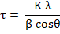 | Eq. 1

The N₂ adsorption/desorption isotherms were obtained using Quantachrome-Autosorb-iQ/MPXR at 77 K. BET (Brunauer-Emmett-Teller) multipoint analysis was used to calculate the specific surface area, as the material being used is mesoporous, the P/P_{o} data points were selected from the range 0.05-0.35. The pore volume and distribution measurements were obtained using discrete Fourier transform (DFT) and Barrett-Joyner-Halenda (BJH) methods respectively. The samples were prepared by degassing at 200 °C for 24 h at 10 °C/min.
The chemical nature of the cerium was investigated by X-ray photoelectron spectroscopy (XPS). The analyses were performed using a K-Alpha X-ray Photoelectron Spectrometer System, Thermo Fisher Scientific (Waltman, MA USA). To identify the overall composition of the surface an initial survey of 3 scans was obtained and for detailed elemental information spectra; 10 scans were done for C and Si, 20 scans for O and 30 scans for Ce. Data acquisition was performed using constant analyzer energy of 20 eV, dwell time of 50 milliseconds, 0.1 eV step size and an X-ray spot size of 400 μm. Data was analyzed using Avantage software V5.9, Thermo Scientific.
  - In vitro cytotoxicity assay
MC3T3-E1 cells - a murine pre-osteoblastic cell line derived from new-born mouse calvaria - were cultured in basal α-MEM supplemented with 10% fetal bovine serum (FBS) (v/v), 100 U·mL⁻¹ penicillin and 100 μg·mL⁻¹ streptomycin. MC3T3-E1 cells were seeded at a concentration 5x10⁴ cells mL⁻¹ in a flat-bottomed 96-well plate and incubated at 37°C and 5% CO₂ for 24 h to allow the cells to attach in a monolayer and expand. The cells were exposed to MSNs and Ce@MSNs at concentration range from 0-1000(0, 0.0001, 0.001, 0.01, 0.1, 1, 50, 100, 1000) μg mL⁻¹ for 24, 48, and 72 h. Cell viability was then assessed using a colorimetric assay based on the conversion of 3- (4,5-dimethyl-thiazol-2-yl)-2,5,diphenyltetrazolium bromide (MTT) soluble dye into insoluble (in aqueous media) blue formazan crystals. The formazan is soluble in dimethyl sulfoxide (DMSO) and the concentration of soluble formazan was determined at 570 nm using a microplate reader (SpectraMax M^{2e}, Molecular device).
  - Evaluation of MSNs and Ce@MSNs uptake into MC3T3-E1 cells
Functionalisation of the MSNs and Ce@MSNs using FITC was performed to track their uptake by the MC3T3-E1 cells. MC3T3-E1 cells were seeded on Gelatin (1mg mL⁻¹ in sterile milliQ water) coated glass cover slips at 10⁵ cells mL⁻¹ and cultured overnight. Then, the cells were treated with FITC-NH₂-MSNs and FITC-NH₂-Ce@MSNs (100 μg mL⁻¹) for 24 h. The cells were subsequently rinsed two times with phosphate buffered saline (PBS) and stained with DAPI (nucleus) and Cytopainter F-actin (cytoplasm) for 15 minutes, protecting them from light. Cells were then rinsed one time with PBS and sealed on microscope slides. The uptake of MSNs and Ce@MSNs into MC3T3-E1 cells was evaluated by inverted confocal microscope Zeiss LSM-510.
  - Assessment of the MSNs and Ce@MSNs radical-scavenging capability
The antioxidant capability of both MSNs and Ce@MSNs was measured in MC3T3-E1 cells previously treated with the oxidising agent t-butyl hydroperoxide (TBHP) by using the DCFDA- Cellular Reactive Oxygen Species Detection Assay Kit. MC3T3-E1 cells (1.5 x 10⁵) were labelled with 20 μM of DCFDA and then cultured an additional 4 h with or without 50 μM of TBHP according to the protocol. Soon after cells were treated with osteogenic factor (ascorbic acid, dexamethasone and beta-glycerol phosphate), MSNs and Ce@MSNs (100 μg mL⁻¹) for 24 h and then analyzed on a fluorescent plate reader. Mean +/- standard deviation was plotted for 3 replicates from each condition. TBHP mimics reactive oxygen species (ROS) activity to oxidize DCFDA to fluorescent DCF, which can be detected by fluorescence spectroscopy with maximum excitation and emission spectra of 495 nm and 529 nm respectively.
  - Effect of MSNs and Ce@MSNs on osteoblast differentiation and mineralisation
Osteoblast (OBs) differentiation and calcified tissue formation following exposure to the MSNs and Ce@MSNs were evaluated measuring the alkaline phosphatase (ALP) activity and Alizarin red staining respectively. The MC3T3-E1 cells were cultured (using a cell density of 5x10⁴ cells mL⁻¹) in a flat-bottomed 24-well plate and incubated at 37°C and 5% CO₂ for 24 h to allow cells to attach to the plate. Cells cultured in α-MEM osteogenic medium (100 µM L-ascorbic acid, 10 mM β-glycerophosphate and 10 nM dexamethasone) served as a positive control. Cells were exposed to 100 μg mL⁻¹ of MSNs and Ce@MSNs in basal condition for 24 hours and then basal medium for 7, 14 and 21 days. The culture medium was changed every three days to ensure a high nutrient concentration. Cells were fixed with 4% paraformaldehyde in PBS at time intervals of 7 days up to 21 days. Cells were stained with ALP detection kit according to the company's protocol. 2% (W/V) Alizarin Red S was prepared in PBS (1 g of Alizarin Red S in 50 mL of PBS) and the pH was adjusted using ammonium hydroxide. The pH of the solution is the critical parameter for this staining process. Cells were stained with 2% Alizarin Red S in PBS at pH 4.2 to detect calcified tissue formation.
  - MSNs and Ce@MSNs effects on MC3T3-E1 differentiation
The therapeutic effect of MSNs and Ce@MSNs on MC3T3-E1 differentiation was assessed by the early marker Collagen type 1 (Col1a1) staining. After 21 days the cells were fixed in 4% paraformaldehyde, permeabilised with a permeability buffer for 30 min. and then blocked with 1% BSA in PBS for 5 min. The cells were stained with a rabbit IgG primary antibodies at 4°C overnight. The secondary antibody used for immunofluorescence was goat anti-rabbit IgG H&L conjugated with Alexa Fluor 455. 4',6- Diamidino-2-Phenylindole, Dihydrochloride was used to stain nuclei according to company protocol.

  - Effects of MSNs and Ce@MSNs on a MC3T3-E1/RAW264.7 indirect co-culture
Millipore® Millicell® cell culture plate inserts (Sigma-Aldrich, UK) were used to set up a co-culture system for the two types of cells: MC3T3-E1 and RAW264.7 (mouse leukaemic monocyte macrophage cell line). RAW264.7 cells were seeded at concentration of 5 × 10⁴ cells mL⁻¹ in the 6-well plates and MC3T3-E1 cells at concentration of 5 × 10⁴ cells mL⁻¹) were placed in the 6-well inserts with 0.4 μm pore size. The co-culture system was cultured in α-MEM supplemented with 10% (v·v⁻¹) foetal bovine serum (FBS), 100 U mL⁻¹ penicillin and 100 μg mL⁻¹ streptomycin at 37°C, 5% CO₂ and fully humidified atmosphere for 24 h to allow cells to form a monolayer. The co-culture system was cultured under basal and osteogenic conditions with and without 20 ng mL⁻¹ of RANKL. Cells were exposed to MSNs and Ce@MSNs both in the basal and osteogenic conditions. The cells were incubated with MSNs and Ce@MSNs after every medium change. TRAP activity and the RANKL expression were measured to confirm that MSNs and Ce@MSNs did not have any effects on the OSC and OBs differentiation. TRAP activity, a marker of OSC differentiation and resorbing activity, was measured in RAW264.7 cells by TRAP histochemical stain. RAW264.7 cells were exposed to MSNs and Ce@MSNs at concentration of 100 μg mL⁻¹ under basal + RANKL condition. The TRAP histochemical stain, a marker of the OSC differentiation and resorbing activity, was used according to the manufacturer’s instructions following day-3 and day-7 in culture.
RANKL expression, a gene related to the differentiation state of OBs, was measured in MC3T3-E1 cells. RANKL levels were quantified using the RANKL (TNFSF11) Mouse ELISA Kit in accordance with the manufacturer’s instructions. The matrix maturation was evaluated in MC3T3-E1/RAW264.7 co-culture by measuring the ALP enzyme activity. At time intervals of up to 14 days, ALP activity of treated MC3T3-E1 cells was measured using the Alkaline Phosphatase Assay Kit according to the manufacturer's instructions.
  - Statistics
Statistical analyses were performed by one-way analysis of variance (ANOVA) in Minitab with the appropriate post hoc comparison test (Tukey's test). A p-value < 0.05 was considered significant.
- Results and discussion
  - Synthesis and characterisation of MSNs.
The MSN delivery system was synthesised by modifying the method of Chang et al., followed by a post impregnation method used to incorporate nanoceria into the silica mesoporous structure []. The stirring rate and the MSNs solution aging time were then changed one at a time in order to obtain the desired MSNs with the size of 80-100 nm and spherical shape. At 400 rpm, no MSNs formed within 2 h of mixing, possibly because of the inadequate mixing of reagents. Fig. 1a shows that the MSN size decreased linearly as the stirring rate increased from 600 to 1000 rpm. According to the aggregative growth model, proposed by Bogush et al. [], the trend is attributed to the faster diffusion of silica monomers at higher stirring rates. This decreases the local concentration of silica monomers available to form silica-surfactant micelles, reducing the MSN growth [].
Since the silica network grows by poly-condensation, we expected that the MSN diameter would also increase with aging time (which starts soon after adding the co-solvent ethyl acetate) [,]. However, Fig. 1b shows that initially the MSN size increased with aging time, but after 4 h, the diameter of the MSN decreased, possibly because the pH of the solution dropped below 7.0 after 4 h causing them to dissolve [36].
The optimal conditions to obtain monodisperse, spherical and small (>70 nm and <200 nm) MSNs (Fig. 1c-d) that facilitate endocytic OB cell uptake were 4 h aging at 70ºC with 1 h of stirring at 600 rpm followed by 3 h without stirring. Stirring for 1 h reduces aggregation of the MSNs due to the increase in the collision frequency between the already-formed MSNs and reduced viscosity of the solution []. This protocol led to a particle size 80 ± 10 nm, with a zeta potential of -30 ± 0.4 mV in DI water, indicating colloidal stability of the MSN as the repulsive charges are enough to prevent agglomeration [].
To remove any residual toxic CTAB used in the MSNs synthesis, the MSNs were carefully washed and treated thermally at a high temperature. The FTIR spectrum in Fig. S1 shows that the C-H stretching (3000-2840 cm⁻¹) absorptions were not visible, which confirmed that all of the CTAB was removed and no TEOS was left unreacted [,]. The band at 453 cm⁻¹ was linked to Si-O-Si bending and the peaks at 798 and 1073 cm⁻¹ were associated with stretching of Si-O and Si-O-Si bonds respectively.
Nanoceria was successfully incorporated into the pores of the MSNs when nanoceria (3 ± 0.85 nm) was introduced post MSN synthesis. X-ray diffraction (XRD) patterns confirmed successful incorporation of the nanoceria, with a broad halo at approximately 2θ = 22.5° (Fig. 2a, black line) of the silica amorphous structure present after heat treatment at 550 °C and diffraction peaks (Fig. 2a red line) corresponding to the (111), (200), (220), (311), (222), (400), (331), and (420) planes for the cubic fluorite structure of CeO₂ cerianite (JCPDS: 34-0394). The average crystallite size of the ceria was calculated to be 3.57 nm from the characteristic peaks at (111), (220) and (311) using the Scherrer equation.
The bulk composition of the Ce@MSNs was assessed by ICP-OES: 49.97 ± 3 mol% of Ce and 50.03 ± 3 mol% of Si. Gas sorption analysis (Fig. 2b) and TEM images (Fig. 2c-d) show the presence of nanoceria both on the MSNs surface and within the pores. Fig. 2b shows the nitrogen adsorption–desorption isotherms of the MSNs (square symbol) and Ce@MSNs (circle symbol). Introduction of nanoceria induced a reduction of surface area and pore volume from 725 ± 18 m² g⁻¹ and 1.05 ± 0.01 cm³ g⁻¹ for MSNs to 435.45 ± 10 m² g⁻¹ and 0.58 ± 0.01 cm³ g⁻¹ for Ce@MSNs respectively. The decrease in the height of the hysteresis loop (Fig. 2b red plot) at 0.6–0.8 of relative pressure, after nanoceria encapsulation, resulted from the fact that its mesopore volume reduced and pore structure had probably collapsed and clogged. The BJH pore distribution exhibited a narrow distribution with the modal pore size of 3 ± 0.07 nm, which was similar to the value reported in literature when CTAB was used as a pore templating agent []. The CeO₂ crystallite sizes measured by TEM were 3 ± 0.85 nm which agreed with the crystallite size calculated from the XRD diffraction peaks and was also similar to the modal MSNs pore size (measured using the BJH method). The nanoceria was visible in the TEM images (Fig. 2c-d) and the presence of nanoceria within the MSNs did not affect the size or morphology of the MSNs (Fig. 2c-d), but incorporation of nanoceria did make the Ce@MSNs less monodisperse in water, with a ζ of +13.27±0.9mV.
The chemical nature of the cerium incorporated into the mesoporous silica network was investigated by using x-ray photoelectron spectroscopy (XPS). Fig. 3 a-f show Ce3d, O1s, and Si2p electron core level XPS spectra of Ce@MSNs (a,c,e) and CeO₂ (b,d,f) samples. The three peaks from the binding energy range 918 to 902 eV of both samples (Fig. 3a and b) correspond to the Ce3d3/2 spin-orbit coupling state whilst the other three peaks with binding energies from 899 to 884 eV are associated with the Ce3d5/2 state [, ]. The peak at 918 eV is exclusive for Ce (IV) state and the peak at 884eV is unique for Ce (III) []. Those peaks were considered in the quantification of the two oxidation state species in both CeO₂ and Ce@MSNs samples. In the bare CeO₂ NPs, the ratio between Ce⁴⁺ and Ce³⁺ was 1/ 2.04 whereas in Ce@MSNs it was 1/1.5. The reduction of Ce³⁺ amount in Ce@MSNs compared to Ce³⁺ in bare nanoceria is probably due to the different synthesis methods used to obtain nanoceria. To synthesise bare CeO₂, a co-precipitation method and microwave treatment was applied [] while for the Ce@MSNs preparation passive diffusion method and thermal furnace treatment were used. Fig. 3 c and d display spectra of O1s electrons from Ce@MSNs and CeO₂ respectively. In Fig. 3c, the peak at 534 eV is attributed to the oxygen atoms present in the form of SiO₂ while the peak at 531 eV is associated to the oxygen atom in SiOH at the surface. In Fig. 3d, the peak at 530 eV is associated with the lattice oxygen and the one at 532eV to the surface oxygen in the naked nanoceria [44]. The peak at 105eV in Fig. 3e corresponds to the presence of SiO₂ species in the Ce@MSNs which is missing in the nanoceria alone (Fig. 3f).
  - Cellular toxicity of MSNs and Ce@MSNs and uptake by MC3T3-E1 cells.
The cytotoxicity of the MSNs and Ce@MSNs towards MC3T3-E1 pre-osteoblast cells was assessed using the MTT assay which measures cellular metabolic activity. There were no significant effects on the viability of MC3T3-E1 cells treated with either MSNs (black line) or Ce@MSNs (red line) up to a concentration of 100 μg mL⁻¹ after 24 hours (Fig 4). The MSN and Ce@MSNs were significantly toxic at 48 and 72 hours exposure at concentrations above 100 μg mL⁻¹ (p < 0.05).
Cellular internalisation of MSNs and Ce@MSNs was imaged through confocal microscopy by conjugating FITC to their surface (Fig. 5 a-d). The Ce@MSNs and MSNs were internalised by the cells and located inside the cytoplasm (yellow) after 24 h exposure (Fig. 5d). Ce@MSNs and MSNs are internalized inside the cytoplasm because of their small size below 100nm which is the cut off for nanoparticles endocytosis. This makes Ce@MSNs able to interact directly with the mitochondria where ROS are produced []. Local doses deliver of therapeutic Ce@MSNs in the cytoplasm increases their radical scavenger efficacy.

  - Ce@MSNs as antioxidants
One of the key triggers of osteoporosis is the levels of ROS inside bone cells. In a stressed condition, ROS overcome natural antioxidant defence mechanisms, causing bone loss and skeletal fragility []. The bar graph in Fig. 6a indicates the Ce@MSNs ability to scavenge ROS, produced by the activity of TBHP as an endogenous inducer of oxidative stress, which is more stable and more effective than H₂O₂ []. When the MC3T3-E1 cells were not treated with TBHP, the ROS level was lower than 5 RFU (black bar) and both the MSNs and Ce@MSNs did not significantly reduce ROS production. When the cells were stressed with TBHP, the ROS level increased to 11 RFU in the basal condition but the Ce@MSNs scavenged the radicals to reduce the RFU from 11 to 8 (p < 0.5), which was similar to the positive control osteogenic media, which contained the antioxidant ascorbic acid. In contrast, exposure to the MSNs did not result in a statistically significant reduction in the ROS level from the basal or osteogenic condition.
We can assume that the higher ROS scavenging capability of the Ce@MSNs compared to the MSNs is due to the incorporation of CeO₂. Moreover, compared to ascorbic acid and other organic exogenous antioxidants, which are limited by chemical instability, nanoceria has the advantage of an auto-regenerative process which allows restoring the radical scavenging properties without continuously dosing the drug [28].

  - Ce@MSNs are osteogenic, induce mineralisation and increase ALP activity in vitro
The therapeutic effects of both MSNs and Ce@MSNs were investigated by measuring the alkaline phosphatase (ALP) marker for the early OBs differentiation and Alizarin red staining for calcium (Fig. 6b-c). Fig. 6b shows the ALP activity in the extracellular matrix of the MC3T3-E1 cells treated with 100 μg mL⁻¹ of both MSNs (light grey bar) and Ce@MSNs (dark grey bar) after three weeks in culture compared to cells cultured in the basal (white bar) and osteogenic media (basal media plus osteogenic supplements that includes ascorbic acid (AA), dexamethasone (DEX) and β-glycerophosphate (GP) (black bar)). Exposure to Ce@MSNs significantly increased the ALP activity in MC3T3-E1 cells compared to those cultured in basal medium after 3 weeks in culture (p < 0.05). The measured increase induced by the Ce@MSNs was similar to that induced by osteogenic media alone. Although MSNs also increased ALP activity, the rise was not statistically significant.
Calcification was observed in MC3T3-E1 cells treated with Ce@MSNs or osteogenic media after 21 days using Alizarin Red staining (right column of Fig. 6c), but no difference was observed between the basal condition and cells exposed to MSNs. The effect of the Ce@MSNs on mineralisation was much more pronounced than in the cells cultured with MSNs and the basal condition.
The osteogenic effect of MSNs and Ce@MSNs on MC3T3-E1 were assessed with the marker Collagen type 1 (Col1a1), using immunohistochemistry (IHC) staining. The green fluorescence in Fig. 6c (left column) and its quantification (Fig. S2) show that exposure to Ce@MSNs increased expression of Col1a1 in MC3T3-E1 cells compared to basal media and media containing MSNs, but the expression was enhanced more by the osteogenic supplements.
In terms of the mechanism, previously, Arakaki et al. [] reported that osteoblast ALP activity and mineralisation are associated with increased ROS production in a time-dependent manner. BMP-2 (bone morphogenetic protein-2) triggers physiological ROS generation through an activation of NADPH oxidase to induce ALP production. During MC3T3-E1 cell differentiation, mitocondria are the major source of endogenous ROS. Gao et al. [] demonstrated SOD2 overexpression is needed to maintain low mitochondrial ROS. Nanoceria is a material with SOD and CAT-like enzyme mimetic activity and this activity is related to the predominance of 3⁺ or 4⁺ species. Nanoceria with higher ratios of Ce³⁺/ Ce⁴⁺ exhibits a higher SOD-like activity, while nanoceria with lower ratios shows a CAT-like activity. Our XPS results showed a prevalence of Ce³⁺ in Ce@MSNs. Therefore, the mechanism by which our Ce@MSNs stimulate ALP activity and calcification is likely to be related to its SOD enzyme mimetic activity, which is needed to buffer the ROS concentration in the mitochondria and so maintain an optimal osteoblastic differentiation of MC3T3-E1 cells.
  - MSNs and Ce@MSNs increase bone-like ECM production and OC activity in a co-culture of pre-osteoblast and macrophage cells.
Since the restoration of the homeostasis between bone resorption by OCs and bone formation by OBs is of fundamental importance in osteoporosis treatment, the effects of Ce@MSNs was evaluated in a co-culture system of MC3T3-E1 and RAW264.7 cells. The co-culture system was cultured under basal and osteogenic conditions with and without 20 ng mL⁻¹ of RANKL, a ligand of RANK receptor, which controls the differentiation, proliferation, and survival of OCs []. Here, RANKL was used to induce OCs differentiation. Cells were exposed to MSNs and Ce@MSNs, both in the basal and osteogenic conditions, at every medium change.
TRAP activity, a marker of OCs differentiation and resorbing activity, was measured in RAW264.7 cells using a TRAP histochemical stain (Fig. 7a-b). Intense blue TRAP staining occurred in large multinucleated cells (red arrows; identified as inactive osteoclasts), and also in smaller cells (green arrows; regarded as mononuclear undifferentiated osteoclast progenitors) (Fig. 7a and Fig. 7b). Large multinucleated cells showed intense staining after 3 days in both basal and osteogenic conditions following exposure to MSNs (Fig. 7a). In contrast, a particularly intense staining occurred in the small cells exposed to Ce@MSNs after 7 days of culture in the basal condition (Fig. 7b). The number of multinucleated cells in cultures treated with Ce@MSNs slightly decreased compared to cultures exposed to MSNs, indicating that nanoceria plays a role in reducing OCs differentiation following 7 days in culture.
Representative confocal micrographs of RAW264 cells showed that the FITC-Ce@MSNs were located inside the cytoplasm of Raw264 cells (Fig. 8a-h, green spots). Z-stacks through the cells (see movie in Supplementary Information) and 3D rendering (Fig. S3) indicated that the FITC-Ce@MSNs did not locate inside the nucleus.
OB differentiation was examined in relation to gene RANKL expression in MC3T3-E1 cells (Fig. 9a-b). Cells of the OBs lineage support two apparently distinct functions: Bone formation and promotion of osteoclast formation. RANKL expression is involved in osteoclast formation []. Fig. 9a suggests that, without the RANKL media supplement, RANKL expression from MC3T3-E1 cells treated with and without MSNs and Ce@MSNs did not change significantly over 3 days of culture in both basal and osteogenic conditions. After 7 days in culture, a significant increase in RANKL expression was measured when cells were treated with MSNs and Ce@MSNs, indicating that pre-osteoblasts were transformed into mature osteoblasts without osteogenic supplements. In the presence of RANKL supplement, the gene RANKL expression was not significantly different in cells treated with Ce@MSNs and MSNs (Fig. 9b). Previous studies on osteoblasts reported that silica nanoparticles provoked increased levels of RANKL [] and that RANKL expression is regulated by Runx2 and intracellular Ca²⁺ signaling. MD simulations indicated that when silica nanoparticles were incorporated into composite biomaterials the αVβ3 integrin also became activated []. Therefore, our MSNs can be linked with upregulated gene expression of Runx2 transcription factor and gene expression of αV integrin subunits. Incorporation of nanoceria in the MSNs, with its SOD enzyme like activity, may buffer the ROS produced in the MC3T3-E1 cells differentiation. Gao et al. proved that a decrease of excessive ROS production is essential to osteogenic differentiation by treating the cells with sublethal doses of FCCP(Carbonyl cyanide 4-(trifluoromethoxy-phenylhydrazone), which induces overgeneration of intracellular ROS. After osteogenic differentiation for 2 days, mRNA expression of Runx2 was suppressed in the presence of FCCP. Hence, MSNs and Ce@MSNs are potentially able to increase expression level of RANKL by regulating the mRNA expression of Runx2 and αVβ3 integrin.

Conclusions
Monodisperse spherical Ce@MSNs (>70 nm and <200 nm) were produced via a facile two-step process. The high surface area of MSNs allowed encapsulation of a high amount of nanoceria (49 mol.%) into the silica structure without any further modification to the size and morphology of the MSNs. The cell viability of the MC3T3-E1 preosteoblasts exposed to both MSNs and Ce@MSNs did not reduce significantly up to a concentration of 100 μg mL⁻¹. The antioxidant and therapeutic effects of Ce@MSNs were tested on MC3T3-E1 cells using TBHP - an endogenous inducer of oxidative stress that is more stable and effective than H₂O₂. The protective role of the Ce@MSNs against ROS production was attributed to the incorporation of nanoceria inside the MSNs. Ce@MSNs elicited improved osteogenic properties than the MSNs in the absence of osteogenic supplements in culture. The ability of these particles to scavenge damaging ROS and impart beneficial osteogenic and anti-osteoclastogenic properties highlights their potential therapeutic value for treatment of osteoporosis disease without using nasty small molecule drugs with their horrible side effects.
- Conflict of Interest
There are no conflicts to declare

- Acknowledgment
The research work has received funding by the Marie Sklodowska-Curie Actions (MSCA) Individual fellowship (IF) in Horizon 2020 program of the European Union, the EPSRC (EP/M004414/1) and the Imperial College Research fellowship scheme (ICRF). Raw data is available on request from rdm-enquiries@imperial.ac.uk.
- Supplementary Information Available
Fig. S1 FTIR spectrum of MSNs after thermal treatment at 550 °C for 6 hours
Fig. S2 Total cell fluorescence (CTCF) quantification of the images related to Collagen Type I (Fig.6c), of MC3T3-E1 cells in basal and osteogenic conditions and in basal media containing 100 μg mL⁻¹ of MSNs and Ce@MSNs. ImageJ software was used for CTCF analysis.
Fig. S3 3D rendering through side projections of confocal Z-stack confirming FITC-Ce@MSNs (green spots) internalization in Raw264 cells.

- Supplementary movie
3D rendering of Raw264 cells with fluorescent Ce@MSNs rotated along the y axis

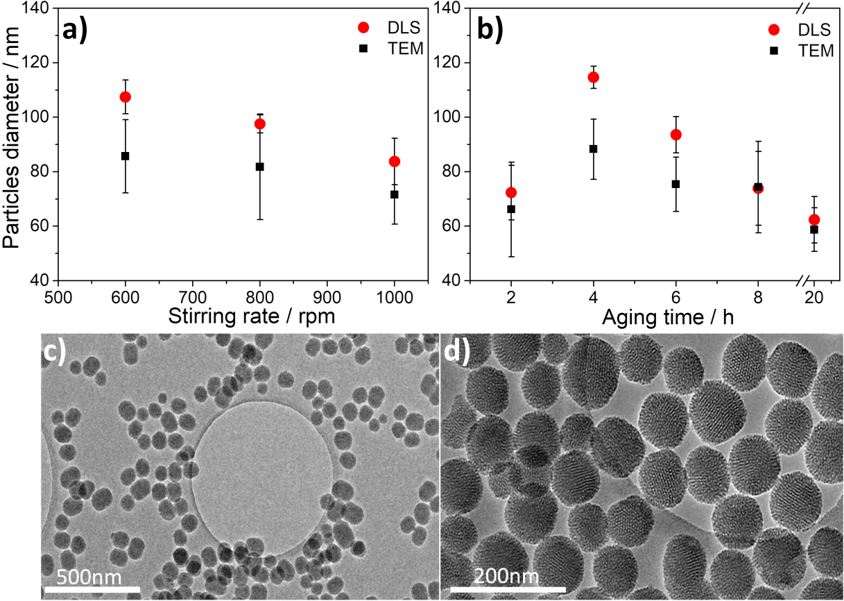
Fig. 1 (a,b) Mean particle diameter of MSNs measured by DLS (number mean) in ethanol and TEM (standard deviation 50 nanoparticles) as a function of: a) stirring rate; b) aging time; (c, d) TEM images of spherical monodispersed 80 ± 10 nm MSNs produced by stirring at 600 rpm with a 4 h aging time.

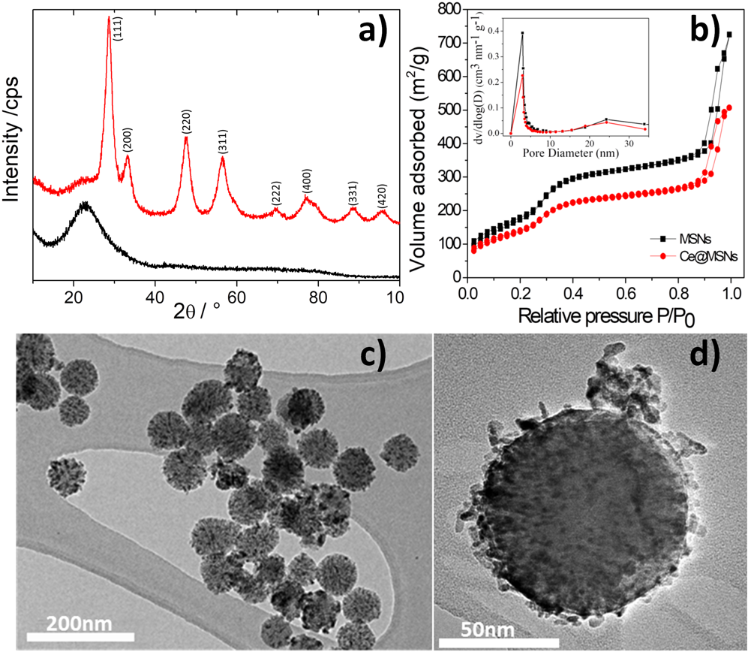
Fig. 2 a) XRD patterns of Ce@MSNs (red line) and MSNs (black line) with the peaks of Ce@MSNs diffraction pattern indexed according to the cerianite structure (JCPDS: 34-0394); b) N₂ adsorption-desorption isotherms of MSNs and Ce@MSN; Inset: pore diameter distributions (BJH method); c) TEM image of Ce@MSNs with 49 mol% of Ce and 50 mol% of Si (as determined by ICP-OES analysis); d) High magnification TEM image of an individual Ce@MSN.

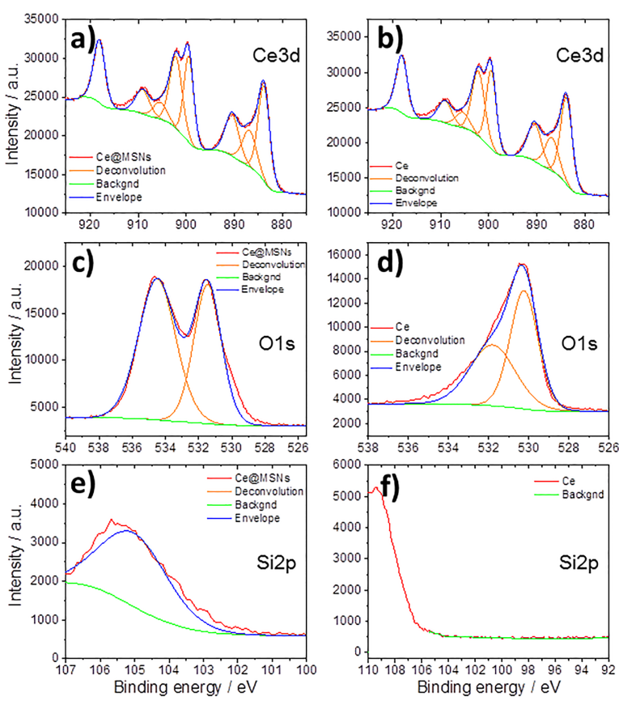

Fig. 3 XPS: Ce3d, O1s and Si2p spectra of a), c), e) Ce@MSNs and b), d) ,f) nanoceria alone.

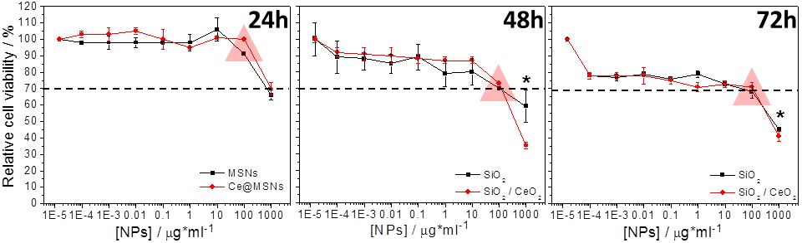
Fig. 4 Cell viability of MC3T3-E1 cells exposed to MSNs and Ce@MSNs for 24 h, 48 h and 72 h, normalised to the control (cells cultured in nanoparticle-free media, first point on the left side of each graph). The data are expressed as mean ± SD of three independent experiments (n = 6). (*) Indicates a statistically significant difference compared to controls (p < 0.05). The dashed line indicates 70% viability with respect to control, which is considered the limit of toxicity.

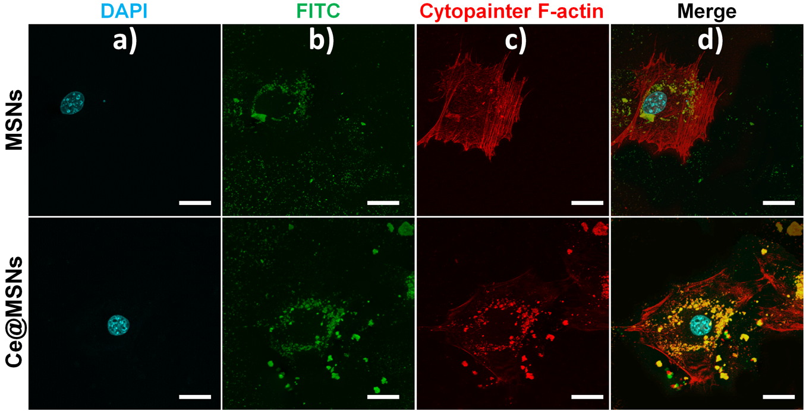
Fig. 5 Confocal images of MC3T3-E1 cells incubated with 100 μg mL⁻¹ of FITC–NH₂MSNs and 100 μg mL⁻¹ of FITC-NH₂- Ce@MSNs for 24 h: a) DAPI staining for nucleus (blue); b) FITC for MSNs and Ce@MSNs (green); and c) cytopainter F-actin for cytoplasm (red); d) Merged images of the 3 channels (Scale bar; 20 μm).

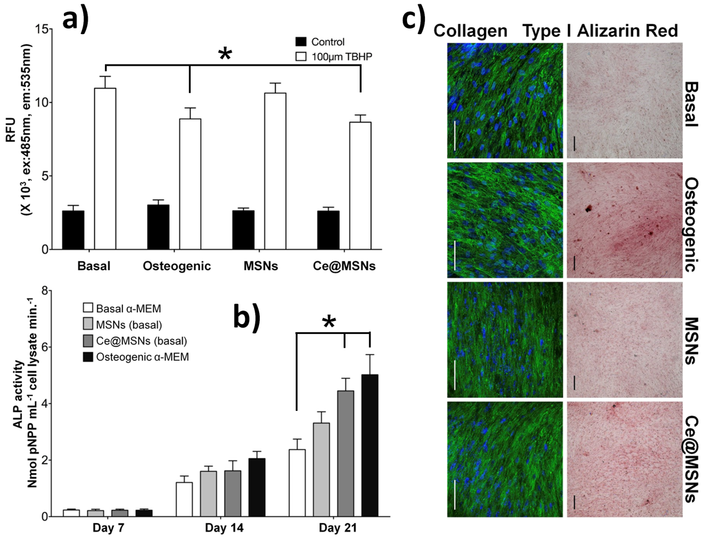
Fig. 6 a) Radical scavenger capability of MSNs and Ce@MSNs (100 μg mL⁻¹) in MC3T3-E1 cells treated with the oxidising agent t-butyl hydroperoxide (TBHP): Bar intensity (relative fluorescence units RFU) represents the ROS fluorescence of media (white bars are for media containing TBHP (basal media, osteogenic media and media containing MSNs and Ce@MSNs); black bars are controls (the same media without TBHP); for the white bars, lower intensity represents the higher radical scavenger property. b) ALP activity of MC3T3-E1 cells treated with 100 μg mL⁻¹ of MSNs and Ce@MSNs following three weeks (7, 14 and 21 days), compared to cells cultured under the basal media control and osteogenic media, p < 0.05, (n = 3). c) Collagen Type I, and Alizarin red immunofluorescence staining of MC3T3-E1 cells in basal and osteogenic conditions and in basal media containing 100 μg mL⁻¹ of MSNs and Ce@MSNs.

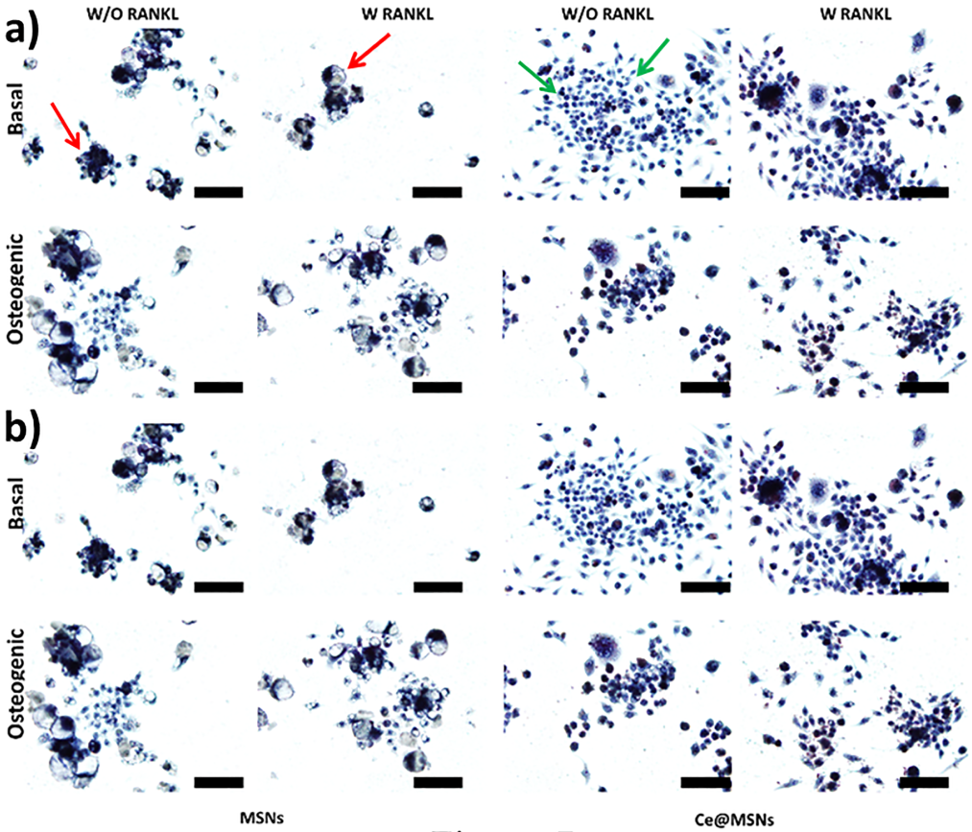
Fig. 7 TRAP activity histochemical staining of RAW264.7 cells in both basal and osteogenic conditions, exposed to MSNs and Ce@MSNs (100 μg mL⁻¹) with (W) and without (W/O) RANKL treatment after a) 3 days and b) 7 days (Scale bars are 100 μm).

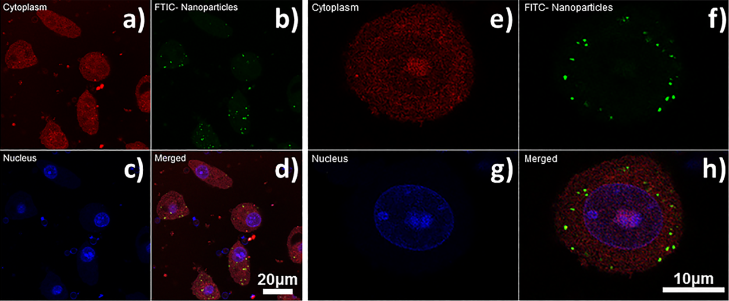
Fig. 8 Confocal images of Raw264 cells incubated with 100 μg mL⁻¹ of FITC–NH₂ Ce@MSNs for 24 h. The Raw264 cells were stained with a,e) cytopainter F-actin for cytoplasm (red). c,g) DAPI for nuclei (blue); The NH₂ Ce@MSNs were functionalised with FITC (green); d, h) merged images of the 3 channels.

Fig. 9 RANKL gene expression of MC3T3-E1 cells in both basal and osteogenic conditions, exposed to MSNs and Ce@MSNs (100 μg mL⁻¹) (n=6): a) without RANKL, b) with RANKL media supplement treatment after 3 (black bars) and 7 (grey bars) days.

References

[] E. Hernlund, A. Svedbom, M. Ivergård, J. Compston, C. Cooper, J. Stenmark, E. V. McCloskey, B. Jönsson, J. A. Kanis. Osteoporosis in the European Union: medical management, epidemiology and economic burden. Arch Osteoporos. 8 (2013) 1-115.
[] J.Y. Reginster, N. Burlet. Osteoporosis: a still increasing prevalence. Bone. 38 (2006) S4–S9.
[] A.M. Parfitt. Trabecular bone architecture in the pathogenesis and prevention of fracture. Am J Med. 82 (1987) 68–72.
[] E.K. Stürmer, D. Seidlová-Wuttke, S. Sehmisch, T. Rack, J. Wille, K. H. Frosch, W. Wuttke, K. M. Stürmer. Standardized Bending and Breaking Test for the Normal and Osteoporotic Metaphyseal Tibias of the Rat: Effect of Estradiol, Testosterone, and Raloxifene. J Bone Miner Res. 21 (2006) 89-96.
[] R. Lindsay, J. Nieves, C. Formica, E. Henneman, L. Woelfert, V. Shen, D. Dempster, F. Cosman. Randomised controlled study of effect of parathyroid hormone on vertebral-bone mass and fracture incidence among postmenopausal women on oestrogen with osteoporosis. Lancet. 350 (1997) 550–555.
[] S. A. Taiwo, K. Chaekyun. Reactive Oxygen Species in Osteoclast Di_erentiation and Possible Pharmaceutical Targets of ROS-Mediated Osteoclast Diseases. Int. J. Mol. Sci. 20 (2019) 3576-3592.
[] D.A. Callaway, J.X. Jiang. Reactive oxygen species and oxidative stress in osteoclastogenesis, skeletal aging and bone diseases. J Bone Miner Metab. 33 (2015) 359–370.
[] V. Domazetovic, G. Marcucci, T. Iantomasi, M.L. Brandi, M.T.Vincenzini. Oxidative stress in bone remodeling: role of antioxidants. Clin Cases Miner Bone Metab. 14 (2017) 209-21.
[] K. N. Tu, J.D. Lie, C.K.V. Wan, M. Cameron, A.G. Austel, J.K. Nguyen, K. Van, D. Hyun. Osteoporosis: A Review of Treatment Options. Pharm. Ther. 43 (2018) 92-104.
[] N. B. Watts, D. L. Diab. Long-Term Use of Bisphosphonates in Osteoporosis. J. Clin. Endocrinol. Metab. 95 (2010) 1555-1565.
[] M.T. Drake, B.L. Clarke, S. Khosla. Bisphosphonates: Mechanism of Action and Role in Clinical Practice. Mayo Clin Proc. 83 (2008) 1032–1045.
[] H. Ji.Yana, T. Casalini, G. Hulsart-Billström, S. Wanga, O.P. Oommend, M. Salvalaglio, S. Larsson, J. Hilborna, O. P. Varghese. Synthetic design of growth factor sequestering extracellular matrixmimetic hydrogel for promoting in vivo bone formation. Biomaterials. 161 (2018) 190-202.
[] P. Naruphontjirakul, S. L. Greasley, S. Chen, A. E. Porter, J. R. Jones. Monodispersed strontium containing bioactive glass nanoparticles and MC3T3-E1 cellular response. Biomed. Glasses. 2 (2016) 72–81.
[] P. Naruphontjirakul, O. Tsigkou, S. Li, A.E. Porter, J.R. Jones. Human mesenchymal stem cells differentiate into an osteogenic lineage in presence of strontium containing bioactive glass nanoparticles. Acta Biomater. 90 (2019) 373-392.
[] G. R. Beck Jr., S.W. Ha, C.E. Camalier, M.Yamaguchi, Y. Li, J.K. Lee, M. N.Weitzmann. Bioactive silica-based nanoparticles stimulate bone-forming osteoblasts, suppress bone-resorbing osteoclasts, and enhance bone mineral density in vivo. Nanomed. Nanotechnol. 8 (2012) 793–803.
[] O. Tsigkou, J. R. Jones, J. M. Polak, M. M. Stevens. 45S5 Bioglass conditioned medium enhances the differentiation of fetal osteoblasts and the formation of mineralized bone nodules in the absence of osteogenic supplements.Biomaterials. 30 (2009) 3542-3550.
[] S. Kwon, R.K. Singh, R.A. Perez, E.A.A. Neel, H.W. Kim, W. Chrzanowski. Silica-based mesoporous nanoparticles for controlled drug delivery. J Tissue Eng. 4 (2013) 1-18.
[] M.Vallet-Regı´, F. Balas, M. Colilla, M. Manzano. Bone-regenerative bioceramic implants with drug and protein controlled delivery capability. Prog. Solid State Ch. 36 (2008) 163-191.
[] F. Balas, M. Manzano, P. Horcajada, M. Vallet- Regı´. Confinement and Controlled Release of Bisphosphonates on Ordered Mesoporous Silica-Based Materials. J. Am. Chem. Soc. 128 (2006) 8116-8117.
[] X. Zhou, W. Feng, K. Qiu, L. Chen, W. Wang, W. Nie, X. Mo, C. He. BMP‑2 Derived Peptide and Dexamethasone Incorporated Mesoporous Silica Nanoparticles for Enhanced Osteogenic Differentiation of Bone Mesenchymal Stem Cells. ACS Appl. Mater. Interfaces. 7 (2015) 15777–15789.
[] L. Yaqin, Lin. Rongcai, M. Lingling, Z. Hui, F. Chun, C. Jiang, W. Chengtie. Mesoporous bioactive glass for synergistic therapy of tumor and regeneration of bone tissue. Appl. Mater. Today. 19 (2020) 1-14.
[] L.Wei, J. Ke, I. Prasadam, R. J. Miron, S. Lin, Y. Xiao, J. Chang, C. Wu, Y. A. Zhang. A comparative study of Sr-incorporated mesoporous bioactive glass scaffolds for regeneration of osteopenic bone defects. Osteoporos Int. 25 (2014) 2089–2096.
[] C. Xu, X. Qu. Cerium oxide nanoparticle: a remarkably versatile rare earth nanomaterial for biological applications. Npg Asia Mater. 6 (2014) 1-16.
[] A. Pinna, B. Lasio, M. Piccinini, B. Marmiroli, H. Amenitsch, P. Falcaro, Y. Tokudome, L. Malfatti, P.Innocenzi. Combining Top-Down and Bottom-Up Routes for Fabrication of Mesoporous Titania Films Containing Ceria Nanoparticles for Free Radical Scavenging. ACS Appl. Mater. Interfaces. 5 (2013) 3168-3175.
[] R.W. Tarnuzzer, J. Colon, S. Patil, S. Seal. Vacancy engineered ceria nanostructures for protection from radiation-induced cellular damage. Nano Lett. 5 (2005) 2573–2577.
[] A. Asati, C. Kaittanis, S. Santra, J. M. Perez. pH-tunable oxidase-like activity of cerium oxide nanoparticles achieving sensitive fluorigenic detection of cancer biomarkers at neutral pH. Anal.Chem. 83 (2011) 2547–2553.
[] F. Pagliari, C. Mandoli, G. Forte, E. Magnani, S. Pagliari, G. Nardone, S. Licoccia, M. Minieri, P. Di Nardo, E.Traversa. Cerium oxide nanoparticles protect cardiac progenitor cells from oxidative stress. ACS Nano. 6 (2012) 3767–3775.
[] A. Pinna, L. Malfatti, G. Galleri, R. Manetti, S. Cossu, G. Rocchitta, R. Migheli, P.A. Serra, P. Innocenzi. RSC Adv. Ceria nanoparticles for the treatment of Parkinson-like diseases induced by chronic manganese intoxication. 5 (2015) 20432-20439.
[] C. Li, X. Shi, Q. Shen, C. Guo, Z. Hou, J. Zhang. Hot Topics and Challenges of Regenerative Nanoceria in Application of Antioxidant Therapy. J Nanomater. 4857461 (2018) 1-12.
[] G. Zhou, Y. Li, B. Zheng, W. Wang, J. Gao, H. Wei, S. Li, S.Wang, J. Zhang. Cerium oxide nanoparticles protect primary osteoblasts against hydrogen peroxide induced oxidative damage. Micro. Nano. Lett. 9 (2014) 91-96.
[] G. Zhou, G. Gu, Y. Li, Q. Zhang, W. Wang, S. Wang, J. Zhang. Effects of cerium oxide nanoparticles on the proliferation, differentiation, and mineralization function of primary osteoblasts in vitro. J.Biol. Trace. Elem. Res. 153 (2013) 411–418.
[] A.S. Karakoti, O. Tsigkou, S. Yue, P.D. Lee, M.M. Stevens, J.R. Jones, S. Seal. Rare earth oxides as nanoadditives in 3-D nanocomposite scaffolds for bone regeneration. J. Mater. Chem. 20 (2010) 8912–8919.
[] V. Nicolini, E. Gambuzzi, G. Malavasi, L. Menabue, M.C. Menziani, G. Lusvardi, A. Pedone, F. Benedetti, P. Luches, S. D’Addato, S.Valeri. Evidence of catalase mimetic activity in Ce3+/Ce4+ doped bioactive glasses. J. Phys. Chem. B. 119 (2015) 4009-4019.
[] W. Stober, A. Fink, E. Bohn. Controlled growth of monodisperse silica spheres in the micron size range. J. Colloid Interface Sci. 26 (1968) 62-69.
[] S. Labbaf, O. Tsigkou, K.H. Muller, M.M. Stevens, A.E. Porter, J.R. Jones. Spherical bioactive glass particles and their interaction with human mesenchymal stem cells in vitro. Biomaterials. 32 (2011) 1010–1018.
[] B. Chang, D.Chen, Y. Wang, Y. Chen, Y. Jiao, X. Sha, W.Yanget. Bioresponsive controlled drug release based on mesoporous silica nanoparticles coated with reductively sheddable polymer shell. Chem. Mater. 25 (2013) 574-585.
[] G. Bogush, C. Zukoski. Uniform silica particle precipitation: an aggregative growth model. J. Colloid Interface Sci. 142 (1991) 19-34.
[] X. Lv, L. Zhang, F. Xing, H. Lin. Controlled synthesis of monodispersed mesoporous silica nanoparticles: particle size tuning and formation mechanism investigation. Microporous Mesoporous Mater. 225 (2016) 238-244.
[] K. Kim, H. Kim. Comparison of the effect of reaction parameters on particle size in the formation of SiO₂, TiO₂, and ZrO₂ nanoparticles. Mater. Lett. 57 (2003) 3211-3216.
[] S. T. F. Grecco, E. A. Urquieta-González, P. Reyes, M. Oportus, M.C. Rangel. Influence of temperature and time of seed aging on the properties of beta zeolite/MCM-41 materials. J. Braz. Chem. Soc. 25 (2014) 2444-2454.
[] B. Gielen, J., Jordens, L. C. J. Thomassen, L. Braeken, T.Van Gerven. Agglomeration control during ultrasonic crystallization of an active pharmaceutical ingredient. Crystals. 7 (2017) 1-20.
[] O. Tsigkou, S. Labbaf, M.M. Stevens, A.E. Porter, J.R. Jones. Monodispersed bioactive glass submicron particles and their effect on bone marrow and adipose tissue-derived stem cells. Adv. Healthc. Mater. 3 (2014) 114-125.
[] A. Putz, M. Putz. Spectral inverse quantum (Spectral-IQ) method for modeling mesoporous systems: application on silica films by FTIR. Int. J. Mol. Sci. 13 (2012)15925-15941.
[] R. Al-Oweini, H. El-Rassy. Synthesis and characterization by FTIR spectroscopy of silica aerogels prepared using several Si(OR)₄ and R′′Si(OR′)₃ precursors precursors. J. Mol. Struct. 919 (2009)140-145.
[] N. I. Vazquez, Z. Gonzalez, B, Ferrari, Y. Castro. Synthesis of mesoporous silica nanoparticles by sol–gel as nanocontainer for future drug delivery applications. Bol Soc Esp Ceram V. 56 (2017) 139–145.
[] P. Nabanita, C. Eun-Bum, Kim. Dukjoon. Synthesis of ordered mesoporous silica/ceria–silica composites and their high catalytic performance for solvent-free oxidation of benzyl alcohol at room temperature. RSC Adv. 4 (2014) 9213-9222.
[] P. Janoš, J. Henych, J. Pfeifer, N. Zemanová, V. Pilařová, D. Milde, T. Opletal, J. Tolasz, M. Malýd, V. Štengl. Nanocrystalline cerium oxide prepared from a carbonate precursor and its ability to breakdown biologically relevant organophosphates. Environ. Sci. Nano. 4 (2017) 1283-1293.
[] https://xpssimplified.com/elements/cerium.php.
[] A. Pinna, C. Figus, B. Lasio, M. Piccinini, L. Malfatti, P. Innocenzi. Release of Ceria Nanoparticles Grafted on Hybrid Organic−Inorganic Films for Biomedical Application. ACS Appl. Mater. Interfaces. 4 (2012) 3916-3922.
[] J.M. Dowding, W. Song, K. Bossy, A. Karakoti, A. Kumar, A. Kim, B. Bossy, S. Seal, M.H. Ellisman, G. Perkins, W.T. Self, E. Bossy-Wetzel. Cerium oxide nanoparticles protect against Aβ-induced mitochondrial fragmentation and neuronal cell death. Cell Death Diff. 21 (2014) 1622 1632.
[] M. J. Smietana, E.M. Arruda, J.A. Faulkner, S. V. Brooks, L. M. Larkin. Reactive Oxygen Species on Bone Mineral Density and Mechanics in Cu,Zn Superoxide Dismutase (Sod1) Knockout Mice. Biochem Biophys Res Commun. 403 (2010) 149–153.
[] R. Ballesteros, I. del Hierro, I. Sierra Alonso. Design and Applications of Novel Titanium and Copper Containing Mesoporous Organic-Inorganic hybrid materials. Dykinson. (2001) Ch 1.3.
[] N. Arakaki, A. Yamashita, S. Niimi, T. Yamazaki .Involvement of reactive oxygen species in osteoblastic differentiation of MC3T3-E1 cells accompanied by mitochondrial morphological dynamics. Biomed. Res. 34 (2013) 161-166.
[] J. Gao, Z. Feng, X. Wang., M. Zeng, J. Liu, S. Han, J. Xu, L. Chen, K. Cao, J. Long, Z. Li, W. Shen, J. Liu. SIRT3/SOD2 maintains osteoblast differentiation and bone formation by regulating mitochondrial stress. Cell Death Diffe. 25 (2018) 29–240.
[] M. McClung. Role of RANKL inhibition in osteoporosis. Arthritis Res Ther. 9 (2007) 1-6.
[] G. J. Atkins, P. Kostakis, B. Pan, A. Farrugia, S. Gronthos, A. Evdokiou, K. Harrison, D.M. Findlay, A.C.W. Zannettino. RANKL Expression Is Related to the Differentiation State of Human Osteoblasts. J Bone Miner Res. 18 (2003) 1088-1098.
[] Z. MartÍn-Moldes, D. Lopez Barreiro, M. J. Buehler, D. L. Kaplan. Effect of the silica nanoparticle size on the osteoinduction of biomineralized silk-silica nanocomposites. Acta Biomater. (2020), doi: https://doi.org/10.1016/j.actbio.2020.10.043.
[] G. A. Fielding, N. Sarkar, S. Vahabzadeh, S. Bose. Regulation of Osteogenic Markers at Late Stage of Osteoblast Differentiation in Silicon and Zinc Doped Porous TCP. J. Funct. Biomater. 10 (2019) 1-13.

