Excessive ozonation stress triggers severe membrane biofilm accumulation and fouling

Li Zhang ª, Nigel Graham ^{b}, Guibai Li ^{c}, Yongguan Zhu ^{d}, Wenzheng Yu ^{a, *}
ª State Key Laboratory of Environmental Aquatic Chemistry, Research Center for Eco–Environmental Sciences, Chinese Academy of Sciences, Beijing 100085, China
^{b} Department of Civil and Environmental Engineering, Imperial College London, South Kensington Campus, London SW7 2AZ, United Kingdom
^{c} State Key Laboratory of Urban Water Resource and Environment (SKLUWRE), School of Environment, Harbin Institute of Technology, Harbin 150090, China
^{d} State Key Laboratory of Urban and Regional Ecology, Research Center for Eco–Environmental Sciences, Chinese Academy of Sciences, Beijing 100085, China
*Corresponding author: wzyu@rcees.ac.cn

Abstract
The established benefits of ozone on microbial pathogen inactivation, natural organic matter degradation, and inorganic/organic contaminant oxidation, have favored its application in drinking water treatment. However, viable bacteria are still present after ozonation of the raw water, bringing a potential risk to membrane filtration systems in terms of biofilm accumulation and fouling. In this study, we shed light on the role of the specific ozone dose (0.5 mg–O₃/mg–C) in biofilm accumulation during long–term membrane ultrafiltration. Results demonstrated that ozonation transformed the molecular structure of influent dissolved organic matter (DOM), producing fractions that were highly bioavailable at a specific ozone dose of 0.5, which was inferred to be a turning point. With the increase of specific ozone dose, the biofilm microbial consortium was substantially shifted, demonstrating a decrease in richness and diversity. Unexpectedly, the opportunistic pathogen Legionella was stimulated and occurred in approximately 40% relative abundance at the higher specific ozone dose of 1. Accordingly, the membrane filtration system with a specific ozone dose of 0.5 presented a lower biofilm thickness, a weaker fluorescence intensity, smaller concentrations of polysaccharides and proteins, and a lower Raman activity, leading to a lower hydraulic resistance, as compared to that with a specific ozone dose of 1. Our findings highlight the interaction mechanism between molecular–level DOM composition, biofilm microbial consortium, and membrane filtration performance, which provides an in–depth understanding of the impact of ozonation on biofilm accumulation.

Keywords
Ozone; biofilm; DOM; microbial consortia; membrane filtration; water treatment

Synopsis: Excessive ozonation stress triggers severe membrane biofilm accumulation

1. Introduction
Membrane fouling continues to be a major concern in the application of membrane filtration technology, in which the biofilm layer plays a critical role. Various oxidants or disinfectants are commonly used for pretreatment upstream of conventional processes, including membrane separation, and these have been intensively investigated in recent years.^{1–4} In terms of the relative benefits of alternative pretreatment methods, involving the inactivation of microbial pathogens, decomposition of natural dissolved organic matter (DOM), oxidation of inorganic contaminants, and the removal of taste–, odor–, and color–causing compounds, ozone is commonly preferred in water treatment.⁵ Although microbial levels are difficult to detect due to the rapid reactivity of ozone, viable microbes have been reported to remain present after ozonation of raw water,⁶ offering an opportunity for the formation of biofilm on the surface of subsequent membranes. Several studies have investigated the effect of ozonation on membrane fouling,^{7–10} but for the long–term operation of a membrane filtration system, the role of ozone in the biofilm accumulation remains unclear.
In the process of ozonation, DOM, a highly complex mixture composed of multiple natural and anthropogenic organic molecules, is the major ozone consumer.^{11,12} Ozone is able to react with electrophilic functional groups and activated aromatic substances, breaking double bonds, thereby splitting molecules and adding oxygen atoms to molecules.^{13,14} Thus, ozone has been shown to lower the aromaticity of DOM by reacting with phenolic moieties found commonly in DOM.¹⁵ Remucal et al. studied molecular–level transformation of two DOM isolates using Orbitrap mass spectrometry and found that, as well as reducing aromaticity, ozonation also decreased the apparent molecular weight and electron donating capacity of DOM with large changes.¹⁶ In addition, ozonation was demonstrated to make organic compounds more hydrophilic and susceptible to biodegradation.^{17,18} However, some research studies have shown that ozone may produce reaction byproducts that are less biodegradable and potentially detrimental.^{19–21} Therefore, the biodegradability of ozonized DOM, and its potential influence on the subsequent formation and accumulation of biofilm on membrane surfaces, requires further evaluation.
As a disinfectant, ozone is highly effective in inactivating bacteria in water,²² but ozone–resistant bacteria can remain after ozonation, which can enhance the accumulation of biofilm on the surface of membranes subsequently. The actively growing microbial species were reported to secrete secondary metabolites that could alter ambient conditions, thus influencing the growth of other microorganisms and shifting relative abundance levels.²³ The variation in the bacterial community is suspected to further affect the biofilm structure and properties, owing to the discrepant extracellular polymeric substances (EPS) secreted.^{1,24–26} At present, detailed information regarding the shift of biofilm bacterial community by ozone remains deficient, and moreover, the influence of specific ozone dose, defined as the ratio of ozone dose to dissolved organic carbon in raw water (mg–O₃/mg–C), on the microbial composition is also largely unknown.
The DOM provides substrates serving as niches for the biofilm microbes and they are major energy sources supporting microbial growth.²⁷ The variation in the molecular composition of DOM has been reported to affect the diversity, structure, and functioning of microbial communities.^{28,29} In turn, microbial consortia produce chemo-diversity by degrading larger molecules into smaller structures and releasing new molecules into the water.³⁰ The interactions between chemo-diversity and biodiversity are complex but vitally important. Several previous studies have investigated the natural ecosystems and endeavored to disclose the interaction mechanisms. In a pelagic marine system, Osterholz et al. found that the active microbial community correlated with specific DOM molecular formulae and the trend was most pronounced at the species level.³¹ Tanentzap and co–workers focused on a fresh water system and they discovered that the chemical and microbial diversities were positively correlated, with DOM having a stronger effect on microbes than vice versa.²⁷ However, less attention has been paid to the engineering system and the interactions between DOM and biofilm microbial consortia remain unknown, which are of particular importance since they likely have a pronounced effect on biofilm accumulation and membrane filtration performance.
In this paper, we present new information that sheds light on the molecular–level DOM composition at varying specific ozone doses, the biofilm microbial structure, interactions between DOM chemo-diversity and biofilm biodiversity, and importantly, decipher the associated influencing mechanism on membrane filtration performance. Here, Fourier transform ion cyclotron resonance mass spectrometry (FT–ICR–MS), the state–of–the–art analytical tool for molecular–level DOM characterization, was employed in the experiments, owing to its high resolution, sensitivity, and mass accuracy.³¹ We hypothesize that the composition of DOM is substantially transformed, depending on the value of specific ozone dose. With the increase of specific ozone dose, the biofilm biodiversity presents a declining trend. The synergistic effect of DOM and biofilm microbial consortia may contribute to the differences in membrane filtration performance. The objective of the study, described subsequently, was to provide an in–depth insight into the role of specific ozone dose in the biofilm formation and the interactions between DOM, biofilm bacterial community, and membrane filtration performance.
2. Materials and Methods
2.1 Experiment set–up and operation
Water samples were collected from River Jingmi (Beijing, China), which serves as the source of drinking water supply for the large majority of the citizens living in Beijing. Polyvinylidene fluoride (PVDF) ultrafiltration (UF) membrane (Beijing Separate Equipment Co., Ltd., China), with a nominal molecular cut–off of 100 kDa, and an area of approximately 78.5 cm², was selected for the experiments. A gravity–driven membrane filtration system, with a constant transmembrane pressure of 35 mbar (35 cm water head), was adopted as the experimental model, due to its advantages in terms of biofilm robustness. Further detailed information concerning the surface water characteristics and filtration system is given in the Supporting Information (SI, Table S1 and Figure S1)
Surface water was ozonized with fresh gaseous ozone, generated from pure oxygen by a laboratory ozone generator (ZA–10G–C, HangMu, China). The gas contacting apparatus was operated under 0.1 kPa pressure and the ozone was added under vigorous mixing on the basis of bubble size, to yield specific doses of 0.5 mg–O₃/mg–C and 1 mg–O₃/mg–C, which were ratios representative of practical applications and verified using the standard indigo method.³² The ozonized samples were stored at room temperature for 20 h, to allow for complete ozone consumption and decay. Thereafter, water samples serving as feed waters were added to the filtration systems. For convenience, the filtration systems with specific ozone dose of 0.5 mg–O₃/mg–C and 1 mg–O₃/mg–C were denoted as ratio 0.5 and ratio 1, respectively.
2.2 DOM preparation for ESI–FT–ICR–MS measurement and data analyses
To desalinate and concentrate DOM, solid phase extraction (SPE) was performed on all the influent samples using Bond Elute PPL cartridges (200 mg, 3 mL; Agilent technologies, USA) according to the method of Dittmar et al.³³ Briefly, the cartridges were rinsed with 3 mL of methanol (MS grade) prior to use. An acidified sample was passed through the cartridge, rinsed with three cartridge volumes of 0.01 M HCl, dried with ultrapure N₂, and immediately extracted with two cartridge volumes of methanol (MS grade). The eluates were blow–dried with ultrapure N₂ and re–dissolved in a 1 mL mixture of 1:1 (v:v) methanol/ultrapure water. The samples were re–filtered with 0.2–μm PTFE syringe filters pre–rinsed with a 1:1 mixture of methanol to ultrapure water. All samples were adjusted to an equal mass concentration of 100 mg–C·L^{–1}, in order to eliminate the influence of concentration on the ionization efficiency of molecules detected. ^{34,35} The extraction efficiency exceeded 75% using this method.³⁶ Each sample was examined in duplicate according to the methods reported prevously.^{37,38} A blank sample for the sorbent was obtained by extracting ultrapure water with the same procedures and volumes as the samples.
Ultrahigh resolution mass spectra were obtained using a solariX FT–ICR–MS instrument (Bruker Daltonik GmbH, Germany) equipped with a 15.0 T superconducting magnet and an ESI ion source under negative ion mode. The details for mass spectra acquirement, calibration, and peak assignment can be found in the SI. Ratios O/C ≤ 1.2 and 0.2 ≤ H/C ≤ 2.3 were used as the further restrictions for the formula calculation.³⁹ Seven compound groups were delineated by the H/C and O/C cutoffs in the van Krevelen diagrams, according to a previous publication.⁴⁰ To further characterize the molecular properties of DOM, aromaticity index (AI), which indicates the fraction of aromatic and condensed aromatic structures,⁴¹ and nominal oxidation state of carbon (NOSC), which is related to the bioavailability of the molecule,⁴² were calculated by the following equations:
$\text{AI=}\frac{\text{1+c–0.5o–0.5h–s}}{\text{c–0.5o–n–s}}$ (1)
$\text{NOSC=4–}\left(\frac{\text{4c+h–3n–2o–2s}}{\text{c}}\right)$ (2)
where c, h, o, n, and s refer to the stoichiometric number of carbon, hydrogen, oxygen, nitrogen, and sulfur atoms per formula, respectively. Significant differences were determined using the Kruskal–Wallis test.
2.3 DOM physicochemical properties
2.3.1 Fluorescence characteristic
An excitation–emission matrix (EEM) fluorescence spectrometer (F–4600, Hitachi, Japan) was employed for the analysis of the fluorescence properties of samples (water and biofilm). A volume of 15 mL 0.1 M NaCl solution was used to rinse the biofilm from the membrane surface. The sample EEM spectra were blank subtracted, and the intensities were normalized by the ultrapure water Raman peak at an excitation of 350 nm (386–410 nm emission), converting fluorescence data to Raman units (R.U.).⁴³ First– and second–order Rayleigh scatters were removed from the EEM spectra. Each sample was measured in triplicate and the results were averaged.
2.3.2 Apparent molecular weight distribution
The apparent molecular weight of the sample organic matter was determined using a high performance size exclusion chromatograph (HPSEC), with an operating wavelength of 254 nm. Based on the apparent molecular weight profile obtained using sodium polystyrene sulfonate as a standard, the correlation between retention time and apparent molecular weight was determined. Accordingly, the sample apparent molecular weight distribution profiles were ascertained. All samples were pre–filtered by a 0.22–μm syringe filter before being injected into the instrument.
2.3.3 Chemical bonds linking the molecules
X–ray photoelectron spectroscopy (XPS; PHI Quantera II, ULVAC, Japan) measurements were conducted with a Thermo Escalab 250 electron spectrometer using 150 W Al–Kα radiations, yielding the identification of chemical compositions and oxidation states of elements on the freeze–dried biofilm surface. A Fourier transform infrared (FTIR) spectrometer (Spectrum Two, PerkinElmer, USA) with an attenuated total reflectance (ATR) accessory was used to analyze the functional groups of freeze–dried biofilm. A Raman spectrometer (inVia–Reflex, Renishaw, UK) was employed to reveal the Raman activity of the freeze–dried biofilm, with a wavelength of 532 nm and a 50× ultra–long working distance objective lens. At least five randomized locations were selected for the measurement. The XPS spectra were further fitted by XPSPEAK software and all the spectral curves were plotted with Origin 2021 software.
2.4 Biofilm morphological structure
At the end of the experiments, the biofilms together with the membranes, were gently taken out of the filtration apparatus, and were then cut into several pieces. Sections of pieces were directly freeze–dried using a lyophilizer (Scientz–18N, China). Both surface and cross–sectional images were captured with a high–resolution field emission gun scanning electron microscope (SEM; S–4800, Hitachi, Japan). Fresh biofilms were analyzed with InfiniteFocus (G5, Alicona, Austria), which is a flexible optical 3D measurement instrument, yielding information on the optical micrographs and roughness data simultaneously.
2.5 Biofilm DNA extraction, sequencing and statistical analyses
The biofilm DNA was extracted from an area of ~2 cm², using proteinase K and SDS–based lysis, and purified with DNA Clean & Concentrator–25 Kit (ZYMO RESEARCH, USA) according to the manufacturer’s protocol. Three areas were selected for each sample in the microbial consortium analysis. Universal primers, containing 515 forward (5′–GTGCCAGCMGCCGCGGTAA–3′) and 806 reverse (5′–GGACTACHVGGGTWTCTAAT–3ʹ), were used to amplify the V4 region of bacterial 16S rRNA genes. Three areas of the same size were selected for each biofilm. All amplified genes were sequenced by an Illumina MiSeq sequencer. Further detailed information concerning the amplification methods and data processing procedures is given in the SI. The raw sequencing data were deposited to the Sequence Read Archive (SRA) database of the National Center of Biotechnology Information (NCBI) under accession number PRJNA970303.
To reveal the commonness and discrepancy in the bacterial communities of different biofilms, an UpSet plot was drawn based on the ASVs data with R package {UpSetR}. To investigate the changes in relative abundance of bacterial taxa under different conditions, we deciphered the taxonomic composition at the phylum and genus levels. The chord chart was delineated with R packages {circlize} and {statnet} and the bar plot was completed by Origin 2021. To evaluate whether differences existed in the bacterial communities under different conditions, principal coordinate analysis (PCoA) was performed (R package {vegan}). To quantify the discrepancies between bacterial communities, a boxplot was drawn based on the Bray–Curtis dissimilarity matrix using Origin 2021. Significant differences were determined using the Kruskal–Wallis test.
2.6 Hydraulic resistance of filtration system
The total hydraulic resistance (R_{t}, [m^{–1}]) was calculated as:
${\text{R}}_{\text{t}}\text{=}\frac{\text{TMP}}{\text{μ∙J}}$ (3)
where μ is the dynamic viscosity of water at a given temperature [Pa·s], TMP is the transmembrane pressure [Pa], and J is the permeate flux of the membrane filtration system [L·m^{–2}·h^{–1}] and was calculated using the following equation:
$\text{J=}\frac{\text{∆V}}{\text{A∙∆T}}$ (4)
where △V is the change of permeate volume [L], A is the filtration area [m²], △T is the change of time [h].
3. Results and Discussion
3.1 Molecular–level transformation of DOM by ozonation
To investigate the molecular–level composition and variation of DOM, a van Krevelen diagram was plotted according to the ESI–FT–ICR spectra acquired (SI Figure S2). As displayed by the van Krevelen diagram, based on the element ratios of O/C and H/C (Figure 1A), the DOM was categorized into seven molecular classes. According to the differential distribution profiles of molecular formulae, the variation in DOM molecules across different influents can be seen visually (Figures 1B–D). Regionally, as a function of increasing specific ozone dose, the molecules with lipid–, unsaturated hydrocarbon–, and lignin–like structures showed a decreased, but then increased, tendency (Figure 1E). In contrast, for the alphatic–like, carbohydrate–like, tannin–like, and condensed aromatic molecules, an opposite trend was observed (Figure 1E). The selective transformation of compounds by ozone through electrophilic substitution and hydroxylation was suspected to be the principal contributor to the observed effects.^{12,44} In addition, the transformation between the molecules could also account for the generated differences. The conversion from lipid– and lignin–like compounds to condensed aromatic substances provided a convincing explanation for the contrary variation behaviour during ozonation.⁴⁵
As shown by the Venn diagram (Figure 1F), a total of 256 formulae were unaffected by specific ozone dose and presented in all the samples. Interestingly, the number of formulae shared by control/ratio 1 group (1784) was larger than that by the control/ratio 0.5 (369) and ratio 0.5/ratio 1 groups (488). Moreover, for the classified CHO, CHON, CHOS, and CHONS molecules, CHO species appeared more dominant in both the control and ratio 1 cases than other species; whereas for the ratio 0.5 case, the CHOS compound occupied the largest percentage (Figure 1G). These results imply that the specific ozone dose of 0.5 may be a turning point in the ozonation process.
With regard to the calculated AI value, it also demonstrated a significantly lower median for the ratio 0.5 case (0.179) than other ozonation treatments (0.313 and 0.281 for control and ratio 1 cases, respectively), which further indicated the transitional role of the specific ozone dose at 0.5 in the variation of DOM molecules. More importantly, according to the NOSC value, the ratio 0.5 case exhibited a significantly higher median (–0.263) than the other two cases (–0.553 and –0.379 for control and ratio 1 cases, respectively), implying molecules formed by the specific ozone dose of 0.5 were more bioavailable, since the NOSC value reflected the bioavailability of molecules.^{42,46} On the basis of the aforementioned findings, we constructed a series of membrane filtration systems fed with the ozonized waters to investigate the biofilm formation and associated mechanisms, which warrant special attention for the long–term membrane operation in water treatment.

Figure 1.

3.2 Shifts in biofilm bacterial community
As revealed by high–throughput sequencing data (Figure 2), the biofilm bacterial composition varied as a function of specific ozone dose. Specifically, a total of 49 amplicon sequence variants (ASVs) presented in all the biofilms, and the number of shared ASVs was 44 for the ratio 0.5 and ratio 1 biofilms, which was larger than that for the control/ratio 0.5 and control/ratio 1 biofilms (both 27 ASVs; Figure 2A). This implied the commonness and otherness of bacterial species in the course of ozonation. In addition, it was noted that the ASVs unique to the control biofilm possessed the highest number of 229, as compared to the number of 105 and 57 for the ratio 0.5 and ratio 1 biofilms, respectively. That is, some of the bacterial species were maladaptive to the increased specific ozone dose and disappeared or died. For detailed information about the bacteria, the bacterial community was taxonomically unveiled. The phylum Proteobacteria consistently occurred in very high members in all the biofilms, while differences can be seen clearly in Figure 2B. For the control biofilm, the occupied percentage was 52.9%, but reached 67.9% in the biofilm of ratio 1. Consistent with this, Ribeirinho–Soares et al. discovered that ozonation promoted alteration of the microbial community, leading to the predominance of Proteobacteria.⁴⁷ The flagella was reported to assist Proteobacteria in resisting the unfavorable external conditions (e.g., ozonation) by means of movement and thus contributed to the proliferation of Proteobacteria, which may be the reason for the increase in the relative abundance.⁴⁸ Furthermore, with regard to the sub–dominant phylum Planctomycetes, the increase in specific ozone dose varied its proportion from ~7.6% (control) to ~25.3% (ratio 0.5) and ~19.6% (ratio 1), reflecting the influence of ozone treatment on the bacterial community.⁴⁹ It was discovered that the members of Planctomycetes played an important role in degrading dissolved organic matter and the different proportion of Planctomycetes may lead to the formation of varying biofilms, which will be evaluated in the following discussion.⁵⁰
To provide further insights into the shifts of community, we analyzed the microorganisms at the genus level. As demonstrated by Figure 2C, genera Gemmata and Bradythizobium dominated the control biofilm and the relative abundance outnumbered 25%. When the specific ozone dose increased to 0.5, the most abundant species shifted to Gemmata, reaching an average proportion of 42.3%. It should be noted that when the specific ozone dose increased to one, the opportunistic pathogen, Legionella, occurred in ~40.0% abundance, which was much greater than that for the control (~4.9%) and ratio 0.5 biofilms (~8.4%). The genus Legionella is a gram–negative facultative intracellular bacterium widely distributed in the natural environment as well as in engineering water systems.⁵¹ It was reported that biofilm was considered as one of the main reservoirs of Legionella,⁵² where protozoa represented a key factor on the survival of Legionella by providing amino acids for intracellular growth and acting as shelter against hostile environmental conditions and disinfection agents.⁵³ Importantly, Legionella is able to regrow after exposure to ozone in the absence of residual ozone,⁵⁴ which may explain why Legionella occupied a high relative abundance in the biofilms formed with ozonized water.
To decipher the induced disparities in the diversity patterns of communities, attention was paid to the biodiversity. As revealed by diversity indexes, such as the Shannon and Simpson indexes, the values significantly declined with the increase of specific ozone dose (Kruskal–Wallis test, P<0.05; Figures 2D and E). Also, the richness and evenness decreased significantly in the course of increasing specific ozone dose, as witnessed by the declining trend of the Chao 1 (Kruskal–Wallis test, P<0.05; Figure 2F) and Pielou evenness indexes (Kruskal–Wallis test, P<0.05; Figure 2G). These implied that the higher specific ozone dose contributed to the lower biodiversity of microbial community and the findings by Gerrity et al. also supported this.⁵⁵
In terms of community β–diversity, the PCoA plot based on the Bray–Curtis distance matrix, revealed that the bacterial communities were clearly separated from each other under different treatments (Figure 2H), which further corroborated that the specific ozone dose affected biofilm bacterial community. As quantified by Bray–Curtis dissimilarity, it was seen that the discrepancy between the control and ratio 1 communities was significantly high (Kruskal–Wallis test, P<0.05), as evidenced by the greatest value (median ~87.0%; Figure 2I). Comparatively, there was less difference between the control and ratio 0.5 bacterial communities (median ~80.6%) and the Bray–Curtis dissimilarity was pronouncedly low for the group of ratio 0.5/ratio 1 (median ~71.2%). Thus, the specific ozone dose played a substantial role in the alteration of the microbial community and a larger differential resulted with the increase of specific ozone dose. In contrast to the previous results for the molecular–level DOM, the turning point did not appear for the bacterial community. This indicated that the specific ozone dose had divergent influences on the water DOM and biofilm bacterial composition. While the DOM chemical composition affected the bacterial species less in comparison to the specific ozone dose, it may play a paramount role in the biofilm accumulation. Therefore, the subsequent results were concerned with the properties of accumulated biofilms and associated filtration performance.

Figure 2.

3.3 Morphological structure of biofilm
According to the images captured by SEM in cross–section, discrepancies were evident in the thickness of different biofilms (Figure 3A). Unexpectedly, the ratio 0.5 biofilm possessed the least thickness, yielding 70.7±2.8 μm, which was only 14.2% of the control biofilm (496.2±44.9 μm). In contrast, when the specific ozone dose increased to one (ratio 1), the biofilm thickness was approximately 227.9 μm, 3.2 times that of the ratio 0.5 biofilm, but only 45.9% of the control biofilm. This showed that ozonation of the feed water indeed decreased the thickness of the biofilm, but the decline was not proportional to the increase of specific ozone dose. This discrepancy was probably caused by the different bioavailability of the feed water DOM (Figure 1I) and the ability of intercepted bacteria to secrete EPS, wherein the former may play a more significant role and could be interpreted as follows. As deciphered on the molecular level, the DOM molecules formed under a specific ozone dose of 0.5 were more bioavailable in comparison to the other treatments (Figure 1I), contributing to the reduced accumulation in the biofilm. Apart from the differences in biofilm thickness, all the biofilms demonstrated network structures with a variety of pore size when viewed from the top (Figure 3B), which was unrelated to the specific ozone dose employed, suggesting the commonness of the biofilm in physical structure.^{1,26,56,57}
With regard to the chemical structure of the biofilms, the XPS full spectra revealed that elements C and O occurred in comparatively high intensity (SI Figure S3) and accordingly, we deciphered these elements with fine spectra (Figures 3C and D). As demonstrated in Figure 3C, the XPS spectra of biofilms showed three types of C peaks, being C–C (284.8 eV), C–O–C (286.6 eV), and O–C=O (288.1, 288.3, and 288.4 eV), repectively.⁵⁸ While the species of C peaks were the same, there were discernible differences in terms of proportion (Figure 3C). For the C–C bond, the area percent increased from 43.0% (control) to 64.7% (ratio 0.5) and then decreased to 29.6% (ratio 1). In contrast, the C–O–C and O–C=O bonds showed a reverse variation trend. The area percent of C–O–C and O–C=O bonds in the control biofilm was 41.3% and 15.7%, respectively. Then they declined to 27.8% and 7.5% for the ratio 0.5 biofilm, but thereafter, increased to 49.9% and 20.5% as the specific ozone dose increased to one (Figure 3C). With respect to the XPS spectra of element O, the peaks (532.1/532.2 eV and 532.9/533.0 eV) assigned to C=O and C–O species (Figure 3D)⁵⁸ presented a different variation trend with the increase of specific ozone dose. The C–O species had a tendency to decrease (from 49.5% to 44.6%) and then increase (73.4%) in the course of increasing specific ozone dose, in concordance with that for the C–O–C species deciphered from element C (Figure 3C). These observations provided further evidence to explain the turning point of specific ozone dose at 0.5, and implied that the molecular–level DOM composition of the feed water could exert an influence on the biofilm chemical bonds.

Figure 3.

3.4 Physicochemical property of biofilm matrix
As shown by fluorescence spectra (Figure 4A), two main peaks appeared for all the biofilm DOM, being tyrosine– and tryptophan–like substances in regions I and IV, respectively. According to the demonstrated colors, the ratio 0.5 biofilm exhibited a discernably lower fluorescence intensity in comparison to that for the ratio 1 and control biofilms, which was inversely proportional to the bioavailability of feed water DOM. That is, the greater bioavailability of feed water DOM the less fluorescent DOM accumulated in the biofilm. In terms of the functional groups in the biofilm matrix, the representative FTIR spectra indicated abundant peaks with varied absorption intensity, such as –OH–, C=O, Amide I, Amide II, Amide III, C–O–C, and C–O (Figure 4B). Although there was only a little difference in the intensity for different biofilms, the absorption of –OH– was obviously strong, which was beneficial for the biofilm to remove undesired pollutants from the influent flow.
With regard to surface morphology, divergent aggregation states of the biofilm matrix were induced by the varying specific ozone dose as revealed by InfiniteFocus G5, which tended to be sparser with the increase of specific ozone dose (Figure 4C). Meanwhile, the surface roughness was reduced, as indicated by the Sq value (Figure 4C and SI Table S2), giving values in the sequence of, the control (2.516 μm) > ratio 0.5 (1.540 μm) > ratio 1 (0.873 μm), which was suspected to be the co–effect generated by the bacteria and DOM. Interestingly, according to the quantified results, the ratio 1 sample yielded about 2.5 times greater concentrations of polysaccharides (173.52±3.77 μg·cm^{–2}) and proteins (30.41±1.53 μg·cm^{–2}) than those for the ratio 0.5 sample (50.60±2.22 μg·cm^{–2} and 8.05±0.92 μg·cm^{–2} for polysaccharides and proteins, respectively), in line with the observed greater biofilm thickness (Figure 3A) and stronger fluorescence intensity (Figure 4A). This further implied the role of bioavailability of the feed water DOM in the influence of accumulated matter.
The representative Raman spectra displayed three major peaks in all the biofilms at 1004 (α), 1155 (β), and 1512 cm^{–1} (γ), which were associated with the vibrations of P–O–P, C–O–C, and –COO–, respectively,⁵⁹ providing valuable complementary information to the FTIR spectra. The P–O–P groups constitute the phosphate backbone of the DNA molecules and the presence of –COO– groups implies a connection between neighboring anionic polymers through electrostatic interactions.^{59,60} In addition, the Raman activity of the control biofilm was evidently the highest, followed by the ratio 1 and ratio 0.5 biofilms, which also indicated the turning point of specific ozone dose at 0.5.
Collectively, the detailed investigation of the biofilm matrix properties provided further information about the role of specific ozone dose in the biofilm formation, and moreover, the multifaceted features of the biofilm were found to be mutually corroborated. Therein, the feed water DOM and biofilm bacteria jointly acted on the formation of biofilm, but their respective contribution was difficult to ascertain due to the experimental limitations.

Figure 4.

3.5 Filtration performance of membrane system
The experiments showed that all of the filtration systems displayed an excellent removal performance of fluorescent substances, especially tyrosine– and tryptophan–like substances in regions I and IV, respectively (Figure 5A). It should be noted that the effluent of ratio 1 system presented an extremely low fluorescence intensity, which was around zero Raman units. This implied that a specific ozone dose of 1 was sufficient to produce a high–quality effluent, and that there would be no significant benefit in increasing the specific ozone dose further, which is an important factor for moderating costs in practical applications.
Regionally, according to the data in Figure 5B, the ratio 1 filtration system exhibited the best performance in removing substances in regions I, II, IV, and V, yielding 64.9±6.6%, 43.6±7.0%, 59.4±9.0%, and 12.6±1.0%, respectively. This could be ascribed to the comparatively greater thickness of biofilm (in comparison to the ratio 0.5 sample) and more importantly, the low richness of the microbial consortium, since abundant microbes would secrete amounts of fluorescent substances. Interestingly, in terms of fulvic acid– (region III) and humic acid–like substances (region V), the removal rate presented a consistent trend with that of biofilm thickness, meaning that the thickness of the biofilm played an important role in removing these two kinds of substances.
From the perspective of apparent molecular weight (Figure 5C), ozonation effectively lowered the intensity of substances ranging from 600 Da to 10,000 Da, as demonstrated by the influent intensities of ratio 0.5 and ratio 1 samples. The intensity disparity was greater for the influent of control/ratio 0.5 samples than that of ratio 0.5/ratio 1 samples, suggesting that a further increase of specific ozone dose (> 0.5) may lead to the limited improvement of removal efficiency.
Furthermore, the hydraulic resistance was investigated to evaluate the membrane filtration efficiency. As a function of filtration time, the control system always possessed the greatest hydraulic resistance, but the impact of ozone, while being beneficial in dramatically reducing the resistance, was unexpected where the ratio 1 system exhibited a greater resistance value than the ratio 0.5 system. In the pseudo–stable period, the hydraulic resistance reached (2.32±0.05) ×10¹² m^{–1} and (5.16±0.34) ×10¹² m^{–1} for the ratio 0.5 and ratio 1 systems, respectively, which accounted for only about 13.5% and 30.0% percentage of the control system ((17.23±1.21) ×10¹² m^{–1}). The corresponding permeate flux was 0.76±0.05, 5.33±0.10, and 2.49±0.15 L·m^{–2}·h^{–1} for the control, ratio 0.5, and ratio 1 filtration systems, respectively (SI Figure S4). These results have shown clearly that ozonation of the feed water can improve membrane filtration efficiency, but the ozone dose needs to be optimized, and excess ozonation avoided.

Figure 5.

3.6 Synergistic driving mechanism of DOM and biofilm microbial consortium on membrane filtration efficiency
3.6.1 Variation in DOM molecules and bacterial community triggered discrepancy in biofilm morphology and properties
The dosed ozone induced the transformation of molecular–level DOM in the feed water, as deciphered by the ESI–FT–ICR data, but the variation in DOM molecules was contingent on the value of specific ozone dose (Figure 1). The specific ozone dose of 0.5 was inferred to be a turning point in the DOM transformation, whereby the lowest AI value was obtained. Importantly, the molecules were highly bioavailable, indicating that they were readily accessible to the bacteria and thus easily degraded, which was beneficial in reducing the accumulation of water organic matter in the biofilm, as witnessed by the lower biofilm thickness (Figure 3A).
In addition, the biofilm microbial community also led to the variation of membrane filtration efficiency through secreting EPS. For the mature biofilms, the succession in the microbial community was influenced by both the specific ozone dose and influent DOM. Therein, the specific ozone dose played a selective role in the biofilm microbes, due to the differential sensitivity and tolerance of microorganisms to ozone dose. For example, Legionella was drastically stimulated by the high specific ozone dose of one (Figure 2C) as demonstrated in this study, and the microbial consortium shifted with the increase of specific ozone dose (Figures 2B and C). The similarity between the ozonized and control bacterial communities decreased as the specific ozone dose increased, while the ratio 0.5/ratio 1 group exhibited a comparatively high similarity (Figure 2I), verifying the significant role of specific ozone dose in altering the biofilm bacterial community. Consistent with this, Sun et al. also discovered that ozone oxidation affected the bacterial community in the biofilms.²²
Meanwhile, the influent DOM provided substrates that acted as niches for the biofilm microbes, which could also affect the microbial species.^{27,28} In this study, even though the biofilm microbial community presented an inconsistent variation with the influent DOM, owing to the weaker role of influent DOM in comparison to specific ozone dose, the contribution of influent DOM to the biofilm microbial composition should not be neglected. As a consequence of the influences of specific ozone dose and influent DOM, the biofilm microbial community varied, resulting in changes in the presence of EPS.
3.6.2 Induced changes in biofilm drove disparity in membrane filtration performance
The generated variation in the accumulated influent DOM and EPS produced changes in the structures and properties of biofilms, which further affected the membrane filtration efficiency. As revealed in this study, the ratio 0.5 filtration system demonstrated a reduced biofilm thickness (Figure 3A), weaker fluorescence intensity (Figure 4A), smaller concentrations of polysaccharides and proteins (Figure 4D), and lower Raman activity (Figure 4E). Accordingly, this resulted in a lower hydraulic resistance (Figure 5D) and higher permeate flux (SI Figure S4), as compared to the zero ozone and the higher (excessive) ratio 1 membrane filtration systems. The findings by Desmond et al. also supported this, revealing that the composition of EPS could determine the meso–scale physical structure of membrane biofilms and in turn its hydraulic resistance.²⁴

Declaration of Competing Interests
The authors declare that they have no known competing financial interests or personal relationships that could have appeared to influence the work reported in this paper.

Acknowledgements
This research was supported financially by the Beijing Natural Science Fund for Distinguished Young Scholars (Grant No. JQ21032) and National Natural Science Foundation of China (Grant No. 51908537).

Author Contributions
Dr Li Zhang did the experiments; Dr Li Zhang, Professor Nigel Graham and Wenzheng Yu exchanged the research ideas, discussed the work, and contributed to the interpretation of the results. Professor Yongguan Zhu involved in the design of the experiment and discussed the results of the research. Professor Guibai Li, Professor Nigel Graham and Wenzheng Yu made the final version of the manuscript.

Supporting Information
The Supporting Information includes 4 figures and 3 tables, which supplement the results in the manuscript. These comprise the following: schematic diagram of membrane filtration system (Figure S1), FT–ICR mass spectra of influent DOM in membrane filtration systems (Figure S2), XPS full spectra of biofilms (Figure S3), variation in permeate flux of membrane filtration systems in the course of each experiment (Figure S4), principal water quality parameters of surface water (Table S1), area percent of XPS spectral peaks (Table S2), and biofilm surface texture of roughness dataset (Table S3).

References
(1) Zhang, L.; Graham, N.; Kimura, K.; Li, G. B.; Yu, W. Z. Targeting membrane fouling with low dose oxidant in drinking water treatment: Beneficial effect and biological mechanism. Water Res. 2022, 209, 117953.
(2) Yu, W. Z.; Grahamn, N. J. D. Application of Fe(II)/K₂MnO₄ as a pre–treatment for controlling UF membrane fouling in drinking water treatment. J. Membrane Sci. 2015, 473, 283–291.
(3) Yu, W. Z.; Xu, L.; Graham, N.; Qu, J. H. Pre–treatment for ultrafiltration: Effect of pre–chlorination on membrane fouling. Sci. Rep. 2014, 4, 6513.
(4) Liu, T.; Chen, Z. L.; Yu, W. Z.; You, S. J. Characterization of organic membrane foulants in a submerged membrane bioreactor with pre–ozonation using three–dimensional excitation–emission matrix fluorescence spectroscopy. Water Res. 2011, 45 (5), 2111–2121.
(5) Kotlarz, N.; Rockey, N.; Olson, T. M.; Haig, S. J.; Sanford, L.; LiPuma, J. J.; Raskin, L. Biofilms in full–scale drinking water ozone contactors contribute viable bacteria to ozonated water. Environ. Sci. Technol. 2018, 52 (5), 2618–2628.
(6) Hammes, F.; Berney, M.; Wang, Y. Y.; Vital, M.; Koster, O.; Egli, T. Flow–cytometric total bacterial cell counts as a descriptive microbiological parameter for drinking water treatment processes. Water Res. 2008, 42 (1–2), 269–277.
(7) Jiang, T.; Tian, T.; Guan, Y. F.; Yu, H. Q. Contrasting behaviors of pre–ozonation on ceramic membrane biofouling: Early stage vs late stage. Water Res. 2022, 220, 118702.
(8) Du, J. Y.; Wang, C.; Zhao, Z. W.; Chen, R.; Zhang, P. F.; Cui, F. Y. Effect of vacuum ultraviolet/ozone pretreatment on alleviation of ultrafiltration membrane fouling caused by algal extracellular and intracellular organic matter. Chemosphere 2022, 305, 135455.
(9) Yu, W. Z.; Liu, T.; Crawshaw, J.; Liu, T.; Graham, N. Ultrafiltration and nanofiltration membrane fouling by natural organic matter: Mechanisms and mitigation by pre–ozonation and pH. Water Res 2018, 139, 353–362.
(10) Wang, L.; Song, S.; Xu, L.; Graham, N. J. D.; Yu, W. Z. Beneficial role of pre– and post–ozonation in a low rate biofiltration–ultrafiltration process treating reclaimed water. Water Res. 2022, 226, 119284.
(11) Jennings, E.; Kremser, A.; Han, L. M.; Reemtsma, T.; Lechtenfeld, O. J. Discovery of polar ozonation byproducts via direct injection of effluent organic matter with online LC–FT–ICR–MS. Environ. Sci. Technol. 2022, 56 (3), 1894–1904.
(12) Phungsai, P.; Kurisu, F.; Kasuga, I.; Furumai, H. Changes in dissolved organic matter composition and disinfection byproduct precursors in advanced drinking water treatment processes. Environ. Sci. Technol. 2018, 52 (6), 3392–3401.
(13) von Gunten, U. Ozonation of drinking water: Part I. Oxidation kinetics and product formation. Water Res. 2003, 37 (7), 1443–1467.
(14) von Gunten, U. Ozonation of drinking water: Part II. Disinfection and by–product formation in presence of bromide, iodide or chlorine. Water Res. 2003, 37 (7), 1469–1487.
(15) Wenk, J.; Aeschbacher, M.; Salhi, E.; Canonica, S.; von Gunten, U.; Sander, M. Chemical oxidation of dissolved organic matter by chlorine dioxide, chlorine, and ozone: Effects on its optical and antioxidant properties. Environ. Sci. Technol. 2013, 47 (19), 11147–11156.
(16) Remucal, C. K.; Salhi, E.; Walpen, N.; von Gunten, U. Molecular–level transformation of dissolved organic matter during oxidation by ozone and hydroxyl radical. Environ. Sci. Technol. 2020, 54 (16), 10351–10360.
(17) Camel, V.; Bermond, A. The use of ozone and associated oxidation processes in drinking water treatment. Water Res. 1998, 32 (11), 3208–3222.
(18) Headley, J. V.; Kumar, P.; Dalai, A.; Peru, K. M.; Bailey, J.; McMartin, D. W.; Rowland, S. M.; Rodgers, R. P.; Marshall, A. G. Fourier transform ion cyclotron resonance mass spectrometry characterization of treated Athabasca oil sands processed waters. Energ. Fuel 2015, 29 (5), 2768–2773.
(19) Scholes, R. C.; King, J. F.; Mitch, W. A.; Sedlak, D. L. Transformation of trace organic contaminants from reverse osmosis concentrate by open–water unit–process wetlands with and without ozone pretreatment. Environ. Sci. Technol. 2020, 54 (24), 16176–16185.
(20) Hubner, U.; von Gunten, U.; Jekel, M. Evaluation of the persistence of transformation products from ozonation of trace organic compounds: A critical review. Water Res. 2015, 68, 150–170.
(21) Papageorgiou, A.; Voutsa, D.; Papadakis, N. Occurrence and fate of ozonation by–products at a full–scale drinking water treatment plant. Sci. Total Environ. 2014, 481, 392–400.
(22) Sun, W.; Lu, Z. L.; Zhang, Z. Y.; Zhang, Y.; Shi, B. Y.; Wang, H. B. Ozone and fenton oxidation affected the bacterial community and opportunistic pathogens in biofilms and effluents from GAC. Water Res. 2022, 218, 118495.
(23) Ratzke, C.; Barrere, J.; Gore, J. Strength of species interactions determines biodiversity and stability in microbial communities. Nat. Ecol. Evol. 2020, 4, 376–383.
(24) Desmond, P.; Best, J. P.; Morgenroth, E.; Derlon, N. Linking composition of extracellular polymeric substances (EPS) to the physical structure and hydraulic resistance of membrane biofilms. Water Res. 2018, 132, 211–221.
(25) Desmond, P.; Morgenroth, E.; Derlon, N. Physical structure determines compression of membrane biofilms during gravity driven membrane (GDM) ultrafiltration. Water Res. 2018, 143, 539–549.
(26) Zhang, L.; Graham, N.; Derlon, N.; Tang, Y. N.; Siddique, M. S.; Xu, L.; Yu, W. Z. Biofouling by ultra–low pressure filtration of surface water: The paramount role of initial available biopolymers. J. Membrane Sci. 2021, 640.
(27) Tanentzap, A. J.; Fitch, A.; Orland, C.; Emilson, E. J. S.; Yakimovich, K. M.; Osterholz, H.; Dittmar, T. Chemical and microbial diversity covary in fresh water to influence ecosystem functioning. Proc. Natl. Acad. Sci. USA 2019, 116 (49), 24689–24695.
(28) Judd, K. E.; Crump, B. C.; Kling, G. W. Variation in dissolved organic matter controls bacterial production and community composition. Ecology 2006, 87 (8), 2068–2079.
(29) Logue, J. B.; Stedmon, C. A.; Kellerman, A. M.; Nielsen, N. J.; Andersson, A. F.; Laudon, H.; Lindstrom, E. S.; Kritzberg, E. S. Experimental insights into the importance of aquatic bacterial community composition to the degradation of dissolved organic matter. ISME J. 2016, 10 (3), 533–545.
(30) Kujawinski, E. B. The impact of microbial metabolism on marine dissolved organic matter. Annu. Rev. Mar. Sci. 2011, 3, 567–599.
(31) Osterholz, H.; Singer, G.; Wemheuer, B.; Daniel, R.; Simon, M.; Niggemann, J.; Dittmar, T. Deciphering associations between dissolved organic molecules and bacterial communities in a pelagic marine system. ISME J. 2016, 10 (7), 1717–1730.
(32) Bader, H.; Hoigne, J. Determination of ozone in water by the indigo method: A submitted standard method. Ozone: Sci. Eng. 1982, 4 (4), 169–176.
(33) Dittmar, T.; Koch, B.; Hertkorn, N.; Kattner, G. A simple and efficient method for the solid–phase extraction of dissolved organic matter (SPE–DOM) from seawater. Limnol. Oceanogr. Meth. 2008, 6, 230–235.
(34) Li, F.; Tang, S.; Lv, J.; He, A.; Wang, Y.; Liu, S.; Cao, H.; Zhao, L.; Wang, Y.; Jiang, G. Molecular–scale investigation on the formation of brown carbon aerosol via iron–phenolic compound reactions in the dark. Environ. Sci. Technol. 2023, 57 (30), 11173–11184.
(35) Zherebker, A.; Shirshin, E.; Rubekina, A.; Kharybin, O.; Kononikhin, A.; Kulikova, N. A.; Zaitsev, K. V.; Roznyatovsky, V. A.; Grishin, Y. K.; Perminova, I. V.; Nikolaev, E. N. Optical properties of soil dissolved organic matter are related to acidic functions of its components as revealed by fractionation, selective deuteromethylation, and ultrahigh resolution mass spectrometry. Environ. Sci. Technol. 2020, 54 (5), 2667–2677.
(36) Lv, J. T.; Zhang, S. Z.; Wang, S. S.; Luo, L.; Cao, D.; Christie, P. Molecular–scale investigation with ESI–FT–ICR–MS on fractionation of dissolved organic matter induced by adsorption on iron oxyhydroxides. Environ. Sci. Technol. 2016, 50 (5), 2328–2336.
(37) Yu, S.; Lv, J.; Jiang, L.; Geng, P.; Cao, D.; Wang, Y. Changes of soil dissolved organic matter and its relationship with microbial community along the Hailuogou Glacier forefield chronosequence. Environ. Sci. Technol. 2023, 57 (9), 4027–4038.
(38) Lv, J.; Miao, Y.; Huang, Z.; Han, R.; Zhang, S. Facet–mediated adsorption and molecular fractionation of humic substances on hematite surfaces. Environ. Sci. Technol. 2018, 52 (20), 11660–11669.
(39) Koch, B. P.; Dittmar, T.; Witt, M.; Kattner, G. Fundamentals of molecular formula assignment to ultrahigh resolution mass data of natural organic matter. Anal. Chem. 2007, 79 (4), 1758–1763.
(40) Sun, K.; Han, L. F.; Yang, Y.; Xia, X. H.; Yang, Z. F.; Wu, F. C.; Li, F. B.; Feng, Y. F.; Xing, B. S. Application of hydrochar altered soil microbial community composition and the molecular structure of native soil organic carbon in a paddy soil. Environ. Sci. Technol. 2020, 54 (5), 2715–2725.
(41) Koch, B. P.; Dittmar, T. From mass to structure: An aromaticity index for high–resolution mass data of natural organic matter. Rapid Commun. Mass Sp. 2006, 20 (5), 926–932.
(42) Ding, Y.; Shi, Z. Q.; Ye, Q. T.; Liang, Y. Z.; Liu, M. Q.; Dang, Z.; Wang, Y. J.; Liu, C. X. Chemodiversity of soil dissolved organic matter. Environ. Sci. Technol. 2020, 54 (10), 6174–6184.
(43) Lawaetz, A. J.; Stedmon, C. A. Fluorescence intensity calibration using the Raman scatter peak of water. Appl. Spectrosc. 2009, 63 (8), 936–940.
(44) Gong, J.; Liu, Y.; Sun, X. O₃ and UV/O₃ oxidation of organic constituents of biotreated municipal wastewater. Water Res. 2008, 42 (4–5), 1238–1244.
(45) Ohno, T.; He, Z.; Sleighter, R. L.; Honeycutt, C. W.; Hatcher, P. G. Ultrahigh resolution mass spectrometry and indicator species analysis to identify marker components of soil– and plant biomass– derived organic matter fractions. Environ. Sci. Technol. 2010, 44 (22), 8594–8600.
(46) LaRowe, D. E.; Van Cappellen, P. Degradation of natural organic matter: A thermodynamic analysis. Geochim. Cosmochim. Ac. 2011, 75 (8), 2030–2042.
(47) Ribeirinho–Soares, S.; Moreira, N. F. F.; Graca, C.; Pereira, M. F. R.; Silva, A. M. T.; Nunes, O. C. Overgrowth control of potentially hazardous bacteria during storage of ozone treated wastewater through natural competition. Water Res. 2022, 209, 117932.
(48) Rehman, Z. U.; Ali, M.; Iftikhar, H.; Leiknes, T. Genome–resolved metagenomic analysis reveals roles of microbial community members in full–scale seawater reverse osmosis plant. Water Res. 2019, 149, 263–271.
(49) Wang, H. W.; Zhang, C.; Wang, Y. N.; Sun, Y. J.; Fu, Y. X.; Gong, Z. G.; Liu, K. Q. Simultaneous degradation of refractory organics, antibiotics and antibiotic resistance genes from landfill leachate concentrate by GAC/O₃. J. Clean. Prod. 2022, 380, 135016.
(50) Tadonléké, R. D. Strong coupling between natural Planctomycetes and changes in the quality of dissolved organic matter in freshwater samples. FEMS Microbiol. Ecol. 2007, 59 (3), 543–555.
(51) Nichols, G.; McLauchlin, J. Microbiology and the investigation of waterborne outbreaks: The use of Cryptosporidium typing in the investigation of waterborne disease. Drinking Water and Infectious Disease: Establishing the Links 2003, 87–95.
(52) Lau, H. Y.; Ashbolt, N. J. The role of biofilms and protozoa in Legionella pathogenesis: Implications for drinking water. J. Appl. Microbiol. 2009, 107 (2), 368–378.
(53) Scheikl, U.; Sommer, R.; Kirschner, A.; Rameder, A.; Schrammel, B.; Zweimuller, I.; Wesner, W.; Hinker, M.; Walochnik, J. Free–living amoebae (FLA) co–occurring with legionellae in industrial waters. Eur. J. Protistol. 2014, 50 (4), 422–429.
(54) Caicedo, C.; Rosenwinkel, K. H.; Exner, M.; Verstraete, W.; Suchenwirth, R.; Hartemann, P.; Nogueira, R. Legionella occurrence in municipal and industrial wastewater treatment plants and risks of reclaimed wastewater reuse: Review. Water Res. 2019, 149, 21–34.
(55) Gerrity, D.; Arnold, M.; Dickenson, E.; Moser, D.; Sackett, J. D.; Wert, E. C. Microbial community characterization of ozone–biofiltration systems in drinking water and potable reuse applications. Water Res. 2018, 135, 207–219.
(56) Zhang, L.; Graham, N.; Li, G. B.; Yu, W. Z. Divergent accumulation of membrane biofouling by slight elevation of nitrogen and phosphorus in drinking water treatment: Performances and mechanisms. Water Res. 2022, 222, 118898.
(57) Desmond, P.; Huisman, K. T.; Sanawar, H.; Farhat, N. M.; Traber, J.; Fridjonsson, E. O.; Johns, M. L.; Flemming, H. C.; Picioreanu, C.; Vrouwenvelder, J. S. Controlling the hydraulic resistance of membrane biofilms by engineering biofilm physical structure. Water Res. 2022, 210, 118031.
(58) Abada, B.; Safarik, J.; Ishida, K. P.; Chellam, S. Surface characterization of end–of–life reverse osmosis membranes from a full–scale advanced water reuse facility: Combined role of bioorganic materials and silicon on chemically irreversible fouling. J. Membrane Sci. 2022, 653, 120511.
(59) Ivleva, N. P.; Wagner, M.; Horn, H.; Niessner, R.; Haisch, C. Towards a nondestructive chemical characterization of biofilm matrix by Raman microscopy. Anal. Bioanal. Chem. 2009, 393 (1), 197–206.
(60) Laue, H.; Schenk, A.; Li, H.; Lambertsen, L.; Neu, T. R.; Molin, S.; Ullrich, M. S. Contribution of alginate and levan production to biofilm formation by Pseudomonas syringae. Microbiolology 2006, 152 (10), 2909–2918.

Figure Captions
Figure 1. Molecular–level DOM compositional patterns of the influents. (A) Regions of van Krevelen diagram based on ratios of O/C and H/C. (B)–(D) Van Krevelen diagrams of influent DOM in the control, ratio 0.5, and ratio 1 membrane filtration systems, respectively. (E) Regional proportion of the DOM molecules. (F) Venn diagram of the molecular DOM formulae shared in the different samples. (G) Proportion of CHO, CHON, CHOS, and CHONS molecules in control, ratio 0.5, and ratio 1 influents. (H) and (I) represent the distribution of AI and NOSC values for molecular formulae of the influent DOM, respectively. Significant differences were investigated using the Kruskal–Wallis test. The marks a, b, and c in bold indicate statistical significance at P<0.05.

Figure 2. Compositional and diversity patterns of biofilm microbial consortium. (A) Upset plot of the average number of bacterial ASVs shared in the control, ratio 0.5, and ratio 1 biofilms. (B) and (C) show the average relative abundance of bacterial taxa at phylum and genus levels, respectively. (D)–(G) demonstrate Shannon, Simpson, Chao 1, and Pielou evenness indexes of the biofilm microbial consortium, respectively. (H) The PCoA plot of the biofilm bacterial communities based on the Bray–Curtis distance matrix. (I) Bray–Curtis dissimilarity of bacterial community across different biofilms. Significant differences were investigated using the Kruskal–Wallis test. The marks a, b, and c in bold indicate statistical significance at P<0.05.

Figure 3. Morphological and chemical structure of biofilms. (A) and (B) are SEM images of biofilms captured in cross–section and top surface, respectively. (C) and (D) represent XPS spectra of the biofilms based on elements C and O, respectively.

Figure 4. Physicochemical properties of the biofilm matrix. (A) Representative fluorescence spectra of the DOM extracted in the biofilm matrix with phosphate buffer solution. (B) Representative FTIR spectra. (C) Representative optical micrographs and the corresponding surface roughness. (D) Concentrations of polysaccharide and protein. (E) Representative Raman spectra. Significant differences were assessed by the Kruskal–Wallis test and * represents P<0.05.

Figure 5. Filtration performance of membrane systems. (A) Representative fluorescence spectra of DOM in the influents and effluents of membrane filtration systems. (B) Regional removal rate of fluorescence intensity by the membrane filtration systems. (C) Apparent molecular weight distribution profile of the DOM in the influents and effluents. (D) Hydraulic resistance of the membrane system in the course of filtration.

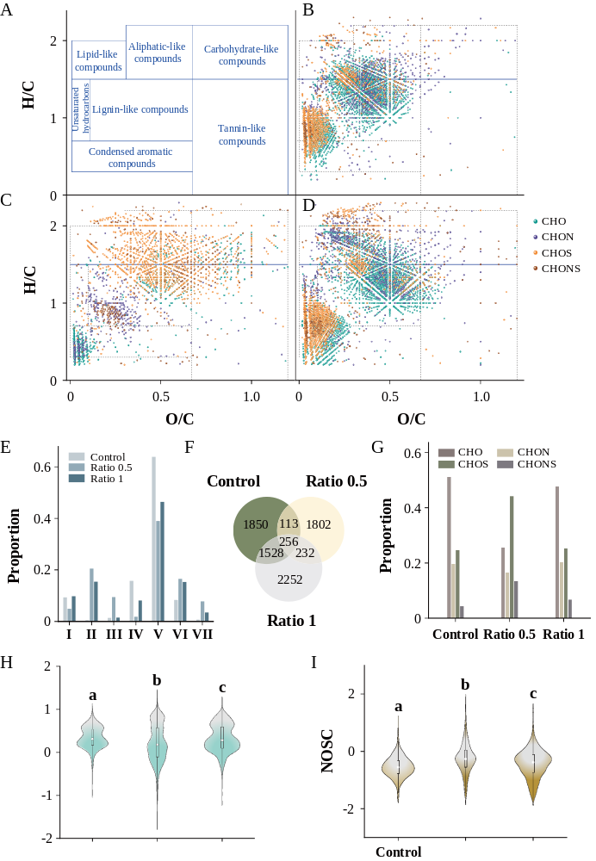
Figure 1. Molecular–level DOM compositional patterns of the influents. (A) Regions of van Krevelen diagram based on ratios of O/C and H/C. (B)–(D) Van Krevelen diagrams of influent DOM in the control, ratio 0.5, and ratio 1 membrane filtration systems, respectively. (E) Regional proportion of the DOM molecules. (F) Venn diagram of the molecular DOM formulae shared in the different samples. (G) Proportion of CHO, CHON, CHOS, and CHONS molecules in control, ratio 0.5, and ratio 1 influents. (H) and (I) represent the distribution of AI and NOSC values for molecular formulae of the influent DOM, respectively. Significant differences were investigated using the Kruskal–Wallis test. The marks a, b, and c in bold indicate statistical significance at P<0.05.

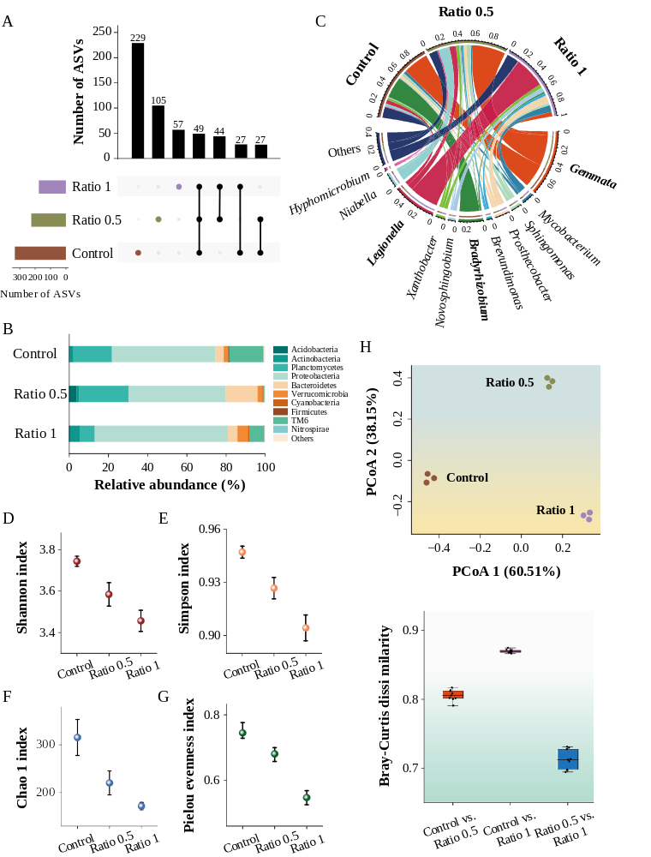
Figure 2. Compositional and diversity patterns of biofilm microbial consortium. (A) Upset plot of the average number of bacterial ASVs shared in the control, ratio 0.5, and ratio 1 biofilms. (B) and (C) show the average relative abundance of bacterial taxa at phylum and genus levels, respectively. (D)–(G) demonstrate Shannon, Simpson, Chao 1, and Pielou evenness indexes of the biofilm microbial consortium, respectively. (H) The PCoA plot of the biofilm bacterial communities based on the Bray–Curtis distance matrix. (I) Bray–Curtis dissimilarity of bacterial community across different biofilms. Significant differences were investigated using the Kruskal–Wallis test. The marks a, b, and c in bold indicate statistical significance at P<0.05.

Figure 3. Morphological and chemical structure of biofilms. (A) and (B) are SEM images of biofilms captured in cross–section and top surface, respectively. (C) and (D) represent XPS spectra of the biofilms based on elements C and O, respectively.

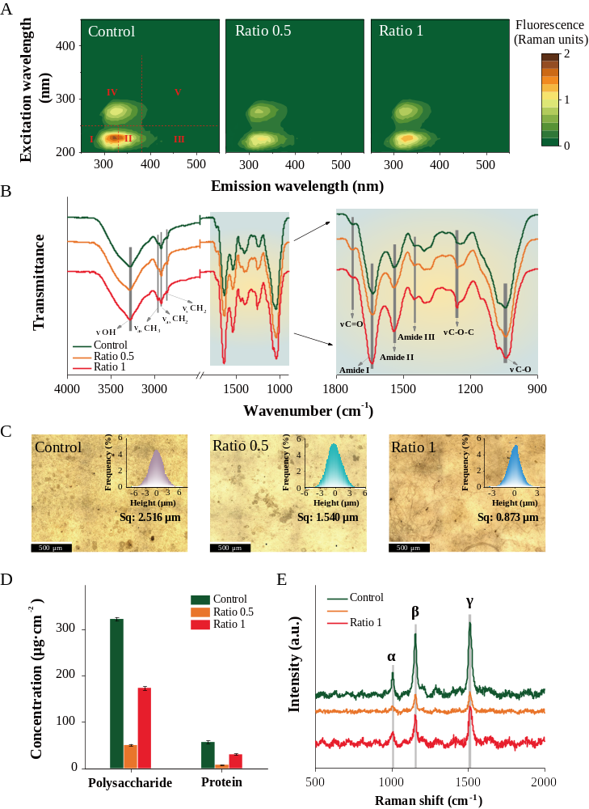
Figure 4. Physicochemical properties of the biofilm matrix. (A) Representative fluorescence spectra of the DOM extracted in the biofilm matrix with phosphate buffer solution. (B) Representative FTIR spectra. (C) Representative optical micrographs and the corresponding surface roughness. (D) Concentrations of polysaccharide and protein. (E) Representative Raman spectra. Significant differences were assessed by the Kruskal–Wallis test and * represents P<0.05.
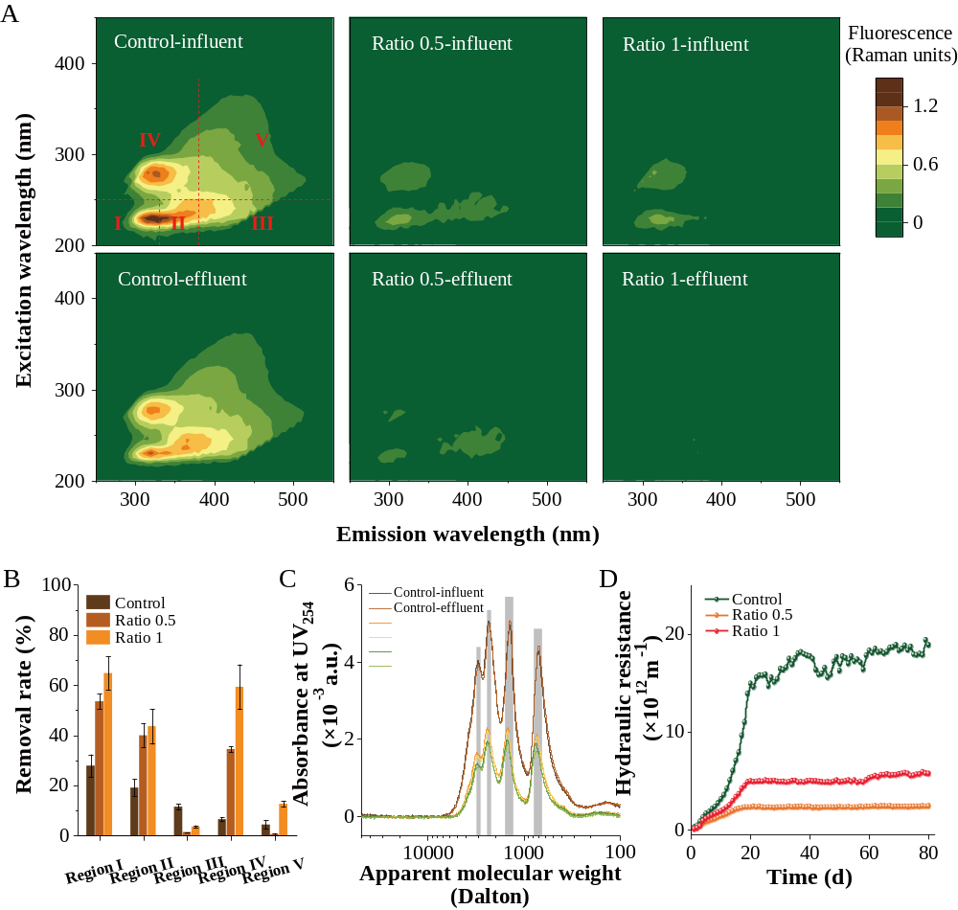
Figure 5. Filtration performance of membrane systems. (A) Representative fluorescence spectra of DOM in the influents and effluents of membrane filtration systems. (B) Regional removal rate of fluorescence intensity by the membrane filtration systems. (C) Apparent molecular weight distribution profile of the DOM in the influents and effluents. (D) Hydraulic resistance of the membrane system in the course of filtration.

