Supplementary Materials and Methods

Animals. Male 8 week old C57BL/6 (n=22) mice were obtained from Harlan (Bicester, UK) and housed in groups for at least 1 week before the start of the experiments. Animals weighed on average 27.2g ±1.4g at the beginning of the study and were given food and water ad libitum. They were kept at room temperature on a 12h light: 12h dark cycle. All experiments were approved by the Academic Medical Center Animal Ethics Committee (DNL 102705) and complied with Dutch national guidelines for the care of experimental animals.

Haemolytic assays. Alternative pathway: Guinea pig erythrocytes (GPE) were washed into AP buffer (5mM Sodium barbitone, 150 mM NaCl, , 10 mM ethylene glycol-bis-(β-aminoethyl ether) N,N,N′,N′-tetraacetic acid (EGTA), 7mM MgCl₂, pH 7.4) and diluted to 2% (v/v). To establish the amount of serum needed to cause 90% lysis, rat serum was diluted in 2-fold serial dilution, beginning at 1 in 2. Diluted serum (50 μl) was incubated with 50 μl GPE and 100μl AP buffer in a 96-well plate. Control wells containing either 50 μl of 0.01% (v/v) Triton or AP buffer instead of serum were included to obtain 100% and 0% lysis respectively. The plate was incubated at 37°C for one hour. The absorbance at 415nm was measured and percentage of lysis was calculated by standard methods (39). To assess CD59a activity, increasing doses of CD59-2a-CRIg (6.25-100μg/ml) in presence or absence of mouse anti-mouse CD59a monoclonal antibody (mCD59.3 or clone 7A6, 300 μg/ml) (40) were incubated with GPE. Rat serum at a concentration that caused 90% lysis in absence of inhibition was added. The assay was performed in a total volume of 200 μl. The percentage of lysis was determined.
Terminal pathway: To compare the ability of CD59-CRIg and CRIg-CD59 to inhibit terminal pathway, GPE were washed and resuspended in Complement Fixation Diluent (CFD; Oxoid) at 2% (v/v). Cells were incubated with 15µg of purified C5b-6 complex for 5 minutes at 37°C, followed by 10µg C7 (added without washing) for 15 min at 37°C. The GPE-C5b-7 were washed and resuspended in 10 mM EDTA/PBS (terminal pathway buffer). The amount of mouse C3 deficient serum that resulted in 60-70% lysis was determined by incubating 50µl of GPE-C5b-7 with 50µl dilutions of mouse serum and 40µl terminal pathway buffer for 30 minutes at 37°C. 40 µl of ncreasing doses of CRIg-CD59 and CD59-CRIg (0.39-100 μg/m) were incubated with GPE-C5b-7 (50µl) for 10 minutes at room temperature. The predetermined concentration of mouse C3 deficient serum (50µl) was then added to the wells and incubated for 20 minutes at 37°C. The percentage of lysis was determined.
To assess the ability of CD59-2a-CRIg to target C3b deposition and then block terminal pathway, GPE were washed and resuspended in CFD at 4% (v/v). C8 depleted human serum (generated in-house by immunoaffinity chromatography), was diluted in CFD to prepare serial dilutions. GPE (50µl) were incubated with 50µl diluted serum. The plate was incubated for 30 minutes at 37°C. The serum concentration causing 15% lysis was used to generate GPE-C3b/C5b-7. Cells were washed and resuspended at 2% in terminal pathway buffer. GPE-C3b/C5b-7 (50 µl) were incubated with 50 µl of increasing doses of CD59-2a-CRIg (1.66-106.5 μg/ml final concentration) for 30 minutes at 37°C. The cells were washed with terminal pathway buffer. Predetermined concentration of mouse C3 deficient serum that caused 60-70 % lysis (50µl) and of terminal pathway buffer (50µl) were added to the wells and incubated for 30 minutes at 37ºC. The percentage of lysis was determined.

Gel filtration chromatography. CD59-2a-CRIg monomer and dimer were separated by size exclusion on a Superdex 200 (GE Healthcare) column equilibrated in Phosphate-buffered saline (PBS) using an Akta Purifier system (GE Healthcare). To measure the relative amounts of monomer to dimer, peak integration was performed and peak area was measured. Fractions were analysed by SDS-PAGE and protein was visualised by silver staining. Fractions containing monomer or dimer were pooled and analysed by Western blot analysis.

SDS-PAGE and Western blot analysis. The proteins were separated on a 7.5% gel under non-reducing or reducing conditions. For SDS-PAGE, proteins were visualised by silver staining or Coomassie blue. For western blotting, proteins were transferred onto a nitrocellulose membrane. Membranes were blocked in 5% w/v non-fat dry milk/PBS. The same buffer was used for diluting the detection and secondary antibodies. CD59-2a-CRIg monomer and dimer were detected with rat anti-mouse CRIg monoclonal antibody (MBI4, generated in house) and anti-rat Ig HRPO (Jackson ImmunoResearch Laboratories, US). The blot was developed using ECLTM Western Blotting Detection Reagents (GE Healthcare).

Surface Plasmon Resonance. CD59-2a-CRIg binding to C3b was assessed using Biacore ® T100 instrument (GE Healthcare). To generate C3b-coated surface, a small nidus of human C3b (aproximately 50 RU) was amine coupled on flow cell 2 of CM5 sensor chip (BIAcore) using 1-ethyl-3(3-dimethyl aminopropyl) carbodiimide/N-hydroxy-succinimide as instructed by the manufacturers (NHS/EDC coupling kit; BIAcore). The immobilization was performed at 3.3 μg/ml in acetate buffer, pH 4.5. Flow cell 1 was similarly activated and blocked but left uncoated with protein as a reference cell. An alternative pathway convertase (C3bBb) was formed by flowing a mixture of human factor B and factor D (CompTech, Inc) over the chip surfaces at 200 μg/ml and 5 μg/ml respectively for 120 seconds at flow rate of 10 μl/min in biacore running buffer (10 mM HEPES, 150 mM NaCl, 0.005% (v/v) Surfactant P20, pH7.4 supplemented with 1 mM MgCl₂). Mouse C3 (isolated from plasma (41)) at a concentration of 400 μg/ml was immediately injected for 120 seconds at flow rate of 5μl/min and cleavage to nascent C3b resulted in covalent deposition on the chip surface. Repeated cycles of fB/fD and mouse C3 resulted in deposition of approximately 700 RU of mouse C3b. Convertase and non-covalently bound C3b were removed by a 30 second injection of 0.1M acetate buffer containing 1M NaCl, pH4.0. To measure binding affinity of CD59-2a-CRIg monomer and dimer for immobilized mouse C3b, two-fold dilution series of the fusion proteins were prepared in biacore running buffer and injected sequentially and in duplicate (monomer) or triplicate (dimer) over the C3b (120s) at a flow rate of 20μl/min; proteins were allowed to dissociate for 180s. Data were collected at 25 °C. The surface was regenerated between binding cycles by a 30s injection of 0.1M acetate buffer containing 1M NaCl, pH4.0. Data from a reference cell was subtracted to control for bulk refractive index changes. The equilibrium dissociation constant for fusion proteins was determined using steady-state analysis.

Neurologic Severity Score and weight. To evaluate neurologic impairment, all mice were scored on a 10-item rating performance, which tests the function of the cortex, the midbrain and the cerebellum, including motor function, balance, alertness and physiological behavior. Briefly, mice were tested for: 1. The ability and initiative to exit a circle of 30 cm diameter within 3 min; 2. Paresis of upper and/or lower limb of the contralateral side; 3. Alertness, initiative and motor ability to walk straight; 4. Innate reflex; the mouse will bounce in response to a loud hand clap; 5. Physiological behavior as a sign of 'interest' in the environment; 6. Ability to balance on a beam of 7 mm width for at least 10 s; 7. Ability to balance on a round stick of 5 mm diameter for at least 10 s; 8. Ability to cross a 30-cm long beam of 2 cm width; 9. Ability to cross a 30-cm long beam of 7 mm width; 10. Ability to cross a 30-cm long beam of 5 mm width. Each task is scored 0 for success or 1 for failure. The sum of the scores from the 10 tasks is the neurological severity score (NSS) (42). NSS was assessed at 1, 4, 24, 48 and 72 hours post-TBI. In addition, all mice were weighed immediately before trauma and every day afterwards.

Treatment with CD59-2a-CRIg. In a first experiment we studied whether CD59-2a-CRIg localized to sites of complement activation and its effect on MAC deposition in vivo. For this experiment, mice were treated with a bolus intravenous (i.v.) injection of CD59-2a-CRIg at a dose of either 10mg/kg (n=3) or 20mg/kg (n=2) or equal volume of phosphate-buffer saline (PBS) (n=3) immediately after the TBI. In a second experiment we studied the effects of CD59-2a-CRIg treatment on the neurological disability, inflammation and neuronal damage in TBI. For this second experiment, mice were treated with a bolus i.v. injection of CD59-2a-CRIg at a dose of 20mg/kg (n=6) at 30 minutes post-TBI followed by a second administration of the agent 24 hours later. Placebo control mice (n=5) were injected with an equal volume of PBS. Sham-operated mice (n=3), which underwent the same surgical procedure, anesthesia and analgesia but did not receive TBI, were used as additional controls.

Tissue processing. At 72 hours post-TBI, mice were deeply anesthetized with isoflurane (2.5 v/l isoflurane and 1.0 v/l O2). In the first experiment, mice were intracardially perfused with PBS. Brains were dissected out, snap-frozen in liquid nitrogen and stored at -80°C until they were used for the immunohistochemical localization of the CD59-2a-CRIg molecule. In the second experiment, mice were intracardially perfused with PBS followed by formalin. Brains were dissected out, placed in formalin for standard processing into paraffin and further used for immunohistochemical studies of pathology.

Immunohistochemistry. Left and right brain hemispheres were either embedded in tissue-tek (snap-frozen tissue) or into paraffin blocks (formalin-fixed tissue). For the snap-frozen tissue, sagittal sections of 6µm thickness were cut using a cryostat and mounted on Superfrost Plus glass slides (Knittel Glass, Germany). Sections were post-fixed in formalin for 15 minutes at RT and subsequently incubated with 10% normal goat serum (DAKO, Glostrup, Denmark) in PBS to block nonspecific binding sites. Sections were then incubated for 1 hour at RT with the primary antibody (see Table S1) diluted in Normal Antibody Diluent (Immunologic, Duiven, the Netherlands). Primary antibodies were detected with FITC-conjugated goat anti-rabbit IgG (Sigma-Aldrich, Saint Louis, MI, USA). Sections were air dried and mounted in Vectashield (Vector Laboratories). Images were captured digitally with a fluorescence microscope (DM LB2; Leica Microsystems, Rijswijk, the Netherlands).
For the formalin-fixed tissue, sagittal sections of 6µm thickness were cut using a microtome, stretched in a 40˚C water bath and mounted on glass slides. Sections were deparaffinated in a standard series of xylene and alcohol. Endogenous peroxidase was blocked with 0.3% H₂O₂ in methanol for 20 minutes at RT. Antigen retrieval was performed in the relevant buffer (see table 1) by microwave for 3 minutes at 900W followed by 10 minutes at 90W. After cooling, sections were incubated with 10% normal goat serum (DAKO) in PBS to block nonspecific binding sites. Sections were then incubated with the primary antibody (see table 1) for 1 hour at RT or o/n at 4˚C. Detection was performed by incubating the sections in the secondary Poly-HRP-Goat anti Mouse/Rabbit/Rat IgG (Immunologic, Duiven, the Netherlands) antibodies diluted 1:1 in PBS for 30 minutes at room temperature followed by incubation in 3,3- diaminobenzidine tetrahydrochloride (DAB; Vector Laboratories, Burlingame, CA, USA) as chromogen and counterstaining with hematoxylin (Histolab, Gothenburg, Sweden) for 5 minutes. Sections stained with the same protocol omitting the primary antibody were included as negative controls with each test (not shown). After dehydration, slides were mounted in Pertex (Histolab).

In situ hybridization. Seven micron paraffin sections of mouse brain were mounted on Superfrost Plus glass slides (Knittel Glass). In situ hybridization for IL-1β mRNA was performed using 5′ FAM-labeled 19 mer antisense oligonucleotide containing LNA and 2′OME RNA moieties (FAM –TugAcuTcuAucTugTugA; Ribotask, Odense, Denmark). The probe was detected using anti-fluorescein-Fab fragments coupled to HRP (1:1000; Roche, Germany) and signal visualized using the VECTOR red HRP substrate kit (Vector Laboratories). For double-staining of Iba-1 protein and IL-1β mRNA, immunohistochemistry was performed first and signal visualised with the VECTOR blue AP substrate kit (Vector Laboratories).

Quantification of immunohistochemistry. Images (3-10 per mouse) of immunostainings for C9/MAC, Iba-1, mtHSP70 and APP covering the impact area of the cortex (ctx), the hippocampus (hc), and periventricular (pv) area of mouse brain sections were captured at 20x magnification with a light microscope (Olympus BX41TF, Zoeterwoude, the Netherlands) using the Cell D software (Olympus, Zoeterwoude, the Netherlands). The percentage of staining per unit area was quantified using the “measurement”, “count size” and “per area/total” functions of the Image Pro Plus 7.0 imaging software (MediaCybernetics, Rockville, MD, USA).

Table S1. Primary antibodies, concentration and source.
Antigen | Clone | Concentration/  Dilution | Source
CD59a | 7A6 | 300μg/ml | Made in house  (BPM and CLH, Cardiff, UK)
Complement receptor of the Ig superfamily (CRIg)ª | MBI4 | 3μg/ml | Made in house  (CLH, Cardiff, UK)
C3/C3b/iC3b/C3dgª | 9H11 | 1.5μg/ml | Hycult (NL)
C9/MAC^{b} | Polyclonal | 1:200 | Made in house  (BPM, Cardiff, UK)
Iba-1^{b} | Polyclonal | 2μg/ml | Wako (CH)
Mitochondrial heat shock protein 70 (mtHSP70) ª | 30A5 | 1:50 | Invitrogen (NL)
Amyloid precursor protein (APP)ª | 22C11 | 0.3μg/ml | Millipore (USA)
Antigen retrieval was performed by heating in 10mM Sodium Citrate (pH 6.5)ª or 10mM Tris/1mM EDTA (pH 9)^{b} buffer.

Supplementary Figure legends

Fig. S1 Targeting and terminal pathway regulatory function of CD59-2a-CRIg. (A) Guinea pig erythrocytes with C3b and C5b-7 on their surface were incubated with intact CD59-2a-CRIg to allow binding C3b-coated cells. Unbound protein was washed and lysis was developed with C3 deficient mouse serum. CD59-2a-CRIg was able to provide cell protection. (B) C5b-7 sites were preformed on guinea pig erythrocytes by adding purified C5b-6 and C7 proteins. The cells were attacked with C3 deficient mouse serum. The ability of N-terminal (closed circle) and C-terminal CD59 (open circle) within CD59-CRIg and CRIg-CD59 respectively, to inhibit MAC formation was assessed. CD59 located at the N-terminus of the protein was more effective complement inhibitor compared to the C-terminal CD59.

Fig. S2 CD59-2a-CRIg reduced MAC deposition, inflammation and neuronal damage in the hippocampus at 3 days post-TBI. (A-L) Representative images of immunostaining for C9/MAC (A-C), Iba-1 marker of microglia/macrophages (D-F), mitochondrial heat shock protein 70 (mtHSP70) marker of mitochondrial stress (G-I) and amyloid precursor protein (APP) marker of acute axonal injury (J-L) in the hippocampus of uninjured mice (A, D, G, J; n=3) or injured mice treated with either PBS (B, E, H, K; n=5) or CD59-2a-CRIg (C, F, I, L; 20mg/kg i.v.; n=6) at 30 min post-TBI and 24 h later. Note in the PBS-treated group the intense immunoreactivity for C9/MAC and Iba-1 in the white matter adjacent to the hippocampus (arrows in B and E, respectively). Also note the localization of C9/MAC, mtHSP70 and APP immunoreactivity in neurons, especially evident in the Cornus Ammonis (CA) 1 region of the hippocampus (zoom B, zoom H and zoom K, respectively). Scale bars in A-L, 100μm; in insets, 50μm. The intensity of the immunoreactivity of all staining is reduced in the CD59-2a-CRIg–treated group compared to PBS–treated controls.

Fig. S3 CD59-2a-CRIg reduced MAC deposition, inflammation and neuronal damage in the periventricular area at 3 days post-TBI. (A-L) Representative images of immunostaining for C9/MAC (A-C), Iba-1 marker of microglia/macrophages (D-F), mitochondrial heat shock protein 70 (mtHSP70) marker of mitochondrial stress (G-I) and the amyloid precursor protein (APP) marker of acute axonal injury (J-L) in the periventricular area of uninjured mice (A, D, G, J; n=3) or injured mice treated with either PBS (B, E, H, K; n=5) or CD59-2a-CRIg (C, F, I, L; 20mg/kg i.v.; n=6) at 30 min post-TBI and 24 h later. Note in the PBS-treated group the intense immunoreactivity for C9/MAC and Iba-1 and the localization of the mtHSP70 and the APP immunoreactivity in neuronal cell bodies (arrows in zoom H and zoom K, respectively). The intensity of the immunoreactivity of all staining is reduced in the CD59-2a-CRIg–treated group compared to PBS–treated controls. V in A-L indicates the ventricle. Scale bars in A-L, 100μm; in insets, 50μm.

Figure S1

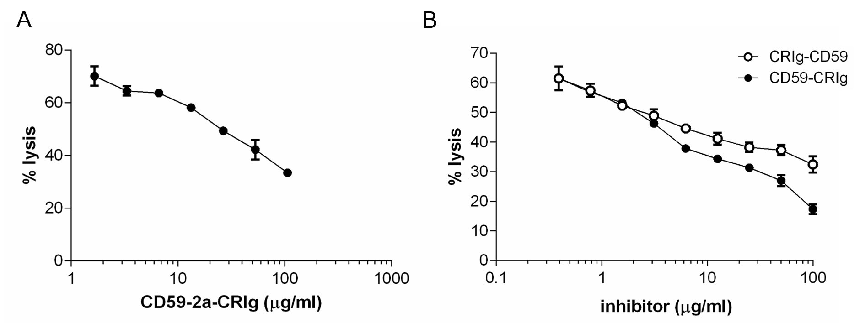

Figure S2

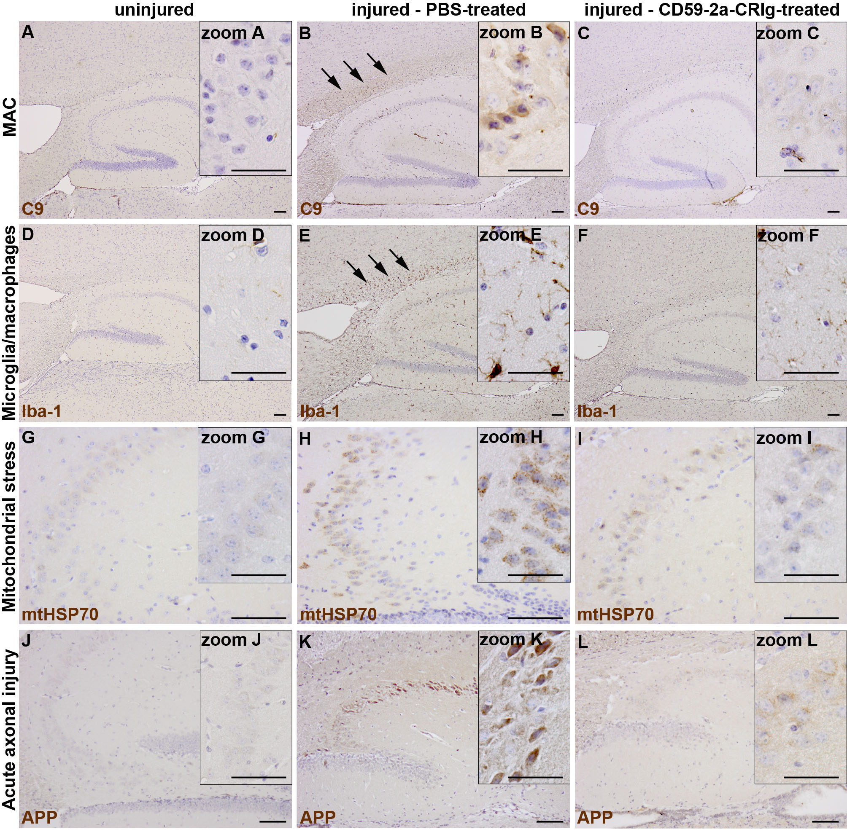

Figure S3

