Controllable heteroatom doping effects of Cr_{x}Co_{2-x}P Nanoparticles: A Robust Electrocatalyst for Overall Water Splitting in Alkaline Solutions
Jun Wuª, Peng Li^{b}, Andres Parra-Puertoª, Shuang Wu^{c}, Xiaoqian Linª, Denis Kramer^{d}, Shengli Chen^{b}, Anthony Kucernakª*
ªImperial College London, Department of Chemistry, London, SW7 2AZ, UK
^{b}Wuhan University, College of Chemistry and Molecular Sciences, Wuhan, Hubei 430072, People’s Republic of China
^{c}SINOPEC Shanghai Research Institute of Petrochemical Technology, Shanghai 201208, People’s Republic of China
^{d}University of Southampton, Faculty of Engineer Physical Sciences, Southampton, SO17 1BJ, UK
Abstract
The effect of doping Cr on the electrocatalytic activity of Co₂P supported on carbon black (Cr_{x}Co_{2-x}P/CB) for the hydrogen evolution reaction (HER) and oxygen evolution reaction (OER) in alkaline solution was investigated. A beneficial improvement in the performance of Co₂P towards HER and OER was discovered. For the HER at -200 mV overpotential the turnover frequency (TOF) increases almost six-fold from 0.26 to 1.52 electrons site_{Co}⁻¹ s⁻¹ when Co₂P/CB has a small amount of Cr added to form Cr_{0.2}Co_{1.8}P/CB. Similarly, we estimate an increase from 0.205 to 0.585 electrons site_{Co}⁻¹ s⁻¹ for the OER at 1.6V for the same change in composition. With 10at% Cr doping, the Cr_{0.2}Co_{1.8}P/CB catalyst needed 226 mV overpotential to produce a cathodic current density of -100 $A g_{Co}^{-1}$$A g_{metal}^{-1}$ and 380 mV overpotential to produce an anodic current density of 100 $A g_{Co}^{-1}$$A g_{metal}^{-1}$. Based on both experimental results and theoretical calculations, the activity improvement results from optimization of electronic properties of Co₂P after Cr doping.
Key words: Electrocatalysis, Heteroatom doping, Water splitting, Cobalt phosphide, Nanomaterials
Introduction
The development of alternative energy resources is a top priority for society. ¹ Hydrogen has been regarded as an ideal energy resource due to its high gravimetric energy density and green combustion product (i.e., water). However, the main way to obtain H₂, currently, is through steam reforming of methane, which relies heavily on fossil fuels and generates large amounts of CO₂. ² Water electrolysis, composed of the hydrogen evolution reaction (HER) on the cathode and the oxygen evolution reaction (OER) on the anode, is one of the most promising and renewable ways of H₂ production due to its advantage of carbon-free emissions provided the electricity used comes from a green source such as hydroelectricity, wind, solar and geothermal. ³ The HER process in alkaline solution is usually considered to involve initially a water dissociation step and then the hydrogen intermediates are formed in the Volmer step (H₂O + e⁻ + M ⇌ M-H_{ad} + OH⁻), followed by either the Tafel step (2 M-H_{ad} ⇌ H₂ + 2M) or the Heyrovsky step (H₂O + M-H_{ad} + e⁻ ⇌ M +H₂ + OH⁻). The only difference to the reaction pathway in acid is that the hydrogen intermediates are formed by the discharge of hydronium ions instead of water.⁴ The OER process, with more reaction intermediates, such as *OH and *OOH, is kinetically more complex than the HER.⁵ The most active electrocatalysts for the hydrogen evolution reaction (HER) and oxygen evolution reaction (OER) so far are still the platinum group metals. However, their low abundances on earth and high costs may limit their large-scale application.
Recently, transition metal phosphides (TMPs) have been reported to have very good HER activities in acid solutions. ^{5–10} The successful incorporation of phosphorus can significantly increase the corrosion resistance of metal phosphides compared to pure metals. Besides, the charge transfer between transition metals and phosphorus could also generate more favorable active sites for the adsorption of reaction intermediates.^{11,12} However, the electrochemical performance of most transition metal phosphides is still limited by the fact that firstly, although these materials are good catalysts for the adsorption of the H intermediates, they are generally inefficient in the initial water discharge step to form reaction intermediates in alkaline solutions.¹³ Secondly, the hydrogen binding strength on these transition metal phosphides catalysts is still too strong, which will hinder the desorption step of H intermediates and thus make the overall HER kinetics more sluggish.^{12,14,15} Different approaches have been applied to further improve the performance of the overall water splitting reaction and also the stability of the transition metal phosphide catalysts in alkaline solutions. One of these strategies is to find a suitable dopant to not only promote the initial water discharge step to generate the reaction intermediates but also to optimize the electronic structures of electrocatalysts to obtain optimum reaction intermediate adsorption. ^{3,16–18}
Among the transition metal phosphides, cobalt-based phosphides (Co_{x}P) have attracted a great deal of attention as promising candidates for both HER and OER catalysts.^{9,19,20} However, in many Co_{x}P fabrication methods, toxic organic solvents are utilized along with sophisticated phosphorization methods.^{21–23} Thus based on our groups previous work, ²⁴ Co₂P was selected and prepared with a facile carbothermal hydrogen reduction method as a model to evaluate its performance for the overall water splitting in alkaline solutions. The carbothermal hydrogen reduction process involves using a transition metal phosphate precursor dispersed on a carbon support and heated in hydrogen. Both the carbon and hydrogen act as reductants to produce the metal phosphide following a process whose stoichiometry follows
$$z{MO}_{x} + {PO}_{y} + {δ\left(zx+y\right)}/2 C + (1-δ)\left(zx+y\right)H_{2}→ M_{z}P + {δ\left(zx+y\right)}/2{CO}_{2}+ (1-δ)\left(zx+y\right)H_{2}O$$
where M represents the transition metal, and $δ$ represents the ratio of direct carbo-reduction ($δ$=1) to hydrogen reduction ($δ$=0). In addition, Chromium, with a low electron negativity (1.66 vs 1.88 of Co) and stable high valent state, was selected as a suitable dopant to modulate both the HER and OER activity of Co₂P. The great difference in the electronegativities between Cr and Co leads to more polarized electron distribution and stronger electron interactions. Therefore, the d-band center of surface Co would be lowered and the H chemisorption strength would be weakened.^{25,26} Besides, the high valent Cr dopant will also serve as active sites on Co₂P surface for water molecular adsorption and thus promote the initial water discharge step to generate H intermediates. Furthermore, in order to improve the electrical conductivity of the material and minimize Co usage, commercial carbon black powder was used as the catalyst support. Another advantage of using carbon support material is that the carbon acts as a reducing agent during pyrolysis in concert with the reducing atmosphere, in the synthesis of metal phosphides as described above. A series of cobalt-based phosphides on carbon black support with different amount of Cr doping were prepared. The Cr doped Co₂P on carbon black support (denoted as Cr-Co₂P/CB) catalyst showed excellent activity towards the HER and the OER in alkaline solutions. On top of this, the Cr-Co₂P/CB also showed good stability with almost no degradation after the 1000th continuous CV scanning in 0.1 M KOH.
Experimental Section
Synthesis of Cr-Co₂P/CB hybrid catalysts.
The supported transition metal phosphide catalysts were prepared by the so-called carbothermal hydrogen route. Typically, a known amount of metal nitrate, 3.768 mmol of Co(NO₃)₂ ·6H₂O (Sigma-Aldrich.Co) and 66.66 mmol of carbon black powder (Vulcan XC72R, Cabot) were dissolved in 2 mL of ultrapure water (Millipore MilliQ 18.2 MΩcm) and sonicated for 2.5 h. For the phosphorus precursor, 1.884 mmol of (NH₄)₂HPO₄(Sigma-Aldrich.Co) was then dissolved in 4 mL of ultrapure water and added to the metal precursor to form metal phosphate (M_{x}(PO₄)_{y}) on carbon black. After another 1.5 h of sonication, a well-dispersed M_{x}(PO₄)_{y} precursor on carbon black was obtained. Then the sample was dried in an oven at 120 °C overnight, and the formed powder was grounded in a mortar and pyrolysed in 5%vol. H₂/N₂ at a temperature of 1000 °C for 3 hours in a tube furnace under a heating ramp of 5 ºC min⁻¹ to obtain 40 wt. % Co₂P on carbon black. The procedures for synthesis of 40 wt.% of Cr_{0.2}Co_{1.8}P, Cr_{0.4}Co_{1.6}P and Cr_{0.6}Co_{1.4}P on carbon black were the same as for Co₂P but in the metal precursor solution CrNO₃·6H₂O (Sigma-Aldrich.Co) with appropriate ratio was added. Moreover, uncatatalyzed carbon black was pyrolyzed under the same condition to obtain the graphitized carbon and then tested as a baseline material.
Catalysts characterization
X-ray diffraction (XRD) was performed on a Bruker AXS D2 Phaser Desktop X-ray Diffractometer. Conventional Transmission Electron Microscope (JEOL 2100-Plus) equipped with energy dispersive X-ray (EDX) was used for TEM and STEM analysis. HR-TEM analysis was performed on a FEI Titan KriosTM G3. X-ray photoelectron spectroscopy (XPS) was performed on a Thermo Scientific K-Alpha X-ray Photoelectron Spectrometer system (Al K α, 1486.6 eV). ICP-AES was performed on an IRIS Intrepid II XSP (Thermo Electron Corporation, USA).
Three-electrode cell set up
The electrochemical measurements were tested using a three-electrode glass cell. To avoid the non-negligible glass corrosion and building up silicates in high-concentration alkaline solution,²⁷ 0.1 M KOH rather than 1M KOH was chosen as the alkaline electrolyte. The catalyst coated glassy carbon electrode (GCE), reversible hydrogen electrode (RHE), and glassy carbon rod were used as the working, reference, and counter electrodes, respectively. Exceptional care was taken to avoid contamination of the electrolyte with any platinum group metals as this can lead to spurious results. We made sure that no platinum group metals were used in the counter electrode, and tested the electrolyte using x-ray fluorescence to establish the absence of materials which might aid the electrocatalytic performance of our electrocatalyst. A potentiostat (Autolab model PGSTAT302N) was used to control the potential and measure the current. The electrolyte was saturated with ultrapure N₂ (Air products, BIP-plus 99.9999%) for at least 30mins before testing. All potentials were measured against the reversible hydrogen electrode (RHE) as reference electrode.
Catalyst ink and working electrode preparation.
Typically, a known amount of catalyst powder was well dissolved in an ultrapure water and 2-Propanol (IPA) (Sigma-Aldrich.Co) mixture solution (volume ratio = 1:1). Then 5% wt. of Nafion solution (Sigma-Aldrich Co) follow the weight ratio of 0.034 (Nafion to carbon black powder) was added as binder. The mixture was ultrasonicated for 1h to form a uniform ink solution. Then 10 μL of the above solution was drop cast onto a 5 mm diameter glassy carbon rotating disk electrode (Pine instruments, model AFE2M050GC and rotator model AFMSRCE) to make a final loading of the hybrid catalysts of 0.1mg cm⁻² and dried thoroughly to obtain the working electrode. RDE experiments were performed using a PINE Instruments RDE system. HER and OER tests were carried out in the N₂-saturated 0.1M KOH. The tests were conducted at a scan rate of 20 mV s⁻¹ and rotation of 1600 rpm at room temperature.
Results and Discussion
The Co₂P and Cr-doped Co₂P on carbon black support (denoted as Cr-Co₂P/CB) were prepared via a carbothermal hydrogen reduction method as described in the experimental section. The XRD patterns of the Co₂P/CB and Cr-doped Co₂P/CB catalysts are presented in Figure 1(a). For both the Co₂P/CB and Cr_{x}Co_{2-x}P/CB (x=0,0.2,0.4,0.6) catalysts, the peaks located at 40.7°, 43.2°, 50.0° can be assigned to the (121), (211), (002) crystal planes of Co₂P (PDF#00-032-0306), respectively.
It is worth noting that no chromium phosphides characteristic peaks were observed in the XRD patterns, but the Cr doping does cause a linear positive peak shift in the XRD characteristic peak of the Cr-doped Co₂P/CB compared to Co₂P/CB due to the replacement of Co atoms by larger Cr atoms. From the TEM images (Figure S1) of the Cr_{0.2}Co_{1.8}P/CB catalysts, the average particle size was determined (30 particles analyzed) to be 35 nm. High resolution TEM Figure 1(b) and high-angle annular dark-field scanning transmission electron microscopy (HAADF-STEM) Figure 1(c) further confirm the crystal structure of Cr_{0.2}Co_{1.8}P nanoparticles. The lattice spacing (0.223nm) of Co₂P (121) crystal planes in Cr_{0.2}Co_{1.8}P is slightly larger than that of undoped Co₂P (0.221 nm), indicating that Cr doping promotes the expansion of the (121) crystal plane. High-angle annular dark-field-energy-dispersive spectroscopy (HAADF-EDS) line scans (Figure 1 (d)) and mapping (Figure 1(e)) were used to characterize the element composition and distribution of Cr_{0.2}Co_{1.8}P. Cr was observed to be distributed homogeneously across the Co₂P nanoparticles, further confirming that the Cr atoms were successfully incorporated into Co₂P.
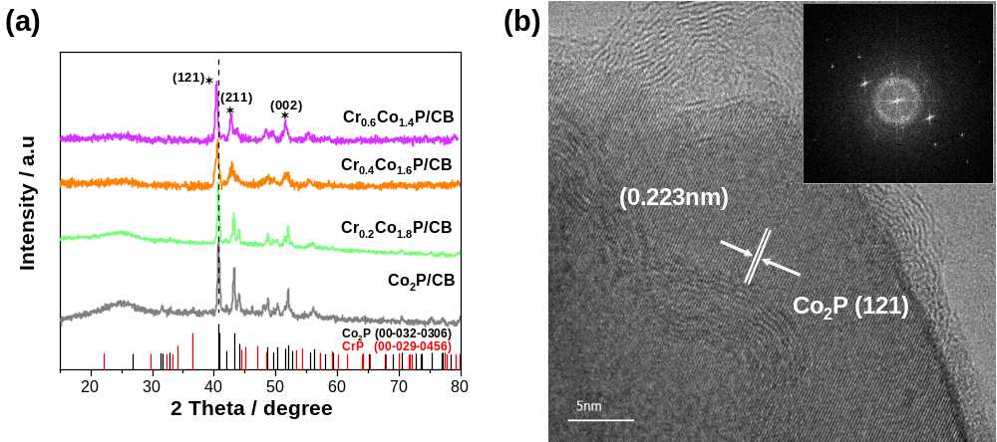
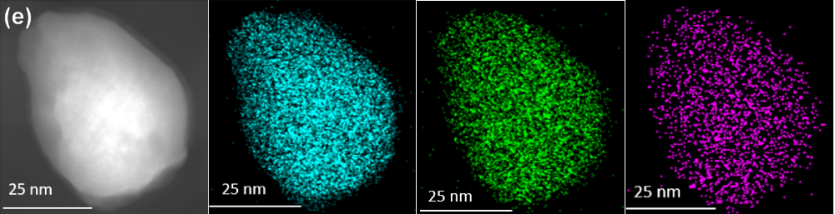

Figure 1. (a) XRD patterns of Cr_{x}Co_{2-x}P/CB (x=0,0.2,0.4,0.6) catalysts. (b) HRTEM images and (c) HAADF-STEM of Cr_{0.2}Co_{1.8}P/CB, inset is the crystal model on the [001] zone axis of Co₂P. (d) STEM-EDS line scan of Cr_{0.2}Co_{1.8}P/CB (e) STEM-EDS mapping of Cr_{0.2}Co_{1.8}P/CB. Cyan: Co, Green: P, Purple: Cr.

Besides, the K edge relative intensity indicated a content ratio of Co to Cr of nearly 8.5:1.5, which is close to the metal ratio added during synthesis. Inductively coupled plasma atomic emission spectrometry (ICP-AES) further confirmed an atomic ratio of 0.182 :1.8 for Cr : Co in Cr_{0.2}Co_{1.8}P.
The elemental compositions and electronic properties of the Co₂P and Cr-doped Co₂P on carbon black support were further characterized by XPS. The XPS survey spectrum for both the Co₂P/CB and Cr-doped Co₂P catalysts can be observed in Figure S2, which showed strong peaks for C, O, Co, P, Cr and their atom ratios in the whole hybrid materials. It was worth noting that the ratio of Co to Cr was larger than expected from the stoichiometry of the survey spectrum, indicating surface segregation of Co. Figure 2(a) showed the C 1s region, the peak at 284.5 eV can be related to the hybridized sp2 carbon atoms, which were also used as calibration for further XPS analysis for other elements.
As shown in Figure 2(b), the peaks located at the binding energy (BE) of 778.6 and 793.5eV represented the Co 2p_{3/2} and Co 2p_{1/2} of Co species in Co₂P, respectively.¹² Two typical peaks at 781.7 and 797.7 eV resulted from oxidized Co²⁺ species due to air contact, which also possessed two apparent satellite peaks at 785.3 and 802.9 eV. As shown in Figure 2(c), the P 2p BEs of 129.6 and 130.6 eV were assigned to P 2p_{3/2} and P 2p_{1/2} in Co₂P, respectively, and the peak at 133.3 eV can be attributed to the oxidized P species.²⁸ It should be noted that the binding energy of Co 2p has a positive shift compared to metallic Co (777.9 eV), while P 2p is negatively shifted compared to elemental P (130.2 eV), suggesting charge transfer from Co to P in Co₂P. ²⁹ For the Cr_{0.2}Co_{1.8}P sample, the ratio of oxidized Co species to metallic Co decreased obviously, indicating strong electron interaction after Cr doping. Finally, as shown in the Cr 2p spectra in Figure 2(d), the two broad peaks at 586.7 and 577.1 eV can only be found in the Cr doped Co₂P samples and should be attributed to the Cr 2p1/2 and Cr 2p3/2 peaks of Cr³⁺.³⁰
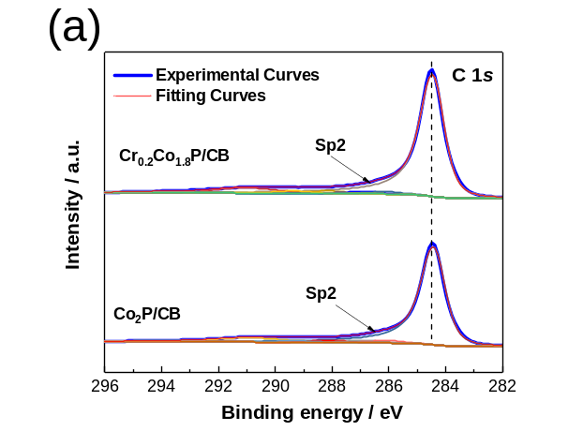 | 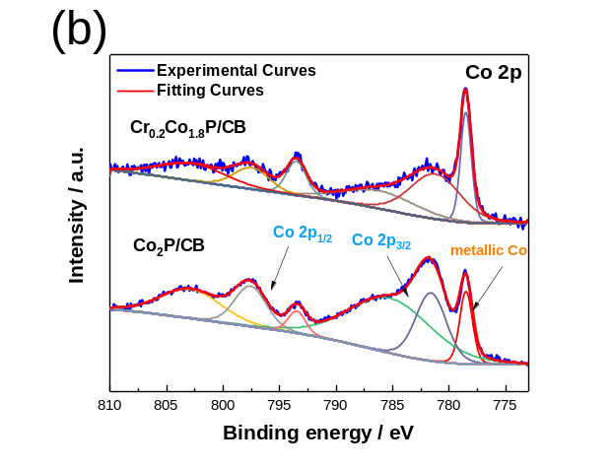
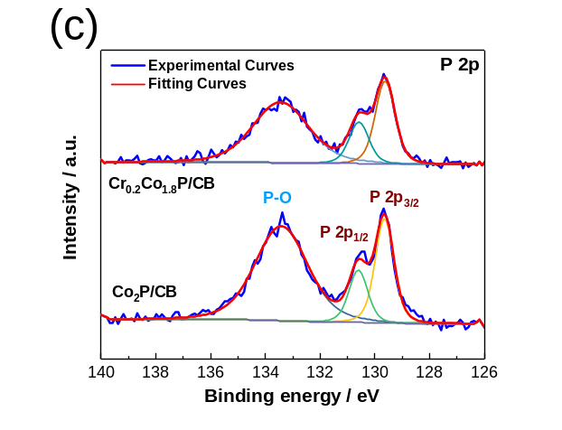 | 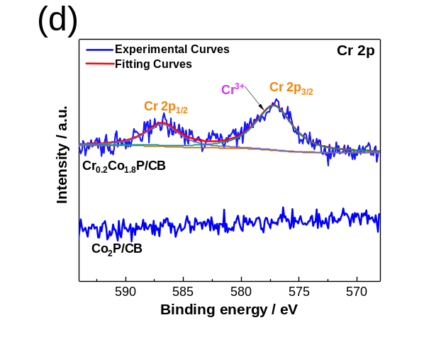
Figure 2. XPS spectra of (a) C 1s, (b) Co 2p, (c) P 2p, and (d) Cr 2p of Co₂P and Cr_{0.2}Co_{1.8}P/CB

The electrocatalytic performance of the as-prepared Co₂P/CB and Cr_{0.2}Co_{1.8}P/CB (Metal Phosphide loading: 40 μg cm⁻²) and graphitized carbon was tested at room temperature in N₂-saturated 0.1M KOH solution for HER and OER using a three-electrode setup. Figure 3(a) and (d) compares the HER and OER activity with iR-compensation of the phosphide catalysts to a reference 20% Pt/C catalyst and IrO₂ catalyst, respectively. As shown in Figure 3(a), the Cr_{0.2}Co_{1.8}P/CB needed 226 mV overpotential to reach a mass activity of -100 $A g_{Co}^{-1}$$A g_{metal}^{-1}$, while the pure Co₂P/CB achieve the same HER current only at 283 mV overpotential.
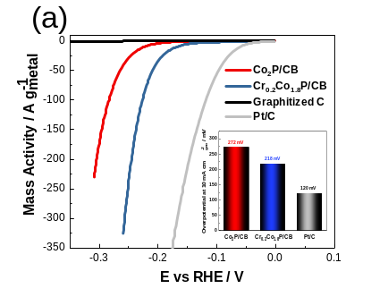 | 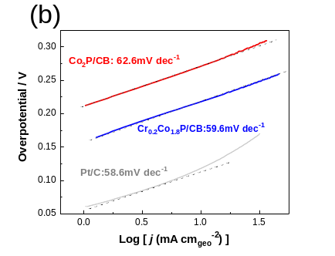 | 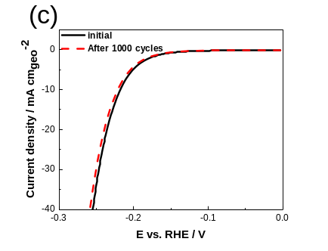
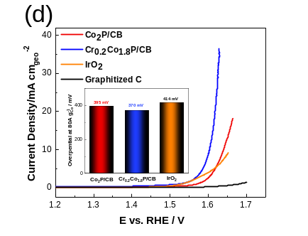 | 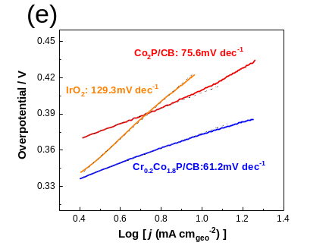 | 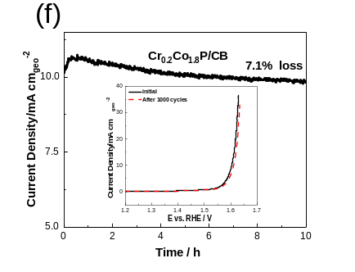
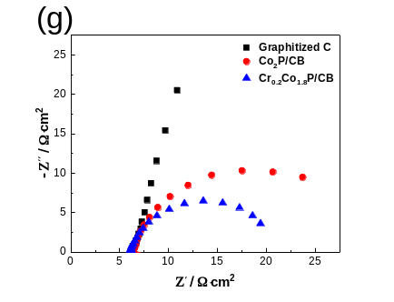 | 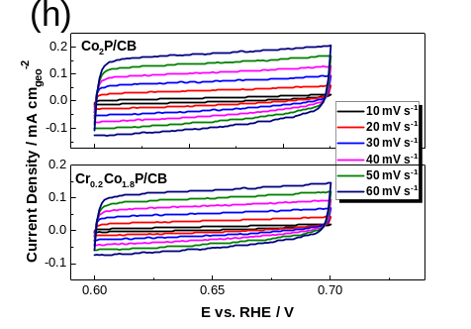 | 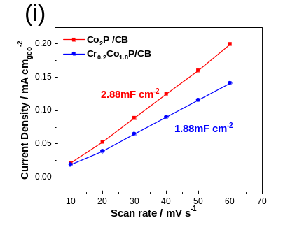
Figure 3. (a) HER and (d) OER mass activity of the as-synthesized Co₂P/CB, Cr_{0.2}Co_{1.8}P/CB catalysts in N₂-saturated 0.1M KOH, with overpotential to achieve a 10 mA cm⁻² for HER and OER as insets, respectively. Metal catalyst loading: 28 μg_{Co} cm⁻² and 2.8 μg_{Cr} cm⁻² for the Cr_{0.2}Co_{1.8}P/CB catalyst. Tafel plots of the as-synthesized Co₂P/CB, Cr_{0.2}Co_{1.8}P/CB catalysts in N₂-saturated 0.1M KOH for (b) HER and (e) OER. Electrochemical stability of Cr_{0.2}Co_{1.8}P/CB for (c) HER and (f) OER in 0.1 M KOH, with 10 h chronoamperometry test of Cr_{0.2}Co_{1.8}P/CB at 1.6V as inset. (g) The EIS plots of the as-synthesized Co₂P/CB, Cr_{0.2}Co_{1.8}P/CB (h) CVs of Co₂P/CB and Cr_{0.2}Co_{1.8}P/CB under different scan rates, (i) Capacitance of the Co₂P/CB and Cr_{0.2}Co_{1.8}P/CB catalyst calculated by their double layer capacitance.

In comparison a 218 mV overpotential is needed to drive a geometrical current density of -10 mA cm⁻² for the Cr_{0.2}Co_{1.8}P/CB, 54mV less than for the unalloyed Co₂P/CB catalyst. Figure 3(b) presents the Tafel plots. Pt/C shows a Tafel slope of 58.6mV dec⁻¹. The Tafel slopes for Co₂P/CB and Cr_{0.2}Co_{1.8}P/CB are 62.6 and 59.6mV dec⁻¹, respectively. As further compared with the current non-precious-metal catalysts (Table S1), our Cr_{0.2}Co_{1.8}P/CB catalysts show the competitive electrocatalytic performances towards HER. The significant improvement of HER performance on Cr doping could be attributed to the previously mentioned electronic effect. Additionally, it was worth noting that the same HER tests were also conducted in 0.1M HCIO₄ (Figure S3a). It is intriguing that when switching from acid to alkaline, the performance of the Cr_{0.2}Co_{1.8}P/CB catalysts change relatively little (~15 mV), suggesting that the electrolyte has relatively little effect on the performance of the catalyst towards the HER. In contrast, the Co₂P/CB catalysts shows a significant decrease in performance in moving from acid to alkaline environments (~100 mV shift). Significant deactivation of the HER in alkaline solutions is well known for platinum group metal catalysts. The significant deactivation of Co₂P/CB in alkaline suggests that OH⁻ may block the more active Co²⁺ sites on that catalyst whereas Cr_{0.2}Co_{1.8}P/CB is hardly affected by OH⁻ blocking of the HER-active sites. This interpretation is also in keeping the change in TDOS for the Cr_{0.2}Co_{1.8}P/CB catalyst which makes anion adsorption less favorable compared to Co₂P (see Figure S8). Furthermore, as shown in Figure S3b, the overpotential to reach -10 mA cm⁻² for the HER gradually increases as the amount of the Cr dopant increases above x=0.2. Performance for x=0.1 is worse than for x=0.2, so this latter composition is close to the optimum chromium composition in alkaline electrolyte. This could be caused by more localized charge-density distribution of Co₂P after the increased Cr incorporation¹⁴ or the lack of more active Co²⁺ sites upon increasing the amount of Cr dopant.
The OER activity of the Co₂P/CB and Cr_{0.2}Co_{1.8}P/CB catalysts were also tested. Figure 3(d) shows their linear sweep voltammetry (LSV) curves in the N₂-saturated 0.1M KOH solution. It can be observed from Figure 3(d) that the Cr_{0.2}Co_{1.8}P/CB shows better OER performance with an overpotential of 380 mV to achieve a mass activity of 100 $A g_{Co}^{-1}$$A g_{metal}^{-1}$, which is smaller than that of Co₂P/CB (420mV). Comparatively, 370 mV overpotential is needed to drive a geometrical current density of 10 mA cm⁻² for the Cr_{0.2}Co_{1.8}P/CB, 40mV less than for the unalloyed Co₂P/CB catalyst. Figure 3(e) presents the Tafel plots. IrO₂ shows a Tafel slope of 129.3mV dec⁻¹. The Tafel slopes for Co₂P/CB and Cr_{0.2}Co_{1.8}P/CB are 75.6 and 61.2mV dec⁻¹, respectively. Moreover, as shown in Figure S4, the overpotential to reach 10 mA cm⁻² for the OER also gradually increases as the amount of Cr dopant increases. As further compared with the current non-precious-metal catalysts (Table S2), our Cr_{0.2}Co_{1.8}P/CB catalysts also show the competitive electrocatalytic performances towards OER. The superior OER activities should be attributed to more favorable reaction intermediates (i.e., *OH, *O, and *OOH) adsorption after Cr doping. And at the same time, the usage of carbon black as support will also accelerate the charge transfer and thus lead to more favorable kinetics on the Cr_{0.2}Co_{1.8}P/CB catalyst towards OER.³¹
Several recent studies have discussed the stability of transition metal phosphides in both acid and alkaline solutions.^{6,32} The main reasons for the electrocatalytic activity loss of transition metal phosphides are from metal dissolution in acid solution and surface oxidation in alkaline solution. In this work, the overpotential increased by only 18 mV (Figure 3(c)) for HER and 11 mV (Figure 3(f)) for OER after the 1000th continuous CV scanning in 0.1M KOH, the chronoamperometry test further demonstrates that the Cr_{0.2}Co_{1.8}P/CB catalyst can keep working efficiently for 10 h with only 7.1% activity loss, demonstrating good electrochemical stability of the Cr_{0.2}Co_{1.8}P/CB catalyst. In addition, to better understand the improved performance for Cr_{0.2}Co_{1.8}P/CB, electrochemical impedance spectroscopy (EIS) was performed. As shown in Figure 3 (g), the EIS plot reveals that Cr_{0.2}Co_{1.8}P/CB has a smaller radius of semicircle than that of Co₂P/CB, indicating that Cr doping can minimize the charge transfer resistance (R_{ct})and thus lead to the more facile electrokinetics of Cr_{0.2}Co_{1.8}P/CB in alkaline solution.
Another important factor to evaluate the performance of an electrocatalyst is the electrochemical surface area (ECSA). And it is always crucial to know the true surface area because the variation of particle size and hence area may mask changes in catalysis due to different synthesis methods or different levels of dopant. However, transition metal phosphides, unlike the platinum group metals, show only weak hydrogen underpotential deposition (HUPD), so it is difficult to obtain the true surface area through measuring their HUPD. Likewise, CO adsorption does not appear to occur to an appreciable level at room temperature and hence formation of monolayer CO coverage cannot be assumed, unlike the case with Pt. Hence, for non-Pt surfaces, such as transition metal phosphides, it can be difficult to quantify their ECSA through CO stripping even if there is CO adsorption on the surface. Furthermore, the copper underpotential deposition, another common method to obtain ECSA, is not applicable in alkaline solution. Thus, the most common and well-accepted approach for estimating the ECSA of transition metal phosphides is still by measuring their double layer capacitance (C_{dl}), although this approach requires the use of unsupported metal phosphide in order to accurately determine the surface area. Figure 3(h) and (i) show the C_{dl} of both the Co₂P/CB (2.88 mF cm⁻²) and Cr_{0.2}Co_{1.8}P/CB (1.88 mF cm⁻²) catalysts. Despite its higher C_{dl}, the Co₂P/CB catalyst still showed worse electrocatalytic performance, which further confirmed that the main improvements of the Cr_{0.2}Co_{1.8}P/CB catalyst towards HER and OER should result from its more favorable intrinsic kinetics modified by the Cr dopant. However, the double-layer capacitance cannot be directly related to ECSA due to the usage of carbon supports in these catalysts. The incorporation of carbon will contribute significantly to the double layer capacitance measured, because there are approximately 60 wt.% of carbon in each catalyst (albeit with a much larger particle size, ca. 60 nm primary particle size). Therefore, the true surface area of the metal phosphide remains hard to measure accurately complicating the assessment of catalytic site activity. Thus, a better method needs to be proposed to evaluate the true surface area of these carbon-supported metal phosphides catalysts. In this work, the ECSA of both the Co₂P/CB and Cr_{0.2}Co_{1.8}P/CB catalysts are estimated by calculating their mean particle size through the Debye-Scherrer equation assuming spherical particles (more details in Note 1 in the supporting information). These are then used to provide the HER specific current density polarization curves (i.e. current normalized by ECSA) in Figure S5. It is worth noting that this ECSA of the electrocatalysts is likely overestimated due to the possible existence of crystal twinning and inevitable agglomeration, and this probably results in an underestimation of the specific current density. Since the ECSA is a reflection of the surface area of a catalyst accessible to the catalytic reactions, the turnover frequency (TOF), which reflects the intrinsic catalytic activity of the catalyst, was studied (see Note 2 in supporting information for calculation method). The TOF of Co₂P/CB and Cr_{0.2}Co_{1.8}P/CB were calculated to be 0.26 electrons site_{Co}⁻¹ s⁻¹ and 1.52 electrons site_{Co}⁻¹ s⁻¹, at an overpotential of -200 mV towards the HER, respectively. Similarly, we estimate an increase in TOF for the OER at 1.6 V from 0.205 to 0.585 electrons site_{Co}⁻¹ s⁻¹ for Co₂P/CB and Cr_{0.2}Co_{1.8}P/CB. Note however, as we will see below, at this potential the particles undergo some change to their morphology, and our estimate of the TOF for the OER, based as it is on the particle size from XRD, may have some error because of the formation of an oxide layer.
As mentioned previously, most transition metal-based catalysts transform into oxy/hydroxides during OER in alkaline solutions. Therefore, the structural and compositional analysis of Cr_{0.2}Co_{1.8}P/CB catalyst was further investigated after long-term chronoamperometry test towards OER in 0.1M KOH. Figure 4 (a) and (b) show the TEM image and HAADF-STEM EDS mapping of the post OER test Cr_{0.2}Co_{1.8}P/CB catalyst, respectively It can be observed that after 10 h chronoamperometry test for OER, a thin layer of Co₃O₄ formed on the catalyst surface.

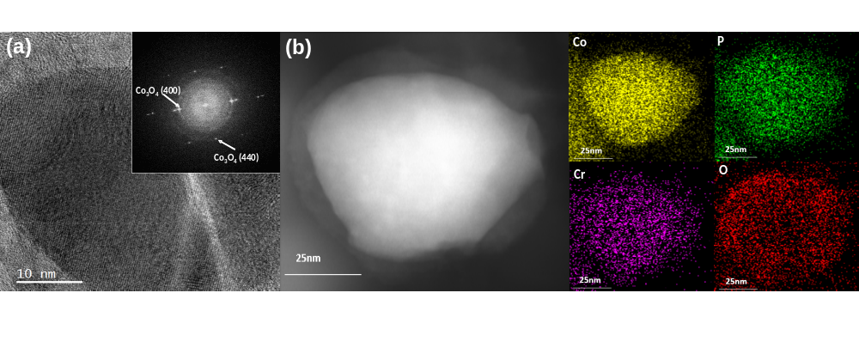
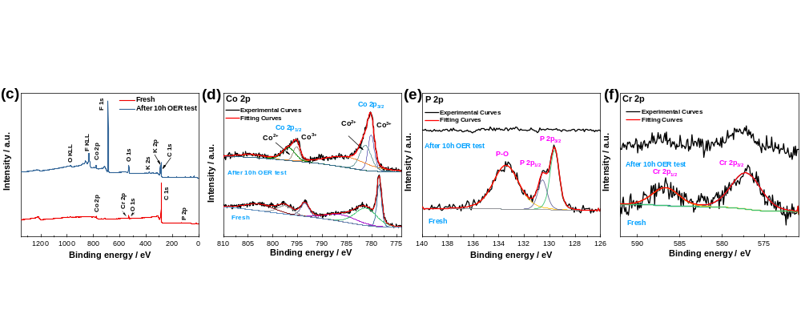
Figure 4. (a) HRTEM and (b) HAADF-STEM EDS mapping images of the post OER test Cr_{0.2}Co_{1.8}P/CB catalyst. (c) XPS survey spectrum and (d) Co 2p, (e) P 2p and (f) Cr 2p spectrum of the fresh and post OER test Cr_{0.2}Co_{1.8}P/CB catalyst.

The EDS mapping in Figure 4 (b) confirmed the existence of Cr, Co and P throughout the bulk of the material while O aggregated on the outer layer. To further analyze the structure and composition of the amorphous shell, XPS was performed. As shown in Figure 4 (c), K 2s and K 2p peaks can be observed after alkaline test resulting from the adsorption of K⁺ cations from the KOH electrolyte. Additionally, F 1s peak can also be observed due to the usage of Nafion solution during ink preparation. Figure 4 (d) shows the high-resolution Co 2p spectrum for the post OER test Cr_{0.2}Co_{1.8}P/CB catalyst. The two fitting peaks at binding energies of 782.3 and 797.7 eV are ascribed to Co²⁺, while another two fitting peaks at 780.5 and 796.1 eV are attributed to Co³⁺ in Co₃O₄,^{33–35} indicating that the amorphous shell formed on the catalyst surface after 10h chronoamperometry test for OER was mainly Co₃O_{4.} Interestingly, there is no clear peak showed in P 2p while trace amount of Cr could still be found in Cr 2p region, indicating that P was fully buried under the oxide layer after 10h OER test. Moreover, we performed the same TEM and XPS characterization on the post OER Co₂P/CB catalyst. As shown in Figure S6, and a similar thin oxide layer was formed on the Co₂P/CB surface as well.
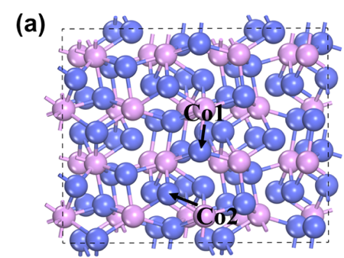 | 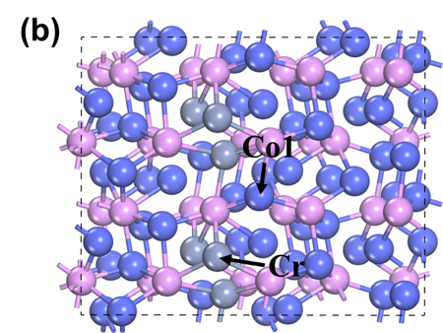 |  | 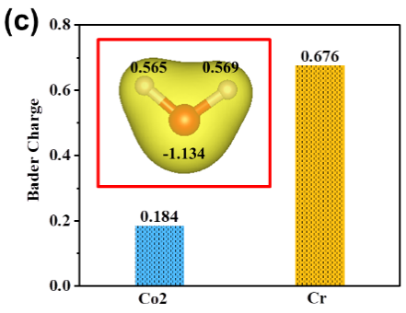
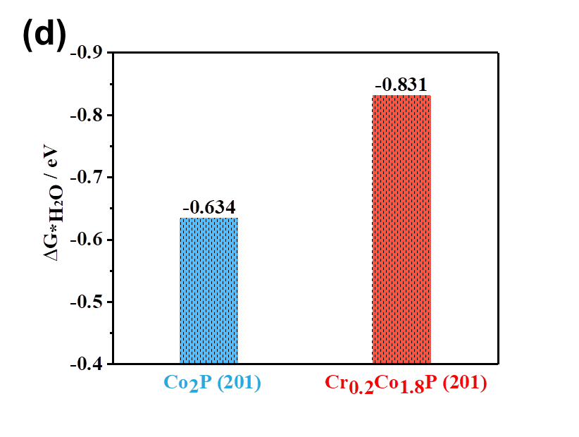 |  | 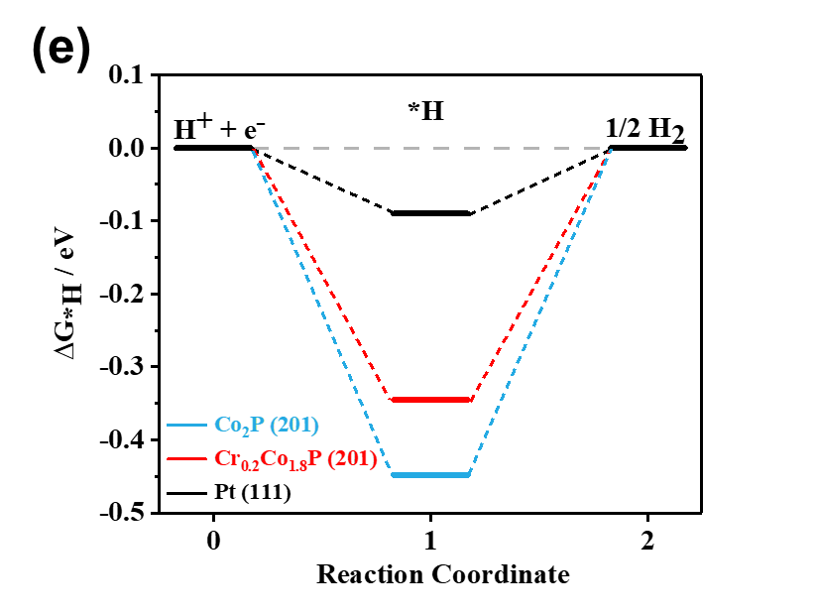
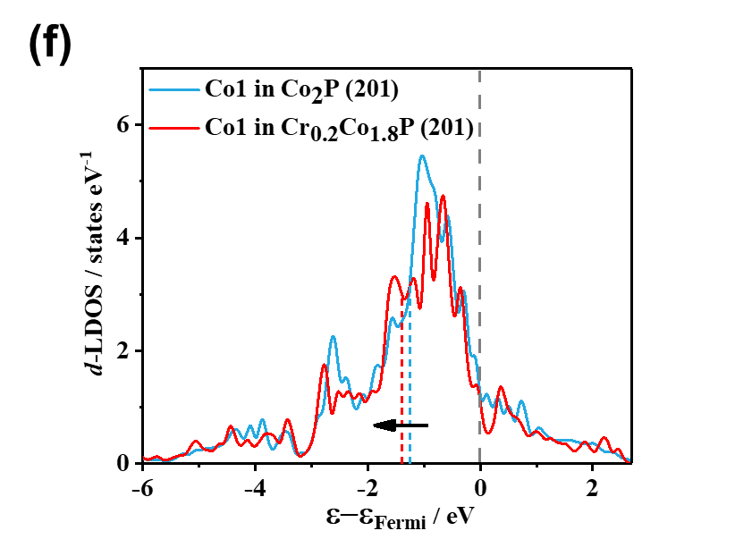 |  | 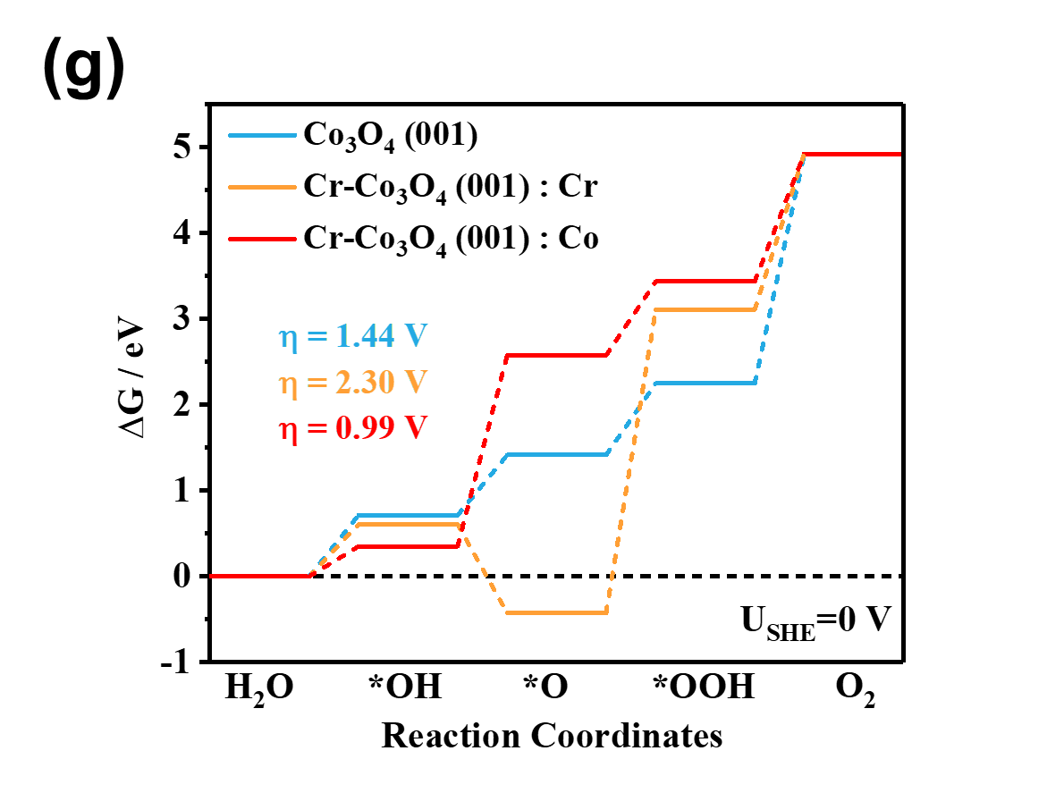
Figure 5. (a) Top view of the optimized structure of Co₂P (201) surface. (b) Top view of the optimized structure of Cr_{0.2}Co_{1.8}P (201) surface. (blue: Co; pink: P; grey: Cr) (c) The Bader charge analysis for Co2 atom in Co₂P (201) surface and Cr atom in Cr_{0.2}Co_{1.8}P (201) surface. The insert is the water molecule structure and corresponding Bader charge analysis. (d) The calculated water adsorption free energies on Co₂P (201) and Cr_{0.2}Co_{1.8}P (201) surfaces. (e) The free energy diagrams (FED) for HER on Co₂P (201) and Cr_{0.2}Co_{1.8}P (201) surfaces. (f) The d-orbital local density of states (d-LDOS) of Co1 in Co₂P (201) and Cr_{0.2}Co_{1.8}P (201), respectively. The blue and red dashed lines represent the positions of d-band center for doped and undoped surfaces. (g) Free energy diagram of OER on Co₃O₄ (001) surface, Cr sites and Co sites of Cr-Co₃O₄ (001) surface, respectively.
To further understand the mechanism of enhanced alkaline HER activity for Cr-Co₂P, density functional theory (DFT) calculations have been performed. The theory models for Co₂P and Cr-Co₂P are shown in Figure 5 (a) and (b), respectively (more details in Supporting Information). We have firstly calculated the work functions (Φ) before and after Cr doping. As shown in Figure S8 (a), it is clear that after Cr doping, the Φ decreases, implying that the electrons transfer faster from the electrode into reactant. Moreover, the calculated total density of states (TDOS) (Figure S8 (b)) demonstrates that the electronic energy level shifts slightly to the right after Cr doping, leading to the electron distribution closer to the Fermi level. As shown in the inset of Figure S8 (b), there are more electron states around Fermi level due to Cr doping. The above change characteristics of the energy level also indicate that the electron transfer kinetics is faster after Cr doping. Besides, figure S9 shows that the hydrogen and water adsorption sites are the Co1 – Co2 bridge and Co2 top sites, respectively, on Co₂P (201) surface, which are in line with previous reports.^{28,36,37} As mentioned above, the adsorption and activation of water are also crucial for whole HER performance in alkaline solution.^{38–40} Therefore, we have firstly conducted the Bader charge analysis for Co₂P (201) and Cr_{0.2}Co_{1.8}P (201) surfaces. As shown in Figure 5 (c), the Cr dopant in Cr_{0.2}Co_{1.8}P (201) surface possesses a higher positive charge (+0.676), compared with that of Co2 atom (+0.184) in undoped Co₂P (201) surface. Considering the oxygen in water is negatively charged (as inserted in Figure 5 (c)), such a higher positive charge indicates that the doped Cr atoms will capture water easier, due to the stronger electrostatic attraction between Cr and O. On the other hand, compared with Co atoms, Cr atoms have less 3d-orbital electrons, implying that the adsorption strength of water on Cr dopant will be much stronger than that on Co atoms of undoped Co₂P (Figure S9 and S10).⁴¹ Correspondingly, as shown in Figure 5 (d), more negative adsorption free energies of water (ΔG_{*H2O}) are observed for the Cr sites in the Cr_{0.2}Co_{1.8}P (201) surface compared with the equivalent Co sites on the Co₂P (201) surface, indicating the higher binding strength between water and doped Cr atoms. Such a strong interaction between Cr and water is likely to activate water molecules, paving the way for the following steps of the HER. The adsorption free energy of hydrogen (ΔG_{*H}) is another crucial criterion to evaluate HER performance of the electrocatalysts, ^{42–46} and the calculated free energy diagram (FED) for hydrogen adsorption is shown in Figure 5 (e). It can be clearly seen that the hydrogen adsorption free energy is more thermo-neutral after Cr doping than undoped Co₂P (201), which indicates that Cr_{0.2}Co_{1.8}P catalyst will have an improved HER performance. The weaker adsorption of hydrogen on the Cr_{0.2}Co_{1.8}P (201) surface can be attributed to the following two reasons. Firstly, the interaction between H and Cr is much weaker than that between H and Co, due to the lower d-band occupation of Cr, which can be easily substantiated by comparing the Cr-H and Co-H bond length.⁴⁷ As shown in Figure S10, the Cr-H bond length is 1.883 Å, which is much larger than the bond length of Co-H (1.609 Å). Therefore, on the Cr_{0.2}Co_{1.8}P (201) surface, the absorption of hydrogen is mainly facilitated by Co atoms. Secondly, but more importantly, the doped Cr atoms will modulate the electronic structure of Co₂P as shown in Figure 5 (f) and shift the d-band center of Co atoms further away from the Fermi level. According to d-band theory, a lower lying d-band center would lead to a weaker binding interaction between the catalysts and adsorbates.^{48,49} Thus, the Cr_{0.2}Co_{1.8}P (201) surface has a weaker adsorption strength. From the above, the synergy of the enhanced activation of water and optimized H adsorption result in the better alkaline HER performance of Co₂P. Furthermore, such a mechanism of enhanced alkaline HER activity can also be seen for the Co₂P (200) surface, as shown in Figure S11-S13. Based on both the experimental results and theoretical calculations, we supposed that the incorporation of high valent Cr dopants plays a key role in accelerating the sluggish water dissociation step in alkaline solutions. Subsequently, the hydrogen intermediates were easily adsorbed on the nearby Co²⁺ sites and recombined into molecular hydrogen. However, in acid solutions, when the hydrogen intermediates were produced from a more facile discharge step involving the hydronium ion, the less active Cr³⁺ sites may exist as spectators for the whole HER process and most of the measured current density comes from the Co²⁺ sites. Moreover, it has been reported before that the weakened hydrogen binding energy (HBE) could also be the controlling factor for the enhanced hydrogen oxidation reaction (HOR) activity.⁵⁰ Thus the electrocatalytic activity of both the Co₂P/CB and Cr_{0.2}Co_{1.8}P/CB for HOR were tested in H₂-saturated 0.1 M KOH solution. However, as shown in Figure S17, even with more favorable HBE towards the HOR, the Cr_{0.2}Co_{1.8}P/CB catalyst still showed minimal HOR activity, which implies there are still considerable improvements to be done to make this cobalt-based phosphide catalysts more efficient and multifunctional.
According to the simplified scheme developed by Nørskov et al.,^{41,51} we have also studied the energetics of the OER process for the undoped and doped catalysts, to understand the origin for higher OER activity after Cr doping. Because we have determined experimentally that the Co₂P catalyst has transformed into Co₃O₄ under OER condition, the DFT calculations for oxygen evolution were performed on Co₃O₄ (001) and Cr doped Co₃O₄ (001) surfaces (Figure S14-S16). The OER is assumed to consist of four elementary reaction steps that proceed through *OH, *O, and *OOH intermediates. In these four elementary reaction steps, the step with the largest reaction free energy change (ΔG_{max}) is the rate-determining step (rds), and the theoretical overpotential of OER is $={{(∆G}_{max}}/e)-1.23 V$. For the Cr doped Co₃O₄ (001) surface, we have calculated the free energy diagram for different active sites, Cr sites (Figure S15) and pristine Co sites (Figure S16), respectively. As shown in Figure 5 (g), it is interesting to note that compared with the theoretical overpotential (η=1.44 V) of pristine Co₃O₄ (001) surface, the OER occurring on the Co sites in Cr-Co₃O₄ (001) possesses a lower theoretical overpotential (η=0.99 V), while the OER occurring on the Cr sites in Cr-Co₃O₄ (001) has a higher theoretical overpotential (η=2.30 V). The DFT results suggest that after Cr doping, the OER active sites are still the Co sites and the enhanced OER activity of the Cr doped catalyst stems from the modulation of electronic structure of Co sites through Cr doping.
Based on the above results, we made an electrode water electrolyzer using bifunctional Cr_{0.2}Co_{1.8}P/CB as both a cathode and anode (Cr_{0.2}Co_{1.8}P/CB|| Cr_{0.2}Co_{1.8}P/CB) for full alkaline water splitting (Figure S18). To afford 10 mA cm⁻² water splitting current, the Cr_{0.2}Co_{1.8}P/CB|| Cr_{0.2}Co_{1.8}P/CB couple needs a cell voltage of 1.63 V, further verified the practical application of this electrocatalyst.
Conclusions
Cr-doped Co₂P catalysts were successfully prepared using a simple carbothermal hydrogen reduction method. Chromium was directly incorporated into the Co₂P lattice and there is no evidence of second phase CrP formation. In alkaline solutions, the Cr_{0.2}Co_{1.8}P/CB catalysts showed superior activity for both the HER and OER reactions. Based on both experimental results and theoretical calculations, the enhancement of HER and OER activity mainly resulted from the changes in electronic property of Co₂P and hence more facile kinetics towards the overall water splitting after Cr doping. Furthermore, the Cr_{0.2}Co_{1.8}P/CB catalyst also showed good electrochemical stability with negligible overpotential shift for the HER and the OER after 1000th continuous CV scanning in 0.1M KOH solution. Considering that there are no toxic and expensive resources being used and no sophisticated procedure being performed during the synthesis, our current research provides a simple and facile carbothermal hydrogen reduction method to prepare the cobalt-based phosphide catalysts and also discussed the Cr doping effects on Co₂P for both the HER and OER.
ASSOCIATED CONTENT
Supporting Information
The Supporting Information is available free of charge on the ACS Publications website at DOI:
Pre- and post- operation TEM, and XPS of Cr_{x}Co_{2-x}P/CB (x=0.0,0.2,0.4); HER and OER electrocatalytic performance of Cr_{x}Co_{2-x}P/CB (x=0.0,0.2,0.4); Comparisons of HER and OER performances of Cr-doped Co₂P with other non-precious metal and precious metal HER and OER catalysts in alkaline solution; Surface area calculation of the Co₂P/CB and Cr_{0.2}Co_{1.8}P/CB catalysts; TOF calculation of Co₂P/CB and Cr_{0.2}Co_{1.8}P/CB catalysts; Details of computational calculations; Two-electrode system test in 0.1M KOH. The data used in generating the plots in this paper is available to download at [DOI inserted at proof stage].
AUTHOR INFORMATION
Corresponding Author
*E-mail: anthony@imperial.ac.uk
Author Contributions
The manuscript was written through contributions of all authors. All authors have given approval to the final version of the manuscript.

Notes
The authors declare no competing financial interest.

Acknowledgements
Jun Wu thanks for the China Scholarship Council and Imperial College London for supporting his PhD research. This research has been supported by the U.K. Engineering and Physical Sciences Research Council under project EP/J016454/1. We would also like to thank the Harwell EPSRC National XPS Facility for XPS service. The DFT calculations in this paper have been done on the supercomputing system in the Supercomputing Center of Wuhan University. The data used in the production of the figures in this paper are available to download at DOI: [DOI inserted during proofing stage].
References
(1) Faber, M. S.; Jin, S. Earth-Abundant Inorganic Electrocatalysts and Their Nanostructures for Energy Conversion Applications. Energy Environ. Sci. 2014, 7 (11), 3519–3542. https://doi.org/10.1039/c4ee01760a.
(2) Zhang, Y.; Gao, L.; Hensen, E. J. M.; Hofmann, J. P. Evaluating the Stability of Co2P Electrocatalysts in the Hydrogen Evolution Reaction for Both Acidic and Alkaline Electrolytes. ACS Energy Lett. 2018, 3 (6), 1360–1365. https://doi.org/10.1021/acsenergylett.8b00514.
(3) Tang, T.; Jiang, W. J.; Niu, S.; Liu, N.; Luo, H.; Chen, Y. Y.; Jin, S. F.; Gao, F.; Wan, L. J.; Hu, J. S. Electronic and Morphological Dual Modulation of Cobalt Carbonate Hydroxides by Mn Doping toward Highly Efficient and Stable Bifunctional Electrocatalysts for Overall Water Splitting. J. Am. Chem. Soc. 2017, 139 (24), 8320–8328. https://doi.org/10.1021/jacs.7b03507.
(4) Staszak-Jirkovský, J.; Malliakas, C. D.; Lopes, P. P.; Danilovic, N.; Kota, S. S.; Chang, K. C.; Genorio, B.; Strmcnik, D.; Stamenkovic, V. R.; Kanatzidis, M. G.; Markovic, N. M. Design of Active and Stable Co-Mo-Sxchalcogels as PH-Universal Catalysts for the Hydrogen Evolution Reaction. Nat. Mater. 2016, 15 (2), 197–203. https://doi.org/10.1038/nmat4481.
(5) Jiao, Y.; Zheng, Y.; Jaroniec, M.; Qiao, S. Z. Design of Electrocatalysts for Oxygen- and Hydrogen-Involving Energy Conversion Reactions. Chem. Soc. Rev. 2015, 44 (8), 2060–2086. https://doi.org/10.1039/c4cs00470a.
(6) Kucernak, A. R. J.; Naranammalpuram Sundaram, V. N. Nickel Phosphide: The Effect of Phosphorus Content on Hydrogen Evolution Activity and Corrosion Resistance in Acidic Medium. J. Mater. Chem. A 2014, 2 (41), 17435–17445. https://doi.org/10.1039/C4TA03468F.
(7) Pan, Y.; Liu, Y.; Lin, Y.; Liu, C. Metal Doping Effect of the M-Co2P/Nitrogen-Doped Carbon Nanotubes (M = Fe, Ni, Cu) Hydrogen Evolution Hybrid Catalysts. ACS Appl. Mater. Interfaces 2016, 8 (22), 13890–13901. https://doi.org/10.1021/acsami.6b02023.
(8) Callejas, J. F.; Read, C. G.; Popczun, E. J.; McEnaney, J. M.; Schaak, R. E. Nanostructured Co2P Electrocatalyst for the Hydrogen Evolution Reaction and Direct Comparison with Morphologically Equivalent CoP. Chem. Mater. 2015, 27 (10), 3769–3774. https://doi.org/10.1021/acs.chemmater.5b01284.
(9) Jin, Z.; Li, P.; Xiao, D. Metallic Co2P Ultrathin Nanowires Distinguished from CoP as Robust Electrocatalysts for Overall Water-Splitting. Green Chem. 2016, 18 (6), 1459–1464. https://doi.org/10.1039/c5gc02462e.
(10) Ye, C.; Wang, M. Q.; Chen, G.; Deng, Y. H.; Li, L. J.; Luo, H. Q.; Li, N. B. One-Step CVD Synthesis of Carbon Framework Wrapped Co2P as a Flexible Electrocatalyst for Efficient Hydrogen Evolution. J. Mater. Chem. A 2017, 5 (17), 7791–7795. https://doi.org/10.1039/c7ta00592j.
(11) Tian, J.; Liu, Q.; Asiri, A. M.; Sun, X. Self-Supported Nanoporous Cobalt Phosphide Nanowire Arrays: An Efficient 3D Hydrogen-Evolving Cathode over the Wide Range of PH 0-14. J. Am. Chem. Soc. 2014, 136 (21), 7587–7590. https://doi.org/10.1021/ja503372r.
(12) Yang, Y.; Liang, X.; Li, F.; Li, S.; Li, X.; Ng, S. P.; Wu, C. M. L.; Li, R. Encapsulating Co2P@C Core–Shell Nanoparticles in a Porous Carbon Sandwich as Dual-Doped Electrocatalyst for Hydrogen Evolution. ChemSusChem 2018, 11 (2), 376–388. https://doi.org/10.1002/cssc.201701705.
(13) Subbaraman, R.; Tripkovic, D.; Strmcnik, D.; Chang, K. C.; Uchimura, M.; Paulikas, A. P.; Stamenkovic, V.; Markovic, N. M. Enhancing Hydrogen Evolution Activity in Water Splitting by Tailoring Li⁺-Ni(OH)₂-Pt Interfaces. Science (80-. ). 2011, 334, 1256–1260. https://doi.org/10.1126/science.1211934.
(14) Xu, K.; Ding, H.; Zhang, M.; Chen, M.; Hao, Z.; Zhang, L.; Wu, C.; Xie, Y. Regulating Water-Reduction Kinetics in Cobalt Phosphide for Enhancing HER Catalytic Activity in Alkaline Solution. Adv. Mater. 2017, 29 (28), 1–6. https://doi.org/10.1002/adma.201606980.
(15) Gao, Y.; Lang, Z.; Yu, F.; Tan, H.; Yan, G.; Wang, Y.; Ma, Y.; Li, Y. A Co2P/WC Nano-Heterojunction Covered with N-Doped Carbon as Highly Efficient Electrocatalyst for Hydrogen Evolution Reaction. ChemSusChem 2018, 11 (6), 1082–1091. https://doi.org/10.1002/cssc.201702328.
(16) Tang, C.; Zhang, R.; Lu, W.; He, L.; Jiang, X.; Asiri, A. M.; Sun, X. Fe-Doped CoP Nanoarray: A Monolithic Multifunctional Catalyst for Highly Efficient Hydrogen Generation. Adv. Mater. 2017, 29 (2), 1–6. https://doi.org/10.1002/adma.201602441.
(17) Zhang, R.; Wang, X.; Yu, S.; Wen, T.; Zhu, X.; Yang, F.; Sun, X.; Wang, X.; Hu, W. Ternary NiCo2Px Nanowires as PH-Universal Electrocatalysts for Highly Efficient Hydrogen Evolution Reaction. Adv. Mater. 2017, 29 (9), 1605502. https://doi.org/10.1002/adma.201605502.
(18) Tang, C.; Gan, L.; Zhang, R.; Lu, W.; Jiang, X.; Asiri, A. M.; Sun, X.; Wang, J.; Chen, L. Ternary FexCo1-XP Nanowire Array as a Robust Hydrogen Evolution Reaction Electrocatalyst with Pt-like Activity: Experimental and Theoretical Insight. Nano Lett. 2016, 16 (10), 6617–6621. https://doi.org/10.1021/acs.nanolett.6b03332.
(19) Yan, K. L.; Shang, X.; Zhang, L. M.; Dong, B.; Liu, Z. Z.; Chi, J. Q.; Gao, W. K.; Chai, Y. M.; Liu, C. G. Boosting Electrocatalytic Activity of Binary Ag-Fe-Doped Co2P Nanospheres as Bifunctional Electrocatalysts for Overall Water Splitting. Electrochim. Acta 2017, 249, 16–25. https://doi.org/10.1016/j.electacta.2017.07.180.
(20) Li, X.; Fang, Y.; Li, F.; Tian, M.; Long, X.; Jin, J.; Ma, J. Ultrafine Co2P Nanoparticles Encapsulated in Nitrogen and Phosphorus Dual-Doped Porous Carbon Nanosheet/Carbon Nanotube Hybrids: High-Performance Bifunctional Electrocatalysts for Overall Water Splitting. J. Mater. Chem. A 2016, 4 (40), 15501–15510. https://doi.org/10.1039/c6ta05485d.
(21) Doan-Nguyen, V. V. T.; Zhang, S.; Trigg, E. B.; Agarwal, R.; Li, J.; Su, D.; Winey, K. I.; Murray, C. B. Synthesis and X-Ray Characterization of Cobalt Phosphide (Co2P) Nanorods for the Oxygen Reduction Reaction. ACS Nano 2015, 9 (8), 8108–8115. https://doi.org/10.1021/acsnano.5b02191.
(22) Zhang, H.; Ha, D. H.; Hovden, R.; Kourkoutis, L. F.; Robinson, R. D. Controlled Synthesis of Uniform Cobalt Phosphide Hyperbranched Nanocrystals Using Tri-n-Octylphosphine Oxide as a Phosphorus Source. Nano Lett. 2011, 11 (1), 188–197. https://doi.org/10.1021/nl103400a.
(23) Yang, W.; Huang, Y.; Fan, J.; Yu, Y.; Yang, C.; Li, H. A Facile Solution-Phase Synthesis of Cobalt Phosphide Nanorods/Hollow Nanoparticles. Nanoscale 2016, 8 (9), 4898–4902. https://doi.org/10.1039/c6nr00208k.
(24) Parra-Puerto, A.; Ng, K. L.; Fahy, K.; Goode, A. E.; Ryan, M. P.; Kucernak, A. Supported Transition Metal Phosphides: Activity Survey for HER, ORR, OER, and Corrosion Resistance in Acid and Alkaline Electrolytes. ACS Catal. 2019, 11515–11529. https://doi.org/10.1021/acscatal.9b03359.
(25) Liu, T.; Liu, D.; Qu, F.; Wang, D.; Zhang, L.; Ge, R.; Hao, S.; Ma, Y.; Du, G.; Asiri, A. M.; Chen, L.; Sun, X. Enhanced Electrocatalysis for Energy-Efficient Hydrogen Production over CoP Catalyst with Nonelectroactive Zn as a Promoter. Adv. Energy Mater. 2017, 7 (15). https://doi.org/10.1002/aenm.201700020.
(26) Yan, L.; Zhang, B.; Zhu, J.; Liu, Z.; Zhang, H.; Li, Y. Callistemon-like Zn and S Codoped CoP Nanorod Clusters as Highly Efficient Electrocatalysts for Neutral-PH Overall Water Splitting. J. Mater. Chem. A 2019, 7 (39), 22453–22462. https://doi.org/10.1039/c9ta08812a.
(27) Mayrhofer, K. J. J.; Wiberg, G. K. H.; Arenz, M. Impact of Glass Corrosion on the Electrocatalysis on Pt Electrodes in Alkaline Electrolyte. J. Electrochem. Soc. 2007, 155 (1), P1. https://doi.org/10.1149/1.2800752.
(28) Liu, T.; Liu, D.; Qu, F.; Wang, D.; Zhang, L.; Ge, R.; Hao, S.; Ma, Y.; Du, G.; Asiri, A. M.; Chen, L.; Sun, X. Enhanced Electrocatalysis for Energy-Efficient Hydrogen Production over CoP Catalyst with Nonelectroactive Zn as a Promoter. Adv. Energy Mater. 2017, 7 (15). https://doi.org/10.1002/aenm.201700020.
(29) Zhang, C.; Pu, Z.; Amiinu, I. S.; Zhao, Y.; Zhu, J.; Tang, Y.; Mu, S. Co2P Quantum Dot Embedded N, P Dual-Doped Carbon Self-Supported Electrodes with Flexible and Binder-Free Properties for Efficient Hydrogen Evolution Reactions. Nanoscale 2018, 10 (6), 2902–2907. https://doi.org/10.1039/c7nr08148k.
(30) Wu, Y.; Tao, X.; Qing, Y.; Xu, H.; Yang, F.; Luo, S.; Tian, C.; Liu, M.; Lu, X. Cr-Doped FeNi-P Nanoparticles Encapsulated into N-Doped Carbon Nanotube as a Robust Bifunctional Catalyst for Efficient Overall Water Splitting. Adv. Mater. 2019, 1900178. https://doi.org/10.1002/adma.201900178.
(31) Wu, Y.; Tao, X.; Qing, Y.; Xu, H.; Yang, F.; Luo, S.; Tian, C.; Liu, M.; Lu, X. Cr-Doped FeNi-P Nanoparticles Encapsulated into N-Doped Carbon Nanotube as a Robust Bifunctional Catalyst for Efficient Overall Water Splitting. Adv. Mater. 2019, 1900178, 1900178. https://doi.org/10.1002/adma.201900178.
(32) Zhang, Y.; Gao, L.; Hensen, E. J. M.; Hofmann, J. P. Evaluating the Stability of Co2P Electrocatalysts in the Hydrogen Evolution Reaction for Both Acidic and Alkaline Electrolytes. ACS Energy Lett. 2018, 3 (6), 1360–1365. https://doi.org/10.1021/acsenergylett.8b00514.
(33) Chen, X.; Liu, B.; Zhong, C.; Liu, Z.; Liu, J.; Ma, L.; Deng, Y.; Han, X.; Wu, T.; Hu, W.; Lu, J. Ultrathin Co3O4 Layers with Large Contact Area on Carbon Fibers as High-Performance Electrode for Flexible Zinc–Air Battery Integrated with Flexible Display. Adv. Energy Mater. 2017, 7 (18), 1–11. https://doi.org/10.1002/aenm.201700779.
(34) Han, X.; He, G.; He, Y.; Zhang, J.; Zheng, X.; Li, L.; Zhong, C.; Hu, W.; Deng, Y.; Ma, T. Y. Engineering Catalytic Active Sites on Cobalt Oxide Surface for Enhanced Oxygen Electrocatalysis. Adv. Energy Mater. 2018, 8 (10), 1–13. https://doi.org/10.1002/aenm.201702222.
(35) Li, L.; Tian, T.; Jiang, J.; Ai, L. Hierarchically Porous Co3O4 Architectures with Honeycomb-like Structures for Efficient Oxygen Generation from Electrochemical Water Splitting. J. Power Sources 2015, 294, 103–111. https://doi.org/10.1016/j.jpowsour.2015.06.056.
(36) Zhou, Q.; Shen, Z.; Zhu, C.; Li, J.; Ding, Z.; Wang, P.; Pan, F.; Zhang, Z.; Ma, H.; Wang, S.; Zhang, H. Nitrogen-Doped CoP Electrocatalysts for Coupled Hydrogen Evolution and Sulfur Generation with Low Energy Consumption. Adv. Mater. 2018, 30 (27), 1–8. https://doi.org/10.1002/adma.201800140.
(37) Men, Y.; Li, P.; Yang, F.; Cheng, G.; Chen, S.; Luo, W. Applied Catalysis B : Environmental Nitrogen-Doped CoP as Robust Electrocatalyst for High-e Ffi Ciency PH- Universal Hydrogen Evolution Reaction. Appl. Catal. B Environ. 2019, 253 (April), 21–27. https://doi.org/10.1016/j.apcatb.2019.04.038.
(38) Danilovic, N.; Subbaraman, R.; Strmcnik, D.; Chang, K. C.; Paulikas, A. P.; Stamenkovic, V. R.; Markovic, N. M. Enhancing the Alkaline Hydrogen Evolution Reaction Activity through the Bifunctionality of Ni(OH)2/Metal Catalysts. Angew. Chemie - Int. Ed. 2012, 51 (50), 12495–12498. https://doi.org/10.1002/anie.201204842.
(39) Strmcnik, D.; Uchimura, M.; Wang, C.; Subbaraman, R.; Danilovic, N.; van der Vliet, D.; Paulikas, A. P.; Stamenkovic, V. R.; Markovic, N. M. Improving the Hydrogen Oxidation Reaction Rate by Promotion of Hydroxyl Adsorption. Nat. Chem. 2013, 5 (4), 300–306. https://doi.org/10.1038/nchem.1574.
(40) Cheng, T.; Wang, L.; Merinov, B. V; Goddard, W. A. Explanation of Dramatic PH-Dependence of Hydrogen Binding on Noble Metal Electrode: Greatly Weakened Water Adsorption at High PH. J. Am. Chem. Soc. 2018, 140 (25), 7787–7790. https://doi.org/10.1021/jacs.8b04006.
(41) Man, I. C.; Su, H. Y.; Calle-Vallejo, F.; Hansen, H. A.; Martínez, J. I.; Inoglu, N. G.; Kitchin, J.; Jaramillo, T. F.; Nørskov, J. K.; Rossmeisl, J. Universality in Oxygen Evolution Electrocatalysis on Oxide Surfaces. ChemCatChem 2011, 3 (7), 1159–1165. https://doi.org/10.1002/cctc.201000397.
(42) Nørskov, J. K.; Bligaard, T.; Logadottir, A.; Kitchin, J. R.; Chen, J. G.; Pandelov, S.; Stimming, U. Trends in the Exchange Current for Hydrogen Evolution. J. Electrochem. Soc. 2005, 152 (3), J23. https://doi.org/10.1149/1.1856988.
(43) Nørskov, J. K.; Bligaard, T.; Rossmeisl, J.; Christensen, C. H. Towards the Computational Design of Solid Catalysts. Nat. Chem. 2009, 1 (1), 37–46. https://doi.org/10.1038/nchem.121.
(44) Sheng, W.; Myint, M.; Chen, J. G.; Yan, Y. Correlating the Hydrogen Evolution Reaction Activity in Alkaline Electrolytes with the Hydrogen Binding Energy on Monometallic Surfaces. Energy Environ. Sci. 2013, 6 (6), 1509–1512. https://doi.org/10.1039/c3ee00045a.
(45) Sheng, W.; Zhuang, Z.; Gao, M.; Zheng, J.; Chen, J. G.; Yan, Y. Correlating Hydrogen Oxidation and Evolution Activity on Platinum at Different PH with Measured Hydrogen Binding Energy. Nat. Commun. 2015, 6, 5848. https://doi.org/10.1038/ncomms6848.
(46) Zheng, J.; Sheng, W.; Zhuang, Z.; Xu, B.; Yan, Y. Universal Dependence of Hydrogen Oxidation and Evolution Reaction Activity of Platinum-Group Metals on PH and Hydrogen Binding Energy. 2016, No. March, 1–9.
(47) Zhou, L.; Shao, M.; Li, J.; Jiang, S.; Wei, M.; Duan, X. Two-Dimensional Ultrathin Arrays of CoP: Electronic Modulation toward High Performance Overall Water Splitting. Nano Energy 2017, 41 (July), 583–590. https://doi.org/10.1016/j.nanoen.2017.10.009.
(48) Hammer, B.; Nielsen, O.; Norskov, J. Structure Sensitivity in Adsorption: CO Interaction with Stepped and Reconstructed Pt Surfaces. Catal. Letters 1997, 46, 31–35. https://doi.org/10.1023/A:1019073208575.
(49) Hammer, B.; Norskov, J. K. Why Gold Is the Noblest of All the Metals. Nature 1995, 376 (July), 238–240.
(50) Sheng, W.; Bivens, A. P.; Myint, M.; Zhuang, Z.; Forest, R. V.; Fang, Q.; Chen, J. G.; Yan, Y. Non-Precious Metal Electrocatalysts with High Activity for Hydrogen Oxidation Reaction in Alkaline Electrolytes. Energy Environ. Sci. 2014, 7 (5), 1719–1724. https://doi.org/10.1039/c3ee43899f.
(51) Rossmeisl, J.; Qu, Z. W.; Zhu, H.; Kroes, G. J.; Nørskov, J. K. Electrolysis of Water on Oxide Surfaces. J. Electroanal. Chem. 2007, 607 (1–2), 83–89. https://doi.org/10.1016/j.jelechem.2006.11.008.

TOC GRAPHICS

