1,071 words (excluding References, Table, Figures)

VIEWPOINT

Maximizing the Public Health Benefits from Climate Action

George D. Thurston, ScD (1), Sara De Matteis, PhD (2), Kris Murray, PhD (3), Pauline Scheelbeek, PhD (4), Noah Scovronick, PhD (5), Mark Budolfson, PhD (6), Dean Spears, PhD (7) and Paolo Vineis, PhD (8).

(1) NYU School of Medicine Nelson Institute of Environmental Medicine, NY 10987-5007, USA
(2) National Heart and Lung Institute, Imperial College London, Royal Brompton Hospital, Chelsea, London, SW3 6NP, UK.
(3) The Grantham Institute, Imperial College London, Kensington, London, SW3 6LR, UK.
(4) London School of Hygiene and Tropical Medicine, London, WC1E 7HT
(5) Princeton University, Princeton, New Jersey, USA
(6) Department of Philosophy, University of Vermont, Burlington, VT 05405, USA
(7) Indian Statistical Unit, Delhi, India and the Department of Economics, University of Texas at Austin, Texas 78712, USA
(8) MRC-PHE Centre for Environment and Health, Imperial College London, W2 1PG, London, UK.
Introduction
Environmental benefits that could be gained by successful climate change mitigation actions are usually subject to long action-reaction time lags. Furthermore, the links of mitigation efforts to major sources of climate forcing greenhouse gas (GHG) emissions are often complex. Therefore, there is a risk that potentially effective mitigation strategies are discounted by policy-makers and the general public, and not given sufficient weight in economic models.

In contrast, if these mitigation strategies have human health co-benefits, they are much more likely to be appreciated by policy makers and the general public. Effects are more immediate, tangible and often represent greater motivation for action. We present the nature, scope, and policy implications of the potential human health and economic co-benefits from climate mitigation actions, as summarized in Table 1.

Diet and Health
Livestock production for animal-based food is immense, and projections suggest that it could double by 2050¹. The livestock sector is responsible for 14.5% of global human-induced GHG emissions², particularly through ruminant animals (cattle, sheep and goat), from enteric fermentation. High meat consumption also contributes to the burden of chronic non-communicable illnesses, such as cardiovascular disease (CVD). Infectious diseases are also associated with meat production, with emerging infectious diseases (EIDs) being much more likely to be associated with animals, while emerging zoonoses being most often related to changes in land-use (e.g., deforestation) and agricultural systems (e.g., intensification). Reducing meat consumption could reduce all of these human health risks, while also reducing a major source of climate forcing methane emissions.

There are several more environmentally friendly – often plant-based –protein alternatives that could replace meat, and contain less saturated fat. These have the potential to decrease the environmental impact of diets while lowering the risk of dying, getting diabetes, and certain types of cancer. A diet switch from red meat to legumes, for example, could provide a substantial reduction in one’s diet “carbon footprint”, whilst also improving nutrition.

Occupational Health, Energy Production, and Climate Change
Worldwide, electricity production is one of the leading contributors to GHG emissions, and many mitigation strategies therefore target this source. What receives less attention, however, are the occupational illnesses and deaths associated with energy production. In particular, coal mining is known as a ‘big killer’ when compared to other energy sectors, such as oil and natural gas extraction. The coal extraction phase is responsible for most of the occupational mortality burden. Considering just respiratory diseases, the Global Burden of Disease (GBD) study estimated that in 2013, coal worker’s pneumoconiosis (a chronic progressive interstitial lung disease caused by exposure to coal dust) caused a loss of 600,200 (447,600 to 838,600) disability-adjusted life-years (DALYs), and a reduction in healthy life expectancy (HALE) of 9·2 (6·9 to 12·8) years.³ Phasing out coal combustion could remove the single most important source of CO₂ pollution in the world, and substantially reduce the high occupational disease burden associated with coal extraction.

Environmental Health and Climate Change
Fossil fuel combustion (e.g., at coal-fired power plants and in transportation) represents a major environmental polluter that strongly affects air quality as well as GHG emissions⁴. Apart from their climate impacts, air pollutants associated with fossil fuel combustion have well-documented adverse human health effects. This is particularly high for particulate matter from coal-burning facilities, which has been associated with an ischemic heart disease mortality risk that is roughly five times that of the average for PM2.5 particles, and more damaging per µg/m³ than PM_{2.5} from other common sources (Figure 1)⁵. Globally, West et al. (2013) found that GHG mitigation can avoid 0·5 and 1·3 million premature deaths globally in 2030 and 2050, respectively from improved air quality.⁶ Associated global marginal health co-benefits were US$50–$380 per ton of CO₂, exceeding abatement costs in 2030 and 2050⁶. (Figure 2).
The Economic Valuations of Health Co-Benefits
Quantifications of the monetary valuations of health benefits are needed for policy decision-making. The monetary benefits of preventing early death are often valued at millions of dollars per life saved⁷. However, a key difference to note about the monetary value of health co-benefits of climate mitigation is that they tend to occur more immediately, and nearer to the source, as compared to direct the benefits of avoiding climate change itself, and so are not subject to the same level of psychological, economic, or political discounting. Thus, if a mitigation strategy improves public health, it is also likely to be much more cost effective when compared to actions that do not.

Available evidence points to the potential for large health-related and economic co-benefits of controlling GHG emissions. Ignoring these benefits has resulted in in estimates of economically optimal carbon reductions that are too low. Indeed, Ikefuji et al. (2014) have estimated that the clean air associated with CO₂ mitigation results in optimal global carbon reductions of ~100-200 GtC higher over this century⁸. Thus, a cost-benefit model that also incorporates the human health benefits from the associated clean air improvements would yield economically optimal carbon reductions that are meaningfully larger than have past models that have excluded these clean air benefits.

Conclusion
Existing economic, environmental, dietary, and occupational evidence makes a strong case that well-designed climate mitigation strategies also include major public health benefits, and that these economic co-benefits are often as large, if not larger, than the direct climate change benefits and marginal mitigation costs. If we fail to fully account for the human health co-benefits of mitigation measures, we will choose sub-optimal policies from both a human health and climate perspective, and fail to most cost-effectively address the climate crisis we face. Here we presented several examples illustrating that a careful consideration of the complex mechanisms of positive spill-over effects from climate mitigation strategies on population health and the economy are crucial imputs for policy development and cost-benefit analyses around climate change mitigation. Scientists, physicians, and economists around the world must speak out to educate the public, and to ensure that their governmental representatives both consider and optimize the public health benefits of climate mitigation measures.
Conflict of Interest
The authors declare no conflict of interest.
All authors certify that they have contributed concept and design, drafting and approval of the final version of the manuscript.
Acknowledgements
This work has been partially supported by the Exposomics EC FP7 grant [Grant agreement no: 308610] to Paolo Vineis. Pauline Scheelbeek was supported by the “Wellcome Trust Our Planet Our Health Programme”. George Thurston was supported in part by the NYU-NIEHS Center of Excellence (NIH Grant ES00260).

Others who contributed substantially to the work included: Sara Farchi, Erica Lapucci, and Paola Michelozzi of the Department of Epidemiology of the Regional Health Service – Lazio, Rome, Italy; and Alejandro Strapasson of the Belfer Center for Science and International Affairs, Harvard University, Cambridge, MA.

References

1. Thornton P, Herrero M. The inter-linkages between rapid growth in livestock production, climate change, and the impacts on water resources, land use, and deforestation. World Bank Policy Research Working Paper Series, Vol 2010.
2. Food and Agriculture Organization. Tackling climate change through livestock. FAO, Rome, 2013
3. GBD 2016 Risk Factors Collaborators. Global, regional, and national comparative risk assessment of 84 behavioural, environmental and occupational, and metabolic risks or clusters of risks, 1990-2016: a systematic analysis for the Global Burden of Disease Study 2016. Lancet. 2017 Sep 16;390(10100):1345-1422. doi: 10.1016/S0140-6736(17)32366-8.

4. Intergovernmental Panel on Climate Change (IPCC), 2013: Summary for Policymakers. In: Climate Change 2013: The Physical Science Basis. Contribution of Working Group I to the Fifth Assessment Report of the Intergovernmental Panel on Climate Change [Stocker, T.F., D. Qin, G.-K. Plattner, M. Tignor, S.K. Allen, J. Boschung, A. Nauels, Y. Xia, V. Bex and P.M. Midgley (eds.)]. Cambridge University Press, Cambridge, United Kingdom and New York, NY, USA.
http://www.ipcc.ch/pdf/assessment-report/ar5/wg1/WG1AR5_SPM_FINAL.pdf
5. Thurston GD, Burnett RT, Turner MC, Shi Y. et al. Ischemic heart disease mortality and long-term exposure to source-related components of US fine particle air pollution. Environmental Health Perspectives (Online) 2016; 124(6): 785.
6. West J, Smith SJ, Silva RA, Naik V. et al. Co-benefits of mitigating global greenhouse gas emissions for future air quality and human health. Nature climate change 2013; 3(10): 885-9.
7. Health Economic Assessment Tool. Value of statistical life. http://heatwalkingcycling.org/index.php?pg=requirements&act=vsl. 2014.
8. Ikefuji et al. (2014) The effect of health benefits on climate change mitigation policies. Climatic Change. September 2014, Volume 126, Issue 1-2. pp 229–243.

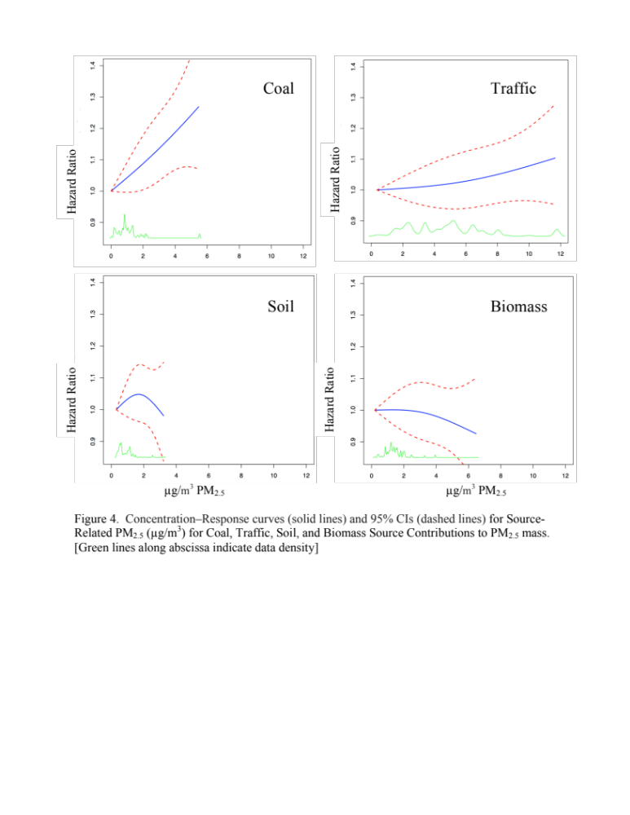
Figure 1. Concentration-response curve (solid lines) and 95% confidence intervals (dashed lines) for Source-Specific PM2.5 mass in the US ACS Cohort⁵.
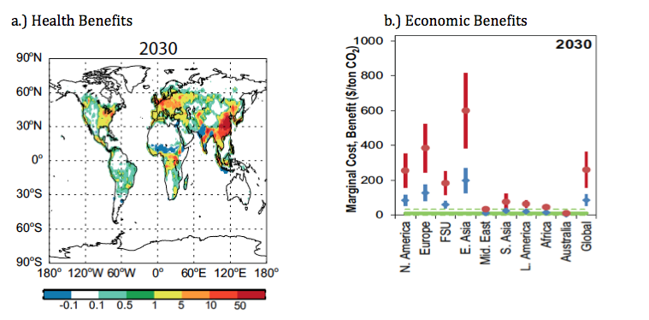
Figure 2. The health and associated economic costs and benefits of climate change mitigation.. Note: a) The premature mortality from PM_{2.5} in 2030 (deaths/yr. per 1000 km2) avoided by climate change mitigation measures; b) the range of associated marginal monetary benefits (US$/tonCO₂) by region (red: high estimate; blue: low estimate) achieved by climate change mitigation vs. cost of mitigation (US$/ton CO₂ (solid green: central estimate; dashed green: high estimate)^{.6}

Table 1. Illustrative examples of climate actions and scope of potential human health
co-benefits to the individuals and/or localities taking the climate mitigation steps
Action | GHG Reduction(s) | Estimated Health Co-benefits | Potential Burdens of Disease Avoided
Convergence of red meat consumption to WHO guidelines and consequent reductions in global demand for livestock production | CH₄, CO₂, N₂O | Reduced diet-related chronic diseases  Reduced diet-driven infectious disease risks, direct (e.g., food-borne illness) and indirect (risk of novel infectious disease emergence, risk of increasing endemic infectious disease burdens) | * Diet related non-communicable disease burden from intake of saturated fats, and salts, including coronary heart disease (CHD), hypertension, stroke episodes, and diabetes mellitus type II;  • Cancer risk related to carcinogens in meat;  • Food-related infections (e.g., Salmonella);  • Endemic infectious diseases from land-use change (e.g., malaria);  * Novel infectious disease emergence associated with concentrated animal food operations (e.g., H1N1);  • Reduced risk of catalysing antibiotic resistance (e.g., Gram-negative bacteria).
Reduce/eliminate coal production-related occupational exposures | CO₂ | Reduced coal mining extraction accidents/fatalities and chronic respiratory diseases* when coal burning is replaced with alternative energy sources. | • Coal workers’ pneumoconiosis (i.e., ‘black lung disease’);  • Silicosis;  • Asbestosis;  • Lung cancer;  • Lung malignant mesothelioma*.
Reduce Air Pollution Exposures | CO₂ | Reduced fossil fuel combustion air pollution-associated illnesses when air quality pollutants (e.g., PM and O₃) are improved along with CO₂ and CH₃ reductions. | * Respiratory disease hospital admissions;  * Cardiovascular disease (CVD) hospital admissions;  • Heart attacks;  • Asthma Attacks;  * Lung Cancer;  • Premature deaths.
*review limited to respiratory diseases

