operator models for delivering municipal solid waste management services in developing countries: Part A - the evidence base
David C. Wilson*¹, Jennifer Bangirana Kanjogera¹ ⁵, Reka Soós², Cosmin Briciu², Stephen R. Smith¹, Andrew D. Whiteman³, Sandra Spies⁴ and Barbara Oelz⁴
¹ Department of Civil and Environmental Engineering, Imperial College London, UK
² RWA Group, Cluj-Napoca, Romania
³ RWA Group, Sofia, Bulgaria
⁴ Deutsche Gesellschaft für Internationale Zusammenarbeit (GIZ), Eschborn, Germany
⁵ Current affiliation: EnviroServ Waste Management, Uganda

* Corresponding author. E-mail: waste@davidcwilson.com
Abstract
This paper presents the evidence base for ‘operator models’ - i.e. how to deliver a sustainable service through the interaction of the ‘client’, ‘revenue collector’ and ‘operator’ functions - for municipal solid waste management (MSWM) in emerging and developing countries. The companion paper addresses selection of locally appropriate operator models. The evidence shows that no ‘standard’ operator model is effective in all developing countries and circumstances. Each city uses a mix of different operator models; 134 cases showed on average 2.5 models per city, each applying to different elements of MSWM - i.e. street sweeping, primary collection, secondary collection, transfer, recycling, resource recovery and disposal or a combination. Operator models were analysed in detail for 28 case studies; the paper summarises evidence across all elements and in more detail for waste collection. Operators fall into three main groups: the public sector; formal private sector; and micro-service providers (MSPs) including micro-, community-based and informal enterprises. MSPs emerge as a common group; they are effective in expanding primary collection service coverage into poor / peri-urban neighbourhoods and in delivering recycling. Both public and private sector operators can deliver effective services in the appropriate situation; what matters more is a strong client organisation responsible for MSWM within the municipality, with stable political and financial backing and capacity to manage service delivery. Revenue collection is also integral to operator models: generally the municipality pays the operator from direct charges and/or indirect taxes, rather than the operator collecting fees directly from the service user.
KEYWORDS: Municipal service delivery, public-private partnerships, private sector participation, privatisation, waste collection, cost recovery, micro-service providers
INTRODUCTION
Managing solid waste is a key utility service, sitting alongside clean water, sanitation, electricity and gas supply, communications and transport as part of the vital infrastructure underpinning society (UNEP, 2015). Since the 1970s, municipal authorities around the world have sought to improve management practices for solid waste (Wilson, 2007) and significant progress has been achieved, particularly but not only in developed countries (Scheinberg et al, 2010; Hoornweg and Bhada-Tata, 2012; UNEP, 2015). Two short-term priorities among the waste-related Sustainable Development Goals are to protect public health through extending waste collection to everyone, and to protect both the local and global environment by eliminating uncontrolled disposal and open burning of solid waste (UNEP, 2015: Rodic and Wilson, 2017). With the support of external support agencies, many middle-income developing countries have improved significantly their levels of both collection coverage and controlled disposal; however further progress is required in lower income countries (Wilson et al, 2012a; Wilson et al., 2013a; UNEP, 2015).
Sustainable solutions need to be developed which take into account local needs and conditions, to address each of the physical components of the solid waste management service involving all stakeholders, and the full range of the technical, environmental, financial, institutional, economic and social factors - an approach termed ‘Integrated Sustainable Waste Management’ (ISWM) (Schübeler et al., 1996; van de Klundert and Anschütz, 2001; Scheinberg et al, 2010; Zurbrügg et al, 2012; Wilson et al., 2013a; Abarca-Guerrero et al., 2013). The technologies to address the physical components have been widely covered in the literature, both in online handbooks focussed on developing countries (e.g. Coffey and Coad, 2010; UN-Habitat, 2012) and in textbooks (e.g. Christensen, 2011; Worrell and Vesilind, 2012). However, there is general recognition that technology alone cannot solve the problem, with attention being needed also to a wide range of ‘governance’ factors, as shown schematically in Figure 1.

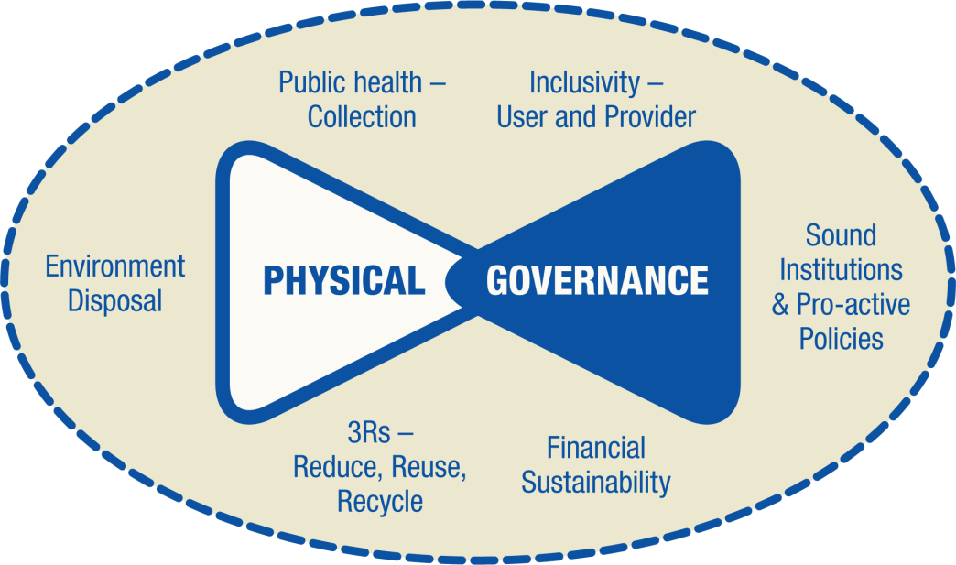
Figure 1. The ‘Two triangles’ representation of the Integrated and Sustainable Waste Management (ISWM) analytical framework. Source: Wilson et al., 2013a. Concept adapted from: Scheinberg et al. 2010.
Significant governance constraints in developing as compared to developed countries include a relatively low level of user and provider inclusivity; a lack of financial capacity, e.g. to sustain facilities once investment funds have been spent; and weak institutions, e.g. limiting the translation of policy and legislation into practice, due to poor application, monitoring and enforcement (Wilson, 2007; Scheinberg et al., 2010; Wilson et al., 2013a; UNEP, 2015).
Cutting across many of the components shown in Figure 1 is the question of how best should services for municipal solid waste management (MSWM) be delivered, particularly in emerging and developing countries? Going back to the middle decades of the twentieth century, the norm was for MSWM services to be delivered directly by the public sector. The private sector has a long history of involvement in the provision of MSWM services in the US, and its involvement has expanded increasingly in the UK and Europe since the 1980s (Cointreau et al., 2000; Coad, 2005). By the 1990s, many external support agencies were advocating the involvement of the private sector in delivering urban services in developing countries, on the premise that market forces would automatically increase efficiency compared to local government (Cointreau, 2000). In the MSWM sector, the standard concept of ‘privatisation’ was modified into what was termed either ‘private sector participation’ (PSP) or ‘public private partnership’ (PPP - which is the term that will be adopted here) (Cointreau, 1994) - there is general acceptance that the municipality retains the responsibility for, but can delegate delivery of, the MSWM service. However, even with this adapted approach, early experience with the adoption of PPP was often negative - to quote from Cointreau, 2000: ‘market forces were not well developed in developing countries …. Procurement procedures were commonly not transparent, and ethical frameworks for doing business were not well established.’ Both the World Bank (Cointreau et al., 2000) and the Deutsche Gesellschaft für Internationale Zusammenarbeit (GIZ) (Coad, 2005) have produced comprehensive guidance documents on implementing PPP in MSWM, focusing on avoiding problems and building on successes. Despite such work, a significant gap in the international literature has been the lack of real evidence on the comparative performance of different ‘operator models’ for MSWM - e.g. how do public sector service delivery and private sector service delivery through PPP compare in practice and which is the more appropriate choice in a particular local situation?
This is the first of two articles reporting the results of a major study commissioned by GIZ to fill this gap by exploring which operator models work well under different conditions, and what needs to be considered in selecting which model(s) to put in place. This article reports for the first time on the detailed evidence base compiled on the effectiveness of operator models applied in different circumstances in emerging and developing countries (Wilson et al., 2013b); it also uses that evidence to derive a typology of commonly-used operator models which can be used for delivering particular elements of the overall MSWM service, as presented in detail in the main GIZ report (Soós et al., 2013a). The companion article (Soós et al., 2017) reports on the decision support system and tools developed to assist in selecting the most appropriate operator models in a specific local situation (Soós et al., 2013b; García-Cortés et al., 2013).
Definition of an ‘operator model’
The working definition of an ‘operator model’ used in this work is shown schematically in Figure 2, which identifies six institutional functions inherent within a MSWM system (Wilson et al, 2001). Three of these - planning, policy and regulator, as defined briefly in Figure 2, set the framework, often at a national level, within which the others assure delivery of the service at the local, municipal level.
An ‘operator model’ is thus defined by the interaction between the three, local institutional functions shown in Figure 2 in terms of ownership, decision making, responsibility, contracts and agreements, management and money flows. The client is responsible for ensuring the provision of a reliable MSWM service which meets the framework requirements , while the revenue collector collects the fees or other sources of revenue. Actual delivery of services in practice is the operator function - which may be provided by the public sector, by the private sector or by some variation of public-private partnership (PPP).
METHODOLOGY
Analytical framework
The approach adopted was to examine case studies of MSWM systems from around the world, with a clear focus on emerging and developing countries. To compare their performance, one needs to examine both their ‘hard’ physical components and also the ‘soft’ governance aspects. Use was thus made of the ‘two triangles’ ISWM analytical framework (Figure 1), which emerged from work on the seminal UN Habitat book: Solid Waste Management in the World Cities (Scheinberg et al. 2010; Wilson et al, 2012a; Wilson et al., 2013a). As part of this study, experience with using the original UN-Habitat indicator set was reviewed, and a revised indicator set was developed and applied to a set of new case studies. This aspect of the work has already been reported; the revised indicators developed here (Wilson and Cowing, 2013) were further reviewed, extensively tested, updated and published as the ‘Wasteaware’ benchmark indicators (Wilson et al., 2015).
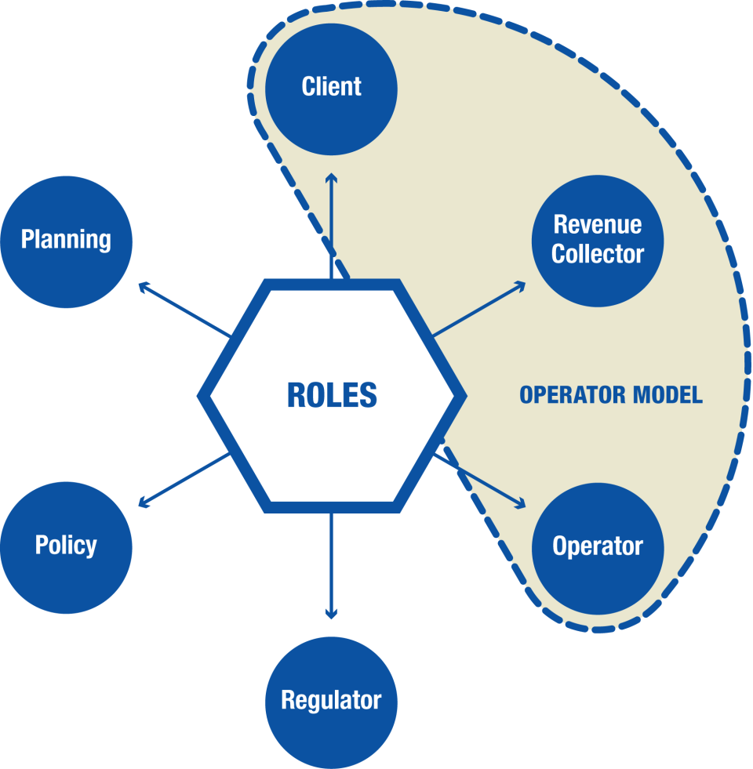 | KEY: Definitions for each function  Framework  Regulator : responsible for monitoring and compliance of MSWM with legal standards for environmental protection  Policy : the framework set at National level and implemented at Regional and Local levels within which MSWM is delivered  Planning : responsibility for strategic and operational planning and general programming and control  Operator model  Client : responsible for ensuring the provision of a reliable MSWM system meeting the required standards  Operator : responsible for delivery of the MSWM service on the ground  Revenue Collector : responsible for collection of revenue for MSWM  Operator Model = Client +  Revenue Collector + Operator
Figure 2. Definition of an operator model. The six institutional roles and responsibilities which must be fulfilled to provide sustainable Municipal Solid Waste Management (MSWM) services are taken from the World Bank's Strategic Planning Guide for Municipal Solid Waste Management (Wilson et al. 2001). Figure after Soós et al. 2013a.

Preliminary screening of case studies
An initial search for potential case studies focused on the published and ‘grey’ literature, and also on specific caches of unpublished case-studies known to the authors. Applying the criterion that each case should provide sufficient detail on the operator models in use to allow preliminary analysis resulted in 134 cases. These were transferred to a database comprising a three-page pro-forma of data for each case (Wilson et al, 2012b). Three further screening criteria were then applied: (i) MSWM systems that were already in implementation so that lessons could be drawn (i.e. planning proposals were excluded as it was not possible to determine if they actually work in practice); (ii) detailed information provided about the operator models in use; and (iii) the physical elements of the MSWM system described in enough detail to match up with a specific operator model.
Detailed shortlist
The results of the preliminary screening were reviewed to ensure that the shortlist contained an interesting and full-spread range of operator models when considered collectively. A good geographic spread was sought across continents and countries; between cites of different population; between countries of different income level (low, lower-middle and upper-middle income); and including small island developing states (SIDS). In addition, a balance was maintained between different data sources, with the inclusion of cases from the published literature as well as the grey literature. The final short-list of 28 case studies included the five new primary case studies specially commissioned for this work.
Mapping and analysing the case studies
Details of each selected case study were mapped to address a number of specific research questions:
- What services are provided and under what conditions?
- Who provides the waste management services and under what conditions?
- How are those services managed, monitored and paid for?
- At what level are those services provided?
The ISWM analytical framework (Figure 1) was used to assess the performance of the overall MSWM system, and thus the efficiency / effectiveness of the operator models used for the five primary case studies, and also (in an earlier form) for those cases taken from the UN-Habitat ’20 cities’ (Scheinberg et al., 2010; Wilson et al., 2012a). For the other cases, the assessment used a combination of mainly qualitative information plus some quantitative data, for example on the collection coverage achieved (i.e. % of MSW covered by regular collection services).
Typology of common operator models
In principle, a very large number of alternative operator models may be envisaged. Within individual municipalities, different operator models can be used, with different variations of public and/or private operators providing day-to-day services for each physical element of the MSWM system. Inter-municipal co-operation can also contribute to the diversity of potential operator models available in practice.
The 28 case studies were therefore examined to identify a sub-set of common operator models (‘coms’). The classification of the generic types of coms included an assessment of three main areas:
- Physical elements of the MSWM system, i.e. street sweeping, primary collection, secondary (or one-step) collection, collection of commercial wastes, transfer, recycling, composting, incineration (waste-to-energy), landfill, or any number of groupings for the integrated delivery of some or all of these services.
- Classification of operators responsible for delivery of the service. A basic distinction was between public service delivery and private sector delivery generally through some form of PPP. ‘Private sector’ operators may be international or local, while local private companies may be large, medium or small. There are also a range of ‘micro-service providers’ (MSPs), which include local micro-enterprises, various social entities and the ‘informal sector’.
- Mechanisms for contracting between the client and the operator, e.g. management contract, service contract, concession, franchise or licensing (open competition) (Cointreau, 1994).
Two of the coms also considered alternative implementation of extended producer responsibility (Cahill et al., 2011; OECD, 2016).

RESULTS AND DISCUSSION
It is not possible in a short paper to provide a full comparative analysis of all the operator models in use for all the physical elements of the MSWM system in all the case studies examined (Kanjogera, 2012). This section provides a brief overview of the numbers and types of operator model in use across the 134 case studies initially screened; an overview of the 28 case studies providing the detailed evidence base; an analysis of the evidence on those parts of the overall MSWM service which are associated with waste collection, as an example of the level of information available and how it has been analysed; evidence on revenue collection; and a categorisation of ‘coms’.
General assessment of operator models in SWM service delivery in emerging and developing countries
Figure 3 shows a categorisation of service providers across the 134 case studies examined. These have been categorised into ‘direct’ public sector delivery of services, or ‘private’ sector service delivery, generally through some form of public-private partnership (PPP). Both groups have been further sub-divided, for the public sector into service delivery by a municipal department and by a commercialised public enterprise. For private sector service delivery, the first group was PPP with formal private companies, which may be international or local; large, medium or small in size; and even a formal joint-venture between the public and private sectors. The second group was PPP with micro-service providers (MSPs), including micro-enterprises and/or social entities such as community-based organisations (CBOs), resident associations or non-governmental organisations (NGOs). The largest individual category of ‘private‘ entity was the informal sector, including co-operatives, family groups and individual workers (shown in Figure 3 as the third sub-category), which usually provided purely private services for collection and/or recycling, but could also be involved in a PPP.
As shown in Figure 3, the total number of operator models distinguished was 330, of which approximately 30% were delivered by public sector operations, 50% through some form of PPP and 15% by the informal sector. Service delivery through PPP was sub-divided approximately equally between small, medium or large formal companies (88 in total), and ‘micro-PPP’, involving either micro- or community-based enterprises (85 in total). Together, there were significantly more micro-service providers (138 micro-PPP and informal sector operators in total) than either public-sector operators (104) or more formal private companies (88).
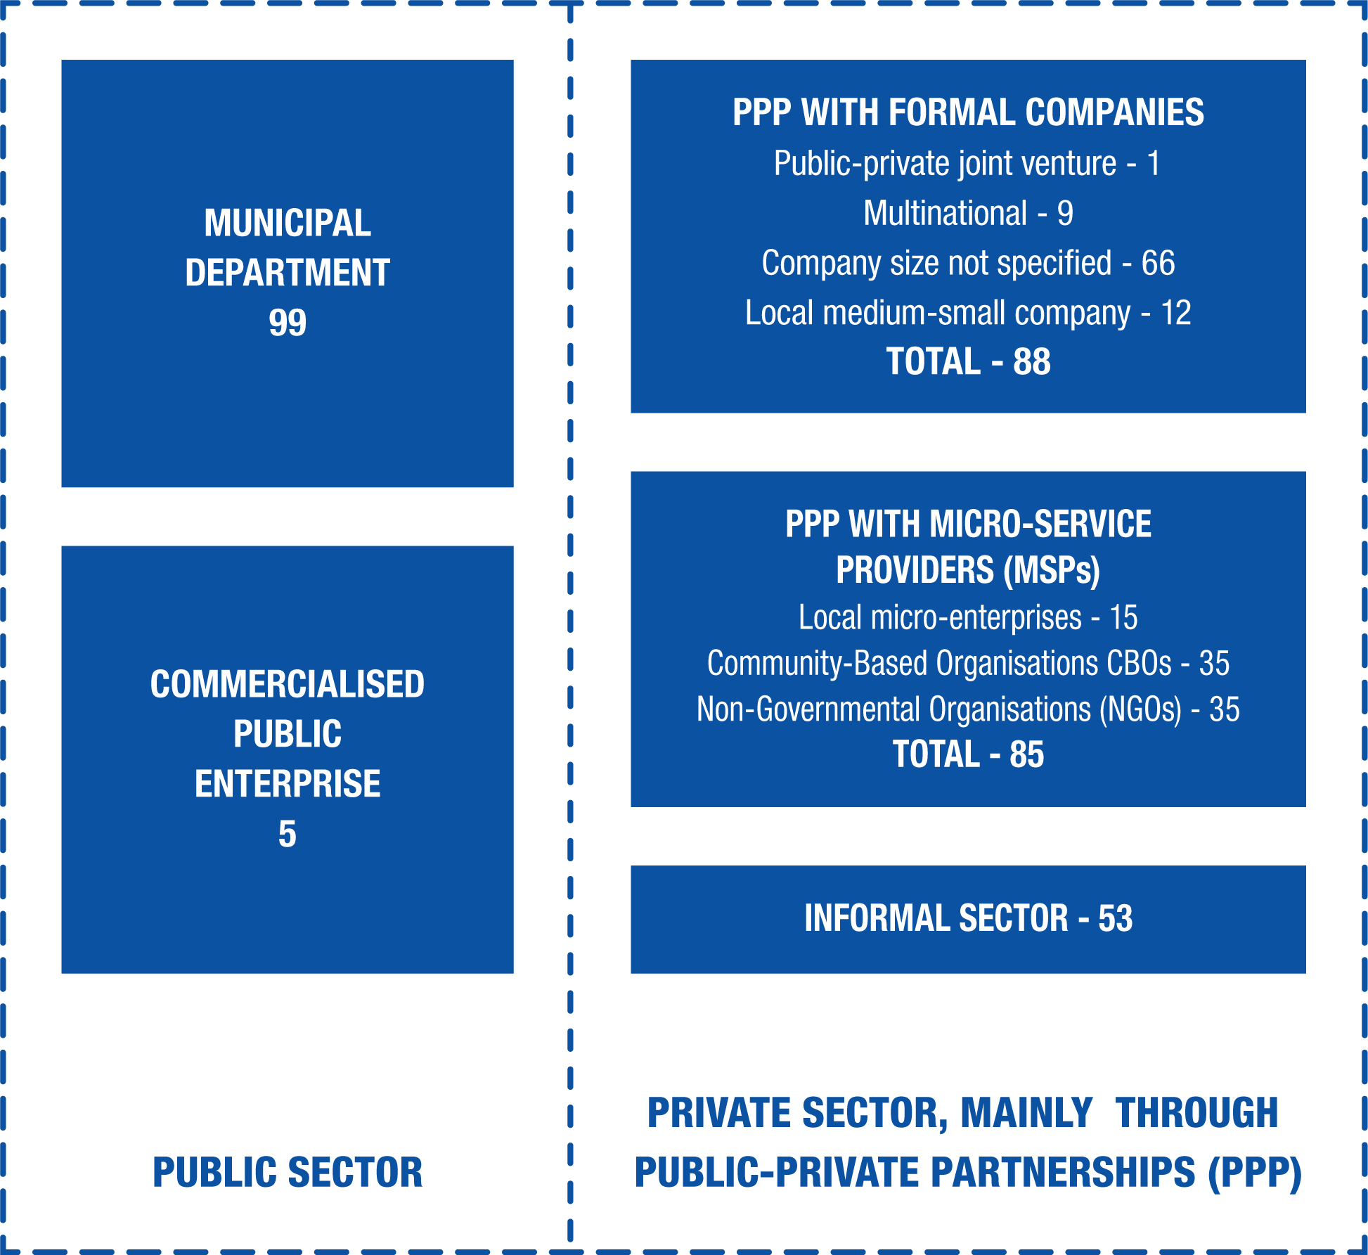
Figure 3: A categorisation of service providers from 134 selected case studies in emerging and developing countries. These have been categorised broadly into ‘direct’ public sector delivery of services, or private sector service delivery mainly through some form of public-private partnership (PPP). The informal sector often provide purely private services for recycling where the only income is from selling the recycled materials, but they may also participate as a micro-service provider (MSP) in a PPP.

The total number of different operator models across the 134 cases was estimated to be 330. This showed that each city had on average 2.5 different operator models; in other words, a number of operator models were in use concurrently, each addressing a different element of the MSWM system.
The analysis so far has focused on one aspect of the overall operator model, i.e. service delivery. The 134 cases also confirmed the conventional view that the client function generally remains at some level of municipal government. It is commonly argued that MSWM is a public responsibility because it is a ‘public good’ (Cointreau, 1994, 2000; UNEP, 2015). A contractual relationship between the municipality as ‘client’ and a PPP service delivery partner was implied in 119 out of 134 case studies (89%). The degree of detailed scrutiny of operator models that was possible from published case studies was generally relatively limited. For example, on the governance aspects (Figure 1), only around half of the 134 cases provided information on user inclusivity, financial sustainability, and the presence or absence of sustained policy commitments or of clear and transparent policy frameworks. There was a paucity of information on operator and client capacities, with only 30 % of the cases providing information on this aspect. Only in 31 out of 119 cases, where there was an implied contractual relationship between the municipality as ‘client’ and a PPP service delivery partner, could some information about the contracts be found.
High level analysis of the 28 detailed case studies
Tables 1-3 allow some preliminary observations to be made on the types of operator model in use across the case study cities. In most of the 28 examples, the original baseline (going back to somewhere between the 1970s and 1990s) was generally public sector service delivery. However, by the date of the case studies (mainly in the range 2008-2012), the situation had been transformed, with only one example of purely public sector service delivery, in Gaza.
While PPP was the most common practice, there were only two examples of all services being contracted out by the city to a single private contractor, in Yaoundé and Tangier, although in at least the former, the informal sector and CBOs operated in areas not served by the contract. The dominant service providers were divided into 3 groups of equivalent size across the 28 cases, and were either mainly public or mainly PPP or a relatively balanced mix of both public and PPP systems. In 23 of the 28 cases, some services were provided directly by the public sector: where services were mainly PPP, the most common services delivered by the public sector were secondary collection and disposal (8 examples of each out of a total of 13 cases).
In 19 out of 28 cases, PPP involving formal private companies supplied at least one aspect of the overall service, while in 11 cases, PPP involved either micro-enterprises and/or NGOs or CBOs (micro-PPP). Municipalities used contracting and concessions more commonly than franchises or open competition for engaging private sector services.
In 22 out of 28 cases, there was direct involvement of the informal sector, most often to provide private recycling services funded entirely by the revenues from selling the materials collected for recycling. This result was consistent with previous studies emphasising that most recycling activities in developing countries are undertaken by the informal sector (e.g. Wilson et al., 2009; Scheinberg et al, 2010; Gunsilius et al., 2011; Velis et al., 2012; Ezeah et al., 2013; Linzner and Lange, 2013; Jaligot et al., 2016).

Table 1: Case studies selected for in-depth analysis - Africa
Location/year | Population |  |  | Case study |  | General description of Operator Model | References
AFRICA | No. (million) | Growth  (% annum⁻¹) | Density  (people km⁻²) | Source | Focus | General description of Operator Model | References
Cameroon, Yaoundé (2008) | 1.7 | 6.8 | 1,100 | Journal | Overview of MSWM in the city | All public up to 1979. Since then PPP: contract with one local company to provide MSWM services. CBOs provided enhanced door-to-door service in high-income areas. No service in peri-urban areas: some CBO/informal sector activity. | Parrot et al., 2009
Egypt, Qena (2012) | 0.53 | 2.1 | 2,200 | GIZ OM project¹ | Project specific case study | Public services run by the municipality in Qena city. The surrounding villages and settlements lacked capacity: in 3 of the larger villages, services provided by NGOs. | Mourdzhev & El Shebriny, 2013
Ghana, Accra (2013, 2010, 2008, 2002) | 1.7 | 4.3 | 8,000 | Journals | Assessing PPP delivery of MSWM services in the city from 1995-2010 | Originally, all public sector. Brief contract with a monopoly joint venture private-public company. By 2010, PPP for collection, concessions to ~10 private companies. Informal sector provided primary collection in some areas, as well as recycling. Dumpsites public sector. Proposal for PPP waste-to-energy. | Obirih-Opareh & Post, 2002; Fobil et al., 2008; Oteng-Ababio, 2010; Oteng-Ababio et al., 2013
Kenya, Nairobi (2009) | 4 | 4.5 | 5,700 | UN-Habitat²  +Journal | City profile using standard methodology + role of civil society | City council contracted out street sweeping, secondary collection and disposal to formal private sector. Private operators offered primary collection services for a fee in richer areas. PPP with CBOs to service poorer areas. Collection for recycling by informal sector. | Kirimi et al, 2009; Tukahirwa et al., 2013
Mali, Bamako (2009) | 1.8 | 4.8 | 6,800 | UN-Habitat² | City profile using standard methodology | Primary collection by private microenterprises/ co-operatives paid directly by householders; secondary collection by municipality. No designated disposal sites. | Keita et al., 2009
Mauritius, Curepipe (2009) | 0.084 | 0.8 | 3,500 | UN-Habitat² | City profile using standard methodology | Services mainly public for collection, transportation and disposal: some waste transportation plus operation of the landfill site contracted out to private companies. | Stentiford and Mohee, 2009
Morocco, Tangier (2007) | 0.2 | 1.1 | 1,200 | PhD thesis | Case study within economic study of PPP in MSWM | Street sweeping, collection and transport contracted out to one international contractor on a 6-year contract. Disposal public sector. | Dorvil, 2007
Mozambique, Maputo (2012) | 1.2 | 1.3 | 3,600 | GIZ OM project¹ | Project specific case study | Street sweeping by each district (public). Five models for collection, tailored to areas, most PPP and some public (details in Table 5). Disposal site public sector. | Stretz, 2013; Stretz, 2012
Nigeria, Benin (2000) | 0.71 | 2.6 | 2,800 | Journal | Assessment of the first 5 years of PPP in MSWM in the city | Contracting out of waste services to small-scale local private companies in 12 zones of the city. Many problems reported, including little or no provision made for waste disposal. | Ogu, 2000
Tanzania, Dar-es-Salaam (2009) | 2.5 | 4.3 | 1,800 | Journals | Analysis of an early example of ‘pro-poor PPP’: does it work/ is it sustainable? | All public up to 1992. Over 50% of city covered by PPP, with local contractors and CBOs granted exclusive franchises to collect door-to-door in a specific area. Elsewhere, the 3 municipalities collected from communal points. Collection for recycling by informal sector. Dumpsite public sector. | Kassim, 2009; Kassim & Ali, 2006; Kaseva & Mbuligwe, 2005; Mbuya, 2009; Tukahirwa et al., 2013
Zambia, Lusaka (2009) | 1.5 | 3.7 | 4,000 | UN-Habitat² | City profile using standard methodology | All public up to 2002. Collection mainly franchised to formal private contractors and to community-based enterprises. Street sweeping contracted out under service contracts. Municipality directly operated some secondary collection + the modern landfill site. Informal sector also provide collection, as well as recycling. | Kabungo & Lifuka, 2009
Notes: Population data all rounded to two significant figures.
1: One of five primary case studies developed specifically for the GIZ Operator Model study on which this paper is based, using an updated set of the UN-Habitat indicators (Soós et al., 2013a).
2. One of the 20 cities featured in the UN-Habitat report Solid Waste Management in the World’s Cities (Scheinberg et al., 2010; Wilson et al., 2012a).
CBO - Community-based organisation. MSWM - Municipal solid waste management. NGO - Non-governmental organisation. PPP - public-private partnership.
Table 2: Case studies selected for in-depth analysis - Asia
Location/year | Population |  |  | Case study |  | General description of Operator Models | References
ASIA | No. (million) | Growth  (% annum⁻¹) | Density  (people km⁻²) | Source | Focus | General description of Operator Models | References
Bangladesh, Dhaka (2009) | 7 | 1.7 | 19,000 | UN-Habitat² +Journal | City profile using standard methodology; + papers on local composting initiatives | Primary collection by MSPs. Street sweeping, secondary collection and disposal by public sector. Informal sector collection in unserved settlements and also for recycling. One social business enterprise ran a centralised compost plant, using source separated market wastes, and decentralised community composting. | Whiteman et al., 2009; Sinha and Enayetullah, 2010; Yedla, 2012
China, Chongqing (2005) | 31 | 7.3 | 380  (includes large hinterland) | Journal | Challenges in MSWM in Chongqing, the fourth largest city in China | Primary collection by resident’s committees or similar local public sector organisations. Collection for recycling by informal sector. Transfer, treatment and disposal by commercialised municipal enterprise. Large institutions serviced in parallel by private companies. | Hui et al., 2006
China, Kunming (2009) | 3.5 | 0.5 | 1600  (Four central districts) | UN-Habitat² | City profile using standard methodology. Focused on the core city (four districts) | Mainly public operation. Primary collection to transfer stations, operated by four districts. Transport and landfill sites by Kunming Sanitary Division. Street sweeping at district level contracted out to private companies. Collection for recycling by informal sector. New incinerator built and operated under PPP. | Rodic and Yang, 2009
China, whole country (2010) | 1,300 | 0.5 | N/A | Journal | Status, problems and challenges of MSWM in urban China | Systems vary, both by city and stage in the MSWM system. Since 2000, generally primary collection public at local level, collection for recycling informal sector, secondary collection/ transport public or a municipal enterprise, disposal public. PPP increasing, particularly for incineration. | Zhang et al., 2010
India, Kolkata (2009) | 6  (14) | 0.5 | 32,000  (KMC only) | Journals | Two overviews of MSWM Kolkata Municipal Corporation (KMC) area (core city) | Complex MSWM system controlled and operated by public sector. Combined street sweeping with door-to-door collection service. Around 50% of vehicles for secondary collection hired from private sector. Collection for recycling by informal sector. | Chattopadhyay et al., 2009; Hazra and Goel, 2009
India, Surat (2012) | 4.5 | 5.0 | 14,000 | GIZ OM project¹ | Project specific case study | Intricate mix of models. Promoted community participation with CBOs. Public operation of most street sweeping + some secondary collection. Public provision of transfer stations and disposal sites - operation contracted out. PPP - contract out waste collection for 90% of city. PPP - 30-yr concessions to BOOT treatment plants (no gate fee paid by city). Collection for recycling by informal sector. | Gupta, 2013
Nepal, Ghorahi (2009) | 0.028  (0.059) | 4.0 | 3100  (800) | UN-Habitat² | City profile using standard methodology | Municipality provided sweeping, collection and transport services in core town; owned/ operated a modern landfill site and plastics waste sorting facility. 35 independent itinerant waste buyers collected waste directly for recycling. Residents in rural areas must self-managed their wastes - much of their organic waste was composted or fed to animals. | Tuladhar, 2009
Philippines, Quezon (2009) | 2.9 | 2.9 | 18,000 | UN-Habitat² | City profile using standard methodology | Mainly PPP, through five integrated contracts for sweeping, primary and secondary collection and one contract for operation of the controlled disposal facility. 10% of local areas operated public sector collection; larger commercial generators used private contractors. Recycling split between informal sector co-operatives and formal operators. | Andres-Po and Tatlonghari, 2009
Notes: Population data all rounded to two significant figures. Population data in brackets refer to the wider urban area (or greater municipal area).
1: One of five primary case studies developed specifically for the GIZ Operator Model study on which this paper is based, using an updated set of the UN-Habitat indicators (Soós et al., 2013a).
2. One of the 20 cities featured in the UN-Habitat report Solid Waste Management in the World’s Cities (Scheinberg et al., 2010; Wilson et al., 2012a)
BOOT - Build, own, operate, transfer. CBO - Community-based organisation. MSP - micro-service provider. MSWM - Municipal solid waste management. PPP - public-private partnership.
Table 3: Case studies selected for in-depth analysis – Central/Latin America, Middle East and Eastern Europe/Former Soviet Union
Location/year | Population |  |  | Case study |  | General description of Operating Model | References
LATIN AMERICA / CARIBBEAN | No. (million) | Growth  (% annum⁻¹) | Density  (people km⁻²) | Source | Focus | General description of Operating Model | References
Brazil, Belo Horizonte (2011) | 2.4 | 1.2 | 7,400 | UN-Habitat² | City profile using standard methodology | Street sweeping, collection, transfer and disposal operated by the commercialised public enterprise or through PPP contracts with formal companies. Recycling PPP with waste picker co-operatives. | Dias et al., 2009  IJgosse et al., 2013
Brazil, Porto Alegre City (2007) | 1.5 | 1 | NA | Journal | Effects of active citizen participation on recycling | Both mixed wastes and source separated recyclables collected on behalf of municipality. The latter were delivered under a PPP to sorting units run by co-operatives. | Bortoleto and Hanaki, 2007
Brazil, Rio Grande do Sul (2012) | 0.17 | 1.1 | 36 | GIZ OM project¹ | Project specific case study. Chosen as an example of inter-municipal co-operation | 30 municipalities formed an inter-municipal commercialised public enterprise, known as ‘CIGRES’. Aimed to raise disposal standards and break up a cartel of private operators. Collection by municipalities - 25 PPP and 5 public. Street sweeping by municipality in town centres and residents elsewhere. Sorting, waste treatment and disposal by CIGRES. | Schmidt, 2013  Schmidt et al., 2014
Nicaragua, Managua (2009, 2013) | 1.0 | 1.7 | 3,800 | UN-Habitat²  +Journal | City profile using standard methodology. Updated and published | MSWM service almost exclusively by municipality. Unserved areas made own arrangements, some recent PPP pilot schemes with MSPs. Collection for recycling by informal sector. Private sector handled much commercial & industrial waste. | Olley et al., 2009  Olley et al., 2014
St Lucia, Castries (2012) | 0.062 | 1.2 | 780 | GIZ OM project¹ | Project specific case study. Example small island developing state (SIDS) | Inter-municipal (island-wide) waste management authority acted as client and as a commercialised public enterprise. Street sweeping PPP with many local MSPs employing 2-4 people. Collection contracted out in four zones to local companies. Modern landfill site public sector. | Cowing, 2013
MIDDLE EAST
Bahrain, Bahrain (2010) | 1.1 | 2.7 | 1,500 | Journal | City (country) profile prepared using UN-Habitat methodology | MSW collection contracted to 2 private companies. Commercial waste generators contracted direct with private sector. Landfill public. Recycling part formal sector (PPP collection contractors, other companies and one NGO collected recyclables, one composting plant) and part informal sector. | Al-Sabbagh et al., 2012
Palestine, Gaza (2007) | 1.4 | variable | 3,800 | Confer-ence | Improvement of performance through inter-municipal services | Operation of services through two commercialised public enterprises owned by municipalities (‘JSWMCs’). One JSWMC provided primary & secondary collection and disposal; while in other area, the municipalities provided primary collection and the JSWMC other service components. | Safi and Luecke, 2007; Scheu and Borno, 2005
EASTERN EUROPE/ FORMER SOVIET UNION
Bulgaria, Varna (2009) | 0.8 | -0.6 | 3,900 | UN-Habitat² | City profile using standard methodology | Collection and transport PPP: 3 companies held 5 zonal contracts. Landfill owned by neighbouring municipality - operation contracted out. Most collection for recycling by informal sector - packaging waste collected by contractor for producer responsibility organisation. | Bozhilova-Kisheva & Ikonomov 2009
Kyrgyz Republic, Bishkek (2011) | 1.2 | 0.9 | 7,500 | Journal | City profile prepared using UN-Habitat methodology | Sweeping, collection and disposal by commercialised public enterprise. Did not cover unregistered housing areas where a service was offered by private companies, some of which used a private semi-controlled landfill. Collection for recycling by informal sector. | Sim et al., 2013
Notes: Population data all rounded to two significant figures. N/A - not available 1: One of five primary case studies developed specifically for the GIZ Operator Model study on which this paper is based, using an updated set of the UN-Habitat indicators (Soós et al., 2013a). 2. One of the 20 cities featured in the UN-Habitat report Solid Waste Management in the World’s Cities (Scheinberg et al., 2010; Wilson et al., 2012a). CIGRES: Consórcio Intermunicipal de Gestão de Resíduos Sólidos - Intermunicipal Consortium for MSWM in the State of Rio Grande do Sul in Brazil;. JSWMC - Joint Solid Waste Management Council. MSP - micro-service provider. MSWM - Municipal solid waste. MSWM - Municipal solid waste management. NGO - Non-governmental organisation. PPP - public-private partnership. SIDS - Small Island Developing States.

Mapping the operator models used for waste collection
Table 4 summarises information on the delivery of waste collection services in the secondary case study cities. The sub-sections which follow use this information on waste collection to provide an example of the depth and breadth of the evidence available on operator models and how it has been analysed.

Table 4: Summary of information on the Operator Models for collection in the different cities¹
The sequence of cities follows that in Tables 1-3. Columns provide a summary classification of the dominant operator model, using the four primary groupings in Figure 3; a description of the operator models in use, elaborating briefly on the information in Tables 1-3; a categorisation of the collection method used²; and an assessment of the comparative collection coverage, including an indication of how that has changed over recent years³.
Country  City | Year | Dominant Operator Model | Description | Collection methods used² | Collection coverage³
AFRICA
Cameroon  Yaoundé | 2008 | PPP | One local private company contracted since 1979 to provide collection along paved roads and mainly from communal points. CBOs provided a door-to-door service for a fee in high-income areas. | Communal points  (+ Door to door) | 43%  ↑
Egypt  Qena | 2012 | Public | The municipality provided the services in Qena City, while NGOs did so for three of the seven larger villages. Elsewhere in the Markaz (administrative area), no service. | Kerbside | 100% ↔(city)  63% ↑ (Markaz)
Ghana  Accra | 1995-2010 | PPP | Originally in public sector. PPP since 1995, initially through franchised private companies. Replaced by a monopoly joint venture private-public company 1997, which sub-contracted to the existing local companies; contract cancelled in 2001. Then ~10 concession contracts, but continuing problems with regular payments to contractors by municipality. | Communal points (70%)  + Door-to-door (30%) | 67%  ↕
Kenya  Nairobi | 2009 | PPP  (including micro) | City council contracted out to the formal private sector - generally covering communal collection points and secondary collection to the disposal site. Private operators also offered direct door-to-door or kerbside primary collection services in richer areas. PPP with NGOs and CBOs to provide basic services in poorer areas. | Communal points  + Door-to-door  / Kerbside | 52%  ↑
Mali  Bamako | 2009 | Private (micro)  Public | Primary waste collection carried out by 120 microenterprises / co-operatives through direct transactions with the users with no involvement of the municipality. The informal sector competed with the microenterprises, particularly in the poorer areas. Secondary collection by the municipality. | Block | 57%  ↑
Mauritius  Curepipe | 2009 | Public | Weekly collection used a mix of tipper and non-tipper vehicles. Most collection by 14 municipality vehicles, another 6 vehicles hired under contract from the private sector. Each vehicle had 8 collectors. Industrial and commercial users paid for collection and transport to landfill (often using private contractors), but not for disposal. | Door-to-door | 100%  ↔
Morocco  Tangier | 2007 | PPP | Services tendered and contract awarded to one private multinational company in 2000 with scope including sweeping, collection and transportation of waste. Contract period 6 years. | Kerbside | 73%  ↑
Mozambique  Maputo | 2012 | PPP  (including micro) | 5 distinct operator models for collection, designed to be appropriate to circumstances, some operated by private sector under variations of PPP (two contracts with international companies, many more with micro-enterprises for primary collection in peri-urban areas), and some by the municipality (details in Table 5). | Communal points (close)  + Door-to-door | 82%  ↑
Nigeria  Benin | 2000 | PPP | City authorities adopted the contracting method of PPP in response to a failure by public sector to provide adequate services. Separate contracts with small local enterprises in 12 zones. New system still had many problems - in principle covered 100% of city but likely collected only half of the waste | Door-to-door | ~50%  ↕
Tanzania  Dar es Salaam | 2009 | PPP (including micro)  + Public | PPP covered 43 city wards, providing mainly a door-to-door collection service. Around 30 local contractors and CBOs had been granted exclusive franchises to collect in a specific area, collecting a fee set by the municipality direct from the waste generator - revenue collections rates around 50%. In 30 wards, the 3 municipalities provided a direct public service, focused on secondary collection from communal collection points (details in Table 6). | Door-to-door  + Communal points | 40%  ↕
Zambia  Lusaka | 2009 | PPP (including micro) | Five systems in parallel. Formal private contractors franchised to collect in planned settlements. In peri-urban areas, CBEs franchised for primary collection with secondary collection by the municipality, or for one-step collection in areas close to the landfill. Municipality directly serviced central business district, to maintain operational capacity in case of problems elsewhere (details in Table 5). | Door-to-door  +Kerbside  + Communal points (close) | 63%  ↑
ASIA
Bangladesh  Dhaka | 2009 | Public  + Private (micro) | Public sector provide secondary collection from large, central collection points. The number and spacing of these had decreased as the city developed, so since an initial pilot in 1987, most formal settlements had a manual primary collection service provided by MSPs, who collected waste for a fee and delivered to the central points. | Door-to-door  + Communal points | 55%  ↑
China  Chongqing | 2005 | Public | Waste collected from collection points for each apartment building by residents‘ committee or similar local public sector organisation. Delivered to 300 small local transfer stations run by the monopoly commercialised public enterprise delivering MSWM services. | Communal points (close) | No data
China  Kunming | 2009 | Public | Different levels of public authority provided primary collection from a central collection point (‘waste houses’) for each apartment building. Waste taken by tricycle to 120 small transfer stations. Secondary collection from transfer stations, or some larger waste houses, undertaken by the city-wide Kunming Sanitary Division. | Communal points (close) | 100%  (in the 4 central districts)  ↔
India  Kolkata | 2008 | Public | Primary collection combined street sweeping and door-to-door collection by the public sector. Served 57-71% of dwellings in most areas, but only 13% in unregistered slums. Waste taken to 664 communal collection points to await secondary collection. Around 50% of secondary collection contracted to the private sector (in effect hiring manned vehicles). | Door-to-door  + Kerbside | 61%  ↑
India  Surat | 2012 | PPP | Five private companies served 90% of population under five-year contracts that were awarded for each of 7 zones in 2011 through e-tendering. Covered primary collection and motorised transport to transfer stations. 10% served by wheelbarrows and central containers with secondary collection by the public sector. | Door to door | 93%  ↑
Nepal  Ghorahi | 2009 | Public | Daily ‘ on-time‘ collection service to 50% of urban area used either a tipper or a compactor vehicle; other 50% had roadside collection using sweepers and rickshaws, who unloaded their waste into the larger vehicles. No service in more rural areas. | Block  + Kerbside | 83% urban area ↑  46% (overall)
Philippines  Quezon City | 2009 | PPP | Five integrated contracts covered most of city - provided door-to-door (on-time) collection. 13 out of 142 barangays (local administrative areas) operated public sector collection, and larger commercial generators used private contractors. Co-operatives of itinerant waste buyers collected recyclable wastes door-to-door, while some barangays operated formal source segregated recycling systems. | Door-to-door | 99%  ↔
LATIN AMERICA / CARIBBEAN
Brazil  Belo Horizonte | 2009 | PPP  (including micro) | Collection by a combination of commercialised public enterprise, private formal sector working under contract and organised cooperatives. Parallel systems for mixed MSW, dry recyclables, large waste generators and construction and demolition wastes (details in Table 5). | Kerbside  + Communal points | 82%  ↔
Brazil  Rio Grande do Sul | 2012 | PPP  (including micro) | Collection controlled by the 30 municipalities; 5 direct public service and 25 PPP. 8 run by one mid-sized company, contracted via tender. 17 municipalities contracted to local small- or micro-enterprises, by letter of invitation or call for tender. Waste collected in plastic bags, 22/30 using modern tipper trucks and 8 older flat-bed trucks. | Kerbside | 95% urban areas  ↔  52% overall
Nicaragua  Managua | 2013 | Public | Waste collection undertaken by the municipality. Unserved areas made own informal arrangements - recent pilot projects involved PPP with local community-based co-operatives/ micro-enterprises. | Door-to-door | 68%  ↔
St Lucia  Castries | 2012 | PPP | MSW collection contracted out in four zones to local companies. Contracts retendered every five years. Contractors had to use compactor vehicles. Kerbside collection provided where road conditions permit, otherwise from central containers (see Table 5). All commercial companies had to make own arrangements using a licensed private company. The municipal contractors allowed to collect commercial wastes, for a set tariff. | Kerbside  + Communal points | 100%  ↑
MIDDLE EAST
Bahrain | 2010 | PPP | Two private contractors provided MSW collection services under 5-year contracts awarded through competitive bidding in 2008. One container served on average 12 households, collected daily. Waste generators contracted private companies direct to collect commercial, industrial and construction and demolition waste. | Communal points (close) | 100%  ↔
Palestine  Gaza | 2007 | Public Commercialised public enterprise  & Inter-municipal) | Two commercialised public enterprises (‘ Joint Solid Waste Management Councils’) provided inter-municipal SWM services to 4 municipalities in ‘North’ and 11 municipalities in ‘Middle’ Gaza. Primary collection by North JSWMC and by municipalities in Middle Gaza. Secondary collection by JSWMCs. Both service frequency and the % door-to-door service had increased under the JSWMCs. | Door-to-door  + communal points | 100%  ↑
EASTERN EUROPE / FORMER SOVIET UNION
Bulgaria  Varna | 2009 | PPP | Three private companies provided waste collection and transportation services in five city districts, on concession contracts paid by the municipality. | Communal points (close)  + kerbside | 100%  ↔
Kyrgyz Republic  Bishkek | 2011 | Public (Commercialised public enterprise) | Services provided by commercialised public enterprise in 75% of the area. In unregistered areas (25%), service offered by private entities, taken up by around one third of households. | Communal points (close)  + kerbside | 83%  ↓
Notes: 1. Information is presented here for 26 out of 28 secondary case studies shown in Tables 1-3. The two exceptions are the national ‘China’ case, for which the details on collection were less specific than in the two individual cities included here; and Porto Allegre, Brazil, where the particular reference did not focus on operator models for collection.
2. The methods used for waste collection broadly follows the categorisation of Coffey and Coad (2010): collection from communal points, in which the waste generator takes waste to containers at fixed locations in the neighbourhood; block collection, in which a vehicle travels a regular route at pre-determined frequencies and alerts waste generators to bring their waste to the vehicle; kerbside collection, from the side of the road outside each property, with the waste being left in bins, in bags or simply in piles; the fourth category used here is termed ‘door-to-door’ collection, while ‘house-to-house’ collection is used widely in the case studies, and corresponds broadly with Coffey and Coad (2010)’s ‘collection from inside the property’. The spacing of communal points can also vary widely - we have used the term ‘communal points (close)’ to differentiate those systems where there is (for example) a dedicated communal collection point for each apartment block.
3. In the ‘collection coverage’ column, the first figure estimates the % of municipal solid wastes covered by regular collection services, whether those be public or private, formal or informal. It is usually calculated by dividing the total quantities of waste collected by an estimate of the total generated. It could also be calculated by multiplying the proportion of the population served by the rate of their take-up of the service. The next symbol indicates how the collection coverage has changed over recent years (decades); ↑ indicates an increase in collection coverage; ↓ a decrease; ↔ relatively constant; ↕ variations over the period, with an increase being followed by a decrease and then perhaps again by an increase.
CBE - Community-based enterprise. CBO - Community-based organisation. JSWMC - Joint Solid Waste Management Council. MSP - micro-service provider; MSW- Municipal solid waste. MSWM - Municipal solid waste management. NGO - Non-governmental organisation. PPP - Public-private partnership. SWM - solid waste management.

Public vs Private operation
Table 4 classifies each case according to the predominant operator model used for collection, following the categories in Figure 3. Qena, Curepipe, Chongqing, Kunming, Kolkata, Ghorahi and Managua all used mainly public sector service delivery, although in some of these cases, elements of the service were delivered privately, for example where the municipality hired some private sector vehicles (Curepipe, Kolkata) or worked with NGOs to provide services in unserved areas (Qena, Managua). In Bishkek, the service was delivered by a city-owned commercialised public enterprise; while in Gaza, all or part of the service was delivered by two inter-municipal commercialised public enterprises.
The largest category in Table 4 is those where the dominant operator model is PPP. Fifteen of these cases involved PPP with formal private companies, although six also included PPP with micro-service providers (MSPs) alongside the formal companies, generally to extend collection coverage to unserved or under-served areas. In Accra and Yaoundé, informal collectors provided some service in areas not served by the PPP contractor. In several cases, the public sector still delivered some services directly alongside PPP; for example, Dar es Salaam operated a public service in 30 out of 73 districts, Rio Grande do Sul in 5 out of 30 municipalities, and Surat and Quezon City in around 10% of the city; in Maputo and Lusaka the public sector operated some secondary collection, particularly in areas where primary collection PPP is with MSPs; in Lusaka, the city directly serviced the central business district, explicitly to retain an operational capability to cope with any contingency.
Three of the cases in Table 4 fall outside this largely bipartite classification into public or PPP service delivery. Dar es Salaam has already been mentioned as a mixed case. In both Bamako and Dhaka, the ‘purely private’ primary collection service delivered by MSPs interfaced closely with the public service for secondary collection (see further discussion and Table 6 below).
Methods used for waste collection.
The categorisation of methods used for waste collection in Table 4 follows that of Coffey and Coad (2010), who suggested that both the level of service provided to the user, and the cost of providing the service, increases in the sequence communal points < block < kerbside < inside the property. From the information provided in the case studies, even for the five purpose-designed cases, we found it quite difficult to apply this 4-fold classification. For example, we have substituted the ‘highest service’ category with door-to-door collection (also described in some of the cases as house-to-house). But door-to-door collection was used in the case studies in a relatively ‘loose’ manner, so that it might include services provided inside the property (e.g. by knocking on the door); and/or collection from a receptacle left on the doorstep (which could also be categorised as kerbside collection); and/or the collector might indicate their presence by ringing a bell or blowing a whistle to summon the householder to the door or to the collection vehicle (which could potentially also be categorised as block collection).
We also found that the suggested linear increase in the level of service with the collection method is an over-simplification. ‘Communal points’ is a very broad term, which can range from containers placed on a main road outside of an informal settlement (commonly used to offer a service in difficult to reach areas, e.g. in Accra, Dar-es-Salaam, Yaoundé and Gaza), which is why they are seen as offering the lowest level of service; to containers or waste collection points placed outside each apartment block (e.g. in Kunming, Chongqing and Bishkek) or at relatively close intervals (e.g. in Maputo or Bahrain), which could be argued as providing a relatively high level of service - we have labelled these in Table 4 as ‘communal points (close)’ to indicate the close spacing between points.
Similarly kerbside collection is common in many high-income countries and is seen as providing a high-level of service when e.g. wheelie bins are collected from outside each house; this system was found e.g. in parts of Lusaka, with variations in e.g. Tangier, Belo Horizonte, Castries and Rio Grande do Sul. But kerbside collection also includes cases where the householder either dumps their waste into the street, or piles it on the roadside, to be picked up by street sweepers (e.g. in parts of Kolkata and Ghorahi). There were thus example cases in which collection from communal points was considered to offer a higher level of service than door-to-door collection, as in Bishkek; and others such as Lusaka where kerbside collection (of wheelie bins by compactor trucks in planned settlements) arguably provided a higher level of service than door-to-door collection (using mainly wheelbarrows in peri-urban areas).
There appear to be no strong linkages between the type of operator model and the method used for collection - Table 4 shows examples of most operator models using most collection methods or combinations of methods.
Evidence for success in waste collection
Collection coverage
One quantitative measure of success in waste collection is the collection coverage achieved, i.e. the % of municipal solid wastes covered by regular collection services. These data are reported for each city case study in Table 4, and these data are displayed in Figure 4 in order of increasing collection coverage, with each bar showing also the dominant operator model in use. The results show that there was no specific type of operator model associated with higher rates of collection coverage. Indeed, service delivery by both the public sector and by PPP with formal private companies can deliver high rates of collection coverage, but there were also examples of relatively low rates of coverage by both models.
Collection coverage was often much higher in ‘core’ urban areas than in the peri-urban and semi-rural surrounding areas, so the data depend critically on how municipal boundaries were defined. For example, the case study for Kunming focused on the four central city districts within the wider metropolitan area, for which the collection coverage is 100%. For Qena, Ghorahi and Rio Grande do Sul, two collection rates are provided for each in Table 4, with high rates of 83-100% occurring in urban areas, but with a lower overall rate of 46-63% applicable across the whole administrative district; the lower rates provide an overall representative value in these cases and are used in Figure 4.
Collection coverage can also be seasonal. For example, the 4-year mean collection rate in Yaoundé was 43%, but varied through the year, from a low of 10% when rainfall is greatest to a high of 70% when there is no rainfall; this was linked to the lack of all-weather roads in the city (Parrot et al., 2009).
The ‘success’ of a city in delivering waste collection services depends on more than just the collection coverage achieved. Other elements include the quality of the collection service (which is a parallel indicator in the Wasteaware indicator set (Wilson et al., 2015)); and also recent success in extending collection services to previously unserved areas, which can be measured by increases in collection coverage (as shown schematically in Table 4). However, in a developing country city that is growing rapidly as people move from rural areas into unplanned settlements on the urban fringes, it can be argued that simply maintaining existing rates of collection coverage in the expanding city is a major achievement. The only example in Table 4 where it is indicated that the collection coverage had declined is Bishkek in the Kyrgyz Republic. This can be explained by the collapse of the economy following the break-up of the former Soviet Union, which led to mass inward migration from rural areas to the peri-urban fringes of the city (the so-called novostroikas), which at the time of the case study were not yet serviced by the city’s commercialised public enterprise (Sim et al., 2013).
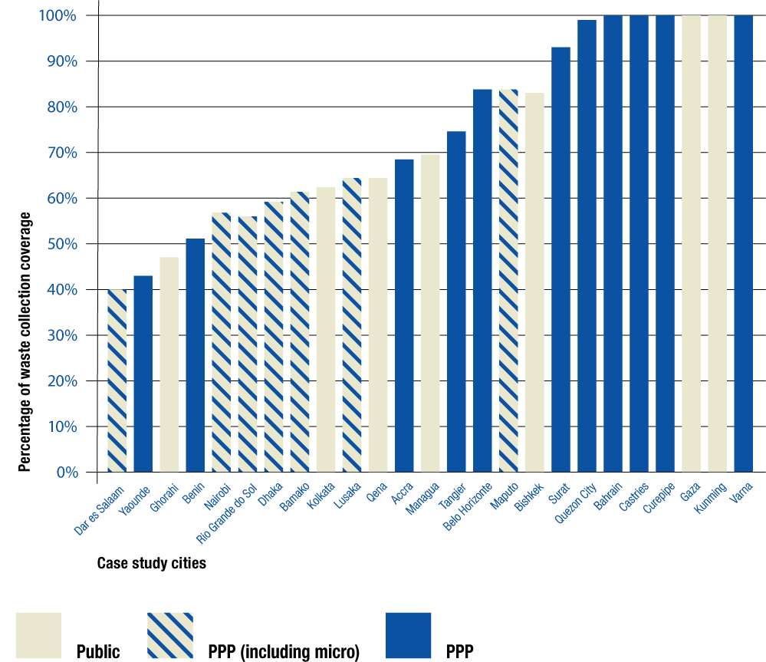
Figure 4: Collection coverage in the case study cities, showing the dominant service provider
The dominant service provider is largely as indicated in Table 4. However, for simplicity, just one category of public sector service delivery is shown. PPP (including micro) includes both those cities, which include a more formal PPP involving MSPs, and those where MSPs provide a purely private service.
MSP - micro-service provider; PPP - public-private partnership
Multiple options for waste collection
The assessment of case studies demonstrated that applying multiple options for waste collection in different areas of a city could improve the extent of collection coverage. A common feature across the eight cases shown in Table 5 was tailoring collection options according to accessibility and infrastructure of the areas being served. For example, in Lusaka, kerbside collection using compactor trucks and wheelie bins was provided by formal PPP contractors in planned settlements, while a large number of micro-PPP community-based enterprises provided primary collection in peri-urban areas. Two models were used for the latter, depending on proximity to the landfill site; most areas were served by wheelbarrows, handcarts or tricycles which delivered to containers for secondary collection by the municipality; while in areas close to the landfill, waste was collected in plastic bags by tractors/trailers which delivered direct to the site. Surat had a similar distinction between formal settlements served by motorised primary collection; and peri-urban areas served by wheelbarrows and central containers. In Varna, the formal PPP contractors provided much larger containers for apartment buildings than for kerbside collection.
Table 5: Multiple options for waste collection
Location | Dominant  Operator Model | Coverage |  | Context
Location | Dominant  Operator Model | % | Trend
Belo Horizonte | PPP (including micro) | 82% | ↔ | Five main variants. 1: In consolidated urban areas, kerbside collection using compactor trucks (62%). In urban slums and other areas with difficult access, either 2: Differentiated kerbside collection using open trucks (6%), or 3: Secondary collection from 135 communal skip containers (10%). 4. Larger generators, required to make their own arrangements (10%). 5. A parallel system for construction and demolition waste was operated through a mix of informal waste collectors, and municipal secondary collection service and recycling plants.
Bishkek | Public (commercialised public enterprise) | 83% | ↓ | The public service was split 70% daily collection from containers serving each block: 30% twice weekly door-to-door collection from lower density, generally older housing.
Castries | PPP | 100% | ↑ | All vehicles must be compactors. Twice-weekly kerbside collection in areas with good roads and pavements to permit access and placement of bins; smaller vehicles used in narrow town centre streets. In other areas, collection from centralised containers, generally daily. Monthly bulky waste collection also provided.
Ghorahi | Public | 83% (urban area only)  46% (overall) | ↑ | In 50% of the urban area, the municipality had ‘on-time’ door-to-door collection service where the municipal tipper or compactor went along the road slowly, ringing a bell to inform people of its arrival, and residents put their waste directly in to the vehicle. Elsewhere, residents deposited the waste along roadside and sweepers collected the waste into small piles and then loaded onto rickshaws made from wood planks or a large piece of tarpaulin. When full, rickshaws were emptied on to a tarpaulin at roadside and waste loaded manually into one of the larger vehicles.
Lusaka | PPP (including micro) | 63% | ↑ | Five systems in parallel. 1: Eight formal private contractors provided services under franchise in planned settlements (one operator per district, using inter alia wheelie bins and compactor trucks). 2. 73 community-based enterprises (CBEs) franchised to provide primary collection in peri-urban areas. Most used wheelbarrows, pushcarts or tricycles and delivered waste to containers, which were collected by municipality. 3. Areas near the landfill used a tractor/ trailer system along main streets, to which people brought waste in plastic bags. 4. Municipality directly serviced central business district. 5. Large waste generators could apply for licence to operate waste collection vehicles for their own waste.  All operators collect fees directly - formal operators paid for waste delivered to the landfill, CBEs did not - payment default was a problem.
Maputo | PPP (including micro) | 82% | ↑ | Five distinct operator models for waste collection. 1: Closely-spaced public containers with collection by compactor trucks for high density inner city (PPP - service contracted to a large private operator). 2: Door-to-door service for high-income residential areas in the inner city (public operation). 3: Split system in suburban areas, where MSPs provided manual door-to-door service, delivering to large containers for secondary collection (PPP, with separate service contracts for each MSP and for one large secondary collection operator). 4: Collection from several points with a tractor in one difficult-to-access rural area (public operation). 5: A purely private but licensed open competition system for large commercial waste generators.
Surat | PPP | 95% | ↑ | Several systems which worked in parallel. 90% of population served by motorised door-to-door primary collection, contracted out to 5 private contractors, one contract per each of 7 zones, who also transported to transfer stations. 10% served by public sector: street sweepers collected waste in wheelbarrows, delivered to central containers, municipality also provided secondary collection (except for one zone, contracted out). Commercial waste from hotels & restaurants collected and taken to transfer station through hotel association of Surat, which appointed and paid the contractor; the municipality only monitored the system.
Varna | PPP | 100% | ↔ | Collection services varied with the characteristics of the neighbourhood. The most common bins were 1.1m³ containers serving an apartment building and 0.24m³ containers for kerbside collection. There were also larger 4m³ communal containers and smaller containers mainly for street litter; plus separate containers for packaging wastes.
CBE - Community-based enterprise. MSP - Micro-service provider. PPP - Public-private partnership.
All four of the generic operator model types identified in Figure 3 are represented among the eight examples in Table 5. However, implementing multiple operator models in parallel does imply that the municipal ‘client’ needs a significant level of institutional capacity. Three examples are Maputo, Lusaka and Belo Horizonte, each of which had five distinct operator models for waste collection. Maputo received technical assistance from GIZ over a nine year period from 2002, with particular focus on improving waste collection, establishing a sustainable financing model (Stretz, 2012) and on strengthening all of the (local) governance aspects (see Figure 1). This resulted in an increase in city-wide collection coverage to 82% (Stretz, 2013), which compares to about 55% expected for similar low-income countries (UNEP, 2015). A semi-autonomous unit responsible for delivery of solid waste management services has also been established in Lusaka, with technical assistance from the Danish government. In Belo Horizonte, a fully autonomous institution, operating separately from the municipality, is responsible for solid waste management; it is empowered to make decisions and has control over expenditure.
Extending collection coverage through primary collection
The engagement of micro-service providers (MSPs) has been an effective way of extending collection coverage to low income areas, both within cities and in peri-urban areas, where settlements are often unplanned and lack proper access and infrastructure, thus improving the equity of service provision (Table 6). Such providers may include small- or micro-enterprises, NGOs, CBOs and Residents Associations or the informal sector. Data on the baseline collection coverage prior to an intervention were scarce in the case studies; one exception was Dar-es-Salaam, where average coverage across the city had increased from 2-4% in 1992 to 40% by 2004 (Mbuya, 2009).
In some of the cases shown in Table 6, there was a formal PPP involving the municipality working directly with the MSP, for example in Dar es Salaam, Lusaka, Maputo, Nairobi and Rio Grande do Sul. In Belo Horizonte, the PPP was with co-operatives of former waste pickers and focused on collection for recycling. In Dhaka, communities had self organised to develop MSPs to provide primary collection services to enhance the publicly-provided SWM service from communal points across the planned city, while NGOs provided the only available service in many unplanned areas. In Surat, the city had involved Resident Welfare Associations to improve community participation and increase the uptake of the available SWM services. In Bamako, women’s groups first set up microenterprises / community cooperatives to provide both youth employment and a primary waste collection service, which at the time of the case study provided a ‘private’ service across the city; smaller ‘informal’ service providers had also emerged to provide competition to the microenterprises in poorer areas. In Accra, in those areas where the formal PPP contractors provided only communal containers, informal waste porters provided a service to take waste to the containers; a similar system was operated by CBOs in Yaoundé.
Table 6: Micro-service provider (MSP) participation in primary waste collection
Location | Dominant operator model | Coverage |  | Context
Location | Dominant operator model | % | Trend | Context
Accra | PPP | 67% | ↕ | PPP contractors provided a door-to-door service in richer areas and communal containers in peri-urban areas. In the latter, informal ‘Kaya Bola’ (waste porters) provided a service to those who paid for their waste to be taken to the containers.
Bamako | Private (micro)  + Public | 57% | ↑ | Primary collection by 120 private microenterprises - originally founded as community co-operatives by women’s groups to provide youth employment. Later faced competition from informal collectors in poorer areas.
Belo Horizonte | PPP (including micro) | 82% | ↔ | Co-operatives of former informal sector workers actively engaged in formal waste management system. As well as collection and sorting of recyclables, collected construction and demolition waste using horse-drawn carts.
Dar es Salaam | PPP (including micro)  +Public | 40% | ↕ | PPP in 43 out of 73 wards. Formal contractors competed for franchises in the richer areas where the fee rate was higher. In low-income, newly developed and other areas distant from the city centre, community based MSPs were franchised to provide primary collection delivering to local transfer stations; transport to disposal site was by the formal contractors.
Dhaka | Public  + Private (micro) | 55% | ↑ | Primary collection by semi-formal MSPs covered most of the planned city. In low income, unplanned areas (30% of population), little service provision. NGOs working in some areas had introduced primary collection or decentralised composting.
Lusaka | PPP (including micro) | 63% | ↑ | Due to the unattractive nature of franchises for waste collection in peri-urban areas to the formal private sector, the municipality organised community based MSPs for primary collection.
Maputo | PPP (including micro) | 82% | ↑ | A total of 35 micro-enterprises or associations had been contracted by the municipality through a competitive bidding process, combined with training and capacity development. The training continued and regular meetings were held with all operators to discuss operational and contractual issues every month. These microenterprises provided waste collection for more than 900,000 people and were a focal point for community involvement and other services.
Nairobi | PPP (including micro) | 52% | ↑ | In low income areas including informal settlements, the Municipality and its contractors worked with youth groups and CBOs to collect waste from households and deposit it in at designated collection points.
Rio Grande do Sul | PPP (including micro) | 95% (urban)  55% (overall)) | ↔ | 17 out of 30 municipalities contracted collection to small- or micro- local enterprises, either by letter of invitation or call for tender.
Surat | PPP | 93% | ↑ | To deliver the goal of daily sweeping and 100% cleanliness, the municipality involved Resident Welfare Associations (a kind of Citizens Association of CBO) to enhance community participation in cleaning of streets and monitoring primary collection services in 620 of the residential colonies.
Yaoundé | PPP | 43% | ↑ | CBOs operated a door-to-door collection service for a fee in some high-income areas, delivering to the PPP communal collection points. CBOs and informal sector provided a service in some neglected areas of the city.
CBO - Community-based organisation. MSP - micro-service provider. NGO - Non-governmental organisation. PPP - public-private partnership.
One-step and secondary collection
While MSPs are effective at delivering primary waste collection services to their local communities, the evidence suggests that the municipality, and larger or medium-sized companies usually provide other aspects of the collection service. These often involve use of motorised vehicles to transport the waste to often distant disposal sites, and thus require more capital investment and a supporting financing, management and maintenance infrastructure.
In some cases, waste collection is undertaken in one-step, without the distinction between primary and secondary collection. This is often the case when householders deliver their own waste directly to (closely spaced) communal collection points, or where the waste is collected in larger vehicles using a block or kerbside method. Among the case studies, we identified 21 examples of one-step collection services, of which 12 were provided by a PPP and 9 by the public sector.
Where primary and secondary collection services are split, the interface between them is critical in designing the waste management system. In Dhaka, the move to extend primary collection services was driven both by demand from residents for a door-to-door service, and also by a desire to reduce the number and spacing of the communal collection points, as these were increasingly being rejected by their immediate neighbours due to environmental and health concerns. In China, both communal collection points and small, local transfer stations are increasingly being moved off street (e.g. the ‘waste houses’ in Kunming). Among our sample of case studies, we identified 15 examples of separate secondary collection, 11 of which were provided by public services or a commercialised public enterprise.
Revenue collection
The revenue collection function is an important component of the operator model (Figure 1). The level of detail available in the secondary case studies was relatively poor and inconsistent, with some information available for 15 out of 28 cities; detailed mapping of the revenue collection function was only possible for the five purpose-designed case studies. This showed that there were generally many different mechanisms in use, with variations even within the same city. Figure 5 both illustrates and comments on the revenue collection methods used for waste collection across the five cases.
In most cases, the municipality paid the operator for the waste collection services, whether that was the public sector (as in Qena city), formal sector private companies through PPP (as in Surat and Castries, St Lucia) or a mix of the public sector and PPP including both larger and micro-service providers (as in Maputo and Rio Grande do Sul). The exception was in the semi-urban areas around Qena, where the NGO service provider collected fees directly from the user; in the secondary case studies, a similar direct fee collection system by the PPP service provider operated in Accra and Dar es Salaam; in all of these cases, the level of fee was set by the municipality.
Where the municipality paid the service provider, the revenue collector function varied widely. A specific waste tariff or cleansing tax may be applied. For example, this was collected in Maputo and Qena city by the electricity company (Figure 5), and this method was also used in Bahrain. In 23 of the 30 municipalities in Rio Grande do Sul, an annual service charge was levied (Figure 5); a similar system operated in Belo Horizonte and Tangier; in Managua, municipal workers collected waste collection charges door-to-door; and in Yaoundé, a waste collection tax was deducted from the wages of those in formal employment (a minority of the population). In other cases, waste was charged as part of the property tax, e.g. in Surat (Figure 5) and Varna.
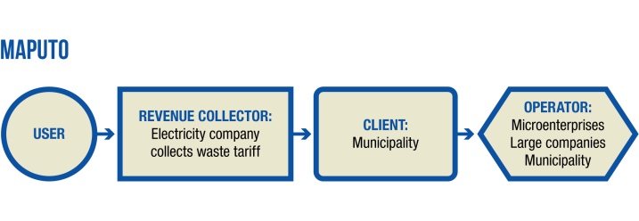 | 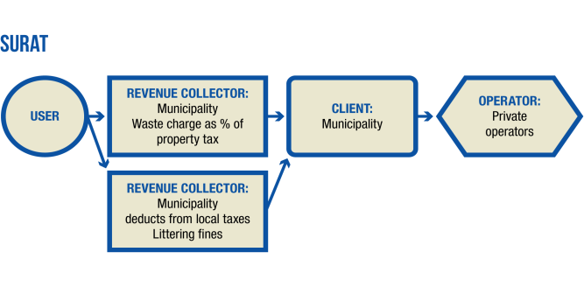
In Maputo, the waste fee was charged monthly through the national Electricity Company. This method was very effective as the payment rate was above 90%. The city had benefited from development financing. The goal for the end of 2012 was 100% cost recovery for investment and operation costs from collected revenue. | Surat was doing well covering its cost from direct municipal charges on waste collected together with property tax (as 5% of property tax annually). The payment rate was 92%.  Collection and transfer were paid for through the same money flow based on the tons handled. There were other municipal sources complementing this budget to cover 100% of operation and re-financing costs.
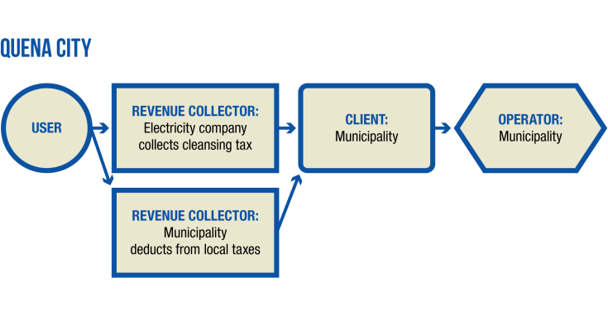 | 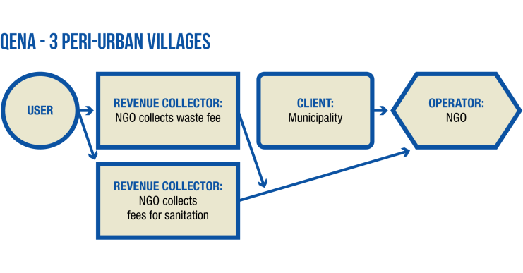
In Qena city, the waste fee was charged monthly, payment rates were very low, but even when these were higher in the past, they were far from covering operation costs. Due to this the city was heavily reliant on state budgetary transfers.  The cost for waste management was monitored but not centralized so the actual cost-recovery rate was not known. | NGOs established through development assistance collected revenues from users directly, based on verbal agreements.  All three NGOs financed their operation cost by cross-subsidizing the service with the service of cleaning septic tanks. For re-financing they relied on the Municipality.
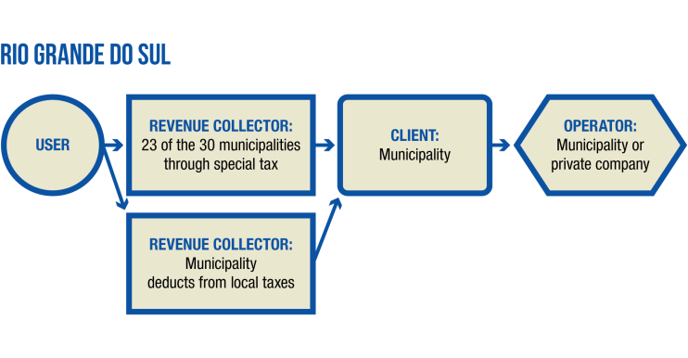 | 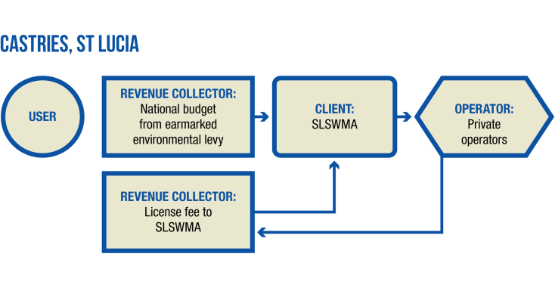
In 23 out of the 30 municipalities in Rio Grande do Sul, households were charged a yearly service fee. In these cities cost recovery rates varied from 7 % to 77% of the costs, depending on the payment rates in the municipalities that varied very widely.  The Federal and State government both provided funds in various forms to close the gap and to support re-financing and investment. | In St Lucia, there were no user charges for waste management. Waste management was organized at national level and paid from the national budget. The main source of financing was funds collected through an Environmental Levy on imported goods and tourism. In addition, residents paid indirectly for waste management services through income and property tax. The authority received some minor funds from license fees issued to waste handling companies, mainly collection companies.
Figure 5: How MSW collection services were paid for in the five detailed case studies
Source: Soós et al., 2013a
NGO : non-governmental organisation.

In all of these cases where a direct or semi-direct charge was being levied for waste services, payment rates were less than 100%. Payment rates above 90% were reported in Maputo and Surat (Figure 5), and also in the more affluent areas of Accra. Much lower payment rates were also reported; in Rio Grande do Sul from 7-77% (Figure 5); in lower income areas of Accra, 60-70%; Dar es Salaam less than 50%; Managua only 25%; and Qena city, ‘very low’.
Directly collected waste fees often do not cover all the costs of providing the MSWM service. Cost coverage is likely to be highest for waste collection, which has been the focus here, as people are more willing to pay for primary waste collection, to get waste ‘out from under foot’ to protect the health of their children, than for less visible aspects of the service such as secondary collection or disposal - this reinforces the results of earlier research (Scheinberg et al., 2010). The shortfall is generally made up either by the municipality itself, using other locally collected taxes, as in Figure 5 in Surat, Qena city and Rio Grande do Sul, and elsewhere in Belo Horizonte (where 50-60% of the budget was financed by central municipal funds); or by the national government, as in Figure 5 in St Lucia (funded via an explicit environmental levy on imported goods and tourism), in Qena and Rio Grande do Sul (where central government transfers complemented the direct fees and local taxes), and also in Chongqing and Kunming (where MSWM was paid from general taxation collected centrally).
Typology of common operator models (coms)
In principle, a large number of possible operator models can be identified across the three primary dimensions of: the physical elements within the MSWM system (at least ten unit operations or combinations); the category of operator (see Figure 3 - at least five options); and the mechanisms for contracting between the client and the operator (at least four options). In practice, not all of the 200+ possible combinations of these three variables are likely; the evidence gathered here was used to identify which are in more widespread use. Table 7 presents a typology or categorisation of the resulting common operator models (coms), showing in each row the unit operations or combinations, and in each column the category of operator and (where applicable) the mechanism of contracting.

CONCLUSIONS
The evidence presented here shows there is no ‘standard’ operator model that is appropriate in all developing countries and in all circumstances for the delivery of SWM services. The use of a single operator model for delivering all aspects of the municipal solid waste management service is extremely unusual, with just one example of purely public service delivery among our 28 detailed case studies (in Gaza) and just one example where all services were contracted to a single private sector contractor (in Tangier). It is much more common for more than one operator model to exist side-by-side within the same city. Across the initial 134 case studies, the average was 2.5 operator models per city. For the same dataset, there were similar numbers for service delivery by the public sector, by the formal private sector through a public-private partnership (PPP) and by micro-service providers (MSPs) through PPP. The finding when all types of MSPs were considered together, including micro-enterprises, various types of community-based organisations and enterprises and the informal sector, was that they outnumbered either the public sector, or small-, medium- and large- formal private sector companies, as service providers.

Table 7: Typology of common operator models (coms)
Unit operation | Service Operator | Public |  | Public-Private | Micro scale | PPP - small, medium or larger private companies
Unit operation | Service Operator | Public authority | Public enterprise | Joint venture | Micro service providers (MSPs) | Contracted | Concession | Franchise | Open competition
Street sweeping |  |  |  |  | com2 (residents or resident association)  com3 (PPP: NGOs or CBOs) | com4
Primary collection (integrated with secondary collection) |  | com5 |  |  |  | com8
Primary collection |  |  |  |  | com6 (PPP: franchise)  com7 (PPP: contracted)
Secondary/ one-step collection |  | com9 | com10 | com14 |  | com11 | com12 | com13
Commercial waste collection |  | com15 |  |  |  |  |  | com16 | com17
Transfer |  | com18 |  |  |  | com19 | com20
Recycling |  | com21 |  |  | com24 (informal) | com22 |  | com23 | com24
EPRᵃ |  |  | com26ᵃ |  |  | com25ᵃ
Composting |  | com27 |  |  | com30 (PPP) | com29 (service) | com28
Incineration |  |  |  |  |  | com31 (DBO) | com32 (DBFO)
Landfill |  | com33 |  |  | com34 (co-operative)ᵇ | com35 (service)  com36 (DBO) | com37 (DBFO)
Integrated service |  | com38 |  | com40 |  |  | com39 (DBFO)
Integrated resource recovery |  | com41 |  |  |  | com42
Notes: The table simplifies the 200+ possible operator models into 42 common operator models (coms) which are relatively widespread. Each com covers one ‘unit operation’ or physical element of MSWM, or integrates part or all of the overall MSWM service, as shown in the rows of the table. The columns broadly classify the options for who performs the ‘operator’ function (i.e. who actually delivers the service), as shown schematically in Figure 3; a column for formal public-private joint ventures has been included; and all the micro-service provision options have been combined into one column (with each option being elaborated specifically). For formal PPP, columns are shown for four different contracting mechanisms. The ‘contracted’ column denotes a management contract, unless a service contract or a design-build operate (DBO) contract is specified. The concept of the coms was conceived by Andrew Whiteman, and details of each com as developed by the GIZ project team are provided in Soós et al. (2013a). This table © David C Wilson.
ᵃ This row covers the coms for administering an extended producer responsibility (EPR) system.
ᵇ This com indicates a PPP with a co-operative of waste pickers on a landfill site to sort wastes for recycling prior to final disposal.
CBO - Community-based organisation. com - common operator model. DBFO - Design, Build, Finance, Operate. DBO - Design, Build, Operate. EPR - extended producer responsibility. MSP- Micro-service provider. NGO - Non-governmental organisation. PPP - Public-private partnership.
Among the 28 detailed case-studies, the dominant service provider was divided into three almost equal groups, either mainly public or mainly private through PPP or a relatively balanced mix of the two. Some services were delivered by the public sector in 23 out of 28 cases, by a PPP involving formal private companies in 19 cases and by a PPP involving MSPs in 11 cases. Purely private provision of services (as opposed to through a PPP) is most common for recycling provided by the informal sector.
To provide a flavour for the depth and breadth of the evidence collected, the detailed evidence on operator models for waste collection from the detailed case studies has been presented and analysed. The results show that there is no specific type of operator model associated with higher rates of collection coverage. Indeed, service delivery by both the public sector and by PPP with formal private companies can deliver high rates of collection coverage, but there are also examples of relatively low rates of coverage by both models. There is however strong evidence of success for two specific approaches to waste collection:
- Use of multiple options. Applying multiple options for waste collection in different areas of a city can improve the extent of collection coverage. A common feature of successful systems is tailoring collection options according to accessibility and infrastructure of the areas being served.
- Extending collection coverage through primary collection. The engagement of multiple micro-service providers (MSPs) through PPP has been an effective way of extending collection coverage to low income areas, both within cities and in peri-urban areas, where settlements are often unplanned and lack proper access and infrastructure, thus improving the equity of service provision.
The type of entity that delivers the MSWM service is just one of three critical aspects of an operator model (Figure 2). The evidence confirmed the conventional view that the client function was generally placed with municipal government. A contractual relationship between the municipality as ‘client’ and a PPP service delivery partner was implied in 119 out of the initial 134 case studies. The existence of a strong client organisation responsible for MSWM within the municipality is identified as a prerequisite for effective delivery of MSWM services. The client organisation requires both a stable political basis that maintains a continuity of policy and decision making concerning MSWM between different administrations and stable financial backing; it should also function transparently in a non-corrupt environment. Another important factor is that the client organisation requires strong, professional capacity to undertake its demanding responsibilities. Municipalities where an autonomous department has sole responsibility for MSWM are often the most effective at finding innovative solutions to service delivery. This reinforces earlier findings that political will and attitude, and attention to the governance aspects shown in Figure 1, are of critical importance to achieving sustainable improvements to MSWM in developing and emerging economies (Scheinberg et al., 2010).
The third component of an operator model is the revenue collector. Direct collection of fees by the service provider from the householder at the point of service delivery is relatively uncommon; more often the municipality pays the public or PPP service provider. The municipality may levy an explicit charge, which may be collected directly, or along with electricity (or water) bills, or with property tax. In several cases, payment collection rates of over 90% were achieved in the case study cities, but very low rates were also reported. In most of the cases, direct fees do not cover the full costs of providing the MSWM service; municipalities make up the deficit by using local taxes, or by transfers from national government (i.e. from general taxation). However, it can be argued that the service user ultimately pays for the MSWM service - the difference is in how directly that charge is levied. The element of the overall MSWM service most likely to be funded through the direct payment of user fees is primary collection, for which people are more willing to pay as they can see the benefits in terms of protecting the health of their children, regardless of their income level.
From the evidence, it is not possible to conclude that any particular MSWM operator model is inherently better than any other. Both public sector service delivery, PPP using the formal private sector and PPP using micro-service providers can all deliver effective services; each can be made to work, or allowed to fail. One overall conclusion is that a blend of public and private service providers can often provide the most resilient framework towards sustainable MSWM solutions. What matters far more than whether services are operated by the public or private sector is the existence of a strong client organisation responsible for MSWM within the municipality, to ensure that the services are implemented to the desired quality and performance; combined with political backing to ensure that the necessary revenues and budget are available, on time.
Another key conclusion is the importance of capacity building. This should include developing the capacity of both public and private service providers, particularly where micro-service providers are to be involved. It should also include developing the capacity of client institutions so that they can take their own decisions and successfully implement and monitor service arrangements/ operator models that suit the local conditions and capacities. This latter aspect is explored further in part B of this paper (Soós et al., 2016), where the set of common operator models (coms), identified here on the basis of the evidence from the case studies, is used as the basis for a series of decision support tools to assist in selecting the most appropriate operator models for use in a specific local situation.
Acknowledgments
We would like to acknowledge the authors of all the case studies contributing to the evidence base on which this paper is based; and in particular the five primary case studies developed specifically for the ‘Operator Model’ project: Borislav Mourdzhev, Joachim Stretz, Michael Cowing, Rami El Sherbiny, Sanjay Gupta and Thilo Schmidt. We would like to thank other members of the client team at GIZ, in particular Ellen Gunsilius, Sofia Nürnberger (formerly García-Cortés) and Johannes Frommann for their direction; and also our colleagues at ERM Germany, RWA, Wasteaware and Imperial College London. We thank the wider project team for their support and collaboration, including: Ekkehard Schwehn, Nikola Doychinov, Sonya Yankova, Daniel Ros, Cristina Rus, Flaviu Petean, Beth Baylay, Monir Chowdhury, Shafiul Ahmed, Kevin Kerwin, Claudia Chelaru and Sonia Dias.
Declaration of conflicting interests
The authors declared no potential conflicts of interest with respect to the research, authorship, and/or publication of this article.
Funding
The authors disclosed receipt of the following financial support for the research, authorship, and/or publication of this article: This work was funded by the Deutsche Gesellschaft für Internationale Zusammenarbeit (GIZ), on behalf of the German Federal Ministry for Economic Cooperation and Development (BMZ), as part of the sector project ‘Concepts for sustainable solid waste management’.
REFERENCES
Abarca-Guerrero, L., Maas, G. & Hogland, W. (2013). Solid waste management challenges for cities in developing countries. Waste Management, 33, 220-232.
Al Sabbagh, M.K., Velis, C.A., Wilson, D.C. & Cheeseman, C.R. (2012). Resource management performance in Bahrain: a systematic analysis of municipal waste management, secondary material flows and organizational aspects. Waste Management & Research, 30(8), 813-824.
Andres-Po, A. & Tatlonghari, P. A. M. (2009). Presentation of Solid Waste Management and Recycling in Quezon City, Philippines in 2009. City case study prepared for UN-Habitat book (Scheinberg et al., 2010, op. cit.). Unpublished.
Bortoleto, A. P. & Hanaki, K. (2007). Report: Citizen participation as a part of integrated solid waste management: Porto Alegre case. Waste Management & Research, 25: 276–282.
Bozhilova-Kisheva, K. & Ikonomov, L. (2009). Presentation of Solid Waste Management and Recycling in Varna, Bulgaria in 2009. City case study prepared for UN-Habitat book (Scheinberg et al., 2010, op. cit.). Unpublished.
Cahill, R., Grimes, S.M. & Wilson, D.C. (2011). Extended producer responsibility for packaging wastes and WEEE - a comparison of implementation and the role of local authorities across Europe. Waste Management & Research, 29(5), 455-479.
Chattopadhyay, S., Dutta, A. & Ray, S. (2009). Municipal solid waste management in Kolkata, India - A review. Waste Management, 29, 1449-1458.
Christensen, T.H. (Ed.) (2011). Solid Waste Technology and Management (2 volumes). Chichester: Wiley.
Coad, A. (2005). Private Sector Involvement in Solid Waste Management, Avoiding Problems and Building on Successes. Report for GIZ and BMZ. Full report published Eshborn: GIZ, summary report St Gallen: CWG. Both versions available at: http://www.giz.de/en/mediacenter/publications.html (Accessed 21.10.16).
Coffey, M. & Coad, A. (2010). Collection of municipal solid waste in developing countries, 2nd edition. ISBN: 978-92-1-132254-5. Nairobi: UN-Habitat. Available at: http://unhabitat.org/books/collection-of-municipal-solid-waste-in-developing-countries-2/ (Accessed 21.10.16).
Cointreau, S. (1994). Private sector participation in Municipal Solid Waste Services in Developing Countries. Urban Management Programme Paper UMP 13. Washington: World Bank. Available at: http://documents.worldbank.org/curated/en/325321468739287095/Private-sector-participation-in-municipal-solid-waste-services-in-developing-countries (Accessed 21.10.16).
Cointreau, S (2000). Private Sector Participation in Municipal Solid Waste Management: Guidance Note. Volume 2, in Cointreau et al., 2000 (op.cit.).
Cointreau, S., Gopalan, P. & Coad, A. (2000). Private Sector Participation in Municipal Solid Waste Management. World Bank Toolkit, 5 volumes. Washington: World Bank.
Cowing, M.J. (2013). Operator Models. Respecting Diversity. Annex 4 - St Lucia Case Study. Eschborn: GIZ. Available at: http://www.giz.de/en/mediacenter/publications.html (Accessed 21.10.16).
Dias, S. M., IJgosse, J. & Barros, R. T. V. (2009). Presentation of solid waste management and recycling in Belo Horizonte, Brazil in 2009. City case study prepared for UN-Habitat book (Scheinberg et al., 2010, op. cit.). Unpublished.
Dorvil, L. (2007). Private sector participation in integrated sustainable solid waste management in low and middle income countries. Economics PhD thesis, University of St. Gallen. Available at: http://verdi.unisg.ch/www/edis.nsf/SysLkpByIdentifier/3381?OpenDocument&lang=en (Accessed 21.10.16).
Ezeah, C., Fazakerley, J.A. & Roberts, C.L. (2013). Emerging trends in informal sector recycling in developing and transition countries. Waste Management, 33, 2509-2519.
Fobil, J.N., Armah, N.A., Horgah, J.N. & Carboo, D. (2008). The influence of institutions and organizations on urban waste collection systems: an analysis of waste collection systems in Accra, Ghana (1985-2000). Journal of Environmental Management, 86: 262-271.
García-Cortés, S., Whiteman, A., Soós, R., Wilson, D.C. & Schwehn, E. (2013). Guidance on the selection of operator models for solid waste management in emerging and developing countries. Proceedings Sardinia 2013, Fourteenth International Waste Management and Landfill Symposium, S. Margherita di Pula, Cagliari, Italy; 30 September - 4 October 2013.
Gunsilius, E., Spies, S., García-Cortés, S., Medina, M., Dias, S., Scheinberg, A., Sabry, W., Abdel-Hady, N., Florisbela dos Santos, A. & Ruiz, S. (2011). Recovering resources, creating opportunities: Integrating the informal sector into solid waste management. Eschborn: GIZ. Available at: https://www.giz.de/de/downloads/giz2011-en-recycling-partnerships-informal-sector-final-report.pdf (Accessed 21.10.16).
Gupta, S.K. (2013). Operator Models. Respecting Diversity. Annex 5 - Surat Case Study. Eschborn: GIZ. Available at: http://www.giz.de/en/mediacenter/publications.html (Accessed 21.10.16).
Hazra, T. & Goel, S. (2009). Solid waste management in Kolkata, India: Practices and challenges. Waste Management, 29, 470-478.
Hoornweg, D. & Bhada-Tata, P. (2012). What a waste: A global review of solid waste management. Urban development series: knowledge papers no. 15. Washington, World Bank. Available at: https://openknowledge.worldbank.org/handle/10986/17388 (Accessed 21.10.16)
Hui, Y., Li’ao, W., Fenwei, S. & Gang, H. (2006). Urban solid waste management in Chongqing: Challenges and opportunities. Waste Management, 26, 1052-1062.
IJgosse, J., Dias, S., Barros, R. and Rodic, L. (2013). Solid Waste Management and Recycling in Belo Horizonte, Brazil - 2013 update. City case study originally prepared for UN-Habitat book (Scheinberg et al., 2010, op. cit.). Unpublished.
Jaligot, R., Wilson, D.C., Cheeseman, C.R., Shaker, B. & Stretz, J. (2016). Applying value chain analysis to informal sector recycling: a case study of the Zabaleen. Resources, Conservation and Recycling, 114, 80–91.
Kabungo, M. K. & Lifuka, R. L. (2009). Presentation of solid waste management and recycling in Lusaka, Zambia in 2009. City case study prepared for UN-Habitat book (Scheinberg et al., 2010, op. cit.). Unpublished.
Kanjogera, J.B. (2012). Operator models for solid waste management in developing countries. Environmental Engineering MSc thesis, Imperial College London.
Kaseva, M. E. & Mbuligwe, S. E. (2005). Appraisal of solid waste collection following private sector involvement in Dar es Salaam city, Tanzania. Habitat International, 29, 353-366.
Kassim, S. M. (2009). Sustainability of private sector in municipal solid waste collection: Is it possible? Paper 112 in: 34th WEDC International Conference, 2009, Water, Sanitation and Hygiene: Sustainable Development and Multisectoral Approaches, 18–22 May 2009, Addis Ababa, Ethiopia. Loughborough: Loughborough University of Technology. Available at: http://wedc.lboro.ac.uk/resources/conference/34/Kassim_S_M_-_112.pdf (Accessed 21.10.16).
Kassim, S. M. & Ali, M. (2006). Solid waste collection by the private sector: Households' perspectives - Findings from a study in Dar es Salaam city, Tanzania. Habitat International, 30, 769-780.
Kéita, M., Trauba, E., Gassama, M., Diallo, B. & Traoré, M. (2009). Presentation of solid waste management and recycling in Bamako, Mali in 2009. City case study prepared for UN-Habitat book (Scheinberg et al., 2010, op. cit.). Unpublished.
Kirimi, M., Oyake-Ombis, L. & Rodic., L. (2009). Presentation of solid waste management and recycling in Bamako, Mali in 2009. City case study prepared for UN-Habitat book (Scheinberg et al., 2010, op. cit.). Unpublished.
Linzner, R. & Lange, U. (2013). Informal sector activities in waste management: a literature review. Proceedings of the Institution of Civil Engineers, Waste and Resources Management, 166, WR2, 69-83.
Mbuya, E. (2009). Solid waste management in Dar es Salaam: Privatizing and improving revenue collection. Coastal cities summit - paper published 17.11.2008, updated 09.10.2009. Available at: ioiusa.net/view/article/141601/ (Accessed 21.10.16).
Mourdzhev, B. & El Shebriny, R. (2013). Operator Models. Respecting Diversity. Annex 6 - Surat Case Study. Eschborn: GIZ. Available at: http://www.giz.de/en/mediacenter/publications.html (Accessed 21.10.16).
Obirih-Opareh, N. & Post, J. (2002). Quality assessment of public and private modes of solid waste collection in Accra, Ghana. Habitat International, 26, 95-112.
OECD (2016). Extended Producer Responsibility: Updated Guidance for Efficient Waste Management. Paris: OECD. Available at: http://www.oecd.org/env/extended-producer-responsibility-9789264256385-en.htm (Accessed 21.10.16).
Ogu, V. I. (2000). Private sector participation and municipal waste management in Benin City, Nigeria. Environment and Urbanization, 12, 103-117.
Olley, J., IJgosse, J. & Rudin, V. (2009). Presentation of Solid Waste Management and Recycling in Managua, Nicaragua in 2009. City case study prepared for UN-Habitat book (Scheinberg et al., 2010, op. cit.). Unpublished.
Olley, J., IJgosse, J., Rudin, V. & Alabaster, G. (2014). Developing a common framework for integrated solid waste management advances in Managua, Nicaragua. Waste Management & Research, 32, 822-833.
Oteng-Ababio, M. (2010). Private sector involvement in solid waste management in the Greater Accra Metropolitan Area in Ghana. Waste Management & Research, 28, 322-329.
Oteng-Ababio, M., Arguello, J.E.M. & Gabbay, O. (2013). Solid waste management in African cities: Sorting the facts from the fads in Accra, Ghana. Habitat International, 39, 96-104.
Parrot, L., Sotamenou, J. & Dia, B. K. (2009). Municipal solid waste management in Africa: Strategies and livelihoods in Yaoundé, Cameroon. Waste Management, 29, 986-995.
Rodic, L. & Wilson, D.C. (2017). Resolving governance issues to achieve priority SDGs related to solid waste management. Sustainability, 9: 404. DOI: 10.3390/su9030404.
Rodic, L. & Yang, Y.L. (2009).Presentation of Solid Waste Management and Recycling in Kunming, Yunnan Province, China in 2009. City case study prepared for UN-Habitat book (Scheinberg et al., 2010, op. cit.). Unpublished.
Safi, W. & Luecke, M. (2007). Higher efficiency and effectiveness in public services through regional approaches - Joint Solid Waste Management Councils. Proceedings Sardinia 2007, Eleventh International Waste Management and Landfill Symposium, S. Margherita di Pula, Cagliari, Italy; 1-5 October 2013.
Scheinberg, A., Wilson, D.C. & Rodic, L. (2010). Solid Waste Management in the World's Cities: Water and Sanitation in the World's Cities, 2010 edition. Prepared on behalf of UN-HABITAT. London: Earthscan. Available at: http://www.waste.nl/en/product/solid-waste-management-in-the-worlds-cities (Accessed 21.10.16).
Scheu, M. and Borno, S. (2005). A commercialized public sector unit serving 11 communities. Case Study D in Coad (2005), op.cit., pp 145-150.
Schmidt, T.H. (2013). Operator Models. Respecting Diversity. Annex 3- CIGRES Case Study. Eschborn: GIZ. Available at: http://www.giz.de/en/mediacenter/publications.html (Accessed 21.10.16).
Schmidt, T.H., García-Cortés, S. & Wilson, D.C. (2014). A tool for the selection of Operator Models for inter-municipal associations of municipal solid waste management – case studies from Brazil. Proceedings of ISWA World Congress 2014, 8-11 September, Sao Paolo, Brazil. Vienna: International Solid Waste Association (ISWA).
Schübeler, P., Wehrle, K. & Christen, J. (1996). Conceptual Framework for Municipal Solid Waste Management in Low-Income Countries. UMP/SDC Collaborative Programme on Municipal Solid Waste Management in Developing Countries. Urban Management Programme (UMP) Working Paper Series, No. 9., pp. 59. St Gallen: SKAT.
Sim, N.M., Wilson, D.C., Velis, C.A. & Smith, S.R. (2013). Waste management and recycling in the former Soviet Union – Case study of Bishkek, Kyrgyz Republic (Kyrgyzstan). Waste Management & Research, 31 (10 Supplement), 106-125.
Sinha, A.H.M.M. and Enayetullah, I. (2010). Waste Concern and worldwide recycling: financing Dhaka market composting with public-private partnerships and carbon credits. Key Sheet 9, in Scheinberg et al. (2010, op. cit.), pages 117-123.
Soós, R., Whiteman, A.D., Wilson, D.C., Briciu, C. & Schwehn E. (2013a). Operator Models. Respecting Diversity. Concepts for Sustainable Waste Management. Eschborn: GIZ. Available at: http://www.giz.de/en/downloads/giz2013-swm-operator-models-sourcebook-en.pdf (Accessed 21.10.16).
Soós, R., Whiteman, A.D., Wilson, D.C., Briciu, C. & Schwehn E. (2013b). Operator Models – Respecting Diversity. Guidance Paper for Solid Waste Management Practitioners. Eschborn: GIZ. Available at: http://www.giz.de/en/downloads/giz2013-swm-operator-models-guidance-paper-en.pdf (Accessed 21.10.16).
Soós, R., Whiteman, A.D., Wilson, D.C., Briciu, C., Nürnberger, S., Oelz, B., Gunsilius, E. & Schwehn E. (2017). Operator Models for delivering municipal solid waste management services in developing countries: Part B - Decision Support. Waste Management & Research, DOI:10.1177/0734242X17704717.
Stentiford, E. & Mohee, R. (2009). Presentation of solid waste management and recycling in Curepipe, Mauritius in 2009. City case study prepared for UN-Habitat book (Scheinberg et al., 2010, op. cit.). Unpublished.
Stretz, J. (2012). Economic Instruments in Solid Waste Management - Case Study Maputo, Mozambique. Eshborn: GIZ. Available at: https://www.giz.de/en/downloads/giz2012-en-economic-instruments-mozambique.pdf (Accessed 24.10.16)
Stretz, J. (2013). Operator Models. Respecting Diversity. Annex 7 - Maputo Case Study. Eschborn: GIZ. Available at: http://www.giz.de/en/mediacenter/publications.html (Accessed 21.10.16).
Tukahirwa, J. T., Mol, A.P.J. & Oosterveer, P. (2013). Comparing urban sanitation and solid waste management in East African metropoles: The role of civil society organisations. Cities, 30, 204-211.
Tuladhar, B. (2009). Presentation of solid waste management and recycling in Gorahi, Nepal in 2009. City case study prepared for UN-Habitat book (Scheinberg et al., 2010, op. cit.). Unpublished.
UNEP (2015). Global Waste Management Outlook. Editor-in-Chief: Wilson, D.C. Authors: Wilson, D.C., Rodic, L., Modak, P., Soos, R., Carpintero, A., Velis, C.A., Iyer, M.,, Simonett, O. Prepared for UNEP and ISWA. Osaka: UNEP. Available at: http://www.unep.org/ietc/what-we-do/global-wastemanagement-outlook-gwmo (Accessed 21.10.16).
UN-Habitat (2012). Recycling and disposal of municipal solid waste in low and middle-income countries: perspectives for municipal managers and environment agencies. Nairobi: UN-Habitat. Available at: http://mirror.unhabitat.org/downloads/docs/Recycling%20and%20disposal%20of%20solid%20waste%20in%20low%20and%20middle-income%20countries.pdf (Accessed 21.10.16).
Van de Klundert, A. & Anschütz, J. (2001). Integrated Sustainable Waste Management - the Concept. WASTE, Gouda, The Netherlands. Available at: http://www.waste.nl/en/concept-tool-iswm (Accessed 05.08.2016).
Velis, C. A., Wilson, D. C., Rocca, O., Smith, S. R., Mavropoulos, A. & Cheeseman, C. R. (2012). An Analytical Framework and Tool for Integrating the Informal Recycling Sector in Waste and Resource Management Systems in Developing Countries. Waste Management and Research, 30 (9 Suppl), 43-66.
Whiteman, A., Chowdhury, M., Ahmed, S. A., bin Yusuf, T., Murtaza, G. & Rodic, L. (2009). Presentation of solid waste management and recycling in Dhaka, Bangladesh in 2009. City case study prepared for UN-Habitat book (Scheinberg et al., 2010, op. cit.). Unpublished.
Wilson, D.C. (2007). Development drivers for waste management. Waste Management & Research, 25, 198-207.
Wilson, D.C. and Cowing M.J. (2013). Operator Models. Respecting Diversity. Annex 2 - Benchmark Indicators for Integrated Sustainable Waste Management (ISWM) - Methodology and in-depth case studies results. Eschborn: GIZ. Available at: http://www.giz.de/en/mediacenter/publications.html (Accessed 08.08.2016).
Wilson, D. C., Whiteman, A. & Tormin, A. (2001). Strategic Planning Guide for Municipal Solid Waste Management. Washington: World Bank.
Wilson, D.C., Araba, A.O., Chinwah, K., Cheeseman, C.R. (2009). Building recycling rates through the informal sector. Waste Management, 29, 629-635.
Wilson, D. C., Rodic, L., Scheinberg, A., Velis, C. A. & Alabaster, G. (2012a). Comparative analysis of solid waste management in 20 cities. Waste Management & Research, 30 (3), 237-254.
Wilson, D.C., Kanjogera, B.J., Soós, R. and Briciu, C. (2012b). Operator Models. Respecting Diversity. Annex 1 - Templates used for data collection – mapping exercise. Eschborn: GIZ. Available at: http://www.giz.de/en/mediacenter/publications.html (Accessed 08.08.2016).
Wilson, D.C., Velis, C.A., Rodic, L. (2013a). Integrated sustainable waste management in developing countries. Proceedings of the Institution of Civil Engineers, Waste and Resource Management, 166, WR2, 52-68.
Wilson, D.C., Kanjogera, J.B., Soós, R., Briciu, C., Spies, S., Whiteman, A.D. & Smith, S.R. (2013b). Operator Models for Delivering Municipal Solid Waste Management Services in Emerging and Developing Countries. Proceedings of ISWA World Congress 2013, 7-11 October, Vienna, Austria. Vienna: International Solid Waste Association (ISWA).
Wilson, D.C., Rodic, L., Cowing, M.J., Velis, C.A., Whiteman, A.D., Scheinberg, A., Vilches, R., Masterson, D., Stretz, J., Oelz, B. (2015). ‘Wasteaware’ benchmark indicators for integrated sustainable waste management in cities. Waste Management, 35 (1), 329-343.
Worrell, W.A. & P.A. Vesilind (2012). Solid Waste Engineering, 2nd edition. Stanford, California: Cengage Learning.
Yedla, S. (2012). Replication of urban innovations - prioritization of strategies for the replication of Dhaka's community based decentralization composting model. Waste Management and Research, 30, 20-31.
Zhang, D. Z., Tan, S. K. & Gersberg, R. M. (2010). Municipal solid waste management in China: Status, problems and challenges. Journal of Environmental Management, 91, 1623-1633.
Zurbrügg, C., Gfrerer, M., Ashadi, H., Brenner, W. & Küper, D. (2012). Determinants of sustainability in solid waste management - The Gianyar Waste Recovery Project in Indonesia. Waste Management, 32, 2126-33.

