Psychological interventions for acute psychiatric inpatients with schizophrenia-spectrum disorders: A systematic review and meta-analysis

Barnicot K,^{a, b*} Michael C,^{c,d} Trione E,^{c} Lang S,^{e} Saunders T,^{e} Sharp M,^{c} Crawford MJ.ª
ª Division of Psychiatry, Imperial College London. Commonwealth Building, Du Cane Road, London, United Kingdom W12 0NN.
^{b} School of Health Sciences, City University of London, Myddleton Street Building, 1Myddleton Street, London, United Kingdom EC1R 1UW
^{c} Department of Clinical, Educational and Health Psychology, University College London, 1‑19 Torrington Place, London, United Kingdom WC1E 7HB.
^{d} Department of Psychology and Neuroscience, University of North Carolina at Chapel Hill, Chapel Hill, NC 27599, United States of America.
^{e} St. George's University of London, Cranmer Terrace, Tooting, London SW17 0RE.

*Corresponding author: Kirsten Barnicot, School of Health Sciences, City University of London, Myddleton Street Building, 1 Myddleton Street, London, United Kingdom EC1R 1UW. Kirsten.Barnicot@city.ac.uk

Abstract
Background. Acute inpatient psychiatric wards are important yet challenging environments in which to implement psychological interventions for people with schizophrenia-spectrum disorders. No meta-analysis to date has evaluated if psychological interventions are effective in this setting.
Methods. We systematically searched Embase, Medline and PsycInfo databases for randomised controlled trials (RCTs) of psychological interventions implemented in acute inpatient psychiatric settings with individuals with schizophrenia-spectrum disorders. We conducted random effects meta-analyses of between-groups outcomes at post-intervention and relapse/re-hospitalisation rates by follow-up.
Results. Twenty-nine trials were suitable for meta-analysis. Psychological interventions improved post-intervention positive symptoms, social functioning and treatment compliance and reduced the risk of relapse/ re-hospitalisation, relative to control conditions. Analyses of specific intervention effects found positive effects of psychoeducation on several key outcomes (power > 80%) and preliminary evidence for positive effects of acceptance and commitment therapy (ACT), cognitive behaviour therapy (CBT) and metacognitive training (MCT) on some outcomes (power < 80%).
Conclusion. Psychological interventions can be helpful for acute inpatients with schizophrenia-spectrum disorders. However, risk of bias was often high or unclear, and some analyses were underpowered. Further research should use more rigorous RCT designs and publish meta-analysable data on positive symptoms, general psychopathology, relapse/ re-hospitalisation, social functioning and treatment compliance.

Schizophrenia; Psychotherapy; Inpatients; Randomized Controlled Trial

Psychological interventions for acute psychiatric inpatients with schizophrenia-spectrum disorders: A systematic review and meta-analysis

Acute inpatient psychiatric wards offer treatment to individuals experiencing mental health crises that cannot be safely managed in the community (The Commission to Review the Provision of Acute Psychiatric Care for Adults, 2015). In the USA and Europe, between 3 and 37% of inpatients are admitted involuntarily under legal compulsion, as they are deemed by mental health professionals to pose an unacceptable level of risk to self, others or both (Salize, Dressing, & Peitz, 2002; Substance Abuse and Mental Health Services Administration, 2016). Acute inpatient psychiatric wards have been criticised as overly focussed on risk management and the medical model, with patients primarily treated using medication rather than psychological interventions (McCulloch, Ryrie, Williamson, & St John, 2005; Slemon, Jenkins, & Bungay, 2017). Investigations of nursing activity have found that although nursing staff spend up to 50% of their time in contact with inpatients, just 4-20% of this time is used to provide therapeutic interventions (Sharac et al., 2010), with the majority of their time focussed on dispensing medication, attending to physical health needs and resolving social problems such as access to housing or welfare payments (Lloyd-Evans, 2010). This is despite a recent UK Care Quality Commission survey (Care Quality Commission, 2009) which showed that half of psychiatric inpatients would like access to psychological therapy. Similarly, the Commission on Acute Adult Psychiatric Care found that UK inpatients and carers desire a wider range of therapies to be made available, including psychological therapies (Crisp, Smith, & Nicholson, 2016). The report emphasised the need for acute mental health services to “deliver a full range of evidence-based biopsychosocial and physical interventions which focus on the patient’s recovery” (p. 57).
This shortfall in provision of psychological therapy may stem from a number of factors which make the acute inpatient psychiatric ward a particularly difficult environment in which to deliver psychological interventions. A major challenge stems from the typically very brief duration of inpatient stays, ranging from 4 to 11 days in the USA depending on diagnosis (Substance Abuse and Mental Health Services Administration, 2016), and slightly longer but still brief in European countries, ranging from 13 to 52 days (Salize et al., 2002). This allows very little time to build a therapeutic relationship, develop an understanding of the inpatient’s psychological difficulties, or conduct therapy sessions (Clarke & Wilson, 2009; Leibenluft, Tasman, & Green, 1993; Sayles, Ayoub, & van Schalkwyk, 2019). Additionally, high levels of emotional exhaustion and ‘burnout’ are reported by psychiatric inpatient staff (Jenkins & Elliott, 2004), contributed to by staff shortages and by pressure to release beds and tackle administrative duties whilst handling inpatient crises involving high levels of risk (Bowers et al., 2005; Campbell, 2016; Crisp et al., 2016; Killaspy, 2006; Quirk, Lelliott, & Seale, 2004). This may lead staff to deprioritise psychological work and to feel that they lack the time and emotional energy to deliver psychological interventions.
A further important consideration is that individuals experiencing acute mental health crises may find it difficult to engage with traditional psychotherapy (Bowers, 2005; Clarke & Wilson, 2009; Quirk & Lelliot, 2001). In particular, across the UK, USA, Europe and New Zealand, between 28 and 44% of acute mental health inpatients are diagnosed with a schizophrenia-spectrum disorder, and patients with this diagnosis have a two-fold increase in the odds of involuntary rather than voluntary hospitalisation (Newman, Harris, Evans, & Beck, 2018; Preti et al., 2009; Saba, Levit, & Elixhauser, 2008; Walker et al., 2019; Wheeler, Robinson, & Robinson, 2005). Psychotherapy may present particular challenges for individuals experiencing acute exacerbation of psychotic symptoms, as paranoid delusional ideation may make it very difficult for the patient to develop trusting therapeutic relationships, whilst increased preoccupation with hallucinatory and delusional content, with a concomitant increase in the cognitive and attentional deficits characteristic of schizophrenia, may make it very difficult for the patient to concentrate on what the therapist is saying, to process and retain information, or to communicate coherently (Freeman & Garety, 2006; Park, Püschel, Sauter, Rentsch, & Hell, 2002; Roth & Pilling, 2013; Sharp, Gulati, Barker, & Barnicot, 2018). Additionally, there is concern that conducting psychotherapy with acutely unwell individuals experiencing high levels of emotional arousal can in some cases worsen rather than relieve emotional distress (Moos, 2012). Whilst it is now increasingly recognised that certain psychological treatments can be effective in this patient group (Hazell et al., 2016; Pilling et al., 2002) and it is recommended that interventions such as CBT for psychosis and family therapy should be implemented both in acute inpatient and community settings (National Institute for Health and Care Excellence, 2014), such interventions have usually been developed for use in outpatient settings and it is unclear how effective they are when delivered to inpatients.
Our systematic search has identified no prior meta-analytic synthesis of the evidence on the effectiveness of psychological interventions for schizophrenia-spectrum disorders in acute mental health care settings. We have identified only one meta-analysis of psychological interventions in acute inpatient settings, which pooled data across diagnostic groups, and concluded that psychological interventions may be helpful in this context (Paterson et al., 2018). However, this analysis was limited by merging of data across RCTs and non-RCTs, across multiple types of interventions and across multiple diagnostic groups, potentially leading to biased or misleading effect estimates and contrary to Cochrane Collaboration guidance (Deeks, Higgins, & Altman, 2011; Reeves, Deeks, Higgins, & Wells, 2011), as well as prohibiting evaluation of which specific interventions are effective for which groups of patients.
Our systematic review and meta-analysis therefore aimed to answer the following question: For people with schizophrenia-spectrum disorders who are treated in acute psychiatric inpatient mental health settings, are psychological interventions effective for improving patients’ mental health and social outcomes?
Methods
Design
A systematic review and meta-analysis of the effectiveness of psychological interventions for people with schizophrenia-spectrum disorders treated in acute adult inpatient psychiatric settings.
Study Inclusion Criteria
Randomised controlled trials in which the authors evaluated the implementation of a psychological intervention in an adult acute psychiatric inpatient ward were eligible for inclusion in the review, if:
1) The “psychological intervention” conformed to the following definition given by the American Psychological Association: “the informed and intentional application of clinical methods and interpersonal stances derived from established psychological principles for the purpose of assisting people to modify their behaviors, cognitions, emotions, and/or other personal characteristics in directions that the participants deem desirable.” (American Psychological Association, 2013). Computer-mediated interventions, which are inherently minimally interpersonal, were included if they fulfilled the rest of these criteria. Non-directive interventions were not considered to meet this definition.
2) The “acute psychiatric inpatient ward” conformed to the following definition: A hospital ward specialising in treating patients experiencing an acute exacerbation of mental illness, on an inpatient basis, and typically with a short length of stay (< 90 days). The length of stay criterion was based on data showing that in the UK, 90% of acute inpatient stays are shorter than 90 days (Thompson et al., 2004).
3) One hundred percent of the sample met diagnostic criteria for a schizophrenia-spectrum disorder as encompassed by category F2 Schizophrenia spectrum and other primary psychotic disorders (schizophrenia, schizoaffective disorder, delusional disorder, schizophreniform disorder, brief psychotic disorder, psychosis associated with substance use or medical conditions) in ICD-11 (World Health Organization, 2018).
4) The authors presented outcome data on any outcome relevant to patients’ mental health or social functioning, including general psychopathology, psychotic symptoms, re-hospitalisation, relapse, depression, anxiety, hopelessness, social functioning, cognitive functioning, illness insight, medication adherence, and episodes of self-harm, violence, physical restraint, and seclusion.
5) The control condition consisted of treatment-as-usual alone, a non-psychological intervention, a non-directive psychological intervention or a psychological intervention.
Both English and non-English language papers were included.
Study Exclusion Criteria
Studies were excluded from the review if: 1) The setting was a specialist residential facility for treating specific disorders (e.g., substance misuse or eating disorders) or a forensic facility; 2) The participants were predominantly adolescents (aged under 18 years) or older adults (aged 65 years or older); 3) The intervention applied was exclusively pharmacological or biological; 4) The intervention applied was predominantly non-verbal; for example, art therapy or music therapy; 5) The study was published only as a conference abstract; 6) The study was not published in a peer-reviewed journal.
Search Strategy
The databases Embase, PsycInfo and Medline were searched in June 2015, and updated searches were performed in January 2016, August 2018 and October 2019, using a combination of article title and abstract search terms describing the study setting (“inpatient” or “hosp*”), the patient group (“psychiatr*” or “mental”), and the intervention (“psycho*” or “therap*” or “train*” or “group*” or “interven*”). The updated searches in August 2018 and October 2019 also included an additional set of search terms describing the acute nature of the inpatient setting (“acute” or “brief” or “short”). In addition, the reference lists of included studies were searched in order to identify any additional eligible studies.
Study Screening and Selection
Following identification and removal of duplicate search results, article titles were screened, and the abstracts and full texts of potentially eligible studies were then screened independently by two review authors in order to determine whether each met the review inclusion or exclusion criteria, using a standardised inclusion and exclusion criteria spreadsheet. Non-English language papers were translated by native or fluent speakers of the publication language. Any disagreements regarding eligibility were then resolved through discussion between the review authors. Where the full texts were not available, or where the information needed to determine study eligibility was not present in the publication, the authors of the publication were contacted and asked to provide this.
Data Synthesis and Meta-Analysis
Additional information on study characteristics and outcome data were extracted from the included studies by authors CM and ET using a standardised extraction spreadsheet. Meta-analysis was conducted for outcomes for which meta-analysable data was reported in at least 5 RCTs, increasing the likelihood of sufficient statistical power to detect treatment effects (Jackson & Turner 2017). These were general psychopathology, positive symptoms of schizophrenia, relapse/ re-hospitalisation, social functioning and treatment compliance. The metan command in STATA was used to conduct random effects meta-analysis. This computes risk ratios (RRs) for dichotomous outcomes and Cohen’s standardised mean differences (SMDs) for continuous outcomes. Where a scale measuring an outcome differed in directionality from those used in other studies, mean scores for this scale were multiplied by -1, as recommended by the Cochrane Collaboration (Deeks et al., 2011). In instances where some studies presented only absolute scores and others only change scores, these were combined as unstandardised mean differences (WMDs) (Deeks et al., 2011). In instances were studies had not published post-intervention means/standard deviations, the study authors were contacted to request this data. First, data was pooled across studies and the effect of any psychological intervention, relative to the control condition, was analysed. Next, subgroup analysis by type of control condition (treatment-as-usual alone, or an alternative intervention), was conducted. Finally, separate meta-analyses for each type of psychological intervention were conducted. For each analysis, the percentage of the variance in an effect estimate due to heterogeneity across studies rather than sampling error was estimated using the I² statistic (Deeks, Higgins, & Altman, 2011). Additionally, for each analysis a power calculator for random effects meta-analysis was used to determine statistical power to detect small (SMD = 0.2), medium (SMD = 0.5) or large (SMD = 0.8) effects at small, medium and high levels of between-study heterogeneity and at alpha = 0.05 (Quintana & Tiebel, 2018; Valentine et al., 2010). For dichotomous risk ratio data, trial sequential analysis software was used to determine whether the total sample size had less than or over 80% power to detect a medium effect (RR = 0.5) at medium heterogeneity at alpha = 0.05 (Thorlund et al., 2017). For both types of outcome, where power was under 80%, the number of additional participants required to detect a medium effect at medium heterogeneity at alpha = 0.05 at 80% power was calculated. Finally, narrative synthesis was used to summarise the findings of included RCTs that did not provide data suitable for meta-analysis.
The Cochrane Collaboration’s Tool for Assessing Risk of Bias (Higgins et al., 2011) was used to assess risk of bias in individual studies. For the two outcomes for which the largest number of RCTs provided data for meta-analysis – general psychopathology and relapse/ re-hospitalisation – Egger’s test was conducted and a funnel plot constructed in order to evaluate the potential presence of publication bias, pooling data across intervention types.

Results
The numbers of potentially eligible articles identified at each stage of the review process are shown in Figure 1. Thirty-four eligible studies were identified as suitable for narrative synthesis. Thirty were in English language, two in German, and two in Mandarin. Within the eligible studies, 9 types of psychological intervention were evaluated: acceptance and commitment therapy, cognitive behaviour therapy, cognitive remediation therapy, eye movement and desensitisation reprocessing therapy, interpersonal psychotherapy, metacognitive training, motivational interventions, psychoeducation and social skills training. Five outcomes were evaluated in at least five trials: general psychopathology, positive symptoms of schizophrenia, relapse/ re-hospitalisation, social functioning and treatment compliance. Twenty-nine trials published or provided upon request post-intervention means and standard deviations for at least one of these outcomes. The authors of ten studies who collected but did not publish analysable data on one or more of these outcomes were contacted, and two provided data (Pitschel-Walz et al. 2006, 2013).
Using the Cochrane Collaboration’s Tool for Assessing Risk of Bias (Higgins et al., 2011), the method of randomisation was judged adequate in all included studies; allocation concealment used was judged adequate in six studies, inadequate in one and unclear in 27; outcome assessments were blinded in 12 studies, unblinded in six, and unspecified in 16; attrition bias was judged low in 17 studies, high in six and unclear in eleven; reporting bias was judged low in two studies and unclear in 32 due to lack of a pre-published trial protocol. Blinding of study participants to allocation is not possible in studies of psychological interventions (Berger, 2016) and thus all studies were considered high risk on this criterion. any criteria were rated unclear as the authors did not publish sufficient information to enable a judgement to be made. The Cochrane Collaboration recommends designating any trial as at high risk overall risk of bias if one or more criteria are deemed high risk; at low overall risk only if all criteria are rated as low risk, and at unclear overall risk of if all criteria are rated either low or unclear (Higgins et al. 2011). As blinding of study participants to allocation is not possible in studies of psychological interventions (Berger, 2016), this criterion was discounted, resulting in 11 studies being rated as at overall high risk of bias, 1 study being rated as overall low risk, and the remaining 22 at unclear risk. Since studies posing an unclear risk of bias may potentially in reality pose a high risk of bias, all but one of the included studies may potentially be considered to pose a high risk of bias. Study characteristics and risk of bias ratings are summarised in Table 1 below.

Figure 1. PRISMA Flow Diagram for study screening and selection

[Insert Figure 1 about here]

Intervention | Intervention sub-type | Study | Sample size | Control | Risk of bias ratings
 |  |  |  |  | a | b | d | e | f | Overall
ACT | ACT | Bach and Hayes (2002) | I = 40, C = 40 | TAU alone | L | U | L | U | U | U
ACT | ACT | Gaudiano and Herbert (2006) | I = 19, C = 21 | Non-directive SC | L | H | H | L | U | H
ACT | ACT | Tyrberg, Calrbring, and Lundgren (2017) | I = 12, C = 10 | TAU alone | L | U | H | H | U | H
ACT | Morita therapy | Wang et al. (2000) | I = 33, C = 33 | TAU alone | L | U | U | U | U | U
CBT | Cognitive therapy | Zhang, Yao, and Fang (1999) | I = 30, C = 30 | Non-directive SC | L | U | U | U | U | U
CBT | CBT for internalised stigma | Wood, Byrne, Enache, and Morrison (2018) | I = 15, C = 15 | Psycho-education | L | L | H | L | L | H
CBT | CBT for low self-esteem | Hall and Tarrier (2003) | I = 12, C = 13 | TAU alone | L | L | U | L | U | U
CBT | CBT for psychosis | Bechdolf et al. (2004) | I = 40, C = 48 | Psycho-education | L | L | U | L | U | U
CBT | CBT for psychosis | Haddock et al. (1999) | I = 10, C = 11 | Non-directive SC + Psycho-education | L | U | U | L | U | U
CBT | CBT for psychosis | Habib, Dawood, Kingdon, and Naeem (2015) | I = 21, C = 21 | TAU alone | L | U | L | U | U | U
CBT | CBT for psychosis | Startup, Jackson, and Bendix (2004) | I = 47, C = 43 | TAU alone | L | L | H | L | U | H
CRT | Cognitive remediation therapy | Pitschel-Walz et al. (2013) | I = 59, C = 57 | TAU alone | L | U | L | L | U | U
CRT | Cognitive remediation therapy | Sanchez et al. (2014) | I = 38, C = 54 | Leisure group (NP) | L | U | L | L | U | U
CRT | Cognitive remediation therapy | Van der Gaag, Kern, van den Bosch, and Liberman (2002) | I = 21, C = 21 | TAU alone | L | U | U | L | U | U
EMDR | EMDR | Kim et al. (2010) | I = 15, C = 15 | TAU alone | L | U | L | L | U | U
Intervention | Intervention sub-type | Study | Sample size | Control | Risk of bias ratings
 |  |  |  |  | a | b | d | e | f | Overall
Interpersonal | Interpersonal therapy | Kanas, Rogers, Kreth, Patterson, and Campbell (1980) | I = 40, C = 46 | Activity group (NP) | L | U | U | H | U | H
MCT | Metacognitive training | Aghotor, Pfueller, Moritz, Weisbrod, and Roesch-Ely (2010) | I = 16, C = 14 | Discussion group (NP) | L | U | L | L | U | U
MCT | Metacognitive training | Kumar et al. (2010) | I = 8, C = 8 | TAU alone | L | U | U | U | U | U
MCT | Metacognitive training | Moritz, Veckenstedt, Randjbar, Vitzthum, and Woodward (2011) | I = 24, C = 24 | CRT | L | U | L | L | U | U
Motivational | Compliance therapy | Kemp, Hayward, Applewhaite, Everitt, and David (1996) | I = 25, C = 22 | Non-directive SC | L | U | L | L | U | U
Motivational | Motivational interviewing | Hayashi, Yamashina, Igarashi, and Kazamatsuri (2001) | I = 25, I = 25 | TAU alone | L | U | H | L | U | H
Psycho-education | Patient-based psycho-education | Bechdolf et al. (2004)* | I = 40, C = 48 | CBT for psychosis | L | L | U | L | U | U
Psycho-education | Patient-based psycho-education | Chan, Lee, and Chan (2007) | I = 44, C = 37 | Occupational therapy (NP) | L | U | U | U | U | U
Psycho-education | Patient-based psycho-education with video self-observation | Davidoff, Forester, Ghaemi, and Bodkin (1998) | I = 9, C = 9 | Patient-based psychoeducation with comedy video (NP) | L | U | L | H | U | H
Psycho-education | Patient-based psycho-education | Klingberg, Wiedemann, and Buchkremer (2001) | I = 63, C = 61 | TAU alone | L | U | U | U | U | U
Psycho-education | Patient-based psychoeducation | Pitschel-Walz et al. (2006) | I = 125, C = 111 | TAU alone | L | L | L | L | U | U
Intervention | Intervention sub-type | Study | Sample size | Control | Risk of bias ratings
 |  |  |  |  | a | b | d | e | f | Overall
Psycho-education | Patient-based psycho-education | Wallace and Liberman (1985) | I = 14, C = 14 | Social skills training | L | U | U | U | U | U
Psycho-education | Patient-based psycho-education | Wang et al. (2015) | I = 14, C = 13 | TAU alone | L | U | H | H | U | H
Psycho-education | Patient-based psycho-education | Wood, Byrne, Enache, and Morrison (2018)* | I = 15, C = 15 | CBT for internalised stigma | L | L | H | L | L | H
Psycho-education | Multiple family psycho-education | McFarlane et al. (1995) | I = 83, C = 89 | Single family psycho-education | L | U | U | H | U | H
Psycho-education | Single family psycho-education | Haas, Glick, Clarkin, Spencer, and Lewis (1988) | I = 37, C = 55 | TAU alone | L | U | U | U | U | U
Psycho-education | Single family psycho-education | Vickar, North, Downs, and Marshall (2009) | I = 26, I = 31 | TAU alone | L | U | L | H | U | H
Psycho-education | Individualised occupational therapy | Shimada et al. (2018, 2019) | I = 68, C = 68 | TAU alone | L | L | L | L | L | L
Social Skills | Social skills training | Wallace and Liberman (1985)* | I = 14, C = 14 | Psychoeducation | L | U | U | U | U | U
Key. ACT = Acceptance and commitment therapy; C = Control condition; CBT = Cognitive behavioural therapy; CRT = Cognitive remediation therapy; EMDR = Eye movement desensitisation and reprocessing; Family = Family therapy; I = Intervention condition; MCT = metacognitive training; Non-directive SC or Nd-SC = Non-directive supportive counselling; NP = Non-psychological; TAU = Treatment as usual. * Study has been double-entered as control condition comprised a psychological intervention of interest. Risk of bias key a = randomisation method; b= allocation concealment; c= blinding of participants and personnel (omitted); d = blinding of outcome assessments; e = attrition bias; f = selective outcome reporting; H = high risk; L = low risk; U = unclear risk.
Table 1. Summary of included studies
Meta-analysis was conducted for outcomes for which meta-analysable data was reported in at least 5 RCTs, increasing the likelihood of sufficient statistical power to detect treatment effects (Jackson & Turner 2017). The five outcomes evaluated were: general psychopathology, positive symptoms of schizophrenia, relapse/ re-hospitalisation, social functioning and treatment compliance. Analysis findings for the effect of any psychological intervention on these outcomes, i.e. pooled across different intervention types, are reported below, followed by a breakdown of analysis findings and a narrative review of other outcomes for specific types of intervention. For each analysis, the estimated power to detect a medium effect (SMD = 0.5 or RR = 0.5) at medium between-studies heterogeneity and alpha = 0.05, is given. The measures used in each study are described in Appendix B. Detailed results of the meta-analyses and power calculations for different effect sizes and degrees of heterogeneity are shown in Appendix C.

Any psychological intervention
General psychopathology
Seventeen trials reported or provided upon request post-interventions means and standard deviations for general psychopathology. One trial was omitted from the main analysis due to reporting pre-post change scores (Aghotor et al. 2010) but is included in the analysis of specific interventions. A further four trials reported non-analysable data on general psychopathology and their findings are summarised in the review of individual psychological treatments below. Meta-analysis found no overall effect of psychological interventions on general psychopathology (SMD = -0.14, 95% CI -0.31 to 0.04, p = 0.12, N = 1144, power 100%); subgroup analysis found a significant effect when the comparator was treatment-as-usual (SMD = -0.27, 95% CI -0.46 to -0.08, p = 0.01, N = 676, power 99%) but not when the comparator was an alternative intervention (SMD = 0.02, 95% CI -0.27 to 0.31, p = 0.91, N =468, power 96%) (Figure 2; Table C.1). However, meta-regression showed no significant effect of control condition (TAU alone vs. alternative intervention) on effect size (β=0.20, 95% CI -0.08 to 0.66, p = 0.12).
Positive symptoms of schizophrenia
Twelve trials reported or provided upon request post-interventions means and standard deviations for positive symptoms. One trial was omitted from the main analysis due to reporting pre-post change scores (Aghotor et al. 2010) but is included in the analysis of specific interventions. A further 2 trials reported non-analysable data on positive symptoms and their findings are summarised in the review of individual psychological treatments below. Meta-analysis found an overall beneficial effect of psychological interventions versus control treatments on positive symptoms (SMD = -0.28, 95% CI -0.51 to -0.06, p = 0.01, N = 703, power 100%); subgroup analysis found a significant effect when the comparator was treatment-as-usual (SMD = -0.32, 95% CI -0.61 to -0.04, p =0.03, N = 483, power 97%) but not when the comparator was an alternative intervention (SMD = -0.23, 95% CI -0.56 to 0.11, p = 0.32, N = 246, power 73%) (Figure 3; Table C.2). Meta-regression showed no significant effect of control condition (TAU alone vs. alternative intervention) on effect size (β=0.11, 95% CI -0.47 to 0.69, p=0.68).
Relapse/ re-hospitalisation
Thirteen trials reported, or provided upon request, relapse or re-hospitalisation rates over post-discharge follow-up periods ranging from 4 months to 2 years. (Re-hospitalisation was used as a proxy for relapse where relapse data was not available). Meta-analysis found an overall beneficial effect of psychological interventions versus control treatments on preventing relapse/ re-hospitalisation (pooled RR = 0.50, 95% CI 0.40 to 0.61, p < 0.01, N = 898, power >80%); subgroup analyses found significant effects both when the comparator was treatment-as-usual (pooled RR = 0.46, 95% CI 0.32 to 0.66, N = 488, p < 0.01, power > 80%) and when the comparator was an alternative intervention (pooled RR = 0.58, 95% CI 0.41 to 0.82, p < 0.01, N = 410, power > 80%) (Figure 4; Table C.3). Meta-regression showed no effect of control condition (TAU alone vs. alternative intervention) on effect size (β=0.05, 95% CI -0.51 to 0.60, p = 0.86).
Social functioning
Eleven trials reported or provided upon request post-interventions means and standard deviations for social functioning. A further four trials reported non-analysable data and their findings are summarised in the review of individual psychological treatments below. Meta-analysis found an overall beneficial effect of psychological interventions versus control treatments on social functioning (SMD = 0.43, 95% CI 0.21 to 0.64, p < 0.01, N = 824, power 100%); subgroup analysis found a significant effect when the comparator was treatment-as-usual (SMD = 0.66, 95% CI 0.31 to 1.00, p < 0.01, N = 512, power 98%) but not when the comparator was an alternative intervention (SMD = 0.21, 95% CI -0.02 to 0.43, p = 0.07, N = 312, power 87%) (Figure 5; Table C.4). Meta-regression showed no significant effect of control condition (TAU alone vs. alternative intervention) on effect size (β = -0.42, 95% CI -0.91 to 0.07, p = 0.09).
Treatment compliance
Five trials reported or provided upon request post-interventions means and standard deviations for treatment compliance. A further two trials reported non-analysable data and their findings are summarised in the review of individual psychological treatments below. Meta-analysis found an overall beneficial effect of psychological interventions versus control treatments on treatment compliance (SMD = 0.46, 95% CI 0.29 to 0.64, p < 0.01, N = 530, power 98%); subgroup analysis found a significant effect both when the comparator was treatment-as-usual (SMD = 0.44, 95% CI 0.24 to 0.64, p < 0.01, N = 395, power 93%) and when the comparator was an alternative intervention (SMD = 0.59, 95% CI 0.06 to 1.13, p = 0.03, N = 135, power 53%) (Figure 6; Table C.5). Meta-regression showed no effect of control condition (TAU alone vs. alternative intervention) on effect size (β =0.11, 95% CI -0.57 to 0.78, p = 0.65).
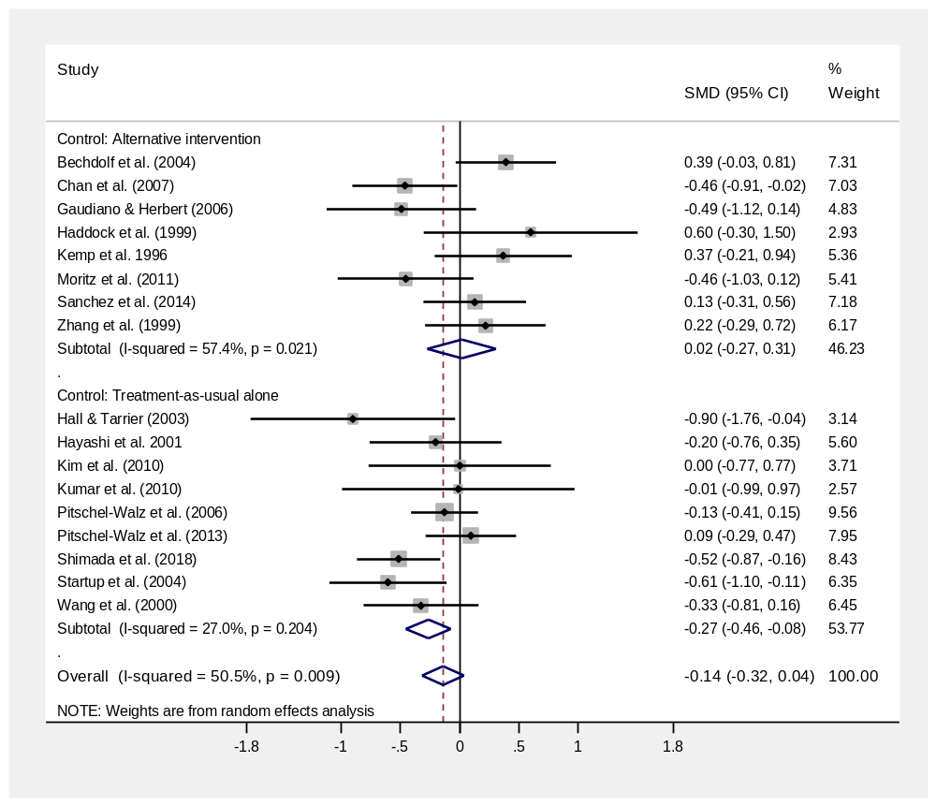
Figure 2. Meta-analysis of psychological interventions versus control treatment for post-
intervention general psychopathology

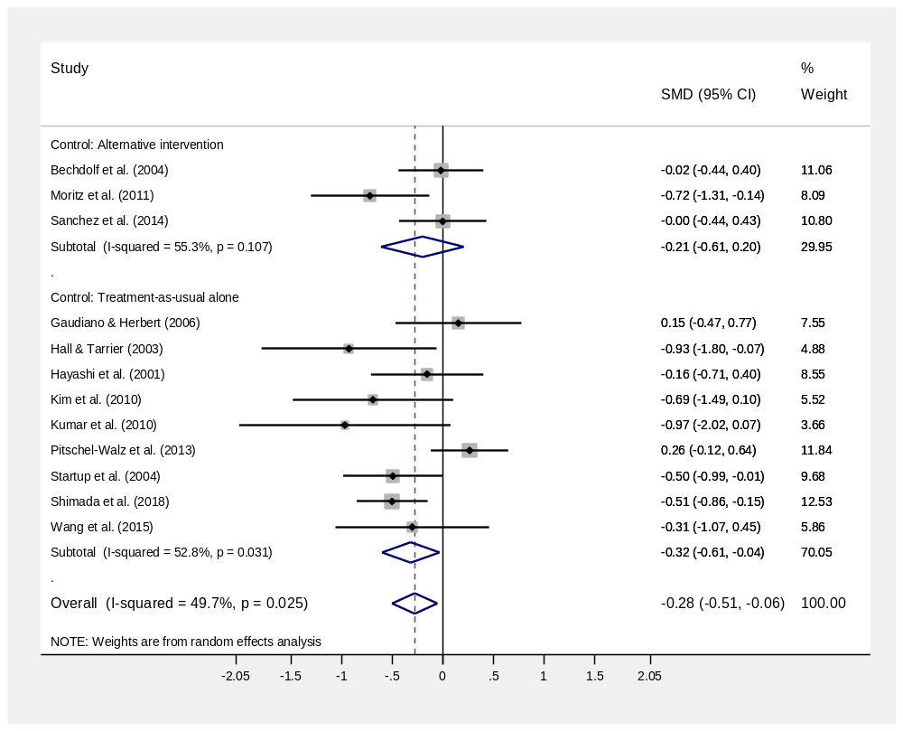
Figure 3. Meta-analysis of psychological interventions versus control treatment for post-intervention positive symptoms
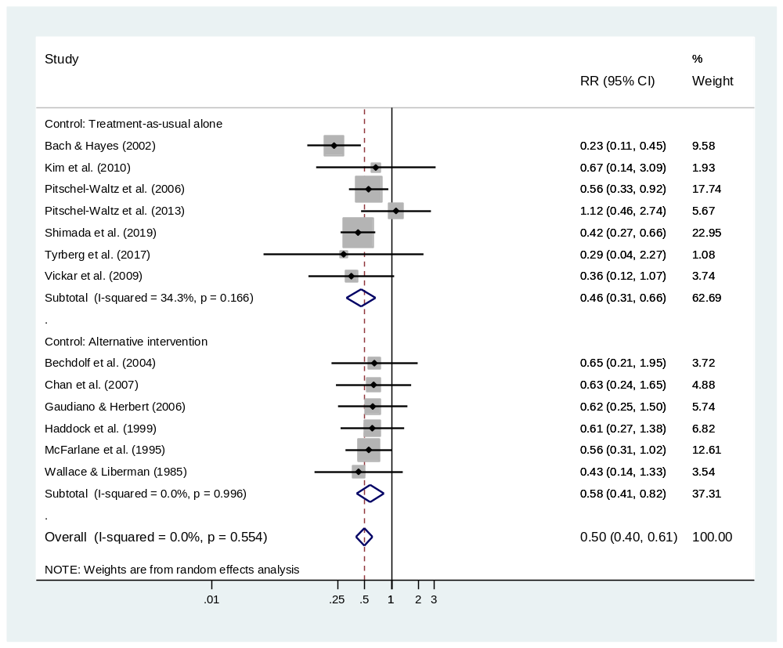
Figure 4. Meta-analysis of psychological interventions versus control treatment for relapse/ re-hospitalisation by follow-up

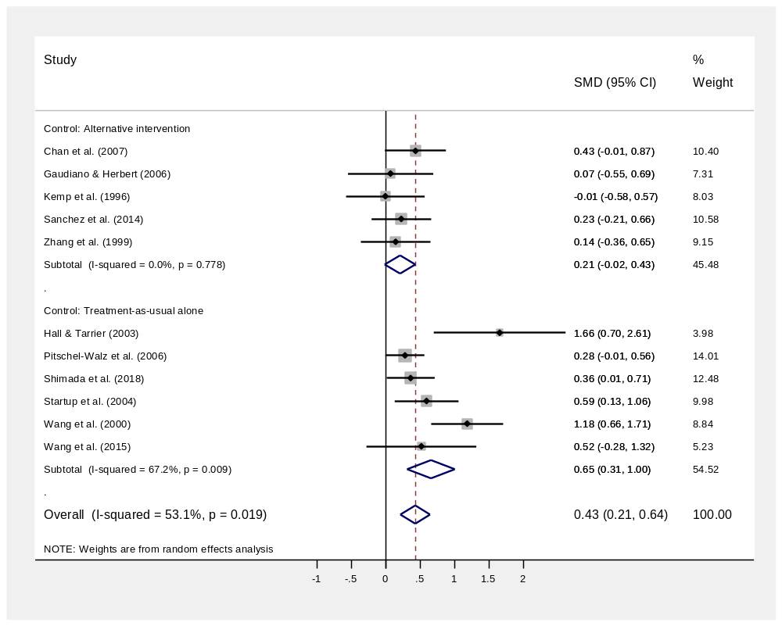
Figure 5. Meta-analysis of psychological interventions versus control treatment for post-intervention social functioning
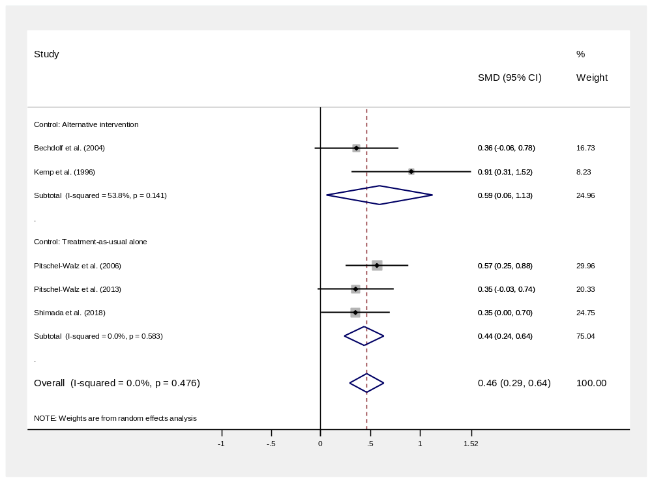
Figure 6. Meta-analysis of psychological interventions versus control treatment for post-intervention treatment compliance

Acceptance and commitment (Morita) therapies
Acceptance and commitment therapy (ACT) is “based on the view that
many maladaptive behaviors are produced by unhealthy attempts to avoid or suppress thoughts, feelings, or bodily sensations…. patients are taught to identify and abandon internally oriented control strategies and accept the presence of difficult thoughts or feelings” (Bach & Hayes, 2002, p. 1130). Morita therapy has been argued to bear striking similarities to ACT and was therefore placed in the same intervention category (Hofmann, 2008). Four RCTs were identified (see Table 1): 3 of ACT and 1 of Morita therapy.
General psychopathology
Meta-analysis of two trials found significantly lower post-intervention general psychopathology relative to the control conditions (SMD = -0.39, 95% CI -0.77 to -0.01, p = 0.04, N = 106, power 43%).
Positive symptoms of schizophrenia
In a single trial, there was no significant difference in post-intervention frequency of positive symptoms relative to the control treatment (SMD = 0.15, 95% CI -0.47 to 0.77, p = 0.64, N = 40, power 34%). A second RCT also found no post-intervention difference in frequency of symptoms but did not report meta-analysable data (Bach & Hayes 2002); a third collected data on this outcome but did not analyse it due to large amounts of missing data (Tyrberg et al. 2017).
Relapse/ re-hospitalisation
Across three RCTs of ACT there was a significant reduction in the risk of re-hospitalisation by follow-up, relative to the control condition (RR = 0.34, 95% CI 0.17 to 0.70, p < 0.01. N = 141, power < 80%).
Social functioning
Across two RCTs of ACT there was no difference in post-intervention social functioning relative to the control condition (SMD = 0.64, 95% CI -0.45 to 1.73, p = 0.25, power 43%).
Treatment compliance
Bach & Hayes (2002) reported no difference in compliance between patients receiving ACT and those receiving TAU alone. The data was reported as percentage with good compliance rather than mean scores and hence could not be included in meta-analysis.
Other outcomes
Wang et al. (2000) found negative symptoms of schizophrenia were lower at post-intervention in patients receiving morita therapy than those receiving treatment-as-usual alone. One RCT found positive symptoms caused patients less distress following ACT than following the control treatment (Gaudiano & Herbert, 2006) but another found no difference on this outcome (Bach & Hayes, 2002).

Cognitive behavioural therapy (CBT)
CBT “aims to reduce distressing emotional experiences or problematic behaviour by changing the way in which the individual appraises, interprets and evaluates their experiences.” (Jones et al., 2018, pg. 7). Seven RCTs evaluating four CBT sub-types were identified (Cognitive therapy, CBT for internalised stigma, CBT for low self-esteem and CBT for psychosis, Table 1).
General psychopathology
Meta-analysis of five RCTs showed no significant overall difference in general psychopathology at post-intervention relative to control treatments (SMD = -0.03, 95% CI -0.24 to 0.25, p = 0.86, N = 284, power 83%). A sixth trial reported a significant post-intervention difference in favour of CBT but could not be included in the analysis as means and sds were not reported (Habib et al. 2015).
Positive symptoms of schizophrenia
Meta-analysis of three RCTs showed no significant difference in positive symptoms at post-intervention relative to control treatments (SMD = -0.39, 95% CI -0.86 to 0.09, p = 0.11, N = 203, power 70%). A fourth RCT also reported no significant difference in post-intervention positive symptoms whilst a fifth reported a significant post-intervention difference in favour of CBT but these could not be included in the analysis as meta-analysable data was not reported (Habib et al. 2015, Haddock et al. 1999).
Relapse/ re-hospitalisation
Meta-analysis of two RCTs showed no significant overall reduction in the risk of relapse relative to alternative psychological interventions (RR = 0.62, 95% CI 0.32 to 1.20, p = 0.16, N = 91, power < 80%).
Social functioning
Meta-analysis of three RCTs showed superior social functioning at post-intervention relative to treatment-as-usual alone (SMD = 0.68, 95% CI 0.01 to 1.36, p = 0.04, N = 158, power 59%).
Treatment compliance
A single RCT found no difference in post-intervention treatment compliance relative to psychoeducation (SMD = 0.36, 95% CI -0.06 to 0.78, p = 0.10, power 37%).
Other outcomes
Hall & Tarrier (2003) found superior outcomes for CBT compared to TAU alone for post-intervention depression, self-esteem and negative symptoms but no difference in anxiety. Wood et al. (2018) found superior outcomes for CBT compared to psychoeducation for post-intervention self-esteem but no differences in depression, internalised stigma, perceived external stigma or personal recovery.

Cognitive remediation therapy (CRT)
CRT is “a behavioral training based intervention that aims to improve cognitive processes (attention, memory, executive function, social cognition or metacognition)… with a further goal that improved cognition will affect community functioning” (Wykes et al. 2011, p. 472). Three RCTs were identified.
General psychopathology
Meta-analysis of two RCTs found no difference in post-intervention general psychopathology relative to control treatment (SMD = 0.11, 95% CI -0.29 to 0.47, p = 0.46, N= 190, power 67%).
Positive symptoms of schizophrenia
Meta-analysis of two RCTs found no difference in post-intervention positive symptoms relative to control treatment (SMD = 0.14, 95% CI – 0.14 to 0.43, p = 0.32, N = 190, power 67%).
Relapse/ re-hospitalisation
A single RCT found no difference in the risk of re-hospitalisation by follow-up relative to the control treatment (RR = 0.43, 95% CI 0.14 to 1.33, p = 0.80, N = 88, power < 80%).
Social functioning
A single RCT found no difference in post-intervention social functioning relative to the control treatment (SMD = 0.23, 95% CI – 0.21 to 0.66, p = 0.31, N = 84, power 36%).
Treatment compliance
A single RCT found no difference in post-intervention treatment compliance relative to the control treatment (SMD = 0.35, 95% CI – 0.03 to 0.74, p = 0.07, N = 106, power 43%).
Other outcomes
Pitschel-Waltz et al. (2013) found no difference in post-intervention global cognitive functioning relative to the control treatment. Sanchez et al. (2014) found no post-intervention differences on any outcome but did find greater pre-post improvements in processing speed, verbal memory, verbal fluency, working memory, executive functioning, negative symptoms, disorganisation and emotional distress relative to the control treatment. Van der Gaag et al. (2002) found greater pre-post improvements in emotion matching, emotion labelling and verbal learning relative to the control treatment.
Eye movement desensitization reprocessing (EMDR)
EMDR “conceptualizes insufficiently processed memories of disturbing or traumatic experiences as the primary source of all psychopathology not caused by organic deficit. The processing of these memories is posited to lead to resolution through the reconsolidation and assimilation within the larger adaptive memory networks.” (Oren & Solomon, 2012, p. 198). One RCT was identified.
General psychopathology
A single RCT found no difference in post-intervention general psychopathology relative to control treatment (SMD = 0.00, 95% CI -0.76 to 0.77, p = 1.00, power 19%).
Positive symptoms of schizophrenia
A single RCT found no difference in post-intervention positive symptoms relative to control treatment (SMD = -0.69, 95% CI -1.49 to 0.09, p = 0.09, power 19%).
Relapse/ re-hospitalisation
A single RCT found no difference in re-hospitalisation by follow-up relative to control treatment (RR = 0.67, 95% CI 0.14 to 1.33, p = 0.60, power < 80%).
Social functioning; Treatment compliance
Not reported.
Other outcomes
Kim et al. (2010) found no benefits over treatment as usual for anxiety or depression.
Interpersonal psychotherapy
Interpersonal psychotherapy aims to “help patients gain insight into intrapsychic and intrapersonal difficulties by focussing on here-and-now group interactions and expression of feelings” (Kanas et al., 1980, pg. 488). One RCT was identified.
General psychopathology
In an RCT including subgroup data for patients meeting criteria for schizophrenia-spectrum disorders, general psychiatric symptoms were reported to be no better and on some measures were worse in patients receiving interpersonal group therapy than in patients participating in a non-psychological activity group (Kanas et al., 1980). This study could not be included in the analysis as meta-analysable data was not reported.
Positive symptoms of schizophrenia; Relapse/ re-hospitalisation; Social functioning; Treatment compliance; Other outcomes
Not reported.

Metacognitive training
Metacognitive training (MCT) aims at “changing the ‘cognitive infrastructure’
of delusional ideation by bringing metacognitive impairments to the attention of patients” (Aghotor et al., 2010, p. 208). Three RCTs were identified (see Table 1).
General psychopathology
General psychopathology outcomes were reported as post-intervention means in some trials and pre-post change scores in others and have therefore been combined using unstandardized weighted mean differences as recommended by the Cochrane Collaboration (Deeks et al., 2011, section 9.5.1). Meta-analysis of three RCTs showed no significant overall difference in general psychopathology outcomes relative to an alternative psychological intervention/treatment as usual alone (WMD = -3.22, 95% CI -8.84 to 2.21, p = 0.26, N = 90, power 38%).
Positive symptoms of schizophrenia
Positive symptom outcomes were reported as post-intervention means in some trials and pre-post change scores in others and have therefore been combined using unstandardized weighted mean differences as recommended by the Cochrane Collaboration (Deeks et al., 2011, section 9.5.1). Meta-analysis of three RCTs showed significantly lower positive symptoms at post-intervention relative to control treatments (WMD = -2.29, 95% CI -4.07 to -0.51, p = 0.01, power 40%).
Relapse/ re-hospitalisation; Social functioning; Treatment compliance
Not reported.
Other outcomes
Two RCTs (Kumar et al., 2010; Moritz et al., 2011) found that the strength of patients’ belief in their delusions was significantly lower following MCT than following an alternative psychological intervention/treatment as usual alone. Two RCTs found no effect of MCT on jumping to conclusions at post-intervention (Aghotor et al., 2010; Moritz et al., 2011).

Motivational Interventions
Motivational interventions “have the overarching goal of addressing and enhancing motivation to change” (Tevyaw & Monti, 2004, p. 63). Two RCTs were identified of motivational interventions targeting patients’ compliance with treatment: One of compliance therapy and one of motivational interviewing (see Table 1).
General psychopathology
Meta-analysis of two RCTs showed no significant overall difference in general psychopathology at post-intervention relative to a non-directive psychological intervention/treatment-as-usual alone (SMD = 0.08, 95% CI -0.48 to 0.64, p = 0.79, N = 72, power 31%).
Positive symptoms of schizophrenia
A single RCT found no difference in post-intervention positive symptoms relative to the control treatment (SMD = -0.16, 95% CI -0.71 to 0.40, N = 50, power 23%).
Relapse/ re-hospitalisation
Kemp et al. (1998) reported a significantly longer time to re-hospitalisation by follow-up, relative to the control condition; however re-hospitalisation rates were not reported.
Social functioning
A single RCT found no difference in post-intervention social functioning relative to the control treatment (SMD = -0.01, 95% CI -0.58 to 0.57, p = 0.98, N = 47, power 22%).
Treatment compliance
A single RCT found superior treatment compliance at post-intervention relative to the control treatment (SMD = 0.91, 95% CI 0.31 to 1.52, p < 0.01, N = 47, power 22%).
Other outcomes
Illness insight was significantly better at post-intervention in one RCT (Kemp et al. 1996) but not the other (Hayashi et al. 2001), relative to the control treatments.

Psychoeducation
Psychoeducation aims to “increase patients’ knowledge and understanding of their illness
and treatment….. (to) enable people with schizophrenia to cope more effectively with their illness” (Xia, Merinder, & Belgamwar, 2011, p.6). Eleven RCTs were identified (see Table 1), including the only trial in this review deemed to pose a low risk of bias (Shimada et al. 2018). Eight of the studied trials were patient-based (i.e., included patients but not their families) and three were family-based (i.e., the patients’ families attended psychoeducation sessions together with the inpatient).
General psychopathology
Meta-analysis of four RCTs found significantly lower post-intervention general psychopathology relative to control treatments (SMD = -0.33, 95% CI -0.53 to -0.14, N = 492, p < 0.01, power 97%). A fifth RCT found significantly greater improvement in general psychopathology following psychoeducation with video self-observation versus psychoeducation with a non-psychological video (Davidoff et al., 1998), whilst a sixth reported no difference in post-intervention general psychopathology relative to the control treatment (Haas et al., 1988) relative to the control treatment; however, meta-analysable data was not reported.
Positive symptoms of schizophrenia
Meta-analysis of three RCTs found no difference in post-intervention positive symptoms, relative to the control condition (SMD = -0.41, 95% CI -0.99 to 0.17, p = 0.17, power 78%).
Relapse/ re-hospitalisation
Meta-analysis of 7 RCTs found a significantly lower risk of relapse/ re-hospitalisation by follow-up, relative to the control treatment (pooled RR = 0.63, 95% CI 0.43 to 0.94, p = 0.02, N = 657, power > 80%).
Social functioning
Meta-analysis of four RCTs found significantly better post-intervention social functioning relative to the control treatment (SMD = 0.35, 95% CI 0.15 to 0.54, p < 0.01. N = 429, power 95%). Conversely, both Klingberg et al. (2001) and Haas et al. (1988) found no difference in post-intervention social functioning relative to the control treatment, whilst Wallace and Liberman (1985) found patients receiving psychoeducation were rated by their families as showing poorer post-intervention social adjustment than patients receiving social skills training. These trials did not report meta-analysable data on these outcomes.
Treatment compliance
Meta-analysis of three RCTs found no difference in post-intervention treatment compliance relative to the control treatment (SMD = 0.20, 95% CI -0.31 to 0.71, p = 0.44, N = 377, power 92%). A fourth RCT also reported no effect on treatment compliance but did not report meta-analysable data (Klingberg et al. 2001).
Other outcomes
Two RCTs examined the effect of psychoeducation versus non-psychological interventions on illness insight at post-intervention, with one finding significantly greater improvement in insight following psychoeducation with video self-observation (Davidoff et al., 1998) and another finding no significant difference on this outcome (Chan et al., 2007). For cognitive functioning, one RCT found significantly better post-intervention cognitive functioning relative to treatment-as-usual alone (Shimada et al. 2018). For depression severity, one RCT found no significant difference following psychoeducation versus CBT for internalised stigma (Wood et al., 2018). For negative symptoms, one RCT found lower negative symptoms following multiple family group psychoeducation than following single family psychoeducation (McFarlane et al., 1995). For quality of life, one RCT found significantly greater improvement following psychoeducation versus treatment-as-usual alone (Wang et al., 2015).
Social skills training
Social skills training “consists of a package of techniques including modeling, behavioral rehearsal and role playing, feedback, coaching, and positive reinforcement” to improve patients’ social skills (Wallace & Liberman, 1985, p. 239). One RCT was identified (Table 1).
Relapse/ re-hospitalisation
A single RCT found no difference in the rate of relapse by follow-up relative to the control condition (RR = 0.43, 95% CI 0.14 to 1.33, p = 0.14, N = 28, power < 80%).
Social functioning
A single RCT reported greater pre-post improvements in self-ratings of assertiveness, family ratings of social adjustment and observer ratings of social competence, compared to the control treatment (Wallace & Liberman, 1985). This study did not report meta-analysable data.
General psychopathology; Positive symptoms of schizophrenia; Treatment compliance; Other outcomes
Not reported.

Publication Bias
Publication bias for general psychopathology outcomes
Egger’s test indicated no evidence of publication bias in RCTs publishing meta-analysable data on general psychopathology outcomes at post-intervention (Bias coefficient = 0.26, 95% CI -2.24 to 2.76). The funnel plot (Figure 7) indicates relatively even distribution of trials finding positive and negative effects across a range of sample sizes.
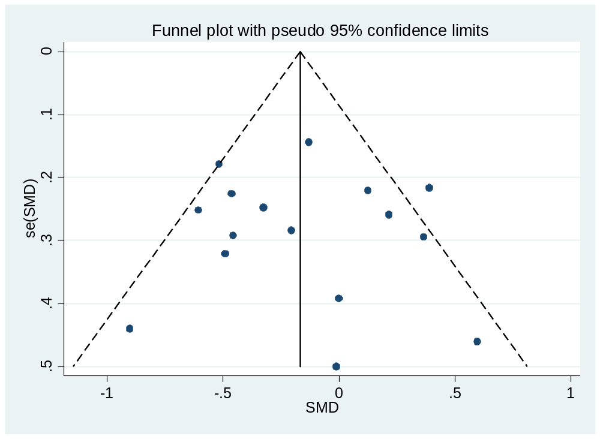
Figure 7. Funnel plot of SMD against standard error for general psychopathology outcomes (16 RCTs).

Publication bias for relapse/ re-hospitalisation
Egger’s test indicated no evidence of significant publication bias in RCTs publishing meta-analysable data on relapse/ re-hospitalisation rates at follow-up (Bias coefficient = 0.35, 95% CI -1.24 to 1.93, p = 0.64). The funnel plot (Figure 8) indicates relatively even distribution of trials finding positive and negative effects across a range of sample sizes.

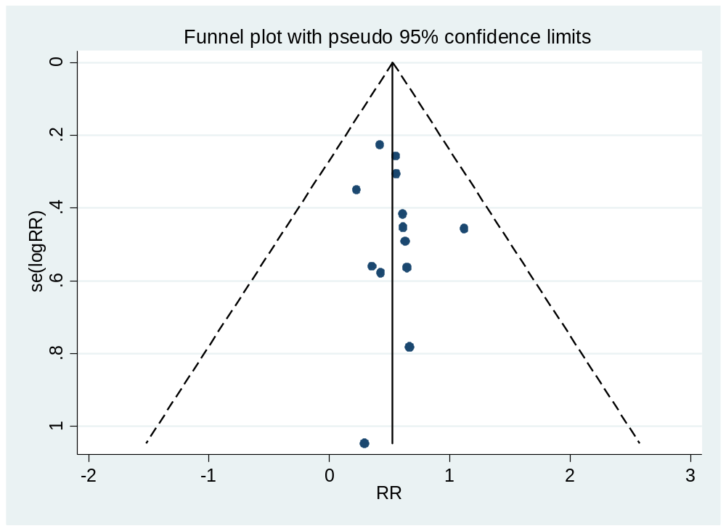
Figure 8. Funnel plot of risk ratio (RR) against standard error of log RR for relapse/ re-hospitalisation (13 RCTs).

Discussion

We reviewed 34 randomised controlled trials of psychological interventions for patients with schizophrenia-spectrum disorders in acute inpatient psychiatric settings, of which 29 published or provided data suitable for meta-analysis. Psychoeducational interventions have been most frequently evaluated, followed by CBT. There have been fewer trials of alternative approaches such as ACT, CRT, MCT, motivational or psychodynamic therapies. In random effects meta-analyses, psychological interventions improved post-intervention positive symptoms, social functioning and treatment compliance, and reduced the risk of relapse/ re-hospitalisation, but did not improve general psychopathology, relative to control conditions. Highly powered (>80%) sub-group analyses showed positive intervention effects for several outcomes (general psychopathology, positive symptoms, and social functioning) where the control condition was treatment-as-usual but not when it was an alternative intervention; however, all meta-regression analyses found no significant effect of control condition on effect size. Further highly powered sub-group analyses (>80% power) of specific intervention effects showed that psychoeducation improved several key outcomes (general psychopathology, relapse/ re-hospitalisation and social functioning, but not positive symptoms or treatment compliance) but did not support the effectiveness of cognitive behaviour therapy for improving general psychopathology. Preliminary underpowered analyses also showed positive intervention effects of ACT for reducing general psychopathology and relapse/ re-hospitalisation, CBT for improving social functioning, and MCT for reducing positive symptoms. Further preliminary analyses found no effect of ACT, CBT, CRT or MCT on any of the other evaluated outcomes; however these analyses were underpowered due to small sample sizes. Separate meta-analyses of EMDR, interpersonal therapy and social skills training effects could not be conducted as they were evaluated only in single trials. Risk of bias was high or unclear in all but one of the included studies, primarily due to inadequate allocation concealment, non-blinding of outcome assessments and/ or incomplete outcome reporting. Analysis of data on the two most frequently studied outcomes found no evidence of publication bias for general psychopathology or relapse/ re-hospitalisation outcomes.
Interpretation of Findings and Comparison to Previous Research
To our knowledge there has been no other meta-analysis of psychological interventions in the acute inpatient psychiatric setting focussed on patients with schizophrenia-spectrum disorders. Our findings broadly concur with those of Paterson and colleagues (2018), who synthesised data across intervention types and a range of diagnostic groups, concluding overall that psychological interventions are effective for reducing positive symptoms, readmissions, depression, and anxiety in acute inpatients. However, they were unable to reach a conclusion about which interventions might be particularly effective or ineffective for which patient groups. Our work follows Cochrane guidance by reducing the heterogeneity of included studies through focussing on a single diagnostic patient group (Deeks et al., 2011), and – where the total sample size of analysable studies was sufficient to give adequate power to do so - allowing us to reach focussed conclusions about which specific interventions have evidence for effectiveness amongst acute inpatients with schizophrenia-spectrum disorders, and which do not. Additionally, our work improves upon the previous meta-analysis by including only RCT evidence, rather than merging RCT and non-RCT data which can lead to biased and potentially over-inflated effect size estimates (Reeves et al., 2011).
Our findings that receiving psychoeducation was associated with lower general psychopathology, better social functioning and a reduced risk of relapse/ re-hospitalisation are in line with a Cochrane review focussed mainly on outpatient studies, which identified superiority of psychoeducation over treatment as usual for improving general psychopathology, social functioning and medication compliance and reducing the risk of relapse in patients with schizophrenia (Xia, Merinder, & Belgamwar, 2011). One possibility is that psychoeducation may have been particularly beneficial as the tested programmes were often explicitly developed for acute inpatient settings, covering a broad range of relevant topics such as the role of medication, managing stress and identifying signs of relapse, whereas other types of intervention were often developed first in outpatient settings and subsequently adapted. Psychoeducation is often employed as an active control in trials of psychological interventions, and indeed was used as a control condition in four of the trials included in this review, with the explicit or implicit hypothesis that patients receiving psychoeducation would achieve poorer outcomes. Yet our analysis and others show that it can be an effective psychological intervention in its own right.
Our findings with regards to the second-most frequently evaluated intervention, CBT, were on the whole disappointing. Whilst we did find a positive effect on social functioning, we found no effect on general psychopathology, positive symptoms or treatment compliance. This stands in contrast to recent meta-analyses based primarily on CBT conducted among outpatients with schizophrenia, which found reductions in post-intervention general psychopathology and positive symptoms compared to control treatments (Eichner & Berna, 2016; Jauhar et al., 2014; Pilling et al., 2002; Turner, van der Gaag, Karyotaki, & Cuijpers, 2014). However, whilst our analysis of the effect of CBT on general psychopathology was based on five trials and was highly powered (>80%) to detect a medium intervention effect at medium heterogeneity, it was likely still underpowered to detect any smaller effects, and our analyses of other outcomes were based on very small numbers of studies and were therefore underpowered.
Conversely, despite also being based on small numbers of studies, our analyses did yield preliminary support for the effectiveness of two interventions which draw on CBT principles but aim to enhance their value by incorporating ideas from other therapeutic paradigms: ACT and MCT. Our findings on the effectiveness of these interventions are in accordance with meta-analytic evidence spanning both in- and outpatient trials (Normann & Morina, 2018; Tonarelli, Pasillas, Alvarado, Dwivedi, & Cancellare, 2016). Both these approaches differ from traditional CBT in that they do not directly challenge patients’ dysfunctional beliefs, but instead target maintaining cognitive and affective processes – MCT by modifying the cognitive biases thought to underlie and maintain delusional thinking in schizophrenia (e.g., jumping to conclusions, resistance to changing beliefs) (Moritz et al., 2011) – and ACT by teaching patients to recognise that their thoughts are products of mental events rather than the self, and encouraging patients to mindfully and non-judgementally observe their thoughts and hallucinatory experiences rather than trying to suppress them (Gaudiano & Herbert, 2006). It is possible that this focus on changing patients’ cognitive and affective response to their thoughts may be particularly helpful for inpatients experiencing acute psychotic symptoms, who may be resistant to more direct challenges to their beliefs.
Limitations
As detailed above, whilst our analyses of the overall effects of psychological interventions, our subgroup analyses by control condition, and our analyses of psychoeducation trials were large and adequately powered, we had limited power to discern the effects of other less frequently evaluated types of psychological intervention. Furthermore, several of the trials included in the narrative review could not be included in the meta-analyses, as some omitted key outcomes such as positive symptoms, general psychopathology and relapse, and others failed to report data in a usable way and were not responsive to requests for this data. For the majority of studies, risk of bias was either high due to inadequate allocation concealment, lack of blinded assessments, high attrition and/or failure to pre-publish planned outcome measures, or risk of bias was unclear as study authors did not provide sufficient information to evaluate these criteria. Our use of non-disorder-specific search terms – “psychiatric” and “mental” - was intended to generate comprehensive search results. Whilst a sensitivity analysis replacing the non-disorder specific terms with disorder-specific ones did not identify any omitted trials, we nonetheless cannot guarantee that we did not miss additional relevant trials which used disorder-specific terms and did not use our non-disorder specific terms.
Implications for Clinical Practice and Further Research
On the basis of our findings, clinicians can be confident that, in general, psychological interventions can be effective and are worthwhile implementing in acute inpatient settings for patients with schizophrenia-spectrum disorders. When deciding which specific interventions to implement, clinicians may find it helpful to know that psychoeducation currently has the best evidence base, with preliminary emerging evidence based on smaller numbers of trials for ACT and MCT. Clinicians should utilise caution in judging whether positive RCT findings are likely to generalise to all acute inpatients with schizophrenia. Whilst some of the studied psychoeducation interventions were developed specifically for acute inpatient settings (e.g., Chan et al., 2007; Vickar et al., 2009), others were adapted from interventions developed for outpatient settings (e.g., Bechdolf et al., 2004) and ACT and MCT were also developed in outpatient settings (Hayes, Strosahl, & Wilson, 1999; Moritz & Woodward, 2007), where patients might be assumed to be suffering from less acute manifestations of psychosis. Whilst the interventions were adapted in frequency and length for acute inpatient settings (e.g., holding sessions twice a week over a 5-week period), it is unclear if and how they were adapted in content. Thus arguably inpatients were introduced to quite complex and abstract ideas – such as considering the pros and cons of different kinds of attributional styles, rating the plausibility of different interpretations of situations, and conducting behavioural experiments to test beliefs – without any adaptations to cater for the increased cognitive and attentional deficits exhibited by inpatients with acute schizophrenia (Park et al., 2002). This is in direct contrast to the views of front-line nursing staff and other clinicians involved in delivering interventions in acute inpatient settings, who have expressed doubt about the capacity of acutely unwell inpatients to concentrate on and process even minimally complex and abstract content and have emphasised the importance of adapting standard interventions to make them simpler (Sharp et al., 2018). However, comparison of participant characteristics suggests that patients’ symptom level may have been surprisingly similar across outpatient trials and the included acute inpatient trials. For instance, positive symptom severity (as rated on the Positive and Negative Symptom Scale) ranged between 14 and 25 in the analysed inpatient MCT trials; our informal literature search identified a range between 14 and 24 in outpatient MCT/CBT trials using this measure (Briki et al., 2014; Lewis et al., 2002; Moritz & Woodward, 2007; Peters et al., 2010). This casts doubt on whether the patients participating in the included trials were truly at the most acute end of the schizophrenic spectrum and raises the issue of potential selection bias. Indeed, several of the included trials specify that individuals demonstrating high levels of disturbed behaviour, distress, hostility, suspiciousness or thought disorder were excluded (Aghotor et al., 2010; Habib et al., 2015; Hall & Tarrier, 2003). Beyond this, clinicians may have preferentially recommended patients with less severe symptoms to participate, or patients with more severe symptoms may have refused to participate or may have lacked capacity to consent. Thus, it is unclear whether the meta-analysis’ findings are generalisable to inpatients experiencing the most severe manifestations of acute psychosis.
All of the reviewed interventions require further testing in well-designed RCTs. In particular, our positive findings on the effectiveness of ACT, MCT and psychoeducation in acute inpatient settings require replication and further evidence is also needed to confirm or disconfirm our negative findings on CBT and CRT and to investigate the effect of intervention subtypes and of active versus non-active/usual treatment control conditions. Future trials should be more rigorously designed, in particular using concealed allocation and blinded outcome assessments. They should also pre-publish their planned outcome measures, should publish clear data on attrition, and should publish meta-analysable data on positive symptoms, general psychopathology, relapse and re-hospitalisation in addition to considering wider outcomes such as social functioning, insight, and quality of life. Furthermore, future trials should be explicit about the extent to which their samples are representative of the typical acute inpatient schizophrenia population and should discuss the potential for selection bias and the implications of any decisions to exclude more disturbed patients.
Conclusion
Overall, our meta-analyses suggested that psychological interventions can be effective for improving several key outcomes for patients with schizophrenia-spectrum disorders who are treated in acute inpatient settings, with strongest evidence so far for the effectiveness of psychoeducation and preliminary evidence for beneficial effects of ACT and MCT. Study methodology often posed a high or unclear risk of bias and further research should use more rigorous RCT designs and publish meta-analysable data on positive symptoms, general psychopathology, social functioning, relapse/ re-hospitalisation and treatment compliance, in addition to considering wider outcomes.
References
Aghotor, J., Pfueller, U., Moritz, S., Weisbrod, M., & Roesch-Ely, D. (2010). Metacognitive training for patients with schizophrenia (MCT): Feasibility and preliminary evidence for its efficacy. Journal of Behavior Therapy and Experimental Psychiatry, 41(3), 207-211. doi.org/10.1016/j.jbtep.2010.01.004
American Psychological Association (2013). Recognition of psychotherapy effectiveness. Psychotherapy, 50, 102-109. doi.org/10.1037/a0030276
Beck, A. T., Rush, A. J., Shaw, B. F., & Emery, G. (1979). Cognitive therapy of depression. New York: Guilford Press.
Beck, J. S. (2011). Cognitive behaviour therapy: Basics and beyond (2nd Ed.). New York, NY: The Guildford Press.
Berger, D. (2016). Double-blinding and bias in medication and cognitive-behavioral therapy trials for major depressive disorder. [version 2; peer review: 2 approved]. F1000Research, 4, 638. doi: 10.12688/f1000research.6953.2
Bowers, L. (2005). Reasons for admission and their implications for the nature of acute inpatient psychiatric nursing. Journal of Psychiatric and Mental Health Nursing, 12(2), 231-236. doi.org/10.1111/j.1365-2850.2004.00825.x
Bowers, L., Simpson, A., Alexander, J., Hackney, D., Nijman, H., Grange, A., & Warren, J. (2005). The nature and purpose of acute psychiatric wards: The Tompkins acute ward study. Journal of Mental Health, 14(6), 625-635. doi: 10.1080/09638230500389105
Briki, M., Monnin, J., Haffen, E., Sechter, D., Favrod, J., Netillard, C., … & Bonin, B. (2014). Metacognitive training for schizophrenia: A multicentre randomised controlled trial. Schizophrenia Research, 157(1-3), 99-106. doi.org/10.1016/j.schres.2014.06.005
Campbell, D. (2016). Number of mental health nurses falls 10%. The Guardian. Retrieved from http://www.theguardian.com/society/2016/jan/25/number-of-mental-health-nurses-falls-10.
Care Quality Commission (2009). National NHS patient survey programme: Mental health acute inpatient service users survey 2009. Retrieved from http://www.nhssurveys.org/Filestore/documents/MH09_RTQ.pdf
Clarke, I., & Wilson, H. (Eds.) (2009). Cognitive behaviour therapy for acute inpatient mental health units: Working with clients, staff and the milieu. London: Routledge, Taylor & Francis Group.
Crisp, N., Smith, G., & Nicholson, K. (Eds.) (2016). Old problems, new solutions – Improving acute psychiatric care for adults in England. The Commission on Acute Adult Psychiatric Care. Retrieved from https://www.basw.co.uk/system/files/resources/basw_92050-3_0.pdf
Deeks, J. J., Higgins, J. P. T., & Altman, D. G. (2011). Chapter 9: Analysing data and undertaking meta-analyses. In J. P. T. Higgins & S. Green (Eds.), Cochrane handbook for systematic reviews of interventions Version 5.1.0 (updated March 2011). The Cochrane Collaboration. Available from www.handbook.cochrane.org
Eichner, C., & Berna, F. (2016). Acceptance and efficacy of metacognitive training (MCT) on positive symptoms and delusions in patients with schizophrenia: A meta-analysis taking into account important moderators. Schizophrenia Bulletin, 42(4), 952-962. doi.org/10.1093/schbul/sbv225
Freeman, D., & Garety, P. (2006). Helping patients with paranoid and suspicious thoughts: A cognitive-behavioural approach. Advances in Psychiatric Treatment, 12(6), 404-415.
doi.org/10.1192/apt.12.6.404
in-patient settings. Acta Psychiatrica Scandinavica 133: 298–309.
Hayes, S. C., & Hofmann, S. G. (2017). The third wave of cognitive behavioral therapy and the rise of process-based care. World Psychiatry, 16(3), 245-246. doi: 10.1002/wps.20442
Hayes, S. C., Strosahl, K., & Wilson, K. G. (1999). Acceptance and commitment therapy: An experiential approach to behavior change. New York: Guilford Press.
Hazell, C.M., Hayward, M., Cavanagh, K., Strauss, C. (2016). A systematic review and meta-analysis of low intensity CBT for psychosis. Clinical Psychology Review, 45, 183-92. doi: 10.1016/j.cpr.2016.03.004.
Higgins, J. P., Altman, D. G., Sterne, J. A. (2011). Chapter 8: Assessing risk of bias in included studies. In: Cochrane Handbook for Systematic Reviews of Interventions, The Cochrane Collaboration, Version 5.1.0.
Hofmann, S. G. (2008). Acceptance and commitment therapy: New wave or morita therapy? Clinical Psychology: Science and Practice, 15(4), 280-285.
doi.org/10.1111/j.1468-2850.2008.00138.x
Jackson, D., & Turner, R. (2017). Power analysis for random-effects meta-analysis. Research Synthesis Methods, 8, 290-302.
Jauhar, S., McKenna, P. J., Radua, J., Fung, E., Salvador, R., & Laws, K. R. (2014). Cognitive-behavioural therapy for the symptoms of schizophrenia: Systematic review and meta-analysis with examination of potential bias. The British Jounral of Psychiatry, 204(1), 20-29. doi.org/10.1192/bjp.bp.112.116285
Jenkins, R., & Elliott, P. (2004). Stressors, burnout and social support: Nurses in acute mental health settings. Journal of Advanced Nursing, 48(6), 622-631. doi.org/10.1111/j.1365-2648.2004.03240.x
Jones, C., Hacker, D., Meaden, A., Cormac, I., Irving, C. B., Xia, J., … & Chen, J. (2018). Cognitive behavioural therapy plus standard care versus standard care plus other psychosocial treatments for people with schizophrenia. Cochrane Database of Systematic Reviews, 11, CD008712. doi: 10.1002/14651858.CD008712.pub3
Kanas, N., Rogers, M., Kreth, E., Patterson, L., & Campbell, R. (1980). The effectiveness of group psychotherapy during the first three weeks of hospitalization. A controlled study. The Journal of Nervous and Mental Disease, 168(8), 487-492.
doi: 10.1097/00005053-198008000-00007
Killaspy, H. (2006). From the asylum to community care: Learning from experience. British Medical Bulletin, 79(1), 245-258. doi.org/10.1093/bmb/ldl017
Leibenluft, E., Tasman, A., & Green, S. A. (Eds.) (1993). Less time to do more: Psychotherapy on the short-term inpatient unit. Washington, DC: American Psychiatric Press.
Lewis, S., Tarrier, N., Haddock, G., Bentall, R., Kinderman, P., Kingdon, D., … & Benn, A. (2002). Randomised controlled trial of cognitive-behavioural therapy in early schizophrenia: Acute-phase outcomes. The British Journal of Psychiatry, 181(S43), s91-s97. doi.org/10.1192/bjp.181.43.s91
Lloyd-Evans, B. (2010). Acute inpatient mental health wards and inpatient alternatives: A qualitative comparison of the care provided (Doctoral thesis, University College London). Retrieved from https://discovery.ucl.ac.uk/id/eprint/19216/1/19216.pdf
McCulloch, A., Ryrie, I., Williamson, T., & St John, T. (2005). “Has the medical model a future?”. Mental Health Review Journal, 10(1), 7-15. doi.org/10.1108/13619322200500003
Minuchin, S. (2012). Family and family therapy. Abingdon: Routledge.
Moos, R. H. (2012). Iatrogenic effects of psychosocial interventions: Treatment, life context, and personal risk factors. Substance Use & Misuse, 47(13-14), 1592-1598. doi.org/10.3109/10826084.2012.705710
Moritz, S., & Woodward, T. S. (2007). Metacognitive training for schizophrenia patients (MCT): A pilot study on feasibility, treatment adherence, and subjective efficacy. German Journal of Psychiatry, 10(3), 69-78.
National Institute for Health and Care Excellence (2014). Psychosis and schizophrenia in adults: Prevention and management (Clinical guideline 178). Retrieved from https://www.nice.org.uk/guidance/cg178/resources/psychosis-and-schizophrenia-in-adults-prevention-and-management-pdf-35109758952133
Newman, L., Harris, V., Evans, L. J., & Beck, A. (2018). Factors associated with length of stay in psychiatric inpatient services in London, UK. Psychiatric Quarterly, 89(1), 33-43. doi: 10.1007/s11126-017-9498-7
Normann, N., & Morina, N. (2018). The efficacy of metacognitive therapy: A systematic review and meta-analysis. Frontiers in Psychology, 9, 2211. doi.org/10.3389/fpsyg.2018.02211
Oren, E., & Solomon, R. (2012). EMDR therapy: An overview of its development and mechanisms of action. European Review of Applied Psychology, 62(4), 197-203.
Park, S., Püschel, J., Sauter, B. H., Rentsch, M., & Hell, D. (2002). Spatial selective attention and inhibition in schizophrenia patients during acute psychosis and at 4-month follow-up. Biological Psychiatry, 51(6), 498-506. doi.org/10.1016/S0006-3223(01)01278-1
Paterson, C., Karatzias, T., Dickson, A., Harper, S., Dougall, N., & Hutton, P. (2018). Psychological therapy for inpatients receiving acute mental health care: A systematic review and meta-analysis of controlled trials. British Journal of Clinical Psychology, 57(4), 453-472. doi.org/10.1111/bjc.12182
Peters, E., Landau, S., McCrone, P., Cooke, M., Fisher, P., Steel, C., … & Howard, A. (2010). A randomised controlled trial of cognitive behaviour therapy for psychosis in a routine clinical service. Acta Psychiatrica Scandinavica, 122(4), 302-318.
doi.org/10.1111/j.1600-0447.2010.01572.x
Pilling, S., Bebbington, P., Kuipers, E., Garety, P., Geddes, J., Orbach, G., & Morgan, C. (2002). Psychological treatments in schizophrenia: I. Meta-analysis of family intervention and cognitive behaviour therapy. Psychological Medicine, 32(5), 763-782.
doi.org/10.1017/S0033291702005895
Preti, A., Rucci, P., Santone, G., Picardi, A., Miglio, R., Bracco, R., … & de Girolamo, G. (2009). Patterns of admission to acute psychiatric in-patient facilities: A national survey in Italy. Psychological Medicine, 39(3), 485-496. doi: 10.1017/S0033291708003607
Quintana, D., & Tiebel, J. (2018). How to calculate statistical power for your meta-analyis.
Center for Open Science, DOI 10.17605/OSF.IO/5C7UZ. From https://osf.io/5c7uz/
Quirk, A., & Lelliott, P. (2001). What do we know about life on acute psychiatric wards in the UK? A review of the research evidence. Social Science & Medicine, 53(12), 1565-1574. doi.org/10.1016/S0277-9536(00)00457-3
Quirk, A., Lelliott, P., & Seale, C. (2004). Service users’ strategies for managing risk in the volatile environment of an acute psychiatric ward. Social Science & Medicine, 59(12), 2573-2583. doi.org/10.1016/j.socscimed.2004.04.005
Reeves, B. C., Deeks, J. J., Higgins, J. P. T., & Wells, G. A. (2008). Chapter 13: Including non-randomized studies. In J. P. T. Higgins & S. Green (Eds.), Cochrane handbook for systematic reviews of interventions Version 5.1.0 (updated March 2011). The Cochrane Collaboration, 2011. Available from www.handbook.cochrane.org.
Roth, A. D., & Pilling, S. (2013). A competence framework for psychological interventions with people with psychosis and bipolar disorder. Retrieved from http://www.ucl.ac.uk/clinical-psychology/CORE/competence_mentalillness_psychosisandbipolar.html
Saba, D. K., Levit, K. R., & Elixhauser, A. (2008). Hospital stays related to mental health, 2006. Statistical Brief 62. Agency for Healthcare Research and Quality, Rockville, MD. Retrieved from http://www​.hcup-us.ahrq​.gov/reports/statbriefs/sb62.pdf
Salize, H. J., Dressing, H., & Peitz, M. (2002). Compulsory admission and involuntary treatment of mentally ill patients – Legislation and practice in EU-member states. European Commission – Health & Consumer Protection Directorate-General. Mannheim, Germany: Central Institute of Mental Health. Retrieved from http://ec.europa.eu/health/ph_projects/2000/promotion/fp_promotion_2000_frep_08_en.pdf
Sayles, K. A., Ayoub, M., & van Schalkwyk, G. I. (2019). Individual therapy on inpatient units: Flexibility in the face of resistance. Journal of the American Academy of Child & Adolescent Psychiatry, 58(9), 837-840. doi.org/10.1016/j.jaac.2019.04.017
Sharac, J., McCrone, P., Sabes-Figuera, R., Csipke, E., Wood, A., & Wykes, T. (2010). Nurse and patient activities and interaction on psychiatric inpatient wards: A literature review. International Journal of Nursing Studies, 47(7), 909-917. doi.org/10.1016/j.ijnurstu.2010.03.012
Sharp, M., Gulati, A., Barker, C., & Barnicot, K. (2018). Developing an emotional coping skills workbook for inpatient psychiatric settings: A focus group investigation. BMC Psychiatry, 18(1), 208. doi:10.1186/s12888-018-1790-z
Slemon, A., Jenkins, E., & Bungay, V. (2017). Safety in psychiatric inpatient care: The impact of risk management culture on mental health nursing practice. Nursing Inquiry, 24(4), e12199. doi.org/10.1111/nin.12199
Substance Abuse and Mental Health Services Administration (2016). National Mental Health Services Survey (N-MHSS): 2014. Data on Mental Health Treatment Facilities. BHSIS Series S-87, HHS Publication No. (SMA) 16-5000. Rockville, MD. Retrieved from https://www.samhsa.gov/data/sites/default/files/2014_National_Mental_Health_Services_Survey.pdf
Tevyaw, T.O., & Monti, P.M. (2004). Motivational enhancement and other brief interventions for adolescent substance abuse: foundations, applications and evaluations. Addiction, 99, 63-75.
The Commission to Review the Provision of Acute Psychiatric Care for Adults (2015). Improving acute inpatient psychiatric care for adults in England: Interim Report. Retrieved from http://media.wix.com/ugd/0e662e_a93c62b2ba4449f48695ed36b3cb24ab.pdf
Thompson, A., Shaw, M., Harrison, G., Ho, D., Gunnell, D., & Verne, J. (2004). Patterns of hospital admission for adult psychiatric illness in England: Analysis of Hospital Episode Statistics data. The British Journal of Psychiatry, 185(4), 334-341.
doi.org/10.1192/bjp.185.4.334
Thorlund, K., Engstrom, J., Wetterslev, J., Brok, J., Imberger, G., Gluud, C. (2017). User Manual for Trial Sequential Analysis. Copenhagen Trials Unit. From http://www.ctu.dk/tools-and-links/trial-sequential-analysis.aspx
Tonarelli, S. B., Pasillas, R., Alvarado, L., Dwivedi, A., & Cancellare, A. (2016). Acceptance and commitment therapy compared to treatment as usual in psychosis: A systematic review and meta-analysis. Journal of Psychiatry, 19(3), 1000366.
doi: 10.4172/2378-5756.1000366
Turner, D. T., van der Gaag, M., Karyotaki, E., & Cuijpers, P. (2014). Psychological interventions for psychosis: A meta-analysis of comparative outcome studies. American Journal of Psychiatry, 171(5), 523-538. doi.org/10.1176/appi.ajp.2013.13081159
Valentine, J.C., Pigott, T.D., & Rothstein, H.R. (2010). How many studies do you need? A primer on statistical power for meta-analysis. Journal of Educational and Behavioural Studies, 35(2), 215-247.
Walker, S., Mackay, E., Barnett, P., Rains, L. S., Leverton, M., Dalton-Locke, C., … & Johnson, S. (2019). Clinical and social factors associated with increased risk for involuntary psychiatric hospitalisation: A systematic review, meta-analysis, and narrative synthesis. The Lancet Psychiatry, 6(12), 1039-1053. doi.org/10.1016/S2215-0366(19)30406-7
Wallace, C. J., & Liberman, R. P. (1985). Social skills training for patients with schizophrenia: A controlled clinical trial. Psychiatry Research, 15(3), 239-247. doi.org/10.1016/0165-1781(85)90081-2
Wheeler, A., Robinson, E., & Robinson, G. (2005). Admissions to acute psychiatric inpatient services in Auckland, New Zealand: A demographic and diagnostic review. New Zealand Medical Journal, 118(1226), U1752.
World Health Organization (2018). ICD-11 for Mortality and Morbidity Statistics. From https://icd.who.int/browse11/l-m/en
Wykes, T., Huddy, V., Cellard, C.,. McGurk, S.R. Czobor, P. (2011). A Meta-Analysis of Cognitive Remediation for Schizophrenia: Methodology and Effect Sizes. American Journal of Psychiatry, 168(5), 472-485.
Xia, J., Merinder, L. B., & Belgamwar, M. R. (2011). Psychoeducation for schizophrenia. Cochrane Database of Systematic Reviews, 6: CD002831. doi.org/10.1002/14651858.CD002831.pub2

