Adverse Childhood Experiences

Mary Boullier, Mitch Blair

Paediatrics and Child Health review article

Authors (need to specify corresponding author and affiliations)

Mary Boullier MB BCh BAO, MRCPCH
Paediatric Registrar
Northwick Park Hospital
Watford Road
Harrow
HA1 3UJ
Tel: 07887399303
Fax: 02088692149
Email: maryboullier@nhs.net

Mitch Blair,
Professor of Paediatrics and Child Public Health,
River Island Academic Centre
Imperial College London
Northwick Park Hospital Campus
Watford Road
Harrow
HA1 3UJ
Tel: 02088693018
Fax: 02088692149
Email: m.blair@imperial.ac.uk

Abstract

The long term poor health outcomes in people who have experienced multiple adverse events in childhood have been well documented since the original CDC-Kaiser study in the late 1990’s. Those people who have experienced 4 or more adverse events in childhood are at significantly increased risk of chronic disease such as cancer, heart disease and diabetes as well as mental illness and health risk behaviours. The ACE pyramid is a model that describes the relationship between adverse childhood experiences, disease and potentially early death. There is growing evidence of the ways in which adversity and toxic stress, cause these poor outcomes. Exposure to adversity has been shown to alter the molecular and genetic makeup of a child as well as changing the way the neurological, immune and endocrine systems develop and function. Adverse events in childhood are of great public health concern given the evidence of their long term impact on health. Finding ways to promote resilience against the effects of adversity as well as preventing adverse childhood experiences and recognizing ACEs as a risk factor for poor health may have a significant impact on the health of future generations.

Introduction

Adverse Childhood Experiences (ACEs) were first described in relation to health outcomes by a large study by CDC-Kaiser in 1998. The findings have led to an explosion of interest on the impact of ACEs and health outcomes in particular diseases both mental and physical and also the impact on behavior, life opportunities and economic stability. ACEs are increasingly being recognized as a risk factor for health that should be addressed and tackled early and with as much effort as other risk factors that are known to have a direct impact on health such as smoking.

There is growing evidence of how toxic stress or repeated adverse experiences can cause permanent damage to the developing brain and also alter the functioning of the immune, neurological and endocrine systems in an individual, predisposing them to high risk of chronic diseases and early death.

The next challenge will be for the health system to adapt to this growing evidence and respond in a way that changes these outcomes.

What are Adverse Childhood Experiences?

Adverse childhood experiences have been described as potentially traumatic events that can have negative lasting effects on health and well-being. This includes maltreatment and abuse as well as living in an environment that is harmful to their development.

Background

The CDC-Kaiser ACE Study took place because US health provider Kaiser-Permanente found that there was a high prevalence of historical sexual abuse amongst their patients attending an obesity clinic. They wanted to investigate further the burden of unrecognized adverse childhood experiences. They developed a questionnaire which asked a patient if they experienced abuse, household challenges or neglect as a child (see box 1.). The questionnaire was sent to over 17,000 patients who had attended for a standardized medical evaluation between 1995 and 1997. A total of 17,337 adults were included in the study, in 2 waves (neglect was added to the questionnaire in the second wave). All ACE questions refer to the respondent’s first 18 years of life.

ACE definitions CDC-Kaiser ACE Study 1998
Abuse
Emotional abuse: A parent, stepparent, or adult living in your home swore at you, insulted you, put you down, or acted in a way that made you afraid that you might be physically hurt.
Physical abuse: A parent, stepparent, or adult living in your home pushed, grabbed, slapped, threw something at you, or hit you so hard that you had marks or were injured.
Sexual abuse: An adult, relative, family friend, or stranger who was at least 5 years older than you ever touched or fondled your body in a sexual way, made you touch his/her body in a sexual way, attempted to have any type of sexual intercourse with you.
Household Challenges
Mother treated violently: Your mother or stepmother was pushed, grabbed, slapped, had something thrown at her, kicked, bitten, hit with a fist, hit with something hard, repeatedly hit for over at least a few minutes, or ever threatened or hurt by a knife or gun by your father (or stepfather) or mother’s boyfriend.
Household substance abuse: A household member was a problem drinker or alcoholic or a household member used street drugs.
Mental illness in household: A household member was depressed or mentally ill or a household member attempted suicide.
Parental separation or divorce: Your parents were ever separated or divorced.
Criminal household member: A household member went to prison.
Neglect
Emotional neglect: Someone in your family helped you feel important or special, you felt loved, people in your family looked out for each other and felt close to each other, and your family was a source of strength and support.¹
Physical neglect: There was someone to take care of you, protect you, and take you to the doctor if you needed it. ¹
You didn’t have enough to eat, your parents were too drunk or too high to take care of you, and you had to wear dirty clothes.
¹Reverse scored
https://www.cdc.gov/violenceprevention/acestudy/about.html

Subsequent studies looking at ACE prevalence have tended to keep to these 10 categories of adversity: (as shown in figure 1.)
- Physical abuse
- Emotional abuse
- Sexual abuse
- Physical neglect
- Emotional neglect
- Mother treated violently / domestic violence
- Substance abuse in the household
- Divorce or separation of parents
- Mental illness in the household
- Incarcerated relative
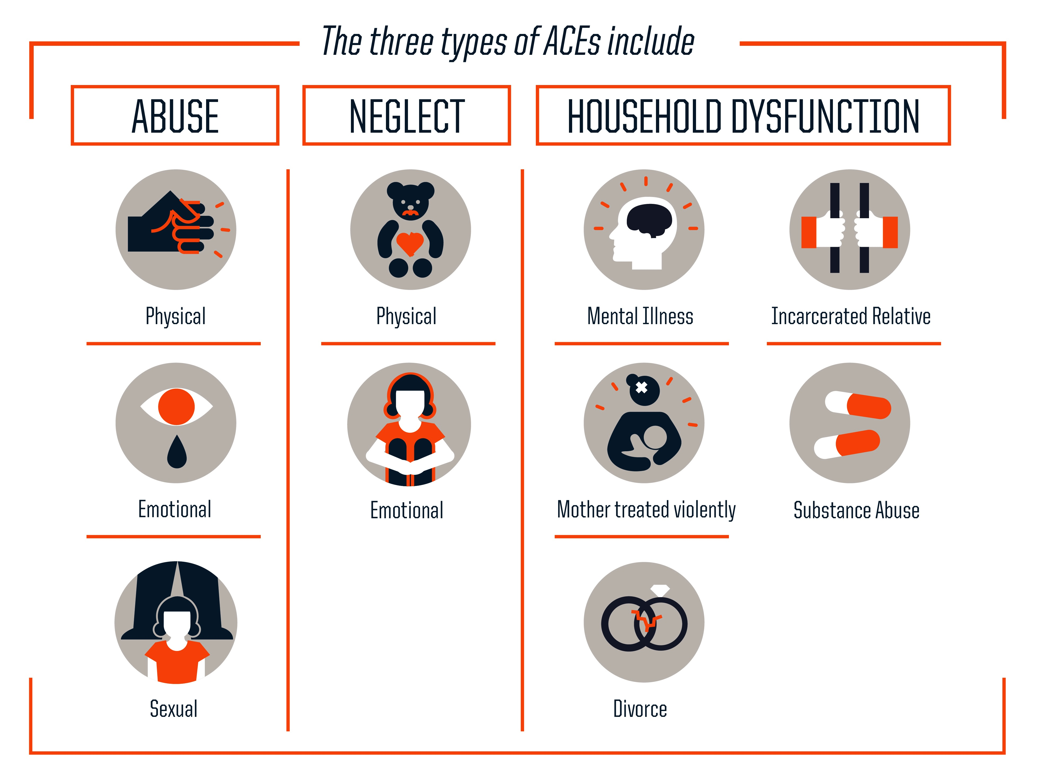Figure 1.

Prevalence

The original CDC-Kaiser ACE study found 12.5% of respondents had experienced 4+ ACEs and 64% had experienced at least 1 ACE. In 2015 a survey of 2028 adults in Wales found that 47% had experienced at least 1 ACE and 14% 4+. (Bellisi et al., 2015). The prevalence reported in other studies in the UK ranges from 9-14% for 4+ ACEs.

The diversity of adversity

It should be recognized that although these categories cover a lot of types of adversity the list is not complete and adversity varies in duration, and type. The majority of the respondents in the Kaiser study were white and college educated. Considering a broader description of adversity may demonstrate even greater correlation between adversity and ill health. Poverty, community deprivation and gang violence/peer victimization may cause chronic adversity. The impact of chronic versus acute adversity needs further research.

A study interviewed young people from deprived areas of Philadelphia, asking the participants to identify causes of childhood adversity and then rate them according to which were the most stressful. (Wade, Shea, Rubin, & Wood, 2014)The most common cause of adversity identified by this group was problems within family relationships. They listed stressors not recognized by the original ACE list, such as lack of love in the family, and having to take on adult responsibilities. The young people also highlight lack of parenting skills, due to their parents’ experience of adversity, recognising the cycle of suffering that can occur, as demonstrated by this quote: “My mom said, ‘I ain’t teach you nothing because I want you to go through the same thing I went through’…It’s just like heartless, like you just don’t care. My parents couldn’t show me [love]. They made me feel like I was just there for a check.” (Wade et al., 2014).

Economic hardship was also recognized and is probably a key point missing from the original ACE study, given the strong links between poverty and ill health. This can lead to lack of resilience within communities to protect children from the effect of an adverse event.

Factors outside the immediate family, that affect the community as a whole are another source of adversity influencing children’s health, as in the case of historical abuse and discrimination as reported by Native Americans. (Brockie, Dana-Sacco, Wallen, Wilcox, & Campbell, 2015) or for example, the existence of child labour or prostitution in the community.

The majority of research into ACE and health has been carried out in high income countries. The WHO has recognized the need to get international data particularly from low and middle income countries to raise the profile of ACE as a global issue of public health concern. They have developed an Adverse Childhood Experiences International Questionnaire (ACE-IQ). In addition to the usual ACE questions it recognizes other factors such as war, peer, community and collective violence. (World Health Organization, 2012)

How do ACEs influence health and well-being

Adverse childhood experiences can affect the developing brain, immune and endocrine systems. Due to the high level of stress in their environment, children who experience more adverse events are more likely to develop behaviours that are harmful to health, such as smoking, drinking alcohol or antisocial behavior. (Danese & McEwen, 2012) This then puts the individual on a pathway to poor adult health with higher risk of many diseases including cancer, (Bellisi et al., 2015)

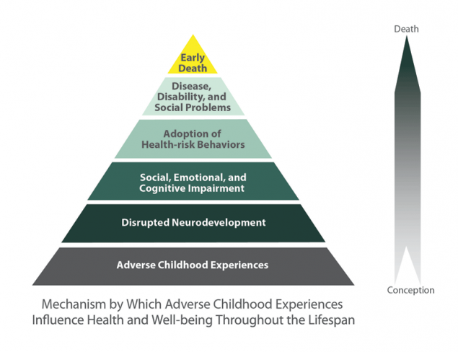
Figure 2. https://www.cdc.gov/violenceprevention/acestudy/about.html

The life trajectory of a person who has experienced ACEs and how they impact on their development and health is illustrated in figure 2. Public Health Wales and Blackburn with Darwen Local Authority have produced an animation which shows how this may play out in someone’s life – see the link in further reading.

Research has focused on the adverse experiences occurring in childhood and the resulting poor health occurring in adulthood. However, the impact on physical health can start as young as 6 years of age, with exposure to 1 ACE doubling the likelihood of overall ill poor health. Children with exposure to four or more ACEs showed almost 3 times the rate of poor health compared to those with no ACEs. (Flaherty et al., 2006)

Allostasis

Our bodies are highly developed to be able to respond to the ever changing environment around us and provide physiological and behavioral stability- the process of “allostasis”. This includes physiological changes to enable us to deal with stressful circumstances.

When we are faced with a stressful experience, the example of facing a “bear in the woods” is often used, our body responds by activating the sympathetic nervous system – causing heart rate to increase, pupils to dilate etc. The hypothalamic-pituitary- adrenal (HPA) axis is also activated releasing cortisol, triggering the production of glucose for immediate utilization by cardiac and skeletal muscle in preparation to escape from the danger posed!.

Thus when our body is subjected to an acutely stressful situation, the physiological changes help us to respond effectively. We then have a period of recovery and return to a healthy level of activation of these pathways. If the stress is severe, we may still be able to regulate effectively through the protective factors such as a parent or caregiver who helps regulate the response and builds the child’s resilience. If however the stressful situations are frequent or there are no protective factors helping us to recover, it can lead to dysregulation of the pathways and have long term consequences on the way the neurological, endocrine and immune systems function. These are known as the allostatic systems. Dysregulation means that these don’t return to a normal allostatic state, which is particularly damaging to the young child.

Multiple adverse childhood experiences can negatively affect the way these systems function and dysregulation can be permanently embedded in the biological processes. Prolonged or chronic exposure to stress can cause allostatic overload.

Neurological

The hippocampus, pre frontal cortex and amygdala have all been shown to be vulnerable to the toxic stress caused by adverse childhood experiences. This in turn can lead to behavioural problems, difficulties with concentration, memory and learning and poor executive function. (Danese & McEwen, 2012)

Endocrine

Adverse childhood experiences or chronic stress have been shown to affect circadian rhythm with overall increased cortisol production, but less variation over 24 hours, it is also associated with glucocorticoid resistance over longer periods.

Immune

Chronic stress leads to chronic inflammation or raised inflammatory markers, this in turn reduces the cell mediated immunity and can lead to increased risk of infection. A chronic inflammatory state will also increase the risk of later cardiovascular disease

These changes to the physiological pathways and anatomical structure can explain why individuals who suffer multiple adverse childhood experiences are at much greater risk of both mental and physical ill health in adulthood. However, the degree of impact of the adversity on their physiological development, is difficult to predict. The type and pervasiveness of the adversity, the strength of their resilience (which may be both genetic and environmental), and other factors which are also impacting their development will determine this. Epigenetics is an exciting area which gives a molecular basis for this gene environment interaction.

Epigenetics

Epigenetics is the study of how factors including the environment, can change gene expression; genes are switched ‘on’ or ‘off’. This change in phenotype can be passed on to the next generation despite there being no change in the genetic code. The genes are repressed or activated by DNA methylation. There is evidence to show that early adversity or exposure to maternal stress and anxiety can have an impact on the degree to which methylation occurs leading to a change in genetic expression that can have a long lasting negative effect on health and development outcomes. A study by Oberlander et al 2008 demonstrated that babies born to mothers that had significant depression and anxiety in the third trimester had a significantly higher rate of methylated genes which cause increased cortisol response to stress. By 3 months of age these infants had significantly higher levels of stress induced cortisol. Another study (Suderman et al 2014) showed that a cohort of adults who were exposed to child abuse had either over or under expression of 997 genes compared to controls that had not been exposed to child abuse. These patterns are not related to socioeconomic status and there is clearly much to learn about the biochemical mediators involved.

Consequences of ACEs on adult health

Physical health

In the Welsh ACE study (Ashton, Bellis, Davies, Hardcastle, & Hughes, n.d.) those with 4 or more ACE were 2 times as likely to develop a chronic disease before the age of 69. For type 2 diabetes they were 4 times as likely and 3 times as likely to develop heart disease or respiratory disease.

These rates of chronic disease were as high as you could expect in a person 10 years older, but with no ACEs. Premature morbidity has an effect on the economic productivity of a society. In the US a study suggested that those with 6 or more ACEs may die 20 years earlier than those with 0.

Mental health

A study (Koskenvuo & Koskenvuo, 2015) has shown a graded relationship between early childhood adversity and use of psychotrophic drugs. The relationship persists even when adjusted for occupation, recent life events and other health risk behaviours, and is strongest when there are multiple ACEs or reported poor child parent relationship.

Accessing healthcare

In the Welsh ACE study (Ashton et al., n.d.) those with 4 or more ACE were 2 times as likely to have visited the GP 6 or more times in the last year, and 3 times as likely to have visited A&E or stayed overnight in hospital.

This increased rate of accessing health services leads to higher healthcare costs – either to the National Health Service as in the case of the UK, or in privatized systems like the USA these costs will be falling to the individual.

The reasons for increased demand for healthcare may be multi factorial. The person with a higher number of ACEs is likely to have greater need due to greater ill health both physical and mental as demonstrated now in multiple studies. Perceived poor health may also be a factor.

Resilience

There are a number of studies that document resilience but little is yet known about what provides resilience. A study (Infurna et al., 2015) looked at the environmental factors that differentiate between healthy and unhealthy individuals who have been exposed to similar levels of adversity. This study compared 2 groups that had both received maltreatment as children, that the group with ill health were significantly more likely to have poor levels of social support. Social support included any form of external support, such as youth clubs, sports groups, a trusted individual to talk to. This gives weight to the idea that we can promote resilience by finding ways for the children at risk to be more socially integrated and have more opportunities. It would be beneficial for those commissioning services for children to be aware of this evidence. Investing in activities for children and improving their access to social support, may reduce health care needs later in life.

Prevention, Recognition and Intervention

The mounting evidence for the impact of ACEs on health, both through neuro/physiological changes, behavior and epigenetics is impressive, however the next question is what is the evidence for intervention to prevent poor health outcomes.

Effective intervention will target:
- Primary Prevention of Adverse Events in Childhood
- Early recognition and intervention

Primary prevention programmes in the UK

The Family Nurse Partnership, a program, developed in the USA to work intensively with young mothers through pregnancy and early years. In the UK, in the areas where the program exists, it is offered to first time mothers under the age of 19 years. The aim is to improve long term outcomes by impacting health behaviours of the mother and her partner and developing parenting skills that are responsive caring and competent. In the USA the program has been found to improve school readiness, reduce behavioural problems in the child and reduce child abuse and neglect.

Maternal Early Childhood Sustained Home Visiting MECSH. This is similar to the FNP program, with intensive health visiting input – at least 25 visits from the same health visitor. There are some trial sites in England, however cost effectiveness for wider NHS implementation is yet to be shown.

Flying Start is a targeted early years program provided by the Welsh government. It focuses on early years child care, enhanced health visiting services, parenting support and language and communication development. It is focused on the most deprived areas in Wales.

A Better Start is an early intervention program run in selected deprived communities in England, funded by The Big Lottery Fund. The program is for all families within the geographical area of the project from pregnancy until the child is 4 years old. It focuses on improving nutrition, speech and language, social and emotional development and systems change. It is a 10 year program with a robust evaluation system in place to assess impact.

Mindfulness is a practice that teaches awareness of the present moment, non-reactivity, focus, attention and non-judgment. Teaching children and young people the practice of mindfulness has been shown to improve mental, physical and behavioral outcomes. There is no requirement for the history of the adversity to be explored and mindfulness is also beneficial to healthy populations. Therefore there is potential application of mindfulness being used for example in schools, to provide a means of resilience for those experiencing adversity, whilst being of some benefit to all. Teaching mindfulness to parents is another way to mitigate the effects of adversity and toxic stress on the child. If the parent can learn ‘mindful’ parenting that is more responsive to the child, the effect of the adversity will decrease.

Early intervention programs
A key first step in intervention is education of professionals, who come into contact with children and families, about the effects of adversity on health. Public health Wales are developing ways of working across agencies to increase awareness of ACEs and their impact. One example is their work with the police, providing training to enable early recognition and intervention for families at risk. Helping families access services within the community early will build resilience through greater support and hopefully prevent further ACEs across generations.

The REACh (Routine Enquiry About Childhood adversity) initiative is a training programe run as a pilot from 2014 in Blackburn with the aim to increase health and social care providers knowledge on issues of childhood adversity.

A model developed in Maryland USA called SEEK aims to increase primary care professionals awareness and enable screening for ACEs, to improve health outcomes again by early intervention.

Programes and policies that promote safe, stable, nurturing relationships and enviroments for children to grow up in will both prevent ACEs occurring and limit the effect of the adversity if it does occur.

In the USA there is growing recognition within the paediatric community of the impact of ACEs and some models of practice are developing. The Centre for Youth Wellness is an example of a response to the ACE evidence in paediatric practice. They assess every child for ACEs and encourage family engagement through home visits. Education on toxic stress and its effect is given to families. They work in conjunction with psychiatrists and psychotherapists for specialist interventions and management and refer on to other partner organisations. Techniques in mindfulness and coping skills and taught to children and families to build resilience. The National Paediatric Practice Community on Adverse Childhood Experiences is their initiative to promote primary care and paediatricians to understand the impact of ACEs and toxic stress and use this knowledge to change their approach to the child. Their website provides practical advice and support for assessing patients for ACEs and also developing referral pathways to local services that will build resilience and mitigate the effects of the adversity.

Conclusion

The evidence of the impact of early adversity is strong and growing rapidly. Taking steps in our local areas to raise awareness of this, consider ACEs when doing a holistic assessment of a child and building links between the medical world and the community services that can help mitigate the effect is likely, based on the evidence, to have long lasting effects on health outcomes into adulthood.

Key reading

National Pediatric Practice Community on Adverse Childhood Experiences http://nppcaces.org/nppc/

Centre for Youth Wellness http://www.centerforyouthwellness.org/

Centers for Disease Control and Prevention ACE https://www.cdc.gov/violenceprevention/acestudy/index.html - Includes page with

Public Health Wales ACEs http://www.wales.nhs.uk/sitesplus/888/page/88504

Animated films explaining ACEs http://www.aces.me.uk/in-wales/ http://www.aces.me.uk/in-england/

