In situ Neutron Diffraction Study of BaCe_{0.4}Zr_{0.4}Y_{0.2}O_{3-δ} Proton Conducting Perovskite: Insight on phase transition and proton transport mechanism
Juan F. Basbus^{ab}*, Mauricio D. Arce^{ac}, José A. Alonso^{d}, Miguel A. González^{e}, Gabriel J. Cuello^{e}, María T. Fernández-Díaz^{e}, Zijie Sha^{f}, Stephen J. Skinner^{f}, Liliana V. Mogniª and Adriana C. Serquisª
The understanding of protonic defect transport mechanism in Ba(Ce,Zr)O₃ perovskites oxides and its proper temperature range of conductivity are fundamentals for materials design and their technological applications as electrolyte for solid oxide fuel and electrolyzer cells, isotopic separation membranes and hydrogen sensors. Structural features of the material, as well as the lattice distortions and proton diffusion, are key factors defining the protonic conduction. The crystal structure of protonated and deuterated BaCe_{0.4}Zr_{0.4}Y_{0.2}O_{3−δ} (BCZY) perovskite and its correlation with protonic transport was studied by in situ Neutron Powder Diffraction (NPD) and complementary Thermogravimetry (TG), Quasi-Elastic Neutron Scattering (QENS) and Isotope Exchange Depth Profiling (IEDP) techniques. A 2nd order phase transition from rhombohedral to cubic symmetry takes place at intermediate temperatures (400 - 600 ºC). Dynamic measurements of NPD allowed the detection of the temperature of the phase transition for BCZY at around 520 ºC. Crystallographic and microstructural parameters, including deuterium occupancy and anisotropic thermal parameters, were determined from high resolution NPD data. The deuterium (and oxygen) occupancy for pre-hydrated BCZY is maximum at low temperature and decreases above 400 ºC, even through the phase transition and beyond 600 ºC. By contrast, proton diffusion increases with temperature above the phase transition. The combination of both effects, deuterium content and diffusion coefficient, explains previous results showing that the proton conductivity dominates the ionic conductivity over the oxygen vacancy mechanism until 600 ºC. The phase transition is mainly related to oxygen sublattice relaxation and does not impact on the protonic transport mechanism.
Introduction

Protonic conductors based on Ba(Ce,Zr)O₃ perovskites have been proposed as electrolytes and electrodes for Proton Conducting Solid Oxide Cells (PC-SOC), i.e. Fuel Cells (PC-SOFC) and Electrolyzer Cells (PC-SOEC) ^{1–8} as well as other electrochemical applications, such as isotopic separation membranes and hydrogen sensors ^{9–14}. These compounds are distinguished by their low activation energy of proton hopping through oxygen lattice sites ¹⁵ and high proton solubility between 400 and 600 ºC ^{1,16}. Otherwise, Ba(Ce,Zr,Y)O_{3-δ} perovskites present several crystal structures, monoclinic ($I2/m$), orthorhombic ($Imma$), rhombohedral ($R\overline{3}c$) and cubic ($Pm\overline{3}m$) symmetries according to the Zr content and temperature range ¹⁷.
Our attention is focused on its use as electrolytes for PC-SOFC (or commonly called as Proton Conducting Fuel Cell (PCFC), H⁺-SOFC, H-SOFC, or Low Temperature SOFC (LT-SOFC)) devices, which have gain increasing attention in recent years due to their due their high efficiencies, low environmental impact, low operating temperatures, fuel flexibility, good stability and durability ^{18–21}. Particularly, proton conducting electrolytes play a crucial role during development of these electrochemical devices. For example, PC-SOFC based on Ba(Ce,Zr,Y,Yb)O_{3-δ} electrolyte were scaled up from button-cells to small-stack and reached power density values at 600 °C of 0.69 and 0.47 Wcm⁻² under H₂ and CH₄ fuels, respectively ²². The efforts have been focused mainly to improve chemical, crystallographic, microstructural, thermodynamic and electrical properties, which represent new challenges and opportunities during materials development ²³. Other strategies have been applied to reduce the proton conducting electrolyte thicknesses and decrease the ohmic overpotentials of electrolytes. PC-SOFCs are typically prepared by combining different methods, such as tape casting, rapid laser sintering, spray coating, lamination, co-firing, etc. ^{24–28}. Thin films based on Ba(Ce,Zr)O₃ perovskites were also explored and characterized ²⁹. Ab initio, first-principles, (kinetic) Monte-Carlo, density functional theory (DFT) investigations, quantum molecular dynamics, simulations, and experimental/theoretical data combining have been done in order to understand, predict material properties and improve and optimize the development of these materials ³⁰³¹³²³³³⁴³⁵³⁶³⁷³⁸³⁹⁴⁰⁴¹⁴². Advanced manufacturing techniques are promising due their significant commercial future for the fast and economic production of protonic ceramic electrochemical cells ⁴³. However, these materials have not been widely manufactured on industrial scale ⁴⁴. The feedback between fundamental and applied sciences is needed for the continuous development of this technology. In this sense, neutron techniques, such as Neutron Powder Diffraction (NPD) ^{45–48} and Quasi-Elastic Neutron Scattering (QENS) ^{49–54}, are ideal for the characterization of protonic conductor materials ⁵⁵ due to the fact that these techniques are highly sensitive towards proton or deuterium content, in contrast with the usually employed techniques for material characterization. Particularly, the BaCe_{0.4}Zr_{0.4}Y_{0.2}O_{3−δ} (BCZY) perovskite was proposed as a potential PC-SOFC electrolyte due its attractive properties related with proton uptake and proton conduction ^{56–64}. The proton conductivity of this Y-doped Ba(Ce,Zr)O₃ compound, also called BCZY44 or even BCZY442, was demonstrated by differentiating the bulk conductivity in H₂O and D₂O vapor atmospheres and by in situ and in operando measurements of conductivity and X-Ray/neutron techniques ^{62,65}. Also, the temperature range of the pure protonic conductivity was confirmed below 400 ºC, while between 400 and 600 ºC it showed mixed protonic and oxygen ionic conductivity ^{62,65}. The hydrogen self-diffusion mechanism involves proton hopping between intra-octahedral oxygen sites ^{18,20,65}. Meanwhile, the transport mechanism was dominated by oxygen vacancies above 600 ºC, which restricts its use as PC-SOFC below this temperature. In addition, BCZY presented rhombohedral symmetry $R\overline{3}c$ between room temperature (RT) and 400 ºC and cubic symmetry $Pm\overline{3}m$ above 600 ºC. This set of measurements indicated a strong correlation between crystallographic and electrochemical properties, which was evidenced by a conductivity reduction and lattice shrinkage between 490 and 530 ºC ⁶⁵. The 2nd order phase transition might be located in this temperature range, however, it is not clear if this phase transition affects the protonic transport mechanism or they are independent processes.
This work presents a complementary in situ crystallographic study of BCZY powders under air with heavy water vapor, aiming to detect the phase transition and deuterium occupancy. This information allows to establish whether the 2nd order phase transition has a correlation with the proton uptake or not.
Experimental

Sample preparation

BaCe_{0.4}Zr_{0.4}Y_{0.2}O_{3−δ} (BCZY) perovskite was synthesized by Solid State Reaction (SSR) and sintered at 1600 ºC, as explained elsewhere ^{62,65}. Subsequent thermal treatments were performed according to the sample preparation and technique requirements. The following description indicates the history of the samples.

- Neutron Powder Diffraction (NPD)
- BCZY_dry: BCZY powder samples were dried at 800 ºC under synthetic air (20 % O₂ and 80 % N₂ mix) for 30 minutes. This ensured the complete structural H₂O loss.
- BCZY_D₂O: the BCZY_dry sample was deuterated at 400 ºC by flowing synthetic air after bubbling in D₂O (~ 2 % D₂O vapor) for 2 hours. This allowed the D₂O incorporation into the crystal structure.
- The BCZY_D₂O sample was cooled to 100 ºC under wet (~ 2 % D₂O vapor) synthetic air.
These steps were performed inside the furnaces of D20 and D2B neutron diffractometers at the ILL.

- Thermogravimetrc analysis (TG) and Quasi-Elastic Neutron Scattering (QENS)
- BCZY_H₂O: BCZY powder samples were hydrated at 400 ºC under air with water vapor at least 2 hours.
- The BCZY_H₂O was cooled at RT under air with water vapor.
These were performed in situ at TG and QENS instruments.

  - Isotope Exchange Depth Profile (IEDP)
Previous reports show that ZnO promotes higher grain sizes, cohesion and densities with respect to the sample without sintering additive ^{66,67}. Then, to improve sintering capabilities, 5 mol % Zn per BCZY mol was tested ⁶⁸.
- BCZY_5Zn: the dense pellets were prepared by mixing BCZY powders with Zn(NO₃)₂ using isopropyl alcohol, pressing at 50 kgcm⁻² in a 10 mm matrix and sintering them at 1400 ºC for 6 hours.
- BCZY_5Zn_H₂O: BCZY_5Zn dense samples were pre-annealed under H₂O vapor during 14 hours.
- BCZY_5Zn_H₂O/D₂O: BCZY_5Zn_H₂O was annealed under 20 mbar D₂O vapor during 30 minutes at 600 ºC.
These thermal treatments were done ex situ.

Characterization by neutron techniques

NPD dynamic measurements were collected at the D20 instrument by using a wavelength (λ) of 1.544 Å ⁶⁹. NPD static measurements were performed at the high resolution D2B diffractometer with λ = 1.594 Å at high flux mode ⁷⁰. In both cases, the powders were placed in tubular quartz sample holders of 1 cm of diameter and the NPD patterns were acquired between 100 and 800 ºC under wet (~ 2 % D₂O vapor) synthetic air. The λ and instrumental broadening were calibrated by diffraction standards. The NPD patterns were collected in the angular range (2θ) between 0.5 and 160 º and plotted in transference moment (Q = (4π/λ) sin θ).
A dynamic NPD measurements (D20) was performed to detect the temperature (T) of the 2nd order phase transition, i.e. rhombohedral $R\overline{3}c$ to cubic $Pm\overline{3}m$ symmetry. For that, the diffraction patterns were collected for the BCZY_D₂O sample as a function of T under wet air (~ 2 % D₂O) each minute during the heating rate of 2 ºC min⁻¹ ⁷¹.
The equilibrium NPD patterns (D2B) were collected at constant temperatures, varying with steps of 100 ºC. The dwell time for each stationary measurement was at least 30 min. These patterns were refined by the Rietveld method using the Fullprof Suite ⁷² with the rhombohedral and cubic structural models ^{17,65}. The background, peak profile, crystallite size, Debye-Waller factors, etc., were fitted according to our previous work ⁶⁵. The oxygen and deuterium atomic positions and thermal displacement parameters were refined and related to the structural distortion. Nuclear density distributions were analyzed by a combination of the Maximum Entropy Method (MEM) with Rietveld analysis using the Dysnomia software ⁷³. The nuclear densities were visualized by VESTA software ⁷⁴.

A second dynamic NPD collection using the D20 instrument was used to study the hydration kinetics of BCZY in D₂O vapor. The BCZY_dry powders were equilibrated at 400 ºC, then the synthetic air was passed throughout heavy water bubbler and NDP patterns were immediately collected each minute for 90 min until reach the stationary state. The selected peaks were fitted by using a pseudo Voigt function (PsdVoigt2), i.e., a linear combination of Gaussian and Lorentzian functions with different Full Width at Half Maximum (FWHM). The Q behavior was modeled by an exponential decay meanwhile the integrated intensity (I. I.) performance was considered as an exponential growth as functions of the time (t). In addition, the 1st order kinetic of BCZY deuteration was proved by Q and I. I. data treatment.

QENS spectra of BCZY_H₂O powder, were collected between 200 and 700 ºC in air at IN16B spectrometer from ILL with an incident λ = 6.271 Å ^{65,75,76}. The powders were placed in a tubular quartz sample holder of 1 cm of diameter through which a constant flow of hydrated air was circulated and then inside a furnace ⁷⁷. Raw data were corrected using the standard procedures with the ILL software LAMP and then fitted using a Chudley-Elliott model (CEM) ^{65,78–80}. Some of the results obtained have already been presented in a previous publication ⁶⁵, however, in this work we have extended the analysis to some temperatures previously not covered and used a different fitting engine based on a Monte Carlo approach ⁸¹ in order to obtain better estimates on the uncertainties of the fitted parameters. First, only the Q-range below 1.2 Å⁻¹ was used in the fitting, in order to avoid any influence from the Bragg peaks in the resulting parameters and be able to extract an average intensity per temperature, which should be approximately proportional to the amount of water adsorbed in the sample. Second, the jump length (l) was not constrained to a fixed value, but was allowed to vary in the range l ± 2 Å, with l = 3.1 Å being the intra-octahedral oxygen distance, where then the proton self-diffusion coefficients (D_{H}) were calculated. Finally, the fit was done using Bayesian inference together with a Markov chain Monte Carlo method to explore as completely as possible the space of possible solutions. This was done by using the DREAM algorithm implemented in the Python package Bumps ⁸¹. DREAM returns a probability distribution for each fitted parameter, allowing to determine the reliability of the results obtained.

Determination of structural water content

The water content into the BCZY perovskite was estimated by TG measurements by using a Cahn 1000 electrobalance ^{47,62,82}. The evolution of mass with T was recorded for BCZY_H₂O powders when this was treated under wet (~ 2 % H₂O vapor) synthetic air , from RT to 800 ºC, with a heating rate of 2 ºCmin⁻¹ ^{47,82}.

Study of the H/D Isotopic Exchange

IEDP experiments were performed in order to estimate the self-diffusion coefficients (D*) of deuterium on hydrogen at 600 ºC. In this sense, the BCZY_5Zn dense sample was pre-annealed to introduce the deuterium tracer and create a D/H profile ⁸³. The high density of BCZY_5Zn pellets were confirmed by Scanning Electron Microscopy (SEM) of polished cross sections by FEI Inspect S50 microscope equipped with Energy Dispersive Spectroscopy (EDS) probe. The overall grain size is around 1 µm. In addition, X-Ray Diffraction (XRD) was used to check the phases present in BCZY_5Zn dense pellets after sintering thermal treatment. These samples were grounded by an agate mortar and pestle. XRD patterns of powders were collected in air at RT through a PANalytical Empyrean diffractometer ^{62,65}. Only BCZY and ZnO phases were detected in BCZY_5Zn after sintering process, so the reactivity between the compounds was discarded. The density value of BCZY_5Zn dense pellet was measured by Archimedes method ^{62,84}. The BCZY_5Zn dense pellets reached high density values, i.e., higher than 95 % respect to theoretical density from XRD data.
The BCZY_5Zn dense sample was annealed to introduce the deuterium tracer and create a D/H profile ⁸³. The hydroxide ion specie (OD⁻) diffusion profile in BCZY_5Zn_H₂O/D₂O sample was collected by Time of Flight - Secondary Ion Mass Spectroscopy (ToF - SIMS) coupled with Low Energy Ion Scattering (LEIS) through a combined IONTOF TOF.SIMS5-Qtac100 LEIS instrument. The data were collected by using a Cs⁺ beam and constant sputter rate. The natural deuterium isotopic concentration in BCZY_Zn_H₂O sample was determined and subtracted from IEDP data of BCZY_5Zn_H₂O/D₂O. The diffusion profile analysis was performed by fitting the data with a Gaussian error function (i.e., the convolution between ideal concentration profile and Gaussian curve).
Results and discussion

The BCZY 2nd order phase transition

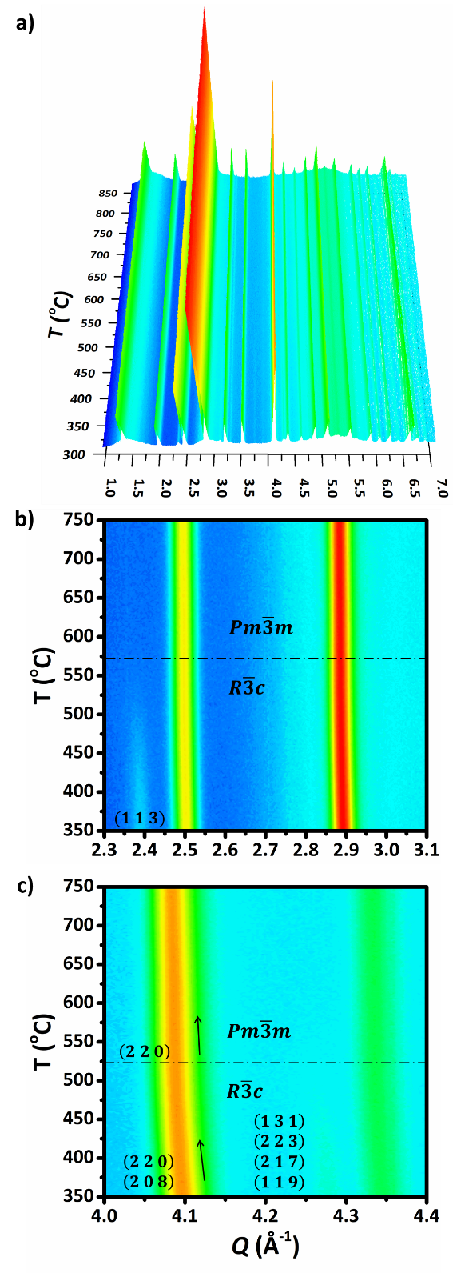
In a previous work, BCZY perovskite presented rhombohedral symmetry $R\overline{3}c$ between RT and 400 ºC and cubic symmetry $Pm\overline{3}m$ above 600 ºC, which was in agreement with other works. Also, it was discarded the possibility of higher symmetries than $R\overline{3}c$ compatibles with the RT diffraction patterns ⁶⁵. However, the temperature of the 2nd order phase transition was not detected. Therefore, dynamic NDP measurements would allow to locate this temperature. Figure 1 shows whole and selected zones of the NPD patterns collected in dynamic mode for BCZY_D₂O powder sample during the heating rate from 300 to 850 ºC. The phase transition from rhombohedral to cubic symmetry was detected at 520 ºC, evidenced by a continuous change in the curvature close to 4.10 Å⁻¹ and the disappearance of low intensity peaks around 2.40 and 4.27 Å⁻¹. The respective Bragg reflections are indicated in the plot. The slope change is associated to a continuous rearrangement of (Ce,Zr,Y)-O coordination sphere and O-D anisotropic vibration effect. These results indicate a 2nd order transition and are in agreement with those reported for BaCe_{0.85-x}Zr_{x}Y_{0.15}O_{3-δ} with x = 0.3 and 0.4, showing the same kind of phase transition above 520 ºC ¹⁷. Also, BaZr_{0.7}Ce_{0.2}Y_{0.1}O_{3-δ} perovskite shows the same 2nd order phase transition, which, according to the authors, influences the ionic transport, moderated by the water incorporation under both oxidizing and reducing atmospheres ⁸⁵. In a previous work, we found that BCZY perovskite presents protonic conductivity as dominant transport mechanism below 400 ºC. Otherwise, the conductivity is mainly associated to oxygen vacancies diffusion above 600 ºC. Mixed conductivity by protons and oxygen vacancies coexists between 400 and 600 ºC ⁶⁵. Thus, the phase transition for the BCZY could be matched to the loss of protons which start above 400 ºC ^{62,65}. However, this NPD dynamic study shows that the phase transition takes place at higher temperatures and seems not be directly triggered by the structural proton loss.
Figure 1. a) Evolution of the NPD patterns as a function of T during heating run under wet (~ 2 % D₂O vapor) synthetic air for the fully deuterated BCZY_D₂O powder sample. b) and c) show the level surfaces zoomed between 2.3 - 3.1 and 4.0 - 4.4 Å⁻¹, respectively. The intensity (I) of the rhombohedral (1 1 3) reflection, close to 2.4 Å⁻¹ and those corresponding to (1 3 1)/(2 2 3)/(2 1 7)/(1 1 9), around 4.25 Å⁻¹, vanish around 520 ºC. Otherwise, peak close to 4.1 Å⁻¹ indicates a slope change associated to the 2nd order phase transition from rhombohedral (2 2 0)/(2 0 8) to cubic (2 2 0) symmetry, as indicated by the black arrows (↑). Bragg reflections are indicated with their Miller index. Also, the phase transition is showed by black dashed lines (─). The I is in arbitrary units (a. u.) and is presented in logarithmic scale in all plots.

Crystallographic study of BCZY

Figure 2a compares NPD patterns collected in high resolution mode at 100 ºC, for fully deuterated (BCZY_D₂O) and completely dry (BCZY_dry) powder samples. From this plot, both samples present rhombohedral symmetry, independently of protonic content into the structure at 100 ºC. However, the I of some reflections close to 2.4 and 4.3 Å⁻¹ are sensitive to D incorporation into the structure (see inset). Also, the NPD patterns showed a slight shift to higher Q for BCZY_D₂O, related to D incorporation into the structure.
The NPD patterns of BCZY_D₂O, collected under wet air containing heavy water vapor, were refinement following some considerations:
  - $R\overline{3}c$ space group was used between 100 and 500 ºC and $Pm\overline{3}m$ above 600 ºC. This is in agreement with our previous study ⁶⁵ and with similar 2nd order phase transition reported for BaZr_{0.7}Ce_{0.2}Y_{0.1}O_{3-δ} perovskite by Mather et al. ⁸⁵.
  - the Wyckoff positions (WPs) of D were assumed as 36f and 12h for $R\overline{3}c$ and $Pm\overline{3}m$, respectively, in agreement with those previously reported by Mather et al. ⁸⁵.
  - below 400 ºC, the occupancy was considered full for O (O_{occ} = 1) and partial for deuterium (D_{occ} = 0.0334) assuming fully D₂O incorporation into the oxygen vacancies sites produced by Y-doping in BCZY compound, (3-δ) ≈ 2.90 (i.e., O_{occ} ~ 0.97 for BCZY_dry) ⁶⁵ (see TG data in Figure 2b).
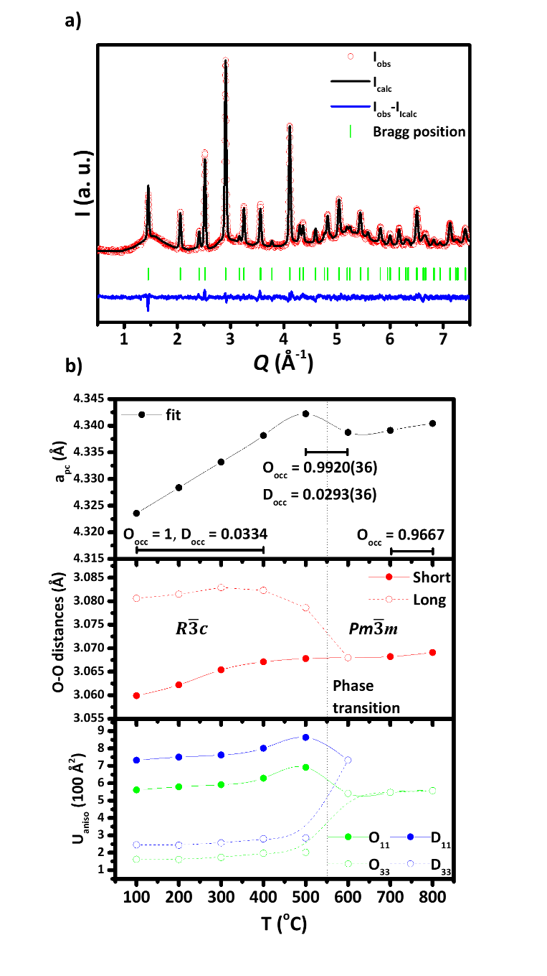
  - between 400 and 600 ºC, both the O and D occupancies were refined, since a fast dehydration is observed above 500 ºC by TG in Figure 2b. Note that, the TG plot shows perovskite losses water vapor up to 800 ºC. This is due to that the experimental conditions (heating rate and the TG design), do not guarantee that fully dehydration observed under thermodynamic equilibrium conditions reached in NPD set-up.
Figure 3. a) Refinement of NPD pattern of fully deuterated BCZY_D₂O powder sample collected under wet (~ 2 % D₂O vapor) synthetic air at 100 ºC. b) Dependence with T of relevant crystallographic parameters obtained from the NPD data refinement. Top panel: a_{pc} where O_{occ} and D_{occ} occupancies were fixed or fitted during refinements at each T. Middle panel: long and short O-O distances are referred to the distances between intra-octahedral O-sites in the rhombohedral structure (i.e., octahedral tilting and distortion). Bottom panel: U_{aniso} parameters for O and D are indicated alongside a (11) and c (33) directions for rhombohedral structure. Above 600 ºC, there is not an anisotropic behavior due to the phase transition and cubic symmetry. The T range of rhombohedral and cubic symmetries are indicated.

  - above 700 ºC the O occupancy is 0.9667, which corresponds to the sample fully dehydrated BCZY with 3-δ = 2.90 due to the oxygen vacancies formation by charge compensation mechanism (Y⁺³ doping).
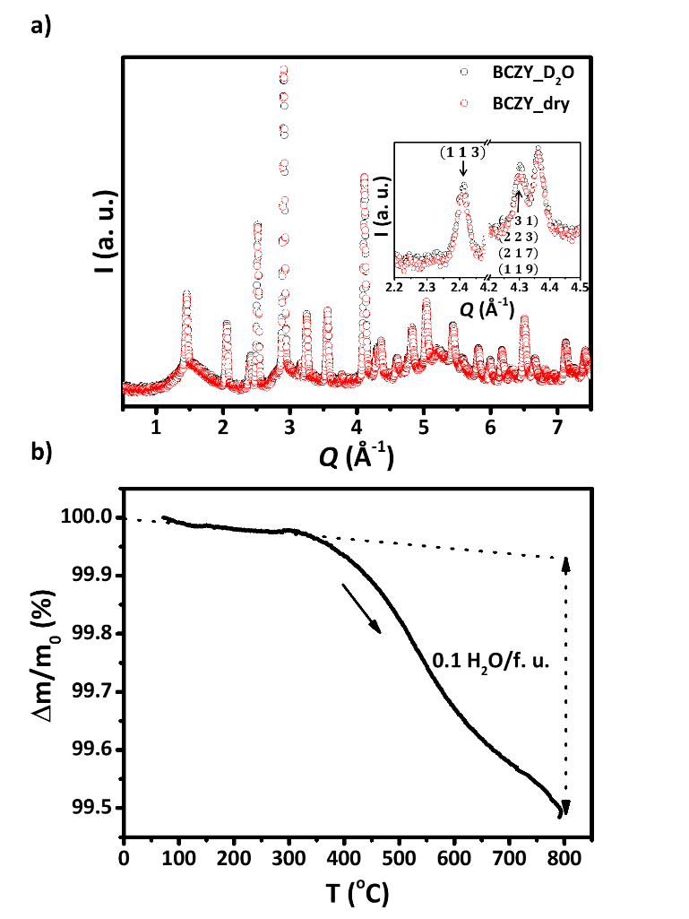
Note that these kind of assumptions are similar to those used for related systems such as BaCe_{0.4}Zr_{0.4}Sc_{0.2}O_{2.90} ⁴⁷. However, at difference of that compounds where the proton hopping mainly involves the O inter-octahedral sites through the shorter O-O distance on the BaO planes (i.e., O-apical) ⁴⁷; in the case of BCZY, the mechanism transport is through intra-octahedral proton hopping. This difference is due to the higher symmetry of BCZY ⁶⁵ compared to the orthorhombic BaCe_{0.4}Zr_{0.4}Sc_{0.2}O_{2.90} perovskite (i.e.,$Pbnm$) ^{37,47,86}.
Figure 2. a) NPD patterns collected of fully deuterated (BCZY_D₂O) and completely dried (BCZY_dry) samples at 100 ºC. The inset indicates some reflections which are sensitive to D2O incorporation. b) Percent mass change of fully hydrated BCZY_H₂O powder as function of T under synthetic air saturated with distilled water vapor, where Δm is the mass change and m₀ corresponds to the initial mass at RT. The H₂O content is expressed in formula unit (f. u.).
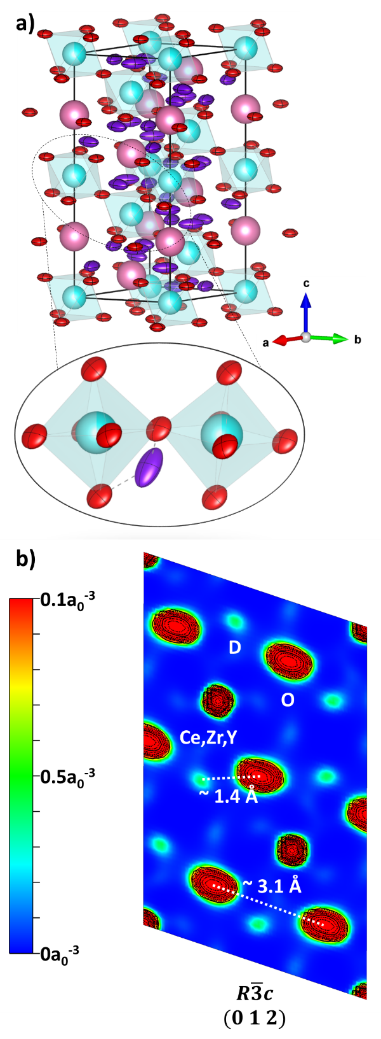
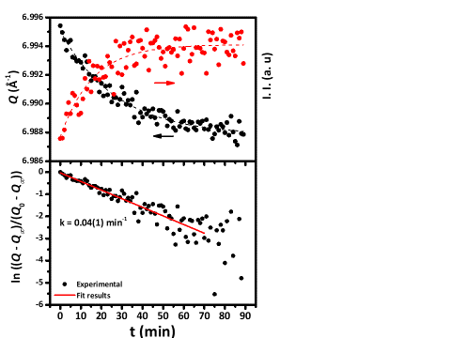
Figure 3a presents the refinement of a NPD pattern of the BCZY_D₂O powder sample at 100 ºC (similar fitting quality were obtained at all temperatures). The heavy atoms (Ba, Ce, Zr and Y) were fitted with isotropic displacement parameters (U_{iso}), meanwhile light atoms (O and D) were adjusted by anisotropic displacement parameters (U_{aniso}). The equivalent U_{iso} for O and D were also considered (see Table 1). Figure 3b compares crystallographic parameters obtained from fits as a function of T. The variation of pseudocubic lattice parameter (a_{pc}) presented in Figure 3b indicates that BCZY suffers shrinkage between 500 and 600 ºC which is associated to the phase transition. The octahedral distortion, generating two different O-O intra-octahedral distances (see Figure 3b), produces the rhombohedral symmetry. During the 2nd order phase transition, these O–O distances suffer a (i) shortening of large distance and (ii) lengthening of short distance, until they converge to a unique cubic intra-octahedral O-O distance. In addition, the increase of the U_{iso} and U_{aniso} values with T suggest the increment of ionic diffusion. However, the U₁₁ (≡ U₂₂) values of O and D are higher than U_{33,} which confirm the preference of the intra-octahedral proton diffusion along particular planes, such as (0 1 2) (see Figure 4a) ⁶⁵. Table 1 presents the resulting crystallographic parameters obtained from Rietveld Method at 100 ºC. Note that the equivalent U_{iso} for O and D is dominated by the U₁₁ values. Figure 4a shows the crystal structure of deuterated BCZY sample when adopts the rhombohedral structure at 100 ºC. The ellipsoids represent the U_{aniso} values of O and D and indicates that the proton hopping occurs by O intra-octahedral by their high anisotropy alongside a direction. The nuclear density distributions calculated by MEM indicates a clear intra-octahedral diffusion pathway. Figure 4b shows the MEM density distribution where it is clear that the D nuclear density is bonded to O (~ 1.4 Å) and displacement alongside with shorter O-O bond (~ 3.1 Å). This is derived from the highly anisotropic distortion of the O and D at plane (0 1 2) ⁶⁵. In the case of D atoms, the U_{aniso} values increment until 500 ºC, and then decay at 600 ºC due to the gain in isotropy. Considering the structural water loss occurs continuously between 400 and 600 ºC, the increment of the D displacement is compensated by its occupancy diminution with the net effect of the proton conductivity suppression above 600 ºC, as it was reported from observed by electrochemical impedance spectroscopy (EIS) measurements ^{62,65}. The O atoms show a similar U_{aniso} trend as D, however, above 600 ºC the effective oxygen vacancies increases due to D₂O loss and the ionic transport is dominating by O-ions transport.
Figure 4. a) BCZY_D₂O rhombohedral structure where the high O₁₁ and D₁₁ anisotropies promote the intra-octahedral proton hopping. The Ba, Ce,Zr,Y, O and D atoms are indicated as magenta (●), cyan (●), red (●) and violet (●), respectively. The O octahedral is also plotted by light cyan (●). b) MEM nuclear density distributions of deuterated BCZY powder sample at 100 ºC. The plane was used to evaluate the (Ce,Zr,Y)-O-D environment. The isosurface levels were 0.1a₀⁻³ (a₀ represents the Bohr radii). These plots correspond to the NPD pattern of fully deuterated powder sample collected at 100 ºC under wet (~ 2 % D₂O vapor) synthetic air.

Table 1. Crystallographic parameters obtained from Rietveld Method at 100 ºC under wet (~ 2 D₂O % vapor) synthetic air. The lattice parameters (a, b and c), angles (α, β and γ) and cell volume (V) are shown. The goodness of fit parameters as profile factor (R_{p}), weighted profile factor (R_{wp}) and chi-square (χ²) are indicated.
$R\overline{3}c$ (Nº 167) Space group
a = b = 6.1145(3) Å, c = 14.9393(8) Å, α = β = 90 º, γ = 120 º, V = 483.71(4) Å³
R_{p} = 2.84 % , R_{wp} = 3.76 %, χ² = 2.69
At. | WP | Occ. | Atomic position |  |  | Displacement parameters (100 Å²)
At. | WP | Occ. | x | Y | z | Anisotropic |  | Isotropic
 |  |  |  |  |  | U₁₁ | U₃₃ | U_{iso}
Ba | 6a | 1 | 0 | 0 | 0.25 | - | - | 2.75(6)
Ce | 6b | 0.4 | 0 | 0 | 0 | - | - | 1.29(4)
Zr | 6b | 0.4
Y | 6b | 0.2
O | 18e | 1 | 0.464(1) | 0 | 0.25 | 5.61(5) | 1.62(4) | 4.28(4)
D | 36f | 0.0334 | 0.146(7) | 0.493(9) | 0.035(3) | 7.32(4) | 2.45(7) | 7.32(5)

Figure 5. D₂O incorporation kinetics: BCZY_dry to BCZY_D₂O at 400 ºC under wet (~ 2 % D₂O vapor) synthetic air. Top panel: the black dots (●) correspond to Q shift of the peak with reflections (1 5 5)/(2 4 7)/(2 3 11)/(1 3 13). The black dashed line (─) shows that Q behaves as an exponential decay. The red dots (●) indicate the I. I. diminution associated to the reflection (1 1 3) at 2.4 Å⁻¹ and can be modeled by an exponential growth, as it can be seen by the red dashed line (─). Bottom panel: the fit of Q relation confirms that the BCZY hydration process occurs by a 1st order kinetic.

Incorporation/diffusion of H/D into BCZY

Figure 5 presents the changes of Q and the I. I. at 400 ºC while air saturated with heavy water vapor was passing through BCZY_dry powder. For Q, we selected the peak around 6.99 Å⁻¹ corresponding to the (1 5 5), (2 4 7), (2 3 11) and (1 3 13) reflections. This peak is selected due its sensitive Q shift and considerable relative intensity. In the case of the I. I., we used (1 1 3) single reflection at 2.40 Å⁻¹, where this peak is highly D sensitive. The hydration reaction is given by $V_{O}^{••}+D_{2}O_{(g)}+O_{O}^{x}⇌2{OD}_{O}^{•}$, where $V_{O}^{••}$, $O_{O}^{x}$ and ${OD}_{O}^{•}$ corresponds to oxygen vacancies, oxygen sites and deuterium interstitial sites (i.e., hydroxide), respectively. Thus, for protonic conduction the material needs first to incorporate protons through hydroxide formation and then the transport mechanism is by interstitial proton hopping between oxygen sites ^{18,20}. To the best of our knowledge, there are no studies reported of the D₂O incorporation rate in proton conducting perovskites by NPD measurements. From Figure 5, it can be observed that the Q decreases and the I. I. increases with t, confirming the D incorporation into the structure and its crystallographic effect (see top panel). In addition, the exponential behaviors of these parameters as a function of t suggest a 1st order kinetic reaction. An accurate approximation to study the D incorporation process can be performed by plotting and fitting ln (Q - Q∞)/(Q₀ - Q∞) and ln (I. I. - I. I.∞)/(I. I.₀ - I. I.∞) vs. t. The initial (Q₀ and I. I.₀) and instantaneous (Q and I. I.), and the final values without an appreciable change (Q∞ and I. I.∞) are known. In this sense, we confirmed that the BCZY deuteration process is due by a 1st order kinetic and constant rates (k) are quite similar between Q and I. I. data analysis (k ~ 0.04 min⁻¹ = 6.7 x 10⁻⁴ s⁻¹). Figure 5 presents Q variation as an example, where BCZY suffers a fast hydration process and would be fully deuterated between 90 and 120 minutes at 400 ºC (see bottom panel).
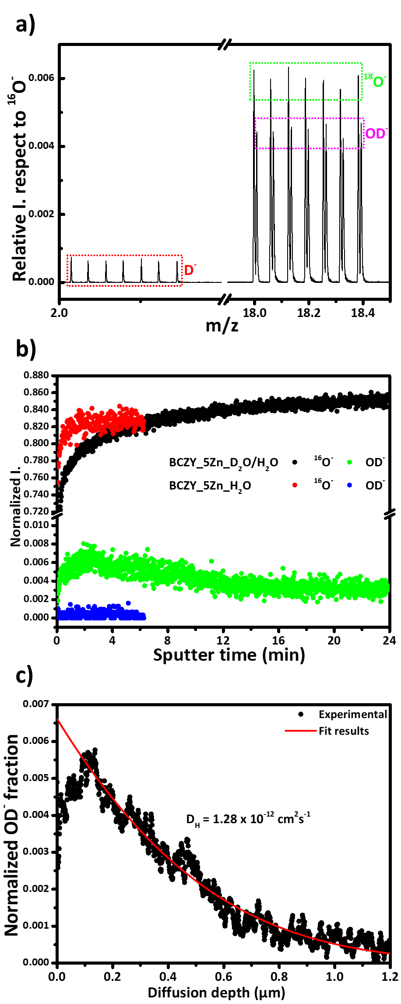
In addition, the BCZY deuteration was proven beyond the temperature of phase transition by the OD⁻ depth profile (IEDP) from ToF - SIMS measurements at 600 ºC. Figure 6 presents sections of the ToF - SIMS mass spectrum of a D₂O-exchanged dense pellet (i.e., BCZY_5Zn_H₂O/D₂O) and unexchanged dense sample as a reference (i.e., BCZY_5Zn_H₂O). This technique is a powerful tool to study the transport properties of materials, in particular protonic conductors, such as PrBaCo₂O_{5+δ} double perovskite mixed conductor or La_{27.15}W_{4.85}O_{55.28}V_{0.73} high temperature proton conductor ^{87,88}. Figure 6a demonstrates the D₂O incorporation in the exchanged sample through the detection of OD⁻ (m/z = 18.007) and D⁻ (m/z = 2.014) ions. To clarify, the m/z ratio corresponds to the relation between atomic mass (m) and atomic number (z). It also shows the mass resolution of the ToF - SIMS was sufficient to separate between the OD⁻ and the ¹⁸O⁻ (m/z = 17.998) peaks. The deuterium diffusion profile was characterized by the OD⁻ rather than the D⁻ due to the higher relative intensity (see Figure 6b). The ¹⁶O⁻ signals of both samples, the D₂O-exchanged and the unexchanged, are steady indicating the stability of the Cs⁺ beam and a constant sputter rate. The unexchanged sample shows a low count of the OD⁻ species at approximately the natural deuterium isotopic concentration, 0.015 %. In contrast, the OD⁻ depth profile of the exchanged sample demonstrates D incorporation into the structure. The OD⁻ depth profile was obtained by ToF - SIMS on a dense (> 95 %) BCZY_5Zn_H₂O/D₂O sample, where the hydrogen tracer diffusion coefficient D* is 1.28 x 10⁻¹² cm²s⁻¹, the surface exchange coefficient (k*) is 1.57 x 10⁻¹⁰ cms⁻¹ and D₂O concentration is 0.78. In addition, SIMS maps indicated a homogeneous distribution of Zn and ZnO secondary ions across the sample. There is an evident superficial effect as there is an initial increase in concentration, which may be related to a surface layer formation.
Figure 6. a) Sections of a negative ToF-SIMS spectrum at around m/z = 2 and m/z = 18 of a D₂O-exchanged BCZY_5Zn dense pellet. The intensities of the secondary ions are plotted relative to the intensity (I.) to ¹⁶O⁻. b) SIMS depth profiles of the OD⁻ and the ¹⁶O⁻ of the D₂O-exchanged and the unexchanged BCZY_5Zn pellets, respectively. The secondary ion counts are plotted in normalized intensities. c) OD⁻ depth profile of the BCZY_5Zn_H₂O/D₂O dense sample obtained by ToF - SIMS. The natural deuterium isotopic concentration was subtracted from the data and fitted.

Note that the proton incorporation kinetics was confirmed by complementary techniques, such as dynamic NPD at 400 ºC and IEDP at 600 ºC. In order to check the proton mobility inside the sample and cover the range between 200 and 700 ºC with a single technique, the QENS spectra were fitted to a CEM using the jump length and the proton self-diffusion coefficient as adjustable parameters. Details of the model and some results have been given previously ⁶⁵. Here we have extended the analysis to a larger temperature range and used a more robust Monte Carlo based minimization algorithm, allowing us to let the jump length as a free parameter. Our new results indicate that the QENS data do not allow us to determine with a high precision the jump length, as at all temperatures the data can be adjusted using a relatively wide distribution of lengths, ranging from 2.2 to 5 Å. These values are consistent with the fixed jump length of 3.4 Å used before ⁶⁵ and the typical octahedral oxygen distance of 3.1 Å, but not much more can be said from the QENS data alone. On the other hand, the self-diffusion coefficient can be obtained with better precision. They are consistent with the values previously reported, and comparable, but slightly higher, to self-diffusion coefficients reported for related systems, such as BaZr_{0.8}In_{0.2}O_{2.90} perovskite (D_{H} ~ 2.8 x 10⁻⁷ cm²s⁻¹ at 277 ºC) ⁸⁰ or BaZr_{0.85}Y_{0.15}O_{2.925} (D_{H} ~ 2.5 x 10⁻⁶ cm²s⁻¹ at 400 ºC) ⁸⁹. Figure 7 presents the Arrhenius plot, which indicates an activation energy (E_{a}) of 0.26(7) eV.
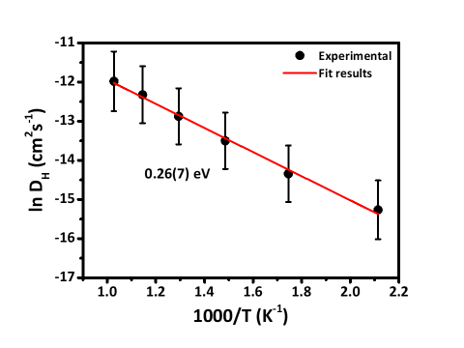
Note that besides the possible effect of ZnO additive, IEDP estimates the deuterium self-diffusion coefficient on hydrogen taking into account bulk and grain boundary pathway, meanwhile QENS infers the long-range H self-diffusion through O sub-lattice by measuring the proton hopping on the atomic scale. In other words, ToF - SIMS is an overall measurement, while the QENS is a bulk technique. Therefore, these two self-diffusion coefficients obtained by two independent techniques would not be comparable due their nature. Note that, the activation energy obtained by QENS is lower than those reported by EIS measurements ^{90–92}, probably because this last one is the result of a mixed O and H ionic conductivity. The information obtained from EIS, QENS and IEDP techniques do not provide the same results since these have different sample requirements and theoretical fundaments. In spite of this, these techniques are in fact complementary, and it has to be taking into account the differences in the measurements, sample conditions and physical meaning of each one. We propose that the intra-octahedral diffusion is favored by the oxygen and proton anisotropies.
Figure 7. Arrhenius plot of self-diffusion coefficients obtained from QENS spectra of BCZY_H₂O sample.

Conclusions

The BCZY perovskite was studied by NPD techniques to determine the 2nd order phase transition and deuterium occupancy as a function of T. Complementary techniques such as TG, QENS and ToF - SIMS were used to evaluate the protonic uptake and transport features of BCZY allowing to have a detailed picture of the protonic transport features. The 2nd phase transition from rhombohedral to cubic symmetry was observed at 520 ºC under wet (~ 2 % D₂O) synthetic air. The D occupancy is full below 400 ºC and it is partially occupied above this temperature up to 600 ºC. The intra-octahedral protonic transport mechanism associated to D occupancy was described and it was proved that the phase transition does not affect the protonic transport mechanism, which depends on H/D content and its self-diffusion coefficients.
Author Contributions

The authors are grouped according to the participation in this work:
- Sample preparation and room temperature characterization: Juan F. Basbus and Mauricio D. Arce.
- Thermogravimetric measurements: Liliana V. Mogni and Adriana C. Serquis.
- Data acquisition by neutron techniques: Juan F. Basbus, Mauricio D. Arce, José A. Alonso, Miguel A. González, Gabriel J. Cuello, María T. Fernández-Díaz.
- Isotope Exchange Depth Profile study: Zijie Sha, Stephen J. Skinner.
- Result discussion: Juan F. Basbus, Mauricio D. Arce, José A. Alonso, Miguel A. González, Gabriel J. Cuello, María T. Fernández-Díaz, Zijie Sha, Stephen J. Skinner, Liliana V. Mogni and Adriana C. Serquis.
- Manuscript writing: Juan F. Basbus, Mauricio D. Arce, José A. Alonso, Miguel A. González, Gabriel J. Cuello, María T. Fernández-Díaz, Zijie Sha, Stephen J. Skinner, Liliana V. Mogni and Adriana C. Serquis.
Conflicts of interest

There are no conflicts to declare.
Acknowledgements

This work was supported by Instituto de Nanociencia y Nanotecnología (INN), Comisión Nacional de Energía Atómica (CNEA), Consejo Nacional de Investigaciones Científicas y Técnicas (CONICET) by PIP 2015-0565, Agencia Nacional de Promoción de Ciencia y Tecnología (ANPCyT) through PICT-2018-03690 and PICT-2019-03721, Consejo Superior de Investigaciones Científicas (CSIC) by the MINECO grant MAT2017-84496-R, Helmholtz-Zentrüm Berlin (HZB), Consiglio Nazionale delle Ricerche (CNR), Dipartimento di Ingegneria Civile, Chimica e Ambientale (DICCA), Università di Genova (UniGe), Imperial College London (ICL) and ILL under proposals number 5-25-269 and 7-03-168.
References

1 D. Medvedev, a. Murashkina, E. Pikalova, a. Demin, a. Podias and P. Tsiakaras, Prog. Mater. Sci., 2014, 60, 72–129.
2 A. V Kasyanova, L. R. Tarutina, A. O. Rudenko, J. G. Lyagaeva and D. A. Medvedev, Russ. Chem. Rev., 2020, 89, 667–692.
3 N. L. R. M. Rashid, A. A. Samat, A. A. Jais, M. R. Somalu, A. Muchtar, N. A. Baharuddin and W. N. R. Wan Isahak, Ceram. Int., 2019, 45, 6605–6615.
4 D. Han, X. Liu, T. S. Bjørheim and T. Uda, Adv. Energy Mater., 2021, 11, 2003149.
5 S. A. Rasaki, C. Liu, C. Lao and Z. Chen, Prog. Solid State Chem., 2021, 63, 100325.
6 C. Y. Regalado Vera, H. Ding, D. Peterson, W. T. Gibbons, M. Zhou and D. Ding, J. Phys. Energy, 2021, 3, 032019.
7 K. Leonard, W. Deibert, M. E. Ivanova, W. A. Meulenberg, T. Ishihara and H. Matsumoto, Membranes (Basel)., 2020, 10, 339.
8 L. Lei, J. Zhang, R. Guan, J. Liu, F. Chen and Z. Tao, Energy Convers. Manag., 2020, 218, 113044.
9 N. TANIGUCHI, T. KUROHA, C. NISHIMURA and K. IIJIMA, Solid State Ionics, 2005, 176, 2979–2983.
10 J. W. P. S. P. S. Badwal, 2006, 103–115.
11 R. Mukundan, J. Electrochem. Soc., 1999, 146, 2184.
12 M. K. Hossain, R. Chanda, A. El-Denglawey, T. Emrose, M. T. Rahman, M. C. Biswas and K. Hashizume, Ceram. Int., 2021, 47, 23725–23748.
13 M. K. Hossain, T. Iwasa and K. Hashizume, J. Am. Ceram. Soc., 2021, 104, 6508–6520.
14 M. K. Hossain, H. Tamura and K. Hashizume, J. Nucl. Mater., 2020, 538, 152207.
15 D. A. Medvedev, J. G. Lyagaeva, E. V Gorbova and A. K. Demin, J. Prog. Mater. Sci., 2016, 75, 38–79.
16 S. Ricote, N. Bonanos and G. Caboche, Solid State Ionics, 2009, 180, 990–997.
17 L. Malavasi, C. Tealdi, C. Ritter, V. Pomjakushin, F. Gozzo and Y. Diaz-Fernandez, Chem. Mater., 2011, 23, 1323–1330.
18 E. Fabbri, D. Pergolesi and E. Traversa, Materials challenges toward proton-conducting oxide fuel cells: a critical review., 2010, vol. 39.
19 F. S. da Silva and T. M. de Souza, Int. J. Hydrogen Energy, 2017, 42, 26020–26036.
20 K. D. Kreuer, Annu. Rev. Mater. Res., 2003, 33, 333–359.
21 T. Norby, Solid State Ionics, 1999, 125, 1–11.
22 L. Q. Le, C. H. Hernandez, M. H. Rodriguez, L. Zhu, C. Duan, H. Ding, R. P. O’Hayre and N. P. Sullivan, J. Power Sources, 2021, 482, 228868.
23 W. Zhang and Y. H. Hu, Energy Sci. Eng., 2021, 9, 984–1011.
24 E. Mercadelli, A. Gondolini, D. Montaleone, P. Pinasco and A. Sanson, J. Eur. Ceram. Soc., 2021, 41, 488–496.
25 A. Ishii, H. Huang, Y. Meng, S. Mu, J. Gao, J. Lei, F. Peng, H. Xiao, J. Tong and K. S. Brinkman, Mater. Res. Bull., 2021, 143, 111446.
26 J. Xiao, L. Chen, H. Yuan, L. Ji, C. Xiong, J. Ma and X. Zhu, Mater. Lett., 2017, 189, 192–195.
27 X. Chen, H. Zhang, Y. Li, J. Xing, Z. Zhang, X. Ding, B. Zhang, J. Zhou and S. Wang, J. Power Sources, 2021, 506, 229922.
28 Y. Ma, B. He, J. Wang, M. Cheng, X. Zhong and J. Huang, Int. J. Hydrogen Energy, 2021, 46, 9918–9926.
29 P. Winiarz, M. S. C. Covarrubias, M. Sriubas, K. Bockute, T. Miruszewski, W. Skubida, D. Jaworski, G. Laukaitis and M. Gazda, Crystals, 2021, 11, 1005.
30 W. Münch, G. Seifert, K. D. Kreuer and J. Maier, Solid State Ionics, 1996, 86–88, 647–652.
31 M. E. Björketun, P. G. Sundell and G. Wahnström, Phys. Rev. B, 2007, 76, 054307.
32 P. G. Sundell, M. E. Björketun and G. Wahnström, Phys. Rev. B, 2007, 76, 094301.
33 M. BJORKETUN, P. SUNDELL, G. WAHNSTROM and D. ENGBERG, Solid State Ionics, 2005, 176, 3035–3040.
34 F. M. Draber, C. Ader, J. P. Arnold, S. Eisele, S. Grieshammer, S. Yamaguchi and M. Martin, Nat. Mater., 2020, 19, 338–346.
35 M. K. Hossain, M. C. Biswas, R. K. Chanda, M. H. K. Rubel, M. I. Khan and K. Hashizume, Emergent Mater., 2021, 4, 999–1027.
36 J. A. Wrubel, J. Gifford, Z. Ma, H. Ding, D. Ding and T. Zhu, Int. J. Hydrogen Energy, 2021, 46, 11511–11522.
37 J. Hermet, M. Torrent, F. Bottin, G. Dezanneau and G. Geneste, Phys. Rev. B, 2013, 87, 104303.
38 J. Hermet, F. Bottin, G. Dezanneau and G. Geneste, Solid State Ionics, 2013, 252, 48–55.
39 J. Hermet, F. Bottin, G. Dezanneau and G. Geneste, Phys. Rev. B, 2012, 85, 205137.
40 M. Swift, A. Janotti and C. G. Van de Walle, Phys. Rev. B, 2015, 92, 214114.
41 J. A. Dawson, J. A. Miller and I. Tanaka, Chem. Mater., 2015, 27, 901–908.
42 R. P. Stoffel and R. Dronskowski, Zeitschrift für Anorg. und Allg. Chemie, 2013, 639, 1227–1231.
43 S. Mu, Z. Zhao, H. Huang, J. Lei, F. Peng, H. Xiao, K. S. Brinkman and J. (Joshua) Tong, Electrochem. Soc. Interface, 2020, 29, 67–73.
44 D. A. Medvedev, Curr. Opin. Green Sustain. Chem., 2021, 32, 100549.
45 J. A. Alonso, M. J. Martínez-Lope, A. Aguadero and L. Daza, Prog. Solid State Chem., 2008, 36, 134–150.
46 M. A. Tamimi and S. McIntosh, J. Mater. Chem. A, 2014, 2, 6015–6026.
47 A. K. Azad and J. T. S. Irvine, Chem. Mater., 2009, 21, 215–222.
48 L. Malavasi, C. Ritter and G. Chiodelli, Chem. Mater., 2008, 20, 2343–2351.
49 N. Malikova, C.-K. C.-K. Loong, J.-M. Zanotti and F. Fernandez-Alonso, J. Phys. Chem. C, 2007, 111, 6574–6580.
50 P. Colomban, O. Zaafrani and A. Slodczyk, Membranes (Basel)., 2012, 2, 493–509.
51 Q. Chen, J. Banyte, X. Zhang, J. P. Embs and A. Braun, Solid State Ionics, 2013, 252, 2–6.
52 M. Karlsson, Phys. Chem. Chem. Phys., 2015, 17, 26–38.
53 D. Noferini, M. M. Koza and M. Karlsson, J. Phys. Chem. C, 2017, acs.jpcc.7b00177.
54 A. Slodczyk, P. Colomban, N. Malikova, O. Zaafrani, S. Longeville, J.-M. Zanotti, O. Lacroix and B. Sala, Solid State Ionics, 2013, 252, 7–11.
55 P. Colomban and A. Slodczyk, Eur. Phys. J. Spec. Top., 2012, 213, 171–193.
56 N. Nasani, P. a. N. Dias, J. a. Saraiva and D. P. Fagg, Int. J. Hydrogen Energy, 2013, 38, 8461–8470.
57 P. Sawant, S. Varma, B. N. Wani and S. R. Bharadwaj, Int. J. Hydrogen Energy, 2012, 37, 3848–3856.
58 L. Zhao, W. Tan and Q. Zhong, Ionics (Kiel)., 2013, 19, 1745–1750.
59 Y. Guo, Y. Lin, R. Ran and Z. Shao, 2009, 193, 400–407.
60 S. Barison, M. Battagliarin, T. Cavallin, L. Doubova, M. Fabrizio, C. Mortalò, S. Boldrini, L. Malavasi and R. Gerbasi, J. Mater. Chem., 2008, 18, 5120.
61 J. Lagaeva, D. Medvedev, A. Demin and P. Tsiakaras, J. Power Sources, 2015, 278, 436–444.
62 J. F. Basbus, M. D. Arce, F. D. Prado, A. Caneiro and L. V. Mogni, J. Power Sources, 2016, 329, 262–267.
63 N. Nasani, D. Ramasamy, S. Mikhalev, A. V Kovalevsky and D. P. Fagg, J. Power Sources, 2015, 278, 582–589.
64 J. Basbus, M. Arce, H. Troiani, Q. Su, H. Wang, A. Caneiro and L. Mogni, Int. J. Hydrogen Energy, , DOI:10.1016/j.ijhydene.2019.06.164.
65 J. F. Basbus, M. D. Arce, F. R. Napolitano, H. E. Troiani, J. A. Alonso, M. E. Saleta, M. A. González, G. J. Cuello, M. T. Fernández-Díaz, M. P. Sainz, N. Bonanos, C. E. Jimenez, L. Giebeler, S. J. A. Figueroa, A. Caneiro, A. C. Serquis and L. V. Mogni, ACS Appl. Energy Mater., 2020, 3, 2881–2892.
66 S. Hossain, A. M. Abdalla, J. H. Zaini, C. D. Savaniu, J. T. S. Irvine and A. K. Azad, Int. J. Hydrogen Energy, 2017, 42, 27308–27322.
67 N. Nasani, Z. Shakel, F. J. A. Loureiro, B. B. Panigrahi, B. B. Kale and D. P. Fagg, J. Alloys Compd., 2021, 862, 158640.
68 F. J. A. Loureiro, N. Nasani, G. S. Reddy, N. R. Munirathnam and D. P. Fagg, J. Power Sources, 2019, 438, 226991.
69 d20, https://www.ill.eu/users/instruments/instruments-list/d20/description/instrument-layout.
70 d2b, https://www.ill.eu/users/instruments/instruments-list/d2b/description/instrument-layout.
71 J. A. Alonso, M. Arce, J. F. Basbus, G. J. Cuello, M. T. Fernandez-Diaz, N. Gamba, M. A. Gonzalez and C. E. Jiménez, In-situ neutron diffraction study of BaCe0.4Zr0.4Y0.2O3-d proton conducting perovskite, 2019.
72 J. Rodríguez-Carvajal, Phys. B Condens. Matter, 1993, 192, 55–69.
73 K. Momma, T. Ikeda, A. A. Belik and F. Izumi, Powder Diffr., 2013, 28, 184–193.
74 K. Momma and F. Izumi, J. Appl. Crystallogr., 2011, 44, 1272–1276.
75 J. F. Basbus, J. A. Alonso, M. Arce, A. Cabrera, G. J. Cuello, M. T. Fernandez-Diaz, M. A. Gonzalez and M. Pardo Sainz, Study of H-diffusion mechanism in BaCe0.4Zr0.4Y0.2O3-d proton conducting perovskite, 2018.
76 in16b, https://www.ill.eu/users/instruments/instruments-list/in16b/description/instrument-layout.
77 C. Goodway, P. McIntyre, A. Sears, N. Belkhier, G. Burgess, O. Kirichek, E. Lelièvre-Berna, F. Marchal, S. Turc and S. Wakefield, J. Neutron Res., 2020, 21, 137–142.
78 D. Richard, M. Ferrand and G. J. Kearley, J. Neutron Res., 1996, 4, 33–39.
79 C. T. Chudley and R. J. Elliott, Proc. Phys. Soc., 1961, 77, 353–361.
80 D. Noferini, B. Frick, M. M. Koza and M. Karlsson, J. Mater. Chem. A, 2018, 6, 7538–7546.
81 P. A. Kienzle, J. Krycka, N. Patel and I. Sahin, 2011, Bumps v0.8.1.
82 a. Caneiro, P. Bavdaz, J. Fouletier and J. P. Abriata, Rev. Sci. Instrum., 1982, 53, 1072–1075.
83 J. A. Kilner, S. J. Skinner and H. H. Brongersma, J. Solid State Electrochem., 2011, 15, 861–876.
84 A. Caneiro and M. Chandrasekaran, Scr. Metall., 1988, 22, 1797–1800.
85 G. C. Mather, G. Heras-Juaristi, C. Ritter, R. O. Fuentes, A. L. Chinelatto, D. Pérez-Coll and U. Amador, Chem. Mater., 2016, 28, 4292–4299.
86 Y.-C. Jeong, B.-K. Kim and Y.-C. Kim, Solid State Ionics, 2014, 259, 1–8.
87 H. Téllez Lozano, J. Druce, S. J. Cooper and J. A. Kilner, Sci. Technol. Adv. Mater., 2017, 18, 977–986.
88 R. Hancke, S. Fearn, J. A. Kilner and R. Haugsrud, Phys. Chem. Chem. Phys., 2012, 14, 13971.
89 B. Groß, C. Beck, F. Meyer, T. Krajewski, R. Hempelmann and H. Altgeld, Solid State Ionics, 2001, 145, 325–331.
90 A. Braun, S. Duval, P. Ried, J. Embs, F. Juranyi, T. Strässle, U. Stimming, R. Hempelmann, P. Holtappels and T. Graule, J. Appl. Electrochem., 2009, 39, 471–475.
91 K. . Kreuer, Solid State Ionics, 1999, 125, 285–302.
92 K. D. Kreuer, S. Adams, W. Münch, A. Fuchs, U. Klock and J. Maier, Solid State Ionics, 2001, 145, 295–306.

