Symptoms predicting the onset and duration of SARS-CoV-2 infectiousness: a community cohort study
Seran Hakki*¹ Kieran J Madon*¹, Sean Nevin*¹, Joe Fenn¹, Jakob Jonnerby¹, Rhia Kundu¹, Emily Conibear¹, Aleksandra Koycheva¹, Nieves Derqui², Sam Baldwin¹, Hamish Houston¹, Timesh D Pillay¹, Janakan Sam Narean¹, Robert Varro¹, Constanta Luca¹, Samuel Evetts¹, Shazaad Ahmad³, Prof. Maria Zambon⁴, Prof. Jake Dunning⁵, Prof. Ajit Lalvani¹.
* S.H, K.J.M and S.N contributed equally to this study (joint-first authors).
Affiliations
1 NIHR Health Protection Research Unit in Respiratory Infections, National Heart and Lung Institute, Imperial College London, London, UK.
2 MRC Centre for Global Infectious Disease Analysis, School of Public Health, Imperial College London, London, UK.
3 Department of Virology, Manchester Medical Microbiology Partnership, Manchester Foundation Trust, Manchester Academic Health Sciences Centre, Manchester, UK.
4 National Infection Service, UK Health Security Agency (UKHSA), London, UK.
5 NIHR Health Protection Research Unit in Emerging and Zoonotic Infections, University of Oxford, Oxford, UK.

Corresponding Author:
Dr Seran Hakki
Imperial College London,
Hammersmith Campus,
72 Du Cane Rd,
London W12 0NN
s.hakki@imperial.ac.uk

Word Count: Abstract: 284/300 words; Main text: 3,568/3,500 words; References: 26/30

Abstract

Introduction: Upper respiratory tract (URT) SARS-CoV-2 viral load (VL) kinetics influence the clinical course of COVID-19, but their relationship to symptoms remains poorly understood. We hypothesised that VL kinetics affect the timing, intensity, and duration of symptoms in community cases.
Methods: Our prospective community cohort provided daily URT swabs for VL quantification for 2 weeks and symptom diaries for 28 days post-recruitment. Symptom data were summarised using a composite Symptom Burden Score (SBS) incorporating symptom presence and severity. Only cases who enrolled sufficiently early post-exposure to discern peak (p)VL were included (n=89). Infectious viral shedding was assessed in a subset (n=37) through quantitative viral culture.
Results: The day of pVL correlated with the day of peak symptom burden score (pSBS) (p<0.001, n=89). Very high pVL (>170,000,000 RNA copies/ml) was linked to prolonged illness, with a subset experiencing symptoms ≥3 weeks (p<0.001). Cases reported more symptoms, as well as an increase in URT symptom burden, on the first day of virus cultivability compared to the preceding day (p<0.001 and p=0.005, n=31). Peak systemic symptom score, and specifically muscle aches, significantly associated with prolonged infectious viral shedding (p=0.012 and p=0.033, n=34). URT symptoms such as rhinitis, sore throat, and hoarse voice showed the steepest increase at infectiousness onset.
Conclusions: The timing of pSBS aligns with pVL, and pVL above 170,000,000 RNA copies/ml predicts prolonged symptom duration. URT symptom escalation often marks the onset of infectiousness, while systemic symptoms, particularly muscle aches, signal prolonged infectiousness. These findings identify symptom-based markers of infectiousness with implications for testing strategies. They also highlight the importance of collecting early, frequent longitudinal symptom and virological data as a core element of the public health response to novel pathogens and future pandemics.
Keywords: COVID-19; SARS-CoV-2; Pandemic Preparedness; kinetics; symptom; viral load.

Introduction

Common respiratory viruses result in a wide range of symptoms with marked inter-individual heterogeneity in the dominance and duration of individual symptoms. Understanding how symptom patterns relate to infectiousness may help to define the onset and duration of infectiousness and inform practical containment measures such as workplace exclusion or self-isolation. However, this has not hitherto been achieved for any naturally acquired respiratory virus infection. Given that in vivo upper respiratory tract viral load (VL) dynamics likely contribute to clinical presentation, it is reasonable to assume that the pattern of symptoms may correlate with certain parameters of the VL trajectory such as peak VL, quantified as RNA copy number, and infectious viral shedding, quantified as cultivable virus.
The response to the COVID-19 pandemic resulted in the creation of the most detailed longitudinal cohort studies of a respiratory virus infection with tracking of RNA VL kinetics to date [1][2][3][4][5]. A very small number of these studies additionally included symptom data and infectious virus shedding [1][4][5]. One of these, the Assessment of Transmission and Contagiousness of COVID-19 in Contacts (ATACCC), enrolled and followed recently exposed contacts of SARS-CoV-2 index cases, enabling the collection of data from COVID-19 cases from the very onset of infection through the full course of illness with daily quantification of infectious virus shedding as well as RNA VL. This made it possible to define the onset and average duration of the SARS-CoV-2 window of infectiousness [1]; however, relationships of infectious virus shedding and RNA VL with specific symptoms, their evolution and duration were not described.
The comprehensive, quantitative self-reported symptom data collected daily from the onset of infection in ATACCC participants presents a unique opportunity to triangulate the temporal evolution of specific symptoms with RNA VL and quantitative infectious virus shedding trajectories. We hypothesised that certain patterns of symptoms, or the temporal evolution of symptoms and symptom intensity, would predict the onset and, potentially, the duration of infectious virus shedding. Since ATACCC participants were enrolled at the very start of their infections, it was possible to resolve peak VL (pVL) in a substantial proportion. To assess whether viral kinetics might be associated with symptom burden as well as infectiousness, we also tested the hypothesis that higher pVL predicts more intense, or longer-lasting, symptomatic illness.

Methods

Study Design
The Assessment of Transmission and Contagiousness of COVID-19 in Contacts (ATACCC) study was an observational longitudinal cohort study of community contacts of newly diagnosed, PCR-confirmed SARS-CoV-2 index cases [6]. ATACCC enrolment spanned from Sept 2020 to Oct 2021, during the pre-alpha to delta variant waves. Contacts performed daily nose and throat swabs for up to 2-weeks and provided demographic information on the day (D) of enrolment (D0).
COVID-19 vaccination history was determined from the UK National Immunisation Management System (NIMS) and GP records. A contact was defined as unvaccinated if they had not received a single dose of a COVID-19 vaccine before enrolment and fully vaccinated if they had received two doses of a COVID-19 vaccine at least a week before study enrolment.
Ethical approval was obtained from the Health Research Authority (20/NW/0231) and samples were obtained with written informed consent.
Symptom Diary Recording
Contacts retrospectively completed symptom questionnaires indicating the presence or absence of twenty symptoms and, where applicable, their respective severities up until the day of recruitment and then prospectively completed symptom questionnaires from D0 up to D28. A composite score, the Symptom Burden Score (SBS), was used to account for both the presence and absence of all reported symptoms, as well as their respective severities (Table-S1). Symptoms were further stratified into body domain scores consisting of the upper respiratory tract (URT), lower respiratory tract (LRT), gastrointestinal (GI) and systemic symptoms (Table-S1). All COVID-19 cases had asymptomatic to symptomatic ambulatory illness.

Laboratory Procedures
Viral RNA load was quantified daily by RT-PCR and the ORF1ab cycle threshold (Ct) values were converted to viral genome copies, as previously described [7]. Peak RNA viral load (pVL) was defined as the log10 maximum measured ORF1ab RNA copies/ml during the study period.
COVID-19 cases were assigned variant lineages via whole-genome sequencing where possible (64 of 89 cases), or by S-gene target assay on their index case (5 of 89 cases) or the predominant circulating variant at the time of recruitment (20 of 89 cases) as previously described [8]. Viral transport media (VTM) from a subset of cases were subjected to serial plaque assay culture as previously described [1].
Statistical Analysis
Statistical analyses were performed using R 4.1.0, Survival (3.7-0). All correlations were calculated using Pearson's correlation coefficient, unless stated otherwise.

Results
Symptom profiles in recently infected ambulatory COVID-19 cases
Recently exposed contacts of SARS-CoV-2 index cases underwent serial daily nose and throat swabbing for SARS-CoV-2 PCR testing for up to 2-weeks. 228 contacts tested PCR-positive and are hereafter referred to as cases. Of the 228 COVID-19 cases, 108 completed longitudinal daily symptom diaries, which documented in detail the onset and progression of their symptoms (Fig.1). 89 of the 108 cases (82%), contributing 1,207 nose and throat swabs, reached their RNA peak viral load (pVL) after their initial study enrolment, indicating that they were recruited early enough to accurately observe their VL kinetics, thus constituting our final cohort for analysis (Fig.1, Fig.S1).
The cohort was mostly White (77 [86.52%] of 89), a median age of 42 years (IQR 28–51) and a median BMI of 25.18 kg/m² (IQR 22.19–29.55), with few reporting comorbidities or pregnancy (24 [26.97%]) (Table.S2). 25 cases were Pre-Alpha, 20 Alpha and 44 Delta variant infected. 34 cases were fully vaccinated, and 55 were unvaccinated. Neither variant nor vaccination status was significantly associated with peak body domain symptom score, or symptom duration within our cohort, however, Delta variant infected cases had a significantly higher pVL than Alpha infected cases (p=0.042) (Fig.S2).
No participants reported haemoptysis, consistent with an ambulatory illness phenotype. Sore throat, fever, headache, and muscle aches followed a distinct temporal pattern, with the highest proportion of cases reporting these symptoms in the days immediately preceding pVL (Fig.2). This observation raises the possibility that these early symptoms could precede peak viral replication, highlighting a temporal sequence that may be relevant for understanding symptom progression. Productive cough generally emerged after persistent cough. Interestingly, although only a few cases reported experiencing a rash (n=8), all reports of rash occurred after the day of pVL (Fig.2).
Higher peak RNA viral load associates with both increased symptom burden and prolonged symptom duration
The number of days it took to reach peak symptom burden score (pSBS) from the day of pVL followed a normal distribution, with most cases reaching pSBS on the day of, or the day before pVL (Fig.3a). The day of pVL and pSBS were significantly correlated (p<0.001, R²=0.29, n=89) (Fig.3b), leading us to hypothesise that pVL magnitude might also associate with pSBS magnitude. pVL and pSBS were only weakly correlated (p=0.002, R²=0.11, n=89) (Fig.4a), and residuals deviated from normality (Shapiro-Wilk test p=0.003), reflecting heterogeneity in the relationship.
To assess longitudinal associations between viral load and symptoms, we analysed within-case, day-by-day correlations between VL and symptom scores across study days 1–7. (Fig.4b). To ensure comparability across timepoints, analyses were restricted to a consistent cohort with complete VL and symptom data across all study days and whose pVL occurred between study days 1-3 (n=34), thereby minimising heterogeneity in enrolment timing relative to infection. VL correlated modestly with symptom burden score at the earliest timepoints in infection (study day 1: p=0.04, R²=0.12; study day 2: p=0.037, R²=0.13), before attenuating over subsequent study days (Fig.3d). We next examined symptom body domains and found that upper respiratory tract (URT) and systemic symptom scores showed similar early associations with VL, reaching significance on day 1 (URT: p=0.028, R²=0.14 systemic: p=0.039, R²=0.13) and day 2 for systemic symptoms (p=0.029, R²=0.14) (Fig.4b). In contrast, lower respiratory tract (LRT) and gastrointestinal (GI) symptom scores showed weak or no association with VL at any timepoint (Fig.4b).
Symptom duration was analysed in a sub cohort of cases (n=71) (Fig.1) that either reported no longer experiencing symptoms or were only experiencing one mild symptom (n=12), usually anosmia (7/12), at the end of their diary reporting. In this cohort, COVID-19 symptoms persisted for a median of 12 days (IQR 7–16), and a greater pVL correlated with a longer symptom duration (p<0.001, R²=0.2, n=71). Notably there was a distinct cluster of nine cases which exhibited symptoms lasting three weeks or more, and all had a pVL exceeding 170,000,000 RNA copies/ml (Fig.4c). These cases did not display any distinguishing demographic characteristics compared to the rest of the cohort (Fig.S3). Therefore, a pVL exceeding 170,000,000 RNA copies/ml was identified as the necessary threshold for experiencing symptoms for three weeks or more (100% sensitivity), however, a high pVL did not consistently result in a long symptom duration, with many cases having a high pVL but shorter symptom duration (52% specificity). Cases with a pVL exceeding 170,000,000 RNA copies/ml had a significantly longer symptom duration than cases with a lower pVL (Fig.S4).
Increased respiratory symptoms mark the onset of infectiousness
We next investigated whether symptoms associated with the onset of infectious viral shedding. We previously conducted serial plaque assay cultures on PCR-positive viral transport media (VTM) from 42 ATACCC cases from which we had successfully captured their RNA viral growth phase [1]. Of these 42 cases, 34 had completed detailed symptom diaries and had shed infectious virus for at least one timepoint (Fig.S5).
We compared the frequency of symptoms reported before the onset of infectious virus shedding and on the first day of infectious virus shedding in cases with both culturable virus and symptom data available at both timepoints (n=31). Although no individual symptom showed a significant increase at the onset of infectiousness (Fig.S6a), there was a notable rise in both the count of symptoms reported and SBS at the onset of infectiousness compared to the day prior (p<0.001 and p=0.017 respectively, paired t-test, n=31) (Fig.S6b). Interestingly, this increase in symptom reporting was primarily driven by a worsening of URT symptoms rather than any other symptom body domain (paired t-test, Bonferroni corrected p=0.019, n=31) (Fig.5a).
Systemic symptom burden is linked to a prolonged duration of infectiousness
We next investigated whether symptoms associated with the duration of infectious viral shedding. Among the symptom body domain scores, only a higher peak systemic symptom score significantly associated with a prolonged infectiousness (Bonferroni corrected p=0.012, R²=0.24, n=34) (Fig.5b).
We therefore investigated whether there was a specific component of the systemic symptom score that would associate with the duration of infectiousness. Of the symptoms comprising the systemic symptom score, we excluded rash as it exclusively appeared after pVL (Fig.2), thereby retaining muscle aches, fever, fatigue and headache in our analysis. Of these, only muscle aches were significantly associated with a longer duration of infectious virus shedding (Bonferroni corrected p=0.033, n=34) (Fig.5c). To further evaluate this association, we compared the duration of infectious virus shedding in cases reporting muscle aches using Kaplan-Meier analysis, which confirmed that these had significantly longer infectious periods than those without muscle aches (log-rank test, p=0.01) (Fig.5d).

Discussion
Symptoms are the primary trigger for individuals in the community to seek testing for respiratory infections, such as SARS-CoV-2, or to modify their behaviour in ways that reduce transmission risk, such as limiting contact with vulnerable individuals or initiating self-isolation. As a result, understanding how symptoms relate to infectiousness is critical for effective public health strategies, especially during pandemics. Tracking viral kinetics from the onset of infectiousness in naturally exposed individuals is logistically challenging, and therefore rarely done; even fewer studies have simultaneously examined the relationship between VL, symptoms, and infectiousness over time. This limits our understanding of how symptoms relate to infectiousness in real-world cases. To address this fundamental knowledge gap, we investigated the temporal relationship between VL, symptoms, and infectiousness in community-based COVID-19 cases, using a unique dataset comprising longitudinal daily measurements of both symptoms and VL from the earliest stages of infection.
We found that the number of symptoms reported increased at the onset of infectiousness, including in cases who were already symptomatic, with a particularly pronounced rise in the intensity of URT symptoms, including rhinitis, sore throat, conjunctivitis, hoarse voice and anosmia. Biddle et al and Ke et al both reported that sore throat and rhinitis were more likely to be present on days when individuals were culture-positive [4] [5]. While those findings suggest that certain symptoms associate with presence of infectious viral shedding, our study is the first to identify temporal symptom patterns that predict the onset of infectiousness. Importantly, we observed that sore throat often increases prior to peak viral load, highlighting it as a potential early warning signal of imminent peak infectiousness.
Gunatilaka et al reported a shorter duration of PCR positivity in asymptomatic compared to symptomatic cases, suggesting that symptoms may also provide useful insights into the duration of viral shedding [9]. Our findings reveal a strong association between the severity of systemic symptoms and prolonged infectious SARS-CoV-2 viral shedding. Among the systemic symptoms, muscle aches emerged as a particularly strong marker for prolonged infectiousness. The presence of early muscle aches is a common feature of COVID-19 [10] and may vary with different SARS-CoV-2 variants [11]. These findings indicate a role for early muscle aches as an indicator of prolonged infectiousness or increased transmission risk in the context of SARS-CoV-2 variant evolution; however, targeted surveillance and further research are needed to confirm the generalisability of this across emerging variants.
Given that we previously showed that LFDs are poor tools for early diagnosis of COVID-19 unless used daily [1], our new findings suggest a more pragmatic strategy: repeating LFD testing in response to self-identified escalation of URT symptoms when already symptomatic. This approach may enhance diagnostic accuracy while avoiding the impracticality of daily testing in community settings. From a practical perspective, the combination of escalating URT symptoms (particularly sore throat) followed by prominent systemic symptoms (particularly muscle aches) may represent a symptom profile with heightened relevance for both the onset and persistence of infectiousness. Such symptom constellations could be incorporated into risk-based guidance for testing frequency or isolation duration, rather than relying solely on calendar-based rules.
The day of pVL, marking the highest concentration of the virus before the immune response begins to effectively suppress viral replication, represents a pivotal early moment in the course of SARS-CoV-2 infection [12]. Since viral replication is closely linked to both tissue damage and immune activation, this raises the question of whether the timing of pVL is directly related to symptom burden and duration. Interpretation of prior studies has been challenging, as differences in study design and the infrequent resolution of pVL have led to conflicting results regarding its relationship with symptom burden [13]. In contrast here we were able to resolve pVL in 89 community-acquired infections in a single study, enabling us to demonstrate a clear correlation between the timing of pVL and peak symptom burden. This relationship, until now, had only been identified in controlled human challenge studies involving nasal inoculation in healthy young adults [14].
When symptom burden was disaggregated into its constituent domains (URT, LRT, GI and systemic symptoms), associations with VL were modest and largely confined to the period around pVL for URT and systemic symptoms. In contrast, associations with LRT and GI symptom scores were non-significant and showed no temporal pattern. These findings suggest that the observed association between VL and symptom burden is driven predominantly by early URT and systemic manifestations of COVID-19, whereas symptoms in other domains may reflect compartmentalised viral replication or downstream immunopathological processes not captured by upper airway VL measurements [15] [16] [17].
These time- and domain-specific relationships suggest that VL exerts its strongest influence on symptom manifestation early in infection, particularly via URT and systemic symptoms, but the subsequent clinical course may depend on the magnitude of this early viral burden. Consistent with this, we identified a weak, non-linear association between the magnitude of pVL and both symptom burden and duration. Notably, we observed a distinct cluster of cases in which symptoms persisted for three weeks or more, all with exceptionally high pVL, suggesting a possible in vivo VL threshold for prolonged illness. However, not all cases with high pVL exhibited extended symptoms, highlighting that high VL is a likely prerequisite, but not on its own sufficient, condition for prolonged symptom duration.
Although our cohort was relatively small, we applied appropriate statistical adjustments, including Bonferroni corrections, to ensure the reliability of our findings. While we identified statistically significant associations between pVL and both symptom burden score and symptom duration, the strength of these correlations were weak, an outcome that was anticipated. Symptom expression arises from a complex interplay of viral dynamics, host immune and inflammatory responses, and individual variability, rather than from VL alone. Given this multifactorial pathogenesis, it is perhaps remarkable that we observed any associations at all. The modest effect sizes we found should not diminish the relevance of these relationships but instead highlight the need for integrated approaches to understanding infectiousness and symptom burden.
Our study had several limitations. We did not directly assess prior immunity from natural infection, as serological data were not collected in this cohort. Prior immune history, including vaccination or previous SARS-CoV-2 infection, can influence viral kinetics, symptoms, and infectiousness, with vaccinated or previously infected individuals often exhibiting lower viral loads, faster viral clearance, and reduced symptom severity [5] [18] [19]. In our cohort, we observed no significant differences between vaccinated and unvaccinated participants in pVL, systemic symptom burden, or symptom duration, though the study was underpowered to detect subtle effects of immunity. Therefore, heterogeneity in symptom-infectiousness relationships may partially reflect unmeasured differences in prior immune exposure. Future studies incorporating both vaccination and serological assessment of previous infection will be critical to understand how host immune history shapes viral load trajectories and symptom profiles.
Our cohort predates the Omicron variant, and some studies have shown that in vaccinated individuals, symptoms caused by Omicron are distinct, milder, and shorter in duration compared to those associated with the Delta variant [20]. In particular, Omicron BA.1 and BA.2 infections are characterised by less frequent loss of smell or taste and a relative increase in URT symptoms such as sore throat and rhinitis, with modest reductions in muscle aches compared with Delta [21]. These differences indicate that the relative importance of individual symptoms has evolved over time and across variants, even in highly vaccinated populations, yet they remain consistent with our central observation that temporal changes in URT symptoms, particularly sore throat, can help identify the onset of infectiousness. Omicron is also associated with a shorter median duration of viable virus shedding (median 4 days, IQR 1-7) than Delta (median 8.5 days, IQR 5-12) [22]. This pattern aligns with our finding that muscle aches characterise individuals with prolonged infectiousness, implying that in an Omicron-dominant setting a smaller proportion of infected individuals will report prominent muscle aches, but those who do are more likely to fall into the longer-shedding tail of the distribution. Because our analysis used a heterogeneous, community-based cohort encompassing multiple pre-Omicron variants and both vaccinated and unvaccinated individuals, our conclusions are likely to generalise beyond any single variant, while still requiring formal validation in Omicron-dominant, highly immune settings.
Our small cohort size limited statistical power to compare demographic subgroups, and while symptom presentation varies with age, sex, and pre-existing health conditions, our study was not designed to assess differences across subgroups. However, because demographic factors also influence VL [23] [24] [25], shaping the VL-symptom relationship rather than acting solely as confounders, our diverse cohort helps capture the natural variability in VL and symptom trajectories. Within our study, cases self-reported symptoms, relying on subjective perceptions, especially with regards to symptom burden. We acknowledge that this introduces an element of subjectivity, which may be considered a limitation when aiming to accurately assess our hypotheses. However, we also note that self-reported symptoms offer a practical advantage by reflecting real-world conditions, where individuals rely on personal symptom monitoring to make informed decisions, such as whether to perform an LFD. Finally, we acknowledge that plaque assays have limitations for inferring infectivity, as the presence of viable virus does not necessarily equate to transmissibility, and the lack of cultivability does not always indicate the absence of infectiousness. However, plaque assay remains the gold-standard virological measurement of infectivity [3], and an association between culture positivity and secondary SARS-CoV-2 transmission risk within households has been established [26].
In conclusion, increased URT symptoms often mark the onset of infectiousness in SARS-CoV-2 infection. In particular, recognition of sore throat as an early symptom that rises before pVL could inform public health guidance by prompting earlier testing and timely isolation, thereby improving the interruption of transmission chains. Given the limited sensitivity of LFDs early in infection, repeat testing after an initial negative result is advisable if URT symptoms intensify. Severe systemic symptoms, particularly early muscle aches, may signal prolonged infectiousness, warranting extra caution when ending isolation, especially before contact with vulnerable individuals. RNA pVL also emerged as a key parameter, relevant not only to acute clinical features such as symptom severity at peak, but also to predicting the overall duration of illness. For epidemiologists, this makes pVL a critical input for modelling disease burden, forecasting healthcare demand, and estimating isolation duration. These findings highlight the importance of collecting early and frequent longitudinal symptom and virological data as a core element of the public health response to novel pathogens and future pandemics.

Acknowledgements
We extend our heartfelt appreciation to all the ATACCC participants who played an integral role in this study. We thank Anjeli Ketkar, Berenice Di Biase, Chitra Tejpal, Eiméar McDermott, Giulia Miserocchi, Harriet Catchpole, Holly Grey, Jack Barnet, Jada Samuel, Jessica Cutajar, Jessica Russell, Koji Nixon, Kristel Timcang, Niamh Nichols, Mohammed Essoussi, Tamara Hopewell, Sarah Hammett, Samuel Bremang and Valerie Quinn for conducting sample collection, data entry and quality control. We thank the UK Health Security Agency (UKHSA) staff for facilitating recruitment into the study, the staff of the Virus Reference Department for doing the PCR and sequencing assays, and the Immunisations Department for assisting with analysis of vaccination data.
Funding
This work is supported by the National Institute for Health and Care Research (NIHR) Health Protection Research Unit (HPRU) in Respiratory Infections, Imperial College London, Imperial College London (Funder reference: NIHR207417 and NIHR200927; AL) in partnership with the UK Health Security Agency and Medical Research Council (MRC) (Funder reference: MR/X004058/1; AL). The views expressed are those of the authors and not necessarily those of the NIHR, MRC, or t0he Department of Health and Social Care.
Data Availability
Deidentified individual participant data including daily RNA viral load measurements, peak viral load and peak symptom scores, and the day of peak values is available at the following GitHub repository (https://github.com/SeanNevin98/SERAN-HAKKI---Symptoms-predicting-the-onset-and-duration-of-SARS-CoV-2-infectiousness.git). Individual daily symptom data and PFU measurements are available upon reasonable request.

Authorship Contributions
Conception and design of the work: SH, KM, SN, JF, JJ, RK, TDP, AL
Data collection/management and statistical analysis: SH, KM, SN, JF, JJ, RK, EC, AK, ND, JSN, RV, CL, SE, SA, MZ, JD, AL
Data interpretation: SH, KM, SN, JF, JJ, EC, ND, AL
Drafting the article: SH, KM, SN, AL
Critical revision of the article: SH, SN, JF, JJ, EC, AK, ND, SB, HH, TDP, SA, MZ, JD, AL
Final approval of the version to be published: MZ, AL
Declaration of Competing Interest
The authors declare that they have no known competing financial interests or personal relationships that could have appeared to influence the work reported in this paper.

References
1. Hakki S, Zhou J, Jonnerby J, et al. Onset and window of SARS-CoV-2 infectiousness and temporal correlation with symptom onset: a prospective, longitudinal, community cohort study. Lancet Respir Med 2022; 10:1061–1073.
2. Owens K, Esmaeili S, Schiffer JT. Heterogeneous SARS-CoV-2 kinetics due to variable timing and intensity of immune responses. JCI Insight 2024; 9.
3. Puhach O, Meyer B, Eckerle I. SARS-CoV-2 viral load and shedding kinetics. Nat Rev Microbiol 2022;
4. Biddle JE, Bonenfant G, Grijalva CG, et al. Association of Symptoms and Viral Culture Positivity for SARS-CoV-2-Tennessee, April-July 2020. Influenza Other Respir Viruses 2024; 18:e13318.
5. Ke R, Martinez PP, Smith RL, et al. Daily longitudinal sampling of SARS-CoV-2 infection reveals substantial heterogeneity in infectiousness. Nat Microbiol 2022; 7:640–652.
6. Houston H, Hakki S, Pillay TD, et al. Broadening symptom criteria improves early case identification in SARS-CoV-2 contacts. European Respiratory Journal 2021; :2102308. Available at: http://erj.ersjournals.com/content/early/2021/11/18/13993003.02308-2021.abstract.
7. Singanayagam A, Hakki S, Dunning J, et al. Community transmission and viral load kinetics of the SARS-CoV-2 delta (B.1.617.2) variant in vaccinated and unvaccinated individuals in the UK: a prospective, longitudinal, cohort study. Lancet Infect Dis 2022; 22:183–195. Available at: https://doi.org/10.1016/S1473-3099(21)00648-4.
8. Jonnerby J, Fenn J, Hakki S, et al. Inferring transmission risk of respiratory viral infection from the viral load kinetics of SARS-CoV-2, England, 2020 to 2021 and influenza A virus, Hong Kong, 2008 to 2012. Euro Surveill 2025; 30.
9. Gunatilaka AB, Marco N, Read GH, et al. Viral Burden and Clearance in Asymptomatic COVID-19 Patients. Open Forum Infect Dis 2022; 9:ofac126.
10. Mohammadian Erdi A, Zakavi M, Amani M, Fooladi S, Abedi A. Clinical manifestations of pain in patients suffering from COVID-19 infected with Delta variant of SARS-Cov-2. Frontiers in pain research (Lausanne, Switzerland) 2023; 4:1282527.
11. Mahase E. Covid-19: Sore throat, fatigue, and myalgia are more common with new UK variant. BMJ 2021; :n288.
12. Chen Y, Li L. SARS-CoV-2: virus dynamics and host response. Lancet Infect Dis 2020; 20:515–516.
13. Dadras O, Afsahi AM, Pashaei Z, et al. The relationship between COVID‐19 viral load and disease severity: A systematic review. Immun Inflamm Dis 2022; 10.
14. Killingley B, Mann AJ, Kalinova M, et al. Safety, tolerability and viral kinetics during SARS-CoV-2 human challenge in young adults. Nat Med 2022; 28:1031–1041.
15. Xu Y, Li X, Zhu B, et al. Characteristics of pediatric SARS-CoV-2 infection and potential evidence for persistent fecal viral shedding. Nat Med 2020; 26:502–505.
16. Costigan D, Fenn J, Yen S, et al. A pro-inflammatory gut mucosal cytokine response is associated with mild COVID-19 disease and superior induction of serum antibodies. Mucosal Immunol 2024; 17:111–123.
17. Del Valle DM, Kim-Schulze S, Huang H-H, et al. An inflammatory cytokine signature predicts COVID-19 severity and survival. Nat Med 2020; 26:1636–1643.
18. Bergwerk M, Gonen T, Lustig Y, et al. Covid-19 Breakthrough Infections in Vaccinated Health Care Workers. New England Journal of Medicine 2021; 385:1474–1484.
19. Levine-Tiefenbrun M, Yelin I, Alapi H, et al. Viral loads of Delta-variant SARS-CoV-2 breakthrough infections after vaccination and booster with BNT162b2. Nat Med 2021; 27:2108–2110.
20. Menni C, Valdes AM, Polidori L, et al. Symptom prevalence, duration, and risk of hospital admission in individuals infected with SARS-CoV-2 during periods of omicron and delta variant dominance: a prospective observational study from the ZOE COVID Study. Lancet 2022; 399:1618–1624.
21. Vihta KD, Pouwels KB, Peto TE, et al. Omicron-associated changes in SARS-CoV-2 symptoms in the United Kingdom. Clinical Infectious Diseases 2022;
22. Kang S, Kim JY, Park H, et al. Comparison of secondary attack rate and viable virus shedding between patients with SARS‐CoV‐2 Delta and Omicron variants: A prospective cohort study. J Med Virol 2023; 95.
23. Hughes DM, Cheyne CP, Ashton M, et al. Association of SARS-CoV-2 viral load distributions with individual demographics and suspected variant type: results from the Liverpool community testing pilot, England, 6 November 2020 to 8 September 2021. Eurosurveillance 2023; 28.
24. Caputo V, Termine A, Fabrizio C, et al. Age and Sex Modulate SARS-CoV-2 Viral Load Kinetics: A Longitudinal Analysis of 1735 Subjects. J Pers Med 2021; 11:882.
25. Crone MA, Hakki S, Fenn J, et al. Rapid emergence of transmissible SARS-CoV-2 variants in mild community cases. Microbiol Spectr 2024; 12.
26. Deyoe JE, Kelly JD, Grijalva CG, et al. Association of Culturable-Virus Detection and Household Transmission of SARS-CoV-2, California and Tennessee, 2020–2022. J Infect Dis 2023; 227:1343–1347.

Figure 1. Selection of ambulatory COVID-19 cases with longitudinal symptom and viral load data.
Flow diagram showing stepwise inclusion of 89 ambulatory SARS-CoV-2–infected participants with daily symptom diaries and RNA viral load measurements. The cohort captures symptom onset, progression, and peak viral load. All symptomatic participants completed symptom diaries for ≥7 days following enrolment (median: 16 days; IQR: 14–28).
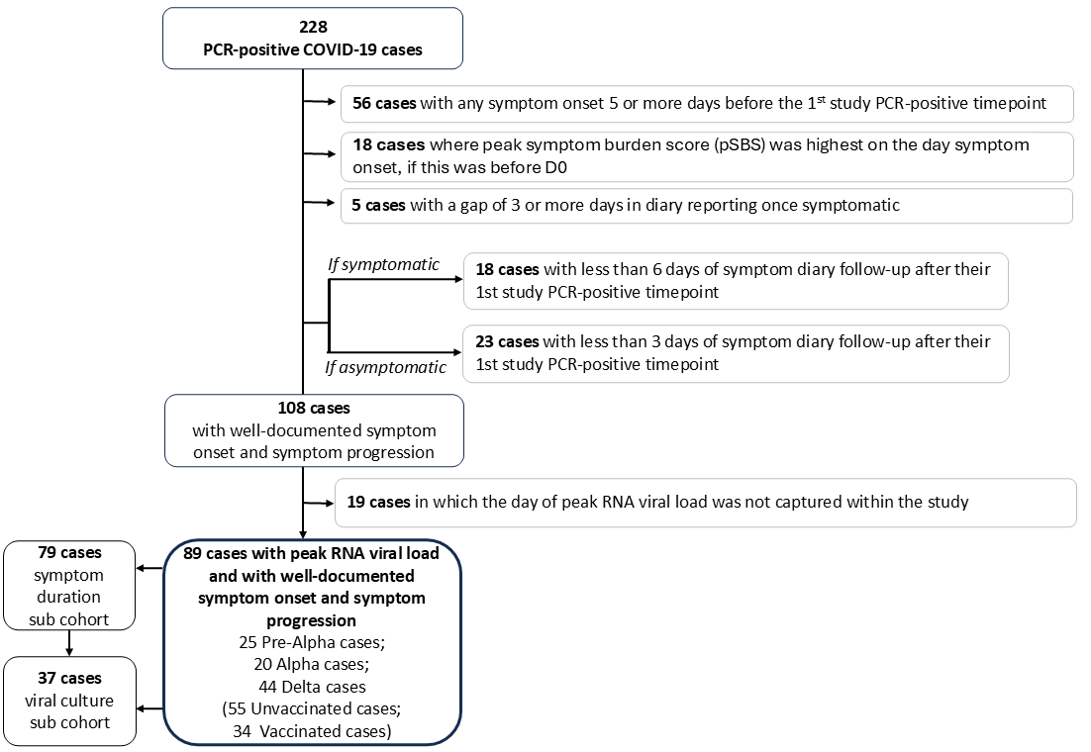

Figure 2. Temporal pattern of symptom reporting relative to peak viral load.
Proportion of ambulatory COVID-19 cases reporting each symptom aligned to the day of peak RNA viral load (vertical red line) (pVL). For each symptom, numerators and denominators indicate the number of participants reporting the symptom and the total number assessed on that day, respectively.
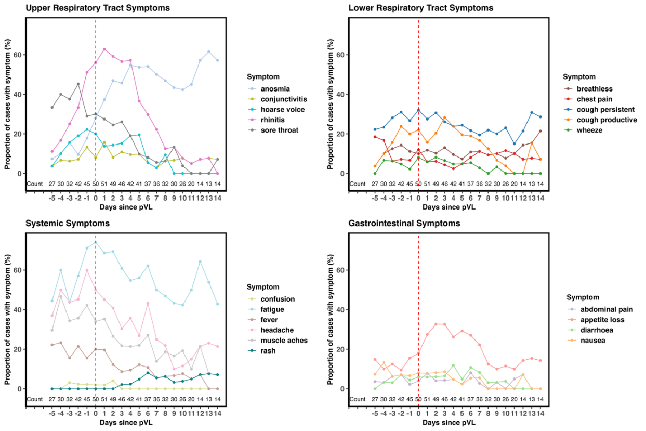

Figure 3. The temporal relationship between peak viral load and peak symptom burden.
(A) Distribution of the day of peak symptom burden score (pSBS) relative to the day of peak RNA viral load (pVL) (n=89). (B) Correlation between the day of pVL and the day of pSBS. Line of best fit shown in blue with 95% confidence interval (grey shaded area) (n=89).
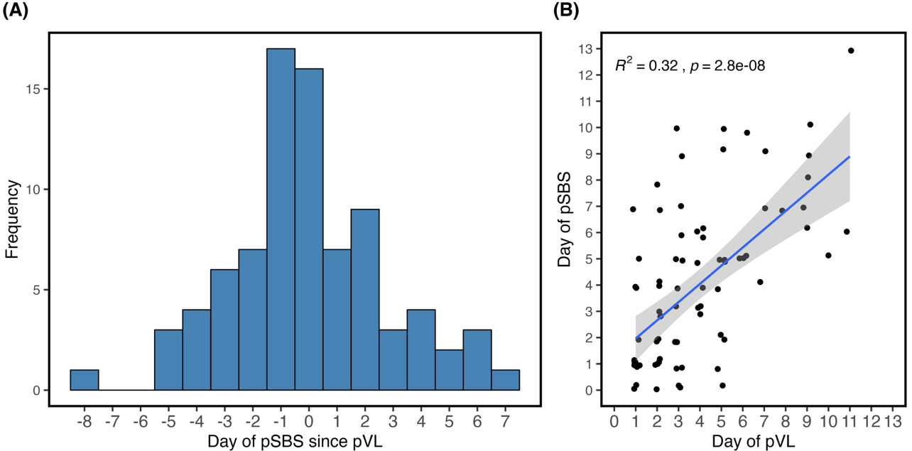

Figure 4. The relationship between viral load and symptom magnitude and duration.
(A) Correlation between the magnitude of pVL (Log10 transformed) and pSBS (n=89). (B) Spearman’s rank correlation was used to assess associations between viral load (Log10 transformed) and symptom burden score, upper respiratory tract (URT), lower respiratory tract (LRT), gastrointestinal (GI), and systemic symptom scores across study days 1-7. R² values correspond to the overlaid linear regression fit. Red points indicate the day of peak viral load (n=34). (C) Correlation between pVL (Log10 transformed) and symptom burden duration. Triangular points represent participants with one ongoing mild symptom on the final day of diary recording, with colours indicating the symptom reported. Horizontal dashed line denotes cases symptomatic for >21 days, all with peak pVL >170,000,000 RNA copies/ml (n=71). Line of best fit shown in blue with 95% confidence interval (grey shaded area).
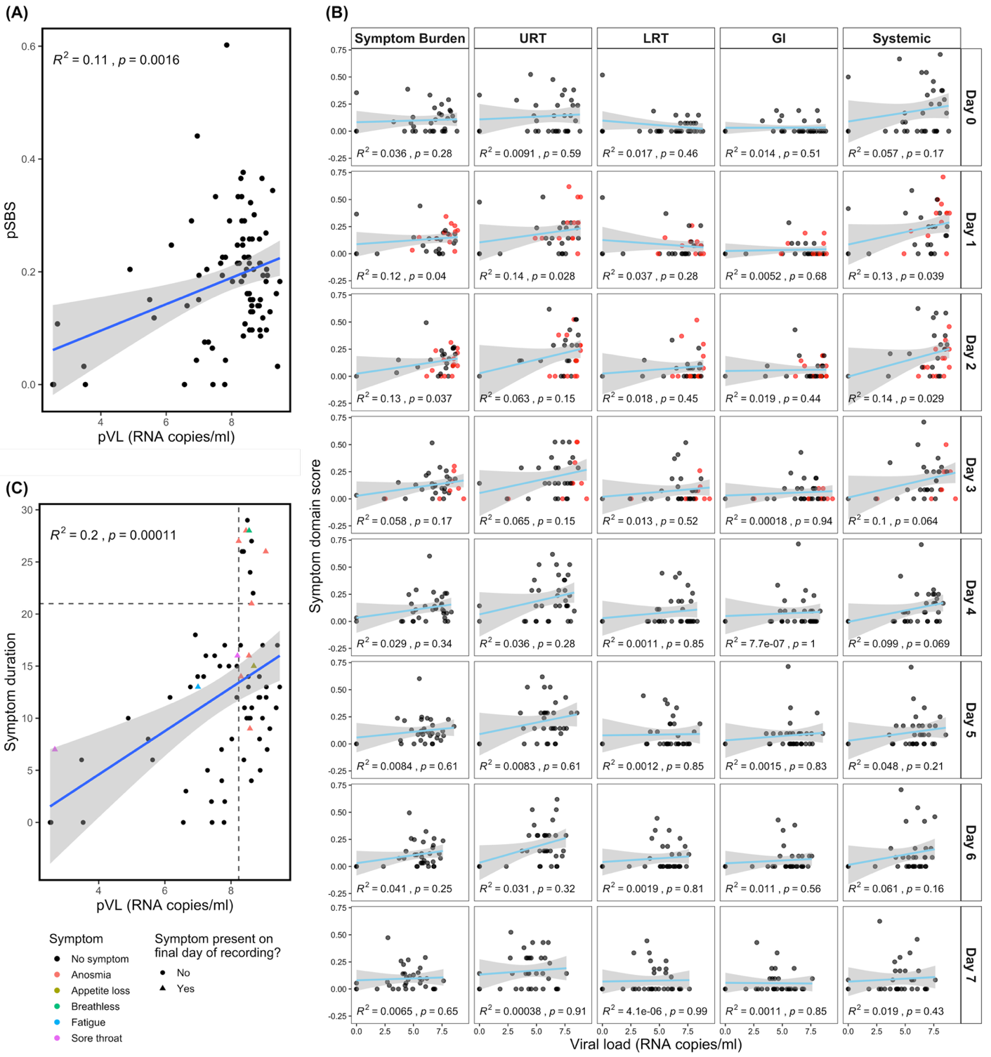

Figure 5. Association between symptoms and infectiousness inferred from culturable virus.
(A) Paired t-test comparing severity of lower respiratory tract (LRT), upper respiratory tract (URT), gastrointestinal (GI), and systemic symptoms on the day before and the day of first infectious viral shedding, defined by virus capable of forming plaques (PFUs) (n=31). (B) Correlation between peak severity of LRT, URT, GI, and systemic symptoms and the duration of infectious viral shedding. Best-fit lines shown in blue with 95% confidence intervals (grey shaded area) (n=34). (C) Duration of infectious viral shedding in cases with systemic symptoms (Confusion, Fatigue, Fever, Headache, Muscle aches) occurring prior to peak pVL, compared with those who did not experience the symptom or only after peak pVL. Analysed using Mann–Whitney U test with Bonferroni correction (n=34). (D) Kaplan–Meier survival curves for presence of infectious virus determined by plaque assay (n=34) with summary table of values. (number at risk = number of ppts at each timepoint; number of events = number of ppts which converted to PFU negative; number censored = number of ppts which left the study before becoming PFU negative, at each time point).


