Disadvantage and Deficits:
Pathways from Early Cumulative Risk to Late-Adolescent Criminal Conviction

Abstract
Early exposure to multiple risk factors has been shown to predict criminal offending, but the mechanisms responsible for this association are poorly understood. Integrating social-environmental and dispositional theories of crime this research investigated the capacity of family socioeconomic disadvantage and individual psychological deficits to mediate the association between childhood cumulative risk and late adolescent criminal convictions. Male participants in the 1986 Northern Finland Birth Cohort Study (n = 3,414) were followed from the prenatal period through age 19-20. The data were analyzed by estimating a structural equation model of the hypothesized pathways. The results found support for both processes of influence, and the model sustained a statistically significant direct effect of cumulative risk on crime. Socioeconomic disadvantage and psychological deficits contribute to criminal offending independently and with roughly equal magnitude. The results point to the utility of both environmental and psychological interventions to prevent criminality among children at risk.

Keywords: Cumulative risk, criminality, economic disadvantage, psychological deficits, Finland
Word count: 4,251 (excluding references, tables, and figure)

Introduction
This research applied the cumulative risk framework (CRF) to examine pathways from prenatal development to criminal offending in mid-to-late adolescence. The core assumption of the CRF is that exposure to multiple risk factors predicts negative outcomes over and above the effects of singular factors (Evans, Li, & Whipple, 2013). Prior research has found consistent support for this basic assumption. In a foundational study, Rutter (1979) observed that children exposed to environmental risk factors (such as marital discord and low social status) were four times more likely to develop psychological disorders than those exposed to only one such factor, and that the presence of four risk factors was associated with a tenfold increase in the prevalence of disorders. Additional studies have linked cumulative risk to internalizing problems, externalizing problems, juvenile delinquency, drug use, and gang membership (Adelmann, 2005; Dekovic, 1999; Gerard & Buhler, 2004a; Gerard & Buhler, 2004b; January et al. 2017; Jessor, Van Den Boss, Vanderryn, Costa, & Turbin, 1995; Mason et al. 2016; Morales & Guerra, 2006; Stouthamer-Loeber, Loeber, Wei, Farrington, & Wikström, 2002; Thornberry, Krohn, Lizotte, Smith, & Tobin, 2003).
In order to interrupt criminal trajectories, it is not sufficient to merely identify those at greatest risk. Effective prevention requires knowledge about the mechanisms responsible for the empirical association (Evans et al., 2013). For example, although educational failure is a well-established risk factor for criminal offending (Maguin & Loeber, 1996; Thornberry, Moore, & Christenson, 1985), the literature disagrees on whether this risk factor exerts causal influence on criminal behavior (Felson & Staff, 2006; Savolainen et al., 2012; Sweeten, Bushway, & Paternoster, 2009). If educational failure is merely a marker of truly criminogenic factors, efforts to prevent crime should focus on modifying those factors, which could include substance misuse, antisocial peer associations, and cognitive deficits.
Criminological literature is inundated with causal theories offering competing accounts of the factors that should be understood as causal vs. merely predictive (Bruinsma, 2016). Strain theory views criminality as an adaptation to negative life circumstances (Agnew, 1992). Social bonding theory views criminal behavior as a consequence of insufficient attachment or commitment to conventional others or institutions (Hirschi, 1969). Labeling theory argues that criminal careers are socially constructed through stigmatizing or ensnaring reactions to common acts of delinquency (Liska, 1981). These three theories are examples of social-environmental explanations of criminal offending. Additional theories of this general variety include social learning theory (Akers, 2011) and social support theory (Cullen, 1994). Although they offer differing accounts of the mechanisms producing the environmental effect, these theories share basic assumptions as to what kinds of environments are criminogenic. In particular, most social-environmental theories of crime assume that concentrated disadvantage exerts causal influence on crime (Savolainen, 2010). Social bonding theory would argue this occurs because exposure to concentrated disadvantage erodes commitment to conventional goals (e.g., Elliot et al., 1996), whereas social learning theory suggests that, for example, disadvantaged children are at increased risk of associating with older delinquent peers (Harding, 2009).
In contrast to the social-environmental paradigm, dispositional theories emphasize the role early emerging psychological factors in the etiology of criminal behavior. Well-known examples include Gottfredson and Hirschi’s (1990) self-control theory and Moffitt’s (1993) account of the life course persistent (LCP) offending type. Gottfredson and Hirschi (1990) have argued that criminal behavior is caused by low self-control, presumed to be a relatively stable individual characteristic acquired in the process of early childhood socialization. In Moffitt’s (1993) LCP theory, the intersection between neuropsychological deficits (low cognitive ability, aggressiveness, inattention, etc.) and family adversity constitutes the “perfect storm” for career criminality. Despite their differences, both theories expect differences in psychological constitution to explain why children exposed to multiple risk factors are more likely to become criminal offenders (Staff, Whichard, Siennick, & Maggs, 2015).
Note that both of these dispositional theories have an environmental component – ineffective parenting and family adversity – but those are understood as factors in the etiology of criminal dispositions during early development. In other words, the environmental factors are not understood as “causes” but, rather, “causes of causes” of criminal behavior (Schepers, 2017), and, as such, they are assumed to be captured in the cumulative risk construct. Note also, that some social-environmental theories, such as general strain theory (Agnew, 1992) recognize the role of individual differences in the actualization of criminal behavior. However, these considerations are, for the most part, auxiliary assumptions of the ceteris paribus variety, the purpose of which is to specify the scope conditions for the empirical tests of the theory (Walker & Cohen, 1985); they are not part of the theoretical “hard core” (Lakatos, 1970).
The present study seeks to advance the CRF by investigating the mechanisms responsible for the association between cumulative risk at birth and criminal offending in late adolescence. Instead of focusing on particular theoretical formulations, such as general strain theory, the current study makes a meta-theoretical distinction between two “orienting strategies” (Berger & Zelditch, 1993) of criminology: the social-environmental and the individual-dispositional paradigms. We used socioeconomic disadvantage as the construct to capture the social-environmental pathway. As noted, most, if not all, social-environmental theories are consistent with such a pathway; they only disagree with respect to the processes responsible for the expected effect. The dispositional pathway is captured by the psychological deficits construct which refers to such criminogenic individual characteristics as low cognitive ability and behavior regulation.
In addition, this research makes a methodological contribution to the measurement of cumulative risk. By summing across identified risk factors, most prior studies assume that all indicators of risk contribute equally to the construct. Stated differently, the traditional approach equates more prevalent sources of risk with less commonly occurring factors that are potentially more severe. The current study addresses this limitation by using a well-known scaling technique – Rasch modeling – which applies item weights to distinguish between sources of risk that are more vs. less common in the population (Osgood, McMorris, & Potenza, 2002).
In sum, we examined the capacity of socioeconomic disadvantage and psychological deficits to mediate the influence of early exposure to cumulative risk on criminal behavior. In light of prior literature, both processes are expected to matter, but the two paradigms disagree about the relative importance of these paths of influence. If early exposure to cumulative risk is understood as a marker of heritable individual traits and antisocial parent characteristics, as dispositional theories would expect, much of the association between cumulative risk and criminal offending will be mediated by such psychological risk factors as hyperactivity, aggression, and cognitive deficits. By contrast, if the causal effect of cumulative risk stems from environmental adversity, its effect on crime will be mediated by such factors as material deprivation and low socioeconomic status of the family (Sampson & Laub, 1994).
In what follows, we will examine the hypothesized fundamental processes using data from the 1986 Northern Finland Birth Cohort Study. The analysis is limited to the male members of the birth cohort given the low incidence of criminal convictions among adolescent females in these data.

Method
Sample
Participants were drawn from the Northern Finland Birth Cohort 1986 Study (NFBC1986), a general population-based study of individuals born during a one-year period in the two northernmost provinces of Finland. The original NFBC1986 cohort included 9,432 children born alive, whose expected date of birth fell between July 1, 1985 and June 30, 1986 (98.5% of all deliveries taking place in the target location). Details about data collection are available elsewhere (Hurtig et al., 2007; Järvelin, Hartikainen-Sorri, & Rantakallio, 1993).
Procedures
Data for the current study were collected during three developmental periods: 1) prenatal/birth, 2) middle childhood, and 3) middle adolescence. A prenatal background questionnaire of mothers was distributed at their first antenatal visit to the local prenatal clinic (on average at the 12th gestational week) and returned by their 24th gestational week. A second pregnancy questionnaire was completed by midwives at mother’s last antenatal visit to the clinic, or during the first home visit by the midwife after delivery. Additional information on pregnancy and delivery was completed by midwives and/or medical staff at the prenatal clinics. Questionnaires concerning child health and socio-demographics were mailed to parents and questionnaires regarding learning difficulties and behavioral problems were mailed to children’s homeroom teachers during middle childhood (ages 7-8). Administrative data obtained from the Finnish Central Register for Criminal Records were used as the source of information about criminal offending. With the exception of fixed amount penal fees for traffic violations, this source captures all offenses – misdemeanors as well as felonies – resulting in a criminal sanction. We had access to data through December 31, 2005 allowing us to track officially sanctioned offending from age 15 (the age of criminal responsibility in Finland) until 19-20 years of age in this birth cohort. Written informed consent was obtained from 92% of the participating households. The study was approved by the ethical committee of the Northern Ostrobothnia Hospital District.
The analysis sample for the current study (n = 3,414) represents all male consented youth in the cohort with data collected during adolescence, with one randomly selected child from each set of participating non-singletons. The focus on males is due to low prevalence of female offenders as captured by the official statistics (see below for details).
Measures
Prenatal or Birth Period
Cumulative Contextual Risk Index (CCR). Seven indicators were used to measure cumulative risk during the prenatal/birth period. With the exception of birth weight (provided by medical staff at time of delivery), all measures were collected through the pregnancy questionnaires completed by mothers. These 7 indicators were selected based on the current cumulative risk literature (see January et al., 2017): 1) teenage mother, 2) single parent, 3) multiple unions, 4) smoking while pregnant, 5) heavy drinking father, 6) economic exclusion, and 7) material deprivation. Each indicator was coded 1 to represent presence of the risk (as defined below) and 0 to represent absence of the risk (i.e., the reference category).
Teenage mother was coded 1 if the mother gave birth to the participant at age 19 or younger. Single parent was coded 1 if the mother was unmarried, widowed, divorced, or not cohabitating (i.e., sharing a household with a registered romantic partner). Multiple unions were coded 1 if the mother had at least one prior registered union, such as marriage or cohabitation (note that this coding assigns the value zero to two kinds of mothers: those in a first relationship and those with no prior or current relationship). Smoking while pregnant was coded 1 if the mother continued to smoke after the first trimester during pregnancy. Heavy drinking father was coded 1 if the mother reported that the child’s father had five or more alcoholic drinks per typical week. Economic exclusion indicates the socioeconomic status of the household. It is coded 1 if the highest occupational status of the adult member of household was either unskilled worker (manual labor), unemployed, or on disability pension. Material deprivation was coded 1 if the household dwelling was missing three of these four items: indoor bathroom, flushing toilet, washing machine, or telephone.
The seven items were used to create a Rasch scale using the irt suite of commands in Stata 14.2 MP (StataCorp, 2015). A Rasch scale was selected over alternative scaling techniques (i.e., additive index) because Rasch models scale items based on the prevalence of the examined indicators, weighting rare items and preventing skew from items that occur more commonly (Osgood, McMorris, & Potenza, 2002; Osgood & Schreck, 2007). The resulting CCR index had an observed mean of .00 (SD = .56) and a range of -.33 to 2.80.
Middle Childhood
Psychological Deficits. This construct was measured using three indicators assessing hyperactivity, antisociality and school difficulty. Following McGee et al. (1985), a hyperactivity scale was created using the sum of three items from the Rutter B2 scale for teachers (restless, squirmy, poor concentration) ranging from 1=does not apply to 3=certainly applies (α = .67). Childhood antisociality scale (α = .83) was also created from the Rutter scale for teachers. Six items assessed the degree to which children destroyed their own or others’ belongings, fought with other children, disobeyed, lied, stolen things and bullied other children (Rutter, 1967). We calculated antisociality as the sum of these 6 items (0=does not apply to 2=certainly applies). We calculated learning deficits as the sum of three dichotomous items that asked teachers to indicate if the student demonstrated difficulties with learning math, reading, or writing.
Family Socioeconomic Disadvantage. We measured family socioeconomic disadvantage using three indicators assessing parents’ educational attainment and household reliance on means-tested income support (referred to as “income support” henceforth). Mother’s and father’s educational attainment was reverse coded so that higher values reflected less education: 1=Upper secondary education (more than the compulsory 9 years), 2=Lower secondary education (no schooling past age 16), and 3=Dropout (did not finish compulsory schooling). Income support was coded 1 if the child was born into a household where one or both parents received unemployment or disability benefits as their only source of income.
Adolescence
Criminal Offending. Using data from the Central Registry of Criminal Records (see above), we included the following offense types as indicators of the latent criminal conviction variable: property crime, driving under the influence, substance use related offenses, and violent crime. As there is no juvenile justice system in Finland, criminal records will not start accumulating until a person turns 15 years of age; youth 14 or younger are not criminally responsible under any circumstances. Moreover, as a matter of policy, the Finnish criminal justice is particularly reluctant to apply official sanctions to juveniles under the age of 18 (Lappi-Seppälä, 2006). Due to the low incidence of criminal convictions, each indicator was treated as a dichotomous variable.

Data Analytic Strategy
We implemented structural equation modeling (SEM) to examine the hypothesized pathways with Mplus version 7.4 (Muthén & Muthén, 1998-2015), using the weighted least squares means variance estimator (WLSMV) to estimate model parameters. Several of our latent variable indicators were categorical, and WLSMV can be applied to models with categorical and continuous indicators, is appropriate for moderate to large sample sizes, and is recommended in Mplus for modeling with categorical variables (Muthén & Muthén, 1998-2015; Wang & Wang, 2012). In Mplus, WLSMV allows missingness to be a function of observed covariates (but not observed outcomes as in ML estimation) and is more efficient in dealing with missing categorical data than listwise deletion (Asparouhov & Muthén, 2010; Wang & Wang, 2012). Mplus employs a pairwise missing data approach on the exogenous (predictor) variables with the WLSMV estimator and given that each participant had complete CCR data, the entire study sample was retained. We conducted tests of selective attrition to explore if those lost to follow up and with missing data differed from those retained.
MacKinnon (2008) suggests that traditional methods of assessing mediation effects are subject to bias due to incorrect distributional assumptions of indirect effects and limited power. One solution to these limitations is bootstrapping with confidence intervals (CIs) (Hayes, 2013; Jose, 2013). We incorporated bias-corrected bootstrapping to account for asymmetry and non-normality in the sampling distribution (Hayes, 2013; MacKinnon, 2008). We report direct, indirect and total effects in their standardized and unstandardized form.
We followed the conventional model building strategy recommended by Anderson and Gerbing (1988). First, we examined the measurement model, including latent factors for psychological deficits, family socioeconomic disadvantage and criminal offending, using confirmatory factor analysis (CFA). Following the measurement model, we examined the structural path model. We investigated a parallel multiple mediator model to simultaneously examine the relative contribution of each mechanism (psychological deficits and family socioeconomic disadvantage) in the relationship between cumulative contextual risk at birth and criminal offending in adolescence, while accounting for an association between them (Hayes, 2013). We examined direct, indirect and total effects of the model that best fit the data. A significant specific indirect effect would suggest that the psychological deficits and/or family socioeconomic disadvantage variables mediate the relationship between CCR and criminal convictions. We evaluated model fit indices using χ², Comparative Fit Index (CFI) values and Standardized Root Mean-Square Error of Approximation (RMSEA) with the associated 90% confidence interval. We used the DIFFTEST function in Mplus to compare nested models due to the WLSMV estimator.
Results
Descriptive Statistics
Univariate descriptive statistics for study variables are reported in Table 1. They show that most indicators in the cumulative risk score apply to around 5% of the individuals, and only one item, maternal smoking (14%) has a prevalence rate above 10%. Very few of the men in this cohort had a criminal conviction before the age of 20. The prevalence rates vary between 2-4% depending on the type of crime. This suggests that the outcome variable captures the serious end of the offending continuum. The relatively high prevalence rate for income support (24%) reflects that fact that Finland is a generous welfare state with a comparatively low threshold of eligibility for means-tested welfare benefits. Note that fathers of this birth cohort were nearly twice as likely as mothers to have dropped out of compulsory schooling. This likely reflects the fathers’ higher propensity to work in unskilled manual labor. The bivariate correlations of the analytic variables are presented in Table 2.
Missing Data
We investigated if individuals with missing data on psychological deficits and family socioeconomic disadvantage indicators differed from those with complete data with respect to criminal offending. We found that those with missing data on mother’s educational attainment (n = 273) were more likely to have had a violent crime offense. Those with missing data on father’s education (n = 325) were more likely to have a DUI, substance use offense and violent crime offense compared to those without missing data. Those with missing data on parent welfare status (n = 238) and the Rutter antisociality scale (n = 270) were more likely to have a DUI conviction compared to those without missing data.
Measurement and Structural Models
Our measurement model consisted of 3 latent factors: family socioeconomic disadvantage, psychological deficits and criminal convictions. A model was considered to fit the data well if the Standardized Root Mean-Square Error of Approximation (RMSEA) was less than .06 and the Comparative Fit Index (CFI) value was greater than .90 (Hu & Bentler, 1999). CFA fit statistics are presented in Table 3; full measurement model results from the CFA are available on request (note that measurement model results for the final structural equation model are reported in Table 4 and Figure 1). First, the confirmatory factor analysis results indicated that the measurement model demonstrated a good fit with the data. Next, we examined the parallel multiple mediator model described above to examine the relative contribution of psychological deficits and family socioeconomic disadvantage in the relationship between cumulative contextual risk (CCR) at birth and criminal offending in adolescence. We tested models with and without the direct path between CCR and crime (Models 3 and 4). Comparative model results indicated the model fit better with the direct path (Model 4; see X² difference test results, Table 3). The fit between the data and the model was good.
Figure 1 includes measurement and structural models for the final model with standardized parameter estimates, Table 4 includes standardized and unstandardized parameter estimates and their standard errors. We found that CCR at birth was positively associated with both psychological deficits and family socioeconomic disadvantage during middle childhood. The results indicated that psychological deficits and family socioeconomic disadvantage during middle childhood were positively associated with criminal convictions in adolescence. Using bootstrapping with CIs, our results indicated significant total effects, total indirect, specific indirect and direct effects (see Table 4). Total effects are the sum of all direct and indirect effects; total indirect effects are the sum of all indirect effects of CCR on criminal convictions (Kline, 2014). Specific indirect effects indicated that each indirect pathway (psychological deficits and family socioeconomic disadvantage) from CCR was positively associated with criminal convictions; standardized values indicated that the magnitude of the indirect effect through socioeconomic disadvantage was larger than the indirect effect through psychological deficits. Finally, CCR at birth had a direct, positive association with criminal convictions in adolescence. Our model explains an estimated 14.8% of the variance in the latent crime variable.
Discussion
In support of the cumulative risk framework, prior research has documented that individuals exposed to multiple childhood risk factors are at increased risk of criminal offending in later development. However, the mechanisms producing this association are understudied and remain poorly understood. This study adds to the literature by examining the contribution of two potential domains of influence derived from criminological theory: socioeconomic disadvantage and psychological deficits. The results from this research found evidence in support for both pathways. In addition, there was a direct effect of CCR on crime, suggesting the need to consider additional explanatory variables and mechanisms of influence.
The findings suggest that, rather than competing with each other, the processes inherent in these two meta-theoretical perspectives operate as dual mechanisms, each providing a partial explanation for the long-term effect. Within the CRF, cumulative risk often is operationalized, in part, by indicators of poverty and related factors. In this sense, the path from cumulative contextual risk to childhood socioeconomic disadvantage in our model may have captured a certain degree of stability in socioeconomic disadvantage over early development. Indicators commonly included as items in cumulative risk indices also likely capture, in part, heritable influences and early constitutional factors that result from either trauma (e.g., exposure to teratogenic substances) or severe adversity in the home. Although the environment can alter these factors and their expression or consequences, they tend to display continuity once established. Thus, similar to the socioeconomic disadvantage pathway, the path from cumulative risk to psychological deficits is likely to capture stability in individual vulnerability over time.
Our study is unique in simultaneously testing two the validity of two major explanatory domains or paradigms. The results indicate that the pathway associated with socioeconomic disadvantage (unstandardized indirect effect = .09) may be slightly stronger than the pathway associated with psychological deficits (unstandardized indirect effect = .03). These patterns contradict extreme versions of the dispositional perspective, such as the general theory of crime (Gottfredson & Hirschi, 1990), which argue that the association between family socioeconomic disadvantage and criminal offending is a spurious function of intergenerational transmission of antisocial propensity (i.e., such characteristics as low self-control). Under this expectation, most of the association between CCR and crime should have been mediated by psychological deficits, and the pathway via socioeconomic disadvantage should have been weak in comparison (Savolainen, Paananen, Merikukka, Aaltonen, & Gissler, 2013). Observing a strong socioeconomic effect net of individual differences in antisocial propensity validates the social-environmental research program in criminology. The fact that cumulative risk continued to be associated with adult crime in our analyses suggests that other important mediators might have been omitted, such as factors that capture developmental processes in the family and school contexts. Future research should consider and test an expanded set of mediators.
This research was based on a secondary data source with imperfect coverage of risk factors. In particular, the NFBCS did not include information about exposure to child maltreatment, which is a commonly included item in measures of cumulative risk (e.g., Appleyard, Egeland, van Dulmen & Sroufe, 2005). It is difficult to say how this affects the pattern of findings. It is possible that such dynamic measures as parental misbehavior are more closely related to the transmission of psychological deficits. Thus, had the measure of cumulative risk included direct indicators of child maltreatment, the amount of the effect mediated by the psychological deficits construct might have been higher.
The purpose of the study was to examine the mechanisms responsible for the longitudinal association between early childhood exposure to cumulative risk and criminal offending in late adolescence. The constructs used to illuminate the hypothesized pathways were limited to relatively general domains of influence: socioeconomic disadvantage and psychological deficits. It is up to future research to refine these pathways further in order to find why socioeconomic disadvantage and psychological deficits matter. An examination of potential interactions between the two domains may also prove useful (Lynam et al., 2000). In light of our results, theoretical perspectives, such as situational action theory (Wikström, Oberwittler, Treiber, & Hardie, 2012), that integrate specific psychological factors and social-environmental processes into coherent etiological models appear to offer the most promising route toward understanding the developmental link between early adversity and criminal offending.
Notwithstanding these limitations, the findings have implications for practice. Cumulative contextual risk captures early adversity that can impact the long-term development of children. A variety of intervention approaches are needed to reduce the likelihood that children will be exposed to such risks (e.g., well-baby classes, home visitation, welfare assistance programs, etc.). Where such risks cannot be prevented, interventions that reduce socioeconomic disadvantage and promote the upward mobility of low-income families are needed. Moreover, to the extent that psychological deficits are malleable, interventions that reduce such risks and promote pro-sociality are promising. Taken together, these strategies can support families and facilitate children’s positive development, thereby reducing the likelihood that early adversities will initiate a chain of events conducive to persistent adult criminality.

References
Adelmann, P. K. (2005). Social environmental factors in preteen health-related behaviors. Journal of Adolescent Health, 36, 36-47.
Agnew, R. (1992). Foundation for a general strain theory of crime and delinquency. Criminology, 30, 47-88.
Akers, R. L. (2011). Social learning and social structure: A general theory of crime and deviance. New Brusnwick, NJ: Transaction Publishers.
Anderson, J. C., & Gerbing, D. W. (1988). Structural equation modeling in practice: A review and recommended two-step approach. Psychological Bulletin, 103, 411-423.
Appleyard, K., Egeland, B., van Dulmen, M. H. M., & Sroufe, L. A. (2005). When more is not better: The role of cumulative risk in child behavior outcomes. Journal of Child Psychology and Psychiatry, 46, 235–245. doi:10.1111/j.1469-7610.2004.00351.
Asparouhov, T., & Múthen, B. (2010). Weighted Least Squares Estimation with Missing Data. Los Angeles, CA. Retrieved from statmodel.com
Berger, J., & Zelditch, M. (1993). Theoretical research programs: Studies in the growth of theory. Palo Alto, CA: Stanford University Press.
Bruinsma, G. (2016). Proliferation of crime causation theories in an era of fragmentation: Reflections on the current state of criminological theory. European Journal of Criminology, 13, 659-676.
Cullen, F. T. (1994). Social support as an organizing concept for criminology: Presidential address to the Academy of Criminal Justice Sciences. Justice Quarterly, 11, 527-559.
Dekovic, M. (1999). Risk and protective factors in the development of problem behavior during adolescence. Journal of Youth and Adolescence, 28, 667-685.
Elliott, D. S., Wilson, W. J., Huizinga, D., Sampson, R. J., Elliott, A., & Rankin, B. (1996). The effects of neighborhood disadvantage on adolescent development. Journal of Research in Crime and Delinquency, 33, 389-426.
Evans, G. W., Li, D., & Whipple, S. S. (2013). Cumulative risk and child development. Psychological Bulletin, 139, 1342-1396.
Felson, R. B., & Staff, J. (2006). Explaining the academic performance-delinquency relationship. Criminology, 44, 299-319.
Gerard, J. M., & Buehler, C. (2004a). Cumulative environmental risk and youth maladjustment: The role of youth attributes. Child Development, 75, 1832-1849.
Gerard, J. M., & Buehler, C. (2004b). Cumulative environmental risk and youth problem behavior. Journal of Marriage and Family, 66, 702-720.
Gottfredson, M. R., & Hirschi, T. (1990). A general theory of crime. Stanford, CA: Stanford University Press.
Harding, D. J. (2009). Violence, older peers, and the socialization of adolescent boys in disadvantaged neighborhoods. American Sociological Review, 74, 445-464.
Hayes, A. (2013). Introduction to mediation, moderation, and conditional process analysis: a regression-based approach. New York: The Guilford Press. Retrieved from http://umichigan.eblib.com/patron/FullRecord.aspx?p=1186800
Hirschi, T. (1969). Causes of delinquency. Berkeley, CA: University of California Press.
Hu, L., & Bentler, P. (1999). Cutoff criteria for fit indexes in covariance structure analysis: Conventional criteria versus new alternatives. Structural Equation Modeling, 6, 1–55. http://doi.org/10.1080/10705519909540118
Hurtig, T. M., Ebeling, H., Taanila, A. J., Miettunen, J., Smalley, S. L., McGough, J. J., … Moilanen, I. K. (2007). ADHD symptoms and subtypes: Relationship between childhood and adolescent symptoms. Journal of the American Academy of Child and Adolescent Psychiatry, 46, 1605-1613.
January, S. A., Mason, W. A., Savolainen, J., Solomon, S., Chmelka, M. B., Miettunen, J., … Järvelin, M. R. (2017). Longitudinal pathways from cumulative contextual risk at birth to school functioning in adolescence: Analysis of mediation effects and gender moderation. Journal of Youth and Adolescence, 46, 180-196.
Järvelin M. R., Hartikainen-Sorri A.-L., & Rantakallio P. (1993). Labour induction policy in hospitals of different levels of specialization. British Journal of Obstetrics & Gynaecology, 100, 310-315.
Jessor, R., Van Den Boss, J., Vanderryn, J., Costa, F. M., & Turbin, M. S. (1995). Protective factors in adolescent problem behavior: Moderator effects and developmental chance. Developmental Psychology, 31, 923-933.
Jose, P. (2013). Doing statistical mediation and moderation. Doing Statistical Mediation & Moderation. New York: The Guilford Press. Retrieved from http://mirlyn.lib.umich.edu/Record/012642695 CN - QA278.2 .J67 2013
Kline, R. (2014). Principles and Practice of Structural Equation Modeling, Third Edition. Structural Equation Modeling. New York: Guilford Publications. Retrieved from http://mirlyn.lib.umich.edu/Record/013984622
Lakatos, I. (1970). Falsification and the methodology of scientific research programmes. In Lakatos, I. & Musgrave, A. (Eds.), Criticism and the Growth of Knowledge. London, UK: Cambridge University Press.
Lappi-Seppälä, T. (2006). Finland: A Model of Tolerance? In J. Muncie & B. Goldson (Eds.), Comparative Youth Justice (pp. 177-195). London, UK: Sage Publications.
Liska, A. E. (1981). Perspectives on deviance. Englewood Cliffs, NJ: Prentice-Hall.
Lynam, D. R., Caspi, A., Moffit, T. E., Wikström, P. O., Loeber, R., & Novak, S. (2000). The interaction between impulsivity and neighborhood context on offending: the effects of impulsivity are stronger in poorer neighborhoods. Journal of Abnormal Psychology, 109, 563-574.
MacKinnon, D. (2008). Introduction to statistical mediation analysis. New York, NY: Lawrence Erlbaum Associates.
Maguin, E., & Loeber, R. (1996). Academic performance and delinquency. In M. Tonry (Ed.), Crime and justice: A review of research (pp. 145-263). Chicago, IL: University of Chicago Press.
Mason, W.A., January, S-A.A., Chmelka, M.B., Parra, G.R., Savolainen, J., Miettunen, J., … Moilanen, I. (2016). Cumulative contextual risk at birth in relation to adolescent substance use, conduct problems, and risky sex: General and specific predictive associations in a Finnish birth cohort. Addictive Behaviors, 58, 161-166.
McGee, R., Williams, S., Bradhsaw, J., Chapel, J. L., Robins, A., & Silva, P. A. (1985). The Rutter scale for completion by teachers: Factor structure and relationships with cognitive abilities and family adversity for a sample of New Zealand children. The Journal of Child Psychology and Psychiatry, 26, 727-739.
Moffitt, T. E. (1993). Adolescence-limited and life-course-persistent antisocial behavior: A developmental taxonomy. Psychological Review, 100, 674-701.
Morales, J. R., & Guerra, N. G. (2006). Effects of multiple context and cumulative stress on urban children's adjustment in elementary school. Child Development, 77, 907-923.
Muthén, L. K., & Muthén, B. O. (1998-2015). Mplus User’s Guide (7th ed.). Los Angeles, CA: Muthén & Muthén.
Osgood, D. W., McMorris, B. J., & Potenza, M. T. (2002). Analyzing multiple-item measures of crime and deviance I: Item response theory scaling. Journal of Quantitative Criminology, 18, 267-296.
Osgood, D. W., & Schreck, C. J. (2007). A new method for studying the extent, stability, and predictors of individual specialization in violence. Criminology, 45, 273-312.
Rutter, M. (1967). A children’s behaviour questionnaire for completion by teachers: preliminary findings. Journal of Child Psychology and Psychiatry and Allied Disciplines, 8, 1–11. Retrieved from https://www.scopus.com/inward/record.uri?eid=2-s2.0-0014089675&partnerID=40&md5=2a8931a42f8ce0ff886cef189a96da4b
Rutter, M. (1979). Protective factors in children's responses to stress and disadvantage. Annals of the Academy of Medicine, 8, 324-338.
Sampson, R. J., & Laub, J. H. (1994). Urban poverty and the family context of delinquency: A new look at structure and process in a classic study. Child Development, 65, 523-540.
Savolainen, J. (2010). Class, inequality, and the etiology of crime. In S. G. Shoham, P. Knepper, & M. Kett (Eds.), International Handbook of Criminology (pp. 541-566). New York, NY: Taylor and Francis.
Savolainen, J., Hughes, L. A., Mason, W. A., Hurtig, T. M., Ebeling, H., Moilanen, I. K., ... Taanila, A. M. (2012). Antisocial propensity, adolescent school outcomes, and the risk of criminal conviction. Journal of research on adolescence, 22, 54-64.
Savolainen, J., Paananen, R., Merikukka, M., Aaltonen, M., & Gissler, M. (2013). Material deprivation or minimal education? Social class and crime in an egalitarian welfare state. Advances in life course research, 18, 175-184.
Schepers, D. (2017). Causes of the causes of juvenile delinquency: Social disadvantages in the context of Situational Action Theory. European Journal of Criminology, 14, 143-159.
Staff, J., Whichard, C., Siennick, S. E., & Maggs, J. (2015). Early life risks, antisocial tendencies, and preteen delinquency. Criminology, 53, 677-701.
StataCorp. (2015). Stata Statistical Software: Release 14 [Computer Software]. College Station, TX: StataCorp LP.
Stouthamer-Loeber, M., Loeber, R., Wei, E., Farrington, D., & Wikström, P. H. (2002). Risk and promotive effects in the explanation of persistent serious delinquency in boys. Journal of Consulting and Clinical Psychology, 70, 111-123.
Sweeten, G., Bushway, S. D., & Paternoster, R. (2009). Does dropping out of school mean dropping into delinquency? Criminology, 47, 47-91.
Thornberry, T. P., Krohn, M. D., Lizotte, A. J., Smith, C. A., & Tobin, K. (2003). Antecedents of gang membership. In T. P. Thornberry, M. D. Krohn, A. J. Lizotte, C. A. Smith & K. Tobin (Eds.), Gangs and delinquency in developmental perspective (pp. 56-76). New York, NY: Cambridge University Press.
Thornberry, T. P., Moore, M., & Christenson, R. L. (1985). The effect of dropping out of high school on subsequent criminal behavior. Criminology, 23, 3-18.
Walker, H. A., & Cohen, B. P. (1985). Scope statements: Imperatives for evaluating theory. American Sociological Review, 50, 288-301.
Wang, J., & Wang, X. (2012). Structural equation modeling with Mplus: methods and applications. Chichester, West Sussex: Wiley. Retrieved from http://dx.doi.org/10.1002/9781118356258
Wikström, P-O H., Oberwittler, D., Treiber, K. and Hardie, B. (2012). Breaking rules: The social and situational dynamics of young people's urban crime. Oxford, UK: Oxford University Press.

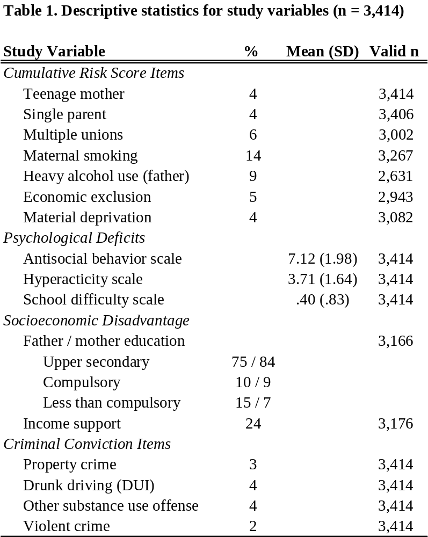

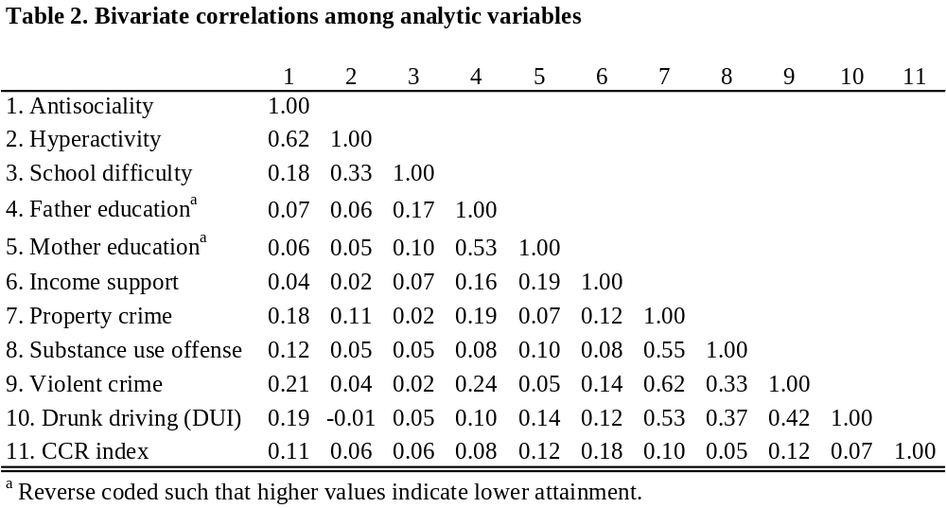
Note: The type of correlation is determined by the scale of the variables: Pearson product moment correlation if both are continuous;
tetrachoric correlation if both are binary; polychoric correlation if both are ordered polytomous; biserial correlation if one is dichotomous
and one is continuous; and polyserial correlation if one is ordered polytomous and one is continuous.

Table 3. Fit indices for study measurement and structural models
 | X²,df | CFI |  | RMSEA (90% CI) |  |  | N |  |  | DIFFTEST
Measurement model
Model 1 (3 soc. disadv., 3 psych. deficit, and 5 criminal conviction indicators) | 153.26**, 32 |  | 0.96 |  |  | .033(.028, .039) |  |  | 3,414 |  | n/a
Structural models
Model 2 (CCR --> psych. deficits and soc. disadv.--> crime) | 292.81**, 41 |  | 0.91 |  |  | .042(.038, .047) |  |  | 3,414 |  | n/a
Model 3 (with direct path CCR --> crime) | 271.62**, 40 |  | 0.92 |  |  | .041(.037, .046) |  |  | 3,414 |  | X²_{D}=16.1, p<.01

**p<.001
Table 4. Structural model results for parallel multiple mediator model for the relationship between cumulative contextual risk at birth and criminal offending in adolescence
 | Unstandardized |  |  | Standardized
 |  | Estimate | SE |  | Estimate | SE
Measurement model
Psych. deficits --> antisociality |  | 1.0ª |  |  | 0.70** | 0.03
Psych. deficits --> hyperactive |  | 0.71 | .06 |  | 0.89** | 0.04
Psych. deficits --> school difficulty |  | .19 | .02 |  | 0.32** | 0.02
Soc. disadvantage --> mother education |  | 1.0ª |  |  | 0.75** | 0.04
Soc. disadvantage --> father education |  | .90 | .11 |  | 0.68** | 0.04
Soc. disadvantage --> income support |  | .45 | .06 |  | 0.34** | 0.04
Criminal convictions --> property crime |  | 1.0ª |  |  | 0.88** | 0.05
Criminal convictions --> subst. use crime |  | .66 | .08 |  | 0.59** | 0.05
Criminal convictions --> violent crime |  | .82 | .09 |  | 0.73** | 0.06
Criminal convictions --> DUI |  | .68 | .07 |  | 0.61** | 0.05
Structural Model
CCR^{b} --> psych. deficits |  | .26 | .04 |  | 0.11** | 0.02
CCR --> soc. disadvantage |  | .28 | .04 |  | 0.21** | 0.03
CCR --> criminal convictions |  | .23 | .06 |  | 0.14** | 0.03
Psych risk --> criminal convictions |  | .11 | .02 |  | 0.17** | 0.04
Soc. disadvantage --> criminal convictions |  | .32 | .08 |  | 0.27** | 0.06
Direct, Indirect and Total Effects |  | Estimate | CI |  | Estimate | CI
Total |  | .35 | .25, .45 |  | 0.22 | .16, .28
Total indirect |  | .12 | .06, .18 |  | 0.08 | .04, .11
Indirect (CCR --> psych. deficits --> crime) |  | .03 | .01, .05 |  | 0.02 | .01, .03
Indirect (CCR --> soc. disadvantage --> crime) |  | .09 | .04, .14 |  | 0.06 | .02, .09
Direct (CCR --> crime) |  | .23 | .12, .34 |  | 0.14 | .08, .21

**p<.001; ª = reference indicator fixed at 1.0 to scale the latent variable and identify the model; ^{b}CCR: cumulative contextual risk.

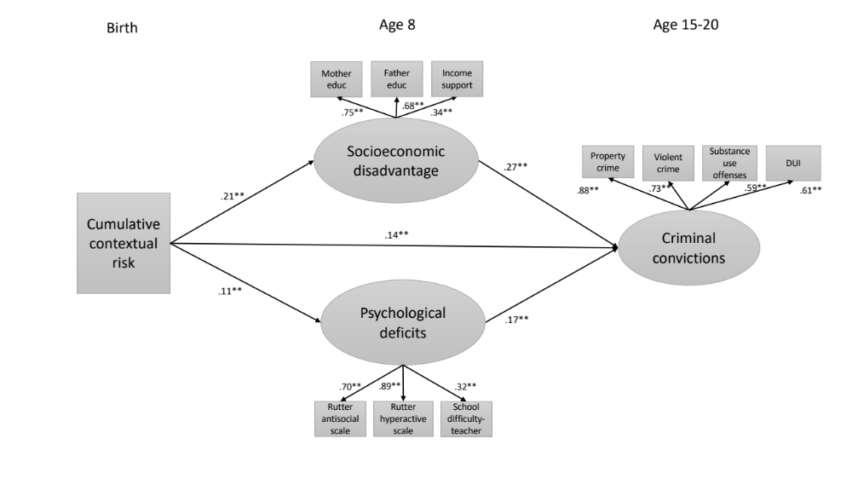
**p < .001
Figure 1. Measurement and structural regression model standardized path estimates for a parallel process model investigating the relationship between cumulative contextual risk at birth and criminal convictions in adolescence.

Although family adversity is an environmental factor, the LCP theory assumes that the interaction between family adversity and psychological liability in early development produces a life-stable propensity to antisocial behavior.

