Supporting Information

Hypercrosslinked PolyHIPEs as Precursors to Designable, Hierarchically Porous Carbon Foams.
Robert T. Woodward*, Arthur Jobbe-Duval, Sofia Marchesini, David B. Anthony, Camille Petit and Alexander Bismarck

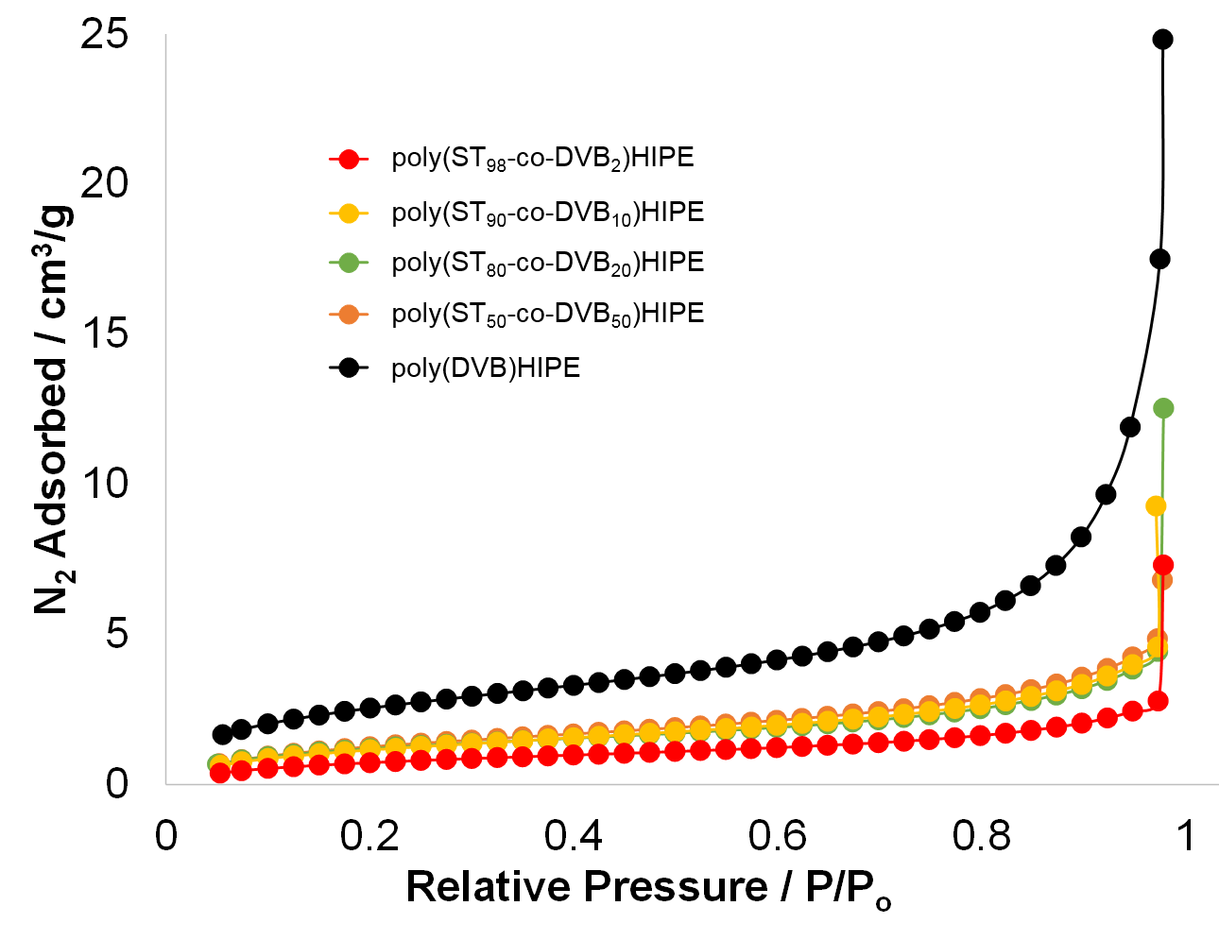
Figure S1 N₂ uptake isotherms for polyHIPEs containing varying ratios of styrene:divinylbenzene.

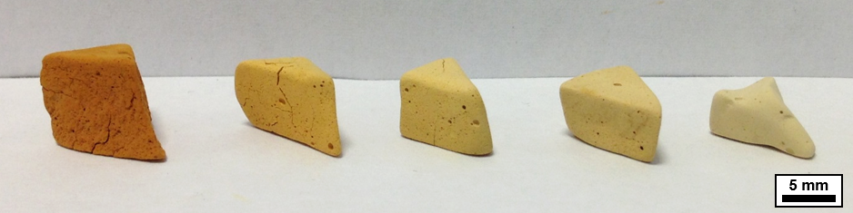
Figure S2 Photograph of HCLHIPEs. From left-right, HCL(ST₉₈-DVB₂)HIPE, HCL(ST₉₀-DVB₁₀)HIPE, HCL(ST₈₀-DVB₂₀)HIPE, HCL(ST₅₀-DVB₅₀)HIPE and HCL(DVB₁₀₀)HIPE.
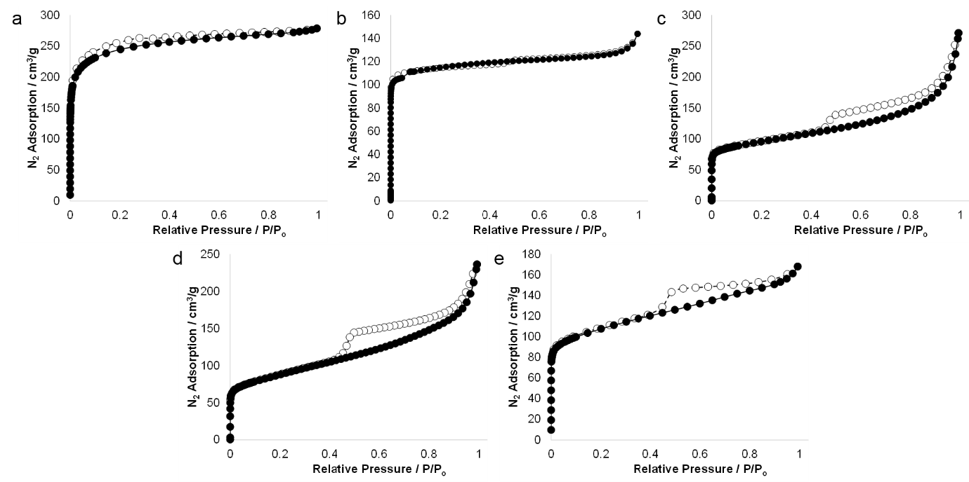
Figure S3 Nitrogen sorption isotherms of HCLHIPEs, a) HCL(ST₉₈-DVB₂)HIPE, b) HCL(ST₉₀-DVB₁₀)HIPE, c) HCL(ST₈₀-DVB₂₀)HIPE, d) HCL(ST₅₀-DVB₅₀)HIPE and e) HCL(DVB₁₀₀)HIPE.

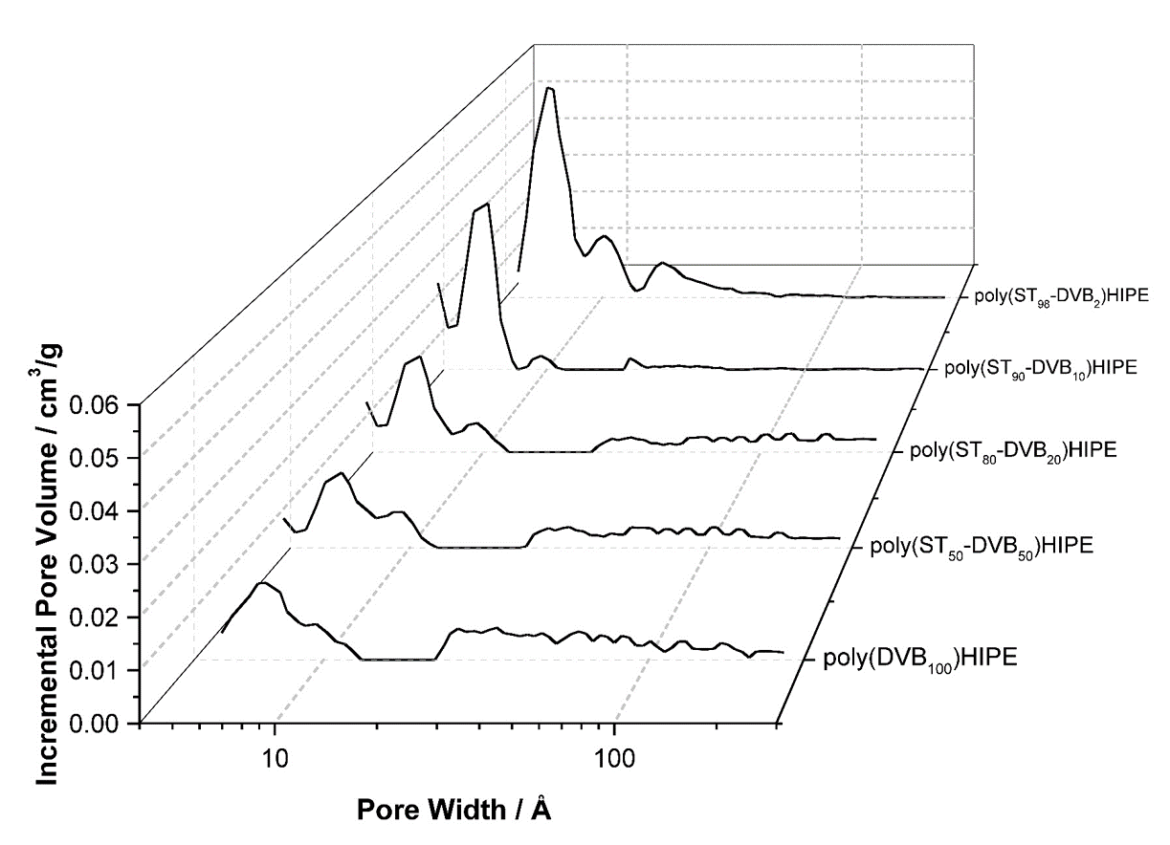
Figure S4 Pore size distributions of HCLHIPEs.

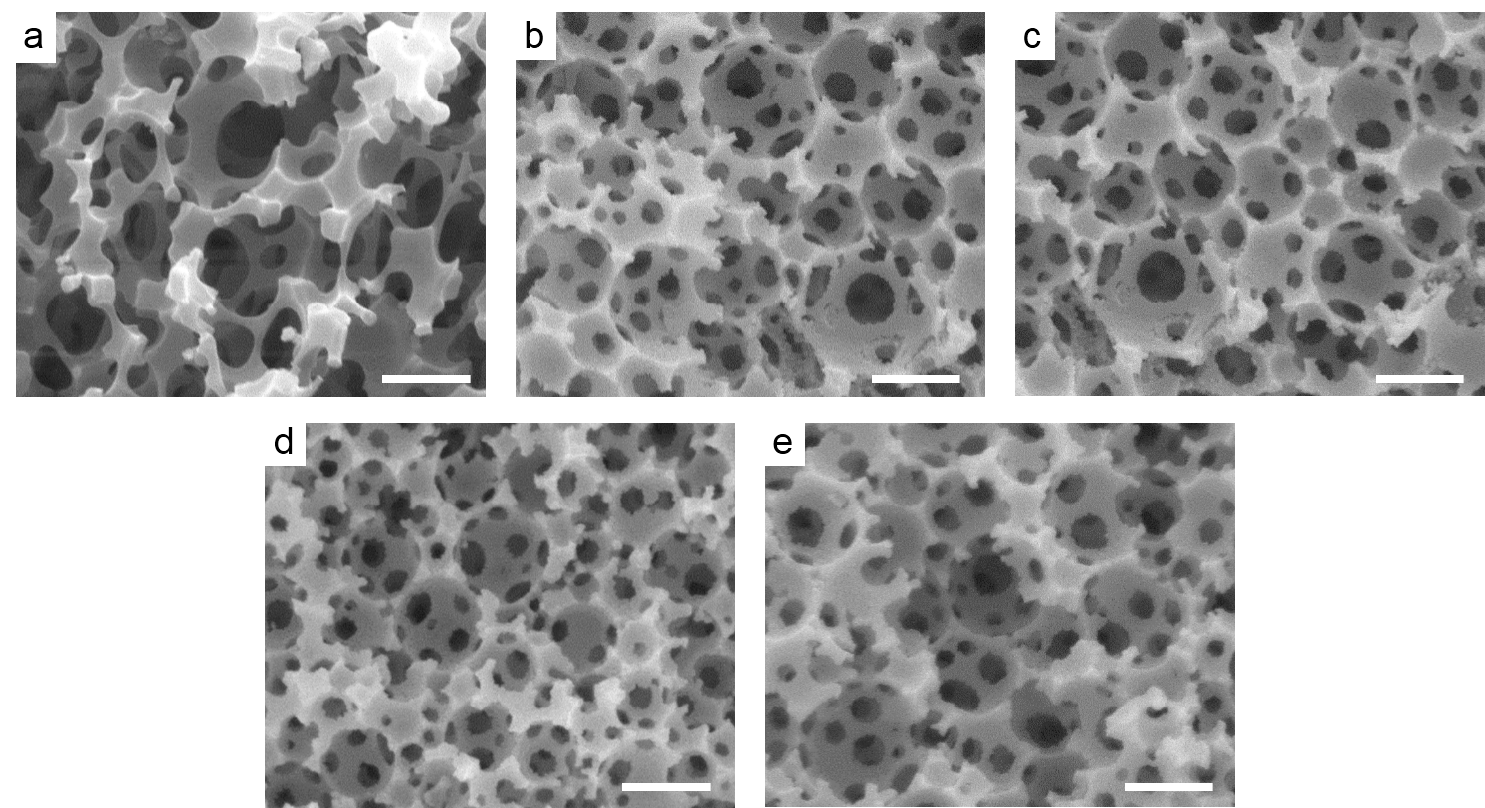
Figure S5 Scanning electron micrographs of hypercrosslinked samples a) HCL(ST₉₈-DVB₂)HIPE, b) HCL(ST₉₀-DVB₁₀)HIPE, c) HCL(ST₈₀-DVB₂₀)HIPE, d) HCL(ST₅₀-DVB₅₀)HIPE and e) HCL(DVB₁₀₀)HIPE. Scale bars represent 5 μm.

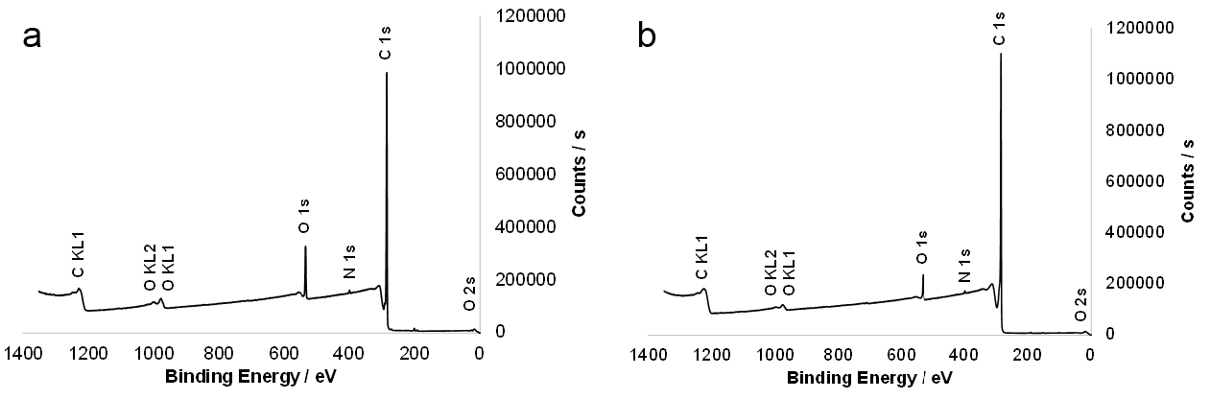
Figure S6 XPS surveys of a) HCL(DVB)HIPE and b) a carboHIPE derived from a HCL(DVB)HIPE.

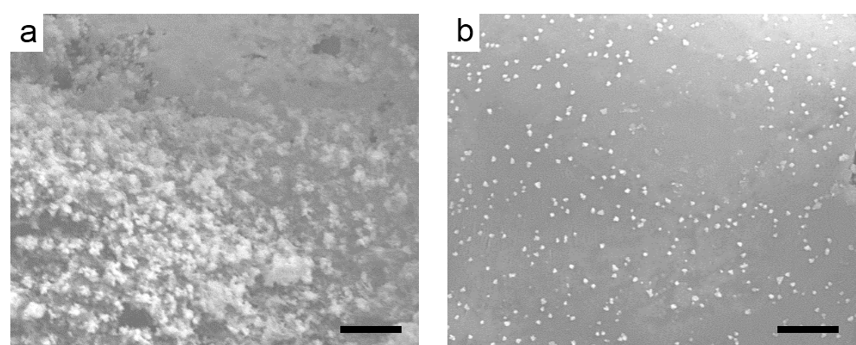
Figure S7 Scanning electron micrographs of carbonized polyHIPE samples a) poly(ST₅₀-co-DVB₅₀)HIPE and b) poly(DVB)HIPE, in which the emulsion-templated macropores were destroyed. Scale bars represent 20 μm.

Table S1 Volume changes for all materials after both hypercrosslinking and carbonization of hypercrosslinked materials.
 | Volume change after hypercrosslinking (%)ª | Volume change after carbonization (%)ª | Volume change after carbonization (%)^{b}
poly(ST₉₈-DVB₂)HIPE | +33 | -42 | -57
poly(ST₉₀-DVB₁₀)HIPE | +32 | -53 | -65
poly(ST₈₀-DVB₂₀)HIPE | +25 | -71 | -77
poly(ST₅₀-DVB₅₀)HIPE | +7 | -78 | -80
poly(DVB)HIPE | -1 | -77 | -77
ªRelative to the volume of the initial polyHIPE. ^{b}Relative to the volume of the HCLHIPE

Table S2 CHN analysis of HCLHIPEs and carboHIPEs showing increased carbon content post-carbonization.
 | C (%) | H (%) | N (%) | C : H
HCL(ST₉₈-DVB₂)HIPE | 75.30 | 5.77 | 0.42 | 13.1 : 1
HCL(ST₉₀-DVB₁₀)HIPE | 79.81 | 6.25 | 0.15 | 12.8 : 1
HCL(ST₈₀-DVB₂₀)HIPE | 82.40 | 6.58 | 0.11 | 12.5 : 1
HCL(ST₅₀-DVB₅₀)HIPE | 81.19 | 6.69 | 0.12 | 12.1 : 1
HCL(DVB)HIPE | 82.84 | 7.22 | 0.27 | 11.5 : 1
carbo(ST₉₈-DVB₂)HIPE | 93.53 | 0.90 | 0.36 | 104.4 : 1
carbo(ST₉₀-DVB₁₀)HIPE | 93.87 | 0.97 | 0.46 | 96.8 : 1
carbo(ST₈₀-DVB₂₀)HIPE | 94.22 | 0.59 | 0.10 | 159.7 : 1
carbo(ST₅₀-DVB₅₀)HIPE | 91.27 | 0.59 | 0.11 | 154.7 : 1
carbo(DVB)HIPE | 90.85 | 0.74 | 0.37 | 122.8 : 1

