Myocarditis in the Setting of Cancer Therapeutics: Proposed Case Definitions for Emerging Clinical Syndromes in Cardio-Oncology

Marc P. Bonaca, MD¹, Benjamin A. Olenchock, MD,PhD^{1,2}, Joe-Elie Salem, MD, PhD^{3,4,5,7}, Stephen D. Wiviott, MD¹, Stephane Ederhy, MD⁸, Ariel Cohen, MD, PhD, FESC⁹, Garrick C. Stewart¹, Toni K. Choueiri¹⁰, Marcelo Di Carli¹, Yves Allenbach, MD, PhD¹¹, Dharam J. Kumbhani, MD, SM¹², Lucie Heinzerling, MD, PhD, MPH¹³, Laleh Amiri-Kordestani, MD¹⁴, Alexander R. Lyon, MD, PhD^{15,16}, Paaladinesh Thavendiranathan¹⁷, Robert Padera, MD, PhD², Andrew Lichtman, MD, MD, PhD² Peter P. Liu, MD¹⁸, Douglas B. Johnson, MD⁶, Javid Moslehi, MD^{3,5,6}
Division of Cardiovascular Medicine, Department of Medicine¹, Department of pathology, Brigham and Women’s Hospital, Harvard Medical School, Boston, MA, USA, Regeneron Pharmaceuticals, Inc., Tarrytown, NY, USA², Division of Cardiovascular Medicine³, Clinical Pharmacology⁴, Cardio-Oncology Program⁵, Division of Oncology⁶, Vanderbilt University Medical Center and Vanderbilt-Ingram Cancer Center, Nashville, TN; Sorbonne Université, INSERM CIC Paris-Est, AP-HP, ICAN, Pitié-Salpêtrière Hospital, Department of Pharmacology, F-75013 Paris, France⁷, Service de cardiologie Hôpitaux Universitaires Est Parisien, Hôpital Saint Antoine, Assistance Publique–Hôpitaux de Paris, INSERM 856, Sorbonne-université (UPMC) , Paris, France⁸, Sorbonne-Université (UPMC) and INSERM 856. Hôpital Saint Antoine, 184 rue du faubourg Saint-Antoine, 75571 Paris, France⁹, Department of Medical Oncology, Dana-Farber Cancer Institute, Boston, MA¹⁰, Sorbonne University, AP-PH, Pitié Salpêtrière Hospital, Department of Internal Medicine and Clinical Immunology, F-75013, Paris, France¹¹, Division of Cardiology, Department of Internal Medicine, UT Southwestern Medical Center, Dallas, TX 75390¹⁰, Center for Drug Evaluation and Research, U.S. Food and Drug Administration, Silver Spring, Maryland, USA¹¹, Department of Internal Medicine, University of Texas Southwestern Medical Center¹², University hospital Erlangen, Dept. of Dermatology, Erlangen, Germany¹³, Center for Drug Evaluation and Research, U.S. Food and Drug Administration¹⁴, Cardio-Oncology Service, Royal Brompton Hospital, London, UK¹⁵, National Heart and Lung Institute, London, UK¹⁶, Peter Munk Cardiac Centre, Ted Rogers Program in Cardiotoxicity Prevention and Department of Medical Imaging, University Health Network, University of Toronto, Toronto, Ontario, Canada¹⁷, Departments of Medicine and Cellular & Molecular Medicine, University of Ottawa Heart Institute, Ottawa, Canada¹⁸

Address for correspondence:
Marc P. Bonaca, MD, TIMI Study Group, Cardiovascular Division, Brigham and Women’s Hospital, 75 Francis Street, Boston, MA 02115, Phone: 617-278-0071; Fax: 617-734-7329, Email: mbonaca@partners.org or Javid Moslehi, MD, Cardio-Oncology Program, Vanderbilt University Medical, 2220 Pierce Avenue, Nashville, TN 37232, Phone: 615-343-9436; Fax: 615-936-1872; Email: javid.moslehi@vanderbilt.edu or javid.moslehi@vumc.org

Abstract:

Recent developments in cancer therapeutics have improved outcomes but have also been associated with cardiovascular complications. Therapies harnessing the immune system have been associated with an immune mediated myocardial injury described as myocarditis. Immune checkpoint inhibitors (ICI) are one such therapy with an increasing number of case and cohort reports describing a clinical syndrome of ICI-associated myocarditis. While the full spectrum of ICI-associated cardiovascular disease still needs to be fully defined, described cases of myocarditis range from more “smoldering” to fatal ones. These observations in the clinic setting stand in contrast to outcomes from randomized clinical trials where myocarditis is a rare event that is investigator reported and lacking in a specific case definition. The complexities associated with diagnosis, as well as the heterogeneous clinical presentation of ICI-associated myocarditis, have made ascertainment and identification of myocarditis with high specificity challenging in clinical trials and other data sets, limiting the ability to better understand the incidence, outcomes and predictors of these rare events. Therefore, establishing a uniform definition of myocarditis for application in clinical trials of cancer immunotherapies will enable greater understanding of these events. We propose an operational definition of cancer therapy associated myocarditis characterizing a broad spectrum of disease to facilitate improved case ascertainment and in turn incidence, outcomes and risk factors.

Introduction
The evolution of cancer therapy over the last decade has brought rapid advancement and improved outcomes. At the same time, therapies targeting specific pathways or harnessing the immune system have been associated with cardiovascular toxicities.¹⁻³ One emerging toxicity is myocarditis. Most recently this clinical entity has been observed in the setting of immune checkpoint inhibitors (ICI); however, myocarditis has the potential to be associated with any therapy that modulates the immune system.^{4, 5} The association between ICI and myocarditis has largely been appreciated in the clinical realm rather than in the pivotal trials that led to the approval of ICI. Identifying myocarditis in clinical trials may be challenging both due to low event rates but also the reliance on site reporting without standardized endpoint definitions. In the following manuscript we discuss the observed association between ICIs and myocarditis to construct a conceptual framework for the proposal of a case definition for myocarditis to be applied prospectively in clinical trials. This definition is proposed to facilitate systematic ascertainment and consistent reporting across trials. While it is framed around ICI therapy, this definition is introduced as an option for any drug induced myocarditis. The proposed case definition is intended for the identification of myocarditis in clinical trials and as such favors specificity over sensitivity in order to reduce noise and improve the ability to characterize differences according to treatment. This is not intended for clinical use where a different balance of sensitivity and specificity may be favored. In addition, it should be noted that the definitions presented are based largely on expert opinion.

Myocarditis Associated with ICI
In 2018, the Nobel prize in physiology and medicine was awarded jointly to Drs. James Allison and Tusuku Honjo for their discovery of cancer therapy by inhibition of negative immune regulation (“immune checkpoints”). Indeed, immune checkpoint inhibitors (ICI) have dramatically improved cancers treatment outcomes. These therapies target the host negative immune regulators (“check points”), thus leading to activation of the immune system against the patient’s cancer cells.⁶ In the last seven years, a total of 7 different ICI have been approved, including programmed cell death-protein 1 inhibitors (anti PD-1 antibodies: nivolumab, pembrolizumab, cemiplimab); programmed cell death-ligand 1 inhibitors (anti PD-L1 antibodies: atezolizumab, avelumab, durvalumab) and cytotoxic T-lymphocyte–associated antigen 4 inhibitors (anti CTLA-4 antibodies: ipilimumab) with several more such therapies pending approval. Increasingly, ICI are being either combined together (e.g. use of ipilimumab plus nivolumab) or combined with other cancer therapies in upcoming clinical trials. Early data suggest further benefit and improved clinical outcomes when ICI are used in combination.⁷⁻⁹ There is emerging appreciation of toxicities from ICIs that stem from activation of autoreactive T cells damaging host tissues and cause immune related adverse events (irAEs) in several organs including colon, liver, lungs, pituitary, thyroid, and skin and other organs.^{10, 11} These toxicities are more frequent when combination therapies involving ICI are delivered.

In 2016, Johnson et al reported two cases of fulminant myocarditis shortly after combination ICI treatment, described the incidence of myocarditis in a retrospective clinical trial population, and defined basic clinical and pathophysiological characteristics of the syndrome.⁴ Since this publication, a number of case series have added to the growing appreciation of this new clinical syndrome.¹²⁻¹⁴ An interrogation of individual case safety reports from publicly available databases indicate substantially increased reporting of ICI-associated myocarditis by health care providers in 2017.¹³ The current data suggest that only severe cases are being identified and reported in the literature.¹⁵ Early data also suggest that ICI may be associated with other cardiovascular irAEs including pericarditis and vasculitis.¹⁶ Takotsubo syndrome (TTS), which may resemble myocarditis, has also been reported in association with ICI.¹⁷ The concomitant presence of other irAEs (specifically myositis and myasthenia gravis) with ICI-associated myocarditis may further raise the suspicion of ICI-associated myocarditis.¹⁸ The possibility of other cardiovascular irAE broaden the differential diagnosis for the treating clinician. With increasing recognition of this new clinical syndrome, it will be important to identify less severe cases to appropriately document the full spectrum of the condition and ascertain the true long term outcomes.

Explosion of Cancer Immunotherapies and Risk of Myocarditis
The success of ICI has propelled the introduction of other means of enhancing the immune response against tumor cells. In 2019, immuno-oncologic therapies include a broad range of agents including antibodies, vaccines, adjuvant therapies, cytokines, modified antibodies and cellular therapies.¹⁹ Genetically engineered T cells, whereby the specificity of T cells are augmented with the use of gene-transfer techniques, represent an important and effective new class of therapies. Chimeric antigen receptors (CAR) redirecting the specificity, function and metabolism of T cells, have been approved for several indications.²⁰⁻²² However, like ICI, other forms of immunotherapies can lead to cardiovascular toxicities. These may include less specific clinical syndromes of fevers, hypotension and hypoxia (“cytokine release syndrome”). On the other hand, more specific cardiovascular toxicities may be observed. For example, the use of genetically modified T cell receptors (TCR) against a cancer antigen (“MAGE-A3”) led to fatal cardiogenic shock as a result of myocarditis. Subsequent work-up revealed cross-reactivity of the T cells with titin, a myocardial protein.^{23, 24} The explosion of these immune-related therapies in oncology clinical trials underscores the need to better define myocardial toxicities including myocarditis.

Proposed Definition of Myocarditis in Clinical Trials

General Considerations
Myocarditis should be diagnosed in the setting of acute cardiac conditions without an alternative primary diagnosis (e.g. acute coronary syndrome, trauma, etc.). Therefore, consideration of these other conditions should be assessed prior to myocarditis in a hierarchical fashion. On the other hand, evidence of myocardial dysfunction and myocardial injury should be ascertained and accounted for even if not meeting a formal definition for myocarditis as these outcomes may represent subacute forms of myocarditis. Therefore, a high level of awareness and vigilance should be present for myocarditis. In addition to adjudicating the outcome of myocarditis, adjudicators should consider characterization by clinicopathologic classification. Moreover, timing of presentation relative to exposure to investigational therapy should be considered when relatedness or etiology of myocarditis is considered. In general, myocarditis related to ICI can develop soon after ICI administration.^{13, 14} A general framework for consideration of myocarditis is presented in Figure 1.

Clinical Presentation
The presenting clinical syndrome is useful in the evaluation of a case of suspected myocarditis. The clinical syndrome associated with myocarditis is broad and can encompass a spectrum of symptoms including palpitations, chest pain, acute or chronic heart failure as well as findings including pericarditis and pericardial effusion. In addition, myocarditis may present in an indolent fashion with mild degrees of ventricular dysfunction.²⁵ Patients with symptoms that are entirely attributable to another non-myocarditis diagnosis will not be counted as having a clinical syndrome.

Biomarker Elevations
Biomarkers for myocarditis are markers of myonecrosis including cardiac troponin, CK-MB or total CK. Natriuretic peptides may be useful in terms of characterizing stress on the ventricle; however, they must be interpreted with caution in the setting of ICI myocarditis as they can be elevated directly through inflammatory pathways even in the setting of normal filling pressures.^{26, 27} Natriuretic peptides are not specific for myocarditis but may be elevated in patients with significant left ventricular dysfunction and heart failure, and are frequently elevated in ICI-associated myocarditis.²⁸ In addition, natriuretic peptide elevations may be particularly complex in the setting of ICI mediated myocarditis, but the elevation may be mediated by other mechanisms such as via Interleukin-6.²⁹

For cardiac biomarkers, laboratories should report an upper reference limit (URL). Troponin is the preferred biomarker especially in settings where concomitant myositis may result in significant elevations of CK, CK isoforms and even troponin T. In this scenario, troponin I would be the most specific option for myocardial injury. If the 99th percentile of the upper reference limit (URL) from the respective laboratory performing the assay is not available, then the URL for myocardial necrosis from the laboratory should be used. If the 99th percentile of the URL or the URL for myocardial necrosis is not available, the myocardial infarction (MI) decision limit for the particular laboratory should be used as the URL. Laboratories can also report both the 99th percentile of the upper reference limit and the MI decision limit. Reference limits from the laboratory performing the assay are preferred over the manufacturer’s listed reference limits in an assay’s instructions for use. In general, cardiac troponins are preferred. CK-MB should be used if troponins are not available, and total CK may be used in the absence of CK-MB and troponin.

Electrocardiogram (ECG) Changes
Electrocardiographic (ECG) changes can be used to support or confirm a diagnosis of myocarditis. ECG changes should be dynamic (change from baseline) in a timeframe consistent with the onset of the myocarditis syndrome. Possible changes are broad including arrhythmia, ST-T wave abnormalities, PR segment changes, or new arrhythmias (e.g. new heart block or ectopy). ECG findings diagnostic for an alternative diagnosis (e.g. regional ST segment elevation in the context of known acute coronary syndrome (ACS)) should not be counted as changes consistent with myocarditis without appropriate investigation. Patients may also present with a range of arrhythmias including atrial tachyarrhythmia, premature ventricular contractions, and ventricular tachycardia. Bradyarrhythmia and heart block have been also described with infectious (e.g. Lyme) and immune-mediated myocarditis.^{4, 30}

Imaging
Echocardiography is generally the first line imaging study to assess cardiac function. Echocardiography is commonly performed for patients with acute or subacute symptoms. Findings may include diffuse left ventricular systolic function, segmental wall motion abnormalities, and change in sphericity of the ventricle.³¹ Patients presenting acutely generally have normal cardiac dimensions; adverse remodeling and dilatation generally represent a more chronic process.³² Increased wall thickness, a pericardial effusion, and strain abnormalities have also been described in the acute phase. Importantly, echocardiography is not specific for myocarditis and lacks sensitivity in cases where systolic function is relatively preserved. ³³.³⁴

CMR is the preferred imaging modality for the diagnosis of myocarditis offering several distinct advantages over echocardiography. The major strength of CMR is with tissue characterization techniques which can be used as a surrogate for myocardial injury.³⁵⁻³⁷ A combination of findings on CMR has been termed the “Lake Louise Criteria” for the diagnosis of acute myocarditis.³⁶ Since the publication of these criteria, there have been significant advances in the use of quantitative tissue characterization techniques such as T1 and T2 mapping and calculation of the extracellular volume fraction. Other imaging modalities may be useful in the consideration of whether a case represents myocarditis. In some cases nuclear medicine modalities including radionuclide ventriculography which may confirm LV systolic dysfunction. Positron emission tomography (PET) using traditional ¹⁸F-fluorodeoxyglucose (FDG) may be utilized in certain circumstances to provide data supportive of inflammation, particularly in patients not suitable for CMR or where CMR results are equivocal. It is critical to use appropriate FDG-PET protocols for cardiac inflammation with an 18 hour carbohydrate-free fast to avoid false positive results. Newer inflammation tracers are currently being evaluated.

Role for endomyocardial biopsy and autopsy
Patients experiencing potential cardiovascular complications from ICI therapy who die should have a post-mortem examination. Even an autopsy limited to biopsies of the heart analyzed by a cardiac pathologist would provide critical information to adjudicate a clinical event for or against myocarditis. In a broader sense, the oncology and cardiology clinical and scientific communities can benefit from post-mortem evaluations on all patients receiving ICI therapies, symptomatic or not, to further study ICI-associated myocarditis. In our experience, asymptomatic patients who die of progressive metastatic disease or other complications can indeed have milder degrees of myocarditis. In addition, endomyocardial biopsy should be considered when there is suspicion of the condition, and facilities and expertise available for both the biopsy procedure, and pathological processing and interpretation of the biopsy samples.

Categories of Myocarditis (Figure 3)

Definite Myocarditis:
Any of the following:
- Tissue pathology diagnostic of myocarditis (e.g. on biopsy or autopsy)
- Cardiac magnetic resonance imaging (CMR) diagnostic of myocarditis, a clinical syndrome and one of following:
  - Elevated biomarker of cardiac myonecrosis
  - ECG evidence of myo-pericarditis
- New wall motion abnormality (WMA) on echocardiogram not explained by another diagnosis (e.g. ACS ruled out by angiography, trauma, stress induced cardiomyopathy, sepsis) and all of the following:
  - Clinical syndrome consistent with myocarditis
  - Elevated biomarker of cardiac myonecrosis
  - ECG evidence of myo-pericarditis
  - Negative angiography or other testing to exclude obstructive coronary disease

Probable Myocarditis:
Any of the scenarios below that are not explained by another diagnosis (e.g. ACS, trauma, stress induced cardiomyopathy)
- CMR with findings diagnostic of myocarditis without any of the following (when screening CMR is being performed routinely as in the context of trial procedure)
  - Clinical syndrome consistent with myocarditis
  - Elevated biomarker of cardiac myonecrosis
  - ECG evidence of myo-pericarditis
- Non-specific CMR findings suggestive of myocarditis with any 1 or more of the following:
  - Clinical syndrome consistent with myocarditis
  - Elevated biomarker of cardiac myonecrosis
  - ECG evidence of myo-pericarditis
- New WMA on echocardiogram with a clinical syndrome consistent with myocarditis and either:
  - Elevated biomarker of cardiac myonecrosis
  - ECG evidence of myo-pericarditis
- A scenario meeting criteria for Possible Myocarditis (see below) with ¹⁸F-Fluorodeoxyglucose (FDG) Positron Emission Tomography (PET) imaging showing patchy cardiac FDG uptake without another explanation

Possible Myocarditis:
Any of the scenarios below that are not explained by another diagnosis (e.g. ACS, trauma, stress induced cardiomyopathy)
- Non-specific CMR findings suggestive of myocarditis with none of the following:
  - Clinical syndrome consistent with myocarditis
  - Elevated biomarker of cardiac myonecrosis
  - ECG evidence of myo-pericarditis
- New WMA on echocardiogram and 1 of the following:
  - Clinical syndrome consistent with myocarditis
  - ECG evidence of myo-pericarditis
- New elevated biomarker (beyond baseline) and 1 of the following:
  - Clinical syndrome consistent with myocarditis
  - ECG evidence of myo-pericarditis

For every case, all additional diagnostic information (e.g. cardiac PET scan or serial imaging) should be reviewed and integrated into the overall adjudication and may result in upgrade or downgrade by not more than 1 level. This includes muscle biopsy showing myositis in cases where cardiac biopsy is not available.

All positively adjudicated cases of myocarditis or new systolic dysfunction above will also be subcategorized as follows:
- Fulminant – presentation with hemodynamic and/or electrical instability
- Clinically significant but not fulminant – clinically recognized and prompting treatment or not recognized by with other evidence of clinical significance.
- Subclinical – not recognized or treated and no other evidence of clinical significance.
In addition, systematic collection of objective information (e.g. peak cardiac troponin, LV ejection fraction, pericardial effusion, RV involvement, arrhythmias) should be considered to provide further characterization of events.

Assessment of Relatedness
During the course of the trial, while treatment allocation may be blinded, it is often necessary to assess the relatedness of an event to the intervention being studied. Ultimately, any relationship is determined at the end of a study based on the presence or absence of imbalance with unblinded randomized therapy. Assessing relatedness during the trial, prior to unblinding, may be useful in alerting investigators to potential unexpected adverse effects of an investigational therapy so they are aware and evaluate for this effect.
As part of standard safety reporting, investigators are generally asked about the likelihood of relatedness and whether the investigational agent appears to have a causal relationship (causality). During central case review, it may also be helpful for adjudicators to assess the likelihood of causality. Potential advantages to central assessment in addition to investigator assessment include greater consistency, systematic application of factors indicating causality, great sample size being evaluated, and assessment by specialists.
Several factors should be considered in the assessment of causality. These include: time course of the event relative to exposure with the investigational therapy, consistency or plausibility based on the mechanism of action of the investigational therapy, the absence of an alternative explanation (e.g. exposure to another intervention known to cause the adverse event), response to removal of the therapy and re-challenge and the results of relevant diagnostic testing. Based on these factors and others, the adjudicators may determine there is a reasonable possibility the event was related to drug exposure. In the absence of evidence of a causal relationship, generally events are assessed as unrelated to treatment exposure. Specific guidance for causality assessment should be determined for each study program and in accordance with regulatory guidance.

Other Myocardial Injury Not Meeting the Definition of Myocarditis
It may be useful to categorize events not meeting the formal definition of myocarditis above but where there is evidence of a change in cardiac function or of myocardial injury. We suggest the following categories.

New ventricular systolic dysfunction without evidence of ischemia or myocarditis
New imaging evidence (e.g. echocardiogram, CMR, ventriculogram, MUGA) of left and/or right ventricular systolic dysfunction not meeting definitions above for cardiac ischemic event or myocarditis. Dysfunction is defined as an ejection fraction less than 50% and a change of at least 10% from baseline. Whenever possible, cases will be subcategorized as below and will also include a categorization of chronicity (acute transient, acute persistent, chronic, unknown):
- Suspected stress-induced cardiomyopathy (includes Takotsubo cardiomyopathy syndrome)
- Suspected sepsis-related cardiac dysfunction, or other catechol-mediated syndromes NOS)
- Suspected direct cardiac toxicity (e.g. chemotherapy, alcohol)
- Suspected genetic cardiomyopathy (e.g. ARVC, familial cardiomyopathy)
- Suspected tachyarrhythmia induced cardiomyopathy
- Suspected hypertensive cardiomyopathy
- Other / Idiopathic cardiomyopathy

Unspecified biochemical evidence of myocardial injury
Elevated biomarker indicating myocardial injury without evidence of myocarditis (any category), ischemia or trauma and with normal left and right ventricular systolic function.

Ascertaining Potential Myocarditis in Clinical Trials
Myocarditis in oncology trials may occur in a population at heightened risk of cardiovascular events and in the context of previous and current oncology therapies that are associated with a range cardiovascular complications, including uncontrolled hypertension, cardiomyopathy, arrhythmias, vascular complications,¹ venous thromboembolism (VTE), increased thrombotic risk.^{3, 3844} The potential diverse complications are particularly relevant to the concept of ascertainment and adjudication of myocarditis as the clinical presentations (chest pain, dyspnea, elevated cardiac troponin) may overlap with myocarditis and therefore broad adjudication of cardiovascular toxicities is necessary to differentiate true cases (Figures 1 & 2). Sensitive cardiac biomarkers may also be elevated in many contexts or be falsely elevated in the setting of inflammatory insults.^{27, 29} In such a context myocarditis or subacute forms of myocardial toxicity may be a diagnosis of exclusion. We therefore propose a hierarchical approach to adjudication to first exclude other causes (e.g. myocardial ischemia) and then categorize the event in terms of the level of certainty with which myocarditis can be defined.

The most specific tests to confirm myocarditis are myocardial biopsy and cardiac MRI. Both of these tests, however, are challenging to obtain and resource intensive, particularly in the setting of acute illness. Patients with more fulminant forms of myocarditis may have complications including unstable arrhythmia and/or cardiogenic shock. Furthermore, patients diagnosed with these complications have high rates of a progressive course and rapid onset mortality. This often results in an absence of definitive diagnostic data for a significant number of cases where myocarditis is suspected. One approach may be to mandate certain testing (e.g. biopsy and or MRI) in patients with myocarditis both to confirm diagnosis using a gold standard as well as to provide opportunity for discovery. Another approach with regards to events of suspected myocarditis without biopsy or MRI would be to adjudicate them as not myocarditis. An advantage to this approach would be greater specificity; however, this would come at a cost of excluding a significant number of cases that likely represent milder cases of myocarditis, reducing rates and power to detect an imbalance with therapy. As an alternative, counting all cases as myocarditis would sacrifice specificity. Therefore, an optimal solution would be to be broadly inclusive of cases where definitive testing was not possible, but also endeavor to maintain specificity.

An analogous situation is that of coronary stent thrombosis where the definitive diagnosis hinges on visualization of thrombotic occlusion either through pathology or angiography. Therefore, in approaching a practically useful definition of myocarditis, a construct similar to that established for stent thrombosis by the Academic Research Consortium was considered.³⁹ By integrating several degrees of certainty rather that treating outcomes in a binary fashion, investigators may analyze outcomes using differing levels of specificity to evaluate for consistency of effect and understand rates within a range.

Establishing a clear baseline at randomization or start of treatment is critical in assessing changes occurring during the trial or therapy (Table 1). Baseline evaluation should include a physical examination and ECG. Baseline measurement of cardiac biomarkers (CK, troponin, potentially natriuretic peptides) and assessment of left ventricular dysfunction using echocardiography are recommended to allow adjudicators to determine if there is a change from baseline in the context of case review following start of trial. Collection of biosamples (plasma and peripheral blood mononuclear cells - PBMC) for future use should be considered high priority whenever possible for exploratory evaluation.

For case identification, any event that an investigator or treating physician considers a possible cardiac event should be a selected for adjudication (Figure 2). In addition, systematic criteria such as serial biomarkers of myocardial necrosis and serial assessments of LV function may capture subclinical cardiac adverse events (Table 1).

Investigators should receive special training on the ascertainment and reporting of suspected cardiovascular events particularly if those are outside of the investigator’s own specialty. In addition, investigators should be educated about myocarditis, when to suspect the diagnosis and what testing to obtain to assess for the diagnosis. Current consensus statements outline a clinical approach to the diagnosis and treatment of patients with myocarditis and should be used as a reference.²⁸ In general, myocarditis should be considered in patients who have a rise in cardiac troponin, ECG changes, arrhythmia, or abnormalities of left ventricular systolic function (e.g. ejection fraction) particularly if unexplained by another diagnosis. Testing should be performed in accordance with guidelines and consensus statements. Tests to consider in selected clinical scenarios are presented in Table 2.

General considerations for source document submission for suspected cardiac events include collection of clinical records with redaction of identifying information. Clinical records and reports including imaging studies, lab results, ECGs and procedure reports may be collected. In addition, collection of primary data for core lab review may be considered in selected cases including cardiac MRI images, echocardiograms, and biopsy tissue (Table 3).

Using Consensus Criteria for Adjudication of Myocarditis in Trials of Investigational Cancer Therapies
As the appreciation for potential cardiotoxicity grows with ICI and other cancer immunotherapies, understanding of the risk factors, incidence and outcomes for myocarditis has become increasingly important. Defining the outcome of interest (in this case, myocarditis) using systematic consensus criteria, as is currently done for ischemic cardiac events, may enable systematic reporting and consistency across datasets.^{39, 40} In addition, defining a spectrum of disease using definitions that allow ascertainment of less severe forms of myocardial injury, may help to identify the full spectrum of cardiotoxicity. In oncology trials, Common Terminology Criteria for Adverse Events (CTCAE) provides a standard chart for reporting the severity of adverse events. However, the most recent CTCAE version does not provide specific guidance to the care provider about which events should be defined as myocarditis. A general definition is provided, where myocarditis is described as “a disorder characterized by inflammation of the muscle tissue of the heart.” Therefore, CTCAE maintains investigator reporting according to their judgement.

The proposed definitions in this document then provide a framework to evaluate these reports and characterize the events according to systematic criteria, increasing consistency and specificity. Application would enable better assessment of drug effect as well as facilitate pooling of datasets and cross trial comparisons. Therefore, the current definitions are not intended as a modification or replacement of CTCAE, but rather as an added step to add systematic criteria and improve specificity. In addition, there is no consensus definition for myocarditis adjudication in clinical trials; therefore, estimates of case incidence is largely based on safety reporting which is highly variable and non-specific. Systematic ascertainment using a consensus definition would allow broader understanding of the predictors, risks and outcomes, as well as evaluation across trials, even across different cancer diagnoses such as melanoma or lung cancer.

Discussion
The rapid development of novel therapies to treat cancer has led to increasing awareness of potential new cardiac toxicities.¹ This includes a range of adverse outcomes including hypertension, arrhythmias, thrombotic complications, accelerated atherosclerosis and immune mediated myocarditis. Understanding risks of these therapies is complex as the prevalence of comorbid cardiovascular disease is high, cardiac events during the course of a given trial may be rare, and traditionally events are captured through standard safety reporting which lacks specificity.

Systematic characterization at randomization including physical examination, electrocardiography, biomarkers, assessments of ventricular dysfunction and other assessments can help establish a baseline against which changes can be evaluated during trial follow up. Serial evaluations and testing in all patients can help ascertain early or subclinical events. Extensive reporting through dedicated case report form pages and by trained site investigators may help to capture these rare but potentially very serious events.

Adjudication using standardized definitions allows characterization of events with greater specificity allowing clearer signals and less noise for rare events. In addition, specialist adjudication may allow further characterization including the certainty of the diagnosis, the severity, and associated findings such as fold elevation in biomarker and objective assessment of left ventricular function. In addition, utilization of standard definitions will allow pooling of data across trials giving more power to understand which patients are truly at risk, how they present, and their prognosis after diagnosis.

Although there are established definitions for a range of cardiovascular outcomes, a clear case definition for myocarditis for use in clinical trials has not been established. Any practical definition must acknowledge that testing may be variable across sites and that some degree of uncertainty is inevitable. Hierarchical adjudication first excluding alternative diagnoses (e.g. coronary disease) and then allowing characterization of myocarditis by the degree of certainty would allow analysis across categories. In addition, capture of cases of subclinical biomarker elevation as well as mild ventricular systolic dysfunction may help to increase ascertainment, identifying pre-exposure risk, and enable a broader description of the range of clinical outcomes. This document proposed a definition for myocarditis and a process for ascertaining and adjudicating this definition in clinical trials of therapies to treat malignancy.

Acknowledgements:

The contributions of Laleh Amiri-Kordestani represent her opinions and not those of the U.S. Food and Drug Administration.

Sources of Funding:

PPL has received grant support from Canadian Institutes of Health Research. JJM was supported by an NIH grant (R56 HL141466).

Disclosures:

MPB reports consulting for Amgen, AstraZeneca, Bayer, Janssen, Pfizer, Sanofi-Aventis, Merck as well as research funding from AstraZeneca, MedImmune, Merck and Pfizer. JES was supported by Cancer ITMO of the French National Alliance for Life and Health Sciences (AVIESAN): “Plan Cancer 2014-2019”. SDW reports ARENA, AstraZeneca, Aegerion, Allergan, Angelmed, Boehringer-Ingelheim, Boston Clinical Research Institute, Bristol Myers Squibb, Daiichi Sankyo, Eisai, Eli Lilly, Icon Clinical, Janssen, Lexicon, Merck, Servier, St Jude Medical, Xoma and research grants from Amgen, Arena, AstraZeneca, Bristol Myers Squibb, Daiichi Sankyo, Eisai, Eli Lilly, Janssen, Merck and Sanofi-Aventis. SDW’s spouse is an employee of Merck Research Laboratories. SE has received consultant and lecture fees from Eli Lilly, Daiichy-Sankyo, Celgene, Pfizer, EspeRare, Bristol-Myers Squibb, Janssen, Philips Healthcare, Bayer, Novartis, Amgen, and Ipsen. AC has received consultant and lecture fees from, Amgen, AstraZeneca, Bayer Pharma, BMS-Pfizer alliance, Boehringer-Ingelheim and Novartis, and has received research grants from ARS, RESICARD, Bayer and Boehringer-Ingelheim. MD has received consulting honoraria from Sanofi and General Electric and research grants from SpectrumDynamics. TKC has been a consultant for AstraZeneca, Bayer, BMS, Cerulean, Eisai, Foundation Medicine Inc., Exelixis, Genentech, Roche, GlaxoSmithKline, Merck, Novartis, Peloton, Pfizer, Prometheus Labs, Corvus, Ipsen and has received research funding from AstraZeneca, Bayer, BMS, Cerulean, Eisai, Foundation Medicine Inc., Exelixis, Genentech, Roche, GlaxoSmithKline, Merck, Novartis, Peloton, Pfizer, Prometheus Labs, Corvus, Ipsen. LH has been a principal investigator in clinical studies for Bristol-Myers Squibb, Merck, Roche, Amgen, GlaxoSmithKline, Curevac and Novartis; had received consultancy and speaker fees from from Bristol-Myers Squibb, Merck, Roche, Amgen,
Novartis, Curevac, and Pierre Fabre. ARL has received speaker, advisory board or consultancy fees and/or research grants from Pfizer, Novartis, Servier, Amgen, Clinigen Group, Takeda, Roche, Eli Lily, Eisai, Bristol Myers Squibb, Ferring Pharmaceuticals and Boehringer Ingelheim.
DJ has served on an advisory board for Array, Bristol-Myers Squibb, Genoptix, Incyte, Merck and Novartis and has received research funding from Bristol-Myers Squibb and Incyte. JM has served on an advisory board for Pfizer, Novartis, Bristol-Myers Squibb, Takeda, Regeneron, and Myokardia and received research funding from Pfizer and Novartis.

Table 1 – Testing for Consideration at Baseline and During Follow up

Tests at Baseline
Physical exam | To evaluate for signs or symptoms of heart failure or vascular disease. Assessment of functional status (e.g. New York Heart Association Heart Failure classification) should be included. Formal assessment such as 6-minute walk should be considered.
Cardiac troponin (troponin I preferred especially if suspicion of concomitant myositis | To evaluate for sub-clinical myocardial injury and to establish a baseline for subsequent testing. Abnormal values should be investigated. Other biomarkers (e.g. natriuretic peptides, C reactive protein) may also be helpful in establishing a baseline value.
Electrocardiogram | To evaluate for arrhythmias and evidence of conduction system disease, to establish a baseline.
Echocardiogram | Echocardiography as first line noninvasive bedside evaluation to rule out valvular diseases or other cardiomyopathies (whether dilated, hypertrophic or restrictive). To monitor patients with pericardial effusion, hemodynamic compromise and to improve prognostic stratification In all cases, to evaluate structural heart disease and to establish baseline biventricular function and hemodynamics.
Other measure of LV function (e.g. nuclear, MRI, CT) | Cardiac MRI is the preferred imaging modality
Ambulatory 24-hour blood pressure monitor | Consider in trials where investigational or background therapy is anticipated to cause hypertension
Interval Tests to Evaluate for Subclinical Myocardial Injury in the Absence of Symptoms
Physical exam | To evaluate for changes indicative of heart failure or vascular disease. Assessment of functional status (e.g. New York Heart Association Heart Failure classification) should be included. Formal assessment such as 6-minute walking should be performed if done at baseline to assess for change (at each visit)
Cardiac troponin (troponin I preferred especially if suspicion of concomitant myositis | To evaluate for new rise indicative of myocardial injury (at each study visit)
Electrocardiogram | To evaluate for arrhythmias and evidence of conduction system disease relative to baseline (at each study visit)
Echocardiogram | To evaluate ventricular function (annual), whatever baseline systolic function  Speckle Tracking: better sensitivity for detection of  regional LV dysfunction compared with conventional echocardiography  Abnormalities in longitudinal myocardial deformation  correlate significantly with lymphocytic infiltrates in AM
Other measure of LV function (e.g. nuclear, MRI, CT) | MRI >> other imaging modalities  Non-invasive tissue characterization and thus myocarditis diagnosis  To detect hyperemia, myocardial edema and fibrosis (TI, T2 techniques)
Ambulatory 24-hour blood pressure monitor | If blood pressure elevated on home or office measurements, consider to better characterize blood pressure (as indicated)
Table 2 – Tests to be Obtained if Myocarditis is Suspected
Presentation | Testing to Consider
Non-specific symptoms including palpitations, dyspnea, chest pain, syncope | - Physical exam  - ECG  - Cardiac troponin (troponin I preferred)  - Echo  - Stress testing with imaging when appropriate  - Additional testing (e.g. cardiac MRI) based on results of initial evaluation  - Positron emission tomography (PET) in selected patients with suspected myocardial inflammation particularly in patients presenting with ventricular arrhythmia or heart block
New congestive heart failure | - Physical exam  - ECG  - Cardiac troponin and natriuretic peptides  - C reactive protein if an inflammatory cause is suspected  - Serum cardiac autoantibodies  - Echocardiogram  - Stress testing with imaging when appropriate  - Coronary angiography (CT or traditional angiography)  - Cardiac MRI with tissue characterization  - Positron emission tomography (PET) in select patients with suspected myocardial inflammation (e.g. suspected sarcoidosis)  - Endomyocardial biopsy should be considered of myocarditis is suspected to establish the diagnosis
Cardiogenic shock | - Physical Exam  - ECG  - Cardiac troponin and natriuretic peptides  - C reactive protein if an inflammatory cause is suspected  - Echocardiogram  - Coronary angiography  - Hemodynamic monitoring if needed  - Endomyocardial biopsy should be considered to establish the diagnosis and assist in management
n.b. in cases where ICI-myocarditis is suspected, a skeletal muscle biopsy may be helpful particularly if signs or symptoms of myositis and cardiac MRI and myocardial biopsy cannot be obtained. Signs or symptoms raising concern for myositis include:
- Muscle weakness
- Elevated total CK (MM fraction) beyond that expected for the degree of myocardial injury
- Muscle FDG update on PET imaging
- Electromyography suggestive of myopathy

Table 3 – Source Document Collection for Cardiac Event Adjudication
Test | Primary data or Report | Comment
Clinical Assessments | - Clinical evaluation  - Emergency room (ED) documentation  - Admission notes  - Specialty consultation notes  - Discharge summaries
Electrocardiogram | - ECG tracings  - Treating physician assessment | Core lab review not mandatory provided adjudicators are trained in cardiovascular medicine. If other concern (e.g. QT prolongation) then core lab review should be considered.
Cardiac biomarkers | - All lab reports including assay name and normal range
Echocardiogram | - Report | Core lab review likely of limited value
Cardiac MRI | - Report  - Consider MRI data | Core lab review may be of value in understanding specificity of findings for myocarditis
Cardiac FDG PET | - Report | Imaging of uncertain value
Coronary CT angiography | - Report | Imaging of uncertain value
Coronary angiography | - Cath lab and procedure reports | Angiograms likely of limited value
Cardiac hemodynamics | - Report | Tracings likely of limited value
Biopsy specimens | - Report  - Consider collection of tissue | Centralized pathology may be of value for core histopathology review

Figure Legends

Figure 1 – A proposed approach to diagnosis of myocarditis in the setting of ICI use.
Abbreviations:
ACS: Acute coronary syndrome
AMICI : Acute myocarditis related to ICI
AHF: acute heart failure
AV: atrioventricular
AF: atrial fibrillation
Bm: biomarkers
CMR: Cardiac magnetic resonance imaging
ECG: Electrocardiogram
EMB: Endo-myocardial biopsy
ICI: immune checkpoint inhibitor
LVEF: Left ventricular ejection fraction
MI: myocardial infarction
NIMI : non ischemic MI
Sd: Syndrome
TTE : Transthoracic echocardiography
TTS : Takotsubo
WMA: Wall motion abnormality

Figure 2 – Scope of ascertainment for cardiovascular events in oncology trials. Cardiac events should be adjudicated in a hierarchical manner excluding ischemia prior to establishing myocarditis. Simultaneous adjudication of heart failure and arrhythmia is recommended as event types may not be mutually exclusive
Abbreviations:
CV: Cardiovascular
ECG: Electrocardiogram
HF: Heart Failure
HTN: Hypertension
VTE: Venous thrombo-embolic

Figure 3 – A proposed definition of myocarditis to be applied in clinical trials

Figure 1

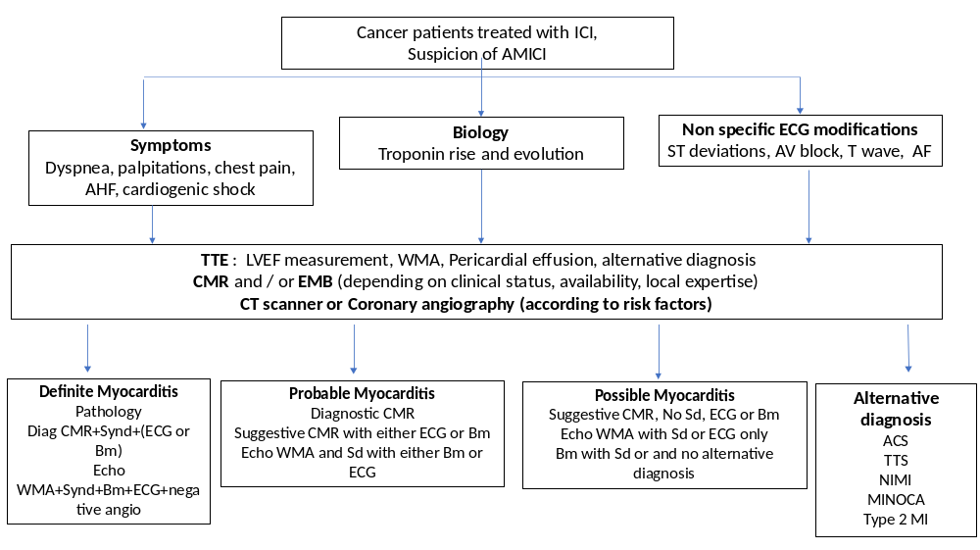
CT Scan
Figure 2
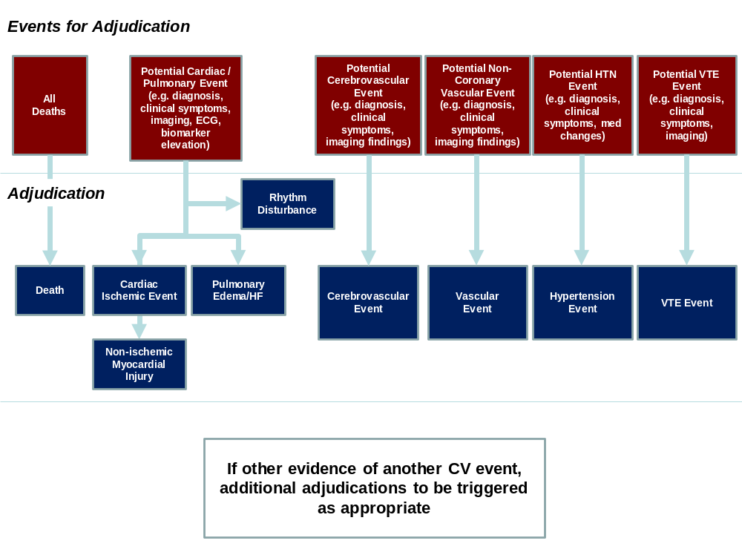

Figure 3
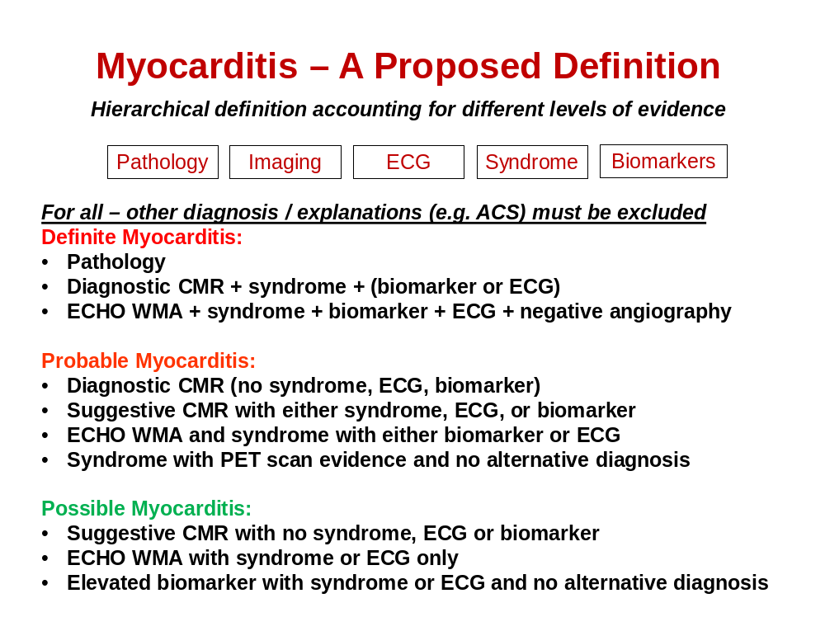

References
1. Moslehi JJ. Cardiovascular Toxic Effects of Targeted Cancer Therapies. N Engl J Med. 2016;375:1457-1467.
2. Bellinger AM, Arteaga CL, Force T, Humphreys BD, Demetri GD, Druker BJ and Moslehi JJ. Cardio-Oncology: How New Targeted Cancer Therapies and Precision Medicine Can Inform Cardiovascular Discovery. Circulation. 2015;132:2248-58.
3. Li W, Croce K, Steensma DP, McDermott DF, Ben-Yehuda O and Moslehi J. Vascular and Metabolic Implications of Novel Targeted Cancer Therapies: Focus on Kinase Inhibitors. J Am Coll Cardiol. 2015;66:1160-78.
4. Johnson DB, Balko JM, Compton ML, Chalkias S, Gorham J, Xu Y, Hicks M, Puzanov I, Alexander MR, Bloomer TL, Becker JR, Slosky DA, Phillips EJ, Pilkinton MA, Craig-Owens L, Kola N, Plautz G, Reshef DS, Deutsch JS, Deering RP, Olenchock BA, Lichtman AH, Roden DM, Seidman CE, Koralnik IJ, Seidman JG, Hoffman RD, Taube JM, Diaz LA, Jr., Anders RA, Sosman JA and Moslehi JJ. Fulminant Myocarditis with Combination Immune Checkpoint Blockade. N Engl J Med. 2016;375:1749-1755.
5. Wang DY, Okoye GD, Neilan TG, Johnson DB and Moslehi JJ. Cardiovascular Toxicities Associated with Cancer Immunotherapies. Curr Cardiol Rep. 2017;19:21.
6. Ribas A and Wolchok JD. Cancer immunotherapy using checkpoint blockade. Science. 2018;359:1350-1355.
7. Wolchok JD, Chiarion-Sileni V, Gonzalez R, Rutkowski P, Grob JJ, Cowey CL, Lao CD, Wagstaff J, Schadendorf D, Ferrucci PF, Smylie M, Dummer R, Hill A, Hogg D, Haanen J, Carlino MS, Bechter O, Maio M, Marquez-Rodas I, Guidoboni M, McArthur G, Lebbe C, Ascierto PA, Long GV, Cebon J, Sosman J, Postow MA, Callahan MK, Walker D, Rollin L, Bhore R, Hodi FS and Larkin J. Overall Survival with Combined Nivolumab and Ipilimumab in Advanced Melanoma. N Engl J Med. 2017;377:1345-1356.
8. Hellmann MD, Ciuleanu TE, Pluzanski A, Lee JS, Otterson GA, Audigier-Valette C, Minenza E, Linardou H, Burgers S, Salman P, Borghaei H, Ramalingam SS, Brahmer J, Reck M, O'Byrne KJ, Geese WJ, Green G, Chang H, Szustakowski J, Bhagavatheeswaran P, Healey D, Fu Y, Nathan F and Paz-Ares L. Nivolumab plus Ipilimumab in Lung Cancer with a High Tumor Mutational Burden. N Engl J Med. 2018;378:2093-2104.
9. Motzer RJ, Tannir NM, McDermott DF, Aren Frontera O, Melichar B, Choueiri TK, Plimack ER, Barthelemy P, Porta C, George S, Powles T, Donskov F, Neiman V, Kollmannsberger CK, Salman P, Gurney H, Hawkins R, Ravaud A, Grimm MO, Bracarda S, Barrios CH, Tomita Y, Castellano D, Rini BI, Chen AC, Mekan S, McHenry MB, Wind-Rotolo M, Doan J, Sharma P, Hammers HJ, Escudier B and CheckMate I. Nivolumab plus Ipilimumab versus Sunitinib in Advanced Renal-Cell Carcinoma. N Engl J Med. 2018;378:1277-1290.
10. Postow MA, Sidlow R and Hellmann MD. Immune-Related Adverse Events Associated with Immune Checkpoint Blockade. N Engl J Med. 2018;378:158-168.
11. Wang DY, Johnson DB and Davis EJ. Toxicities Associated With PD-1/PD-L1 Blockade. Cancer J. 2018;24:36-40.
12. Escudier M, Cautela J, Malissen N, Ancedy Y, Orabona M, Pinto J, Monestier S, Grob JJ, Scemama U, Jacquier A, Lalevee N, Barraud J, Peyrol M, Laine M, Bonello L, Paganelli F, Cohen A, Barlesi F, Ederhy S and Thuny F. Clinical Features, Management, and Outcomes of Immune Checkpoint Inhibitor-Related Cardiotoxicity. Circulation. 2017;136:2085-2087.
13. Moslehi JJ, Salem JE, Sosman JA, Lebrun-Vignes B and Johnson DB. Increased reporting of fatal immune checkpoint inhibitor-associated myocarditis. Lancet. 2018;391:933.
14. Mahmood SS, Fradley MG, Cohen JV, Nohria A, Reynolds KL, Heinzerling LM, Sullivan RJ, Damrongwatanasuk R, Chen CL, Gupta D, Kirchberger MC, Awadalla M, Hassan MZO, Moslehi JJ, Shah SP, Ganatra S, Thavendiranathan P, Lawrence DP, Groarke JD and Neilan TG. Myocarditis in Patients Treated With Immune Checkpoint Inhibitors. J Am Coll Cardiol. 2018;71:1755-1764.
15. Amiri-Kordestani L, Moslehi, J., Cheng, J., Tang, S., Schroeder, R., Sridhara, R., Karg, K., Connolly, J., Beaver, JA, Blumenthal, GM, Pazdur, R. Cardiovascular adverse events in immune checkpoint inhibitor clinical trials: A U.S. Food and Drug Administration pooled analysis. Journal of Clinical Oncology. 2018;36 (suppl; abstract 3009).
16. Salem JE, Manouchehri A, Moey M, Lebrun-Vignes B, Bastarache L, Pariente A, Gobert A, Spano JP, Balko JM, Bonaca MP, Roden DM, Johnson DB and Moslehi JJ. Cardiovascular toxicities associated with immune checkpoint inhibitors: an observational, retrospective, pharmacovigilance study. Lancet Oncol. 2018;19:1579-1589.
17. Ederhy S, Cautela J, Ancedy Y, Escudier M, Thuny F and Cohen A. Takotsubo-Like Syndrome in Cancer Patients Treated With Immune Checkpoint Inhibitors. JACC Cardiovasc Imaging. 2018.
18. Hu JR, Florido R, Lipson EJ, Naidoo J, Ardehali R, Tocchetti CG, Padera R, Johnson DB and Moslehi J. Cardiovascular Toxicities Associated with Immune Checkpoint Inhibitors. Cardiovasc Res. 2019.
19. June CH and Sadelain M. Chimeric Antigen Receptor Therapy. N Engl J Med. 2018;379:64-73.
20. Maude SL, Laetsch TW, Buechner J, Rives S, Boyer M, Bittencourt H, Bader P, Verneris MR, Stefanski HE, Myers GD, Qayed M, De Moerloose B, Hiramatsu H, Schlis K, Davis KL, Martin PL, Nemecek ER, Yanik GA, Peters C, Baruchel A, Boissel N, Mechinaud F, Balduzzi A, Krueger J, June CH, Levine BL, Wood P, Taran T, Leung M, Mueller KT, Zhang Y, Sen K, Lebwohl D, Pulsipher MA and Grupp SA. Tisagenlecleucel in Children and Young Adults with B-Cell Lymphoblastic Leukemia. N Engl J Med. 2018;378:439-448.
21. Schuster SJ, Svoboda J, Chong EA, Nasta SD, Mato AR, Anak O, Brogdon JL, Pruteanu-Malinici I, Bhoj V, Landsburg D, Wasik M, Levine BL, Lacey SF, Melenhorst JJ, Porter DL and June CH. Chimeric Antigen Receptor T Cells in Refractory B-Cell Lymphomas. N Engl J Med. 2017;377:2545-2554.
22. Maude SL, Frey N, Shaw PA, Aplenc R, Barrett DM, Bunin NJ, Chew A, Gonzalez VE, Zheng Z, Lacey SF, Mahnke YD, Melenhorst JJ, Rheingold SR, Shen A, Teachey DT, Levine BL, June CH, Porter DL and Grupp SA. Chimeric antigen receptor T cells for sustained remissions in leukemia. N Engl J Med. 2014;371:1507-17.
23. Linette GP, Stadtmauer EA, Maus MV, Rapoport AP, Levine BL, Emery L, Litzky L, Bagg A, Carreno BM, Cimino PJ, Binder-Scholl GK, Smethurst DP, Gerry AB, Pumphrey NJ, Bennett AD, Brewer JE, Dukes J, Harper J, Tayton-Martin HK, Jakobsen BK, Hassan NJ, Kalos M and June CH. Cardiovascular toxicity and titin cross-reactivity of affinity-enhanced T cells in myeloma and melanoma. Blood. 2013;122:863-71.
24. Cameron BJ, Gerry AB, Dukes J, Harper JV, Kannan V, Bianchi FC, Grand F, Brewer JE, Gupta M, Plesa G, Bossi G, Vuidepot A, Powlesland AS, Legg A, Adams KJ, Bennett AD, Pumphrey NJ, Williams DD, Binder-Scholl G, Kulikovskaya I, Levine BL, Riley JL, Varela-Rohena A, Stadtmauer EA, Rapoport AP, Linette GP, June CH, Hassan NJ, Kalos M and Jakobsen BK. Identification of a Titin-derived HLA-A1-presented peptide as a cross-reactive target for engineered MAGE A3-directed T cells. Sci Transl Med. 2013;5:197ra103.
25. Norwood TG, Westbrook BC, Johnson DB, Litovsky SH, Terry NL, McKee SB, Gertler AS, Moslehi JJ and Conry RM. Smoldering myocarditis following immune checkpoint blockade. J Immunother Cancer. 2017;5:91.
26. Phelan D, Watson C, Martos R, Collier P, Patle A, Donnelly S, Ledwidge M, Baugh J and McDonald K. Modest elevation in BNP in asymptomatic hypertensive patients reflects sub-clinical cardiac remodeling, inflammation and extracellular matrix changes. PLoS One. 2012;7:e49259.
27. Bar SL, Swiggum E, Straatman L and Ignaszewski A. Nonheart failure-associated elevation of amino terminal pro-brain natriuretic peptide in the setting of sepsis. Can J Cardiol. 2006;22:263-6.
28. Caforio ALP, Adler Y, Agostini C, Allanore Y, Anastasakis A, Arad M, Bohm M, Charron P, Elliott PM, Eriksson U, Felix SB, Garcia-Pavia P, Hachulla E, Heymans S, Imazio M, Klingel K, Marcolongo R, Matucci Cerinic M, Pantazis A, Plein S, Poli V, Rigopoulos A, Seferovic P, Shoenfeld Y, Zamorano JL and Linhart A. Diagnosis and management of myocardial involvement in systemic immune-mediated diseases: a position statement of the European Society of Cardiology Working Group on Myocardial and Pericardial Disease. Eur Heart J. 2017;38:2649-2662.
29. Witthaut R, Busch C, Fraunberger P, Walli A, Seidel D, Pilz G, Stuttmann R, Speichermann N, Verner L and Werdan K. Plasma atrial natriuretic peptide and brain natriuretic peptide are increased in septic shock: impact of interleukin-6 and sepsis-associated left ventricular dysfunction. Intensive Care Med. 2003;29:1696-702.
30. Steere AC, Batsford WP, Weinberg M, Alexander J, Berger HJ, Wolfson S and Malawista SE. Lyme carditis: cardiac abnormalities of Lyme disease. Ann Intern Med. 1980;93:8-16.
31. Pinamonti B, Alberti E, Cigalotto A, Dreas L, Salvi A, Silvestri F and Camerini F. Echocardiographic findings in myocarditis. Am J Cardiol. 1988;62:285-91.
32. Mendes LA, Picard MH, Dec GW, Hartz VL, Palacios IF and Davidoff R. Ventricular remodeling in active myocarditis. Myocarditis Treatment Trial. Am Heart J. 1999;138:303-8.
33. Skouri HN, Dec GW, Friedrich MG and Cooper LT. Noninvasive imaging in myocarditis. J Am Coll Cardiol. 2006;48:2085-93.
34. Logstrup BB, Nielsen JM, Kim WY and Poulsen SH. Myocardial oedema in acute myocarditis detected by echocardiographic 2D myocardial deformation analysis. Eur Heart J Cardiovasc Imaging. 2016;17:1018-26.
35. Abdel-Aty H, Boye P, Zagrosek A, Wassmuth R, Kumar A, Messroghli D, Bock P, Dietz R, Friedrich MG and Schulz-Menger J. Diagnostic performance of cardiovascular magnetic resonance in patients with suspected acute myocarditis: comparison of different approaches. J Am Coll Cardiol. 2005;45:1815-22.
36. Friedrich MG, Sechtem U, Schulz-Menger J, Holmvang G, Alakija P, Cooper LT, White JA, Abdel-Aty H, Gutberlet M, Prasad S, Aletras A, Laissy JP, Paterson I, Filipchuk NG, Kumar A, Pauschinger M, Liu P and International Consensus Group on Cardiovascular Magnetic Resonance in M. Cardiovascular magnetic resonance in myocarditis: A JACC White Paper. J Am Coll Cardiol. 2009;53:1475-87.
37. Mahrholdt H, Goedecke C, Wagner A, Meinhardt G, Athanasiadis A, Vogelsberg H, Fritz P, Klingel K, Kandolf R and Sechtem U. Cardiovascular magnetic resonance assessment of human myocarditis: a comparison to histology and molecular pathology. Circulation. 2004;109:1250-8.
38. Li W, Garcia D, Cornell RF, Gailani D, Laubach J, Maglio ME, Richardson PG and Moslehi J. Cardiovascular and Thrombotic Complications of Novel Multiple Myeloma Therapies: A Review. JAMA Oncol. 2017;3:980-988.
39. Garcia-Garcia HM, McFadden EP, Farb A, Mehran R, Stone GW, Spertus J, Onuma Y, Morel MA, van Es GA, Zuckerman B, Fearon WF, Taggart D, Kappetein AP, Krucoff MW, Vranckx P, Windecker S, Cutlip D, Serruys PW and Academic Research C. Standardized End Point Definitions for Coronary Intervention Trials: The Academic Research Consortium-2 Consensus Document. Circulation. 2018;137:2635-2650.
40. Hicks KA, Mahaffey KW, Mehran R, Nissen SE, Wiviott SD, Dunn B, Solomon SD, Marler JR, Teerlink JR, Farb A, Morrow DA, Targum SL, Sila CA, Hai MTT, Jaff MR, Joffe HV, Cutlip DE, Desai AS, Lewis EF, Gibson CM, Landray MJ, Lincoff AM, White CJ, Brooks SS, Rosenfield K, Domanski MJ, Lansky AJ, McMurray JJV, Tcheng JE, Steinhubl SR, Burton P, Mauri L, O'Connor CM, Pfeffer MA, Hung HMJ, Stockbridge NL, Chaitman BR, Temple RJ and Standardized Data Collection for Cardiovascular Trials I. 2017 Cardiovascular and Stroke Endpoint Definitions for Clinical Trials. Circulation. 2018;137:961-972.

