SUPPLEMENTARY MATERIAL
Low shear stress at baseline predicts expansion and aneurysm-related events in patients with abdominal aortic aneurysm
Nikhilesh Bappoo MPE^{1,2}, Maaz B.J. Syed MD³, Georgia Khinsoe MPE^{1,2}, Lachlan J. Kelsey PhD^{1,2}, Rachael O. Forsythe MD, PhD³, Janet T. Powell MD, PhD⁴, Peter R. Hoskins DSc^{3,5}, Olivia M.B. McBride MD, PhD³, Paul E. Norman DS^{1,6}, Shirley Jansen MD, PhD^{6,7,8,9}, David E. Newby MD, PhD³, Barry J. Doyle PhD^{1,2,3,10}.
- Vascular Engineering Laboratory, Harry Perkins Institute of Medical Research, QEII Medical Centre, Nedlands and the UWA Centre for Medical Research, The University of Western Australia, Perth, Australia.
- School of Engineering, The University of Western Australia, Perth, Australia.
- Centre for Cardiovascular Science, Queens Medical Research Institute, University of Edinburgh, UK.
- Vascular Surgery Research Group, Imperial College London, London, UK
- Biomedical Engineering, Dundee University, Dundee, UK.
- Medical School, The University of Western Australia, Perth, Australia
- Heart and Vascular Research Institute, Harry Perkins Institute of Medical Research, QEII Medical Centre, Nedlands.
- Department of Vascular and Endovascular Surgery, Sir Charles Gairdner Hospital, Perth, Australia.
- Curtin Medical School, Curtin University, Perth, Australia.
- Australian Research Council Centre for Personalised Therapeutics Technologies, Australia.

Address for Correspondence:

Name: Barry Doyle
Address: Harry Perkins Institute of Medical Research, 6 Verdun Street, Nedlands, Western Australia, 6009, Australia.
Tel: +61 8 6151 1084
Fax: +61 8 6151 1084
Email: barry.doyle@uwa.edu.au

Twitter: @vasclab_uwa

SUPPLEMENTAL METHODS

STROBE Checklist
Table S1: STROBE checklist of items. MS Page = manuscript page number.
 | Item | Recommendation | MS Page
Title and abstract | 1 | (a) Indicate the study’s design with a commonly used term in the title or the abstract | 2
Title and abstract | 1 | (b) Provide in the abstract an informative and balanced summary of what was done and what was found | 2,3
Introduction
Background/rationale | 2 | Explain the scientific background and rationale for the investigation being reported | 5,6
Objectives | 3 | State specific objectives, including any prespecified hypotheses | 5,6
Methods
Study design | 4 | Present key elements of study design early in the paper | 6
Setting | 5 | Describe the setting, locations, and relevant dates, including periods of recruitment, exposure, follow up, and data collection | 6
Participants | 6 | (a) Give the eligibility criteria, and the sources and methods of selection of participants. Describe methods of follow up | 6
Participants | 6 | (b) For matched studies, give matching criteria and number of exposed and unexposed | NA
Variables | 7 | Clearly define all outcomes, exposures, predictors, potential confounders, and effect modifiers. Give diagnostic criteria, if applicable | 7
Data sources/ measurement | 8* | For each variable of interest, give sources of data and details of methods of assessment (measurement). Describe comparability of assessment methods if there is more than one group | 6-8
Bias | 9 | Describe any efforts to address potential sources of bias | 7,8
Study size | 10 | Explain how the study size was arrived at | 6
Quantitative variables | 11 | Explain how quantitative variables were handled in the analyses. If applicable, describe which groupings were chosen and why | 7,8
Statistical methods | 12 | (a) Describe all statistical methods, including those used to control for confounding | 7,8
Statistical methods | 12 | (b) Describe any methods used to examine subgroups and interactions | 7,8
Statistical methods | 12 | (c) Explain how missing data were addressed | 8, Table 1, Supplementary Material
Statistical methods | 12 | (d) If applicable, explain how loss to follow up was addressed | Supplementary Material
Statistical methods | 12 | (e) Describe any sensitivity analyses | Supplementary Material
Results
Participants | 13* | (a) Report numbers of individuals at each stage of study—e,g, numbers potentially eligible, examined for eligibility, confirmed eligible, included in the study, completing follow up, and analysed | Supplementary Material
Participants | 13* | (b) Give reasons for non-participation at each stage | NA
Participants | 13* | (c) Consider use of a flow diagram | Supplementary Material
Descriptive data | 14* | (a) Give characteristics of study participants (e.g. demographic, clinical, social) and information on exposures and potential confounders | Table 1
Descriptive data | 14* | (b) Indicate number of participants with missing data for each variable of interest | Table 1
Descriptive data | 14* | (c) Summarise follow up time (e.g., average and total amount) | 9
Outcome data | 15* | Report numbers of outcome events or summary measures over time | 9
Main results | 16 | (a) Give unadjusted estimates and, if applicable, confounder adjusted estimates and their precision (e.g., 95% confidence interval). Make clear which confounders were adjusted for and why they were included | Table 3
Main results | 16 | (b) Report category boundaries when continuous variables were categorised | Table 1
Main results | 16 | (c) If relevant, consider translating estimates of relative risk into absolute risk for a meaningful time period | NA
Other analyses | 17 | Report other analyses done—e.g. analyses of subgroups and interactions, and sensitivity analyses | Supplementary Material
Discussion
Key results | 18 | Summarise key results with reference to study objectives | 16
Limitations | 19 | Discuss limitations of the study, taking into account sources of potential bias or imprecision. Discuss both direction and magnitude of any potential bias | 19-21
Interpretation | 20 | Give a cautious overall interpretation of results considering objectives, limitations, multiplicity of analyses, results from similar studies, and other relevant evidence | 16-22
Generalisability | 21 | Discuss the generalisability (external validity) of the study results | 21
Other information
Funding | 22 | Give the source of funding and the role of the funders for the present study and, if applicable, for the original study on which the present article is based | 22

Participant Recruitment and Study Design
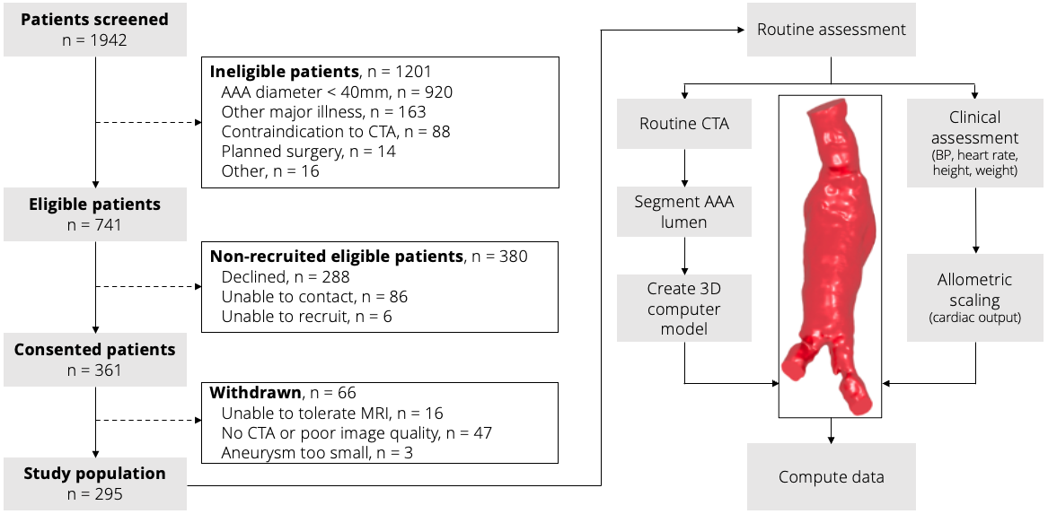
Figure S1: Flow diagram of participant recruitment (left) and computational workflow of the study (right). Patients (n = 295) in this study population underwent routine computed tomography angiography (CTA) from which the computational model of the AAA was created for flow simulations. Measured clinical metrics (blood pressure, heart rate, height and weight) were used to determine inputs for the computational model.

Blood Flow Simulations
Simulation methods were based on established methods⁴³⁻⁴⁵ and were fully automated following creation of CT-based 3D reconstructions. Computational meshes consisted of polyhedral elements throughout the lumen domain with layers of prism elements adjacent to the lumen wall. Patient mass (M, kg) and height (H, m) were used to calculate patient body surface areas (BSA, m²) as per Equation 1^{46, 47} which were in turn used to calculate the expected cardiac output as per Equation 2⁴⁸ for each patient. We used an established infrarenal AAA flow waveform obtained from literature⁴⁶ and computed the expected cardiac output of the cohort (BSA = 2.06 m²; cardiac output = 6.6736 L/min). The ratio of patient-specific cardiac outputs (computed for each case in this study) to the average cardiac output of the infrarenal AAA flow waveform cohort⁴⁶ (Equation 3) was used to adjust the amplitude of the flow waveform to improve the fidelity of patient-specific model input.
$BSA=\sqrt{\left(\frac{H×M}{36}\right)}$ Eqn. 1
$Cardiac Output \left(patient specific\right)=3.06×BSA+0.37$ Eqn. 2
$Scaling factor=\frac{Cardiac Output (patient specific)}{6.6736}$ Eqn. 3
Windkessel models were implemented to represent the distal arterial bed at truncated outlets and parameters were tuned using patient-specific systolic and diastolic blood pressure and verification was done to ensure the correct pressure waveforms were produced. Blood was modelled as a non-Newtonian fluid using a Carreau-Yasuda rheological model based on established parameters⁴⁹⁻⁵¹. Numerical accuracy of the simulations was tested using the grid convergence index (GCI)^{52, 53} to ensure results were independent of the mesh used; specifically, we verified convergence of time-averaged wall shear stress (TAWSS), time-averaged pressure (TAP), oscillatory shear index (OSI) and relative residence time (RRT). All GCI values were < 1 % indicating the asymptotic convergence of the solution as the computational mesh was refined. Data was averaged over the cardiac cycle and extracted from each case for the entire domain.
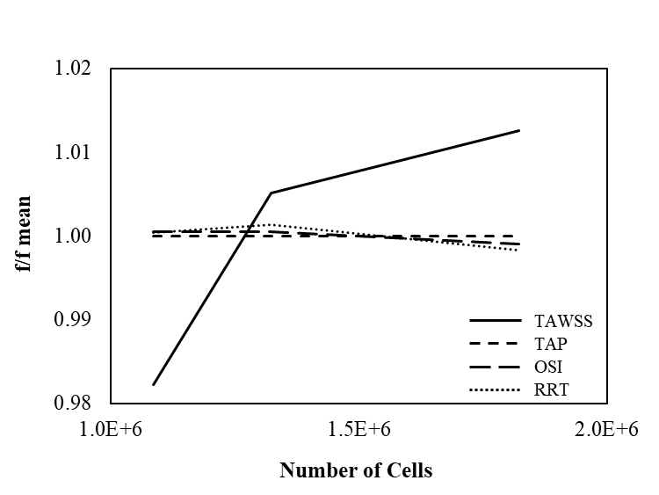

Figure S2: Convergence of hemodynamic parameters. GCI values were well below 1% for all parameters (TAWSS = 0.35%, TAP = 0.001%, OSI = 0.15%, RRT = 0.44%).

Repeatability of 3D Reconstructions
Table S2: Reconstruction repeatability study. Measurements 1-3 were completed by the primary analyst whilst 4-6 were completed by three separate analysts. Error (ɛ) is the difference from the mean of the three measurements made.
Measurement | Volume [mm³] | ɛ % | Surface Area [mm²] | ɛ %
1 | 126,259 | 0.18 | 22,581 | 2.60
2 | 126,593 | -0.09 | 23,836 | -2.82
3 | 126,591 | -0.09 | 23,131 | 0.22
Mean | 126,481 | 0.12 | 23,183 | 1.88
Std. dev. | 192 | 0.05 | 629 | 1.44
Primary | 126,481 | -1.16 | 23,183 | 3.03
4 | 125,216 | 0.15 | 22,139 | 7.40
5 | 119,951 | 4.06 | 23,439 | 1.96
6 | 128,473 | 2.75 | 26,866 | 12.38
Mean | 125,030 | 2.03 | 23,907 | 6.19
Std. dev. | 3642 | 1.73 | 2,051 | 4.75
Additionally, we calculated the intra-class correlation coefficient (ICC) to quantify reproducibility. The ICC for intra-observer measurements was 1 (95% confidence interval [0.9998, 1]) and 0.9983 (95% confidence interval [0.9976, 1]) for inter-observer measurements, both representing excellent reproducibility.
Missing Growth Rate Data
As with our previous study of this same cohort⁵⁴, growth rate was not available in 46 cases, either due to repair prior to follow up ultrasound (n = 37) or death (AAA rupture, n = 2; myocardial infarction, n = 1; cancer, n = 1; other cause, n = 1). A further three cases of large AAA in elderly men were not repaired as they were unfit for surgery or declined. One case with a small AAA (36 mm) was lost to follow up after initial ultrasound.

Shear Stress as a Continuous Variable
We developed a Random Forest regression model and hyperparameter tuned the model on 75% of the data as a training set using Bootstrap samples. The best fit was obtained with 1000 trees, a target node size of 35 and a mtry of 4. The resultant model had an accuracy of 70.7% and an ROC AUC of 0.80. The partial dependence profile for each variable suggested that patients with a TAWSS of 0.4 Pa or less were most likely to encounter a major adverse aortic event.
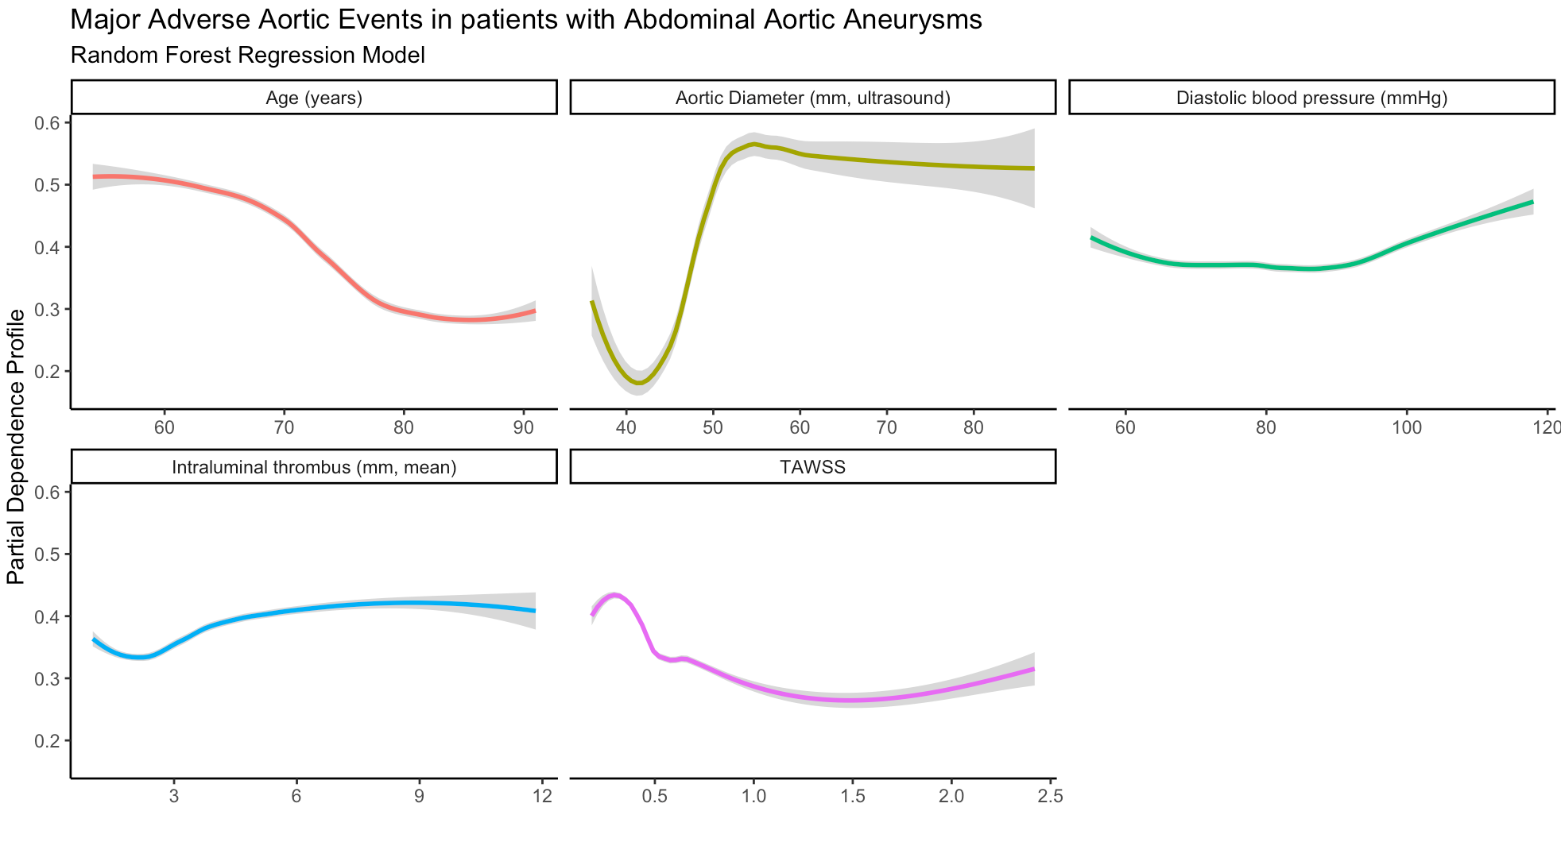
Figure S3: Random Forest regression model showing the dependence on shear stress below 0.4 Pa.

Inlet Flow Sensitivity Analysis
Aortic flow is likely to vary, particularly in AAA patients with hypertension, so we investigated the effect of varying flow rates. First, we examined the sensitivity of TAWSS to the inlet flow condition by simulating one case from each TAWSS tertile (low, medium, high) with 80%, 90%, 110% and 120% of the applied flow rate. A strong linear relationship was observed between the inlet flow rate and TAWSS, however no major changes to the surface distribution were observed.
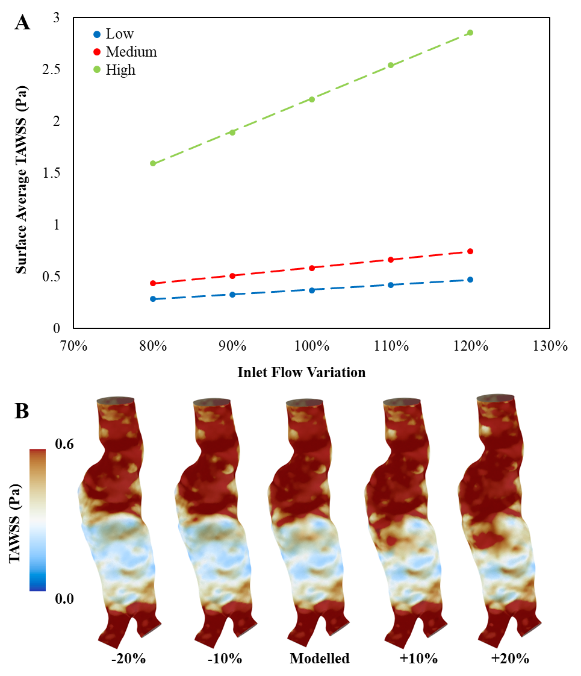
Figure S4: (A) Linear association between TAWSS and inlet flow rate for low, medium and high tertiles. (B) Surface plots of TAWSS scaled to the normal modeled scenario. No significant changes in TAWSS distributions were found with varying inlet conditions.
Next, we examined the sensitivity of TAWSS to heart rate in 12 randomly selected patients from the three tertiles (four per tertile). Briefly, we compared the effect of scaling the period of the inlet waveform to the average heart rate of the cohort to patient-specific heart rates. Differences were insignificant between the two approaches, with no association between TAWSS and heart rate ($r_{s}=-0.15, p=0.6003$). Cases remained in the same grouped tertiles (Table S3).

Table S3: Effect on TAWSS (Pa) of using patient-specific heart rates compared to the cohort averaged heart rate to scale the period of the inlet waveform. Differences were minimal and cases remained in the same tertile grouping.
Case | TAWSS |  |  |  | Tertiles
Case | Cohort HR | Patient specific HR | % difference |  | Cohort HR | Patient specific HR
1 | 0.3578 | 0.3592 | -0.40 |  | Low | Low
2 | 0.2986 | 0.3105 | -3.98 |  | Low | Low
3 | 0.3241 | 0.3276 | -1.10 |  | Low | Low
4 | 0.3446 | 0.3534 | -2.53 |  | Low | Low
5 | 0.4876 | 0.4782 | 1.92 |  | Medium | Medium
6 | 0.5149 | 0.4864 | 5.54 |  | Medium | Medium
7 | 0.5147 | 0.5151 | -0.08 |  | Medium | Medium
8 | 0.5050 | 0.5077 | -0.52 |  | Medium | Medium
9 | 0.6524 | 0.6494 | 0.47 |  | High | High
10 | 0.6792 | 0.6862 | -1.03 |  | High | High
11 | 0.7204 | 0.7177 | 0.39 |  | High | High
12 | 0.8173 | 0.8078 | 1.17 |  | High | High

REFERENCES
43. Parker LP, Powell JT, Kelsey LJ, Venermo M, Koncar I, Norman PE and Doyle BJ. Morphology and Computational Fluid Dynamics Support a Novel Classification of Common Iliac Aneurysms. Eur J Vasc Endovasc Surg. 2020;59:786-793.
44. Parker LP, Powell JT, Kelsey LJ, Lim B, Ashleigh R, Venermo M, Koncar I, Norman PE and Doyle BJ. Morphology and Hemodynamics in Isolated Common Iliac Artery Aneurysms Impacts Proximal Aortic Remodeling. Arterioscler Thromb Vasc Biol. 2019;39:1125-1136.
45. Kelsey LJ, Powell JT, Norman PE, Miller K and Doyle BJ. A comparison of hemodynamic metrics and intraluminal thrombus burden in a common iliac artery aneurysm. Int J Numer Method Biomed Eng. 2017;33.
46. Les AS, Shadden SC, Figueroa CA, Park JM, Tedesco MM, Herfkens RJ, Dalman RL and Taylor CA. Quantification of Hemodynamics in Abdominal Aortic Aneurysms During Rest and Exercise Using Magnetic Resonance Imaging and Computational Fluid Dynamics. Annals of Biomedical Engineering. 2010;38:1288-1313.
47. Mosteller RD. Simplified calculation of body-surface area. N Engl J Med. 1987;317:1098.
48. Jegier W, Sekelj P, Auld PA, Simpson R and McGregor M. The Relation between Cardiac Output and Body Size. Br Heart J. 1963;25:425-30.
49. Cho YI and Kensey KR. Effects of the non-Newtonian viscosity of blood on flows in a diseased arterial vessel. Part 1: Steady flows. Biorheology. 1991;28:241-62.
50. Kenner T. The measurement of blood density and its meaning. Basic Res Cardiol. 1989;84:111-24.
51. Robertson AM, Sequeira A and Owens RG. Rheological models for blood. Cardiovasular Mathematics: Modeling and Simulation of the Circualtory System. 2009;1:211-241.
52. Celik IB, Ghia U, Roache PJ and Freitas CJ. Procedure for estimation and reporting of uncertainty due to discretization in CFD applications. J Fluid Eng-T Asme. 2008;130.
53. Roache PJ. Perspective - a Method for Uniform Reporting of Grid Refinement Studies. J Fluid Eng-T Asme. 1994;116:405-413.
54. Doyle BJ, Bappoo N, Syed MBJ, Forsythe RO, Powell JT, Conlisk N, Hoskins PR, McBride OMB, Shah ASV, Norman PE and Newby DE. Biomechanical Assessment Predicts Aneurysm Related Events in Patients with Abdominal Aortic Aneurysm. Eur J Vasc Endovasc Surg. 2020;60:365-373.

