Body Composition of the Host and Human Dendritic Cells Phenotype in Patients Treated for Colorectal Cancer
George Malietzis MBBS MSc MRCS ^{1,2,}, Gui Han Lee MBBS MRCS ^{1,2}, Hafid O Al-Hassi PhD ¹, David Bernardo PhD ¹, Alexandra I F Blakemore PhD ³, Robin H Kennedy², Morgan Moorghen MD FRCPath ⁴, John T Jenkins MD FRCS ², Stella C Knight PhD ¹,

- Antigen Presentation Research Group, Imperial College London, North West London Hospitals Campus, Watford Road, Harrow HA1 3UJ, UK
- Department of Surgery St Marks Hospital, Watford Road, Harrow, Middlesex, HA1 3UJ, UK
- Section of Investigative Medicine, Division of Diabetes, Endocrinology, and Metabolism, Faculty of Medicine, Imperial College, London W12 0NN, UK
- Department of Histopathology St Marks Hospital, Watford Road, Harrow, Middlesex, HA1 3UJ, UK

Corresponding Author:
Professor Stella C Knight
Antigen Presentation Research Group, Imperial College London,
North West London Hospitals Campus,
Watford Road, Harrow, HA1 3UJ, United Kingdom
Email: s.knight@imperial.ac.uk
Telephone: +44 20 8869 3494
Fax: +44 20 8869 3532

Abstract
Dendritic cells (DCs) are antigen-presenting cells, can acquire tumour antigens and initiate cytotoxic T-cells reactions against tumour. Obesity has been proposed as a cause for tumours escaping immune surveillance but very few studies investigates the impact of other Body Composition parameters. Our aim was to examine the relationship of Computer Tomography defined parameters on DC phenotype in patients with CRC. Peripheral blood mononuclear cells were obtained from CRC patients before surgical bowel resection. DC identified as HLA-DR positive and lineage negative cells. DCs were further classified as CD11c+ myeloid (mDC) or CD11c− putative plasmacytoid. CD40, CD86, CD83, CD36 and CCR7 expression was determined on DC by flow-cytometry. Image analysis of CT scans was used to calculate Lumbar skeletal muscle index (LSMI), and mean muscle attenuation (MA) 21 patients (13 males) were recruited for this study with median age of 70. A significant positive correlation between the LSMI and the expression of CD40 in all DCS (r = 0.45; p = 0.04) The MA was also significantly correlated with levels of CCR7 expression in all DCs (r=-0.46, P=0.03). For the CD 83 the association was a negative one [all DCs (r=-0.63; p=0.01) and mDCs (r=-0.75; p<0.01)] whereas for the CD 36 was a positive correlation [all DCS (r=0.60; p=0.01) and mDCs (r=0.63; p<0.01)]. There were no relationships between the fat indexes and the DC phenotype markers used. These results highlight a direct relationship between muscle depletion and the presence of altered DCs phenotypes in patients with operable CRC. Understanding what factors contribute to these may lead to novel and more effective interventions that support optimal body composition and metabolism, improving clinical and metabolic outcomes in cancer patients.
Introduction

Dendritic Cells (DCs) are the most potent antigen presenting cells, capable of sampling antigens and initiating cytotoxic T-lymphocyte response against cancer cells. Colorectal tumor antigens induce DC recruitment, maturation, and cytokine release in order to generate effective T cell immune response ¹. Despite their crucial role in generating an immune response, DCs are a heterogeneous and rare type of immune cell. In cancer tumour derived factors appear to exploit this by producing a variety of immunosuppressive factors capable of affecting DC. Herber et al. gave an explanation on how the host immune system can be compromised during cancer; an increase in lipid content of dendritic cells (DCs) diminishes their capacity to present antigens from tumour cells and to activate effector T cells ². O’Shea et al studying the susceptibility to viral infection observed in severe obesity also showed that obesity negatively impacts the ability of systemic DC’s to mature and elicit appropriate T-Cell responses to a general stimulus ³.
The interactions between tumor cells and DCs are complicated and have yet to be fully comprehended. Certain cancer disease characteristics such as stage may have an impact on the function and the DCs phenotype but again the evidence is limited. Associations between the TNM stage, the grade, the location, the presence of lymph vascular invasion and more importantly features of the tumour host – the patient such as the Body Composition (BC) and the DCs profiles have rarely been explored.
BC describes the percentages of fat, bone and muscle in human bodies. BC changes have been documented in patients with malignant disease; however, associated metabolic and immune changes developing during disease and its legacy are less clear, particularly in CRC ⁴.
Understanding the links between DCs, colorectal cancer tumours and BC profiles will lead to better understating of the immune surveillance and escape mechanisms and ultimately will provide novel therapeutic targets. Here, using circulating blood DCs and flow Cytometry analysis we aimed to identify the relationship of BC anthropometric parameters and tumour characteristics on DC phenotype in patients with CRC.

Materials and methods
Study population
Consecutive patients undergoing colorectal cancer surgery patients at St Mark’s Hospital, London between December 2012 and December 2013 were identified from a prospective database and considered for inclusion. Patients with recurrent or metastatic disease confirmed preoperatively or at surgery, emergency cases, those receiving neo-adjuvant treatment, patients with diabetes, history of smoking and blood transfusion, patients not willing to enroll to this study and patients with ASA status > 3 were excluded.

Body Composition Analysis
CT scan images were retrieved from digital storage in the Picture Archiving and Communication System [PACS]. CT image analysis Slice-O-Matic V4.3 software (Tomovision, Montreal, Canada) was performed as described previously. ⁵ Briefly, total skeletal muscle, subcutaneous and visceral fat surface areas (cm²) were evaluated on a single image at the third lumbar vertebrae (L3) using Hounsfield unit (HU) thresholds. The sum of skeletal cross-sectional tissue areas was normalised for stature (m²) and reported as lumbar skeletal muscle index- LSMI (cm²m⁻²) and Total Adipose Tissue Index (cm2 m⁻²). Reduced L3 skeletal muscle index (myopenia) and low MA (myosteatosis) were defined using predefined sex-specific skeletal muscle index cut-points. Increased visceral adipose tissue area (visceral obesity) was also described by using gender-specific and pathologically relevant cut-off values ⁶⁻⁸. Myopenic obesity was defined as the combination of myopenia with a BMI of > 30 Kg/m².

Blood Samples and processing
20 ml of venous blood was obtained from the selected CRC patients and collected into heparinized Vacutainers (Becton Dickinson, Oxford, UK). Peripheral blood mononuclear cells (PBMC) were obtained by centrifugation of human peripheral and the cells were assessed for viability by their ability to exclude trypan blue (Sigma, Poole).

Antibody labeling
PBMCs were labeled with monoclonal antibody (mAb) at predetermined optimal concentrations. Antibodies to HLA-DR (G46-6), CD40, CD36, CD86, CD80 (L307.4), CD83 (HB15e), CD34 (581), CCR7 (2H4) and matching isotype control were purchased from BD Pharmingen, Oxford, UK. Antibodies to CD3 (UCHT-1), CD14 (MIP9), CD16 (B73.1), CD19 (4G7), and CD56 (N901) came from Beckman Coulter, High Wycombe, UK. Antibodies to CD14 (TÜK-4) and CD19 (SJ25-C1) were obtained from ABD Serotec, Kidlington, UK. Anti-CD11c (clone KB90) was purchased from Dako - Alere, Stockport, UK. Appropriate isotype-matched control for the rest of tested antibodies was purchased from the same companies.

Flow Cytometry and data analysis
Labeled samples were acquired on FACS Canto-II flow cytometer (Becton-Dickinson, UK) using FACS diva software for partial compensation and creation of list mode data files. List mode data files were then analyzed using offline WinListTM software (Verity, Topsham, ME).

Winlist analysis
Compensation was completed online using compensation toolbox on the WinlistTM software program. DCs were identified as HLA-DR+ Lineage − cells where linage was a mixture of monoclonal antibodies to CD3, CD14, CD16, CD19 CD34, and CD56. The mDC was identified as a CD11c+ subset; plasmacytoid DC were CD11c−. The proportion of cells expressing any given surface marker of interest was determined by comparing fluorescence to that of an isotype - matched control antibody. Enhanced normalised subtraction was used and the results was reported as percentage positive (% positive) values.

Results

Study population
After applying the selection criteria 21 patients undergoing surgery for CRC were enroll and consented to the study.

Body Composition Parameters
The mean LSMI was 38.65 cm²/m² with standard deviation (SD) of 9.10 cm²/m² and the mean HU value for the skeletal muscle demarcated was 30.74 HU with a SD of 9.64 HU. Out of the 21 patients CRC patients included in the study 8 (38.1%) were obese as defined by BMI > 30 kg/m², 14 (66.7%) had visceral obesity, 14 (66.7%) were myopenic and 4 (19%) were myopenic obese patients. 13 (61.9%) patients were found to be have myosteatosis after their CT images were analyzed.
Table 1 describes the demographics the clinicopathological characteristics and the BC parameters of the CRC group

Body composition and Dendritic Cells phenotype profiles
There was no significant correlation between the CD 40, CD 80, CD 83, CD 86, CCR 7 and CD 36 expression on DCs and the L3 VFA, SFA and total fat tissue index. However there was a statistically significant positive correlation of the expression of CD 40 in all DCS and LSMI (r=+0.45, P = 0.04). The mean HU were also significantly correlated with levels of CCR 7 expression in all DCs (r=-0.46, P=0.03).
A significant correlation between the mean HU values and both the expression of CD 83 and CD 36 was found. For the CD 83 the association was a negative one [all DCs (r=-0.63; p=0.01) and mDCs (r=-0.75; p<0.01)] whereas for the CD 36 was a positive correlation [all DCS (r=0.60; p=0.01) and mDCs (r=0.63; p<0.01)].

Discussion
This study is amongst the first to report correlations between DCs phenotype and CT defined BC parameters. Muscle depleted patients treated surgically for CRC appear to have a more “immature” DC phenotype as seen by the positive correlation between CD40 expression and LSMI. Also this study demonstrated that high levels of CCR7 and CD83 expression on all DCs were correlated with low levels of MA and hence myosteatosis. However the correlation between CD36 expression and MA was of a positive change. Thus, DCs might be directly sensitive to BCs profiles such as myopenia and myosteatosis, providing a partial explanation of the immunodeficiency associated with CRC. If we relate the findings of this study with the fact that muscle depleted CRC patients have worse survival outcomes then we can speculate that DCs efficient activation is of paramount importance ⁹.
Obesity is known to alter the immune system and its impact on the cells of the adaptive immune system has also been explored but the DCs are probably the least explored subset ¹⁰. Macia et al reported that DCs from obese mice showed are less potent in stimulation of allogenic T cells in vitro and that this impaired functionality was linked with the secretion of immunosuppressive cytokines such as TGF-beta. The obese mice were also found to have minimum levels of functional leptin, a key adipokine linking nutrition, metabolism, and immune functions ¹¹. In another study diet induced obese mice showed distorted and inefficient T-cell responses to influenza infection, attributed to upregulation of immunosuppressive cytokines from lung DCs ¹².
To convey muscle depletion, obesity, and declining immunity in cancer, we can assumed that these conditions are linked processes, which are controlled by adipose tissue derived and skeletal muscle-derived cytokines, known as adipokines and myokines, respectively. Evidence suggests that as adipose tissue increase the amount of the anti-inflammatory cytokine decreases whereas there is an increase in the level of the pro-inflammatory molecules such as leptin, TNF-a, IL-1 and IL-6 ¹³. These pro-inflammatory cytokines produced by especially visceral fat, negatively regulate muscle and muscle negatively regulates adipose tissue via IL-15 and other myokines ¹⁴. Skeletal muscle tissue produces very high levels of IL-15 and levels of IL-15 are reported to increase rapidly immediately following resistance and aerobic exercise ^{15, 16}. IL-15 is required for DC development, survival and enhancement of their tumoricidal activity, whereas inflammatory cytokines such as TNF-a and IL-6 shorten DC cell survival ¹⁷. In cancer, muscle mass and quality diminishes and this may influence also the production of the IL-15 and other myokines and therefore these changes might impact negatively the ability of DCs to “fight” the cancer insult.
The findings of the above study suggest that in CRC patients there are phenotypic differences of peripheral blood DCs compartment possibly related to the host’s BC profile. Further studies are necessary to better clarify the contribution of BC to DC impairment and to explore and optimize treatment modalities such as DCs targeted immunotherapy.

Table 1 Demographics, clinicopathological characteristics and the Body Composition parameters of the Colorectal Cancer group
Demographics |  | Colorectal Cancer  N=21
 |  | Mean (SD) | N
Age (years) |  | 70 (9.22)
BMI (Kg/m²) |  | 28.70 (5.02)
Skeletal Muscle Area (cm²) |  | 117.30 (32.42)
Mean Hounsfield Units |  | 30.74 (9.64)
Visceral Fat Area (cm²) |  | 197.93 (138.23)
Subcutaneous Fat Area (cm²) |  | 233.73 (115.53
Total Fat Tissue Area (cm²) |  | 439.19 (190.20)
L3 Skeletal Muscle Index (cm²/m²) |  | 38.65 (9.10)
Total Adipose Tissue Index (cm²/m²) |  | 155.77 (58.84)
Gender | Male |  | 13
Gender | Female |  | 8
ASA status | ASA 2 |  | 15
ASA status | ASA 3 |  | 6
Tumour Location | Rectum |  | 11
Tumour Location | Colon |  | 10
Tumour stage | T1 |  | 2
Tumour stage | T2 |  | 4
Tumour stage | T3 |  | 11
Tumour stage | T4 |  | 4
Node stage | N negative |  | 11
Node stage | N positive |  | 10
UICC stage | Stage I |  | 6
UICC stage | Stage II |  | 5
UICC stage | Stage III |  | 10
UICC stage | Stage IV |  | 0
Lymph vascular Invasion | Absent |  | 15
Lymph vascular Invasion | Present |  | 6
Grade of differentiation | Moderate |  | 19
Grade of differentiation | Poorly |  | 2

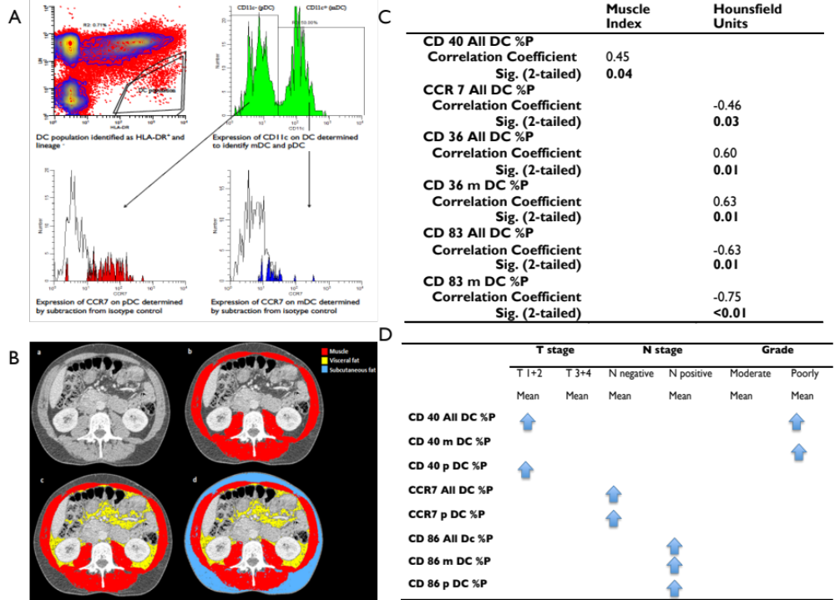
Figure 1

Reference

1. Legitimo A, Consolini R, Failli A, et al. Dendritic cell defects in the colorectal cancer. Hum Vaccin Immunother 2014; 10(11):3224-35.
2. Herber DL, Cao W, Nefedova Y, et al. Lipid accumulation and dendritic cell dysfunction in cancer. Nat Med 2010; 16(8):880-6.
3. O'Shea D, Corrigan M, Dunne MR, et al. Changes in human dendritic cell number and function in severe obesity may contribute to increased susceptibility to viral infection. Int J Obes (Lond) 2013; 37(11):1510-3.
4. Thibault R, Pichard C. The evaluation of body composition: a useful tool for clinical practice. Ann Nutr Metab 2012; 60(1):6-16.
5. Mourtzakis M, Prado CM, Lieffers JR, et al. A practical and precise approach to quantification of body composition in cancer patients using computed tomography images acquired during routine care. Appl Physiol Nutr Metab 2008; 33(5):997-1006.
6. Doyle SL, Bennett AM, Donohoe CL, et al. Establishing computed tomography-defined visceral fat area thresholds for use in obesity-related cancer research. Nutr Res 2013; 33(3):171-9.
7. Prado CM, Lieffers JR, McCargar LJ, et al. Prevalence and clinical implications of sarcopenic obesity in patients with solid tumours of the respiratory and gastrointestinal tracts: a population-based study. Lancet Oncol 2008; 9(7):629-35.
8. Martin L, Birdsell L, Macdonald N, et al. Cancer cachexia in the age of obesity: skeletal muscle depletion is a powerful prognostic factor, independent of body mass index. J Clin Oncol 2013; 31(12):1539-47.
9. Malietzis G, Aziz O, Bagnall NM, et al. The role of body composition evaluation by computerized tomography in determining colorectal cancer treatment outcomes: a systematic review. Eur J Surg Oncol 2015; 41(2):186-96.
10. Mraz M, Haluzik M. The role of adipose tissue immune cells in obesity and low-grade inflammation. J Endocrinol 2014; 222(3):R113-27.
11. Macia L, Delacre M, Abboud G, et al. Impairment of dendritic cell functionality and steady-state number in obese mice. J Immunol 2006; 177(9):5997-6006.
12. Smith AG, Sheridan PA, Tseng RJ, et al. Selective impairment in dendritic cell function and altered antigen-specific CD8+ T-cell responses in diet-induced obese mice infected with influenza virus. Immunology 2009; 126(2):268-79.
13. Stefanyk LE, Dyck DJ. The interaction between adipokines, diet and exercise on muscle insulin sensitivity. Curr Opin Clin Nutr Metab Care 2010; 13(3):255-9.
14. Lutz CT, Quinn LS. Sarcopenia, obesity, and natural killer cell immune senescence in aging: altered cytokine levels as a common mechanism. Aging (Albany NY) 2012; 4(8):535-46.
15. Quinn LS. Interleukin-15: a muscle-derived cytokine regulating fat-to-lean body composition. J Anim Sci 2008; 86(14 Suppl):E75-83.
16. Riechman SE, Balasekaran G, Roth SM, et al. Association of interleukin-15 protein and interleukin-15 receptor genetic variation with resistance exercise training responses. J Appl Physiol (1985) 2004; 97(6):2214-9.
17. Anguille S, Lion E, Van den Bergh J, et al. Interleukin-15 dendritic cells as vaccine candidates for cancer immunotherapy. Hum Vaccin Immunother 2013; 9(9):1956-61.

