Understanding the stability of dopamine and dobutamine over 24 hours in simulated neonatal ward conditions.
Katherine Kirupakaran¹, Liam Mahoney^{1,2}, Heike Rabe^{1,2} and Bhavik A Patel³
¹Brighton and Sussex Medical School, Brighton, UK
²Department of Neonatology, Brighton and Sussex University Hospital NHS Trust, Brighton, UK
³School of Pharmacy and Biomolecular Sciences, University of Brighton, Brighton, UK

ABSTRACT
Objectives. Our objectives were to investigate the possible effects temperature and light have on the stability of dopamine and dobutamine continuous infusions over 24 hours when prepared in varying dilution vehicles.
Methods Syringe-driver infusion apparatuses were set up of either dopamine or dobutamine, diluted with either 0.9% sodium chloride or 5% glucose, delivering 3mcg/kg/min and 5mcg/kg/min respectively via 206 cm extension sets. All infusions were prepared for a neonate weight of 1 kg. Infusions were run over 24 hours, where approximately half the tubing was within an incubator set at 35ᵒC. Cyclic voltammetry was utilised to monitor the initial concentration of the inotrope and that after 24 hours within the syringe and end of the extension set.
Results. The variation in the concentration of dopamine and dobutamine in the vials was 3.58 % and 1.22 % respectively (n=6). This variation in the concentration increased to 10.88 % for dopamine and 5.76 % for dobutamine in preparation of the syringe. A significant reduction in the concentration of dopamine was observed at the end of the extension set after 24 hours when prepared in 0.9 % NaCl when compared to dopamine prepared in 5 % glucose (p<0.001, n=6-7) or dobutamine prepared in 0.9 % NaCl (p<0.001, n=6-7). No differences in the concentration of dopamine in 0.9 % NaCl were observed after 24 hours in light-exposed and light-protected extension sets (n=6-7).

Conclusions. Dobutamine is more stable in dilution vehicles when compared to dopamine and inotropes are more stable in 5 % glucose dilution vehicle when compared to 0.9 % NaCl. Such findings will provide guidance on the choice of inotropes.

Key points
- Inotropes such as dopamine and dobutamine are commonly utilised to treat neonatal hypotension and are administered as a continuous infusion over 24 hours
- Under experimental conditions that mimicked the local neonatal unit environment, dopamine prepared in 0.9 % sodium chloride was significantly less stable than that prepared in 5 % glucose over 24 hours. Dopamine was also significantly less stable than dobutamine over 24-hours when prepared in 0.9 % sodium chloride.
- Clinical staff might want to consider the results of our study, as our findings indicate that the stability of inotropes vary specifically in the dilution vehicle, of which 5% glucose is the preferred dilution vehicle.

INTRODUCTION
Previous literature has quoted that hypotension develops between 20-50 % of all neonates admitted to the neonatal intensive care units (NICU) and is caused by conditions including patent ductus arteriosus or sepsis [1, 2]. Hypotension leads to inadequate organ perfusion and is thought to cause detrimental effects such as poor long-term neurodevelopment and associated increases in mortality [1-3]. Preterm neonates suffering from hypotension are particularly vulnerable to brain injury given the delicate sensitivity of developing cranial tissue to perfusion inadequacies [4]. Therefore, it is crucial that these patients are treated effectively to minimise the debilitating consequences.
Inotropes, drugs that raise mean arterial pressures (MAP) by either improving myocardial contractility or increasing systemic vascular resistance, are commonly used to treat neonatal hypotension [2-6]. The most commonly used inotropes to treat neonatal hypotension are dopamine and dobutamine [2, 3, 7], which are administered intravenously (IV) as a continuous infusion by syringe drivers, and are changed every 24 hours. Within our local tertiary neonatal unit, it has been noted anecdotally that during changes between infusions, rapid swings in MAP were observed. This could potentially lead to a reduction in blood flow to the germinal matrix in the lateral ventricles of the brain which can cause ischaemia. Consequently re-perfusion of this region, as a result of a sudden rise in MAP can result in rupturing of these ischaemic blood vessels causing intraventricular haemorrhage, which is associated with poor neurodevelopment [8-10].
Various explanation can be attributed to the rapid changes in MAP observed between infusions. These could be due variations in the preparation of inotropes as a dilution is required, dead space in infusion lines or the influence of multiple drugs entering through the same line causing a reduction in observed inotrope delivery. However, such changes are observed in patients with single or multiple inotropes on a regular basis, suggestive the underlying cause may be associated with the availability of the inotrope for therapeutic effect during the infusion rather than mode of delivery. One potential explanation of this observation is due to the stability of the drug. There are a limited number of studies conducted on the stability of dopamine and dobutamine which have found that light and temperature appear to be dominating factors for influencing stability [11-16]. However, most these studies have not been conducted on clinical doses and in environments that match ward settings.
The aim of this study was to investigate how environmental conditions (light and temperature) and vehicle (0.9% sodium chloride and 5% glucose) influence the stability of dopamine and dobutamine in a clinical laboratory model that is designed to mimic neonatal ward conditions.

METHODS
Preparation of the inotrope infusion solutions
Vials of 40 mg/ml dopamine hydrochloride (Mercury Pharmaceuticals, Dublin, Ireland) or 12.5 mg/ml dobutamine hydrochloride (Wockhardt, Wrexham, UK) were prepared in either 0.9% sodium chloride (NaCl) or 5% glucose to a concentration of 0.6 mg/mL. Dilutions of the vials were carried out using 1ml syringes as conducted on NICU. Within the NICU the weight of neonates varies, however we assumed a baby with a body weight of 1kg for the preparation of inotrope infusions. Infusion solutions were delivered at 3mcg/kg/min for dopamine and 5mcg/kg/min for dobutamine, as recommended by the British National Formulary for Children (BNFC) as a starting dose prescribed for a 1kg neonate [17].

Evaluating the stability of an inotrope infusion in a laboratory clinical model
A small aliquot of the infusion solution was obtained to calculate the initial concentration of either dopamine or dobutamine. To simulate ward conditions, 50 ml syringes (Terumo, Lagana, Philippines) containing either 0.6 mg/mL dopamine or dobutamine were driven by a NIKI T34 syringe pump (Caesarea Medical Electronics, Lichtenstein, Germany), and set to run continuously for 24 hours at the flow rate determined by the BNFC. The syringe (placed in room temperature, 21 °C) was connected to a 206cm extension set (Alaris, Carefusion UK Ltd, Basingstoke, UK) which terminated to a 10cm bifurcated minibore extension set (Codan, Santa Ana, CA, USA) and a 21G needle. The needle pierced through parafilm which acted as a lid for the 15mL conical centrifuge tube (Thermo Fisher Scientific, Walthan, MA, UK) that was used to collect the infusion solution over the 24-hour period. Approximately half of the tubing and collecting tube were placed in a compact incubator (Thermo Fisher Scientific, Walthan, MA, UK) set at 35ᵒC (Figure 1). This is the maximum neonatal incubator temperature according to the Temperature Protocol routinely used in the local neonatal unit. Following 24 hours, a second aliquot was obtained from the remaining solution within the syringe (Figure 1B, location A) and from the 15mL conical centrifuge tube (Figure 1C, location B).
Aliquot samples were analysed for their concentration using cyclic voltammetry. To eliminate any temperature variation affecting cyclic voltammetry responses, a one in ten dilution was utilised for the analysis of each sample. The Electrochemical Analyser (CH Instruments) employed a 3-electrode system, where a 3 mm glassy carbon electrode served as the working electrode, a Ag|AgCl electrode served as the reference electrode and a platinum wire was utilised as a counter electrode. A scan rate of 50 mV/s was utilised for each of the cyclic voltammetry studies.

Data analysis
From each cyclic voltammogram, the oxidation peak current was recorded from the initial sample (measured 30 minutes following preparation) and those collected at location A and B after 24 hours. The current was converted to concentration of dopamine and dobutamine using calibration responses obtained using standards at concentrations reflective of those observed clinically. This data was statistically analysed using one-way paired ANOVA with post hoc Tukey tests.
To compare between the inotropes and vehicle solutions they were prepared in, data was shown as the percent loss in the concentration of dopamine or dobutamine at location A and B after 24 hours, when compared to the initial response. This data was statistically analysed using two-way paired ANOVA with post hoc Sidak test.
Data from each trial was presented as a data point in a before-after plot to observe the trend between the varying measures. Based on British Pharmacopeia guidelines for medicines production [18], any product > ±7.5% would be classed as unsuitable and therefore this was highlighted on the graphs presented.

RESULTS
Vial variations and errors in dilution
There was a 3.58 % variation in the concentration present in dopamine vials, however this was significantly lower for the dobutamine vials (1.22%, n=6 vials). Following dilution of the dopamine using a 1ml syringe to prepare a 0.6 mg/ml solution, the variance in the concentration of dopamine and dobutamine increased to 10.88 % and 5.76 % respectively (n=6 syringe preparations).

Alterations in the concentration of dopamine infusions over 24 hours
No visual changes were observed in the syringes post-infusion. The oxidation peaks of dopamine (0.4 V in 0.9 % NaCl and 0.6 V in 5 % glucose) in both vehicles from location A and B post-infusion were consistently lower than the initial response (Figure 2A and 2B). When dopamine was prepared in 0.9 % NaCl, a significant decrease in the concentration was observed at location A (p<0.05, Tukey test) and B (p<0.01, Tukey test) when compared to the initial response (n=7, Figure 2C). There was also a significant decrease in the concentration between location A and B when dopamine was prepared in 0.9 % NaCl (p<0.01, Tukey test, Figure 2C). A similar, but less dramatic trend was seen in the glucose vehicle, where the concentration of dopamine significantly decreased at location B when compared to the initial response (p<0.05, n=6, Figure 2D). All trials in both NaCl and glucose showed similar patterns, with the concentration declining from initial to location A and then B.

Alterations in the concentration of dobutamine infusions over 24 hours
No visual changes were observed in the syringes post-infusion. The oxidation peaks of dobutamine (0.4 V in 0.9 % NaCl and 0.6 V in 5 % glucose) in both vehicles were like those observed for dopamine. The amplitude of the peaks from location A and B post-infusion were consistently lower than the initial response (Figure 3A and 3B). When dobutamine was prepared in 0.9 % NaCl, a significant decrease in the concentration was observed at location A (p<0.01, Tukey test) and B (p<0.01, Tukey test) when compared to the initial response (n=7, Figure 3C). A similar effect was observed when prepared in 5 % glucose, where the concentration of dobutamine significantly decreased at location B when compared to the initial response (p<0.01, Tukey test, n=6, Figure 3D). There was also a significant reduction in dobutamine concentration between location A and B (p<0.01, n=6). In both NaCl and glucose, similar patterns where observed, with the concentration declining over 24 hours at both locations.

Influence of the dilution vehicle on the stability of dopamine and dobutamine
The percentage change in concentration from initial response for each trial illustrates the magnitude of decay at location A and B (Figure 4). In trials of both dopamine and dobutamine infusions, the majority showed a reduction in the response from location A to B, suggestive that temperature as well as light may have a role in the stability of the two inotropes.
For dopamine infusions prepared in 0.9 % sodium chloride, there was a significant reduction in the response from location A to B (p<0.001, Sidak test, n=7, Figure 4A & C). When comparing the preparation of dopamine in 0.9 % NaCl and 5 % glucose, no differences in the concentration lost after 24 hours was observed at location A (n=6-7), however a significantly greater concentration loss was observed in location B when dopamine syringes were prepared in 0.9 % NaCl when compared to 5 % glucose (p<0.001, Sidak test, n=6-7, Figure 4A).
For dobutamine infusions prepared in 5 % glucose, there was a significant reduction in the concentration from location A to B (p<0.01, n=6, Figure 4B & D). No significant differences were observed in the degree of dobutamine concentration lost at location A and B in either 0.9 % NaCl or 5 % glucose syringes after 24 hours (Figure 4B).
The majority of trials for dopamine in 5 % glucose, dobutamine in 0.9 % NaCl and dobutamine 5 % glucose were within pharmaceutical acceptable tolerance (indicated by the grey dashed lines in Figure 4) in both location A and B. The majority of trails for dopamine in 0.9 % NaCl in both location A and B were outside pharmaceutical acceptable tolerance guidelines.

Differences in the stability of the inotropes in varying dilution vehicles
In syringes prepared in 0.9 % NaCl, there was no significant difference in the concentration loss observed in dopamine and dobutamine at location A over 24 hours (n=6-7, Figure 4C). A significant decrease in dopamine prepared in 0.9 % NaCl was observed when compared to dobutamine prepared in 0.9 % NaCl at location B after 24 hours (p<0.01, Sidak test, n=6-7, Figure 4C).
In 5 % glucose preparations, no significant differences in the concentration were observed when comparing dopamine to dobutamine in either location A and B over 24 hours (n=6-7, Figure 4D)

Influence of light on stability of dopamine syringes prepared in 0.9 % NaCl
Our finding clearly indicates that dopamine infusions prepared in 0.9 % NaCl is the least stable over 24 hours. Therefore, we wanted to understand if this was mainly due to heat or light. To study this, we prepared syringes in light (clear tubing) and light-protected (orange tubing) extension sets and syringes. Figure 5 shows that there was a significant reduction in the concentration of dopamine prepared in 0.9 % NaCl in the orange tubing from location A to B over 24 hours (p<0.05, Sidak Test, n=6, Figure 5). Overall there is no significant difference in the degree of concentration loss observed at location A and B over 24 hours in the clear and orange tubing (n=6-7, Figure 5).

DISCUSSION
Variability in the vials and during infusion preparation
We observed greater variability in the concentration of dopamine present in-between vials when compared to dobutamine. This increased variation was significantly enhanced following preparation of the syringe for infusion in both inotropes. In the case of the dopamine infusion the resultant variation in the concentration is already significantly greater than the acceptable pharmaceutical tolerance limits.
The variation in the dopamine vials is most likely due to the smaller dose/volume utilised in the vial preparation when compared to dobutamine, which introduces more error in preparing infusions and diluting. Measuring inotrope concentration at every step from vial to infusion, highlights the degree of error that is introduced in each step prior to delivery of the drug. This ultimately leads to inconsistency in the resulting clinical dose delivered to a neonate. It is widely acknowledged that preparation of medication in clinical practice is liable to a degree of error which can result in ill-prepared doses. Therefore, much work has gone into developing strategies to standardising clinical preparation of medications[19, 20]. However, such preparation errors need to be taken into consideration when titrating doses in between infusion changes.

Differences in the stability of inotropes following 24-hour infusion
The results illustrated in Figures 2 and 3 are suggestive that both dopamine and dobutamine concentrations decrease over 24 hours at both the syringe (location A) and the end of the infusion line (location B). These decreases are also irrespective of the dilution vehicle they are prepared in. Concentration losses in both inotropes is not surprising as catecholamine’s are well known to undergo oxidation and show limited stability [21]. Such decreases in stability should be negligent to the addition of antioxidant preservatives, however our findings indicate that this is still not sufficient to present loss in the concentration of dopamine and dobutamine.
Looking solely at the concentration observed at 24 hours at location A and B relative to the initial prepared syringe provides limited information on the true impact of might have clinically, as in most instances the loss is less than 0.1 mg/ml over 24 hours due to the robust nature of the measurement. To gain insight into if such changes vary, the percentage change in the concentration from initial was obtained so that the differences in the dilution vehicle and type of inotrope could be obtained.
Figure 4 shows that dopamine is significantly more stable when prepared in 5 % glucose when compared to 0.9 % NaCl and that dobutamine is more stable that dopamine when both are prepared in 0.9 % NaCl. Overall this indicates that dobutamine is more stable than dopamine in our ward-stimulated conditions and inotropes are more stable in 5 % glucose than 0.9 % NaCl. Dobutamine’s enhanced stability under all investigated conditions may be due to its larger molecular weight and chemical structure, which can resist oxidation when compared to dopamine. More interesting within out study was the finding that inotropes are more stable in glucose than NaCl. This has not been shown before, however this may be due to the fact at previous studies have predominately all utilised glucose as the vehicle for the preparation of the inotropes, or have only focused on one type of vehicle when investigating stability [15, 16]. It is unknown on why preparation in glucose provides more stability to the inotrope infusion, however it may be associated with the higher solution viscosities and and/or varying pH and therefore restricting diffusion of the inotropes and preservatives during infusion.
Within our clinical model, the ability to record concentrations of the inotropes at location A and B provides insight into the factors that result in a loss in the stability of the drugs. At location A, which represents the syringe, the temperature is not altered and therefore light plays the significant contribution to the loss in stability. However, at location B, where half of the extension set is placed within the incubator both light and temperature are responsible for the changes in inotrope concentrations. In all trails conducted, a decrease in the concentration was observed at location B when compared to A. In all trials, there is a loss in the concentration of the inotrope at location A after 24 hours. At location B, the loss in the concentration after 24 hours was approximately between 5-10 % from initial in all conditions (2.7 – 2.85 mcg/kg/min for dopamine and 4.5 - 4.75 mcg/kg/min for dobutamine) bar that of dopamine in 0.9 % NaCl, where losses were between 10-35% (1.95 – 2.7 mcg/kg/min).
Our data indicate that light does influence the stability of the inotropes, but elevated temperature has a more enhanced effect on reducing the stability of the inotropes. Exposure to light is thought to be one of the dominating stability factors [14, 15, 22], however in our study differentiation in the stability of inotropes in varying dilution vehicles was not seen at location A after 24 hours. More importantly we did not observe any significant differences in the concentration of dopamine in 0.9 % NaCl at location A and B after 24 hours in clear and orange tubing (utilised to present light). Previous studies have also shown that in differing types of light, dopamine is stable in those all those conditions [23].
This would indicate that temperature plays a pivotal role in altering the stability of the inotropes over a 24-hour infusion. Due to this it would be interesting to note whether neonates undergoing hypothermia therapy for hypoxic ischaemic encephalopathy would experience similar reductions or fluctuations in MAP towards the end of a 24-hour inotrope infusion as the evaluated temperature of the incubator would be negated. Other factors that could explain the potential loss in the concentration of dopamine and dobutamine may be due to oxygen levels causing oxidation of inotropes or due to the adsorption/leaching of the drug onto the syringe and extension set tubing.
Despite great efforts being made to simulate neonatal ward conditions as accurately as possible in a laboratory setting, there are a few experimental design limitations which can affect the interpretation of the data. These include the nature of the incubator utilised, which does not allow for maximal light, as utilised on the neonatal ward, therefore underestimating the degree of degradation. Secondly, the collection tube remained in the incubator for the duration of the 24 hours, therefore overestimating the degree of degradation. Overall these two limitations may compensate for one another; the observed tends in our data are more likely to reflect the stability of the inotropes, even if the precise levels observed may not be accurate.
Another important consideration is that our study is a very simple clinical model that doesn’t fully mimic drug delivery of inotropes, as often they are co-administered with other compounds, formulations, or parenteral nutrition. The latter, which is more commonly utilised is of significance as these formulations often contain NaCl, which could potentially alter the stability of dopamine no matter which dilution vehicle the drug was prepared in. Another important factor to consider is that the data presented highlights that impact of changes in the accuracy of concentration due to environmental factors and medicine preparation. Such factors in combination can have significant reductions in the delivered dose compared to actual dose which may result in why most infusions are titrated during delivery. Significantly clinical consideration needs to be taken into the impact of these factors during delivery of inotropes, particularly during times of syringe changes.

Conclusion
Overall the stability study has shown that during a 24-hour continuous infusion, under conditions such as exposure to light and 35ᵒC temperature as experienced in NICU, dobutamine is a more stable inotrope than dopamine and 5% glucose is a more stable vehicle than 0.9% NaCl. These findings may indicate why particular fluctuations in the MAP are observed during changeover of infusions. Clinical staff might want to take the results of our study into account when prescribing inotropes in the future as 5% glucose might be the preferred dilution vehicle or dobutamine as the inotrope if 0.9 % NaCl dilution vehicle is needed.

Acknowledgements
The authors would like to thank the nursing staff of the Department of Neonatology, Brighton & Sussex University Hospitals for the valuable advice on the practical part of the study.

Contributors
Data collection, analysis, and interpretation of data for the study were conducted by KK. Data interpretation, conception or design of the study was conducted by LM, HR and BAP. Drafting of the manuscript was done by BAP with the revision for important intellectual content and final approval of the version to be published given by KK, LM and HR.

Funding
The study was partly supported by FP7-HEALTH grant no. 282533 NEO-CIRCulation.

Competing Interests
None declared

REFERENCES
1. Mattia FR. Chronic physiologic instability is associated with neurodevelopmental morbidity at one and two years in extremely premature infants. Pediatrics. 1998;102(3):e35-e.
2. Patwardhan K. Inotropes in term neonates. Infant. 2009;5(1):12.
3. Paradisis M, Osborn DA. Adrenaline for prevention of morbidity and mortality in preterm infants with cardiovascular compromise. The Cochrane Library. 2004.
4. Seri I, Evans J. Controversies in the diagnosis and management of hypotension in the newborn infant. Current opinion in pediatrics. 2001;13(2):116-23.
5. Mahoney L, Crook D, N Walter K, Sherman E, Rabe H. What is the Evidence for the use of Adrenaline in the Treatment of Neonatal Hypotension? Cardiovascular & Hematological Agents in Medicinal Chemistry (Formerly Current Medicinal Chemistry-Cardiovascular & Hematological Agents). 2012;10(1):50-98.
6. Mahoney L, Shah G, Crook D, Rojas-Anaya H, Rabe H. A literature review of the pharmacokinetics and pharmacodynamics of dobutamine in neonates. Pediatric cardiology. 2016;37(1):14-23.
7. Lasky T, Greenspan J, Ernst FR, Gonzalez L. Dopamine and dobutamine use in preterm or low birth weight neonates in the premier 2008 database. Clinical therapeutics. 2011;33(12):2082-8.
8. Volpe JJ. Intraventricular hemorrhage in the premature infant—current concepts. Part I. Annals of neurology. 1989;25(1):3-11.
9. Tsuji M, Saul JP, du Plessis A, Eichenwald E, Sobh J, Crocker R, et al. Cerebral intravascular oxygenation correlates with mean arterial pressure in critically ill premature infants. Pediatrics. 2000;106(4):625-32.
10. O'Leary H, Gregas MC, Limperopoulos C, Zaretskaya I, Bassan H, Soul JS, et al. Elevated cerebral pressure passivity is associated with prematurity-related intracranial hemorrhage. Pediatrics. 2009;124(1):302-9.
11. Bhatt-Mehta V, Nahata M. Stability of dopamine hydrochloride injection in the presence of dobutamine hydrochloride, tolazoline hydrochloride, and theophylline injections. Journal of perinatology: official journal of the California Perinatal Association. 1990;10(2):129-33.
12. Grillo JA, Gonzalez ER, Ramaiya A, Karnes HT, Wells B. Chemical compatibility of inotropic and vasoactive agents delivered via a multiple line infusion system. Critical care medicine. 1995;23(6):1061-6.
13. Allen EM, Van Boerum DH, Olsen AF, Dean JM. Difference between the measured and ordered dose of catecholamine infusions. Annals of Pharmacotherapy. 1995;29(11):1095-100.
14. Patel N, Taki M, Tunstell P, Forsey P, Forbes B. Stability of dobutamine 500 mg in 50 ml syringes prepared using a Central Intravenous Additive Service. European Journal of Hospital Pharmacy: Science and Practice. 2012;19(1):52-6.
15. Allwood M. The stability of four catecholamines in 5% glucose infusions. Journal of clinical pharmacy and therapeutics. 1991;16(5):337-40.
16. Braenden J, Stendal T, Fagernaes C. Stability of dopamine hydrochloride 0· 5 mg/mL in polypropylene syringes. Journal of clinical pharmacy and therapeutics. 2003;28(6):471-4.
17. Committee PF. British National Formulary for Children (2009). London: BMJ Group. 2009.
18. Commission BP. British Pharmacopoeia 2016. London: TSO; 2016.
19. Bullock J, Jordan D, Gawlinski A, Henneman EA. Standardizing IV infusion medication concentrations to reduce variability in medication errors. Critical care nursing clinics of North America. 2006;18(4):515-21.
20. Moyen E, Camiré E, Stelfox HT. Clinical review: medication errors in critical care. Critical Care. 2008;12(2):1.
21. Roberts NB, Higgins G, Sargazi M. A study on the stability of urinary free catecholamines and free methyl-derivatives at different pH, temperature and time of storage. Clinical Chemistry and Laboratory Medicine. 2010;48(1):81-7.
22. Barros DP, Fonseca FLA, Pedreira MdLG, Peterlini MAS. Hydrogen Profiles of Dobutamine Hydrochloride and Fentanyl Citrate Solutions According to Intravenous Administration Systems, Temperature, and Luminosity Conditions. Journal of Infusion Nursing. 2014;37(5):362-8.
23. Dandurand K, Stennett D. Stability of dopamine hydrochloride exposed to blue-light phototherapy. American Journal of Health-System Pharmacy. 1985;42(3):595-7.

FIGURE LEGENDS
Figure 1. Experiment set up of the continuous infusion. (A) A photograph showing the experiment set-up during an infusion, where half of the extension set is placed inside the incubator at 35 °C. (B) A photograph of the syringe and syringe driver delivering the inotrope, which is location A. (C) Close up photograph of the equipment inside the incubator depicting the IV tubing and collecting tube. The sample monitored at source B represents the inotrope concentration at the point of venous catheter entry.

Figure 2. Stability data for dopamine infusion. Cyclic voltammograms following initial measurements and after 24 hours in location A (syringe) and B (end of the extension set) in (A) 0.9% NaCl and (B) 5 % glucose. Overall data from multiple studies showing the concentration of dopamine following initial measurements and after 24 hours in location A and B in (C) 0.9% NaCl and (D) 5 % glucose. Data shown as individual trials through a before-after plot, where n=6-7, *p<0.05 and **p<0.01 (Tukey test)

Figure 3. Stability data for dobutamine infusion. Cyclic voltammograms following initial measurements and after 24 hours in location A (syringe) and B (end of the extension set) in (A) 0.9% NaCl and (B) 5 % glucose. Overall data from multiple studies showing the concentration of dobutamine following initial measurements and after 24 hours in location A and B in (C) 0.9% NaCl and (D) 5 % glucose. Data shown as individual trials through a before-after plot, where n=6-7, *p<0.05 and **p<0.01 (Tukey test)

Figure 4. Percentage change in the concentration of inotropes from initial when compared to location A and B after 24 hours. Trials are shown for dopamine (A) and dobutamine (B) in varying dilution vehicles. Trials are shown for inotropes prepared in with 0.9 % NaCl (C) or 5 % glucose (D). The dashed lines indicate the acceptable pharmaceutical tolerance of ±7.5%. Note that location A indicates the syringe and location B indicates the collection tube at the end of the extension set tubing. Data shown as individual trials through a before-after plot, where n=6-7, **p<0.01 and ***p<0.001 (Sidak test)

Figure 5. Influence of light on the stability of dopamine infusion prepared in 0.9 % NaCl. The percent change in the concentration of dopamine from initial is shown in location A and B after 24-hours when using light-sensitive (clear tubing) and light-protective (orange tubing) infusion sets. The dashed lines indicate the pharmaceutical tolerance of ±7.5%. Note that location A indicates the syringe and location B indicates the collection tube at the end of the extension set tubing. Data shown as individual trials through a before-after plot, where n=6-7, **p<0.01 and ***p<0.001 (Sidak test)

FIGURE 1
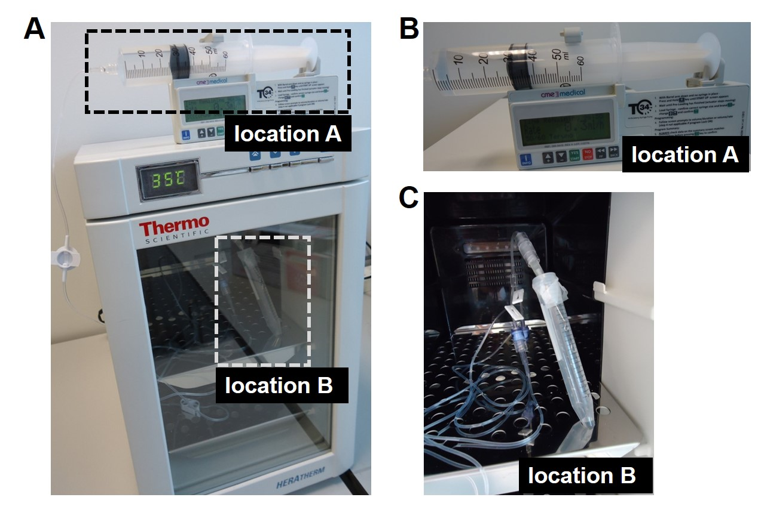

FIGURE 2
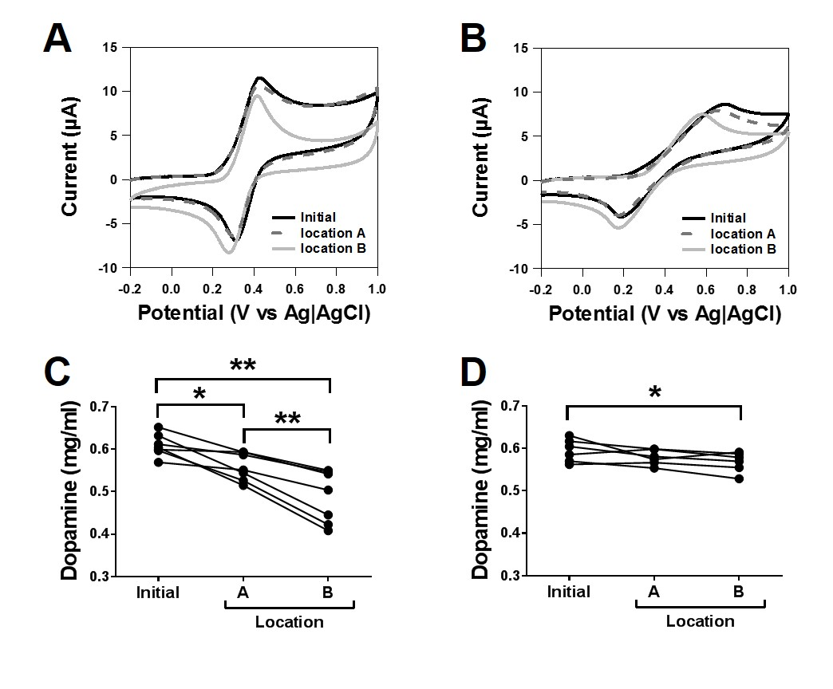

FIGURE 3
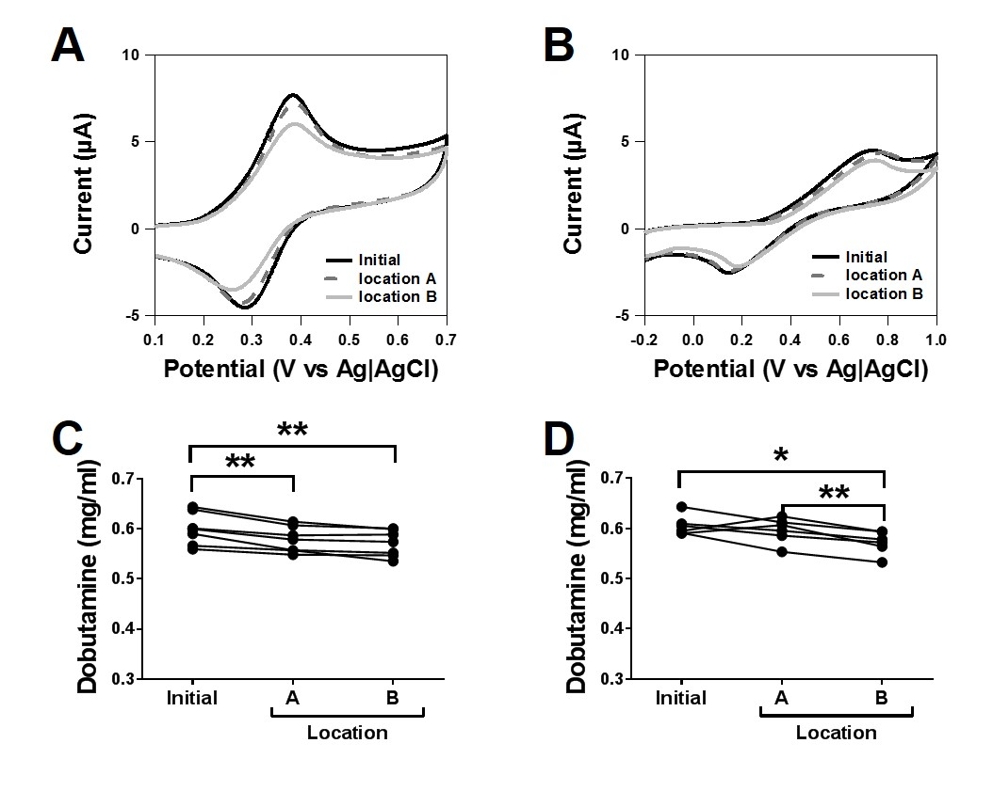

FIGURE 4

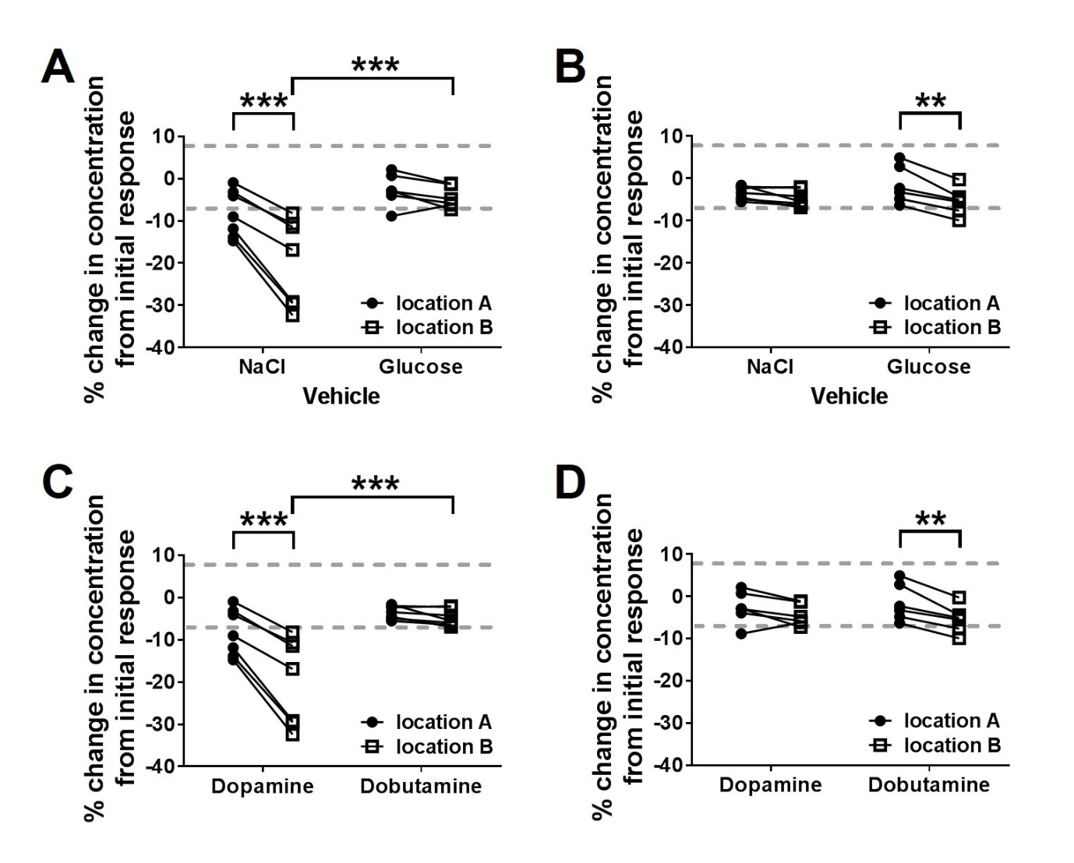

FIGURE 5
