The Impact of Time Pressure on Prefrontal Cortical Activation and Technical Performance During Robotic Suturing
Introduction
Intra-operative haemorrhage requires surgeons to rapidly gain control of bleeding vessels. When such temporal demands are experienced during laparoscopy, there is a loss of prefrontal engagement and a deterioration in technical performance. Robotic platforms confer advantages over laparoscopy such as reduced subjective workload, improved depth perception and greater manual dexterity. However, the effect of robotic technology on prefrontal activation during temporal stress is unknown. This study aims to assess the impact of time pressure on prefrontal activation and technical performance during robotic suturing.
Methods
8 surgical trainees performed a robotic suturing task under “self-paced” (SP) and “time pressure” (TP) (2-minutes maximum per knot) conditions. Subjective workload was measured using the Surgical Task Load Index (SURG-TLX). Heart rate was used as a physiological measure of workload. Optical neuroimaging was used to assess prefrontal cortical activation as a surrogate for objective workload assessment. Technical skill was assessed using progression scores (au), error score (mm), leak volume (ml) and knot tensile strength (N).
Results
Time pressure led to greater subjective workload (SURG-TLX scores: 115.9±72.1 vs 183.9±75.9, P=0.024), greater leak volume (15.5±1.3ml vs 18.3±1.2ml, P<0.001), lower knot tensile strength (21.2N (38.8) vs 1.4N (13.1), P<0.001) and lower progression scores (6.0 (0.0) vs 5.0 (2.0), P<0.001).Activation was greater in TP compared to the SP condition, particularly in the dorsolateral prefrontal cortex (SP = 10 activated channels vs TP = 16 activated channels) (Figure 1).
Conclusion
These preliminary results suggest that robotic surgery facilitates prefrontal engagement during stressful intraoperative conditions. Further analysis is required to establish whether this compares favourably to laparoscopy.

Word count: 250
Authors:
Samriddha Ranjan (corresponding author samriddha.ranjan13@imperial.ac.uk 07533250631)
Hemel N. Modi
Harsimrat Singh
Ara Darzi
Daniel R. Leff
Institution: Hamlyn Centre for Robotic Surgery, Imperial College London, United Kingdom

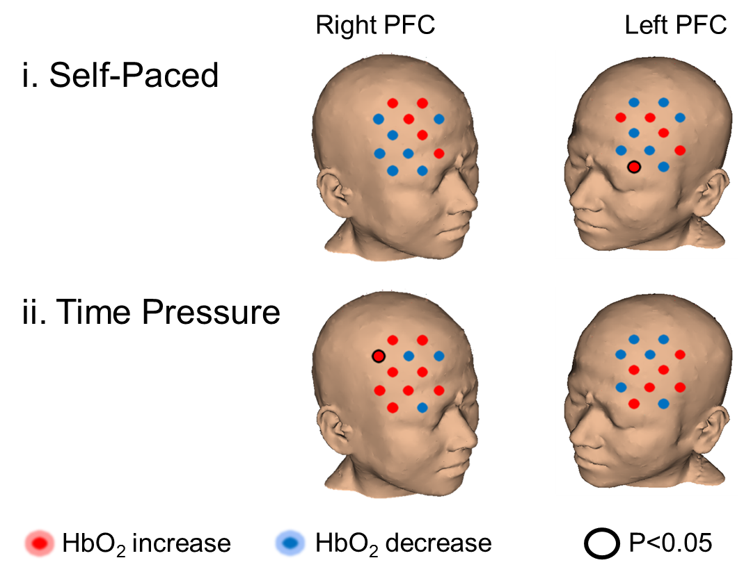
Figure 1. The 3D MRI head reconstructions show channel-wise activation based on averaged statistical analysis of HbO₂. Channel-wise statistical results of PFC responses in the self-paced (i) and the time pressure (ii) conditions are presented. Channels that show an increase (activation) in [HbO₂] are shown as red dots, whilst channels with a decrease (deactivation) in [HbO₂] are shown in blue. Channels where the change is statistically significant (Wilcoxon signed-ranks, P<0.05) are outlined by black circles.

