Experimental and numerical investigation of high velocity soft impact loading on aircraft materials
J. Zhou¹, J. Liu¹, X. Zhang², Y. Yan², L. Jiang², I. Mohagheghian³, J.P. Dear¹, M.N. Charalambides¹
¹ Mechanical Engineering Department, Imperial College London, London, SW7 2AZ, United Kingdom
² Beijing Institute of Aeronautical Materials (BIAM), Beijing 100095, China
³ Department of Mechanical Engineering Sciences, University of Surrey, Guildford GU2 7XH, United Kingdom

Abstract
Bird strike on aircraft remains a serious threat to flight safety. Experimental investigations employing real birds are associated with high cost and low reproducibility. Therefore, physical substitute materials are often used instead of real birds. This study investigates the soft impact loading on aluminium and laminated glass targets from ballistic gelatine and rubber projectiles. The two targets simulate strike on the aircrafts’ fuselage and windshield respectively. The full field out of plane displacements of the targets were recorded for velocities 110 to 170 m s⁻¹ using digital image correlation during gas gun experiments. A simulation model based on Smoothed Particle Hydrodynamics was developed and validated against the experimental data from all four projectile-target material combinations. It was shown that for the same momentum, a rubber projectile exerts a higher pressure on a target as compared to gelatine, even though the out of plane displacements and in-plane strains are similar. This led to fractures in the impacted laminated glass when rubber was used. The study offers new experimental data as well as efficient design modelling tools to mitigate damage imposed during bird strike. The models provide a way towards enabling the optimisation of real, large scale aircraft structures and components.

Keywords: Bird strike; Gas gun; SPH model; aluminium target; laminated glass target; Digital Image correlation

Introduction

Bird strikes are collisions between a bird and an aircraft resulting in the death or injury of the bird, damage to the aircraft or both (Montoney and Boggs 1995). Near-collisions with birds reported by pilots also are considered strikes. According to the FAA’s National Wildlife Strike Database, there were 177,269 wildlife strike reports on civil aircraft between 1st January 1990 and 31st December 2015 (Seidenman and Spanovich 2016). Serious damage to the aircraft due to bird strike constitutes a severe threat to the safety of the passengers and also brings high repair costs to the aviation industry. Accordingly, there has been an increasing amount of literature in this field which includes a recent textbook on bird strike (Hedayati and Sadighi 2016).
Conducting multiple high speed impact studies such as gas gun experiments using real birds as projectiles on aircraft structure targets, leads to prohibitively expensive studies; furthermore, the data obtained from such experiments are often inconsistent, with low repeatability and a high scatter due to the varying size and shape of real birds (Allan and Orosz 2001). Therefore, research has been focused on using bird substitutes such as rubbers and gels in order to improve data repeatability. In addition, in order to bring down the investigation costs, numerical simulations are also conducted, enabling thorough studies through virtual testing, before validation experiments are undertaken.
Gelatine and Room Temperature Vulcanised (RTV) rubber projectiles have both been used as surrogate bird models as their behaviour under high speed impact (velocity range of 100 - 300 ms⁻¹) is similar to that from real birds (Heimbs 2011). The density of rubber and gelatine is close to that of the real bird, which is approximately 1000 kgm⁻³ since over 90% of the bird’s mass consists of water. During impact both gelatine and rubber behave as fluids (Wilbeck 1978). The requirements for a material to "flow" is that the stresses generated during impact substantially exceed the strength of the material (Wilbeck 1978). Lavoie et al (Lavoie et al. 2009) used ballistic gelatine with a bespoke recipe as a replacement of the real bird when studying impact pressure under a bird strike scenario.
Since the 1970s, complex fluid–structure interactions have been simulated with explicit numerical codes and high-performance computing (HPC) (Heimbs 2011). A well-represented bird constitutive model is an essential element in the numerical simulation of the bird strike. A simple elastic-plastic material law developed by Stoll et al. (Stoll and Brockman 1997) was used extensively to model the bird, but fluid-like flow response cannot be obtained with such a law unless a low shear modulus is set. The Equation of State (EoS) constitutive model is now commonly adopted as the material model of the bird impactor (Smojver and Ivančević 2010a; Smojver and Ivan 2009; Smojver and Ivančević 2012) and it is defined as the relationship between the projectile pressure and corresponding volume at room temperature, with the density of the projectile close to that of water. Common forms of EoS that are extensively adopted include Polynomial, Mie- Grüneisen and Murnaghan forms. A good agreement from simulations where the gelatine projectiles were modelled using the EoS, with theoretical and experimental shock pressure-time history curves has been reported (Smojver and Ivančević 2012).
An extensive review of the effect of the bird geometry assumed in numerical studies is given in Hedayati and Sadighi (2016) including ellipsoid, hemispherical-ended cylinders and straight -ended cylinders, with the latter found to be the most damaging in an impact. Furthermore, Dear and Field (1988), Field et al (1985) and Wilbeck (1978) commented on the effect of the projectile nose shape, i.e. flat versus hemi-spherical nose, on the intensity and duration of the hydrodynamic loading, with flat shapes leading to higher values. Using more accurate bird anatomy models were also investigated in numerical studies by McCallum et al (2013) who reported that the results in terms of Hugoniot pressure, maximum impact force and impact duration were similar to those obtained from simplified geometries including cylindrical, hemi-spherical and ellipsoid shapes. The effect of the bird model geometry was also investigated by Hedayati et al (2014) who concluded that a real mallard bird geometry as obtained from a CT scan led to closer agreement to experimental pressure profile data.
Regarding the target materials used in bird strike experiments and simulations, both metallic based structures (monolithic as well as foam sandwich structures) and glass structures have been employed in an effort to replicate damage to parts of the aircraft prone to bird strike such as the fuselage and the windshield. The results from these studies are briefly described below.
Hanssen et.al. (Hanssen et al. 2006) used real birds as impact projectiles to compare experimental results to their Finite Element simulations for predicting the failure of Aluminium Foam-Based sandwich panels due to bird strike. They varied the thickness of the AlSi7Mg0.5 aluminium foam (as the core material) bonded to AA2024 T3 cover plates to evaluate the penetration. They adopted strain gauges to measure the target compliance during impact and they determined the minimum foam-core thickness to avoid penetration of the bird strike. Liu et al. 2014 used gas gun tests with steel and aluminium alloy targets. Both studies (Hanssen et al. 2006, Liu et al 2014) chose aluminium alloy as an impact target due to its pivotal role in aircraft structures, especially the 2000 series and 7000 series aluminium alloys.
Regarding bird strike studies on aircraft windshield targets, most investigations have focused on numerical simulations, with only a limited number of reported experimental studies (Doubrava and Strnad 2010; Doubrava 2011, Kangas and Plgman 1950, Mohagheghian et al. 2017 and Mohagheghian et al. 2018). Doubrava et al. (Doubrava and Strnad 2010; Doubrava 2011) studied the performance of laminated windows with overall thicknesses of 14, 18 and 20 mm against impact by a 1.81 kg bird at a velocity range of 83-125 ms⁻¹. The details of the laminated configuration were not specified, but the velocity at which the failure occurred indicated a linear trend with increasing thickness of the windshield. Kangas et al. (Kangas and Plgman 1950) conducted bird impact tests at velocities up to 208 ms⁻¹ on various windshield materials and structures. Their studies suggested that the primary factor affecting the impact strength of laminated windows is the thickness of the polymer interlayer (Kangas and Plgman 1950). Different methods of assembly of the windshield to the cockpit were also investigated and it was concluded that it has a great effect on the impact strength of the windshield.
Salehi et al (Salehi et al 2010) investigated the impact response of various aircraft bubble windows using three numerical approaches, namely the Lagrangian, Arbitrary Lagrangian Eulerian (ALE) and Smoothed Particle Hydrodynamics (SPH) approaches. Single layer stretched acrylic, multi-walled stretched acrylic, laminated acrylic with Polyvinyl Butyral (PVB) and Polyurethane (PU) were evaluated. The laminated configuration with the PU interlayer was shown to be able to withstand bird strike according to the FAR25 (Salehi et al 2010). Dar et al. (Dar et al 2013) studied the impact response of the canopy made of monolithic PMMA. Parameters such as the bird mass, shape and impact velocity were assessed. Also, the effect of the impact angle and location were studied. Additionally, Wang et al. (Wang and Yue 2010; Wang et al 2014) tested the impact response of the PMMA canopy, taking the influence of ambient temperature, impact location and velocity into account.
Mohagheghian et al (Mohagheghian et al. 2017), investigated the deformation and damage mechanisms of laminated glass windows experimentally and numerically under high velocity soft impact. Impact tests were performed using silicon rubber projectiles at a velocity range of 100–180 ms⁻¹. High-speed 3D DIC was employed to monitor the deformation and strain at the back surface of the target and its results were validated using strain gauges. The simulations were performed in ABAQUS/EXPLICIT using a Eulerian approach. The simulations were validated with the experimental results and a good agreement was observed. It was found that the damage inflicted is sensitive to the nose shape of the projectile with a flat-fronted nose soft projectile being more damaging than a projectile with a hemi-spherical nose. Two impact velocity thresholds for damage are identified for a flat-fronted nose projectile. When the impact velocity exceeds the first threshold, the glass front layer breaks whereas a second threshold was determined for failure to occur in the glass back layer. The glass front layer damage occurs in the early stages of the hydrodynamic loading and has similar characteristics to that observed for liquid jet impact (Mohagheghian et al. 2017). In a separate study, Mohagheghian et al. (2018) investigate the effect of polymer interlayer type and thickness on the impact performance of laminated glass windows through a combined experimental and numerical approach. Three polymer interlayers including thermoplastic Polyurethane (TPU), Polyvinyl Butyral (PVB) and Ionoplast interlayer-SentryGlas® Plus (SGP) were studied. The choice of polymer interlayer was found to have a strong influence on both the damage and the failure of laminated glass windows at room temperature. This influence becomes less pronounced when the testing temperatures decreases.
The present study, aims at investigating the impact performance of aluminium alloy 2024-T3 as well as laminated glass, which are the materials of the fuselage and the laminated glass windshield of the aircraft. These two parts of the aircraft undergo 10% and 13% of the overall body impacts reported worldwide respectively (Heimbs 2011). It is therefore crucial that methodologies are developed facilitating the design against bird strikes failures in these critical components. For the first time, these two target materials are impacted at speeds ranging from 100-170 ms⁻¹, using both rubber and gelatine projectiles. This comprehensive study involving two targets as well as two projectile materials is therefore unique as it enables the collection of experimental data needed in answering questions such as what the effect is, if any, of the simulant material choice on the two types of aircraft structures. Most crucially, the experimental data additionally provide crucial validations of newly developed numerical models, enabling predictions of the imposed displacement and strain fields in both the impacted targets for both rubber and gelatine materials. Such accurate modelling tools are needed for the design and optimisation of safe fuselage and windshield aircraft components.

2. Experimental methods and materials

In this section, first the gas gun experiments conducted to mimick bird strike are outlined. This is followed by the projectile and target material details.

2.1. Gas gun experiments
The gas gun apparatus used for conducting impact experiments is shown in Figure 1. The apparatus used a 4-litre cylinder, which was filled by either compressed air or Helium, to provide the necessary pressure to accelerate the projectile. The gas was released by a fast-acting pneumatic valve value into a 3 m long barrel with a diameter of 25 mm. The impact speed was attained by two infra-red (IR) sensors attached towards the end of the barrel, indicated in Figure 1.
The time taken for the projectile to travel between the two IR sensors was recorded by the oscilloscope. Since the distance between two IR sensors was known, the impact velocity could be computed. Note that the tests were performed at speeds of 100-170 ms⁻¹. Most birds are found near the ground, during take off and landing of the aircraft, where the typical speeds of impact are around 80 - 100 ms⁻¹. However, at greater altitudes with higher aircraft speeds, the proportion of bird strikes producing major damage increases, even though there is less chance of a bird strike event. Therefore, the range of 100 – 170 ms⁻¹ is studied here, in line with other bird strike studies (Kangas and Pigman, 1948, Doubrava and Strnad, 2010, Liu et al, 2014, Zakir and Li 2012).
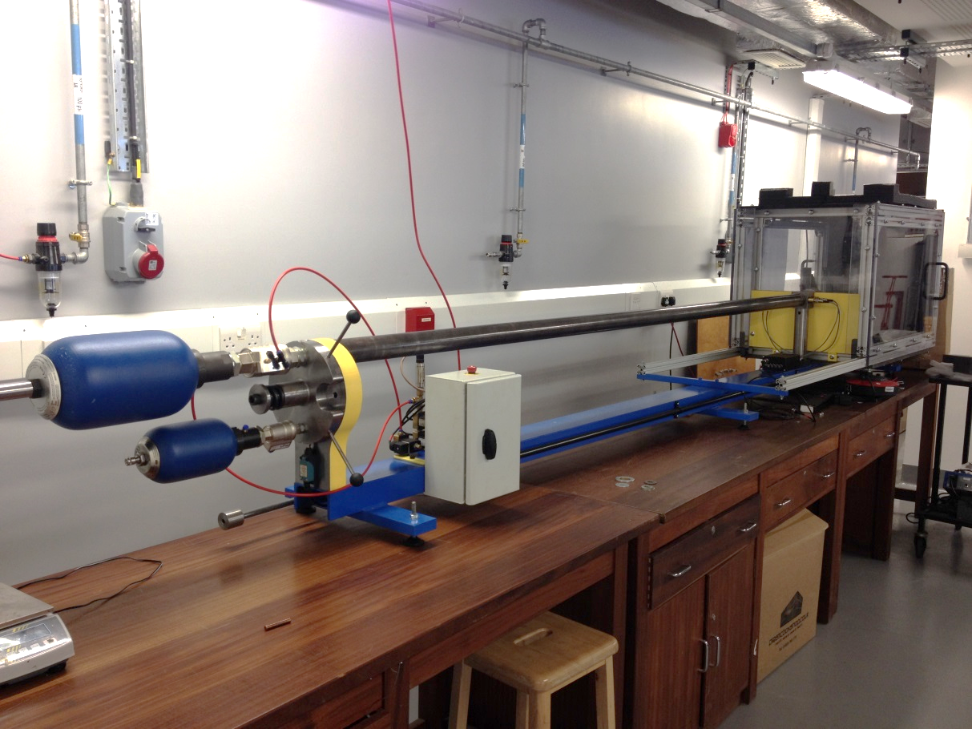
Pressuriser
Barrel
Infra-red sensor
Target chamber
Feed and switch chamber
Figure 1: Overview of the light gas gun and its key components
A high speed camera was used to film the entire event from the moment the gelatine projectile emerges from the barrel outlet to the final impact onto the target materials. This camera was a Photron FASTCAM Mini UX50 model recording at a rate of 20,000 frames per second and was located on the impacted side of the sample monitoring the interaction of the projectile with the target.
The target chamber confined the area where target materials and the clamping system were located and guarded against flying debris from the impact. In order to measure the impact deformation of the target materials, the 3D Digital Image Correlation (DIC) technique was used (Mohagheghian et al. 2017). The back plate of the target chamber was modified by cutting out two square windows (250 mm x 250 mm) so that two synchronised high-speed cameras (Phantom Miro M/R/LC310) can film the response of the target. These two cameras at the back of the target plate recorded the deformation of the target at the rate of 40,000 frames per second. A pair of identical Nikon lenses with a fixed focal length of 50 mm was used for both cameras. The two cameras were separated from each other by a distance of 410 mm and were 925 mm away from the centre point of the target. This created an angle of approximately 25˚ between the two cameras (Mohagheghian et al. 2017). This is equal to the recommended angle for stereo-vision measurements (ARAMIS 2011).
The whole DIC setup is depicted in Figure 2. The GOM ARAMIS software (ARAMIS 2011) was employed to determine deformation and strain from the raw DIC data.
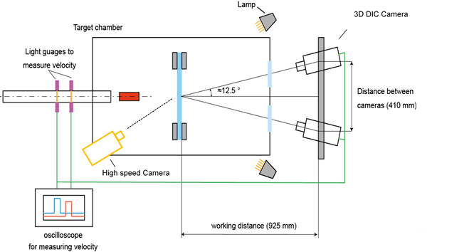
Barrel
Projectile
IR sensors to measure velocity
Target and clamping system
Distance between cameras (410 mm)
Target chamber
DIC cameras
Oscilloscope to record velocity
High speed camera
Working distance (925 mm)
Figure 2: 3D digital image correlation set up in the gas gun

2.2. Materials

2.2.1. Projectiles
Both gelatine (42043 porcine skin ballistic gelatine type 3 with 255-265 Bloom value, Sigma-Aldrich Co. LLC) and rubber (Mold Max ® 10T, Smooth-On Inc.) projectiles were employed in this study. The gelatine solution was mixed to a 10% powder to water weight ratio over a hot plate (temperature kept at 80 °C) with a magnetic stirrer and was subsequently poured into PTFE moulds (60 mm Diameter x 50 mm length, with two 24.8 mm bore holes as shown in Figure 3). The moulds were then placed in a domestic refrigerator at 4 ºC. The RTV rubber was made of two solutions A and B, which are mixed to a weight ratio of 10:1 before placing in the oven (around 150 °C), where the liquid solution was vacuumed to reduce its porosity. After twelve hours, the casting process was completed and the rubber was taken out from its aluminium mould. Finished samples are shown in Figure 3. The finished rubber and gelatine projectiles had similar dimensions, nominally a diameter of 25 mm and a length of 50 mm. The mass of the rubber and gelatine projectiles were in the range of 27.0 – 27.5 g and 25.8 - 26.7 g respectively.

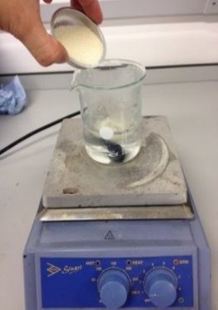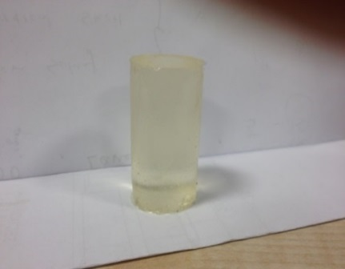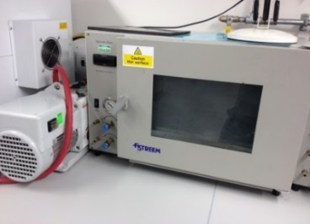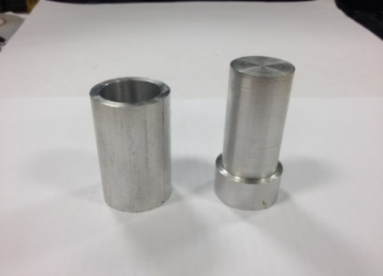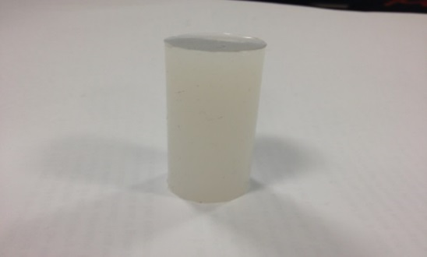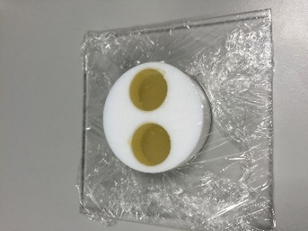
Ballistic Gelatine
(Sigma Aldrich)
RTV rubber 10T
(Smooth-On, Inc.)
Figure 3: Moulding of gelatine and rubber projectile samples
Both projectiles presented some difficulties when they were fired into the gun barrel due to their compliant nature and high deformability. It was found that they often jammed inside the barrel when no protective wrapping was used. Hence, a sabot (see Figure 4) was designed out of a thin layer of polystyrene film and a 2 mm PMMA backing disc. It has a wall thickness of 0.6 ± 0.02 mm and weight of 4.0 ± 0.2 g. As can be seen in Figure 4, the thin-walled sabot was open at the top and sealed at the bottom using Araldite adhesive. It is worth noting that the bottom “lid” was necessary to ensure that the projectile did not disintegrate when it was fired in the gas gun. The sabot height was equal to the projectile length (50 mm). The sabot was used to wrap and accommodate the projectile during the gas gun test so that friction was reduced, and the projectiles could pass through the barrel without jamming. (Mohagheghian et al. 2017) found that the nose shape of the projectile has a profound effect on the pressure profile imposed onto the target and consequently the type of the damage it produces. Therefore, this arrangement ensured that the projectile had a perfectly flat front as it hit the target.
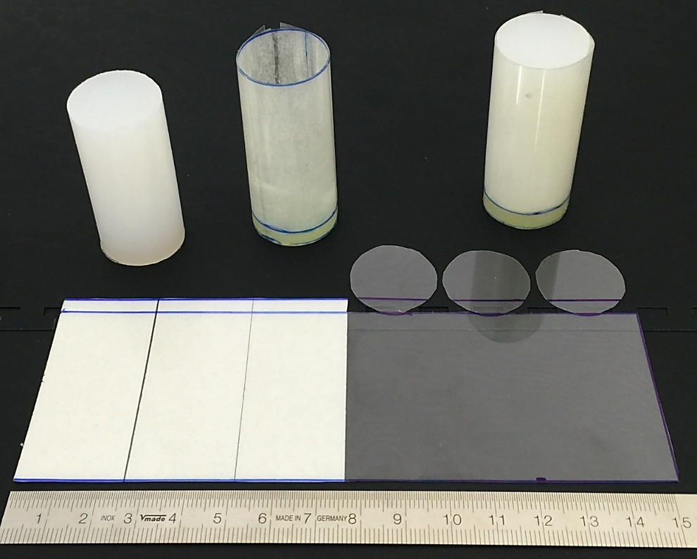
Figure 4: Design of a lightweight sabot for both rubber and gelatine projectiles
After the projectile wrapped inside the sabot was fired and impacted the centre of the target, the sabot peeled off and the bottom adhesive was fractured by the shock wave generated inside the projectile. Since the mass of each sabot was precisely controlled and contributed less than 10% of the entire mass, the initial kinetic energy of each sabot should be consistent and negligible compared to that of the projectile.

2.2.2. Target materials and DIC details

Monolithic aluminium alloy plate
An Aluminium alloy (2024-T3) sheet of 1 mm thickness used widely in aircraft structural components, e.g. the wing flap and the fuselage, was chosen as one of the two target materials of the study. In order to capture the deformation on the aluminium target using 3D DIC, the back surface of the target was initially painted white using an acrylic spray and then random black dots were manually drawn in the region of most interest for maximum colour contrast. It should be mentioned that to enhance the adhesion between the white acrylic paint and aluminium, the surface of aluminium was grit blasted. The 1 mm aluminium sheet with the DIC dots is shown in Figure 5.
As shown in Figure 5, twelve holes of a 10 mm diameter were distributed around the perimeter of the target. This enabled the aluminium target (230 mm x 230 mm) to be bolted onto the clamping system. The latter consisted of two mild steel frames with a thickness of 15 mm. Hence, this generated a 150 mm x 150 mm open area exposed to the projectile.
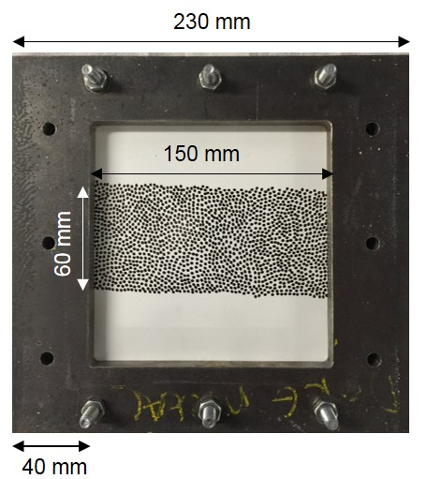
Figure 5: The clamping system for the aluminium target. The top and bottom sides shown here with the rows of bolts in place; the left and right sides were also bolted for the experiments.

Laminated glass plate
The laminated glass sample consisted of a 2.2 mm thick front glass layer, a 3.2 mm thick interlayer made from Thermoplastic Polyurethane (TPU) (KRYSTALFEX ®PE499) and a 4.0 mm thick back glass layer (see Figure 6 where the clamping system is also shown). Both glass layers were made from chemically toughened glass.
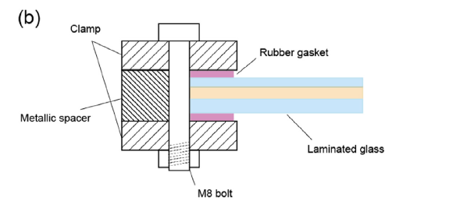

Rubber gasket
Laminated glass
TPU interlayer
Chemical toughened glass
Clamp
Metallic spacer
M8 bolt
Figure 6: The clamping boundary conditions of the laminated glass
Similar to the DIC pattern drawn at the back of the aluminium plate in Figure 5, a number of black speckles were randomly drawn upon a white sprayed area at the back of the laminated glass sample, such that the DIC cameras can be used to visualise and record their movement during the high-speed impact. Figure 7 illustrates a rectangular dotted area with dimensions of 150 x 60 mm where the full field out of plane displacement and major principal strain were obtained. Figure 7 also shows the strain gauge located 30mm off the centre of the laminated glass target, whose purpose was to validate the accuracy of the DIC results by comparing the vertical strain value along the y-direction at the same spot. The strain gauge employed was a 2 mm linear gauge and was thermally compensated for glass and ceramic (FLA-2-8 from Techni Measure Ltd). The surface of the glass was cleaned before attaching the strain gauge using a cyanoacrylate adhesive. Note that this strain gauge only allowed the strain along the y-axis to be measured and that strain gauges were not used for the aluminium target experiments.
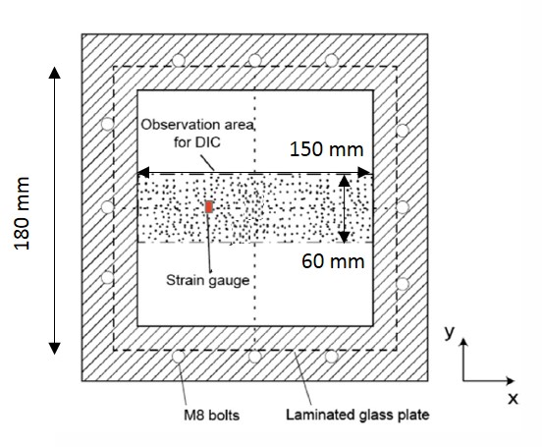
Figure 7: DIC sample configurations: a rectangular-dotted area
The clamping system used to fix the laminated glass is highlighted in Figure 6. A pair of rubber gaskets with thickness of 4.1 ± 0.1 mm was compressed between the laminated glass and the metallic clamp. The gaskets were employed in order to prevent a hard contact between the glass and the clamp during the high speed impact which could potentially damage the target material (Mohagheghian et al. 2017).

3. Numerical methods
A finite element model was generated to analyse the mechanical performance of the aluminium and the laminated glass targets under soft impact strike. The Smoothed Particle Hydrodynamics (SPH) approach in the ABAQUS/EXPLICIT solver (Dassault Systems 2012) was selected for the soft projectile impact as it is suitable for modelling large material deformation and for solving computational fluid dynamics problems. This method was first adopted for bird strike problems between the late 1990s and early 2000s, where the PLEXUS code was used at that time to model the bird strike on the engine fan blade (Heimbs 2011). Grimaldi et al. adopted this method for performing bird impact on windshield simulations (Grimaldi et al. 2013). Lavoie et al. (Lavoie et al. 2007), McCarthy et al. (Mccarthy et al. 2004), Liu et al. (Liu et al. 2014), and Zakir and Li (Zakir and Li 2012) used the SPH approach to simulate bird strike also reporting that it is a suitable simulation method for this application.
For the projectiles, 3920 C3D8R (8-node linear brick, reduced integration, hour glass control) elements were created with 15844 corresponding nodes. The SPH method was then generated using a finite element to particle conversion. The number of particles per parent element needed to be determined so a parametric study was conducted via monitoring the out of plane displacements and impact pressure on the target in order to determine the optimised number of particles. As a result, one particle per isoparametric direction was chosen. A time criterion, zero threshold and cubic Kernel were used and the conversion was activated at the start of the simulation, i.e. at time t =0 (Dassault Systems 2012).
The aluminium and laminated glass targets were modelled using 3D linear reduced integration brick elements. Since the aluminium target was rigidly fixed by two steel plates and bolts (see Figure 5), a built-in boundary condition (zero translations and rotations) was defined at the edges of the target panel. The laminated glass was held in the experiments as shown in Figure 6, and this arrangement was replicated in the numerical model by explicitly modelling the rubber gasket pad geometry. Figures 8(a) and 8(b) illustrate the numerical models for the aluminium and glass target simulations respectively. The conversion of the Finite Element mesh to the respective SPH particles for the projectile is shown in Figure 8(c).
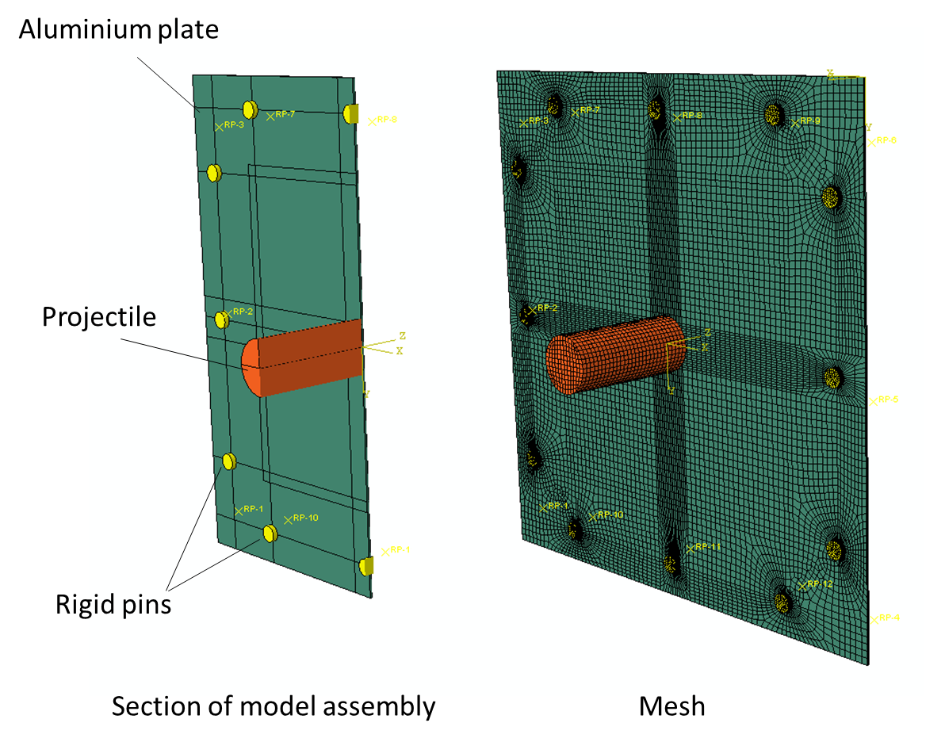
(a)
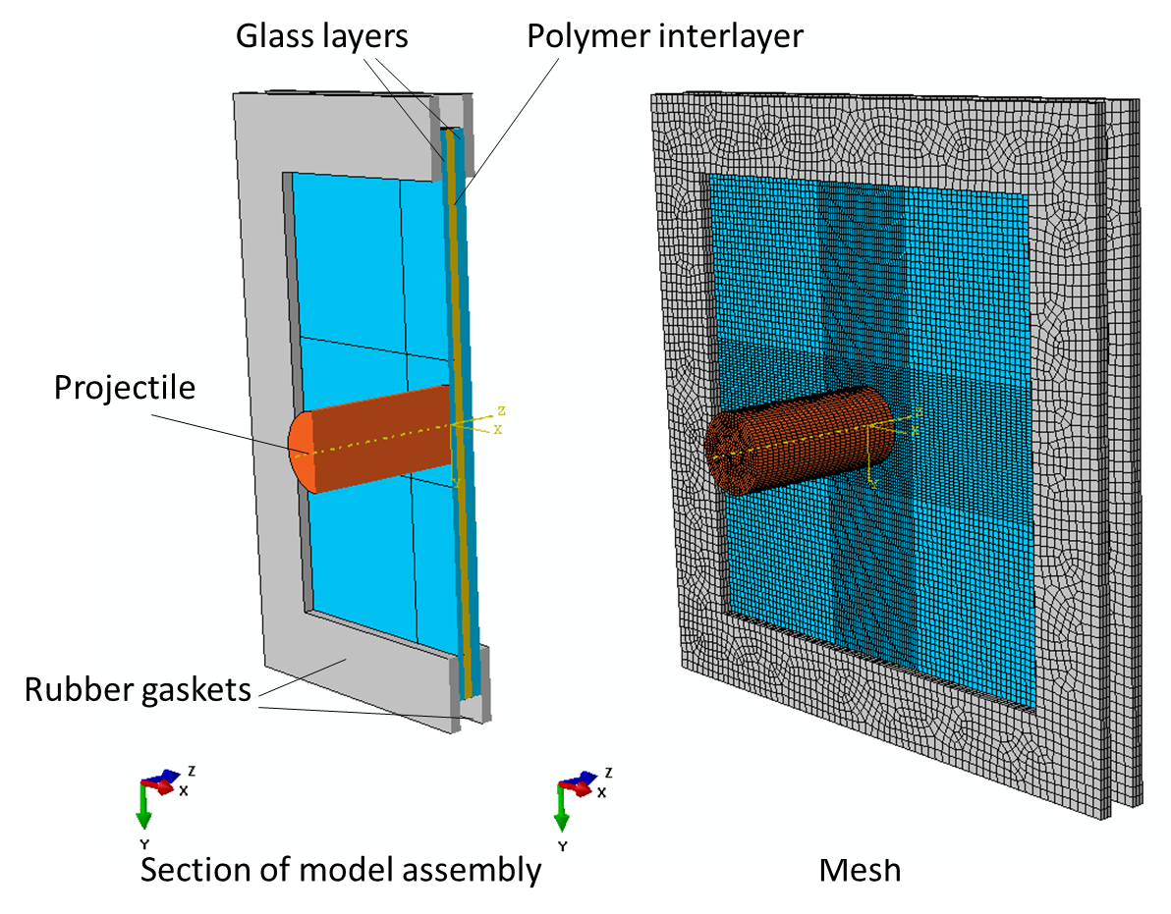
(c)
(b)
Figure 8: (a) Numerical model for the aluminium alloy target experiments, (b) numerical model for the laminated target experiments and (c) the transition from the Langrangian mesh of the projectile to SPH particles.
The contact interaction between the target and the projectile as well as the gasket and the target was assumed to be frictionless with no penetration possible. No contact pressure is transmitted unless the nodes of the two interacting surfaces are in contact. For the gasket and glass contact, the contact pair algorithm was used (Abaqus version 6.14) with the slave surface being the gasket and master surface being the target. For the contact between the projectile and the target, the general contact algorithm was used which is the only possible option when SPH particles are involved (Abaqus version 6.14). By defining a contact domain, general contact allows contact between all projectile SPH particles with the target without having to define specific contact pairs.
The following subsections give details regarding modelling the constitutive response of the target, projectile materials and the rubber gaskets. The material parameters needed as an input in the simulation of the gas gun test are also given.

3.1. Aluminium target
The aluminium alloy 2024-T3 target material is commonly characterised using the Johnson–Cook (J-C) material model which is a strain-rate and temperature-dependent (adiabatic assumption) viscoplastic model. It has the form shown below:
$σ_{Y}=\left(A+Bε^{n}\right)(1+C\ln{{\dot{ε}}^{*})(1-T^{*m})}$ Equation 1 $σ_{Y}=\left(A+Bε^{n}\right)(1+C\ln{{\dot{ε}}^{*})(1-T^{*m})}$$P_{H}=ρ_{0}u_{s}$$P_{H}=ρ_{0}(1.77{u_{0}}^{2}+1.57u_{0}$
where $σ_{Y}$ is effective yield stress; $ε$ is an effective plastic strain, ${\dot{ε}}^{*}$ and $T^{*}$ are normalised strain rate and temperature whereas A, B, C, m and n are material constants. For the aluminium alloy 2024-T3, the latter parameters are defined as follows: A =265 MPa; B=426 MPa; C=0.015; n=0.34, and m=1.0 (Buyuk et al 2009).

3.2. Laminated glass target
The laminated target consisted of two glass panels, one polymer interlayer and the rubber gaskets. The chemically toughened glass was modelled as an elastic material with density, ρ= 2440 kg m⁻³, Young’s Modulus, E = 71.7 GPa and Poisson’s ratio, v = 0.21 (Xue et al. 2017). Note that the response of the laminated glass windows was simulated only at impact velocities for which no fracture occurs in the glass layers. Therefore, no failure model is employed for the glass in the FE model (Mohagheghian et al. 2017).
The rubber gaskets were modelled using a hyperelastic material model (Mooney–Rivlin) with density of 1060 kgm⁻³ and C₁₀ and C₀₁ (Mooney–Rivlin material model constants) of 0.69 MPa and 0.17 MPa respectively (Li et al. 2009). For the polymer interlayer (TPU), a linear viscoelastic material model (generalised Maxwell model) was chosen as follows:
$E\left(t\right)=E_{∞}+\sum_{i=1}^{n}{E_{i}e^{-(\frac{t}{τ_{i}})}}$ Equation 2
where $E_{∞}$ is the long-term modulus and $E_{i}$ is the elastic modulus associated to the relaxation time $τ_{i}$. Material parameters used for the generalised Maxwell model ( Table 1 ) were extracted with a method similar to Macaloney (Macaloney et al. 2007), who utilised multi-frequency sweeps with a Dynamic Mechanical Analyser so that the Williams-Landell-Ferry constants and Prony series coefficients were determined (Macaloney et al. 2007). The parameters were imported in ABAQUS in the form of normalised shear moduli (G_{i}), which have a value approximately one-third of E_{i}. The values of 1070 kgm⁻³ and 0.485 were chosen for the density and Poisson’s ratio of the TPU, respectively. The density was taken from the Product Data sheet (KRYSTALFLEX® PE499 Thermoplastic Polyurethane Film, Huntsman) and the Poisson’s ratio from Qi and Boyce 2005. A linear viscoelastic model was employed as opposed to a nonlinear viscoelastic model in order to simplify the model calibration; TPU has a linear viscoelastic range in the order of 0.5% (Tabuani et al 2012). It was assumed that the strains experienced by TPU in this study do not exceed this range as the glass plates restrict high deformation. This assumption was in fact later validated from the numerical model output.

Table 1: Prony series material constants extracted for TPU (KRYSTALFEX ®PE499)
 | G_{i} / G₀ ∗ | $τ_{i}$ (s)
1 | 0 .44231 | 10⁻¹⁰
2 | 0.11511 | 10⁻⁹
3 | 0 17258 | 10⁻⁸
4 | 0 08917 | 10⁻⁷
5 | 0 07606 | 10⁻⁶
6 | 0 04828 | 10⁻⁵
7 | 0 02867 | 10⁻⁴
8 | 0 01444 | 10⁻³
9 | 0 00611 | 10⁻²
10 | 0 00249 | 10⁻¹
11 | 0 00097 | 10⁰
12 | 0 00058 | 10⁺¹
13 | 0 00050 | 10⁺²
14 | 0.00041 | 10⁺³
15 | 0 00036 | 10⁺⁴
16 | 0 00029 | 10⁺⁵
17 | 0 00016 | 10⁺⁶
Long-term | 0 001404 | 10⁺⁷
* G₀ is the instantaneous shear modulus and it value is equal to: $G_{∞}+\sum_{i=1}^{n}{G_{i}}$

3.3. Soft projectiles (rubber and gelatine)
The Mie-Grüneisen EoS was used to model both projectiles. This has the form:
 | $$P=\frac{ρ_{0}{c_{o}}^{2}η}{{\left(1-sη\right)}^{2}}\left(1-\frac{Γ_{0}η}{2}\right)+Γ_{0}ρ_{0}E_{m}$$ | Equation 3
where $η=1-{ρ_{0}}/ρ$ is the nominal volumetric compressive strain; $Γ_{0}$ and s are material properties, $c_{o}$ is the sound velocity in the projectile and $E_{m}$is the internal energy per unit mass.
This form has been used in several bird strike studies (Smojver and Ivančević 2011; Heimbs and Guimard 2011; Smojver and Ivančević 2010; Heimbs 2011). In order to use this EoS model, four material properties need to be specified - $ρ_{0}$, $c_{o}$, $Γ_{0}$ and s. The values used in this study are shown in Table 2 and were taken from literature (Smojver and Ivančević 2011, Iyama et al. 2009 ).
Table 2: EoS model parameters for the rubber and gelatine projectiles
 | Rubber projectile | Gelatine projectile
Parameter | s =0.5072, $Γ_{0}$=0,  $ρ_{0}=1090$ kgm⁻³,  c₀=1869 ms⁻¹ | s =0, $Γ_{0}$=0,  $ρ_{0}=968$ kgm⁻³, c₀=1480 ms⁻¹

The results from the simulations detailed here will be compared in section 5 with the data from the gas gun experiments presented in section 4, in order to assess the accuracy of the developed models.

4. Experimental Results
The experimental results from the tests with an aluminium target are first presented in this section, followed by the laminated glass target test results.

4.1. Aluminium alloy target
The out of plane displacement and major principal strain at the centre of the aluminium target for each gas gun test were attained using the 3D DIC. In order to compare the impact behaviour of the target under both rubber and gelatine projectile strikes, the maximum values of the out of plane displacement and major principal strain were plotted against projectile velocity in Figures 9(a) and 9(c) respectively and against momentum in Figures 9(b) and 9(d), respectively. As expected, as the impact velocity increases, the central displacement and major principal strain both increase linearly. This linear increase of deformation with respect to momentum has also been previously reported for bird strike on a metallic riveted airframe (Langrand et al. 2002). Despite permanent deformation, for thin metallic targets, it has been reported that the maximum deflection is approximately a linear function of force, in particular for projectiles with flat-ended shape (Mohagheghian et al. 2017); it is also a linear function of impulse transferred to the target for impulsive loading (Olson et al 1993). For thin plates, the deformation is highly controlled by membrane stretching rather than bending, which dominates the response of thick metal plates. Onat and Haythornthwaite (1954) analysed the deformation of a rigid-ideally plastic circular plate loaded over a central patch. They found a linear force-deflection response with a gradient proportional to the material yield strength. Their model was later extended by Simonsen and Lauridsen (2000) to include strain hardening of the material and was used to predict the indentation response of a circular plate by a spherical indenter. Although, strain hardening increases the gradient of the force-deflection, the response remains approximately linear.
Since the mass of the rubber and gelatine projectiles varied somewhat, the projectile’s momentum was chosen as a better quantity for comparison rather than projectile speed. In addition, momentum is chosen because of its link to the applied impulse on the target. By observing Figure 9, it is apparent that the experimental data from both projectiles indeed seem to fall on the same trend line when they are plotted against momentum. One pair of data is highlighted in Figure 9(a) corresponding to rubber and gelatine projectiles shot at a similar speed (122 ms⁻¹). At this speed, the momentum was also similar at approximately 3.3 kgms⁻¹. This pair of rubber and gelatine impact tests is next used to compare the corresponding impact response of the aluminium target.

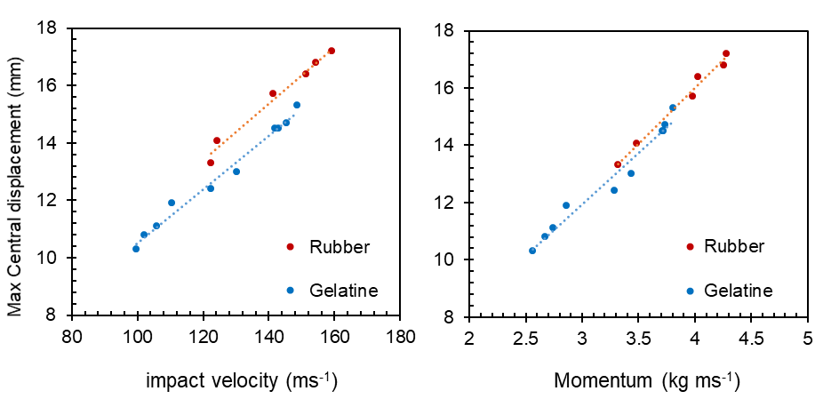
(b)
(a)
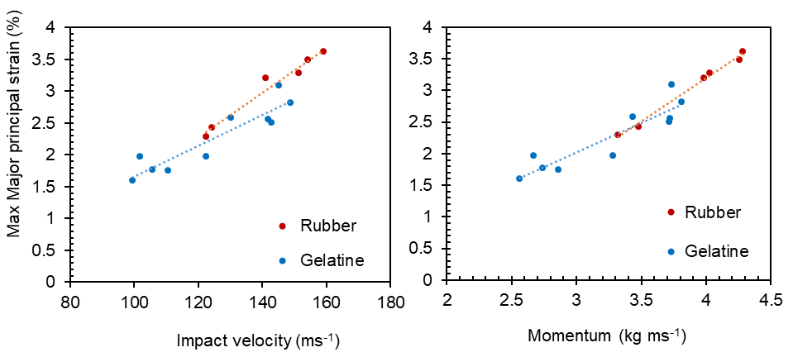
(d)
(c)

Figure 9: (a) maximum central displacement of the aluminium target plotted versus impact velocity for rubber and gelatine projectiles; (b) maximum central displacement of the aluminium target plotted versus initial momentum for rubber and gelatine projectiles; (c) maximum central major principal strain of the aluminium target plotted versus impact velocity for rubber and gelatine projectiles; (d) maximum central major principal strain of the aluminium target plotted versus initial momentum for rubber and gelatine projectiles.
Figures 10 (a) and 10 (b) illustrate a series of sequential DIC images corresponding to the rubber and gelatine impacts at 122 ms⁻¹ respectively for the central out of plane displacement of the aluminium target. The field area is the same as the one shown in Figure 7, but it is now rotated by 90º to facilitate the presentation of the data. One DIC image is extracted for each 25 µs time interval.
0
2
8
6
4
13.3
(mm)
10
(a)

(b)
4
12.4
0
6
8
10
2
(mm)
Figure 10: (a) DIC images of central out of plane displacement of the aluminium target under rubber impact at an initial velocity of 122 ms⁻¹ (momentum of 3.3 kgms⁻¹). The frame image rate is one per 25 μs time interval; (b) DIC images of central out of plane displacement of the aluminium target under gelatine impact at an initial velocity of 122 ms⁻¹ (momentum of 3.3 kgms⁻¹) The frame image rate is one per 25 μs time interval.
From Figure 10 it is apparent that the values of central displacement from the two tests corresponding to the same initial momentum are similar, in agreement to the data shown in Figure 9.

4.2. Laminated glass target
The experimental maximum central out of plane displacement and the maximum major principal strain of the laminated glass target from both rubber and gelatine impacts are shown in Figures 11(a) - (d). It is worth noting here that the tests with the rubber projectile shot at the four highest speeds (146 ms⁻¹ or higher) resulted in fracture in the front glass panel of the structure whilst the rear glass panel was still intact. In comparison, there were no fractures occurring in the target for the gelatine impact tests for the range of impact speeds that were investigated. Similar to the data shown in Figure 9, the pre-cracked data collapse on the same trendline when plotted against momentum. A linear increase of maximum central displacement and maximum major principal strain at the centre of plate is observed with increasing impact velocity. This is the result of the elastic response of the laminated glass target. It should be noted that as for velocities above 157 ms⁻¹ the front facing glass is broken, there is a jump on the level of strain and displacement values in Figure 11. For the rubber projectile test at 118 ms⁻¹ (the lowest rubber test speed), the corresponding momentum was 3.19 kgms⁻¹. The latter was closest to the momentum value of 3.33 kgms⁻¹ corresponding to the gelatine projectile test at 128 ms⁻¹. Thus, this pair of tests as highlighted in Figure 11 (b), are used to extract the time evolution of the contour plots of central displacement as shown in Figures 12 (a) and 12(b) for the two projectiles.
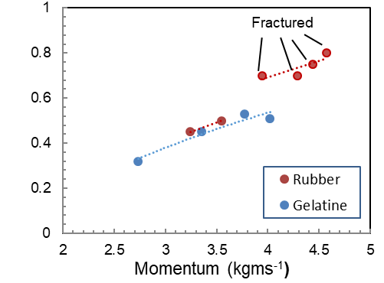
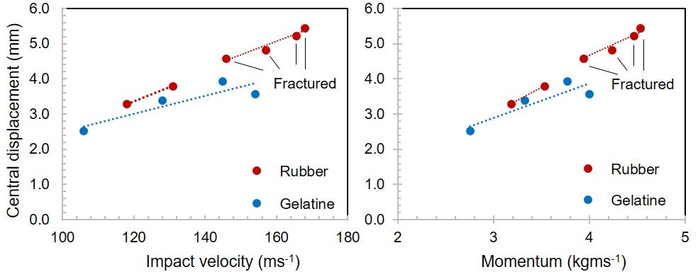
(d)
(b)
(a)
(c)
Max
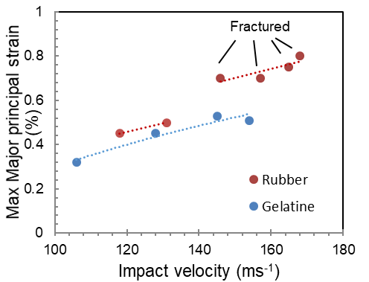
Figure 11: (a) maximum central displacement of the laminated glass target plotted versus impact velocity for both rubber and gelatine projectiles; (b) maximum central displacement of the laminated glass target plotted versus initial momentum for both rubber and gelatine projectiles. (c) maximum central major principal strain of the laminated glass target plotted versus impact velocity for rubber and gelatine projectiles; (d) maximum central major principal strain of the laminated glass target plotted versus initial momentum for rubber and gelatine projectiles.

(a)
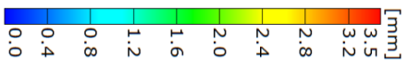
(b)
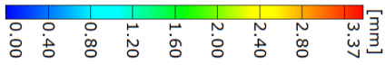
Figure 12: (a) DIC images of central out of plane displacement of the laminated target under rubber impact at an initial velocity of 118 ms⁻¹ (momentum of 3.2 kgms⁻¹). The frame image rate is one per 25 μs time interval; (b) DIC images of central out of plane displacement of the laminated target under gelatine impact at an initial velocity of 128 ms⁻¹ (momentum of 3.3 kgms⁻¹). The frame image rate is one per 25 μs time interval.

In agreement to the case of the aluminium target tests (Figure 10), it is apparent that the values of central displacement from the two projectiles corresponding to the same initial momentum are similar. However, in contrast to the aluminium impact, the out of plane displacement images from the laminated glass impact show a more symmetric pattern along the time axis (each individual image was taken at intervals of 25 μs), which demonstrates that the glass panel bounced back to its initial position, whereas the aluminium alloy target underwent permanent deformation. This was also evident from visual observation of the impacted target materials after the tests.

4.2.1. Comparison with strain gauge results
The data from the strain gauge mounted at a distance of 30 mm off the centre of the back glass panel (see Figure 7) are next used to validate the DIC results. Figures 13(a) and 13(b) show a comparison between strain values from the strain gauge and the DIC for the rubber and gelatine impacts respectively.

(a)
(b)
Figure 13: Comparison of gauge strain and DIC strain in the vertical y-direction: (a) rubber impact at 118 ms⁻¹; (b) gelatine impact at 128 ms⁻¹. All data correspond to a time interval of 1 ms.
The data plotted in Figure 13 correspond to a time interval of 1 ms which falls during the initial flexing of the glass panel and subsequent bouncing backwards. The vertical strain profile obtained from DIC agrees reasonably well with the strain extracted from the strain gauges. Hence, the DIC results at this gauge location were verified. It is assumed that the full field DIC results are also accurate so that they can be used for a comparison to the simulation results presented in the next section.

5. Simulation results and comparison to experimental data
The simulation results are compared with the output from the DIC experiments in this section for both aluminium and laminated glass targets under rubber and gelatine impacts.

5.1. Aluminium target
The projectile deformation images recorded by the high-speed camera located at the impacted side of the aluminium target (see Figure 2) are compared with the images generated from the SPH simulation in Figures 14(a) and 14(b) for rubber and in Figures 15(a) and 15(b) for gelatine. Additionally, the out of plane displacement from DIC is compared with the simulation results in Figures 14(c) and 14(d) for rubber and Figures 15(c) and 15(d) for gelatine. All images shown correspond to 122 ms⁻¹ for both rubber and gelatine.
The thin-walled sabot wrapped around the rubber and gelatine projectiles is seen to readily peel off when the projectile impacts onto the target in Figures 14 (a) and 15 (a). This was evidence that the presence of the sabot did not affect the target’s deformation profile. The radial spread of the projectiles is predicted accurately from the simulations for both projectiles, with the gelatine showing a wider spread than the rubber, as expected. The out of plane central displacement is also predicted accurately for both projectiles as shown by the agreement between the contours of Figure 14(c) with Figure 14(d) and between Figure 15(c) and 15(d).
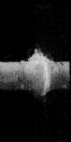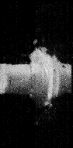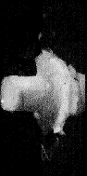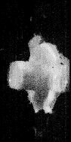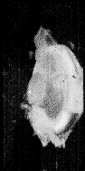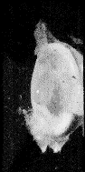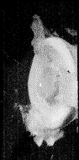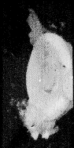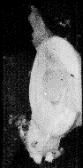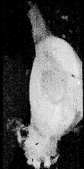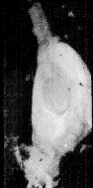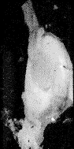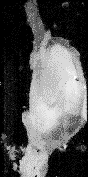

0
2
8
6
4
13.3
(mm)
10
(a)
(b)
(c)
(d)
T=0 µs
T=100 µs
T=200 µs
T=300 µs

Figure 14: Experimental and simulation results for rubber impact on Aluminium target: (a) rubber deformation from high speed camera (b) rubber deformation from SPH model (c) displacement field at the back surface of the target from DIC (d) displacement field from SPH. Impact speed was 122 ms⁻¹.
(f)
(e)
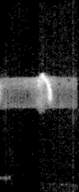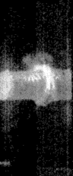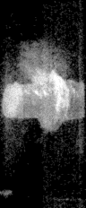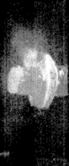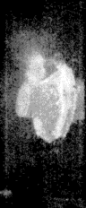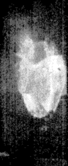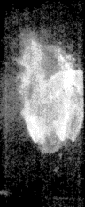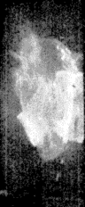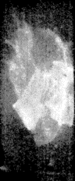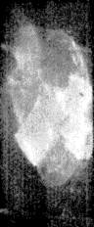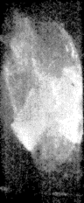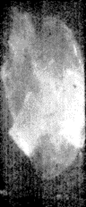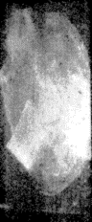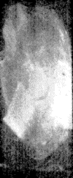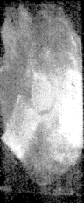
(c)
(d)
(b)
(a)

T=0 µs
T=100 µs
T=200 µs
T=300 µs

4
12.4
0
6
8
10
2
(mm)

Figure 15: Experimental and simulation results for gelatine impact on Aluminium target: (a) gelatine deformation from high speed camera; (b) gelatine deformation from SPH model; (c) displacement field at the back surface of the target from DIC; (d) displacement field from SPH. Impact speed was 122 ms⁻¹.
A further check of the accuracy of the simulation predictions is made via plotting the central displacement of the target versus time and comparing with the DIC data for rubber and gelatine in Figures 16(a) and 16(b) respectively. The displacement profile is initially predicted accurately for both projectiles. A discrepancy of 7% is then observed for the value of the peak displacement though the onset of this peak is predicted accurately. After the peak points, the DIC displacement continues to be larger than that from the SPH model for both projectiles with the difference increasing with time. The latter is thought to be due to the additional compliance introduced from the clamped edges of the target during the experiments (see Figure 5). This additional compliance is the result of some permanent plastic deformation occurring in aluminium around the holes under the clamped area in Figure 5. This additional compliance becomes pronounced later in the deformation process for t > 220 µs when the flexural waves reach to the clamped edges (Figures 14(c) and 14(d)). In the simulation, a perfect built-in condition at the clamped area was assumed.
(a)
(b)
Figure 16: Central displacement at the back of the aluminium target during (a) rubber and (b) gelatine impact at a speed of 122 ms⁻¹ versus time; a comparison between the experimental and simulation data.
Apart from the central displacement, the displacement along a line through the centre of the target and across the target’s width (see Figure 7) is also analysed in order to have a more thorough comparison in a larger region instead of one single point. These results are shown in Figures 17(a) and 17(b) for both rubber and gelatine projectiles.
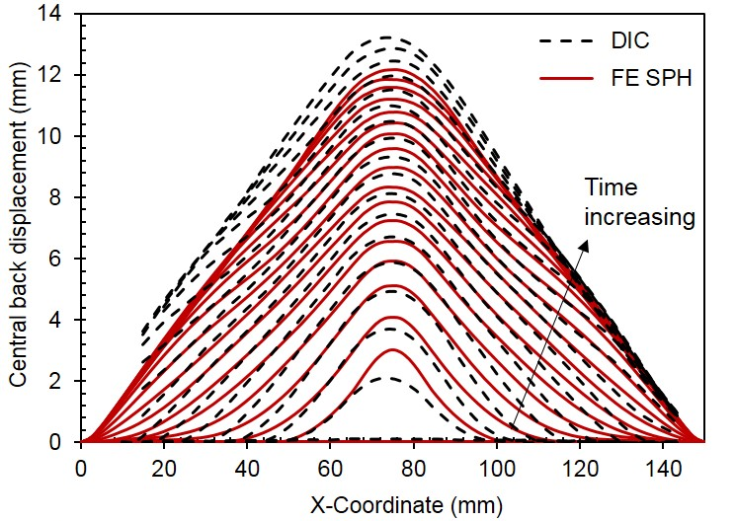
(a)
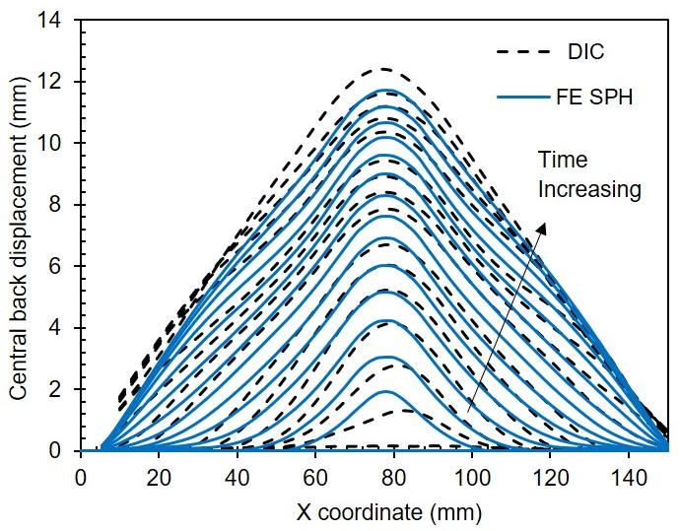
(b)
Figure 17: Out of plane displacement along the width of the sample for (a) rubber impact at 122 ms⁻¹ and (b) gelatine impact at 122 ms⁻¹ on aluminium target; comparison between experimental data and numerical simulation.
The time increment between consecutive curves in Figures 17(a) and 17(b) is 25 μs with the final curve corresponding to 0.5 ms. The latter is approximately equal to the time of the peak displacement shown in Figures 16 (a) and 16(b).
A reasonable agreement between the experimental data and the numerical predictions is observed for both rubber and gelatine projectiles along the whole width of the target though the DIC data towards the edges are missing since the edges were not tracked by the camera during the impact test.

5.2. Laminated glass target
The comparison described in the section above between the experimental and numerical data for the aluminium target was replicated for the case of the laminated glass impact. The history plots of the central displacement for rubber and gelatine are compared in Figures 18(a) and 18(b) respectively whereas the displacement across the width of the target are plotted in Figures 19(a) and 19(b) for the two projectiles. The time increment between consecutive curves in Figures 19 is again 25 μs with the final curve corresponding to 0.5 ms. The latter is approximately equal to the time of the peak displacement shown in Figure 19. Similar observations are made regarding the accuracy of the simulation predictions as in the case of the aluminium target. The agreement between the experiments and simulations is once again demonstrated, lending more confidence in the generated numerical models.

(a)
(b)
Figure 18: Central displacement of laminated glass target versus time (a) rubber impact at 118 ms⁻¹; (b) gelatine impact at 128 ms⁻¹
(a)
(b)

Figure 19: Out of plane displacement along the width of the laminated glass target; comparison between experimental data and numerical simulation: a) rubber impact at 118 ms⁻¹ (b) gelatine impact at 128 ms⁻¹.
As already stated, fractures occurred in the laminated glass structure under rubber impact for speeds equal to or higher than 145 ms⁻¹ which corresponds to a momentum of approximately 4 kgms⁻¹. These are shown in Figure 20. However, a gelatine projectile carrying the same momentum at the speed of 154 ms⁻¹ (see Figure 11(d)), did not lead to fracture on the surface of the laminated glass window. In addition, the target’s compliance (shown as out of plane displacement and major strain) was found to be roughly the same for both projectiles at the same momentum. Hence, the reason why the fracture occurs during the rubber impact but not with the gelatine impact at the same momentum and compliance was investigated. Another important parameter, the contact pressure, was examined to enable comparisons between the gelatine and rubber impact tests.

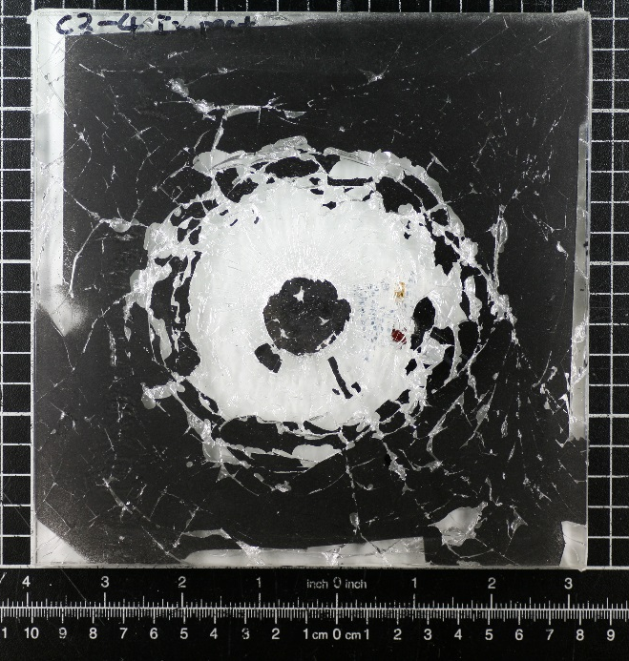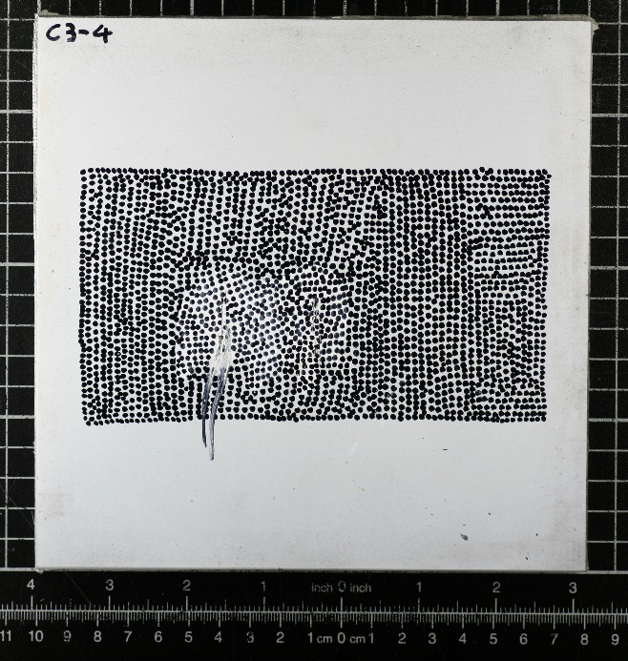
(b)
(a)

Figure 20: Impact damage on a laminated glass: (a) impact face and (b) rear face caused by a rubber projectile impacted at velocity of 168 ms⁻¹. The glass front face is painted black prior to impact.

As soon as the projectile comes into contact with the front surface of the target, a shock wave is generated that then propagates along the projectile (Wilbeck 1978). The high intensity pressure behind the shock wave in the projectile is called the “Hugoniot pressure”, P_{H}, and depends on the initial density (ρ₀) and velocity of the projectile (V₀) as well as the shock wave speed in the projectile material (V_{s}):
$P_{H}=ρ_{0}V_{0}V_{s}$ Equation 4
Since both rubber and gelatine projectiles were modelled using the Mie-Grüneisen EoS approach with the assumption of a linear relationship between the velocity of the projectile $V_{0}$ and the shock wave speed in the projectile ($V_{s}$), the shock wave speed relationship to the particle/projectile speed is:
$V_{s}=c_{0}+sV_{0}$ Equation 5
where c₀ is the speed of sound in the projectile and s is a material parameter.
The EoS material parameters used for rubber and gelatine projectiles in the simulation are shown in Table 2. These parameters together with the densities of 1090 kgm⁻³ and 968 kgm⁻³ for rubber and gelatine respectively are used in equation (5) which is then substituted in equation (4) to yield the following relationships for rubber (equation 6) and gelatine (equation 7):
$P_{H}=0.0005{V_{0}}^{2}+2.04V_{0}$ Equation 6

$P_{H}=1.43V_{0}$ Equation 7
The two theoretical Hugoniot pressure relationships of Equations 6 and 7 are compared in Figure 21. The analytical curves show a significant difference between the contact pressures arising from the rubber and gelatine impact in the early impact stages. This therefore could explain the earlier damage threshold velocity in the glass front layer when rubber was used as a projectile (see Figures 11 and 20) as the fracture in the frontal glass layer was observed to occur in the first few microseconds after the initial contact between the projectile and the glass. Therefore, the fracture is believed to be driven by the initial high intensity pressure (i.e. Hugoniot pressure). It is shown above that despite having similar densities, the different shock properties of rubber compared to gelatine projectile, cause a greater Hugoniot pressure for the rubber projectile even at the same momentum. It can be inferred that using a gelatine projectile can result in a higher damage threshold velocity for the frontal glass layer. This finding has important implications for other experimental studies where simulant physical models are employed. For structures such as glass which can be susceptible to fracture under short but high intensity pressure loading, not only the density and momentum of the projectile need to be considered but also the diameter as well as shock properties of the projectile material. The latter affects the duration and magnitude of the high intensity pressure phase respectively and should therefore be carefully selected.

Figure 21: A comparison between Hugoniot pressure at centre of target as calculated from theoretical predictions for rubber and gelatine projectiles
It was then attempted to determine the peak value of the contact pressure during the impact event from the SPH models presented earlier such that comparisons can be made with the theoretical values in Figure 21. As the projectile used in this study was a straight ended cylinder, the pressure across the projectile was almost uniform (results not shown). Therefore, the peak contact pressure was plotted by taking an average across the 484 nodes on the front glass layer of the target impacted by the projectile (see Figure 22 (a)). Figure 22 (b) shows the pressure results for a gelatine projectile on glass, at a speed of 128 ms⁻¹, plotted as a function of time. It is observed that two peaks occur before 10 μs. This was thought to be a result of the chosen mesh density; the second, lower peak coincided with the instant when the second row of particles hit the glass target. Therefore, it was decided to study the effect of mesh density on the contact pressure. Figure 23 shows the four meshes that were investigated, with ‘Mesh X’ designating the mesh corresponding to the results shown in Figure 22. The first three meshes (X, 2X and 4X) are uniform meshes of increasing mesh density as designated by the factor in front of X. The fourth mesh used biased discretisation and resulted in very small elements (0.01 mm) hitting the target during the initial impact when the peak pressure occurred. The effect of the mesh size on the peak pressure results are shown in Figure 24. Even though for larger times, the steady state pressure is not a function of mesh density, the initial pressure profile is seen to vary significantly. The double peaks are seen to disappear as the mesh density is increased and the results seem to converge but only after a time of 8 μs. Before that time, the peak pressure does not show any correlation to the mesh density. As the peak pressure occurs before that time, it is not possible therefore to use the SPH models to determine the value of peak pressures. It is worth noting here that the four meshes in Figure 23 led to similar results for all other quantities plotted in the preceding Figures; only the Hugoniot pressure was affected by the mesh.
The shape of the pressure profiles at small times is very jagged; this brought the question whether the sampling rate at which results from the numerical model are stored would also have an impact on the quoted peak pressure. Therefore, the sampling rate was varied from 4 MHz (corresponding to the data shown in Figure 24) to 10 MHz and 20 MHz. The effect of the sampling rate on the pressure profile is shown in Figure 25. Unfortunately, it is again shown that for times less than 3 μs, the results are not accurate in the sense that the peak pressure can not be identified; it varies between approximately 140 MPa to 310 MPa depending on the chosen sampling rate. Hedayati et al (Hedayati et al 2014) and Hedayati and Sadighi (Hedayati and Sadighi 2016) reviewed the literature regarding the calculation of Hugoniot (peak) pressures. A wide difference in pressures was reported when comparisons were made to experimental or theoretical data by several authors. The findings of our study could in fact explain these large discrepancies.

Figure 22: (a) Contours of contact pressure (in Pa) across the 484 nodes impacted by the projectile, (b) average contact pressure profile; both plots are for gelatine projectile fired on glass laminate target at an impact velocity of 128 ms⁻¹.
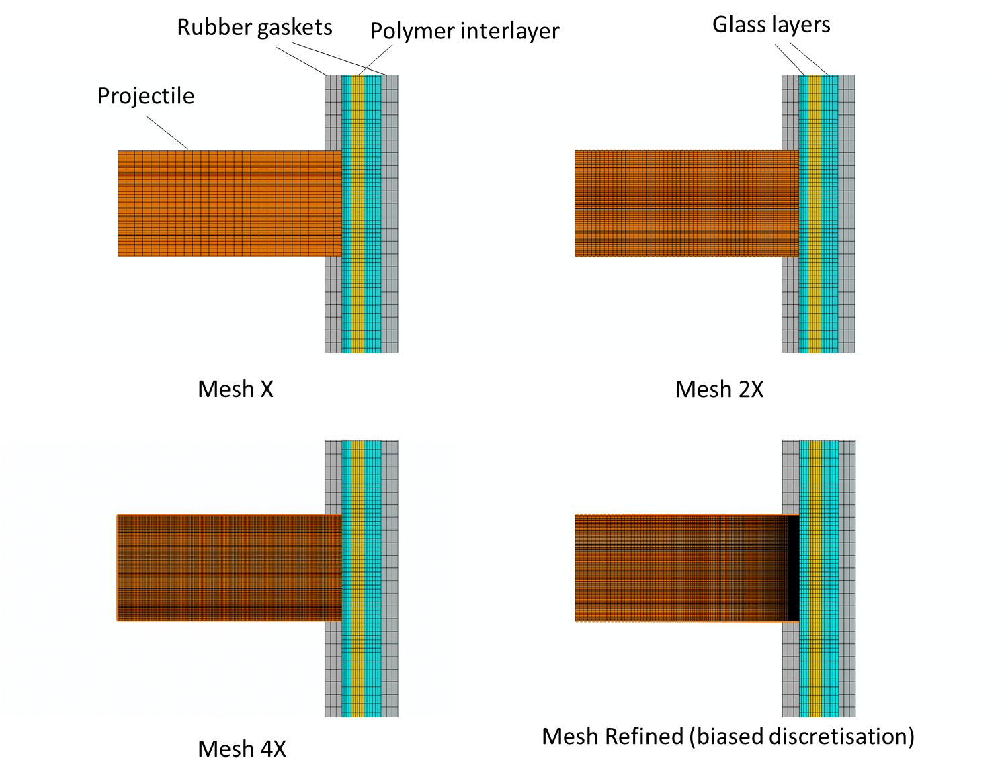
Figure 23: Four mesh designs used in the mesh sensitivity study of Hugoniot pressure. Mesh X corresponds to the results shown in Figure 23; Mesh 2X and Mesh 4X have twice and four times as many elements as Mesh X respectively. “Mesh refined” used biased discretisation to reduce the size of the elements in the rows hitting the target during the initial stages of the impact. The meshes were all converted to SPH particles as shown in Figures 8 and 9.

Figure 24: The effect of the projectile’s mesh design on the contact pressure profile for the four meshes shown in Figure 24. Results shown are for gelatine gel projectile fired on glass laminate target at an impact velocity of 128 ms⁻¹.

Figure 25: The effect of data sampling rate on the contact pressure profile. Results shown are for gelatine gel projectile on glass laminate target fired at an impact velocity of 128 ms⁻¹.

6. Conclusion
The response of aluminium and laminated glass targets under soft impact loading was investigated using both rubber and gelatine projectiles in order to simulate bird strikes on the fuselage and windshield of aircraft. Such collisions between birds and aircraft can lead to catastrophic events; therefore, new methods for measuring impact performance are paramount to develop efficient tools which may be employed to design against such events.
In this study, gas gun impact tests were performed at velocities from 110 to170 m s⁻¹ on a test matrix consisting of two target and two projectile materials for the first time. A high-speed 3D digital image correlation technique was employed to monitor and evaluate the impact performance of the two targets whilst a strain gauge was attached to the back surface of the glass target so that the DIC results could be validated. In addition to the experiments, simulations of the soft impact loading were also performed, based on the Smoothed Particle Hydrodynamics (SPH) approach. The model output as regards the out of plane displacement of the targets was found to match the experimental data, giving confidence in the developed models and indicating that these may be used in future design studies. The study showed that the displacements and strains induced in the two targets were independent of the type of the projectile material, i.e. rubber and gelatine led to similar displacement and strain fields for a given value of momentum. An interesting finding was that fracture was found to occur in the frontal glass layer of the laminated glass windows with rubber projectiles at momentum values above 3.9 kgms⁻¹. No fracture in the glass was observed for momentum values up to 4 kgms⁻¹ when using gelatine projectiles. This difference in results, was shown to be due to the higher Hugoniot pressure when rubber is used as bird simulant. Our study therefore highlights the importance of the shock properties of the bird simulant material on the impact loading of brittle structures such as glass. Finally, the study presented here provides a basis for performing scale-up investigations with the validated developed models being used in more realistic scenarios, i.e. a real bird strike against an aircraft windshield or fuselage. The latter would provide major cost savings as compared to alternative large-scale experimental studies.

Acknowledgement
The authors would like to acknowledge the support from Beijing Institute of Aeronautical Materials (BIAM). The research was performed at the BIAM-Imperial Centre for Materials Characterisation, Processing and Modelling at Imperial College London.

References

Abaqus Version 6.14. Dassault Systèmes Simulia Corp n.d.
Allan, J. R., and A. P. Orosz. 2001. “The Costs of Birdstrikes to Commercial Aviation.” Bird Strike Committee-USA/Canada, Third Joint Annual Meeting, Calgary, AB, 217–26.
ARAMIS. 2011. “User Information - Hardware. GOM.”
Barber, J. P., and J. S. Wilbeck. 1978. “Bird Impact Forces and Pressures on Rigid and Compliant Targets.” In , 1–78. Dayton, Ohio: Technical Report AFFDL-TR-77-60, University of Dayton Research Insitute.
Buyuk, M, S. Kan, and M. J. Loikkanen. 2009. “Explicit Finite-Element Analysis of 2024-T3/T351 Aluminum Material under Impact Loading for Airplane Engine Containment and Fragment Shielding.” Journal of Aerospace Engineering 22 (3): 287–95. doi:10.1061/(ASCE)0893-1321(2009)22:3(287).
Dear, J.P., Field, J.E., 1988. “High-speed photography of surface geometry effects in
liquid/solid impact”. J. Appl. Phys. 63, 1015–1021. doi:10.1063/1.340000
Dar, U. A., W. Zhang, and Y. Xu. 2013. “FE Analysis of Dynamic Response of Aircraft Windshield against Bird Impact.” International Journal of Aerospace Engineering 1–12. doi:10.1155/2013/171768.
Dassault Systems. 2012. “Best Practices for Bird Strike Simulations with Abaqus/Explicit.” DS Simulia.
Doubrava, R. 2011. “Test and Numerical Simulation of Bird Synthetic Model.” In SIMULIA Customer Conference, 1–7.
Doubrava, R, and V. Strnad. 2010. “Bird Strike Analysis on the Parts of Aircraft Structure.” In 27th International Congress of The Aeronautical Sciences, 1–4.
doi:10.1016/j.compstruct.2008.03.025.
Field, J.E., Lesser, M.B., Dear, J.P., 1985. “Studies of Two-Dimensional Liquid-Wedge Impact and Their Relevance to Liquid-Drop Impact Problems”. Proc. R. Soc. A 401, 225-249. doi:10.1098/rspa.1985.0096.
Gingold, R. A., and J. J. Monaghan. 1977. “Smoothed Particle Hydrodynamics: Theory and Application to Non-Spherical Stars.” Monthly Notices of the Royal Astronomical Society 181: 375–389.
Hanssen, A. G., Y. Girard, L. Olovsson, T. Berstad, and M. Langseth. 2006. “A Numerical Model for Bird Strike of Aluminium Foam-Based Sandwich Panels.” International Journal of Impact Engineering 32 (7): 1127–44. doi:10.1016/j.ijimpeng.2004.09.004.
Hedayati, R, and Sadighi, M. 2016. “Bird strike: an experimental, theoretical and numerical investigation”, Woodhead Publishing in Mechanical Engineering, Elsevier, ISBN: 978-0-08-100093-9.
Hedayati, R., Sadighi, M. and Mohammadi-Aghdam, M. 2014. “On the difference of pressure readings from the numerical, experimental and theoretical results in different bird strike studies”. Aerospace Science and Technology 32, 260-266.
Heimbs, S, and J. M. Guimard. 2011. “Towards the Industrial Assessment of Bird Strike Simulations on Composite Laminate Structures.” In Composites 3, 627–34. Munich, Germany.
Heimbs, S. 2011. “Computational Methods for Bird Strike Simulations: A Review.” Computers & Structures 89 (23–24). Elsevier Ltd: 2093–2112. doi:10.1016/j.compstruc.2011.08.007.
Iyama, H., Hamashima, H., Nishi, K., Itoh, S., 2009. Study on expansion of a silicon tube by underwater shock wave. In: Proceedings of the ASME 2009 Pressure Vessels & Piping Conference, pp. 1–5. doi:10.1115/PVP2009-77502.
Kangas, P., Pigman, G.L., 1948. “Development of aircraft windshields to resist impact with birds in flight part II~Investigation of windshield materials and methods of windshield mounting”, No. 4580001. SAE Technical paper. doi:10.4271/480001.
Langrand B, Bayart AS, Chauveau Y, Deletombe E. 2002. Assessment of multi-physics FE methods for bird strike modelling-Application to a metallic riveted airframe. International Journal of Crashworthiness. 7(4), 415–28.
Lavoie, M. A., A. Gakwaya, M. N. Ensan, D. G. Zimcik, and D. Nandlall. 2009. “Bird’s Substitute Tests Results and Evaluation of Available Numerical Methods.” International Journal of Impact Engineering 36 (10–11). Elsevier Ltd: 1276–87. doi:10.1016/j.ijimpeng.2009.03.009.
Li, L., S. H. Yang, C. Hwang, and Y. S. Kim. 2009. “Effects of String Tension and Impact Location on Tennis Playing.” Journal of Mechanical Science and Technology 23: 2990–97. doi:10.1007/s12206-009-0903-5.
Liu, J., Y. Li, and X. Gao. 2014. “Bird Strike on a Flat Plate: Experiments and Numerical Simulations.” International Journal of Impact Engineering 70. Elsevier Ltd: 21–37. doi:10.1016/j.ijimpeng.2014.03.006.
Macaloney, N., A. Bujanda, R. Jensen, and N. Goulbourne. 2007. “Viscoelastic Characterization of Aliphatic Polyurethane Interlayers.” Army Research Laboratory Reprt No: (October): ARL-TR-4296.
Montoney, A.J., and H. C. Boggs. 1995. Effects of a bird hazard reduction force on reducing bird/aircraft strike hazards at the Atlantic City International Airport, NJ. Proceedings of the Eastern Wildlife Damage Control Conference 6: 59-66.
Mohagheghian I, Stronge W.J., McShane G.J. 2017. Predicting indenter nose shape sensitivity for quasi-static perforation of thin metallic plates. European Journal of Mechanics A/Solids. 61, 134-150.
Mohagheghian, I., Y. Wang, J. Zhou, L. Yu, X. Guo, Y. Yan, M. N. Charalambides, and J. P. Dear. 2017. “Deformation and Damage Mechanisms of Laminated Glass Windows Subjected to High Velocity Soft Impact.” International Journal of Solids and Structures 109: 46–62. doi:10.1016/j.ijsolstr.2017.01.006.
Mohagheghian I, Charalambides M, Wang Y, Jiang L, Zhang X, Yan Y, Kinloch A, Dear J . 2018 “Effect of the polymer interlayer on the high-velocity soft impact response of laminated glass plates”, International Journal of Impact Engineering 120. 150-170. doi.org/10.1016/j.ijimpeng.2018.06.002
McCallum S., Shoji H. and Akiyama H. 2013. “Development of an advanced multi-material birdstrike model using the Smoothed Particle Hydrodynamics method. Int J Crashworthiness.18:579–97. doi.org/10.1080/13588265.2013.843498
Olson M.D., Nurick G.N., Fagnan J.R. 1993. Deformation and rupture of blast loaded square plates-predictions and experiments. International Journal of Impact Engineering.;13(2):279–91.
Onat, E. and Haythornthwaite, R., 1954. The Load Carrying Capacity of Circular Plates at Large Deflection. Journal of Applied Mechanics, 23, 49–55.
Qi, H.J, and Boyce, M.C. 2005. “Stress-strain behaviour of thermoplastic polyurethanes.” Mechanics of Materials 37, 817-839.
Salehi, H, S. Ziaei-Rad, and M. A. Vaziri-Zanjani. 2010. “Bird Impact Effects on Different Types of Aircraft Bubble Windows Using Numerical and Experimental Methods.” International Journal of Crashworthiness 15 (1): 93–106. doi:10.1080/13588260903047689.
Seidenman, P., and D. J. Spanovich. 2016. “How Bird Strikes Impact Engines.” Sourced from online: http://www.mro-network.com/maintenance-repair-overhaul/how-bird-strikes-impact-engines
Simonsen, B.C. and Lauridsen, L.P., 2000. Energy absorption and ductile failure in metal sheets under lateral indentation by a sphere. International Journal of Impact Engineering, 24(10), 1017–1039.
Smojver, I., and D. Ivančević. 2010. “Numerical Simulation of Bird Strike Damage Prediction in Airplane Flap Structure.” Composite Structures 92 (9): 2016–26. doi:10.1016/j.compstruct.2009.12.006.
Smojver, I, and D. Ivan. 2009. “Numerical Modelling of Impact Damage in Multi-Material Airplane Structure.” In 17th International Conference on Composite Materials, ICCM-17. Edinburgh, UK.
Smojver, I., and D. Ivančević. 2012. “Advanced Modelling of Bird Strike on High Lift Devices Using Hybrid Eulerian–Lagrangian Formulation.” Aerospace Science and Technology 23 (1): 224–32. doi:10.1016/j.ast.2011.07.010.
Smojver, I, and D. Ivančević. 2011. “Bird Strike Damage Analysis in Aircraft Structures Using Abaqus/Explicit and Coupled Eulerian Lagrangian Approach.” Composites Science and Technology 71 (4): 489–98. doi:10.1016/j.compscitech.2010.12.024.
Stoll, F, and R. A. Brockman. 1997. “Finite Element Simulation of High-Speed Soft-Body Impacts.” American Institute of Aeronautic and Astronautics. American Institute of Aeronautics and Astronautics. University of Dayton Research Institute Dayton, OH, USA.
Tabuani, D., Belluci, F., Terenzi, A. and Camino, G. 2012. “Flame retarded Thermoplastic Polyurethane (TPU) for cable jacketing application”. Polymer Degradation and Stability 97, 2594-2601.
Wang, F. S., and Z. F. Yue. 2010. “Numerical Simulation of Damage and Failure in Aircraft Windshield Structure against Bird Strike.” Materials and Design 31 (2). Elsevier Ltd: 687–95. doi:10.1016/j.matdes.2009.08.029.
Wang, J., Y. J. Xu, and W. H. Zhang. 2014. “Finite Element Simulation of PMMA Aircraft Windshield against Bird Strike by Using a Rate and Temperature Dependent Nonlinear Viscoelastic Constitutive Model.” COMPOSITE STRUCTURE 108 (2014). Elsevier Ltd: 21–30. doi:10.1016/j.compstruct.2013.09.001.
Wilbeck, J. S. 1978. “Impact Behavior of Low Strength Projectiles.” In Air Force Materials Laboratory, Technical Report AFML-TR-77-134, 1–115.
Xue, L., C. R. Coble, H. Y. Lee, D. Yu, S. Chaparala, and S. Park. 2017. “Dynamic Analysis of Thin Glass Under Ball Drop Impact With New Metrics.” Volume 1: Ad- Vanced Packaging; Emerging Technologies; Modeling and Simulation; Multi- Physics Based Reliability; MEMS and NEMS; Materials and Processes. ASME V0 01T03A0 06 Doi: 10.1115/IPACK2013-73291 ., 1–8.
Zakir, S.M. and Li Y. 2012. “Dynamic response of the leading edge wing under soft body impact”, International Journal of Crashworthiness, 17, 357-376. Doi: 10.1080/13588265.2012.661239.

