Supplementary Information for
Discovery of welcome biopolymers in surface water: Improvements on drinking water production

Zhaoyang Su,†,‡,⊥ Wenzheng Yu,*,†,‡ Ting Liu,§ Xing Li,‖ Nigel J.D. Graham,‡ Yonglong Lu,¶ and Mark R. Wiesner⊥,＃
†State Key Laboratory of Environmental Aquatic Chemistry, Research Center for Eco-Environmental Sciences, Chinese Academy of Sciences, Beijing 100085, China
‡Department of Civil and Environmental Engineering, Imperial College London, South Kensington Campus, London SW7 2AZ, UK
⊥Department of Civil and Environmental Engineering, Duke University, Durham, North Carolina 27708, USA
＃Center for the Environmental Implications of NaNotechnology (CEINT), Duke University, Durham, North Carolina 27708, USA
§School of Chemistry and Chemical Engineering, Beijing Institute of Technology, Beijing 100081, China
‖College of Architecture and Civil Engineering, Beijing University of Technology, Beijing 100024, China
¶State Key Laboratory of Urban and Regional Ecology, Research Center for Eco-Environmental Sciences, Chinese Academy of Sciences, Beijing 100085, China

zysu@rcees.ac.cn; zhaoyang.su@duke.edu, wzyu@rcees.ac.cn, liuting@bit.edu.cn, lixing@bjut.edu.cn, n.graham@imperial.ac.uk, yllu@rcees.ac.cn, wiesner@duke.edu
*To whom correspondence should be addressed
This PDF file includes:

Note S1. Analytical methods of organic matter
Note S2. Nuclear Magnetic Resonance (NMR) Spectroscopy
Note S3. Bioinformatics derived from source water
Note S4. Fourier Transform infrared (FTIR) spectroscopy
Note S5. Inductively coupled plasma-optical emission spectroscopy (ICP-OES)
Note S6. Floc characteristics analyses
Note S7. Membrane pore measurement
Figure S1. Molecular weight distribution of organic matter in the microfiltration and ultrafiltration filtrates.
Figure S2. SEM observations of biopolymers in Jingmi River.
Figure S3. EDS mapping of biopolymers in Jingmi River.
Figure S4. SEM observations on reference biopolymers.
Figure S5. 1H NMR spectra of reference polysaccharides.
Figure S6. Floc formation, breakage and settlement processes, and their zeta potential.
Figure S7. The distribution of different constituents in the specific feedwater containing five metals (Fe, Al, Cu, Mn and Cr).
Figure S8. Adsorption/complexation of biopolymers (River Thames) on aquatic metal pollutants.
Figure S9. The distribution of cake layer depth formed with and without biopolymers in Jingmi River.
Figure S10. Improved performance of membrane nanofiltration with and without biopolymers (River Thames).
Figure S11. EEM spectra of membrane filtrates (River Thames).
Figure S12. Morphology observations and analyses of the fouled membrane surface (River Thames) using AFM.
Table S1. Principal water quality characteristics of raw waters collected in China and UK.
Table S2. A summary of researches on coagulation influenced by biopolymers.
Table S3. EDS analysis of the membranes.
Table S4. A summary of researches on metal ion(s) adsorption by biopolymers.
References 1–24

Note S1. Analytical methods of organic matter
For general understanding of the concentration of organic matter, samples previously filtered by 0.45 μm cellulose acetate membrane were simultaneously measured using a total organic carbon (TOC) analyzer (TOC-VWP, Shimadzu, Japan) and an ultraviolet/visible spectrophotometer (U-3010, Hitachi, Japan), and denoted as dissolved organic carbon (DOC) and UV absorbance at 254 nm (UV₂₅₄) respectively.
Fluorescence fingerprints (EEM) of water samples were measured using a spectrophotometer (F-4600, Hitachi, Japan) equipped with a 150 W xenon lamp at ambient temperature of 25 ± 2 ºC. In this work, emission scans were conducted from 250 to 550 nm at 5 nm steps, and excitation wavelengths ranged from 250 to 450 nm at an interval of 5 nm. The scanning speed was maintained at 2000 nm/min, and the detector was selected at the high-sensitive level for all measurements. Prior to targeted samples, the spectrum for ultrapure water from the Milli-Q purification system was used to eliminate background noise and Raman scattering. The final EEM spectra are plotted as the elliptical contour which gives fluorescent intensity in 2D mapping.
The distribution of apparent molecular weight (MW) of UV-active organic substances was investigated via size exclusion chromatography (SEC) method using a high-performance liquid chromatography system (HPLC, Alliance 2695, Waters corp., USA) equipped with a BIOSEP-SEC-S3000 column (Phenomenex, UK) (7.8 mm × 300 mm) and a Security Guard column (GFC-3000 disc 4 mm (ID)). 10 mM sodium acetate (Aldrich, USA) was employed as the mobile phase at a predetermined flow rate of 1 mL/min. Prior to operation, the mobile phase was continuously pumped for at least 3 hours to rinse the column and the whole system. The injection volume of samples was set as 100 μL and the UV/Visible detector (2489, Waters corp., USA) operated at a wavelength of 254 nm with autosampler (2707, Waters corp., USA). A standard working curve was established using reference polystyrene sulfonate materials (PSS; American Polymer Standard Corp., US).

Note S2. Nuclear Magnetic Resonance (NMR) Spectroscopy
NMR spectra of the target polymers were studied by a spectrometer (AVANCE IIITM 400 MHz, Bruker, Switzerland) equipped with a multinuclear CryoProbe (BrukerBioSpin, Germany). Three reference polysaccharides (5 mg), alginate, xanthan gum, and cellulose, were purchased from Sigma-Aldrich Corp., and were dissolved in 0.5 mL deuterium oxide (D₂O, 99.9%). The samples containing lyophilized biopolymers extracted from the rivers Jingmi and Thames were prepared in a similar manner at a concentration of 20 mg/mL. MestReNova software (v 12.01) was employed for the following NMR data analyses.
The similarities among different NMR spectra were visually presented using non-metric multidimensional scaling (NMDS).¹ Hierarchical clustering with the complete linkage method was analyzed based on R Studio (http://www.rstudio.org/). The dissimilarity matrix was calculated using the Bray-Curtis coefficient included in the community ecology package vegan (http://CRAN.R-project.org/package=vegan).

Note S3. Bioinformatics derived from source water
Source water (~ 2 L) was filtered through a 0.22 μm hydrophilic nylon membrane (Millipore, USA) immediately after sampling. This membrane was placed in a 2.0 ml sterilized centrifuge tube and stored at -80 ⁰C until further analysis. DNeasy PowerWater kit (14900-50-NF, QIAGEN GmbH, Germany) was used for DNA extraction of the filter membranes according to the manufacturer’s protocol. The universal primers were adopted to amplify the hypervariable regions of 18S ribosomal RNA (rRNA) and 16S rRNA. Therein, primer pair of 1380 forward (5′- TCCCTGCCHTTTGTACACAC-3′ and 1510 reverse (5′-CCTTCYGCAGGTTCACCTAC-3′) was used for amplification of V9 region in 18S rRNA; 341 forward (5′-ACCTACGGGRSGCWGCAG-3′) and 518 reverse (5′-GGTDTTACCGCGGCKGCTG-3′) was for regions of V3-V4 in 16S rRNA.^{2,3} All primers were synthesized in Sangon Biotech Co., Ltd (Shanghai, China) and sequencing was performed in Novogene company (Beijing, China).

Note S4. Fourier Transform infrared (FTIR) spectroscopy
The samples of lyophilized biopolymers were put onto a clean gold mirror, and the infrared reflection spectra were collected using a FTIR spectrometer (Nicolet iN10, Thermal, USA) within a scan range from 500 nm to 4000 nm. The final data were obtained with a mean spectrum of 3 scans.

Note S5. Inductively coupled plasma-optical emission spectroscopy (ICP-OES)
The metal concentration in water samples was measured by an Inductively Coupled Plasma Optical Emission Spectrometer (Optima 7000DV, Perkin Elmer, USA). Prior to measurement, water samples were filtered using 0.45 μm cellulose acetate membrane to remove large particles and then adjusted to pH 2 by adding 0.1 M HCl solution.

Note S6. Floc characteristics analyses
The strength and recoverability of flocs were evaluated in terms of an indicator, FI value, which is dimensionless and strongly proportional to the value of floc size, and a specified mixing procedure (Figure S6a) was set according to the literature.⁴ Floc setteleability was investigated based on the decreased ratio of FI value vs. time (Figure S6b).
Particularly, the strength and recovery factors were calculated via the following equations:
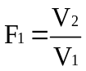(strength factor) (1)
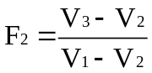(recovery factor) (2)
Where V₁ is the maximum FI value before floc breakage; V₂ is the minimum FI value when flocs are broken, and V₃ is the maximum FI value after regrowth of broken flocs.
Floc size distributions were measured using a laser diffraction instrument (Mastersizer 3000, Malvern, UK) which gives precise information on floc size ranging from 0.01 μm to 3500 μm, and the stirring parameters and systems were the same as the coagulation experiment by PDA 2000. The volume median equivalent diameter (d_{0.5}) was quoted as the representative floc size, and the plotted data were obtained from three repeated experiments.
Flocs were carefully withdrawn during the slow mixing period and their images were immediately captured using an optical microscope (Axioskop 2, Zeiss, Germany) which was equipped with a CCD camera (AxioCam MRm, Zeiss, Germany). The camera has a sensor matrix consisting of 1388 (horizontal) × 1040 (vertical) pixels, and thus 1 pixel representing 0.62 μm.

Note S7. Membrane pore measurement
NF membrane was first thoroughly rinsed using DI water to remove residues left during production (such as glycerinum) and then cut into several small strips. The distribution of membrane pore size was analyzed using these small strips by a pore size analyzer (ASAP 2460, Micromeritics, USA).

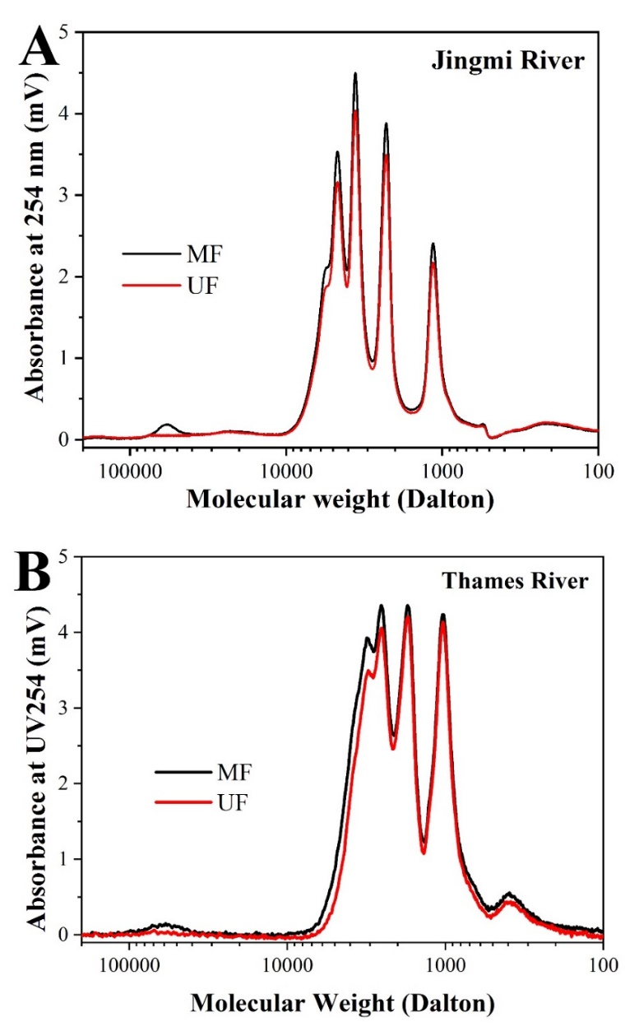
Figure S1. Molecular weight distribution of organic matter in the microfiltration and ultrafiltration filtrates. Water samples were collected from (A) Jingmi River in summer and (B) Thames River in autumn. Spectra of UV-active organic matter were determined at 254 nm. Organic matter with a molecular weight ranging from 30 kDa to 90 kDa are described as biopolymers. Cellulose acetate microfiltration membrane (MF - membrane pore size: 0.45 μm) and PES ultrafiltration membrane (UF - MW cutoff: 20 kDa) were employed here to separate organic matter.
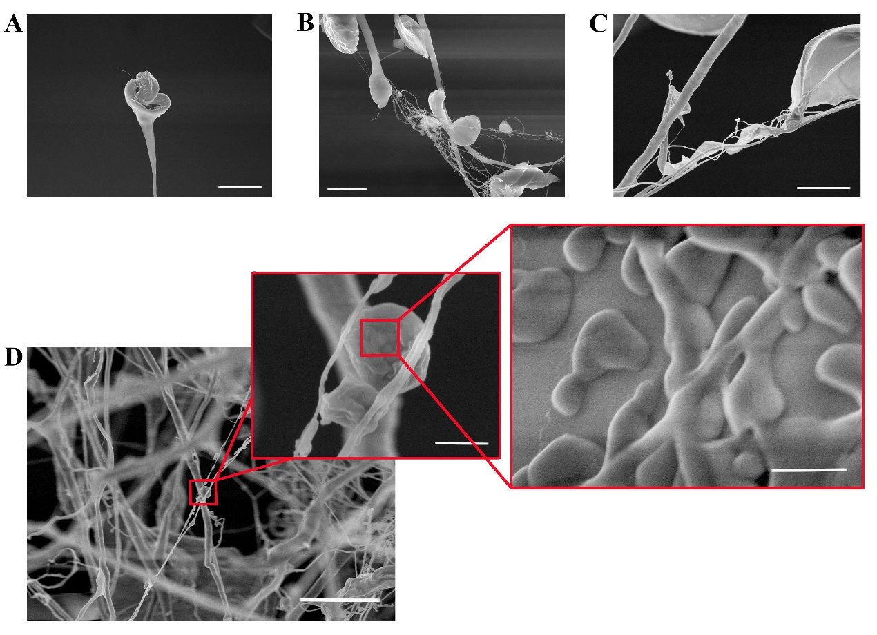
Figure S2. SEM observations of biopolymers in Jingmi River. These representative photographs A-D display the various morphologies of biopolymers which are excreted by different microbes. The scale bars are: in A and B 20 μm (1k ×) and 10 μm (2k ×) respectively; in C 5 μm (5k ×); in D 5 μm (10k ×), 0.5 μm (50k ×) and 0.125 μm (10k ×) from left to right, respectively.
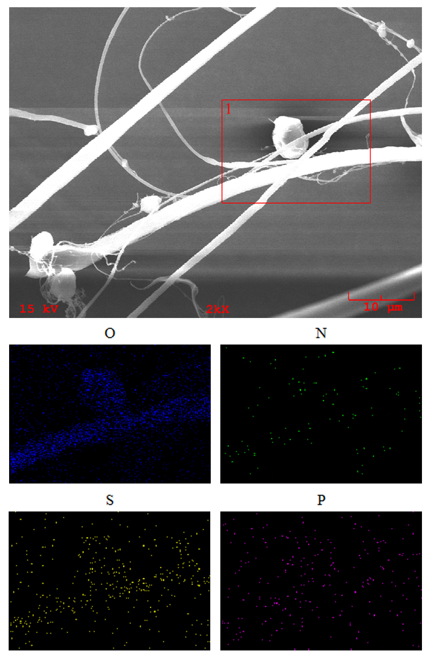
Figure S3. EDS mapping of biopolymers in Jingmi River. The preparation method was the same as that described in Figure S5. EDS mapping was performed within a predetermined duration of 15 min.
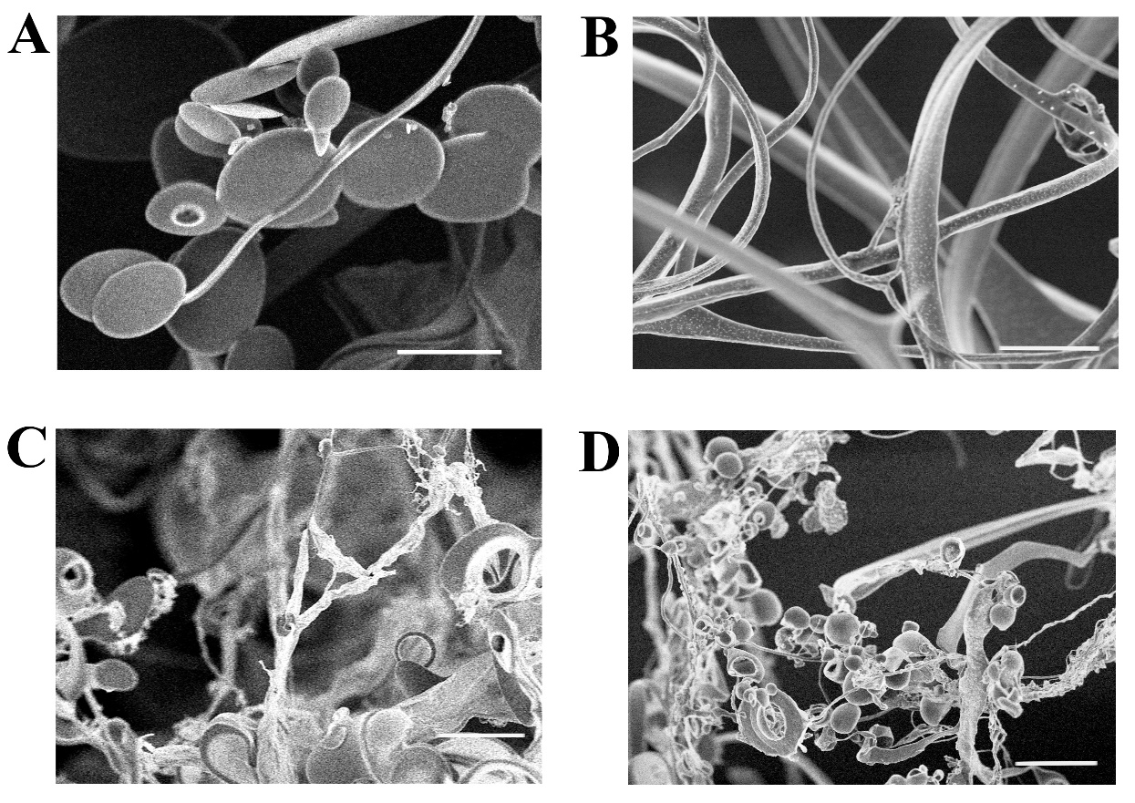
Figure S4. SEM observations on reference biopolymers. (A) bovine serum albumin and (B) sodium alginate. These biopolymers were dissolved in DI water at a concentration of 5 mg/L, and then freeze-dried for 48 hours. Lyophilized biopolymers were carefully fastened onto a silicon slice with intact structure by using conductive adhesive. The scale bars in both images (5k ×) are 5 μm. Mass ratios of BSA: SA: (C) 2:8 and (D) 8:2. The total concentration was 5 mg/L. The preparation and observation processes were same as those indicated in Supplementary Figure 6. SEM images (2k ×) of blended reference biopolymers (BSA and SA) at different ratios. The scale bars in both images are 10 μm.
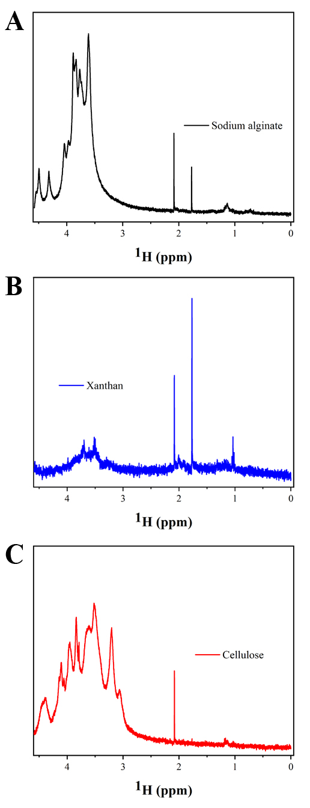
Figure S5. ¹H NMR spectra of reference polysaccharides. (A) sodium alginate, (B) xanthan gum and (C) cellulose. For NMR spectra measurements, three reference polysaccharides were dissolved beforehand in deuterium oxide (D₂O, 99.9%) at a concentration of 10 mg/mL.
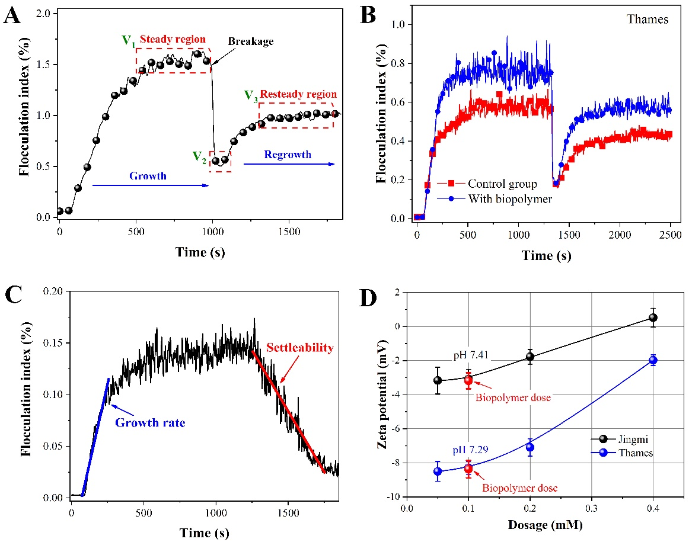
Figure S6. Floc formation, breakage and settlement processes, and their zeta potential. (A) Floc growth and regrowth after breakage. The specific mixing parameters were as follows: (1) coagulation stage: 300 rpm for 1min and 50 rpm for 15 min; (2) breakage stage: 300 rpm for 1 min; (3) regrowth stage: 50 rpm for 15 min. (B) Enhanced coagulation performance with aid of natural biopolymers extracted from Thames River. Floc growth (15 min) and reformation (10 min) after breakage (1 min) with and without biopolymers monitored by PDA 3000 and recorded at an interval of 1 s. (C) A representative floc growth and settlement process. (D) Zeta potential of flocs at various alum doses with and without biopolymers. The specific mixing settings were: 1 min rapid mixing at 300 rpm and 15 min slow mixing at 50 rpm. After the mixing, 15 min quiescent settlement was applied to evaluate floc settleability. Detailed procedure for biopolymers addition: 1 ml prepared solution (200 mL extraction was separated and concentrated from 10 L source water; TOC 17.3 mg/L) was added 60 s after 0.1 mM Al₂(SO₄)₃ (calculated as Al) dosing.
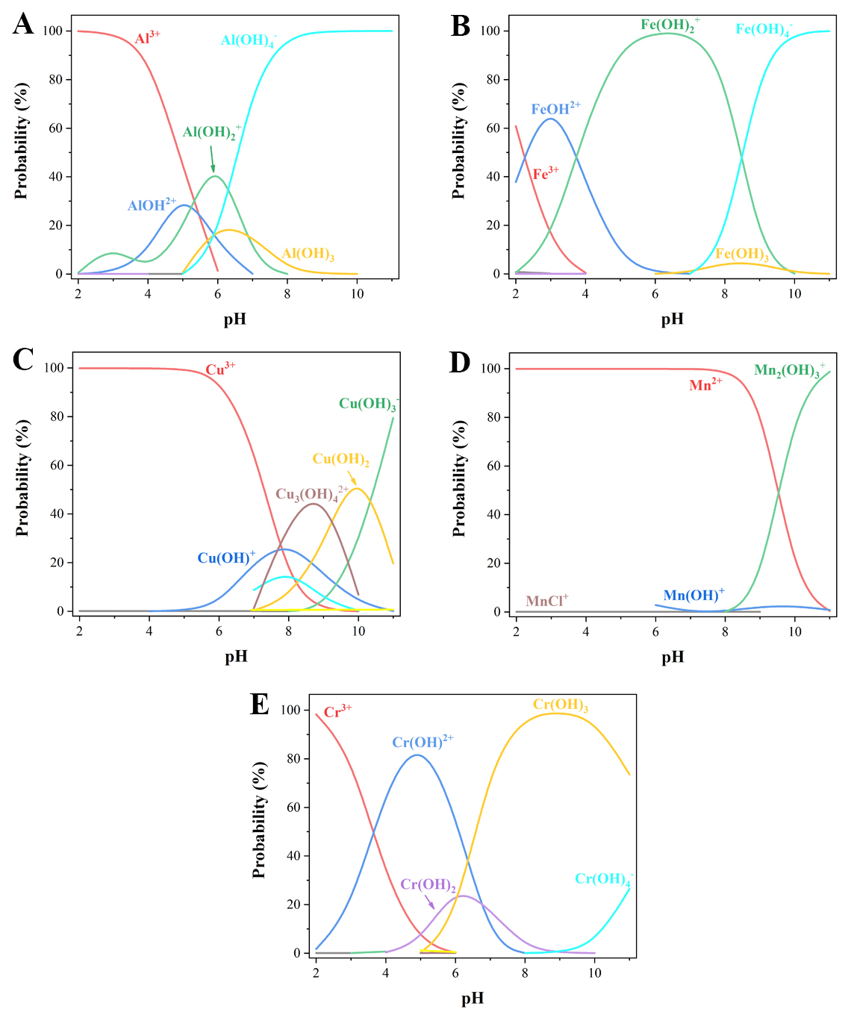 Figure S7. The distribution of different constituents in the specific feedwater containing five metals (Fe, Al, Cu, Mn and Cr). This feed was prepared using DI water and the final pH was adjusted to 4. The concentration of each metal was 2 mg/L. This distribution was calculated using Visual MINTEQ software (version 3.11).
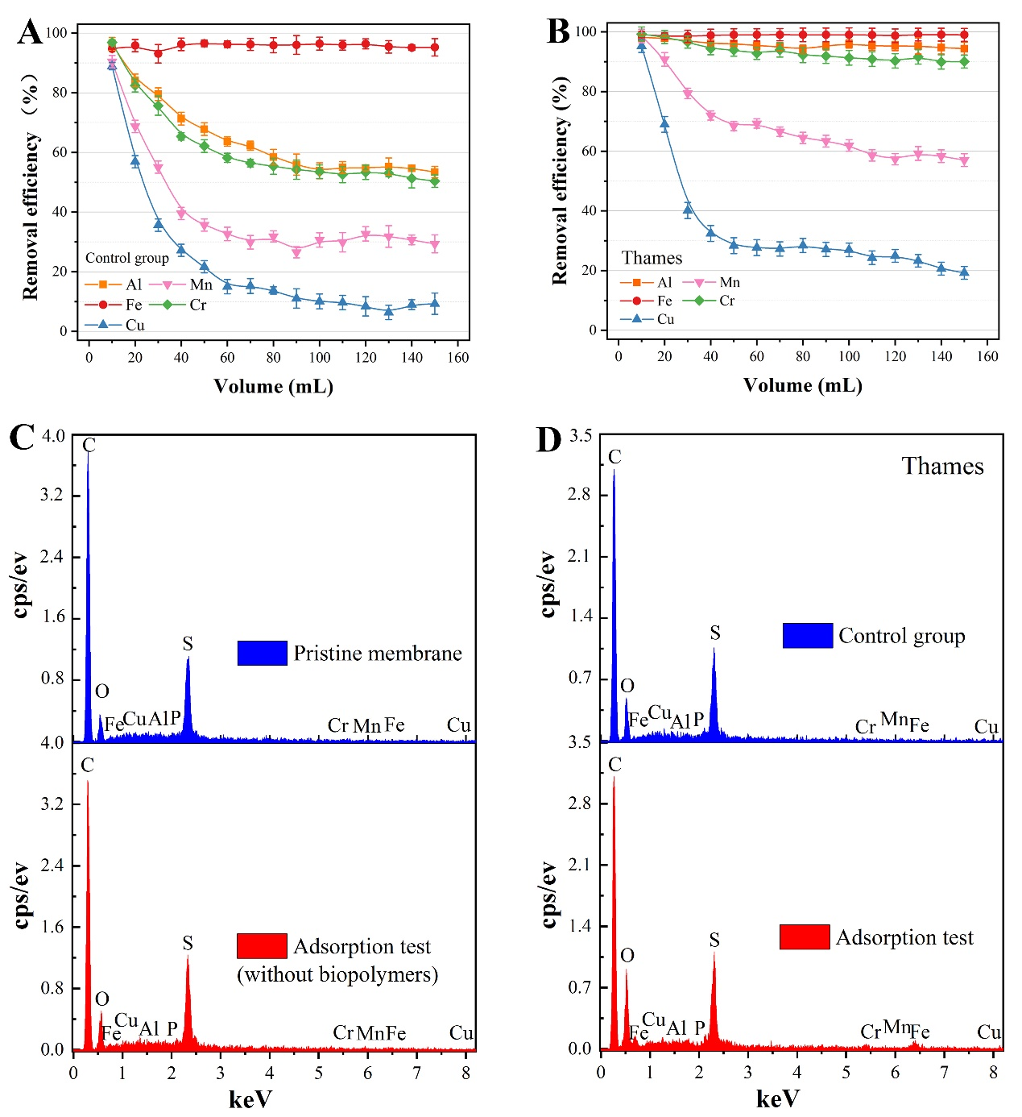
Figure S8. Bioadsorptive function of biopolymers (River Thames) on aquatic metal pollutants. Adsorption performance of the pristine 20 kDa PES membrane (A) and the group containing biopolymers (B) as indicated by removal efficiency of metal pollutants. The concentration of each metal ion in the feed was 2 mg/L. (C) EDS spectra of the pristine PES UF membrane (upper) and that fouled by metal contaminants (lower). (D) EDS spectra of pre-deposited biopolymers (Thames) membrane (upper) deNoted as ‘control group’ here and that filtered by metal-contaminated feed (lower).
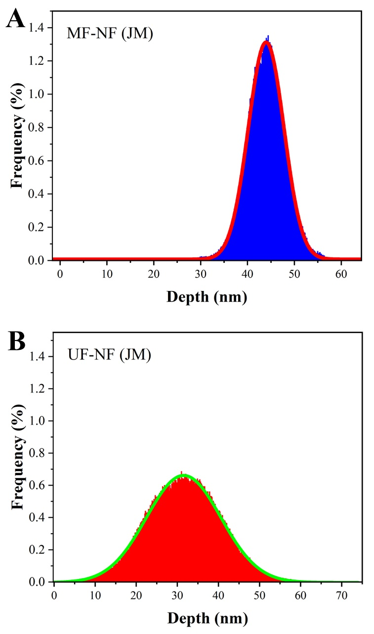
Figure S9. The distribution of cake layer depth formed with (upper, A), and without (below, B), biopolymers in Jingmi River. These results were obtained from AFM measurement by using Nanoscope Analysis software (version v1.5).
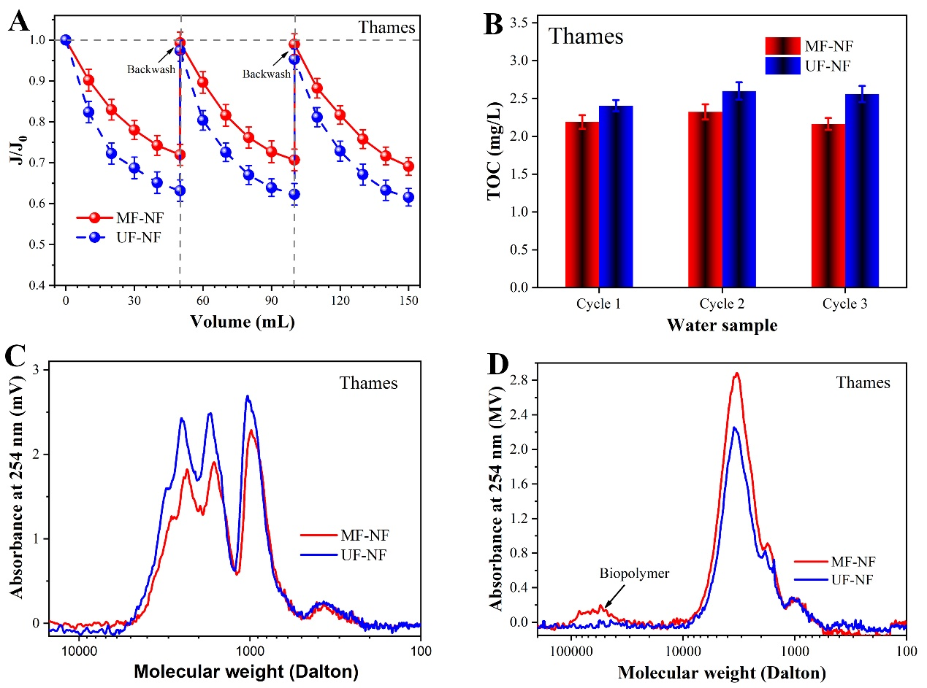
Figure S10. Improved performance of membrane nanofiltration with and without biopolymers (River Thames). (A) Normalized NF flux (J/J₀) decline with permeate volume (J₀ = 9.13±0.41 L/m².h.bar); MF/UF-NF filtration was carried out for 3 cycles (50 mL filtration followed by backwash using 10 mL DI water). (B) Total organic matter (TOC) in MF-NF and UF-NF filtrates. Molecular weight distribution of organic matter in filtrates (C) and backwashing samples (D).
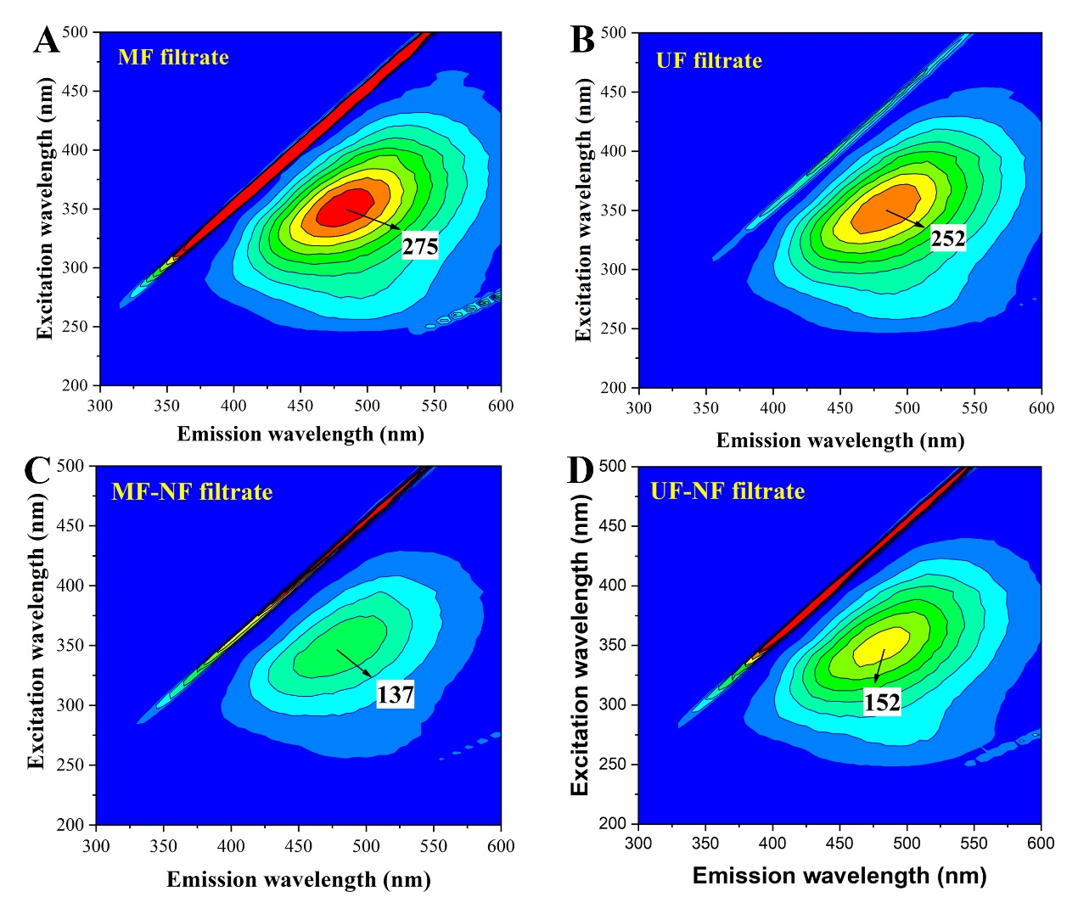
Figure S11. EEM spectra of membrane filtrates (River Thames). (A) MF filtrate, (B) UF filtrate, (C) MF-NF filtrate and (D) UF-NF filtrate. The maximum value of scale bars in A, B and C, D were 300 and 200 A.U. respectively.
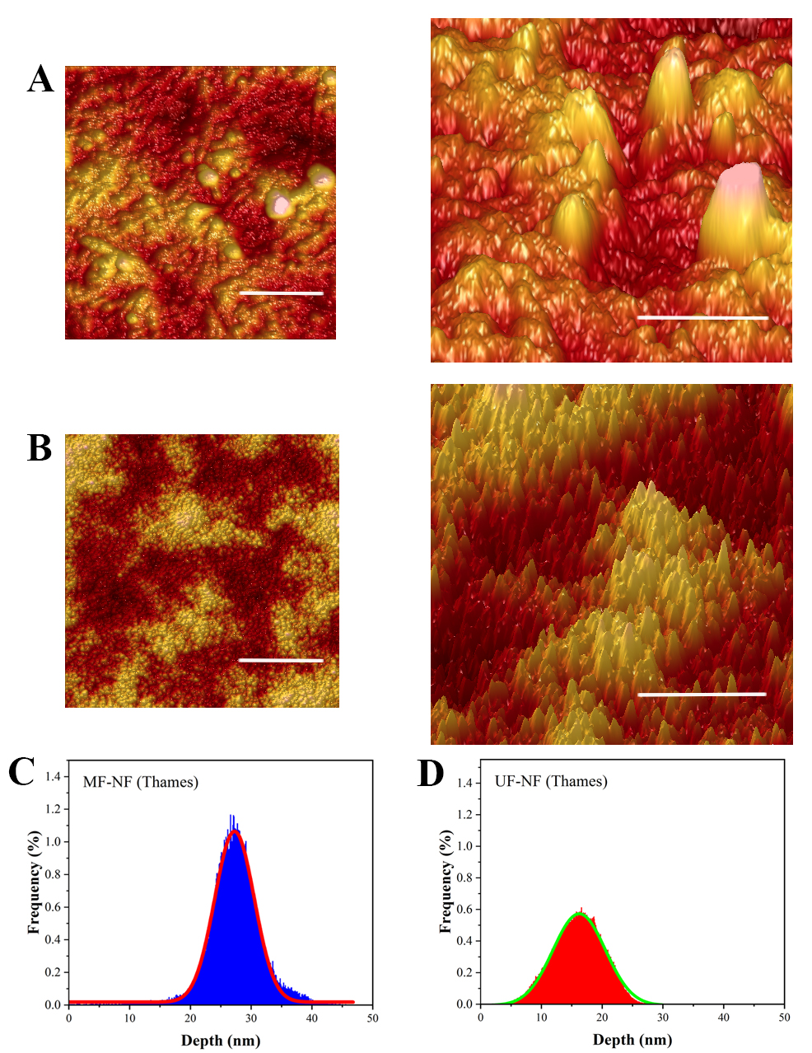
Figure S12. Morphology observations and analyses of the fouled membrane surface (River Thames) using AFM. (A) MF-NF and (B) UF-NF membranes; top-view image (left) and 3D structure image (right). The scale bars in top-view images and 3D images are 1 μm and 0.5 μm respectively. The distribution of cake layer depth formed with (C) in left and without (D) in right biopolymers (River Thames). These results were obtained from AFM measurement by using Nanoscope Analysis software (version v1.5)

Table S1. Principal water quality characteristics of raw waters collected in China and UK
 | UV₂₅₄  (cm⁻¹) | TOC  (mg/L) | Turbidity  (NTU) | Zeta potential (mV) | pH | Conductivity (μS/cm) | Ca²⁺  (mg/L) | Mg²⁺  (mg/L) | Al³⁺  (mg/L) | Fe³⁺  (mg/L)
Jingmi River (S) | 0.071 ± 0.009 | 4.14 ± 0.19 | 4.78 ± 1.95 | -3.46 ± 1.26 | 7.67 ± 0.22 | 233 ± 41 | 75.82 ± 0.73 | 5.96 ± 0.42 | 0.08 ± 0.02 | < 0.02
Thames River (A) | 0.127 ± 0.015 | 3.28 ± 0.52 | 12.63 ± 2.23 | -11.73 ± 1.87 | 7.55 ± 0.32 | 501 ± 67 | 35.71 ± 0.26 | 9.97 ± 0.35 | 0.03 ± 0.01 | < 0.02
Note: ‘S’ for summer (sampling in July) and ‘A’ for autumn (sampling in September).

Table S2. A summary of researches on coagulation influenced by biopolymers
No. | Biopolymers | Source | Main findings | Ref.
1 | chitosan | commercially available | A novel chitosan-based flocculant exhibited higher contaminant removal efficiency, wider applicable pH range, and better floc properties, in comparison with polyaluminum chloride. | Yang, et al.⁵
2 | bacterial exudates | Bacillus megaterium TF10 | Biopolymers excreted by Bacillus megaterium TF10 improved flocculation performance, the functional constituents were polysaccharides, other than proteins. | Yuan, et al.⁶
3 | alginate | commercially available | Alginate and polyaluminum chloride showed a synergistic effect (positive) on organic matter and particles removal, and floc formation rate and size were also increased. | Zhao, et al.⁷
4 | alginate and bovine serum albumin (BSA) | commercially available | The presence of biopolymers significantly retarded the single-walled carbon nanotube aggregation rate (BSA < alginate < control). | Saleh, et al.⁸
5 | peptides and proteins | Microcystis aeruginosa | Coagulation was inhibited due to the formation of Fe-peptide/protein surface complexes at pH 6-7. | Pivokonsky, et al.⁹
6 | chitosan | commercially available | Chitosan not only acts as an adsor- bent, but also spontaneously coagulates to agglomerate the microalgae cells | Ahmad, et al.¹⁰
7 | algal exudates | Microcystis aeruginosa | The presence of algal biopolymers from Microcystis aeruginosa reduced the rate of aggregates formation, however, increase reactivity of iron oxide particles. | Garg, et al.¹¹
8 | chitosan | commercially available | The chitosan-based coagulant has bactericidal action through the breaking of bacterial cell walls by grafted quaternary ammonium salt | Yang, et al.¹²
9 | exopolysaccharide | Antarctic sea-ice bacterium | Exopolysaccharide enhanced decolorization in dye wastewater coagulation and contributed to form more effective ferric hydrolysis species to improve the floc aggregation. | Zhou, et al.¹³

Table S3. EDS analysis of the membranes
Element |  | Pristine membrane |  |  | Pristine membrane* |  |  | Pre-deposited biopolymers membrane (Jingmi) |  |  | Pre-deposited biopolymers membrane (Jingmi)* |  |  | Pre-deposited biopolymers membrane (Thames) |  |  | Pre-deposited biopolymers membrane (Thames)*
Elt. | Line | Intensity  (c/s) | Atomic  % | Conc wt.% | Intensity  (c/s) | Atomic  % | Conc wt.% | Intensity  (c/s) | Atomic  % | Conc wt.% | Intensity  (c/s) | Atomic  % | Conc wt.% | Intensity  (c/s) | Atomic  % | Conc wt.% | Intensity  (c/s) | Atomic  % | Conc wt.%
C | Ka | 161.90 | 85.109 | 74.56 | 119.30 | 82.331 | 70.27 | 114.38 | 83.487 | 72.23 | 37.99 | 53.293 | 36.58 | 106.31 | 81.503 | 70.62 | 76.62 | 68.980 | 53.49
N | Ka | .41 | 1.107 | 1.13 | .35 | 1.101 | 1.10 | .43 | 1.462 | 1.48 | 2.50 | 6.940 | 5.55 | .37 | 1.354 | 1.37 | 1.03 | 3.046 | 2.79
O | Ka | 13.00 | 8.159 | 9.52 | 13.52 | 10.201 | 11.60 | 11.08 | 8.875 | 10.23 | 30.46 | 25.933 | 23.71 | 13.29 | 11.557 | 13.34 | 25.2 | 19.570 | 20.45
Al | Ka | 7.00 | .407 | .80 | 5.88 | .449 | .86 | 5.91 | .450 | .88 | 8.64 | 1.252 | 1.93 | 3.53 | .304 | .59 | 4.78 | .490 | .86
P | Ka | 7.25 | .366 | .83 | 4.82 | .316 | .70 | 5.35 | .353 | .79 | 3.86 | .455 | .81 | 3.70 | .274 | .61 | 3.05 | .261 | .53
S | Ka | 78.00 | 3.872 | 9.06 | 63.45 | 4.074 | 9.28 | 66.22 | 4.292 | 9.91 | 48.30 | 5.429 | 9.95 | 55.22 | 4.005 | 9.26 | 53.02 | 4.370 | 9.15
Cr | Ka | 1.30 | .096 | .36 | 1.50 | .141 | .52 | 1.20 | .115 | .43 | 3.86 | .570 | 1.69 | .96 | .103 | .39 | 2.09 | .240 | .82
Mn | Ka | .86 | .073 | .29 | 1.22 | .132 | .51 | .90 | .100 | .39 | .96 | .169 | .53 | .90 | .111 | .44 | 0.98 | .128 | .96
Fe | La | 2.16 | .557 | 2.27 | 2.76 | .920 | 3.65 | 1.56 | .529 | 2.13 | 9.85 | 5.411 | 17.27 | 1.06 | .416 | 1.67 | 5.81 | 2.507 | 9.14
Cu | Ka | 1.41 | .255 | 1.18 | 1.45 | .335 | 1.51 | 1.44 | .337 | 1.54 | 1.44 | .548 | 1.99 | 1.42 | .373 | 1.71 | 1.44 | .408 | 1.81
‘*’ indicates the membrane fouled by metal contaminants during the adsorption test
Table S4. A summary of researches on metal ion(s) adsorption by biopolymers
No. | Biopolymers | Metal ion(s) | Major findings | Ref.
1 | γ-D-poly(glutamic acid) | U⁶⁺ | Biopolymers produced by Bacillus lichenformis were effective in absorbing uranium(VI), and performance was affected by their α-helical and/or a β-sheet structure. | He, et al.¹⁴
2 | poly(c-glutamic acid) | Hg²⁺ | An extracellular biopolymer, poly(c-glutamic acid) (c-PGA), presented a good capability of adsorbing mercury(II), and a maximum was reached at pH 6. | Inbaraj, et al.¹⁵
3 | biopolymers from Azotobacter spp. | Cd²⁺ and Cr⁶⁺ | Biopolymers produced by Azotobacter spp. played a key role in restricting the uptake of heavy metals by wheat plants which were cultivated in soils contaminated by cadmium and chromium. | Joshi, et al.¹⁶
4 | MerR protein | Hg²⁺ | A bacterial metalloregulatory protein can bind mercury with a high affinity and selectivity, demonstrated at an expected ratio of 0.5 mercury/biopolymer, and minimal binding of 100-fold competing heavy metals. | Kostal, et al.¹⁷
5 | chitin and chitosan | Au³⁺, Ni²⁺, Cu²⁺, and Sn²⁺ | Chitin and chitosan can be as adsorbents to recover valuable metals from leachates of mobile phone wastes. | Zazycki, et al.¹⁸
6 | chitosan modified by benzaldehyde | Mn²⁺, Fe²⁺, Co²⁺, Cu²⁺, Ni²⁺, Cd²⁺, and Pb²⁺ | A new biopolymer synthesized by using chitosan and benzaldehyde showed good adsorption capacity for various metal ions in all studied pH ranges. | Krishnapriya, et al.¹⁹
7 | ELPH12 protein | Cd²⁺ | An elastin-like polypeptide was exploited as a metal-binding biopolymer with high affinity toward cadmium in both contaminated water and soil. | Prabhukumar, et al.²⁰
8 | lignocellulosic from wheat bran | Cr⁶⁺ | Lignocellulosic substrate derived from wheat bran can be used to adsorb Cr(VI), combined with reduction of Cr(VI) into Cr(III) via the oxidation of lignin moieties. | Dupont, et al.²¹
9 | polysaccharides in sugar beet pulp | Pb²⁺, Cu²⁺, Zn²⁺, Cd²⁺, and Ni²⁺ | Polysaccharides in sugar beet pulp generated by sugar-refining factories showed to be an effective adsorbent for the removal of heavy metals from aqueous solutions | Reddad, et al.²²
10 | sodium alginate | Cr⁶⁺, Cd²⁺, Cr³⁺, Cu²⁺, and Co²⁺ | Sodium alginate was used as a template to generate mesoporous titania beads which could efficiently remove several metal ions from simulated wastewater. | Wu, et al.²³
11 | biopolymers from Bacillus subtilis | Pb²⁺, Cu²⁺, and Zn²⁺ | Biopolymers from Bacillus subtilis associated with minerals showed an improved immobilization of heavy metals. | Mikutta, et al.²⁴

References
(1) Gonzalez-Gil, G.; Thomas, L.; Emwas, A. H.; Lens, P. N. L.; Saikaly, P. E. NMR and MALDI-TOF MS Based Characterization of Exopolysaccharides in Anaerobic Microbial Aggregates from Full-Scale Reactors. Sci. Rep. 2015, 5, 14316.
(2) Amaral-Zettler, L. A.; McCliment, E. A.; Ducklow, H. W.; Huse, S. M. A Method for Studying Protistan Diversity Using Massively Parallel Sequencing of V9 Hypervariable Regions of Small-Subunit Ribosomal RNA Genes. PLoS One 2009, 4 (7), e6372.
(3) Klindworth, A.; Pruesse, E.; Schweer, T.; Peplies, J.; Quast, C.; Horn, M.; Glöckner, F. O. Evaluation of General 16S Ribosomal RNA Gene PCR Primers for Classical and next-Generation Sequencing-Based Diversity Studies. Nucleic Acids Res. 2013, 41 (1), e1.
(4) Yu, W. Z.; Gregory, J.; Graham, N. Regrowth of Broken Hydroxide Flocs: Effect of Added Fluoride. Environ. Sci. Technol. 2016, 50 (4), 1828–1833.
(5) Yang, Z.; Degorce-Dumas, J. R.; Yang, H.; Guibal, E.; Li, A.; Cheng, R. Flocculation of Escherichia Coli Using a Quaternary Ammonium Salt Grafted Carboxymethyl Chitosan Flocculant. Environ. Sci. Technol. 2014, 48 (12), 6867–6873.
(6) Yuan, S. J.; Sun, M.; Sheng, G. P.; Li, Y.; Li, W. W.; Yao, R. S.; Yu, H. Q. Identification of Key Constituents and Structure of the Extracellular Polymeric Substances Excreted by Bacillus Megaterium TF10 for Their Flocculation Capacity. Environ. Sci. Technol. 2011, 45 (3), 1152–1157.
(7) Zhao, Y. X.; Gao, B. Y.; Wang, Y.; Shon, H. K.; Bo, X. W.; Yue, Q. Y. Coagulation Performance and Floc Characteristics with Polyaluminum Chloride Using Sodium Alginate as Coagulant Aid: A Preliminary Assessment. Chem. Eng. J. 2012, 183, 387–394.
(8) Saleh, N. B.; Pfefferle, L. D.; Elimelech, M. Influence of Biomacromolecules and Humic Acid on the Aggregation Kinetics of Single-Walled Carbon Nanotubes. Environ. Sci. Technol. 2010, 44 (7), 2412–2418.
(9) Pivokonsky, M.; Safarikova, J.; Bubakova, P.; Pivokonska, L. Coagulation of Peptides and Proteins Produced by Microcystis Aeruginosa: Interaction Mechanisms and the Effect of Fe-Peptide/protein Complexes Formation. Water Res. 2012, 46 (17), 5583–5590.
(10) Ahmad, A. L.; Mat Yasin, N. H.; Derek, C. J. C.; Lim, J. K. Optimization of Microalgae Coagulation Process Using Chitosan. Chem. Eng. J. 2011, 173 (3), 879–882.
(11) Garg, S.; Wang, K.; Waite, T. D. Impact of Microcystis Aeruginosa Exudate on the Formation and Reactivity of Iron Oxide Particles Following Fe(II) and Fe(III) Addition. Environ. Sci. Technol. 2017, 51 (10), 5500–5510.
(12) Yang, Z.; Li, H.; Yan, H.; Wu, H.; Yang, H.; Wu, Q.; Li, H.; Li, A.; Cheng, R. Evaluation of a Novel Chitosan-Based Flocculant with High Flocculation Performance, Low Toxicity and Good Floc Properties. J. Hazard. Mater. 2014, 276 (51378250), 480–488.
(13) Zhou, W.; Shen, B.; Meng, F.; Liu, S.; Zhang, Y. Coagulation Enhancement of Exopolysaccharide Secreted by an Antarctic Sea-Ice Bacterium on Dye Wastewater. Sep. Purif. Technol. 2010, 76 (2), 215–221.
(14) He, L. M.; Neu, M. P.; Vanderberg, L. A. Bacillus Lichenformis γ-Glutamyl Exopolymer: Physicochemical Characterization and U(VI) Interaction. Environ. Sci. Technol. 2000, 34 (9), 1694–1701.
(15) Inbaraj, B. S.; Wang, J. S.; Lu, J. F.; Siao, F. Y.; Chen, B. H. Adsorption of Toxic mercury(II) by an Extracellular Biopolymer Poly(γ-Glutamic Acid). Bioresour. Technol. 2009, 100 (1), 200–207.
(16) Joshi, P. M.; Juwarkar, A. A. In Vivo Studies to Elucidate the Role of Extracellular Polymeric Substances from Azotobacter in Immobilization of Heavy Metals. Environ. Sci. Technol. 2009, 43 (15), 5884–5889.
(17) Kostal, J.; Mulchandani, A.; Gropp, K. E.; Chen, W. A Temperature Responsive Biopolymer for Mercury Remediation. Environ. Sci. Technol. 2003, 37 (19), 4457–4462.
(18) Zazycki, M. A.; Tanabe, E. H.; Bertuol, D. A.; Dotto, G. L. Adsorption of Valuable Metals from Leachates of Mobile Phone Wastes Using Biopolymers and Activated Carbon. J. Environ. Manage. 2017, 188, 18–25.
(19) Krishnapriya, K. R.; Kandaswamy, M. A New Chitosan Biopolymer Derivative as Metal-Complexing Agent: Synthesis, Characterization, and metal(II) Ion Adsorption Studies. Carbohydr. Res. 2010, 345 (14), 2013–2022.
(20) Prabhukumar, G.; Matsumoto, M.; Mulchandani, A.; Chen, W. Cadmium Removal from Contaminated Soil by Tunable Biopolymers. Environ. Sci. Technol. 2004, 38 (11), 3148–3152.
(21) Dupont, L.; Guillon, E. Removal of Hexavalent Chromium with a Lignocellulosic Substrate Extracted from Wheat Bran. Environ. Sci. Technol. 2003, 37 (18), 4235–4241.
(22) Reddad, Z.; Gerente, C.; Andres, Y.; Le Cloirec, P. Adsorption of Several Metal Ions onto a Low-Cost Biosorbent: Kinetic and Equilibrium Studies. Environ. Sci. Technol. 2002, 36 (9), 2067–2073.
(23) Wu, N.; Wei, H.; Zhang, L. Efficient Removal of Heavy Metal Ions with Biopolymer Template Synthesized Mesoporous Titania Beads of Hundreds of Micrometers Size. Environ. Sci. Technol. 2012, 46 (1), 419–425.
(24) Mikutta, R.; Baumgärtner, A.; Schippers, A.; Haumaier, L.; Guggenberger, G. Extracellular Polymeric Substances from Bacillus Subtilis Associated with Minerals Modify the Extent and Rate of Heavy Metal Sorption. Environ. Sci. Technol. 2012, 46 (7), 3866–3873.

