Supplementary Materials

eMethods
The CPRD Division within the Medicines and Healthcare Products Regulatory Agency has received Institutional Review Board approval for all observational research using de-identified CPRD data. This protocol was approved by the CPRD Independent Scientific Advisory Committee with protocol 17-044.

Variable creation
All medication use, including lipid-lowering therapies, were identified based on primary care prescription data. Laboratory values were based on test records available in CPRD. Baseline conditions, including the Charlson comorbidity index¹, were based on Read codes in the general practitioner record. These definitions were based, as much as possible, on definitions provided by the pay-for-performance Quality Outcomes Framework (QOF) business rules.^{2,3} Measured variables were averaged during the 2-year period prior to the index date and reported as descriptive characteristics of the cohort. Pre-treatment cholesterol measures were based on the mean value over the 2-year period prior to the initiation of lipid-lowering therapy. Hypertension was defined as the use of anti-hypertensive medication, a coded diagnosis of hypertension, or either a mean systolic pressure ≥ 140 mmHg, or mean diastolic pressure ≥ 90 over the 2 years prior to the index date. Vascular beds (range 1 to 3) were defined according to the REACH study.⁴
Polypharmacy was defined as individuals with at least five distinct chronic medications in the year prior to initiating lipid lowering therapy. This count included cardiovascular medications but not lipid lowering medications. Chronic disease medications were identified using categories defined in British National Formulary categories. Patients must have received at least 4 prescriptions in the year, with at least 273 days (9 months) between the earliest and latest prescriptions. ^{5,6}

Analyses
For categorical analyses of adherence, individuals switching intensity groups during the year were assigned to the category with the longest duration during the year; otherwise, intensity was based on the mean intensity across all days with a prescription during the year.

In the Cox proportional hazards models of adherence and intensity, other comorbid conditions were treated as fixed covariates and included initial use of high intensity therapy, sex, smoking status, hypertension status, anti-thrombotic medication use, CKD status (except CKD cohort), history of chronic CVD (i.e., carotid stenosis, peripheral artery disease, abdominal aortic aneurysm, or stable angina; CVD cohort only), diabetes status (except diabetes cohort), duration of diabetes (diabetes cohort only), atrial fibrillation status, and Charlson comorbidity score. History of an acute cardiovascular event and the initial treatment intensity were incorporated as stratification variables, allowing the baseline risk to vary across strata within the CVD cohort. In several models, when the tests of proportional hazards assumption were not met, covariates were incorporated as stratification factors instead of covariates, or vice versa. Due to the small ezetimibe sample size, we could not conduct a robust subgroup analysis and instead evaluated ezetimibe use as an independent predictor. Prior to finalizing the Cox proportional hazards models, we explored categorical and spline versions of the combined measure to ensure the results were consistent across model specifications.
For the analyses of LDL-C change, we used random effects regression models with random effects for patient and baseline LDL-C above 135 mg/dL, and fixed effects for age, sex, hypertension, smoking, CKD, diabetes, Charlson score, and year of follow up. Only available LDL measures were included in the model (i.e., there was no imputation). The mean of all available values within each year of follow-up was used.
All analyses involving hypothesis tests were conducted in the context of statistical models. We considered effects to be significant if the 95% CI did not cross the null measure of association (e.g., a hazard ratio of 1 or percent change of 0).
eFigure 1: Study Design
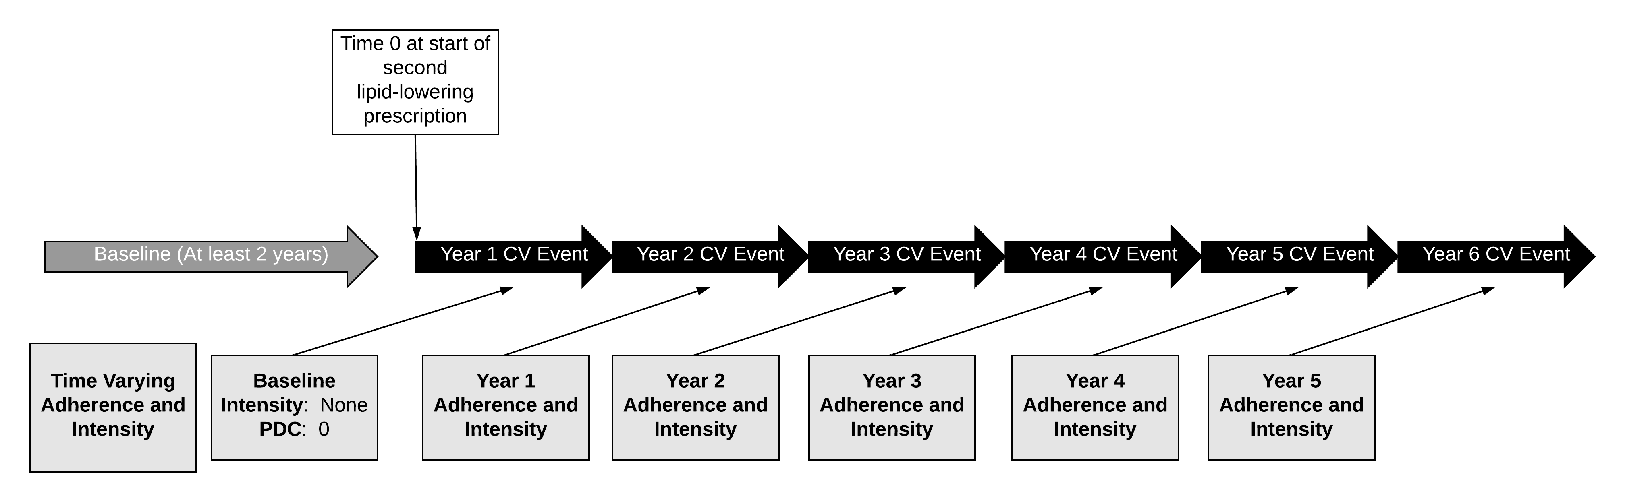
Note: The figure above shows the 1-year lag between the time-varying adherence and intensity measures and the cardiovascular (CV) outcome events. PDC = proportion of days covered.
eFigure 2: Attrition During Cohort Creation Process
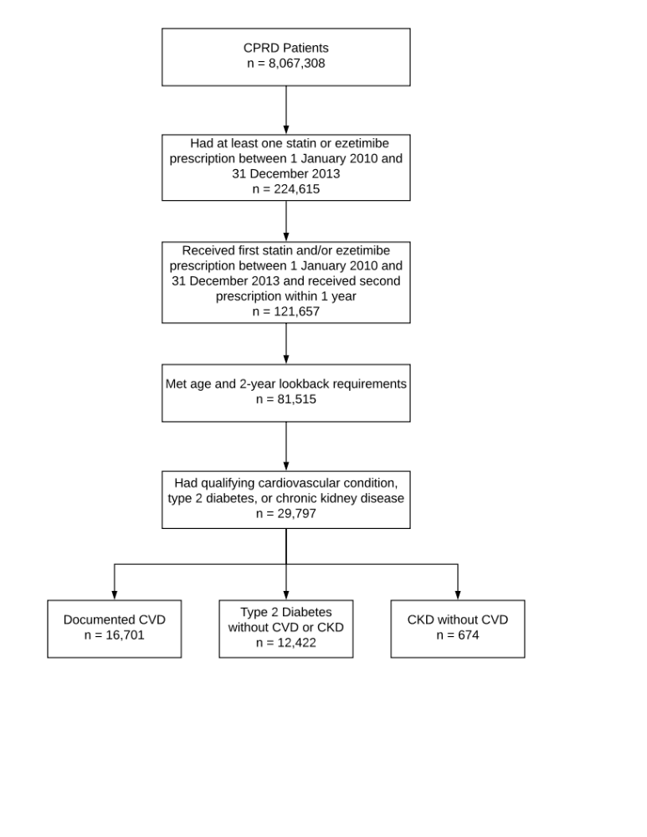

eFigure 2: Cumulative Number of Cardiovascular Events for Actual and Optimal Adherence and Intensity by Cohort
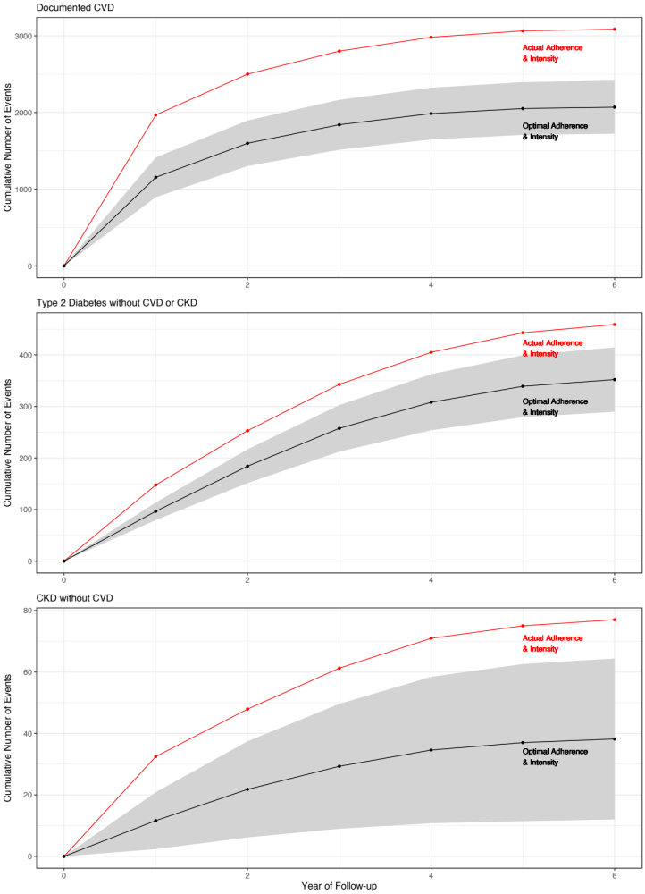
Note: Expected events for optimal adherence and intensity assume all patients achieve a combined measure of 50% (e.g., high intensity statin with a 55% expected LDL-C reduction and 91% adherence) for all follow-up. Shaded area reflects a confidence interval based on 100 bootstrap samples.

eTable 1: Estimated Percent LDL-C Change for the Continuous Measure of Treatment Intensity
Reduction in low-density lipoprotein cholesterol |  |  |  |  |  | Reference
Therapy | Dose (mg/day) |  |  |  |  | Reference
Therapy | 5 | 10 | 20 | 40 | 80
Fluvastatin |  |  | 21% | 27% | 33% | ^{7,8}
Pravastatin |  | 20% | 24% | 29% |  | ^{7,8}
Simvastatin |  | 27% | 32% | 37% | 42% | ^{7,8}
Atorvastatin |  | 37% | 43% | 49% | 55% | ^{7,8}
Rosuvastatin | 38% | 43% | 48% | 53% |  | ^{7,8}
Ezetimibe monotherapy |  | 19% |  |  |  | ^{9,10}
Ezetimibe added to statin | Varies by statin: 24% reduction for ezetimibe applied to remaining LDL after first applying statin % reduction |  |  |  |  | ^{10–12}
Notes: Analyses for continuous treatment intensity used the expected percent LDL-C reduction. The categories were created according to AHA and NICE guidelines; red indicates low intensity, green indicates moderate intensity, and blue indicates high intensity. Ezetimibe combination therapy was identified as the combination product or simultaneous prescriptions for a statin and for ezetimibe. Adherence was calculated simultaneously for statins and ezetimibe because the two products were prescribed simultaneously.

eTable 2: Codes Used to Define Outcomes
Cardiovascular Event | Coding System | Codes
Myocardial infarction | ICD-10 | I21.x, I22.x
Unstable angina | ICD-10 | I20.0, I20.9, I24.0, I24.8, I24.9
Ischemic stroke | ICD-10 | I63.x
Heart failure | ICD-10 | I11.0, I13.0, I13.2, I50.x
Revascularization | OPCS | K40 – K46, K49, K50 and K75
Cardiovascular death | ICD-10 | I00.x to I78.x or non-cardiovascular death within 30 days of cardiovascular hospitalization
Note: Hospitalizations were classified by primary diagnosis code. OPCS = Office of Population, Census and Surveys; ICD-10 = International Classification of Diseases, 10th Edition.

eTable 3: Distribution of Cardiovascular Risk Factors in Documented CVD Cohort (n = 16,701)
Cardiovascular Risk Factor | Proportion | Count
Acute Cardiovascular Event in Last Year | 54.8% | 9,150
Any Cardiovascular Event in Last Year | 79.0% | 13,194
Acute Myocardial Infarction | 31.4% | 5,238
Ischemic Stroke | 11.0% | 1,833
Unstable Angina | 5.3% | 888
Peripheral Artery Disease | 11.6% | 1,945
Revascularization | 15.7% | 2,617
Transient Ischemic attack | 21.6% | 3,604
Carotid Stenosis | 1.2% | 204
Abdominal Aortic Aneurysm | 1.1% | 178
Angina | 31.9% | 5,335
Note: Conditions above were defined at baseline and qualified patients in the Documented CVD cohort.

eTable 4: Composite Annual Rate of Cardiovascular Events By Cohort
Year of Follow-up | Documented CVD | Type 2 Diabetes without CVD or CKD | CKD without CVD
Year of Follow-up | Rate (SE) | Rate (SE) | Rate (SE)
1 | 136 (3.1) | 14 (1.1) | 52 (9.2)
2 | 46 (2) | 10 (1) | 28 (7.3)
3 | 35 (2) | 12 (1.3) | 41 (9.9)
4 | 36 (2.6) | 13 (1.7) | 29 (10.1)
5 | 33 (3.7) | 13 (2.3) | 20 (11.4)
6 | 30 (6.4) | 20 (5.1) | 45 (32.2)
Overall | 72 (1.3) | 13 (0.6) | 38 (4.3)
Note: Rates are per 1,000 person-years and do not include non-cardiovascular death. SE = standard error; CVD = cardiovascular disease; CKD = chronic kidney disease

eTable 5: Individual Cardiovascular Event Counts and Event Rates for Each Component of the Composite Endpoint by Cohort
Cardiovascular Event | Documented CVD |  | Type 2 Diabetes without CVD or CKD |  | CKD without CVD
Cardiovascular Event | N (%) | Rate (SE) | N (%) | Rate (SE) | N (%) | Rate (SE)
Myocardial infarction | 508 (16%) | 12 (0.5) | 112 (24%) | 3.0 (0.3) | 12 (16%) | 5.9 (1.7)
Cardiovascular death | 543 (18%) | 13 (0.5) | 115 (25%) | 3.1 (0.3) | 34 (44%) | 17 (2.9)
Heart failure | 252 (8%) | 5.9 (0.4) | 41 (9%) | 1.1 (0.2) | 17 (22%) | 8.3 (2.0)
Ischemic stroke | 271 (9%) | 6.3 (0.4) | 75 (16%) | 2.0 (0.2) | 5 (6%) | 2.5 (1.1)
Revascularization | 1001 (32%) | 23 (0.7) | 49 (11%) | 1.3 (0.2) | 6 (8%) | 2.9 (1.2)
Unstable angina | 511 (17%) | 12 (0.5) | 67 (15%) | 1.8 (0.2) | 3 (4%) | 1.5 (0.9)
Overall | 3,086 (100%) | 72 (1.3) | 459 (100%) | 13 (0.6) | 77 (100%) | 38 (4.3)
Note: Rates are per 1,000 person-years. SE = standard error; CVD = cardiovascular disease; CKD = chronic kidney disease

eTable 6: Sample Sizes for Groups Defined by Adherence and Intensity Over Study Follow-up

Follow-up | Adherence | Documented CVD | Type 2 Diabetes without CVD or CKD | CKD without CVD
By Adherence
Year 1 | Adherent | 12473 | 8142 | 427
Year 1 | Non-adherent | 4228 | 4280 | 247
Year 2 | Adherent | 8570 | 6677 | 315
Year 2 | Non-adherent | 4254 | 4185 | 259
Year 3 | Adherent | 6766 | 5537 | 270
Year 3 | Non-adherent | 3481 | 3431 | 213
Year 4 | Adherent | 4343 | 3782 | 182
Year 4 | Non-adherent | 2370 | 2304 | 164
Year 5 | Adherent | 2298 | 2133 | 112
Year 5 | Non-adherent | 1312 | 1333 | 104
Year 6 | Adherent | 959 | 943 | 52
Year 6 | Non-adherent | 551 | 575 | 40
By Intensity
Year 1 | High | 4029 | 300 | 24
Year 1 | Moderate | 12057 | 11406 | 576
Year 1 | Low | 615 | 716 | 74
Year 2 | High | 2799 | 447 | 21
Year 2 | Moderate | 8443 | 8941 | 400
Year 2 | Low | 508 | 607 | 66
Year 2 | Untreated for ≥ 1 year | 1074 | 867 | 87
Year 3 | High | 2195 | 499 | 16
Year 3 | Moderate | 6472 | 7066 | 322
Year 3 | Low | 408 | 446 | 54
Year 3 | Untreated for ≥ 1 year | 1172 | 957 | 91
Year 4 | High | 1431 | 393 | 13
Year 4 | Moderate | 4087 | 4625 | 220
Year 4 | Low | 284 | 304 | 42
Year 4 | Untreated for ≥ 1 year | 911 | 764 | 71
Year 5 | High | 726 | 269 | 9
Year 5 | Moderate | 2185 | 2562 | 137
Year 5 | Low | 156 | 178 | 23
Year 5 | Untreated for ≥ 1 year | 543 | 457 | 47
Year 6 | High | 279 | 133 | 5
Year 6 | Moderate | 927 | 1056 | 59
Year 6 | Low | 63 | 86 | 8
Year 6 | Untreated for ≥ 1 year | 241 | 243 | 20

eReferences
1. Khan NF, Perera R, Harper S, Rose PW. Adaptation and validation of the Charlson Index for Read/OXMIS coded databases. BMC Fam Pract. 2010;11:1. doi:10.1186/1471-2296-11-1.
2. Health and Social Care Information Centre. QOF Business Rules, v28.0. http://www.hscic.gov.uk/qofbrv28. Accessed January 20, 2015.
3. Lester H, Campbell S. Developing Quality and Outcomes Framework (QOF) indicators and the concept of “QOFability.” Qual Prim Care. 2010;18(2):103-109.
4. Wilson PWF, D’Agostino R, Bhatt DL, et al. An international model to predict recurrent cardiovascular disease. Am J Med. 2012;125(7):695-703.e1. doi:10.1016/j.amjmed.2012.01.014.
5. Masnoon N, Shakib S, Kalisch-Ellett L, Caughey GE. What is polypharmacy? A systematic review of definitions. BMC Geriatr. 2017;17(1):1-10. doi:10.1186/s12877-017-0621-2.
6. Melzer D, Tavakoly B, Winder RE, et al. Much more medicine for the oldest old: trends in UK electronic clinical records. Age Ageing. 2015;44(1):46-53. doi:10.1093/ageing/afu113.
7. NICE. Lipid modification: NICE guideline (CG181). Natl Inst Heal Clin Excell. 2014;12(July):231-254.
8. Stone NJ, Robinson JG, Lichtenstein AH, et al. 2013 ACC/AHA guideline on the treatment of blood cholesterol to reduce atherosclerotic cardiovascular risk in adults: a report of the American College of Cardiology/American Heart Association Task Force on Practice Guidelines. Circulation. 2014;129(25 Suppl 2):S1-45. doi:10.1161/01.cir.0000437738.63853.7a.
9. Pandor A, Ara RM, Tumur I, et al. Ezetimibe monotherapy for cholesterol lowering in 2,722 people: systematic review and meta-analysis of randomized controlled trials. J Intern Med. 2009;265(5):568-580. doi:10.1111/j.1365-2796.2008.02062.x.
10. Ara R, Tumur I, Pandor A. Ezetimibe for the treatment of hypercholestraemia: Assessment Report. 2006;12(05).
11. Cannon CP, Blazing M a., Giugliano RP, et al. Ezetimibe Added to Statin Therapy after Acute Coronary Syndromes. N Engl J Med. 2015;372(25):2387-2397. doi:10.1056/NEJMoa1410489.
12. Reiner, De Backer G, Fras Z, et al. Lipid lowering drug therapy in patients with coronary heart disease from 24 European countries - Findings from the EUROASPIRE IV survey. Atherosclerosis. 2016;246:243-250. doi:10.1016/j.atherosclerosis.2016.01.018.

