Risk score for incident heart failure: a subject-level meta-analysis from the Heart 'omics’ in AGEing (HOMAGE) study
Short title: Risk score for incident heart failure
Word count: manuscript 7204, abstract 300
Number: tables 4; figures 2; references 40
Correspondence to:
Jan A. Staessen, MD, PhD,
Studies Coordinating Centre,
Research Unit Hypertension and Cardiovascular Epidemiology,
KU Leuven Department of Cardiovascular Sciences,
University of Leuven,
Campus Sint Rafaël,
Kapucijnenvoer 35, Block D, Box 7001,
BE-3000 Leuven, Belgium
Telephone: +32-16-34-7104 (office)
+32-15-41-1747 (home)
+32-47-632-4928 (mobile)
Facsimile: +32-16-34-7106 (office)
+32-15-41-4542 (home)
email: jan.staessen@med.kuleuven.be
ja.staessen@maastrichtuniversity.nl
Lotte Jacobs¹, Ljupcho Efremov^{1 *}, João Pedro Ferreira², Lutgarde Thijs¹, Wen-Yi Yang¹, Zhen-Yu Zhang¹, Roberto Latini³, Serge Masson³, Nera Agabiti⁴, Peter Sever⁵, Christian Delles⁶, Naveed Sattar⁶, Javed Butler⁷, John G.F. Cleland^{8,9}, Tatiana Kuznetsova¹, Jan A. Staessen¹, Faiez Zannad². On behalf of the Heart 'omics’ in AGEing (HOMAGE) investigators.

Affiliations
¹Studies Coordinating Centre, Research Unit of Hypertension and Cardiovascular Epidemiology, KU Leuven Department of Cardiovascular Sciences, University of Leuven, Leuven, Belgium; ²INSERM, Centre d’Investigations Cliniques Plurithe´matique 1433, INSERM U1116, Universite´ de Lorraine, CHRU de Nancy, F-CRIN INI-CRCT, Nancy, France; ³Department of Cardiovascular Research, IRCCS – Istituto di Ricerche Farmacologiche “Mario Negri”, Milan, Italy; ⁴Department of Epidemiology, Lazio Regional Health Service, Rome, Italy; ⁵International Centre for Circulatory Health, Imperial College London, UK; ⁶Institute of Cardiovascular and Medical Sciences, BHF Glasgow Cardiovascular Research Centre, University of Glasgow, Glasgow, UK; ⁷Division of Cardiology, Stony Brook University, Stony Brook, New York, USA; ⁸Cardiology Department, University of Hull, Castle Hill Hospital, Hull, UK; ⁹National Heart and Lung Institute, Imperial College London, London, UK.
Correspondence
Prof. Jan A. Staessen, Studies Coordinating Centre, Research Unit Hypertension and Cardiovascular Epidemiology, KU Leuven Department of Cardiovascular Sciences, University of Leuven, Campus Sint Rafaël, Kapucijnenvoer 35, Block D, Box 7001; BE-3000 Leuven, Belgium; Tel: +32 16 34 7104; Fax: +32 16 34 7106;
Email: jan.staessen@med.kuleuven.be
*Lotte Jacobs and Ljupcho Efremov contributed equally and are joined authors

Abstract
Introduction. Heart failure (HF) is associated with diminished quality of life, recurrent and costly hospitalisations and premature death. Addressing the need for developing preventive strategies, we conducted a subject-level meta-analysis to identify simple clinical risk factors and to develop a risk prediction model for HF, within the framework of the Heart ‘OMics’ in AGEing (HOMAGE) study.
Methods. Two population-based studies (PREDICTOR and Health ABC) and two clinical trials including patients at risk for cardiovascular disease (ASCOT and PROSPER) were included. Time-to-event analysis was conducted using the Cox proportional hazard model. Incident HF was defined as HF hospitalisation and/or HF death. A point-based risk score for assessment of 3-year HF risk in each cohort was derived from the Cox regression model, which was evaluated for discrimination (area under the receiver operating characteristic curve [AUC]) and calibration (Grønnesby-Borgan χ² statistic).
Results. In the population cohort, during a follow-up of 5.5 years, 228 of 4387 elderly persons (mean age 73.4 ± 3.8 years, 51% women) developed HF. In the patient cohort 17764 patients at risk for cardiovascular disease were included (mean age 65.9 ± 9.2 years, 30% women), of whom 396 developed HF. Higher age, systolic blood pressure, heart rate, blood glucose, serum creatinine, smoking, history of coronary artery disease and use of antihypertensive medication were identified as significant predictors of HF. More specifically use of vasodilators (in the population cohort) and use of diuretics (in the patient cohort) were associated with increased HF risk. Discrimination was assessed by the AUC, which was 0.756 for the population and 0.784 for the patient model. We converted these findings into an easy-to-use point-based risk prediction tool.
Conclusion. Incident HF risk can be reliably estimated in both general and in patient populations. The associated risk scores may aid in risk stratification and future HF prevention strategies.
Keywords. Heart failure – risk factors – meta-analysis – risk score

Introduction
Heart failure (HF) is a complex syndrome often characterised by an abnormal cardiac structure and function leading to a diminished quality of life, recurrent and costly hospital admissions and premature death.¹ HF remains a major public health concern, because of the ageing of the populations together with an increased frequency of co-morbidities such as diabetes and obesity, which are known risk factors.²
Remarkable therapeutic advances in the last decades have led to a decrease in HF-related mortality by ≈3 fold (increasing its incidence and subsequent prevalence), however these advances are limited to HF with reduced ejection fraction (HF-REF) while its counterpart HF with preserved ejection fraction (HF-PEF) still has a tremendous lack of indisputably effective therapies despite its increasing incidence, affecting many (>50% in some series) patients with HF. Altogether, these findings contribute to an increase in HF burden. The estimated prevalence of HF amounts to 1-2% of the adult population in developed countries, with the prevalence rising to >10% in those aged ≥ 70 years of age. The incidence is approximately 5-10 per 1000 person-years.³ Still, due to the non-uniformity in the definition of the disease, absence of a gold standard and a limited number of population-based studies, the estimates of HF vary greatly.^{2,3}
Given the overall magnitude and seriousness of the condition, it is essential to identify individuals at high risk of incident HF, ideally before the HF syndrome becomes overt. This early identification will potentially allow testing preventive strategies in at-risk populations delaying HF onset and subsequently the disease burden. In this regard, a well-calibrated, easily applicable and generalizable risk model will help clinicians and trialists to identify “high-risk” patients. The former should concentrate on risk-factor control with potential to delay HF onset, while the latter must focus on the test and development of more effective preventive therapies.⁴
In this study we aimed to identify risk factors that predict incident HF in both the general population and in patients with cardiovascular risk. These risk factors were translated into an easy-to-use point-based scoring system allowing estimation of an individuals’ risk for incident HF. The Heart ‘OMics’ in AGEing (HOMAGE) study⁵ was used as a resource to conduct this subject-level meta-analysis and to develop an adequate scoring model.
Materials and methods
HOMAGE database
The HOMAGE study database is constructed and maintained at the Studies Coordinating Centre in Leuven, Belgium. By sending anonymised data, the contributing partners confirmed that their study complies with good clinical practice (Helsinki Declaration), that all participants provided written informed consent, and that at the time of its conduct the study conformed to national regulations on clinical research in humans and privacy. A detailed description of the database is available elsewhere.⁵ The database used for this analysis was locked on 16th January 2016.
Study population
From the entire HOMAGE database consisting of 21 studies, four were selected to develop the risk score. Studies (total n=33376) were eligible if information was available on fatal and/or non-fatal HF (at least 20 events). We excluded one study (n=3239) that included patients with suspected HF. Among the four included studies, patients with history of HF at baseline (n=223), those with missing information on incident HF (n=144) or lost to follow-up (n=273) were excluded. Figure 1 gives a detailed overview of the selection of the studies. Supplementary Table S1 gives a description of the aforementioned cohorts.
Population cohort
The population cohort consists of two studies: PREDICTOR (Valutazione della PREvalenza di DIsfunzione Cardiaca asinTOmatica e di scompenso cardiaco) and the Health Aging and Body Composition (Health ABC) study. PREDICTOR is a population-based study on a random sample of 5940 people from the Regional Population Registry of four Italian cities in the Lazio region. A total of 2001 people (33.7%), between 65 and 84 years, provided written informed consent and were referred to eight cardiology centres for a clinical examination, blood test, ECG and echocardiography between June 2007 and January 2010.^{6,7} The Health ABC study is a population-based cohort of 3075 men and women aged 70 to 79 years, recruited randomly among Medicare beneficiaries residing in Pittsburg, Pennsylvania and Memphis, Tennessee, USA in the period starting from April 1997 until June 1998.⁸
Patient cohort
Two other studies comprise the patient cohort: the Anglo-Scandinavian Cardiac Outcomes Trial (ASCOT) and the PROspective study of pravastatin in the elderly at risk (PROSPER). ASCOT is a prospective, randomised, open, blinded endpoint trial, which recruited 19257 high-risk hypertensive patients aged 40-79, from 1998 until 2000 in Scandinavian countries, United Kingdom and Ireland.^{9,10} PROSPER is a randomised, double-blind, placebo-controlled trial designed to test the hypothesis that treatment with pravastatin would reduce the risk of cardiovascular and cerebrovascular events in a cohort of men and women who are 70 to 82 years and with or at high risk of developing vascular disease. This study recruited 5804 patients between 1997 and 1999 from three coordinating centres in Scotland, Ireland and The Netherlands.^{11,12}
Definition of events
Supplementary Table S1 gives an overview of the definition of events within each study. In the PREDICTOR study, heart failure hospitalisation during the follow-up was identified as the diagnosis code 428 of the ICD-9-CM, as the main cause of admission. HF mortality was identified with the same code, as cause of death, registered in the Regional Mortality Registry For the ascertainment of events in the Health ABC study, medical records of participants were reviewed and hospital admissions confirmed as related to HF were classified as incident HF. HF diagnosis was adjudicated based on symptoms, signs, chest radiography and echocardiography, as reported previously.¹³ All deaths were reviewed by the Health ABC Diagnosis and Disease Ascertainment committee; cause of death was determined by central adjudication. Since HF was not allowed as a cause of death, there were no deaths considered as incident HF in the Health ABC study.
The ASCOT trial defined HF events based on clinical signs and symptoms, chest x-rays and echocardiography or diagnosis of HF by the attending physician, but without a requirement for hospitalisation of patients. For the PROSPER trial incident HF hospitalisations were examined and defined based on a combination of symptoms and signs, including chest radiography with fluid congestion or echocardiogram with severely diminished left ventricular function. Deaths were adjudicated to: definite coronary heart disease, suspect coronary heart disease, stroke, other cardiac, other vascular and other.¹⁴ HF was not an adjudicated endpoint for the death in PROSPER.
Statistical analysis
For database management and statistical analyses SAS software version 9.3 (SAS Institute, Cary, NC, USA) was used. Continuous variables were expressed as mean ± standard deviation (SD) and categorical variables as proportions. For comparison of means and proportions, large sample Z-test and chi-square test were used respectively. Statistical significance was a two-sided p-value of less than 0.05.
Time-to-event analysis was conducted using the Cox proportional hazard model. Follow-up time in the Health ABC study was limited to the maximum follow-up time in the PREDICTOR study,i.e 5.5 years. Log-linearity was checked by testing the functional forms of the covariable by the Kolmogorov-type supremum test. Covariables were entered in the multivariable model according to a stepwise selection procedure with p-values to enter and stay in the model set to p=0.15 and p=0.05, respectively. Age and sex were forced into all models and other covariables considered to be of potential prognostic impact were body mass index, systolic and diastolic blood pressure, heart rate, blood glucose, serum total, HDL- and LDL-cholesterol, serum creatinine, smoking and drinking, use of antihypertensive medication (including beta-blockers, angiotensin-converting [ACE] enzyme inhibitors, angiotensin-II type-1 receptor blockers [ARBs], calcium-channel blockers, α-blockers and diuretics), as well as history of diabetes, cardiovascular, coronary artery disease, peripheral artery and cerebrovascular disease. All models were adjusted for study and analyses in the patient cohort, combining data from 2 randomised clinical trials, were further adjusted for randomisation group.
Discrimination of the Cox regression models was assessed by calculating the area under the receiver operating characteristic (ROC) curve (AUC), through a method taking into account time dependence and censoring, as previously described by Chambles et al.¹⁵ Assessment of the calibration, which demonstrates the goodness-of-fit of the models, was done by the Grønnesby-Borgan Χ² statistic. This test measures the level of agreement between observed versus predicted number of events, which were visually plotted across deciles of the predicted risk. SAS macros developed in the Atherosclerosis Risk in Communities (ARIC) study¹⁶ were used for these calculations. We created a training and a test dataset, (at random, ratio 3:1), to validate our models.
Development of a point-based risk score
By using the parameter estimates (β_{i}) from the Cox regression model from the training dataset we assigned points to each risk factor using the same approach as described in the Framingham Heart Study.¹⁷ Briefly, each continuous risk factor was categorised and reference values (W_{ij}, where i refers to the risk factor and j refers to the risk category) corresponding to the midpoint of each category were set. Categorical variables were kept in their original form. Next, a base category (W_{i,ref}) was established for each risk factor, indicating the reference profile. This category was later assigned 0 points in the score system. We then calculated the distance from each of the categories to the base category in terms of regression units: β_{i}*(W_{ij} - W_{i,ref}). The number of regression units that corresponds to 1 point in the scoring system, was set to be the increase in risk associated with an increase in age of 5 years (constant B). The distance [β_{i}*(W_{ij} – W_{i,ref})], in terms of regression units, was divided by this constant B and rounded to the nearest integer to obtain the points. To calculate the risk ($\hat{p})$ associated with each point total the formula below was used:
$${\hat{p}=1-S_{0}(t)}^{\begin{aligned}exp\left(\left[\left(\sum_{i=1}^{q}{β_{i}W_{i,ref}}\right)+B*point total\right]-\left(\sum_{i=1}^{p}{β_{i}{\overline{X}}_{i}}\right)\right) \\ \end{aligned}}$$
where S₀(t) is average survival at follow-up time t (t=3 years), q is the number of continuous risk factors, p is the total number of risk factors (continuous and categorical), β_{i} is the regression coefficient of the i-th risk factor as estimated by the Cox regression model, w_{i,ref} is the reference value of the base category of the i-th risk factor, ${\overline{X}}_{i}$ is the mean of the i-th risk factor and B is the constant as defined above. The average 3-year survival estimate of incident heart failure was incorporated in the calculations so that the 3-year HF risk can be derived from the total score. The agreement between the risk estimates obtained by direct application of the Cox model and the risk estimates produced by the point-based risk score was assessed by calculating the weighted kappa statistic.
Results
Population cohort
In the population cohort 4387 people (50.8% women) with a mean age ± SD of 73.4 ± 3.8 years were included. Mean body mass index ± SD was 26.9 ± 4.6 kg/m² (Table 1). Except for the distribution of sex, smoking and drinking status, diastolic blood pressure, LDL- and HDL-cholesterol, all variables listed in Table 1 differed significantly between persons with incident HF and those without.
After a median follow-up time of 5.5 years (5th to 95th percentile: 2.2 to 5.5 years), 228 incident HF cases were present in the population cohort. Overall sex and age-adjusted incidence of HF was 11.3 (95% CI: 9.9 to 13.2) per 1000 person-years. In persons younger than 75 years old the sex-adjusted incidence rate was 9.5 (95% CI:7.9 to 12.0) per 1000 person-years, while the sex-adjusted incidence rate for HF in persons older than 75 years was 14.5 (95% CI: 11.9 to 18.1) per 1000 person-years. The sex-adjusted cumulative incidence per age group is shown in Figure 2A.
The Cox regression analysis, corrected for study, showed that higher age, smoking, history of coronary artery disease, use of antihypertensive medication, higher systolic blood pressure, heart rate, blood glucose and serum creatinine were significantly associated with an increased risk of HF onset in the population cohort. Hazard ratios for 1 unit increase in risk factor, obtained from the training dataset (n=3289, 170 events) are given in Table 2.
Patient cohort
In the patient cohort of all 17764 patients (30% women) combined, mean values ± SD for age and body mass index were 67.1 ± 9.1 years and 28.0 ± 4.5 kg/m², respectively. Baseline characteristics of these patients (Table 1) differed significantly between patients with incident HF and those without, except for body mass index, systolic blood pressure, heart rate, LDL- and HDL-cholesterol and distribution of sex, smoking and peripheral artery disease.
The overall sex and age-adjusted incidence rate of HF in the patient cohort was 5.3 (95% CI: 4.8 to 6.4) per 1000 person-years (median follow-up of 5.2 years [5th to 95th percentile: 2. 4 to 6.5]). The incidence rate for patients below 65 years old was 1.4 (95% CI: 1.0 to 4.0) per 1000 person-years, while the rate for patients between 65 and 75 years old was 5.2 per 1000 person-years (95% CI: 4.4 to 7.4). In patients above the age of 75 years, HF incidence rate was 12.6 (95% CI:10.8 to 15.4) per 1000 person-years. The sex -adjusted cumulative incidence per age group is shown in Figure 2B.
For the patient cohort higher age, smoking, history of coronary artery disease, use of antihypertensive medication, higher systolic blood pressure, heart rate, blood glucose and serum creatinine were significantly related with HF incidence, while adjusting for study and randomisation group. Hazard ratios obtained from the training dataset (n=13323, 303 events) are given in Table 2.
Sensitivity analyses
We examined the effect of antihypertensive treatment on incident HF in more detail by using specific classes of antihypertensive treatment: beta-blockers, inhibitors of the renin-angiotensin-aldosterone system (RAAS-inhibitors, including ACE-inhibitors and ARBs), vasodilators (calcium channel blockers and alpha-blockers) and diuretics. Results (supplementary Table S2) show that in the population cohort vasodilators were significantly associated with risk of incident HF (HR: 1.91 [95%CI: 1.40 to 2.63]), while use of beta-blockers, RAAS-inhibitors and diuretics were not. In the patient cohort, use of RAAS-inhibitors (HR: 1.85 [95%CI: 1.44 to 2.36]) and use of diuretics (HR: 1.43 [95%CI: 1.13 to 1.81]) were significantly associated with incident HF.
Point-based risk score
Model assessment
The AUC for discriminating HF risk in the population cohort based on the Cox model was 0.756 for the training dataset (n=3289, 170 events), and 0.746 when we applied this model to the test dataset (n=1098, 58 events). The AUC of the Cox model, derived from the patient cohort training dataset (n=13323, 303 events) was estimated at 0.784, while the corresponding AUC of the test dataset (n=4441, 93 events) was 0.764. Observed versus expected numbers of HF according to deciles of the 3-year risk show good agreement in both the population cohort (Grønnesby-Borgan χ²: 6.37, p=0.70) and the patient cohort (Grønnesby-Borgan χ²: 8.7, p=0.47). Supplementary Figure S1 shows the calibration of the Cox model by plotting deciles of HF risk for the test datasets. We assessed calibration across the individual studies included in the population and patient cohort. Grønnesby-Borgan χ²-statistics for PREDICTOR, Health ABC, ASCOT and PROSPER were 2.9 (p=0.97, 5.1 (p=0.83), 5.1 (p=0.82) and 16.2 (p=0.06), respectively. Supplementary Figure S2 shows the observed versus expected number of events for each individual study.
Risk score
The point-based risk score for the population and patient model are shown in Table 3. For the population, point totals ranged from -3 to 21. Table 4 gives the 3-year HF risk associated with each point total, ranging from less than 1% risk for a point total ≤ 1, to more than 20% risk for point totals ≥15. An example calculating the 3-year HF risk of an individual using the scoring system can be found in Appendix 1a of the supplement. Similarly, point totals for the patient cohort ranged from -2 to 16 and the corresponding 3-year HF risk can be found in Table 3. A point total of ≤ 6 corresponds to a 3-year HF risk of less than 1%, while the 3-year HF risks amounts to 20% or more for a point total of ≥15. Supplementary Appendix 1b gives an example of the use of the scoring system for the patient cohort. Supplementary Table S4 shows the agreement between the HF risk based on the Cox regression model and the HF risk calculated by the risk score for both the population and the patient model.

Discussion
In this study, we developed a multivariable risk prediction tool that estimates incident HF risk in individual persons based on a population-based database of elderly people and a database including patients at cardiovascular risk. Our stepwise approach identified several routinely available risk factors such as smoking, blood pressure, heart rate, blood glucose and creatinine levels, as well as non-modifiable factors such as sex and age.
Risk factors
Risk factors identified were in line with expectations and have been previously shown to be associated with incident heart failure¹⁸⁻²⁰. Older individuals had a higher risk for incident HF, explained by the age-related cardiac structural and functional changes. One analysis from the Framingham Study calculated that the risk for heart failure increased per decade by approximately 37% in men and by 24% in women.²¹ Several studies examined the effect of smoking in older adults and found a higher risk for HF in both current and former heavy cigarette smokers.^{22,23} Elevated systolic blood pressure is associated with increased risk of cardiovascular events and death in the general population.²⁴ In both models, higher systolic blood pressure was identified as a risk factor. Resting heart rate is another parameter with potential predictive capacity in heart failure and cardiovascular disease development. A recent study showed that resting heart rate was independently associated with incident heart failure in men during follow-up and this association was found significant in men both with single and repeated heart rate measurement over time.²⁵ This evidence was corroborated by a recent prospective study and meta-analysis which observed rising risk estimates beyond a heart rate of 60 bpm.²⁶ These findings are replicated in our analyses as well. We also showed that higher blood glucose levels were associated with increased HF risk. Hyperglycaemia and insulin resistance are known to have unfavourable effects on the heart by increasing left ventricular mass index and wall thickness, and promoting myocardial fibrosis, left ventricular dysfunction, increased oxidative stress and cardiac autonomic neuropathy.^{27,28} As a matter of fact, incident HF was among the most frequent events among other CV events, in recently published diabetes cardiovascular outcome trial on new oral hypoglycaemic drugs in patients with diabetes type 2.²⁹⁻³¹ Also in a subgroup of the Health ABC Study, in persons without diabetes, glucose was a strong predictor of incident HF.³². Serum creatinine was identified as a risk factor for incident heart failure. Creatinine is widely used to measure kidney function and kidney damage has been associated with increased HF risk.³³.
Our results further reveal that persons who take antihypertensive drugs are at higher risk of incident HF. Previous studies showed that treatment with antihypertensive medication was associated with an increased residual cardiovascular risk.³⁴⁻³⁷ It seems that the cardiovascular risk associated with hypertension cannot be totally diminished by intake of medication. Probably, patients on hypertensive treatment at entry, already had a higher cardiovascular risk profile, independent of blood pressure control. Looking into specific classes of antihypertensive treatment, we identified vasodilators, diuretics and RAAS-inhibitors as predictors of incident HF.
Data of the Health ABC study, included in the population cohort were previously used to develop a HF risk score.¹³ To develop our risk score we pooled the Health ABC data with data from the Italian PREDICTOR study, which also includes elderly people, randomly recruited from a general population sample. Inclusion of both US and European persons adds to the generalizability of the developed risk score in elderly persons. In both models (population and patient), similar risk factors that predicted incident HF were identified. The estimates for age, use of antihypertensive treatment, and heart rate were comparable. Hazard ratios for smoking, coronary artery disease, systolic blood pressure were higher in the population model, while those of blood glucose and serum creatinine were higher in the patient model.
Limitations
Limitations of our study include the inability to systematically distinguish between participants with incident HF according to the type of left ventricular dysfunction (systolic vs diastolic). Recently, a large study including 4 population-based cohorts identified differences in risk factors predicting HFpEF and HFrEF.²⁰ Although age, body mass index, systolic blood pressure, previous myocardial infarction and antihypertensive treatment were identified as risk factors for both HF subtypes, male sex, smoking, left ventricular hypertrophy, left bundle branch block and diabetes were found to predict only HFrEF.²⁰ Next, the definition of HF incidence was not uniform across the different cohorts. The HF endpoints in the Health ABC (population cohort) and PROSPER (patient cohort) were based on hospitalised HF and included only non-fatal events, which could results in a higher specificity, but lower sensitivity. However, a sensitivity analysis, defining HF event as non-fatal HF hospitalisation or fatal cardiovascular mortality (Supplementary Table S3) identified the same risk factors.
Strengths
The strengths of our study are that we included persons from well characterised populations, with an adequate follow-up period. Risk factors included are routinely available and our estimates are derived from a large sample. While the population score is based on healthy elderly, our patient score, based on patients with present cardiovascular risk factors, should be interpreted as additional risk for developing HF added to their already present underlying risk. Both scores are easy to use either by clinicians or nurses, and could be useful as tools in risk factors modification screening within a population or patients setting.
According to a recent systematic review, there are no recommendations in current guidelines for using risk prediction models for heart failure or studies assessing the effect of such models in clinical practice.³⁸ Research into a practical application of our risk prediction scores should give a definitive answer if they are useful predictors of incident heart failure development and if by their use improvement of outcome can be expected. Indeed, for example, collaborative care in patients at risk of developing HF based on BNP screening reduced the combined rates of LV systolic dysfunction, diastolic dysfunction, and heart failure³⁹.
Conclusion
An increase in HF over the next decades will translate to more than a 200% increase in direct medical costs of care .⁴⁰ To mitigate mortality and health care costs, effective prevention of heart failure that can offer early correction of predisposing conditions and risk factors in susceptible persons is required. Implementation of a risk score may help in distinguishing persons at high risk to develop clinically apparent HF from those at low risk. The rationale for using risk stratification based on absolute risk allows high risk individuals to derive the greatest benefit by risk factor modification. The HOMAGE consortium remains dedicated to discovering biomarkers that could lead to new insights and/or solutions to this public health problem, and which could eventually be added to this model of traditional risk factors to improve risk stratification, mechanistic profiling and early detection (EU FP7 305507 http://www.homage-hf.eu).

References
1. McMurray JJ, Adamopoulos S, Anker SD, Auricchio A, Bohm M, Dickstein K, Falk V, Filippatos G, Fonseca C, Gomez-Sanchez MA, Jaarsma T, Kober L, Lip GY, Maggioni AP, Parkhomenko A, Pieske BM, Popescu BA, Ronnevik PK, Rutten FH, Schwitter J, Seferovic P, Stepinska J, Trindade PT, Voors AA, Zannad F, Zeiher A, Bax JJ, Baumgartner H, Ceconi C, Dean V, Deaton C, Fagard R, Funck-Brentano C, Hasdai D, Hoes A, Kirchhof P, Knuuti J, Kolh P, McDonagh T, Moulin C, Popescu BA, Reiner Z, Sechtem U, Sirnes PA, Tendera M, Torbicki A, Vahanian A, Windecker S, McDonagh T, Sechtem U, Bonet LA, Avraamides P, Ben Lamin HA, Brignole M, Coca A, Cowburn P, Dargie H, Elliott P, Flachskampf FA, Guida GF, Hardman S, Iung B, Merkely B, Mueller C, Nanas JN, Nielsen OW, Orn S, Parissis JT, Ponikowski P. ESC guidelines for the diagnosis and treatment of acute and chronic heart failure 2012: The Task Force for the Diagnosis and Treatment of Acute and Chronic Heart Failure 2012 of the European Society of Cardiology. Developed in collaboration with the Heart Failure Association (HFA) of the ESC Eur J Heart Fail. 2012;14:803-869.
2. Krum H, Abraham WT. Heart failure Lancet. 2009;373:941-955.
3. Mosterd A, Hoes AW. Clinical Epidemiology of Heart Failure Heart. 2007;93:1137-1146.
4. Yusuf S, Bosch J, Dagenais G, Zhu J, Xavier D, Liu L, Pais P, Lopez-Jaramillo P, Leiter LA, Dans A, Avezum A, Piegas LS, Parkhomenko A, Keltai K, Keltai M, Sliwa K, Peters RJ, Held C, Chazova I, Yusoff K, Lewis BS, Jansky P, Khunti K, Toff WD, Reid CM, Varigos J, Sanchez-Vallejo G, McKelvie R, Pogue J, Jung H, Gao P, Diaz R, Lonn E. Cholesterol Lowering in Intermediate-Risk Persons without Cardiovascular Disease N Engl J Med. 2016;374:2021-2031.
5. Jacobs L, Thijs L, Jin Y, Zannad F, Mebazaa A, Rouet P, Pinet F, Bauters C, Pieske B, Tomaschitz A, Mamas M, Diez J, McDonald K, Cleland JG, Rocca HP, Heymans S, Latini R, Masson S, Sever P, Delles C, Pocock S, Collier T, Kuznetsova T, Staessen JA. Heart 'omics' in AGEing (HOMAGE): design, research objectives and characteristics of the common database J Biomed Res. 2014;28:349-359.
6. Mureddu GF, Agabiti N, Rizzello V, Forastiere F, Latini R, Cesaroni G, Masson S, Cacciatore G, Colivicchi F, Uguccioni M, Perucci CA, Boccanelli A. Prevalence of preclinical and clinical heart failure in the elderly. A population-based study in Central Italy Eur J Heart Fail. 2012;14:718-729.
7. Mureddu GF, Tarantini L, Agabiti N, Faggiano P, Masson S, Latini R, Cesaroni G, Miceli M, Forastiere F, Scardovi AB, Uguccioni M, Boccanelli A. Evaluation of different strategies for identifying asymptomatic left ventricular dysfunction and pre-clinical (stage B) heart failure in the elderly. Results from 'PREDICTOR', a population based-study in central Italy Eur J Heart Fail. 2013;15:1102-1112.
8. Kalogeropoulos A, Georgiopoulou V, Kritchevsky SB, Psaty BM, Smith NL, Newman AB, Rodondi N, Satterfield S, Bauer DC, Bibbins-Domingo K, Smith AL, Wilson PW, Vasan RS, Harris TB, Butler J. Epidemiology of incident heart failure in a contemporary elderly cohort: the health, aging, and body composition study Arch Intern Med. 2009;169:708-715.
9. Dahlof B, Sever PS, Poulter NR, Wedel H, Beevers DG, Caulfield M, Collins R, Kjeldsen SE, Kristinsson A, McInnes GT, Mehlsen J, Nieminen M, O'Brien E, Ostergren J. Prevention of cardiovascular events with an antihypertensive regimen of amlodipine adding perindopril as required versus atenolol adding bendroflumethiazide as required, in the Anglo-Scandinavian Cardiac Outcomes Trial-Blood Pressure Lowering Arm (ASCOT-BPLA): a multicentre randomised controlled trial Lancet. 2005;366:895-906.
10. Sever PS, Dahlof B, Poulter NR, Wedel H, Beevers G, Caulfield M, Collins R, Kjeldsen SE, McInnes GT, Mehlsen J, Nieminen M, O'Brien E, Ostergren J. Rationale, design, methods and baseline demography of participants of the Anglo-Scandinavian Cardiac Outcomes Trial. ASCOT investigators J Hypertens. 2001;19:1139-1147.
11. Shepherd J, Blauw GJ, Murphy MB, Cobbe SM, Bollen EL, Buckley BM, Ford I, Jukema JW, Hyland M, Gaw A, Lagaay AM, Perry IJ, Macfarlane PW, Meinders AE, Sweeney BJ, Packard CJ, Westendorp RG, Twomey C, Stott DJ. The design of a prospective study of Pravastatin in the Elderly at Risk (PROSPER). PROSPER Study Group. PROspective Study of Pravastatin in the Elderly at Risk Am J Cardiol. 1999;84:1192-1197.
12. Shepherd J, Blauw GJ, Murphy MB, Bollen EL, Buckley BM, Cobbe SM, Ford I, Gaw A, Hyland M, Jukema JW, Kamper AM, Macfarlane PW, Meinders AE, Norrie J, Packard CJ, Perry IJ, Stott DJ, Sweeney BJ, Twomey C, Westendorp RG. Pravastatin in elderly individuals at risk of vascular disease (PROSPER): a randomised controlled trial Lancet. 2002;360:1623-1630.
13. Butler J, Kalogeropoulos A, Georgiopoulou V, Belue R, Rodondi N, Garcia M, Bauer DC, Satterfield S, Smith AL, Vaccarino V, Newman AB, Harris TB, Wilson PW, Kritchevsky SB. Incident heart failure prediction in the elderly: the health ABC heart failure score Circ Heart Fail. 2008;1:125-133.
14. Nanchen D, Stott DJ, Gussekloo J, Mooijaart SP, Westendorp RG, Jukema JW, Macfarlane PW, Cornuz J, Rodondi N, Buckley BM, Ford I, Sattar N, de Craen AJ. Resting heart rate and incident heart failure and cardiovascular mortality in older adults: role of inflammation and endothelial dysfunction: the PROSPER study Eur J Heart Fail. 2013;15:581-588.
15. Chambless LE, Diao G. Estimation of time-dependent area under the ROC curve for long-term risk prediction Stat Med. 2006;25:3474-3486.
16. Chambless LE, Cummiskey CP, Cui G. Several methods to assess improvement in risk prediction models: extension to survival analysis Stat Med. 2011;30:22-38.
17. Sullivan LM, Massaro JM, D'Agostino RB, Sr. Presentation of multivariate data for clinical use: The Framingham Study risk score functions Stat Med. 2004;23:1631-1660.
18. Chahal H, Bluemke DA, Wu CO, McClelland R, Liu K, Shea SJ, Burke G, Balfour P, Herrington D, Shi P, Post W, Olson J, Watson KE, Folsom AR, Lima JA. Heart failure risk prediction in the Multi-Ethnic Study of Atherosclerosis Heart. 2015;101:58-64.
19. Echouffo-Tcheugui JB, Greene SJ, Papadimitriou L, Zannad F, Yancy CW, Gheorghiade M, Butler J. Population risk prediction models for incident heart failure: a systematic review Circ Heart Fail. 2015;8:438-447.
20. Ho JE, Lyass A, Lee DS, Vasan RS, Kannel WB, Larson MG, Levy D. Predictors of new-onset heart failure: differences in preserved versus reduced ejection fraction Circ Heart Fail. 2013;6:279-286.
21. Kannel WB, D'Agostino RB, Silbershatz H, Belanger AJ, Wilson PW, Levy D. Profile for estimating risk of heart failure Arch Intern Med. 1999;159:1197-1204.
22. Gopal DM, Kalogeropoulos AP, Georgiopoulou VV, Smith AL, Bauer DC, Newman AB, Kim L, Bibbins-Domingo K, Tindle H, Harris TB, Tang WW, Kritchevsky SB, Butler J. Cigarette smoking exposure and heart failure risk in older adults: the Health, Aging, and Body Composition Study Am Heart J. 2012;164:236-242.
23. Ahmed AA, Patel K, Nyaku MA, Kheirbek RE, Bittner V, Fonarow GC, Filippatos GS, Morgan CJ, Aban IB, Mujib M, Desai RV, Allman RM, White M, Deedwania P, Howard G, Bonow RO, Fletcher RD, Aronow WS, Ahmed A. Risk of Heart Failure and Death After Prolonged Smoking Cessation: Role of Amount and Duration of Prior Smoking Circ Heart Fail. 2015;8:694-701.
24. Vasan RS, Larson MG, Leip EP, Evans JC, O'Donnell CJ, Kannel WB, Levy D. Impact of high-normal blood pressure on the risk of cardiovascular disease N Engl J Med. 2001;345:1291-1297.
25. Nanchen D, Leening MJ, Locatelli I, Cornuz J, Kors JA, Heeringa J, Deckers JW, Hofman A, Franco OH, Stricker BH, Witteman JC, Dehghan A. Resting heart rate and the risk of heart failure in healthy adults: the Rotterdam Study Circ Heart Fail. 2013;6:403-410.
26. Khan H, Kunutsor S, Kalogeropoulos AP, Georgiopoulou VV, Newman AB, Harris TB, Bibbins-Domingo K, Kauhanen J, Gheorghiade M, Fonarow GC, Kritchevsky SB, Laukkanen JA, Butler J. Resting heart rate and risk of incident heart failure: three prospective cohort studies and a systematic meta-analysis J Am Heart Assoc. 2015;4:e001364.
27. Khan H, Kunutsor SK, Kauhanen J, Kurl S, Gorodeski EZ, Adler AI, Butler J, Laukkanen JA. Fasting plasma glucose and incident heart failure risk: a population-based cohort study and new meta-analysis J Card Fail. 2014;20:584-592.
28. Kasznicki J, Drzewoski J. Heart failure in the diabetic population - pathophysiology, diagnosis and management Arch Med Sci. 2014;10:546-556.
29. Zannad F, Cannon CP, Cushman WC, Bakris GL, Menon V, Perez AT, Fleck PR, Mehta CR, Kupfer S, Wilson C, Lam H, White WB. Heart failure and mortality outcomes in patients with type 2 diabetes taking alogliptin versus placebo in EXAMINE: a multicentre, randomised, double-blind trial Lancet. 2015;385:2067-2076.
30. McMurray JJ, Gerstein HC, Holman RR, Pfeffer MA. Heart failure: a cardiovascular outcome in diabetes that can no longer be ignored Lancet Diabetes Endocrinol. 2014;2:843-851.
31. Fitchett D, Zinman B, Wanner C, Lachin JM, Hantel S, Salsali A, Johansen OE, Woerle HJ, Broedl UC, Inzucchi SE. Heart failure outcomes with empagliflozin in patients with type 2 diabetes at high cardiovascular risk: results of the EMPA-REG OUTCOME(R) trial Eur Heart J. 2016;37:1526-1534.
32. Kalogeropoulos A, Georgiopoulou V, Harris TB, Kritchevsky SB, Bauer DC, Smith AL, Strotmeyer E, Newman AB, Wilson PW, Psaty BM, Butler J. Glycemic status and incident heart failure in elderly without history of diabetes mellitus: the health, aging, and body composition study J Card Fail. 2009;15:593-599.
33. Kottgen A, Russell SD, Loehr LR, Crainiceanu CM, Rosamond WD, Chang PP, Chambless LE, Coresh J. Reduced kidney function as a risk factor for incident heart failure: the atherosclerosis risk in communities (ARIC) study J Am Soc Nephrol. 2007;18:1307-1315.
34. Andersson OK, Almgren T, Persson B, Samuelsson O, Hedner T, Wilhelmsen L. Survival in treated hypertension: follow up study after two decades BMJ. 1998;317:167-171.
35. Blacher J, Evans A, Arveiler D, Amouyel P, Ferrieres J, Bingham A, Yarnell J, Haas B, Montaye M, Ruidavets JB, Ducimetiere P. Residual cardiovascular risk in treated hypertension and hyperlipidaemia: the PRIME Study J Hum Hypertens. 2010;24:19-26.
36. D'Agostino RB, Sr., Vasan RS, Pencina MJ, Wolf PA, Cobain M, Massaro JM, Kannel WB. General cardiovascular risk profile for use in primary care: the Framingham Heart Study Circulation. 2008;117:743-753.
37. Glynn RJ, L'Italien GJ, Sesso HD, Jackson EA, Buring JE. Development of predictive models for long-term cardiovascular risk associated with systolic and diastolic blood pressure Hypertension. 2002;39:105-110.
38. Echouffo-Tcheugui JB, Greene SJ, Papadimitriou L, Zannad F, Yancy CW, Gheorghiade M, Butler J. Population risk prediction models for incident heart failure: a systematic review Circ Heart Fail. 2015;8:438-447.
39. Ledwidge M, Gallagher J, Conlon C, Tallon E, O'Connell E, Dawkins I, Watson C, O'Hanlon R, Bermingham M, Patle A, Badabhagni MR, Murtagh G, Voon V, Tilson L, Barry M, McDonald L, Maurer B, McDonald K. Natriuretic peptide-based screening and collaborative care for heart failure: the STOP-HF randomized trial JAMA. 2013;310:66-74.
40. Heidenreich PA, Trogdon JG, Khavjou OA, Butler J, Dracup K, Ezekowitz MD, Finkelstein EA, Hong Y, Johnston SC, Khera A, Lloyd-Jones DM, Nelson SA, Nichol G, Orenstein D, Wilson PW, Woo YJ. Forecasting the future of cardiovascular disease in the United States: a policy statement from the American Heart Association Circulation. 2011;123:933-944.

Acknowledgments
We would like to thank all investigators of selected cohorts :
For PREDICTOR study: Alessandro Boccanelli, Marina Davoli, Gian Francesco Mureddu
For HEALTH ABC cohort: Stephen Kritchevsky, Anne Newman, Lampros Papadimitrious
For ASCOT study: Bjorn Dahlof, Neil Poulter, Peter Sever
For PROSPER cohort : Gerard J Blauw, Wouter Jukema, Michael B Murphy, Jim Shepherd,
Table 1. Baseline characteristics by incident heart failure
 | Population cohort |  |  | Patient cohort
 | All | HF | No HF | All | HF | No HF
Number of patients | 4387 | 228 | 4159 | 17764 | 396 | 17391
Mean of characteristics ± SD
Age, years | 73.4±3.8 | 74.3±3.6 | 73.4±3.8‡ | 67.1±9.1 | 72.9±7.0 | 67.0±9.1§
Body mass index, kg/m² | 26.9±4.6 | 28.1±5.2 | 26.9±4.5§ | 28.1±4.5 | 28.2±4.5 | 28.1±4.5
Systolic blood pressure, mmHg | 136.8±19.6 | 144.5±23.3 | 136.4±19.3§ | 161.1±19.9 | 161.9±24.7 | 161.1±19.8
Diastolic blood pressure, mmHg | 74.9±11.6 | 74.5±12.8 | 74.9±11.5 | 91.1±11.9 | 88.2±14.0 | 91.1±11.8§
Heart rate, beats per minute | 67.2±11.5 | 69.1±12.6 | 67.1±11.4* | 70.0±12.6 | 70.1±12.4 | 70.0±12.6
Blood glucose, mmol/L | 5.8±1.8 | 6.4±2.7 | 5.7±1.7§ | 6.0±2.0 | 6.3±2.5 | 6.0±1.9†
Cholesterol, mmol/L | 5.3±1.0 | 5.1±1.1 | 5.3±1.0* | 5.8±1.0 | 5.7±1.0 | 5.8±1.0*
LDL-cholesterol, mmol/L | 3.2±0.9 | 3.1±0.9 | 3.2±0.9 | 3.8±0.9 | 3.8±0.9 | 3.8±0.9
HDL-cholesterol, mmol/L | 1.4±0.4 | 1.3±0.4 | 1.4±0.4 | 1.3±0.4 | 1.3±0.4 | 1.3±0.4
Serum creatinine, µmol/L | 89.8±32.4 | 101.1±52.9 | 89.2±30.8§ | 99.5±18.8 | 108.5±25.1 | 99.3±18.6§
Number with characteristics (%)
Women | 2227 (50.8) | 100 (48.3) | 2127 (50.9) | 5689 (32.0) | 131 (33.1) | 5558 (32.0)
Smokers | 490 (11.2) | 35 (16.9) | 455 (10.9)† | 5166 (29.1) | 108 (27.3) | 5058 (29.1)
Consume alcohol | 2347 (53.7) | 104 (50.2) | 2243 (53.8) | 12085 (68.0) | 234 (59.1) | 11851 (68.2)§
Hypertension | 2955 (67.6) | 173 (84.0) | 2782 (66.8)§ | 15599 (87.8) | 300 (75.8) | 15299 (88.1)§
Diabetes mellitus | 666 (15.2) | 52 (25.1) | 614 (14.7)§ | 3848 (21.7) | 113 (28.5) | 3735 (21.5)§
History of cardiovascular disease | 1141 (26.0) | 104 (50.2) | 1037 (24.8)§ | 7592 (42.7) | 216 (54.6) | 7376 (42.5)§
History of coronary artery disease | 719 (16.4) | 85 (41.1) | 634 (15.2)§ | 5034 (28.2) | 144 (36.4) | 4890 (28.2)‡
History of peripheral artery disease | 133 (3.0) | 15 (7.3) | 118 (2.8)§ | 898 (5.1) | 27 (6.8) | 871 (5.0)
History of cerebrovascular incident | 206 (4.7) | 22 (10.7) | 184 (4.4)§ | 1963 (11.1) | 60 (15.2) | 1903 (11.0)†
Use of antihypertensive medication | 2294 (52.2) | 147 (71.0) | 2147 (51.4)§ | 14009 (78.9) | 330 (83.3) | 13679 (78.8)*
Use of ACE inhibitors | 738 (16.8) | 51 (24.6) | 687 (16.4)† | 4084 (23.0) | 120 (30.2) | 3964 (22.8)‡
Use of calcium channel blockers | 882 (20.1) | 79 (38.2) | 803 (19.2)§ | 4976 (28.0) | 136 (34.3) | 4840 (27.9)‡
Use of diuretics | 1003 (22.9) | 73 (35.3) | 930 (22.3)§ | 5798 (32.6) | 171 (43.2) | 5627 (31.4)§
Use of beta-blockers | 580 (13.2) | 36 (17.4) | 544 (13.0) | 5247 (29.5) | 103 (26.0) | 5144 (29.6)
Use of angiotensin receptor blockers | 383 (8.7) | 15 (7.3) | 368 (8.8) | 814 (4.6) | 21 (5.3) | 793 (4.6)
Data are reported as mean ± standard deviation (SD) or number (%). Significance for the comparison between subject developing HF and those not developing HF: *p≤0.05; †p≤0.01; ‡p≤0.001; §p≤0.0001. HF: heart failure, LDL: low-density lipoprotein, HDL: high-density lipoprotein, ACE: angiotensin-converting enzyme
Population cohort
Risk factor | Hazard ratio | 95% confidence interval | p-value
Female | 0.98 | 0.72 to 1.34 | 0.91
Age, per year | 1.05 | 1.005 to 1.10 | 0.028
Smoking (0,1) | 1.93 | 1.27 to 2.94 | 0.002
History of coronary artery disease (0,1) | 2.81 | 2.03 to 3.88 | <0.0001
Use of antihypertensive medication (0,1) | 1.70 | 1.20 to 2.42 | 0.003
Systolic blood pressure, per mmHg | 1.02 | 1.01 to 1.03 | <0.0001
Heart rate, per beat/minute | 1.03 | 1.01 to 1.04 | <0.0001
Blood glucose, per mmol/L | 1.08 | 1.02 to 1.41 | 0.005
Serum creatinine, per µmol/L | 1.004 | 1.002 to 1.007 | <0.0001
Patient cohort
Risk factor | Hazard ratio | 95% confidence interval | p-value
Female | 0.78 | 0.60 to 1.01 | 0.062
Age, per year | 1.08 | 1.06 to 1.10 | <0.0001
Smoking (0,1) | 1.46 | 1.12 to 1.90 | 0.005
History of coronary artery disease (0,1) | 1.50 | 1.18 to 1.92 | 0.001
Use of antihypertensive medication (0,1) | 1.68 | 1.22 to 2.31 | 0.002
Systolic blood pressure, per mmHg | 1.008 | 1.003 to 1.01 | 0.002
Heart rate, per beat/minute | 1.02 | 1.008 to 1.03 | 0.0001
Blood glucose, per mmol/L | 1.14 | 1.09 to 1.19 | <0.0001
Serum creatinine, per µmol/L | 1.02 | 1.01 to 1.02 | <0.0001
Table 2. Hazard ratios relating HF outcome to risk factors
Hazard ratios are expressed per 1 unit increase in continuous risk factors and are given for the Cox regression model applied on the training datasets, which included 3289 persons (170 HF events) in the population cohort and 13323 persons (303 events) in the patient cohort. All analyses are corrected for study; the analysis in the patient cohort was further corrected for randomisation group.
Table 3. Point-based risk score
Population |  |  | Patient
Risk factor | Points |  | Risk factor | Points
Sex
Men | 0 |  | Men | 0
Women | -1 |  | Women | -1
Age, years
 |  |  | ≤50 | 0
 |  |  | 50-59 | 2
≤69 | 0 |  | 60-69 | 4
70-74 | 1 |  | 70-74 | 5
≥75 | 2 |  | ≥75 | 6
Current smoking
No | 0 |  | No | 0
Yes | 2 |  | Yes | 1
History of coronary artery disease
No | 0 |  | No | 0
Yes | 4 |  | Yes | 1
Need to use antihypertensive medication
No | 0 |  | No | 0
Yes | 2 |  | Yes | 1
Systolic blood pressure, mmHg
≤119 | 0
120-139 | 2 |  | ≤140 | 0
140-159 | 3 |  | 140-159 | 0
≥160 | 5 |  | 160-179 | 1
 |  |  | ≥180 | 1
Heart rate, beats per minute
≤59 | -2 |  | ≤59 | -1
60-74 | 0 |  | 60-74 | 0
≥75 | 2 |  | ≥75 | 1
Blood glucose, mmol/L
≤4.4 | 0 |  | ≤4.4 | 0
4.5-6.4 | 1 |  | 4.5-6.4 | 1
6.5-8.4 | 1 |  | 6.5-8.4 | 1
≥8.5 | 2 |  | ≥8.5 | 2
Serum creatinine, µmol/L
≤69 | 0 |  | ≤69 | 0
70-89 | 0 |  | 70-89 | 1
90-109 | 1 |  | 90-109 | 1
110-129 | 1 |  | 110-129 | 2
≥130 | 2 |  | ≥130 | 3

Table 4: 3-year HF risk based on the point system

Population |  | Patient
Points | Risk, % | Points | Risk, %
-3 to 1 | <1% | -2 to 6 | <1%
2 to 8 | 1-5% | 7 to 10 | 1-5%
9 to 11 | 5-10% | 11 to 12 | 5-10%
12 to 14 | 10-20% | 13 to 14 | 10-20%
≥15 | ≥20% | ≥15 | ≥20%
The 3-year estimated survival S(3)=0.9715 for the population model and S(3)=0.9830 for the patient model.

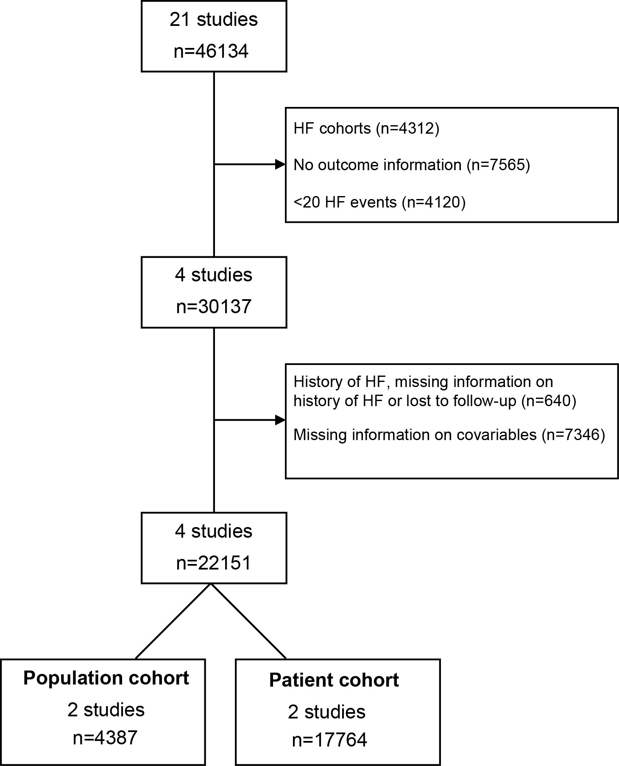

Figure 1: Flow chart of studies and participants included in the analysis

A
B

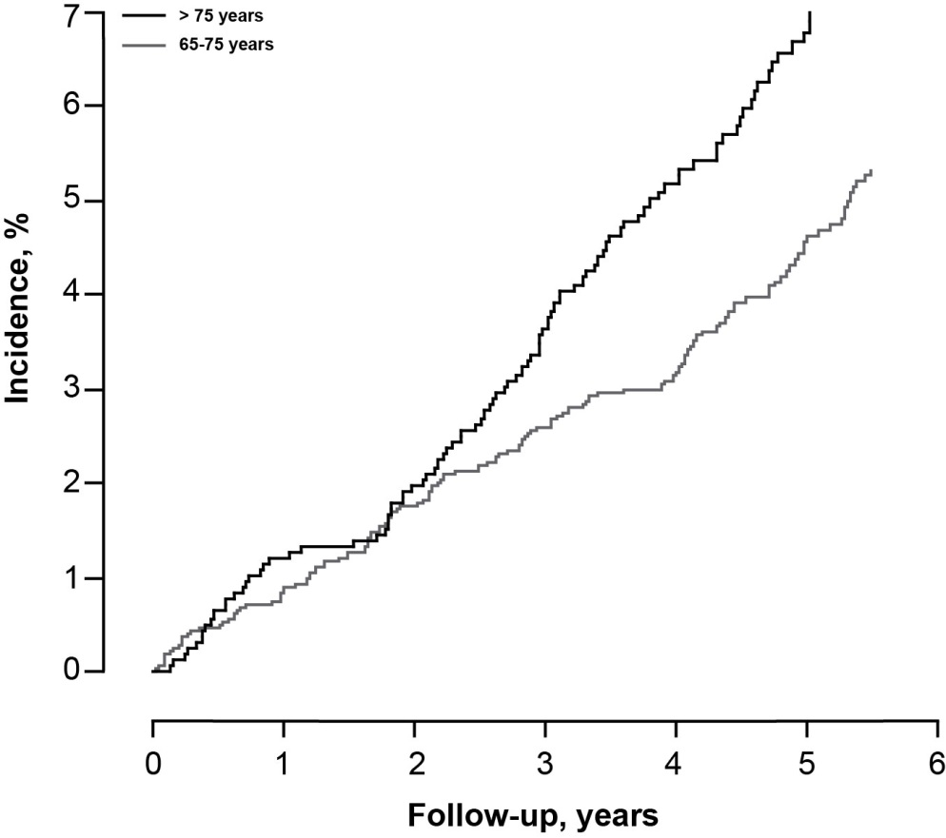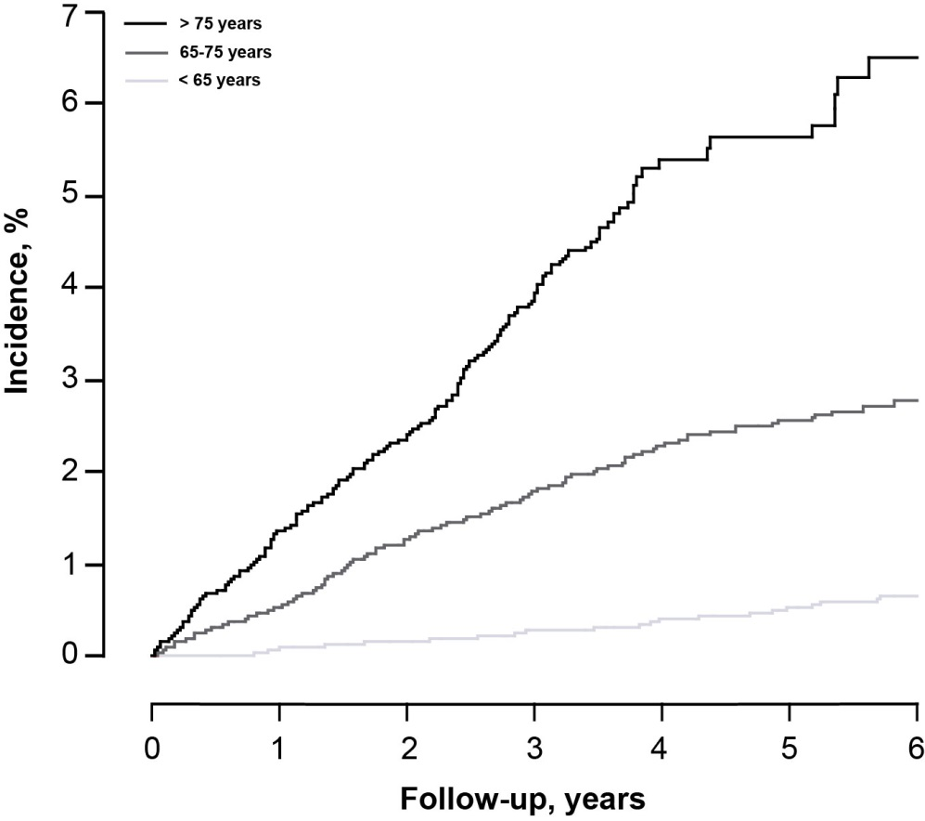

Figure 2. Sex-adjusted cumulative HF incidence (%) per age group in the population cohort (A) and in the patient cohort (B).

