Evaluation of a novel polyamide-polyethylenimine nanofiltration membrane for wastewater treatment: removal of Cu²⁺ ions

Jinqiang Wang^{1,2}, Wenzheng Yu^{2*}, Nigel J. D. Graham³, Lei Jiang^{1,4*}

¹ State Key Laboratory of Urban Water Resource and Environment, School of Environment, Harbin Institute of Technology, Harbin, China, 150001
² Key Laboratory of Drinking Water Science and Technology, Research Centre for Eco-Environmental Sciences, Chinese Academy of Sciences, Beijing, China, 100086
³ Department of Civil and Environmental Engineering, Imperial College London, South Kensington Campus, London SW7 2AZ, UK.
⁴ Key Laboratory of Bio-inspired Materials and Interfacial Science, Technical Institute of Physics and Chemistry, Chinese Academy of Sciences, Beijing, China 100190

wzyu@rcees.ac.cn, n.graham@imperial.ac.uk, jianglei@mail.ipc.ac.cn
Abstract
This paper describes a novel approach for enhancing membrane technology for the removal of heavy metal cations in contaminated waters. A simple method of forming a positively charged polyamide (PA) nanofiltration (NF) membrane has been developed by attaching a layer of hyperbranched polyethylenimine (PEI) to the PA surface, involving the linking of PEI amino groups to the PA surface carboxyl groups. The nature of the PEI modified PA membrane, in terms of surface morphology, zeta potential and hydrophobicity was found to depend on the PEI molecular weight (MW), and the PEI concentration and membrane exposure time during preparation. In turn, the nature of the modified membrane determined its performance in terms of hydraulic flux and metal ion rejection. In tests using a model solution of 5 mg/L Cu²⁺ and a 70,000 MW PEI membrane the Cu rejection was >90%, with only a modest reduction in flux compared to blank water. The Cu²⁺ rejection was found to be a combination of electrostatic repulsion and adsorption, with the relative proportions depending on the nature of the PEI modified PA membrane. In addition, the Cu²⁺ rejection and membrane flux were found to be sustainable over repeated filtration cycles, and the rejection was not adversely affected by the presence of humic acid in solution (5mg/L).
Keywords: wastewater treatment; polyethylenimine (PEI); polyamide (PA); nanofiltration membrane; Cu²⁺ ion

1 Introduction
Nowadays, the occurrence of heavy metals in natural waters, arising from the discharge of industrial wastewaters, is a cause of serious public attention because of their potential toxicity to human beings and the environment [1-3], and bioaccumulation in animals and humans through the food chain [4-6]. Copper is one of the most important heavy metal pollutants which arises from industrial and household waste, refineries, mine washing waste, and toxic paints [7]. Although the typical daily intake of Cu element for an adult is 1.5~2 mg, toxic effects can be significant when the concentration of Cu²⁺ is higher than the guideline value of 2 mg/L [8].
In general, it remains a scientific challenge to remove Cu²⁺ efficiently in order to meet wastewater discharge standards [9-11]. Over the past few decades a large number of methods have been utilized to separate and concentrate Cu²⁺ and other heavy metal ions, including solid-phase extraction (SPE) [8, 12-14], liquid-liquid extraction [15, 16], ion-exchange [17-21], co-precipitation [22-24], electrochemical deposition [25-27], cloud point extraction [28, 29], membrane separation [30-33], and flotation. Among these methods, membrane separation one of the most promising technologies owing to its comparatively high efficiency, easy operation, decreased footprint, and potential for metal recovery [34, 35].
In general, membrane separation technologies for Cu²⁺ removal include ultrafiltration (UF), nanofiltration (NF) and reverse osmosis (RO). UF is a low-pressure membrane separation process with a much higher flux and lower investment cost than NF and RO; however, this method of removing heavy metal ions is limited by the large membrane pore size, and UF membranes are usually modified with functional groups with a saturated adsorption capacity that limits the continuous application of the UF process [36, 37]. In contrast, RO membranes can remove heavy metal ions efficiently, but require high operational pressures which increases their energy costs [38-40]. Thus, the lower energy and operational costs of NF, together with its treatment potential, represent the most promising form of membrane technology for heavy metal separation [35, 41, 42].
Both size exclusion and the Donnan effect are important mechanisms governing the rejection of heavy metal ions by NF membranes [43]. The surface chemical composition, and particularly the charge on the membrane surface, have a major influence on the interception of ions [44, 45]; in turn, the pollutants rejected by the NF membrane correspondingly influence the surface chemical composition and charge [43]. PA based composite membranes are widely used as NF membranes owing to their high permeation performance. However, the surfaces of PA membranes are negatively charged due to the presence of abundant carboxyl groups, which mitigates their effectiveness in the rejection of heavy metal ions. One approach to improve cation rejection is to reverse the charge on the membrane surface.
Recently, many methods have been used to prepare positively charged NF membranes, which have included interfacial polymerization [46], phase inversion [47, 48], surface crosslinking [34, 49, 50], layer-by-layer assembly [51, 52] surface grafting [53-55], and electrospinning[56]. However, most of these methods have been developed for ad-hoc membrane applications, and a simple and effective method for more general commercial use is currently required. In this paper, we describe the development of a novel NF membrane based on a commercial PA membrane modified with a single molecular layer of hyperbranched polyethylenimine (PEI). The resulting positively charged NF membrane has been evaluated in detail and has demonstrated an exceptional interception performance for Cu²⁺ ions; this is described in the following sections.

2 Experimental methods and materials
2.1 Materials
Commercial aromatic PA membranes were supplied by Beijing Separate Equipment Co., Ltd (Beijing, China). Hyperbranched PEI (Figure S1) with four different number-average molecular weights of 600 g/mol (99 w.t.% water solution), 1,800 g/mol (99 w.t.% water solution), 10,000 g/mol (99 w.t.% water solution) and 70,000 g/mol (50 w.t.% water solution), were used as the modifying agents and were purchased from Aladdin (Shanghai, China). N-Hydroxysuccinimide (NHS, purity 98 w.t.%) and N-(3-Dimethylaminopropyl)-N'-ethylcarbodiimide hydrochloride (EDC, purity 98 w.t.%) were also purchased from Aladdin (Shanghai, China). Copper (II) nitrate trihydrate (Cu(NO₃)₂·3H₂O, AR) and magnesium chloride hexahydrate (MgCl₂·6H₂O, AR) were obtained from Sinopharm Chemical Reagent Limited Corporation (Shanghai, China). Humic acid sodium salt (technical grade) was purchased from Sigma-Aldrich (Shanghai, China). All chemicals were used as received without further purification unless otherwise specified.

2.2 Chemical modification
Carboxyl activator was prepared by dissolving 0.45 g EDC (1.5 w.t.%) and 0.09 g NHS (0.5 w.t.%) in 29.46 g DI water [57, 58]. A PA membrane with a diameter of 7.8 cm was immersed in DI water for at least two days to remove protective agents contained in the membrane. The PA membrane was then immersed in the EDC and NHS solution for at least one hour to activate the carboxyl on the surface of the PA membrane. After washing at least three times with DI water to remove excess EDC and NHS, the PA membrane was immersed in PEI solution with different concentrations and for different times. Finally, the modified PA membrane was carefully rinsed with DI water to remove excess modifying agent and then kept in DI water for later use. The above chemical modification procedure for changing the charge on the PA membrane surface from negative to positive is shown schematically in Figure 1 (a) and Figure S1.

2.3 Characterization
The near-surface chemistry of the membranes was analyzed by X-ray photoelectron spectroscopy (XPS) (ESCALAB 250Xi, Thermo Fisher, UK) and energy dispersive spectrometry (EDS) (GM×30, Ortec, USA). The charge property of the membrane surface and the zeta potential of the PEI solutions for different pH conditions were characterized by zeta potential measurements performed with a Zetasizer Nano analyzer (ZS 90, Malvern, UK). Fourier transform infrared spectroscopy (FTIR) of PA membranes modified with PEI were measured by using a Thermo Fisher (Nicolet 8700, USA) instrument with a wavenumber range of 500~4000 cm⁻¹. Water contact angles (WCAs) of the PA membranes were performed using a contact angle goniometer (OCA 15EC, Dataphysics, Germany). The morphologies of the PA membranes were observed by a field emission scanning electron microscope (FESEM) (SU 8020, Hitachi, Japan). The surface roughness of the PA membranes was measured by an atomic force microscope (AFM) (Fastscanbio, Bruker, Germany) with a scan area of 1.5 μm × 1.5 μm. The Cu concentration and conductivity of all feed solutions, filtrate solutions and concentrated solutions of Cu²⁺, were analyzed by inductively coupled plasma-optical emission spectroscopy (ICP-OES) (Optima 8300, Perkinelmer, USA) and conductivity meter (FD38-Standard, Mettler Toledo, USA), respectively.

2.4 Nanofiltration (NF) performance
The water flux of membranes (J, L·m⁻²·h⁻¹·MPa⁻¹) and Cu²⁺ ion rejection (R_{s}, %) were determined using a lab-scale ‘dead-end’ flow cell (8500, Millipore, USA) with an effective membrane diameter of 7.8 cm. The filtration experiments were carried out at room temperature under an applied pressure of 0.4 MPa, and an electronic balance (AX523ZH, Ohaus, USA) was used for recording the mass of flow continuously (Figure S6).
The flux of water and Cu²⁺ solution (J, L·m⁻²·h⁻¹·MPa⁻¹) were determined using Eq. (1) [59]:
J=V/(A·t·P) (1)
Where V represents the volume of permeate (L), A is the effective membrane area (m²), t is the permeation time (h) and P is the applied pressure (MPa). The densities of pure water and Cu²⁺ solution were assumed to be 1 g/mL in both cases.
The solute rejection R_{s} (%) was calculated using Eq. (2) [34]:
R_{s} = (1－C_{p}/C_{f} )×100% (2)
where C_{p} and C_{f} represent the solute filtrate and feed concentrations (mg/L), respectively.
The value of R_{s} is determined by many factors, such as the pore size, hydrophilicity and surface charge of the PA membrane, with the latter, in this study, causing a repulsive force because of the positive charge of the PEI on the surface of the PA membrane. In addition, the adsorption of Cu²⁺ ions by the PEI surface modification of the PA NF membrane could also improve the R_{s} of the modified PA membrane for the Cu²⁺ ions. Therefore, in our analysis we divided the Cu²⁺ ion content during filtration into three parts, the mass of Cu²⁺ adsorbed by the PEI modification on the surface of the PA membrane (M_{a}, mg), the mass of Cu²⁺ rejected by PA membrane by other effects (M_{i}, mg), and the mass of Cu²⁺ permeating through the PEI-PA membrane (M_{p}, mg). Thus, the mass M_{i} of Cu²⁺ remains in the concentrated solution and the mass M_{p} of Cu²⁺ passes through the PEI-PA NF membrane in the permeate solution. In this analysis, the term R_{s} can be described as the apparent rejection, which represents all the factors contributing to the rejection of Cu²⁺ ions. Another term related to R_{s}, is the actual rejection, R_{a} (%), which represents the rejection performance of the membrane for the Cu²⁺ ions but excluding the adsorption effect of the PEI modification on the PA membrane. The four parameters, M_{a}, M_{i}, M_{p} and R_{a}, were calculated using the Eqs. (3) to (6), respectively:
M_{a}=V_{f}·C_{f}－V_{p}·C_{p}－V_{c}·C_{c} (3)
M_{i}=V_{p}·C_{f}－V_{p}·C_{p}－M_{a} (4)
M_{p}=V_{p}·C_{f}－M_{i}－M_{a}=V_{p}·C_{p} (5)
R_{a}=M_{i}/(V_{p}·C_{f})×100% (6)
where V_{f}, V_{p}, V_{c} represent the volume (L) of total feed solution, permeate solution and concentrated solution; C_{f}, C_{p}, C_{c} represent the solute concentration (mg/L) of the feed, permeate and concentrated solutions, respectively. As the mode of filtration was ‘dead-end’, the volume ratio of permeate and concentrate was 1:1 unless otherwise specified.
As the filtration process was conducted under a constant applied pressure with no stirring, a concentrated polarization layer of Cu²⁺ will occur at the surface of the PA membrane during the filtration process. However, little Cu²⁺ in the concentrated solution would be expected to diffuse into the surface of the PA membrane and pass through into the permeate solution. Therefore, it was assumed that the adsorbance M_{a}, interception M_{i} and permeate M_{p} quantities could be determined approximately by Eqns (3) ~ (5). As indicated above, the calculated values of R_{s} (%) in this study represented all the solute rejection effects, while the calculated values of R_{a} (%) excluded the effect of physico-chemical adsorption and represented the Cu²⁺ separation arising from the pore size exclusion, hydrophilicity and electrostatic repulsive force from the positively charged PEI-PA membrane surface; thus, the role of the latter can be inferred from the values of R_{a}.

3 Results and discussion
3.1 Characterization of modified PA NF membranes
It has been reported previously that negative charges are widely distributed on the surface of PA membrane owing to the dissociation of carboxyl groups [60, 61]. These negative charges on the solid surface can adsorb positively charged species by weak electrostatic attraction, such as some heavy metal ions. To improve the separation performance of the membrane for heavy metal ions like copper ions (Cu²⁺), a method of chemically modifying the membrane with PEI, comprising abundant amino groups, was employed in this study.
Based on the fundamentals of amide chemistry, the reaction between carboxyl and amino groups can occur at room temperature in an aqueous environment by using carboxyl activator agents, such as the NHS (Figure S1 c) and EDC used in this study (Figure S1 d) [62, 63]. PEI, of four different molecular weights (Figure S1 b), was utilized to react with the carboxyl groups on the surface of PA membranes (Figure S1 a) to form alternative PEI-PA membranes. Since the carboxyl group activation by EDC and NHS was unstable, the activated and rinsed PA membranes needed to be immersed in the PEI solution as soon as possible. Figure 1 (a) and Figure S1 (e) show schematically the process of PA membrane modification with PEI. Figure 1 (a) also highlighted the mechanism of rejecting Cu²⁺ by the modified PA membrane. Thus, the PEI was able to change the surface charge from negative to positive by reducing the content of carboxyl groups and increasing the presence of amino groups on the membrane surface. Owing to the presence of ample positive charged amino groups, copper ions initially bind to the amino groups by means of coordination bonds, which then leads to electrostatic repulsion between the PEI-PA membrane surface and the copper ions in the bulk solution. In addition, the presence of the PEI polymer structure covering the membrane surface reduced the effective pore size of the NF membrane which also contributed to the rejection of the copper ions. With enrichment of the copper ions on the membrane surface, a concentrated polarization layer of copper ions formed, which continued to intercept subsequent copper ions in the feed solution. Thus, the combination of the above phenomena led to the substantially greater interception of copper ions by the PEI modified membrane, compared to the unmodified PA membrane (Figure 5c).
X-ray photoelectron spectroscopy (XPS) is a useful analytical technique for providing quantitative and qualitative information about the surface composition of the unmodified and PEI modified membranes. Prior to XPS analysis, samples were oven-dried at 30 °C overnight. Figure 1 (b) summarized the XPS results for the pristine PA membrane, the pristine PA membrane after filtering Cu²⁺ solution, the PA membrane modified with 1 w.t.% PEI 70,000 for 4 h and this modified PA membrane after filtering Cu²⁺ solution. The XPS spectra of the four samples all displayed emission peaks at 283.1 eV for C1s, 398.0 eV for N1s and 531.0 eV for O1s. After filtering the Cu²⁺ solution, the peaks of Cu 3p (77.0 eV) and Cu 2p (~940 eV) appeared only for the modified PA membrane, and there were no detectable peaks corresponding to the Cu element in the spectra of the other three samples. Magnified images of the spectra in the 925-970 eV range are shown on Figure 1 (c) to highlight the characteristic peaks of Cu 2p. The peaks at 955.0 eV and 935.6 eV were assigned to Cu 2p_{1/2} and Cu 2p_{3/2}, respectively [64]. The two main peaks and the shake up satellites at a higher energy of 943.9 eV and 964.5 eV identified the presence of Cu²⁺. The peak at 933.0 eV was also observed, which corresponds to the Cu 2p_{3/2} peak of Cu¹⁺ [65], while the peak at 952 eV, corresponding to the Cu 2p_{1/2} peak of Cu⁰, was not observed. The XPS information implied that the Cu element on the surface of the PEI-PA membrane was in two states, these being Cu²⁺ and Cu¹⁺. The appearance of Cu¹⁺ might be the result of chemical reduction of the Cu²⁺ to Cu¹⁺ by the amino groups on the PEI chain. A surface element analysis of the four samples is given in Table S1, which indicated that the PEI modification increased the nitrogen content of the PA membrane from ~10% to ~12% and decreased the C/N ratio from 7.3 to 5.8. The quantity of copper present on the surface of the modified PA membrane after filtration of the Cu²⁺ solution was 2 w.t.%. FTIR spectroscopy was used to reveal the functional groups of the modified and unmodified PA membranes (Figure S2). The magnitude of the peak at 1,680 cm⁻¹ assigned to the amide group increased slightly with the molecular weight of the PEI used in the modification. Since the modification corresponded to only a single molecular layer of PEI, the differences in the FTIR spectra of the pristine and modified PA membranes were not obvious or significant which indicated that the method of membrane modification used in this study is substantially different from other methods (e.g. spin, deposition, soaking, etc.) [66]. In summary, these results showed that the surface of the PA membrane was successfully modified by PEI and that the amino groups could bind the Cu²⁺ during the filtration of influent Cu²⁺ solution.
Zeta potential measurements can indicate the electrical charge properties of the PEI polymer and the membrane surface. Figure 1 (d) shows the variation of zeta potential with pH for the PEI of different molecular weights. It can be seen that the pattern of variation was similar for all membranes, whereby the zeta potential generally increased with pH value from 2 to 7, with a positive charge, and then decreased to zero (or negative) with pH value from 7 to 11. The maximum zeta potential of all PEI at neutral pH is believed to be a consequence of the decreasing cationic charge of PEI with pH. Thus, at low pH the PEI is strongly cationic and this leads to a more linear polymer structure and greater contact with the negatively charged PA surface (carboxyl groups) and charge neutralization. At higher pH (6-8), the PEI cationic charge is less, which leads to less surface contact and more polymer loops and tails, and thus more residual cationic charges. With the change of pH from neutral to basic, the overall zeta potentials decrease as the PA surface becomes increasingly negative and the PEI less cationic. And it could be seen that the zeta potential decreased with the molecular weight of PEI decreasing at the neutral environment which might be because of the bigger loops and tails for the higher molecular weight PEI. The two reasons conspired to cause the zeta potential of PEI 70,000 reaching the highest value of 45 mV at the natural environment.
Figure 1 (e) summarized the surface zeta potentials of the pristine and PEI modified PA membranes at neutral pH. It can be seen that the zeta potential of the pristine PA membrane was negatively charged (ζ = -6.97 mV), and after modification with PEI 600, PEI 1,800, PEI 10,000 and PEI 70,000, the surface charge became increasingly positive with potentials of +16.2 mV, +17.8 mV, +26.9 mV and +35.5 mV, respectively. For the latter case (PEI 70,000) the zeta potential declined from +35.5 mV to +23.8 mV after filtration of Cu²⁺ solution, which was attributed to the negative charge of nitrate ions located around the Cu²⁺ binding to the amino group of the PEI by coordination bonding. To verify this experimental phenomenon, we prepared other PEI modified PA membranes and immersed the membranes in Zr⁴⁺ solution for 1 hour. Similar results were obtained with the zeta potential value of “PA + PEI + Zr” of 26.9±1.9 mV was lower than the 35.5±1.4 mV of “PA+PEI”. In summary, the results confirmed that the PEI-based modification method successfully modified to the surface of the PA membrane by changing the surface charge from negative to positive.

3.2 Morphology of modified PA NF membranes
The morphology of the functional layer of the pristine and modified PA membranes was examined by SEM analysis and details are shown in Figure 2 (a)~(c). The granular analogue appeared in all of the three SEM graphs with little variation. The mathematical statistics and Gaussian distribution of the granular analogue size embedded in the three SEM maps were based on at least 500 particles counted by using Nano Measure software. The average size and principal size range of the granular analogue for the pristine PA membrane was 53.7 nm and 30~70 nm, and after modification with PEI 70,000 the average size increased to 57.7 nm and the principal size range narrowed slightly to 40~70 nm. After filtration of the Cu²⁺ solution with the latter membrane (PEI 70,000) there was little change in both the average size and size range of the granular analogue, which were 56.4 nm and 40~70 nm respectively. Figure 2 (d) shows the EDS mapping of C, N, O and Cu for the PEI 70,000 membrane after filtration of the Cu²⁺ solution. The corresponding EDS energy graph and element contents are shown in the Supporting Information (Figure S3 and Table S2). The elemental content for C, N, O and Cu were 66.94%, 12.41%, 18.64% and 2.00% respectively, which were consistent with the XPS results that showed the surface binding of Cu²⁺ ions to the PEI modified membrane.
Further information regarding the membrane surface morphology was provided by AFM analysis and stereo AFM pictures are presented in Figure 3 (a)~(d), and with quadruple magnification in Figure 3 (e)~(h). The calculated arithmetic mean roughness (Ra) of the pristine PA membrane was 3.88 nm, and this increased to 4.08 nm and 3.96 nm after modification with PEI 1,800 and PEI 70,000 respectively. The corresponding root-mean-square roughness (Rq) of the pristine PA membrane was 4.98 nm, and this similarly increased to 5.09 nm and 5.16 nm after modification with PEI 1,800 and PEI 70,000. The Ra and Rq values were relatively close due to the relatively small quantity of PEI on the surface of the PA membrane, and which was obvious distinct from the handing method of multiple spin. After filtration of Cu²⁺ solution, the Ra and Rq of the PA membrane modified with PEI 70,000 increased to 4.55 nm and 5.86 nm, which was attributed to the deposition of copper nitrate and its conversion to copper hydroxide in the process of drying the membrane. Complementary depth analysis results for the PA and PEI-PA membranes are shown in Figure 3 (i)~(l). Compared to the pristine PA membrane, the depth distribution of the PA membranes modified with PEI 1,800 and PEI 70,000 varied in two directions because the PEI 1,800 with smaller polymer chains was more easily modified at lower depths on the membrane surface than the larger PEI 70,000 polymer. After filtering Cu²⁺ solution, the solutes deposited at the lower depths on the membrane leading to the depth distribution moving toward smaller depths.

3.3 Flux and water contact angles of modified PA NF membranes
Figure 4 (a) (c) (d) (f) (g) summarized the variation of flux for the PA membrane with different modification conditions (i.e. PEI MW, concentration and exposure time). The initial pure water flux of the PA membrane was approximately 100 L·m⁻²·h⁻¹·MPa⁻¹ and this decreased by more than 10% after modification with PEI under all conditions. As could be seen in Figure 4 (a), the decrease of flux was greater as the molecular weight of the PEI increased, possibly because increasing molecular weight of PEI reduces the effective flow openings, and/or increases the PEI layer thickness (Figure 3(l)), of the PA membrane. The influence of PEI concentration on membrane flux can be seen in Figure 4 (c) and (d). For PEI 70,000 it was clear that the flux decrease due to the PEI was greater with increasing PEI concentration. Thus, the percentage decrease of flux was 13.9% at a concentration of 0.1%, which rose to 26.2% at a concentration of 2% of PEI 70,000. In contrast, for the membrane modified with PEI 1,800 there was less reduction in flux compared to the membrane modified by PEI 70,000, which can be attributed to a reduced blocking effect on the membrane pores with the lower MW of PEI 1,800, but also an opposite trend with PEI concentration was evident. The corresponding values for PEI 1,800 were a percentage decrease of flux of 15.4% at a concentration of 0.1%, which decreased to 13.2% at a concentration of 2% of PEI 1800. The reason for this contrasting behavior is unclear but may be related to a PEI morphology which is flatter (reduced depth) with the smaller polymer chain length of PEI 1,800, and increasing concentration leads to a slightly more porous PEI layer.
Meanwhile, the membrane hydrophilia increased with the added modified content. And in Figure 4 (f) and (g), we could see that when the PA membranes were modified with 0.1% PEI 70,000 for 0.5, 1, 2, 4, 6 and 8 hours, the decrease percentage of fluxes were 17.5%, 18.8%, 19.0%, 20.2%, 18.8% and 17.6%. The decrease percentage of fluxes firstly increased with the time of modification for the amino of PEI reacting with the carboxyl that resulted in the decrease of the membrane hydrophilia. And then the decrease percentage of fluxes decreased with the time of modification for the amino of PEI increasing with the deposition of PEI on the membrane that resulted in the increase of the membrane hydrophilia. When the PA membranes were modified with 1% PEI 70,000 for 0.5, 1, 2, 4, 6 and 8 hours, the decrease percentage of fluxes were 25.6%, 24.1%, 22.2%, 25.4%, 26.5% and 27.7%. It was the exact opposite of modifying 0.1% PEI 70,000 for modifying 1% PEI 70,000. The decrease percentage of fluxes firstly decreased with the time of modification for the amino of PEI increasing with the deposition of PEI on the membrane that resulted in the increase of the membrane hydrophilia. Whereafter the decrease percentage of fluxed increased with the time of modification for the great amount PEI depositing on the membrane that resulted in the increase of blockage effect on the membrane.
The water contact angle (WCA) is widely used as an indication of the relative hydrophilicity / hydrophobicity of membranes in water/wastewater treatment. The WCA was found to vary with time and so measurements were made within the first 180 seconds of the measurement procedure, and the variation of the WCA with the PEI modification conditions are displayed in the Supporting Information (Figure S7 (a)~(f)). The contact angle for all the membranes was calculated in each case as an average for the initial 180 seconds, and the results are shown in Figure 4 (b) (e) (h). The WCA was found to be influenced by the modification conditions, specifically the exposure time, the concentration and molecular weight of PEI, and the behavior can be described with reference to four different conditions (labelled I-IV in Figure 4 (b) (e) (h)): (I) under the modification corresponding to short time, low concentration and small molecular weight of PEI, the carboxyl groups on the membrane surface were consumed by reactions with the amine group of PEI which resulted in a decrease in the hydrophilicity of the membrane and increase in the WCA; (II) at greater modification time, concentration and molecular weight of PEI, the amount of amine groups of PEI increased, which resulted in an increase in the hydrophilicity of the membrane and decrease of WCA; (III) for particular combinations of modification time, concentration and molecular weight of PEI whereby the PEI layer obstructs the nanochannels in the PA membrane so that the flow of water through the PA membrane is impeded. For this case the hydrophilicity of PA membrane decreased and the WCA increased; (IV) when the modification time and concentration of PEI were at their greatest, the thickness of the PEI deposition on the PA membrane significantly exceeded that of a single molecular layer. In this case, the WCA of the PA membrane was determined principally by the properties of PEI, and the measured WCA decreased with longer time and higher concentration.

3.4 Rejection performance of modified PA NF membrane for Cu²⁺
Filtration tests were conducted using the laboratory system shown schematically in the Supporting Information (Figure S6) and ICP-OES analysis to measure the Cu²⁺ rejection by the modified PA membranes under different conditions. All the feed solutions had a Cu²⁺ concentration of ~5 mg/L and all the volume ratios of filtrate and concentrate was 1:1 unless otherwise specified.
The results shown in Figure 5 consider the role of the PEI molecular weight. In Figure 5 (a), it can be seen that the flux of the Cu²⁺ solution decreased for the unmodified and modified PA membranes because of the enriched Cu²⁺ on the membrane surface forming an additional resistance to flow. The decreases in flux were 9.6% for unmodified PA, 9.4% for PEI 600, 6.2% for PEI 1,800, 9.2% for PEI 10,000 and 9.0% for PEI 70,000. Although the average flux reduction was slightly lower for PEI 1,800, the difference was within the experimental variation of the tests and therefore of uncertain significance. In Figure 5 (b), it was evident that the filtrate Cu²⁺ concentrations decreased significantly and systematically with increasing PEI molecular weight of the modified membrane. Thus, the lowest filtrate Cu²⁺ concentration of 0.38 mg/L was obtained with the PA membrane modified with PEI 70,000 (1%, 4h), in sharp contrast to the filtrate concentration of the unmodified PA membrane which only decreased to 3.15 mg/L. This is regarded as an important and promising result whereby the modified PA membrane was able to treat a high concentration (5 mg/L) of Cu²⁺ to a concentration well below the drinking water standard. The corresponding rejection values, calculated by the two methods, are shown in the Figure 5 (c). The apparent rejection value, R_{s}, was only 38.9% of the unmodified (blank) membrane, but reached a very high value of 92.5% with the membrane modified with PEI 70,000. For the actual rejection value, R_{a}, there was a major difference between 36.0% for the unmodified membrane and 68.2% for the membrane modified with PEI 70,000. The proportions of Cu²⁺ adsorbed, intercepted and in the permeate (permeance) by the modified membrane with different PEI molecular weights are shown in Figure 5 (d). It can be seen that the adsorbance and interception ratio of Cu²⁺ increased with the molecular weight of PEI, with PEI 70,000 achieving the greatest separation of Cu²⁺ through adsorption and interception. These results showed that the high degree of Cu²⁺ rejection was not only due to adsorption by PEI, but also due to the repulsion of copper ions by the positive charge of PEI.
In Figure 6, the influence of PEI concentration is summarized with respect to the use of PEI 70,000 for the membrane modification. As shown in Figure 6 (a). the decrease in flux with the Cu²⁺ solution was not significantly affected by the PEI 70,000 concentration in the range of 0% to 2%. In terms of separation performance, a high degree of Cu²⁺ removal was found with all PEI 70,000 concentrations (Figure 6 (b)), with the lowest Cu²⁺ concentration of 0.35 mg/L achieved by the 2% PEI. The corresponding Cu²⁺ rejection values are shown in Figure 6 (c). Although the apparent rejection (R_{s}) was consistently high for all PEI concentrations, with the highest at 2% PEI, the actual rejection (R_{a}) also increased up to 1% PEI but decreased at the higher PEI concentrations of 1.5% and 2%. It is suggested that this might be because of greater adsorption of Cu²⁺ ions at higher PEI 70,000 concentrations, and this was indicated by the results shown in Figure 6 (d) where the proportion of adsorbed Cu²⁺ was greater for 1.5% and 2% PEI 70,000, than lower concentrations. Thus, the high level of Cu²⁺ rejection by the PA membrane modified with 1.5% and 2% PEI 70,000 was due more equally to adsorption of Cu²⁺ ions by the PEI 70,000 layer and the repulsive, interception effect on the Cu²⁺ ions.
The corresponding results for the PA membrane modified by PEI 1,800 are given in the Supporting Information (Figure S8). In summary, the results (Figure S8 (a)) show that the decrease of Cu²⁺ flux was 9.6%, 12.8%, 11.6%, 6.2%, 9.7% and 11.6% for PEI concentrations of 0%, 0.1%, 0.5%, 1%, 1.5% and 2%, respectively. The results of the filtration test with the PEI 1,800 modified membrane showed a significantly lower apparent rejection to the PEI 70,000 modified membrane, but only a slightly lower actual rejection (Figure S8 (c)). This appeared to be because the PEI 1,800 did not adsorb the Cu²⁺ ions as much as the PEI 70,000 (Figure 8 (c) and (d)) and the positive charge of the PEI 1,800 membrane was much lower than that of the PEI 70,000. Finally, solution conductivity was investigated as a surrogate for Cu²⁺ concentration owing to close linear correlation between the two parameters (Figure S9 (a)). The results of the Cu²⁺ filtration tests based on conductivity measurements were very similar to those obtained by ICP analysis, as summarized in Figure S9 (b) ~ (d).
The sustainability of the filtration performance was evaluated by conducting a series of 10 filtration tests with the PEI 70,000 modified membrane (1%, 4h), and the decrease of Cu²⁺ flux was consistently in the range of 3.6% ~ 7.7% (Figure 7 (a)). An additional filtration test was undertaken, indicated in Figure 7 by the symbol “∞”, in which the modified PA membrane was immersed in a high concentration of Cu²⁺ (5 g/L) overnight and then rinsed by filtering pure water until the measured Cu²⁺ concentration of the filtration solution was less than 0.1 mg/L Cu²⁺, to remove residual copper ions, prior to filtration of the Cu²⁺ feed solution. It was clear that the decrease of flux of the Cu²⁺ solution for the “∞” test was in the same range as the previous tests. In addition, the sustainability of the filtration performance of the PEI 70,000 membrane was evaluated in the same way, by repeated tests, and the results are shown in Figure 7 (b). While the initial value (test 1) of the filtrate Cu²⁺ concentration was 0.28 mg/L, and increased slightly with repeated tests, the concentration was consistently low for all tests, including the “∞” test. Furthermore, the zeta potential and XPS test results of the “1” and “∞” samples are given in Figure S4 and Figure S5, respectively. It can be seen that the zeta potential values of “1” and “∞” samples were very close and the copper element was found in the XPS results of both “1” and “∞” samples, which indicated that the properties of PEI modified PA membrane surfaces were similar no matter how many times the membranes filtered the Cu²⁺ solution. Thus, the results made it clear that repeated exposure of the membrane to high concentrations of Cu²⁺ did not have a significant adverse impact on the membrane rejection, as demonstrated in Figure 7 (c) and (d).
In the practical application, the effect of heavy metal ion concentration on water treatment is very important. The effect of the Cu²⁺ feed solution and the filtrate volume percentage on PEI modified membrane performance were studied and the results are shown in Figure 8 and 9, respectively. In Figure 8 (a), it can be seen that the percentages decrease of flux between pure water and Cu²⁺ solution did not vary greatly with the feed solution concentration. The apparent/actual rejection increased from ~70%/~25% to ~90%/~60% with the feed solution concentration from 1 to 5 mg/L, and fell just slightly with the feed solution concentration from 5 to 10 mg/L; the results are represented in Figure 8 (b)~(c). An unexpected result was that the PEI modified PA membrane had a lower rejection for Cu²⁺ ions at a lower feed solution concentration, which was investigated by calculating the permeate, intercepted and absorbed Cu²⁺, as shown in Figure 8 (d). When the lower concentration of feed solution was filtered with the PEI modified PA membrane, a larger proportion of Cu²⁺ was adsorbed on the membrane surface. The adsorption rate of Cu²⁺ for the lower concentration feed solution was not fast enough so that the stable double positive charge layers of PEI and Cu²⁺ formed slower than that at a higher concentration feed solution. Thus a higher proportion of Cu²⁺ passed through the PEI modified PA membrane.
In Figure 9 (a), the results show that the percentage decrease of flux between pure water and Cu²⁺ solution increased slightly with the volume percentage of flux increasing from 50% to 90%. With the continuous process of filtration, the concentration of the concentrate increases, which led to a lower flux. It was found, as expected, that the apparent rejection decreased from ~90% to ~65% with the volume percentage of flux, as shown in Figure 9 (c), which could be ascribed to an excessive concentration factor and the Cu concentration of the concentrate increasing rapidly, as indicated in Figure 9 (b). It was surprising that the actual rejection, given in Figure 9 (c), did not decrease at a higher volume percentage of filtrate. These results illustrate that the rejection performance of the PEI modified PA membrane, due to electrostatic repulsion and size exclusion effects, was not affected by the volume percentage of filtrate. The proportion of intercepted Cu²⁺, shown in Figure 9 (d), also supported these results. With respect to, the proportion of absorbed Cu²⁺ (Figure 9 (d)), this decreased with the volume percentage of filtrate and this was exactly the reason for the decreased apparent rejection, as indicated in Figure 9 (d).
In addition, we also studied the effect of pH on the modified membrane performance using Cu²⁺ solutions prepared at pH 4.5 and pH 5.5. The results, summarized in Figure S10 (a)~(c) showed that the filtrate concentration and apparent rejection were similar for the two pH conditions, but the concentrated concentration and the actual rejection were lower for pH 4.5 than for pH 5.5. This can be explained by the greater degree of adsorbed Cu²⁺ by the modified PA membrane at pH 4.5, as indicated in Figure S10 (c). As illustrated in Figure 1 (d), the lower zeta potential at pH 4.5 may reflect a flatter, more widely distributed morphology of the PEI 70,000 on the membrane surface, and therefore greater adsorption opportunities, compared to a lower surface coverage with more lops and tails at the higher pH, as well as less charge repulsion at pH 4.5. Thus, adsorption was principal separation effect for the Cu²⁺ ions at pH 4.5, while interception was principal effect at pH 5.5.
Finally, the effect of carboxyl activators on PA performance for Cu²⁺ was studied and the results are summarized in Figure S11. Before backwash, all the parameters shown in Figure S11 for the PEI modified PA membrane with and without EDC/NHS were almost the same. This showed that the PEI could attach to the PA membrane surface because of the attraction of the negatively charged carboxyl group and the positively charged amino group without EDC/NHS. Hence, the PEI modified PA membrane without EDC/NHS retained an acceptable rejection performance for Cu²⁺. After backwash, the apparent rejection without the use of EDC/NHS decreased from ~90% to ~65%, and the actual rejection with the use of EDC/NHS increased from ~60% to ~80%, as indicated in Figure S11 (a)~(b). This might be because that most of the physical adsorption of PEI was washed away by the backwash so that the proportion of adsorbed Cu²⁺ fell sharply for the PEI modified PA membrane without/with EDC/NHS, as summarized in Figure S11 (c). Only a small amount of PEI was left on the membranes and this could enhance the rejection performance of the PA membrane for Cu²⁺ by the electrostatic repulsive-forces. In summary, the use of EDC/NHS carboxyl activators could strengthen the binding capacity of the PA membrane for PEI via the amide bond and improve the service life of the PEI modified PA membrane.
3.5 The influence of HA on the modified PA NF membrane
Since most natural and waste waters contain background levels of organic matter which typically carry negative charges, the comparative performance of the PEI modified membrane was investigated in the presence of 5 mg/L humic acid (HA), as a representative natural organic component. In these tests, the membrane rejection performance for the metal ions, Cu²⁺ and Mg²⁺, both at 5 mg/L, was determined and the results are summarized in Figure 8. The influence of the HA was considered in two ways: either where the HA solution was filtered before the metal ion solution (denoted as ‘HA*M’), or where the HA and metal ion were mixed (denoted as ‘HA+ M’). It can be seen that the rejection (apparent rejection) of Cu²⁺ (Figure 10 (c)) and Mg²⁺ (Figure 10 (d)) was not significantly decreased (by 1-2 %) by the presence of HA in the influent solution. In contrast, the Cu²⁺ rejections of the unmodified and modified PA membranes both increased slightly (reaching 39.2% and 94.1% respectively) when HA solution was filtered in advance. We have established that the HA is retained to a high degree on the PA NF membrane (95% removal). Based on the results obtained, it is evident that the negatively charged HA did not decrease the Cu²⁺ and Mg²⁺ rejections by the PEI modified PA membrane and the reason for this can be speculated as follows. For the HA*M case, the filtration of the 5 mg/L HA solution led to the distribution of negative charges on the surface of the modified PA membrane. In simple terms this created a ‘sandwich’ surface structure with a PEI middle layer that was positively charged, and upper and lower layers that were negatively charged (HA and PA membrane, respectively). Consequently, during filtration the positively charged Cu²⁺ and Mg²⁺ ions were excluded by a combination of electrostatic repulsion by the positively charged PEI and attraction by the negatively charged HA. For the HA+M case, a similar but less formalized arrangement of the HA on the membrane surface may have led to the slightly reduced rejection compared to the HA*Cu (Figure 10 (c)). In addition to electrostatic effects it is possible that metal ion separation occurred as a result of chemical complexation by HA. Overall, the results indicated that the presence of HA had no deleterious impact on the Cu²⁺ and Mg²⁺ rejection by the modified PA membrane.
However, the anti-fouling performance is also an important characteristic of the membrane. The test results given in Figure S12 show the effect of humic acid (5mg/L) on the flux recovery of the pristine “PA” membrane and the “PA+PEI” membrane. The two membranes were operated through three cycles of 60 mL humic acid solution (5 mg/L) and were backwashed with 15 mL pure water between each cycle. It was found that the normalized flux (J/J₀) of the pristine PA membrane decreased from 1.0 to 0.86 in the first filtration cycle and increased to 0.92 after the first backwash. Then the J/J₀ of pristine PA membrane decreased to 0.83 in the second filtration cycle and recovered to 0.88 after the second backwash. Finally, the J/J₀ of pristine PA membrane decreased to 0.81 in the third filtration cycle. In comparison, the J/J₀ of the “PA+PEI” membrane decreased dramatically from 1.0 to 0.62 in the first filtration cycle, which indicated that the humic acid had a substantially negative effect on the flux of the modified PA membrane on account of the electrostatic attraction of the positively charged PEI and negatively charged humic acid. However, the J/J₀ of the “PA+PEI” membrane tended towards a stabilized value of 0.6 in the following two filtration cycles which indicated that the degree of humic acid fouling to the “PA+PEI” membrane had reached a maximum. In view of the moderate and stable nature of, the humic acid fouling of the “PA+PEI” membrane, this would indicate that the “PA+PEI” membrane has the practical application value.

4 Conclusions
In this study, we have developed a successful method for modifying a conventional polyamide NF membrane to carry a substantial positive surface charge (+40 mV) through the attachment of a layer of hyperbranched PEI. Using a range of PEI molecular weights and preparation conditions, the nature of the modified membrane was found to vary in terms of surface morphology, zeta potential and hydrophobicity. The membrane performance was related to these properties and a high degree of cation rejection was found (>90%) in tests using 5 mg/L Cu²⁺ solutions with a 70,000 MW PEI modified membrane. The rejection was the result of both electrostatic charge repulsion and surface adsorption, with the proportions depending on the PEI modification. Repeated filtration cycles showed consistent performance in Cu²⁺ separation and flux, and no significant adverse effect from the presence of humic acid as a surrogate for natural organic matter. Future work will focus on loading both Zr⁴⁺ ions and PEI simultaneously on to the PA membrane surface to increase the positive surface charge of the PA membrane surface, so as to improve the interception/rejection performance of the PA membrane for other heavy metal ions and positively charged organic pollutants.

Acknowledgements
This work was supported by the National Natural Science Foundation of China (Grants 51108444).

Author contributions
J. W., W. Y. and L. J. have contributed to the design of the study and the critical revision of the article. J. W. and W. Y. did the experiments, analyzed the data, prepared figures and drafted the article. W. Y., L. J. and N.J.D.G. finished the final version of the manuscript.

Additional information
Competing financial interests: The authors declare that there are no competing interests.

References
[1] B. Southichak, K. Nakano, M. Nomura, N. Chiba, O. Nishimura, Phragmites australis: a novel biosorbent for the removal of heavy metals from aqueous solution, Water research 40 (2006) 2295-2302.
[2] M. Lu, Y. Deng, Y. Luo, J. Lv, T. Li, J. Xu, S.W. Chen, J. Wang, Graphene Aerogel-Metal-Organic Framework-Based Electrochemical Method for Simultaneous Detection of Multiple Heavy-Metal Ions, Anal Chem (2018).
[3] S. Yu, Y. Liu, Y. Ai, X. Wang, R. Zhang, Z. Chen, Z. Chen, G. Zhao, X. Wang, Rational design of carbonaceous nanofiber/Ni-Al layered double hydroxide nanocomposites for high-efficiency removal of heavy metals from aqueous solutions, Environ Pollut 242 (2018) 1-11.
[4] D.T. Sun, L. Peng, W.S. Reeder, S.M. Moosavi, D. Tiana, D.K. Britt, E. Oveisi, W.L. Queen, Rapid, Selective Heavy Metal Removal from Water by a Metal-Organic Framework/Polydopamine Composite, ACS Cent Sci 4 (2018) 349-356.
[5] X. Zhang, M. Wu, H. Dong, H. Li, B. Pan, Simultaneous Oxidation and Sequestration of As(III) from Water by Using Redox Polymer-Based Fe(III) Oxide Nanocomposite, Environ Sci Technol 51 (2017) 6326-6334.
[6] N. Chitpong, S.M. Husson, Polyacid functionalized cellulose nanofiber membranes for removal of heavy metals from impaired waters, Journal of Membrane Science 523 (2017) 418-429.
[7] R.N.R. Sulaiman, N. Othman, Synergistic green extraction of nickel ions from electroplating waste via mixtures of chelating and organophosphorus carrier, J Hazard Mater 340 (2017) 77-84.
[8] A. Tobiasz, S. Walas, Solid-phase-extraction procedures for atomic spectrometry determination of copper, TrAC Trends in Analytical Chemistry 62 (2014) 106-122.
[9] F. Ansari, M. Ghaedi, M. Taghdiri, A. Asfaram, Application of ZnO nanorods loaded on activated carbon for ultrasonic assisted dyes removal: Experimental design and derivative spectrophotometry method, Ultrason Sonochem 33 (2016) 197-209.
[10] A. Asfaram, M. Ghaedi, F. Yousefi, M. Dastkhoon, Experimental design and modeling of ultrasound assisted simultaneous adsorption of cationic dyes onto ZnS: Mn-NPs-AC from binary mixture, Ultrason Sonochem 33 (2016) 77-89.
[11] A. Senthamizhan, B. Balusamy, A. Celebioglu, T. Uyar, “Nanotraps” in porous electrospun fibers for effective removal of lead(ii) in water, Journal of Materials Chemistry A 4 (2016) 2484-2493.
[12] O.M. Kalfa, O. Yalcinkaya, A.R. Turker, Synthesis of nano B2O3/TiO2 composite material as a new solid phase extractor and its application to preconcentration and separation of cadmium, J Hazard Mater 166 (2009) 455-461.
[13] O. Yalcinkaya, O.M. Kalfa, A.R. Turker, Chelating agent free-solid phase extraction (CAF-SPE) of Co(II), Cu(II) and Cd(II) by new nano hybrid material (ZrO2/B2O3), J Hazard Mater 195 (2011) 332-339.
[14] K.M. Diniz, F.A. Gorla, E.S. Ribeiro, M.B.O.d. Nascimento, R.J. Corrêa, C.R.T. Tarley, M.G. Segatelli, Preparation of SiO2/Nb2O5/ZnO mixed oxide by sol–gel method and its application for adsorption studies and on-line preconcentration of cobalt ions from aqueous medium, Chemical Engineering Journal 239 (2014) 233-241.
[15] M.A. Farajzadeh, M. Bahram, S. Zorita, B.G. Mehr, Optimization and application of homogeneous liquid-liquid extraction in preconcentration of copper (II) in a ternary solvent system, J Hazard Mater 161 (2009) 1535-1543.
[16] H. Valdés, J. Romero, J. Sanchez, S. Bocquet, G.M. Rios, F. Valenzuela, Characterization of chemical kinetics in membrane-based liquid–liquid extraction of molybdenum(VI) from aqueous solutions, Chemical Engineering Journal 151 (2009) 333-341.
[17] P. Dydo, M. Turek, Boron transport and removal using ion-exchange membranes: A critical review, Desalination 310 (2013) 2-8.
[18] W. Plazinski, W. Rudzinski, Modeling the Effect of Surface Heterogeneity in Equilibrium of Heavy Metal Ion Biosorption by Using the Ion Exchange Model, Environmental Science & Technology 43 (2009) 7465-7471.
[19] M. Vaca Mier, R. López Callejas, R. Gehr, B.E. Jiménez Cisneros, P.J.J. Alvarez, Heavy metal removal with mexican clinoptilolite:: multi-component ionic exchange, Water research 35 (2001) 373-378.
[20] M.M. Figueira, B. Volesky, V.S.T. Ciminelli, F.A. Roddick, Biosorption of metals in brown seaweed biomass, Water research 34 (2000) 196-204.
[21] C. Zhao, R. Ge, Y. Zhen, Y. Wang, Z. Li, Y. Shi, X. Chen, A hybrid process of coprecipitation-induced crystallization-capacitive deionization-ion exchange process for heavy metals removal from hypersaline ternary precursor wastewater, Chemical Engineering Journal 378 (2019) 122136.
[22] M. Tuzen, M. Soylak, Multi-element coprecipitation for separation and enrichment of heavy metal ions for their flame atomic absorption spectrometric determinations, J Hazard Mater 162 (2009) 724-729.
[23] O. Gibert, J. de Pablo, J.L. Cortina, C. Ayora, Sorption studies of Zn(II) and Cu(II) onto vegetal compost used on reactive mixtures for in situ treatment of acid mine drainage, Water research 39 (2005) 2827-2838.
[24] X. Guo, Z. Yang, H. Dong, X. Guan, Q. Ren, X. Lv, X. Jin, Simple combination of oxidants with zero-valent-iron (ZVI) achieved very rapid and highly efficient removal of heavy metals from water, Water research 88 (2016) 671-680.
[25] B.D. Falola, I.I. Suni, Low temperature electrochemical deposition of highly active elements, Current Opinion in Solid State and Materials Science 19 (2015) 77-84.
[26] L.M. Ortega, R. Lebrun, J.-F. Blais, R. Hausler, P. Drogui, Effectiveness of soil washing, nanofiltration and electrochemical treatment for the recovery of metal ions coming from a contaminated soil, Water research 42 (2008) 1943-1952.
[27] R. Seenivasan, W.-J. Chang, S. Gunasekaran, Highly Sensitive Detection and Removal of Lead Ions in Water Using Cysteine-Functionalized Graphene Oxide/Polypyrrole Nanocomposite Film Electrode, ACS Applied Materials & Interfaces 7 (2015) 15935-15943.
[28] L. Zhao, S. Zhong, K. Fang, Z. Qian, J. Chen, Determination of cadmium(II), cobalt(II), nickel(II), lead(II), zinc(II), and copper(II) in water samples using dual-cloud point extraction and inductively coupled plasma emission spectrometry, Journal of Hazardous Materials 239-240 (2012) 206-212.
[29] J. Borkowska-Burnecka, A. Szymczycha-Madeja, W. Żyrnicki, Determination of toxic and other trace elements in calcium-rich materials using cloud point extraction and inductively coupled plasma emission spectrometry, Journal of Hazardous Materials 182 (2010) 477-483.
[30] Y. Zhang, F. Liu, C. Ji, R. Yuan, H. Wu, A. Li, TAP/GMA@CN metal-chelating membrane for enhanced and efficient capture of Cu(II), Journal of Membrane Science 570-571 (2019) 362-370.
[31] H.-W. Liang, X. Cao, W.-J. Zhang, H.-T. Lin, F. Zhou, L.-F. Chen, S.-H. Yu, Robust and Highly Efficient Free-Standing Carbonaceous Nanofiber Membranes for Water Purification, Advanced Functional Materials 21 (2011) 3851-3858.
[32] C. Blöcher, J. Dorda, V. Mavrov, H. Chmiel, N.K. Lazaridis, K.A. Matis, Hybrid flotation—membrane filtration process for the removal of heavy metal ions from wastewater, Water research 37 (2003) 4018-4026.
[33] M.L. Gerardo, N.H.M. Aljohani, D.L. Oatley-Radcliffe, R.W. Lovitt, Moving towards sustainable resources: Recovery and fractionation of nutrients from dairy manure digestate using membranes, Water research 80 (2015) 80-89.
[34] J. Gao, S.P. Sun, W.P. Zhu, T.S. Chung, Chelating polymer modified P84 nanofiltration (NF) hollow fiber membranes for high efficient heavy metal removal, Water research 63 (2014) 252-261.
[35] J. Gao, S.-P. Sun, W.-P. Zhu, T.-S. Chung, Polyethyleneimine (PEI) cross-linked P84 nanofiltration (NF) hollow fiber membranes for Pb2+ removal, Journal of Membrane Science 452 (2014) 300-310.
[36] J. Tian, C. Wu, H. Yu, S. Gao, G. Li, F. Cui, F. Qu, Applying ultraviolet/persulfate (UV/PS) pre-oxidation for controlling ultrafiltration membrane fouling by natural organic matter (NOM) in surface water, Water research 132 (2018) 190-199.
[37] L. Song, X. Zhao, J. Fu, X. Wang, Y. Sheng, X. Liu, DFT investigation of Ni(II) adsorption onto MA-DTPA/PVDF chelating membrane in the presence of coexistent cations and organic acids, J Hazard Mater 199-200 (2012) 433-439.
[38] B.D. Coday, B.G. Yaffe, P. Xu, T.Y. Cath, Rejection of trace organic compounds by forward osmosis membranes: a literature review, Environ Sci Technol 48 (2014) 3612-3624.
[39] K. Ikehata, Y. Zhao, H.V. Kulkarni, Y. Li, S.A. Snyder, K.P. Ishida, M.A. Anderson, Water Recovery from Advanced Water Purification Facility Reverse Osmosis Concentrate by Photobiological Treatment Followed by Secondary Reverse Osmosis, Environmental Science & Technology 52 (2018) 8588-8595.
[40] T.V. Bartholomew, N.S. Siefert, M.S. Mauter, Cost Optimization of Osmotically Assisted Reverse Osmosis, Environmental Science & Technology 52 (2018) 11813-11821.
[41] Y. Zhang, S. Zhang, T.-S. Chung, Nanometric Graphene Oxide Framework Membranes with Enhanced Heavy Metal Removal via Nanofiltration, Environmental Science & Technology 49 (2015) 10235-10242.
[42] K.-H. Choo, D.-J. Kwon, K.-W. Lee, S.-J. Choi, Selective Removal of Cobalt Species Using Nanofiltration Membranes, Environmental Science & Technology 36 (2002) 1330-1336.
[43] H. Wang, Q. Zhang, S. Zhang, Positively charged nanofiltration membrane formed by interfacial polymerization of 3,3′,5,5′-biphenyl tetraacyl chloride and piperazine on a poly(acrylonitrile) (PAN) support, Journal of Membrane Science 378 (2011) 243-249.
[44] C. Wu, S. Zhang, D. Yang, J. Wei, C. Yan, X. Jian, Preparation, characterization and application in wastewater treatment of a novel thermal stable composite membrane, Journal of Membrane Science 279 (2006) 238-245.
[45] T. He, M. Frank, M.H.V. Mulder, M. Wessling, Preparation and characterization of nanofiltration membranes by coating polyethersulfone hollow fibers with sulfonated poly(ether ether ketone) (SPEEK), Journal of Membrane Science 307 (2008) 62-72.
[46] X. Wei, S. Wang, Y. Shi, H. Xiang, J. Chen, B. Zhu, Characterization of a positively charged composite nanofiltration hollow fiber membrane prepared by a simplified process, Desalination 350 (2014) 44-52.
[47] Y. Su, X. Jian, S. Zhang, G. Wang, Preparation and characterization of quaternized poly(phthalazinone ether sulfone ketone) NF membranes, Journal of Membrane Science 241 (2004) 225-233.
[48] X. Zhao, C. Liu, Efficient removal of heavy metal ions based on the selective hydrophilic channels, Chemical Engineering Journal 359 (2019) 1644-1651.
[49] H. Wang, Q. Zhang, S. Zhang, Positively charged nanofiltration membrane formed by interfacial polymerization of 3,3′,5,5′-biphenyl tetraacyl chloride and piperazine on a poly(acrylonitrile) (PAN) support, Journal of Membrane Science 378 (2011) 243-249.
[50] R. Huang, G. Chen, B. Yang, C. Gao, Positively charged composite nanofiltration membrane from quaternized chitosan by toluene diisocyanate cross-linking, Separation and Purification Technology 61 (2008) 424-429.
[51] L. Ouyang, R. Malaisamy, M.L. Bruening, Multilayer polyelectrolyte films as nanofiltration membranes for separating monovalent and divalent cations, Journal of Membrane Science 310 (2008) 76-84.
[52] W. Jin, A. Toutianoush, B. Tieke, Use of Polyelectrolyte Layer-by-Layer Assemblies as Nanofiltration and Reverse Osmosis Membranes, Langmuir 19 (2003) 2550-2553.
[53] H. Deng, Y. Xu, Q. Chen, X. Wei, B. Zhu, High flux positively charged nanofiltration membranes prepared by UV-initiated graft polymerization of methacrylatoethyl trimethyl ammonium chloride (DMC) onto polysulfone membranes, Journal of Membrane Science 366 (2011) 363-372.
[54] P.S. Zhong, N. Widjojo, T.-S. Chung, M. Weber, C. Maletzko, Positively charged nanofiltration (NF) membranes via UV grafting on sulfonated polyphenylenesulfone (sPPSU) for effective removal of textile dyes from wastewater, Journal of Membrane Science 417-418 (2012) 52-60.
[55] J. Li, S. Yuan, J. Zhu, B. Van der Bruggen, High-flux, antibacterial composite membranes via polydopamine-assisted PEI-TiO2/Ag modification for dye removal, Chemical Engineering Journal 373 (2019) 275-284.
[56] S. Deng, X. Liu, J. Liao, H. Lin, F. Liu, PEI modified multiwalled carbon nanotube as a novel additive in PAN nanofiber membrane for enhanced removal of heavy metal ions, Chemical Engineering Journal 375 (2019) 122086.
[57] X. Shang, G. Xie, X.-Y. Kong, Z. Zhang, Y. Zhang, W. Tian, L. Wen, L. Jiang, An Artificial CO2-Driven Ionic Gate Inspired by Olfactory Sensory Neurons in Mosquitoes, Advanced Materials 29 (2017).
[58] Q. Liu, L. Wen, K. Xiao, H. Lu, Z. Zhang, G. Xie, X.-Y. Kong, Z. Bo, L. Jiang, A Biomimetic Voltage-Gated Chloride Nanochannel, Advanced Materials 28 (2016) 3181-3186.
[59] H. Sun, X. Yang, Y. Zhang, X. Cheng, Y. Xu, Y. Bai, L. Shao, Segregation-induced in situ hydrophilic modification of poly (vinylidene fluoride) ultrafiltration membranes via sticky poly (ethylene glycol) blending, Journal of Membrane Science 563 (2018) 22-30.
[60] V.T. Do, C.Y. Tang, M. Reinhard, J.O. Leckie, Degradation of Polyamide Nanofiltration and Reverse Osmosis Membranes by Hypochlorite, Environmental Science & Technology 46 (2012) 852-859.
[61] A.M. Saenz de Jubera, J.H. Herbison, Y. Komaki, M.J. Plewa, J.S. Moore, D.G. Cahill, B.J. Mariñas, Development and Performance Characterization of a Polyamide Nanofiltration Membrane Modified with Covalently Bonded Aramide Dendrimers, Environmental Science & Technology 47 (2013) 8642-8649.
[62] Z. Zhang, X.-Y. Kong, G. Xie, P. Li, K. Xiao, L. Wen, L. Jiang, “Uphill” cation transport: A bioinspired photo-driven ion pump, Science Advances 2 (2016) e1600689.
[63] Q. Liu, K. Xiao, L. Wen, H. Lu, Y. Liu, X.-Y. Kong, G. Xie, Z. Zhang, Z. Bo, L. Jiang, Engineered Ionic Gates for Ion Conduction Based on Sodium and Potassium Activated Nanochannels, Journal of the American Chemical Society 137 (2015) 11976-11983.
[64] X. Hou, H. Zhou, J. Zhang, Y. Cai, F. Huang, Q. Wei, High Adsorption Pearl-Necklace-Like Composite Membrane Based on Metal-Organic Framework for Heavy Metal Ion Removal, Particle & Particle Systems Characterization 35 (2018) 1700438.
[65] C. Weisbart, S. Raghavan, K. Muralidharan, B.G. Potter, Electrocoagulation driven fabrication of graphene oxide films, Carbon 116 (2017) 318-324.
[66] S.P. Sun, T.A. Hatton, T.S. Chung, Hyperbranched polyethyleneimine induced cross-linking of polyamide-imide nanofiltration hollow fiber membranes for effective removal of ciprofloxacin, Environ Sci Technol 45 (2011) 4003-4009.

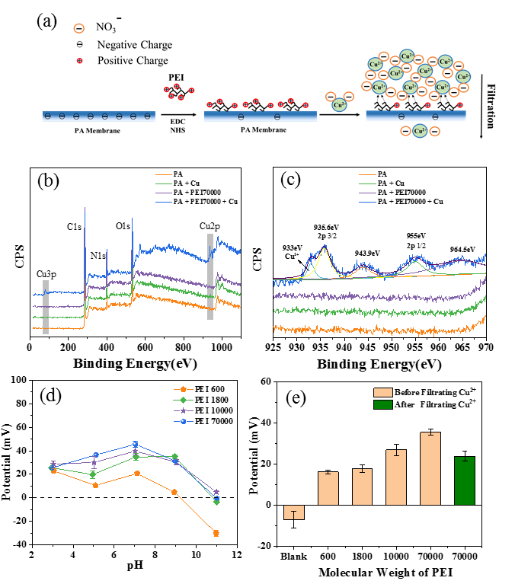
Figure 1. Details of the preparation and properties of PEI modified PA membrane (before and after Cu²⁺ filtration): (a) schematic of modification and Cu²⁺ filtration/rejection; (b) XPS spectra of PA and PEI-modified PA surfaces; (c) magnified XPS peaks of Cu 2p of pristine PA membrane (orange), pristine PA membrane after filtration of Cu²⁺ solution (green), PA membrane modified with 1 w.t.% PEI 70000 for 4 h (purple), and the PA membrane modified with PEI 70,000 after filtration of Cu²⁺ solution (blue); (d) variation of zeta potential of PEI with pH for different PEI molecular weights (1w.t.% for all PEI); (e) Surface zeta potentials of the PEI modified membrane with different molecular weight PEI at neutral pH.
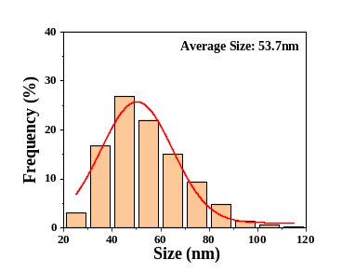
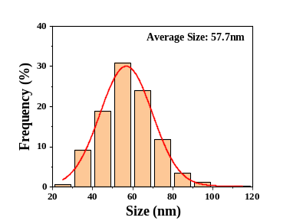
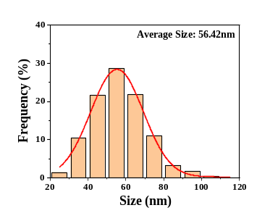
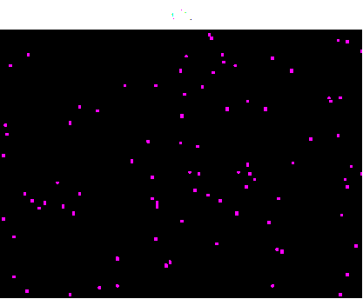
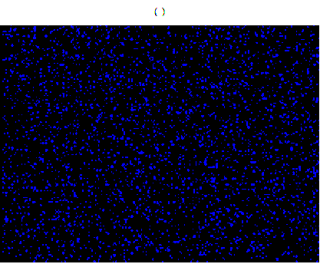
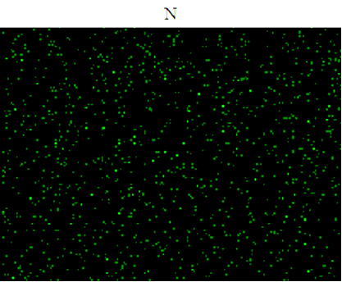
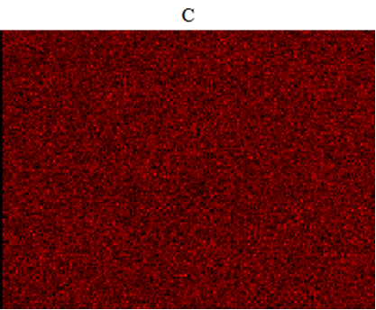
Figure 2. SEM morphology for: (a) pristine PA membrane; (b) PA membrane modified with PEI 70,000; (c) PA membrane modified with PEI 70,000 after filtration of Cu²⁺ solution; (d) EDS mapping and element content (C, N, O, Cu) on the PA membrane modified with PEI 70,000 after filtration of Cu²⁺ solution. Figure insets (a-c), show the mathematical statistics and Gaussian distribution of the granular analogue size of the functional surface layer of respective PA membranes.
(a)
(b)
(c)
(d)
Cu
O
C
N
500nm
500nm
500nm
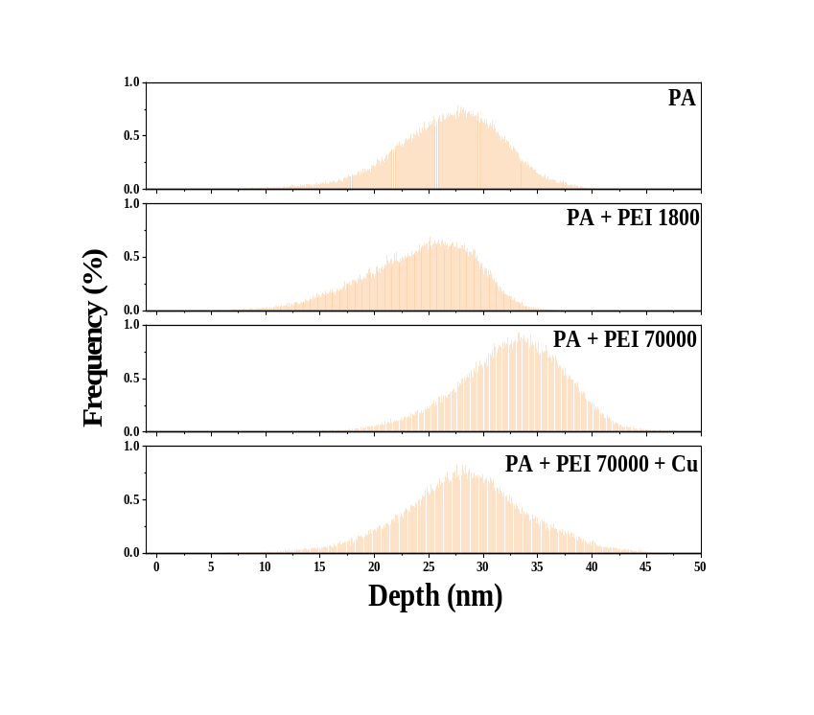
Figure 3. AFM morphology for: (a) pristine PA membrane; (b) PA membrane modified with PEI 1,800; (c) PA membrane modified with PEI 70,000; (d) PA membrane modified with PEI 70,000 after filtration of Cu²⁺ solution; (e-h) corresponding AFM morphologies of (a-d) at quadruple magnification, respectively; depth analysis for (i) pristine PA membrane, (j) PA membrane modified with PEI 1800, (k) PA membrane modified with PEI 70,000, and (l) PA membrane modified with PEI 70,000 after filtration of Cu²⁺ solution.
0.5 μm
0.5 μm
0.5 μm
0.5 μm
0.5 μm
0.5 μm
0.5 μm
0.5 μm
(e)
(f)
(g)
(h)
(i)
(j)
(k)
(l)
(a)
(b)
(c)
(d)
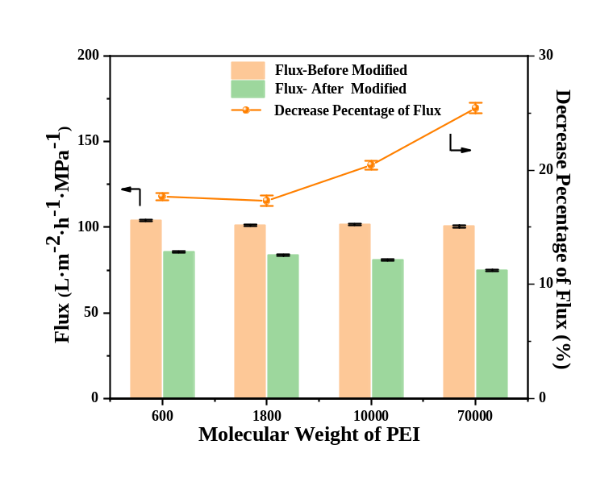
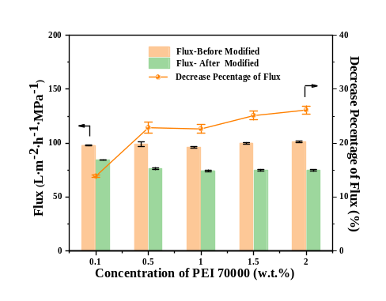
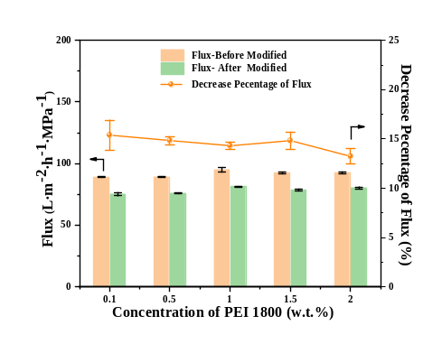
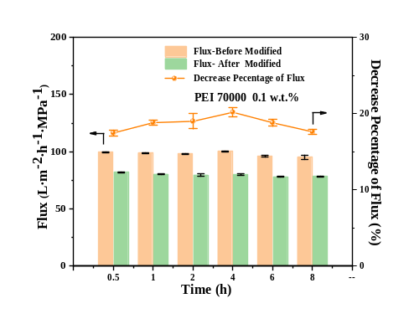
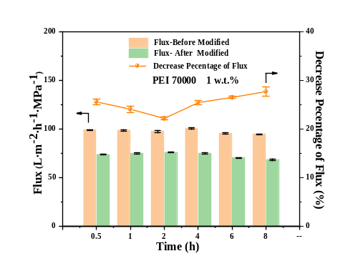
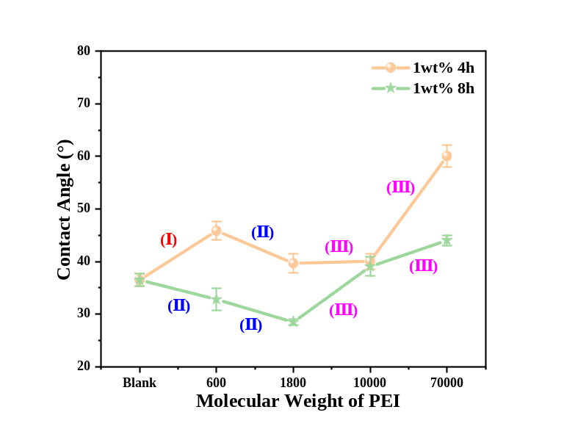
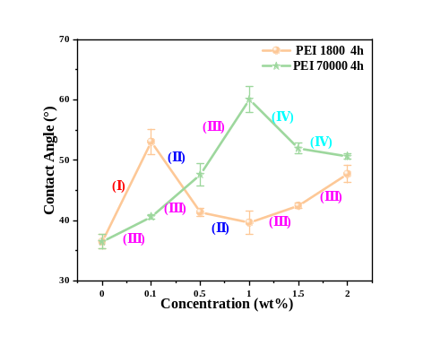
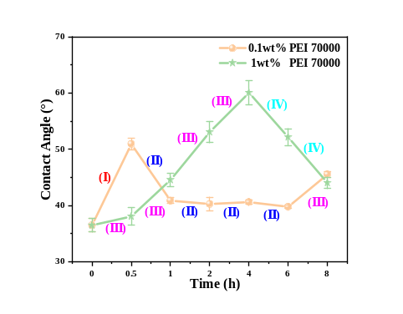
Figure 4. Variation of hydraulic flux and contact angle with properties of PEI modified membranes: (a) flux change with PEI molecular weight (1 w.t.%, 4 h); (c) and (d) flux change with PEI concentration of PEI 70,000 and PEI 18,00 (4 h), respectively; (f) and (g) flux change with contact time for 0.1 w.t.% and 1 w.t.% PEI 70,000, respectively; (b) variation of contact angle with PEI molecular weight (1 w.t.%, 4 h and 8 h); (e) variation of contact angle with concentration of PEI 70,000 and PEI 1,800 (4h); (f) variation of contact angle with contact time for 0.1 w.t.% and 1 w.t.% PEI 70,000.
(a)
(b)
(c)
(f)
(d)
(g)
(e)
(h)
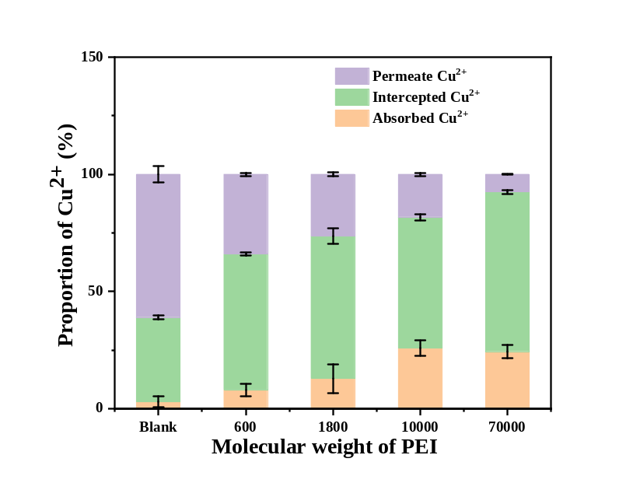
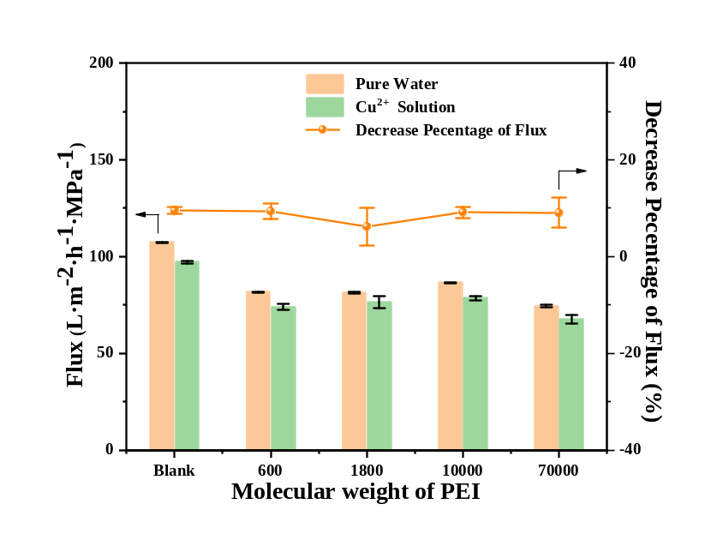
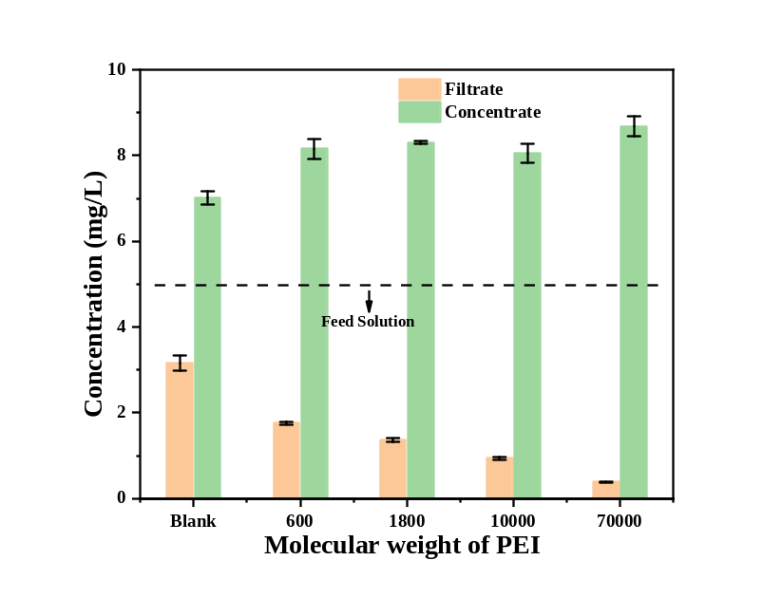
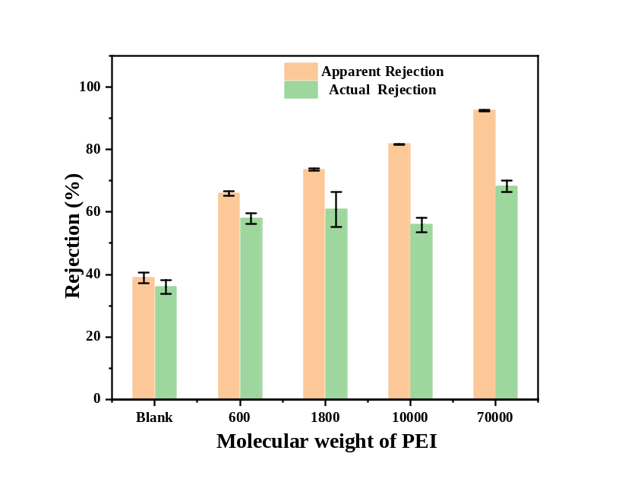
Figure 5. Effect of PEI molecular weight on modified membrane performance for Cu²⁺ solutions: (a) variation of flux; (b) Cu²⁺ concentration of filtrate and concentrate; (c) apparent and actual rejection; (d) the proportion of Cu²⁺ adsorbed, intercepted and in the permeate (1 w.t.%, 4 h; blank – unmodified membrane).
(a)
(b)
(c)
(d)

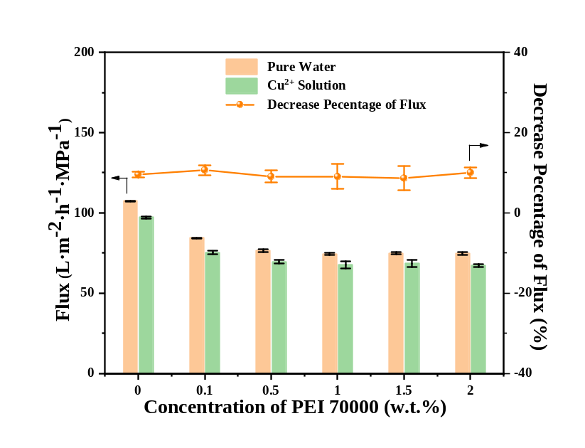
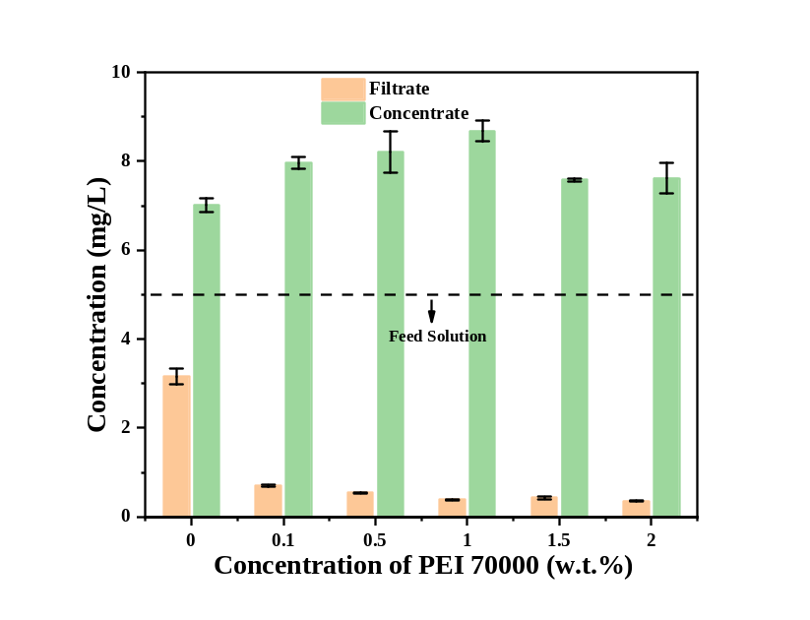
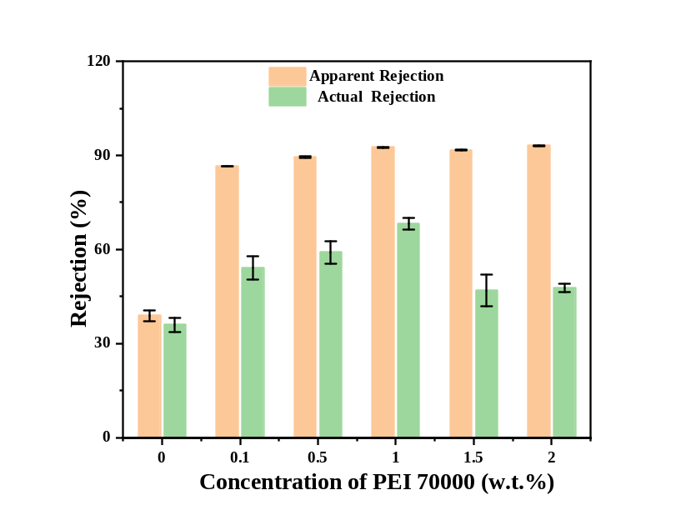
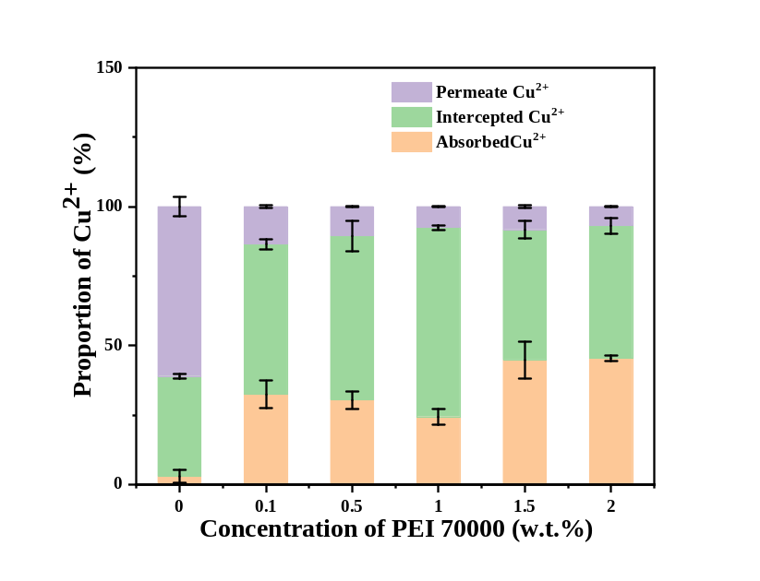
Figure 6. Effect of PEI concentration on modified membrane performance for Cu²⁺ solutions: (a) variation of flux; (b) Cu²⁺ concentration of filtrate and concentrate; (c) apparent and actual rejection; (d) the proportion of Cu²⁺ adsorbed, intercepted and in the permeate (1 w.t.% PEI 70,000, 4 h).
(a)
(b)
(c)
(d)

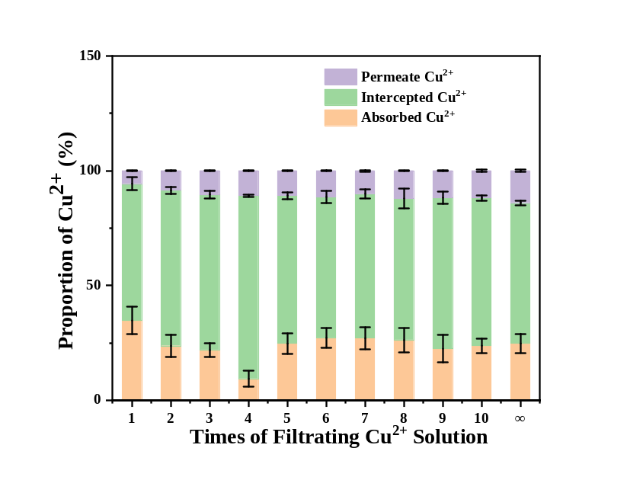
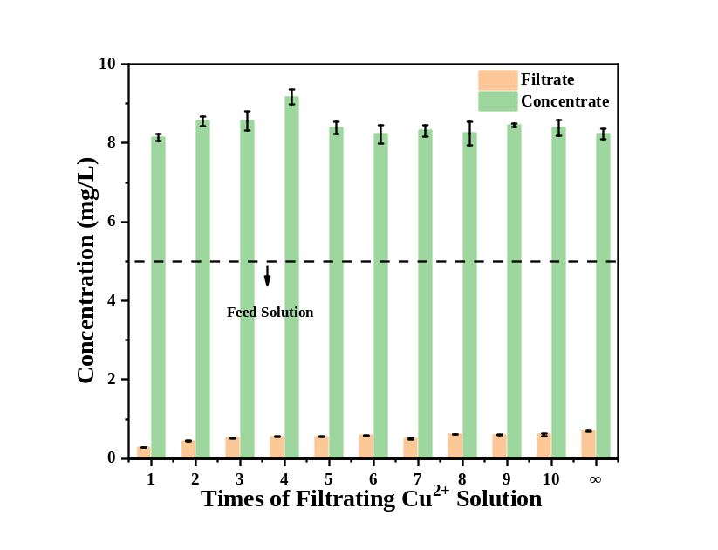
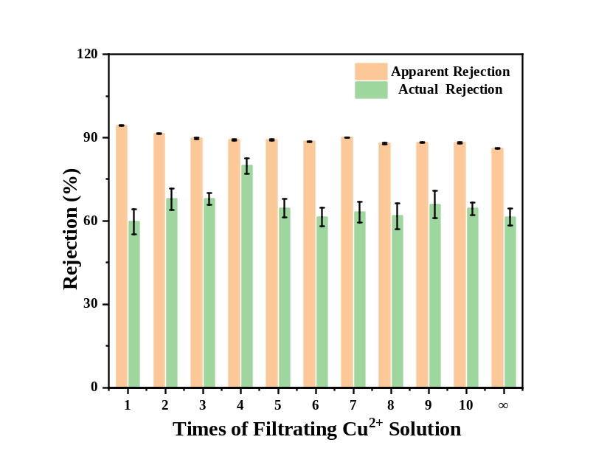
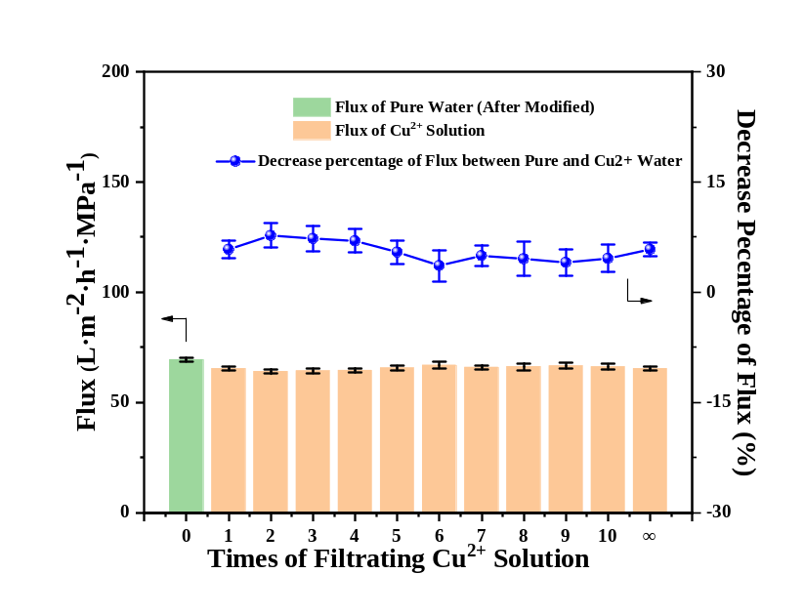
Figure 7. Variation of modified membrane performance for Cu²⁺ solutions with repeated filtration cycles: (a) variation of flux; (b) Cu²⁺ concentration of filtrate and concentrate; (c) apparent and actual rejection; (d) the proportion of Cu²⁺ adsorbed, intercepted and in the permeate (1 w.t.% PEI 70,000, 4 h). (Between filtration cycles the modified PA membrane was filtered with 30 mL of pure water. The symbol “∞” meant that before filtering Cu²⁺ solution, the modified PA membrane was immersed in high concentration (5 g/L) Cu²⁺ solution overnight and then rinsed by filtration of pure water until the filtrate Cu²⁺ concentration was lower than 0.1 mg/L.
(a)
(b)
(c)
(d)

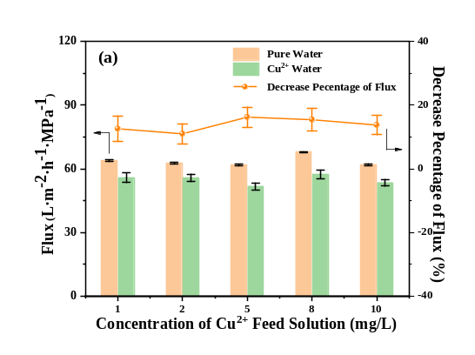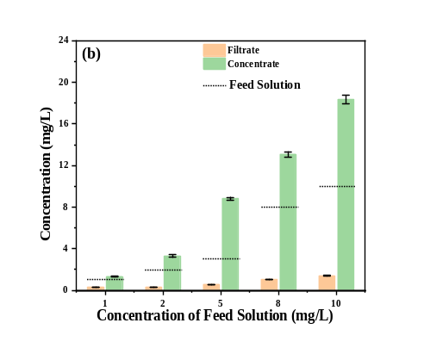
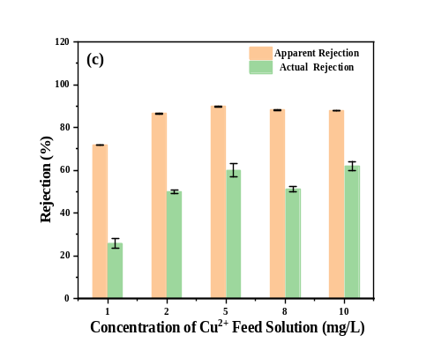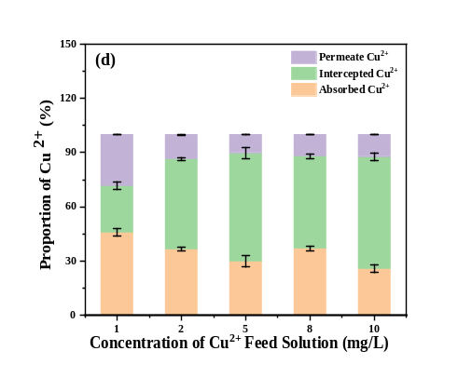
Figure 8. Effect of the Cu²⁺ feed solution on modified membrane performance for Cu²⁺ solutions: (a) variation of flux; (b) Cu²⁺ concentration of filtrate and concentrate; (c) apparent and actual rejection; (d) the proportion of Cu²⁺ adsorbed, intercepted and in the permeate (1 w.t.% PEI 70,000, 4 h).

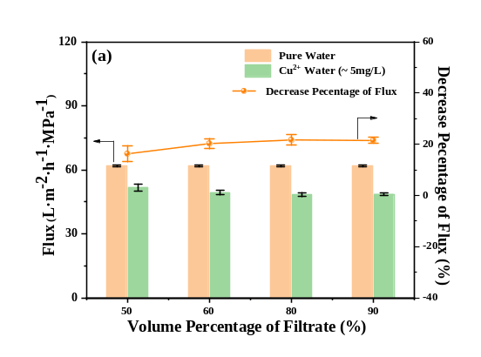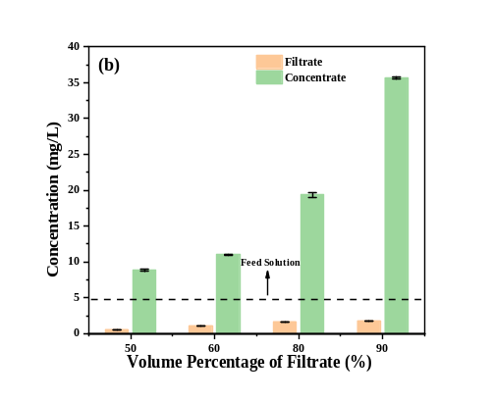
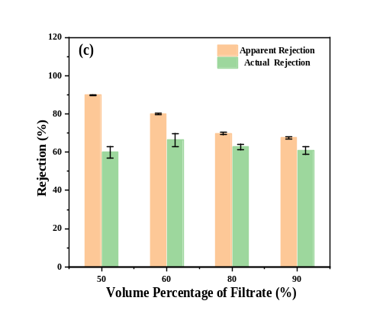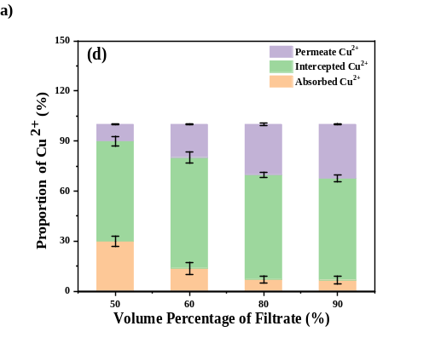
Figure 9. Effect of the volume percentage of filtrate on modified membrane performance for Cu²⁺ solutions: (a) variation of flux; (b) Cu²⁺ concentration of filtrate and concentrate; (c) apparent and actual rejection; (d) the proportion of Cu²⁺ adsorbed, intercepted and in the permeate (1 w.t.% PEI 70,000, 4 h).

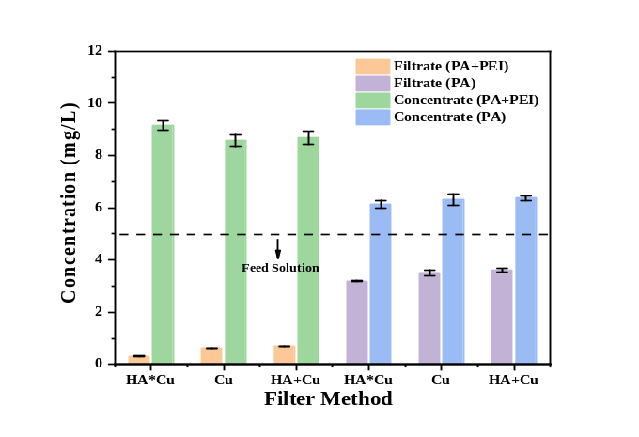
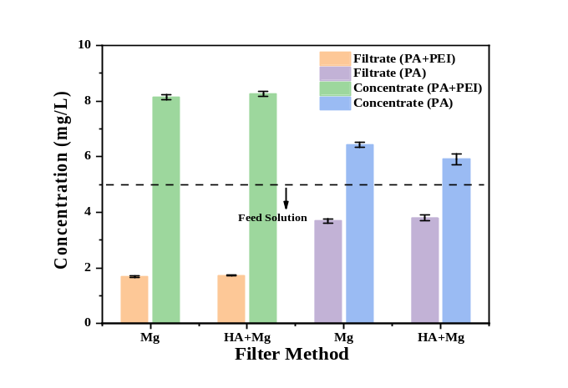
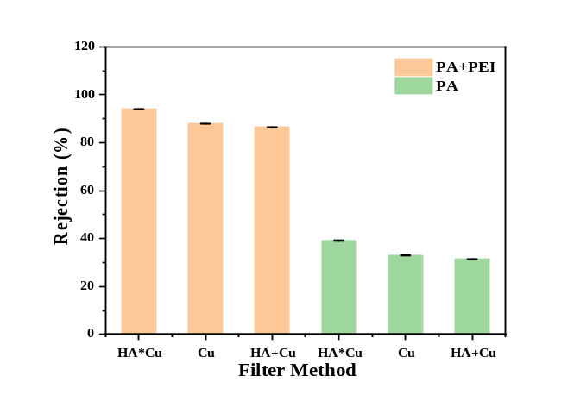
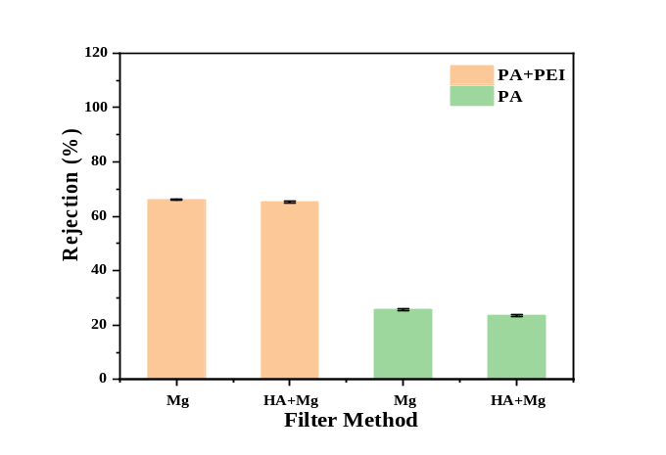
Figure 10. The effect of humic acid (HA) on the rejection (apparent rejection) performance of the modified and unmodified PA membrane for Cu²⁺ and Mg²⁺. The filtrate and concentrate concentrations of Cu²⁺ (a) and Mg²⁺ (b) by different filter method with “PA” and “PA+PEI” NF membranes; the rejection (apparent rejection) of Cu²⁺ (c) and Mg²⁺ (d) by different filter method with “PA” and “PA+PEI” NF membranes. The filter methods of “HA*M”, “M” and “HA+M” were as follows: “HA*M” meant the NF membrane initially filtered the humic acid solution and then filtered the M²⁺ solution; “M” meant filtration of the M²⁺ solution only; “HA+M” meant filtration of the mixture solution of HA and M²⁺. All the concentrations of HA and M²⁺ feed solutions were 5 mg/L. The “PA” was the original PA NF membrane and the “PA+PEI” was the PEI modified membrane with 1 w.t.% PEI 70,000 for 4 h.
(a)
(b)
(c)
(d)

Supporting Information

Evaluation of a novel polyamide-polyethylenimine nanofiltration membrane for wastewater treatment: removal of Cu²⁺ ions

Jinqiang Wang^{1,2}, Wenzheng Yu^{2*}, Nigel J. D. Graham³, Lei Jiang^{1,4*}

¹ State Key Laboratory of Urban Water Resource and Environment, School of Environment, Harbin Institute of Technology, Harbin, China, 150001
² Key Laboratory of Drinking Water Science and Technology, Research Centre for Eco-Environmental Sciences, Chinese Academy of Sciences, Beijing, China, 100086
³ Department of Civil and Environmental Engineering, Imperial College London, South Kensington Campus, London SW7 2AZ, UK.
⁴ Key Laboratory of Bio-inspired Materials and Interfacial Science, Technical Institute of Physics and Chemistry, Chinese Academy of Sciences, Beijing, China 100190

wzyu@rcees.ac.cn,n.graham@imperial.ac.uk, jianglei@mail.ipc.ac.cn

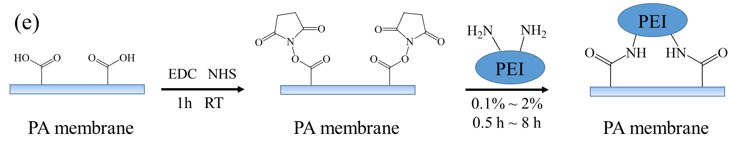
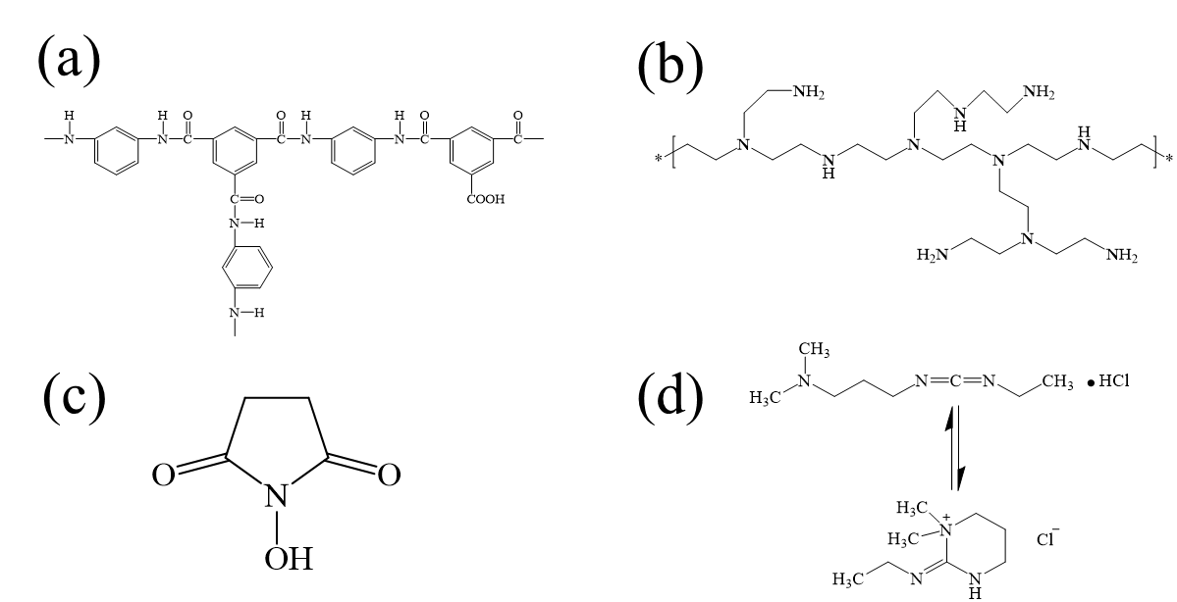
- Process of PA membrane modification with PEI by using NHS and EDC
Figure S1. Chemical structure of (a) PA membrane, (b) hyperbranched PEI, (c) NHS and (d) EDC; (e). schematic process of PA membrane modification with PEI by use of NHS and EDC.

- FTIR analysis of modified PA membranes
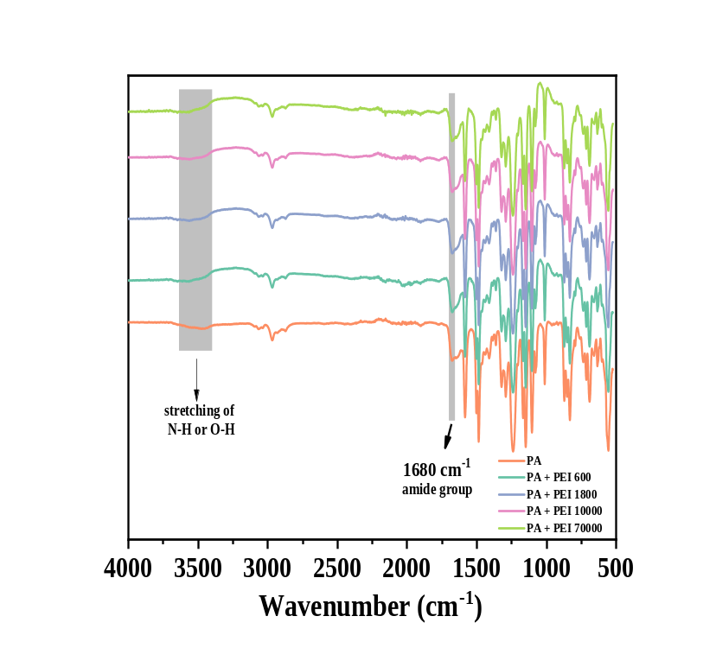
Figure S2. The FTIR spectra of PA membranes modified with different molecular weights of 1 w.t.% PEI for 4 h.

- Surface element analysis and surface zeta potentials of modified PA membranes
Table S1. XPS surface element analysis of modified PA membranes: (1). Original PA membrane; (2). Original PA membrane after filtration of Cu²⁺ solution; (3). PA membrane modified with 1 w.t.% PEI 70,000 for four hours; (4). Modified membrane (as #3) after filtration of Cu²⁺ solution.

Element | C  (%) | N  (%) | O  (%) | Cu  (%) | C/N
¹PA | 74.11 | 10.12 | 15.68 | 0.09 | 7.32
²PA+Cu | 70.02 | 9.71 | 20.15 | 0.12 | 7.21
³PA+PEI | 70.89 | 12.18 | 16.74 | 0.2 | 5.82
⁴PA+PEI+Cu | 66.71 | 12 | 19.18 | 2.11 | 5.56

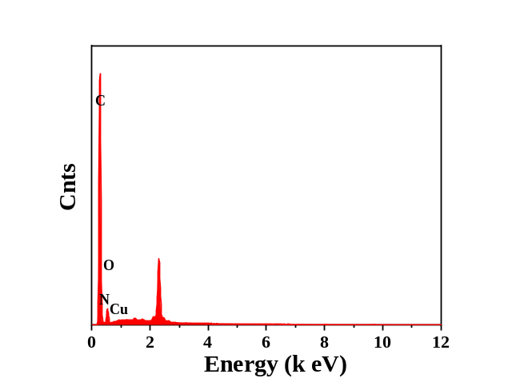
Figure S3. EDS spectra of modified PA membrane (1 w.t.% PEI for 4h) after filtration of Cu²⁺ solution

Table S2. Element content of the modified PA membrane (1 w.t.% PEI for 4h) after filtration of Cu²⁺ solution

Elt. | Line | Intensity (c/s) | Conc | Units
C | Ka | 11607.27 | 66.94 | w.t. %
N | Ka | 184.90 | 12.41 | w.t. %
O | Ka | 905.12 | 18.64 | w.t. %
Cu | Ka | 101.30 | 2.00 | w.t. %

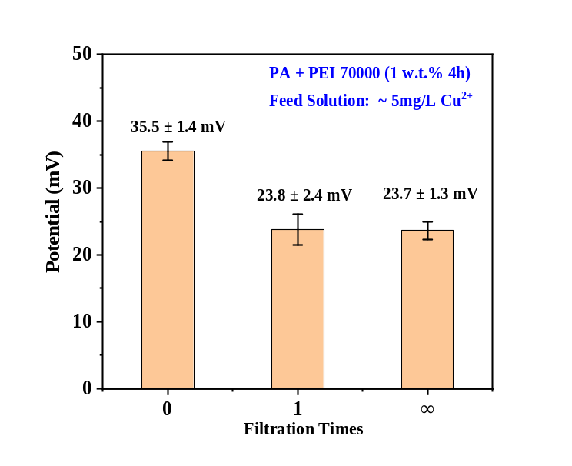
Figure S4. Surface zeta potentials of the PEI modified membrane with different filtration times. The “0” of filtration time was the sample of the modified PA membrane before filtrating Cu²⁺ solution in Figure 1(e), the “1” and “∞” filtration times were the samples shown in Figure 7 (b).

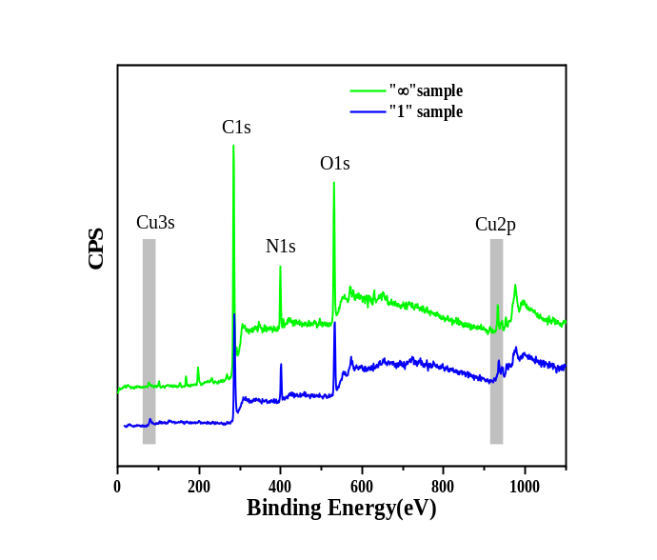
Figure S5. XPS spectra of the sample of “1” and “∞” filtration times in Figure 7(b)

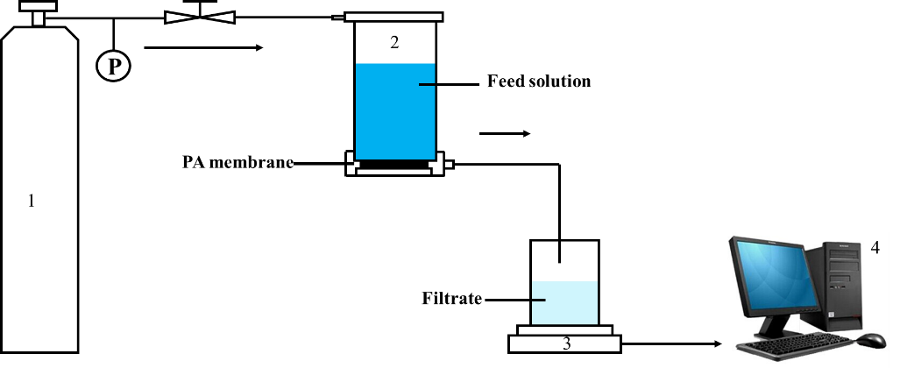
- Schematic of NF dead-end filtration system

Figure S6. NF dead-end filtration system: (1) nitrogen gas cylinder; (2) ultrafiltration cup; (3), electronic balance; (4), computer (recording one measurement per second).

- Measurement of the water contact angles of the modified PA membrane

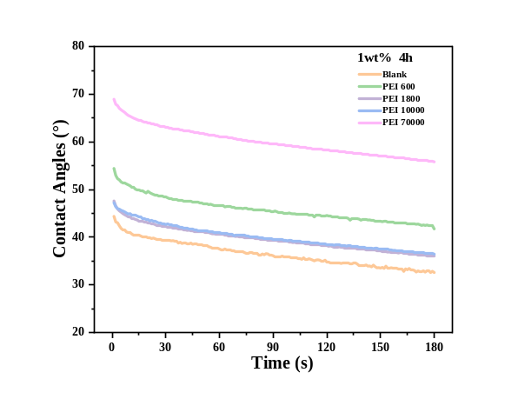
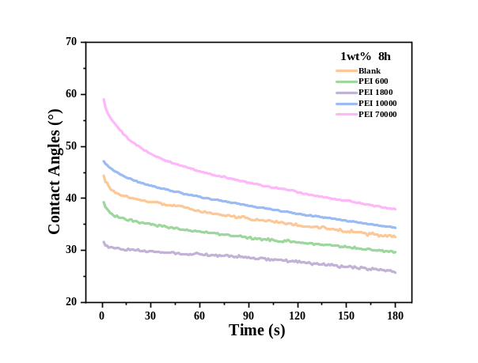
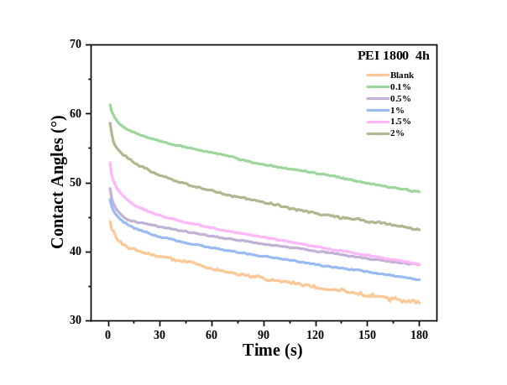
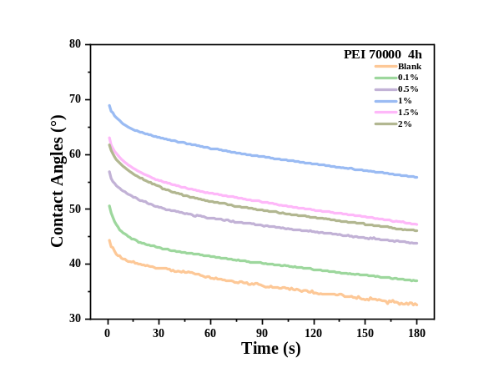
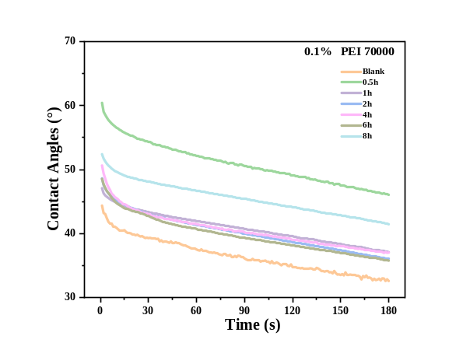
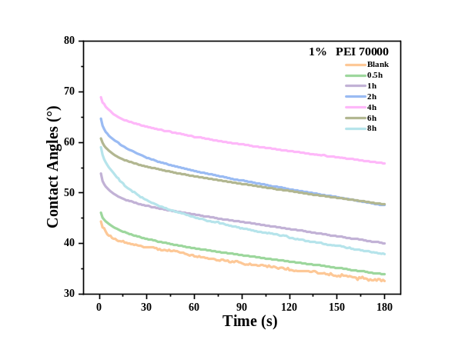
(c)
(a)
(b)
(d)
(e)
(f)

Figure S7. The initial temporal variation of water contact angles of the PA membrane modified with different PEI molecular weights for: (a) 4 h and (b) 8 h; different concentrations of (c) PEI 1,800 and (d) PEI 70,000 for 4 h; (e) 0.1 w.t.% and (f) 1 w.t.% PEI 70,000 for different polymer contact times.
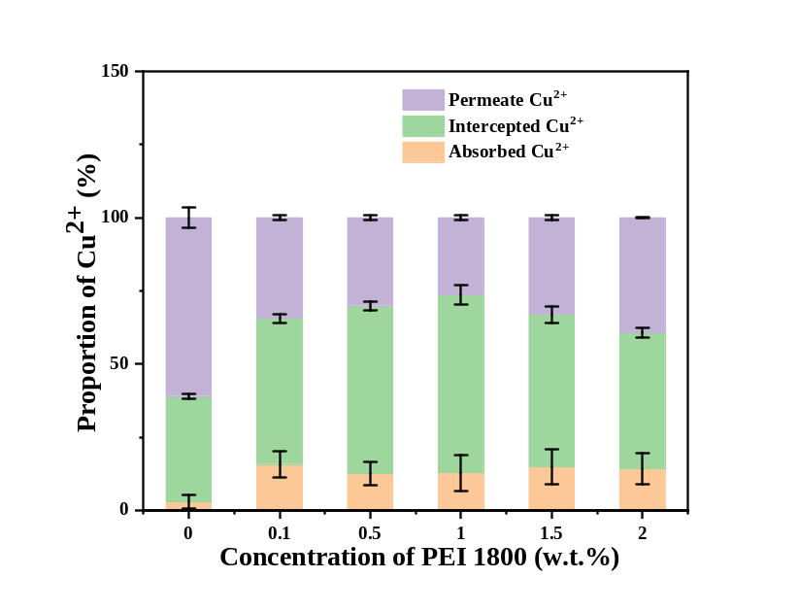
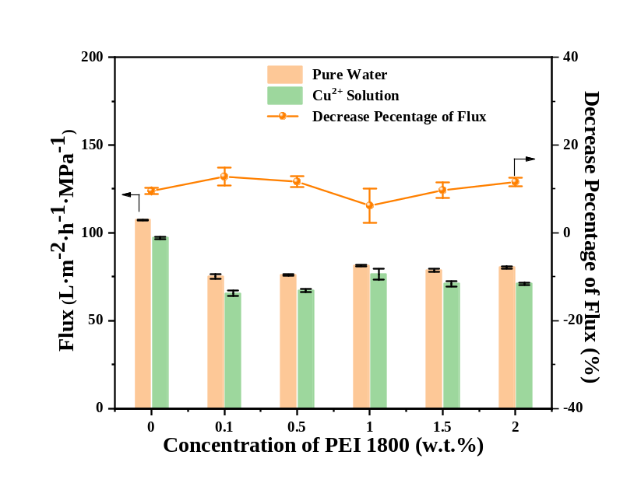
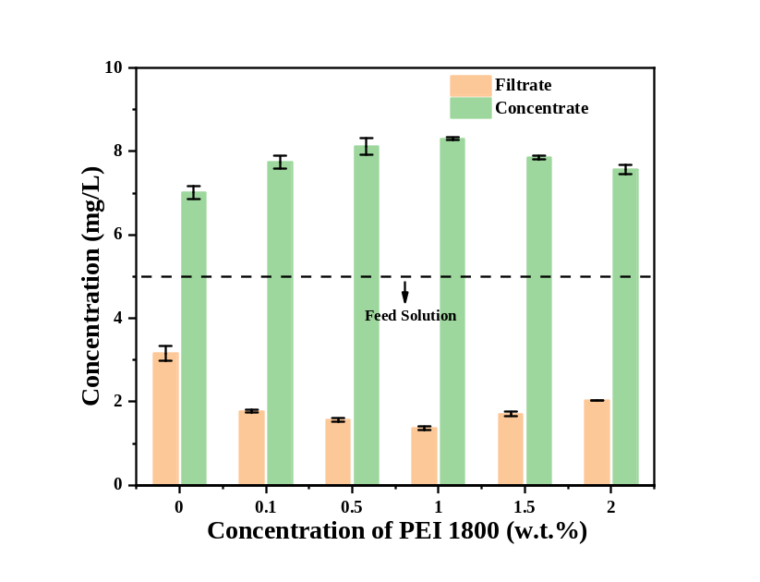
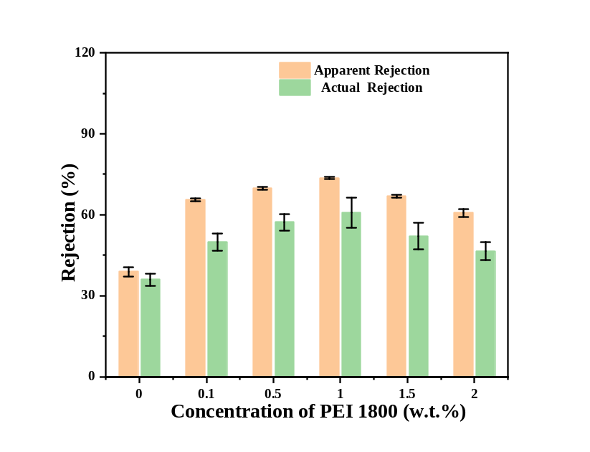
- Analysis of nanofiltration performance
(a)
(b)
(c)
(d)

Figure S8. Effect of PEI concentration on modified performance for Cu²⁺ solutions: (a) variation of flux change; (b) Cu²⁺ concentration of filtrate and concentrate; (c) apparent and actual rejection; (d) the proportion of Cu²⁺ absorbed, intercepted and in the permeate (1 w.t.% PEI 1,800, 4 h).

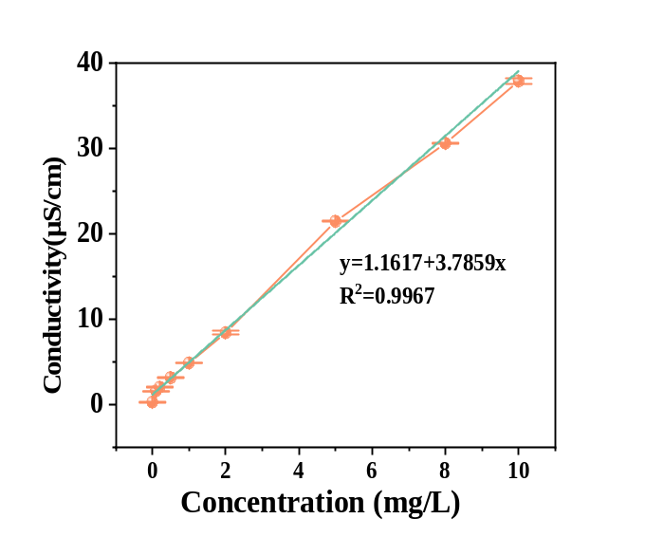
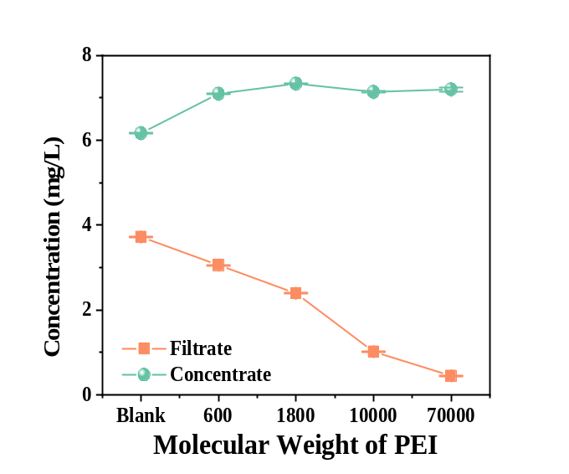
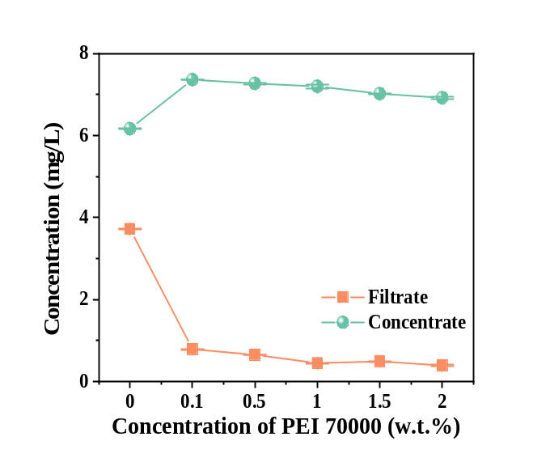
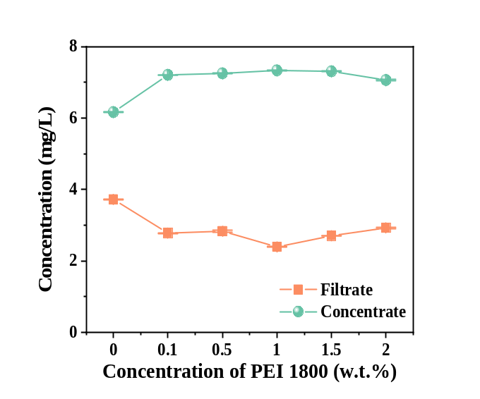
Figure S9. Use of electrical conductivity as a surrogate for Cu²⁺ concentration: (a) correlation between conductivity (by conductivity meter) and Cu²⁺ concentration; (b) the corresponding Cu²⁺ concentration of filtrate and concentrate of PA membrane modified with different molecular weights (1 w.t.% PEI, 4 h); (c) Cu²⁺ concentrations for different concentrations of PEI 70,000 (4 h); (d) Cu²⁺ concentrations for different concentrations of PEI 1,800 (4h).
(a)
(b)
(c)
(d)
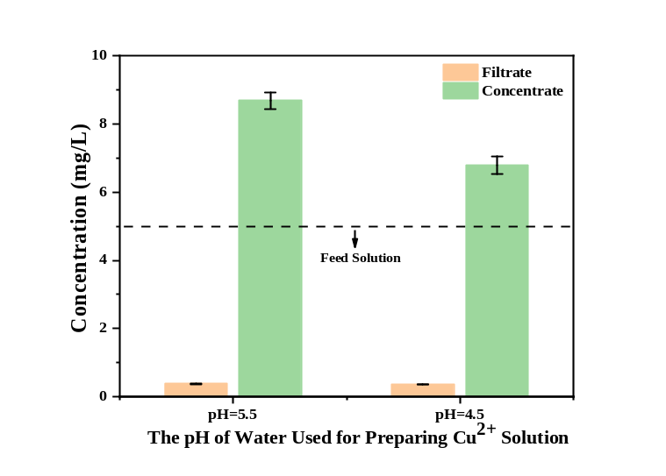
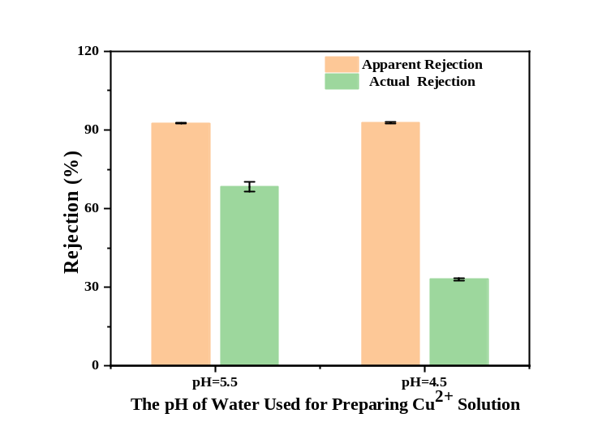
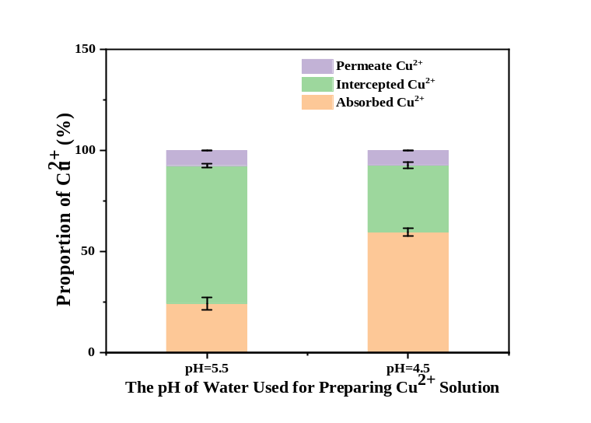
Figure S10. Influence of Cu²⁺ solution pH on Cu²⁺ rejection: (a) Cu²⁺ concentration of filtrate and concentrate; (b) apparent and actual rejection; (c) the proportion of Cu²⁺ absorbed, intercepted and in the permeate (1 w.t.% PEI 70,000, 4 h).
(a)
(b)
(c)

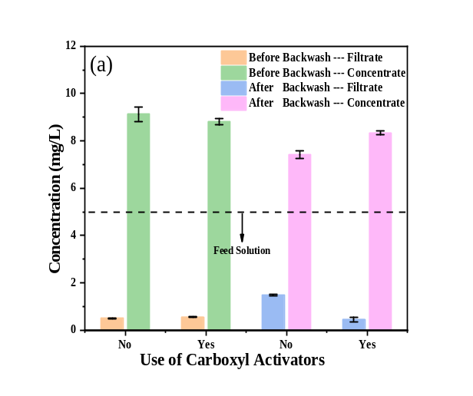
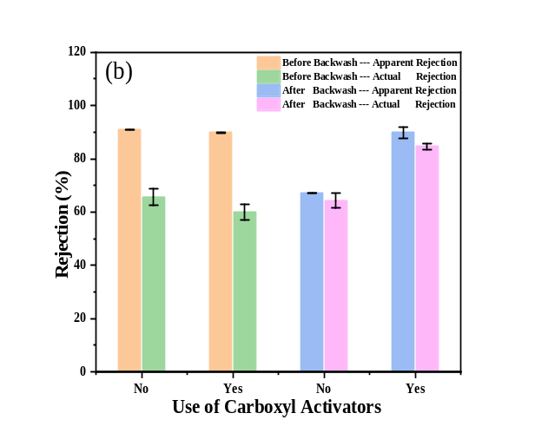
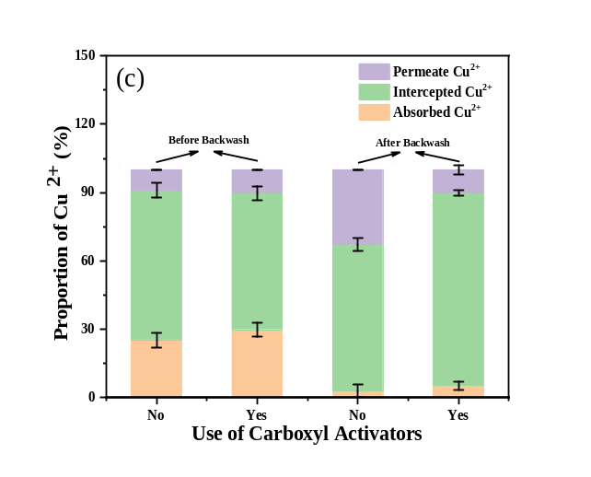
Figure S11. Effect of carboxyl activators on PA performance for Cu²⁺ solutions before and after backwash: (a) Cu²⁺ concentration of filtrate and concentrate; (b) apparent and actual rejection; (c) the proportion of Cu²⁺ absorbed, intercepted and in the permeate (1 w.t.% PEI 70,000, 4 h).

- Anti-pollution performance test
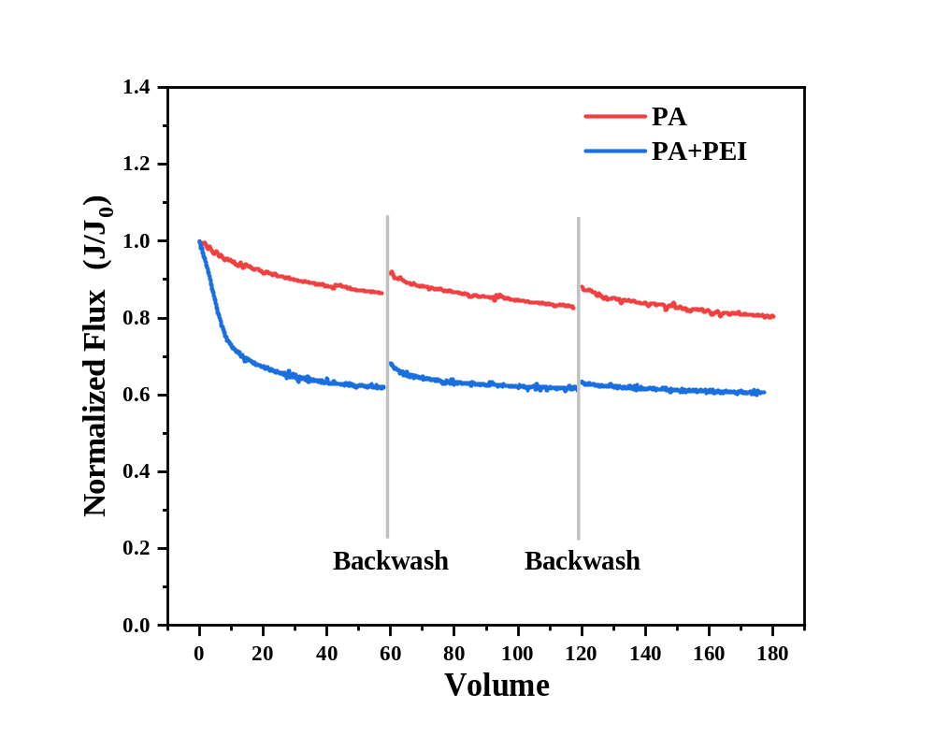
Figure S12. Effect of humic acid (5mg/L) on the flux recovery of pristine PA membrane (PA) and PA membrane modified with PEI 70,000 (PA+PEI, 1 w.t.%, 4h).

