Periodic repolarization dynamics predict the mortality benefit in patients undergoing prophylactic implantation of a defibrillator: a prospective controlled multicentre cohort study
A. Bauer^{1,2,3}, MD, M. Klemm^{1,3}, MD, KD. Rizas^{1,3}, MD, W. Hamm^{1,3}, MD, L. v. Stülpnagel^{1,3}, MSc, M. Dommasch^{3,13}, MD, A. Steger^{3,13}, MD, A. Lubinski⁴, MD, P. Flevari⁵, MD, M. Harden^{6,7}, MSc, T. Friede^{6,7}, PhD, S. Kääb^{1,3}, MD, B. Merkely⁸, MD C. Sticherling⁹, MD, R. Willems¹⁰, MD, H. Huikuri¹¹, MD, M. Malik¹², PhD, G. Schmidt^{3,13,*}, MD, M. Zabel^{7,14,*}, MD, and the EU-CERT-ICD investigators

¹ Medizinische Klinik und Poliklinik I, Munich University Clinic, Munich, Germany; ² University Hospital for Internal Medicine III, Medical University of Innsbruck, Austria; ³ German Center for Cardiovascular Research (DZHK), partner site: Munich Heart Alliance, Munich, Germany; ⁴ Dept. of Cardiology, Medical University of Lodz (MUL) WAM Hospital, Lodz, Poland; ⁵ 2nd Dept. of Cardiology, Attikon University Hospital, Athens, Greece; ⁶ Dept. of Medical Statistics, University Medical Center Göttingen, Göttingen, Germany; ⁷ German Center for Cardiovascular Research (DZHK), partner site: Göttingen, Göttingen, Germany;⁸Dept. of Cardiology, Semmelweis University Heart Center, Budapest, Hungary; ⁹ University Hospital, University of Basel, Basel, Switzerland; ¹⁰ University Hospitals of Leuven, Leuven, Belgium; ¹¹ Medical Research Center, Oulu University Hospital and University of Oulu, Finland; ¹² National Heart and Lung Institute, Imperial College, London, United Kingdom; ¹³ Med. Klinik und Poliklinik I, Technische Universität München, Klinikum rechts der Isar, Munich, Germany, ¹⁴Dept. of Cardiology and Pneumology, Heart Center, University Medical Center, Göttingen, Germany and the EU-CERT-ICD Study Investigators

*both authors contributed equally
Word count: 3286 (manuscript text only); 300 (summary)
Conflicts of interest: no author has a conflict of interest

Correspondence
Univ-Prof. Dr. med. Axel Bauer
Medizinische Klinik III, Medizinische Universität Innsbruck, Austria
Anichstr. 35, 6020 Innsbruck
Tel: +43 (0) 512 504- 25621 Fax: +43 (0) 512 504- 25622
Email: axel.bauer@i-med.ac.at
Summary
Background: A rather small proportion of patients undergoing primary prophylactic ICD implantation experience malignant arrhythmias. We postulated that Periodic Repolarization Dynamics (PRD), a novel marker of sympathetic activity-associated repolarization instability, identifies electrically vulnerable patients who benefit from prophylactic ICD implantation in terms of mortality reduction.
Methods: The present study is a prespecified sub-study of the EUropean Comparative Effectiveness Research to Assess the Use of Primary ProphylacTic Implantable Cardioverter Defibrillators (EU-CERT-ICD), a prospective, investigator-initiated, non-randomised, controlled, cohort study performed at 44 centres in 15 EU countries. Patients with ischemic or non-ischemic cardiomyopathy were eligible if they met guideline-based criteria for primary prophylactic ICD-implantation. Primary endpoint was all-cause mortality. PRD was assessed blindly from 24-hour Holter recordings. Propensity scoring and multivariable models were used to assess the interaction between PRD and the ICD treatment effect on mortality.
Findings: Between May 2014 and April 2019, 1,371 patients were enrolled. Of these, 968 patients (62 (12) years; 174 females) underwent ICD-implantation, while 403 patients (63 (12) years; 78 females) were treated conservatively. During median follow-up of 2·5 years, 138 (14·2%) and 64 (15·9%) patients died in the ICD and control groups, respectively. PRD significantly predicted the ICD treatment effect on mortality (p=0·0307 for interaction). The 199 patients with the highest PRD (≥7.5 deg) had the greatest mortality benefit from ICD-implantation (adjusted HR 0·25 (95% CI 0·13–0·47); p<0·0001), while the 1,172 patients with lower PRD (<7.5deg) had significantly less benefit (adjusted HR 0·69 (95% CI 0·47-1·00); p=0·0492; p=0·0056 for interaction). Number needed to treat decreased from 18·3 in patients with low PRD to 3·1 in patients with high PRD.
Interpretation: PRD predicts mortality reduction by prophylactic ICD implantation in contemporarily treated patients with ischemic or non-ischemic cardiomyopathy. PRD may help to guide prophylactic ICD implantation.
Funding: European Community’s 7th Framework Programme FP7/2007-2013 (602299)

Keywords: Implantable cardioverter defibrillator; ECG; mortality; risk factors; sudden cardiac death; sympathetic nervous system
Introduction
Current guidelines recommend prophylactic ICD implantation in patients with ischemic or non-ischemic cardiomyopathy and reduced left ventricular ejection fraction (LVEF ≤35%).^{1,2} The implementation of guidelines into clinical practice has led to a substantial increase of ICD implantation rates in Europe.³ At present, an estimated > 100.000 ICDs are implanted in the EU annually with device costs exceeding €2 billion per year.⁴ Since the publication of landmark trials, however, the management of heart failure as well as device programming has improved significantly, resulting in a substantial decline of malignant arrhythmias over the last 20 years.⁵ A recent study found no net benefit of prophylactic ICD therapy in unselected patients with non-ischemic cardiomyopathy, suggesting that the value of ICD is found only in certain patient subgroups.⁶
Presently, only few patients treated with an ICD for primary prophylactic reasons ever experience malignant arrhythmias and adequate ICD interventions.⁷ In contrast, the risk of side effects of ICD therapy applies to all ICD patients. It is assumed that approximately one in four patients suffers from a considerable complication such as device infections or inappropriate shocks within 10 years.⁸ Because of the high economic burden and of patient safety, better patient selection is urgently needed.⁹ However, the accurate identification of vulnerable patients susceptible for malignant arrhythmias who actually benefit from ICD implantation has not yet been successful.¹⁰
A large body of evidence indicates that sympathetic mechanisms play a pivotal role in the genesis of malignant tachyarrhythmias.¹¹ Periodic Repolarization Dynamics (PRD) is a novel electrophysiological marker that quantifies sympathetic-activity related low-frequency oscillations of cardiac repolarization instability.¹² Previous studies in post-infarct patients showed that increased PRD was not only a strong and independent predictor of all-cause mortality^{12,13,14}, but was also specifically associated with arrhythmic events such as SCD and adequate ICD interventions.¹⁵
Consequently, we tested the hypothesis that PRD predicts the treatment effect of prophylactic ICD implantation on mortality in contemporarily treated patients with ischemic or non-ischemic cardiomyopathy.

Methods
Study design and participants
The EUropean Comparative Effectiveness Research to Assess the Use of Primary ProphylacTic Implantable Cardioverter Defibrillators (EU-CERT-ICD) was a prospective investigator-initiated, non-randomised, controlled, multicentre cohort study funded within the 7th Framework Programme (EU 602299). A main goal of EU-CERT-ICD was to identify subgroups of patients who benefit from ICD-implantation.¹⁶
EU-CERT-ICD was conducted at 44 centres across 15 EU countries and, between May 2014 to September 2018, enrolled patients who met the criteria of primary prophylactic ICD-implantation according to the current guidelines. Main inclusion criteria were age ≥18 years, presence of ischemic or non-ischemic cardiomyopathy and reduced left ventricular ejection fraction (LVEF) ≤35%. Patients were excluded if they had an indication for secondary prophylactic ICD-treatment, were considered to be candidates for cardiac resynchronization therapy, had higher degree AV block (≥ II) at resting heart rates, had a pacemaker implanted, were in unstable cardiac conditions such as decompensated heart failure (NYHA functional class IV) or acute coronary syndrome, or had a limited life expectancy ≤1 year.
Study approval was given by all local ethics committees. All patients gave their informed written consent prior to inclusion. The study has been conducted in accordance with the Declaration of Helsinki and Good Clinical Practice (GCP) principles.
The therapy decision for an ICD implantation or a conservative approach was not determined by the study design, but was based on the decision of the physician or patient and was influenced by regional health policy practices in the given European country.¹⁶ Accordingly, two groups of patients were recruited. ICD Group consisted of patients who underwent ICD-implantation; Control Group consisted of patients who were treated conservatively.
The PRD study was conducted according to a prespecified analysis plan within the EU-CERT-ICD framework. By a prospective definition, patients were excluded from the PRD dataset if they were not in sinus rhythm or if the Holter recordings (as described further) did not fulfil the quality criteria of PRD assessment.
Procedures
In the ICD group, a commercially available ICD was implanted according to local practice of the study centres. Mandatory ICD programming was established, consisting of a ventricular tachycardia (VT) therapy zone from 200 to 250 bpm, a ventricular fibrillation (VF) therapy zone above 250 bpm and a monitor zone from 170 to 200 bpm. VT was treated by ATP followed by shocks of maximum output. VF was treated by ATP during charge (if applicable) and shocks of maximum output. ICD programming could be individualized by the physician on clinical grounds.
A high-resolution (1 kHz) 12-channel Holter recording (CM 3000-12 BT; Getemed, Teltow/Germany) was obtained in all patients on the day before ICD implantation (ICD group) or study enrolment (Control group). The ECG raw data were digitally transferred and centrally stored at the university of Goettingen, Germany (T.F., M.Z.). Data pre-processing including quality checks, exclusion of artefacts and beat annotations was performed blindly at the Technical University of Munich, Germany (G.S., M.D., A.S.).
PRD assessment was performed blindly at the Munich University Clinic, Germany, according to standardized technologies (A.B., M.K., L.S., K.R.). Only the night hours (midnight–6 AM) were considered. All ECGs were visually inspected (M.K. and L.S.). ECGs not meeting the predefined quality criteria (baseline wondering, loss of one ore more signal electrodes, significant noise or artefacts during T-wave) for PRD assessment were excluded. ECGs were accepted if at least 4·5 hours of high-quality signal (within the recording period from midnight to 6 AM) was available.
PRD was calculated by use of a validated software (SMARTlab V1·5). Twelve-lead ECGs were converted into Frank leads configuration using the inverse Dower matrix. The technical details of PRD assessment have been described elsewhere.^{12,17} The principle of the method is to quantify low frequency oscillations that modulate the beat-to-beat repolarization processes. Briefly, T-wave vectors were constructed for all T-waves within the observation period (e.g. 30,000 heartbeats within 6 hours), representing the spatiotemporal properties of each cardiac repolarization. The beat-to-beat sequence of T-wave vector changes dT° was analysed by Phase-Rectified Signal Averaging¹⁷ (using T=9) to extract the low-frequency component.
Following additional variables were recorded at baseline: Underlying cardiac disease, NYHA functional class, pulse rate, resting blood pressure, weight, height, cardiovascular pharmacological treatment and co-morbidities including peripheral arterial disease, cerebral vascular disease, pulmonary disease, diabetes mellitus, hypertension, sleep apnoea, tobacco use, and any malignant disease within the last 5 years. Standard laboratory parameters were recorded including creatinine, estimated glomerular filtration rate, serum blood urea nitrogen, and N-terminal pro BNP or BNP.

Endpoints and follow-up
All ICD patients were followed in the outpatient clinic of the respective study centres every 3 to 6 months or remote follow-up. Episodes of shock or ATP were stored as electrograms for adjudication; programming changes were recorded. Patients in the control group were scheduled for visits every 6 to 12 months. In both groups, information was also retrieved from hospital records, via telephone and/or mail from patients, relatives, general practitioners, or local authorities. If a patient underwent heart transplant or implantation of a ventricular assist device, follow-up was censored on that date without an event considered.
The primary endpoint was all-cause mortality. Co-primary endpoint in ICD patients was occurrence of a first appropriate ICD shock. All endpoints were reviewed by an external blinded endpoint committee. ICD shocks were adjudicated after review of device electrograms (EGMs) and classified as appropriate or inappropriate.

Statistical analyses
Continuous data are presented as mean (standard deviation); categorical data are summarized by frequencies (percentages). Baseline characteristics were compared between ICD and control patients using Wilcoxon and chi-square tests for continuous and categorical variables, respectively. Study sites were grouped into four geographical regions (Eastern, Western, Northern and Southern Europe); the grouping by countries is given in the supplementary material (Table S6).
The primary endpoint all-cause mortality was displayed by Kaplan-Meier curves and analysed by Cox proportional hazards models. Model diagnostics included visual checks of the proportionality assumption in log-minus-log plots of survival. To account for potential differences in baseline variables, the primary analyses (Model 1; reported in the main text) were stratified by quintiles of a propensity score¹⁸. The propensity score was developed by fitting a logistic regression for the treatment group indicator (ICD or control) as dependent variable and numerous baseline characteristics as independent variables which were selected using a stepwise selection with p≤0.05 as criterion for entry and stay; the lists of considered and selected baseline characteristics are included in the supplementary Table S1. To check whether the propensity score stratification resulted in more balanced treatment groups within the strata, the baseline characteristics were compared within the strata; additionally also the SHOCKED score for mortality by Bilchick et al. was computed.¹⁹ As supporting analyses (reported in the supplementary material), Cox proportional hazards models stratified by region were fitted that included the ICD effect (ICD vs. control) as factor and the propensity score as covariate (Model 2). Furthermore, Cox proportional hazards regressions stratified by region that included the ICD effect as factor and relevant baseline characteristics as factors or covariates were fitted as additional supporting analyses (Model 3; reported in the supplementary material); the baseline characteristics were selected using a stepwise selection with p≤0.1; the considered and selected baseline characteristics are listed in the supplementary Table S1.
The effects of PRD and in particular their interactions with the ICD effects were assessed in Cox regressions including ICD effect as factor, PRD as covariate and their interactions in Models 1- 3. Again, Model 1 is considered the primary analysis (reported in the main text) whereas Models 2 and 3 serve as supporting analyses (reported in the supplementary material). The optimum cut-off value for the continuous PRD marker was identified by maximizing the interaction between ICD and the dichotomized PRD marker groups varying the PRD cut-off between the 10% and 90% quantiles. For interpretation, selected hazard ratios were converted into numbers needed to treat (NNT) using Equation 1 in Altman & Andersen²⁰ and survival probabilities in the control group at year 3.
The incidence of first appropriate shocks is presented by cumulative incidence functions and analysed using a Fine & Gray model stratified by regions accounting for competing events (mortality, heart transplantation or ventricular assist device (VAD) implantation). Predictors of mortality and first appropriate shock were identified using stepwise model selection with p ≤0·1 as selection criterion for entry and stay.
As the proportion of patients with missing items was 3.2% (44 out of 1371), complete case analyses were conducted; depending on the specific analyses slightly different numbers of patients were included; the number of patients included in any analyses are reported in the legends of the tables and figures. Statistical significance was indicated by two-sided p-values less than 0·05. All analyses were performed with SAS software, version 9·4. The sample size was determined for the EU-CERT-ICD cohort as explained elsewhere.¹⁶

Role of funding source
The funders of this study had no role in study design, collection of data and data analysis, or writing of the manuscript. AB, GS, TF and MZ had full access to the data and take full responsibility for the decision to submit for publication. This study is registered with ClinicalTrials.gov (number NCT0206419).

Results
During the recruitment period, 2,247 patients were prospectively enrolled (1,516 patients in the ICD group and 731 patients in the control group). Out of these, 876 patients had to be excluded (absence of sinus rhythm (n=255), insufficient ECG quality (n=595) or insufficient data (n=26); Figure 1). Thus, 1,371 patients qualified for the PRD study and formed the actual study population. Out of these, 968 patients were in the ICD-group, while 403 patients were of the control group. Baseline and treatment characteristics are shown in Table 1. Despite the non-randomised design, patients in the ICD and control groups were well matched for the majority of clinical and demographic variables. Patients in both groups were relatively young (61·5 (11·8) years and 62·7 (11·7) years in the ICD and control group, respectively) and predominantly male (82% and 81%, respectively). Ischemic cardiomyopathy was the leading cardiac disease in both groups (72% and 62% in the ICD and control group, respectively). Pharmacological treatment was up to date in both groups, with beta-blockers prescribed in 95% and 93% of ICD and control patients, respectively. Median follow-up was 2·7 years (IQR 2·0–3·3; max 4·8 years) in ICD patients and 1·2 (IQR 0·8–2·7; 4·8 years) in control patients. Thirty-three patients in the ICD group (3·4%) and 8 patients in the control group (2·0%) were lost to follow-up. During follow-up, 138 (14·2%) and 64 (15·9%) ICD and control patients died. Sixty-five patients (6·7%) in the ICD-group received a first appropriate shock. There were 31 cross-overs from the control group to the ICD-group. Stratification by propensity score quintiles resulted in balanced treatment groups with regard to relevant baseline characteristics (supplementary Tables S5 and Figure S1).
In the PRD study population, there was an adjusted 43%-mortality reduction by ICD-implantation (adjusted HR 0·57 (95% CI 0·41-0·79); p=0·0008; Model 1). PRD showed a significant interaction with the ICD treatment effect on mortality (adjusted p=0·0307). The relation between PRD and ICD treatment effect on mortality is shown in Figure 2. With low PRD, the survival benefit of ICD therapy was absent or low. With increasing PRD, however, the survival benefit of ICD therapy improved continuously and became substantial at high PRD levels.
There are no PRD cut-off values for ICD treatment effect prediction. In the study population, a cut-off value of PRD at 7.5 deg enabled the best separation between responders and non-responders to ICD therapy in terms of mortality reduction. Figure 3 shows the crude cumulative mortality rates in ICD and control patients with PRD < 7.5 deg and ≥ 7.5 deg (panel A and B). While difference in mortality rates between the ICD and control groups was small in the 1,166 patients with PRD <7.5 deg, it was substantial in the 199 patients with PRD ≥7.5 deg. Panel A of Figure 4 shows the adjusted HR of ICD therapy vs. control in patients with PRD < and ≥ 7.5 deg, respectively. ICD therapy was associated with a mortality reduction by 31% (adjusted HR 0·69 (95% CI 0·47–1·00); p=0·049) in the 1,166 patients with PRD <7·5 deg, whereas it showed a 75%-reduction of mortality in the 199 patients with PRD ≥7·5 deg (adjusted HR 0·25 (95% CI 0·13-0·47); p<0·0001; p=0·0056 for interaction). Accordingly, the number needed to treat (NNT) reduced from 18·3 (95% CI 10·6-4895·3) in patients with PRD <7·5 deg to 3·1 (95% CI 2.6-4.8) in patients with PRD ≥7·5 deg (Panel B of Figure 4).
In line with these findings, PRD was a significant and independent predictor of appropriate shocks in ICD patients (adjusted HR 1·30 (95% CI 1·08-1·56); p=0·0050; supplementary Table S2), whereas it predicted mortality in control patients (adjusted HR 1·40 (95% CI 1·07-1·83); p=0·0154; supplementary Table S3).

Discussion
The findings of our study indicate that PRD, a marker of electric instability, predicts the treatment effect of ICD therapy on mortality in contemporarily treated patients undergoing primary prophylactic treatment according to present guidelines. There was a strong and independent relationship between PRD and the mortality reduction by ICD treatment. In patients with low PRD, mortality reduction by ICD therapy was moderate or low, whereas in patients with high PRD mortality reduction was substantial. Thus, PRD ≥7·5 deg identified a high-risk group of 199 patients in whom ICD implantation was associated with a significant 75%-reduction in mortality. PRD significantly predicted appropriate shocks in ICD patients, while it predicted mortality in control patients. Our results are therefore consistent with the mechanisms by which the ICD saves lives.
The strong prognostic power of PRD for prediction of arrhythmic events appears to be explained by its underlying physiological mechanisms. PRD quantifies low frequency oscillations of cardiac repolarization instability most likely caused by phasic sympathetic activation.^{12,17} Experimental^{12,17}, electrophysiological^{12,17,21,22} and model-based²³ studies suggest that PRD provides a direct insight into the sensitive coupling between sympathetic innervation and ventricular repolarization. If this is disturbed, the susceptibility to malignant arrhythmias is significantly increased.¹¹ Several studies have validated PRD as a strong and independent predictor of long-term mortality in post-infarction patients and in patients with stable coronary artery disease.^{12,13,14} The specific link between PRD and arrhythmic risk was first demonstrated in a post-hoc analysis of the MADIT-2 study, in which PRD was found to be the strongest predictor of SCD in conventionally treated patients and of appropriate shocks in ICD-treated patients.¹⁵
However, a marker that predicts arrhythmic risk does not necessarily predict the net benefit of ICD therapy in terms of mortality reduction, as competing risks may arise. This was impressively shown by the DINAMIT²⁴ and IRIS²⁵ studies which both investigated patients early after myocardial infarction. In both trials, prevention of SCD by prophylactic ICD-implantation was compensated by an excess of non-sudden death, resulting in a zero net effect on total mortality.^{25,26} The finding of our study that PRD predicts not only the arrhythmic risk but also the clinical net benefit of a prophylactic ICD therapy in terms of mortality reduction is therefore of substantial importance. Our study shows a monotonic relationship between PRD and clinical net benefit of an ICD implantation, with patients with the highest PRD values having the greatest benefit. PRD assessment can therefore help to individualise the treatment decision of a primary prophylactic ICD implantation. Better patient selection also leads to a smaller number of devices that need to be implanted to save a life. In our study, the NNT decreased substantially from 18·3 in patients with low PRD to 3·1 in patients with high PRD. Considering the substantial costs for the health care system as well as the significant side effects of a prophylactic ICD therapy, our results might therefore have significant economic and clinical implications.
The limitations of our study should be recognized. First, the EU-CERT-ICD study was not randomised. Undoubtedly, randomised studies are the gold standard for therapy effect evaluation. However, when EU-CERT-ICD was designed in 2012, a randomised trial seemed ethically impossible. A non-randomised but strictly controlled study design was therefore used, taking the advantage of the heterogeneous ICD implantation practices across Europe.¹⁶ Indeed, ICD and control groups were relatively well balanced in our study, and comprehensive statistical methodologies including multiple adjustments and propensity scoring were applied to compensate for residual differences. Sensitivity analyses using different statistical models showed consistent results (Table S3). We are therefore convinced that the results of our study are valid. Second, the proposed cut-off value of PRD for predicting an ICD treatment effect needs to be independently confirmed. In this context, it is important to note that optimum cut-off values for predicting a therapy effect and for predicting control group outcomes are not necessarily identical. Third, according to the prospective analysis plan, only patients in sinus rhythm were eligible for PRD assessment. It is presently unknown whether PRD could also be assessed in atrial fibrillation patients. Fourth, PRD was assessed from the night hours of Holter recordings which are not obtained under standardized conditions. Therefore, we had to exclude a relatively large number of patients due to ECGs that did not meet the strictly defined quality criteria. PRD assessment undoubtedly requires high-quality T-wave signals, but it is up to further investigations whether shorter recording times would be sufficient. Finally, follow-up was short, particularly in control patients in whom arrhythmias might not have been detected. Therefore, the findings of our study should be confirmed by a longer follow-up, perhaps still in the EU-CERT-ICD population.
In conclusion, PRD predicts the treatment effect of primary prophylactic ICD therapy in terms of mortality reduction in contemporarily treated patients. Therefore, PRD assessment may help to guide prophylactic ICD-implantation in patients with ischemic heart disease or non-ischemic cardiomyopathy. It could be promising to combine PRD with complementary markers that identify patients who do not benefit from ICD implantation due to competing risks. Further studies are needed to validate that PRD-guided treatment decisions improve the efficacy of prophylactic ICD therapy.

Figure legends:
Figure 1: Flow chart of the study population

Figure 2: ICD treatment effect as function of PRD. Adjusted hazard ratios (ICD vs. control) for mortality are shown. Model was adjusted by propensity quintiles. Solid line shows point estimates, dotted lines shows upper and lower 95% confidence intervals, respectively. Analysis was performed in 1,365 patients.

Figure 3: Unadjusted cumulative mortality rates of ICD (red curves) and control (blue curves) patients. Panel A shows patients with PRD <7·5 deg; panel B shows patients with PRD ≥7·5 deg.

Figure 4: Adjusted hazard ratios (ICD vs control; panel A) and numbers needed to treat (panel B) for the study population as well as for patients with PRD <7·5 deg and PRD ≥7·5 deg, respectively. Please note that x-scale in panel B is logarithmic. Model was adjusted by propensity quintiles.

Contributors
AB, GS and MZ designed the study and analysed and interpreted the data. MK, KR, WH and LS run the ECG corelab and were responsible for ECG analyses. G.S., M.D. and A.S. were responsible for ECG preprocessing. AL, PF, SK, MB, CS, RW, MM participated to the steering committee, contributed to implementation of the study, enrolment, and follow-up of patients, and revised the manuscript. MH and TF did the statistical analyses. AB, GS, and MZ wrote the first draft and submitted the final version for publication. All authors reviewed the final draft and agree with the content and conclusions.

Declaration of interests
R.W. reports personal fees from Fund Scientific Research Vlaanderen (FWO Vlaanderen), during the conduct of the study; grants from Medtronic, grants from Biotronik, grants from Abbott, outside the submitted work; B.M. reports personal fees from Biotronik, Abbott and Medtromic and other from Boston Scientific during conduct of the study. T.F. reports personal fees from Novartis, Bayer, AstraZeneca, Janssen, SGS, Roche, Mediconomics, Boehringer Ingelheim, Daiichi-Sankyo, Galapagos, Penumbra, Parexel, Vifor, BiosenseWebster, CSL Behring, Fresenius Kabi and Coherex Medical outside the submitted work; M.Z. reports other grants from Biotronik during the conduct of the study;
All other authors declare no competing interests.

Data sharing
Deidentified individual participant data will be made available after the main analyses within the EU-CERT-ICD consortium are finished. Applications may be submitted to the consortium.

Acknowledgements
The study was funded from the European Community's Seventh Framework Programme (grant agreement No. HEALTH-F2-2009-602299) for 5 years (starting 1 Oct 2013).

References
1. Priori SG, Blomstrom-Lundqvist C, Mazzanti A, et al. 2015 ESC Guidelines for the management of patients with ventricular arrhythmias and the prevention of sudden cardiac death: The Task Force for the Management of Patients with Ventricular Arrhythmias and the Prevention of Sudden Cardiac Death of the European Society of Cardiology (ESC). Endorsed by: Association for European Paediatric and Congenital Cardiology (AEPC). Eur Heart J 2015; 36(41): 2793-867.
2. Al-Khatib SM, Stevenson WG, Ackerman MJ, et al. 2017 AHA/ACC/HRS Guideline for Management of Patients With Ventricular Arrhythmias and the Prevention of Sudden Cardiac Death: Executive Summary: A Report of the American College of Cardiology/American Heart Association Task Force on Clinical Practice Guidelines and the Heart Rhythm Society. J Am Coll Cardiol 2018; 72(14): 1677-749.
3. Banks H, Torbica A, Valzania C, et al. Five year trends (2008-2012) in cardiac implantable electrical device utilization in five European nations: a case study in cross-country comparisons using administrative databases. Europace 2018; 20(4): 643-53.
4. Raatikainen MJP, Arnar DO, Merkely B, et al. A Decade of Information on the Use of Cardiac Implantable Electronic Devices and Interventional Electrophysiological Procedures in the European Society of Cardiology Countries: 2017 Report from the European Heart Rhythm Association. Europace 2017; 19(suppl_2): ii1-ii90.
5. Shen L, Jhund PS, Petrie MC, et al. Declining Risk of Sudden Death in Heart Failure. N Engl J Med 2017; 377(1): 41-51.
6. Kober L, Thune JJ, Nielsen JC, et al. Defibrillator Implantation in Patients with Nonischemic Systolic Heart Failure. N Engl J Med 2016; 375(13): 1221-30.
7. Moss AJ, Schuger C, Beck CA, et al. Reduction in inappropriate therapy and mortality through ICD programming. N Engl J Med 2012; 367(24): 2275-83.
8. Koneru JN, Jones PW, Hammill EF, Wold N, Ellenbogen KA. Risk Factors and Temporal Trends of Complications Associated With Transvenous Implantable Cardiac Defibrillator Leads. J Am Heart Assoc 2018; 7(10).
9. Goldenberg I, Vyas AK, Hall WJ, et al. Risk stratification for primary implantation of a cardioverter-defibrillator in patients with ischemic left ventricular dysfunction. J Am Coll Cardiol 2008; 51(3): 288-96.
10. Seegers J, Bergau L, Exposito PM, et al. Prediction of Appropriate Shocks Using 24-Hour Holter Variables and T-Wave Alternans After First Implantable Cardioverter-Defibrillator Implantation in Patients With Ischemic or Nonischemic Cardiomyopathy. Am J Cardiol 2016; 118(1): 86-94.
11. Rubart M, Zipes DP. Mechanisms of sudden cardiac death. J Clin Invest 2005; 115(9): 2305-15.
12. Rizas KD, Nieminen T, Barthel P, et al. Sympathetic activity-associated periodic repolarization dynamics predict mortality following myocardial infarction. J Clin Invest 2014; 124(4): 1770-80.
13. Rizas KD, Doller AJ, Hamm W, et al. Periodic repolarization dynamics as a risk predictor after myocardial infarction: Prospective validation study. Heart Rhythm 2019.
14. Hamm W, Stulpnagel L, Vdovin N, Schmidt G, Rizas KD, Bauer A. Risk prediction in post-infarction patients with moderately reduced left ventricular ejection fraction by combined assessment of the sympathetic and vagal cardiac autonomic nervous system. Int J Cardiol 2017; 249: 1-5.
15. Rizas KD, McNitt S, Hamm W, et al. Prediction of sudden and non-sudden cardiac death in post-infarction patients with reduced left ventricular ejection fraction by periodic repolarization dynamics: MADIT-II substudy. Eur Heart J 2017; 38(27): 2110-8.
16. Zabel M, Sticherling C, Willems R, et al. Rationale and design of the EU-CERT-ICD prospective study: comparative effectiveness of prophylactic ICD implantation. ESC Heart Fail 2019; 6(1): 182-93.
17. Rizas KD, Hamm W, Kaab S, Schmidt G, Bauer A. Periodic Repolarisation Dynamics: A Natural Probe of the Ventricular Response to Sympathetic Activation. Arrhythm Electrophysiol Rev 2016; 5(1): 31-6.
18. Heinze G, Juni P. An overview of the objectives of and the approaches to propensity score analyses. Eur Heart J 2011; 32(14): 1704-8.
19. Bilchick KC, Stukenborg GJ, Kamath S, Cheng A. Prediction of mortality in clinical practice for medicare patients undergoing defibrillator implantation for primary prevention of sudden cardiac death. J Am Coll Cardiol 2012; 60(17): 1647-55.
20. Altman DG, Andersen PK. Calculating the number needed to treat for trials where the outcome is time to an event. BMJ 1999; 319(7223): 1492-5.
21. Porter B, van Duijvenboden S, Bishop MJ, et al. Beat-to-Beat Variability of Ventricular Action Potential Duration Oscillates at Low Frequency During Sympathetic Provocation in Humans. Front Physiol 2018; 9: 147.
22. Porter B, Bishop MJ, Claridge S, et al. Autonomic Modulation in Patients with Heart Failure Increases Beat-to-Beat Variability of Ventricular Action Potential Duration. Front Physiol 2017; 8: 328.
23. Pueyo E, Orini M, Rodriguez JF, Taggart P. Interactive effect of beta-adrenergic stimulation and mechanical stretch on low-frequency oscillations of ventricular action potential duration in humans. J Mol Cell Cardiol 2016; 97: 93-105.
24. Hohnloser SH, Kuck KH, Dorian P, et al. Prophylactic use of an implantable cardioverter-defibrillator after acute myocardial infarction. N Engl J Med 2004; 351(24): 2481-8.
25. Steinbeck G, Andresen D, Seidl K, et al. Defibrillator implantation early after myocardial infarction. N Engl J Med 2009; 361(15): 1427-36.
26. Hohnloser SH, Kuck KH, Dorian P, et al. Prophylactic use of an implantable cardioverter-defibrillator after acute myocardial infarction. N Engl J Med 2004; 351(24): 2481-8.

Research in Context
Evidence before this study
Current guidelines recommend prophylactic implantation of a cardioverter-defibrillator (ICD) in patients with ischemic or non-ischemic cardiomyopathy and reduced left ventricular ejection fraction (LVEF ≤35%). However, most of the evidence comes from randomised trials that are outdated in terms of concomitant heart failure therapy. Sudden cardiac death (SCD) rates have decreased significantly over the years. Only a rather small proportion of patients who receive an ICD for primary prophylactic reasons today get an appropriate shock. Despite significant improvements in ICD therapy, potential side effects remain relevant. Prophylactic ICD therapy, however, also represents a major burden for the health systems.
The identification of patients who really benefit from ICD therapy urgently needs to be improved. In particular, it is difficult to identify electrically vulnerable patients who actually need life-saving ICD interventions during the course of the disease and who benefit from ICD therapy in terms of mortality reduction. Periodic Repolarization Dynamics (PRD) is a novel ECG-based risk maker which quantifies sympathetic activity-associated repolarization instabilities. Previous studies have shown that increased PRD is specifically associated with the occurrence of arrhythmic events such as adequate ICD discharges and sudden cardiac death.

Added value of this study
EU-CERT-ICD, conducted at 44 centres in 15 European countries, is currently the only prospectively controlled study available to investigate the therapy effect of prophylactic ICD implantation in a broad spectrum of contemporarily treated patients. For the first time it is possible to predict the therapy effect of a prophylactic ICD therapy in terms of mortality reduction with a comparatively simple, non-invasive procedure. Thereby, a significant monotonic relationship between PRD and mortality benefit by ICD therapy was found. The higher PRD the greater the benefit from prophylactic ICD therapy. High-risk patients identified by PRD benefited significantly more than the rest of the population. This also had a major impact on the number of patients needed to treat to save one life. Also in EU-CERT-ICD, PRD was significantly associated with adequate ICD discharges in ICD patients and with mortality in control patients, providing an explanation for the findings of the study.

Implications of all the available evidence
Based on all the available evidence, primary prophylactic ICD therapy remains standard of care in patients with ischemic or non-ischemic cardiomyopathy and reduced LVEF. Our study confirmed the overall mortality benefit of prophylactic ICD implantation and no subgroups were identified in which such therapy would be harmful. Nevertheless, the decision for or against a medical measure always remains an individual decision, especially if it is invasive and has potential complications. Our study shows that the benefit of prophylactic ICD therapy can be predicted by a simple, non-invasive measurement. Our results therefore help the individual patient, who has to make a personal therapy decision taking into account individual circumstances and preferences. Our results also have socio-economic implications when limited resources have to be allocated to the right patients.

Tables
Table 1: Baseline characteristics and treatment of ICD and control patients (n=1,371)
 | ICD group | Control group | p-value
Number of patients | 968 | 403
Female | 174 (18%) | 78 (19%) | 0·548
Age (years) | 61·5 (11·8) | 62·7 (11·7) | 0·120
BMI (kg/m²) | 27·3 (5·1) | 27·4 (4·6) | 0·494
Creatinine (mg/dL) | 1·2 (0·6) | 1·2 (0·7) | 0·074
Diastolic blood pressure (mmHg) | 73·7 (10·9) | 74·7 (10·7) | 0·061
Haemoglobin (g/dL) | 13·8 (1·9) | 13·7 (1·7) | 0·884
LVEF (%) | 28 (6) | 29 (5) | <0·0001
PRD (deg²) | 7·1 (4·4) | 7·1 (4·5) | 0·759
PRD (deg) | 5·3 (2·5) | 5·2 (2·4) | 0·638
QTc (ms) | 439 (37) | 430 (50) | 0·0012
QRS (ms) | 107 (18) | 104 (18) | 0·0095
Sodium (mmol/L) | 139 (3) | 139 (3) | 0·085
History of AF | 137 (14%) | 59 (15%) | 0·814
Chronic obstructive pulmonary disease | 107 (11%) | 38 (9%) | 0·373
Diabetes | 293 (30%) | 115 (29%) | 0·523
Leading cardiac disease |  |  | 0·0001
Ischemic cardiomyopathy | 699 (72%) | 249 (62%)
Dilated cardiomyopathy | 269 (28%) | 154 (38%)
NYHA Class ≥III | 337 (35%) | 163 (40%) | 0·048
Tobacco use | 634 (66%) | 213 (53%) | <·0001
Amiodarone | 68 (7%) | 52 (13%) | 0·0005
AT1 antagonist | 178 (18%) | 100 (25%) | 0·007
Beta-blocker | 917 (95%) | 376 (93%) | 0·297
Loop diuretic | 663 (69) | 296 (73%) | 0·068
AF atrial fibrillation; AT angiotensin; BMI body mass index; LVEF left ventricular ejection fraction; NYHA New York Heart functional class; PRD periodic repolarization dynamics
Figure 1
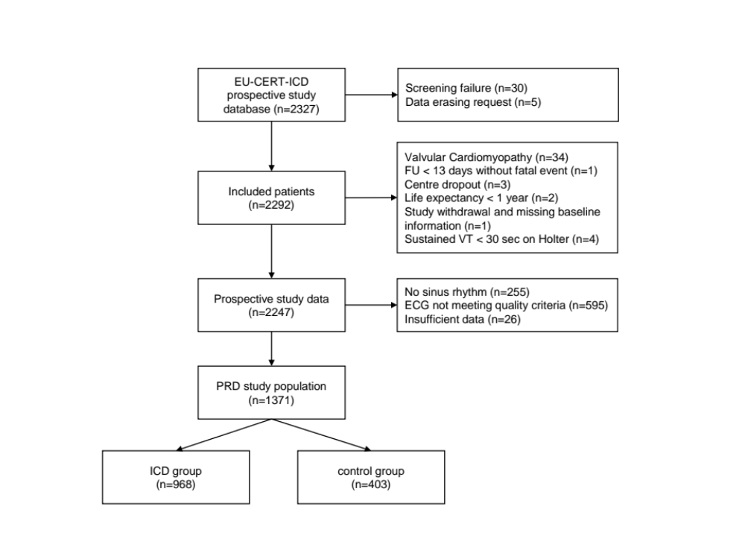

Figure 2
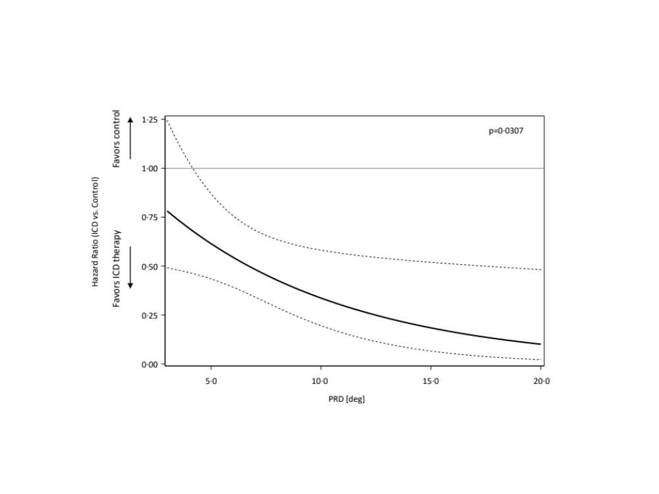

Figure 3

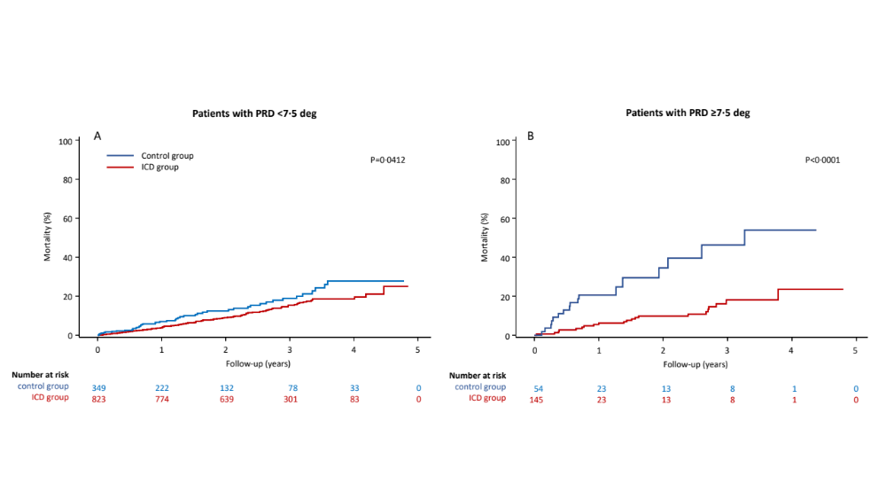
Figure 4
