Supplementary material

The potential impact of the COVID-19 pandemic on the tuberculosis epidemic – a modelling analysis

Lucia Cilloni¹*, Han Fu¹*, Juan F Vesga¹, David Dowdy², Carel Pretorius³, Sevim Ahmedov⁴, Sreenivas A.Nair⁵, Andrei Mosneaga⁵, Enos Masini⁵, Suvanand Sahu⁵, Nimalan Arinaminpathy¹

¹ MRC Centre for Global Infectious Disease Analysis, School of Public Health, Imperial College London, United Kingdom
² Department of Epidemiology, Johns Hopkins Bloomberg School of Public Health, Baltimore, Maryland, United States of America
³ Avenir Health, Glastonbury, Connecticut, United States of America
⁴ Bureau for Global Health, Office of HIV/AIDS, United States Agency for International Development, Washington, DC, United States of America
⁵ Stop TB Partnership, Geneva, Switzerland

*Contributed equally

Table of contents

1. Model overviews 2
Figure S1. Schematic illustration of the basic model framework. 2
Table S1. Calibration targets for each country, per 100,000 population 3
Figure S2. Results of model calibration for India 4
Table S2. Parameter table for the India model. 5
Figure S3. Results of model calibration for Kenya 7
Table S3. Parameter table for the Kenya model. 8
Figure S4. Results of model calibration for Ukraine 10
Table S4: Care cascade parameters for Ukraine 11
Table S5. Parameter table for the Ukraine model. 12
2. Additional supplementary figures 14
Figure S5. Projection of long-term TB trends in India, 14
3. An approach for extrapolating country-specific estimates to the Global level 15
Table S6: Excess global TB cases and deaths between 2020 and 2025 16
References 17

1. Model overviews

Our three focal countries reflect contrasting epidemiologies. In India, as with many countries in South- and South-East Asia, tuberculosis (TB) care is dominated by a large private healthcare sector. India also has the world’s largest burden of TB, accounting in 2018 for an estimated 27% of global TB incidence.¹ In Kenya, infection of human immunodeficiency virus (HIV) plays a strong role in driving the TB epidemic, with an estimated 27% of incident TB cases in 2018 being HIV coinfected.¹ Ukraine has a high burden of drug-resistant TB (DR-TB), with an estimated 29% of new cases and 46% of previously treated cases in 2018 being resistant to at least rifampicin.¹

Governing equations for each of these countries are provided in Vesga and colleagues,² and the same were used in the current study. However, for the current analysis we adapted the Moldova model in that earlier study to Ukraine, a country having a similar burden of drug resistance but - being a more populous country than Moldova - having a larger TB epidemic in absolute terms.¹ While keeping the same model equations as for Moldova, we fitted the model to World Health Organization (WHO) estimates for TB burden, from Ukraine. Table S1 shows these calibration targets, along with those used for India and Kenya.
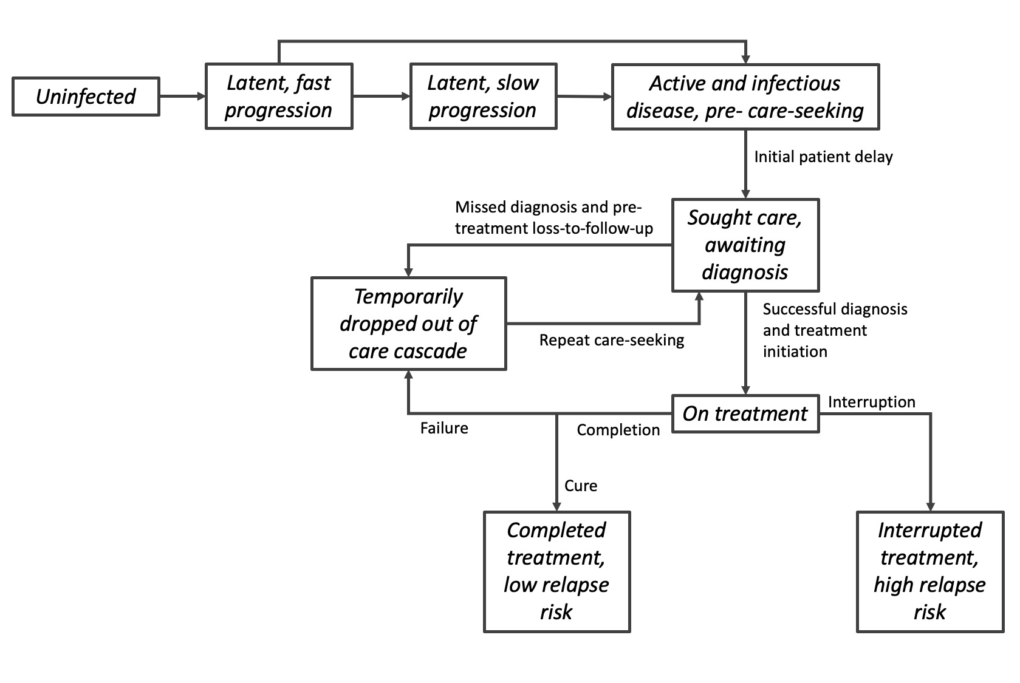
Figure S1. Schematic illustration of the basic model framework.
While this figure illustrates flows in the underlying model structure, as described above, for each country this framework was further stratified to reflect the difference between public and private sectors (for India); the role of HIV in driving TB (for Kenya); and the co-circulation of drug-sensitive and rifampicin-resistant TB, along with distinct features of the second-line care cascade, including drug sensitivity testing (Ukraine). Full governing equations are provided in Vesga and colleagues.²

Figure S1 shows a schematic illustration of the basic framework on which each country model was developed. We assumed that, following reactivation of latent infection, incident TB cases undergo an initial ‘patient delay’, a period of active, infectious TB prior to first presentation for care (calibrated, as with other model parameters, to the available data - see Table S1). Once presented for care, we assumed that a proportion $p_{Dx}$ would be successfully diagnosed, and further that a proportion $p_{Tx}$ of diagnosed cases would initiate treatment. Of those presenting for diagnosis, the overall proportion successfully initiating treatment is thus ($p_{Dx}×p_{Tx}$). We assumed that the remaining proportion temporarily drops out of the care cascade, before presenting for care once again after a certain delay (Tables S4 - S6). In this way, the models capture the effect of missed diagnoses and initial loss-to-follow up (through their effects on $p_{Dx}$ and $p_{Tx}$ respectively), on the delay to treatment initiation. Amongst those who have initiated treatment, we assumed that those completing treatment and bring cured would enter a compartment with low relapse risk; those failing treatment would temporarily drop out of the care cascade; and those interrupting treatment would enter a state of temporary bacteriological suppression, with high relapse risk.

This basic framework was developed further to reflect the epidemiological conditions and respective care cascades in each country, as described in Vesga and colleagues,² and in brief: for India, by stratifying diagnosis and treatment by public and private providers; for Kenya, by stratifying the whole care cascade and natural history by status of HIV and antiretroviral treatment (ART); and for Ukraine, by stratifying the whole care cascade and natural history by drug resistance status, as well as by new- and previously-treated cases.

As described in the main text, calibrations were performed by Markov Chain Monte Carlo (MCMC) simulation. In particular, we constructed log-normal likelihoods capturing the central estimates and uncertainty ranges of each of the calibration targets listed in Table S1. We constructed the overall posterior density straightforwardly as a product over these likelihood terms (equivalently, a summation over log-likelihoods). Certain model parameters have little systematic data, for example, the degree to which the quality of TB diagnosis in the private sector in India compares to that in the public sector.³ For these parameters we adopted prior distributions with broad ranges. Adopting uniform distributions for these and other model parameters over the ranges shown in Tables S4 - S6, we sampled from the posterior density using an adaptive MCMC algorithm, as described in Haario, Saksman, and Tamminen.⁴ MCMC chains were simulated over 50,000 samples. After removing the ‘burn-in’, the samples were ‘thinned’ to yield 250 independent samples from the posterior density. The resulting calibrations are shown in Figures S2 - S4.

To simulate the lockdown impact, we assumed all disruptions listed in Table 1 to be in full effect during the period of the suspension period (2 months for a mild scenario, and 3 months for a severe scenario). Following the end of the suspension period, we assumed that all TB services would be gradually restored to normal (pre-lockdown) levels in a linear fashion, over the course of a restoration period (2 months for a mild scenario, and 10 months for a severe scenario). However, overall transmission rates depend not on the readiness of the TB programme, but on the pace at which normal community contact rates are restored. In high-burden, low-income settings, any gradual easing of a lockdown would be complicated by economic pressure, particularly on the most disadvantaged in society to return to their livelihoods. Accordingly, in the main text we assumed that contact rates in the community return to normal at the same time as lifting the suspension period.

Table S1. Calibration targets for each country, per 100,000 population
Country | Calibration target | Value  [95% uncertainty range] | Source
India | TB incidence (2013)  TB incidence (2018)  TB incidence, DR (2018) | 228 [118-374]  199 [136-273]  9·6​ [5·7-15] | WHO¹
India | TB mortality (2018) | 33 ​[31-36] | WHO¹
India | TB notification (2018) | 147​ [+/-20%] | WHO¹
Kenya​ | TB prevalence (2016) | ​558 [455-662] | Enos et al.⁵
Kenya​ | TB incidence (2013)  TB incidence (2018)  TB incidence, DR (2018)  TB incidence, HIV-positive (2018) | 443 [271-656]  292 [179-432]  4·5 [2·1-7·9]  79 [48-117] | WHO¹
Kenya​ | TB mortality, HIV-positive (2018)  TB mortality, HIV-negative (2018) | 26 [16-38]  38 [22-59] | WHO¹
Kenya​ | TB notification (2018) | 184 [+/-20%] | WHO¹
Kenya​ | Antiretroviral therapy coverage among HIV-positive incident TB cases (2018) | 60% [40-98%] | WHO¹
Ukraine | TB incidence (2018)  TB incidence, DR (2018) | 80​ [52-155]  29 [18-41] | WHO¹
Ukraine | TB mortality (2018) | 13 [11-15]​ | WHO¹
Ukraine | TB notification (2018) | 60 [+/-20%] | WHO¹
Ukraine | DR-TB among new cases (2018)​  DR-TB among previously treated cases (2018)​ | 29% [28-30%]  46% [45-48%] | WHO¹
Central estimates are presented with corresponding 95% uncertainty intervals in square brackets. We assigned +/-20% of central estimates as uncertainty ranges when the original data source is not available. Rates per 100,000 population are presented if otherwise stated. Abbreviations: HIV: human immunodeficiency virus, DR: rifampicin-resistant/multi-drug-resistant, TB: tuberculosis, WHO: World Health Organization.

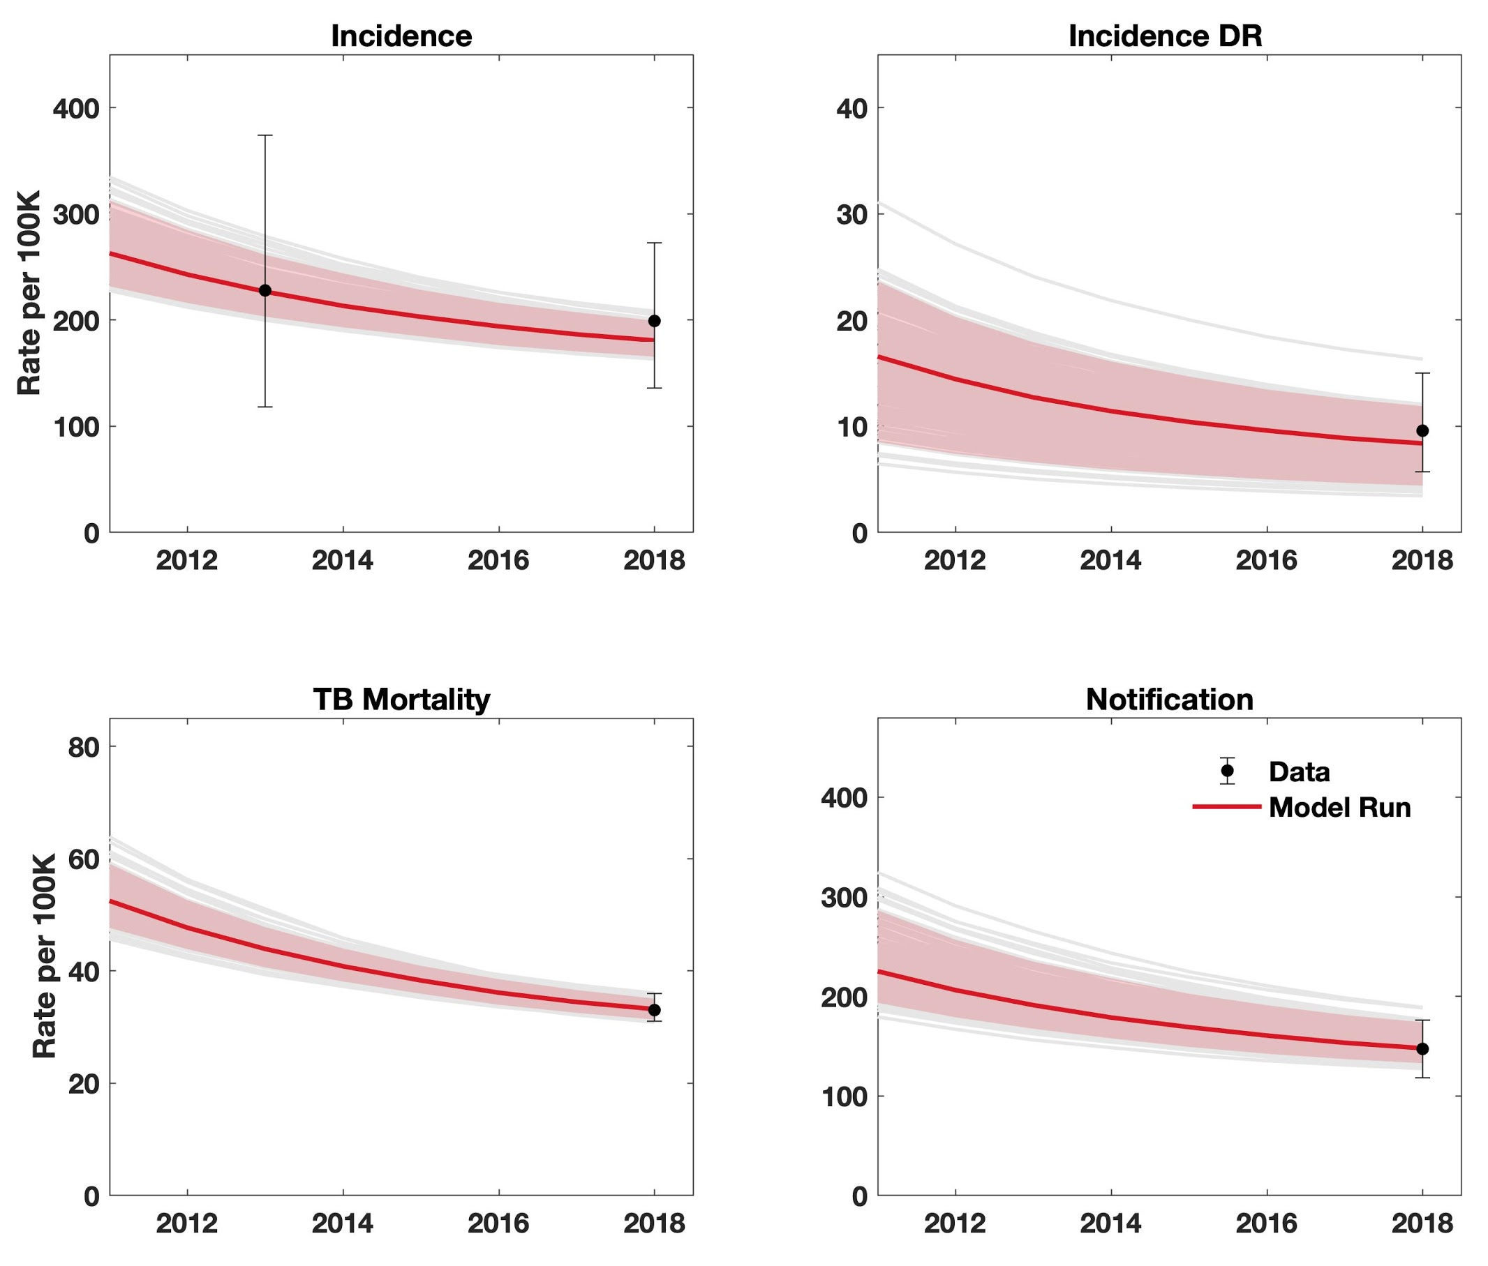

Figure S2. Results of model calibration for India. Points in black show data, while red lines show model simulations. Shaded areas show 95% Bayesian credible intervals.

Table S2. Parameter table for the India model. Entries highlighted in yellow are those that are affected by the lockdown scenarios shown in Table 1.

Parameter | Value |  | Source/Notes
TB natural history
Mean rate of transmission per TB case | DS-TB | 19·7  (95% CrI 19·5 -19·8) | Model estimates
Mean rate of transmission per TB case | DR-TB | 4·92  (95% CrI 4·8 - 5·1) | Model estimates
Relative infectivity, post vs pre-care-seeking | [0·8 – 1·2] |  | Assumed range (uniform distribution)
TB disease progression rates | Fast progressors | 0·083  [0·066 - 0·099] | Ragonnet et al.⁸
TB disease progression rates | Slow progressors | 5·9×10⁻⁴  [4·8×10⁻⁴ -7·1×10⁻⁴] | Ragonnet et al.⁸
Stabilisation of progression from fast to slow progressors | 0·87  [0·70-1·0] |  | Ragonnet et al.⁸
Relapse, per-capita hazard rates | Relapse following treatment completion | 0·032 | Driver et al.,⁹ Thomas et al.,¹⁰ Menzies et al.¹¹
Relapse, per-capita hazard rates | Relapse following treatment default | 0·14 | Driver et al.,⁹ Thomas et al.,¹⁰ Menzies et al.¹¹
Relapse, per-capita hazard rates | Relapse >2 years after treatment | 0·0015 | Driver et al.,⁹ Thomas et al.,¹⁰ Menzies et al.¹¹
‘Stabilisation’ of relapse risk following treatment | 0·5 |  | Based on Thomas et al.:¹⁰ most relapse occurs in first 2 years after treatment.
TB mortality rate | 0·26  [0·14 – 0·30] |  | Tiemersma et al.,¹² specified together to yield 50% cure, 50% mortality in average of 3 years
Spontaneous cure | 0·16  [0·14 – 0·18]
Reduced susceptibility from past infection | [0·25 – 0·75] |  | Assumed range (uniform distribution)
Health system
Per-capita rate of initial presentation to care | 2·2  (95% CrI 2·1 - 2·4) |  | Model estimate
Per-capita rate of secondary care-seeking | 12  [9·6 – 14] |  | Assumed mean secondary patient delay of 1 month
Proportion visiting the public sector at each care-seeking episode | 0·46  (95% CrI 0·41 - 0·56) |  | Model estimate
Treatment initiation delay | 52 |  | Model assumption, corresponds a mean treatment delay of 1 week
Probability of diagnosis per patient-provider interaction ($p_{Dx}$) | Public sector | 0·83  [0·8 – 0·84] | Subbaraman et al.¹³
 | Private sector | 0·58  [0·50 - 0·70] | Model estimate
Following diagnosis, proportion initiating treatment ($p_{Tx}$) | Public sector | 0·88  [0·86 - 0·89] | Subbaraman et al.¹³
 | Private sector | 0·42  [0·30 - 0·70] | Model estimate
First-line treatment outcomes (proportions) | Death | 0·04, 0·09 | WHO global TB database¹⁴ Proportions are transformed into per-capita hazard rates in the model, based on the assumption of a mean duration of 6 months for completing FL treatment completion (includes success and failure). For example, given treatment completion rate = 2 year⁻¹, per capita hazard rate of deaths is derived using 0·04*(2/(0·90+0·01)).
First-line treatment outcomes (proportions) | Loss to follow-up | 0·049, 0·11
First-line treatment outcomes (proportions) | Failure | 0·01, 0·02
First-line treatment outcomes (proportions) | Success | 0·90, 1·98
Second-line treatment outcomes (proportions) | Death | 0·20, 0·16 | WHO global TB database¹⁴ Proportions are transformed into per-capita hazard rates in the model, based on the assumption of a mean duration of 2 years for completing SL treatment completion (includes success and failure).
Second-line treatment outcomes (proportions) | Loss to follow-up | 0·20, 0·17
Second-line treatment outcomes (proportions) | Failure | 0·09, 0·08
Second-line treatment outcomes (proportions) | Success | 0·51, 0·42
Treatment default rates for private sector | FL | 2·1  [1·6 - 3·4] | Model estimates
Treatment default rates for private sector | SL | 50  [40 - 60] | Model estimates
Probability of receiving DST | Public sector | 0·30  (95% CrI 0·25 – 0·36) | Model estimate
Probability of receiving DST | Private sector | 0 | Model assumption
Proportion of acquiring DR during FL treatment | 0·02  [0·01-0·05] |  | Model assumption
Demographics
Birth rate | 0·024 |  | WHO GHO data ¹⁵, adjusted to yield 2·4% annual population growth from 1970·
Background mortality | 0·015 |  | WHO GHO data ¹⁵, corresponds to mean life expectancy of 67 years.
Abbreviations: CrI: credible interval, DR: drug-resistant (i.e. rifampicin-resistant), DS: drug-susceptible, DST: drug susceptibility test, FL: first-line, GHO: Global Health Observatory, SL: second-line, TB: tuberculosis, WHO: World Health Organization.

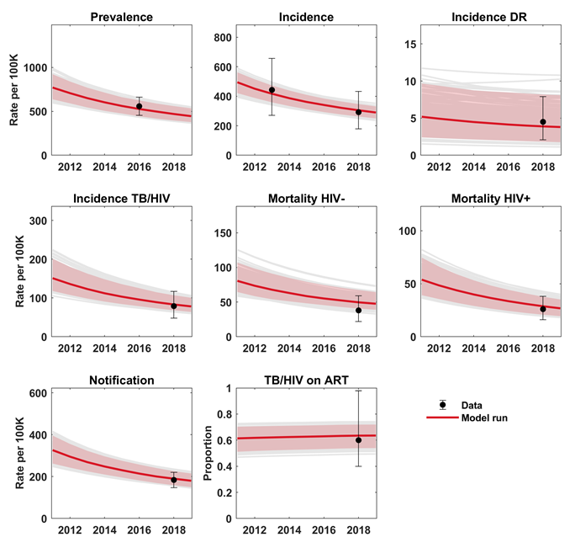

Figure S3. Results of model calibration for Kenya. Points in black show data, while red lines show model simulations. Shaded areas show 95% Bayesian credible intervals.

Table S3. Parameter table for the Kenya model. Entries highlighted in yellow are those that are affected by the lockdown scenarios shown in Table 1.

Parameter | Value |  | Source/Notes
TB natural history
Mean rate of transmission per TB case (infections per year) | DS-TB | 8·4  (95% CrI 5·8-12·7) | Model estimates
Mean rate of transmission per TB case (infections per year) | DR-TB | 3·9  (95% CrI 1·4-7·7) | Model estimates
Relative infectivity, post- vs pre-care-seeking | [0·80 -1·2] |  | Model assumption
Per-capita rate of progression to TB disease from latent TB | Fast progressors | 0·083  [0·066-0·099] | Ragonnet et al.⁸
Per-capita rate of progression to TB disease from latent TB | Slow progressors | 5·9×10⁻⁴  [4·8×10⁻⁴-7·1×10⁻⁴] | Ragonnet et al.⁸
Stabilisation of progression from ‘fast’ to ‘slow’ progressors | 0·87  [0·70-1·05] |  | Ragonnet et al.⁸
Relapse, per-capita hazard rates | Relapse following treatment completion | 0·032 | Driver et al.,⁹ Thomas et al.,¹⁰ Menzies et al.¹¹
Relapse, per-capita hazard rates | Relapse following treatment default | 0·14 | Driver et al.,⁹ Thomas et al.,¹⁰ Menzies et al.¹¹
Relapse, per-capita hazard rates | Relapse >2 years after treatment | 0·0015 | Driver et al.,⁹ Thomas et al.,¹⁰ Menzies et al.¹¹
Stabilisation of relapse risk following treatment | 0·5 |  | Based on Thomas et al.:¹⁰ most relapse occurs in first 2 years after treatment.
TB mortality, per-capita hazard rates | HIV⁽⁻⁾ | 0·17  [0·13 – 0·20] | Tiemersma et al.,¹² and assumed untreated HIV show a higher risk of TB mortality
TB mortality, per-capita hazard rates | HIV⁽⁺⁾ | 0·28  (95%CrI 0·15 – 0·68)
Per-capita rate of spontaneous cure | 0·17  [0·13 – 0·20] |  | Tiemersma et al.¹²
Reduced susceptibility from past infection | 0·48  (95% CrI 0·26 – 0·74) |  | Model estimate
Relative infectiousness, HIV⁽⁺⁾ vs HIV⁽⁻⁾ | 0·88  (95% CrI 0·76 – 0·99) |  | Model estimate
Increased risk of TB progression, HIV⁽⁺⁾ vs HIV⁽⁻⁾ | 26  [21-31] |  | Getahun et al.,¹⁶ Selwyn et al.¹⁷
Health system
Per-capita rate of initial presentation to care | HIV⁽⁻⁾ and HIV⁽⁺⁾ untreated | 0·60  (95% CrI 0·60 - 0·99) | Model estimate, corresponds to mean initial patient delay of 20 months (95% CrI 12 - 24) for HIV⁽⁻⁾ and HIV⁽⁺⁾ untreated and 4·7 months (95% CrI 191-18) for HIV⁽⁺⁾ on ART
Per-capita rate of initial presentation to care | HIV⁽⁺⁾ on ART | 2·6  (95% CrI 0·66 - 6·5)
Per-capita rate of repeat care-seeking | HIV⁽⁻⁾ and HIV⁽⁺⁾ untreated | 12  [9·6 - 14] | Assumed mean secondary patient delay of 1 month
Per-capita rate of repeat care-seeking | HIV⁽⁺⁾ on ART | 2·6  (95% CrI 0·66 - 6·5) | Assumed the same rate as initial care-seeking
Per-capita rate of treatment initiation | 52 |  | Model assumption, corresponds to 1-week delay
Probability of diagnosis per patient-provider interaction ($p_{Dx}$) | HIV⁽⁻⁾ and HIV⁽⁺⁾ untreated | 0·32  (95% CrI 0·24 - 0·61) | Model estimates, with constraint that a higher probability for HIV⁽⁺⁾ on ART
 | HIV⁽⁺⁾ on ART | 0·65  (95% CrI 0·44- 0·80)
Diagnosis probability before NTP expansion, relative to after | 0·41  (95% CrI 0·11 - 0·76) |  | Model estimate
Following diagnosis, proportion initiating treatment ($p_{Tx}$) | 0·80  [0·77 - 0·82] |  | Tollefson et al.¹⁸
Probability of receiving drug sensitivity test (provided by Xpert) | 0·46  [0·37 - 0·55] |  | WHO Global TB Report 2019¹
First-line treatment outcomes (proportions) | Death: HIV⁽⁻⁾, HIV⁽⁺⁾ | 0·045, 0·12 | WHO global TB database¹⁴  Proportions are transformed into per-capita hazard rates in the model, based on the assumption of a mean duration of 6 months for completing first-line treatment (includes success and failure). For example, given treatment completion rate = 2 year⁻¹, per capita hazard rate of default in HIV⁽⁻⁾ was derived by 0·045*(2/(0·89+0·0042)).
First-line treatment outcomes (proportions) | Loss to follow-up: HIV⁽⁻⁾, HIV⁽⁺⁾ | 0·058, 0·053
First-line treatment outcomes (proportions) | Success: HIV⁽⁻⁾, HIV⁽⁺⁾ | 0·89, 0·82
First-line treatment outcomes (proportions) | Failure: HIV⁽⁻⁾, HIV⁽⁺⁾ | 0·0042, 0·0035
Second-line treatment outcomes (proportions) | Death | 0·19 | WHO global TB database¹⁴  Proportions are transformed into per-capita hazard rates in the model, based on the assumption of a mean duration of 2 years for completing second-line treatment completion (includes success and failure). HIV-related risk of death was further applied based on the observations in first-line treatment.
Second-line treatment outcomes (proportions) | Loss to follow-up | 0·083
Second-line treatment outcomes (proportions) | Success | 0·72
Second-line treatment outcomes (proportions) | Failure | 0·01
Per-capita hazard of acquiring DR during first-line treatment | [0·01-0·05] |  | Model assumption
Probability of initiating second-line treatment after failure of first-line treatment | 0·80 |  | Model assumption
ART initiation rate | 4·2  (95% CrI 1·8- 7·8) |  | Model estimate
Reduced risk of TB progression, HIV⁽⁺⁾ on ART vs untreated | 0·35  [0·28-0·44] |  | Suthar et al.¹⁹
Reduced risk of TB progression among HIV⁽⁺⁾ on ART, with vs without IPT | 0·64  (95% CrI 0·51- 0·75) |  | Rangaka et al.²⁰
Fraction of newly recruited ART patients receiving IPT | 0·63  [0·50-0·76] |  | Kenya TB programme
IPT completion rate | 2 |  | WHO latent TB guideline,²¹ corresponds to 6 months of IPT
Probability of receiving HIV test | In TB care cascade | 0·97 | WHO Global TB Report 2019¹
Probability of receiving HIV test | Not seeking TB care | 0·12 | Olney et al.²²
Probability of initiating ART treatment and achieving viral suppression | In TB care cascade | 0·95 | UNAIDS Data 2017 ²³
 | Not seeking TB care | 0·64 | UNAIDS Data 2017 ²³
ART drop-out, per-capita hazard rate | 0·16 |  | Olney et al.²²
Demographics
Population growth rate | 0·155 |  | WHO GHO data,¹⁵ adjusted to simulate population growth from 1970
Background mortality, per-capita hazard rates | HIV⁽⁻⁾ | 0·015 | WHO GHO data,¹⁵ corresponds to life expectancy of 67 years old
Background mortality, per-capita hazard rates | HIV⁽⁺⁾ untreated | 0·097  [0·078-0·12] | Mangal et al.,²⁴ corresponds to mean survival of 10·3 years
Background mortality, per-capita hazard rates | HIV⁽⁺⁾ on ART | 0·028  [0·022-0·033] | Assumed that ART extends life to as far as can be observed (36 years)
Abbreviations: ART: Antiretroviral treatment, CrI: credible interval, DR: drug-resistant (i.e. rifampicin-resistant), DS: drug-susceptible, DST: drug susceptibility test, GHO: Global Health Observatory, HIV: human immunodeficiency virus, IPT: isoniazid preventive therapy, NTP: National TB Programme, TB: tuberculosis, WHO: World Health Organization, USAIDS: Joint United Nations Programme on HIV/AIDS.

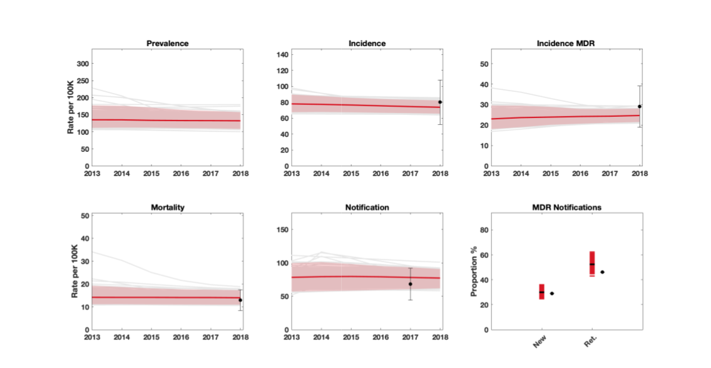

Figure S4. Results of model calibration for Ukraine. Points in black show data, while red lines show model simulations. Shaded areas show 95% Bayesian credible intervals.

Gap or Delay in the TB care cascade, Ukraine | Modelled parameter values
Gap: proportion of individuals with incident tuberculosis who die or self-cure before presenting for care​ | 17% (15∙7–18∙0)*​
Delay: initial patient delay before first presentation for care​ | 10 months (9.2 -11)*​
Gap: proportion of individuals with tuberculosis presenting who are diagnosed​ | 71% (62–80)*​
Gap: proportion of individuals with incident tuberculosis undergoing drug sensitivity testing​ | 85% (ECDC)​
Gap: proportion of individuals with retreated tuberculosis undergoing drug sensitivity testing​ | 43% (ECDC)​
Delay: interval between diagnosis and treatment initiation​ | 2∙5 days (1∙9–3∙6) (assumption)​
Gap: proportion of individuals diagnosed with tuberculosis who initiate treatment​ | 95% (assumption)​
Gap: proportion individuals diagnosed with tuberculosis completing first-line treatment​ | 80% (WHO)​
Gap: proportion of individuals with tuberculosis completing second-line treatment​ | 53% (WHO)​

Table S4: Care cascade parameters for Ukraine, representing pre-disruption state of the TB care cascade. For corresponding parameter values for India and Kenya, see Vesga et al, 2019 ². Asterisks denote those quantities that were estimated through model calibration to the available data, while numbers in brackets denote 95% uncertainty intervals. For additional model parameters, see Table S7.

Table S5. Parameter table for the Ukraine model. Entries highlighted in yellow are those that are affected by the lockdown scenarios shown in Table 1.

Parameter | Value |  | Source/Notes
TB natural history
Mean rate of transmission per TB case | DS-TB | 1·21  (95% CrI 1 - 1·50) | Model estimates
Mean rate of transmission per TB case | DR-TB | 3·37  (95% CrI 2·65 - 4·10) | Model estimates
Relative infectivity, post vs pre-care-seeking | [0·8 – 1·2] |  | Model assumption (uniform distribution)
Proportion infections being ‘fast’ progressors to active disease | 0·14  [0·11 – 0·17] |  | Vynnycky & Fine²⁵
Breakdown to active disease | 0·001 |  | Horsburgh et al.²⁶
Relapse, per-capita hazard rates | Relapse following treatment completion | 0·032 | Driver et al.,⁹ Thomas et al.,¹⁰ Menzies et al.,¹¹
Relapse, per-capita hazard rates | Relapse following treatment default | 0·14 | Driver et al.,⁹ Thomas et al.,¹⁰ Menzies et al.,¹¹
Relapse, per-capita hazard rates | Relapse >2 years after treatment | 0·0015 | Driver et al.,⁹ Thomas et al.,¹⁰ Menzies et al.,¹¹
Relapse, per-capita hazard rates | Relapse in DR recovered from FL treatment | 0·7 | Driver et al.,⁹ Thomas et al.,¹⁰ Menzies et al.,¹¹
‘Stabilisation’ of relapse risk following treatment | 0·5 |  | Based on Thomas et al.:¹⁰ most relapse occurs in first 2 years after treatment.
TB mortality rate | 0·13  [0·1 – 0·18] |  | Tiemersma et al.,¹² specified together to yield 50% cure, 50% mortality in average of 3 years
Spontaneous cure | 0·16  [0·14 – 0·18]
Reduced susceptibility from past infection | [0·25 – 0·75] |  | Assumed range (uniform distribution)
Health system
Per-capita rate of initial presentation to care | See Table S4
Secondary care-seeking, per-capita hazard rate | 12  [9·6-14·4] |  | Assumed mean secondary patient delay of 1 month
Treatment initiation delay | See Table S4
Probability of diagnosis per patient-provider interaction ($p_{Dx}$) | See Table S4
Following diagnosis, proportion initiating treatment ($p_{Tx}$) | See Table S4
SL treatment initiation probability | See Table S4
Probability of receiving DST  (provided by Xpert) | New cases | 0·74 | ECDC surveillance report²⁷
Probability of receiving DST  (provided by Xpert) | Retreated cases | 0·47 | ECDC surveillance report²⁷
Treatment default rate | DS-TB on FL treatment | 0·20 | WHO Global TB Report 2019¹
Treatment default rate | DR-TB on SL treatment | 0·51 | WHO Global TB Report 2019¹
Treatment default rate | DR-TB on FL treatment | 0·25 | Model assumption
Treatment duration | FL Treatment | 2 | WHO treatment guideline,²⁸ corresponds to 6 months for standard FL regimen and 2 years for SL regimen
Treatment duration | SL treatment | 0·5
Treatment success rate | DS-TB on FL treatment | 0·74 | For DS-TB on FL treatment this is a weighted average between new and retreated cases. WHO Global TB Report 2019¹.
Treatment success rate | DR-TB on SL treatment | 0·49
Treatment success rate | DR-TB on FL treatment | 0·3 | Model assumption
DR acquisition rate while on FL | [0 - 0·05] |  | Model assumption
Demographics
Birth rate | 0·01 |  | WHO GHO data,¹⁵ adjusted to yield 1% annual population growth from 1970
Background mortality | 0·015 |  | WHO GHO data,¹⁵ corresponds to mean life expectancy of 68 years
Abbreviations: CrI: credible interval, DR: drug-resistant (i.e. rifampicin-resistant), DS: drug-susceptible, DST: drug susceptibility test, ECDC: European Centre for Disease Prevention and Control, FL: first-line, GHO: Global Health Observatory, SL: second-line, TB: tuberculosis, WHO: World Health Organization

2. Additional supplementary figures

Figure S5. Projection of long-term TB trends in India, as a result of the lockdown. The figure illustrates a pronounced short-term increase in TB mortality (upper panel), followed in the longer term by a ‘tail’ that is fueled by a persistent increase in incidence (lower panel). As mentioned in the main text, even in the mild lockdown scenario (red curve), incidence remains at least 4% higher than the baseline, for a period of 32 months following the restoration.

3. An approach for extrapolating country-specific estimates to the Global level

The methods described for the country analyses can be extended to other country settings, as more data becomes available. Here, and in the interest of timely estimates, we adopted a simple approach to extrapolate the India, Kenya and Ukraine modelling analysis to global estimates.

First, baseline trends for key TB indicators were established: TB incidence (by HIV and DR status), notification (by DR status) and mortality (by HIV status). These trends are based on penalized B-splines, a method that is widely used for projecting trends forward in time.⁶ We used data that is published annually by WHO for more than 200 countries.¹ TB prevalence data were last published by WHO in 2017 (i.e. estimates for 2016), and we obtained prevalence trends for the purposes of this analysis by applying the 2016 ratio between incidence and prevalence to the incidence trends estimated via cubic splines.

The above trends were readily available from an analysis conducted late 2019,⁷ following the publication of the Global tuberculosis report 2019. It should be noted that interventions that define TB programs are implicitly represented in these statistical trends. There is no explicit scale-up of specific interventions modelled with this statistical method, and the resulting ~1% annual decline in TB burden (measured for example in TB incidence decline), leads to an interpretation that these trends represent ‘status quo’ TB program efforts.

Next, we applied the impact, relative to status-quo baseline, of each modelled scenario of lockdown-related disruption on TB (represented by duration of suspension and duration of restoration) to defined groups of countries: the India model informed projections for countries with high TB burden and private sector involvement; the Kenya model informed projections for countries where HIV is a driver of the TB epidemic; and the Ukraine model informed projections for countries with a high proportion of drug-resistant TB, and hospital-based care delivery systems. Countries not in these groups were assigned the average impact of the three country models. Impact estimates were applied to cubic spline projections of TB cases and deaths reported by WHO.

We used a simple approach to make impact adjustments to status quo trends for a given country:

$$I\left(t\right)=B\left(t\right)× \left(1+r(t)\right)$$

Where t is a year from 2020 to 2025, I(t) is a burden indicator (e.g. TB incidence, mortality or notification), B(t) its baseline or status quo trend (constructed as described above) and r(t) the lockdown-related change in I(t) in year t relative to baseline, for India, Kenya or Ukraine (as relevant for the country’s group), as simulated in the dynamical modeling. Projections for TB incidence and mortality were thus obtained at country level, and aggregated to the global level.

Table S2 summarizes the excess TB cases and TB deaths that would result from the two scenarios examined in the main text: a ‘mild’ scenario of 2-month suspension and 2-month restoration and a ‘severe’ scenario of 3-month suspension and 10-month restoration. The relative increases are, by construction, a weighted average of the same relative impacts estimated for India, Kenya and Ukraine and is thus weighted towards the results for India.

At global level, cumulative impact for 2020-2025 is significant and poses a serious challenge for global and country stakeholders in the fight against TB to address. Globally, a scenario of 3-month suspension and 10-month restoration, could lead to an additional 6·3 million cases of TB between 2020 and 2025, and an additional 1·4 million TB deaths during this period. TB burden by 2021 could increase to levels last seen 5 years ago, posing a serious setback to recent progress in the fight against TB.

The characteristics of suspension and restoration are likely to vary by country context, mitigation policies, economic outlook and other country-specific determinants. TB programmatic variables will therefore be impacted differently at country level, and impact on TB burden would differ too. Table S3 presents a heuristic method for relative impact on global TB burden, per month of suspension and per month taken to restore normal TB services (that is, a global projection of Table 3 in the main text). This heuristic method can be applied to refine estimates for global TB impact as more clarity emerges regarding country suspension and recovery approaches, particularly for those countries that contribute most to the global TB burden.

Table S6: Excess global TB cases and deaths between 2020 and 2025, as a result of the different scenarios for COVID-related lockdowns.

Excess cases between 2020-2025  (% increase) |  | Excess deaths between 2020-2025  (% increase)
2-month suspension + 2-month restoration | 3-month suspension + 10-month restoration | 2-month suspension + 2-month restoration | 3-month suspension + 10-month restoration
702,400 (1·2%) | 4,702,300 (8.0%) | 165,500 (1.9%) | 1,044,800 (12·3%)

References

1 World Health Organization. Global tuberculosis report 2019. Geneva, Switzerland, 2019.
2 Vesga JF, Hallett TB, Reid MJA, et al. Assessing tuberculosis control priorities in high-burden settings: a modelling approach. Lancet Glob Health 2019; 7(5): e585-e95.
3 Satyanarayana S, Subbaraman R, Shete P, et al. Quality of tuberculosis care in India: a systematic review. Int J Tuberc Lung Dis 2015; 19(7): 751-63.
4 Haario H, Saksman E, Tamminen J. An adaptive Metropolis algorithm. Bernoulli 2001; 7(2): 223-42.
5 Enos M, Sitienei J, Ong'ang'o J, et al. Kenya tuberculosis prevalence survey 2016: Challenges and opportunities of ending TB in Kenya. PloS one 2018; 13(12): e0209098.
6 Wood SN. Generalized Additive Models: An Introduction with R. Second ed. Boca Raton, Florida: Chapman and Hall/CRC; 2017.
7 Stop TB Partnership. The Global Plan to End TB 2018-2022. Geneva, Switzerland; 2019.
8 Ragonnet R, Trauer JM, Scott N, Meehan MT, Denholm JT, McBryde ES. Optimally capturing latency dynamics in models of tuberculosis transmission. Epidemics 2017; 21: 39–47.
9 Driver CR, Munsiff SS, Li J, Kundamal N, Osahan SS. Relapse in persons treated for drug-susceptible tuberculosis in a population with high coinfection with human immunodeficiency virus in New York City. Clin Infect Dis 2001; 33(10): 1762–9.
10 Thomas A, Gopi PG, Santha T, et al. Predictors of relapse among pulmonary tuberculosis patients treated in a DOTS programme in South India. Int J Tuberc Lung Dis 2005; 9(5): 556–61.
11 Menzies D, Benedetti A, Paydar A, et al. Effect of duration and intermittency of rifampin on tuberculosis treatment outcomes: a systematic review and meta-analysis. PLoS Med 2009; 6(9): e1000146.
12 Tiemersma EW, van der Werf MJ, Borgdorff MW, Williams BG, Nagelkerke NJ. Natural history of tuberculosis: duration and fatality of untreated pulmonary tuberculosis in HIV negative patients: a systematic review. PloS one 2011; 6(4): e17601.
13 Subbaraman R, Nathavitharana RR, Satyanarayana S, et al. The Tuberculosis Cascade of Care in India's Public Sector: A Systematic Review and Meta-analysis. PLoS Med 2016; 13(10): e1002149.
14 World Health Organization. WHO's global tuberculosis database.
15 World Health Organization. Global Health Observatory (GHO) data. Geneva, Switzerland.
16 Getahun H, Gunneberg C, Granich R, Nunn P. HIV infection-associated tuberculosis: the epidemiology and the response. Clin Infect Dis 2010; 50 Suppl 3: S201–7.
17 Selwyn PA, Hartel D, Lewis VA, et al. A prospective-study of the risk of tuberculosis among intravenous drug-users with Human Immunodeficiency Virus-infection. New Engl J Med 1989; 320(9): 545–50.
18 Tollefson D, Ngari F, Mwakala M, et al. Under-reporting of sputum smear-positive tuberculosis cases in Kenya. Int J Tuberc Lung Dis 2016; 20(10): 1334–41.
19 Suthar AB, Lawn SD, del Amo J, et al. Antiretroviral therapy for prevention of tuberculosis in adults with HIV: a systematic review and meta-analysis. PLoS Med 2012; 9(7): e1001270.
20 Rangaka MX, Wilkinson RJ, Boulle A, et al. Isoniazid plus antiretroviral therapy to prevent tuberculosis: a randomised double-blind, placebo-controlled trial. Lancet 2014; 384(9944): 682–90.
21 World Health Organization. Latent tuberculosis infection: updated and consolidated guidelines for programmatic management. Geneva, Switzerland, 2018.
22 Olney JJ, Braitstein P, Eaton JW, et al. Evaluating strategies to improve HIV care outcomes in Kenya: a modelling study. Lancet HIV 2016; 3(12): e592–e600.
23 Joint United Nations Programme on HIV/AIDS. UNAIDS Data 2017. Switzerland: Geneva; 2017.
24 Mangal TD, Unaids Working Group on CD4 Progression Mortality Amongst HIV-1 Seroconverters including the Cascade Collaboration in EuroCoord. Joint estimation of CD4+ cell progression and survival in untreated individuals with HIV-1 infection. AIDS 2017; 31(8): 1073–82.
25 Vynnycky E, Fine PE. The natural history of tuberculosis: the implications of age-dependent risks of disease and the role of reinfection. Epidemiol Infect 1997; 119(2): 183–201.
26 Horsburgh CR, Jr., O'Donnell M, Chamblee S, et al. Revisiting rates of reactivation tuberculosis: a population-based approach. Am J Respir Crit Care Med 2010; 182(3): 420–5.
27 European Centre for Disease Prevention and Control. Tuberculosis surveillance and monitoring in Europe, 2018 – 2016 data. Stockholm, Sweden, 2018.
28 World Health Organization. Guidelines for treatment of tuberculosis. fourth ed. Geneva, Switzerland; 2010.

