Nalmefene Reduces Reward Anticipation in Alcohol Dependence - An Experimental Functional Magnetic Resonance Imaging Study

Supplemental Information

Contents
- Supplementary Methods
  - Alcohol Clamp
  - MRI Data Acquisition
  - fMRI Task Protocol
  - fMRI Data Processing
  - fMRI Data Analysis
- Supplementary Results
  - Exclusions, Missing Data, and Randomization
  - Perfusion Analysis
  - fMRI Region of Interest Analysis
  - fMRI Whole Brain Analysis
  - fMRI Task Behavioral Measures
- Supplementary Tables and Figures
  - Supplementary Figure S1. Study Recruitment and Data Selection Flow
  - Supplementary Figure S2. Blood Alcohol Concentration
  - Supplementary Figure S3. Pulsed Arterial Spin Labeling Results
  - Supplementary Figure S4. Detailed fMRI Results
  - Supplementary Table S1. Detailed Monetary Incentive Delay: Reward Anticipation > Neutral Anticipation fMRI Results
  - Supplementary Table S2. Detailed ‘Amount Won’ and ‘Reaction Time’
- Supplementary References

Supplementary Methods - Alcohol Clamp
Following a 20 minute ‘ramp’ phase, the participants were then ‘clamped’ at 80 mg% BAC using a MRI compatible breathalyzer feedback system to adjust the exponential decline of alcohol infusion rate for the remainder of the scanning session. Due to its metal constituents, the breathalyzer was unable to enter the MRI suite, therefore in order to obtain breath samples throughout the ramp and clamp phase participants were asked to provide breath samples for feedback to the infusion system whilst lying supine in the scanner according to (1). A balloon was inflated by the participant by blowing down a short length of PVC tubing. The air was then expelled into an Alcotest 6810 breathalyzer (Draeger; Luebeck, Germany). A direct breathalyzer reading outside the MRI suite was taken for each participant and compared with a balloon reading. A conversion factor of 1.1 was used to correct the balloon derived breath alcohol concentrations (1). Balloon inflation breath alcohol concentration (BrAC; mg/L) was converted to %BAC (g/100ml) using the following equation:
$$\%BAC=\frac{BrAC \left(mg/L\right)× 2.1}{10}×1.1$$
A bathroom break was scheduled in the scanning protocol immediately following the second ASL sequence. Prior to disconnection from the intravenous infusion system a 60 second increased infusion rate was administered in order to minimize the reduction in BAC during the toilet break. Following the break the participant was immediately reconnected to the infusion system and the infusion resumed. After a short acclimatization period, during which radiological reporting scans were performed, a breathalyzer reading was taken in order to adjust the infusion rate following the toilet break. The MID task was initiated when the participant reached 80mg% again.

Supplementary Methods - MRI Data Acquisition
All MRI data were acquired using a Siemens 3T Tim Trio system running the syngo MR B17 software, and with a Siemens 32 channel receive-only phased-array head coil.
At each visit the imaging session consisted of: localizer scans to set up the positioning of those that would follow; two groups of arterial spin labelling sequences; main magnetic field mapping; a high resolution structural scan for anatomical registration and radiological reporting; a T2 and proton density weighted scan and a fluid-attenuated T2-weighted volume to provide additional contrasts for radiological reporting; one run of resting state fMRI; two runs of the monetary incentive delay fMRI task; two runs of the go/no-go fMRI task; one run of the evocative images fMRI task; and a short high coverage fMRI sequence. At every visit, all tasks were practiced outside of the scanner immediately prior to the start of the imaging session.
The resting state, go/no-go task, evocative image task, and structural data (apart from its use in spatial registration) will not be explored further here.
The high-resolution T1-weighted volumes were acquired using a magnetization-prepared 3D rapid gradient echo (MPRAGE) sequence (2) (TR = 2300 ms, TE = 2.98 ms, TI = 900 ms, flip angle = 9°, field of view = 256 mm, image matrix = 240 x 256, 160 sagittal partition encodes) with a resolution of 1 mm isotropic. Parallel imaging using generalized autocalibrating partially parallel acquisition (GRAPPA) with an acceleration factor of 2 was performed.
Functional imaging was performed using a multi-echo gradient echo echoplanar imaging (EPI) sequence (TR = 2000 ms, TE = 13 & 31 ms, flip angle = 80°, field of view = 225 mm, image matrix = 64 x 64) with an in-plane resolution of 3.516 x 3.516 mm and a slice thickness of 3.000 mm. The phase encoding direction was anterior to posterior. Echo spacing was 0.52 ms.
For each functional volume, 36 abutting oblique axial slices were collected in an ascending manner at an angle of around 30° to the anterior/posterior commissural line. This results in slightly less than whole brain coverage, with the most superior 9 mm not being imaged in most subjects. To achieve the desired resolution and repetition time, parallel imaging using GRAPPA with an acceleration factor of 2 was performed. The first three volumes of each functional run were automatically discarded to allow for T1 saturation effects and are not included in any number of volumes reported here.
Pulsed arterial spin labeling (pASL) was carried out using Q2TIPS (second version of quantitative imaging of perfusion by using a single subtraction MRI pulse sequence with thin-slice TI1 periodic saturation (3)). Five inversion times were used: 750 ms; 1050 ms; 1350 ms; 1500 ms; and 1800 ms. 13 control-tag volume pairs were acquired at each TI. Five M0 calibration image were also acquired. This entire process was carried out twice during each session; once before infusion of alcohol began, and again half-way through the fMRI tasks.

Supplementary Methods - fMRI Task Protocol
The monetary incentive delay task was designed to probe the reward sensitivity, with the version used here being modified from Knutson, et al. (4). E-Prime 2.0 RC (version 2.0.8.90) was used to run the task.
Subjects could win or lose money depending upon how quickly they reacted to a target stimulus. The task contained win, loss, and neutral trials. For the win trials, subjects could win £0.50 if they responded quickly enough; for the loss trials, subjects lost £0.50 if they did not respond quickly enough; and for the neutral trials subjects neither won nor lost money. During each run, 216 volumes were collected, for a run length of 7 min 12 s, with each run containing 18 win trials, 18 neutral trials and 6 loss trials. In total, across both runs, the task contained 36 win trials, 36 neutral trials and 12 loss trials. The task was set to obtain approximately 66% accuracy for the win trials. Furthermore, the task was designed to give an approximate winnings total of £10.
Subjects were informed as to what trial they were about to perform via ‘cues’ that appeared on screen for one second. Following the cues, there was an ‘anticipation period’ before the target stimulus was presented. The duration of the anticipation period was jittered (being either 2, 3 or 4 s). The anticipation period was followed by the presentation of the target stimulus. The duration of the target stimulus differed depending upon the accuracy of subjects.
The starting duration for the win and neutral trials was 280 milliseconds (ms) for both runs. If a subject responded in time for the target stimulus, the target duration dropped by 10 ms (until the floor duration of 150 ms was reached). If the subjects missed a trial, the target duration increased by 10 ms (until the ceiling duration of 300 ms was reached). The duration of each of the target symbols for each trial (win, neutral, and loss) was contingent upon the subject’s accuracy for the same trial type only, i.e. win trial accuracy only affected stimulus duration of subsequent win trials, and not neutral or loss trials. Subjects were informed if they were successful after each trial.
The starting duration for the loss trials was 240 ms for both runs. A reduced loss starting duration was chosen, as subjects were required to lose in order that the total winnings did not vastly exceed £10, and to ensure that the reward trials were salient.
A region of interest (ROI) was placed at the MNI coordinates ±14, 12, -4 mm. This centered on the white matter of the internal capsule, but overlaps parts of the putamen, globus pallidus, nucleus accumbens, and caudate.

Supplementary Methods - fMRI Data Processing
Structural and functional processing was carried out using Analysis of Functional NeuroImages (AFNI) (version AFNI_2011_12_21_1014), FreeSurfer (version freesurfer-x86_64-unknown-linux-gnu-stable5-20130513), Advanced Normalization Tools (ANTs) (version ANTs-1.9.v4-Linux), and FMRIB Software Library’s (FSL) (version 5.0.6) randomise (version 2.9), FMRI Expert Analysis Tool (FEAT) (version 6.00), and Bayesian Inference for Arterial Spin Labeling MRI (BASIL). All were run on CentOS 6.5 (version centos-release-6-5.el6.centos.11.2.x86_64).
T1 images were first corrected for intensity non-uniformity (AFNI’s 3dUniformize) before having extracerebral tissues removed (as part of FreeSurfer’s recon-all pipeline). The whole brain images were then non-linearly registered to the MNI ICBM152 non-linear 6th generation symmetric average brain stereotaxic registration model in a 2 mm isotropic voxel space (ANTs’ antsRegistration).
EPIs were corrected for slice timing effects (AFNI’s 3dTshift) before each volume was registered (AFNI’s 3dvolreg) to the volume most similar, in the least squares sense, to all others (in-house code). For each task a summary of movement was recorded as the speed of motion over the runs (i.e. the sum of framewise displacements (FD) over the time taken for the runs, measured in mm/s).
EPIs for the fMRI tasks then had residual extracerebral tissues removed (FSL’s Brain Extraction Tool (BET)). Linear registration to the T1 image was achieved through a Boundary Based Registration (BBR) approach (FSL’s epi_reg) before combining transformations to bring the EPIs into the same standard stereotaxic space as the transformed T1 (ANTs’ antsApplyTransforms). Finally, these were smoothed with a three-dimensional Gaussian kernel of full width at half maximum of 6.0 mm (i.e. standard deviation = 2.5 mm) (AFNI's 3dBlurInMask).
ASL data were motion corrected in the same manner as the task data (the images themselves also being EPIs). Quantification of perfusion was carried out using BASIL’s oxford_asl (itself part of FSL). The resulting perfusion maps were transformed into a standard stereotaxic space through the method described for the EPIs above.

Supplementary Methods - fMRI Data Analysis
Task processing and modelling was carried out using E-Prime (version 2.0.8.90), Microsoft Office Excel 2007 (version 12.0.4518.1014), in-house Python (version 2.7.6) scripts, and FSL.
Data from task responses was processed into usable formats (E-Prime’s E-DataAid) before behavioral data and timings were extracted (Excel) and processed further (Python scripts) into 3-column-format text files for each event type for compatibility with FEAT.
FMRIB's Improved Linear Modelling (FILM) prewhitening was performed on all voxel time courses. Estimates of six motion parameters (translations in the three orthogonal directions along with pitch, roll and yaw) calculated during preprocessing (AFNI’s 3dvolreg) were included in each model as confounding explanatory variables.
In all modeling convolution with a haemodynamic response function (HRF) was performed, this being FSL’s commonly used gamma function with standard deviation 3 s and mean lag 6 s. No temporal derivatives were used in any model. All models had the same temporal filtering applied to them as was done to the image data.
Nine explanatory variables were used for modeling the task itself. These were the three different general conditions – reward, neutral, or loss – with each of these having three potential phases – anticipation, successful outcome, or unsuccessful outcome. ‘Anticipation’ was modeled as a block beginning at the cue (an arrow or line) onset and ending at the trial (a star) onset (these blocks lasting between approximately 3 s and 5 s). ‘Outcome’ was modeled as an immediately abutting block beginning at the trial (a star) onset and ending two seconds later. A high-pass filter cutoff of periods above 50 s was applied. The contrast explored here is that of ‘reward anticipation’ compared with ‘neutral anticipation’, with ‘reward anticipation’ being expected to show greater blood-oxygen-level dependent (BOLD) response in the striatal ROI. FEAT was used to run the model within a general linear model framework. The mean of the results for both runs was used in all higher level analyses.
The drug comparison here is performed in the direction such that a positive value is given if on nalmefene a stronger response in the main contrast is produced compared with that on placebo. Negative values are given if a stronger response is found on placebo compared with that on nalmefene.
Subjects were excluded from further analysis (for only a specific acquisition type) if: head movement was faster than 0.9 mm/s in a task; negative ‘winnings’ were reached in the monetary incentive delay task; coverage was unusably low in the ASL; artifacts prevented usable signal being acquired in the ASL.
Perfusion data was analyzed at a group level using FSL’s randomise to carry out a non-parametric permutation based analysis of the voxelwise perfusion data. The resulting image was processed using adaptive threshold-free cluster enhancement (TFCE) to produce a statistical image with a corrected cluster significance threshold of p = 0.05.
For ROI analysis, the contrasts’ mean percentage signal changes within the ROI was calculated (FSL’s Featquery).
The null hypothesis, for all tasks and acquisitions, was that there would not be a difference between nalmefene and placebo sessions. The mean ROI values were compared between session types using paired samples t-tests.
The voxelwise analysis carried out with FEAT was extended to a group level in a mixed-effects analysis using FSL’s FLAME 1 for a two-sample paired t-test. The Z statistic images shown in this work were thresholded using clusters determined by Z > 2.3 (i.e. an initial uncorrected cluster forming threshold of p = 0.01) and a (corrected) cluster significance threshold of p = 0.05. Group analysis was performed on the whole brain, insofar as including all those voxels which all subjects had in common (areas outside this common coverage are shown masked in gray in all figures).

Supplementary Results - Exclusions, Missing Data, and Randomization
21 subjects had at least one imaging session from which data were collected. All of these attended both sessions. Data were not collected for the monetary incentive delay task for one session.
Data were excluded from 11 ASL acquisitions due to lack of coverage and artefacts (each session had 2 ASL acquisitions). Data were excluded in the monetary incentive delay task for three sessions (negative winnings, high head movement, and both negative winnings and high head movement).
If data were excluded for a subject in a single session, that subject was not included in paired analyses for that task or acquisition type. All fMRI task exclusions took place before unblinding. From the original 11 randomization blocks there were 21 subjects imaged. This altered the intended balance, with 11 subjects having nalmefene and 10 subjects having placebo on their first visit. In the case of the monetary incentive delay task the three exclusions meant that of the subjects included in the group analysis ten had nalmefene on their first visit, while eight had placebo.
15 subjects had usable data from all of their ASL acquisitions. 18 subjects had usable data for all their monetary incentive delay tasks.

Supplementary Results - Perfusion Analysis
The null hypothesis, that there would be no difference between nalmefene and placebo sessions for perfusion, as measured using arterial spin labeling, was supported. Below significance differences were in the direction of a reduction in the increase in perfusion due to alcohol on nalmefene.
The general response to the administration of alcohol corresponded to that observed in other studies, namely an increase, compared with the pre-infusion baseline, of approximately 15 ml/100g/min in the thalamus bilaterally. This can be seen for the placebo session in Supplementary Figure S3 where the quantitative difference map has been masked to show only those regions where a significant difference (p < 0.05, corrected) was observed between conditions.

Supplementary Results - fMRI Region of Interest Analysis
The null hypothesis, that there would be no difference between nalmefene and placebo sessions for the contrast ‘reward anticipation > neutral anticipation’, was not supported in the region of interest. The signal change for this contrast was reduced during the nalmefene session (t = 2.78, p = 0.013, d.f. = 17).
The mean difference in response between sessions of those who received nalmefene on the first session (0.10% ± 0.14%) compared with those who received nalmefene on the second session (0.09% ± 0.17%) was not significant (t = 0.09, p = 0.92, d.f. = 16). It is notable that the general strength of response to the task is similar on both sessions (r = 0.81, p < 0.0001).
Results in these directions could have been produced as a result of an increased neutral response as it is the contrast of the reward and neutral condition that is being calculated. Upon more detailed investigation of the task it was found that it was indeed the reward anticipation response that was reduced on nalmefene (-0.13% ± 0.30%) while neutral anticipation was unchanged (-0.03% ± 0.27%).

Supplementary Results - fMRI Whole Brain Analysis
The group mean for the placebo session had a characteristic pattern similar to that usually seen in healthy controls for the contrast of interest (reward anticipation > neutral anticipation), indicating that the task worked as expected. However, peak activity was displaced to a position around 7 mm posterior and superior to that generally seen in healthy controls.
The null hypothesis, that there would be no difference between nalmefene and placebo sessions for the contrast ‘reward anticipation > neutral anticipation’, was not supported in three clusters which encompassed putamen and globus pallidus bilaterally and brainstem. All these results were in the direction of there being a reduced response to reward anticipation during the nalmefene session. Figure 3 in the main paper shows an overview of these clusters on three orthogonal slices, with Supplementary Figure S4 giving a more detailed view showing only axial slices. Supplementary Table S1 provides details of the clusters themselves along with local maxima coordinates.

Supplementary Results - fMRI Task Behavioral Measures
Response time was slower on nalmefene sessions (t = 2.61, p = 0.018, d.f. = 17) while accuracy did not differ between sessions (the task is adaptive so accuracy would not be expected to change). Less money was won on nalmefene sessions (£8.17 ± £3.28) compared with placebo (£9.17 ± £2.95) (t = 2.16, p = 0.045, d.f. = 17). Motion did not differ between sessions.

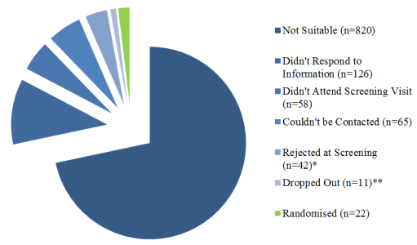
Responses to Advertisements
1144
Number Randomized
22
Nalmefene - Placebo
11
Placebo - Nalmefene
11
Losses During Study
2
1 due to sickness and vomiting on scanning day two
1 due to claustrophobia prior to scanning day one initiation
Losses During Study
0
Data Included
MID 10
Data Excluded
MID 1 (High motion##)
Data Included
MID 8
Data Excluded
MID 2 (1 data not captured, 1 negative winnings)

Supplementary Figure S1. Study Recruitment and Data Selection Flow. * Rejections at screening: Psychiatric assessment failure 18, Positive drug of abuse screen 8, ECG abnormalities 5, Allergies 1, Claustrophobic 1, Positive alcometer reading on familiarisation day 2, Blood/Urine abnormalities 2, Blood pressure abnormalities 2, Lack of GP reply/Medical exam/Over-volunteering abnormality 3. ** Drop outs: Unused reserves 4, Unexpected work commitments 5, Family bereavement 1, Lack of abstaining from alcohol 1. #Low ‘Go’ accuracy was any accuracy below 70%. ##High motion was any speed above 0.9mm/s. Go-NoGo Task (GNG); Monetary Incentive Delay (MID).
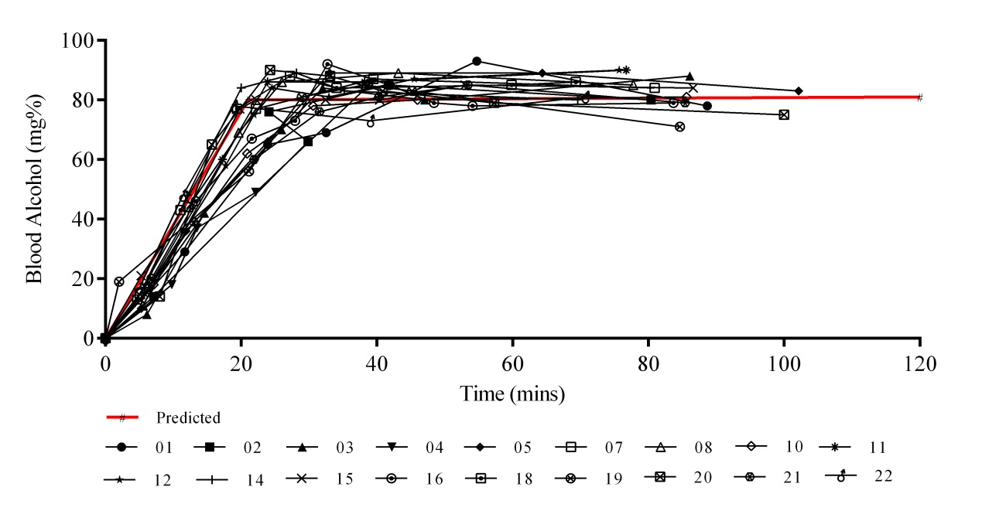

Supplementary Figure S2. Blood Alcohol Concentration. The blood alcohol concentration during the study for each participant and mean (in red). Participants 06, 09, and 17 were not used in the fMRI analysis.

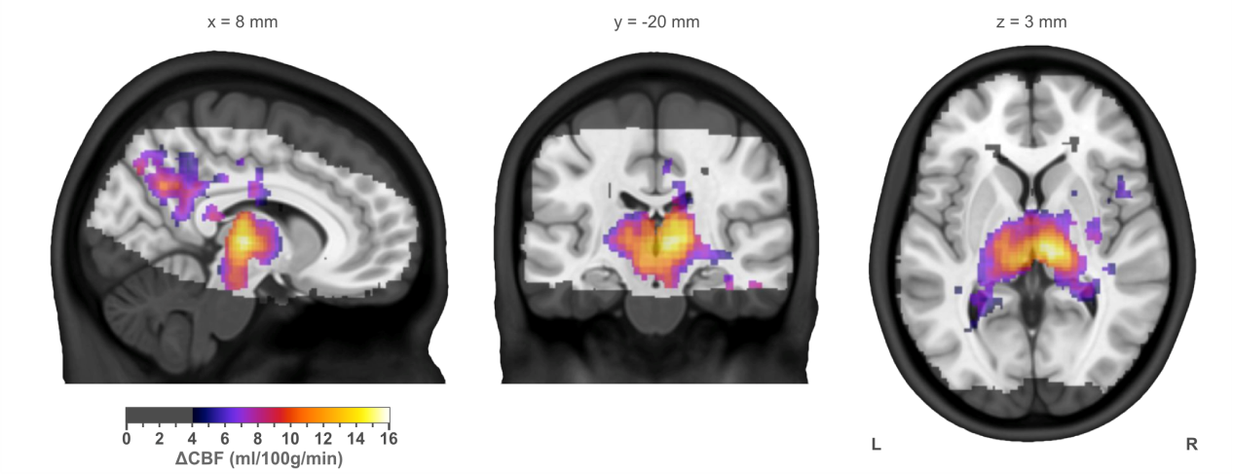

Supplementary Figure S3. Pulsed Arterial Spin Labeling Results. The group mean placebo quantitative difference map, masked to show only those regions where a significant (p < 0.05, corrected) difference was observed between alcohol conditions. The positive changes in cerebral blood flow (CBF) shown here indicate an increase in perfusion on alcohol.
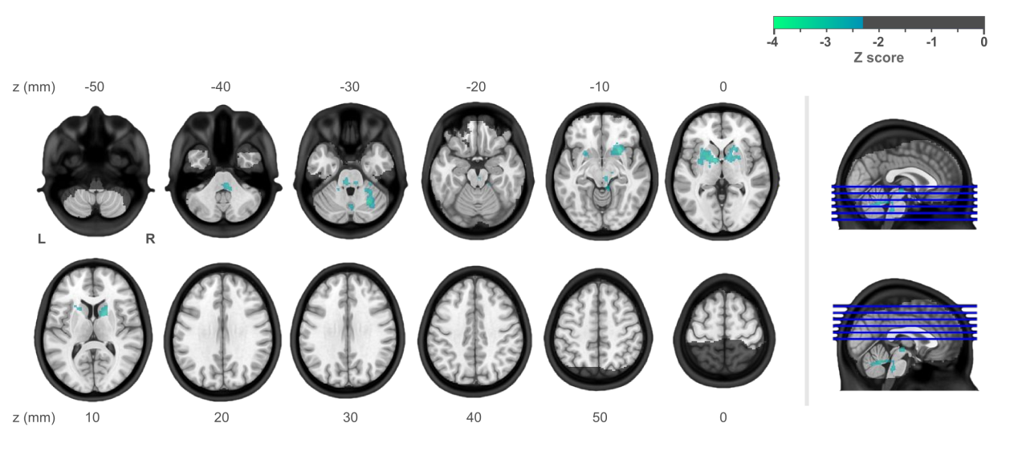

Supplementary Figure S4. Detailed fMRI Results. A more detailed view of the whole brain results showing decreased response on nalmefene compared with placebo (thresholded at Z >2.3, p<0.05 (cluster corrected)).

Supplementary Table S1. Detailed Monetary Incentive Delay: Reward Anticipation > Neutral Anticipation fMRI Results
Monetary incentive delay: reward anticipation > neutral anticipation
nalmefene > placebo
Region | Cluster volume (ml) | p | Local maxima Z score |  | MNI coordinates of maxima (mm)
 |  |  |  |  | x | y | z
Cluster 1 | 8.71 | 0.0007
Right globus pallidus |  |  | -3.62 |  | 14 | 4 | 6
Right putamen |  |  | -3.44 |  | 24 | 14 | -12
Right putamen |  |  | -3.34 |  | 20 | 16 | 6
Right thalamus |  |  | -3.13 |  | 12 | -16 | -4
Right thalamus |  |  | -3.10 |  | 8 | -24 | -6
Right caudate |  |  | -3.08 |  | 16 | 20 | -6
Cluster 2 | 8.3 | 0.001
Right cerebral WM |  |  | -3.56 |  | 2 | -56 | -26
Right cerebral gray matter |  |  | -3.54 |  | 28 | -62 | -30
Brainstem |  |  | -3.52 |  | 6 | -34 | -34
Parahippocampal gyrus |  |  | -3.41 |  | 26 | -30 | -24
Brainstem |  |  | -3.29 |  | -6 | -34 | -26
Brainstem |  |  | -3.14 |  | 8 | -42 | -38
Cluster 3 | 6.06 | 0.0079
Left putamen |  |  | -3.94 |  | -26 | 12 | -4
Left putamen |  |  | -3.34 |  | -18 | 2 | 2
Left globus pallidus |  |  | -3.28 |  | -10 | 0 | -2
Left putamen |  |  | -3.00 |  | -30 | 6 | 6
Left putamen |  |  | -2.94 |  | -26 | 18 | 6
Left putamen |  |  | -2.86 |  | -32 | 0 | 2
The clusters found to differ between nalmefene and placebo sessions. The gray matter structures which contain the coordinates of maxima within each cluster are listed. Negative Z scores indicate a reduction in this contrast on nalmefene compared with placebo. WM = white matter.

Supplementary Table S2. Detailed ‘Amount Won’ and ‘Reaction Time’
Block | Treatment |  | Subject | Visit | ROI BOLD mean (%) | Motion (mm/s) | Amount won | Response time mean (ms) | Accuracy (%)
1 | 2 | placebo | 101 | 1 | 0.11 | 0.13 | £9.50 | 227 | 65
1 | 2 | nalmefene | 101 | 2 | 0.16 | 0.22 | £10.50 | 205 | 69
1 | 1 | nalmefene | 102 | 1 | 0.11 | 0.23 | £12.00 | 206 | 76
1 | 1 | placebo | 102 | 2 | 0.26 | 0.23 | £13.50 | 192 | 81
2 | 1 | nalmefene | 103 | 1 | -0.15 | 0.19 | £8.50 | 248 | 56
2 | 1 | placebo | 103 | 2 | 0.24 | 0.09 | £9.00 | 221 | 64
2 | 2 | placebo | 104 | 1 | 0.09 | 0.25 | £9.50 | 232 | 60
2 | 2 | nalmefene | 104 | 2 | -0.01 | 0.13 | £9.00 | 233 | 61
3 | 2 | placebo | 105 | 1 | 0.17 | 0.14 | £3.50 | 260 | 45
3 | 2 | nalmefene | 105 | 2 | -0.02 | 0.20 | £3.50 | 285 | 32
3 | 1 | nalmefene | 106 | 1 | -0.14 | 0.93 | -£2.00 | 247 | 16
3 | 1 | placebo | 106 | 2 | -0.41 | 1.78 | £0.50 | 323 | 26
4 | 2 | placebo | 107 | 1 | 0.39 | 0.07 | £7.50 | 248 | 56
4 | 2 | nalmefene | 107 | 2 | 0.09 | 0.14 | £6.00 | 267 | 47
4 | 1 | nalmefene | 108 | 1 | 0.40 | 0.30 | £10.50 | 222 | 67
4 | 1 | placebo | 108 | 2 | 0.48 | 0.35 | £9.00 | 254 | 57
5 | 2 | placebo | 109 | 1 | -0.04 | 0.45 | £8.50 | 243 | 60
5 | 2 | nalmefene | 109 | 2
5 | 1 | nalmefene | 110 | 1 | 0.04 | 0.13 | £11.00 | 214 | 70
5 | 1 | placebo | 110 | 2 | 0.01 | 0.10 | £10.50 | 214 | 69
6 | 1 | nalmefene | 111 | 1 | -0.07 | 0.12 | £11.00 | 221 | 71
6 | 1 | placebo | 111 | 2 | 0.04 | 0.11 | £11.50 | 216 | 72
6 | 2 | placebo | 112 | 1 | -0.02 | 0.19 | £7.00 | 265 | 49
6 | 2 | nalmefene | 112 | 2 | 0.04 | 0.12 | £6.50 | 281 | 47
7 | 2 |  | 113
7 | 1 | nalmefene | 114 | 1 | 0.15 | 0.17 | £9.50 | 226 | 59
7 | 1 | placebo | 114 | 2 | 0.40 | 0.21 | £15.00 | 153 | 86
8 | 2 | placebo | 115 | 1 | 0.25 | 0.14 | £10.50 | 225 | 68
8 | 2 | nalmefene | 115 | 2 | 0.18 | 0.08 | £10.00 | 223 | 64
8 | 1 | nalmefene | 116 | 1 | 0.28 | 0.30 | £10.50 | 232 | 67
8 | 1 | placebo | 116 | 2 | 0.19 | 0.11 | £10.50 | 229 | 67
9 | 2 | placebo | 117 | 1 | 0.41 | 0.24 | £7.00 | 281 | 53
9 | 2 | nalmefene | 117 | 2 | 0.10 | 0.07 | -£1.50 | 344 | 19
9 | 1 | nalmefene | 118 | 1 | 0.01 | 0.16 | £2.50 | 320 | 31
9 | 1 | placebo | 118 | 2 | 0.04 | 0.11 | £3.50 | 298 | 37
10 | 2 | placebo | 119 | 1 | 0.48 | 0.13 | £6.00 | 273 | 51
10 | 2 | nalmefene | 119 | 2 | 0.16 | 0.19 | £0.50 | 323 | 26
10 | 1 | nalmefene | 120 | 1 | 0.02 | 0.16 | £6.00 | 286 | 46
10 | 1 | placebo | 120 | 2 | 0.04 | 0.08 | £9.50 | 227 | 68
11 | 2 | placebo | 121 | 1 | 0.55 | 0.11 | £9.00 | 220 | 43
11 | 2 | nalmefene | 121 | 2 | 0.68 | 0.09 | £9.50 | 229 | 61
11 | 1 | nalmefene | 122 | 1 | 0.78 | 0.18 | £10.00 | 239 | 62
11 | 1 | placebo | 122 | 2 | 0.86 | 0.22 | £10.50 | 222 | 68
Task brain and behavioral data used in this work. Data not used due to exclusions is shown in gray italics. Empty lines indicate data was not collected.

Supplementary References
1. Gan G, Guevara A, Marxen M, Neumann M, Junger E, Kobiella A, et al. (2014): Alcohol-induced impairment of inhibitory control is linked to attenuated brain responses in right fronto-temporal cortex. Biol Psychiatry. 76:698-707.
2. Mugler JP, Brookeman JR (1990): Three-dimensional magnetization-prepared rapid gradient-echo imaging (3D MP RAGE). Magnetic Resonance in Medicine. 15:152-157.
3. Luh W-M, Wong EC, Bandettini PA, Hyde JS (1999): QUIPSS II with thin-slice TI1 periodic saturation: A method for improving accuracy of quantitative perfusion imaging using pulsed arterial spin labeling. Magnetic Resonance in Medicine. 41:1246-1254.
4. Knutson B, Adams CM, Fong GW, Hommer D (2001): Anticipation of increasing monetary reward selectively recruits nucleus accumbens. The Journal of neuroscience : the official journal of the Society for Neuroscience. 21:RC159.

