SUPPLEMENTAL DATA

Supplemental Note

Datasets used in the expression quantitative trait loci (eQTL) analyses

We queried RBC/WBC/PLT loci in over 100 separate eQTL datasets in a wide range of tissues. Datasets were collected through publications, publically available sources, or private collaboration. A general overview of a subset of >50 eQTL studies has been published (PMID: 24973796), with specific citations for >100 datasets included in the current query following here.

Blood cell related eQTL studies included fresh lymphocytes (17873875), fresh leukocytes (19966804), leukocyte samples in individuals with Celiac disease (19128478), whole blood samples (18344981, 21829388, 22692066, 23818875, 23359819, 23880221, 24013639, 23157493, 23715323, 24092820, 24314549, 24956270, 24592274, 24728292, 24740359, 25609184, 22563384, 25474530, 25816334, 25578447), lymphoblastoid cell lines (LCL) derived from asthmatic children (17873877, 23345460), HapMap LCL from 3 populations (17873874), a separate study on HapMap CEU LCL (18193047), additional LCL population samples (19644074, 22286170, 22941192, 23755361, 23995691, 25010687, 25951796), neutrophils (26151758, 26259071), CD19+ B cells (22446964), primary PHA-stimulated T cells (19644074, 23755361), CD4+ T cells (20833654), peripheral blood monocytes (19222302,20502693,22446964, 23300628, 25951796, 26019233), long non-coding RNAs in monocytes (25025429) and CD14+ monocytes before and after stimulation with LPS or interferon-gamma (24604202), CD11+ dendritic cells before and after Mycobacterium tuberculosis infection (22233810) and a separate study of dendritic cells before or after stimulation with LPS, influenza or interferon-beta (24604203). Micro-RNA QTLs (21691150, 26020509), DNase-I QTLs (22307276), histone acetylation QTLs (25799442), and ribosomal occupancy QTLs (25657249) were also queried for LCL. Splicing QTLs (25685889) and micro-RNA QTLs (25791433) were queried in whole blood.

Non-blood cell tissue eQTLs searched included omental and subcutaneous adipose (18344981, 21602305, 22941192, 23715323, 25578447), visceral fat (25578447) stomach (21602305), endometrial carcinomas (21226949), ER+ and ER- breast cancer tumor cells (23374354), liver (18462017,21602305,21637794, 22006096, 24665059, 25578447), osteoblasts (19654370), intestine (23474282) and normal and cancerous colon (25079323, 25766683), skeletal muscle (24306210, 25578447), breast tissue (normal and cancer)(24388359, 22522925), lung (23209423, 23715323, 24307700, 23936167, 26102239), skin (21129726, 22941192, 23715323, 25951796), primary fibroblasts (19644074, 23755361, 24555846), sputum (21949713), pancreatic islet cells (25201977), prostate (25983244), rectal mucosa (25569741), arterial wall (25578447) and heart tissue from left ventricles (23715323, 24846176) and left and right atria (24177373). Micro-RNA QTLs were also queried for gluteal and abdominal adipose (22102887) and liver (23758991). Methylation QTLs were queried in pancreatic islet cells (25375650). Further mRNA and micro-RNA QTLs were queried from ER+ invasive breast cancer samples, colon-, kidney renal clear-, lung- and prostate-adenocarcinoma samples (24907074).

Brain eQTL studies included brain cortex (19222302, 19361613, 22685416, 25609184, 25290266), cerebellar cortex (25174004), cerebellum (20485568, 22685416, 22212596, 22832957, 23622250), frontal cortex (20485568, 22832957, 25174004), gliomas (24607568), hippocampus (22832957, 25174004), inferior olivary nucleus (from medulla) (25174004), intralobular white matter (25174004), occiptal cortex (25174004), parietal lobe (22212596), pons (20485568), pre-frontal cortex (22031444, 20351726, 22832957, 23622250), putamen (at the level of anterior commussure) (25174004), substantia nigra (25174004), temporal cortex (20485568, 22685416, 22832957, 25174004), thalamus (22832957) and visual cortex (23622250).

Additional eQTL data was integrated from online sources including ScanDB, the Broad Institute GTEx Portal, and the Pritchard Lab (eqtl.uchicago.edu). Cerebellum, parietal lobe and liver eQTL data was downloaded from ScanDB and cis-eQTLs were limited to those with P<1.0E-6 and trans-eQTLs with P<5.0E-8. Results for GTEx Analysis V4 for 13 tissues were downloaded from the GTEx Portal and then additionally filtered as described below [www.gtexportal.org: thyroid, leg skin (sun exposed), tibial nerve, aortic artery, tibial artery, skeletal muscle, esophagus mucosa, esophagus muscularis, lung, heart (left ventricle), stomach, whole blood, and subcutaneous adipose (23715323)]. Splicing QTL (sQTL) results generated with sQTLseeker with false discovery rate P≤0.05 were retained. For all gene-level eQTLs, if at least 1 SNP passed the tissue-specific empirical threshold in GTEx, the best SNP for that eQTL was always retained. All gene-level eQTL SNPs with P<1.67E-11 were also retained, reflecting a global threshold correction of P=0.05/(30,000 genes X 1,000,000 tests).

Figure S1. Flow chart of the study design. Data was contributed from 24 studies for the discovery phase. We applied QC steps to remove low quality variants and samples. We also excluded individuals with extreme phenotypes. After the proper adjustments, we applied inverse normal transformation on the residuals. We then performed study-specific association analyses using RV test or RareMetalWorker followed by QC of the individual association results. We meta-analyzed the association results using RareMetals and performed single variant (SV) and gene-based analyses. Additionally, we performed conditional analyses on the SV results, and attempted replication of the significant independent markers in the replication phase which comprised 8 independent studies. HW: Hardy Weinberg; PC: principle components; SKAT: Sequence Kernel Association Test; VT: Variable threshold test; EA; European ancestry; AA: African American ancestry; All: combined ancestry (EA + AA + Asians + Hispanics).
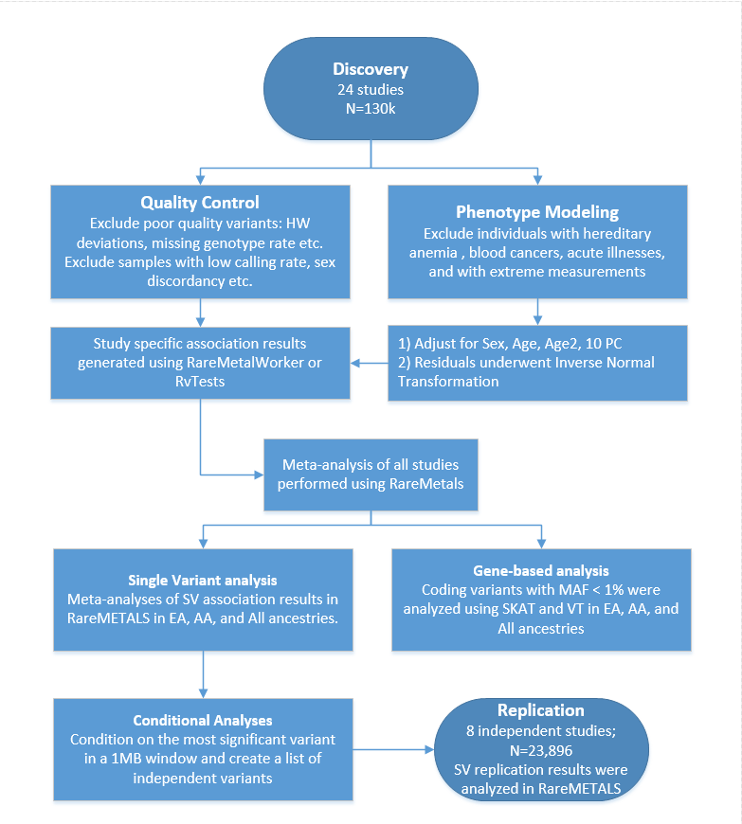
Figure S2. Manhattan plots of the all-ancestry single-variant meta-analyses results of the seven red blood cell traits of the discovery phase. Variants with P<2x10⁻⁷ are shown in pink.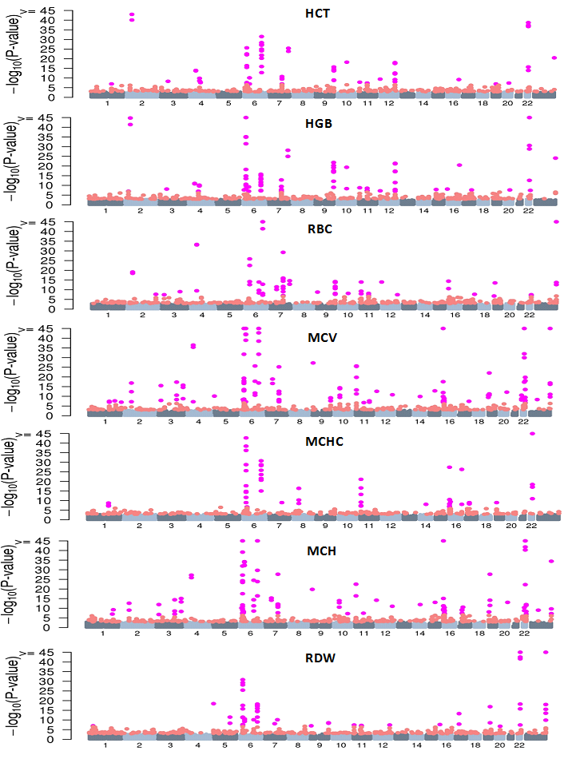

Figure S3. Scatter plots showing the correlation between the seven red blood cell traits. Shown here are raw values from the MHI Biobank cohort (N=7911). Strong correlations can be observed between HGB and HCT (r = 0.978) and between MCH and MCV (r = 0.934). RBC is highly correlated with HCT (r = 0.874) and HGB (r = 0.835).

Figure S4. Expression levels of the HNF4A isoforms detected in hematopoietic cells by RNA-seq by the BLUEPRINT Project. HNF4 is only detectable in erythroblasts (EB) and megakaryocytes (MK).

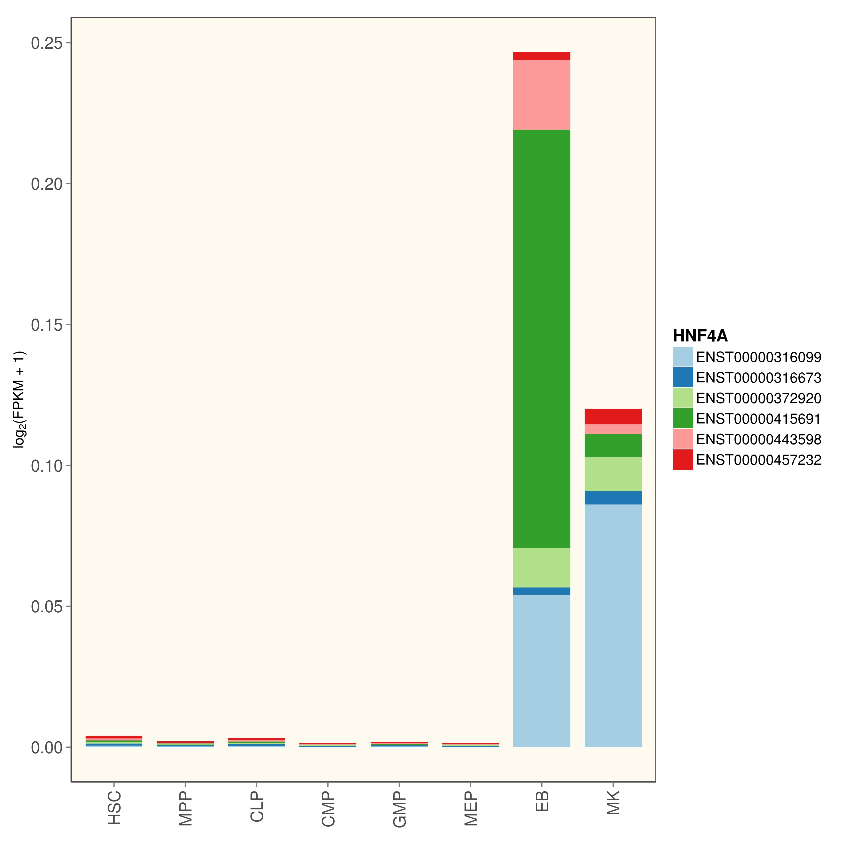

Figure S5. The nonsense variant rs3211938 in CD36 is associated with CD36 expression levels in the GTEx dataset. (A) rs3211938 is an expression quantitative trait locus (eQTL) for CD36 in whole blood samples. The G-allele is associated with reduced expression levels (P_{eQTL}=1.1x10⁻¹⁵) in 338 samples, including 11 heterozygous samples. (B) Allelic imbalance (also known as allele-specific expression or ASE) of CD36-rs3211938 in several available tissues. The upper panel shows the ratio of G-allele among all RNA-sequencing reads that cover the site. Consistent with our erythroblast results, several tissues show a ratio well under the expected 50:50, suggesting that the nonsense G-allele is under-represented. For instance, the ratio is 30:70 is whole blood (WHLBLD). The lower panel summarizes the statistical evidence of ASE in the same tissues based on the model developed by Rivas et al., Science, 2015. For instance in whole blood, the probability to observe moderate evidence of ASE is 94% whereas the probability that there is no ASE is 6%. ADPSBQ, adipose-subcutaneous; ARTAORT, artery-aorta; ARTCRN, artery-coronary; ARTTBL, artery-tibial; HRTLV, heart-left ventricle; MSCLSK, skeletal muscle; STMACH, stomach.

A
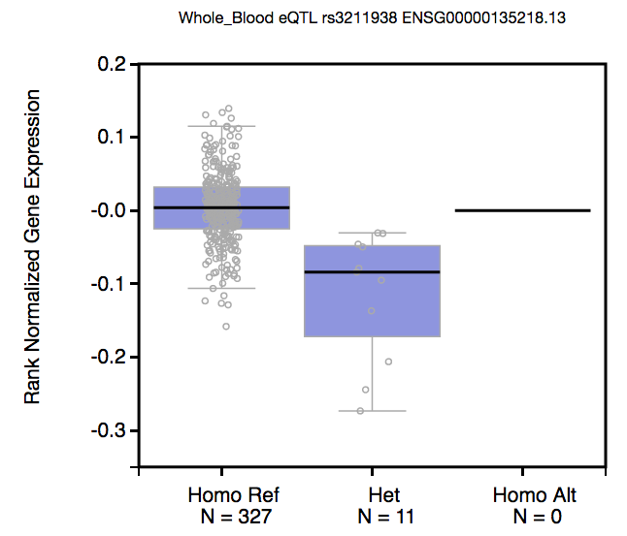
B
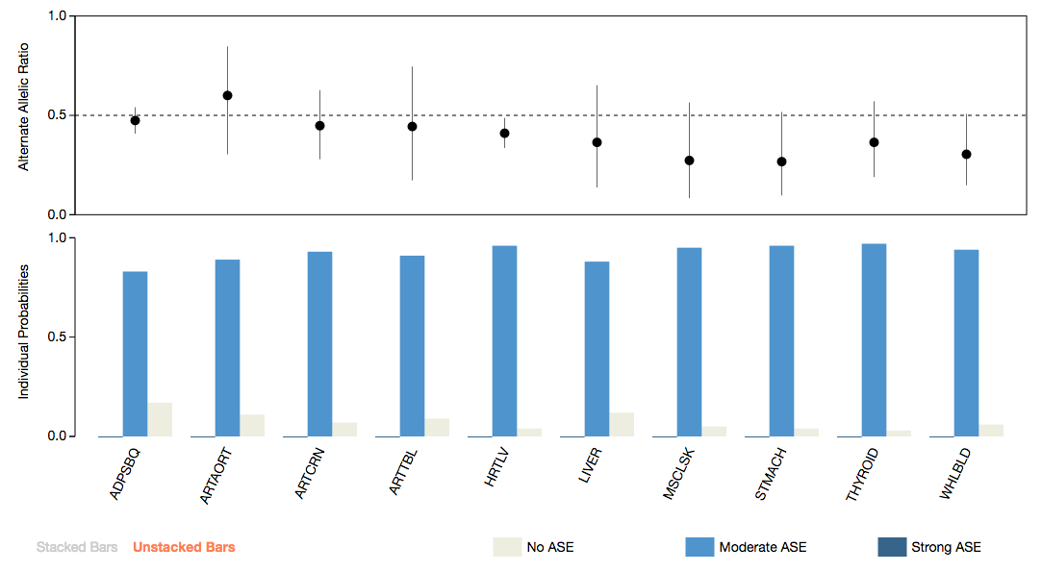
Table S4. Description of the replication cohorts.
Abbreviated Study Name | Full Study Name | Study Design | Ethnicity | Total Sample Size (N)
AIRWAVE | Airwave Health Monitoring Study | Cohort | European | 14,866
GeneSTAR | Study of Atherosclerosis Risk in Families | Family-based | European | 1,020
FINCAVAS | The Finnish Cardiovascular Study | Hospital-based | European | 912
NWIGM | Northwest Institute of Genetic Medicine | Cohort and case-control | European | 1,274
REGARDS | REasons for Geographic and Racial Differences in Stroke | Cohort | African American | 5,039
YFS | The Cardiovascular Risk in Young Finns Study | Cohort | European | 1,888
BioVU-Replication | Vanderbilt University DNA data bank | EMR Database at Vanderbilt University | European | 1,783
BioVU | Vanderbilt University DNA data bank | EMR Database at Vanderbilt University | African American | 968

Table S6. Expression quantitative trait loci (eQTL) results for variants associated with red blood cell phenotypes. eSNP, SNP associated with the gene expression phenotype; eSNP.p, eQTL association P-value; r², linkage disequilibrium in European populations between the eSNP (from the RBC analyses) and the best eSNP for a given gene; Best_eSNP, best reported eSNP for the gene tested; Best_eSNP.p, eQTL P-value for the best eSNP for the gene tested.

CHR | POS | eSNP | Gene | Trait | Tissue | eSNP.p | Transcript | r² | Best_eSNP | Best_eSNP.p
1 | 25768937 | rs10903129 | TMEM57 | RDW-EA/All | Whole blood | 2.67E-128 | RHD | 0.669 | rs909832 | 9.81E-198
1 | 155162067 | rs4072037 | MUC1 | HCT-All | CD16+ neutrophils | 2.30E-05 | THBS3 | 1 | rs2066981 | 2.30E-05
2 | 219509618 | rs2230115 | ZNF142 | RBC-All | CD16+ neutrophils | 7.26E-17 | CYP27A1 | 1 | rs10187066 | 7.26E-17
3 | 56771251 | rs3772219 | ARHGEF3 | HCT/HGB-All | Whole blood | 3.10E-21 | ARHGEF3 | 0.682 | rs2046823 | 1.16E-27
3 | 56771251 | rs3772219 | ARHGEF3 | HCT/HGB-All | Peripheral blood mononuclear cells | 4.55E-15 | ARHGEF3 | SameSNP | rs3772219 | 4.55E-15
4 | 88008782 | rs236985 | AFF1 | HCT/RBC-EA | Peripheral blood mononuclear cells | 4.42E-18 | AFF1 | 0.932 | rs442177 | 1.05E-18
4 | 88030261 | rs442177 | AFF1 | HGB-EA | Peripheral blood mononuclear cells | 1.05E-18 | AFF1 | same SNP | rs442177 | 1.05E-18
5 | 127371588 | rs10063647 | LINC01184 | RDW-EA/All | Peripheral blood mononuclear cells | 2.78E-16 | FLJ33630 | 0.327 | rs2250127 | 2.03E-40
5 | 127371588 | rs10063647 | LINC01184 | RDW-EA/All | CD14+ monocytes | 1.48E-12 | FLJ33630 | 0.327 | rs3749748 | 3.24E-38
5 | 127522543 | rs10089 | SLC12A2 | RDW-EA/All | Whole blood | 2.78E-09 | FBN2 | 0.002 | rs764369 | 9.81E-198
7 | 80300449 | rs3211938 | CD36 | RDW-AA/All | Whole blood | 6.40E-14 | CD36 | SameSNP | rs3211938 | 6.40E-14
10 | 105659826 | rs2487999 | OBFC1 | MCV-All | Liver | 2.05E-14 | OBFC1 | SameSNP | rs2487999 | 2.05E-14
17 | 59483766 | rs8068318 | TBX2 | HGB-EA | Fibroblasts | 4.09E-06 | C17ORF82 | 1 | rs2240736 | 4.09E-06
17 | 59483766 | rs8068318 | TBX2 | HGB-EA | Monocytes (CD14+) | 9.97E-07 | CCDC47 | 0.527 | rs9905140 | 2.73E-07
20 | 31140165 | rs4911241 | NOL4L | MCV/RDW-EA; RDW-All | Peripheral blood mononuclear cells | 7.65E-11 | ASXL1 | 0.293 | rs6141282 | 1.85E-22
20 | 31140165 | rs4911241 | NOL4L | MCV/RDW-EA; RDW-All | Whole blood | 4.37E-07 | ASXL1 | 0.293 | rs3746612 | 9.13E-18

Table S7. Single-variant replication results for the variants identified by gene-based testing. A1, reference allele; A2, alternate allele; N, sample size; AF, allele frequency; se, standard error; HCT, hematocrit; HGB, hemoglobin; RBC, red blood cell count; MCV, mean corpuscular volume; MCHC, mean corpuscular hemoglobin concentration; MCH, mean corpuscular hemoglobin; RDW, red blood cell distribution width.
Marker Info |  |  |  | Discovery |  |  |  |  | Replication
Gene | MarkerName | A1/A2 | Trait | EAF | N | beta | se | Pvalue | N | EAF | beta | se | Pvalue | Study
PKLR | 1:155260382 | C/T | HGB_EA | 0.002 | 106377 | -0.128 | 0.047 | 0.006 | 20723 | 0.003 | -0.287 | 0.100 | 0.004 | Meta (NWIGM, BIOVU-replication, FINCAVAS, YFS, AIRWAVES)
PKLR | 1:155261649 | C/T | HGB_EA | 0.006 | 106377 | 0.083 | 0.028 | 0.003 | 20723 | 0.005 | 0.0144 | 0.156 | 0.926 | Meta (NWIGM, BIOVU-replication, FINCAVAS, YFS, AIRWAVES)
PKLR | 1:155261709 | G/A | HGB_EA | 0.003 | 106377 | -0.174 | 0.040 | 1.23E-05 | 20723 | 0.003 | -0.182 | 0.088 | 0.039 | Meta (NWIGM, BIOVU-replication, FINCAVAS, YFS, AIRWAVES)
PKLR | 1:155260382 | C/T | HCT_EA | 0.002 | 87444 | -0.155 | 0.052 | 0.003 | 18945 | 0.003 | 0.069 | 0.314 | 0.839 | Meta (NWIGM, FINCAVAS, YFS, AIRWAVES)
PKLR | 1:155261709 | G/A | HCT_EA | 0.003 | 87444 | -0.187 | 0.041 | 4.53E-06 | 18945 | 0.003 | -0.130 | 0.194 | 0.503 | Meta (NWIGM, FINCAVAS, YFS, AIRWAVES)
PKLR | 1:155264320 | G/T | HCT_EA | 0.0004 | 87444 | -0.359 | 0.174 | 0.039 | NA | NA | NA | NA | NA | Meta (NWIGM, FINCAVAS, YFS)
ALAS2 | X:55035659 | G/A | MCH_EA | 0.0005 | 54009 | 0.287 | 0.125 | 0.021 | 3056 | 0.0015 | -0.067 | 0.333 | 0.840 | Meta (NWIGM, BIOVU-replication)
ALAS2 | X:55039960 | G/A | MCH_EA | 0.002 | 52758 | -0.324 | 0.053 | 7.32E-10 | 5855 | 0.001 | -0.291 | 0.235 | 0.215 | Meta (NWIGM , BIOVU-replication, YFS, GeneSTAR)
ALPK3 | 15:85382313 | C/T | MCHC_EA | 7.53E-06 | 67917 | 2.211 | 0.995 | 0.026 | NA | NA | NA | NA | NA | BIOVU-replication
ALPK3 | 15:85399650 | C/T | MCHC_EA | 3.18E-05 | 67917 | 1.360 | 0.499 | 0.006 | 1783 | 0.0003 | -0.131 | 0.994 | 0.895 | BIOVU-replication
ALPK3 | 15:85400482 | G/T | MCHC_EA | 3.79E-05 | 67917 | 1.555 | 0.447 | 0.001 | 1783 | 0.0003 | 1.280 | 0.995 | 0.198 | BIOVU-replication

Table S8. Association results for five novel RBC trait loci, before and after adjustment for lipids. HGB, hemoglobin; RDW, red blood cell distribution width, TC, total cholesterol, TG, triglycerides, HDL, high-density lipoprotein cholesterol
SNP | RBC  trait | Lipid  trait | No adjustment |  |  |  | Adjustment for corresponding lipid trait
SNP | RBC  trait | Lipid  trait | beta | se | p-value | N | beta | se | p-value | N
TMEM57-RHD rs10903129 | RDW | TC | -0.0266 | 0.0141 | 0.0588 | 10406 | -0.0276 | 0.0140 | 0.0490 | 10406
AFF1 rs442177 | HGB | TG | 0.0257 | 0.0096 | 0.0072 | 22872 | 0.0264 | 0.0095 | 0.0055 | 22872
TRIB1 rs2954029 | RDW | TG | 0.0188 | 0.0141 | 0.1818 | 10405 | 0.0004 | 0.0002 | 0.0356 | 10405
MAP1A rs55707100 | HGB | TG | -0.0529 | 0.0263 | 0.0442 | 22858 | -0.0678 | 0.0262 | 0.0096 | 22858
HNF4A rs1800961 | HGB | HDL | 0.0745 | 0.0275 | 0.0068 | 23441 | 0.0662 | 0.0275 | 0.0161 | 23441

Additional Funding Information

AIRWAVE
The Airwave Study is funded by the Home Office (grant number 780-TETRA) with additional support from the National Institute for Health Research (NIHR) Imperial College Healthcare NHS Trust (ICHNT) and Imperial College Biomedical Research Centre (BRC) (Grant number BRC-P38084). Paul Elliott is an NIHR Senior Investigator and is supported by the ICHNT and Imperial College BRC, the MRC-PHE Centre for Environment and Health and the NIHR Health Protection Research Unit on Health Impact of Environmental Hazards.

ARIC
The Atherosclerosis Risk in Communities (ARIC) Study is carried out as a collaborative study supported by National Heart, Lung, and Blood Institute contracts (HHSN268201100005C, HHSN268201100006C, HHSN268201100007C, HHSN268201100008C, HHSN268201100009C, HHSN268201100010C, HHSN268201100011C, and HHSN268201100012C), R01HL087641, R01HL59367 and R01HL086694; National Human Genome Research Institute contract U01HG004402; and National Institutes of Health contract HHSN268200625226C. Infrastructure was partly supported by Grant Number UL1RR025005, a component of the National Institutes of Health and NIH Roadmap for Medical Research. The meta-analysis and meta-regression analyses were funded by grant R01 HL086694 from the National Heart, Lung, and Blood Institute. The authors thank the staff and participants of the ARIC study for their important contributions.

BioMe
The Mount Sinai IPM Biobank Program is supported by The Andrea and Charles Bronfman Philanthropies.

BIOVU
The dataset used in the analyses described were obtained from Vanderbilt University Medical Center's BioVU which is supported by institutional funding and by the Vanderbilt CTSA grant UL1 TR000445 from NCATS/NIH. Genome-wide genotyping was funded by NIH grants RC2GM092618 from NIGMS/OD and U01HG004603 from NHGRI/NIGMS. Funding for TLE and DRVE was provided by 1R21HL12142902 from NHLBI/NIH. Funding for the BioVU replication cohort was provided by 5R01HD074711 from NICHD/NIH.

CARDIA
The CARDIA Study is conducted and supported by the National Heart, Lung, and Blood Institute in collaboration with the University of Alabama at Birmingham (HHSN268201300025C & HHSN268201300026C), Northwestern University (HHSN268201300027C), University of Minnesota (HHSN268201300028C), Kaiser Foundation Research Institute (HHSN268201300029C), and Johns Hopkins University School of Medicine (HHSN268200900041C). CARDIA is also partially supported by the Intramural Research Program of the National Institute on Aging. Exome Chip genotyping was supported from grants R01-HL093029 and U01- HG004729 to MF. This manuscript has been reviewed and approved by CARDIA for scientific content.

CHS
This CHS research was supported by NHLBI contracts HHSN268201200036C, HHSN268200800007C, N01HC55222, N01HC85079, N01HC85080, N01HC85081, N01HC85082, N01HC85083, N01HC85086; and NHLBI grants HL080295, HL087652, HL103612, HL105756, HL120393 with additional contribution from the National Institute of Neurological Disorders and Stroke (NINDS). Additional support was provided through AG023629 from the National Institute on Aging (NIA). The provision of genotyping data was supported in part by the National Center for Advancing Translational Sciences, CTSI grant UL1TR000124, and the National Institute of Diabetes and Digestive and Kidney Disease Diabetes Research Center (DRC) grant DK063491 to the Southern California Diabetes Endocrinology Research Center. A full list of CHS investigators and institutions can be found at http://chs-nhlbi.org/.

EGCUT
This study was supported by EU H2020 grants 692145, 676550, 654248, Estonian Research Council Grant IUT20-60, NIASC, EIT – Health and NIH-BMI grant 2R01DK075787-06A1.

FINCAVAS
This work was supported by the Competitive Research Funding of the Tampere University Hospital (Grant 9M048 and 9N035), the Finnish Cultural Foundation, the Finnish Foundation for Cardiovascular Research, the Emil Aaltonen Foundation, Finland, and the Tampere Tuberculosis Foundation. FINCAVAS thanks the staff of the Department of Clinical Physiology for collecting the exercise test data.

Framingham Heart Study
Genotyping, quality control and calling of the Illumina HumanExome BeadChip in the Framingham Heart Study was supported by funding from the National Heart, Lung and Blood Institute Division of Intramural Research (Daniel Levy and Christopher J. O’Donnell, Principle Investigators). Support for the centralized genotype calling was provided by Building on GWAS for NHLBI-diseases: the U.S. CHARGE consortium through the National Institutes of Health (NIH) American Recovery and Reinvestment Act of 2009 (5RC2HL102419). The NHLBI’s Framingham Heart Study is a joint project of the National Institutes of Health and Boston University School of Medicine and was supported by contract N01-HC-25195. The FHS authors are pleased to acknowledge that the computational work reported on in this paper was performed on the Shared Computing Cluster, which is administered by Boston University’s Research Computing Services. URL: www.bu.edu/tech/support/research/. The views expressed in this manuscript are those of the authors and do not necessarily represent the views of the National Heart, Lung, and Blood Institute; the National Institutes of Health; or the U.S. Department of Health and Human Services.

GeneSTAR
GeneSTAR was supported by the National Institutes of Health/National Heart, Lung, and Blood Institute (U01 HL72518, HL087698, and HL112064) and by a grant from the National Institutes of Health/National Center for Research Resources (M01-RR000052) to the Johns Hopkins General Clinical Research Center. Genotyping services were provided through the RS&G Service by the Northwest Genomics Center at the University of Washington, Department of Genome Sciences, under U.S. Federal Government contract number HHSN268201100037C from the National Heart, Lung, and Blood Institute.

GSK-STABILITY and SOLID TIMI-52
The GSK-STABILITY and SOLID TIMI-52 studies were funded by GlaxoSmithKline.

HABC
HABC funding/acknowledgement: The Health ABC Study was supported by NIA contracts N01AG62101, N01AG62103, and N01AG62106 and, in part, by the NIA Intramural Research Program. The genome-wide association study was funded by NIA grant 1R01AG032098-01A1 to Wake Forest University Health Sciences and genotyping services were provided by the Center for Inherited Disease Research (CIDR). CIDR is fully funded through a federal contract from the National Institutes of Health to The Johns Hopkins University, contract number HHSN268200782096C. This study utilized the high-performance computational capabilities of the Biowulf Linux cluster at the National Institutes of Health, Bethesda, Md. (http://biowulf.nih.gov).

HANDLS
The Healthy Aging in Neighborhoods of Diversity across the Life Span Study (HANDLS) research was supported by the Intramural Research Program of the NIH, National Institute on Aging and the National Center on Minority Health and Health Disparities (project # Z01-AG000513 and human subjects protocol # 2009-149). Data analyses for the HANDLS study utilized the computational resources of the NIH HPC Biowulf cluster at the National Institutes of Health, Bethesda, MD (http://hpc.nih.gov).

Health2006/2008
The Health2006 was financially supported by grants from the Velux Foundation; The Danish Medical Research Council, Danish Agency for Science, Technology and Innovation; The Aase and Ejner Danielsens Foundation; ALK-Abello A/S, Hørsholm, Denmark, and Research Centre for Prevention and Health, the Capital Region of Denmark. The Novo Nordisk Foundation Center for Basic Metabolic Research is an independent Research Center at the University of Copenhagen partially funded by an unrestricted donation from the Novo Nordisk Foundation (www.metabol.ku.dk). This work was supported by the Timber Merchant Vilhelm Bang’s Foundation, the Danish Heart Foundation (Grant number 07-10-R61-A1754-B838-22392F), and the Health Insurance Foundation (Helsefonden) (Grant number 2012B233).

JHS
The JHS is supported by contracts HHSN268201300046C, HHSN268201300047C, HHSN268201300048C, HHSN268201300049C, HHSN268201300050C from the National Heart, Lung, and Blood Institute and the National Institute on Minority Health and Health Disparities.

LBC1921/1936
Phenotype collection in the Lothian Birth Cohort 1921 was supported by the UK’s Biotechnology and Biological Sciences Research Council (BBSRC), The Royal Society and The Chief Scientist Office of the Scottish Government. Phenotype collection in the Lothian Birth Cohort 1936 was supported by Age UK (The Disconnected Mind project). Genotyping was supported by Centre for Cognitive Ageing and Cognitive Epidemiology (Pilot Fund award), Age UK, and the Royal Society of Edinburgh. The work was undertaken by The University of Edinburgh Centre for Cognitive Ageing and Cognitive Epidemiology, part of the cross council Lifelong Health and Wellbeing Initiative (MR/K026992/1). Funding from the BBSRC and Medical Research Council (MRC) is gratefully acknowledged. WDH is supported by a grant from Age UK (Disconnected Mind Project).

MDCC
The Malmö Diet and Cancer cohort studies were supported by grants from the Swedish Research Council, the Swedish Heart and Lung Foundation, the Påhlsson Foundation, the Novo Nordic Foundation and European Research Council starting grant StG-282255.

MESA
MESA and the MESA SHARe project are conducted and supported by the National Heart, Lung, and Blood Institute (NHLBI) in collaboration with MESA investigators. Support for MESA is provided by contracts N01-HC-95159, N01-HC-95160, N01-HC-95161, N01-HC-95162, N01-HC-95163, N01-HC-95164, N01-HC-95165, N01-HC-95166, N01-HC-95167, N01-HC-95168, N01-HC-95169, UL1-TR-001079, UL1-TR-000040, and DK063491. MESA Family is conducted and supported by the National Heart, Lung, and Blood Institute (NHLBI) in collaboration with MESA investigators. Support is provided by grants and contracts R01HL071051, R01HL071205, R01HL071250, R01HL071251, R01HL071258, R01HL071259, by the National Center for Research Resources, Grant UL1RR033176, and the National Center for Advancing Translational Sciences, Grant UL1TR000124. Funding support for the inflammation dataset was provided by grant HL077449. The MESA Epigenomics & Transcriptomics Study was funded by NIA grant 1R01HL101250-01 to Wake Forest University Health Sciences. MESA thanks its Coordinating Center, MESA investigators, and study staff for their valuable contributions. A full list of participating MESA investigators and institutions can be found at http://www.mesa-nhlbi.org.

Montreal Heart Institute Biobank (MHIBB)
We thank all participants and staff of the André and France Desmarais MHIBB. The MHI Biobank acknowledges the technical support of the Beaulieu-Saucier MHI Pharmacogenomic Center. Genotyping of the MHIBB participants was funded by the MHI Foundation.

NWIGM
This phase of the eMERGE Network was initiated and funded by the NHGRI through the following grants: U01HG8657 (Group Health Cooperative/University of Washington); U01HG8685 (Brigham and Women’s Hospital); U01HG8672 (Vanderbilt University Medical Center); U01HG8666 (Cincinnati Children’s Hospital Medical Center); U01HG6379 (Mayo Clinic); U01HG8679 (Geisinger Clinic); U01HG8680 (Columbia University Health Sciences); U01HG8684 (Children’s Hospital of Philadelphia); U01HG8673 (Northwestern University); U01HG8701 (Vanderbilt University Medical Center serving as the Coordinating Center); U01HG8676 (Partners Healthcare/Broad Institute); and U01HG8664 (Baylor College of Medicine). NWIGM dataset please also add "Additional support was provided by the University of Washington’s Northwest Institute of Genetic Medicine from Washington State Life Sciences Discovery funds (Grant 265508).

REGARDS
This research was supported by cooperative agreement U01 NS041588 from the National Institute of Neurological Disorders and Stroke, National Institutes of Health, Department of Health and Human Services. Additional funding was provided by an investigator-initiated grant-in-aid from Amgen Corporation (Thousand Oaks, California). Amgen did not have any role in the design and conduct of the study or in the collection and management of the data. This research project is supported by a cooperative agreement U01 NS041588 from the National Institute of Neurological Disorders and Stroke, National Institutes of Health, Department of Health and Human Service. The authors thank the other investigators, the staff, and the participants of the REGARDS study for their valuable contributions. A full list of participating REGARDS investigators and institutions can be found at http://www.regardsstudy.org. The genotyping for this project was provided by NIH/NCRR center grant 5U54RR026137-03.
We thank the investigators, staff and participants of the REGARDS study for their valuable contributions. A full list of participating REGARDS investigators and institutions can be found at http://www.regardsstudy.org.

RS
The generation and management of the Illumina exome chip v1.0 array data for the Rotterdam Study (RS-I) was executed by the Human Genotyping Facility of the Genetic Laboratory of the Department of Internal Medicine, Erasmus MC, Rotterdam, The Netherlands. The Exome chip array data set was funded by the Genetic Laboratory of the Department of Internal Medicine, Erasmus MC, from the Netherlands Genomics Initiative (NGI)/Netherlands Organisation for Scientific Research (NWO)-sponsored Netherlands Consortium for Healthy Aging (NCHA; project nr. 050-060-810); the Netherlands Organization for Scientific Research (NWO; project number 184021007) and by the Rainbow Project (RP10; Netherlands Exome Chip Project) of the Biobanking and Biomolecular Research Infrastructure Netherlands (BBMRI-NL; www.bbmri.nl ). We thank Ms. Mila Jhamai, Ms. Sarah Higgins, and Mr. Marijn Verkerk for their help in creating the exome chip database, and Carolina Medina-Gomez, MSc, Lennard Karsten, MSc, and Linda Broer PhD for QC and variant calling. Variants were called using the best practice protocol developed by Grove et al. as part of the CHARGE consortium exome chip central calling effort.

The Rotterdam Study is funded by Erasmus Medical Center and Erasmus University, Rotterdam, Netherlands Organization for the Health Research and Development (ZonMw), the Research Institute for Diseases in the Elderly (RIDE), the Ministry of Education, Culture and Science, the Ministry for Health, Welfare and Sports, the European Commission (DG XII), and the Municipality of Rotterdam. The authors are grateful to the study participants, the staff from the Rotterdam Study and the participating general practitioners and pharmacists.

SHIP and SHIP-TREND
SHIP is part of the Community Medicine Research net of the University of Greifswald, Germany, which is funded by the Federal Ministry of Education and Research (grants no. 01ZZ9603, 01ZZ0103, and 01ZZ0403), the Ministry of Cultural Affairs as well as the Social Ministry of the Federal State of Mecklenburg-West Pomerania, and the network ‘Greifswald Approach to Individualized Medicine (GANI_MED)’ funded by the Federal Ministry of Education and Research (grant 03IS2061A). ExomeChip data have been supported by the Federal Ministry of Education and Research (grant no. 03Z1CN22) and the Federal State of Mecklenburg-West Pomerania. SHIP and SHIP-TREND are part of the Research Network of Community Medicine of the University Medicine Greifswald (www-community-medicine.de). The studies were supported by the Federal Ministry of Education and Research, by the Federal State of Mecklenburg-Pomerania and the Siemens AG. The University Medicine Greifswald is a member of the Caché Campus program of the InterSystems GmbH. The SHIP and SHIP-TREND samples were genotyped at the Helmholtz Zentrum München.

WHI
The WHI program is funded by the National Heart, Lung, and Blood Institute, the US National Institutes of Health and the US Department of Health and Human Services (HHSN268201100046C, HHSN268201100001C, HHSN268201100002C, HHSN268201100003C, HHSN268201100004C and HHSN271201100004C). Exome chip data and analysis were supported through the Exome Sequencing Project (NHLBI RC2 HL-102924, RC2 HL-102925 and RC2 HL-102926), the Genetics and Epidemiology of Colorectal Cancer Consortium (NCI CA137088), and the Genomics and Randomized Trials Network (NHGRI U01-HG005152). The authors thank the WHI investigators and staff for their dedication, and the study participants for making the program possible. A full listing of WHI investigators can be found at: http://www.whi.org/researchers/Documents%20%20Write%20a%20Paper/WHI%20Investigator%20Short%20List.pdf.

YFS
The Young Finns Study has been financially supported by the Academy of Finland: grants 285902, 286284, 134309 (Eye), 126925, 121584, 124282, 129378 (Salve), 117787 (Gendi), and 41071 (Skidi); the Social Insurance Institution of Finland; Kuopio, Tampere and Turku University Hospital Medical Funds (grant X51001); Juho Vainio Foundation; Paavo Nurmi Foundation; Finnish Foundation of Cardiovascular Research ; Finnish Cultural Foundation; Tampere Tuberculosis Foundation ; Emil Aaltonen Foundation ; and Yrjö Jahnsson Foundation.

