Who really responds to asthma biologics? The clue lies in the journey before treatment

Freda Yang¹, Apostolos Bossios^{2,3,4}
- National Heart and Lung Institute, Imperial College London, London, UK
- Karolinska Severe Asthma Centre, Department of Respiratory Medicine and Allergy, Karolinska University Hospital, Stockholm, Sweden
- Division for Lung and Airway Research, Institute for Environmental Medicine, Karolinska Institute, Stockholm, Sweden
- Lung Laboratory, Centre for Molecular Medicine, Karolinska University Hospital, Stockholm, Sweden

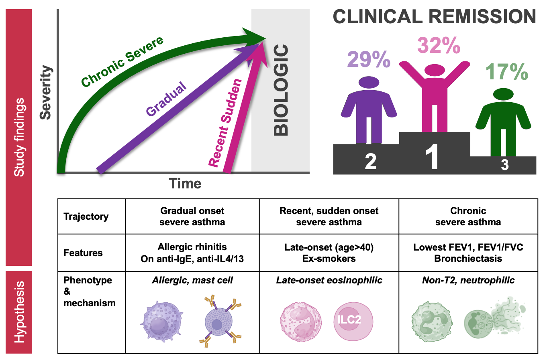

For patients with severe asthma, life can often be divided into two distinct chapters: “before biologic” and “after biologic.” Biologics have revolutionised clinical practice and, for many, transformed lives.(1) However, the question remains: who benefits most from biologics, and why?

The story of asthma biologics began with omalizumab, which reigned as the sole therapy for over a decade.(2) Then came mepolizumab, a drug initially deemed a failure in broad asthma populations but later rescued by its efficacy in exacerbation-prone eosinophilic asthma.(3,4) This pivotal moment underscored the importance of phenotyping and the use of exacerbation reduction as an endpoint. Fast forward to today, we now have six highly effective biologics targeting different aspects of T2 pathways, all aimed at reducing exacerbations and, to some extent, improving lung function and symptoms.(5) Yet, as these treatments entered the real-world, it became clear that responses to biologics exist on a spectrum, despite patients meeting similar eligibility criteria.

Some patients achieved complete control on biologics with no further exacerbations or symptoms and showed improvements in lung function, and were named “super-responders”.(6) This gave rise to the concept of clinical remission, now seen as the ultimate goal of asthma therapy. Clinical remission encompasses three domains beyond being exacerbation-free: cessation of all oral corticosteroid use, complete symptom control and normalisation of lung function.(7)

Previous studies have primarily relied on cross-sectional data collected at the time of biologic initiation to uncover why some patients achieve remission while others do not. In 501 Danish patients, Hansen et al showed remission correlated with shorter duration of asthma and lower body mass index.(8) In 453 Australian severe asthma patients, remission was shorter asthma duration in univariate analysis but only lower body mass index and better lung function in the multivariable analysis.(9) Later, in 1,111 UK severe asthma patients, McDowell et al showed remission on biologic therapy was independently associated with shorter asthma duration, higher T2 biomarkers, male sex, lower body mass index and symptoms at baseline.(10) These studies suggest remission is currently achievable in approximately 20-30% of patients and shorter duration may be a key factor for attaining on-biologic remission.

A new study in this issue of the European Respiratory Journal takes a different approach, exploring not only the moment biologics begin but the journey leading up to it. Soendergaard et al examined data from the Danish Severe Asthma Registry (DSAR), linking individual patient prescription recordings dating back 26 years before starting biologic therapy. By applying an unsupervised clustering method and sequencing analysis, the researchers identified three distinct trajectories of disease progression in patients initiating biologic therapy:

Chronic Severe Asthma (26%): Characterized by sustained high-dose inhaled corticosteroids (ICS) over decades, the longest disease duration (median 35 years), most impaired lung function, high comorbidity burden, and lowest employment rates.

Gradual Onset Severe Asthma (35%): Represented a progressive increase in inhaled corticosteroid use over time, with an intermediate burden of disease and comorbidity.

Recent, Sudden Onset Severe Asthma (39%): Defined by a rapid escalation in ICS use shortly before starting biologics, with more than half of patients not using ICS just three years prior. These patients had shorter asthma duration (median 5 years) and better baseline lung function.

A key finding of this study was the association between disease trajectory and outcomes on biologic therapy. Patients with recent, sudden onset severe asthma were most likely to achieve remission (32%), compared to those with gradual onset (29%) and chronic severe asthma (17%). The stark contrast in disease duration between the most and least likely groups to achieve remission (median 5 years vs. 35 years) suggests that earlier intervention could be pivotal in achieving optimal outcomes.

Interestingly, remission in the chronic severe asthma group was primarily precluded by the lack of lung function normalisation, defined as FEV1 ≥80% predicted. This raises important questions: Is the inability to normalise FEV1 a sign of ongoing disease activity, or is it reflective of irreversible damage caused by years of chronic inflammation or other early-life events? A recent post-hoc analysis of randomised controlled trials of benralizumab showed response according to exacerbation reduction was only observed in the late-onset subgroups. Of the responder subgroups, the one with the most severely obstructed lung function at baseline experienced substantial improvements in FEV1 but fell short of reaching FEV1 normalisation.(11) This underscores the need to interpret “non-remission” with nuance, particularly in chronic respiratory diseases, where lung damage may be irreversible despite disease control.

Soendergaard et al introduced the concept of “too-late” asthma, defined as a lack of FEV1 normalisation and at least two comorbidities. Over half of the patients with chronic severe asthma fell into this category of “too-late” asthma. The median disease duration of patients with “too-late” asthma was 8 years longer than those without. The authors suggest that these findings highlight the importance of early intervention in preventing irreversible outcomes. However, this should be interpreted with caution, as they do not definitely demonstrate that early intervention decreases the likelihood of comorbidities and increases the likelihood of remission.

While this study provided valuable insights, it also raises some intriguing questions. What are the mechanisms driving these disease trajectories? And how do they relate to biologic response? Although there were no differences in baseline blood eosinophil counts, FeNO, total IgE level or atopic status across the trajectories, the study offers compelling clues elsewhere:

- Patients with recent sudden onset severe asthma were more likely to be ex-smokers and older at asthma onset—characteristics commonly associated with those of late-onset severe eosinophilic asthma. Whilst eosinophilic inflammation was present across all groups, emerging evidence suggests that the mechanisms underlying eosinophilia in adult-onset asthma differ from those of childhood-onset asthma. Eosinophilic inflammation in adult-onset asthma often occurs independently of allergens and involves innate lymphoid cells (ILC2s), activated by epithelial cytokines (e.g. TSLP, IL-25, IL-33) in response to triggers like pollutants or infections.(12,13) These differences may contribute to the higher likelihood of remission observed in this recent sudden onset severe asthma cohort.

- The gradual onset severe asthma group had a higher prevalence of allergic rhinitis and the greatest proportion of patients on anti-IgE and anti-IL4/IL13 therapies, pointing to an allergic phenotype. This association highlights the potential role of allergic inflammation in shaping disease progression and biologic response within this subgroup.

- Patients in the chronic severe asthma group had the lowest FEV1 and highest prevalence of bronchiectasis, raising questions about overlapping mechanisms at play. Bronchiectasis may indicate chronic non-T2 inflammation with mucociliary dysfunction and airway damage, but it also suggests a potential role for airway dysbiosis in poor biologic response.(14) Understanding whether dysbiosis and altered microbial ecosystems act as drivers of disease chronicity in this cohort is crucial, as it implies that even early intervention with current asthma biologic therapies in patients predisposed to or already exhibiting bronchiectasis may not fully arrest the underlying destructive processes.

Overall, these three cohorts share some resounding resemblances to those described by Schofield et al in U-BIOPRED using airway proteomic signatures, where three phenotypes were identified; highly eosinophilic, highly atopic and neutrophilic.(15)

This study from Soendergaard et al represents a major step forward in understanding the factors that influence response to biologics. It suggests that the journey to severe asthma—the "life before biologics"—is just as critical as the clinical snapshot at initiation and the presence of T2 biomarkers.

Moving forward, research should prioritise uncovering the mechanisms that drive these disease trajectories and how they inform biologic selection and timing. Of particular interest is understanding why individuals with similar clinical and inflammatory characteristics diverge in their asthma progression. Is it purely the duration of chronic inflammation, or do specific inflammatory characteristics and other underlying factors play a more pivotal role? For example, evidence has emerged on the existence of two eosinophil subtypes: inflammatory eosinophils and resident eosinophils. Initially identified in murine models and now observed in human studies, inflammatory eosinophils are more prominent in patients with asthma and may have a greater involvement in driving disease progression.(16) Additionally, airway remodelling initiated by environmental insults, such as allergens and pollutants, may perpetuate disease progression independently of airway inflammation and are influenced by genetic and epigenetic factors.(17)

In the meantime, the findings from Soendergaard et al highlight the potential importance of early intervention to prevent the long-term consequences of severe asthma. For clinicians, this means looking beyond biomarkers and exacerbation histories to understand the patient's broader disease trajectory. For patients, it reinforces the need for timely diagnosis and phenotyping to facilitate personalised treatments to achieve the best possible outcomes.

Ultimately, this study reminds us that the path to remission is not just about what happens after biologics—but the steps taken long before.

References

1. Lanario JW, Cartwright L, Jones RC, Sayers R, Hyland ME, Masoli M. ‘Life-changing’: the experience of super-responders to biologics in severe asthma. BMC Pulm Med. 2022 Nov 28;22(1):445.
2. Fahy JV. Type 2 inflammation in asthma — present in most, absent in many. Nat Rev Immunol. 2015 Jan;15(1):57–65.
3. Flood-Page P, Swenson C, Faiferman I, Matthews J, Williams M, Brannick L, et al. A study to evaluate safety and efficacy of mepolizumab in patients with moderate persistent asthma. Am J Respir Crit Care Med. 2007 Dec 1;176(11):1062–71.
4. Pavord ID, Korn S, Howarth P, Bleecker ER, Buhl R, Keene ON, et al. Mepolizumab for severe eosinophilic asthma (DREAM): a multicentre, double-blind, placebo-controlled trial. Lancet Lond Engl. 2012 Aug 18;380(9842):651–9.
5. Kyriakopoulos C, Gogali A, Markozannes G, Kostikas K. Biologic agents licensed for severe asthma: a systematic review and meta-analysis of randomised controlled trials. Eur Respir Rev [Internet]. 2024 Apr 24 [cited 2025 Jan 7];33(172). Available from: https://publications.ersnet.org/content/errev/33/172/230238
6. Upham JW, Le Lievre C, Jackson DJ, Masoli M, Wechsler ME, Price DB, et al. Defining a Severe Asthma Super-Responder: Findings from a Delphi Process. J Allergy Clin Immunol Pract. 2021 Nov;9(11):3997–4004.
7. Thomas D, McDonald VM, Pavord ID, Gibson PG. Asthma remission: what is it and how can it be achieved? Eur Respir J. 2022 Nov 1;60(5):2102583.
8. Hansen S, Søndergaard M, von Bülow A, Bjerrum AS, Schmid J, Rasmussen LM, et al. Clinical response and remission in severe asthma patients treated with biologic therapies. Chest. 2023 Nov 2;S0012-3692(23)05695-7.
9. Thomas D, McDonald VM, Stevens S, Harvey ES, Baraket M, Bardin P, et al. Biologics (mepolizumab and omalizumab) induced remission in severe asthma patients. Allergy. 2023 Aug 25;
10. McDowell PJ. Clinical remission in severe asthma with Biologic Therapy: an analysis from the UK Severe Asthma Registry. ERJ Press. 2023;
11. Li X, Newbold P, Katial R, Hirsch I, Li H, Martin UJ, et al. Multivariate Cluster Analyses to Characterize Asthma Heterogeneity and Benralizumab Responsiveness. J Allergy Clin Immunol Pract. 2024 Oct 1;12(10):2732–43.
12. Groot JC de, Brinke A ten, Bel EHD. Management of the patient with eosinophilic asthma: a new era begins. ERJ Open Res [Internet]. 2015 Sep 24 [cited 2024 Nov 26];1(1). Available from: https://publications.ersnet.org/content/erjor/1/1/00024-2015
13. Miranda C, Busacker A, Balzar S, Trudeau J, Wenzel SE. Distinguishing severe asthma phenotypes: role of age at onset and eosinophilic inflammation. J Allergy Clin Immunol. 2004 Jan;113(1):101–8.
14. Perea L, Faner R, Chalmers JD, Sibila O. Pathophysiology and genomics of bronchiectasis. Eur Respir Rev. 2024 Jul 3;33(173):240055.
15. Schofield JPR, Burg D, Nicholas B, Strazzeri F, Brandsma J, Staykova D, et al. Stratification of asthma phenotypes by airway proteomic signatures. J Allergy Clin Immunol. 2019 Jul 1;144(1):70–82.
16. Cabrera López C, Sánchez Santos A, Lemes Castellano A, Cazorla Rivero S, Breña Atienza J, González Dávila E, et al. Eosinophil Subtypes in Adults with Asthma and Adults with Chronic Obstructive Pulmonary Disease. Am J Respir Crit Care Med. 2023 Jul 15;208(2):155–62.
17. Varricchi G, Brightling CE, Grainge C, Lambrecht BN, Chanez P. Airway remodelling in asthma and the epithelium: on the edge of a new era. Eur Respir J. 2024 Apr 18;63(4):2301619.

