EFFECT OF NANOPARTICLES to inhibit and prevent CaCO₃ SCALING USING an INLINE TECHNIQUE
W. N. AL Nasser¹, U. V. Shah², K. Nikiforou², P. Petrou² & J. Y. Heng²
1 Saudi Aramco, Research and Development Centre, Dhahran 31311, P.O. Box 961, Saudi Arabia
2 Department of Chemical Engineering, Imperial College London, London SW7 2AZ, U.K.
waleed.nasser@aramco.com

ABSTRACT
Scale minerals in the oil and gas industries are a major concern to reservoir and operations engineering. The main types of oilfield scales found are carbonate and sulfate scales. Calcium carbonate (CaCO₃) is a major component of fouling in heat transfer surfaces across different sectors of industry, resulting in additional capital, maintenance and operating costs. Various techniques, including the use of chemical inhibitors, have been used to prevent the formation of scale. In the last decade, there have been considerable advances in the development of chemicals, effective in small concentrations for the control of scale deposits. The challenges to be solved are the choice of the most suitable inhibitor, its concentration, the design of the system for application and injection into the industrial applications and facility of the communities. In addition, the difficulty in choosing an inhibitor for a particular application is due to the fundamentals of inhibition mechanisms.
The purpose of this study was to investigate the possibilities of utilizing nanoparticles as sacrificial surface for enhancement and control of the nucleation and crystallisation of CaCO₃, as a method for fouling mitigation in the oil and gas industries. Here, the turbidity profile of the solution, using a light reflection technique, is used to monitor the process. The outcomes of this study will improve revenues by preventing the unscheduled shutdown of facilities and avoidance of using an excess of scale inhibitors. Silica nanoparticles of different size and surface functional groups were added to the solution. The results showed a reduction in the induction period, consequently indicating improved control over crystallization. Modified silica nanotemplates with a –NH₂ functional group exhibited the highest reduction in induction time at room temperature. This resulted in preventing scale formation on the wall of the crystallizer. It is proposed that this may be due to the attraction of the charged surface with the aqueous ions. This conclusion is very significant, and further studies are proposed, which will attempt to understand the mechanisms of reactions between the nanoparticles and scaling ions.
KEYWORDS
crystallization, fouling, nucleation, particle, phase change, turbidimeter
1. introduction
Scaling refers to the solid particulates that are formed in fluid systems and can be either living (biological scales) and consist of bacteria and fungi or non-living and consist of inorganic salts. Scale can either precipitate from solution or grow on surfaces and is undesirable in most cases. Physically, they are hard and adherent, and cause many problems once they are formed. The sector where the problems caused by scale are most evident is probably the industrial sector. Scaling creates problems by reducing the efficiency of heat exchange surfaces, restricting fluid flow through piping and blocking valves.
In recent decades, the use of heat exchangers in all industries has increased dramatically. Improved knowledge of heat transfer mechanisms and the requirement of viable production processes have led to the need for energy management, enhancing the evolution of heat exchangers. The design of heat exchangers differs for each process due to the deposits formed in each stream as a result of the nature of heat exchange. The formation of deposits on the heat exchange surface is known as fouling and is an essential consideration for a design, due to safety and operating reasons. Several ways of minimizing the effects of fouling are present such us pretreatment of streams and regular mechanical or chemical cleaning [1]. A survey conducted in New Zealand showed that more than 90% of heat exchangers were reported to have some sort of fouling [2].
The presence of the fouling layer on the metal heat transfer surface (Figure 1) results in primarily two major implications, an increase in heat transfer resistance and the restriction of the flow through the plates of the heat exchanger. The increase in the heat transfer resistance is captured in the expression for the overall heat transfer coefficient for heat transfer across a metal plate, U:

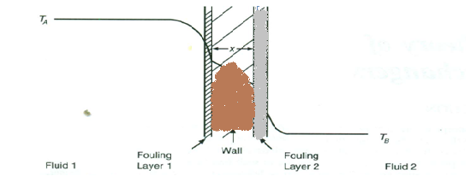
Figure 1. Heat transfer between two fluids separated by flat plate [3].

$\frac{1}{U}=R_{A}+R_{B}+\frac{x}{k_{w}}+\frac{1}{∝_{A}}+\frac{1}{∝_{B}}$ Eq. (1)
Where $R_{A}$ and $R_{B}$ are fouling resistance, which decreases the overall heat transfer coefficient, resulting in decreasing heat transfer efficiencies. The physical reason for a decrease in efficiency is because the thermal conductivity of the fouling layer is much less than that of the metal surface, and also because of the additional length over which heat transfer must now take place, resulting in reduced heat transfer compared to the case where no fouling layer is present.
The other important implication of fouling, which is especially noticeable in the plate and fin heat exchanger, is blockage. This results from the formation of the deposits, which stick to the surface and occupy much of the space available for fluid flow. This causes a drop in the pressure, restricts the flow and so the fluid volume, which can be processed per unit of time, decreases.
The cost of fouling in industry results from process downtime for physical cleaning (i.e., mechanical scrubbing), from additional heat exchanger surface to take into account fouling formation and additional fuel used to compensate for the decrease in heat transfer efficiency. For example, an additional 30-40% of area in the heat exchanger corresponds to about 25% additional capital cost. Considering the additional fuel, about 1-5% of the energy consumed by the industrial sector in 1978 was used to overcome fouling [2]. It was estimated that only in the United States, the cost of crude oil fouling in the preheat trains of a refinery around 1992 was about $1.2 billion per annum (ESDU 2000). Recent reports mentioned that in 2009, the energy loss in the order of 1°C in a 200,000 bbl/day U.K. refinery, was equivalent to additional cost of £250,000 per annum [4].
Various approaches have been developed to mitigate scale formation and fouling in the industry, and are discussed below. The main approach is to alter the thermodynamics of the process fluids to prevent the thermodynamically stable solid precipitate from forming. The most common practice is the addition of specially designed chemicals but these are expensive, harmful for the environment and not always appropriate. Developing new technologies to prevent fouling on the metal surfaces of heat exchangers would drastically benefit the industrial sector and many companies are currently sponsoring research on the field.
To address these problems, understanding the basic mechanism that is responsible for the formation of scales is of major interest. This mechanism is crystallization and more specifically homogeneous and heterogeneous crystallization of CaCO₃, which is the process of interest in this study.

Salts involved in scaling
The most common components of mineral scales formed in industrial processes are calcium carbonate (CaCO₃) and calcium sulphate (CaSO₄). The scales usually appear on heated surfaces of process equipment or are carried and deposited in components where there is restriction of flow, causing a variety of problems. The most usual problems are obstruction of the flow through pipes, decreasing the efficiency of heat exchangers and blocking moving parts such as valves. Understanding the physicochemical properties of these substances is essential to mitigate the problems they are causing.
These salts are formed due to the presence of Ca²⁺, HCO₃⁻ and SO₄²⁻ ions in the process streams. These ions are naturally found in water systems at varying concentrations, depending on their geographical location. They are therefore found in every process that uses water as a cooling liquid or treats wet hydrocarbons, such as the upstream oil and gas industries. Some indicative values of the concentrations of these ions in natural water reservoirs can be found in a water quality assessment by Chapman [5], published by the World Health Organization (WHO).
Calcium ions are found in most water systems. In natural water systems the concentration is <15 mg/L while water systems associated with carbon-rich rocks reach a calcium concentration of between 30 and 100 mg/L. The leaching of ions from the rocks into the water system is responsible for the increased concentration. Consequently, salt waters can reach concentrations of several hundred milligrams per litre. It is therefore obvious that is very difficult to develop a process free from calcium ions.
Carbonate (CO₃²⁻) and bicarbonate (or hydrogen carbonate - HCO₃¹⁻) ions are responsible for the hardness of water and vital for the formation of scales. The hydrogen carbonate form of the ion is much more common at surface waters and is about 25-500 mg/L compared with a concentration of up to 10 mg/L for carbonate ions, which are more commonly found in groundwaters with higher pH. The source of inorganic carbonate and bicarbonate ions is atmospheric CO₂ and biological respiration at the surface of the water. In areas of rich carbonate rock like limestone, there is about equal contribution from rock leaching and atmospheric contribution.
Sulphate ions (SO₄²⁻) are also present in many water systems from the deposition of oceanic aerosols and leaching of ions from sulphide minerals such as pyrite. The concentration can vary between 2 and 80 mg/L, while it may exceed 1000 mg/L in water systems suffering from industrial discharge.
2. Calcium carbonate (CACO₃) formation
One of the major components of inorganic scaling in oilfield production is calcium carbonate, which is the chemical of interest in this study. The chemical equation leading to the formation of calcium carbonate is:
$Ca^{2+}(aq)+2HCO_{3}^{-} (aq)\overset{⇔}{ } CaCO_{3}(s)+CO_{2}(aq)+H_{2}O$ $(l)$ Eq. (2)
The forward solid formation reaction in the above equilibrium reaction is endothermic, while the backward dissolution reaction is exothermic. Considering this equilibrium reaction, according to Le Chatelier’s principle an increase in temperature will favor the forward endothermic reaction and so the formation of the solid precipitate, while a decrease in temperature will favor the backward exothermic reaction; and so the dissolution of the carbonate. In effect, this thermodynamic behaviour results in an inverse solubility curve for calcium carbonate.
The direct relation of this property to this study is the formation of fouling along heated metal surfaces, which have a steep temperature gradient. Cold water containing Ca²⁺ and HCO₃⁻ ions enters the cold side of the heat exchanger. As the cold stream heats up, the solution enters the metastable zone of the supersaturated region and the formation of scales is favorable. This leads to precipitation on the heated metal surface, which provides an active surface for crystal nucleation and growth. The typical solubility curve and the inverse solubility curve of calcium carbonate are shown in Figures 2 and 3 below, from which it is clear that the problem of fouling is unavoidable due to the nature of the process.

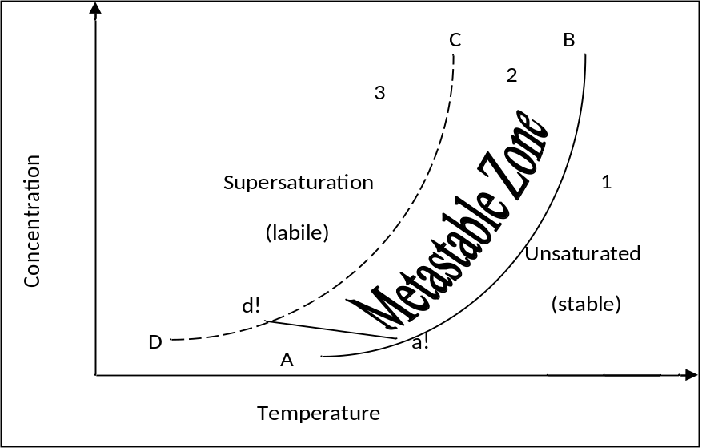
Figure 2. Typical solubility curve, showing increasing solubility with increasing temperature [6, 7].
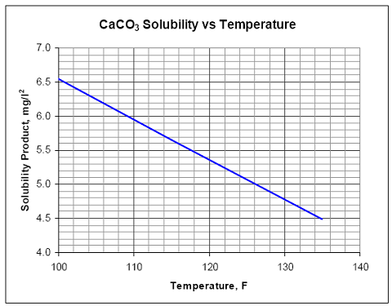
Figure 3. Inverse solubility curve of calcium carbonate at 1 bar [8].

During precipitation from solution, calcium carbonate can exist in primarily three forms, known as polymorphs, which are calcite (homboheral morphology), vaterite (spherical morphology) and aragonite (needle-like morphology). Precipitation into any of the forms is possible depending on the Ca²⁺ concentration and pH, but calcite is thermodynamically the most stable form and all other forms will eventually be transformed into this form under the conditions employed in this study [9].
As MacAdam, Parsons (2004) mentioned, the formation of calcium carbonate scales is a complex and poorly understood process [10]. Many strategies for control and prevention are available but the effectiveness of each strategy varies with different applications. They indicated that there exists a linear relationship between the concentration of CaCO₃ in solution and the scale formed. It was noticed that increasing concentrations of the two solutions gave shorter induction periods, which implies an increased rate of nucleation. This is consistent with the classical nucleation theory for homogeneous nucleation as described by Equation 3,
$J =A exp\left[-\frac{16πγ^{3}v^{2}}{3k^{3}T^{3}{\left(lnS\right)}^{2}}\right]$ Eq. (3)
As a higher concentration corresponds to a higher supersaturation ratio (S), an increased nucleation rate [10, 11] occurs. A study also indicated that nucleation and crystal growth take place simultaneously and that the presence of scales accelerates the process of crystallisation [11].
3. POSSIBILITIES TO ENHANCE crystallisation by addition of nanoparticles
The purpose of this study is to examine the possibility of enhancing the rate of crystallization of the salts instead of inhibiting it. Even though this might seem paradoxical, it can provide potential solutions to the problem of scaling, as the scales will form around the nanoparticles in the solution and not on the metal surface of pipes and heat exchangers. The result of this is that the scales will be able to follow the flow and be removed from the process by a possible separation by filtration or sedimentation.
Nanoparticles are particles that are defined by their size, but there is still much debate on the precise scale. Several authors consider the nanoscale to be anywhere between 1 to several hundred nanometres. The remarkable capabilities that nanoparticles have to offer emerge from the combination of a huge surface area and the phenomenon of quantum confinement, which in the nanoscale gives rise to interesting combinations of energy levels within a molecule. These allow the molecule to take part or catalyze a whole range of reactions at a substantial rate, which is several orders of magnitude larger than the rate observed when a bulk concentration of the same chemical is used [13].
The momentum that nanotechnology has gained over the past 15 years is huge, as is evident from many views of industrial fields such as carbon-based nanometaterials, anano-glasses, biological nanomaterials and thin films and coatings [13]. The Nanotechnology Industries Association (Nanotechnology Industries Association ) reports that nanotechnology innovation can result in high added value to products and services while requiring smaller amounts of raw materials compared with traditional technologies [13].
Dickinson (2012) mentioned in one of his publications that new opportunities exist in the food industry for exploiting the special properties of nanoparticles and the stabilised emulsions they can generate to achieve nutrient encapsulation, texture modification and greater product quality [14]. This conclusion was reached through the study of the effect that nanoparticles have in emulsions. This is of special interest in this study as Dickinson’s study dealt with the surface and interphase chemistry between nanoparticles, oil and water. The adsorption of silica nanoparticles on the surface of oil droplets surrounded by water is thermodynamically favorable and so the nanoparticles form a barrier around the droplets allowing them to exist in the water. This shows that the presence of nanoparticles in a solution can provide surfaces which can potentially affect crystal formation by altering interfacial free energies. If this is the case, the precise effect they have can be studied in order to be utilized in enhancing nucleation and mitigating scaling issues in industrial equipment.
The effect of nanoparticles on the crystallisation rate of calcium carbonate has not been studied in the past and so there is no published literature directly related to this study. The aim of this study is to gain an understanding on the effect that the presence of nanoparticles has on the rate of crystallization and how different types of nanoparticles affect the induction period. This will provide valuable insight into the various parameters affecting nucleation and suggest possibilities for further research. The overall aim is to explore the possibility of the application of nanoparticles for controlling the rate of nucleation and crystallization. As a result, the fouling phenomena will be mitigated in the oil and gas industry. This will maintain the operation and give reliable systems.
This research focuses on controlling nucleation instead of preventing it and developing techniques to utilize nanoparticles as a sacrificial surface, where the scaling can form, and so protecting the metal heat transfer surface from scale. Nanoparticles are ideal for utilization as sacrificial surface as they have very large surface areas per gram, usually in the order of 200-400 m²/g, and so small amounts can be used to provide enough surface area [13]. This is in contrast to traditional additives, which are required in large amounts to inhibit CaCO₃ nucleation and crystallization. An additional benefit of this is that once the scaling has been formed, a separation technique can be used to extract it in a continuous manner, and so eliminating the need for downtime in the process for cleaning and maintenance due to scaling and fouling.
4. Experimental method and material

Experimental setup
For the experimental procedure an HEL Parallel Automated 1L glass batch reactor with a pitched blade turbine stirrer was used to keep the solution mixed during the crystallization reaction. The reactor was fitted with an automated water circulation to ensure that the temperature of the mixture was kept at the required temperature (25°C). The motor was a Heidolph RZR 2051 control motor with a set rotation at 200rpm (~4-5 Nm). CrystalEYES turbidity and temperature probes were fitted on the glass reactor to record the temperature and turbidity of the solution as shown in Figure 4. The turbidity probe is placed at a 45° angle and uses a light reflection technique where a source emits light and a receiver records the reflected light from a shiny surface. The presence of any particles that are large enough to interfere with and scatter the light beam will create a change in the signal, which is translated in a change in the turbidity of the solution. The source emits light near to infrared light with wavelength 763 nm and can operate at temperatures of between -30ºC to 300ºC. These particles, even though unseen to the eye, can be quickly detected and recorded. Any changes in the signal of the probe should accurately and reliably correspond to the appearance or disappearance of solid particles [15]. The signal from the turbidity and temperature probes was automatically recorded using the HEL WinISO (version 2.3.104.1 E899) software running on a Windows XP desktop computer. This allowed electronic and accurate logging of the measurements from the experiment every 20 seconds.
For the preparation of the solutions a Satorius electronic balance (±0.01mg) was used to weigh the chemicals, predominately calcium chloride (CaCl₂) and sodium bicarbonate (NaHCO₃).
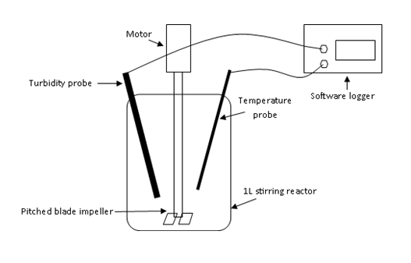
Figure 4. Simplified diagram of the experimental apparatus used.

Preparation of the two solutions
For each run, two 500 ml solutions were prepared using deionised water; one containing Ca²⁺ ions and the other containing HCO₃⁻ ions. The solutions were magnetically stirred for one hour at 25°C to ensure complete dissolution of the salts.

Preparation of the nanoparticles
The amount of calcium carbonate expected to be formed according experiments carried by Al-Nasser (2008) prior to this study is 0.57g [11]. This value was used as a reference, when the seed percentage was calculated. To clarify this, the amount of seed represented by the term “5% of seeds” in all of the experiments carried, refers to 5% of 0.57g of calcium carbonate that was expected to be formed. From this point onward, when a solution concentration term is used, it always refers to CaCl₂ concentration.
Modified nanotemplates were produced according to the method developed by Shah et al. (2012). The functionalization of the nanoparticle surface is also detailed in [16].

Experimental Procedure
The following experimental procedure was precisely carried out for each run to ensure that all the parameters that might affect the results were minimized:
- Half of the 500 ml NaHCO₃ (aq) solution was poured into the glass reactor and premixed for 5 minutes. This allowed for homogenizing the solution in the glass batch reactor and brought the temperature of one of the two solutions to 25°C.
- In the case where seeds or nanoparticles were to be used, the remaining NaHCO3 (aq) solution was used to transfer the particles into the batch reactor. This ensured that the particles were well mixed in the solution. If no seeds were to be used, the remaining solution was transferred directly to the batch reactor. Skip this step and pour all of the solution into the batch reactor.
- At the end of the 5 minutes of premixing, the 500 ml CaCl₂ (aq) solution was added into the batch reactor and data logging was initiated for 60 minutes.
For each of the washing, premixing and crystallization procedures, a plan was prepared on the logging software. For washing, the plan ran and logged for 30 min. For the premixing, it ran for 5 min and for the actual experiment it ran for 60 min. All of the plans were programmed to bring the temperature at 25°C and the stirring speed was set at 200 rpm for all the experiment.
The reaction taking place is shown below in equation 4. The formation of calcium carbonate crystals from the reaction of sodium bicarbonate and calcium chloride represents crystallization fouling.
$2NaHCO_{3}\left(aq\right)+CaCl_{2}\left(aq\right)→CaCO_{3}\left(s\right)+2NaCl \left(aq\right)+H_{2}O\left(l\right)+CO_{2}(g)$ Eq. ( 4)

Experiments
Table 1 summarizes the experiments performed using various types of seed with different sizes and surface chemistry. Experiments 2 and 3 were performed to ensure reproducibility of the results. The reason is that nucleation process is random, sensitive and can be affected by many factors. Experiment 4 was carried out as it is common practice to seed solutions with the same seeds as the crystals formed.
Experiments 6 and 7 were performed to investigate the effect of seed size on the induction time. Similarly, experiments 8 and 9 were performed with the aim of exploring the effect of different functional groups attached to the modified silica nanoparticles.
Table 1. Summary of all experiments using different types, size and surface chemistry of seeds.
Experiment | Solution conc. | Seed used | Seed conc. (%) | Seed diameter | Seed pore size | Seed Functional Group
1 | 0.07M, 0.01M-0.05M | No seeds | - | - | - | -
2 | 0.07M | No seeds | - | - | - | -
3 | 0.01M | No seeds | - | - | - | -
4 | 0.01M | Calcium Carbonate | 5%, 10% | 10 μm | - | -
6 | 0.01M | Silica Fumed | 3.5%,5%, 7.5%,10%, 20% | 7 nm | - | -
7 | 0.01M | Silica Fumed | 5%, 10%, 20% | 14 nm | - | -
8 | 0.01M | Modified Silica | 5%, 10% | 1-3 μm | 4-6 nm | Hydroxyl  (-OH)
9 | 0.01M | Modified Silica | 5%, 10% | 1-3 μm | 4-6 nm | Amine  (-NH₂)

Data processing
The software used logged the turbidity and temperature readings in Excel every 20 seconds. These data were then processed in Excel using the Moving Average function in the data analysis section. This function calculates the average of the last three readings. In this way the “noise” was reduced in the system, and the turbidity fluctuations were minimized, therefore resulting in a smoother turbidity-time curve.
Figure 5 shows an example of such a plot using the data of 0.01M unseeded experiment, used for reproducibility purposes. The average and standard deviation of the turbidity reading were calculated for the flat part of the curve, as shown in Figure 6. In this example, the average and standard deviation were found to be 0.0970 and 0.0006, respectively. As for most of the experiments carried out, the corresponding standard deviation lay between 0.0005 and 0.002, it was decided that it was best to use the value of 0.0025, as the “step” above the average, where the induction time would be identified. This value was, therefore, added to the calculated average of 0.0970 in this case. The Conditional Formatting tool was used to find all the turbidity values greater than 0.0995 along with the corresponding time. The induction time for each experiment was the minimum time, where beyond that time the corresponding turbidity values were all greater than 0.0995. In this case, the induction time was found to be 17.68 mins.

Figure 5. Induction time identification using reproducibility run 6 data (0.0 M solution and no seeds).
5. RESULTS

Reproducibility and choice of solution concentration
Experiments using 0.007 M, 0.01 M, 0.02 M, 0.0 3M, 0. 04 M and 0.05 M solutions were carried out to find the appropriate concentration that should be used for the following experiments where seeding with different particles would be employed. Figure 6 presents the results of the different concentrations used with the exception of 0.007 M, which proved to give inconsistent results, as shown in Figures 7. It is clear that 0.01M solutions gave the most satisfactory induction time, which could be used in the following experiments to investigate any change in induction time when using different seeds. It can be noticed that by increasing the solution concentrations, the induction time was reduced considerably. It is very difficult to obtain a reading of the induction times at concentrations greater than 0.02 M as the flat part of the curve is very small. The change of turbidity against time increased significantly with increasing concentration, beyond the flat part of the curves. Also the final turbidity value increases from 0.35 using 0.01 M solutions to 1.36 when a 0.05 M solution was used.

Figure 6. Results using different solution concentrations (experiment set 1).

Figure 7 shows the sets of experiment 2, where 0.007 M solutions were used to obtain reproducibility of induction time results. The induction time was calculated to be equal to 18 minutes and standard deviation of 7 min. The largest change in turbidity reading was observed in RUN 1, where there was an increase from 0.087 to 0.214. RUN3 data showed the smallest turbidity increase with an increase from 0.070 to 0.013. RUN5 and RUN6 gave an induction time of 10 and 11 min respectively, which is a much shorter time compared to the other runs.

Figure 7. Successful experiments using 0.007M solutions (Experiment set 2).

As 0.007 M experiments were not satisfactory, 0.01 M solutions were used to obtain reproducible results. These induction time results are summarized in Table 2. In total, 5 runs were carried out giving induction times between 15 to 19 min. The average induction time was found to be 17 min with a standard deviation of 1.21 min. Generally, the standard deviation of turbidity in the first 10 mins (straight part of the curve) is very low for all of the runs.
Table 2. 0.01 M reproducibility results.

Experiment | Induction Time (mins) | Standard Deviation of turbidity in first 10mins (initial flat part of curve)
RUN1 | 17 | 0.00060
RUN2 | 15 | 0.00059
RUN3 | 19 | 0.00120
RUN5 | 17 | 0.00060
RUN6 | 18 | 0.00066
Average | 17.0
Standard deviation of Induction time | 1.2

Calcium carbonate seeding
When calcium carbonate was used as the seed material, the system was very noisy, giving large fluctuations even after using the Moving Average function. The turbidity standard deviation for the “flat” part of the curve was approximately equal to 0.01, making identification of the induction time very difficult and inaccurate. Figure 8 showed the results from an average of series of runs carried using 5% and 10% of calcium carbonate seeds. A very rough estimate for the induction time for both 5% and 10% seed concentration resulted 20 and 18 minutes respectively. In addition, the final turbidity reading after 60 minutes was found to be 0.32 and 0.37 for 5% and 10% seeding respectively. The induction time found using this kind of seeding was very close to the 0.01 M unseeded experiments.

Figure 8. Calcium carbonate seeding using 0.01 M solutions at 5% and 10% seed concentration.

Silica (fumed) seeding
Silica fumed is composed of spheres fused into short highly branched chains. The size of the spheres is quite uniform but the chain length varies between 10 to 30 units in length. The particle sizes used in the experiments were 7nm and 14nm with a surface area of 390±40 m² and 200±25 m² respectively. The structure of fumed silica is amorphous and it is estimated that 3.5-4.5 hydroxyl groups are present per square mg of silica surface compared to the theoretical maximum of 7.85.
Table 3. Induction time results for 7nm Silica particles.

 | 3.5% Silica  7nm |  | 5% Silica 7nm |  | 7.5% Silica 7nm |  | 10% Silica 7nm |  | 20% Silica 7nm
Experiment | RUN1 | RUN2 | RUN1 | RUN2 | RUN1 | RUN2 | RUN1 | RUN2 | RUN1 | RUN2
Induction Time (min) | 13 | 10 | 10 | 11 | 10 | 12 | 8 | 7 | 8 | 6
Average Induction time (min) | 11.5 |  | 10.5 |  | 11 |  | 7.5 |  | 7
Standard deviation | 2.1 |  | 0.7 |  | 1.4 |  | 0.7 |  | 1.4

Table 3 shows the results for the induction time obtained at different concentrations. It is again clear that by increasing the concentration of the nanoparticles the induction time is reduced. The only discontinuity is the 7.5% silica, where the induction time was larger than that of 5%. By doubling the silica concentration from 5% to 10%, a decrease of 26.5% in the induction time was noticed. When comparing 10% to 20% silica concentration it was observed that the induction time was only reduced by 10.6%.
Table 4. Induction time results for 14 nm silica particles.

 | 5% Silica 14nm |  | 10% Silica 14nm |  | 20% Silica 14nm
Experiment | RUN1 | RUN2 | RUN1 | RUN2 | RUN1 | RUN2
Induction Time (min) | 6.5 | 7.5 | 5 | 4 | 3.5 | 4.5
Average Induction time (min) | 6.0 |  | 4.5 |  | 3
Standard deviation | 0.7 |  | 0.7 |  | 0.7

Table 4 shows that the induction time decreases with increasing concentration of nanoparticles. By doubling the silica concentration from 5% to 10% wt the induction time was reduced by 18.5%, whereas by doubling from 10% to 20% the induction time was reduced by 36.4%, which contradicts the corresponding trend observed for the 7nm silica concentrations.

Modified silica-OH seeding
Modified silica nanoparticles with hydroxyl groups attached, showed similar behaviour to the other experiments. The results are very similar to the silica 7nm seeding. An increase in concentration from 5% to 10% resulted in a decrease of 32.3% in the induction time. The results are summarized in Table 5.
Table 5. Modified silica-OH seeding results.

 | 5 % Modified -OH nanoparticles |  | 10% Modified -OH nanoparticles
Experiment | RUN 1 | RUN 2 | RUN 1
Induction Time (min) | 10 | 11 | 7.34
Average Induction time (min) | 10.5 |  | 7.34
Standard deviation | 0.7 |  | 0

Modified silica-NH₂ seeding
Table 6 shows the induction times resulting from 5% and 10% modified silica-NH₂ seeding. The induction times for all runs were very stable at both concentrations. The increase seed concentration had only a small effect, as the induction time was decreased by 8.5%.
Table 6. Modified silica-NH₂ seeding results.
 | 5 % Modified –NH₂ nanoparticles |  | 10% Modified -NH₂ nanoparticles
Experiment | RUN 1 | RUN2 | RUN1 | RUN2
Induction Time (min) | 4 | 4 | 3 | 3
Average Induction time (min) | 4 |  | 3
Standard deviation | 0 |  | 0

Summary of results
Figure 9 clearly shows the general trend identified in all of the experiments carried out, where the induction time decreases with increasing seeding particles. The best seeding particles were modified silica-NH₂ nanoparticles, which at even low quantities such as 5% reduced the induction time considerably from 17.61 min to 4.01 min. In addition, Figure 9 shows by the overlapping of the corresponding data points, that modified silica-OH particles have almost the same effect on the induction as silica 7 nm particles.

Figure 9. Induction time plotted against seed loading for the different particles
Comparing the relative induction times shown in the tables above, the 14 nm silica particles show significantly lower induction times compared to the 7 nm experiments. For example, when comparing the 5% seeding for each particle size, a reduction of 40.6% in the induction time was recorded from the 7 nm to the 14 nm size. Similarly, when comparing the 10% and 20% seeding, a reduction of 34.1% and 52.4% was observed from 7 nm to 14 nm.

SEM results
Figure 10 shows SEM micrographs of modified silica seeds with amine groups attached before and after crystallization had taken place. The seeds appeared to have a deformed surface after crystallization which indicated that heterogeneous nucleation took place.
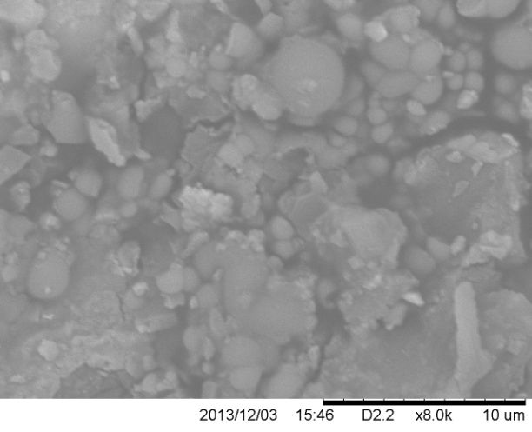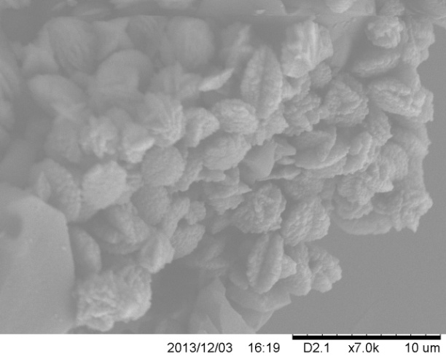
Figure 10. SEM micrograph of modified silica-NH₂ seeding experiment. The left image was produced by using clean modified silica-NH₂ templates (before placed in the vessel). The right image was produced using sample of crystals after crystallization of CaCO₃ in the reactor.
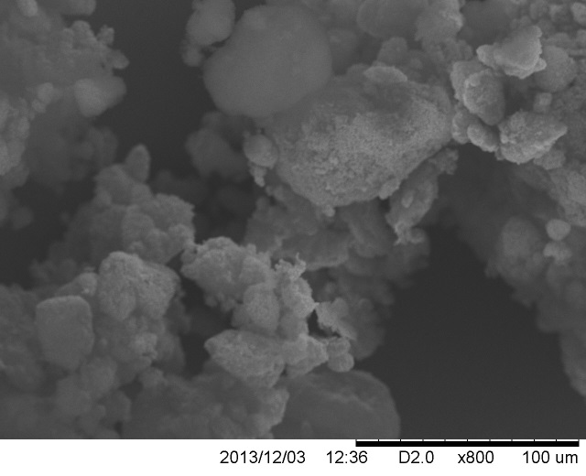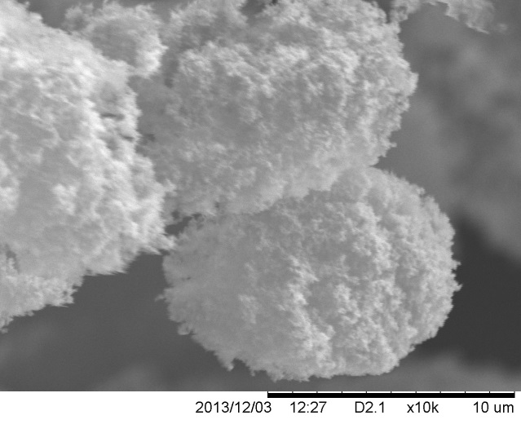
Figure 11. SEM micrographs showing 14 nm silica particles prior to experiments.
Figure 11 shows images of 14 nm silica particles prior to crystallization at different magnifications. As can be seen, even though the size of the nanoparticles is 14 nm, structures in the range 10-100 μm appear the SEM images, indicating that agglomeration takes place, resulting in a reduction of the surface area available from the nanoparticles.
6. Discussion

Experimental conditions
As already stated, one of the main objectives of this research was to establish a consistent experimental procedure that would allow the examination of the effect of seeding on the crystallization profile of CaCO₃. As can be seen from the results of Figures 7-10 the concentration of the solutions used was very important as it gave a value for the induction time of unseeded crystallization that could be compared with the induction time of seeded crystallization.
A higher final turbidity value was expected for increasing concentrations, as more CaCO₃ was available for crystallization and hence more crystals were produced in the process. A further complication introduced by higher concentrations was that the excessive scale formed adhered to the walls of the glass vessel. This made the cleaning procedure more time consuming as it was more difficult to remove it by scrubbing compared to scale formed at lower concentrations.
The choice of 0.01 M concentration of the initial solutions was selected because it gave an average time of 17.6 minutes for the induction period. This was considered to be a very favourable time as it was long enough to be able to see potential improvements after the addition of seeds, and it was much more consistent compared to lower concentrations. As can be seen from the results in Figure 7, higher concentrations resulted in very short induction periods of less than 5 minutes. This would not allow effective comparison of the effect of seeding on induction time, as the value of induction time for seeded nucleation would be very close to the unseeded nucleation. From Figures 8 and 9 it is clear why a lower concentration of 0.007 M was not used in seeded experiments. As the concentration decreases, the value of the supersaturation ratio decreases and the solution becomes increasingly sensitive to noise from the surrounding environment. This resulted in more variation in the value of the induction period and in some cases no crystallization was observed at all. For these reasons, the choice of using 0.01 M concentration for the initial solutions was made as it provided a consistent comparison value for unseeded crystallization.

Effectiveness of seeds
As expected from the classical nucleation theory, heterogeneous nucleation was a much faster process compared to homogeneous nucleation. As can be seen from the summarized results in Figure 9 in all the cases where seeding was used there was a substantial reduction in the induction time, ranging from 32.7-79.2% depending on the type of nanoparticle used. Additionally, for every type of nanoparticle used, it was observed that by increasing the amount of the nanoparticles in the solution the induction period decreased. This can be explained from the fact that additional nanoparticles provide additional surface area, which is indeed utilized for crystallization. From the two observations mentioned above, it can be deduced that the particles did indeed enhance the rate of nucleation crystallization by providing a sacrificial surface for calcium carbonate precipitation. This can be further supported by the achievement of a steady value of around 0.3-0.4 for turbidity in the cases where nanoparticles have been utilized, compared to the unseeded experiments, where the turbidity kept increasing at a low rate even after one hour.
This suggests that nanoparticles provide a better control for nucleation and crystal growth as the process was initiated and completed in less time than the unseeded experiment. This can be particularly useful in industrial applications as CaCO₃ that is to be precipitated as scale or fouling could preferentially precipitate on the surface of nanoparticles at a much faster and controllable rate and so move inside the pipes as slurry or separated out of the process. Obviously an improved control was demonstrated compared to homogeneous nucleation but this does not necessarily mean that the scales will preferentially be formed on the nanoparticle surface instead of the equipment surfaces. This constitutes a limitation to our current work and provides a direction for future work which is discussed in more detail in the following section below. Some of the issues related with the competition of the surface of nanoparticles and heated metal surfaces can be avoided if seeding is introduced at a stage prior to the heat exchanger stage, so that only the nanoparticle surface is available for heterogeneous crystallization, and so lowering the supersaturation ratio of the process stream before entering the heat exchanger stage and minimizing fouling.
The results also appear to agree with the classical nucleation theory for heterogeneous nucleation, as the presence of a wetting surface implies a lower energy barrier for heterogeneous nucleation $∆G_{c}^{'}$ compared with the homogeneous case$∆G_{c}$.
This resulted in heterogeneous nucleation taking place at a faster rate compared with homogeneous nucleation and so a decrease in the induction time was observed as crystals were formed and grown earlier on. The overall energy for homogenous nucleation can be expressed as shown below:
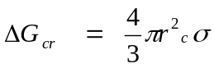 Eq. (5)
r is the radius of the nucleus, is the surface tension (N/m)
Considering the behavior of a newly created particle in a supersaturated solution, the survival of the particle depends on its size. The system aims at attaining minimum energy. A particle whose size is less than 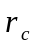 contributes to minimum energy by redissolving and the particle whose size is greater than will tend to survive, agglomerate and grow. The influence of the nucleation process may depend on the particles present in a crystallizing system. When particles are present in a system they provide areas where nuclei can start developing (heterogeneous nucleation) [17].
For heterogeneous nucleation process, the overall excess free energy is:
G!_{cr} 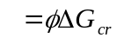 Eq. (6)
Where is a factor less than unity.
In addition, the better control provided by seeding was also demonstrated by the smaller standard deviation of the repeated experimental measurements by using nanoparticles compared with unseeded experiments. This shows that the randomness and effect of noise in the process was minimized when nanoparticles were used, indicating the desirable consistency that is absent from uncontrolled processes.

Different types of nanoparticles
Even though the addition of CaCO₃ particles should theoretically be the best seeding method, experimental results showed otherwise. In addition to the fact that turbidity measurements were fluctuating, and so making data analysis more difficult, CaCO₃ performed worse than any other type of seeding and was so was not investigated further. An additional reason why CaCO₃ is not of much interest to this study is that the addition of a scale into a process stream to mitigate scaling and fouling problems is not a very good solution. The reason for this is that the addition of CaCO₃ crystals would increase the amount of the chemical that is causing the problem in the process stream, and so creating more problems than it can solve. Further, the fact that even though seeding with the same chemical is theoretically the best choice but is still not used in industry probably means that it creates practical problems like sedimentation fouling.
For the nanoparticle the seeds, the main feature of interest was the surface chemistry. As can be seen from the summarized results in Figure 12, nanotemplates with –NH₂ functional groups resulted in the lowest induction time and hence influence the rate of crystallization of CaCO₃ the most. The probable reason for the better performance compared to the other seeds is the presence of the –NH₂ group which attains a positive charge once it comes in contact with water to become –NH₃⁺. According to the electric double layer theory, the presence of the positive charge on the surface of the nanoparticle will attract the CO₃²⁻ ions, that are the most negatively charged compared to the other ions in the solution, which will form a layer around this surface. This will in turn attract the Ca²⁺ ions, which are the most positively charged ions in the solution, in order to form an outer layer that is rich in calcium ions around the first layer that is rich in carbonate ions. This high concentration of Ca²⁺ and CO₃²⁻ ions around the surface of the nanotemplate results in faster heterogeneous nucleation as the movement of ions to the surface is no longer diffusion controlled but it is enhanced by the electrostatic attraction that they experience. The presence of dipole moments in the solution might have caused the ions form multiple layers within the double layer and helped in arranging the ions in a pattern favorable for crystallization. This hypothesis is supported by the images attained by SEM which show that the surface of the nanoparticles is covered by a crystalline layer as can be seen by the roughness of the surface after crystallization in Figure 10.
In a similar manner, the presence of the –OH functional group on the modified nanotemplate (and the fumed silica ions in a lesser degree) becomes –O⁻ in the presence of water, even though one would expect that a smaller percentage of the groups would dissociate to produce a charged ion compared to the amine group (-NH₂) because of the strong attraction of the oxygen atom to the H⁺ ion. Even though this hypothesis has not been tested, as these nanoparticles have only been recently produced at Imperial College (Chemical Engineering Department, Prof. Jerry Heng), it provides a consistent framework to interpret the results obtained. This may be the reason that even though a similar ion transfer mechanism is employed, a lower performance was observed with the –OH functional group. These, of course, are only hypotheses that are used to interpret the results. Further work should examine the degree of dissociation of the –OH bond and also include the use of models to predict the zeta potential around the charged surfaces of the modified nanotemplates and understand the how this influences the crystallization of CaCO₃.

Effect of particle size
Different size of silica particles were used to gain an understanding that the effect of the size has on the performance of the particles. The results obtained showed that there was no clear effect from particle size variation. This can be attributed to the effect of agglomeration for smaller nanoparticles, especially silica 7 nm and 14 nm, as seen in Figure 12, and so forming larger particle structures. Agglomeration occurs due to the higher surface area per gram of particles which allows for a high area for Van der Waals forces to act upon, attracts the nanoparticles to each other and hence causing them to “stick” together [16, 17]. The effect of this is a reduction in the effective area available for nucleation per gram of nanoparticle. As a result, this may be the reason why expected results of an increase in the rate with decreasing size were not obtained.

Effect of porosity
The effect of porosity was not made clear from the results obtained. Fumed silica (7 nm and 14 nm) was nonporous, while modified nanoparticles had 4-6 nm pores. No solid conclusions could be made from the results obtained as the range of values for induction time for porous and nonporous silica overlapped as shown in Figure 11. The effect of the porosity on nucleation crystallization is an area in which we did not manage to draw any conclusions and so should be investigated further by using more appropriately manufactured nanotemplates, using techniques that allow the preparation of such nanotemplates with varying pore size.
7. CONCLUSION
It was concluded that the addition of 500 ml of 0.01M CaCl₂(aq) and 0.02M NaHCO₃ solutions in a stirred batch reactor at 25°C, coupled with a consistent cleaning procedure can provide a suitable set of conditions for the study of nanoparticle seeded crystallization through the turbidity profile of the solution. Silica based nanoparticles provide a sacrificial surface for calcium carbonate nucleation and crystallisation. Also, modified silica nanoparticles with –NH₂ functional groups added to the surface demonstrated the highest reduction in induction period (79.2% reduction). Therefore, a direction for future research was proposed focusing on (i) the utilisation of the electrical double layer theory to understand the effect of the functional groups, (ii) investigation on the extent at which homogeneous and heterogeneous nucleation takes place using SEM, (iii) examination of more functional groups and (iv) alteration of the nature of the apparatus to closer represent the process equipment.

ACKNOWLEDGMENT
The authors would like to thank U. Shah, K. Nikiforou and P. Petrou for their technical assistance, support and cooperation, and Saudi Aramco for the permission to publish this paper.

REFERENCES
[1] M. Bohnet, Fouling of heat transfer surfaces, Chemical Engineering & Technology, 10 (1) (1987) 113-125.
[2] B. Bansal, M. Muller-steinhagen, Crystallization fouling in plate heat exchangers, Journal of heat transfer, 115 (3) (1993) 584-591.
[3] G.F. Hewitt, G.L Shires, T.R, Bott, Basic Theory of Heat Exchangers, Process heat transfer, CRC press London, (1994) 155-158.
[4] S. Macchietto, G. Hewitt, F. Coletti, B.D. Crittenden, D. Dugwell, A. Galindo G. Jackson, R. Kandiyoti, S. Kazarian, P. Luckham, Fouling in crude oil preheat trains: a systematic solution to an old problem, Heat Transfer Engineering, 32 (3-4) ( 2011) 197-215.
[5] D. Chapman, D. Water Quality Assessment-A Guide to Use of Biota, Sediments and Water Environmental Monitoring," 2nd ed., Chapman on Behalf of UNESCO, WHO and UNEP, 1992.
[6] R. Dastillung, In-situ analysis of electrodeposited scale, M.Sc. thesis, Heriot-Watt University, U.K., 2003.
[7] A.P. Marizot, Electrochemically based study of mineral scale formation and inhibition, Ph.D. thesis, Heriot-Watt University, U.K., 1999.

[8] M.N. DiFilippo, Cooling tower water quality parameters for degraded water, Pier Final Project Report, in Berkeley, USA , 2006, 28 and 78.

[9] N.H. De Leeuw, S.C Parker, Surface structure and morphology of calcium carbonate polymorphs calcite, aragonite, and vaterite: An atomistic approach, The Journal of Physical Chemistry, 102 (16) (1998) 2914-2922.
[10] J. Macadam and S.A. Parsons, Calcium carbonate scale formation and control, Re/Views in Environmental Science & Bio/Technology, 3 (2 ) (2004) 159-169.
[11] W. Al nasser. A. Shaikh, C. Morriss, M. Hounslow, A. Salman, Determining kinetics of calcium carbonate precipitation by inline technique, Chemical Engineering Science, 63 (5) (2008) 1381-1389.
[12] W. Zhong, Nanoscience and Nanomaterials: Synthesis, Manufacturing and Industry Impacts, Destech Publications, Inc., (2012).
[13] Mini Innovation & Growth Team, Nanotechnology: a U.K. Industry View, Materials U.K., 2010
[14] E. Dickinson, Use of nanoparticles and microparticles in the formation and stabilization of food emulsions, Trends in Food Science & Technology, 24 (1) (2012) 4-12.
[15] HEL GROUP, Solubility and Metastable zone determination platforms, 2013
[16] U.V. Shah, D.R. Williams, J.Y. Heng, Selective crystallization of proteins using engineered nanonucleants, Crystal Growth & Design, 12 (3) (2012) 1362-1369.
[17] J.W. Mullin, Crystallization, 3rd edition, Butterworth-Heinemann, U.K., 1993

