RSV infection of regulatory B-cells: a mysterious new twist

Peter JM Openshaw, Respiratory Sciences Division, National Heart and Lung Institute, Imperial College London, St Mary’s Campus, Norfolk Place, London, W2 1PG, UK ^{1,} p.openshaw@imperial.ac.uk
Acknowledgements: The author is a member of the EU FP7 PREPARE consortium (project 602525) and has a National Institute for Health Research (NIHR) Senior Investigator award. His work is also supported by Imperial’s Health Protection Research Unit (HPRU) in Respiratory Infection and the Imperial Biomedical Research Centre (BRC) at Imperial College Healthcare NHS Trust. He is in receipt of research funds from the Wellcome Trust and Medical Research Council, UK. The author declares no competing interests.
Summary
The viral attachment protein of RSV has many surprising features, especially its mimicry of fractalkine (CX3CL1). In addition to using this homology to attach to ciliated cells Zhivaki et al. now show that it activates human neonatal regulatory B cells, thus inhibiting immunological responses.
Respiratory syncytial virus (RSV) is common pathogen that infects the ciliated respiratory epithelium, causing variable disease that ranges from severe infantile bronchiolitis to a mild (or unapparent) common cold. It infects virtually all children by the age of three and repeatedly re-infects throughout life. It has two major surface proteins, one mediating fusion (F) and the other attachment (G). The latter has a structure similar to the chemokine fractalkine (CX3CL1), binding CX3CR1 on the apical surface of ciliated cells in the lung. In a new twist, Zhivaki et al (Zhivaki) now show that RSV G also binds to a novel subset of neonatal regulatory B cells (nBreg) that make the immunosuppressive cytokine interleukin 10 (IL-10), thus inhibiting protective immune responses.
Rather than depending on rapid evolution to escape immune pressure, RSV’s success seems to depend on a partial but specific immunological amnesia (Openshaw et al., 2017). RSV’s attachment protein G has few parallels in the viral kingdom. It is known to inhibit TLR-induced type I interferon host responses; one of its several interesting properties is that vaccinating mice with it can induce enhanced and eosinophilic lung disease during subsequent RSV infection, a phenomenon that requires an intact central conserved domain (Sparer et al., 1998).
When the structure of fractalkine (CX3CL1) was described in 1997, RSV aficionados immediately appreciated its close resemblance to G. Both G and CX3CL1 have heparin binding domains; both have membrane bound and soluble forms and both have ‘mucinoid’ proximal regions on extended serine-threonine rich stalk that ends in a cysteine-rich chemokine domain (Melero et al., 2017). News of this remarkable similarity spread quickly in the RSV community and by 2001 Tripp et al showed that the attachment protein G does indeed bind to the receptor CX3CR1 (Tripp et al., 2001). RSV also exploits this property to infect the respiratory epithelium by G binding to CX3CR1 on ciliated cells (Jeong et al., 2015); (Johnson et al., 2015), although it remains a mystery why CX3CL1 should be present at this site.
CX3CL1 is chemoattractive for both lymphocytes and monocytes and is normally made by activated endothelial cells. Its receptor is naturally present on cells with high cytotoxic potential (such as NK cells, cytotoxic T cells, and γδ T cells); presumably the soluble form of RSV’s attachment protein recruits such cells into sites of infection, but the benefit to the virus of such an effect is not clear: RSV bronchiolitis is characterised by an abundance of inflammation, but does cell ingress benefit the virus? Again, a mystery.
Seeking to better understand why RSV has such a special ability to infect people early and often, they focussed on regulatory B cells (Breg). These cells have been recently described as an immunosuppressive subset of B cells (Rosser and Mauri, 2015). Their functions have been well characterised in mice, in which they promote tolerance via the production of IL-10, IL-35 and TGF-b and thereby inhibit inflammation by actions on monocytes, IL-12-producing dendritic cells, iNKT cells, Th17 cells, Th1 cells and cytotoxic CD8+ T cells. Breg can also induce the differentiation of regulatory T cells, Foxp3+ T cells, and T regulatory 1 (Tr1) cells.
Zhivaki et al now identify a novel subset of CD5hi B cells that they term neonatal Bregs (nBregs), which they have not been able to identify in adults. The RSV fusion protein (F) binds to them via polyreactive (IGHJ4/D6) IgM, causing upregulation of CX3CR1 and making them a target for engagement of G. This double-handed grip leads to non-lytic but activating RSV infection and the production of IL-10, which in turn and inhibits Th1 and Th0 cells that would have an antiviral effect (see figure).
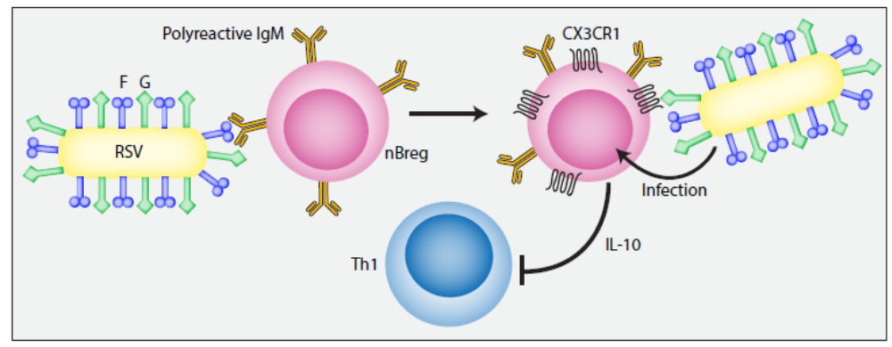
Figure 1 RSV targets neonatal regulatory B cells. RSV fusion protein engages polyreactive IgM on neonatal regulatory B cells (nBreg). This causes increased expression of CX3CR1, which is also expressed on resting ciliated respiratory epithelial cells and monocytes. CX3CR1 is the natural ligand for fractalkine (CX3CL1), but also binds the RSV attachment protein G. This engagement leads to non-lytic infection of nBreg, cell activation and IL-10 production
Looking for nBregs in nasopharyngeal aspirates of hospitalized RSV-infected children requiring respiratory assistance, Zhavaki et al found that in 6 out of the 13 patients RSV infected nBregs were found in NPA; two patients showed RSV infected MN B cells. The frequency of nBregs correlated with the severity of the disease as assessed by the duration of oxygen support and hospitalization in the ICU. They also found a higher frequency of nBregs in the blood of RSV-infected patients suffering from acute bronchiolitis compared to non-infected children and a positive correlation between the percentage of nBregs with the disease severity and the viral load. The frequency of CXCR3⁺ T_{EM} cells was significantly lower in the peripheral blood when nBregs were infected in the NPA.
Although the observations of Zhavaki et al are intriguing and create an attractive model that gives new depth to our understanding of RSV immunopathogenesis, there are questions left open. Are the observed changes in Bregs caused by RSV infection, or an effect of disease? Zhavaki et al find that nBregs wane rapidly in the postnatal period, so what happens in older children or adults? If nBregs play an essential role in immune evasion by RSV, how is it that older children and adults also show a deficit in B cell memory to RSV infection? Clearly studies of cord blood (or of peripheral blood) may not fully reveal what happens in relevant tissue sites: accessing those sites remains a major challenge: there are yet more mysteries to solve.
In conclusion, Zhivaki et al show that B cells have a more complex and interesting role in RSV disease that was hitherto appreciated. They identify a novel subset of neonatal regulatory B cells that become infected with RSV and may inhibit many of the responses that normally play a part in restricting viral inflammation, favouring viral replication and possibly inhibiting immunological memory, thus allowing reinfection. If this hypothesis is correct, nBregs may represent a novel target for the manipulation of lower respiratory tract viral infections and their pathological consequences later in life. At the dawn of RSV vaccination, this is a new and exciting twist in understanding immune responses to this fascinating virus.

Bibliography
Jeong, K.-I., Piepenhagen, P.A., Kishko, M., DiNapoli, J.M., Groppo, R.P., Zhang, L., Almond, J., Kleanthous, H., Delagrave, S., and Parrington, M. (2015). CX3CR1 Is Expressed in Differentiated Human Ciliated Airway Cells and Co-Localizes with Respiratory Syncytial Virus on Cilia in a G Protein-Dependent Manner. PLoS ONE 10, e0130517.
Johnson, S.M., McNally, B.A., Ioannidis, I., Flano, E., Teng, M.N., Oomens, A.G., Walsh, E.E., and Peeples, M.E. (2015). Respiratory syncytial virus uses CX3CR1 as a receptor on primary human airway epithelial cultures. PLoS Pathog 11, e1005318.
Melero, J.A., Mas, V., and McLellan, J.S. (2017). Structural, antigenic and immunogenic features of respiratory syncytial virus glycoproteins relevant for vaccine development. Vaccine 35, 461–468.
Openshaw, P.J., Chiu, C., Culley, F.J., and Johansson, C. (2017). Protective and harmful immunity to RSV infection. Annual Reviews of Immunology 35, 501–32.
Rosser, E.C., and Mauri, C. (2015). Regulatory B cells: origin, phenotype, and function. Immunity 42, 607–612.
Sparer, T.E., Matthews, S., Hussell, T., Rae, A.J., Garcia-Barreno, B., Melero, J.A., and Openshaw, P.J. (1998). Eliminating a region of respiratory syncytial virus attachment protein allows induction of protective immunity without vaccine-enhanced lung eosinophilia. J Exp Med 187, 1921–1926.
Tripp, R.A., Jones, L.P., Haynes, L.M., Zheng, H., Murphy, P.M., and Anderson, L.J. (2001). CX3C chemokine mimicry by respiratory syncytial virus G glycoprotein. Nat Immunol 2, 732–738.
Zhivaki, D. Inborn Ig polyreactivity cooperates with CX3CR1 to mediate the infection of regulatory B cells by respiratory syncytial virus related to lung disease severity. Immunity.
.

