The Influences of a Di-zinc Catalyst and Bifunctional Chain Transfer Agents on the Polymer Architecture in the Ring-Opening Polymerization of ɛ-Caprolactone
Yunqing Zhu, Charles Romain, Valentin Poirier and Charlotte K. Williams*
Department of Chemistry, Imperial College London, London, SW7 2AZ, UK
c.k.williams@imperial.ac.uk
ABSTRACT:
The polymerization of ε-caprolactone is reported using various bifunctional chain transfer agents and a di-zinc catalyst. Conventionally, it is assumed that using a bifunctional chain transfer agent (CTA), polymerization will be initiated from both functional groups, however, in this study this assumption is not always substantiated. The different architectures and microstructures of poly(ɛ-caprolactone) samples (PCL) are compared using a series of bifunctional and monofunctional alcohols as the chain transfer agents, including trans-1,2-cyclohexanediol (CHD), ethylene glycol (EG), 1,2-propanediol (PD), poly(ethylene glycol) (PEG), 2-methyl-1,3-propanediol (MPD), 1-hexanol, 2-hexanol and 2-methyl-2-pentanol. A mixture of two architectures is observed when diols containing secondary hydroxyls are used, such as cyclohexane diol or propanediol; there are chains which are both chain extended and chain terminated by the diol. These findings indicate that not all secondary hydroxyl groups initiate polymerization. In contrast, chain transfer agents containing only primary hydroxyl groups in environments without steric hindrance afford polymer chains of a single chain extended architecture, whereby polymer chains are initiated from both hydroxyl groups on the diol. Kinetic analyses of the polymerizations indicate that the propagation rate constant (k_{p}) is significantly higher than the initiation rate constant (k_{i}): k_{p}/k_{i} > 5. A kinetic study conducted using a series of monofunctional chain transfer agents, shows that the initiation rate, k_{i}, is dependent on the nature of the hydroxyl group, with the rates decreasing in the order: k_{i(,primary)} > k_{i(,secondary)} > k_{i(,tertiary)}. It is proposed that two polymer architectures are present as a consequence of slow rates of initiation from the secondary hydroxyl groups, on the the diol, compared to propagation which occurs from a primary hydroxyl group. In addition to the reactivity differences of the alcohols, steric effects also influence the polymer architecture. Thus, even if a chain transfer agent with only primary hydroxyl groups, such as 2-methyl-1,3-propanediol, is applied, a mixture of different polycaprolactone architectures results. The manuscript highlights the importance of analyzing the polymer architecture in the ring-opening polymerization of caprolactone, using a combination of NMR spectroscopic techniques, and refutes the common assumption that a single chain extended structure is produced in all cases.

INTRODUCTION
Due to its biocompatibility and biodegradability, poly(ɛ-caprolactone) (PCL) is a widely applied and thoroughly investigated biomaterial.¹⁻⁹ PCL, and its copolymers, have been used in controlled release, tissue-engineering, medical devices and implants, amongst other applications.¹⁰⁻¹⁵ Furthermore, PCL is miscible, and so can be easily blended, with a wide range of other polymers.¹⁶⁻¹⁸ Currently, PCL is usually prepared via the ring-opening polymerization (ROP) of ɛ-caprolactone using a range of anionic,^{19,20} cationic^{21,22} and coordination initiators.^{3,6,23-25} The development of organocatalyst for ROP of ɛ-caprolactone has also been a thriving field.²⁶⁻²⁹ There are also a few reports of its production by the free radical ring-opening polymerization of 2-methylene-1,3-dioxepane.³⁰⁻³² Considering the ROP route, a range of lower-toxicity catalysts have been developed, including complexes of zinc,^{6,33} magnesium,^{34,35} aluminium ^{36,37} and calcium.³⁸
Recently, we have reported the successful polymerization of ɛ-CL using a di-zinc pre-catalyst (Scheme 1).³⁹ The zinc carboxylate groups, on the pre-catalyst, were ineffective initiators, however, zinc alkoxides, which were generated in situ by the reaction with sub-stoichiometric amounts of epoxide, were active polymerization initiators. Most importantly, the di-zinc pre-catalyst is a rare example of a chemoselective catalyst: able to selectively catalyze ring-opening copolymerization of epoxides/CO₂ and ring-opening polymerization of lactones from mixtures of different monomers in the feedstock.³⁹
As macromolecules with reactive end-groups, telechelic polymers have attracted much industrial interest, especially in producing thermoplastic elastomers or higher molecular weight polymers, such as polyurethanes/polyesters.⁴⁰⁻⁴⁷ Telechelic polymers with predictable molecular weights, low dispersities (M_{w}/M_{n}) and controllable architectures are also of value as cross-linkers, chain extenders and precursors for making block or graft copolymers.⁴⁸⁻⁵² To date, two main approaches have been developed to prepare telechelic polyesters: (i) The addition of a diol ^{49,50,53-55} or (ii) The use of discrete metal borohydride initiators.^{41,56,57} The ‘diol’ approach is more widely applied due to its versatility and the PCL chains are believed to propagate from both hydroxyl groups due to the rather high chain transfer rate constant (k_{e}) usually observed in immortal ROP. However, the exact microstructure of the telechelic PCL, in particular the proportion of chains where the diol is a chain extender vs. those where it is a chain end group, is rarely quantified. For multifunctional initiators, which are widely applied in the preparation of star-shaped polymers, graft copolymers and H-shaped copolymers,⁵⁸⁻⁶² the same microstructure issue is frequently overlooked or unreported. There are very few specific reports on the architecture of telechelic PCL. In 2004, Chen et al., reported the application of an yttrium tris(2,6-di-tert-butyl-4-methylphenolate) catalyst with ethylene glycol and showed the production of polymer chains end-capped and chain extended from the diol.⁶³ This catalyst system resulted in bimodal molecular weight distributions. Recently, Lin and coworkers, applied the same yttrium complex with 2-propanediol which led to an exclusive chain extended type of architecture.⁶⁴ However, the extent to which this result may be generalized to other catalyst systems remains unknown.

Results and Discussion
It is important to control telechelic polymer end groups for post-polymerization modification, such as chain extension. Our group have recently reported that a di-zinc catalyst shows an unusual ability to switch between ring-opening polymerization (ROP) and ring-opening copolymerization (ROCOP) using mixtures of caprolactone, epoxide and carbon dioxide.³⁹ This is important as it provides a means to control the polymer composition on the basis of the catalyst propagating chain chemistry. However, the precise nature of the polymer structures generated by the switch catalysis is not yet elucidated. In the context of this switch catalysis, it is important to understand the influence of the dizinc catalyst in lactone ring-opening polymerization and the architecture of the PCL.
To address this deficiency, several bifunctional chain transfer agents: trans-1,2-cyclohexanediol (CHD) (as a good model for the end group of the polycarbonate prepared via ring-opening copolymerization), ethylene glycol (EG), 1,2-propanediol (PD), polyethylene glycol 1500 (PEG) and 2-methyl-1,3-propanediol (MPD) bearing either secondary or/and primary hydroxyl groups, were applied with the di-zinc pre-catalyst for the immoral polymerization of ε-CL (Scheme 1).
Scheme 1. The immortal ring-opening polymerization of ɛ-caprolactone, initiated by a di-zinc complex and different diol chain transfer agents. Two types of PCL architecture are considered possible, illustrated as Type I and II structures. Reagents and Conditions: (a) Di-zinc pre-catalyst (0.1 mole eq.), in neat cyclohexene oxide (100 mole eq.), and with HO-R-OH( 1 mol eq.) as CTA, 353 K, 2.5-3.0 h.
Firstly, a control polymerization was conducted using only the di-zinc bis(acetate) complex and trans-1,2-cyclohexanediol (CHD) (i.e. without any cyclohexene oxide), this failed to result in any PCL formation even after 18 h. This demonstrates that the diol chain transfer agents are not directly involved in the initiation reaction and cannot by themselves form the active zinc alkoxide species. Rather, the di-zinc bis(acetate) pre-catalyst is efficiently transformed into the catalytically active zinc alkoxide complex by reaction with cyclohexene oxide (CHO).³⁹ This occurs in situ under the reaction conditions, where cyclohexene oxide is used as the reaction solvent. The insertion of the CHO into the zinc acetate activates the dizinc catalyst (kinetic constant: k_{a}, see catalyst activation process in Scheme S1). After the formation of the zinc alkoxide species, the diol chain transfer agents are thus able to exchange to form new zinc alkoxide species (kinetic constant: k_{e’,} in Scheme S1). It is also important to point out that it has already been established that there is no homopolymerization of the CHO by either of the zinc species.^{39,65-67} Once the alkoxide complex is generated, it was applied as the active initiator for the immortal ROP of ε-CL in the presence of each chain transfer agent (for an illustration of the proposed in situ catalyst formation and initiation, see Scheme S1, ESI). The results of these polymerizations, at different relative loadings of monomer (molar) and CTA, are presented in Table 1.
Table 1. The immortal ROP of ɛ-CL, at different molar ratios, using trans cyclohexane diol (CHD), ethylene glycol (EG), 1,2-propanediol (PD), poly(ethylene glycol) (PEG) and 2-methyl-1,3-propanediol (MPD) as the chain transfer agents.
Entry | Cat./CTA/ɛ-CL/CHO | CTA | t (h) | M_{nexp}ª (kg/mol) |  | M_{nth}^{b} (kg/mol) |  | M_{w}/M_{n}
1 | 1/10/300/1000 | CHD | 2.5 | 4.1 | 3.4 |  | 1.21
2 | 1/10/500/1000 | CHD | 2.5 | 5.7 | 6.0 |  | 1.17
3 | 1/10/700/1000 | CHD | 2.5 | 7.5 | 7.9 |  | 1.26
4 | 1/10/900/1000 | CHD | 3.0 | 9.4 | 10.3 |  | 1.36
6 | 1/10/300/1000 | EG | 2.5 | 3.3 | 3.4 |  | 1.25
7 | 1/10/300/1000 | PD | 2.5 | 3.8 | 3.4 |  | 1.27
8 | 1/10/300/1000 | PEG | 2.5 | 7.8 | 4.9 |  | 1.36
9 | 1/10/300/1000 | MPD | 2.5 | 3.7 | 3.4 |  | 1.32
Polymerization Conditions: All polymerizations were run in neat cyclohexene oxide (CHO) as the reaction solvent at 80 °C, for 2.5-3.0 hours where upon the conversion of ɛ-CL > 95%.The molar ratio of [cat.]/[CTA]/[CHO] is kept constant. ^{a)}M_{nexp} was determined by SEC, in THF using polystyrene calibration, with a correction factor (0.56) applied (except for entry 8) as described by Soum et al.⁵ ^{b)} M_{nth} was determined on the basis of ([ɛ-CL]×conversion)/([cat.] + [CTA]).
In all cases, controllable, immortal ring-opening polymerization was observed, as evidenced by the PCL molecular number (M_{n}) being predictable and corresponding closely to the values predicted on the basis of monomer conversion and the number of equivalents of chain transfer agent added. Figure 1 illustrates the molecular weights (MW) for the PCL produced using different quantities of the chain transfer agents. In most cases the dispersities were quite narrow (< 1.30) (Table 1, entry 4).
Figure 1. Shows the molecular weights (MW) for different PCL samples (Entries 1-4 in Table 1, obtained by SEC using polystyrene calibration); and the influence over the MW of changing the molar ratio of [ɛ-CL]/[CHD].
The MALDI-ToF spectra (Figure 2) displayed two series, indicative of bimodal molecular weight distributions. Each series showed the same separation (ca. 114 m/z), corresponding to the repeated addition of [ɛ-CL] units and consistent with the two series resulting from different initiating groups. The major series is assigned to PCL initiated from the added chain transfer agent, showing α,ω-di(hydroxyl) end groups and a single unit of CTA incorporated. The minor series is assigned to PCL prepared from the residual zinc acetate initiator (present in 1/10 the molar quantity), showing α-actetyl-cyclohexylene ester and ω-hydroxyl end groups.
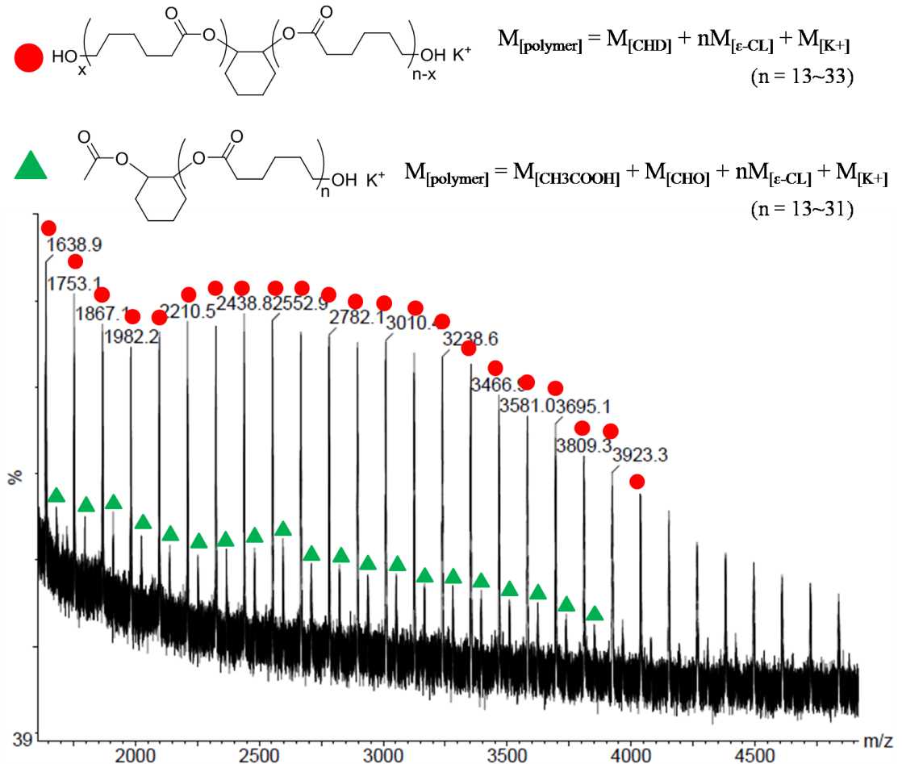
Figure 2. A representative MALDI-ToF spectrum of the PCL synthesized with CHD as the CTA (Table 1, entry 2). The major series (red circles) consists of α, ω-hydroxyl end-groups, which are calculated according to: (C₆H₁₀O₂)_{n}C₆H₁₀(OH)·K⁺. The minor series (green triangles) is assigned to chains having α-acetyl-cyclohexyl ester and ω-hydroxyl end-groups, which are calculated according to: C₈H₁₃O₂(C₆H₁₀O₂)_{n}OH·K⁺.

Even for the major series observed in the MALDI-ToF spectrum, which is initiated from the chain transfer agent, there are additionally two different possible architectures for the PCL (Types I and II, Scheme 1 and Figure 3). ¹H-¹³C HSQC NMR spectroscopy (Figure 3B and C) was utilized to distinguish them, using a sample of the PCL₃₀ (Table 1, entry 1) which has sufficiently low molecular weight that the end group signals can be clearly examined.
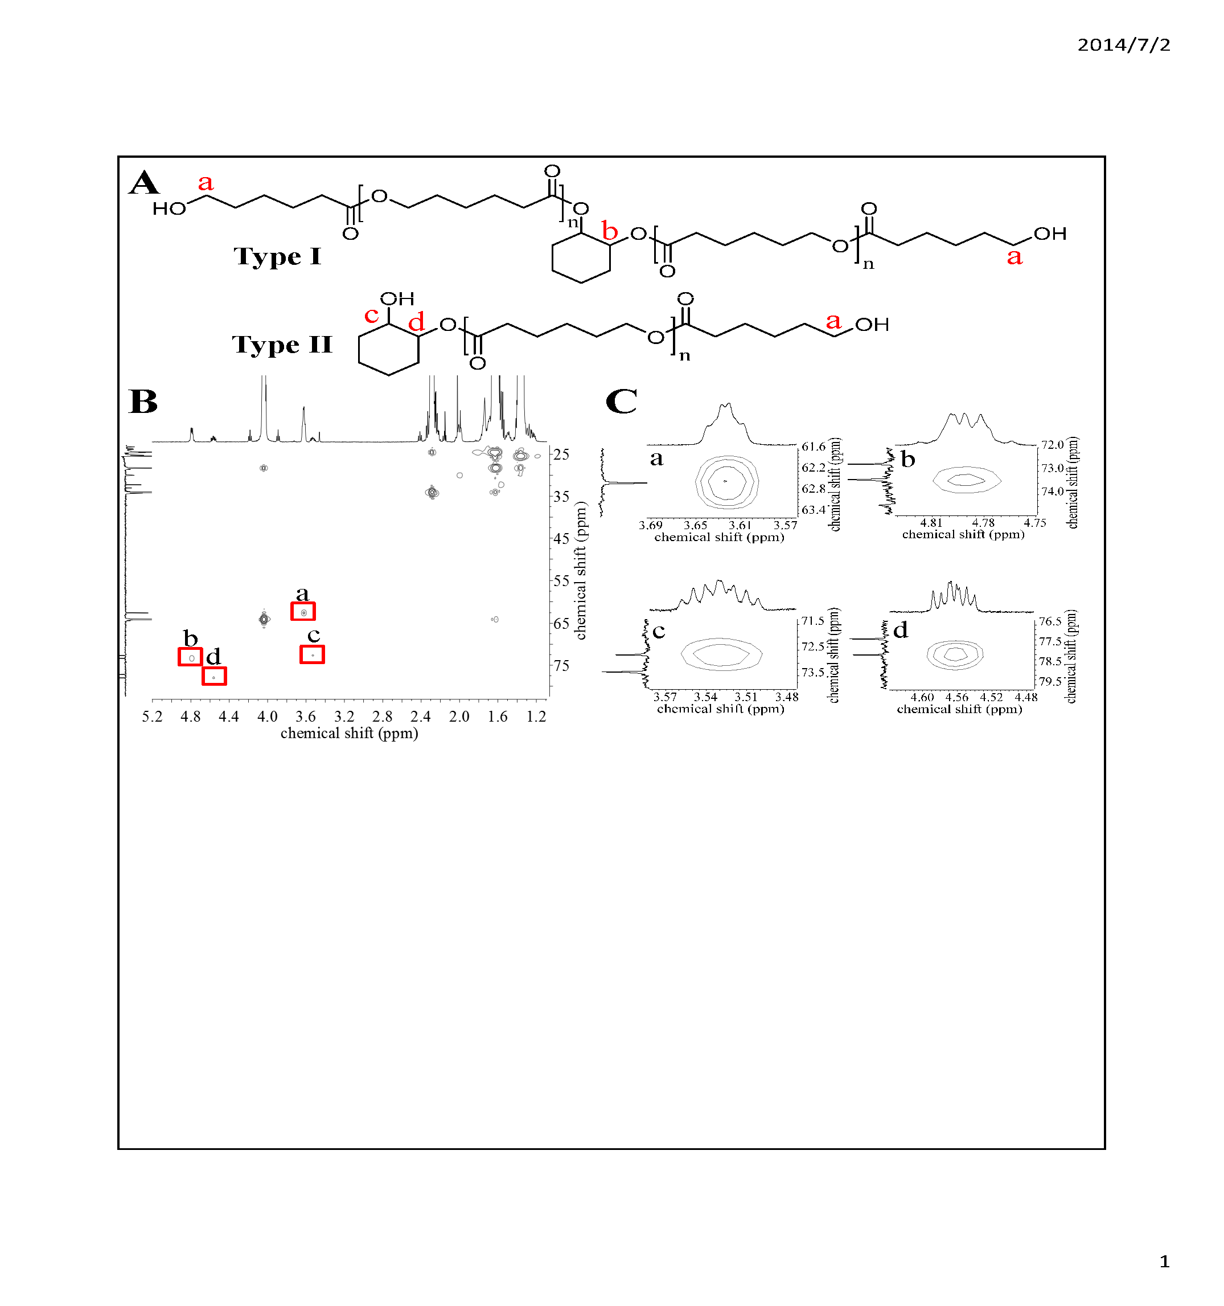
Figure 3. (A) Schematic diagram showing the two PCL architectures (Type I & II) using trans 1,2-cyclohexane diol (CHD) as the CTA; (B) Typical ¹H-¹³C HSQC NMR spectrum of PCL₃₀ (Table 1, entry 1) and (C) Enlarged HSQC NMR spectrum (y-axis: ¹³C DEPT 135º) corresponding to the selected area in (B) and showing the correlation between the ¹H and ¹³C{¹H} NMR signals for each of the junction/end groups (A). Peak a (¹H: 3.6 ppm; ¹³C{¹H}: 62.5 ppm) is assigned to the CH₂OH (confirmed by ¹³C NMR DEPT 135°); Peak b (¹H: 4.8 ppm;¹³C{¹H}: 73.45 ppm) is assigned to the CH ‘cyclohexylene junction’ group; Peaks c & d [(¹H: 3.5 ppm; ¹³C{¹H}: 72.7 ppm) and (¹H: 4.6 ppm;¹³C{¹H}: 78.0 ppm), respectively] are assigned to the CH ‘cyclohexanediol’ end groups. Note that the signal at 77.15 ppm in the spectrum illustrating peak d is due to CDCl₃.

The end-groups for PCL chains initiated from acetyl-cyclohexyl ester groups, which were observed as the minor series in the MALDI-ToF, cannot be unambiguously assigned in the ¹H NMR spectrum due to their low signal intensity (<10 mol%). This is exacerbated by signal overlap between methylene groups on cyclohexanediol units and acetyl methyl signal, both of which resonate at ca. 2.0 ppm. On the other hand, the major distribution (>90 mol%) observed in the MALDI spectrum, is clearly defined in the ¹H NMR spectrum. The ¹H-¹³C HSQC NMR spectrum indicates that within this series there are two different architectures corresponding to chains which are chain extended by the CTA (Type I) and those which are end-capped by it (Type II). As shown in Figure 3, the methylene protons at the chain end in Type I, peak a (¹H: 3.6 ppm; ¹³C{¹H}: 62.5 ppm), are assigned by their chemical shifts and by the correlation with CH₂ groups in the HSQC NMR spectrum. For this same architecture (Type I), the cyclohexylene junction methyne protons, peak b (¹H: 4.8 ppm; ¹³C{¹H}: 73.45 ppm), are assigned based on their chemical shift and correlation with CH signals in the HSQC spectrum. For Type II, peaks c and d [(¹H: 3.5 ppm; ¹³C: 72.7 ppm) and (¹H: 4.6 ppm; ¹³C: 78.0 ppm), respectively] corresponding to methyne signals on the cyclohexylene end-group are assigned based on their chemical shifts and correlation with the relevant CH groups in the HSQC spectrum. Therefore, both of the architectures show signals for protons adjacent to alcohol end groups (a or c) and for protons at cyclohexylene junction groups (b or d). Further support for the assignment of the Type II architecture was obtained from the ¹H-¹H COSY spectrum (Figure 4) which showed coupling between the signals for H_{c} and H_{d}.
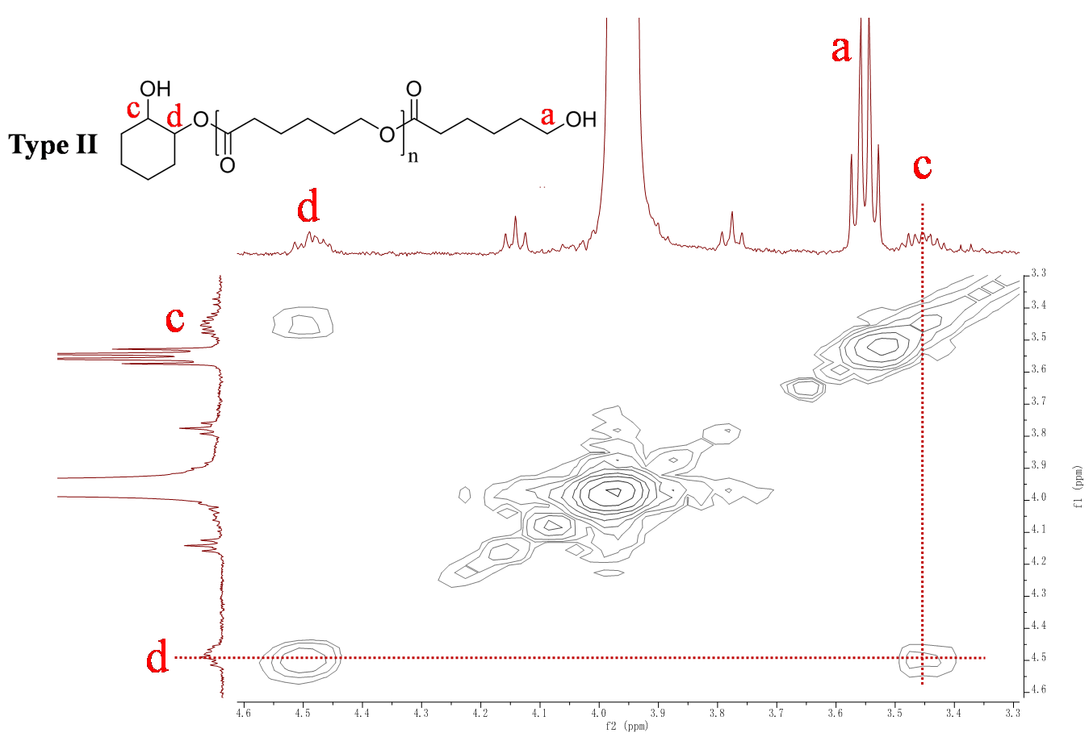
Figure 4. ¹H-¹H COSY spectrum of PCL₃₀ (Table 1, entry 1) containing chains of architecture Type II (the signal at 3.95 ppm is assigned to methylene protons in the polymer backbone). Since the deuterated solvent is dry, peak a is a quartet due to the coupling between the methylene proton and hydroxyl proton. This has been confirmed by the addition of D₂O, where upon a triplet was observed (Figure S1).

³¹P{¹H} NMR was utilized to further confirm the presence of both primary and secondary hydroxyl end-groups, consistent with the presence of both Type I and II chain architectures.^{68,69} The primary and secondary hydroxyl groups are distinguished on the basis of their chemical shifts after reaction with 2-chloro-4,4,5,5-tetramethyl dioxaphospholane, and using the reaction with bisphenol A (BPA) as an internal reference. Using this method, two signals were observed at 146.5 and 147.8 ppm (see Figure S2 in ESI) which are assigned to secondary and primary hydroxyl groups, respectively, on the basis of the chemical shift assignments in the literature.^{68,69}
In order to quantify the relative quantities of Type I and II chains, the normalised peak integrals in the ¹H NMR spectra for characteristic signals a and b were compared (Figure 3 for the assignment and ESI for more details of the calculations). During the ¹H NMR data acquisition, the values for t₁ and the relaxation delay (d₁ = 25 s) were maximized so as to ensure the reliability in peak integral values. By calculating the relative integrals of peaks a and b (see Figure S3 & Table S1), the composition of Type I and II PCL chains was determined (Table 2).
Table 2. The relative contents of Type I and II in PCL synthesized with various chain transfer agents ª

Entry | Polymer | CTA | Type I (mol%)^{b} | Type II (mol%)^{b}
1 | PCL₃₀ | CHD | 64 | 36
2 | PCL₅₀ | CHD | 69 | 31
3 | PCL₇₀ | CHD | 75 | 25
4 | PCL₉₀ | CHD | 82 | 18
5 | PCL₃₀ | EG | 100 | 0
6 | PCL₃₀ | PD | 65 | 26 (a); 9 (b) ^{c}
7 | PCL₃₀ | PEG | 100 | 0
8 | PCL₃₀ | MPD | N.A.^{d} | N.A.^{d}
^{a)} The complete details of the calculations and the relative integrals of the peaks used to determine Type I/II for each sample are presented in the ESI (Figure S3 and Table S1). ^{b)} Due to signal overlap (peak b in Figure 3) between Type I and the minor PCL species end-capped by α-acetyl-cyclohexyl ester and ω-hydroxyl groups, the content of Type I might be overestimated by ca. 10 mol%, considering that [CTA]/[cat.] = 10/1; ^{c)} Two variants of Type II (a and b) co-exist when 1,2-propane diol is used as the CTA depending on the regio-chemistry of initiation; ^{d)} A mixture of Type I and II was observed, but due to the signal overlap between the methyl groups of MPD belonging to both Type I and II, the ratio of Type I and II cannot be quantitatively determined.

When trans-1,2-cyclohexanediol is applied as the chain transfer agent, there is a mixture of Type I and II chains in all cases, meaning that the polymer chains are both extended and end-capped by the chain transfer agent. It is important to note that the integral for peak b (present only in Type I chains) may be slightly overestimated due to the expected signal overlap with the minor species (identified in the MALDI-ToF experiments) which is chain end-capped with α-acetyl-cyclohexyl ester and ω-hydroxyl groups. Thus, the quantity of Type I chains may be over-estimated by upto 10% using this method. In every case there is a significant proportion of chains which are end-capped with the chain transfer agent (Type II), indicating that the common assumption that all hydroxyl groups initiate chains is not substantiated using trans-1,2-cyclohexane diol as the chain transfer agent with the di-zinc initiator. Interestingly, the relative quantity of chain extended PCL (Type I), increases with the molecular weight of the PCL. This implies that greater quantities of monomer (ɛ-CL), and extended times, may enable the complete conversion of Type II chains (end-capped) to Type I (chain extended).
In order to investigate this observation further, aliquots were taken during the polymerization to monitor the temporal relationship with the relative quantities of Type I and II chains. As the conversion of ɛ-CL increased from 41 % to 96 %, the relative amount of Type II chains decreased from 37 to 17 mol% (Table 3, entries 1 and 2), suggesting that as ɛ-CL is polymerized, the quantity of Type II chains present decreases. To rule out the possibility that the decrease of Type II is the consequence of transesterification between secondary hydroxyl groups and the PCL chain, the polymer solution was kept at 80 °C, after complete ɛ-CL conversion, for a further 4.5 h. The increase in M_{w}/M_{n} and the slight decrease in M_{n} indicate that transesterification reactions, including probable back-biting depolymerization, happened over this extended period (Table 3, entries 3–5). Despite these transesterification reactions occurring, the relative amount of Type II chains remained constant over this period.

Table 3. Shows the relative contents of Type I and II chains present in a sample of PCL₉₀ over time.

Entry |  | t (min) | conv. of ɛ-CL (%)ª | M_{n} (kDa)^{b} | M_{w}/M_{n} | Type I (mol%) | Type II (mol%)
 | 1 | 110 | 41 | 8.5 | 1.15 | 63 | 37
 | 2 | 180 | 96 | 16.8 | 1.36 | 83 | 17
 | 3 | 210 | > 98 | 14.6 | 1.30 | 79 | 21
 | 4 | 330 | > 98 | 11.7 | 1.50 | 85 | 15
 | 5 | 450 | > 98 | 11.1 | 1.52 | 82 | 18
^{a)} The conversion of ɛ-CL was determined from the ¹H NMR spectra; ^{b)} M_{n} was determined by SEC, in THF using polystyrene calibration, with a correction factor (0.56) applied as described by Soum et al.⁵
Meanwhile, both ethylene glycol and polyethylene glycol, PEG, (primary diol) were utilized as the chain transfer agents (Table 1, Entry 6 and 8). Lemaire et al. have previously reported that the CH₂ groups of mono-esterified ethylene glycol show ¹H NMR resonances at 4.21 ppm and 3.82 ppm, respectively.⁷⁰ However, as can be seen in Figure 5, chains initiated from ethylene glycol show only a single resonance at 4.28 ppm. The resonance is assigned to the methylene groups in chain extended PCL. The same result was also observed in PEG-b-PCL. No signals of Type II can be observed in either the ¹H NMR (Figure 6A) or the ¹H COSY spectra (see Figure S8, ESI). ³¹P{¹H} NMR spectroscopy was used again to determine the nature of the end group of PEG-b-PCL and a single signal was observed 147.8 ppm, assigned to the hydroxyl end group of PCL (Figure 6B). No signal of the hydroxyl end group of PEG can be observed, suggesting an exclusive Type I architecture.
Figure 5. ¹H NMR spectrum of PCL polymerized using ethylene glycol (EG) as the chain transfer agent (Table 1, entry 6) .The polymerization was run in neat cyclohexene oxide as the reaction solvent at 80 °C, for 2.5 hours.
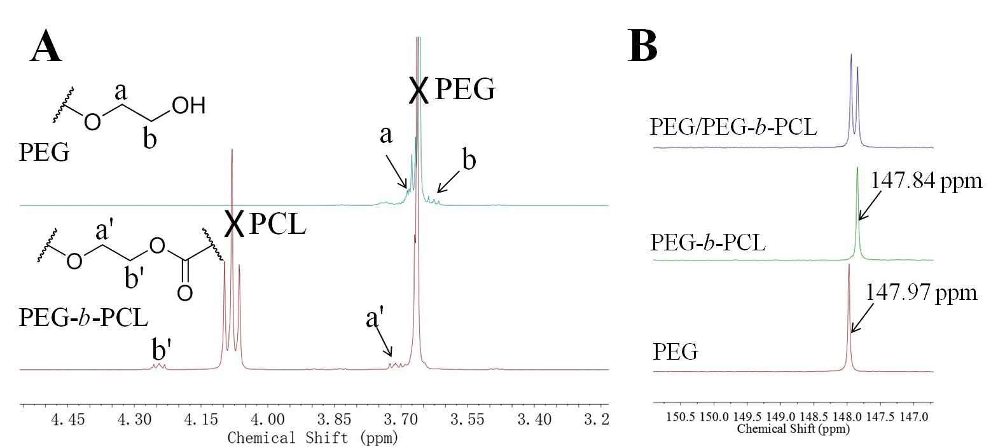
Figure 6. (A) ¹H NMR spectra of both PEG and PEG-b-PCL (Table 1, entry 8), the polymerization was run in neat cyclohexene oxide as the reaction solvent at 80 °C, for 2.5 hours; (B) ³¹P{¹H} NMR spectrum of PEG, PEG-b-PCL (Table 1, entry 8) and a mixture of PEG/ PEG-b-PCL after reaction with 2-chloro-4,4,5,5-tetramethyl dioxaphospholane (using bisphenol A as an internal standard). The signals at 147.97 and 147.84 ppm are assigned to the primary –OH end groups of PEG and PCL, respectively.
The different PCL architectures resulting from primary or secondary hydroxyl groups on the chain transfer agent was proposed to result from different initiation rates (k_{i}, see initiation process in Scheme S1), depending on the nature of the hydroxyl group. To verify this hypothesis, three mono-functional alcohols were employed as chain transfer agents: 1-hexanol (primary -OH), 2-hexanol (secondary -OH) and 2-methyl-2-pentanol (tertiary -OH) The polymerization was monitored using in situ ATR-IR spectroscopy. In all cases, plots of monomer conversion vs. reaction time exhibited sigmoid shapes (Figure S6, in SI), indicating that the initiation rate constant, k_{i}, is lower than the propagation rate constant k_{p} (see propagation process in Scheme S1).⁷¹ The plots were fit, for the initiation stages (monomer conversions < 25%), using a kinetic model developed by Wang et al. which enables direct determination of the values of k_{i} and k_{p} (Table 4).⁷² The ROP of ɛ-CL in the presence of chain transfer agents shows equivalent control to that in the absence, indicating fast and reversible chain transfer occurs [M_{w}/M_{n} < 1.3, suggesting k_{e} >> k_{i}, k_{p;} see chain exchange process in Scheme S1]. Thus, for the kinetic models, the value of chain exchange rate constant (k_{e}) was set at 100 L·mol⁻¹·s⁻¹(for further details, see the ESI).⁷² The kinetic models demonstrate that even for primary alcohols, k_{p} is ~5 times larger than k_{i}. Furthermore, the ratio of k_{p}/k_{i} depends on the structure of the alcohol. For secondary hydroxyl groups, k_{p} is ~8 times larger and for tertiary groups it is around 10 times larger (Table 4 and Figure S7).
Therefore, it is reasonable to conclude that the coexistence of the two different architectures arises from different initiation rates (where initiation refers to the insertion of the first CL monomer into the zinc alkoxide bond, the nature of which depends on the type of hydroxyl group on the chain transfer agent). The decrease in the quantity of Type II chains with increasing chain length (degree of polymerization) can also be rationalized by the slow initiation from secondary hydroxyl groups compared to propagation from a primary CL alkoxide. It is notable that other catalyst systems have also been reported which show faster rates of propagation than initiation, but the impact of these kinetics over telechelic polymer architecture were not yet studied.^{71,73,74}

Table 4. The immortal ROP of ɛ-CL using mono-functional alcohols as the chain transfer agents.ª

Entry | CTA | Type of -OH | Rates^{b}
Entry | CTA | Type of -OH | k_{i} x 10⁻³  (L·mol⁻¹·s⁻¹) | k_{p} x 10⁻³  (L·mol⁻¹·s⁻¹) | k_{p}/k_{i}
1 | 1-Hexanol | primary | 47.4 | 226.2 | 5
2 | 2-Hexanol | secondary | 34.2 | 265.6 | 8
3 | 2-Methyl-2-pentanol | tertiary | 27.0 | 275.2 | 10
^{a)} Reaction conditions: [cat.]/[CTA]/[ɛ-CL]/[CHO] = 1/20/500/1000, [cat.] = 10 mM; ^{b)} Determined from the plots of monomer conversion (< 25 %) vs. reaction time (see ESI for further details).

In order to compare these results with other systems from the literature applied for the synthesis of telechelic PCL,⁶⁴ 1,2-propanediool was also employed as a CTA (Table 2, entry 6). The ¹H NMR spectrum of the PCL shows peaks at 5.15 and 4.18 ppm (Figure 7B), which are indicative of Type I PCL.⁶⁴ Meanwhile signals at 3.96/4.14 and 5.03 ppm (H_{e} and H_{g} in Figure 7A, respectively) indicate that two kinds of Type II PCL are also present, in which chains either initiate from the primary or secondary hydroxyl groups of the propane diol. Due to the overlap of the methyne/methylene signals assigned to Type II chains with those from the main chain PCL,⁷⁵ the peaks for H_{d} (4.06 ppm), H_{e} (3.96 & 4.14 ppm) and H_{h} (3.65 ppm) cannot be unambiguously assigned either in the ¹H NMR or ¹H-¹H COSY spectra (Figure 7B). Fortunately, there is no such signal overlap between the methyl groups on the propane diol units in the different polymer architectures (Figure 7, H_{c}, H_{f} and H_{i}). Three signals were clearly observed in the methyl region of the ¹H-¹H COSY spectrum, each coupling with a different methyne proton, at (1.24 & 4.06 ppm), (1.26 & 5.03 ppm) and (1.27 & 5.15 ppm) (Figure 7C). This suggests there are three different types of methyl environments and is consistent with methyl groups coupling to H_{a} (Type I), H_{d} (Type II a) or H_{g} (Type II b), confirming that the sample contains a mixture of Type I (chain extended) and II (chain end-capped) chains. The molar ratio of the different PCL architectures is calculated to be [Type I]/[Type II a]/[Type II b] = 65/26/9, from the relative integrals of H_{c}/H_{f}/H_{i} (see Figure S5 & Table S2). However, in addition to the PCL species which are initiated from 1,2-propane diol, a minor distribution initiated from cyclohexanediol was also observed in the MALDI-ToF spectrum (Figure S4). This latter series is proposed to result from trace contamination of cyclohexene oxide by the diol, which might form by the catalyzed reaction between CHO and any residual water, as has been previously noted by various other groups working with this epoxide.⁷⁶⁻⁸⁰ The minor distribution, initiated from CHD, is not well defined in the ¹H NMR spectrum due to its low content.
Therefore, using 1,2-propanediol as the CTA results in a mixed architecture PCL, even at comparable molecular weights to those used by Lin and co-workers. In addition, the observation that the molar content of Type IIa is much higher than Type IIb also strongly supports the notion that primary hydroxyl groups show higher initiation rates than secondary groups. Nevertheless, the fact that some primary –OH groups do not react, i.e. in Type IIb, seems contrary to the kinetic findings. It is proposed that the methyl substituent, on 1,2-propanediol, might lead to sufficient steric hindrance even at the proximal primary hydroxyl group to slow initiation from that site.
Figure 7. (A) A schematic diagram of the two architectures (Type I & II) of PCL formed using 1,2-propanediol as the CTA; (B) A typical ¹H-¹H COSY spectrum of the PCL (PD as CTA) and (C) An enlarged ¹H-¹H COSY spectrum corresponding to the selected area in (B) and the correlative hydrogens in (A). The signals at (1.24, 4.06) ppm are assigned to the coupling between H_{f} and H_{d} resulting from Type II a chains; those at (1.26, 5.03) ppm are assigned to the coupling between H_{i} and H_{g} resulting from Type II b chains; whilst the signal at (1.27, 5.15) ppm is assigned to the coupling between H_{c} and H_{a} resulting from Type I chains.
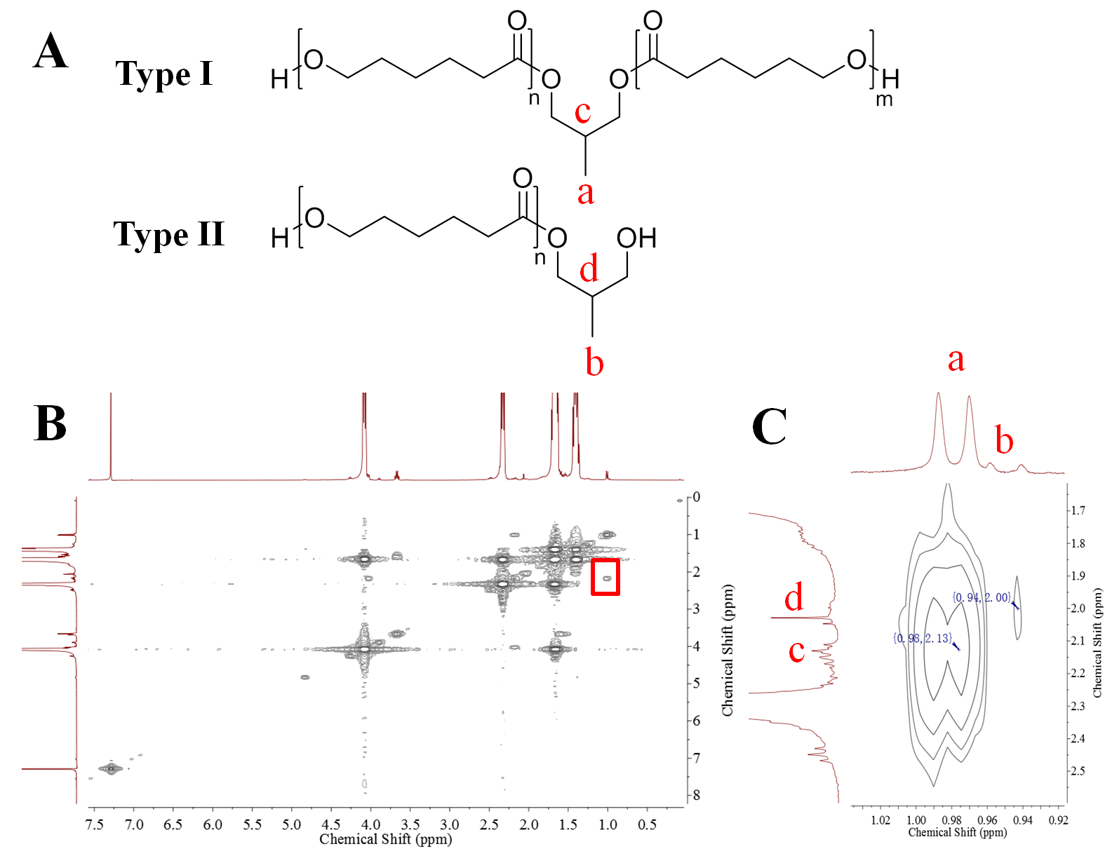
Figure 8. (A) A schematic diagram of the two architectures (Type I & II) of PCL formed using 2-methyl-1,3-propanediol (MPD) as the CTA (Table 1, entry 9); (B) A typical ¹H-¹H COSY spectrum of the PCL (MPD as CTA) and (C) An enlarged ¹H-¹H COSY spectrum corresponding to the selected area in (B) and the correlative hydrogen in (A). The signal at (0.98, 2.13) ppm is assigned to the coupling between H_{a} and H_{c} resulting from Type I; another signal at (0.94, 2.00) ppm is assigned to the coupling between H_{b} and H_{d} resulting from Type II.
To test this steric hindrance hypothesis, 2-methyl-1,3-propanediol (MPD), having a similar molecular structure to 1,2-propanediol but with two primary –OH groups, was used as the CTA (Table 1, entry 9). In contrast to the results using other difunctional primary hydroxyl CTAs (i.e. EG and PEG), a mixture of two PCL architectures was observed (Figure 8). In the NMR spectra, two different methyl signals (H_{a} and H_{b}) were observed, these coupled with the methyne protons, H_{c} and H_{d}, respectively. It is, therefore, proposed that both the steric hinderance and the nature of the –OH group on the chain transfer agent influence the rate of initiation, k_{i}, a factor which directly affects the architecture of the final polymer.
Conclusions
The ROP of ε-CL was investigated using a dizinc catalyst and various chain transfer agents. This system resulted in controlled, immortal polymerization, where the polymer molecular weight was predicted from [monomer]/[chain transfer agent]. By using the dizinc catalyst, an unexpected and unusual result was that the nature of the hydroxyl groups, on the chain transfer agent, influenced the architecture of the PCL chains. Chain transfer agents with primary hydroxyl groups and having limited/no steric hindrance, such as ethylene glycol and PEG, exhibited quantitative initiation from all the hydroxyl groups. In contrast, chain transfer agents with secondary hydroxyl groups, such as trans-1,2-cyclohexanediol and 1,2-propanediol, resulted in a mixture of different PCL architectures. These were polymers chain extended or end-capped by the diol. 2-Methyl-1,3-propanediol, also resulted in the formation of the two different PCL chain architectures. The polymerization kinetics revealed that the rate of initiation, k_{i}, (i.e. the insertion of the first CL monomer into the zinc-O(chain transfer agent) bond is significantly slower than the rate constant of propagation (k_{p}) (i.e. insertion of subsequent CL monomers into the Zn-O(PCL) bond). Using a series of mono-functional chain transfer agents, the rate of initiation was related to the structure of hydroxyl group, with the rates decreasing in the order: k_{i,(primary)} > k_{i,(secondary)} > k_{i,(tertiary)}. Taken as a whole, the studies revealed that the architecture of PCL formed by the dizinc complex/CTA system depends on both the nature of the hydroxyl group and on the steric environment(s) proximal to the hydroxyl groups on the chain transfer agent. The studies also highlight the importance of the catalyst system in controlling the relative rates of initiation vs. propagation, and thereby the polymer chain architectures. In this case, the di-zinc catalyst shows a clear kinetic selectivity for certain hydroxyl groups/chemical environments compared to others. Such selectivity may be an interesting means to control and target specific polymer chain architectures. Further investigation of the generality of these findings using other catalysts is warranted, as are studies to exploit the catalytic selectivity as a means to target particular chain architectures for application.

ASSOCIATED CONTENT
Supporting Information
This describes the experimental procedures, characterization data, the structure of the di- zinc initiator and the equations used to determine the relative content of Type I and II chains. This material is available free of charge via the Internet at http://pubs.acs.org.
AUTHOR INFORMATION
Corresponding Author
c.k.williams@imperial.ac.uk
ACKNOWLEDGMENTS
The Engineering and Physical Sciences Research Council (EPSRC) are acknowledged for research funding (EP/K035274/1, EP/K014070/1, EP/K014668). Acknowledgement for funding is also gratefully made to the Imperial College London-CSC Scholarship awarded to YZ.
References
(1) Ropson, N.; Dubois, P.; Jerome, R.; Teyssie, P. Macromolecules 1995, 28, 7589-7598.
(2) Stevels, W. M.; Ankone, M. J. K.; Dijkstra, P. L.; Feijen, J. Macromol. Chem. Phys. 1995, 196, 1153-1161.
(3) Dubois, P.; Ropson, N.; Jérôme, R.; Teyssié, P. Macromolecules 1996, 29, 1965-1975.
(4) Stevels, W. M.; Ankoné, M. J. K.; Dijkstra, P. J.; Feijen, J. Macromolecules 1996, 29, 8296-8303.
(5) Save, M.; Schappacher, M.; Soum, A. Macromol. Chem. Phys. 2002, 203, 889-899.
(6) Chen, H.-Y.; Huang, B.-H.; Lin, C.-C. Macromolecules 2005, 38, 5400-5405.
(7) Zhang, D.; Hillmyer, M. A.; Tolman, W. B. Biomacromolecules 2005, 6, 2091-2095.
(8) Nomura, N.; Taira, A.; Nakase, A.; Tomioka, T.; Okada, M. Tetrahedron 2007, 63, 8478-8484.
(9) Woodruff, M. A.; Hutmacher, D. W. Prog. Polym. Sci. 2010, 35, 1217-1256.
(10) Chen, S.; Zhang, X. Z.; Cheng, S. X.; Zhuo, R. X.; Gu, Z. W. Biomacromolecules 2008, 9, 2578-2585.
(11) Zhang, Y. Z.; Wang, X.; Feng, Y.; Li, J.; Lim, C. T.; Ramakrishna, S. Biomacromolecules 2006, 7, 1049-1057.
(12) Gan, Z. H.; Jim, T. F.; Li, M.; Yuer, Z.; Wang, S. G.; Wu, C. Macromolecules 1999, 32, 590-594.
(13) Calandrelli, L.; Calarco, A.; Laurienzo, P.; Malinconico, M.; Petillo, O.; Peluso, G. Biomacromolecules 2008, 9, 1527-1534.
(14) Kwon, I. K.; Kidoaki, S.; Matsuda, T. Biomaterials 2005, 26, 3929-3939.
(15) Tang, M.; Purcell, M.; Steele, J. A. M.; Lee, K.-Y.; McCullen, S.; Shakesheff, K. M.; Bismarck, A.; Stevens, M. M.; Howdle, S. M.; Williams, C. K. Macromolecules 2013, 46, 8136-8143.
(16) Allard, D.; Prudhomme, R. E. J. Appl. Polym. Sci. 1982, 27, 559-568.
(17) Cheung, Y. W.; Stein, R. S. Macromolecules 1994, 27, 2512-2519.
(18) Yang, J. M.; Chen, H. L.; You, J. W.; Hwang, J. C. Polym. J. 1997, 29, 657-662.
(19) Kowalski, A.; Duda, A.; Penczek, S. Macromolecules 2000, 33, 7359-7370.
(20) Shen, Y. Q.; Shen, Z. Q.; Zhang, Y. F.; Yao, K. M. Macromolecules 1996, 29, 8289-8295.
(21) Nomura, N.; Taira, A.; Tomioka, T.; Okada, M. Macromolecules 2000, 33, 1497-1499.
(22) Sanda, F.; Sanada, H.; Shibasaki, Y.; Endo, T. Macromolecules 2002, 35, 680-683.
(23) Mecerreyes, D.; Jerome, R.; Dubois, P. Adv. Polym. Sci. 1999, 147, 1-59.
(24) Vanhoorne, P.; Dubois, P.; Jerome, R.; Teyssie, P. Macromolecules 1992, 25, 37-44.
(25) Zhong, Z. Y.; Dijkstra, P. J.; Birg, C.; Westerhausen, M.; Feijen, J. Macromolecules 2001, 34, 3863-3868.
(26) Lohmeijer, B. G. G.; Pratt, R. C.; Leibfarth, F.; Logan, J. W.; Long, D. A.; Dove, A. P.; Nederberg, F.; Choi, J.; Wade, C.; Waymouth, R. M.; Hedrick, J. L. Macromolecules 2006, 39, 8574-8583.
(27) Simón, L.; Goodman, J. M. J. Org. Chem. 2007, 72, 9656-9662.
(28) Dove, A. P. ACS Macro Lett. 2012, 1, 1409-1412.
(29) Pratt, R. C.; Lohmeijer, B. G. G.; Long, D. A.; Waymouth, R. M.; Hedrick, J. L. J. Am. Chem. Soc. 2006, 128, 4556-4557.
(30) Bailey, W. J.; Ni, Z.; Wu, S. R. Macromolecules 1982, 15, 711-714.
(31) Jin, S.; Gonsalves, K. E. Macromolecules 1997, 30, 3104-3106.
(32) Yuan, J. Y.; Pan, C. Y.; Tang, B. Z. Macromolecules 2001, 34, 211-214.
(33) Darensbourg, D. J.; Karroonnirun, O. Macromolecules 2010, 43, 8880-8886.
(34) Sanchez-Barba, L. F.; Garces, A.; Fajardo, M.; Alonso-Moreno, C.; Fernandez-Baeza, J.; Otero, A.; Antinolo, A.; Tejeda, J.; Lara-Sanchez, A.; Lopez-Solera, M. I. Organometallics 2007, 26, 6403-6411.
(35) Tsai, Y. H.; Lin, C. H.; Lin, C. C.; Ko, B. T. J. Polym. Sci., Part A: Polym. Chem. 2009, 47, 4927-4936.
(36) Darensbourg, D. J.; Karroonnirun, O.; Wilson, S. J. Inorg. Chem. 2011, 50, 6775-6787.
(37) Pepels, M. P. F.; Bouyahyi, M.; Heise, A.; Duchateau, R. Macromolecules 2013, 46, 4324-4334.
(38) Darensbourg, D. J.; Choi, W.; Karroonnirun, O.; Bhuvanesh, N. Macromolecules 2008, 41, 3493-3502.
(39) Romain, C.; Williams, C. K. Angew. Chem., Int. Ed. 2014, 53, 1607-1610.
(40) Martello, M. T.; Hillmyer, M. A. Macromolecules 2011, 44, 8537-8545.
(41) Lin, J.-O.; Chen, W.; Shen, Z.; Ling, J. Macromolecules 2013, 46, 7769-7776.
(42) Kaszas, G.; Puskas, J. E.; Kennedy, J. P.; Hager, W. G. J. Polym. Sci., Part A: Polym. Chem. 1991, 29, 427-435.
(43) Shin, J.; Martello, M. T.; Shrestha, M.; Wissinger, J. E.; Tolman, W. B.; Hillmyer, M. A. Macromolecules 2011, 44, 87-94.
(44) Storey, R. F.; Chisholm, B. J. Macromolecules 1993, 26, 6727-6733.
(45) Wanamaker, C. L.; O'Leary, L. E.; Lynd, N. A.; Hillmyer, M. A.; Tolman, W. B. Biomacromolecules 2007, 8, 3634-3640.
(46) Baez, J. E.; Marcos-Fernandez, A.; Lebron-Aguilar, R.; Martinez-Richa, A. Polymer 2006, 47, 8420-8429.
(47) Barqawi, H.; Ostas, E.; Liu, B.; Carpentier, J. F.; Binder, W. H. Macromolecules 2012, 45, 9779-9790.
(48) Guillaume, S. M. Eur. Polym. J. 2013, 49, 768-779.
(49) Duda, A. Macromolecules 1994, 27, 576-582.
(50) Duda, A. Macromolecules 1996, 29, 1399-1406.
(51) Tasdelen, M. A.; Kahveci, M. U.; Yagci, Y. Prog. Polym. Sci. 2011, 36, 455-567.
(52) Sisson, A. L.; Ekinci, D.; Lendlein, A. Polymer 2013, 54, 4333-4350.
(53) Lendlein, A.; Neuenschwander, P.; Suter, U. W. Macromol. Chem. Phys. 2000, 201, 1067-1076.
(54) Kricheldorf, H. R.; Rost, S. Polymer 2005, 46, 3248-3256.
(55) Kricheldorf, H. R.; Behnken, G.; Schwarz, G. J. Polym. Sci., Part A: Polym. Chem. 2006, 44, 3175-3183.
(56) Nakayama, Y.; Okuda, S.; Yasuda, H.; Shiono, T. React. Funct. Polym. 2007, 67, 798-806.
(57) Guillaume, S. M.; Schappacher, M.; Soum, A. Macromolecules 2003, 36, 54-60.
(58) Dove, A. P. Chem. Commun. 2008, 6446-6470.
(59) Magbitang, T.; Lee, V. Y.; Connor, E. F.; Sundberg, L. K.; Kim, H. C.; Volksen, W.; Hawker, C. J.; Miller, R. D.; Hedrick, J. L. Macromol. Symp. 2004, 215, 295-306.
(60) Magbitang, T.; Lee, V. Y.; Miller, R. D.; Toney, M. F.; Lin, Z.; Briber, R. M.; Kim, H. C.; Hedrick, J. L. Adv. Mater. 2005, 17, 1031-1035.
(61) Lee, H.-i.; Jakubowski, W.; Matyjaszewski, K.; Yu, S.; Sheiko, S. S. Macromolecules 2006, 39, 4983-4989.
(62) Han, D.-H.; Pan, C.-Y. J. Polym. Sci., Part A: Polym. Chem. 2007, 45, 789-799.
(63) Chen, W.; Ling, J.; Shen, Z. Q. Sci. China, Ser. B: Chem. 2005, 48, 334-342.
(64) Ling, J.; Liu, J.; Shen, Z.; Hogen-Esch, T. E. J. Polym. Sci., Part A: Polym. Chem. 2011, 49, 2081-2089.
(65) Kember, M. R.; Knight, P. D.; Reung, P. T. R.; Williams, C. K. Angew. Chem., Int. Ed. 2009, 48, 931-933.
(66) Buchard, A.; Jutz, F.; Kember, M. R.; White, A. J. P.; Rzepa, H. S.; Williams, C. K. Macromolecules 2012, 45, 6781-6795.
(67) Saini, P. K.; Romain, C.; Zhu, Y.; Williams, C. K. Polym. Chem. 2014, 5, 6068-6075.
(68) Hatzakis, E.; Archavlis, E.; Dais, P. J. Am. Oil Chem. Soc. 2007, 84, 615-619.
(69) Spyros, A.; Argyropoulos, D. S.; Marchessault, R. H. Macromolecules 1997, 30, 327-329.
(70) Sutter, M.; Dayoub, W.; Métay, E.; Raoul, Y.; Lemaire, M. Chemsuschem 2012, 5, 2397-2409.
(71) Wang, L.; Bochmann, M.; Cannon, R. D.; Carpentier, J.-F.; Roisnel, T.; Sarazin, Y. Eur. J. Inorg. Chem. 2013, 2013, 5896-5905.
(72) Wang, L.; Poirier, V.; Ghiotto, F.; Bochmann, M.; Cannon, R. D.; Carpentier, J.-F.; Sarazin, Y. Macromolecules 2014, 47, 2574-2584.
(73) Kowalski, A.; Duda, A.; Penczek, S. Macromolecules 1998, 31, 2114-2122.
(74) Puaux, J.-P.; Banu, I.; Nagy, I.; Bozga, G. Macromol. Symp. 2007, 259, 318-326.
(75) Fevrier, P.; Guégan, P.; Yvergnaux, F.; Pierre Callegari, J.; Dufossé, L.; Binet, A. J. Mol. Catal. B-Enzym. 2001, 11, 445-453.
(76) van Meerendonk, W. J.; Duchateau, R.; Koning, C. E.; Gruter, G.-J. M. Macromolecules 2005, 38, 7306-7313.
(77) Sugimoto, H.; Ohtsuka, H.; Inoue, S. J. Polym. Sci., Part A: Polym. Chem. 2005, 43, 4172-4186.
(78) Sugimoto, H.; Kuroda, K. Macromolecules 2007, 41, 312-317.
(79) Nakano, K.; Nakamura, M.; Nozaki, K. Macromolecules 2009, 42, 6972-6980.
(80) Cyriac, A.; Lee, S. H.; Lee, B. Y. Polym. Chem. 2011, 2, 950-956.

For Table of Contents use only:
The Influences of a Di-zinc Catalyst and Bifunctional Chain Transfer Agents on the Polymer Architecture in the Ring-Opening Polymerization of ɛ-Caprolactone
Yunqing Zhu, Charles Romain, ValentinPoirier and Charlotte K. Williams*
Department of Chemistry, Imperial College London, London, SW7 2AZ, UK
c.k.williams@imperial.ac.uk

