Peptide Receptor Radionuclide Therapy in Gastroenteropancreatic High-Grade Neuroendocrine Neoplasms: a multicenter cohort study
Esben Andreas Carlsen¹, Nicola Fazio², Dan Granberg³, Simona Grozinsky-Glasberg⁴, Hojjat Ahmadzadehfar⁵, Chiara Maria Grana², Wouter T. Zandee⁶, Jaroslaw Cwikla⁷, Martin A. Walter⁸, Peter Sandor Oturai¹, Anja Rinke⁹, Andrew Weaver¹⁰, Andrea Frilling¹¹, Sara Gritti², Anne Kirstine Arveschoug¹², David J. Gross⁴, Ulrich Knigge¹³ and Halfdan Sorbye¹⁴

Author affiliations
¹ Dept. of Clinical Physiology, Nuclear Medicine & PET and Cluster for Molecular Imaging, Dept. of Biomedical Sciences, Rigshospitalet and University of Copenhagen, Denmark.
² Division of Gastrointestinal Medical Oncology and Neuroendocrine Tumors, Division of Nuclear Medicine, European Institute of Oncology, Milano, Italy.
³ Dept. of Medical Sciences, Uppsala University, Sweden.
⁴ Neuroendocrine Tumor Unit, Dept. of Endocrinology & Metabolism, Hadassah-Hebrew University Medical Center, Jerusalem, Israel.
⁵ Dept. of Nuclear Medicine, University Hospital Bonn, Germany.
⁶ Erasmus Medical Center, Rotterdam, The Netherlands.
⁷ Medical Centre and Central Clinical Hospital, Warsaw, Poland.
⁸ Dept. of Nuclear Medicine, University Hospital of Geneva, Switzerland.
⁹ Dept. of Gastroenterology, Philipps University of Marburg, Germany.
¹⁰ Dept. of Oncology, Churchill Hospital, Oxford, United Kingdom.
¹¹ Department of Surgery and Cancer, Imperial College London, United Kingdom.
¹² Dept. of Nuclear Medicine and PET, Aarhus University Hospital, Denmark.
¹³ Department of Surgical Gastroenterology and Department of Clinical Endocrinology, Rigshospitalet, University of Copenhagen, Denmark.
¹⁴ Department of Oncology, Haukeland University Hospital, Bergen, and Department of Clinical Science, University of Bergen, Norway.

Corresponding author: Esben Andreas Carlsen. Email: esben.a.carlsen@gmail.com.

Keywords: Neuroendocrine Tumors; Neuroendocrine Carcinoma; Neuroendocrine Neoplasm; High-grade; Peptide receptor radionuclide therapy; Radiolabeled somatostatin analogues; ¹⁷⁷Lutetium; ⁹⁰Yttrium; Progression-free survival; Overall survival.

Abstract word count: 247.
Manuscript word count: 3000.

Running title: PRRT in GEP-NEN G3.
Abstract
Background
Peptide receptor radionuclide therapy (PRRT) is an established treatment of metastatic neuroendocrine tumors grade 1-2 (G1-G2). However, its possible benefit in high-grade gastroenteropancreatic (GEP) neuroendocrine neoplasms (NEN G3) is unknown. We therefore aimed to assess the benefits and harms of PRRT in patients with GEP NEN G3.

Methods
A retrospective cohort study at 12 centers to assess efficacy and toxicity of PRRT in patients with GEP NEN G3. Main outcomes were response rate, disease control rate, progression-free survival (PFS), overall survival (OS) and toxicity.

Results
We included 149 patients (primary tumor: pancreatic n=88, gastrointestinal n=34, unknown n=27). PRRT was 1st-line (n=30), 2nd-line (n=62) or later line treatment (n=57). Of 114 patients evaluable, 1% had complete response, 41% partial response, 38% stable disease and 20% progressive disease. Of 104 patients with documented progressive disease before PRRT, disease control rate was 69%. The total cohort had median PFS of 14 months and OS 29 months. Ki-67 21-54% (n=125) vs. Ki-67≥55% (n=23): PFS 16 vs. 6 months (p<0.001) and OS 31 vs. 9 months (p<0.001). Well (n=60) vs. poorly-differentiated NEN (n=62): PFS 19 vs. 8 months (p<0.001) and OS 44 vs.19 months (p<0.001). Grade 3-4 hematological/renal toxicity occurred in 17% of patients.

Conclusion
The outcome of PRRT in a large international cohort of patients with GEP NEN G3 demonstrates promising response rates, disease control rates, PFS and OS in patients with mainly progressive disease. Based on these results, PRRT may be considered for patients with GEP NEN G3.

Introduction
Neuroendocrine neoplasms (NEN) are a very heterogeneous entity classified according to primary tumor location, stage, proliferation rate and differentiation. The 2010 World Health Organization (WHO) Classification grades NEN according to the proliferation index Ki-67; ≤ 2% (Grade 1 [G1]), 3-20% (G2) and > 20 % (G3) [1]. G1-G2 was collectively referred to as neuroendocrine tumors (NET) and G3 as neuroendocrine carcinoma (NEC). The classification is strongly prognostic, but is also used to guide treatment decisions. In 2017, WHO refined the classification of pancreatic NEN; G3 tumors are further classified as well (NET G3) and poorly differentiated (NEC) [2], and a similar expansion to gastrointestinal (GI) G3 tumors is anticipated in the next WHO classification. The NET category is now only used for well-differentiated tumors regardless of their proliferation index (G1-G3), whereas the NEC category is used for poorly differentiated high-grade neuroendocrine carcinomas (G3). The terminology of NEN G3 relates to all high-grade (G3, Ki-67 >20%) neuroendocrine malignancies; i.e. both NET G3 and NEC.
Gastroenteropancreatic (GEP) NENs G3 are rare, highly malignant, with poor prognosis and limited therapeutic options [3-5]. The majority of patients have metastases at the time of diagnosis and median overall survival (OS) is 5.8 months including all patients [6]. Platinum-based chemotherapy is the standard treatment in metastatic disease with response rates (RR) of 30-35%, progression-free survival (PFS) of 4-5 months and OS 11-14 months [7-10].
In metastatic GEP NET G1-G2, peptide receptor radionuclide therapy (PRRT) targeting somatostatin receptors has been used with excellent results for the last two decades in Europe and Israel [11-15]. The recent NETTER-1 phase 3 trial of patients with advanced, progressive, somatostatin receptor imaging (SRI) positive midgut NET G1/G2 supports this approach [16]. Contrary, PRRT has generally not been recommended for GEP NEN G3 based on expectance of low expression of somatostatin receptors and rapid growth behavior. According to guidelines, PRRT can be considered in SRI-positive NET G3, but data are lacking [3]. PRRT could, however, be a relevant therapeutic option for NEN G3 since SRI positivity has been reported for both NET G3 and NEC [7, 8, 17, 18], as well as having expression of somatostatin receptor 2A on immunohistochemistry [19].
Randomized large studies to assess the benefit of specific treatments are frequently not feasible to perform in very rare diseases. Large retrospective datasets may then initially be the only way on which to base treatment decision. In a large multicenter international cooperation, we therefore collected retrospectively the outcomes after PRRT in patients with GEP NEN G3.

Methods
Patients
At 12 university hospitals, we retrospectively included patients that fulfilled the following criteria: 1) GEP NEN or NEN of unknown primary with dominance of abdominal metastases, 2) Ki-67 > 20%, and 3) treated with PRRT. Regional ethical committees for the 12 institutions approved the conductance of the study. Data on demographics, diagnosis, previous treatments, PRRT, outcome and toxicity were registered. SRI (⁶⁸Ga-somatostatin analogue positron emission tomography [PET]/computer tomography [CT] or ¹¹¹In-octreotide scintigraphy) results were reported as tumor uptake in relation to liver uptake (none, < liver, = liver or > liver) and used as a surrogate for somatostatin receptor density. ¹⁸F-FDG PET/CT results were reported as tumor uptake present or not (positive or negative by qualitative assessment). Histological examination included chromogranin A and synaptophysin staining, Ki-67% in hot-spots, and tumor differentiation (poor, intermediate and well). Most of the centers have specific NET pathologists and in cases where differentiation was lacking in the original pathology report, a reclassification was done if sections were available. Plasma values of chromogranin A (CgA), lactate dehydrogenase (LDH) and alkaline phosphatase (ALP) were reported at first PRRT.
Patients were grouped according to Ki-67 index (21-54% and ≥ 55%) based on the Nordic NEC study and other reports [3, 8, 20, 21]. Furthermore, patients were grouped by combined Ki-67% and differentiation: Ki-67: 21-54% and well-differentiated tumor (NET G3) vs. Ki-67: 21-54% and poorly differentiated tumor (NEC; Ki-67 21-54%) vs. Ki-67 ≥ 55% and poorly differentiated tumors (NEC; Ki-67 ≥ 55%) [22](20).

Treatment
Patients received PRRT according to local guidelines at their respective institution. In general, treatment was given intravenously and consisted of a radioisotope (¹⁷⁷Lutetium, ⁹⁰Yttrium or ¹¹¹ Indium) conjugated with a somatostatin analogue (octreotide or octreotate). Patients were planned to a series of PRRT, typically consisting of four cycles of 7.4 GBq each and separated by approximately 8 weeks. The intended cumulative activity was calculated by taking renal function and bone marrow irradiation into account. To reduce renal irradiation, patients were pretreated with an intravenous amino-acid solution. Planned PRRT cycles were discontinued in case of progression of disease or adverse effects limiting further cycles.

Outcomes
RR was defined as complete response (CR) or partial response (PR) according to the response evaluation criteria in solid tumors (RECIST 1.1) [23]. Disease control rate (DCR) was defined as CR or PR in all patients or stable disease (SD) in patients with progressive disease (PD) at the start of PRRT. PFS was time from first cycle of PRRT to disease progression radiologically by RECIST 1.1, or clinically assessed by a physician [i.e. worsening of performance status due to NEN]. If no progression was documented, date of death or date of last follow-up if alive were used. OS was time from first cycle of PRRT to death or date of last follow-up if still alive. Toxicity was reported as acute if occurring during PPRT and as long-term if occurring after PRRT and within 1 year of PRRT. Toxicity was graded according to the Common Terminology Criteria for Adverse Events v.4, reporting grade 3 and grade 4 only.

Statistics
Continuous variables are reported as median and range. By means of Kaplan-Meier estimation, PFS and OS was calculated and reported as median with 95 % confidence intervals (CI). Log-rank test was used to compare PFS and OS estimates between groups. Cox regression analysis was performed for PFS and OS with covariates: age, gender, performance status, SRI tumor uptake, Ki-67 (dichotomized), primary tumor site, tumor morphology (well vs. poorly differentiated, excluding the intermediate group due to few cases), plasma LDH and plasma ALP. P-values < 0.05 were considered statistically significant. All analyses were performed using SPSS statistics 25.

Results
Patients
One hundred and forty-nine patients with GEP NEN G3 received PRRT from August 1999 to May 2017 in the 12 centers (Table 1). The primary tumor site was predominantly in the pancreas (n=89) or unknown (n=26). Other sites included the esophagus (n=1), stomach (n=4), gallbladder/common bile duct (n=2), small bowel (n=18), colon (n=3), rectum (n=3) and other abdominal sites (n=2), here collectively referred to as GI (n=34). All but two patients had metastatic disease. The median Ki-67 was 30%, ranging from 21-100%. Ki-67 21-54% was found in the majority of patients (n=125) vs. ≥ 55% (n=23), missing for one patient. Tumor morphology was equally distributed among poorly (n=62) and well differentiated (n=60) with only few cases of intermediate differentiation classification (n=9). Seventeen of 20 patients (85%) with Ki-67% ≥ 55% vs. 44 of 110 patients (40%) with Ki-67 21-54% had poorly differentiated tumor morphology. All patients with SRI showed tumor uptake, predominantly > liver uptake.

Treatment
At the start of PPRT, 104 patients (70%) had radiologically progressive disease (determined by RECIST in 67 patients), which also was the main indication for PRRT (65%) (Table 1). The median time from diagnosis to first PRRT was 8 months; however, the range (0-174 months) reflected that PRRT was being frequently given as 2nd-line (n=62) or a later line of treatment (n=57). Patients received a median of 4 cycles PRRT (range: 1-15 cycles) with a median cumulative activity of 18 GBq (range: 4-85 GBq). Radioisotopes ¹⁷⁷Lutetium and/or ⁹⁰Yttrium were used for PRRT in all patients other than a single patient who received ¹¹¹Indium. Overall, 98 patients (65.8%) completed their planned protocol of PRRT cycles, while 51 patients did not complete the protocol (Table 2). The main reasons for not completing the planned PRRT cycles were progressive disease (n=19), clinical deterioration (n=6) or toxicity (n=6). Data on treatment after PRRT was available for 118 patients (79.2%). Chemotherapy (n=65) and somatostatin analogs (n=67) were frequently used, while surgery on the primary tumor or metastases (n=8), liver embolization (n=12) and external radiotherapy (n=19) were less frequently used.

Response and survival analysis
Of 114 patients evaluable by RECIST, 1 (0.9%) had CR, 47 (41.2%) PR, 43 (37.7%) SD and 23 (20.2%) PD. Disease control was seen in 79 patients (69.3%) responding to PRRT. RR did not differ among subgroups, including differentiation (42% vs. 43% for well and poorly differentiated, respectively) and Ki-67 index (42% vs. 43% for Ki-67 21-54% and Ki-67 ≥ 55%, respectively) (Table 3). We observed similar RR from the 12 centers (data not shown). Median follow up was 23 months (range: 0-210 months) and during follow-up 107 patients died. The cause of death was NEN in 91 of 94 cases with available data. The median PFS was 14 months (95%CI 10.4-17.6 months) and median OS was 29 months (95%CI 23.3-34.7 months) for all patients. Median PFS and OS were significantly longer for patients with a Ki-67 21-54% (p < 0.001), well differentiated tumor (p < 0.001), PS < 2 (p < 0.001), as well as with normal plasma levels of LDH (p < 0.001) and ALP (p < 0.001) (Figures 1-2). PFS and OS were independent of the amount of SRI tumor uptake, primary tumor site and line of treatment. In univariate analyses of PFS and OS, PS, differentiation and Ki-67 index as well as plasma LDH and ALP were statistically significant (Supplementary Table 1). In multivariate analysis (n=75), PS, plasma LDH and ALP were significant for PFS and OS, and age was significant for PFS and differentiation for OS (Table 4). Excluding plasma LDH and ALP from the multivariate analysis resulted in 106 patients being included; PS and differentiation were statistically significant for PFS and OS (data not shown).

Toxicity
Acute grade 3-4 toxicity occurred in 19 patients (13%), most frequently hematological (n=9) or renal (n=3) (Table 2). In four patients, the acute hematological toxicity persisted beyond the time of PRRT and was thus included as long-term toxicity as well. Another 15 patients without any acute severe toxicity developed long-term hematological (n=11), renal (n=3) or not specified (n=1) grade 3-4 toxicity. For first, second and later line of treatment 5 (17%), 16 (26%) and 13 (23%) had grade 3-4 toxicity. With ¹⁷⁷Lu 24 (24%), ⁹⁰Y 7 (21%) and combination of ¹⁷⁷Lu and ⁹⁰Y 3 (25%) had grade 3-4 toxicity. Renal grade 3/4 toxicity occurred in two patients (6%) treated with ⁹⁰Y and four patients (4%) treated with ¹⁷⁷Lu.

Discussion
To the best of our knowledge, this is the largest study to assess the outcome after PRRT in patients with advanced high-grade GEP NEN. The majority of the patients had radiological progressive disease at the start of PRRT; RR was 42% and DCR was 69% for evaluable patients. Furthermore, a promising median PFS of 14 months and median OS of 29 months was found. Hematological or renal grade-3-4 toxicity occurred in 17% of patients, not more than observed for other patient groups given PRRT. These results suggest that PRRT can be effective and tolerable in high-grade GEP NEN patients.

Comparison with standard treatment
The current recommendations for first-line treatment of advanced GEP NEC is systemic platinum-based chemotherapy giving a RR of 30%, PFS 4-5 months and OS 11 months [7-10]. Second-line treatment for NEC is usually of short benefit with an estimated PFS of 3-4 months [9, 24-28]. The Nordic NEC study showed a poorer RR to platinum-based chemotherapy in patients with Ki-67 < 55% (RR: 15%) compared to patients with a Ki-67 ≥ 55% (RR: 42%) [8]. Data for advanced NET G3 are generally scarce; however, RR to platinum-based chemotherapy is low (0-17%) with a short PFS (2.4 months in one study) [20]. Median survival is reported to be more than 40 months but as data is presented as a mixture of stages, results are difficult to interpret [7, 18, 20, 29]. In a high-grade GEP-NEN population of 136 patients, median survival from time of first diagnosis was best for NET G3 (43.6 months), intermediate for NEC with a Ki-67 21-54% (24.5 months) and 5.3 months for NEC cases with a Ki-67 ≥ 55% [22]. A combination of capecitabine and temozolomide has been suggested for patients with well differentiated tumor morphology and a Ki-67 21-54%, but data are scarce [3, 7, 20]. In our cohort half the patients were treated with somatostatin analogs (SSA) either before and/or after PRRT. This is usually not recommended for high-grade NEN, and may be due the selection of patients with a positive SRI or the standard use of SSA after PRRT in general.
Cross-trial comparisons are difficult as well as evaluation of the benefit of PRRT without a control arm. However, a RR of 42% and DCR of 69% indicates that PRRT has an effect in our cohort. No differences in RR were observed in subgroups according to both well vs. poor differentiation and Ki-67 21-54% and Ki-67 ≥ 55% as RR was approximately 40% in all subgroups. It may be that the efficacy of PRRT mediated by radiation is less sensitive to the degree of differentiation and rate of proliferation as long as the somatostatin receptor target is present on the tumor cells. The benefit of chemotherapy seems to be more dependent on a high degree of proliferation, as evident in the Nordic NEC study [8]. As most of our patients had radiologically progressive disease at the start of PRRT, a PFS of 14 months indicates that PRRT seems to benefit many patients. However, the true benefit of PRRT for PFS and especially OS is not possible to decide without a prospective randomized trial, which will be difficult to perform in such a rare disease. Interestingly, no differences in RR, PFS and OS were evident in our cohort in regard to the line of treatment. Differentiation, Ki-67, PS, LDH and ALP were all significantly correlated to OS, as shown in previous studies [8, 30].

Comparison with previous PRRT data in NEN G3 and classification
Two smaller single-center studies recently reported the outcome of PRRT in NEN with a high Ki-67. Nicolini et al. [31] retrospectively assessed 33 patients with advanced GEP NEN and a Ki-67 index of 15-70% (median Ki-67 25%) and SRI tumor uptake ≥ liver. The RR was 6%, PFS 23 months and OS 52.9 months. Thang et al. [21] retrospectively assessed 28 patients with NEN, Ki-67 > 20% (median Ki-67 32.5%) and SRI uptake > liver. The RR was 35%, PFS 9 months and OS 19 months for all patients. In their study, classification according to Ki-67 index showed differences in PFS (12 vs. 4 months) and OS (46 vs. 7 months) for Ki-67 ≤55% and Ki-67 > 55%. In our study we found quite similar results: PFS (16 vs.6 months) and OS (31 vs.9 months) differed significantly in patients with Ki-67 < 55% vs. Ki-67 ≥ 55%. In general, the likelihood of somatostatin receptor expression on neuroendocrine cells decreases with increasing grade of tumor, whereas the opposite applies for FDG uptake [32, 33]. NET G3 seems to have a positive SRI uptake in 70% of cases, whereas for NEC the figure is more likely 30% [7, 8, 17, 18, 20]. Preliminary studies have also shown the effectiveness of PRRT in patients with a more aggressive grade NEN with ¹⁸F-FDG-avid and SRI uptake [34]. Patients with concordant ¹⁸F-FDG and SRI avid lesions may be more radiosensitive by having a high proliferative fraction. Few of the patients in our cohort had ¹⁸F-FDG PET/CT data available limiting further analysis.
As previously reported [35], the grading of NET according to Ki-67 may be further optimized with reclassification of patients with Ki-67 > 20%. In the current study of patients graded as NEN G3 based on Ki-67, nearly half the patients had well-differentiated tumor morphology. The majority of patients with well-differentiated tumors also had Ki-67 21-54%. There was a marked difference in outcomes in our cohort when comparing subgroups based on tumor morphology: PFS (19 vs.8 months) and OS (44 vs.19 months) differed significantly comparing well differentiated vs. poorly-differentiated neoplasms.

Toxicity
In our study, 26 patients (17%) had either acute or long-term grade 3-4 renal or hematological toxicity. This is similar to that reported in other larger retrospective analysis of patient groups given PRRT [11, 14], although in NETTER-1 no evidence of renal adverse effects was observed in patients treated with ¹⁷⁷Lu [16]. We observed renal toxicity both in patients treated with ⁹⁰Y and ¹⁷⁷Lu. Furthermore, we found similar frequency of toxicity for patients receiving PRRT as first line vs. later line of treatment.

Limitations
High-grade GEP NEN patients treated with PRRT are probably highly selected on factors as being positive on SRI imaging and having a rather low median Ki-67 compared to the NEN G3 group as a whole. RR, PFS and OS should be interpreted carefully in light of the retrospective design of the study. However most of our patients were classified as having radiological progression of disease at the start of PRRT, and approximately half were based on RECIST. The rate of side effects of PRRT in our analysis was in line with that previously reported for PRRT, but toxicity reports in a retrospective study must be interpreted cautiously. With no central pathological review, there may be misclassified patients; however, pathologist reports were mainly from NET expert centers and reclassification was done in reports with missing data when sections were available. A general problem is that the distinction between well and poor differentiation is not standardized [36].

Conclusion
This large retrospective multicenter study is at present the most comprehensive report on which to base treatment decisions regarding the use of PRRT in high-grade GEP NEN. It shows promising RR, DCR, PFS and OS after PRRT in patients with mainly progressive disease. This suggests that PRRT is active and potentially effective in patients with GEP NEN G3. Awaiting further data, PRRT may therefore be a treatment option for GEP NEN G3 patients.

Funding: None
Acknowledgements
We thank Drs. Ophra Maimon and Amichay Meirovitz (Oncology Department and Radiation Therapy Unit at Hadassah) for assistance in collecting patient data from Jerusalem.
Thanks to Ashley Grossman for assisting in collecting patient data from Oxford and linguistic advice for the paper.

Disclosures: None
Table 1. Baseline characteristics of 149 patients with GEP NEN G3 receiving PRRT.
Characteristics | Value
Age (years), median (range) | 57 (24-85)
Time since diagnosis (m), median (range) | 8 (0-174)
Gender, n (%): Male  Female | 76 (51)  73 (49)
PS, n (%): 0  1  2  Missing | 74 (50)  41 (28)  11 (7)  23 (15)
Primary tumor site, n (%): Pancreas  Gastrointestinal  Unknown primary | 89 (60)  34 (23)  26 (17)
Metastatic disease, n (%)  Liver metastases | 147 (99)  141 (95)
Tumor differentiation, n (%): Well  Intermediate  Poor  Not specified | 60 (40)  9 (6)  62 (42)  18 (12)
Ki-67 (%), median (range)  21-54%  ≥ 55%  Not specified | 30 (21-100)  125 (84)  23 (15)  1 (1)
Ki-67 and differentiation: NET G3  NEC; Ki-67 21-54%  NEC; Ki-67 ≥ 55%  Not specified | 58 (39)  44 (30)  17 (11)  30 (20)
CgA staining of tumor: Strongly positive  Partly positive  Negative  Not specified | 90 (60)  19 (13)  9 (6)  31 (21) *
Synaptophysin staining of tumor: Strongly positive  Partly positive  Not specified | 105 (71)  11 (7)  33 (22)
SRI available, n (%)  Uptake: None  < liver  = liver  > liver | 146 (98)  0  5 (3)  10 (7)  131 (88)
¹⁸F-FDG PET/CT available, n (%)  Tumor positive | 39 (26)  34 (87)
Plasma-CgA (n, %): Normal  Elevated  Missing | 15 (10)  83 (56)  51 (34)
Plasma-LDH, n(%): Normal  Elevated  Missing | 76 (51)  35 (24)  38 (26)
Plasma-ALP, n (%): Normal  Elevated  Missing | 54 (36)  67 (45)  28 (19)
Number of prior lines of medical treatment, n (%): 0  1  2  > 2 | 30 (20)  62 (42)  31 (21)  26 (18)
Prior treatment, n (%)  Primary tumor resected  Somatostatin analog  Chemotherapy/targeted therapy  Cisplatin  Carboplatin  Etoposide  Capecitabine or 5-fluorouracil  Temozolomide  Streptozotocin  Everolimus  Doxorubicin  Sunitinib  Oxaliplatin  Interferon | 58 (39)  74 (50)**  88 (59)  31 (21)  26 (17)  46 (31)  38 (26)  19 (13)  13 (9)  9 (6)  5 (3)  4 (3)  4 (3)  2 (1)
PS: Performance status. CgA: chromogranin A. SRI: Somatostatin receptor imaging. LDH: lactate dehydrogenase. ALP: alkaline phosphatase.
* In 29 patients, CgA and synaptophysin staining results were not available; hereof 28 patients had SRI available that showed tumor uptake.
**Missing values for seven patients.

Table 2. Treatment details and toxicity of PRRT for 149 patients with GEP NEN G3.
 | Value
Radiologically progressive disease at start of PRRT, n (%)  Yes  No  Unknown | 104 (70)  35 (24)  10 (7)
Indication for PRRT, n (%)  Progression of disease  First line  Side effects (not further specified) to other therapies  Other | 97 (65)  30 (20)  6 (4)  16 (11)
Radioisotope, n (%)  ¹⁷⁷Lutetium  ⁹⁰Yttrium  ¹⁷⁷Lutetium + ⁹⁰Yttrium  ¹¹¹Indium  Not specified | 101 (68)  34 (23)  12 (8)  1 (1)  1 (1)
Cumulative activity (GBq), median (range) | 18.0 (4-85)
Number of PRRT cycles, median (range) | 4.0 (1-15)
Fulfilled planned number of cycles  Discontinuation of PRRT:  Disease progression  Clinical deterioration  Hematological side effects  Renal side effects  Lack of compliance  Other  Not specified | 98 (66)  19 (13)  6 (4)  5 (3)  1 (1)  1 (1)  17 (11)  2 (1)
WHO performance status after treatment, n (%)  0  1  2  3  Not specified | 74 (50)  34 (23)  11 (7)  5 (3)  25 (17)
Absence of acute toxicity (grade 3-4), n (%)  Acute toxicity  Hematological, grade 3/grade 4, n *  Renal  Diarrhea  Nausea  Other, not specified  Unknown | 121 (81)  19 (13)  8/1  2/1  0/2  0/2  14/1  9 (6)
Absence of long-term toxicity (grade 3-4), n (%)  Long-term toxicity  Hematological, grade 3/grade 4, n *  Renal  Other, not specified  Unknown | 101 (68)  19 (13)  13/2  3/0  3/3  29 (20)
*More than one may be reported for a patient.

Table 3. PRRT response rates (n=114) and outcomes (n=149) in GEP NEN G3.

*Denotes statistically significant difference in PFS and OS. P-values as shown in Figures 1-2.

 | CR  (%) | PR  (%) | SD  (%) | PD  (%) | PFS (m),  (95% CI) | OS (m),  (95% CI)
All patients | 1 (1) | 47 (41) | 43 (38) | 23 (20) | 14.0 (10.4-17.6) | 29.0 (23.3-34.7)
PS  - 0  - 1  - 2 | 1 (2)  0  0 | 21 (36)  17 (53)  3 (38) | 26 (45)  8 (25)  2 (25) | 10 (17)  7 (22)  3 (38) | 16.0 (11.0-21.0)  14.0 (8.2-19.8)  3.0 (0-6.2) | 39.0 (28.1-49.9)  23.0 (16.2-29.8)  4.0 (0-12.6) | *
SRI tumor uptake  - ≤liver  - > liver | 1 (9)  0 | 3 (27)  44 (43) | 4 (36)  38 (37) | 3 (27)  20 (20) | 16.0 (7.9-24.1)  14.0 (10.0-18.0) | 25.0 (8.6-41.4)  29.0 (21.6-36.4)
Primary tumor site  - Pancreas  - Gastrointestinal  - Unknown | 0  0  1 (5) | 32 (48)  11 (42)  4 (19) | 23 (34)  9 (35)  11 (52) | 12 (18)  6 (23)  5 (24) | 14.0 (10.4-17.6)  10.0 (0-21.2)  16.0 (8.4-23.6) | 29.0 (21.7-36.3)  31.0 (7.5-54.5)  29.0 (11.4-46.6)
Differentiation  - Well  - Poor | 0  1 (2) | 19 (42)  21 (41) | 23 (51)  13 (25) | 3 (7)  16 (31) | 19.0 (13.9-24.1)  8.0 (3.3-12.7) | 44.0 (25.2-62.8)  19.0 (11.7-26.3) | *
Proliferation  - Ki-67 21-54%  - Ki-67≥ 55% | 1 (1)  0 | 41 (41)  6 (43) | 41 (41)  2 (14) | 16 (16)  6 (43) | 16.0 (12.7-19.3)  6.0 (3.0-9.0) | 31.0 (24.2-37.8)  9.0 (4.5-13.5) | *
Differentiation and proliferation  - NET G3  - NEC; Ki-67 21-54%  - NEC; Ki-67 ≥ 55% | 0  1 (3)  0 | 18 (42)  16 (41)  5 (45) | 22 (51)  12 (31)  1 (9) | 3 (7)  10 (26)  5 (45) | 19.0 (14.4-23.6)  11 (5.4-16-6)  4 (0.8-7.2) | 44 (25.3-62.7)  22.0 (16.0-28.0)  9.0 (1.6-16.4) | *
Line of treatment  - First line  - Second line  - Later line | 0  0  1 (2) | 10 (42)  20 (45)  17 (37) | 9 (38)  16 (36)  18 (39) | 5 (21)  8 (18)  10 (22) | 13 (6.3-19.7)  12.0 (6.5-17.5)  19.0 (13.6-24.4) | 29 (12.5-45.5)  29 (16.8-41.2)  29.0 (18.0-40.0)
plasma-LDH  - Normal  - Elevated | 1 (2)  0 | 30 (48)  8 (30) | 24 (38)  8 (30) | 8 (13)  11 (41) | 18.0 (14.3-21.7)  4.0 (0.5-7.5) | 39.0 (30.8-47.2)  13.0 (7.4-18.6) | *
plasma-ALP  - Normal  - Elevated | 1 (2)  0 | 21 (47)  22 (40) | 18 (40)  19 (35) | 5 (11)  14 (25) | 18.0 (9.9-26.1)  14.0 (9.2-18.8) | 39.0 (30.8-47.2)  21.0 (16.8-25.2) | *
CR: complete response. PR: partial response. SD: stable disease. PD: progressive disease per Response Evaluation Criteria In Solid Tumours. PFS: progression-free survival. OS: overall survival. CI: confidence interval. SRI: somatostatin receptor imaging. LDH: lactate dehydrogenase. ALP: alkaline phosphatase.

Table 4. Multiple Cox regression analysis of predictors for PFS and OS in 75 GEP NEN G3 patients treated with PRRT.
Model 1 | PFS |  | OS
Covariate | Hazard ratio (95% CI) | P-value | Hazard ratio (95% CI) | P-value
Age | 0.98 (0.95-1.00) | 0.045 | 0.99 (0.96-1.02) | 0.42
Male | 1.53 (0.85-2.74) | 0.16 | 1.05 (0.53-2.10) | 0.89
PS 0 | 1 |  | 1
1 | 2.57 (1.33-4.93) | 0.005 | 2.35 (1.13-4.89) | 0.02
2 | 3.42 (0.90-13.06) | 0.07 | 4.20 (0.98-18.01) | 0.05
SRI ≤ liver | 0.72 (0.13-4.03) | 0.70 | 0.43 (0.04-4.33) | 0.47
Primary tumor site (unknown primary) | 1 |  | 1
Gastrointestinal | 0.80 (0.32-2.02) | 0.64 | 0.78 (0.26-2.37) | 0.66
Pancreas | 0.66 (0.28-1.57) | 0.35 | 0.46 (0.18-1.22) | 0.12
Poorly differentiated | 1.69 (0.88-3.23) | 0.11 | 2.92 (1.31-6.50) | 0.009
Ki-67 ≥ 55% | 1.11(0.51-2.42) | 0.80 | 1.97 (0.83-4.66) | 0.13
Line of treatment(first line) | 1 |  | 1
Second line | 0.76 (0.38-1.54) | 0.46 | 1.55 (0.70-3.43) | 0.28
Later line | 1.04 (0.48-2.27) | 0.91 | 1.77 (0.67-4.65) | 0.25
Elevated plasma-LDH | 2.66 (1.29-5.49) | 0.008 | 2.61 (1.16-5.90) | 0.02
Elevated plasma-ALP | 2.24 (1.22-4.09) | 0.009 | 2.79 (1.42-5.49) | 0.003
74 patients not included in the regression due to missing values for one or more of the covariates.

Supplementary Table 1. Univariate analyses of predictors for PFS and OS in 149 GEP NEN G3 patients treated with PRRT.
 | PFS |  | OS
Covariate | Hazard ratio (95% CI) | P-value | Hazard ratio (95% CI) | P-value
Age | 1.00 (0.99-1.02) | 0.84 | 1.01 (0.99-1.03) | 0.20
Male | 0.96 (0.68-1.34) | 0.79 | 0.78 (0.53-1.1) | 0.19
PS 0 | 1 |  | 1
1 | 1.36 (0.91-2.04) | 0.14 | 1.65 (1.04-2.63) | 0.04
2 | 3.53 (1.83-6.83) | < 0.001 | 6.84 (3.40-13.76) | < 0.001
SRI ≤ liver | 1.17 (0.67-2.04) | 0.59 | 0.79 (0.40-1.57) | 0.50
Primary tumor site (unknown primary) | 1 |  | 1
Gastrointestinal | 1.13 (0.65-1.95) | 0.67 | 0.75 (0.41-1.39) | 0.36
Pancreas | 1.29 (0.80-2.07) | 0.30 | 0.83 (0.50-1.37) | 0.46
Poorly differentiated | 1.62 (1.11-2.36) | 0.01 | 2.55 (1.62-4.02) | < 0.001
Ki-67 ≥ 55% | 2.15 (1.34-3.47) | 0.002 | 2.48 (1.51-4.06) | < 0.001
Differentiation and proliferation (NET G3) | 1 |  | 1
NEC; Ki-67 21-54% | 1.38 (0.91-2.07) | 0.13 | 2.06 (1.26-3.39) | 0.004
NEC; Ki-67 ≥ 55% | 2.81 (1.55-5.11) | 0.001 | 4.77 (2.51-9.06) | < 0.001
Line of treatment (first line) | 1 |  | 1
Second line | 1.08 (0.69-1.69) | 0.73 | 1.04 (0.63-1.71) | 0.87
Later line | 0.79 (0.50-1.24) | 0.31 | 0.86 (0.52-1.42) | 0.55
Elevated plasma-LDH | 2.35 (1.54-3.59) | < 0.001 | 3.14 (1.96-5.02) | < 0.001
Elevated plasma-ALP | 1.53 (1.04-2.24) | 0.03 | 2.21 (1.42-3.45) | < 0.001
CI: Confidence interval. PS: performance status. SRI: Somatostatin receptor imaging. GI: gastrointestinal. LDH: lactate dehydrogenase. ALP: alkaline phosphatase.

Figure 1. Kaplan-Meier curves of PFS for 149 patients with GEP NEN G3 treated with PRRT. Stratification by Ki-67 index (n=148), differentiation (n=122), performance status (n=126), combined Ki-67 index and differentiation (n=119), LDH (n=111) and ALP (n=121), respectively. P-values shown in figures for statistically significant differences.
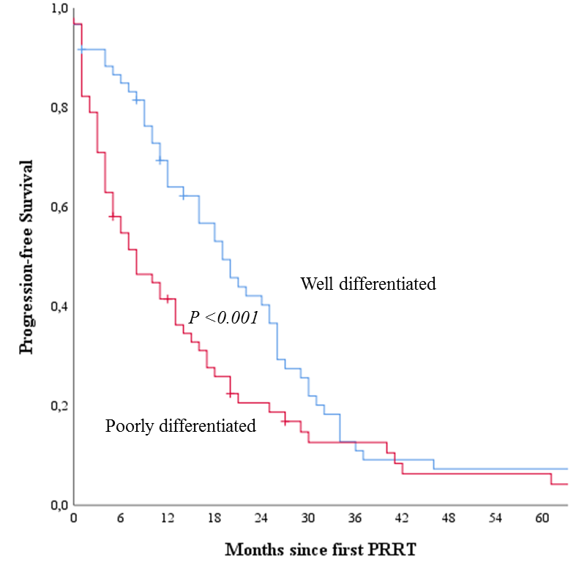
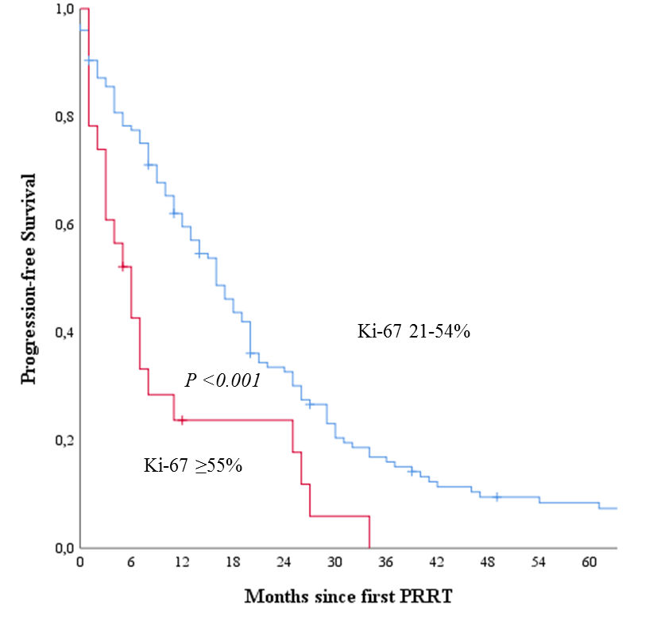

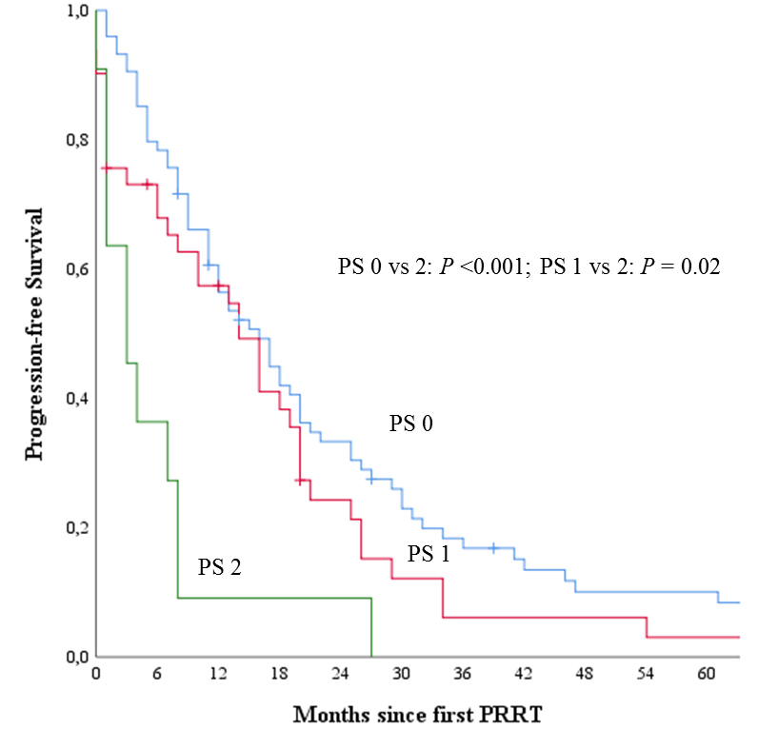
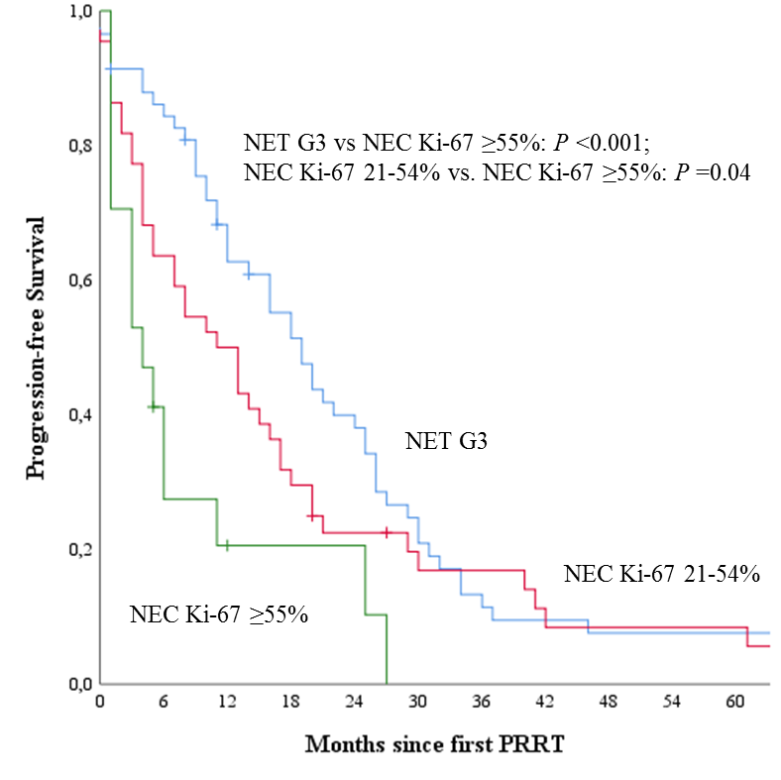

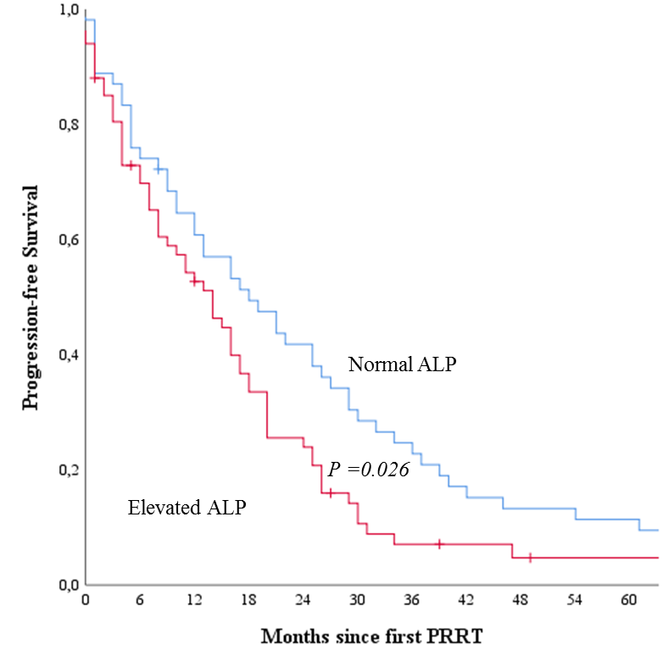
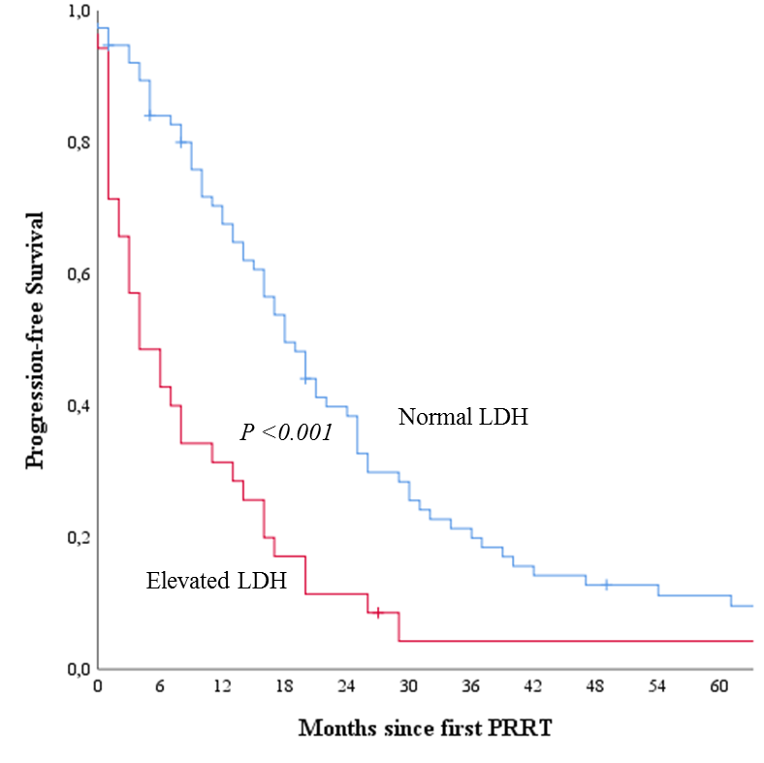

Figure 2. Kaplan-Meier analysis of OS for 149 patients with GEP NEN G3 treated with PRRT. Stratification by Ki-67 index (n=148), differentiation (n=122), performance status (n=126), combined Ki-67 index and differentiation (n=119), LDH (n=111) and ALP (n=121), respectively. P-values shown in figures for statistically significant differences.
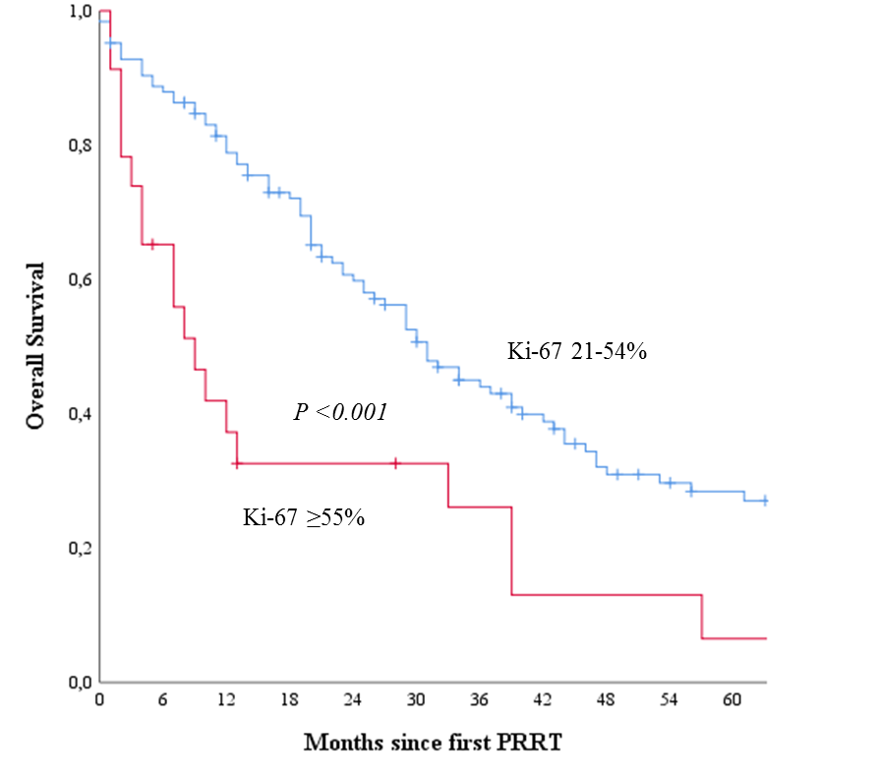
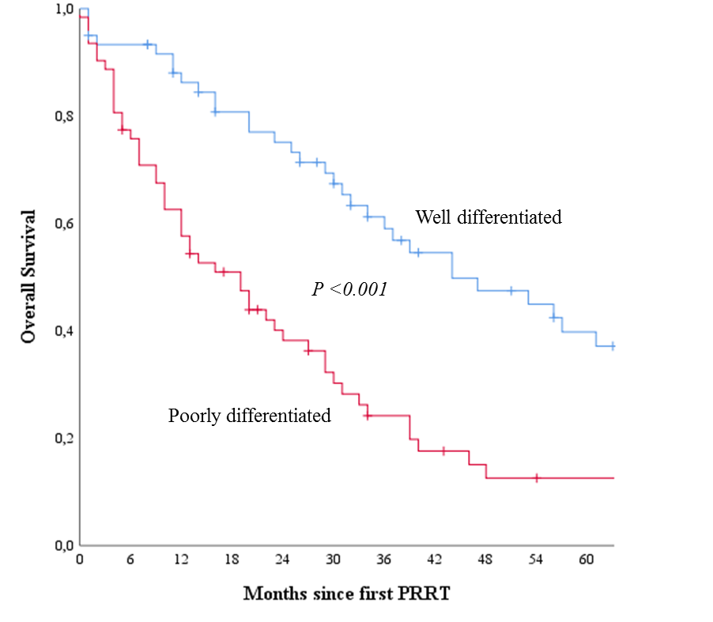

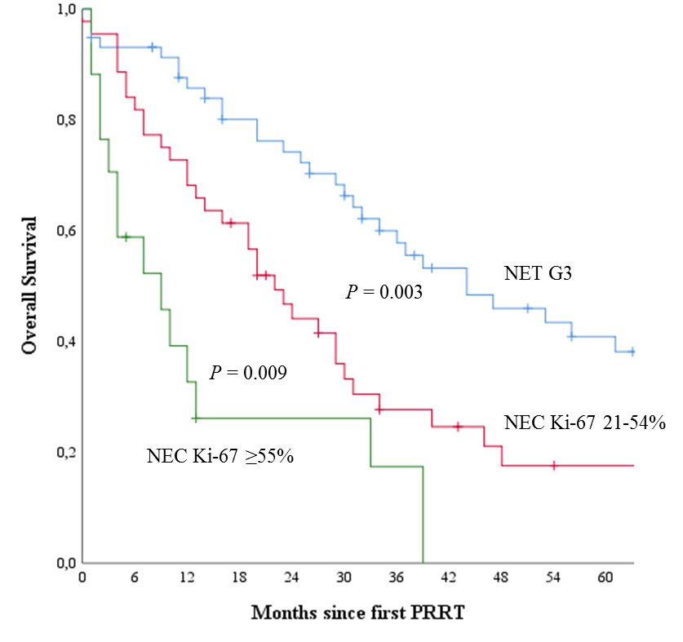
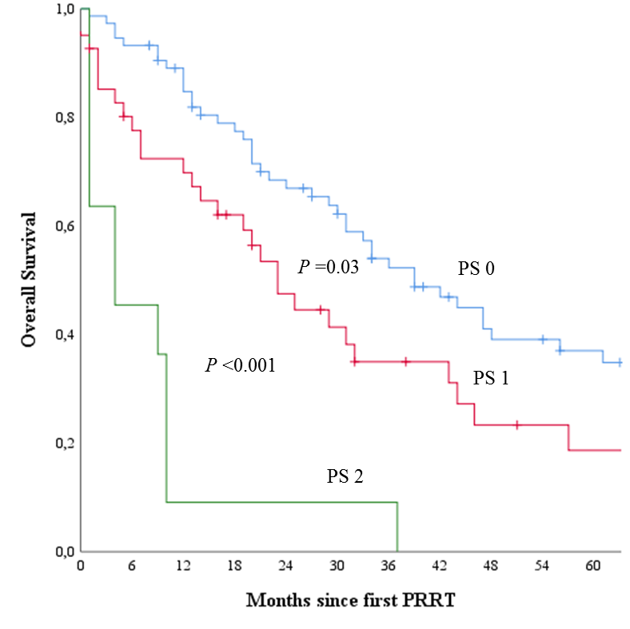

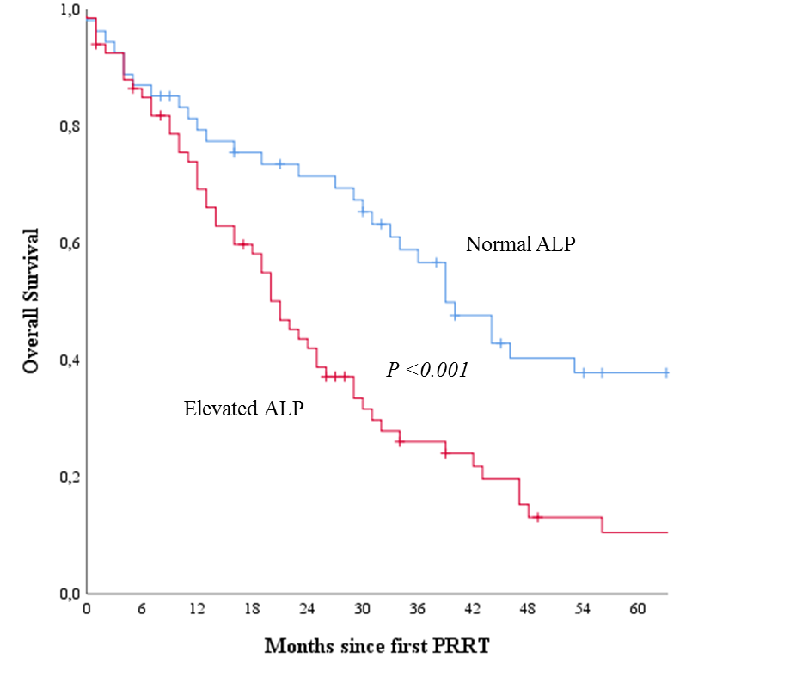
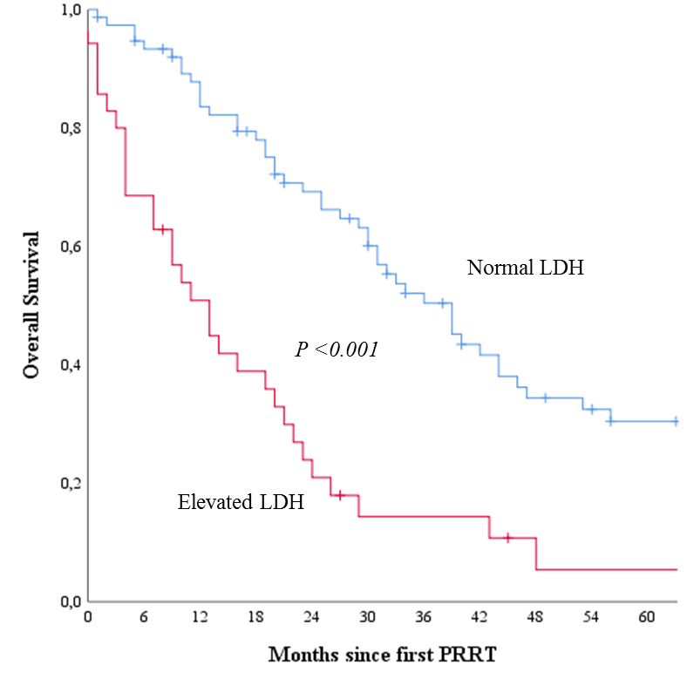
References

1. Bosman FT, Carneiro F, Hruban RH, et al. WHO Classification of Tumours of the Digestive System. 4th ed. Lyon: International Agency for Research on Cancer; 2010.
2. Kloppel G, Couvelard A, Hruban RH, et al. In: Lloyd RV, Osamura RY, Klöppel G, et al., (eds). WHO Classification of Tumours of Endocrine Organs. 4th ed. Lyon: International Agency for Research on Cancer; 2017, 211-214.
3. Garcia-Carbonero R, Sorbye H, Baudin E, et al. ENETS Consensus Guidelines for High-Grade Gastroenteropancreatic Neuroendocrine Tumors and Neuroendocrine Carcinomas. Neuroendocrinology 2016;103(2):186-94.
4. Ilett EE, Langer SW, Olsen IH, et al. Neuroendocrine Carcinomas of the Gastroenteropancreatic System: A Comprehensive Review. Diagnostics (Basel) 2015;5(2):119-76.
5. Sorbye H, Strosberg J, Baudin E, et al. Gastroenteropancreatic high-grade neuroendocrine carcinoma. Cancer 2014;120(18):2814-23.
6. Dasari A, Mehta K, Byers LA, et al. Comparative study of lung and extrapulmonary poorly differentiated neuroendocrine carcinomas: A SEER database analysis of 162,983 cases. Cancer 2018;124(4):807-815.
7. Heetfeld M, Chougnet CN, Olsen IH, et al. Characteristics and treatment of patients with G3 gastroenteropancreatic neuroendocrine neoplasms. Endocr Relat Cancer 2015;22(4):657-64.
8. Sorbye H, Welin S, Langer SW, et al. Predictive and prognostic factors for treatment and survival in 305 patients with advanced gastrointestinal neuroendocrine carcinoma (WHO G3): the NORDIC NEC study. Ann Oncol 2013;24(1):152-60.
9. Walter T, Tougeron D, Baudin E, et al. Poorly differentiated gastro-entero-pancreatic neuroendocrine carcinomas: Are they really heterogeneous? Insights from the FFCD-GTE national cohort. Eur J Cancer 2017;79:158-165.
10. Yamaguchi T, Machida N, Morizane C, et al. Multicenter retrospective analysis of systemic chemotherapy for advanced neuroendocrine carcinoma of the digestive system. Cancer Sci 2014;105(9):1176-81.
11. Kwekkeboom DJ, de Herder WW, Kam BL, et al. Treatment with the radiolabeled somatostatin analog [177 Lu-DOTA 0,Tyr3]octreotate: toxicity, efficacy, and survival. J Clin Oncol 2008;26(13):2124-30.
12. Pfeifer AK, Gregersen T, Gronbaek H, et al. Peptide receptor radionuclide therapy with Y-DOTATOC and (177)Lu-DOTATOC in advanced neuroendocrine tumors: results from a Danish cohort treated in Switzerland. Neuroendocrinology 2011;93(3):189-96.
13. Romer A, Seiler D, Marincek N, et al. Somatostatin-based radiopeptide therapy with [177Lu-DOTA]-TOC versus [90Y-DOTA]-TOC in neuroendocrine tumours. Eur J Nucl Med Mol Imaging 2014;41(2):214-22.
14. Imhof A, Brunner P, Marincek N, et al. Response, survival, and long-term toxicity after therapy with the radiolabeled somatostatin analogue [90Y-DOTA]-TOC in metastasized neuroendocrine cancers. J Clin Oncol 2011;29(17):2416-23.
15. Bodei L, Cremonesi M, Grana CM, et al. Peptide receptor radionuclide therapy with (1)(7)(7)Lu-DOTATATE: the IEO phase I-II study. Eur J Nucl Med Mol Imaging 2011;38(12):2125-35.
16. Strosberg J, El-Haddad G, Wolin E, et al. Phase 3 Trial of (177)Lu-Dotatate for Midgut Neuroendocrine Tumors. N Engl J Med 2017;376(2):125-135.
17. Raj N, Valentino E, Capanu M, et al. Treatment Response and Outcomes of Grade 3 Pancreatic Neuroendocrine Neoplasms Based on Morphology: Well Differentiated Versus Poorly Differentiated. Pancreas 2017;46(3):296-301.
18. Velayoudom-Cephise FL, Duvillard P, Foucan L, et al. Are G3 ENETS neuroendocrine neoplasms heterogeneous? Endocr Relat Cancer 2013;20(5):649-57.
19. Konukiewitz B, Schlitter AM, Jesinghaus M, et al. Somatostatin receptor expression related to TP53 and RB1 alterations in pancreatic and extrapancreatic neuroendocrine neoplasms with a Ki67-index above 20. Mod Pathol 2017;30(4):587-598.
20. Sorbye H, Perren A, Baudin E. The problem of high-grade (WHO 3) gastroenteropancreatic neuroendocrine neoplasms: NET G3, NEC and beyond. Endocrinology and Metabolism Clinics of North America 2018 In press.
21. Thang SP, Lung MS, Kong G, et al. Peptide receptor radionuclide therapy (PRRT) in European Neuroendocrine Tumour Society (ENETS) grade 3 (G3) neuroendocrine neoplasia (NEN) - a single-institution retrospective analysis. Eur J Nucl Med Mol Imaging 2018;45(2):262-277.
22. Milione M, Maisonneuve P, Spada F, et al. The Clinicopathologic Heterogeneity of Grade 3 Gastroenteropancreatic Neuroendocrine Neoplasms: Morphological Differentiation and Proliferation Identify Different Prognostic Categories. Neuroendocrinology 2017;104(1):85-93.
23. Eisenhauer EA, Therasse P, Bogaerts J, et al. New response evaluation criteria in solid tumours: revised RECIST guideline (version 1.1). Eur J Cancer 2009;45(2):228-47.
24. Hadoux J, Malka D, Planchard D, et al. Post-first-line FOLFOX chemotherapy for grade 3 neuroendocrine carcinoma. Endocr Relat Cancer 2015;22(3):289-98.
25. Hentic O, Hammel P, Couvelard A, et al. FOLFIRI regimen: an effective second-line chemotherapy after failure of etoposide-platinum combination in patients with neuroendocrine carcinomas grade 3. Endocr Relat Cancer 2012;19(6):751-7.
26. Olsen IH, Knigge U, Federspiel B, et al. Topotecan monotherapy in heavily pretreated patients with progressive advanced stage neuroendocrine carcinomas. J Cancer 2014;5(8):628-32.
27. Welin S, Sorbye H, Sebjornsen S, et al. Clinical effect of temozolomide-based chemotherapy in poorly differentiated endocrine carcinoma after progression on first-line chemotherapy. Cancer 2011;117(20):4617-22.
28. Olsen IH, Sorensen JB, Federspiel B, et al. Temozolomide as second or third line treatment of patients with neuroendocrine carcinomas. ScientificWorldJournal 2012;2012:170496.
29. Hijioka S, Hosoda W, Matsuo K, et al. Rb Loss and KRAS Mutation Are Predictors of the Response to Platinum-Based Chemotherapy in Pancreatic Neuroendocrine Neoplasm with Grade 3: A Japanese Multicenter Pancreatic NEN-G3 Study. Clin Cancer Res 2017;23(16):4625-4632.
30. Lamarca A, Walter T, Pavel M, et al. Design and Validation of the GI-NEC Score to Prognosticate Overall Survival in Patients With High-Grade Gastrointestinal Neuroendocrine Carcinomas. J Natl Cancer Inst 2017;109(5).
31. Nicolini S, Severi S, Ianniello A, et al. Investigation of receptor radionuclide therapy with (177)Lu-DOTATATE in patients with GEP-NEN and a high Ki-67 proliferation index. Eur J Nucl Med Mol Imaging 2018;45(6):923-930.
32. Hicks RJ, Kwekkeboom DJ, Krenning E, et al. ENETS Consensus Guidelines for the Standards of Care in Neuroendocrine Neoplasia: Peptide Receptor Radionuclide Therapy with Radiolabeled Somatostatin Analogues. Neuroendocrinology 2017;105(3):295-309.
33. Binderup T, Knigge U, Loft A, et al. Functional imaging of neuroendocrine tumors: a head-to-head comparison of somatostatin receptor scintigraphy, 123I-MIBG scintigraphy, and 18F-FDG PET. J Nucl Med 2010;51(5):704-12.
34. Kashyap R, Hofman MS, Michael M, et al. Favourable outcomes of (177)Lu-octreotate peptide receptor chemoradionuclide therapy in patients with FDG-avid neuroendocrine tumours. Eur J Nucl Med Mol Imaging 2015;42(2):176-85.
35. Basturk O, Yang Z, Tang LH, et al. The high-grade (WHO G3) pancreatic neuroendocrine tumor category is morphologically and biologically heterogenous and includes both well differentiated and poorly differentiated neoplasms. Am J Surg Pathol 2015;39(5):683-90.
36. Tang LH, Basturk O, Sue JJ, et al. A Practical Approach to the Classification of WHO Grade 3 (G3) Well-differentiated Neuroendocrine Tumor (WD-NET) and Poorly Differentiated Neuroendocrine Carcinoma (PD-NEC) of the Pancreas. Am J Surg Pathol 2016;40(9):1192-202.

