Catalysts for CO₂/Epoxide Ring-Opening Copolymerisation
G. Trott,† P. K. Saini† and C. K. Williams*
Department of Chemistry, Imperial College London, Exhibition Road, London, SW7 2AZ, UK.
Keywords: Catalysis, Polycarbonate, Ring-Opening Copolymerisation, CO₂

*Author for correspondence (c.k.williams@imperial.ac.uk).
†Joint First Authors

Summary

The article summarizes and reviews recent progress in the development of catalysts for the ring-opening copolymerization of carbon dioxide and epoxides. The copolymerization is an interesting method to add-value to carbon dioxide, including from waste sources, and to reduce pollution associated with commodity polymer manufacture. The selection of the catalyst is of critical importance to control the composition, properties and applications of the resultant polymers. This review highlights and exemplifies some key recent findings and hypothesis, in particular using examples drawn from our own research.

Main Text
The ring-opening copolymerisation (ROCOP) of carbon dioxide and epoxides is an interesting method to synthesise a range of aliphatic polycarbonates (Figure 1).[1-5] The reaction was discovered more than forty years ago and has since continued to attract attention as a means to reduce pollution associated with polymer manufacture and to ‘add-value’ to carbon dioxide.[1] It should be made clear that the use of CO₂ in any chemical manufacturing process is unable to make a large impact on overall CO₂ levels in the atmosphere. However, it remains important to pursue CO₂ utilisation as a means to reduce emissions, particularly those associated with existing, large-scale industrial processes and as an economic driver to support carbon capture.[6, 7] The ROCOP process is strongly dependent on the selection of the catalyst, with various homogeneous and heterogeneous catalysts having been reported.[5, 8-15] The focus for this review article will be to highlight and exemplify some of the key findings in this area of catalysis, in particular using examples drawn from our own research. The intention is not to provide a comprehensive review of all known catalysts; indeed, such reviews are already available.[5, 8-15]
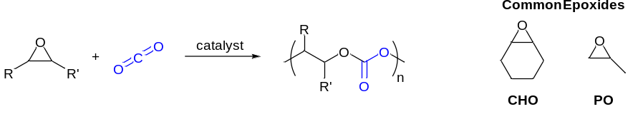

Figure 1: Illustrates the ring-opening copolymerisation (ROCOP) of carbon dioxide and epoxides to produce aliphatic polycarbonates.
The ROCOP reaction is a rare example of a truly catalytic process with the potential to deliver large-scale quantities of product, which genuinely consumes carbon dioxide. The most commonly studied epoxides are cyclohexene oxide (CHO) and propylene oxide (PO). Depending on the epoxide and the selectivity of the catalyst, up to 31 % (polycyclohexene carbonate) or 43 % (polypropylene carbonate) of the polymer mass derives from CO₂. The primary application for the polymer products is as low molecular weight (M_{n}) , (poly)hydroxyl terminated ‘polyols’ which are widely used in the manufacture of polyurethanes.[16] Polyurethanes themselves are applied as flexible/rigid foams, adhesives, coatings, elastomers, as well as in many other areas. It has been shown that the properties of CO₂-derived polyols are suitable to replace polyether polyols in some applications.[16, 17] Given that polyether polyols are prepared by epoxide homopolymerisation, the ROCOP of CO₂ and epoxides can also be viewed as a means to ‘replace’ a substantial portion of petrochemically derived (epoxide) with a renewable resource (CO₂). A recent detailed life-cycle-analysis (LCA) study compared these two types of polyols, showing significant reductions (~20 %) in both fossil resource depletion and greenhouse gas emissions for the CO₂ derived polymers.[18]

Furthermore, the replacement of fossil-derived epoxides is economically attractive and is stimulating a number of commercialisation studies.[16, 19, 20] It has also recently been demonstrated that ROCOP catalysts are compatible with carbon capture and storage processes.[21] Studies have shown that some homogeneous magnesium catalysts can be used in polymerisations where the carbon dioxide is captured at a CCS demonstrator plant attached to a UK power station. The catalysts showed near-equivalent performances using such captured gases compared to using ‘pure’ carbon dioxide. Furthermore, the catalyst showed a high tolerance to various impurities present in captured CO₂, including water, N₂, CO, thiols, amines.[21]

Polymerisation Pathways and Mechanisms
A range of different catalysts are known but all catalysts contain metals, with Zn(II), Co(III) and Cr(III) being particularly common.[5, 8-14] Prior to an examination of these catalysts, it is worth considering the series of reactions which are proposed to occur at the metal active site during polymerisation, the major ones are illustrated in Figure 2 [3] The polymerisation is initiated by coordination of an epoxide molecule and the subsequent ring-opening by the nucleophilic attack of a carbonate group or ligand (X), so as to form a metal-alkoxide intermediate. During chain propagation, carbon dioxide inserts into the metal-alkoxide intermediate to form a metal carbonate species. The metal coordinates another molecule of epoxide and nucleophilic attack by the carbonate group leads to the ring-opening of the epoxide and formation of a new metal-alkoxide species. Propagation therefore involves the ‘cycling’ between metal-alkoxide and carbonate intermediates. The polymerisation is terminated by exposure to conditions/reagents which lead to hydrolysis of the growing polymer chain and formation of a polymer chain end-capped with a hydroxyl group.
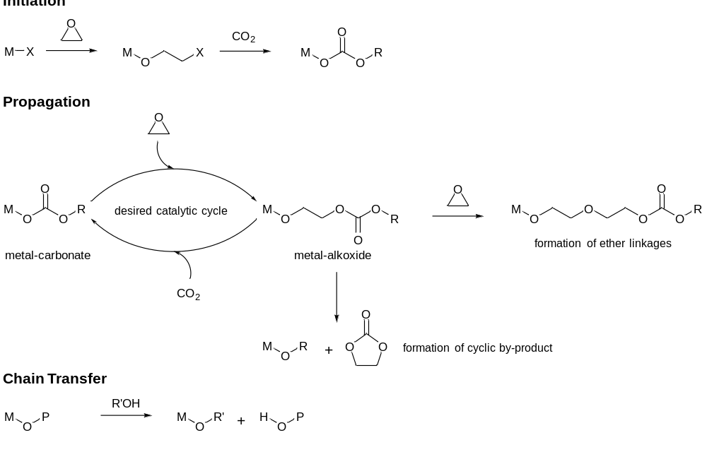
Figure 2: Catalytic cycle of CO₂/epoxide copolymerisation.
There are also side-reactions within this process, the proportions of which depend on the conditions, substrate and catalyst selected. The formation of ether linkages in the polymer chain can occur due to the occurrence of a metal-alkoxide attack on an epoxide molecule instead of CO₂ insertion. Such linkages change the polymer properties, which may be beneficial depending on the application, but nevertheless reduce the CO₂ sequestered in the polymer backbone.[16, 17]

Five membered ring cyclic carbonate by-products can also form; indeed this is the thermodynamic product of the reaction between CO₂ and epoxides and thus favoured under forcing conditions. The cyclic carbonates can form by de-polymerisation or ‘back-biting’ reactions, the extent of these depend on the catalyst and the ceiling temperature for the given polymer.[22, 23] The cyclic carbonates can also form ‘off-metal’ and are particularly common, and sometimes problematic, contaminants when co-catalysts or ionic additives are applied.[5, 13] For some types of catalyst, most commonly with metal salen catalysts, it is proposed that the addition of ionic co-catalysts leads to the polymer chains being in equilibrium between metal-coordination and ‘free’ anionic polymer chains.[5] Such ‘off-metal’ chains have been shown to undergo cyclisation to form cyclic carbonate by-products.[24]

Chain transfer reactions also need to be considered. These reactions occur when the polymerisations are conducted under so-called ‘immortal’ conditions in the presence of protic compounds, such as alcohols, amines and water, amongst others.[25-28] When such protic reagents are present, the metal-alkoxide terminated polymer chain is proposed to be in rapid exchange with the protic reagent, generating metal alkoxides and ‘free’ hydroxyl terminated polymer chains. The chain transfer processes are proposed to occur more rapidly than propagation, leading to highly controlled polymerisations where the M_{n} of the polymer is determined by both the catalyst and chain transfer agent (protic reagent) concentrations. It is worth noting that in ROCOP, the polycarbonate M_{n} is commonly experimentally observed to be rather lower than those expected for living polymerisations (where the M_{n} would depend only on the catalyst concentration).[26] This is due to the presence or formation of chain transfer agents, such as diols, in the epoxide monomers used.[29-33] In fact, the exploitation of catalysts able to operate under immortal polymerisation conditions, i.e. where such chain transfer agents are added in larger excess compared to the catalyst, is essential to selectively prepare the polyols which are required in polyurethane manufacture.[18, 21, 25]

The catalysts for ROCOP have some general features, the metals are Lewis acids, the metals redox reactivity should be limited, the metal alkoxide and carbonate intermediates are labile and initiating ligands (X) include alkoxides, carboxylates, halides and other anionic groups.[5, 8-14] It is common in this area of catalysis that dinuclear or bimetallic catalysts show good performances and bimetallic pathways are proposed to accelerate epoxide ring-opening.[10] Finally, the polymerisation catalysts should ideally be colourless, odourless, inexpensive and have low-toxicity as they may contaminate the polymer product. In this context, there have been a number of reports of strategies to remove and recycle homogeneous catalysts.[34-36]

Heterogeneous catalysts
The two major classes of heterogeneous catalysts are zinc glutarate (or other carboxylates) and double metal cyanides.[4, 37-53] Both are well-known, and in some cases industrially applied, as epoxide homopolymerisation catalysts.[53] For copolymerisations using carbon dioxide, these heterogeneous catalysts require much more forcing conditions than homogeneous species. In particular, high pressures of carbon dioxide are necessary and perfectly alternating enchainment does not occur but rather ether enriched polycarbonates are produced.

Zinc glutarate has been extensively studied, two features stand-out that increase activity: 1) the addition of ethylsulphinate groups and 2) an increase in crystallinity of the catalyst.[4, 37-45] The most commonly studied double metal cyanide catalyst is Zn₃(CoCN₆)₂ (Figure 3), although mixed Zn/Fe(III) species are also reported. These catalysts are typically applied as part of mixtures with so-called ‘complexation’ agents, including salts, alcohols and solvents.[46-53] They generally show very high activities but low CO₂ uptakes, indeed, they commonly yield poly(ether carbonates) rather than perfectly alternating copolymers. Studying the mechanisms of such heterogeneous catalysts is very challenging, nevertheless, theoretical and experimental studies have led to the proposal that bimetallic polymerisation processes are important. In particular one study proposes that the active sites in zinc carboxylates should be separated by 4-5 Å.[45]

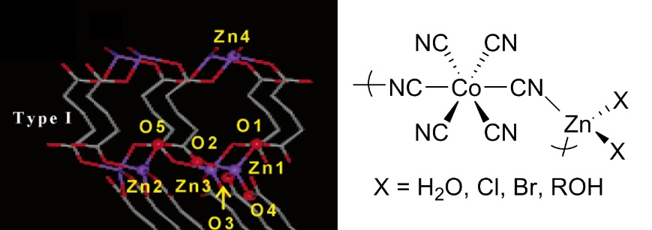
Figure 3: Illustrates one of the crystal structures for zinc glutarate and a generic illustration of the structure of the repeat unit in zinc-cobalt double metal cyanide catalysts. Reprinted with permission from reference [39]. Copyright (2004) American Chemical Societ.

Homogeneous catalysts
The common homogeneous catalysts can be classified into two broad types:

1) Bicomponent catalyst systems comprising metal(III) complexes used with co-catalysts. The catalysts are usually complexes of Co(III), Cr(III), Mn(III) or Al(III) coordinated by ligands such as salens or porphyrins. The co-catalysts are typically ionic compounds, the most common of which is bis(triphenylphosphine)iminium chloride (PPNCl) or Lewis bases, commonly 4-dimethylaminopyridine (DMAP).

2) Dinuclear or bimetallic catalysts comprising metal(II/III) complexes, most commonly these are complexes where two metals are coordinated by tethered ‘mononucleating’ ligands, such as Zn(II) β-diiminates (BDIs) or tethered Co(II)/Cr(III) salens. There are also examples of deliberately dinucleating ligands, such as macrocyclic ligands coordinated to Zn(II), Mg(II), Co(II/III) or Fe(III).

Most homogeneous catalysts operate under moderate/high pressures of CO₂, and usually require
> 10 bar pressure, but in contrast to heterogeneous catalysts, they do yield highly alternating copolymers.[15, 54-58] In a drive to change the polymerisation process conditions, catalysts have now been developed which show high activities and perfectly alternating enchainment under low pressures of carbon dioxide, including at 1 bar pressure.[59-61]

Bicomponent Catalysts
These catalysts are used with an exogeneous co-catalyst or, more recently, have the co-catalyst attached to the ancillary ligand scaffold.[5, 33, 62-64] The ligands are usually planar, tetradentate, dianionic compounds such as salens or porphyrins. The commonly used co-catalysts are ionic salts, such as PPNX and ammonium halides. The structures of typical catalysts in this class are illustrated in Figure 4.[5, 33, 62-64]
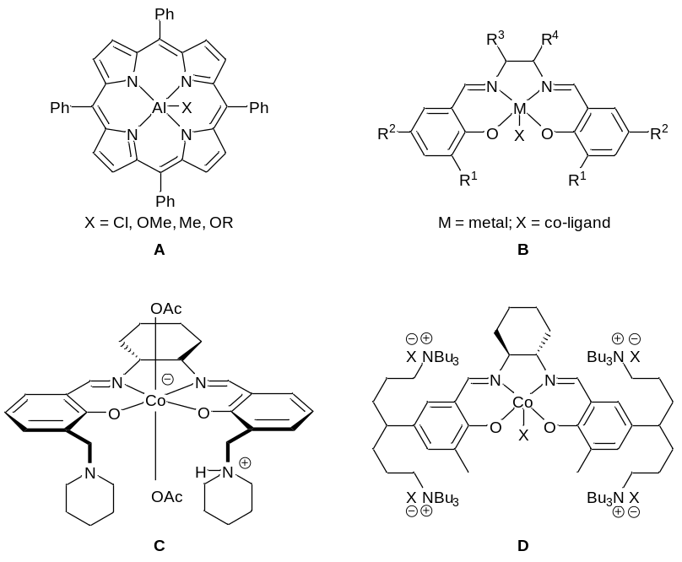
Figure 4: Bicomponent catalysts for CO₂/epoxide copolymerisation. A) general porphyrin structure;[33, 54, 64-66] B) general salen structure;[56, 58, 67] C) bifunctional salcy complex tethered to piperidinium moieties;[68] D) bifunctional salen complex tethered to quaternary ammonium groups.[34]
The first well-defined homogeneous catalysts were metal(III) porphyrin complexes (e.g. structure A, Figure 4), which in combination with an ionic salt allowed the controlled ROCOP of CO₂/epoxide.[69] There have subsequently been several studies to elucidate the influences of various ligand substituents and metal centres, which revealed that Co(III) centres coordinated by porphyrin ligands, substituted with electron withdrawing groups showed the best performances.[33, 54, 64, 65, 70-77] However in general, metal porphyrin catalysts have lower activities and productivities compared to metal salen catalysts.

Catalysts based on salen ligands (B, Figure 4) are some of the most active catalysts for CO₂/epoxide copolymerisations.[5] Darensbourg,[5, 23, 63, 78-81] Coates,[15, 32, 56, 82, 83] Lu,[84-90] Nozaki,[29, 68, 91-93] Lee,[30, 31, 34, 94-97] Rieger,[67, 70, 98-100] and others have led the development of various [salenMX] complexes (where M = Cr(III), Co(III), Al(III)), many of which show very high rates and selectivities. Coates pioneered the application of chiral [Co(salen)] complexes as highly active CO₂/propylene oxide ROCOP catalysts; this class of chiral cobalt salen catalysts has been extensively investigated by a number of groups and they now show outstanding levels of regio- and stereochemical control.[2, 32, 56] Indeed, they have been applied in the preparation of entirely new classes of stereocomplex polycarbonates, starting from racemic mixtures of epoxides.[82-84, 92]

The nature of the co-catalyst is also important, as mentioned PPNX salts are widely applied. Furthermore, the amount of co-catalyst is generally optimum at 1 equivalent (vs. metal complex) as greater quantities reduce activity. This is proposed to be due to competitive binding (vs. epoxide) at the metal centre.[101, 102] Using > 1 equivalent of co-catalyst also increases the rate of back biting side reactions to form cyclic carbonate products.[5, 58, 102, 103] The co-catalyst serves a number of roles in the catalytic cycle. It is proposed that the co-catalyst binds to the metal complex in order to complete an octahedral coordination geometry and, by trans-coordination, enhances the labilisation of the initiating or propagating group.[5] Additionally, the co-catalyst may act as an external nucleophile which initiates polymerisation. The precise mechanisms by which such catalysts operate are rather complex and not yet fully defined, but it is generally proposed that the rate limiting step involves epoxide ring-opening rather than carbon dioxide insertion.[5]

Recent kinetic studies have revealed that the polymerisation rates, using metal salen catalysts, are typically dependent on catalyst concentration to a fractional order, usually between 1 and 2.[91] This is indicative of pathways involving two metal complexes and/or dimerisation in the rate limiting step. Figure 5 illustrates the two different proposed pathways for epoxide ring-opening. The fractional orders in catalyst concentration could be rationalised if both pathways are feasible and occurring concurrently. Significant work has also been carried out to investigate the coordination of epoxides to such catalysts.[104-106] The gas phase binding of epoxides in Al(III) and Cr(III) salen and porphyrin complexes was studied by Chisholm and co-workers and found to follow metal Lewis acidity trends.[105] Darensbourg also showed that the ring-opening of epoxides by a nucleophile was dependent on the metal-epoxide bond length and the binding enthalpies, not solely on the rate at which epoxide binding occurred.[106] It is worth noting that the coordination of co-catalysts change the Lewis acidity of the metal centre and so would affect epoxide binding.[107]

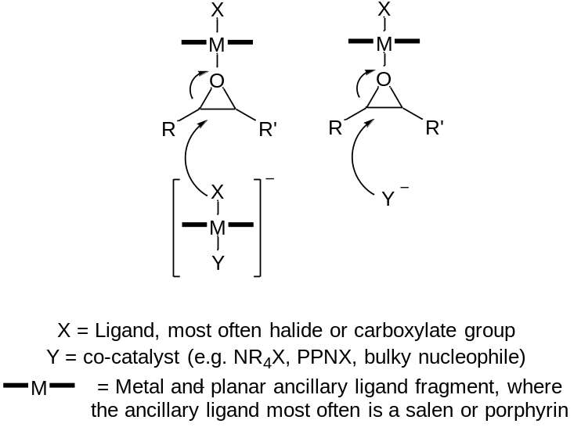

Figure 5: Illustrates possible pathways for epoxide ring-opening by the bicomponent catalysts.
Recently, Nozaki and co-workers demonstrated a theoretical model to predict the catalytic activity and selectivity, in propylene oxide ROCOP using planar bicomponent catalysts.[91] By comparing the difference between the dissociation energies for metal -epoxide, -carbonate and -alkoxide intermediates, the preferred pathway at each stage of the catalytic cycle could be quickly estimated.[91]

One challenge of exogeneous co-catalysts is that if the stoichiometry (vs. catalyst) is not finely balanced, significant side-reactions to produce cyclic carbonate can result. Furthermore, because the systems are bi-component, low catalyst loadings are not generally feasible. Finally, the fractional orders in catalyst imply that dimerisation may be necessary, thereby providing an entropic barrier to catalysis at low metal loading. Two strategies have been used to overcome these limitations: 1) the development of catalysts whereby the co-catalyst is attached to the ancillary ligand and 2) the development of dinuclear salen catalysts.

Increased activities, tolerance and selectivities were observed by covalently bonding the co-catalyst moiety to the catalyst ligand, removing the need to add an exogenous co-catalyst source. Nozaki first reported this phenomenon for a Co(III) salen complex, substituted with piperidinium ‘arms’ (C, Figure 4).[68] This catalyst showed very high selectivity for carbonate formation (˃ 99 %), a high TOF (250 h⁻¹) and operated at room temperature, under 14 bar pressure of CO₂.[68] Lee subsequently also developed various bifunctional catalysts (D, Figure 4) substituted with ionic groups, which have shown some of the highest activities (TOF = 26000 h⁻¹) ever reported and which are active under low catalyst loadings (1:25000, Catalyst:PO).[30, 31, 34] Lu has also shown a cobalt salen complex with a tethered quarternary ammonium salt is highly efficient (TOF up to 5160 h⁻¹) for the terpolymerisation of cyclohexene oxide with a range of aliphatic epoxides (such as PO) and CO₂.[108]

Dinuclear or Bimetallic Catalysts
An important development for the field was the report from Coates, in 1998, of highly active zinc β-diiminate (BDI) catalysts.[109] These catalysts have shown good activity and selectivity for CO₂/CHO ROCOP, at 50 °C and 7 bar pressure of CO₂. A wide range of [(BDI)ZnX] complexes have since been synthesised where ligand substituents exert a strong effect on activity (E, Figure 6).[109-113] In a land-mark paper investigating the mechanism it was shown that the most active catalysts existed as ‘loosely associated’ dimers under the polymerisation conditions.[57] Rate studies revealed the order in zinc varied from 1.0 to 1.8, implicating dimeric active sites.[57]

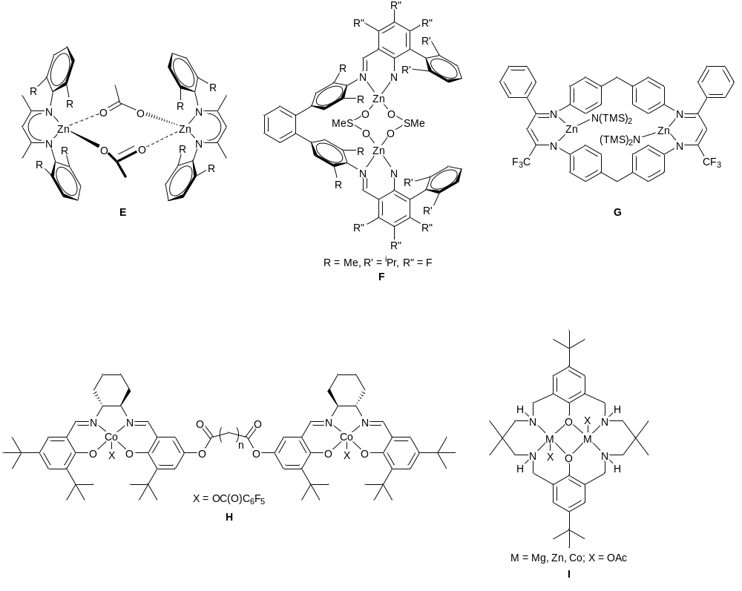
Figure 6: Dinuclear catalysts for CO₂/epoxide copolymerisation: E) zinc β-diiminate (BDI) complex;[57] F) zinc bis(anilido-aldimine) catalysts;[114] G) tethered zinc BDI complex;[115] H) tethered cobalt salen complex;[93] I) dinuclear macrocyclic catalyst.[116]

This study has inspired many others to develop dinuclear catalysts so as to increase activity and selectivity. Lee pioneered this with a series of bis(anilido-aldimine) Zn(II) complexes which showed high activities (TOF = 2860 h⁻¹) in copolymerisation, at 1:50000 [Zn]:[epoxide] loadings (F, Figure 6).[114] The activity is sensitive to the N-aryl ortho-substituents and the fluorination of the aromatic rings significantly increased the TOF values.[114] Many researchers have investigated methods to ‘tether’ Zn(II) β-diiminate catalysts.[115, 117-119] The geometry, site and flexibility of the tether exerts a significant influence over the activity, the best system for CO₂/CHO being a dinuclear Zn(II) catalyst (G, Figure 6) which showed TOF values of 155 000 h^{–1}, at 100 °C and 30 bar.[115, 118, 119]

Nozaki and Rieger have investigated the tethering together of two salen ligands (H, Figure 6) so as to target dinuclear catalysts.[93, 99] When no co-catalyst was used, these catalyst operated via a bimetallic mechanism and showed improved performances, (6 to 11 times better than the monometallic counterparts). Additionally, these catalysts were able to operate at low catalyst loadings (up to 20000, epoxide/catalyst), supporting the notion that two metal sites may be involved in the pathway.[93, 99]

Our research group have focussed on dinuclear catalysts coordinated by macrocyclic diphenolate ancillary ligands for CO₂/CHO ROCOP.[21, 27, 61, 116, 120-131] The di-zinc catalyst (I, Figure 6) was the first catalyst to show promising activity under 1 bar pressure of CO₂.[61] Subsequently, we have explored a range of ligands, metals and co-ligands, including the first reports of active Fe(III) and Mg(II) catalysts for ROCOP.[21, 27, 61, 116, 120-130] Changing the metal centre significantly affects the polymerisation rates, with the order of activity being Co(III) > Mg(II) > Fe(III) > Zn(II) using the same symmetrical ancillary ligand.[21, 27, 61, 116, 120-130] Kinetic studies of CO₂/epoxide ROCOP, using the di-zinc acetate complex, showed a first order dependence in cyclohexene oxide and catalyst concentrations and zero order dependence in CO₂ (1-40 bar).[126]

Furthermore, the detailed analysis of the temperature dependence of the rate coefficients for both polymerisation and cyclic carbonate formation enables a comparison of the relative barriers for polymerisation (PCHC) vs. cyclic carbonate formation, the results of which are qualitatively illustrated in Figure 7.[126] It is apparent that the di-zinc catalyst shows a high selectivity for polymer formation due to the barrier to polymerisation being approximately half the value for cyclic carbonate formation (E_{a} (PCHC) of 96.8 kJ mol⁻¹ and E_{a} (CHC) of 137.5 kJ mol⁻¹).

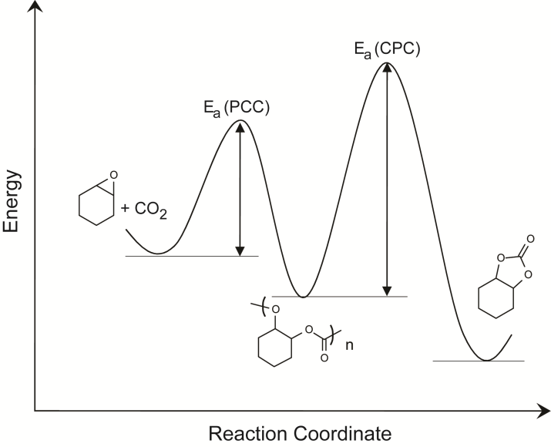
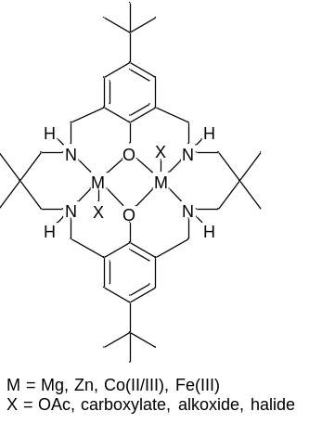

Figure 7: Illustrates the different reaction energy barriers to the formation of PCHC vs. cyclic carbonate. As part of the full kinetic analysis of the polymerisation, the relative barriers were determined to be E_{a} (PCHC) of 96.8 kJ mol⁻¹ and E_{a} (CHC) of 137.5 kJ mol⁻¹. Reprinted with permission from reference [126]. Copyright (2011) American Chemical Society.
The rate law shows a zero order dependence of carbon dioxide pressure (1-40 bar) which suggests that, under these conditions, the ring-opening of the epoxide is rate determining. The first order catalyst dependence also supports the proposal of dinuclear propagation pathways. Although the catalyst is dinuclear, it also has two acetate co-ligands and therefore could potentially initiate two polymer chains per catalyst.[125] The polymerisation kinetics show first order dependences on both catalyst and epoxide concentrations which implies that only one acetate co-ligand initiates polymerisation, although more complex pathways cannot be ruled out on the basis of the rate law. This led to further investigations into the possible roles for the co-ligands.

A series of di-cobalt halide catalysts were prepared, with various neutral co-ligands being coordinated to them, including pyridine, methyl imidazole and DMAP (Figure 8 and 9).[124] The complexes all showed closely related solid state structures, with the ancillary ligand adopting a ‘bowl’ conformation whereby the NH substituents occupy the same ‘face’ of the molecule. In the concave face of the molecule, a halide ligand bridges the two cobalt centres. On the opposite convex face, a halide and Lewis base donor molecule coordinate to the cobalt centres (Figure 8). It was discovered that the complexes showed rates strongly dependent on the nature of the donor ligand, with DMAP complexes having low activities and those coordinated by the weaker pyridine donor being equivalently active to catalysts without any co-ligand coordination. The finding that coordination of a single DMAP molecule could significantly slow the catalysis, supported the notion that polymerisation dominates from the convex face of the molecule and that two metals are involved.

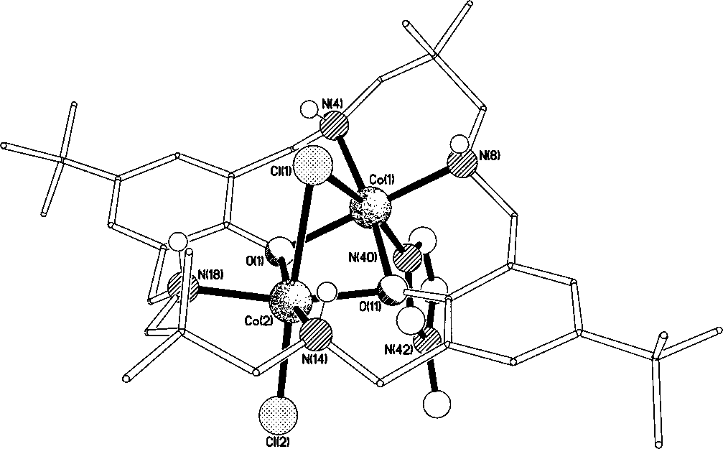

Figure 8: Illustrates the structure, as determined using X-ray crystallography, of the di-cobalt catalyst [LCo₂Cl₂(methyl imidazole)]. The ‘bowl’ shape to the ligand is notable in the structure as are the two faces. The convex face refers to the outside of the ‘bowl’ (i.e where Cl and MeIm are coordinated) and the concave face refers to the inside of the ‘bowl’ (i.e. where the bridging Cl ligand is coordinated). Figure reproduced, with permission from reference [124].
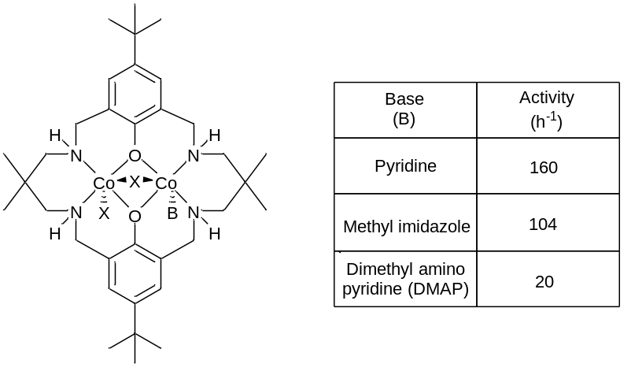

Figure 9: Illustrates the structures of the di-Co(II) complexes and the corresponding activities in the copolymerisation of CO₂/cyclohexene oxide. Polymerisation conditions: CHO:Catalyst = 1000:1, 80 °C, 1 bar CO₂.[124]
A detailed spectroscopic and DFT study also shed light on the polymerisation pathways and key intermediates.[125] Using in situ ATR-IR spectroscopy to characterise the reaction between di-zinc acetate complex and cyclohexene oxide, showed that there were different environments for the acetate co-ligand. One of the acetate groups shows resonances consistent with attack at the cyclohexene oxide group, whilst the other has a resonance consistent with it maintaining a ‘bridging’ coordination mode between the two zinc centres.

The DFT study, carried out in solution, using appropriate functionals to model the polar environment, and using the complete catalyst structure, also substantiated the proposal that although both metals are involved in propagation, only one of the two co-ligands initiates and propagates polymerisation. The remaining co-ligand remains coordinated to the metal centres and mediates the polymerisation process. Indeed, it was revealed by DFT that the polymer chain ‘switches’ coordination site between the two metal centres with each monomer insertion (epoxide or carbon dioxide). The chain shuttling is counter-balanced by an equal but opposite change in coordination site for the acetate co-ligand. It was shown that by changing the co-ligand, it was possible to alter the rate of polymerisation and DFT could be used to predict activity.[125]

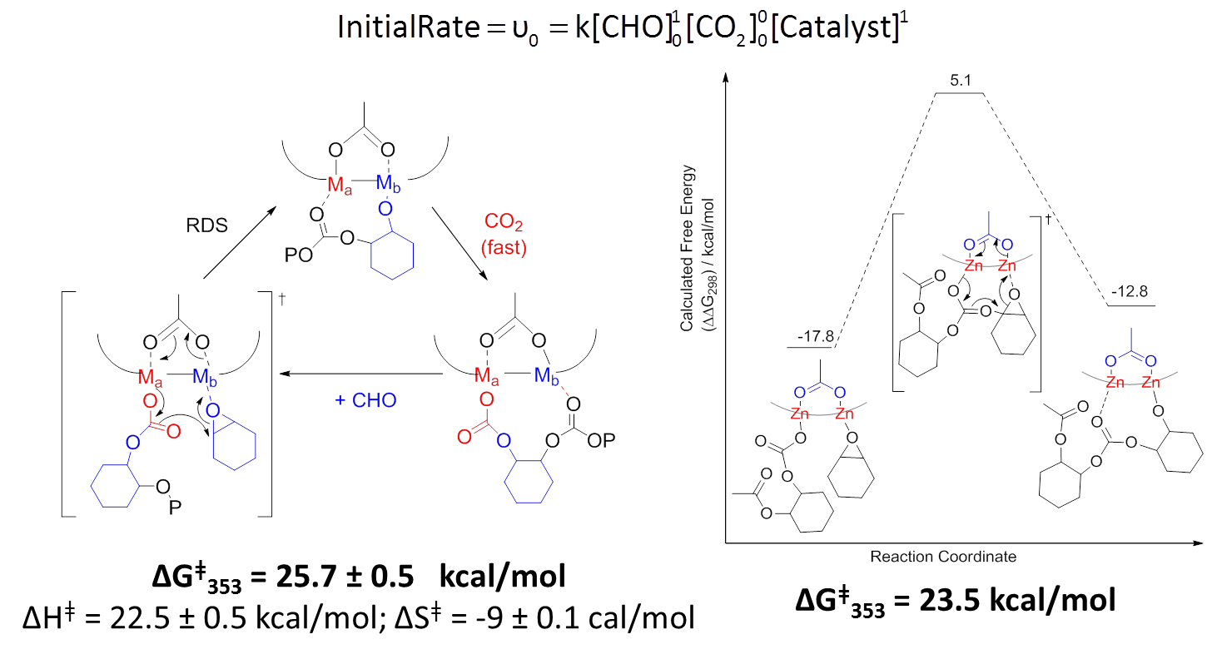
Figure 10: Compares the experimentally determined free energy barrier (left) to polymerisation with the value determined by DFT (right).[125]
The chain shuttling mechanism implies there are distinct roles for the two metal centres, as sketched in Figure 10. Thus, one of the metal centres (illustrated in blue above) coordinates the epoxides, whilst the other centre (illustrated in red) inserts carbon dioxide. The requirements for these processes are distinct, with epoxide coordination being accelerated by Lewis acidic/electrophilic metal centres, whilst the carbonate formation and attack step is favoured by metals showing labile carbonate groups. Such a mechanism would be expected to be improved by having distinct metals serving the two roles and thus provided an impetus to study heterodinuclear catalysts.

In 2014, our group have reported the first example of such a system.[122] The catalyst is a mixture of compounds, including both homodinuclear complexes and the heterodinuclear complex. Figure 11 compares the activity and productivity of this catalyst mixture, the homodinuclear complexes alone and in a 50:50 combination. It is clear that the mixture containing the heterodinculear catalyst shows an activity which is greater than either of the homodinuclear complexes, or combinations of them. This finding provides the first evidence, albeit of a mixture of components, that heterodinuclear complexes are worth investigation in this field of catalysis.[122]

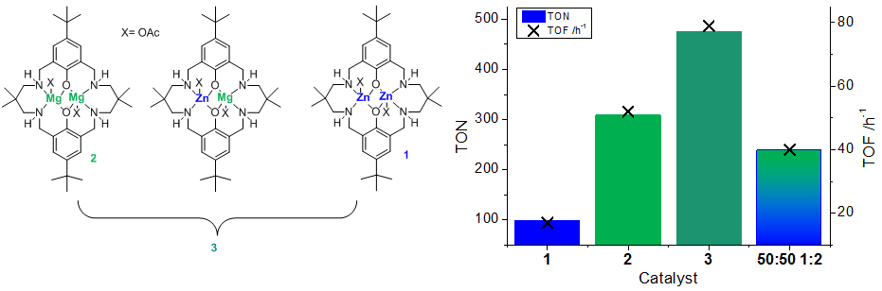
Figure 11: Illustrates the structures of di-zinc (1), di-magnesium (2), the heterodinuclear mixed catalyst system (3) which were compared for the ROCOP of CO₂/CHO.[122]

Conclusions
The ROCOP of carbon dioxide and epoxides provides a useful means to reduce pollution, consume carbon dioxide and to produce aliphatic polycarbonates. Low M_{n}, hydroxyl end-capped, polycarbonate polyols are emerging as useful materials for the production of higher polymers, notably polyurethanes. There remains significant opportunities and challenges to understand and optimise the material properties of the polymers depending on the catalyst and raw materials available.

Catalysis plays a key role in the success and scope of this reaction. The selection of the catalyst is central to being able to control features such as the rate, productivity, selectivity, regio-/stereo-chemistry, polymer molecular weight, polymer end-groups, polymer composition and to produce block copolymers. So far, several successful heterogeneous and homogeneous catalyst types have been studied. A common theme is that the pathways are often proposed to occur via dinuclear or bimetallic routes, whereby one metal activates the epoxide, whilst the other metal provides the nucleophile (carbonate) to attack and ring-open the epoxide. Thus, recently a number of improvements to catalyst rate and selectivity have been achieved by targeting structures which optimise the coordination chemistry of dinuclear catalysts. The discovery and further development of dinuclear and bimetallic homo- and heterogeneous catalysts is an important area for future research.

Additional Information
Funding Statement
The Engineering and Physical Sciences Research Council (EPSRC) are acknowledged for funding (EP/K035274/1; EP/K014070/1; EP/K014668; EP/L017393/1).

Competing Interests
CKW is a director and CSO of econic technologies.

Authors' Contributions
All authors have contributed to the review article.

References
1. Inoue S., Koinuma H., Tsuruta T., 1969, Copolymerization of carbon dioxide and epoxide, J. Poly. Sci., Part B: Polym. Lett. 7, 287-92.
2. Childers M. I., Longo J. M., Van Zee N. J., LaPointe A. M., Coates G. W., 2014, Stereoselective Epoxide Polymerization and Copolymerization, Chem. Rev. 114, (16), 8129-52.
3. Paul S., Zhu Y. Q., Romain C., Saini P. K., Brooks R., Williams C. K., 2015, Ring-Opening Copolymerization (ROCOP): Synthesis and Properties of Polyesters and Polycarbonates, Chem. Commun., in press.
4. Luinstra G. A., 2008, Poly(propylene carbonate), old copolymers of propylene oxide and carbon dioxide with new interests: Catalysis and material properties, Polym. Rev. 48, (1), 192-219.
5. Darensbourg D. J., 2007, Making plastics from carbon dioxide: Salen metal complexes as catalysts for the production of polycarbonates from epoxides and CO2, Chem. Rev. 107, (6), 2388-410.
6. Markewitz P., Kuckshinrichs W., Leitner W., Linssen J., Zapp P., Bongartz R., et al., 2012, Worldwide innovations in the development of carbon capture technologies and the utilization of CO2, Energy Environ. Sci. 5, (6), 7281-305.
7. MacDowell N., Florin N., Buchard A., Hallett J., Galindo A., Jackson G., et al., 2010, An overview of CO2 capture technologies, Energy Environ. Sci. 3, (11), 1645-69.
8. Darensbourg D. J., Yeung A. D., 2014, A concise review of computational studies of the carbon dioxide-epoxide copolymerization reactions, Polym. Chem. 5, (13), 3949-62.
9. Darensbourg D. J., Wilson S. J., 2012, What's new with CO2? Recent advances in its copolymerization with oxiranes, Green Chem. 14, (10), 2665-71.
10. Romain C., Thevenon A., Saini P. K., Williams C. K., Dinuclear metal complex-mediated formation of CO2-based polycarbonates, Lu XB, editor, Topics in Organometallic Chemistry: Carbon Dioxide and Organometallics, Springer DE., 2015.
11. Kember M. R., Buchard A., Williams C. K., 2011, Catalysts for CO2/epoxide copolymerisation, Chem. Commun. 47, (1), 141-63.
12. Nozaki K., 2004, Asymmetric catalytic synthesis of polyketones and polycarbonates, J. Macromol. Sci., Pure Appl. Chem. 76, (3), 541-6.
13. Lu X.-B., Ren W.-M., Wu G.-P., 2012, CO2 Copolymers from Epoxides: Catalyst Activity, Product Selectivity, and Stereochemistry Control, Acc. Chem. Res. 45, (10), 1721-35.
14. Klaus S., Lehenmeier M. W., Anderson C. E., Rieger B., 2011, Recent advances in CO2/epoxide copolymerization-New strategies and cooperative mechanisms, Coord. Chem. Rev. 255, (13-14), 1460-79.
15. Coates G. W., Moore D. R., 2004, Discrete Metal-Based Catalysts for the Copolymerization of CO2 and Epoxides: Discovery, Reactivity, Optimization, and Mechanism, Angew. Chem. Int. Ed. 43, (48), 6618-39.
16. Langanke J., Wolf A., Hofmann J., Bohm K., Subhani M. A., Muller T. E., et al., 2014, Carbon dioxide (CO2) as sustainable feedstock for polyurethane production, Green Chem. 16, (4), 1865-70.
17. Lee S. H., Cyriac A., Jeon J. Y., Lee B. Y., 2012, Preparation of thermoplastic polyurethanes using in situ generated poly(propylene carbonate)-diols, Polym. Chem. 3, (5), 1215-20.
18. Assen N. v. d., Bardow A., 2014, Life cycle assessment of polyols for polyurethane production using CO 2 as feedstock: insights from an industrial case study, Green Chem. 16, (6), 3272-80.
19. Korashvili R., Noernberg B., Bornholdt N., Borchardt E., Luinstra G. A., 2013, Poly(Propylene Carbonate) from Carbon Dioxide: Challenges for Large-Scale Application, Chem. Ing. Tech. 85, (4), 437-46.
20. http://www.empowermaterials.com/, http://www.novomer.com/, http://www.covestro.com/en/Sustainability/Productions/Polyols, http://www.econic-technologies.com/. [25/09/15].
21. Chapman A. C., Keyworth C., Kember M. R., Lennox A. J. J., Williams C. K., 2015, Adding value to Power-Station Captured CO₂: Tolerant Di-Zn and Mg Homogeneous Catalysts for Polycarbonate Polyol Production, ACS Catal., 10.1021/cs501798s.
22. Darensbourg D. J., Wei S.-H., 2012, Depolymerization of Polycarbonates Derived from Carbon Dioxide and Epoxides to Provide Cyclic Carbonates. A Kinetic Study, Macromolecules. 45, (15), 5916-22.
23. Darensbourg D. J., Moncada A. I., Wei S.-H., 2011, Aliphatic Polycarbonates Produced from the Coupling of Carbon Dioxide and Oxetanes and Their Depolymerization via Cyclic Carbonate Formation, Macromolecules. 44, (8), 2568-76.
24. Wu G.-P., Wei S.-H., Ren W.-M., Lu X.-B., Li B., Zu Y.-P., et al., 2011, Alternating copolymerization of CO2 and styrene oxide with Co(III)-based catalyst systems: differences between styrene oxide and propylene oxide, Energy Environ. Sci. 4, (12), 5084-92.
25. Cyriac A., Lee S. H., Varghese J. K., Park E. S., Park J. H., Lee B. Y., 2010, Immortal CO2/Propylene Oxide Copolymerization: Precise Control of Molecular Weight and Architecture of Various Block Copolymers, Macromolecules. 43, (18), 7398-401.
26. Inoue S., 2000, Immortal polymerization: The outset, development, and application, J. Polym. Sci., Part A: Polym. Chem. 38, (16), 2861-71.
27. Kember M. R., Copley J., Buchard A., Williams C. K., 2012, Triblock copolymers from lactide and telechelic poly(cyclohexene carbonate), Polym. Chem. 3, (5), 1196-201.
28. Yi N., Unruangsri J., Shaw J., Williams C. K., 2015, Faraday Discuss., DOI: 10.1039/c5fd00073d.
29. Nakano K., Nakamura M., Nozaki K., 2009, Alternating Copolymerization of Cyclohexene Oxide with Carbon Dioxide Catalyzed by (salalen)CrCl Complexes, Macromolecules. 42, (18), 6972-80.
30. Na S. J., S. S., Cyriac A., Kim B. E., Yoo J., Kang Y. K., et al., 2009, Elucidation of the Structure of a Highly Active Catalytic System for CO2/Epoxide Copolymerization: A salen-Cobaltate Complex of an Unusual Binding Mode, Inorg. Chem. 48, (21), 10455-65.
31. Noh E. K., Na S. J., Sujith S., Kim S. W., Lee B. Y., 2007, Two components in a molecule: Highly efficient and thermally robust catalytic system for CO2/Epoxide copolymerization, J. Am. Chem. Soc. 129, (26), 8082-3.
32. Cohen C. T., Chu T., Coates G. W., 2005, Cobalt catalysts for the alternating copolymerization of propylene oxide and carbon dioxide: Combining high activity and selectivity, J. Am. Chem. Soc. 127, (31), 10869-78.
33. Chatterjee C., Chisholm M. H., 2011, The Influence of the Metal (Al, Cr, and Co) and the Substituents of the Porphyrin in Controlling the Reactions Involved in the Copolymerization of Propylene Oxide and Carbon Dioxide by Porphyrin Metal(III) Complexes. 1. Aluminum Chemistry, Inorg. Chem. 50, (10), 4481-92.
34. S. S., Min J. K., Seong J. E., Na S. J., Lee B. Y., 2008, A Highly Active and Recyclable Catalytic System for CO2 Propylene Oxide Copolymerization, Angew. Chem. Int. Ed. 47, (38), 7306-9.
35. Nakano K., Fujie R., Shintani R., Nozaki K., 2013, Efficient catalyst removal and recycling in copolymerization of epoxides with carbon dioxide via simple liquid-liquid phase separation, Chem. Commun. 49, (81), 9332-4.
36. Yu K., Jones C. W., 2003 Organometallics. 22, 2571-80.
37. Ree M., Hwang Y., Kim J. S., Kim H., Kim G., 2006, New findings in the catalytic activity of zinc glutarate and its application in the chemical fixation of CO2 into polycarbonates and their derivatives, Catal. Today. 115, (1-4), 134-45.
38. Hwang Y., Kim H., Ree M., 2005, Zinc glutarate catalyzed synthesis and biodegradability of poly(carbonate-co-ester)s from CO2, propylene oxide, and epsilon-caprolactone, Macromol.Symp. 224, 227-37.
39. Kim J. S., Kim H., Ree M., 2004, Hydrothermal synthesis of single-crystalline zinc glutarate and its structural determination, Chem. Mater. 16, (16), 2981-3.
40. Kim J. S., Ree M., Shin T. J., Han O. H., Cho S. J., Hwang Y. T., et al., 2003, X-ray absorption and NMR spectroscopic investigations of zinc glutarates prepared from various zinc sources and their catalytic activities in the copolymerization of carbon dioxide and propylene oxide, J. Catal. 218, (1), 209-19.
41. Kim J. S., Ree M., Lee S. W., Oh W., Baek S., Lee B., et al., 2003, NEXAFS spectroscopy study of the surface properties of zinc glutarate and its reactivity with carbon dioxide and propylene oxide, J. Catal. 218, (2), 386-95.
42. Ree M., Bae J. Y., Jung J. H., Shin T. J., 1999, A new copolymerization process leading to poly(propylene carbonate) with a highly enhanced yield from carbon dioxide and propylene oxide, J. Polym. Sci., Part A: Polym. Chem. 37, (12), 1863-76.
43. Eberhardt R., Allmendinger M., Zintl M., Troll C., Luinstra G. A., Rieger B., 2004, New zinc dicarboxylate catalysts for the CO2/propylene oxide copolymerization reaction: Activity enhancement through Zn(II)-ethylsulfinate initiating groups, Macromol. Chem. Phys. 205, (1), 42-7.
44. Wu X., Zhao H., Nörnberg B., Theato P., Luinstra G. A., 2014, Synthesis and Characterization of Hydroxyl-Functionalized Poly(propylene carbonate), Macromolecules. 47, (2), 492-7.
45. Klaus S., Lehenmeier M. W., Herdtweck E., Deglmann P., Ott A. K., Rieger B., 2011, Mechanistic Insights into Heterogeneous Zinc Dicarboxylates and Theoretical Considerations for CO2-Epoxide Copolymerization, J. Am. Chem. Soc. 133, (33), 13151-61.
46. Varghese J. K., Park D. S., Jeon J. Y., Lee B. Y., 2013, Double Metal Cyanide Catalyst Prepared Using H3Co(CN)(6) for High Carbonate Fraction and Molecular Weight Control in Carbon Dioxide/Propylene Oxide Copolymerization, J. Polym. Sci., Part A: Polym. Chem. 51, (22), 4811-8.
47. Sebastian J., Srinivas D., 2013, Influence of method of preparation of solid, double-metal cyanide complexes on their catalytic activity for synthesis of hyperbranched polymers, Appl. Catal. A. 464, 51-60.
48. Zhang X.-H., Wei R.-J., Sun X.-K., Zhang J.-F., Du B.-Y., Fan Z.-Q., et al., 2011, Selective copolymerization of carbon dioxide with propylene oxide catalyzed by a nanolamellar double metal cyanide complex catalyst at low polymerization temperatures, Polym. J. 52, (24), 5494-502.
49. Sun X. K., Zhang X. H., Liu F., Chen S., Du B. Y., Wang Q., et al., 2008, Alternating copolymerization of carbon dioxide and cyclohexene oxide catalyzed by silicon dioxide/Zn-Co-III double metal cyanide complex hybrid catalysts with a nanolamellar structure, J. Polym. Sci., Part A: Polym. Chem. 46, (9), 3128-39.
50. Robertson N. J., Qin Z. Q., Dallinger G. C., Lobkovsky E. B., Lee S., Coates G. W., 2006, Two-dimensional double metal cyanide complexes: highly active catalysts for the homopolymerization of propylene oxide and copolymerization of propylene oxide and carbon dioxide, Dalton Trans., (45), 5390-5.
51. Kim I., Yi M. J., Lee K. J., Park D.-W., Kim B. U., Ha C.-S., 2006, Aliphatic polycarbonate synthesis by copolymerization of carbon dioxide with epoxides over double metal cyanide catalysts prepared by using ZnX2 (X = F, Cl, Br, I), Catal. Today. 111, (3-4), 292-6.
52. Chen S., Qi G.-R., Hua Z.-J., Yan H.-Q., 2004, Double metal cyanide complex based on Zn3[Co(CN)6]2 as highly active catalyst for copolymerization of carbon dioxide and cyclohexene oxide, J. Polym. Sci., Part A: Polym. Chem. 42, (20), 5284-91.
53. Kruper Jr. W. J., Swart D. J., The Dow Chemical Company, Carbon dioixide oxirane copolymers prepared using double metal cyanide complexes, Patent US 4,500,704, 15 August 1983.
54. Sugimoto H., Ohshima H., Inoue S., 2003, Alternating copolymerization of carbon dioxide and epoxide by manganese porphyrin: The first example of polycarbonate synthesis from 1-atm carbon dioxide, J. Polym. Sci., Part A: Polym. Chem. 41, (22), 3549-55.
55. Darensbourg D. J., Wildeson J. R., Yarbrough J. C., Reibenspies J. H., 2000, Bis 2,6-difluorophenoxide Dimeric Complexes of Zinc and Cadmium and Their Phosphine Adducts: Lessons Learned Relative to Carbon Dioxide/Cyclohexene Oxide Alternating Copolymerization Processes Catalyzed by Zinc Phenoxides, J. Am. Chem. Soc. 122, (50), 12487-96.
56. Qin Z., Thomas C. M., Lee S., Coates G. W., 2003, Cobalt-Based Complexes for the Copolymerization of Propylene Oxide and CO2: Active and Selective Catalysts for Polycarbonate Synthesis13, Angew. Chem. Int. Ed. 42, (44), 5484-7.
57. Moore D. R., Cheng M., Lobkovsky E. B., Coates G. W., 2003, Mechanism of the Alternating Copolymerization of Epoxides and CO2 Using β-Diiminate Zinc Catalysts: Evidence for a Bimetallic Epoxide Enchainment, J. Am. Chem. Soc. 125, (39), 11911-24.
58. Darensbourg D. J., Yarbrough J. C., 2002, Mechanistic Aspects of the Copolymerization Reaction of Carbon Dioxide and Epoxides, Using a Chiral Salen Chromium Chloride Catalyst, J. Am. Chem. Soc. 124, (22), 6335-42.
59. Xiao Y., Wang Z., Ding K., 2005, Copolymerization of Cyclohexene Oxide with CO2 by Using Intramolecular Dinuclear Zinc Catalysts, Chem. Eur. J. 11, (12), 3668-78.
60. Xiao Y., Wang Z., Ding K., 2006, Intramolecularly Dinuclear Magnesium Complex Catalyzed Copolymerization of Cyclohexene Oxide with CO2 under Ambient CO2 Pressure: Kinetics and Mechanism, Macromolecules. 39, (1), 128-37.
61. Kember M. R., Knight P. D., Reung P. T. R., Williams C. K., 2009, Highly Active Dizinc Catalyst for the Copolymerization of Carbon Dioxide and Cyclohexene Oxide at One Atmosphere Pressure, Angew. Chem. Int. Ed. 48, (5), 931-3.
62. Lu X.-B., Darensbourg D. J., 2012, Cobalt catalysts for the coupling of CO2 and epoxides to provide polycarbonates and cyclic carbonates, Chem. Soc. Rev. 41, (4), 1462-84.
63. Darensbourg D. J., Salen Metal Complexes as Catalysts for the Synthesis of Polycarbonates from Cyclic Ethers and Carbon Dioxide, Rieger B, Kunkel A, Coates GW, Reichardt R, Dinjus E, Zevaco TA, editors, Synthetic Biodegradable Polymers, Advances in Polymer Science2012, 1-27.
64. Chatterjee C., Chisholm M. H., 2012, Influence of the Metal (Al, Cr, and Co) and the Substituents of the Porphyrin in Controlling the Reactions Involved in the Copolymerization of Propylene Oxide and Carbon Dioxide by Porphyrin Metal(III) Complexes. 2. Chromium Chemistry, Inorg. Chem. 51, (21), 12041-52.
65. Chatterjee C., Chisholm M. H., El-Khaldy A., McIntosh R. D., Miller J. T., Wu T., 2013, Influence of the Metal (Al, Cr, and Co) and Substituents of the Porphyrin in Controlling Reactions Involved in Copolymerization of Propylene Oxide and Carbon Dioxide by Porphyrin Metal(III) Complexes. 3. Cobalt Chemistry, Inorg. Chem. 52, (8), 4547-53.
66. Aida T., Inoue S., 1983, Activation of carbon dioxide with aluminum porphyrin and reaction with epoxide. Studies on (tetraphenylporphinato)aluminum alkoxide having a long oxyalkylene chain as the alkoxide group, J. Am. Chem. Soc. 105, (5), 1304-9.
67. Klaus S., Vagin S. I., Lehenmeier M. W., Deglmann P., Brym A. K., Riegert B., 2011, Kinetic and Mechanistic Investigation of Mononuclear and Flexibly Linked Dinuclear Complexes for Copolymerization of CO2 and Epoxides, Macromolecules. 44, (24), 9508-16.
68. Nakano K., Kamada T., Nozaki K., 2006, Selective formation of polycarbonate over cyclic carbonate: Copolymerization of epoxides with carbon dioxide catalyzed by a cobalt(III) complex with a piperidinium end-capping arm, Angew. Chem. Int. Ed. 45, (43), 7274-7.
69. Takeda N., Inoue S., 1978, Polymerization of 1,2-epoxypropane: a Copolymerization with Carbon Dioxide Catalyzed by Metalloporphyrins, Macromol. Chem. Phys. 179, (5), 1377-81.
70. Xia W., Salmeia K. A., Vagin S. I., Rieger B., 2015, Concerning the Deactivation of Cobalt(III)-Based Porphyrin and Salen Catalysts in Epoxide/CO2 Copolymerization, Chem. Eur. J. 21, (11), 4384-90.
71. Xia W., Vagin S. I., Rieger B., 2014, Regarding Initial Ring Opening of Propylene Oxide in its Copolymerization with CO2 Catalyzed by a Cobalt(III) Porphyrin Complex, Chem. Eur. J. 20, (47), 15499-504.
72. Harrold N. D., Li Y., Chisholm M. H., 2013, Studies of Ring-Opening Reactions of Styrene Oxide by Chromium Tetraphenylporphyrin Initiators. Mechanistic and Stereochemical Considerations, Macromolecules. 46, (3), 692-8.
73. Anderson C. E., Vagin S. I., Hammann M., Zimmermann L., Rieger B., 2013, Copolymerisation of Propylene Oxide and Carbon Dioxide by Dinuclear Cobalt Porphyrins, ChemCatChem. 5, (11), 3269-80.
74. Anderson C. E., Vagin S. I., Xia W., Jin H., Rieger B., 2012, Cobaltoporphyrin-Catalyzed CO2/Epoxide Copolymerization: Selectivity Control by Molecular Design, Macromolecules. 45, (17), 6840-9.
75. Sugimoto H., Kuroda K., 2008, The cobalt porphyrin - Lewis base system: A highly selective catalyst for alternating copolymerization of CO2 and epoxide under mild conditions, Macromolecules. 41, (2), 312-7.
76. Sugimoto H., Kuroda K., 2007, The Cobalt Porphyrin−Lewis Base System: A Highly Selective Catalyst for Alternating Copolymerization of CO2 and Epoxide under Mild Conditions, Macromolecules. 41, (2), 312-7.
77. Mang S., Cooper A. I., Colclough M. E., Chauhan N., Holmes A. B., 2000, Copolymerization of CO2 and 1,2-cyclohexene oxide using a CO2-soluble chromium porphyrin catalyst, Macromolecules. 33, (2), 303-8.
78. Darensbourg D. J., Yeung A. D., 2015, Kinetics of the (salen)Cr(III)- and (salen)Co(III)-catalyzed copolymerization of epoxides with CO2, and of the accompanying degradation reactions, Polym. Chem. 6, (7), 1103-17.
79. Darensbourg D. J., Wilson S. J., 2013, Synthesis of CO2-Derived Poly(indene carbonate) from Indene Oxide Utilizing Bifunctional Cobalt(III) Catalysts, Macromolecules. 46, (15), 5929-34.
80. Darensbourg D. J., Chung W.-C., 2013, Relative basicities of cyclic ethers and esters. Chemistry of importance to ring-opening co- and terpolymerization reactions, Polyhedron. 58, 139-43.
81. Darensbourg D. J., Moncada A. I., Choi W., Reibenspies J. H., 2008, Mechanistic Studies of the Copolymerization Reaction of Oxetane and Carbon Dioxide to Provide Aliphatic Polycarbonates Catalyzed by (Salen)CrX Complexes, J. Am. Chem. Soc. 130, (20), 6523-33.
82. Auriemma F., De Rosa C., Di Caprio M. R., Di Girolamo R., Ellis W. C., Coates G. W., 2015, Stereocomplexed Poly(Limonene Carbonate): A Unique Example of the Cocrystallization of Amorphous Enantiomeric Polymers, Angew. Chem. Int. Ed. 54, (4), 1215-8.
83. Auriemma F., De Rosa C., Di Caprio M. R., Di Girolamo R., Coates G. W., 2015, Crystallization of Alternating Limonene Oxide/Carbon Dioxide Copolymers: Determination of the Crystal Structure of Stereocomplex Poly(limonene carbonate), Macromolecules. 48, (8), 2534-50.
84. Liu Y., Ren W. M., Wang M., Liu C., Lu X. B., 2015, Crystalline Stereocomplexed Polycarbonates: Hydrogen-Bond-Driven Interlocked Orderly Assembly of the Opposite Enantiomers, Angew. Chem. Int. Ed. 54, (7), 2241-4.
85. Liu Y., Ren W. M., He K. K., Lu X. B., 2014, Crystalline-gradient polycarbonates prepared from enantioselective terpolymerization of meso-epoxides with CO2, Nat. Commun. 5.
86. Wu G.-P., Zu Y.-P., Xu P.-X., Ren W.-M., Lu X.-B., 2013, Microstructure Analysis of a CO2 Copolymer from Styrene Oxide at the Diad Level, Asian J. Chem. 8, (8), 1854-62.
87. Wu G.-P., Xu P.-X., Zu Y.-P., Ren W.-M., Lu X.-B., 2013, Cobalt(III)-Complex-Mediated Terpolymerization of CO2, Styrene Oxide, and Epoxides with an Electron-Donating Group, J. Polym. Sci., Part A: Polym. Chem. 51, (4), 874-9.
88. Wu G.-P., Xu P.-X., Lu X.-B., Zu Y.-P., Wei S.-H., Ren W.-M., et al., 2013, Crystalline CO2 Copolymer from Epichlorohydrin via Co(III)-Complex-Mediated Stereospecific Polymerization, Macromolecules. 46, (6), 2128-33.
89. Niu Y., Li H., 2013, Alternating copolymerization of carbon dioxide and cyclohexene oxide catalyzed by salen Co-III(acetate) complexes, Colloid. Polym. Sci. 291, (9), 2181-9.
90. Liu Y., Ren W.-M., Liu J., Lu X.-B., 2013, Asymmetric Copolymerization of CO2 with meso-Epoxides Mediated by Dinuclear Cobalt(III) Complexes: Unprecedented Enantioselectivity and Activity, Angew. Chem. Int. Ed. 52, (44), 11594-8.
91. Ohkawara T., Suzuki K., Nakano K., Mori S., Nozaki K., 2014, Facile Estimation of Catalytic Activity and Selectivities in Copolymerization of Propylene Oxide with Carbon Dioxide Mediated by Metal Complexes with Planar Tetradentate Ligand, J. Am. Chem. Soc. 136, (30), 10728-35.
92. Nakano K., Hashimoto S., Nakamura M., Kamada T., Nozaki K., 2011, Stereocomplex of Poly(propylene carbonate): Synthesis of Stereogradient Poly(propylene carbonate) by Regio- and Enantioselective Copolymerization of Propylene Oxide with Carbon Dioxide, Angew. Chem. Int. Ed. 50, (21), 4868-71.
93. Nakano K., Hashimoto S., Nozaki K., 2010, Bimetallic mechanism operating in the copolymerization of propylene oxide with carbon dioxide catalyzed by cobalt-salen complexes, Chem. Sci.
94. Jeon J. Y., Lee J. J., Varghese J. K., Na S. J., Sujith S., Go M. J., et al., 2013, CO2/ethylene oxide copolymerization and ligand variation for a highly active salen-cobalt(III) complex tethering 4 quaternary ammonium salts, Dalton Trans. 42, (25), 9245-54.
95. Yoo J., Na S. J., Park H. C., Cyriac A., Lee B. Y., 2010, Anion variation on a cobalt(III) complex of salen-type ligand tethered by four quaternary ammonium salts for CO2/epoxide copolymerization, Dalton Trans. 39, (10), 2622-30.
96. Seong J. E., Na S. J., Cyriac A., Kim B.-W., Lee B. Y., 2010, Terpolymerizations of CO2, Propylene Oxide, and Various Epoxides Using a Cobalt(III) Complex of Salen-Type Ligand Tethered by Four Quaternary Ammonium Salts, Macromolecules. 43, (2), 903-8.
97. Kim B. E., Varghese J. K., Han Y., Lee B. Y., 2010, Cobalt(III) Complexes of Various Salen-Type Ligand Bearing Four Quaternary Ammonium Salts and Their Reactivity for CO2/Epoxide Copolymerization, Bull. Korean Chem. Soc. 31, (4), 829-34.
98. Luinstra G. A., Haas G. R., Molnar F., Bernhart V., Eberhardt R., Rieger B., 2005, On the formation of aliphatic polycarbonates from epoxides with chromium(III) and aluminum(III) metal-salen complexes, Chem. Eur. J. 11, (21), 6298-314.
99. Vagin S. I., Reichardt R., Klaus S., Rieger B., 2010, Conformationally Flexible Dimeric Salphen Complexes for Bifunctional Catalysis, J. Am. Chem. Soc. 132, (41), 14367-9.
100. Eberhardt R., Allmendinger M., Rieger B., 2003, DMAP/Cr(III) Catalyst Ratio: The Decisive Factor for Poly(propylene carbonate) Formation in the Coupling of CO<SUB><FONT SIZE='-1'>2</FONT></SUB> and Propylene Oxide, Macromol. Rapid Commun. 24, (2), 194-6.
101. Paddock R. L., Nguyen S. T., 2001, Chemical CO2 Fixation: Cr(III) Salen Complexes as Highly Efficient Catalysts for the Coupling of CO2 and Epoxides, J. Am. Chem. Soc. 123, (46), 11498-9.
102. Darensbourg D. J., Bottarelli P., Andreatta J. R., 2007, Inquiry into the Formation of Cyclic Carbonates during the (Salen)CrX Catalyzed CO2/Cyclohexene Oxide Copolymerization Process in the Presence of Ionic Initiators, Macromolecules. 40, (21), 7727-9.
103. Darensbourg D. J., Mackiewicz R. M., Rodgers J. L., Phelps A. L., 2004, (Salen)CrIIIX Catalysts for the Copolymerization of Carbon Dioxide and Epoxides: Role of the Initiator and Cocatalyst, Inorg. Chem. 43, (6), 1831-3.
104. Jacobsen E. N., 2000, Asymmetric Catalysis of Epoxide Ring-Opening Reactions, Acc. Chem. Res. 33, (6), 421-31.
105. Chen P., Chisholm M. H., Gallucci J. C., Zhang X., Zhou Z., 2005, Binding of Propylene Oxide to Porphyrin− and Salen−M(III) Cations, Where M = Al, Ga, Cr, and Co, Inorg. Chem. 44, (8), 2588-95.
106. Darensbourg D. J., Billodeaux D. R., Perez L. M., 2004, 113Cd NMR Determination of the Binding Parameters of Alicyclic Epoxides to [Hydrotris(3-phenylpyrazol-1-yl)borate]Cd(II) Acetate, Organometallics. 23, (22), 5286-90.
107. Aida T., Inoue S., 1996, Metalloporphyrins as Initiators for Living and Immortal Polymerizations, Acc. Chem. Res. 29, (1), 39-48.
108. Ren W.-M., Zhang X., Liu Y., Li J.-F., Wang H., Lu X.-B., 2010, Highly Active, Bifunctional Co(III)-Salen Catalyst for Alternating Copolymerization of CO2 with Cyclohexene Oxide and Terpolymerization with Aliphatic Epoxides, Macromolecules. 43, (3), 1396-402.
109. Cheng M., Lobkovsky E. B., Coates G. W., 1998, Catalytic Reactions Involving C1 Feedstocks: New High-Activity Zn(II)-Based Catalysts for the Alternating Copolymerization of Carbon Dioxide and Epoxides, J. Am. Chem. Soc. 120, (42), 11018-9.
110. Ellis W. C., Jung Y., Mulzer M., Di Girolamo R., Lobkovsky E. B., Coates G. W., 2014, Copolymerization of CO2 and meso epoxides using enantioselective [small beta]-diiminate catalysts: a route to highly isotactic polycarbonates, Chem. Sci. 5, (10), 4004-11.
111. Byrne C. M., Allen S. D., Lobkovsky E. B., Coates G. W., 2004, Alternating Copolymerization of Limonene Oxide and Carbon Dioxide, J. Am. Chem. Soc. 126, (37), 11404-5.
112. Allen S. D., Moore D. R., Lobkovsky E. B., Coates G. W., 2002, High-Activity, Single-Site Catalysts for the Alternating Copolymerization of CO2 and Propylene Oxide, J. Am. Chem. Soc. 124, (48), 14284-5.
113. Jeske R. C., Rowley J. M., Coates G. W., 2008, Pre-Rate-Determining Selectivity in the Terpolymerization of Epoxides, Cyclic Anhydrides, and CO2: A One-Step Route to Diblock Copolymers, Angew. Chem. Int. Ed. 47, (32), 6041-4.
114. Lee B. Y., Kwon H. Y., Lee S. Y., Na S. J., Han S.-i., Yun H., et al., 2005, Bimetallic Anilido-Aldimine Zinc Complexes for Epoxide/CO2 Copolymerization, J. Am. Chem. Soc. 127, (9), 3031-7.
115. Kissling S., Lehenmeier M. W., Altenbuchner P. T., Kronast A., Reiter M., Deglmann P., et al., 2015, Dinuclear zinc catalysts with unprecedented activities for the copolymerization of cyclohexene oxide and CO2, Chem. Commun. 51, (22), 4579-82.
116. Kember M. R., White A. J. P., Williams C. K., 2010, Highly Active Di- and Trimetallic Cobalt Catalysts for the Copolymerization of CHO and CO2 at Atmospheric Pressure, Macromolecules. 43, (5), 2291-8.
117. Piesik D. F. J., Range S., Harder S., 2008, Bimetallic Calcium and Zinc Complexes with Bridged Î²-Diketiminate Ligands: Investigations on Epoxide/CO2 Copolymerization, Organometallics. 27, (23), 6178-87.
118. Kissling S., Altenbuchner P. T., Lehenmeier M. W., Herdtweck E., Deglmann P., Seemann U. B., et al., 2015, Mechanistic Aspects of a Highly Active Dinuclear Zinc Catalyst for the Co-polymerization of Epoxides and CO2, Chem. Eur. J. 21, (22), 8148-57.
119. Lehenmeier M. W., Kissling S., Altenbuchner P. T., Bruckmeier C., Deglmann P., Brym A.-K., et al., 2013, Flexibly Tethered Dinuclear Zinc Complexes: A Solution to the Entropy Problem in CO2/Epoxide Copolymerization Catalysis?, Angew. Chem. Int. Ed. 52, (37), 9821-6.
120. Winkler M., Romain C., Meier M. A. R., Williams C. K., 2015, Renewable polycarbonates and polyesters from 1,4-cyclohexadiene, Green Chem. 17, (1), 300-6.
121. Saini P. K., Romain C., Zhu Y., Williams C. K., 2014, Di-magnesium and zinc catalysts for the copolymerization of phthalic anhydride and cyclohexene oxide, Polym. Chem. 5, (20), 6068-75.
122. Saini P. K., Romain C., Williams C. K., 2014, Dinuclear metal catalysts: improved performance of heterodinuclear mixed catalysts for CO2-epoxide copolymerization, Chem. Commun. 50, (32), 4164-7.
123. Kember M. R., Williams C. K., 2012, Efficient Magnesium Catalysts for the Copolymerization of Epoxides and CO2; Using Water to Synthesize Polycarbonate Polyols, J. Am. Chem. Soc. 134, (38), 15676-9.
124. Kember M. R., Jutz F., Buchard A., White A. J. P., Williams C. K., 2012, Di-cobalt(II) catalysts for the copolymerisation of CO2 and cyclohexene oxide: support for a dinuclear mechanism?, Chem. Sci. 3, (4), 1245-55.
125. Buchard A., Jutz F., Kember M. R., White A. J. P., Rzepa H. S., Williams C. K., 2012, Experimental and Computational Investigation of the Mechanism of Carbon Dioxide/Cyclohexene Oxide Copolymerization Using a Dizinc Catalyst, Macromolecules. 45, (17), 6781-95.
126. Jutz F., Buchard A., Kember M. R., Fredrickson S. B., Williams C. K., 2011, Mechanistic Investigation and Reaction Kinetics of the Low-Pressure Copolymerization of Cyclohexene Oxide and Carbon Dioxide Catalyzed by a Dizinc Complex, J. Am. Chem. Soc. 133, 17395–405.
127. Buchard A., Kember M. R., Sandeman K. G., Williams C. K., 2011, A bimetallic iron(III) catalyst for CO2/epoxide coupling, Chem. Commun. 47, (1), 212-4.
128. Kember M. R., White A. J. P., Williams C. K., 2009, Di- and Tri-Zinc Catalysts for the Low-Pressure Copolymerization of CO2 and Cyclohexene Oxide, Inorg. Chem. 48, (19), 9535-42.
129. Zhu Y., Romain C., Poirier V., Williams C. K., 2015, Influences of a Dizinc Catalyst and Bifunctional Chain Transfer Agents on the Polymer Architecture in the Ring-Opening Polymerization of ε-Caprolactone, Macromolecules. 48, (8), 2407-16.
130. Romain C., Williams C. K., 2014, Chemoselective Polymerization Control: From Mixed-Monomer Feedstock to Copolymers, Angew. Chem. Int. Ed. 53, (6), 1607-10.
131. Zhu Y., Romain C., Williams C. K., 2015, Selective Polymerization Catalysis: Controlling the Metal Chain End Group to Prepare Block Copolyesters, J. Am. Chem. Soc. 10.1021/jacs.5b04541

