Appendix 1: Search Strategy

Ovid Medline
1 (long covid or long-haul covid).mp.
2 post-covid syndrome.mp.
3 exp coronaviridae/ or exp coronavirus/
4 (coronavirus or corona virus or coronavirinae).mp.
5 (covid-19 or 2019-nCoV or SARS-CoV or SARS-COV-2 or MERS-CoV).mp.
6 or/3-5
7 ((post-virus or post-viral or persisten$ or ongoing or fail$ or incomplete) adj3 recover$).mp.
8 ((post-virus or post-viral or persist$ or ongoing) adj3 (illness or symptom$ or fatigue$ or unwell)).mp.
9 or/7-8
10 6 and 9
11 1 or 2 or 10
12 (chronic adj1 (coronavirus or corona virus or coronavirinae or covid-19 or 2019-nCoV or SARS-CoV or SARS-COV-2 or MERS-CoV)).mp.
13 11 or 12
14 ((long-haul$ or lasting illness) adj1 (coronavirus or corona virus or coronavirinae or covid-19 or 2019-nCoV or SARS-CoV or SARS-COV-2 or MERS-CoV)).mp.
15 13 or 14

EMBASE
1 (long covid or long-haul covid).mp
2 post-covid syndrome.mp.
3 exp coronaviridae/
4 (coronavirus or corona virus or coronavirinae).mp.
5 (covid-19 or 2019-nCoV or SARS-CoV or SARS-COV-2 or MERS-CoV).mp.
6 or/3-5
7 ((post-virus or post-viral or persisten$ or ongoing or fail$ or incomplete) adj3 recover$).mp.
8 ((post-virus or post-viral or persist$ or ongoing) adj3 (illness or symptom$ or fatigue$ or unwell)).mp.
9 or/7-8
10 6 and 9
11 1 or 2 or 10
12 (chronic adj1 (coronavirus or corona virus or coronavirinae or covid-19 or 2019-nCoV or SARS-CoV or SARS-COV-2 or MERS-CoV)).mp.
13 11 or 12
14 ((long-haul$ or lasting illness) adj1 (coronavirus or corona virus or coronavirinae or covid-19 or 2019-nCoV or SARS-CoV or SARS-COV-2 or MERS-CoV)).mp.
15 13 or 14

PsychINFO
1 (long covid or long-haul covid).mp.
2 post-covid syndrome.mp.
3 exp coronavirus/
4 (coronavirus or corona virus or coronavirinae).mp.
5 (covid-19 or 2019-nCoV or SARS-CoV or SARS-COV-2 or MERS-CoV).mp.
6 or/3-5
7 ((post-virus or post-viral or persisten$ or ongoing or fail$ or incomplete) adj3 recover$).mp.
8 ((post-virus or post-viral or persist$ or ongoing) adj3 (illness or symptom$ or fatigue$ or unwell)).mp.
9 or/7-8
10 6 and 9
11 1 or 2 or 10
12 (chronic adj1 (coronavirus or corona virus or coronavirinae or covid-19 or 2019-nCoV or SARS-CoV or SARS-COV-2 or MERS-CoV)).mp.
13 ((long-haul$ or lasting illness) adj1 (coronavirus or corona virus or coronavirinae or covid-19 or 2019-nCoV or SARS-CoV or SARS-COV-2 or MERS-CoV)).mp.

Appendix 2: Statistical analysis

A meta-analysis of proportions was conducted using the metaprop command within the meta package in RStudio version 3.6.3 (R Studio, Boston, MA, USA)¹.
In order to allow the observed proportions to follow a normal distribution and stabilise the variance, the Freeman-Tukey double arcsine transformation was applied as follows²:
$$arcsin\sqrt{\frac{x}{n+1}}+arcsin\sqrt{\frac{x+1}{n+1}}$$
(1)
Heterogeneity was assessed using Higgin’s I² which measures percentage of total variation across trials³. We considered a value less than 30% as low heterogeneity, between 30-60% moderate, and over 60% as high. This was calculated as follows:
$$I^{2}=100\%×\frac{(Q-df)}{Q}$$
(2)
where: Q = Cochran’s heterogeneity statistic
df = degrees of freedom

Effect size was calculated using a random effects model due to the likely presence of between-study variance and estimated using the DerSimonian and Laird method⁴. The pooled estimate and 95% confidence limits on the transformed scale were back-transformed to provide the pooled summary estimate and confidence limits calculated through the Clopper-Pearson interval⁵.
Back-transformation was achieved as per Miller, 1978⁶:

$$p= \frac{1}{2}\left[1-sgn(\cos{t})\sqrt{\left[1-{(\sin{t}+ \frac{\sin{t}-\frac{1}{\sin{t}}}{n^{'}})}^{2}\right]}\right]$$
(3)
where: t = transformed value
sgn = sign operator whereby $\operatorname{sgn}{x≔}\left\{\begin{aligned}-1 if x<0, \\ 0 if x=0, \\ 1 if x>0.\end{aligned}\right.$
n’ = harmonic mean of individual sample sizes

References:

1. RDocumentation. metaprop: Meta-analysis of single proportions. https://www.rdocumentation.org/packages/meta/versions/4.9-6/topics/metaprop.
2. Freeman MF, Tukey JW. Transformations Related to the Angular and the Square Root. The Annals of Mathematical Statistics 1950; 21(4): 607-11, 5.
3. Higgins JPT, Thompson SG, Deeks JJ, Altman DG. Measuring inconsistency in meta-analyses. BMJ 2003; 327(7414): 557-60.
4. DerSimonian R, Laird N. Meta-analysis in clinical trials. Control Clin Trials 1986; 7(3): 177-88.
5. Newcombe RG. Two-sided confidence intervals for the single proportion: comparison of seven methods. Stat Med 1998; 17(8): 857-72.
6. Miller JJ. The Inverse of the Freeman – Tukey Double Arcsine Transformation. The American Statistician 1978; 32(4): 138-.

Appendix 3: Sub-group meta-analysis

Acute Post-COVID syndrome

Figure 1: Ageusia
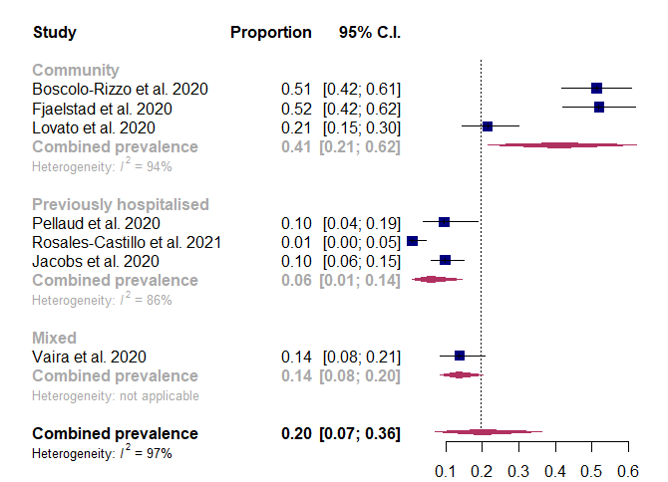
Figure 2: Anosmia
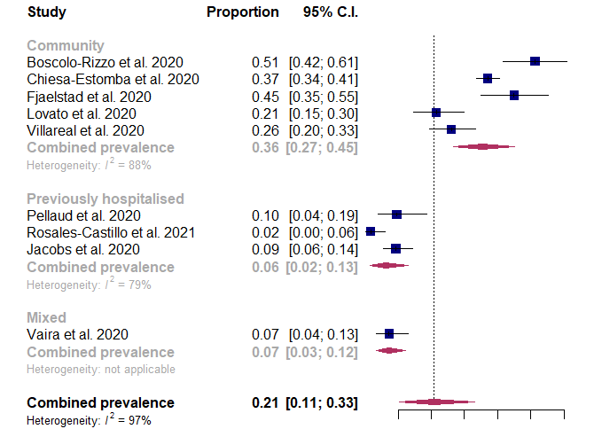
Figure 3: Cough
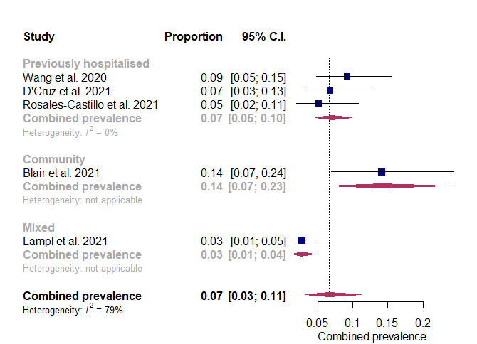
Figure 4: Depression
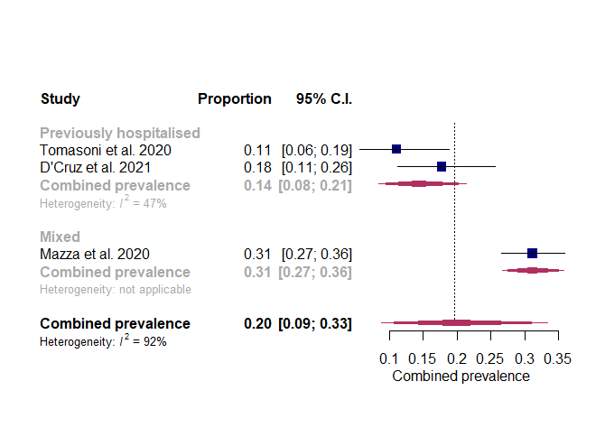
Figure 5: Dyspnoea
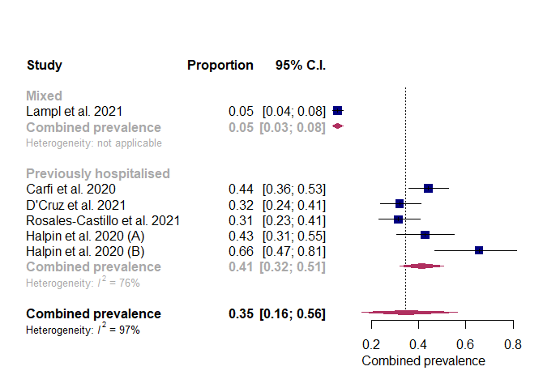
Figure 6: Fatigue
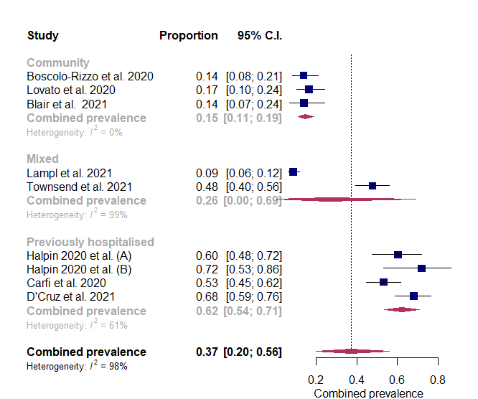

Chronic Post-COVID Syndrome
Figure 7: Ageusia
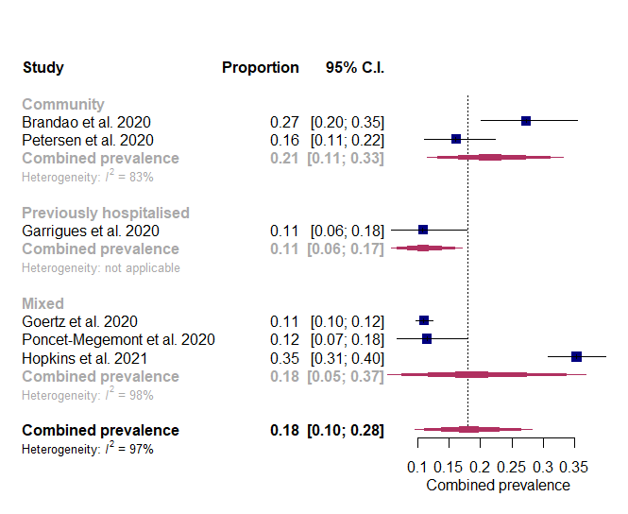
Figure 8: Anosmia
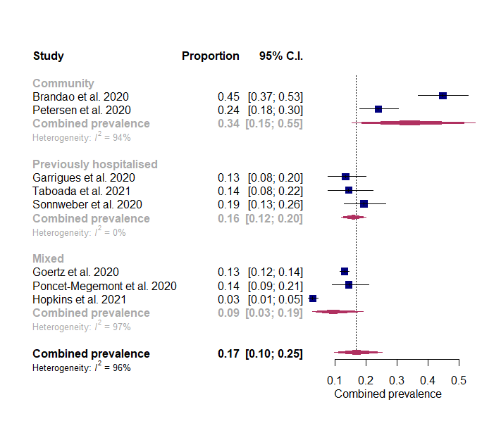
Figure 9: Cough
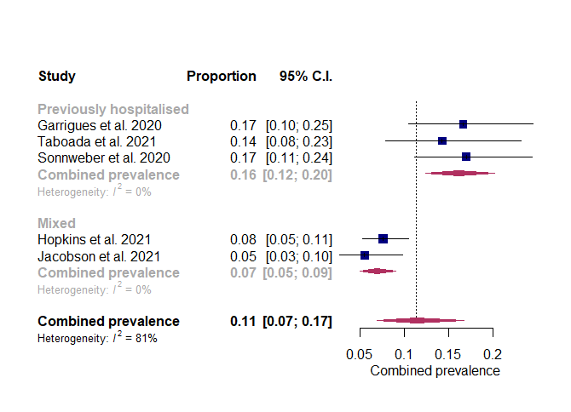
Figure 10: chest pain/tightness
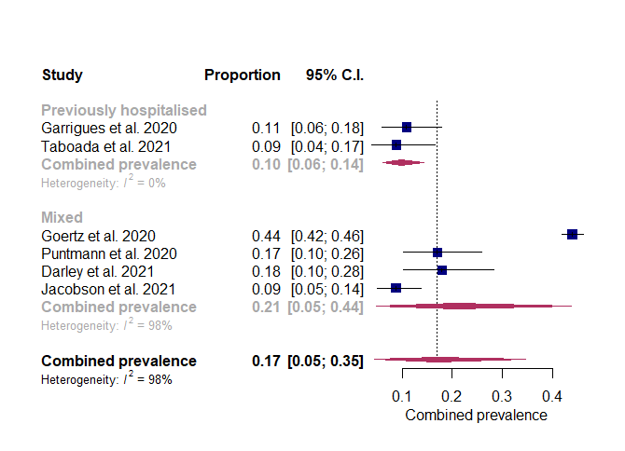
Figure 11: dyspnoea
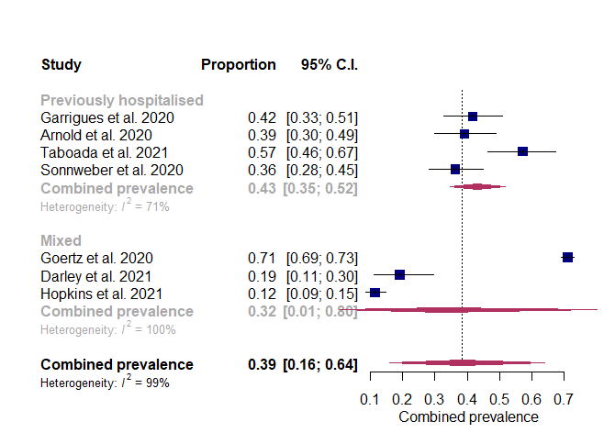
Figure 12: fatigue
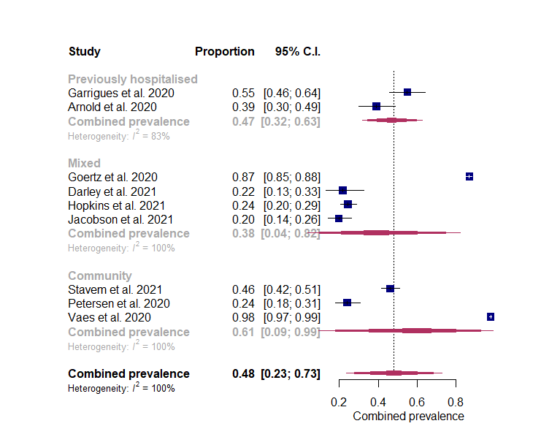
Figure 13: headache
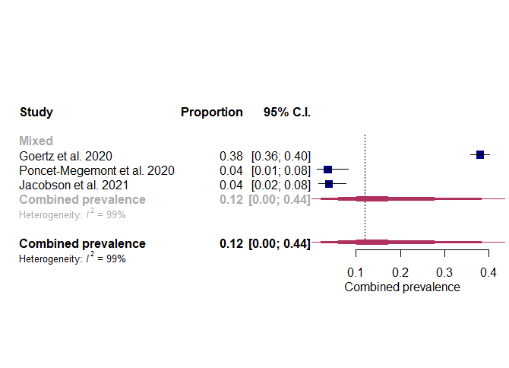
Figure 14: sleep disturbance
