Clustering based Coordinated Control of Large Scale Wind Farm for Power System Frequency Support
Shaokang Ma, Student Member, IEEE, Hua Geng, Senior Member, IEEE, Geng Yang, Senior Member, IEEE, and Bikash C. Pal, Fellow, IEEE
Abstract—This paper proposed a frequency support control scheme for large scale wind farm (WF) by considering distributed layout of wind turbines (WT) and wake effects inside the WF. The frequency support of WF is formulated as optimization problems. A novel clustering based optimization method is proposed to coordinate all the WTs so that the whole WF can work at the optimal operating states. In large scale WF, number of WTs is numerous. With the proposed method, the WTs are firstly clustered into groups according to their wind profiles. By dispatching the same control commands to the WTs belonging to the same group, each group can be further seen as one single WT. As a result, the number of the WTs and control variables reduces significantly and hence the optimization problems are highly simplified. A case study is carried out to verify the effectiveness of the proposed method.

Index Terms—Frequency support, virtual inertia, primary frequency control, coordinated control, wind farm.

INTRODUCTION
W
ind penetration level is increasing dramatically in power networks throughout the world. In order to maintain the equilibrium, the wind farms (WFs) are required to participate in the frequency support for the power grid. That means the WF should regulate its active power to support the power grid when the grid frequency deviates from its nominal value. In autonomous or isolated grids, the frequency fluctuation is even worse and hence it is more necessary for the WF to participate in the frequency support. Usually, wind turbines (WTs) are controlled to operate at the maximum power point tracking (MPPT) mode, which has no frequency support capability[1].
To provide frequency support, advanced control scheme should be developed for the WTs. The inertia emulation of WT is a temporary energy injection method which aims at reducing the power system rate of change of frequency (RoCoF) and improving the nadir of system frequency. The emulation of primary frequency control is to reduce the deviation between setting frequency and the nominal value by increasing or decreasing the active power supply[2].
Intuitively, when the grid frequency gets high, it is easy to curtail the wind power by stopping some WTs or increasing the pitch angle of the WTs. When the grid frequency drops, it is difficult to supply more power from the WTs. Although the kinetic energy (KE) of the WTs can be temporally released to increase the output power, it can only sustain for a short period because the KE is limited[3-5]. Energy storage equipment can be installed in the WF for frequency support, which is an expensive proposition[6, 7]. Alternatively, by de-loading the WTs, mechanical power can be reserved and injected when frequency drops[8-12]. Such scheme requires no additional devices but would result in efficiency decrease of the WT. Even though, some grid codes have already required WTs to reserve certain power margin and contribute to the frequency control[13, 14]. De-loading of the WT can be achieved by increasing rotor speed, increasing pitch angle or the combination of both[15]. Normally, WTs can be controlled to operate at de-loading mode. When power system frequency drops, switching WTs from the de-loading mode to the MPPT mode could inject the reserved power and release the rotor KE[15]. Adding auxiliary power commands to the original power loops is also feasible for reserved power injection and release of KE[16-19].
Most of the papers study frequency support of WT from the perspective of one single machine. In real WF, frequency support should be elaborated taking all WTs and their interaction into consideration. In WF, the upstream WTs will affect the wind speed experienced by the downstream WTs thus their KE and output power. Such influence is determined by the working state of the upstream WTs and geographical locations of the WTs. This is known as wake effect. It has been reported that wake effect within a WF has significant impact on WF frequency response[20-22]. Since wind profiles of WTs are correlated, the WTs should be coordinated for frequency support of WF. For example, if we want to achieve certain power reserve, the rotor speed and pitch angle of every WT should be determined considering the total output power and wake effect of the whole WF. Moreover, there may be more than one solution to achieve the same power reserve, among which there must be an optimal one for our secondary goal, such as maximum rotor KE. G. Verbič has made great progress on WF coordinated control[21-23]. [21, 22] formulate the coordination of WF as an optimization problem considering the wake effect. In [23], two more optimization formulas are further proposed and the contribution of a WF to frequency control of grid is studied considering the wake effect. A major concern of the optimization is that when the scale of WF is large, the number of WTs is large and hence the total number of variables to be coordinated are numerous. It is hard to find the solution of the optimization with such large amount of variables. Besides, solving the optimizations with large amount of variables is extremely time-consuming. Prestoring the coordinated optimization results for large scale WF in look-up tables is also impractical because the WTs may accidently shut down and the structure of WF is hence variable.
In this paper, a novel clustering based optimization method is proposed to coordinate the WTs for frequency support. WTs are de-loaded and the reserved power can be injected to reduce the deviation of the settling frequency. Meanwhile, the stored KE can be also released to further limit the RoCoF. Three operating states of WF are designed and cooperated to inject maximum potential KE for the frequency control. The method firstly clusters WTs into several groups according to their wind profiles. WTs belonging to the same group are dispatched the same control commands. Consequently, they can be further aggregated into one re-scaled single machine. By doing this, the number of WTs reduces. Hence the number of control variables to be optimized and the computational burden would significantly reduce. This paper uses Jensen’s Wake Model as an instance to depict the WF wake effect and illustrate the WF clustering, which is feasible for WFs with regular terrains. Nevertheless, the idea to divide WF into groups to simplify the optimizations can be extended to the WFs with complex terrains. The clustering indices for WFs with complex terrains could be the terms of the utilized wake model or even the measured data.
The rest of this paper is organized as follow: Section II illustrates the wake effect and the mechanism of frequency support. In Section III, the clustering based coordinated optimization method is introduced in detail. A case study is developed in Section IV to evaluate the proposed method under different wind directions(WD) and wind speed situations. Conclusions are given in Section V.

Frequency Support of WF

Wake Effect
Wind speed of the downstream WTs is lower than that of the upstream WTs because wind energy is partly extracted by the upstream WTs. This phenomenon could be depicted as wake effect. The wake effect is determined by the direction of wind, the layout of the WTs and the working status of each WT. Several models have already been proposed to describe wake effect[24-26]. Since this paper mainly discusses the basic idea of clustering based coordinated control, a WF with regular layout is studied and the Jensen’s Model, which has been integrated into commercial software such as WindPRO, and validated in practical WFs[20, 26], is used as an example to describe the wake effect, as shown in Fig.1.
In Fig.1, r₀ is the radius of wind turbine and x is the distance between the upstream WT and the downstream WT along with the WD. A₀ is the sweep area of WT. The downstream WT is partly shadowed by the upstream WT in Fig.1 and A_{s} is the shadowed area. Radius r_{i} describes the expansion effect of the wake. The affected area in downstream increases according to decay coefficient α. The expression of r_{i} is r_{i}=r₀+αx. The wind speed of downstream WT is[25]
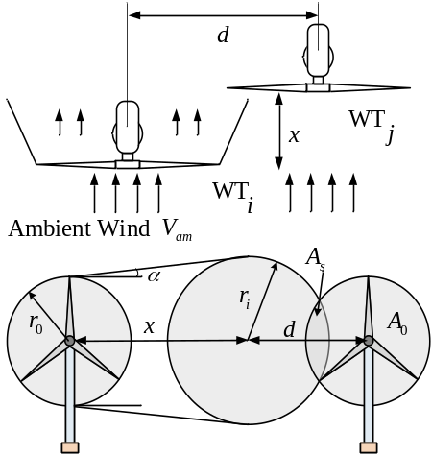
Fig.1 Illustration of wake effect
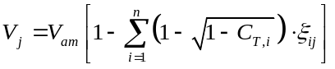
where
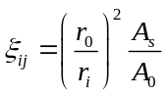
C_{T,i} is the thrust coefficient of WT_{i}, which is determined by the tip-speed ratio λ and the pitch angle β of WT[27]. C_{T,i} would vary according to the working states of the upstream WTs. If WT is tripped and its speed equals to zero, the thrust coefficient will be zero and hence this WT will have no impact on the downstream WTs. In ., A_{s} and r_{i} are the coefficients determined by the geographical location and the WD.

Mechanism of Frequency Support
The power characteristic of an individual WT is
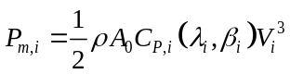
Where C_{p,i} is the performance coefficient which is related to tip-speed ratio λ_{i} and pitch angle β_{i} of WT. The KE stored in rotor is
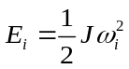
Fig.2 shows the power curve of a typical 5MW doubly-fed induction generator(DFIG) based WT[27]. When no frequency support is required, DFIG usually works at MPPT curve, i.e. the point B in Fig.2. At point B, no extra wind power can be further captured and hence DFIG cannot provide primary frequency support when the grid frequency drops. By increasing the rotor speed and pitch angle, DFIG could operate at point A. Compared with point B, point A has certain power reserve and higher rotor KE. When grid frequency drops, the WT can inject the reserved power and release rotor KE simultaneously for frequency support by transferring its operating point from point A to point B. Point C in Fig.2 has similar power output but lower rotor KE compared with point B. Consequently, if DFIG moves from point A to point C when grid frequency drops, nearly the same amount of reserved power can be injected for the frequency support but more rotor KE could be released compared with moving from point A to point B. For point A, certain amount of power should be reserved, which can be employed to reduce the deviation of the system settling frequency. Several combinations of rotor speed and pitch angle could achieve this goal. Hence, an optimal combination which has maximum rotor speed should be selected as point A to store as much rotor KE as possible for temporary frequency support. It is a similar situation for point C to find a combination of rotor speed and pitch angle with minimum rotor KE and nearly the same output power as point B. Consequently, finding the operating points of WT could be formulated as optimization problems[15].
Similarly, for WF, here we define three states, which are maximum kinetic energy with de-loading (MaxKEwD) state, maximum power (MaxP) state and minimum kinetic energy with nearly maximum power (MinKE) state. The WF aiming to participate in power system frequency support should normally work at the MaxKEwD state (similar to point A in Fig.2) to reserve certain primary power. When the grid frequency drop exceeds the threshold value and frequency support of WF is activated, WF should be switched to MaxP state (similar to point B) or MinKE state (similar to point C) to inject the reserved power and release rotor KE. Therefore, the system RoCoF can be limited and the deviation of the settling frequency can be reduced.
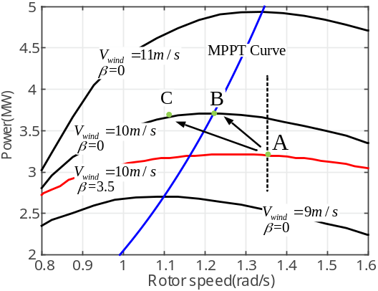
Fig.2 Power characteristic of single DFIG

Clustering based Coordinated Control
All WTs should be coordinated so that WF could work at the desired states. The coordination of WTs could be formulated as optimization problems. Rotor speed and pitch angle are the two control variables to be optimized for each WT. For small scale WF, number of WTs is small and the number of control variables is small. Hence, there is no problem in solving the optimization problems in small scale WF. However, for large scale WF, the number of control variables is numerous. Solving the optimization problems would be time consuming and the results may not be satisfactory. As has mentioned in Section I, storing the pre-calculated results in a look-up table is impractical because the structure of WF is not fixed for the reason that WTs may trip due to accidents or repairing plans. In this section, to solve the optimization problems in a large scale WF, all WTs are firstly clustered into groups. WTs in the same group are dispatched the same control variables and hence they could be seen as one re-scaled machine. Consequently, the total number of variables to be optimized is significantly reduced.

WF Clustering
Output power of WT depends on its wind speed. As illustrated in Section II, two factors affect wind speed of WTs. One is geographical factor, referring to the WD, the distance between WTs and the shadowed area. The other one is the working states of the upstream WTs, i.e. tip-radio and pitch angle. Since the working states of WTs are controllable, the geographical information of WTs is selected as the clustering index. WTs are firstly clustered into groups according to the index. WTs in the same group are dispatched the same control variables. Furthermore, each WT is ensured that it has no wake interaction with the WTs belonging to the same group. Consequently, WTs in the same group have similar wind profile and could be seen as a re-scaled single machine. The several groups could approximately reflect the output power characteristics of the whole WF. Since every group has one rotor speed variable and one pitch angle variable, the number of control variables are significantly reduced. The detailed steps of the proposed clustering method is demonstrated as follows:
Step 1:
Separate the WF into several zones, i.e. zone 1, zone 2, … , zone n. WTs in zone 1 are not shadowed by any other WT. WTs in zone i are shadowed only by WTs in zone 1, zone 2, … zone i-1. WTs in zone i are also not shadowed by WTs in zone i.
Step 2:
From zone 1 to zone n, WTs are clustered into groups in order. Because WTs in zone 1 are not shadowed by any other WT, all WTs in zone 1 are clustered into one group (i.e. group 1), and the wind speed of WTs belonging to group 1 equals to the ambient wind speed. Dispatching the same control commands (rotor speed and pitch angle) to WTs in group 1, then thrust coefficient of all WTs in group 1 could be regarded as identical.
WTs in zone 2 are shadowed only by WTs in group 1. Since thrust coefficient of all WTs in group 1 are regarded identical, wind speed of WTs in zone 2 is
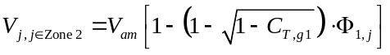
Where
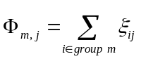
From ., Φ_{1,j} is the only parameter that leads to wind profiles difference of WTs in zone 2. Hence, [Φ_{1,j}]_{1x1} is selected as the index vector for clustering WTs of zone 2. The clustering algorithm used in this paper is k-means[28, 29]. As a result, WTs in zone 2 would be clustered into several groups. WTs in the same group have similar Φ_{1,j}, thus they receive similar wind speed. As mentioned above, since the same control commands would be dispatched to WTs within the same group, thrust coefficient of WTs in the same group could be further assumed identical.
Define nog(k) as the total number of groups after clustering zone 1 to zone k-1 in order. The wind speed of WTs in zone k can be expressed as
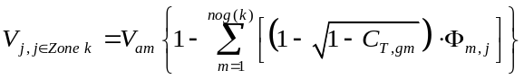
WTs in zone k are affected by all the nog(k) groups in zone 1 to zone k-1. Because different groups may work at different status, hence the thrust coefficients C_{T,gm} of each group are not the same. To cluster WTs in zone k, multi-dimension rather than one-dimension index should be used for clustering. Hence, the index vector is
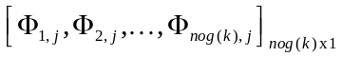
Finally, all WTs with similar wind profiles are clustered into groups. WTs belonging to the same group receive identical control commands and hence are coherent. Note that Φ_{m,j} is determined only by the WTs locations and the WD.
In the WFs where wind characteristic and layout of WF are regular, such as offshore WFs, the wake model applied here is accurate enough[20, 26], and the proposed clustering method is feasible. However, in some onshore WFs with complex terrain, the use of the above mentioned wake model may lose accuracy and more sophisticated wake models should be used instead. Nevertheless, the idea to divide WF into groups to simplify the optimization is still feasible.

Optimization Formula
The WF is clustered into several groups. WTs in the same group are dispatched with the same control commands. Hence, only one rotor speed and one pitch angle for each group are to be optimized.
As mentioned in Section II-B, three working states of WF are defined for frequency support: 1. MaxP state. 2. MaxKEwD state. 3. MinKE state. How to coordinate all WTs so that WF could work at the desired working states is formulated as three optimization problems in this part. The details of the three optimizations are described as follows:

Optimal output power (OptP)
Because of the wake effect, every WT working at MPPT curve may not mean that the whole WF reaches its MaxP state. For example, assuming that all WTs are working at the MPPT mode at the beginning, then if we slow down the upstream WTs, the output power of them will reduce. However, the shadowing effect will also reduce hence the wind speeds of the downstream WTs will increase. Consequently, the total output power of the WF may increase. This optimization is to obtain the actual MaxP state of the WF. The objective function is
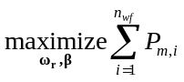
where n_{wf} is the number of WTs in the WF and P_{m,i} is the mechanical power of WT.

Maximum KE with de-loading (MaxKEwD)
The purpose of this optimization is to obtain a de-loading operation point for frequency support, which is similar to point A in Fig.2. The desired power reserve is set by power system operators. By optimally coordinating rotor speed and pitch angle of all WTs, the WF can store as much KE as possible for temporary frequency support. The objective function is
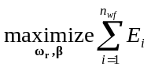
For a given power reserve, constraint should also be met.
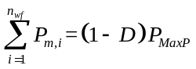
where P_{MaxP} is the power of WF at MaxP state and D is the percentage of the power margin.

Minimum KE with nearly maximum power output (MinKE)
This optimization is to find a WF operating state with minimum KE and almost the same output power as the P_{MaxP}. If the WF is switched from the MaxKEwD state to the MinKE state, the maximum potential KE can be released and the reserved wind power can be injected to the power grid for frequency control. Example of such operating state is the point C in Fig.2. The objective function of this operating state is
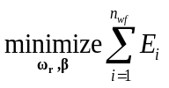
To ensure that the output power will not decrease too much, the following constraint should be met.
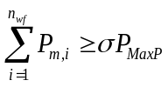
Where σ is a factor slightly less than 1, for example, 0.995. If σ is too small, the final output power may decrease too much and hence primary frequency support requirement will not be complied with.
The interaction between WTs is considered. The wake effect equations are considered as the constraints of all the three optimization problems. Some other constraints for the three optimization problems are
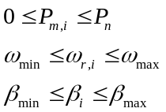
where ω_{r,i} is rotor speed and β_{i} is pitch angle of WT. Each WT must not exceed its working boundary.
As the optimization problem is nonlinear, the particle swarm optimization (PSO) algorithm is used. PSO is an analogy of birds or insects swarm. PSO utilizes a set of particles to search the optimal results. At each step, the objective function is evaluated and the next direction and velocity are determined. The detail instruction of PSO could be found in [30].

Control System
A WF central controller is required to coordinate all the WTs. The central controller receives power demand and power margin commands from the power system operators. Then the clustering and optimization problems are solved in central controller. Control commands of each WT are then dispatched via communication lines to individuals. Individual WT tracks the received control commands and feed working states back to the central controller.

WT Controller
In this paper, the utilized control scheme for individual WT is based on GE control structure[31]. The outer loop is rotor speed loop and inner loop is electrical torque loop. The pitch control loop is used to ensure that WT would not exceed its power rating. Each WT has two working modes: MPPT mode and control commands mode. WTs at MPPT mode can work without central controller. WTs working at control commands mode need communication between WTs and WF central controller. The WT control scheme is shown in Fig.3. Switch SW decides whether to work at MPPT mode or control commands mode.
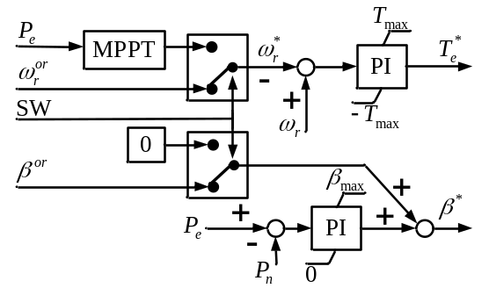
Fig.3 Control scheme of individual WT
When P_{e} exceeds P_{n}, the pitch controller increases the pitch angle to limit the WT output power. In the control commands mode, power limitation of single WT is one of the constraints of the optimization, as shown in . The control commands obtained from the optimization should meet the constraints and will ensure that WTs operate below their upper power limitations, even if the wind speed is higher than the rated wind speed. As a result, P_{e} is less than P_{n} and the output of the pitch controller will be zero and the final pitch angle equals to its command.

WF Central Controller
The ambient wind speed and WD of WF is detected by central controller. All the information of individual WT such as rotor speed, pitch angle and wind speed are also collected and submitted to the central controller. In real-time application, if the WD changes or some of the WTs are cut off, the clustering indices will change and the result of the clustering will change accordingly. Hence the WF central controller is supposed to monitor the WD and WF states periodically. After clustering the WF into groups and solving the optimizations, rotor speed and pitch angle commands are dispatched to each WT via communication lines.
The central controller should also measure power system frequency, and decide whether WF is to participate in frequency support or not. If the frequency deviation Δf = f − f_{n} and/or RoCoF df/dt exceed the threshold, frequency support of WF is then activated[32].
Note that the proposed coordinated control assumes that the WTs suffer the same ambient wind speed. In very large wind farm, WTs installed at different locations may suffer different ambient wind speeds, which is another dimension of factors that affects the wind speed of each WT. Under this situation, elaborated measurement systems and improved models are necessary. If the WF can be separated into several independent subsystems, each with the same ambient wind speed, according to the WT locations, then the proposed algorithm can be applied independently to each of the subsystems.
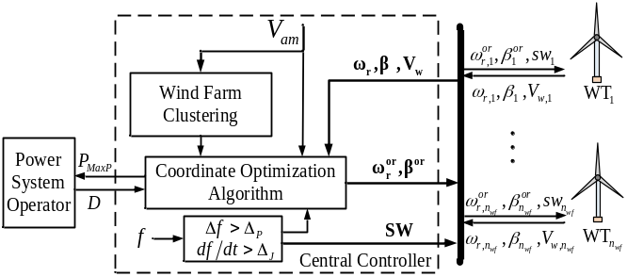
Fig.4 Block diagram of WF central controller

Case Study
A regular WF, which consists of 5 rows of WTs and each row has 5 WTs is used to validate the proposed method. The NREL 5MW DFIG, whose parameters could be found in the web-site given in the Section I of [27], is used in this case. The configuration of WF and the number of WTs are shown in Fig.5. The parameters of the WF is listed in Table.I.
TABLE I
Parameters of the tested WF
Symbol | Description | Value
r₀ | Turbine radius(m) | 63
L | Distance(m) | 630
α | Deficit factor | 0.075
P_{n} | Rated power(MW) | 5
ω_{n} | Rated speed(rad/s) | 1.267
ω_{min} | Speed lower limit(rad/s) | 0.76
ω_{max} | Speed upper limit(rad/s) | 1.364
β_{min} | Pitch lower limit(deg.) | 0
β_{max} | Pitch upper limit(deg.) | 45
Wind speeds of individual WTs can be obtained by practical measurements or calculating the wake model. In this paper, the model error is not taken into consideration, hence the simulated wind speed is obtained by the latter way[23]. In practice, the model error may lead to a lower performance. Applying advanced algorithms such as the robust optimization and sophisticated modeling techniques may reduce the influence caused by the model error. These will be our future work.
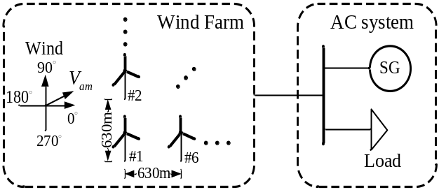
Fig.5 Configuration of tested WF

WF Clustering Results
The total number of WTs in the WF is 25 in this case. The following Table.II shows different clustering results under four WDs which are 0^{ο}, 18 ^{ο}, 32 ^{ο} and 45 ^{ο}.
TABLE II
Results of WF clustering under different wind conditions
WD | Clustering Results
0 | Zone1 | Zone2 | Zone3 | Zone4 | Zone5
0 | Group1 | Group2 | Group3 | Group4 | Group5
0 | 1-5 | 6-10 | 11-15 | 16-20 | 21-25
18 | Zone1 | Zone2 |  |  | Zone3
18 | Group1 | Group2 | Group3 | Group4 | Group5
18 | 1-10,11,16,21 | 12-15 | 17-20 | 22 | 23-25
32 | Zone1 | Zone2 |  |  | Zone3
32 | Group1 | Group2 | Group3 | Group4 | Group5
32 | 1-10,11,16,21 | 12-15 | 17-20 | 22 | 23-25
45 | Zone1 | Zone2 | Zone3 | Zone4 | Zone5
45 | Group1 | Group2 | Group3 | Group4 | Group5
45 | 1-6,11,16,21 | 7-10,12,17,22 | 13-15,18,23 | 19,20,24 | 25
Since a regular WF is used in this paper, the 25 WTs are clustered into five groups in all the four cases, as shown in Table.II. Fig.6 shows the wind speed of each WT under 18^{ο} and 11m/s wind condition, which clearly illustrates the clustering results. In Fig.6, different groups are distinguished by different colors. WTs in the same group have similar wind profiles. Actually, how many groups will the clustering algorithm obtain depends on the clustering indices. If all the indices are different a lot, for example in an extremely irregular WF, there would be the possibility that in some zones, number of groups equals to the number of WTs.
TABLE III
Power comparison between MPPT and OptP modes
WD | Mode | WF power under different wind speed(MW)
WD | Mode | 8m/s | 9 m/s | 10 m/s | 11 m/s | 12 m/s | 13 m/s | 14 m/s | 15 m/s | 16 m/s
0^{ο} | MPPT | 23.8 | 34.7 | 47.4 | 62.8 | 84.1 | 111.7 | 125 | 125 | 125
0^{ο} | OptP | 27.4 | 38.9 | 53.2 | 70.2 | 91.3 | 113 | 125 | 125 | 125
18^{ο} | MPPT | 34.7 | 49.2 | 67.2 | 89.4 | 111.7 | 125 | 125 | 125 | 125
18^{ο} | OptP | 35.3 | 50.4 | 69.0 | 91.9 | 113.0 | 125 | 125 | 125 | 125
32^{ο} | MPPT | 32.9 | 46.7 | 64.0 | 85.2 | 107.7 | 119.6 | 125 | 125 | 125
32^{ο} | OptP | 33.6 | 47.9 | 65.8 | 87.6 | 108.6 | 119.6 | 125 | 125 | 125
45^{ο} | MPPT | 34.9 | 49.4 | 67.5 | 89.6 | 113.7 | 125 | 125 | 125 | 125
45^{ο} | OptP | 35.6 | 50.3 | 69.1 | 91.9 | 114.8 | 125 | 125 | 125 | 125

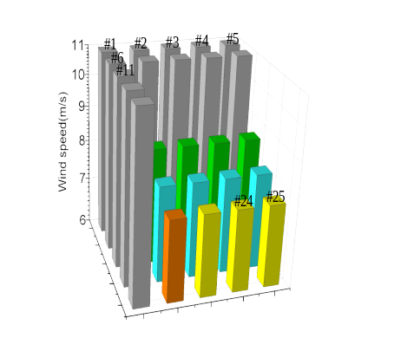
Fig.6 Wind speed of each WT under 18^{ο} and 11m/s wind condition

MaxP state of WF
For single WT, working at MPPT curve can capture maximum wind power. Since wake effect impacts wind profiles of the WTs, whether making each WT work at MPPT curve can extract maximum wind power should be further studied[33]. In Section III-B, objective function . (i.e. OptP) aims at obtaining a maximum output power of WF. Table.III lists the WF output power at both OptP and MPPT modes under different wind speed and WDs.
Fig.7 shows the power increase, which is calculated by .
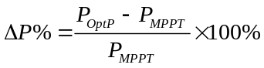
Fig.7 indicates that when WD equals to 18^{ο}, 32^{ο} and 45^{ο}, the increased power is below 2%. However, when WD is 0^{ο}, the increased power reaches 14.5% at 8m/s. From Table.III we can see that under a same wind speed, 0^{ο} WD situation has the least output power compared with the other three WDs. This indicates that wake effect impacts the most at 0^{ο} among the four WDs we examined here. At 0^{ο} WD, only five WTs receive ambient wind directly while other WTs are all shadowed. However, when WD equals to 18^{ο}, number of WTs that directly receive ambient wind is thirteen, as shown in Fig.6.
The power difference between OptP and MPPT is quite limited when WD equals to 18^{ο}, 32^{ο} and 45^{ο}. Since working at MPPT mode is free of both complicated calculation and communication (MPPT curve is usually stored in a look-up table), it is recommended to use MPPT curve mode rather than OptP for WF MaxP state under those WDs. When WD is close to 0^{ο}, OptP mode should be applied instead of MPPT.
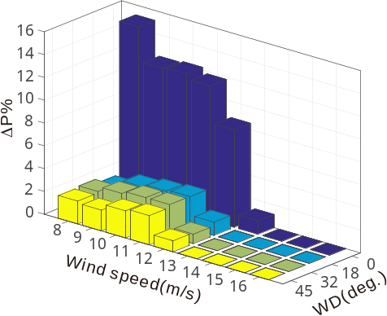
Fig.7 Comparison between MPPT and OptP

Power Reserve and KE for Frequency Support
As mentioned in Section II, WF works at MaxKEwD state at first. When system frequency drops and frequency support control of WF is activated, WF move from the de-loading state to MaxP state or MinKE state to participate in frequency support. In this part, WD is 18^{ο}. Hence, MPPT mode is used for WF MaxP state, as explained in Section IV-B. Finding MaxKEwD state and MinKE state of WF needs to solve the optimizations. The percentage of power reserve D in . is given by power system operator according to power system situation, which is set to 0.1 in this case. Parameter σ in . is set to 0.999. The optimization results are shown as follows.
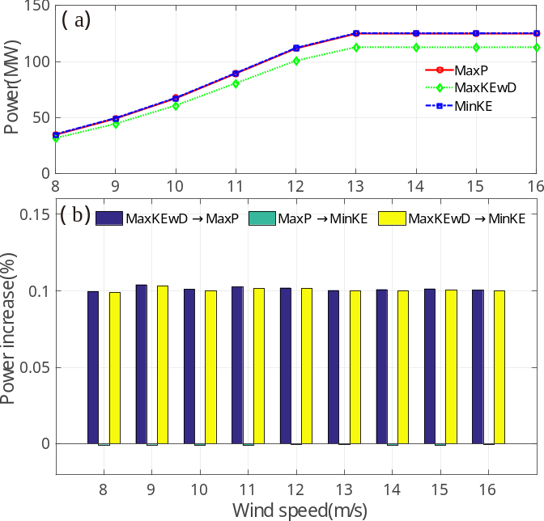
Fig. 8. Power of WF under different wind speed
Fig.8(a) shows the output power of the three states under different wind speed and Fig.8(b) shows the power increase. When wind speed is higher than 13m/s, WF at MaxP state reaches its power limit. From Fig.8, power of MinKE state is similar to the power of MaxP state at each wind speed examined here. The power increase from MaxKEwD state to MaxP state is about 10%, which is the same as D, the desired power reserve. From MaxP state to MinKE state, the output power slightly decreases. The value of power decrease is less than 0.1%, complying with the value of σ .
Fig.9(a) shows rotor KE of the three states under different wind speeds. Fig.9(b) shows the KE difference between different working states. Under MaxKEwD state, rotor speed of each WT reaches its maximum and hence the KE of WF reaches maximum at 9m/s. However, not until wind speed is higher than 13m/s does KE reach its maximum under MaxP state. KE under MinKE state keeps below 0.75p.u.. Fig.9(b) shows that when wind speed is higher than 13m/s, potential KE from MaxKEwD state to MaxP state is zero. This is because under MaxP state, all WTs have already reached their maximum rotor speed.
When wind speed is higher than 13m/s, each WT reaches its maximum power rate under both MaxP state and MinKE states. Even though potential KE is stored, excessive power cannot inject to the grid because the pitch control loop limit the injected power below the rated value. This will be further justified in Section IV–D.
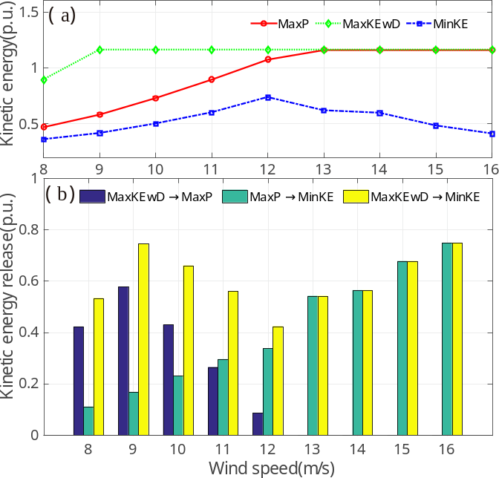
Fig.9. KE of WF under different wind speed

Time Domain Simulation
In this part, time domain simulation is established via Simulink. The AC system is aggregated into a 500MW single synchronous generator and constant load, as shown in Fig.5. At t = 380s, a severe 90MW power unbalance occurs which leads to the system frequency drop. The possible reasons for the power unbalance can be the loss of generation, the faults and its resultant tripping of inter-area transmission lines or the blocking out of a HVDC station. The following figures show the time domain results. Three strategies are examined: 1.Basic case without any frequency support. 2.WF moves from MaxKEwD state to MaxP state when system frequency drops. 3.WF moves from MaxKEwD state to MinKE state when system frequency drops.
Fig.10 shows the simulation results under 11m/s wind speed and 18^{ο} WD. From Fig.10(a) we can obtain that both the strategy 2 and strategy 3 could improve system frequency response. Since the power reserve of strategy 2 and strategy 3 are similar, the setting frequencies after power disturbance are almost the same. Fig.10(b) shows the output power of the three strategies. Both strategy 2 and strategy 3 inject extra power to the power system for frequency support. Strategy 3 injects more temporary power than strategy 2 because moving from MaxKEwD state to MinKE state can release more KE. Compared with strategy 2, strategy 3 can further heighten system frequency nadir. Fig.10(c) shows the total KE of WF under the three strategies.
Fig.11 shows the simulation results under 15m/s wind speed and 18^{ο} WD. Since all WTs reach their maximum output power limitation at MaxP state and MinKE state, rotor KE from MaxP state to MinKE state cannot inject to power grid because the pitch control loop keeps output power below power limitation, as mentioned in Section IV-C. In this simulation, the KE decreases to 0.5p.u. in strategy 3 while KE keeps unchanged in strategy 2, as shown in Fig.11(c). But the injected power of strategy 2 and strategy 3 are similar, as shown in Fig.11(b). Because output power of strategy 2 and strategy 3 are similar, frequency responses of the two strategies are also similar, as shown Fig.11(a). Note that when system recovers, the released KE should be regained from the grid. Hence, strategy 2 is recommended at high wind speed region (higher than 13m/s in this case).
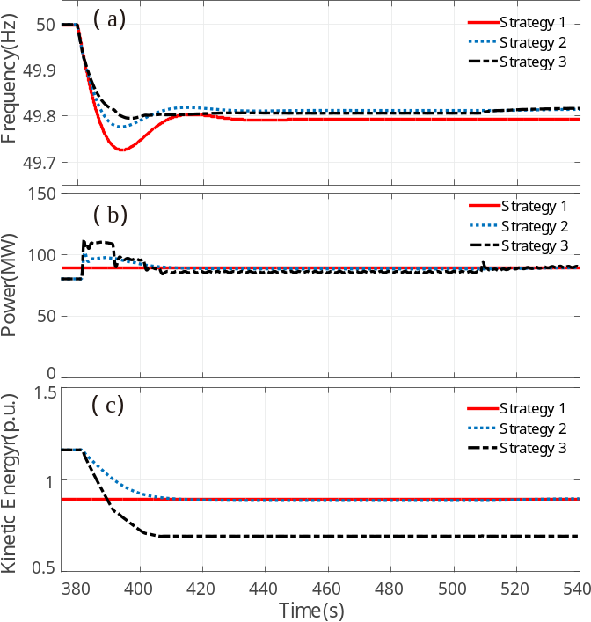
Fig. 10. Simulation results under 11m/s and 18^{ο} wind condition
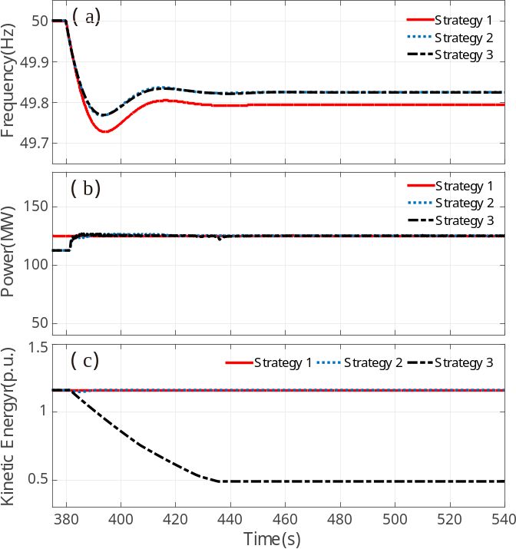
Fig11. Simulation results under 15m/s and 18^{ο} wind condition

Conclusion
Frequency support of large scale WF considering individual WT and wake effect is studied in this paper. A clustering based optimization method is proposed to coordinate all the WTs so that the whole WF could optimally work at the desired operating state. By clustering the WF into groups, number of variables to be optimized are significantly reduced. Jensen’s wake model is considered in this study, which is feasible in the WFs with regular layout and wind profile such as offshore WFs. The idea of clustering WF into groups for optimization proposed in this paper can be extended to other scenario such as the control of WFs with more complex terrain.
In the case study, a WF containing 5x5 WTs is clustered into 5 groups under the tested wind conditions. Hence the number of variables to be optimized reduces to one fifth. The case study shows that when most WTs are not directly shadowed, the OptP has similar output power compared with the traditional MPPT mode. While when most WTs are directly shadowed by their upstream WTs, OptP could output more power than the MPPT mode. At the low wind speed region, which is the <13m/s region in the studied case, moving WF from MaxKEwD state to MinKE state can release more KE for temporary frequency support compared with moving from MaxKEwD state to MaxP state. However, at high wind speed region, which is the 13m/s region in the studied case, the two strategies have similar power injection curves because all WTs have already reached their maximum power limitation. Since rotor speed recovering needs to absorb power from the power grid, moving WF from MaxKEwD state to MaxP state for frequency support is recommended at high wind speed region. While at low wind speed region, moving from MaxKEwD state to MinKE state is recommended for more rotor KE could be released.

References
[1] F. Wilches-Bernal, J. H. Chow, and J. J. Sanchez-Gasca, "A Fundamental Study of Applying Wind Turbines for Power System Frequency Control," IEEE Trans. Power Syst., vol. 31, no. 2, pp. 1496-1505, Mar 2016.
[2] S. Ghosh, S. Kamalasadan, N. Senroy, and J. Enslin, "Doubly Fed Induction Generator (DFIG)-Based Wind Farm Control Framework for Primary Frequency and Inertial Response Application," IEEE Trans. Power Syst., vol. 31, no. 3, pp. 1861-1871, May 2016.
[3] A. Zertek, G. Verbic, and M. Pantos, "A Novel Strategy for Variable-Speed Wind Turbines' Participation in Primary Frequency Control," IEEE Trans. Sustainable Energy, vol. 3, no. 4, pp. 791-799, Oct 2012.
[4] Y. Wang, J. H. Meng, X. Y. Zhang, and L. Xu, "Control of PMSG-Based Wind Turbines for System Inertial Response and Power Oscillation Damping," IEEE Trans. Sustainable Energy, vol. 6, no. 2, pp. 565-574, Apr 2015.
[5] H. J. Wang, Z. Chen, and Q. Y. Jiang, "Optimal control method for wind farm to support temporary primary frequency control with minimised wind energy cost," IET Renew. Power Gen., vol. 9, no. 4, pp. 350-359, May 2015.
[6] S. Q. Zhang, Y. Mishra, and M. Shahidehpour, "Fuzzy-Logic Based Frequency Controller for Wind Farms Augmented With Energy Storage Systems," IEEE Trans. Power Syst., vol. 31, no. 2, pp. 1595-1603, Mar 2016.
[7] L. Miao, J. Y. Wen, H. L. Xie, C. Y. Yue, and W. J. Lee, "Coordinated Control Strategy of Wind Turbine Generator and Energy Storage Equipment for Frequency Support," IEEE Trans. Ind. Appl., vol. 51, no. 4, pp. 2732-2742, Jul-Aug 2015.
[8] A. B. T. Attya and T. Hartkopf, "Control and quantification of kinetic energy released by wind farms during power system frequency drops," IET Renew. Power Gen., vol. 7, no. 3, pp. 210-224, May 2013.
[9] Y. Liu, J. R. Gracia, T. J. King, and Y. L. Liu, "Frequency Regulation and Oscillation Damping Contributions of Variable-Speed Wind Generators in the US Eastern Interconnection (EI)," IEEE Trans. Sustainable Energy, vol. 6, no. 3, pp. 951-958, Jul 2015.
[10] H. Ye, W. Pei, and Z. P. Qi, "Analytical Modeling of Inertial and Droop Responses From a Wind Farm for Short-Term Frequency Regulation in Power Systems," IEEE Trans. Power Syst., vol. 31, no. 5, pp. 3414-3423, Sep 2016.
[11] Y. J. Tan, L. Meegahapola, and K. M. Muttaqi, "A Suboptimal Power-Point-Tracking-Based Primary Frequency Response Strategy for DFIGs in Hybrid Remote Area Power Supply Systems," IEEE Trans. Energy Convers., vol. 31, no. 1, pp. 93-105, Mar 2016.
[12] K. V. Vidyanandan and N. Senroy, "Primary Frequency Regulation by Deloaded Wind Turbines Using Variable Droop," IEEE Trans. Power Syst., vol. 28, no. 2, pp. 837-846, May 2013.
[13] Eirgrid. EirGrid Grid Code Version 6.0 [Online]. Available: http://www.eirgridgroup.com/site-files/library/EirGrid/GridCodeVersion6.pdf
[14] Energinet. Technical regulation 3.2.5 for wind power plants above 11 kW [Online]. Available: http://www.energinet.dk/
[15] A. Z. Zertek, G. Verbic, and M. Pantos, "Optimised control approach for frequency-control contribution of variable speed wind turbines," IET Renew. Power Gen., vol. 6, no. 1, pp. 17-23, Jan 2012.
[16] M. Akbari and S. M. Madani, "Analytical evaluation of control strategies for participation of doubly fed induction generator-based wind farms in power system short-term frequency regulation," IET Renew. Power Gen., vol. 8, no. 3, pp. 324-333, Apr 2014.
[17] J. Morren, S. W. H. de Haan, W. L. Kling, and J. A. Ferreira, "Wind turbines emulating inertia and supporting primary frequency control," IEEE Trans. Power Syst., vol. 21, no. 1, pp. 433-434, Feb 2006.
[18] J. J. Zhao, X. Lyu, Y. Fu, X. G. Hu, and F. X. Li, "Coordinated Microgrid Frequency Regulation Based on DFIG Variable Coefficient Using Virtual Inertia and Primary Frequency Control," IEEE Trans. Energy Convers., vol. 31, no. 3, pp. 833-845, Sep 2016.
[19] M. Hwang, E. Muljadi, J. W. Park, P. Sorensen, and Y. C. Kang, "Dynamic Droop-Based Inertial Control of a Doubly-Fed Induction Generator," IEEE Trans. Sustainable Energy, vol. 7, no. 3, pp. 924-933, Jul 2016.
[20] S. Kuenzel, L. P. Kunjumuhammed, B. C. Pal, and I. Erlich, "Impact of Wakes on Wind Farm Inertial Response," IEEE Trans. Sustainable Energy, vol. 5, no. 1, pp. 237-245, Jan 2014.
[21] A. S. Ahmadyar and G. Verbič, "Control strategy for optimal participation of wind farms in primary frequency control," in 2015 IEEE Eindhoven PowerTech, Eindhoven, 2015, pp. 1-6.
[22] A. S. Ahmadyar and G. Verbič, "Exploring Wake Interaction for Frequency Control in Wind Farms," in the 13th Wind Integration Workshop, Berlin, 2016, pp. 551-557.
[23] A. S. Ahmadyar and G. Verbič, "Coordinated Operation Strategy of Wind Farms for Frequency Control by Exploring Wake Interaction," IEEE Trans. Sustainable Energy, vol. 8, no. 1, pp. 230-238, Jan 2017.
[24] D. Madjidian and A. Rantzer, "A stationary turbine interaction model for control of wind farms," IFAC Proceedings Volumes, vol. 44, no. 1, pp. 4921-4926, 2011.
[25] F. Gonzalez-Longatt, P. Wall, and V. Terzija, "Wake effect in wind farm performance: Steady-state and dynamic behavior," Renewable Energy, vol. 39, no. 1, pp. 329-338, Mar 2012.
[26] D. R. VanLuvanee, "Investigation of observed and modeled wake effects at Horns Rev using WindPRO," Ph.D dissertation, Dept. Mech. Eng., Technical Univ. of Denmark, 2006.
[27] J. D. Grunnet, M. Soltani, T. Knudsen, M. N. Kragelund, and T. Bak, "Aeolus toolbox for dynamics wind farm model, simulation and control," in Proc. Eur. Wind Energy Conf., 2010.
[28] F. Vallee, G. Brunieau, M. Pirlot, O. Deblecker, and J. Lobry, "Optimal Wind Clustering Methodology for Adequacy Evaluation in System Generation Studies Using Nonsequential Monte Carlo Simulation," IEEE Trans. Power Syst., vol. 26, no. 4, pp. 2173-2184, Nov 2011.
[29] P. N. Tan, M. Steinbach, and V. Kumar, Introduction to Data Mining, (First Edition): Addison-Wesley Longman Publishing Co., Inc., 2005.
[30] J. Kennedy and R. Eberhart, "Particle swarm optimization," in Proc. IEEE Int. Conf. Neural Netw., 1995, pp. 1942-1948 vol.4.
[31] D. Gautam, L. Goel, R. Ayyanar, V. Vittal, and T. Harbour, "Control Strategy to Mitigate the Impact of Reduced Inertia Due to Doubly Fed Induction Generators on Large Power Systems," IEEE Trans. Power Syst., vol. 26, no. 1, pp. 214-224, Feb 2011.
[32] L. Ruttledge and D. Flynn, "Emulated Inertial Response From Wind Turbines: Gain Scheduling and Resource Coordination," IEEE Trans. Power Syst., vol. 31, no. 5, pp. 3747-3755, Sep 2016.
[33] J. Tian, C. Su, M. Soltani, and Z. Chen, "Active power dispatch method for a wind farm central controller considering wake effect," in Proc. 2014 40th IEEE Industrial Electronics Society Conf., 2014, pp. 5450-5456.

This work is supported by National Key Research and Development Program under Grant 2016YFB0900300, National Natural Science Foundation of China (NSFC) under Grant 61273045, U1510208, 51361135705, and UK China grant EP/L014343/1: Stability and Control of Power Networks with Energy Storage(STABLE-NET) (P48270). S. Ma, H. Geng, and G. Yang are with the Department of Automation, Tsinghua University, Beijing 100084, China (e-mail: msk15@mails.tsinghua. edu.cn; genghua@tsinghua.edu.cn; yanggeng@tsinghua.edu.cn). Bikash C. Pal is with the Department of Electrical and Electronic Engineering, Imperial College London, London SW7 2BT, U.K. (e-mail: b.pal@imperial.ac.uk).

