Mechanism of Action in NiOH2/NiOOH Photoactuators – Electronic Supplementary Information

Joseph H. L. Hadden*, Marie Bouchet, George Morgan, D. Jason Riley
Department of Materials, Imperial College London, Price Consort Road, London, SW7 2AZ
Appendix 1 – Table of video data

Table S1 Key for Actuator Videos showing active and substrate layer thicknesses and brief description of treatment.
Video Number | Active layer thickness (h_{a}) / μm | Substrate layer thickness (h_{s}) / μm | Treatment
S1 | 1 | 2 | Illumination 100 mW cm⁻²
S2 | 2 | 5 | Illumination 100 mW cm⁻²
S3 | 5 | 6 | Illumination 100 mW cm⁻²
S4 | 10 | 9 | Illumination 100 mW cm⁻²
S5 | 2 | 3 | Humidity decrease according to Figure S1.

Figure S1 Change in relative humidity inside glovebag with time under N₂ atmosphere

Appendix 2
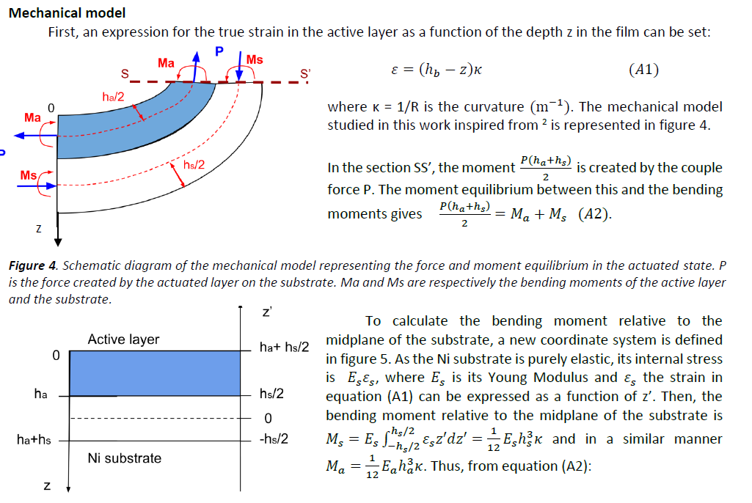
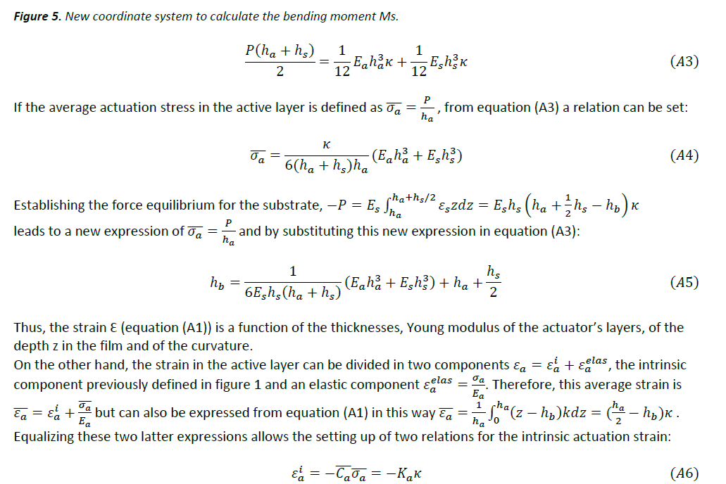
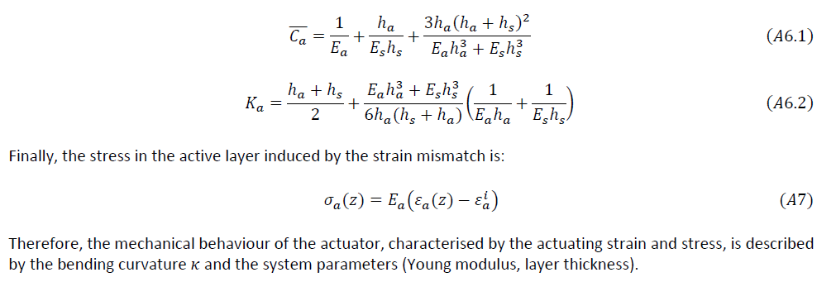

Appendix 3 – Python script for conversion of bending radius to C-parameter change
Plot of (𝒙𝟎−𝒙)=𝒇(𝒙𝟎) for different values of 𝜺𝒂𝒊 as per equation 2:
import matplotlib.pyplot as plt
import numpy as np
def epsi (x,y):
return(((0.8*x+(1-x)*0.4605)/(y*0.8+(1-y)*0.4605))-1)*100;
x=[i for i in range (0,10001)]
y=[i for i in range (0,10001)]
n=len(x)
z=n*[n*[0]]
S1=[]
S2=[]
S3=[]
S4=[]
S5=[]
S6=[]
S7=[]
S8=[]
S9=[]
S10=[]
Ys1=[]
Ys2=[]
Ys3=[]
Ys4=[]
Ys5=[]
Ys6=[]
Ys7=[]
Ys8=[]
Ys9=[]
Ys10=[]
for k in range (0,n):
for l in range(k,n):
z[k][l]=epsi(k/10000,l/10000)
if -0.110 <= z[k][l] and z[k][l]<= -0.09:
Ys1.append(l/100)
S1.append(l/100-k/100)
if -0.210 <= z[k][l] and z[k][l]<= -0.19:
Ys2.append(l/100)
S2.append(l/100-k/100)
if -0.310 <= z[k][l] and z[k][l]<= -0.29:
Ys3.append(l/100)
S3.append(l/100-k/100)
if -0.410 <= z[k][l] and z[k][l]<= -0.39:
Ys4.append(l/100)
S4.append(l/100-k/100)
if -0.510 <= z[k][l] and z[k][l]<= -0.49:
Ys5.append(l/100)
S5.append(l/100-k/100)
if -0.610 <= z[k][l] and z[k][l]<= -0.59:
Ys6.append(l/100)
S6.append(l/100-k/100)
if -0.710 <= z[k][l] and z[k][l]<= -0.69:
Ys7.append(l/100)
S7.append(l/100-k/100)
if -0.810 <= z[k][l] and z[k][l]<= -0.79:
Ys8.append(l/100)
S8.append(l/100-k/100)
if -0.910 <= z[k][l] and z[k][l]<= -0.89:
Ys9.append(l/100)
S9.append(l/100-k/100)
if -1.10 <= z[k][l] and z[k][l]<= -0.99:
Ys10.append(l/100)
S10.append(l/100-k/100)
fig = plt.figure(figsize = (10, 5))
plt.plot(Ys1, S1,c='lightblue',label='epsI=0.1%')
plt.plot(Ys2, S2,c='cyan')
plt.plot(Ys3, S3,c='blue',label='epsI=0.3%')
plt.plot(Ys4, S4,c='green')
plt.plot(Ys5, S5,c='yellow',label='epsI=0.5%')
plt.plot(Ys6, S6,c='coral')
plt.plot(Ys7, S7,c='red', label='epsI=0.7%')
plt.plot(Ys8, S8,c='brown')
plt.plot(Ys9, S9,c='black')
plt.plot(Ys10, S10,c='grey',label='epsI=1%')
plt.xlabel('xo : before actuation (%)')
plt.ylabel('(xo-x) humidity concentration change during actuation(%)')
plt.xlim(40,60)
plt.legend()
plt.show()
if -0.610 <= z[k][l] and z[k][l]<= -0.59:
Ys6.append(l/100)
S6.append(l/100-k/100)
if -0.710 <= z[k][l] and z[k][l]<= -0.69:
Ys7.append(l/100)
S7.append(l/100-k/100)
if -0.810 <= z[k][l] and z[k][l]<= -0.79:
Ys8.append(l/100)
S8.append(l/100-k/100)
if -0.910 <= z[k][l] and z[k][l]<= -0.89:
Ys9.append(l/100)
S9.append(l/100-k/100)
if -1.10 <= z[k][l] and z[k][l]<= -0.99:
Ys10.append(l/100)
S10.append(l/100-k/100)
fig = plt.figure(figsize = (10, 5))
plt.plot(Ys1, S1,c='lightblue',label='epsI=0.1%')
plt.plot(Ys2, S2,c='cyan')
plt.plot(Ys3, S3,c='blue',label='epsI=0.3%')
plt.plot(Ys4, S4,c='green')
plt.plot(Ys5, S5,c='yellow',label='epsI=0.5%')
plt.plot(Ys6, S6,c='coral')
plt.plot(Ys7, S7,c='red', label='epsI=0.7%')
plt.plot(Ys8, S8,c='brown')
plt.plot(Ys9, S9,c='black')
plt.plot(Ys10, S10,c='grey',label='epsI=1%')
plt.xlabel('xo : before actuation (%)')
plt.ylabel('(xo-x) humidity concentration change during actuation(%)')
plt.xlim(40,60)
plt.legend()
plt.show()

Appendix 4 – Supplementary Figures and Tables

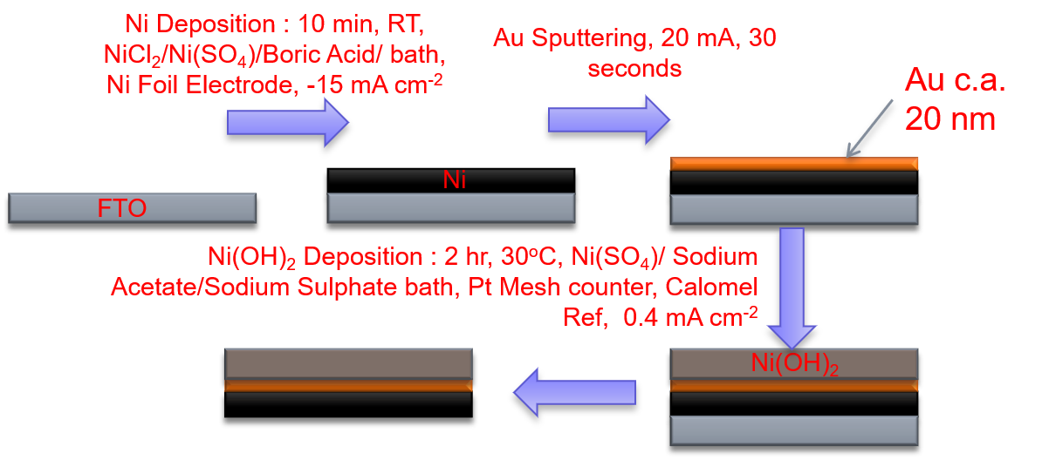
Figure S2 Synthetic method for production of tri-layer actuator devices

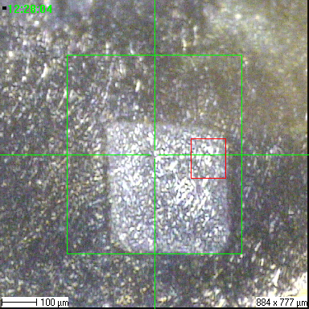
Figure S3 Video Snapshot showing sputter (green) and analysis (red) areas during a typical ToF-SIMS analysis
(a)
(b)
(c)
Figure S4 Potential traces vs time for galvanostatic electrochemical deposition of actuator layers. (a) Deposition of Ni substrate layer (b) Deposition of Ni(OH)₂ active layer onto Ni/Au substrate (Insert is magnification of first 1000 s)(c) Deposition of Ni(OH)₂ onto FTO substrate
Figure S5 EDX spectra for electrodeposited layers showing the substrate Ni layer (black) and the Ni/Au/Ni(OH)₂ tri-layer device (red) deposited on FTO (a) Whole spectrum taken up to 10 keV (b) Detailed spectrum of low BE region
(a)
(b)

Table S2: EDX atomic percentages in deposited layers on FTO.
Deposited Layers | Element / atomic %
Deposited Layers | C | O | Na | S | Ni | Au
Ni Only | 7 | 8 | 3 | 1 | 81 | 0
Ni/Au/Ni(OH)₂ | 6 | 54 | 9 | 11 | 18 | 2
Figure S6 XRD diffractogram of the substrate and tri-layer actuator after each synthetic step. * denotes a peak assigned to FTO substrate.

Figure S7 Cyclic Voltammetry of tri-layer Ni/Au/Ni(OH)₂ actuator. CV was performed at 50 mV s⁻¹

