Systematic Comparison of Single-Walled Carbon Nanotube/ Poly(vinyl Acetate) Graft-to Reactions
Adam J. Clancy,‡ James M. Serginson,‡ Jake L. Greenfield, and Milo S. P. Shaffer*.
London Centre for Nanotechnology, Department of Chemistry and Department of Materials, Imperial College London, South Kensington Campus, London, SW7 2AZ, U.K

The covalent grafting of polymers to single-walled carbon nanotubes (SWCNTs) is widely used to improve solvent compatibility, as well as composite and functional performance. Here, three different graft-to strategies are directly compared, using azide, diazonium, and bromide terminated polymers, over four different molecular weights (oligomeric to 10 kDa) using specifically synthesized low polydispersity, end-group controlled poly(vinyl acetate) (PVAc) prepared by polymerisation using a bespoke protected-amine RAFT agent. Coupling of the bromo-polymer to reduced SWCNTs led to higher degrees of functionalisation (grafting ratios up to 68.9 %) than the azide and diazonium grafting reactions, attributed to better initial dispersion of the pre-grafted SWCNTs. The use of higher molecular weight polymers led to a decrease in the total weight of polymer grafted, as the increase in per-polymer weight is more than offset by steric occlusion on the SWCNT surface. For these graft-to reactions, the dispersibility of grafted SWCNTs was found to depend most strongly on the polymer molecular weight, not total weight of grafted polymer or grafting chemistry, with an intermediate M_{n}~5757 PVAc giving the best dispersibilities, at up to 118 mg L⁻¹.
1. Introduction
Single walled carbon nanotubes (SWCNTs) are attractive in many diverse areas of materials science, due to their exceptional mechanical [1], thermal [2] and (opto)electronic [3] properties. However, in many cases, inherent processing challenges have hindered their large-scale use. Covalent functionalization of SWCNTs (f-SWCNTs) is a well-established route to increasing solubility/dispersibility, improving compatibility with other materials, and introducing new functionalities. Polymers are often grafted to SWCNTs to aid matrix dispersion and enhance stress transfer [4], but are also relevant to applications as diverse as imaging agents increasing in vivo imaging agents [5], chemical sensors [6], and crystallization nucleation agents [7]. Grafted polymers offer significant steric bulk and can significantly alter surface characteristics through only a low concentration of attachment points.

There are many strategies for the chemical modification of SWCNTs, including oxidative acid treatments, non-covalent physisorption of polymers and small molecules, and the covalent attachment of molecules using a range of common chemical reactions [8]. Whilst acid oxidation is popular and introduces carboxylic acids suitable for further reaction (often via ester/amidification), it causes significant damage to the SWCNT framework, forms vacancy defects which cannot be healed via annealing [9], and introduces contaminating debris [10]. The severely diminished electronic [3] and mechanical [11] properties render this approach less suitable for the majority of, though not all, applications. Non-covalent physisorption (often with polyaromatics) causes no inherent damage to the SWCNT framework and can alter surface chemistry of the nanomaterial, however, the weak interactions are less attractive in many cases, especially for mechanical reinforcement in composites.

Direct covalent functionalisation of the SWCNT sidewall (without relying on initial defect formation) is, therefore, often preferred. Highly reactive species including carboradicals [12], nitrenes [13], and azomethine ylides [8] are capable of functionalising the pristine, delocalized sp² framework of the nanotubes and are often synthesized in situ given their high reactivity and short lifetimes. Usually, SWNT bundles are ultrasonicated to increase the degree of dispersion and hence improve reagent access to the surface [14], however, the SWCNTs are rarely fully individualized, and may be cut or damaged by the sonication [15, 16].

While nitrenes are predominantly formed by degradation of azides, there are several routes used to form carboradicals, such as photolysis of iodides and in situ radical polymerization (using SWCNT functionalisation as a termination mechanism); however, the most common route relies on the degradation of diazonium salts [8]. An interesting alternative carboradical route uses ‘nanotubide’: negatively charged SWCNT anions [17]. Although several mechanisms can be proposed for nanotubide functionalisation, single electron transfer, is the most commonly accepted [18]. In this mechanism, the charge on nanotubide is transferred to one of a large family of functionalities, most commonly organohalides; the resulting radical anion subsequently degrades to form a carboradical which reacts with the SWCNT. This route offers the important benefit that the SWCNTs can be spontaneously dissolved as individualized nanotubides in certain solvents [17, 19, 20] such as N,N-dimethylacetamide (DMAc), exposing the entire surface for the subsequent grafting reactions.

There are two overarching approaches to functionalizing nanomaterials with polymers: graft-from and graft-to [21]. The former involves in situ polymerization from a specific initiating site bound to the SWCNT sidewall, while graft-to strategies couple pre-synthesised polymers to the SWCNT surface. The graft-from approach limits the ability to determine molecular weight and polydispersity index (PDI) after synthesis, making it challenging to analyze the underlying factors controlling the reaction. While polymerization routes with fine control over PDI are possible from the SWCNT surface after grafting initiator groups (e.g. dithioates [22] or trithiocarbonates [23, 24] for reversible addition−fragmentation chain-transfer (RAFT), and atom-transfer radical polymerisations) [25], the kinetics are not yet understood and molecular weights are either omitted or calculated assuming a PDI of 1. On the other hand, the grafting of bulky polymer molecules is usually sterically constrained, limiting the grafting stoichiometry (C/R, number of SWCNT framework carbons per polymer chain) and thus grafting ratio (weight polymer as percentage relative to the SWCNT framework) for graft-to reactions.

The theory governing the grafting of polymers to flat (non-curved, infinite) surfaces is well established by the comprehensive works of de Gennes, detailing the relationship of polymer conformation, grafting density, and molecular weight [26]. While there are obvious overlaps, the curved and bundled nature of SWCNTs suggest distinct differences; to date, few studies have systematically considered the physical aspects of polymer grafting on SWCNTs. The most comprehensive study, by Chadwick et al. studied the graft-to reaction of azide-terminated polystyrene reacted with SWCNTs pre-functionalised with alkyne containing moieties [27]. The grafting ratio displayed a maximum at intermediate molecular weight, presumably due to the balance between the increasing weight of each polymer chain and steric occlusion of polymers already present at the surface, similar to de Gennes theory (though at lower absolute nominal coverage); the dispersibility of grafted nanotubes was greatest for shorter polymer molecular weights. However, the use of the alkyne anchors intrinsically limits the number and location of the grafting sites and complicates a direct comparison to de Gennes theory. Further studies of graft-to reactions on SWCNTs are therefore of interest. In addition, the extent of grafting and the resulting dispersability may depend on the specific grafting chemistry, either due to intrinsic character of the bond formed or the reaction conditions required.

This study explores a series of reactions directly grafting monofunctional polymers to SWCNTs, using three alternative strategies for direct SWCNT modification, across a systematic series of molecular weights. Diazonium and azide terminated polymers represent macromolecular embodiments of two of the most common SWCNT sidewall chemistries; the third approach exploits the reaction of individual nanotubide ions with bromo-terminated polymers. A well-defined, low polydispersity, model polymer, poly(vinyl acetate), with a single, terminal, easy to manipulate end-group allowed a consistent set of molecular weights to be studied in all three approaches.

2. Experimental
2.1 Materials
Single-walled carbon nanotubes (Elicarb PR929, batch 108511/g) were supplied by Thomas Swan Ltd (U.K.). 4-aminobenzylalcohol (98 %) was purchased from Fluorochem Ltd. (UK). Phosphorous pentoxide (>98%), di-t-butyl dicarbonate (>99%), pyridine (anhydrous, 99.8%), thionyl chloride (>99%), anhydrous ethanol (200 proof >99.5%), vinyl acetate (>99% with 3-20 ppm hydroquinone stabiliser), acetic acid (>99.8%), trifluoroacetic acid (TFA, 99%), 2,2′-azobis(2-methylpropionitrile) (AIBN, 98%), lauroyl peroxide (Luperox® LP, 97%), sodium nitrite (99.999%), sodium azide (>99.5%), sodium (ingot, 99.99%), naphthalene (99%), bromoacetyl bromide (>98%), anhydrous N,N-dimethylacetamide (99.9%), triethylamide (TEA, >99%) and isoamyl nitrite (96%) were purchased from Sigma Aldrich Ltd. (U.K.). Potassium O-ethyl xanthate (98%) was purchased from Alfa Aesar (UK). Dichloromethane (DCM, 99.9%), n-hexane (99.9%), ethanol (96%), tetrahydrofuran (THF, 99.9%), petroleum benzene (petrol, 40-60 ºC fraction), N,N-dimethylacetamide (99%), N,N-dimethylformamide (DMF, 99.7%, HPLC grade), sodium sulphate (>99%), sodium hydrogen carbonate (>98%), sodium hydroxide (99.9%), and calcium chloride (99%) were purchased from VWR UK Ltd. (U.K.). Argon (pureshield 99.9999%), piped nitrogen, and dry oxygen (custom 20/80 v/v oxygen nitrogen mix) were purchased from BOC gases (DE).
Vinyl acetate was distilled under reduced pressure to remove inhibitor and oligomers immediately before use. AIBN was recrystallized from methanol (1.5 g in 5 mL MeOH at 60 ºC, cooling to RT over ca. 30 min) and collected via vacuum filtration as needle-like crystals before drying under vacuum for 1 h. The purified crystals were stored under argon at 0 ºC in the absence of light, and used within a week of purification.. Anhydrous DMAc was dried further with activated 4 Å molecular sieves (Sigma Aldrich) in a glovebox for 2 days prior to use. Naphthalene was dried under vacuum in the presence of P₂O₅ overnight before use. SWCNTs were also purified before use (vide infra), and all other reagents were used as received and without additional purification. All work involving sodium, sodium naphthalide, and nanotubide was performed in a N₂ glovebox (mBraun, <0.1 pm O₂, <0.1 ppm H₂O) using oven dried glassware. All reactions were carried out under nitrogen unless otherwise stated with inert gases passed through a silica, calcium chloride and sodium hydroxide drying column before use. Purification over silica refers to flash column chromatography using Silica Gel 60 (VWR). Unless specified otherwise, filtration refers to the use of a Buchner funnel fitted to a water aspirator and using Whatman brand filter paper (VWR). 200 nm PTFE syringe filters and filter membranes were purchased from Whatman. PTFE membranes (100 nm pore size, hydrophilic) were purchased from Millipore (UK).

2.2 Characterisation
¹H NMR spectra were recorded on Bruker AV400 (400 MHz) spectrometers as homogenous solutions and processed using Topspin software (Ver 1.3, by Bruker BioSpin). Deuterated solvents were purchased from VWR and used as received. d_{H} values are quoted to the nearest 0.01 ppm and coupling constants to the nearest 0.5 Hz. Spectra were calibrated to the non-deuterated solvent peak with peaks numbered according to Cahn-Ingold-Prelog rules. NMR backbone analysis of polymer molecular weight was calculated from the relative integrals of the integrals of the polymer backbone peaks (δ = 1.55-2.10 ppm (5nH/monomer) and 4.66-5.10 ppm (nH/monomer)) and the less downshifted aromatic protons of the carbon β to the nitrogen (δ = 6.4 to 7.0 ppm, 2H), with the exception of acylbrominated 8 where the γ carbon’s protons are used (δ = 7.5 ppm, 2H) to avoid the CHCl₃ signal.

UV-Vis spectra were recorded on a Perkin-Elmer Lambda 950 between 300–1200 nm using an optical glass 4 mm pathlength cuvette. Infra-red spectra were recorded on a Perkin-Elmer Spectrum 100 with a Universal ATR sampling accessory. Gel permeation chromatography was carried out using a Polymer Labs GPC 50 system with two PL-gel 5µ columns. Samples were eluted with DMF with 1% TEA and 1% acetic acid. The instrument was calibrated to PMMA standards. Data were processed using Polymer Labs Cirrus software. Centrifugation was carried out using a Sigma 2-16K centrifuge using fluorinated ethylene propylene centrifuge tubes (Thermo Fischer Scientific), with the neck sealed with PTFE tape in the thread when centrifuging nanotubide to avoid air ingress.

Thermogravimetric analysis was carried out using a Pyris 1 TGA, using 1–2 mg of sample, under nitrogen (60 sccm), heating at 100 °C for 60 min followed by a heating ramp to 700 °C at 10 °C min⁻¹. Weight of polymer in the sample were measured as the weight loss at 550 °C (above the degradation temperature of PVAc, ESI Fig. S1) minus the weight loss at 550 °C for the purified SWCNTs. Grafting ratios are presented as weight polymer as a percentage of SWCNT framework weight, calculated from the weight loss. Grafting stoichiometries (C/R, number of SWCNT framework carbons per polymer chain) were calculated using a SWCNT M_{w} of 12 Da and polymer M_{n} of the parent, amine/hydrogen-terminated polymer (6) minus 2 Da for azide grafting, minus 16 Da for diazonium grafting and plus 41 for bromide grafting (ESI, Table S3) to account for the different expected grafting mechanisms (Fig. 2). Instrumental errors are provided, calculated using the lower weight threshold (1 mg).

2.3 Synthesis
Preparation of t-butyl 4-(hydroxymethyl)phenyl carbamate (1).
4-aminobenzylalcohol (8.26 g, 67.2 mmol, 1.0 eq) was dissolved in in dry dichloromethane (500 mL) before di-t-butyl dicarbonate (17.0 g, 73.8 mmol, 1.1 eq) was added. The resulting solution was stirred for 18 h under nitrogen at room temperature, before removing the solvent under reduced pressure to leave a brown residue. This crude product was purified over silica (EtOAc/Hexane 1:1 (v/v), R_{f} 0.49) to give a white solid (10.7 g, 71.6%). ¹H NMR (CDCl₃), (400 MHz): δ_{H} = 1.53 (s, 9H, CH₃), 2.25 (br s, 1H, OH), 4.60 (s, 2H, PhCH₂), 6.72 (br s, 1H, NH), 7.27 (d, ³J_{HH} 8.5 Hz, 2H, ArH²), 7.34 (d, ³J_{HH} 8.5 Hz, 2H, ArH³).

Preparation of t-butyl 4-(chloromethyl)phenyl carbamate (2)
Pyridine (0.45 mL, 3.63 mmol, 0.09 eq) was added to a solution of alcohol 1 (9.00 g, 40.3 mmol, 1.0 eq) in DCM (300 mL), followed by thionyl chloride (6.44 g, 88.7 mmol, 2.2 eq). The resulting solution was stirred for 30 min followed by the addition of water (50 mL). The two phases were separated and the aqueous layer extracted with DCM (2 x 50 mL). The combined organics were dried over sodium sulphate, filtered and reduced to dryness to give an off-white solid (6.56 g, 68%). ¹H NMR (CDCl₃), (400 MHz): δ_{H} = 1.51 (s, 9H, CH₃), 4.54 (s, 2H, PhCH₂), 6.63 (br s, 0.91H, NH), 7.29 (d, ³J_{HH} 8.0 Hz, 2H, ArH²), 7.35 (d, ³J_{HH} 8.0iiii Hz, 2H, ArH³).

Preparation of S-(4-((t-butoxycarbonyl)amino)benzyl)-O-ethyl xanthate (3)
Chloride 2 (6.00 g, 24.8 mmol, 1.0 eq) was dissolved in dry ethanol (100 mL) under nitrogen with stirring. In one portion, potassium O-ethyl xanthate (4.39 g, 27.4 mmol, 1.1 eq) was added and the resulting suspension left to stir at room temperature for 18 h. After this time, the solvent was removed under vacuum to leave a pale yellow solid. Acetone (100 mL) was added and the suspension filtered through a sintered glass funnel. The filtrate was evaporated to dryness and the resulting solid recrystallized from ethanol to give pale yellow crystals (6.15 g, 76%). ¹H NMR (CD₃)₂ CO), (400 MHz): δ_{H} = 1.42 (t, ³J_{HH} 7.2 Hz, 3H, CH₂CH₃), 1.51 (s, 9H, CH₃C), 4.31 (s, 2H, PhCH₂), 4.65 (q, ³J_{HH} 7.2 Hz, 2H, CH₂CH₃), 6.46 (br s, 0.91H, NH), 7.26 (d, ³J_{HH} 8.0 Hz, 2H (overlaps CHCl₃), ArH²), 7.30 (d, ³J_{HH} 8.0 Hz, 2H, ArH³).

RAFT polymerisation of vinyl acetate to yield “Xan-PVAc-NHBoc” (4)
In a typical procedure, a 100 mL polymerisation tube was sealed with a septum was which was then evacuated and refilled with nitrogen three times. Vinyl acetate (5.1 mL, 55.3 mmol, 60 eq.) was then added. After degassing three times with the freeze-pump-thaw method, the tube was refilled with argon and the septum exchanged for a PTFE screw top. The sealed tube was then heated to 80 °C before adding RAFT agent 3 (300 mg, 0.92 mmol, 1.0 eq) and AIBN (30 mg, 0.18 mmol, 0.2 eq.) to the mixture, and heating for the specified time. Solvent was removed under vacuum to afford crude polymer 4 (ca. 95%). ¹H NMR (CDCl₃), (400 MHz): δ_{H} = 1.44 (t, 3H, CH₂CH₃), 1.53 (s, 9H, (CH₃)₃C), 1.63-2.15 i(m, 5nH, CH₂CHOCOCH₃ (backbone)), 2.23 (br, 2H, CH₂CHOCOCH₃ (endgroup)), 4.65 (dd, 2H, CH₂CH₃), 4.77-5.30 (br m, nH, CH₂CHOCOCH₃ (backbone)), 6.49 (br s, 1H, NH), 6.61 (br m, 1H, CH₂CHOCOCH₃ (endgroup)), 7.06 (m, 2H, ArH²), 7.25 (m, 2H, ArH³). IR: ν = 2976.7 (w), 2931.4 (w), 1730.6 (s; acetate C=O), 1530.0 (w; Boc C=O), 1433.1 (w), 1369.3 (m), 1227.0 (s; acetate C-O), 1115.3 (w), 1019.6 (s, acetate C-O), 943.79 (w), 769.6 (w), 604.03 (w).

Removal of xanthate groups to yield “H-PVAc-NHBoc” (5)
In a typical procedure, lauroyl peroxide (2.1 eq), xanthate-terminated polymer 4 (1.0 eq. of xanthate), THF (3 mL) and IPA (6 mL) were added to a polymerisation tube with a stirrer bar. After degassing three times with the freeze-pump-thaw method, the tube was refilled with argon and the septum exchanged for a PTFE screw top. The sealed tube was then heated at 80 °C for 18 h. After this time, the solution was evaporated to dryness and the residue dissolved in the minimum amount of THF, then precipitated into petrol and left to settle overnight. The supernatant was decanted and the remaining solid dissolved in THF, transferred to a round-bottom flask and reduced to dryness under vacuum to give polymer 5 which was purified using precipitation from THF into petrol (40-60 °C fraction, >99%). ¹H NMR (CDCl₃), (400 MHz): δ_{H} = 1.44 (t, 3H, CH₂CH₃), 1.53 (s, 9H, (CH₃)₃C), 1.63-2.15 (m, 5nH, CH₂CHOCOCH₃ (backbone)), 2.23 (br, 2H, CH₂CHOCOCH₃ (endgroup)), 4.09 (m, 2H, CH₂OCOCH₃), 4.77-5.30 (br m, nH, CH₂CHOCOCH₃ (backbone)), 6.53 (br s, 1H, NH), 7.09 (m, 2H, ArH²), 7.28 (m, 2H, ArH³). IR: ν = 2981.0 (w), 2928.6 (w), 1729.7 (s; acetate C=O), 1530.4 (w; Boc C=O), 1433.0 (w), 1369.3 (m), 1226.8 (s; acetate C-O), 1117.9 (w), 1019.7 (s, acetate C-O), 944.1 (w), 796.9 (w), 604.17 (w).

Boc deprotection of polymer to yield “H-PVAc-NH₂” (6)
The boc-protected polymer 5 was dissolved in the DCM component of 3:1 DCM:TFA such that the concentration of the boc-group was of the order of 10⁻⁷ mol mL⁻¹. The TFA was added and the solution was then stirred at room temperature for one hour. After this time, ice was added and the mixture transferred to a large flask. Sodium hydrogen carbonate was added until the effervescence ceased. The biphasic-mixture was separated and the organic layer washed with water. After drying with sodium sulphate and filtration, solvent was removed under vacuum to give a material of similar physical character to the parent polymer which was purified using precipitation from THF into petrol (40-60 °C fraction, >99%). ¹H NMR (CDCl₃), (400 MHz): δ_{H} = 1.60 - 1.96 (m, 2nH, CH₂CH (backbone)), 1.97-2.10 (t, 3nH, (CH₃), 2.49 (br, 2H, ArCH₂), 4.10 (m, 2H, CH₂C(OAc)H₂), 4.77-5.30 (br m, n-1H, CH₂CH (backbone)), 6.61 (d, ³J_{HH} 8.0 Hz, 2H, ArH²), 6.94 (m, 2H, ArH³). IR: ν = 2982.8 (w), 2929.7 (w), 1729.7 (s; acetate C=O), 1432.8 (w), 1369.7 (m), 1227.2 (s; acetate C-O), 1119.1 (w), 1019.9 (s, acetate C-O), 944.0 (w), 797.6 (w), 604.3 (w).

Azidation of aniline terminated polymer to yield “H-PVAc-N₃” (7)
Polymer 6 (1.0 eq. of amine) was dissolved in 9:1 (v/v) AcOH:water (25 mL). The solution was cooled in an ice bath and sodium nitrite (1.5 eq) was added. After ten minutes, sodium azide (2.0 eq.) was added and stirring continued for 1 h. After this time, DCM (10 mL) was added. The organic layer was separated and the aqueous layer washed with further DCM (3 x 10 mL). The combined organic fractions were then washed with water (3 x 50 mL), dried over sodium sulphate and evaporated to dryness to give polymer 7 (>99%) which was used without further purification. ¹H NMR (CDCl₃), (400 MHz): δ_{H} = 1.59-1.95 (m, 2nH, CH₂CH (backbone)), 1.97-2.10 (t, 3nH, (CH₃), 2.58 (br, 2H, ArCH₂), 4.11 (t, 2H, CH₂C(OAc)H₂), 4.77-5.30 (br m, (n-1)H, CH₂CH (backbone)), 6.94 (d, ³J_{HH} 8.4 Hz, 2H, ArH²), 7.14 (d, ³J_{HH} 8.4 Hz 2H, ArH³). IR: ν = 2981.0 (w), 2929.8 (w), 2115.2 (w; azide), 1730.2 (s; acetate C=O), 1432.5 (w), 1370.1 (m), 1227.4 (s; acetate C-O), 1118.0 (w), 1020.0 (s, acetate C-O), 944.4 (w), 797.2 (w), 603.7 (w).

Alkylation of aniline terminated polymer to yield “H-PVAc-Br” (8)
Polymer 6 (1.0 eq. of amine) was dissolved in dry DCM (50 mL) under nitrogen with stirring. The solution was cooled to 0 °C in an ice bath and bromoacetyl bromide (2.0 eq.) was added. The ice bath was removed and the solution stirred for 1 h. The residue was purified using precipitation from THF into petrol (40-60 °C fraction) to give the dark brown polymer 8 (>99%) which was stored out of direct sunlight. ¹H NMR (CDCl₃), (400 MHz): δ_{H} = 1.62-1.96 (m, 2nH, CH₂CH (backbone)), 1.97-2.10 (t, 3nH, (CH₃), 2.57 (br, 2H, ArCH₂), 3.71 (s, 2H, BrCH₂), 3.97 (s, 2H, CH₂C(OAc)H₂), 4.73-5.21 (br m, n-1H, CH₂CH (backbone)), 7.11 (d, ³J_{HH} 7.2 Hz, 2H, ArH²), 7.41 (d, ³J_{HH} 7.2 Hz 2H, ArH³), 8.23 (s. 1H, NH).

Purification of SWCNTs
A bulk solution of sodium naphthalide (NaNp) in (DMAc) was prepared by stirring sodium (50 mg) and naphthalene (278 mg) in DMAc (50 mL) using a glass stirrer bar. This solution was stored out of light (covered in aluminium foil), used as soon as possible (maximum 1 week) and monitored for degradation immediately before use, as indicated visually by the appearance of white precipitate and spectroscopically by the reduced intensity of the characteristic absorbance band (ε_{798 nm} = 26200 m M⁻¹). SWCNTs (100 mg) were dried under vacuum (~10⁻² mbar) at 300 ⁰C for 1 h and 16 h at room temperature before leaving to soak for 24 h in 9.6 mL of NaNp solution diluted with 80.4 mL of DMAc. The mixture was centrifuged at 10,000 g for 30 min and the supernatant containing dissolved amorphous carbon, catalyst particles, and short/defecting SWCNTs was discarded. The remaining SWCNTs were left in an atmosphere of dry oxygen overnight to remove residual charge on the SWNCT framework through the formation of sodium oxidides, before washing with copious acetone, then copious DI water to leave purified SWCNTs (ca. 80 % initial weight). Procedure adapted from Clancy et al. [28].

General Procedure for diazonium grafting
Procedure adapted from Chadwick et al. [27] Purified SWCNTs (5 mg) were added to dry DMF (50 mL) and bath sonicated for 30 min. After this time, PVAc-NH₂ (200 mg) was added and the mixture heated at 70 °C. Upon reaching this temperature, isoamyl nitrite (0.1 mL) was added. The suspension was then stirred for 18 h, then allowed to cool slightly before filtering through a 100 nm PTFE membrane. Before drying on the filter membrane, the membrane was placed in a further 100 mL of DMAc and briefly sonicated to redisperse the nanotubes. The resulting suspension was again filtered through a fresh membrane. The resulting nanotube filtrate was washed with THF (100 mL) and dried under vacuum. The procedure was repeated without the addition of polymer solution to give the ‘diazonium control’.

General procedure for azide grafting
Purified SWCNTs (5 mg) were added to dry DMAc (50 mL) and bath sonicated for 30 min. Polymer 7 (200 mg) was added and the mixture heated at 140 °C with stirring for three days. After this time, the suspension was allowed to cool slightly before being filtered through a 100 nm PTFE membrane. Before drying on the filter membrane, the membrane was placed in a further 100 mL of DMAc and briefly sonicated to redisperse the nanotubes. The resulting suspension was again filtered through a fresh membrane. The resulting nanotube filtrate was washed with THF (100 mL) and dried under vacuum. Procedure adapted from Qin et al. [25] The procedure was repeated without the addition of polymer to give the ‘azide control’, and was repeated using polymers 4 and 6 (M_{w} 5767) as non-grafting polymer controls.

General Procedure for nanotubide grafting
Procedure adapted from Clancy et al. [29]. Purified SWCNTs (12 mg) were dried under vacuum (~10⁻² mbar) at 300 ⁰C for 1 h and at room temperature for 16 h. In a nitrogen glovebox, the SWCNTs were stirred in NaNp/DMAc solution (24 mL, 1 mmol Na, for preparation see SWCNT purification) for 24 h. After this time, the solution was diluted with sufficient DMAc to afford a final 0.1 mg mL⁻¹ solution, taking into account the additional DMAc that would be added with the polymer. A solution of polymer 8 (0.33 mmol) in DMAc was added (2.5 mM) and the solution stirred overnight. The solution was removed from the glovebox residual charge was removed by bubbling dry oxygen through the dispersion for 15 min before being filtered through a PTFE filter membrane. Before drying on the filter membrane, the membrane was placed in a further 100 mL of DMAc and briefly sonicated to redisperse the nanotubes. The resulting suspension was again filtered through a fresh membrane. The resulting nanotube filtrate was washed with THF (100 mL) and dried under vacuum. The procedure was repeated without the addition of polymer solution to give the ‘nanotubide control’.

Dispersibility measurements
SWCNTs (2.0 mg carbon framework, e.g. 3 mg of functionalised SWCNTs with 50% grafting ratio) were placed in a glass vial and DMAc (4.0 mL) was added; the total weight of functionalised material added was calculated using grafting density derived from TGA, to ensure a consistent weight of SWCNT framework. The sample was bath sonicated for 30 min, the suspension transferred to a centrifuge tube and centrifuged at 20,000 g for 30 min. A portion of the decanted supernatant (0.4 mL) was taken and diluted with further DMAc (0.8 mL). UV-vis spectra were recorded between 300 – 1200 nm and measurements were repeated three times. Dispersibilities were calculated using the absorbance recorded at 660 nm (less the measurement for neat DMAc) using an extinction coefficient of 3616.6 mL mg⁻¹ m⁻¹ (± 7.4 %, ESI Table S2).

3. Results and Discussion
Asymmetric end-group controlled polymers were prepared via reversible addition-fragmentation chain transfer (RAFT); mono-para-aniline and hydrogen were selected as the end-groups, since the primary amine facilitates all the chosen grafting strategies, allowing the same series of polymers to be compared. Poly(vinyl acetate) (PVAc) was selected as a well-studied RAFT-synthesised polymer, highly soluble in the solvent used throughout this work (DMAc) while remaining unreactive towards all the chemistries employed. In addition, PVAc is the typical intermediate in poly(vinyl alcohol) synthesis, which is commonly used as the matrix for nanocomposites [30], including some of the highest performance SWCNT [31] composites to date, providing a potential future application for the synthesised f-SWCNTs.

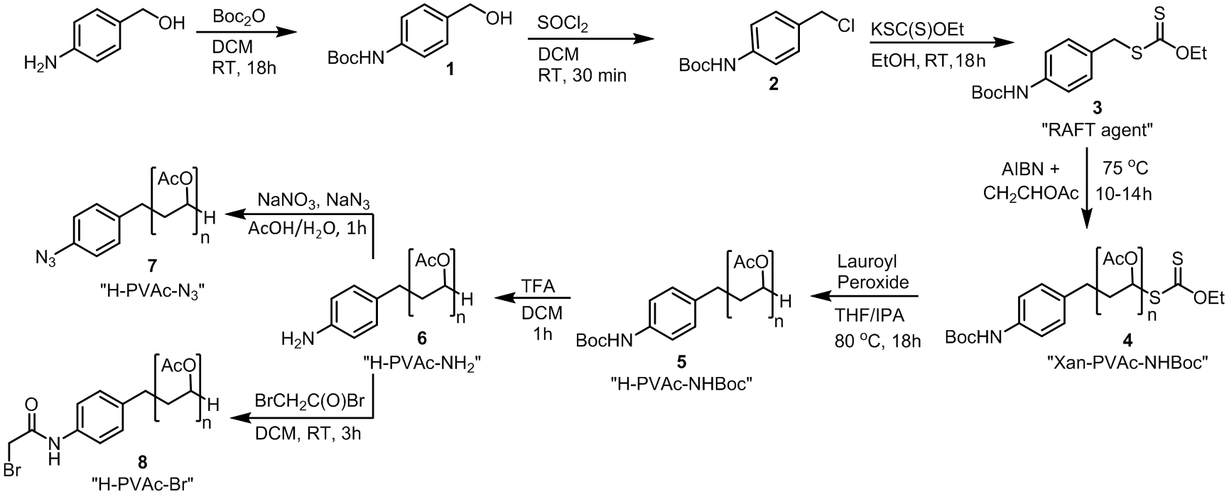
Scheme 1. Preparation of RAFT agent 3, Polymerisation of vinyl acetate, and subsequent end-group modifications.

The preparation of the RAFT reagent (Scheme 1) was adapted from Tong et al. [32], with O-ethyl xanthate used in lieu of O-2-methoxyethyl xanthate, for reasons of availability. The RAFT agent (3) was synthesized from 4-aminobenzalcohol through tert-butyloxycarbonyl (Boc) protection of the amine, followed by chlorination of the alcohol with thionyl chloride to form the benzyl chloride (2) before final substitution with O-ethyl xanthate to give 3. Vinyl acetate was polymerised from 3 using 60 equivalents of monomer under typical RAFT conditions [33] (75 °C, Ar atmosphere, solvent free). Most polymers were characterised using gel permeation chromatography (GPC), however for oligomers of less than 1000 Da, ¹H NMR end-group analysis was used; for products where both GPC and NMR was possible, number average molecular weights derived from NMR analysis correlated with the values obtained with GPC (ESI Table S1). Molecular weight was monitored as a function of time for 60 eq. monomer versus 3 (Fig. 1a): the reaction required an approximately 10 hour RAFT initiation period [34], after which, the M_{w} increased rapidly until a plateau was seen at a weight corresponding to approximately 120 equivalents. The low efficiency of the RAFT agent (ca. 50%) may be attributed to premature termination due to dimerization of the carboradical (here CH₂PhNHBoc) during the initiation stage [34]. The specific kinetics of this particular polymerization system was not investigated further, however, and polymers of predetermined molecular weight were created through stoichiometric monomer control, taking into account the RAFT agent efficiency. Polymers were purified through precipitation into petroleum ether, removing short chains and side products, with recovery typically >90% (by weight), and final PDIs ranging between 1.10–1.17 (ESI, Table S1).

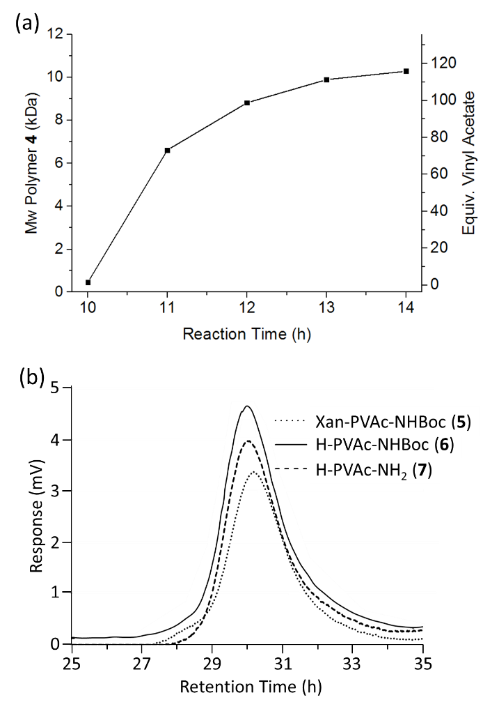
Figure 1. (a) PVAc M_{w} measured via GPC as a function of time for 60:1 initial ratio of vinyl acetate to RAFT agent, (b) GPC curves of as-polymerised and end-group modified PVAcs.

Subsequent end-group functionalisations were performed to facilitate the grafting reactions (Scheme 2); reactions were performed on the same batch of polymer to ensure molecular weight and PDI consistency. After polymerization, the xanthate was cleaved using lauryl peroxide [35] to give the hydrogen-terminated H-PVAc-NHBoc (5), with NMR showing elimination of the xanthate O-ethyl protons (δ = 4.65, Fig. 2) and emergence of a peak corresponding to the terminal hydrogens (δ = 4.09). Subsequently, the polymers’ aniline Boc protection was removed through addition of trifluoroacetic acid, exposing the amine used to adhere all grafting functionalities, giving H-PVAc-NH₂ (6). Removal of the Boc group could be seen through disappearance of the Boc carbonyl in IR spectroscopy (1530.4 cm⁻¹, ESI Fig. S2) and a substantial downshift in the aryl peaks in NMR (Fig. 2). The post-polymerisation end-group manipulations were shown to not influence the polymer molecular weight of the backbone chain with GPC showing a single peak with no broadening before and after all steps (Fig. 1b).

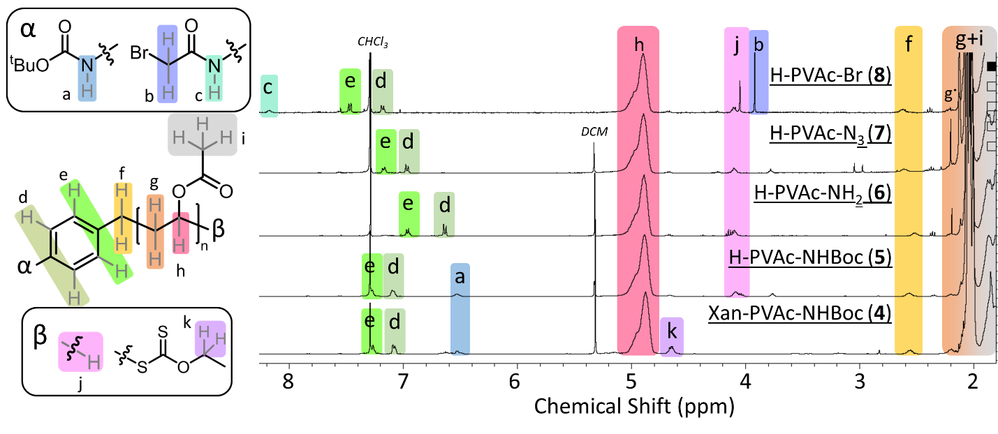
Figure 2. ¹H NMR spectra of PVAc with varying end-groups. g* at δ ~ 2.2 ppm corresponds to “g” assignment closest to the aryl (i.e. C₆H₄CH₂CH₂). The δ < 2 ppm region (containing backbone hydrogens g/i) is excluded here for clarity: full spectra are provided in the ESI (Fig. S3–S13), and full values and assignment given in experimental section

The azide-terminated polymer (7) was synthesised by ipso-substitution of azide via an in situ generated diazonium at the aniline using typical azidination conditions [36]. Substitution was confirmed through appearance of the characteristic asymmetric azide stretch in IR (2115.2 cm⁻¹); the reaction was quantitative as illustrated by the disappearance of the aryl aniline peaks in ¹H NMR (Fig. 2). Bromination to H-PVAc-Br (8) was performed through reaction with bromoacyl bromide and was confirmed by the appearance of a singlet in NMR corresponding to the acetyl end-group (4.04 ppm) and a highly upshifted amide hydrogen (8.18 ppm). Acyl halides were required for amidification, as ‘milder’ condensation reactions would lead to partial deacetylation of the PVAc backbone. It is also noted that the use of acyl chlorides led to an equilibrium between chloride and bromide terminated polymers due to attack of the liberated chloride anion; the use of the acyl bromide bypassed this issue. Characteristic acetate ester peaks remained constant at approximately 1730, 1227 and 1020 cm⁻¹ for 6, 7, and 8, indicating stability of the acetate backbone throughout the transformations. Diazonium-terminated polymers were generated in situ from 7 during the grafting to SWCNTs, following an established procedure [27], and not isolated for characterization.

The modified PVAc (6, 7 and 8) were grafted to the SWCNTs (Scheme 2) using reaction conditions adapted from literature [25, 27, 29]. Briefly, diazonium reactions were performed by adding 6 to a sonicated dispersion of SWCNTs at 70 °C and forming the diazonium in situ with isoamyl nitrite and heating for 18h. Azide functionalisation was performed by adding 7 to a sonicated dispersion of SWCNTs in DMF and heating at 140 °C for 72 h. Bromide functionalisation was performed by stirring 8 and nanotubide DMAc solution at RT for 24 h in a nitrogen glovebox. Nanotube and polymer quantities and concentrations were kept constant between reactions, for ease of comparison. Whilst some reactions are known to have stoichiometric dependence, notably influencing both grafting ratio and electronic selectivity of diazonium grafting to SWCNTs [37], these effects are relatively modest in terms of the absolute degree of grafting. The stoichiometry of each reaction type was not optimised independently, as polymer concentration is known to control both reaction kinetics and depletion interactions, complicating comparisons.
The f-SWCNTs in all cases were filtered, washed with copious DMAc and THF, before redispersing and refiltering to remove excess, ungrafted polymer. To explore the effects of these reaction environments, the SWCNTs were subjected to identical conditions and work-up, without the addition of the polymer, to generate “polymer-free control samples”.

Scheme 2. PVAc functionalisations of SWCNTs.

In TGA, all polymer-free controls show modest additional weight losses between 100–700 °C (ESI Fig. S14), indicative of either physisorption or adventitious functionalisation by the reaction medium. The small weight loss from the bromide polymer-free control (GR = 5.2 %) is thought to derive from the introduction of oxygen-containing groups during discharge, as has been previously reported [38]. It is worth noting that recent developments in reduced nanocarbon chemistry provide alternative discharging routes can mitigate the mild damage to the SWCNTs observed here, if needed [39, 40]. Both diazonium and azide polymer-free controls involve heating in DMF, leading to some apparent functionalization due to degradation of DMF which proceeds via radical intermediates [41] which are likely to react with the SWCNT framework. The diazonium control exhibits a low grafting ratio (2.5%), particularly in comparison to the azide polymer-free control (8.3%), in line with the difference in reaction temperatures (70 and 140°C, respectively). Similarly, while the dispersibilities of the diazonium (18.4 μg mL⁻¹) and nanotubide (3.0 μg mL⁻¹) controls remain similar to untreated SWCNTs (11.7 μg mL⁻¹), the dispersibility of the azide control increases notably (57.8 μg mL⁻¹), as has been seen previously for sonochemically degraded amidic solvents adsorbed on SWCNTs [42].

Nominally unreactive polymers 4 (as-polymerised Xan-PVAc-NHBoc) and 6 (fully deprotected H-PVAc-NH₂, both M_{n} ~5731) were subjected to the azide grafting conditions (the most extreme conditions) as controls to explore potential polymer wrapping/adsorption on the SWCNTs. The grafting ratios of each (6.3 % and 8.2 % respectively) were similar to the azide polymer-free control; however, the thermogravimetric data (ESI Fig. S14) showed a steep increase in degradation at ca. 300 °C, typical of both commercial and synthesized PVAc (ESI Fig. S1). No equivalent continuous decrease was seen for the previous polymer-free controls, suggesting that the weight loss relates to residual polymer rather than adsorbed degraded solvent. The dispersibility of the 4 and 6 control SWCNTs only increased mildly (28.8 and 31.7 μg mL⁻¹ respectively). It seems that the free polymer occludes the SWCNT surface and reduces the trapping of degraded solvent.

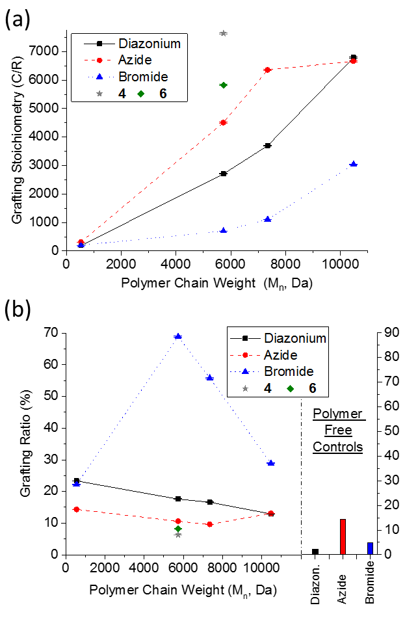

Figure 3. (a) Grafting stoichiometry of f-SWCNTs as a function of PVAc backbone molecular weight for diazonium (black square, solid line), azide (red circle, dashed line) and reductive (blue triangle, dotted line) routes and non-grafting polymers 4 (grey star) and 6 (green diamond) under azide grafting conditions. (b) Grafting ratio of f-SWCNTs. Controls of SWCNTs under the respective functionalization conditions, in the absence of polymer, are given in bar chart on the right.
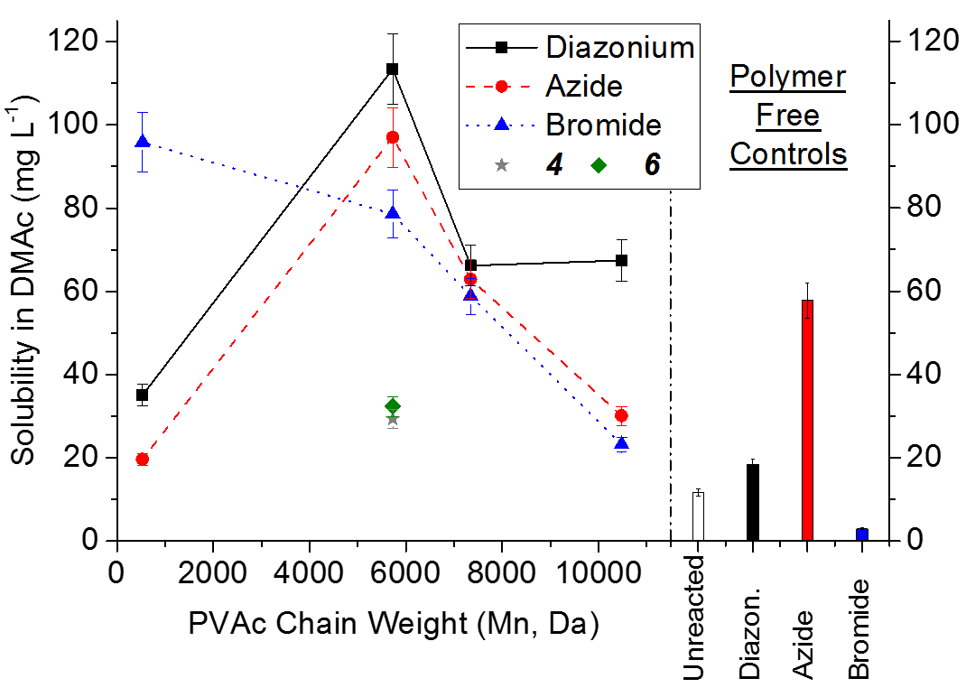
Figure 4. Dispersibility of f-SWCNTs in DMAc (after initial dispersion at 500 mg L⁻¹ and centrifugation) versus PVAc backbone weight for diazonium (black square, solid line), azide (red circle, dashed line), and reductive (blue triangle, dotted line) functionalisation routes, and non-grafting polymers 4 (grey star) and 6 (green diamond) under azide grafting conditions. Controls of SWCNTs under the respective functionalization conditions in the absence of polymer given in bar chart on the right.

Grafted f-SWCNTs in all reaction routes also show polymer-like thermogravimetric behavior, indicating that weight loss is attributable to PVAc. There is a clear trend in grafting ratio (Fig. 3) between reaction types: bromide functionalisation shows the highest degree of functionalisation, followed by diazonium, with azide showing the lowest grafting ratio. The high degree of grafting seen for the bromide reaction is likely due to the higher degree of individualization (thus larger accessible SWCNT surface for functionalisation) intrinsic to solutions of reduced SWCNTs; the sonication derived dispersions used for the azide and diazonium reactions are likely to remain significantly bundled. For all the reaction types, increasing molecular weight decreases grafting density (Fig. 3a), as expected, due to steric occlusion of the accessible SWCNT surface [29]. Generally, the grafting ratio decreases with increasing molecular weight (Fig. 3b), independent of grafting route, as seen in previous research [27]. In the case of the bromide route, the shortest, oligomer chain (M_{n} 600 Da), however, does not have as high a grafting ratio as might be expected from steric interactions alone. This sample has the lowest C/R ratio (200), and hence highest consumption of charge, and it is possible that the reaction is limited by availability of electrons on the SWCNTs. The reactivity of nanotubide is complex, thought to be governed by the reduction potential of the electrons, which is a function of the degree of charging, due to the continuum density of states. As the charge is consumed, the Fermi level of the nanotubide falls, eventually below the level needed for reaction [18, 38, 43].

Significant covalent functionalisation can be seen for the bromide and diazonium routes with the grafting ratios clearly exceeding all controls (by at least a factor of two). On the other hand, the grafting ratios of azide grafting reactions are of the same order as the non-grafting polymer controls. Nevertheless, the high dispersibility of azide grafted materials compared to non-grafting controls (118.1 μg mL⁻¹ vs < 32 μg mL⁻¹) indicates a different structure, and suggests some grafting. For all the covalent grafting routes, the best dispersibilities were greater than the polymer-free and unreactive polymer control samples, highlighting the importance and utility of covalent grafting. The optimal azide functionalised 5 kDa sample showed similar dispersibility to the commonly used approach in N-methyl-pyrrolidone [44] (NMP, 116 μg mL⁻¹), but without requiring the more damaging probe sonication known to introduce contamination [42].

The f-SWCNT dispersibility showed a strong correlation with the molecular weight of the initial polymer, reaching the maximum at a M_{w} of ~5 kDa for both diazonium and azide reactions (the bromide functionalised sample showed high dispersibility at both 5 kDa and for the oligomer system). Given the differences in grafting ratios between grafting methodologies for polymers of matching polymer size, these results confirms that the dispersibility of the f-SWCNTs is dominated by polymer molecular weight and not grafting ratio/stoichiometry. It should be noted that higher dispersibilities have been demonstrated [45] for other polymer-grafted SWCNTs with different polymer/solvent systems and it is expected that those systems may be improved by adapting the trends elucidated here.

Conclusions
In summary, three routes to SWCNT polymer graft-to functionalization were successfully compared through the use of a bespoke low-PDI, monoterminal-amine PVAc: simple end-group transformations provided equivalent length polymer chains suitable for comparing azide, diazonium, and bromide graft-to reactions. Bromide functionalisation through the use of reduced SWCNTs provides the highest grafting ratios; the difference in grafting ratios between reaction types highlights that degree of fuctionalisation in graft-to reactions are not controlled solely by polymer size. The success of bromide functionalization here is attributed to the maximized accessible SWCNT surface area from the spontaneously individualized anionic nanotubes. The bromide functionalisation gives the best grafting ratios but requires more stringent inert conditions and is less versatile; many solvents and potential side groups may react with the charged nanotubide framework. Of the other methodologies, diazonium grafting generally gives higher grafting ratios, and higher dispersibility than azide functionalisation, while requiring milder conditions (avoiding contaminating solvent degradation products) and shorter reaction times.

In terms of polymer molecular weight, shorter polymers generally maximize grafting ratio, as they minimize steric repulsion between the grafted polymer coils, but the best dispersibilities are found at intermediate polymer molecular weights, around 5 kDa. Crucially, the dispersibilities of the f-SWCNTs were shown to be most closely linked to the initial polymer’s molecular weight, and not the grafting methodology, or total weight of grafted polymer. Overall, the bromide route is recommended (where compatible) to maximise the degree of functionalisation, while diazonium grafting can be used in other scenarios. Polymer functionalization of SWCNTs is relevant to wide range of applications, particularly in nanocomposites; strategies to maximize the grafting ratio and dispersibility should offer significant benefits. Many of trends observed in this study are likely to be applicable to other nanocarbons which are known to react in similar conditions [7], allowing the processing of a broad range of nanomaterials to be improved.

Acknowledgements
The authors would like to thank the EPSRC (Program Grant EP/I02946X/1 on high performance ductile composite technology in collaboration with Bristol University). Supporting data can be requested from the corresponding author, but may be subject to confidentiality obligations. The authors declare no competing financial interest.

References
[1] J.N. Coleman, U. Khan, W.J. Blau, Y.K. Gun’ko, Small but strong: A review of the mechanical properties of carbon nanotube–polymer composites, Carbon 44(9) (2006) 1624–1652.
[2] A.A. Balandin, Thermal properties of graphene and nanostructured carbon materials, Nat. Mater. 10(8) (2011) 569-581.
[3] S.A. Hodge, M.K. Bayazit, K.S. Coleman, M.S. Shaffer, Unweaving the rainbow: a review of the relationship between single-walled carbon nanotube molecular structures and their chemical reactivity, Chemical Society reviews 41(12) (2012) 4409-29.
[4] A.J. Clancy, D.B. Anthony, S.J. Fisher, H. Leese, C.S. Roberts, M.S.P. Shaffer, Reductive Dissolution of Supergrowth Carbon Nanotubes for Tougher Nanocomposites by Reactive Coagulation Spinning, Nanoscale (2017).
[5] R. Wang, P. Cherukuri, J.G. Duque, T.K. Leeuw, M.K. Lackey, C.H. Moran, V.C. Moore, J.L. Conyers, R.E. Smalley, H.K. Schmidt, R.B. Weisman, P.S. Engel, SWCNT PEG-eggs: Single-walled carbon nanotubes in biocompatible shell-crosslinked micelles, Carbon 45(12) (2007) 2388-2393.
[6] H.J. Salavagione, A.M. Diez-Pascual, E. Lazaro, S. Vera, M.A. Gomez-Fatou, Chemical sensors based on polymer composites with carbon nanotubes and graphene: the role of the polymer, J. Mater. Chem. A 2(35) (2014) 14289-14328.
[7] H.S. Leese, L. Govada, E. Saridakis, S. Khurshid, R. Menzel, T. Morishita, A.J. Clancy, E.R. White, N.E. Chayen, M.S.P. Shaffer, Reductively PEGylated carbon nanomaterials and their use to nucleate 3D protein crystals: a comparison of dimensionality, Chem. Sci. 7(4) (2016) 2916-2923.
[8] P. Singh, S. Campidelli, S. Giordani, D. Bonifazi, A. Bianco, M. Prato, Organic functionalisation and characterisation of single-walled carbon nanotubes, Chemical Society reviews 38(8) (2009) 2214-2230.
[9] B. Gebhardt, F. Hof, C. Backes, M. Muller, T. Plocke, J. Maultzsch, C. Thomsen, F. Hauke, A. Hirsch, Selective polycarboxylation of semiconducting single-walled carbon nanotubes by reductive sidewall functionalization, Journal of the American Chemical Society 133(48) (2011) 19459-73.
[10] R. Verdejo, S. Lamoriniere, B. Cottam, A. Bismarck, M. Shaffer, Removal of oxidation debris from multi-walled carbon nanotubes, Chem. Commun. (5) (2007) 513-515.
[11] A. Zandiatashbar, G.-H. Lee, S. An, S. Lee, N. Mathew, M. Terrones, T. Hayashi, C. Picu, J. Hone, N. Koratkar, Effect of defects on the intrinsic strength and stiffness of graphene, Nat. Commun. 5 (2014) 3186.
[12] G. Schmidt, S. Gallon, S. Esnouf, J.P. Bourgoin, P. Chenevier, Mechanism of the Coupling of Diazonium to Single‐Walled Carbon Nanotubes and Its Consequences, Chem. Eur. J. 15(9) (2009) 2101-2110.
[13] J. Han, C. Gao, Functionalization of carbon nanotubes and other nanocarbons by azide chemistry, Nano-Micro Lett. 2(3) (2010) 213-226.
[14] J.J. Stephenson, J.L. Hudson, A.D. Leonard, K.B. Price, J.M. Tour, Repetitive Functionalization of Water-Soluble Single-Walled Carbon Nanotubes. Addition of Acid-Sensitive Addends, Chem. Mater. 19(14) (2007) 3491-3498.
[15] A. Lucas, C. Zakri, M. Maugey, M. Pasquali, P. Schoot, P. Poulin, Kinetics of nanotube and microfiber scission under sonication, J. Phys. Chem. C 113(48) (2009) 20599-20605.
[16] S.D. Bergin, Z. Sun, P. Streich, J. Hamilton, J.N. Coleman, New Solvents for Nanotubes: Approaching the Dispersibility of Surfactants, J. Phys. Chem. C 114(1) (2009) 231-237.
[17] A. Pénicaud, P. Poulin, A. Derré, E. Anglaret, P. Petit, Spontaneous dissolution of a single-wall carbon nanotube salt, Journal of the American Chemical Society 127 (2005) 8-9.
[18] D. Voiry, O. Roubeau, A. Pénicaud, Stoichiometric control of single walled carbon nanotubes functionalization, J. Mater. Chem. 20 (2010) 4385-4391.
[19] S. Fogden, C.A. Howard, R.K. Heenan, N.T. Skipper, M.S.P. Shaffer, Scalable method for the reductive dissolution, purification, and separation of single-walled carbon nanotubes, ACS nano 6(1) (2011) 54-62.
[20] D.J. Buckley, S.A. Hodge, M. De Marco, S. Hu, D.B. Anthony, P.L. Cullen, N.T. Skipper, M.S.P. Shaffer, C.A. Howard, Trajectory of the Selective Dissolution of Charged Single-Walled Carbon Nanotubes, J. Phys. Chem. C (2017).
[21] N. Rubio, H. Au, H.S. Leese, S. Hu, A.J. Clancy, M.S. Shaffer, Grafting from versus Grafting to Approaches for the Functionalization of Graphene Nanoplatelets with Poly (methyl methacrylate), Macromol. (2017).
[22] G.-J. Wang, S.-Z. Huang, Y. Wang, L. Liu, J. Qiu, Y. Li, Synthesis of water-soluble single-walled carbon nanotubes by RAFT polymerization, Polymer 48(3) (2007) 728-733.
[23] Y. Shi, G. Zeng, D. Xu, M. Liu, K. Wang, Z. Li, L. Fu, Q. Zhang, X. Zhang, Y. Wei, Biomimetic PEGylation of carbon nanotubes through surface-initiated RAFT polymerization, Mater. Sci. Eng. C (2017).
[24] P. Salice, M. Mauri, M. Castellino, M. De Marco, A. Bianchi, A. Virga, A. Tagliaferro, R. Simonutti, E. Menna, Synthesis and characterisation of a trithiocarbonate for the decoration of carbon nanostructures, Chem. Commun. 49(73) (2013) 8048-8050.
[25] S.H. Qin, D.Q. Qin, W.T. Ford, D.E. Resasco, J.E. Herrera, Functionalization of single-walled carbon nanotubes with polystyrene via grafting to and grafting from methods, Macromol. 37(3) (2004) 752-757.
[26] P.G. de Gennes, Conformations of polymers attached to an interface, Macromol. 13(5) (1980) 1069-1075.
[27] R.C. Chadwick, U. Khan, J.N. Coleman, A. Adronov, Polymer grafting to single-walled carbon nanotubes: effect of chain length on solubility, graft density and mechanical properties of macroscopic structures, Small 9(4) (2013) 552-60.
[28] A.J. Clancy, E.R. White, H.H. Tay, H.C. Yau, M.S.P. Shaffer, Systematic comparison of conventional and reductive single-walled carbon nanotube purifications, Carbon 108 (2016) 423-432.
[29] A.J. Clancy, J. Melbourne, M.S.P. Shaffer, A one-step route to solubilised, purified or functionalised single-walled carbon nanotubes, J. Mater. Chem. A 3(32) (2015) 16708-16715.
[30] W.J. Lee, A.J. Clancy, E. Kontturi, A. Bismarck, M.S. Shaffer, Strong and Stiff: High-Performance Cellulose Nanocrystal/Poly (vinyl alcohol) Composite Fibers, ACS Appl. Mater. Interf. 8(46) (2016) 31500-31504.
[31] P. Miaudet, S. Badaire, M. Maugey, A. Derré, V. Pichot, P. Launois, P. Poulin, C. Zakri, Hot-drawing of single and multiwall carbon nanotube fibers for high toughness and alignment, Nano Lett. 5(11) (2005) 2212-2215.
[32] Y.-Y. Tong, R. Wang, N. Xu, F.-S. Du, Z.-C. Li, Synthesis of well-defined azide-terminated poly(vinyl alcohol) and their subsequent modification via click chemistry, J. Polym. Sci. A 47(18) (2009) 4494-4504.
[33] J. Hui, Z. Dong, Y. Shi, Z. Fu, W. Yang, Reversible-deactivation radical polymerization of chloroprene and the synthesis of novel polychloroprene-based block copolymers by the RAFT approach, RSC Adv. 4(98) (2014) 55529-55538.
[34] J.B. McLeary, F.M. Calitz, J.M. McKenzie, M.P. Tonge, R.D. Sanderson, B. Klumperman, A1H NMR Investigation of Reversible Addition−Fragmentation Chain Transfer Polymerization Kinetics and Mechanisms. Initialization with Different Initiating and Leaving Groups, Macromol. 38(8) (2005) 3151-3161.
[35] H. Willcock, R.K. O'Reilly, End group removal and modification of RAFT polymers, Polym. Chem. (2010).
[36] T. Meguro, S. Yoshida, T. Hosoya, Aromatic Azido-selective Reduction via the Staudinger Reaction Using Tri-n-butylphosphonium Tetrafluoroborate with Triethylamine, Chem. Lett. (2017).
[37] W.-J. Kim, M.L. Usrey, M.S. Strano, Selective functionalization and free solution electrophoresis of single-walled carbon nanotubes: Separate enrichment of metallic and semiconducting SWNT, Chem. Mater. 19(7) (2007) 1571-1576.
[38] F. Hof, S. Bosch, S. Eigler, F. Hauke, A. Hirsch, New basic insight into reductive functionalization sequences of single walled carbon nanotubes (SWCNTs), Journal of the American Chemical Society 135(49) (2013) 18385-18395.
[39] P. Vecera, J. Holzwarth, K.F. Edelthalhammer, U. Mundloch, H. Peterlik, F. Hauke, A. Hirsch, Solvent-driven electron trapping and mass transport in reduced graphites to access perfect graphene, Nat. Commun. 7 (2016) 12411.
[40] S.A. Hodge, D.J. Buckley, H.C. Yau, N.T. Skipper, C.A. Howard, M.S. Shaffer, Chemical routes to discharging graphenides, Nanoscale 9(9) (2017) 3150-3158.
[41] A.J.C. Bunkan, J. Hetzler, T. Mikoviny, A. Wisthaler, C.J. Nielsen, M. Olzmann, The reactions of N-methylformamide and N,N-dimethylformamide with OH and their photo-oxidation under atmospheric conditions: experimental and theoretical studies, Phys. Chem. Chem. Phys. 17(10) (2015) 7046-7059.
[42] H.C. Yau, M.K. Bayazit, J.H.G. Steinke, M.S.P. Shaffer, Sonochemical degradation of N-methylpyrrolidone and its influence on single walled carbon nanotube dispersion, Chem. Commun. 51(93) (2015) 16621-16624.
[43] S. Hodge, H. Tay, D. Anthony, R. Menzel, D. Buckley, P. Cullen, N. Skipper, C. Howard, M. Shaffer, Probing the charging mechanisms of carbon nanomaterial polyelectrolytes, Faraday Discuss. 172.
[44] S.D. Bergin, Z. Sun, D. Rickard, P.V. Streich, J.P. Hamilton, J.N. Coleman, Multicomponent solubility parameters for single-walled carbon nanotube− solvent mixtures, ACS nano 3(8) (2009) 2340-2350.
[45] B.I. Kharisov, O.V. Kharissova, A.V. Dimas, The dispersion, solubilization and stabilization in “solution” of single-walled carbon nanotubes, RSC Adv. 6(73) (2016) 68760-68787.

