Monoclinic domain populations and enhancement of the piezoelectric properties in a PZT single crystal at the morphotropic phase boundary

Krystian Roleder1*, Andrzej Majchrowski2, Iwona Lazar1, Roger W. Whatmore3,
A. Mike Glazer4,5, Dariusz Kajewski1, Janusz Koperski1, Andrzej Soszyński1

1Institute of Physics, University of Silesia, Chorzów, Poland
2Institute of Applied Physics, Military University of Technology, Warszawa, Poland 3 Department of Materials, Faculty of Engineering, Imperial College London, London, United Kingdom
4Clarendon Laboratory, University of Oxford, Oxford, United Kingdom
5 Department of Physics, University of Warwick, Coventry, United Kingdom
*Corresponding Author: Krystian.Roleder@us.edu.pl

Keywords: PZT single crystal, piezoelectricity, domains population, monoclinic symmetry

Abstract
The origin of the strong piezoelectric phenomenon in PZT perovskites still suffers from a lack of complete understanding. It concerns the distinction between the intrinsic and extrinsic mechanisms that govern PZT's piezo-activity. These two mechanisms have been investigated in single-crystal PbZr0.54Ti0.46O3 at the morphotropic phase boundary. After poling in a DC electric field, the piezoelectric properties were examined on the same crystal by observing piezoelectric resonances to determine the piezoelectric coefficient d31 and measuring quasi- static deformation to determine the coefficient d33. The domain populations were investigated during and after poling in a DC electric field. These populations were also investigated as a function of DC fields for strengths similar to those used to measure quasi-static piezoelectric properties for a poled crystal. The experiments indicate that the intrinsic origin of the enhancement of the piezoelectric properties is connected with a change in the population of domains with monoclinic symmetry, in which there is an easy polarisation rotation under the action of the electric field.

Introduction
The excellent electromechanical properties of the solid solutions of the perovskite PbZr1-xTixO3 (PZT) have made these materials widely used, e.g., in the production of scientific instruments (scanning probe microscopes [1]), in electronics (transducers [2]), medicine (ultrasonography [3]), sport (electro-active vibration damping [4]), and the automotive sector (fuel injection [5]). Even though PZT has been intensively studied for decades, new unique properties continue to be discovered. PZTs are used only in ceramic form, mainly because it is hard to grow large single crystals. Hence, the first phase diagram for PZT solid solutions proposed by Sawaguchi in 1953 was derived only from measurements on ceramics [6]. Even now, nearly seven decades since the system's discovery, very few papers have reported the properties of PZT single crystals [7-11], mainly because of the technical difficulties involved in their growth [12]. Most papers

on PZT have been on ceramics with compositions around the morphotropic phase boundary (MPB). This is a complex boundary with the co-existence of ferroelectric rhombohedral, monoclinic and tetragonal phases. The strong piezoelectric effects found in MPB-composition ceramics have led to the multitude of practical applications mentioned above.
PZT single crystals have the potential to be even more impressive from the perspective of piezoelectric properties. Recently, sophisticated structural investigations of PZT materials have revealed a highly complex phase diagram. Long-range average rhombohedral and long-range and short-range monoclinic regions coexist for Zr-rich compositions of PZT [13]. The monoclinic ferroic phase possesses three structural variants denoted as MA, MB, and MC [14]. In the MA and MB phases, the mirror plane is parallel to {110}p, (where the subscript 'p' indicates Miller indices referred to the pseudo-cubic perovskite axes) while in the MC phase, it is parallel to {100}p. The MA, MB, and MC phases differ in the direction of spontaneous polarisation, which in the MC phase is along <0uv>, in the MA along <uuv> with u < v, and in the MB along <uuv> with u > v. The monoclinic MA phase has been considered as being responsible for the high piezo-activity in PZT [14]. It was also found that for a PbZr0.52Ti0.48O3 composition, which is at the monoclinic-tetragonal phase boundary, the crystal structure at room temperature shows after poling a clear tendency to adopt monoclinic symmetry [15]. Moreover, it has been demonstrated that changes induced in the unit cell after applying an electric field do not increase either the rhombohedral or the tetragonal strains. A definite elongation is induced along directions associated with the monoclinic distortion [15].
Recently, a co-existence of the monoclinic MA and MB phases has been found at room
temperature in a PbZr0.75Ti0.25O3 composition from the nominally rhombohedral side of the MPB, also indicating a local polarisation rotation in these phases driven by temperature changes [16]. However, PZTs from the other (nominally-tetragonal) side of the MPB have exhibited monoclinic distortions only at short length scales. It seems that independent of PZT composition, the monoclinic phase – in which polarisation rotation is easily realised – appears to be the main actor deciding on the strength of piezoelectric activity.
Until recently, it was theoretically considered that a sufficiently high domain-wall density rather than domain movements could explain the high piezoelectric properties [17]. It was argued that it is the symmetry of the domain walls that accounts for the variety of average symmetries observed in the switching of [001]-oriented lead-based relaxor single crystals into the tetragonal phase via a symmetry-improbable MC phase. It was also stated that for a crystal in the rhombohedral state, the presence of domain walls imparts monoclinic symmetry. Moreover, this symmetry prevails with increasing domain-wall density. A crucial conclusion

relies on domain walls breaking the crystal symmetry, allowing observation of the monoclinic phases. This should be especially important in high electric-field switching [17].
On the other hand, results obtained from a three-dimensional x-ray diffraction intensity distribution study, which enabled the separation of Bragg peaks diffracted from differently oriented domain sets, made it possible to find, in a single PbZr0.65Ti0.35O3 crystal, the contribution of the domain-wall motion estimated at 99 pm/V to the total piezoelectric coefficient of 112 pm/V [18]. This means that the mechanisms that govern the piezoelectric phenomena in ABO3 perovskites remain unresolved.
We think that experiments mainly on single crystals may distinguish the extrinsic and intrinsic contributions to the excellent piezoelectric properties of PZT compounds. A broad description of such excellent properties of PbZr1-xTixO3 single crystals from the MPB region has been reported in [19]. In this article, we report on the dielectric, piezoelectric and optical properties of the PbZr0.54Ti0.46O3 single crystal, discussing the origin of extrinsic enhancement of its piezoelectric properties.

PZT single crystal growth
The incongruent melting of PbZrO3 (PZO) and PZTsolid-solutions make crystallisation of these compounds possible only at temperatures below the temperature of the peritectic phase transition at 1570°C [20]. Moreover, high growth temperatures lead to a nonstoichiometry of as-grown crystals because of the volatility of PbO. Therefore, the method of choice for crystallisation of PZO and PZT is high-temperature solution growth with a self-flux of PbO. This lowers the temperature of PZO crystallisation to the 1050-850°C range. Small amounts of B2O3 are usually used to improve crystallisation conditions. The melt composition used in our early experiments of PZO spontaneous crystallisation was the same as in [21]: 2.4 mol% of PbZrO3, 77 mol% of PbO, and 20.6 mol% of B2O3. During further investigations, it was found that the replacement of PbO by Pb3O4 notably improves the optical quality of as-grown PZO single crystals [22]. The positive influence of Pb3O4 on the quality of growing PZT crystals is not understood, but the only additional factor in the system is the higher valence of some Pb ions connected with a surplus of oxygen. Although pure Pb3O4 decomposes at elevated temperatures, it is thought that some intermediate compounds related to Pb3O4 can exist in the flux resulting in the crystallisation of totally transparent, colourless PZO single crystals. In our further investigations, it was found that crystallising PZT compounds is far more difficult than in the case of PZO, mainly as a result of the small distribution coefficient of Ti between the melt and growing PZT crystals. During spontaneous and TSSG crystallisation of PZT from

melts of composition used to crystallise PZO (see above), the distribution coefficient k of Ti was near 0.2. Such a small value of k makes it impossible to reach the proper conditions for crystallisation of PZT at the MPB composition under the above crystallisation parameters. In general, the distribution coefficient depends on the temperature of crystallisation, which is connected with the starting composition of the melt. Therefore, starting from the composition mentioned above, we carried out a series of long-lasting crystallisation experiments (four weeks each). Both solute concentration in the flux and Ti concentration in the solute were gradually increased. In this way, we could reach an equilibrium crystallisation temperature that allowed spontaneous crystallisation of PZT crystals with a broad composition range from 20mol% of Ti up to MPB. The photograph in Figure 1 shows a single crystal in the MPB region of composition PbZr0.54Ti0.46O. The final composition was determined by energy-dispersive x-ray spectroscopy (EDS) with a precision of ± 1%. The dielectric properties of this crystal (see below) point to phase transitions that correspond well to those shown in the phase diagram for crystals and ceramics with compositions within the range of the MPB [13, 19, 23, 24, 25].
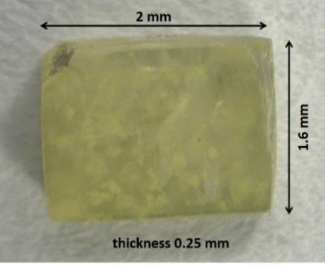

Figure 1. A single crystal of composition PbZr0.54Ti0.46O obtained by the method described in this paper.

Dielectric and Piezoelectric Measurements
Samples were coated with silver paste electrodes fired at 750K for 10 minutes. Dielectric measurements were conducted using a standard capacitance method. An Agilent 4192A impedance analyser was used to measure the capacity C and conductance G in parallel circuit mode over the frequency range 1kHz-1MHz and at an AC electric-field strength of 0.01kV/cm. The real part of the complex permittivity was calculated as a ratio of the measured capacity to the capacity of a vacuum condenser of the same size as the sample. The temperature was controlled using a self-designed temperature controller to a precision of the order of 0.05K, and measurements were performed at a temperature rate of 1K/min.

Two methods were used to determine the piezoelectric properties (see Figure 2). The first employed the IEEE standard measurements [27, 28] of piezoelectric resonances to obtain the piezoelectric coefficient d31. The crystal in Figure 1 was cut to the shape of a bar 1.75*0.42*0.3mm, as in Figure 2a and poled in a DC electric field of 15kV/cm applied along the [001] direction at 340K, after which the crystal was cooled at 2K/minute under this field, and then switched off at 300K. The complex admittance Y (magnitude |Y| and phase angle θ) was measured as a function of frequency using the Agilent 4192A impedance analyser with a sinusoidal voltage of 1V amplitude to find the piezoelectric resonance frequencies. A small frequency step was used to accurately detect the admittance changes near the resonance frequencies. A forced damped harmonic oscillator model [26] was applied to calculate the elastic compliances, electromechanical coupling coefficient, and low-frequency relative permittivity.
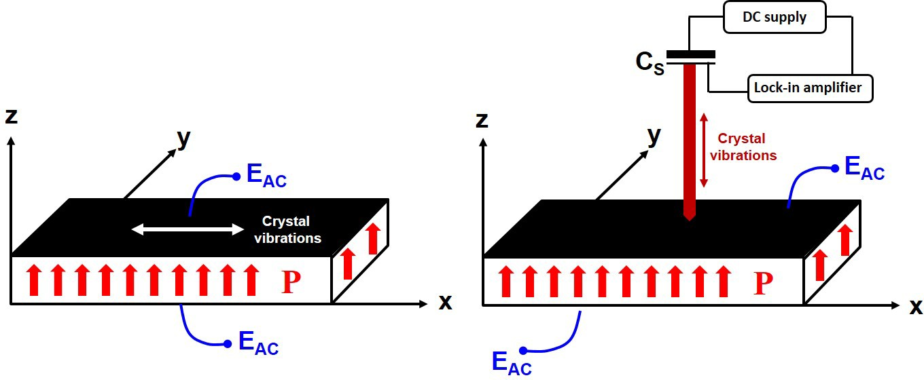

Figure 2. a) Sample geometry used to determine the piezoelectric coefficient d31 (x, y, and z denote the pseudo-cubic axis). The black area represents an electrode, and P denotes the resulting direction of polarisation in the crystal after poling in a DC electric field. An alternating electric field EAC of the strength of 0.01kV/cm and frequency in the range 500kHz-1MHz was used to measure the piezoelectric resonances. b) Detection of strain η3 as a function of electric field EAC of frequency 160Hz and strength between 0.2kV/cm. CS is the sensor capacity to which a DC voltage of the order of 90V was applied. A lock-in amplifier was used to detect the alternating current, which was proportional to the sample strain η3 and induced by changes ∆Cp of the sensor capacity (for more details, see the text).

For the same poled sample, the strain η3 was measured using a quasi-static method based on a
capacitance sensor to find the piezoelectric coefficient d33 from the relationship $d_{33}=\frac{∂η_{3}}{∂E_{3}}$, where E3 is the amplitude of the electric field EAC. Details of the measurement method can be found in [29]. η3 was induced by an alternating electric field EAC. of frequency 160Hz and amplitude 1.6kV/cm applied to the sample and transferred via a quartz rod with one end placed
on the sample surface. The other end was connected to the plate of a capacitor sensor CS. The frequency 160Hz was chosen to minimise external noise and experimental errors. The surface area of the end of the quartz rod touching the crystal was of the order of tens of µm2. The field amplitude increase was automatically controlled and equal to 0.025kV/cm per minute. Piezoelectric deformation appeared synchronously with the applied voltage frequency ω causing changes ∆CS of the sensor capacity CS, according to the time-dependent function CS(t)
= CS+ΔCSsin(ωt). The initial value CS0 was adjustable depending on the magnitude of the strain measured, and ΔCS was determined through recording of the current using a lock-in amplifier,
and the piezoelectric strain amplitude η₃ was calculated from $η_{3}=\frac{ε_{0}S}{t_{0}} \frac{∆C_{S}}{C_{S}^{2}}$, where S is the surface area of the sensor capacitance plates, t0 the thickness of the sample, and ε₀ the vacuum permittivity (Figure 2b). This lock-in technique records the amplitude of the strain exhibited by the sample under the alternating electric field.

- Experimental results

4a. Dielectric properties of single PbZr_{0.54}Ti₄₆O₃ crystal
These properties are determined by temperature changes of the real part of the relative permittivity $ε_{r}^{'}$in a broad temperature range from 300 to 750K, for virgin crystal (Figure 3). The $ε_{r}^{'}$(T) runs reach maximal values in the vicinity of 650K, depending on the frequency. In the phase diagrams mentioned above, this temperature corresponds to the transition to the paraelectric phase for PZT with x=0.46. Moreover, the existence of another transition to the tetragonal ferroelectric phase (near 460K) is indicated in phase diagram reported in [23, 24]. While in the $ε_{r}^{'}$(T) run there is no distinct anomaly at this transformation, the $ε_{r}^{''}$(T) does reveal an anomaly at around 460K.

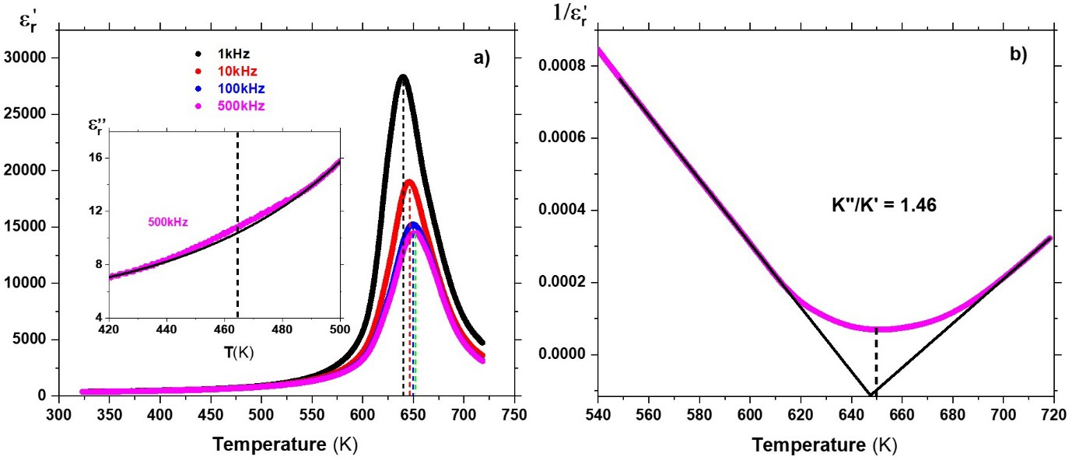
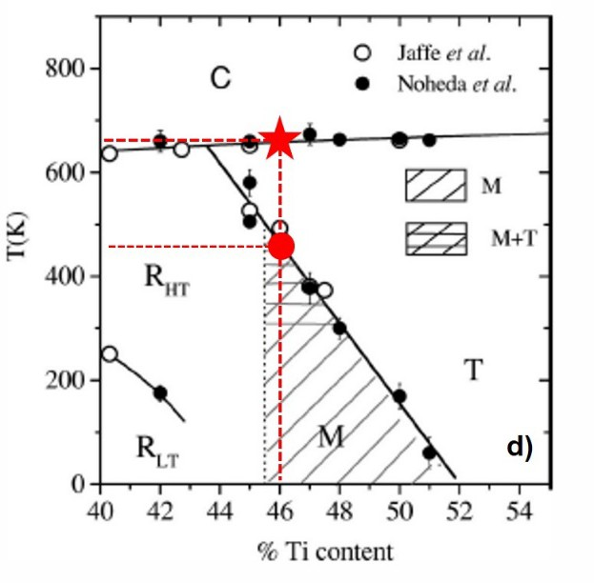
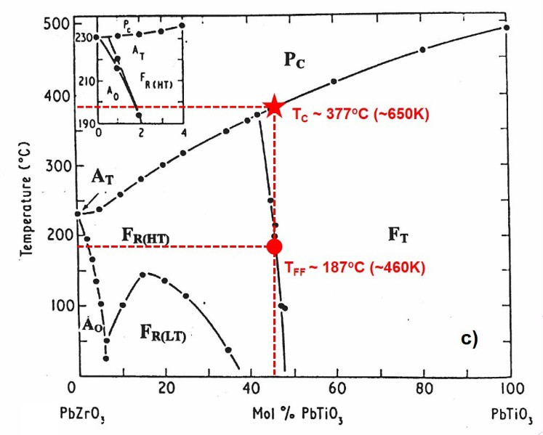
Figure 3. a) Temperature and frequency dependence of the real part of the permittivity εr, near the transition at 650K (on heating). The inset indicates the existence of another diffuse transition near 460K on the temperature dependence of the imaginary part ε′′ of the permittivity (the thin black line is a guide for the eye). b) The temperature dependences of the inverse permittivities 1/ε′ , measured at 500kHz, below and above the upper transition reveal linear functions which allow the Curie-Weiss constants to be calculated. The ratio K" (below the transition) to K' (above the transition) is very close to that expected for a continuous transition. Also, the minimum value of 1/ε′ (T), denoted by the dashed line, almost coincides with the point of intersection of straight lines corresponding to the Curie-Weiss law. This intersection does not occur at zero, as predicted by theory. This is connected with the fact that the permittivity does not take, as theory indicates, an infinite value at the transition point. c) and d) Phase diagrams adapted from [23,24] on which the chemical composition of the investigated crystal is marked. The transitions depicted by the red stars and circles correspond to those in a) and b).

Figure 3 shows that the temperature of the ε′ maximum shifts towards higher temperature with increasing frequency. There are a number of possible explanations for this dielectric dispersion. It is most probably linked to the motion of complex domain structures. The influence of DC conductivity, which increases with temperature, on the real part of the permittivity cannot be excluded [30], although this seems less likely. The observed dispersion resembles that which occurs in the relaxor-PbTiO3 solid solutions, which is considered as an indicator of dielectric
r
r
r
r

relaxation attributed to the existence of polar nanoregions [31, 32]. One cannot also exclude an influence of a disorder in Pb sublattice, as it was reported in [33], where first principle calculations indicated that Pb is differently distorted in relation to the Zr and Ti sublattices in PZT50/50, i.e. in the composition of very similar composition to the investigated crystal. Other possible mechanisms that could cause the dispersion include time-dependent domain wall motion phenomena [34, 35] and/or a time-dependent rotation of the polarisation under the driving field, which would be linked with the effects on the piezoelectric coefficients discussed below. Further work would be necessary to elucidate which of these effects is responsible. Independently on the above discussed mechanisms, it appears that the transition at 650K exhibits a continuous (second-order) phase transition. The ratio of Curie-Weiss constants K' and K'', respectively above and below the transition, is dependent on frequency, varying from
2.05 at 1kHz through 1.90 at 10kHz, 1.51 at 100kHz to 1.46 at 500kHz (see Supplement Information). This value should be 2 for a second-order transition, as predicted by the Landau- Ginzburg-Devonshire theory, but measurements have not been made for a single domain state. Thus, the dielectric response below TC may be affected by domain structures. These values, the frequency dispersion and the shape of ε′ (T) around TC points to a phase transition is much closer to continuous than discontinuous, with some relaxational character which may be domain related and requires further study. This result corresponds well to the properties of the single crystal of similar composition reported in [36].
r
Summarising this part, we state that the single crystal reveals transition points that correspond to a PZT composition close to the morphotropic phase boundary region. Its dielectric properties show that the crystal undergoes a continuous phase transition near TC.

4b. Piezoelectric properties of single-crystal PbZr0.54Ti0.46O3

The dependence of the |Y|, θ and the magnitude of the impedance (|Z|) as functions of frequency at constant electric field strength 0.03kV/cm, for a mechanically-free crystal, are shown in Figure 4. The curves in this Figure are characteristic for a crystal in an almost single-domain state, i.e., the function |Y|(f) reaches practically zero for the antiresonance frequency fa, and the minimum of θ(f) is very close to -0.5π. Moreover, the theoretically predicted function |Y|(f) fits the experimental points well.

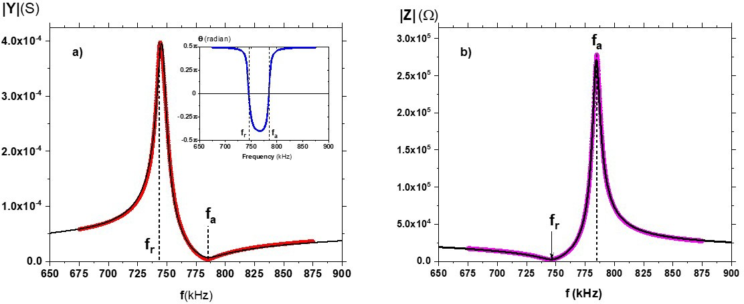

Figure 4. a) The modulus |Y| of the complex admittance Y=G+iB (where G and B are respectively the real and imaginary parts of Y) as a function of frequency at 300K for a poled single PbZr0.54Ti46O3 crystal. The inset shows the dependence of the phase angle θ as a function of frequency f. The maximum and minimum of |Y|(f) corresponds to the resonance fr and antiresonance fa frequency, respectively. The black line is a fit for the experimental data. The set of equations (Eq 1) was used to fit the |Y|(f) dependence, where C0=C0’+iC0" is the low- frequency complex capacitance of the sample, angular frequency ω=2πf. Γ is damping, β is constant, and, respectively. b) The modulus |Z| of the complex impedance Z=R+iX (where R and X are respectively the real and imaginary parts of Z) as a function of frequency at 300K for a poled single PbZr0.54Ti46O3 crystal. The black line gives the experimental data from which the resonance fr and antiresonance fa frequencies were determined. The set of equations (Eq 2) was used to fit the |Z|(f) dependence, where the angular frequency ω=2πf. Γ is damping, α is a constant, R0 is the sample resistivity at low frequency.

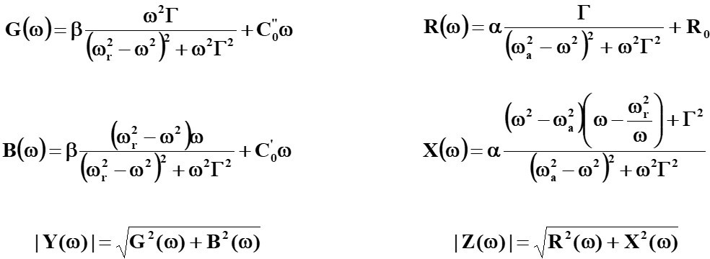

(Eq 1) (Eq 2)

Determination of the piezoelectric coefficient d31 was made by fitting the experimentally- measured |Y|(f) and |Z|(f) frequency-dependences (Figure 4) to the theory given by the sets of equations in Eq 1 and Eq 2, respectively. The |Z|(f) function was chosen because it allows one to find the piezoelectric frequencies from the same experimental dependence. We determined

fr=746.56kHz (ωr = 2πfr) and fa=784.37kHz (ωa = 2πfa) from |Z|(ω) (Eq2), and permittivity ε33=451.1 along z-direction from |Y|(ω) (Eq1) containing static value C′ (in the B(ω) function). The relationships 3, 4, and 5, below, were used to calculate from |Y|(f) the piezoelectric coefficient d31=93.4±0.2 pm/V, elastic compliance $s_{11}^{'}$=1.8x10⁻¹¹ m²/N and coefficient of electromechanical coupling k31=0.34, taking the theoretical crystal density to be 7.98g/cm³ [37]:
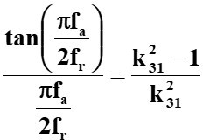

0

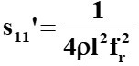 (3) (4) (5)
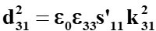

The values obtained are of the same order as for ceramics presented in [23]. To the best of our knowledge, these are the first time such data have been given for a PZT crystal of this composition.
Determination of the coefficient d33 was carried out at room temperature according to the quasi-static (160Hz) procedure described above (Figure 2b), which is well away from the resonance frequencies. The advantage of this approach is that measurement of the piezoelectric coefficients d31 and d33 are for the same sample and at the same state of sample polarisation. It is worth noting that, in the measurement of d33 based on the resonance method, different sample shapes would have been needed to be used, and this would have required different polarisation in a DC field. The strain η3 as a function of increasing and decreasing field amplitude E3 is shown in Figure 5.

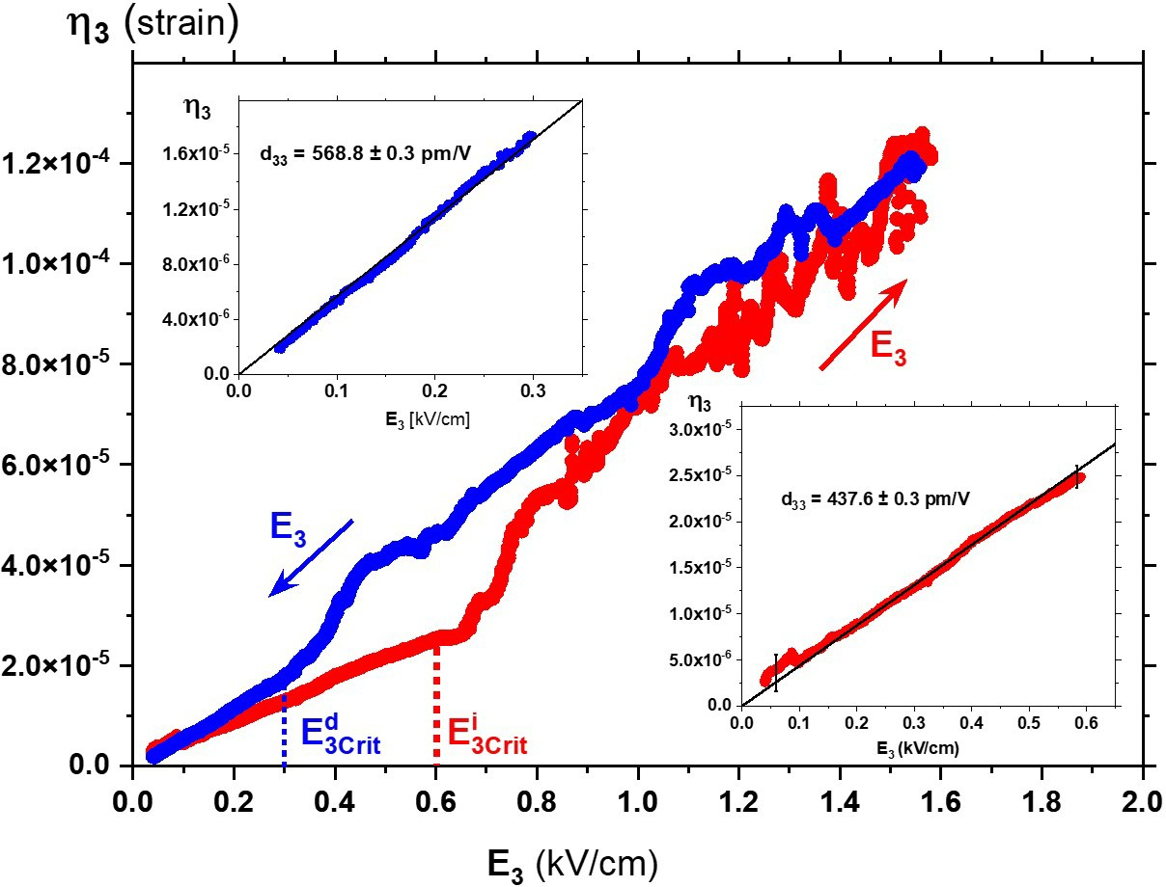
Figure 5. Quasi-static field-dependent strain η3 on field-increasing (red) and field decreasing (blue) for the same poled single PbZr0.54Ti46O3 crystal, for which d31 was determined from the observation of piezoelectric resonances. The insets show the η3(E3) dependence as functions of the AC field amplitude E3 for which the piezoelectric coefficient d33 could be directly determined. The black lines fit the relationship describing the piezoelectric phenomenon η3=d33E3 (in Voigt notation).

As Figure 5 shows, the linear strain amplitude at low electric-field strengths changes smoothly and linearly with the field E3, independently of the direction of field increase. For these parts of the η3(E3) runs, the piezoelectric coefficient d33 could be calculated. This was equal to about 440 and 570 pm/V for increasing and decreasing fields, respectively. These values are a few times larger than those obtained for d31 and are comparable with the values of d33 known from the literature [e.g. 10, 17, 37 and 38]. However, there are critical values of E₃, denoted by $E_{3Crit}^{i}$ and $E_{3Crit}^{d}$ and the vertical dotted lines in Figure 5, above which the η₃(E₃) dependence becomes irregular, although on average, it remains linear. When the field increases, the critical values are $E_{3Crit}^{i}$=0.6kV/cm and $E_{3Crit}^{d}$=0.3kV/cm on the field-decreasing leg. However, this hysteresis is not related in any way to the coercive field because P(E) observed in a Sawyer-Tower setup was linear for all the fields used.
Moreover, it was checked that after these experiments, the |Y|(f) and θ(f) dependences did not change, and they were the same as that observed after poling the crystal in a DC electric field (see the Suplement Information). It means that the state of polarisation in the sample was not destroyed by the AC field used to measure d33.

It should be stressed that the maximum AC field of 1.6 kV/cm was much smaller than the coercive field (8 to 10 kV/cm), and thus the P(E) run was a linear function during the whole experiment. It also means that the relationships η3(E3) are reversible, at least for field strengths not exceeding those used in our experiments.
The most unusual effect is an irregular η₃(E₃) dependence above $E_{3Crit}^{i}$ and $E_{3Crit}^{d}$. Interestingly, in the case of strains detected for increasing E3, the irregularities are stronger than for decreasing fields. However, as shown in Figure 6, also for these irregular parts of η3(E3), a linear extrapolation closely obeys the piezoelectric relationship η3=d33E3. It can be said that in this case, we are dealing with an enhancement of the piezoelectric coefficient d33. This increases from 40% (for decreasing field) to 66% (for increasing field) compared with low fields.
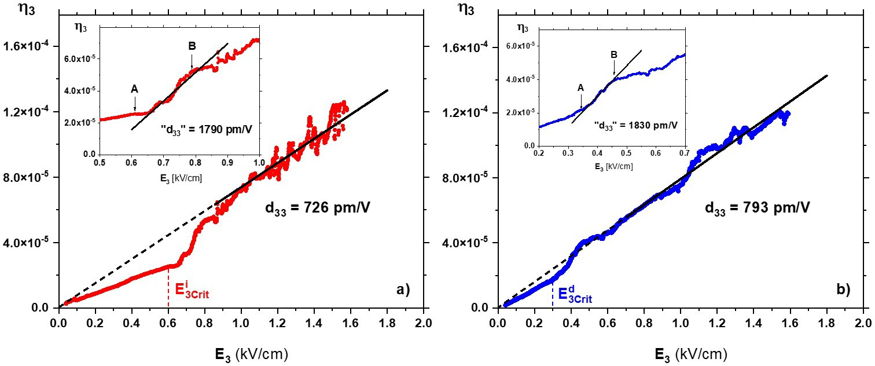

Figure 6. Fitting the irregular part of the η3(E3) dependence to the relationship describing the piezoelectric phenomenon η3=d33E3. These extrapolations give a value of the piezoelectric coefficient d33 for increasing (a) and decreasing (b) strength of the electric field E3. In both Figures (see insets), the A-B transient region can be distinguished, in which the population of the monoclinic phases changes (see Figure 9 further in the text). Insets in Figures (a) and (b) show that these changes occur in the same way, i.e. slopes of the black lines are almost the same for increasing and decreasing AC field. The slopes correspond to high piezoelectric coefficients denoted as "d33".

As the piezoelectric resonances are unchanged by the quasi-DC strain measurements, this means that the polarisation state of the sample was also unchanged under the alternating field cycle. Therefore, the observed irregularities could not have come from domain movements induced by a possible depolarisation process while the sample was under the 160Hz AC electric field. If this had been the case, the polarisation would have been considerably smaller, and the piezoelectric resonances would have disappeared or at least become significantly weaker. Also,

the quasi-static P(E) dependence would not have been linear. This means that the origin of the enhancement of the piezoelectric properties of single-crystal PbZr0.54Ti46O3 must be connected with another mechanism. It is known that domain walls can move in low electric fields [39, 40]. In such a case, the polarisation state of the sample would not be significantly changed because the applied AC field is far below the coercive field. Nevertheless, domains wall motions can certainly contribute to the jumps in η3(E3) dependence.
To find the mechanism enhancing the piezoelectric properties, we decided to observe domain behaviour during the poling process and their reorganisation during the action of DC fields in the range of electric-field strengths at which the high quasi-static piezoelectric properties were detected (Figures 5 and 6).

4c. Optical investigations
To understand the complex piezoelectric response presented in the previous section, we have carried out optical studies of the domain structures of the PbZr0.54Ti46O3 single crystal using the Metripol technique. This experimental setup is described in the Supplement Information based on articles [41-43]. This technique measures an orientation angle φ, the extinction angle in polarising microscopy. A feature of the Metripol is the visualisation of optical indicatrix orientations. These orientations are presented as a coloured map, in which different colours are related to different angles φ. The empirical distribution of orientations (histogram) can be plotted based on such maps. Each point of such a histogram corresponds to the orientation distribution calculated for one-degree intervals.
Using the experimental technique mentioned above, we have studied the domain structures in the virgin and DC poled PbZr0.54Ti0.46O3 single crystal. The direction of the applied electric field was along with the thickness of the sample, i.e., it was parallel to the incident light path. This electric field orientation was achieved in a specially prepared capacitor placed in the Linkam stage. This capacitor consisted of two glass plates coated with indium tin oxide forming transparent electrodes. The crystal was placed between these plates to which a constant electric field could be applied using thin silver wires glued to the electrodes. Measurements of the optical properties of the PbZr0.54Ti0.46O3 single crystal were carried out from 300K to 390K, i.e. the temperature at which the sample was poled in a DC field.
At room temperature, the domain structure in the ferroelectric phase of the virgin crystal is a mixture of domains differently oriented to each other when viewed along [001]p. As can be seen from the PZT phase diagram (Figure 3d), the structure of the crystal at 300K consists of a mixture of rhombohedral, monoclinic and tetragonal phases. However, Figure 8 shows the population of the extinction positions of domains, where there is a continuous change of these orientations (the data were fitted with a Gaussian distribution function called Gaussian lines, further in the text). The domains with rhombohedral symmetry with extinction orientations of 45o and 135o correspond to local minima in the two halves of Figure 7. This diffuse dependence of the domain populations stems from domains of monoclinic symmetry MA, MB and MC [44], which can also take any orientation, different from the angles 0o, 45o, 90o, 135o and 180o [10]. As discussed in [44], the Gausssian lines correspond to the distribution of the optical indicatrix orientations (responsible for extinction directions of domains) characterising the monoclinic symmetries.
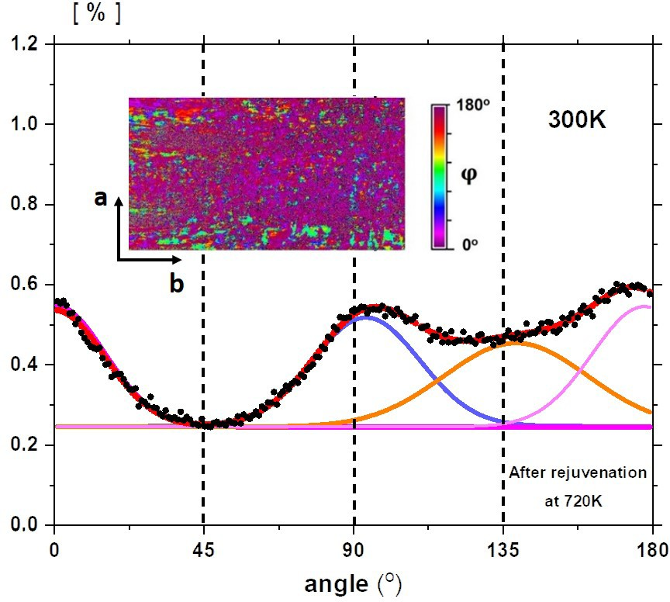

Figure 7. Histogram at 300K of randomly oriented domains for a crystal annealed at 720K for 30mins. a and b denote <100>p axes (c axis is perpendicular to the crystal surface). Continuous Gaussian lines are fits showing extinction angles very close to the tetragonal (0o and 90o) and rhombohedral (135o) symmetries. There is a 'background' in the whole range of angles (a continuous line for each Gaussian line) which originate from numerous domains walls or domains sitting on each other and affect the average optical indicatrix section. Inset is a representative orientation map for a region of 820µm x 440µm. φ denotes the angle at which the slow axis of the indicatrix is inclined to the horizontal direction. A diagram showing possible excitation orientations for each phase is reported in [5].

Interestingly, the poling of the crystal does not lead to asymmetric distribution of domain orientations. Figure 8a presents changes in time of the domain populations (looking down [001]p) after switching in a DC field of 15kV/cm, i.e. in the same way that the electroded crystal was poled to induce piezoelectric properties. It is seen that there is no distinct influence from the DC field applied at 390K. The population of indicatrix orientations points to a co-existence of the tetragonal and rhombohedral symmetries (Figure 8b). Only after cooling, in the presence of this field, do the domain populations evolve toward an asymmetric distribution at 300K, with a different population of indicatrix orientations corresponding to angles distinctly different from 0o and 90o (Figure 8c and 8d). This points to developing populations of domains with monoclinic symmetry, in which the continuous rotation of PS in the DC fields can take place [10]. Moreover, the 'background' decrease suggests that the poling reduces the population of domain walls.
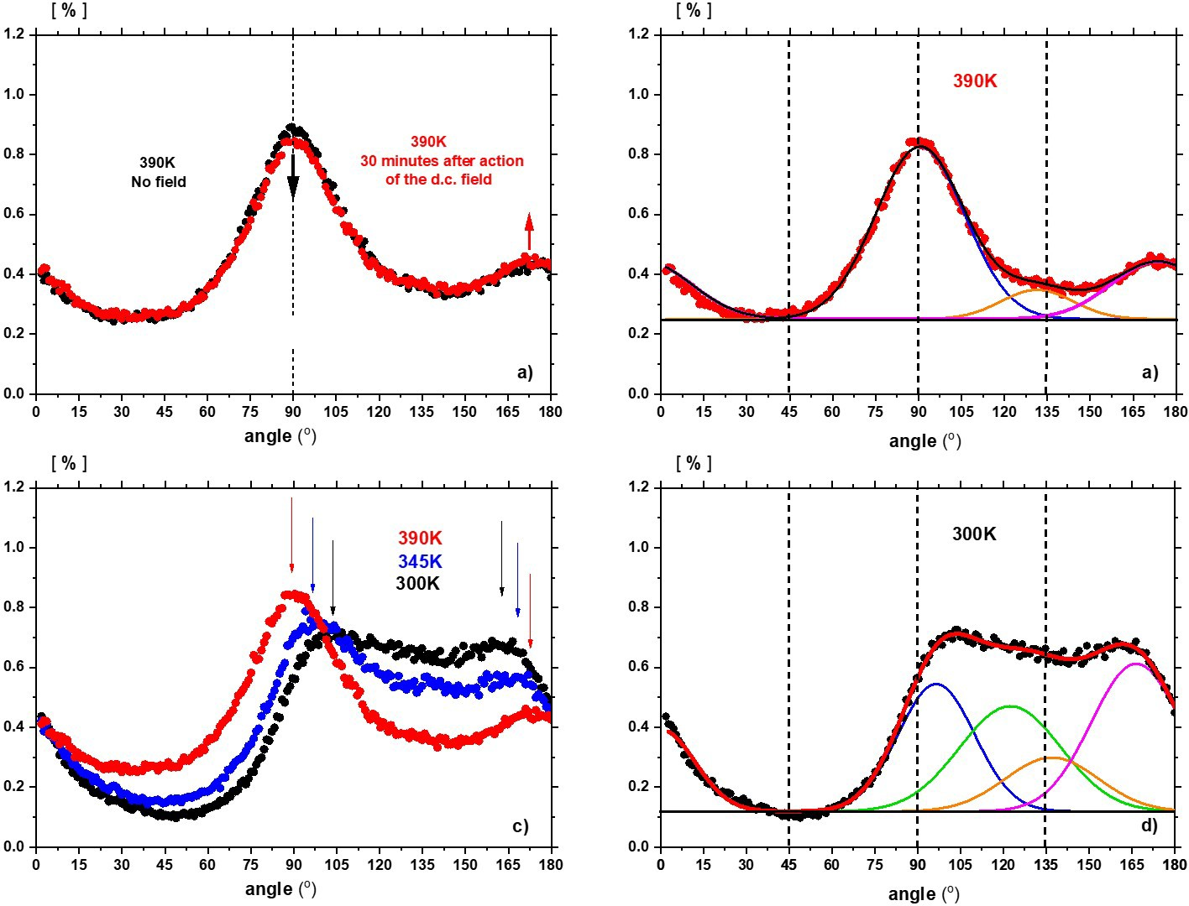

Figure 8. a) Domain populations during poling in a DC electric field of strength 15kV/cm applied at 390K. Even after 30 minutes, the population does not change significantly, with only a tendency to decrease around 90o and increase around 170o. b) Gaussian lines fitted to the histogram obtained 30 minutes after the DC electric field was applied at 390K. These prove the co-existence of tetragonal and rhombohedral optical orientations. c) Cooling the crystal in the presence of the DC field makes this tendency much higher and eventually a distinct difference in the distribution of optical orientations at 300K. This tendency is denoted by arrows showing

a shift of local diffuse maxima of populations towards higher and lower angles, respectively. d) Final distribution of optical orientations after poling process. All Gaussian lines point to monoclinic symmetries of the final state, in which optical orientations of domains can take any orientation different than 90o, 135o and 180o [10]. Note the distinctly lower 'background' compared to that in Figure b). The black (Figure b) and red (Figure d) curves are a result of (cumulative) curves.

To find the origin of the high values of the piezoelectric coefficient d33 presented in Figure 6, we carried out measurements of domain populations as a function of the DC electric field strength for a crystal polarised under the same conditions (the crystal was not electroded). This dependence is shown in Figure 9, from which it appears that with the DC strength (denoted as E+) increasing, many more orientable domains appear with angles in between 90o and 180o. Moreover, the higher the DC field strength, the population of angles between 90o and 135o increases at a cost in domain populations between 150o and 180o (see Figure 10a with shadow areas). With decreasing field E+, the population of domains does not change (Figure 10b), although there is a discrepancy in the population between the ranges (0o-90o) and (90o-180o).
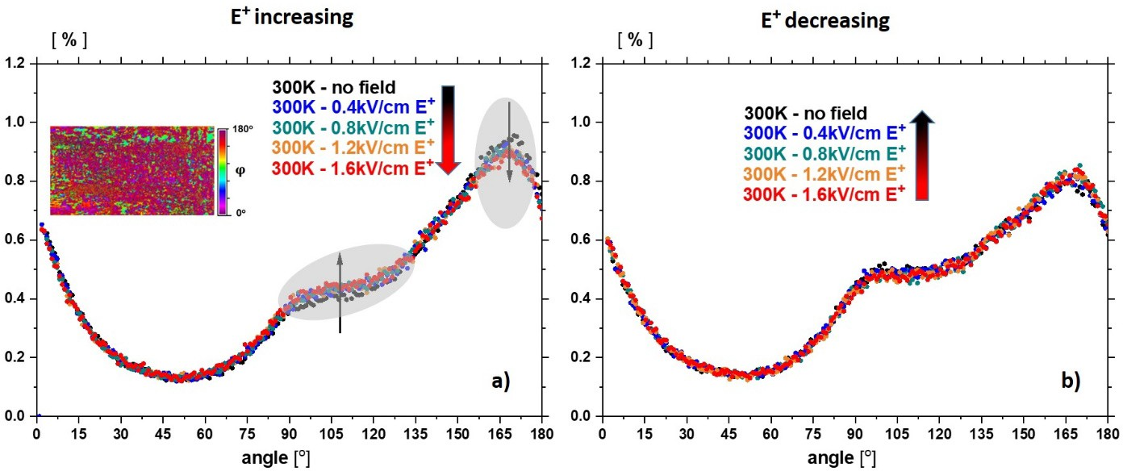

Figure 9. a) Changes of domain population, four days after poling, as a function of the applied DC electric fields of intensities the same as used in AC field (see Figures 5 and 6). With the increase of this field, many distinct changes take place for orientations greater than 90o. The most sensitive regions to the action of the DC field are shadowed, and black arrows denote the direction of change in population with the increase in the field strength E+. The inset is a map of indicatrix orientations at 300K in the absence of the field. b) In the case of the decreasing field, the sensitivity of these regions can be neglected, although a discrepancy in experimental points for orientations greater than 90o can be recognised.

Moreover, the reorientation process is not symmetric concerning the electric field direction. With the change of DC field direction of the same field strength, from E+ to E-, the distribution

of domain orientations is not symmetric. This is visible in Figures 10a and b, representing this effect for the same field strengths as used in measurements of the quasi-static piezoelectric properties (Figure 5 and 6).
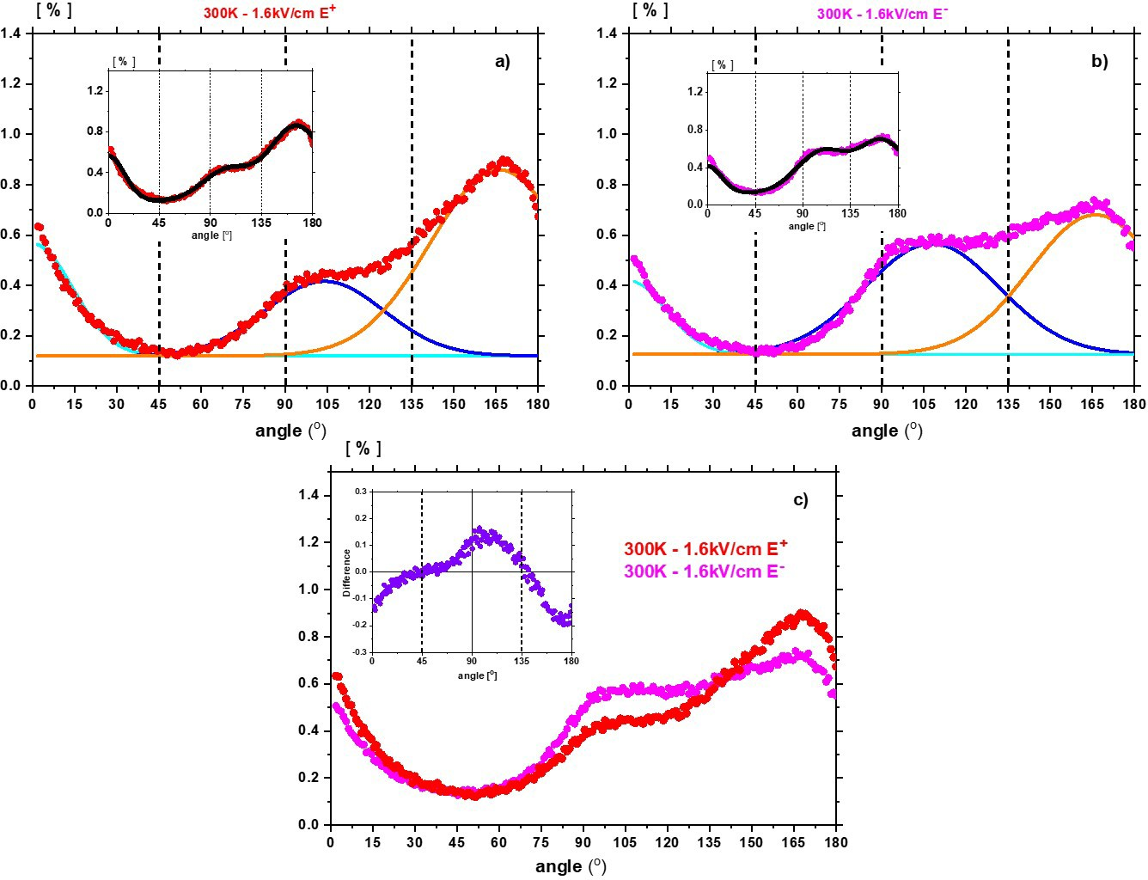

Figure 10. Fit with Gaussian lines describes the domain populations a) at final electric-field strength 1.6kV/cm E+ and b) opposite field 1.6kV/cm E-. The action of such a field on the poled crystal leaves the 'background' unchanged while broadening distributions of domains with monoclinic symmetries. The insets present the resulting curves and experimental points. c) Distribution of the domains for two opposite DC fields denoted E+ and E-. Inset shows the difference in domain populations under the action of such fields. Interestingly, these fields do not affect the population of the rhombohedral domains 45o and 135o.

The most prominent result of the optical properties investigations is represented in Figure
- Gaussian line fitting shows that the enhancement of the piezoelectric properties is not related to domains of rhombohedral symmetry. These domains are not involved in domain reorientation under an electric field producing a piezoelectric strain (Figure 11c). This points to the domains of monoclinic symmetry playing an essential role in the enhanced piezoelectric properties demonstrated in Figure 5 and 6.

Discussion
If the domains were purely rhombohedral, with their spontaneous polarisations appearing along the [111]p direction (with 45o and 135o extinction angles), then after poling, the crystal should be close to being in a state in which the polarisation is ordered around the [001]p axis, i.e. perpendicular to the crystal surface. However, as was previously reported [15], such crystals tend to have monoclinic symmetry after poling in a DC field. After poling, a complex distribution of the monoclinic (M_{A}, M_{B} and M_{C}), rhombohedral (R3m) and tetragonal (P4mm) phases has been observed in the investigated crystal (Figure 8, 9 and 10). Classical piezoelectric resonances have been observed (Figure 4), as generally for a single-domain crystal under a low-strength electric field. Another proof of this permanent state is given by the quasi-static strains induced by low AC electric-field strengths for the same sample and the same polarisation state. As shown in the insets in Figure 5, a smooth η3(E3) dependence, for low strengths of the field E₃, is well described by the piezoelectric relationship η3= d33E3 with piezoelectric coefficient d33, much higher than d31, was observed.
However, the most crucial feature in Figures 5 and 6 is the η3(E3) dependence for AC electric fields greater than 0.6kV/cm. This dependence remains linear, as expected for the piezoelectric effect, and contains strain jumps. They are easily visible with increasing field strength and make the high-field η3(E3) dependence irregular. It has to be stressed that when the AC field was switched off, the sample revealed the same piezoelectric resonances as those observed before the experiments in AC fields. This proves that the action of this field has not destroyed the resultant polarisation state.
Although domain-wall movements have a share in the enhancement of the piezoelectric properties, we consider that mainly rotation of the polarisation in the monoclinic phases dominates, as theoretically considered by Ballaiche et al. [45]. It also indicates that with the application of an electric field along [001]p to rhombohedral PbZr1-xTixO3 with x=0.47, i.e. very close to the composition of the crystal investigated by us, both the triclinic and monoclinic MC symmetries are induced. At the same time, it was found that in the monoclinic structure, significant shear piezoelectric coefficients appear. Hence, a part of the strain η3 presented in Figure 6 for fields greater than 0.6kV/cm corresponds to the piezoelectric modulus d33 and piezoelectric shear coefficients, e.g. d15 [26]. In this way, a high piezoelectric response for fields above the A-B area in Figure 6 can be understandable in the context of a change in the population of regions with monoclinic symmetry in Figure 9 for the fields with the same values as in Figure 6.

The observed irregularities (pulses) in the η3(E3) dependence originate from the irregular rotation of PS, because of blocking of domains of monoclinic symmetry on crystal defects, or from the internal friction in the crystal caused by this rotation in the presence of neighbouring regions with domains of, e.g. the rhombohedral symmetry, which does not react to the DC field (Figure 10c). If the domain walls have any influence on the piezoelectric response, it manifests itself only in the form of observed irregularities and does not cause any significant enhancement of this response. Interestingly, the strain jumps are much smaller in cycles with decreasing electric fields. Moreover, there is a kind of hysteresis in the η3(E3) dependence, distinctly seen when region A-B in Figure 7 is considered. As presented in Figures 10a and b, this is connected with stabilising the population of regions with monoclinic symmetries. This stabilisation is mainly associated with the pinning of the monoclinic domains by defects (e.g. space charge). The domain pinning process would be expected to exhibit a relaxation process to approach the pre-field-application monoclinic domain population state with a particular time constant. This time constant is longer than the period over which the experiment was made and accounted for the apparent hysteretic behaviour in the A-B segments in the strain-field amplitude plots shown in Figures 7a and b.

Conclusions
Intrinsic and extrinsic mechanisms responsible for the piezoelectric effect in single-crystal PbZr0.54Ti0.46O3, of composition near the morphotropic phase boundary, have been considered based on the dielectric, piezoelectric and optical properties measurements. At room temperature, domains with the tetragonal, rhombohedral and monoclinic symmetries coexist. However, the monoclinic symmetries dominate after poling in the DC electric field. For the first time, changes in domain populations during poling have been investigated. By combining the investigations of optical properties and quasi-static and dynamic piezoelectric properties of a poled single crystal, it was possible to find that the main extrinsic origin of enhancement of the piezoelectric properties is connected with a change in the population of domains with monoclinic symmetries. The polarisation can easily rotate under the electric field's action in such symmetries, to which belongs the MA, MB, and MC phases (see Introduction and [44]. We have found that rhombohedral domains do not participate in the piezoelectric response.

Acknowledgements
A.M. appreciates the technical assistance of J. Sobieraj and B. Żmijewski, from the Military
University of Technology in Warsaw, during PZT crystallisation.
This work was supported by the National Science Centre, Poland, grant number 2020/37/B/ST3/02015.

Conflict of Interest
The authors declare no conflict of interest.

Data Availability Statement
The data that support the findings of this study are available from the corresponding author upon reasonable request.

References
[1] G. Binnig, H. Rohrer, Surf. Sci. 126, 236-244 (1983).
[2] A. Safari, E. K. Akdogan, Piezoelectric and acoustic materials for transducer applications.
Springer Science & Business Media, (2008).
[3] K. Shung, J. M. Cannata, Q. F. Zhou, Journal of Electroceramics 19, 141-147 (2007).
[4] X. Hou, S. Zhang, J. Yu, M. Cui, J. He, L. Li, X. Wang and X Chou,
Energy Technol. 8, 1901242 (2020).
[5] M. S. Senousy, F. X. Li, D. Mumford, M. Gadala, R. K. N. D. Rajapakse, J. Intell. Mater.
Syst. Struct. 20, 387-399 (2009).
[6] E. Sawaguchi, Journal of the Physical Society of Japan 8, 615 (1953).
[7] J. Frantti, Y. Fujioka, A. Puretzky, Y. Xie, Z. G. Ye, A. M. Glazer J. Appl. Phys. 113,
174104 (2013).
[8] R. G. Burkovsky, Y. A. Bronwald, A. V. Filimonov, A. I. Rudskoy, D. Chernyshov,
A. Bosak, J. Hlinka, X. Long, Z. G. Ye, S. B.Vakhrushev, Phys. Rev. Lett. 109, 09760 (2012).
[9] D. Phelan, X. Long, Y. Xie, Z. G. Ye, A. M. Glazer, H. Yokota, P. A. Thomas,
P. M. Gehring, Phys. Rev. Lett. 105, 207601 (2010).
[10] A. Bokov, X. Long, Z. G. Ye, Phys. Rev. B, 81, 172103 (2010).
[11] S. Gorfman, D. S. Keeble, A. M. Glazer, X. Long, Y. Xie, Z. G. Ye, S. Collins,
P. A. Thomas, Phys. Rev. B 84, 020102, (2011).
[12] R. Clarke, R. W. Whatmore, Journal of Crystal Growth, 33, 29 (2010).
[13] N. Zhang, H. Yokota, A. M. Glazer, Z. Ren, D. Keen, D. S. Keeble, P. A.Thomas,
Z. G. Ye, Nat. Commun. 5, 5231 (2014).
[14] D. Vanderbilt, M. H. Cohen. Phys. Rev. B 63, 094108 (2001).
[15] R. Guo, L. E. Cross, S. E. Park, B. Noheda, D. E. Cox, G. Shirane, Phys. Rev. Lett.
84(23), 5423 (2000).
[16] Z. Wang, N. Zhang, H. Yokota, A. M. Glazer, Y. Yoneda, W. Ren, Z-G. Ye, Appl. Phys. Lett. 113, 012901 (2018).
[17] A. J. Bell, P. M. Shepley, Y. Li, Acta Materialia 195, 292 (2020).
[18] S. Gorfman, H. Ch. G. Zhang, N. Zhang, H.Yokota, A. M. Glazer, Y. Xie, V. Dyadkin,
D. Chernyshov, Z.-G. Yee, J. Appl. Cryst. 53, 1039 (2020).
[19] Y. Xie, PhD Thesis "Synthesis and Characterisation of Piezo-/ferroelectric Lead Zirconate-Titanate (PZT) Single Crystals and Related Ternary Ceramics", Simon Fraser University, Canada, (2013).
[20] S. Fushimi, T. Ikeda, J. American Ceram. Soc. 50, 129 (1967).
[21] J. Dec, K. Roleder, K. Stróż, Solid State Commun. 99, 157 (1996).
[22] A. K. Tagantsev, K. Vaideeswaran, S. B. Vakhrushev, A. V. Filimonov, R. G. Burkovsky,
A. Shaganov, D. Andronikova, A. I. Rudskoy, A. Q. R.Baron, H. Uchiyama, D. Chernyshov,
A. Bosak, Z. Ujma, K. Roleder, A. Majchrowski, J.-H. Ko, N. Setter,
Nature Communications 4, 2229 (2013).
[23] B. Jaffe, W. Cook, H. Jaffe, Piezoelectric ceramics, Academic Press, London and New York, (1971).
[24] B. Noheda, D. E. Cox, G. Shirane, Phys. Rev. B, 63, 014103 (2000).
[25] D. E. Cox, B. Noheda, G. Shirane, Y. Uesu, K. Fujishiro, and Y. Yamada, Appl. Phys. Lett. 79 (3), 400 (2001).
[26] K. Roleder, I, Franke,A.M. Glazer, P.A. Thomas, S. Miga, and J. Suchanicz, Journal of
Physics: Condens. Matter 14, 5399 (2002).
[27] IEEE Std. 178-1958 (ANSI C83.23-1960) (1958).
[28] IEEE Std. 179-1961 (ANSI C83.24-1962) (1961).
[29] K. Roleder, Journal of Physics E-Scientific Instruments 16(12), 1157 (1983).
[30] J. Petzelt, D. Nuzhnyy, V. Bovtun, M. Savinov, M. Kempa and I. Rychetsky, Phys. Status Solidi A 210, 2259 (2013).
[31] A. A. Bokov and Z.-G. Ye, Phys. Rev. B, 65(14), 144112 (2002).
[32] F. Li, S. Zhang, D. Damjanovic, L-Q. Chen and T. R. Shrout, Adv. Funct. Mater.
28(37), 1801504 (2018).
[33] I. Grinberg and A. M. Rappe, Phase Transitions 80 (4-5), 351 (2007).
[34] A. M. Lotonov, V.K. Novik, N. D.Gavrilova, Physics of the Solid State 49 (7), 1330, (2007)
[35] J. L. Jones, E. Aksel, G. Tutuncu, T. M. Usher, J. Chen, X. Xing, A.J. Studer, Phys. Rev. B 86 (2), 024104 ((2012)
[36] A. A. Bokov, P. Bajewski, J . Dudek and M. A. Malicka, Rocznik Naukowo-
Dydaktyczny, Prace Fizyczne (Kraków) 6, 55 (1990). http://rep.up.krakow.pl/xmlui/handle/11716/6520
[37] B. Jaffe, R. S. Roth and S. Marzullo, Journal of Applied Physics 25, 809 (1954).
[38] D. Phelan, Ch. Stock, J. A. Rodriguez-Rivera, S.Chi, J. Leão, X. Long, Y. Xie,
A. A. Bokov, Z-Guang Ye, P. Ganesh and P. M. Gehring, PNAS 111(5), 1754 (2014).
[39] Q. M. Zhang, W. Y. Pan, S. J. Jang, and L. E. Cross, J. Appl. Phys. 64, 6445 (1988).
[40] F. Li, S. Zhang, Z. Xu, X. Wei, J. Luo, and T. R. Shrout, J. Appl. Phys. 108, 034106 (2010).
[41] A. M. Glazer, J. G. Lewis, W. Kaminsky, Proc. R. Soc. A 452, 275 (1996).
[42] A. Geday, W. Kaminski, J. G. Lewis, A. M. Glazer, J. Microsc. 198, 1-9 (2000).
[43] A. Geday, A. M. Glazer, J. Phys.: Condens. Matter 16, 3303 (2004).
[44] I. Lazar, A. Majchrowski, D. Kajewski, A. Soszyński, K. Roleder, Acta Materialia 216,
117129 (2021).
[45] L. Bellaiche, A. Garcıa and D. Vanderbilt, Phys. Rev. B 64, 060103(R) (2001).

