Classification, prevalence and outcomes of anticancer therapy-induced cardiotoxicity: The CARDIOTOX registry

José López-Sendón (1), Carlos Álvarez-Ortega (1), Pilar Zamora Auñon (1), Antonio Buño Soto (1), Alexander R Lyon (2), Dimitrios Farmakis (3), Daniela Cardinale (4), Miguel Canales Albendea (1), Jaime Feliu Batlle (1), Isabel Rodríguez Rodríguez (1), Olaia Rodríguez Fraga (1) Ainara Albaladejo (1), Guiomar Mediavilla (1), Jose Ramón González-Juanatey (5), Amparo Martínez Monzonis (5) Pilar Gómez Prieto (1), José González-Costello (6), José María Serrano Antolín (7), Rosalía Cadenas Chamorro (8), Teresa López Fernández (1), on behalf of the CARDIOTOX registry investigators.

(1) University Hospital La Paz, UAM, IdiPaz, CiberCV, CiberONC Madrid, Spain
(2) Royal Brompton Hospital and Imperial College, Cardiology, London, United Kingdom of Great Britain & Northern Ireland
(3) University of Cyprus Medical School, Nicosia, Cyprus; Heart Failure Unit, Department of Cardiology, Athens University Hospital Attikon, National and Kapodistrian University of Athens, Athens, Greece
(4) European Institute of Oncology, Cardioncology Unit, I.R.C.C.S., Milan, Italy
(5) University Hospital of Santiago de Compostela, Cardiology, Santiago De Compostela, Spain
(6) University Hospital of Bellvitge, Cardiology, Barcelona, Spain
(7) University Hospital of Fuenlabrada, Cardiology, Fuenlabrada, Spain
(8) University Hospital Infanta Sofia, Cardiology, San Sebastián de los Reyes-Madrid, Spain

Funding. This study was partially funded by the Fondo Investigaciones Sanitarias, Spain (FIS 113/00559), Centro de Investigación Biomédica en Red Cardiovascular CIBER-CV (Spain) and Instituto de Investigación Hospital Universitario La Paz (IdiPaz)

Address for correspondence: José López-Sendón and Teresa López-Fernández. Cardiology Department. Hospital U. La Paz. Paseo de la Castellana 261. Madrid 28046

ABSTRACT 226 words

Background. Cardiotoxicity (CTox) is a major side effect of cancer therapies, but uniform diagnostic criteria to guide clinical and research practices are lacking.
Aim and methods. We prospectively studied 865 patients, aged 54.7±13.9; 16.3% men, scheduled for anticancer therapy related with moderate/high CTox risk. Four groups of progressive myocardial damage / dysfunction were considered according to current guidelines: Normal: normal biomarkers (hs-cTnT and NT-proBNP) and left ventricular (LV) function; Mild: abnormal biomarkers and/or LV dysfunction (LVD) maintaining a LV ejection fraction (LVEF) ≥50%; Moderate: LVD with LVEF 40-49% and severe: LVD with LVEF ≤40% or symptomatic heart failure. CTox was defined as new or worsening of myocardial damage / ventricular function from baseline during follow up.
Results. Patients were followed for a median of 24 months. CTox was identified in 37.5% patients during follow-up (95% CI 34.22 % to 40.8%), 31.6% with mild, 2.8% moderate and 3.1% with severe myocardial damage / dysfunction. The mortality rate in the severe CTox group was 22.9 deaths per 100 patients-year vs 2.3 deaths per 100 patients-year in the rest of groups, hazard ratio of 10.2 (95% CI 5.5 to 19.2) (p<0.001).
Conclusions. The majority of patients present objective data of myocardial injury/dysfunction during or after cancer therapy. Nevertheless, severe CTox, with a strong prognostic relationship, was comparatively rare. This should be reflected in protocols for clinical and research practices.

Key words: Cardiotoxicity, chemotherapy, myocardial injury, left ventricular dysfunction, heart failure, cardio-oncology, radiotherapy.

INTRODUCTION
Cardiotoxicity (CTox) has long been recognized as a major side effect of chemotherapy in patients with cancer (1,2,3,4). New, more effective therapies and some forms of radiotherapy may also have a variety of cardiovascular (CV) secondary effects, in particular left ventricular dysfunction (LVD) and heart failure (HF) (5,6,7,8,9,10). Early diagnosis and treatment of HF increase the chance of complete LV function recovery (11,12), highlighting the relevance of developing new techniques and protocols for early management of cancer therapy-induced LVD, commonly named CTox, and a multidisciplinary clinical approach throughout the cancer process (13,14,15). Several definitions of CTox have been proposed (16,17,18), somehow different from the standard definition of LVD and HF in major guidelines (19,20).
To better understand the relationship between cancer, cancer therapy and CV disease we conducted a prospective, multicentre registry (CARDIOvascular TOXicity induced by cancer related therapies; CARDIOTOX registry). The main objective of the registry was the risk assessment and early diagnosis of CTox. The aim of the present study is to determine (I) the prevalence of common clinical, biochemical and echocardiographic (ECHO) parameters currently accepted as indicative of CTox and identified after initiation of cancer therapies and (II) their relationship with HF criteria and treatment recommendations in current guidelines (19,20).

PATIENTS AND METHODS
Study design. The CARDIOTOX registry (Clinical trials identifier NCT02039622) is a prospective multicentre study aiming at identifying the factors related with risk of cancer therapy CTox and assessing the utility of clinical, biochemical and ECHO parameters for the early detection of CV disease in patients treated with cancer therapies as well as the possible factors related with prognosis and the recovery of LV function.
The study was approved by the ethical committee at La Paz Hospital and collaborative hospitals and certified by the Health Authority of the Madrid Autonomic Community. All patients signed an informed consent.
Patients. A total of 1324 adult patients receiving cancer therapies previously associated with moderate / high risk for CV toxicity (reported incidence of cardiac toxicity ≥2%) (Appendix, Table 1) and with an expected life survival of more than 6 months were prospectively included in the registry, from April 2012 to October 2017. Patient selection and oncologic treatment were determined by the responsible oncologist or haematologist trained as investigator in the CARDIOTOX registry. Seven hospitals participated in the study including patients according to a pre-established protocol. Patients with a previous history of cancer, chemotherapy, radiation therapy or with known CV disease were not excluded. Patients were treated following cancer and HF guidelines according to the best criteria of the patient responsible physician. Special care was given to the identification and control of CV risk factors. To improve the precision of CTox definitions, patients with pre-existing symptomatic HF or LVEF <40%, patients in whom baseline biomarkers and/or baseline ECHO data were not complete and those who died before 3 months were excluded. A total of 865 patients were considered for this analysis. (Fig. 1).
Clinical data, blood samples and ECHO parameters were prospectively collected according to protocol, at baseline before cancer therapy and then at 3 weeks, 3 months, 6 months, 1 year, 1.5 years and 2 years after initiation of cancer therapy.
Clinical variables included age, sex, CV risk factors, previous CV history, previous cancer treatments and current cancer diagnosis and treatment. The cumulative dose of chemotherapy and radiotherapy was measured in every visit.
Blood samples to determine plasma levels of high sensitivity troponin T (hs-cTnT) and N-terminal natriuretic pro-peptide (NT-proBNP) were processed in a central laboratory (La Paz Hospital) using standardized methods. Upper normal limit for high sensitivity troponin T (hs-cTnT) was the 99th percentile (women 9 pg/ml; men 16 pg/ml). For NT-proBNP, the upper normal limit was 125 pg/ml, according to European Society of Cardiology (ESC) HF guidelines (19); however, as NT-proBNP concentration correlates more strongly with age, for patients older than 75 years this value was considered as 450 pg/ml (21).
Echocardiograms were obtained at each participating hospital by a cardiologist with experience in advanced echocardiography and trained for the requirements of the study, using local echocardiographers [GE Vivid E9 (Vingmed Ultrasound, Horten, Norway) or iE33 or EPIC 7 (Philips Medical Systems, Andover, MA, USA)] and following current recommendations for cardiac chamber quantification in adults (22,23,24).
Patients were followed in each centre by a dedicated cardio-oncology team. Data was centrally reviewed for quality by participating cardiologists / oncologist at La Paz Hospital. All cases with suspected myocardial toxicity were reviewed and centrally adjudicated. For LVEF, several cut-offs were considered following the ESC-HF guidelines (19) and current consensus documents for the evaluation of CTox (16,17,18). (Table 1).
Study data were collected and managed using REDCap electronic data capture tools hosted at IdiPaz Research Institute, Madrid (25).
Grading of myocardial injury/dysfunction. Myocardial injury / dysfunction was defined by the presence of abnormal values of cardiac biomarkers, LV function parameters or clinical symptoms of HF. Several mutually exclusive degrees of myocardial injury/dysfunction that may require different treatment recommendations according to clinical practice guidelines were defined as illustrated in Figure 2 (19,20):
Normal. No evidence of myocardial injury/dysfunction. Asymptomatic patients with normal biomarkers and LV function parameters.
Mild. Asymptomatic patients with LVEF ≥50% with elevated biomarkers or at least one additional abnormal echo parameter (increased LVESV, LAA >30cm², 10% decrease of LVEF to a LVEF <53%, average E/E’ >14, GLS > -18%, 15% relative reduction of GLS from baseline).
Moderate. Asymptomatic patients with LVEF ≥40% and <50% with or without biomarker increase or other LV function abnormalities.
Severe. Patients with asymptomatic LVEF <40% or clinical HF. HF was defined as following: HF with reduced ejection fraction (HFrEF): HF symptoms/signs and LVEF <40%; HF with mid-range ejection fraction (HFmrEF): symptoms/signs of HF with elevated NT-proBNP, LVEF 40-49% and at least one additional criterion (enlarged LA, LV hypertrophy or other relevant diastolic function parameters) and HF with preserved ejection fraction (HFpEF): in presence of symptoms/signs of HF, elevated NT-proBNP, LVEF ≥50% and at least one additional criterion (enlarged LA, LV hypertrophy or other diastolic dysfunction parameters) (19).
Definition and grading of cardiotoxicity. CTox was defined in presence of new or worsening myocardial damage / dysfunction during follow-up, from normal to mild moderate or severe, mild to moderate or severe or moderate to severe. CTox was classified as mild, moderate or severe according to the worst myocardial injury/dysfunction observed during follow-up.
In addition to this new CTox definition and classification, we explored the prevalence of abnormal biomarkers and LVD parameters using a recently published classification, based on the cardio-oncology consult experience at the Royal Brompton Hospital (15). In brief, they proposed a practical clinical strategy aimed to improve CV prognosis and cancer treatment continuation in high risk patients. They described 6 different CTox risk categories: (i) Early biochemical cardiotoxicity: new BNP or troponin-I rise but with normal cardiac imaging. (ii) Early functional cardiotoxicity: new reduction in GLS or grade III–IV diastolic dysfunction and normal biomarkers. (iii) Early mixed cardiotoxicity: normal LVEF with abnormal biomarkers and GLS/diastolic dysfunction. (iv) symptomatic HFpEF. (v) Asymptomatic LVD: new LVEF reduction to <50%, or a reduction in LVEF >10% to a LVEF <55% and (vi) Symptomatic LVD: symptomatic reduction in LVEF <50%, or a reduction in LVEF >10% to a LVEF <55%.
Cardiotoxicity hard endpoint. Generally accepted as a composite endpoint in HF morbidity/mortality trials (26), defined by all cause death, CV death or HF hospitalization receiving intravenous diuretics or other intravenous HF therapies.
Statistical analysis. Baseline characteristics, including demographics, medical history, type of cancer, previous chemotherapy and radiotherapy were summarized using mean and standard deviation for continuous variables and frequencies and percentages for categorical ones. Non-normal distributed continuous variables were summarized with medians and interquartile range. Confidence intervals of proportions of different CTX groups were calculated using Wilson’s method. Sankey diagrams were developed depicting the flow of patients through categories between baseline and follow-up. Differences between all groups were tested with analysis of the variance or Kruskal-Wallis rank test for continuous variables and with the Pearson χ2 or Fisher’s exact test for categorical data. Event rates of myocardial injury/dysfunction and mortality were estimated using Kaplan-Meier methods. A Cox-proportional hazards model was used to compare the all-cause-mortality rates between myocardial injury/dysfunction groups. An overall alpha-level of 0.05 was be used as a cut-point for statistical significance and all statistical tests were two-sided. All data were analyzed using STATA v.15 statistical software (StataCorp LLC. 2017. College Station, TX).

RESULTS

A total of 865 patients were included with a median follow up of 24.1 months (ICR 22.1 to 24.9 months), accounting for a total of 5058 ECHO studies. Mean age was 54.7±13.9 and 16% were men. Patient demographic characteristics, cancer diagnosis and type of cancer therapy are detailed in Table 1. Eleven patients (1.3%) had a previous history of myocardial infarction; 42 (4.9%) received previous anticancer drugs, and 4 (0.5%) were previously diagnosed of CTox, (none with LVEF <50% at inclusion). Forty-three (4.9%) had already received at least one dose of chemotherapy before the first echocardiogram and blood sampling. Breast cancer was the most common type of cancer (65.7%), followed by non-Hodgkin´s lymphoma (15.4%) and Hodgkin´s disease (5.1%). Myocardial damage/dysfunction abnormalities at baseline are also detailed in Table 1. In 9 patients (1%) LVEF was ≥40% <50%, GLS was < -18 %in 147 (28.3%) and none presented a LVEF <40%.
Cancer therapy and HF-related medications during follow-up are detailed in Table 2. 731 patients (84.5%) received anthracyclines, 177 (20.5%) anti-HER2 therapy and 140 (16.2%) both treatments. 27.3% received left breast radiotherapy and 2.7% mediastinal radiotherapy.
Patients with CTox were older and more likely to have a previous history of cancer or previous anticancer drugs or radiotherapy and presented with a lower LVEF and GLS at baseline (Table 1).
Biomarkers abnormalities and ECHO parameters during follow-up. Detailed information of studied parameters is included in Appendix table 2. Many of the biomarker and ECHO abnormalities were transient, with a peak around 6 months of follow up. Abnormal values of biomarkers at any time point during follow-up was found in 78.4% of the patients; 2DE abnormalities in 64.6%; advanced ECHO abnormalities in 79.5%. Appendix Figure 1 illustrates the prevalence of abnormal values of myocardial injury and left ventricular dysfunction during follow-up. Figure 3 illustrates the cumulative prevalence of representative myocardial damage/dysfunction parameters during follow-up.
Myocardial dysfunction and CTox during follow-up. The prevalence and different grades of myocardial impairment through the study is detailed in Table 3. Sixteen patients (1.8%, 95% CI: 1.1% -3%) did not present any clinical, analytical or ECHO abnormality during the follow-up; 792 (91.6%, 95% IC: 89.5% - 93.2%) presented only mild myocardial damage; 30 (3.5%, 95% CI: 2.4% - 4.9%) moderate and 27 (3.1%, 95% CI: 2.2% - 4.5%) severe myocardial damage through the follow-up (Fig. 4A). The number of patients in each Royal Brompton Hospital myocardial toxicity class at baseline and through the follow up is shown in Figure 4B.
Defining cardiotoxicity as a worsening of myocardial damage, 541 (62.2%, 95% CI 59.3% - 65.7%) did not suffer an impairment during follow up (No CTox); 273 (31.6%, 95% CI 28.6% - 34.7%) fulfilled criteria for mild CTox; 24 (2.8%, 95% CI 1.9% - 4.1%) moderate CTox and 27 (3.1%, 95% CI 2.2 - 4.5%) severe CTox.
Mortality. Fifty-four patients (6.2%) died of any cause during follow up. CV death occurred in 4 patients (0.4%), all caused by HF. All-cause mortality was higher in patients with severe CTox (48,15%) than patients with none (5.5%), mild (3.7%) or moderate (4.2%) CTox (p<0.001). The odds-ratio for all-cause death for severe CTox was 15.8 (95% CI 6.8 to 36.6). The mortality rate in the severe CTox group was 22.9 deaths per 100 patients-year vs 2.3 deaths per 100 patients-year in the rest of groups, hazard ratio of 10.2 (95% CI 5.5 to 19.2) (p<0.001) (Fig. 5A). All-cause mortality rates by the Royal Brompton Hospital CTox classes are shown in Figure 5B.

DISCUSSION
Incidence of CTox. Using a new definition of CTox, we found a high incidence (37.5%) of patients with worsening ventricular function during high risk chemotherapy (Table 3 and Fig. 4). However, functional abnormalities considered as clear targets for HF evidence-based treatment recommendations (19,20) were much less frequent; severe CTox with asymptomatic LVEF <40% was only present in 6 (0.7%) and only 21 (2.4 %) fulfilled the ESC clinical HF criteria (19).
In previous studies, the incidence of CTox varied depending on the selection of patients, cancer therapies, the methodology for identifying LVD and, in particular, the definition of CTox. (1,2,11,12,15,16).
The relatively low prevalence of severe CTox in this moderate/high risk population study may be partially explained by the exclusion of patients with previous HF and severe LVD. Besides, the management and follow-up of cancer patients at risk for CTox in the context of an integrated Cardio-Oncology service may considerably improve clinical outcomes (15). It is plausible that early identification and treatment of CV risk factors as well as milder, asymptomatic forms of CTox may delay further deterioration of ventricular function and severe CTox might have been higher with a longer follow-up period, but the majority of ventricular function abnormalities were identified during the first months after initiation of chemotherapy, as in other series (11,12). Unfortunately, the nature of this registry does not allow determining the value of HF therapies used during follow-up.
Identification of myocardial damage and dysfunction. All variables of myocardial injury/dysfunction used have been applied in contemporary studies and proposed by guidelines (16,17,18,19,20,22,23). Abnormal values of cardiac troponins have been related with poor prognosis in cancer patients (11,12, 27,28,29,30). The ECHO parameters included in this study have also been related with prognosis in different HF scenarios, including cancer (19,31,32,33,34,35,36).
Recent consensus statements in cardio-oncology recommend serial ECHO monitoring of LVEF with the best available method to identify changes in LV function leading to subsequent therapeutic decisions (16,17,18). 2DE LVEF has low sensitivity for the detection of small changes in LV function, and a high test-re-test variability (23,37,38) and, in experienced hands, 3DE is the preferred technique for the longitudinal monitoring of cancer patients (16,17,18,23) due to the poor availability of cardiac magnetic resonance imaging outside academic centres.
A growing body of literature supports the use of myocardial deformation analysis in patients receiving cancer therapy for early detection of myocardial damage throughout the cancer process (32,33,36). Technologies such as speckle tracking provide accurate information in the early phases of myocardial diseases by measuring global longitudinal strain (GLS) (23) and recent industry standardization process helps in minimizing inter-vendor differences, leading to non-significant differences between GE and Philips vendors (39,40).
CTox grading and prognosis. CTox, was defined as a new or worsening in myocardial damage or functional parameters after initiation on chemotherapy and we propose a simple grading CTox definition based on current HF guidelines classification (19,20) (Fig. 1).
Severe CTox as defined in this study seems to be related with all-cause mortality, with a 10 fold increase in total mortality as compared with patients without or milder forms of CTox (Fig. 5A). LVEF <40% with or without biomarker abnormalities is a poor ventricular function parameter but has been the gold standard to select patients for clinical trials. For these reasons our label of severe CTox includes symptomatic HF and asymptomatic LVEF <40.
Moderate CTox. LVEF ≥40 <50% (with or without the presence of abnormal values of other LV function parameters), is related with subsequent development of severe and potentially irreversible LVD and HF (12); however, we could not find a relationship between moderate CTox and outcomes (Fig. 5A). Although more information is needed in this area the fact that many of these patients were on HF drugs could prevent further deterioration of ventricular function.
Mild CTox. Another grade of myocardial damage may be represented by abnormal biomarkers with normal LVEF (≥50%) with or without any other LV function abnormalities. We explored troponin, NT-proBNP, and some advanced ECHO parameters; however, we did not find a relationship with poor outcomes at 2 years follow-up in patients who remain in this stage (Fig. 5). Nevertheless, the identification of mild forms of CTox seems to be critical for the long-term follow-up of cancer survivors. Cardinale et al. proved that patients who experience a persistent increase in cardiac troponins during therapy have a high risk of further LVD in the long-term follow-up (11,12,29,30,41), and early troponin-guided treatment with enalapril changes the natural history of CTox and minimizes this risk (11,30). Although natriuretic peptides are considered extremely useful for HF diagnosis and prognosis (19, 20,21), a threshold value related with subsequent significant ventricular dysfunction has not been determined in cancer patients and smaller increments in our population may not be relevant.
Another critical clinical question is whether GLS-guided management would prevent subsequent deterioration in LVEF. Although several small studies have shown some benefit in terms of LVD prevention, larger randomized trials are needed before incorporating this strategy in clinical guidelines (16,17,18,36). The ongoing Strain Surveillance of Chemotherapy for Improving Cardiovascular Outcomes (SUCCOUR) trial will be the first randomized controlled trial to address the role of advanced imaging-guided cardiotoxicity prevention (42).
The Royal Brompton hospital classification of CTox is different (15), focusing on more specific biomarker, clinical or ECHO abnormalities, not considering the degree of LVEF reduction below normal, whereas the CARDIOTOX classification was aligned to the HF guideline-based definitions of HFmrEF and HFrEF (LVEF <40%). Grade 6 in the Royal Brompton hospital classification found in about 2% cases, is the only class related with higher all-cause mortality (Fig. 5B). The other grades of CTox have no apparent relationship with poor outcomes in the middle term follow-up when managed by a coordinate Cardio-Oncology team.
Limitations. The strengths of this study include the prospective collection of a broad range of commonly used clinical, biomarker and ECHO data at pre-specified frequent intervals during a 2-year follow-up in patients with different forms of cancer receiving treatments previously related with a relatively high incidence of CTox.
Patients with abnormal biomarkers or ECHO values at baseline were included in the registry and this could be considered as a bias to determine the CTox of cancer therapies. However, this represents a more real population of patients in whom some degree myocardial injury or dysfunction may be present before cancer treatments (43). We excluded however patients with a LVEF < 40 or previous HF.
We used the left atrial area, as recommended when we planned the study. Currently, left atrial volume is more precise and recommended instead of the atrial area
A number of missing visits or incomplete data collection during follow-up related to the investigational nature of the registry also includes a bias to estimate the prevalence of myocardial damage but was unavoidable due to priorities in the treatment of cancer patients.
Conclusions. A significant number of patients receiving high-risk cancer therapies present objective data of myocardial injury or LVD. Nevertheless, the number of patients with severe CTox is comparatively very low but is strongly related with all-cause mortality. This highlight the need of selecting high risk subgroups of patients to be followed with particular care during and after cancer therapy completion. Nowadays, CV prognosis of patients with mild or even moderate CTox does not justify significant changes in oncology therapy, however, a comprehensive CV monitoring is critical to identify and treat HF risk factors and preclinical LVD when needed. This fact may explain the low percentage of cardiotoxicity hard endpoint in this registry and the urgent need to involve cardiologists in the design and monitoring of oncologic trials. We propose a classification of CTox (summarizing illustration) that could be used in protocols defining strategies for early identification, prevention and treatment in patients receiving potentially cardiotoxic cancer therapies.
Future clinical research is recommended to confirm the relationship of different grades of CTox with clinical outcomes. The elaboration of a practical clinical score to determine the risk of severe CTox during and long term after cancer therapies will help to refine current strategies to follow-up asymptomatic patients. The ultimate form of classifying CTox is considering the complete clinical profile of the patient; that is developing a clinical score able to more accurately predict the evolution of myocardial dysfunction and outcomes in this population (44). There is also emerging evidence for genetic susceptibility (e.g. titin gene mutations) and screening targeted populations may be appropriate (7). This is beyond the scope of this study.
The other relevant area for clinical research is the robust identification of therapies that permit the prevention and recovery of myocardial damage/dysfunction. There is a clear need to explore strategies that provide benefit in these newly recognized forms of LVD. HF has proved to be an elusive setting for demonstrating benefit, and most outcomes in clinical trials showed neutral results or increased mortality against all expectations (45,46). We may use empirical treatments based on common sense, but further research is much needed.

References
- Chang HM, Moudgil R, Scarabelli T, Okwuosa TM, Yeh ETH. Cardiovascular complications of cancer therapy best practices in diagnosis, prevention, and management: Part 1. J Am Coll Cardiol 2017;70:2536–5

- Chang HM, Okwuosa TM, Scarabelli T, Moudgil R, Yeh ETH. Cardiovascular complications of cancer therapy best practices in diagnosis, prevention, and management: Part 2. J Am Coll Cardiol 2017;70:2552-65.

- López-Fernández T, Van der Meer P. Cardio-oncology: it is not only heart failure! E-Journal of Cardiology Practice 2019;38:13

- Farmakis D, Parissis J, Filippatos G. Insights into onco-cardiology: atrial fibrillation in cancer. J Am Coll Cardiol 2014;63:945-53

- Ameri P, Canepa M, Anker MS, Belenkov Y, Bergler-Klein J, Cohen-Solal A, Farmakis D, López-Fernández T, Lainscak M, Pudil R, Ruschitska F, Seferovic P, Filippatos G, Coats A, Suter T, Von Haehling S, Ciardiello F, de Boer RA, Lyon AR, Tocchetti CG; Heart Failure Association Cardio-Oncology Study Group of the European Society of Cardiology. Cancer diagnosis in patients with heart failure: epidemiology, clinical implications and gaps in knowledge. Eur J Heart Fail 2018;20:879-887

- Kenigsberg B, Anton Wellstein A, Barac A. Left Ventricular Dysfunction in Cancer Treatment. Is it Relevant? J Am Coll Cardiol HF. 2018;6:87–95.

- Mehta LS, Watson KE, Barac A, Bittner V, Cruz-Flores S, Dent S, Kondapalli L, Ky B, Okwuosa T, Piña I, Santos Volgman A. Cardiovascular disease and breast cancer: Where these entities intersect: A Scientific Statement From the American Heart Association. Circulation 2018;137:e30-e66.

- Desai MY, Jellis CL, Kotecha R, Johnston DR, Griffin BP. Radiation-Associated Cardiac Disease: A practical approach to diagnosis and management. JACC Cardiovasc Imaging 2018;11:1132-49.

- Bonaca MP, Olenchock BA, Salem JE, Wiviott SD, Ederhy S, Cohen A, Stewart GC, Choueiri TK, Di Carli M, Allenbach Y, Kumbhani DJ, Heinzerling L, Amiri-Kordestani L, Lyon AR, Thavendiranathan P, Padera R, Lichtman A, Liu PP, Johnson DB, Moslehi J. Myocarditis in the setting of cancer therapeutics: proposed case definitions for emerging clinical syndromes in cardio-oncology. Circulation. 2019;140:80-91.

- Banke A, Fosbøl, ML Ewertz M, Videbæk L, Dahl JS, Kjær Poulsen M, Cold, S Jensen, Gislason G, Schou M, Møller JE. Long-term risk of heart failure in breast cancer patients after adjuvant chemotherapy with or without trastuzumab. J Am Coll Cardiol HF 2019;7:217-24.

- Cardinale D, Colombo A, Lamantia G, Colombo N, Civelli M, De Giacomi G, Rubino M, Veglia F, Fiorentini C, Cipolla CM. Anthracycline-induced cardiomyopathy. Clinical relevance and response to pharmacologic therapy. J Am Coll Cardiol 2010;55:213-20.

- Cardinale D, Colombo A, Bacchiani G, Tedeschi I, Meroni CA, Veglia F, Civelli M, Lamantia G, Colombo N, Curigliano G, Florentini C, Cipolla CM. Early detection of anthracycline cardiotoxicity and improvement with heart failure therapy. Circulation 2015;131:1981-1988.

- Lancellotti P, Suter TM, López-Fernández T, Galderisi M, Lyon AR, Van der Meer P, Cohen Solal A, Zamorano JL, Jerusalem G, Moonen M, Aboyans V, Bax JJ, Asteggiano R. Cardio-Oncology Services: rationale, organization, and implementation: A report from the ESC Cardio-Oncology council. Eur Heart J 2018. doi/10.1093/eurheartj/ehy453/5066804.

- Farmakis D, Keramida K, Filippatos G. How to build a cardio-oncology service? Eur J Heart Fail 2018;12:1732-1734

- Pareek N, Cevallos J, Moliner P, Shah M, Tan LL, Chambers V, Baksi AJ, Khattar RS, Sharma R, Rosen SD, Lyon AR. Activity and outcomes of a cardio-oncology service in the United Kingdom-a five-year experience. Eur J Heart Fail 2018;20:1721-1731.

- Zamorano JL, Lancellotti P, Rodriguez Muñoz D, Aboyans V, Asteggiano R, Galderisi M, Habib G, Lenihan DJ, Lip GYH, Lyon AR, Lopez Fernandez T, Mohty D, Piepoli MF, Tamargo J, Torbicki A, Suter TM; ESC Scientific Document Group. 2016 ESC Position Paper on cancer treatments and cardiovascular toxicity developed under the auspices of the ESC Committee for Practice Guidelines. Eur Heart J 2016;37:2768-801.

- Plana JC, Galderisi M, Barac A, Ewer MS, Ky B, Scherrer-Crosbie M, Ganame J, Sebag IA, Agler DA, Badano LP, Banchs J, Cardinale D, Carver J, Cerqueira M, DeCara JM, Edvardsen T, Flamm SD, Force T, Griffin BP, Jerusalem G, Liu JE, Magalhães A, Marwick T, Sanchez LY, Sicari R, Villarraga HR, Lancellotti P. Expert consensus for multimodality imaging evaluation of adult patients during and after cancer therapy: a report from the American Society of Echocardiography and the European Association of Cardiovascular Imaging. J Am Soc Echocardiogr 2014;27:911-939.

- López-Fernández T, Martín García A, Santaballa Beltrán A, Montero Luis Á, García Sanz R5, Mazón Ramos P, Velasco Del Castillo S, López de Sá Areses E, Barreiro-Pérez M, Hinojar Baydes R, Pérez de Isla L, Valbuena López SC, Dalmau González-Gallarza R, Calvo-Iglesias F, González Ferrer J, Castro Fernández A, González-Caballero E, Mitroi C, Arenas M, Virizuela Echaburu JA, Marco Vera P, Íñiguez Romo A, Zamorano JL, Plana Gómez JC, López-Sendón J. Cardio-Onco-Hematology in Clinical Practice. Position Paper and Recommendations. Rev Esp Cardiol 2017;70:474-86.

- Ponikowski P, Voors AA, Anker SD, Bueno H, Cleland JF, Coats AS, Falk V, González-Juanatey JR, Harjola VP, Jankowska EA, Jessup M, Linde C, Nihoyannopoulos P, Parissis JT, Pieske B, Riley JP, Rosano J, Ruilope LM, Ruschitzka F, Rutten F, van der Meer P. Guidelines for the diagnosis and management heart failure. Eur Heart J 2016;37:2129–2200.

- Jessup M, Bozkurt B, Butler J, Casey Jr DE, Colvin MM, Drazner MH, Filippatos GS, Fonarow GC, Givertz MM, Hollenberg SM, Lindenfeld J, Masoudi FA, McBride PE, Peterson PN, Stevenson LW, Westlake C, 2017 ACC/AHA/HFSA Focused Update of the 2013 ACCF. Circulation 2017;136:e137-e161.

- Mueller C, McDonald K, de Boer RA, Maisel A, Cleland JGF, Kozhuharov N, Coats AJS, Metra M, Mebazaa A, Ruschitzka F, Lainscak M, Filippatos G, Seferovic PM, Meijers WC, Bayes-Genis A, Mueller T, Richards M, Januzzi JL Jr. Heart Failure Association of the European Society of Cardiology practical guidance on the use of natriuretic peptide concentrations. Eur J Heart Fail. 2019;21:715-731.

- Lang RM1, Bierig M, Devereux RB, Flachskampf FA, Foster E, Pellikka PA, Picard MH, Roman MJ, Seward J, Shanewise JS, Solomon SD, Spencer KT, Sutton MS, Stewart WJ Recommendations for chamber quantification: a report from the American Society of Echocardiography's Guidelines and Standards Committee and the Chamber Quantification Writing Group, developed in conjunction with the European Association of Echocardiography, a branch of the European Society of Cardiology. J Am Soc Echocardiogr. 2005;18:1440-63.

- Lang RM, Badano LP, Mor-AVI V, Afilalo J, Armstrong A, Ernande L, DFlachskampf FA, Foster E, Goldstein SA, Kuztnetsova T, Lancelloti P, Muraru D, Picard MH, Riezchel ER, Rudski L, Spencer KT, Tsang W, Voight JV. Recommendations for cardiac chamber quantification by echocardiography in adults: An update from the American Society of Echocardiography and the European Association of Cardiovascular Imaging J Am Soc Echocardiogr.2015;28:1-39.

- Galderisi M, Cosyns B, Edvardsen T, Cardim N, Delgado V, Di Salvo J, Donal E,
Elif Sade L, Ernande L, Garbi M, Grapsa J, Hagendorff A, Kamp O, Magne J, Santoro C, Stefanidis A, Lancellotti L, Popescu P, Habib G. Standardization of adult transthoracic echocardiography reporting in agreement with recent chamber quantification, diastolic function, and heart valve disease recommendations: an expert consensus document of the European Association of Cardiovascular Imaging. Eur Heart J Cardiovasc Imaging 2017;18:1301–1310.

- Harris PA, Taylor R, Thielke R, Payne J, Gonzalez N, Conde JG, Research electronic data capture (REDCap). A metadata-driven methodology and workflow process for providing translational research informatics support, J Biomed Inform 2009;42:377-81.

- Cowie MR, Filippatos G, Alonso Garcia MA, Anker SD, Anna Baczynska A, Anker, SD; Baczynska, A; Bloomfield DM, Borentain M, Bruins Slot K, Cronin M, Doevendans PA, El-Gazayerly, A; Gimpelewicz, C, Honarpour N, Janmohamed S, Janssen H, Kim AM, Lautsch D, Laws I, Lefkowitz M, Lopez-Sendon J, Lyon AR, Malik FI, McMurray JJ, Metra M, Figueroa Perez S, Pfeffer MA, Pocock SJ, Ponikowski, P, Prasad K, Richard-Lordereau I, Roessig L, Rosano GM, Sherman W, Stough WG, Swedberg K, Tyl B, Zannad F Boulton C, De Graeff P. New medicinal products for chronic heart failure: advances in clinical trial design and efficacy assessment. Eur Heart J 2017; doi:10.1002/ejhf.809.

- Tan LL, Lyon AR. Role of biomarkers in prediction of cardiotoxicity during cancer treatment. Curr Treat Options Cardiovasc Med 2018;20:55

- Zardavas D, Suter TM, Van Veldhuisen DJ, Steinseifer J, Noe J, Lauer S, Al-Sakaff N, Piccart-Gebhart MJ, de Azambuja E. Role of Troponins I and T and N-Terminal Prohormone of Brain Natriuretic Peptide in monitoring cardiac safety of patients with early-stage human epidermal growth factor receptor 2-positive breast cancer receiving trastuzumab: A herceptin adjuvant study cardiac marker substudy. J Clin Oncol 2017;35:878-884.

- Cardinale D, Sandri MT, Colombo A, Colombo N, Boeri M, Lamantia G, Civelli M, Peccatori F, Martinelli G, Fiorentini C, Cipolla CM. Prognostic value of troponin I in cardiac risk stratification of cancer patients undergoing high-dose chemotherapy. Circulation 2004;109:2749-54

- Cardinale D, Ciceri F, Latini R, Franzosi , , MG, Sandri MT, Civelli M, Cucchi GF, Menatti E, Mangiavacchi M, Cavina R, iBarbieri E, Gori E, Colombo A, Curigliano A, Salvatici M, Rizzo A, Ghisoni F, Bianchi A, Falci C, Aquilina M, Andrea Rocca A, Anna Monopoli A, Carlo Milandri C, Giuseppe Rossetti G, Marco Bregni M, Marco Sicuro M, Alessandra Malossi A, Daniele Nassiacos D, Claudio Verusio C, Monica Giordano M, Lidia Staszewsky L, Simona Barlera S, Enrico B. Nicolis EB, Michela Magnoli M, Serge Massonc, Cipolla CM on behalf of the ICOS-ONE Study Investigators. Anthracycline-induced cardiotoxicity: A multicenter randomized trial comparing two strategies for guiding prevention with enalapril: The International Cardio-Oncology Society-one trial. Eur J Cancer 2018 May;94:126-137

- Čelutkienė J, Plymen CM, Flachskampf FA, de Boer RA, Grapsa J, Manka R, Anderson L, Garbi M, Barberis V, Filardi PP, Gargiulo P, Zamorano JL, Lainscak M, Seferovic P, Ruschitzka F, Rosano GMC, Nihoyannopoulos P. Innovative imaging methods in heart failure: a shifting paradigm in cardiac assessment. Position statement on behalf of the Heart Failure Association of the European Society of Cardiology. Eur J Heart Fail. 2018;20:1615-1633.

- López-Fernández T, Thavendiranathanb P. Emerging cardiac imaging modalities for the early detection of cardiotoxicity due to anticancer therapies. Rev Esp Cardiol. 2017;70:487-495

- Plana JC, Thavendiranathan P, Bucciarelli-Ducci C, Lancelloti P. Multi-modality imaging in the assessment of cardiovascular toxicity in the cancer patient. J Am Coll Cardiol Img 2018;11:1173-86

- Zhang KW, Finkelman BS, Gulati G, Narayan HK, Upshaw J, Narayan V, Plappert T, Englefield V, Smith AM, Zhang C, Hundley WG, Ky B Abnormalities in 3-dimensional left ventricular mechanics with anthracycline chemotherapy are associated with systolic and diastolic dysfunction. JACC Cardiovasc Imaging. 2018;11:1059-1068.

- Demissei BG, Finkelman BS, Hubbard RA, Smith AM, Narayan HK, Narayan V, Shah P, Waxman AJ, Domchek SM, Ky B. Cardiovascular function phenotypes in response to cardiotoxic breast cancer therapy. J Am Coll Cardiol. 2019;73:248-249

- Oikonomou EK, Kokkinidis DG, Kampaktsis PN, Amir EA, Marwick TH, Gupta D, Thavendiranathan P. Assessment of Prognostic Value of Left Ventricular Global Longitudinal Strain for Early Prediction of Chemotherapy-Induced Cardiotoxicity. A Systematic Review and Meta-analysis. JAMA Cardiol 2019. doi:10.1001/jamacardio.2019.2952.

- Thavendiranathan P, Grant AD, Negishi T, Plana JC, Popovic ZB, Marwick TH. Reproducibility of echocardiographic techniques for sequential assessment of left ventricular ejection fraction and volumes: Application to patients undergoing cancer chemotherapy. J Am Coll Cardiol. 2013;61:77-84

- Marwick TH. Ejection Fraction Pros and Cons: JACC State-of-the-art review. J Am Coll Cardiol. 2018;72:2360-2379

- Farsalinos KE, Daraban AM, Unlü S, Thomas JD, Badano LP, Voigt JU. Head-to-head comparison of global longitudinal strain measurements among nine different vendors. The EACVI/ASE inter-vendor comparison study. J Am Soc Echocardiogr. 2015;28:1171-1181.

- Sugimoto T, Dulgheru R, Bernard A, Ilardi F, Contu L, Addetia K, Caballero L, Akhaladze N, Athanassopoulos GD, Barone D, Baroni M, Cardim N, Hagendorff A, Hristova K, Lopez T, de la Morena G, Popescu BA, Moonen M, Penicka M, Ozyigit T, Rodrigo Carbonero JD, van de Veire N, von Bardeleben RS, Vinereanu D, Zamorano JL, Go YY, Rosca M, Calin A, Magne J, Cosyns B, Marchetta S, Donal E, Habib G, Galderisi M, Badano LP, Lang RM, Lancellotti P. Echocardiographic reference ranges for normal left ventricular 2D strain: results from the EACVI NORRE study Eur Heart J Cardiovasc Imaging 2017;18:833-840

- Cardinale D, Biasillo G, Cipolla CM Curing Cancer, Saving the Heart: A challenge that cardioncology should not miss. Curr Cardiol Rep. 2016;18:51

- Negishi T, Thavendiranathan P, Negishi K, Marwick TH; SUCCOUR investigators Rationale and design of the strain surveillance of chemotherapy for improving cardiovascular outcomes: The SUCCOUR Trial. JACC Cardiovasc Imaging. 2018;11:1098-1105.

- Al-Kindi SG, Oliveira GH. Prevalence of preexisting cardiovascular disease in patients with different types of cancer: the unmet need for onco-cardiology. Mayo Clin Proc. 2016;91:81-3.

- Lyon AR. Cardiovascular disease following breast cancer treatment: can we predict who will be affected? Eur Heart J. 2019 Sep 13. pii: ehz598. doi: 10.1093/eurheartj/ehz598.

- Montoro N, López-Sendón JL. Heart failure years after cancer treatment. Future Cardiol. 2015;11:433-40.

- Triposkiadis F, Butler J, Abboud FM. The continuous heart failure spectrum: moving beyond an ejection fraction classification. Eur Heart J. 2019 doi:10.1093/eurheartj/ehz158

Figure 1. Patient selection diagram
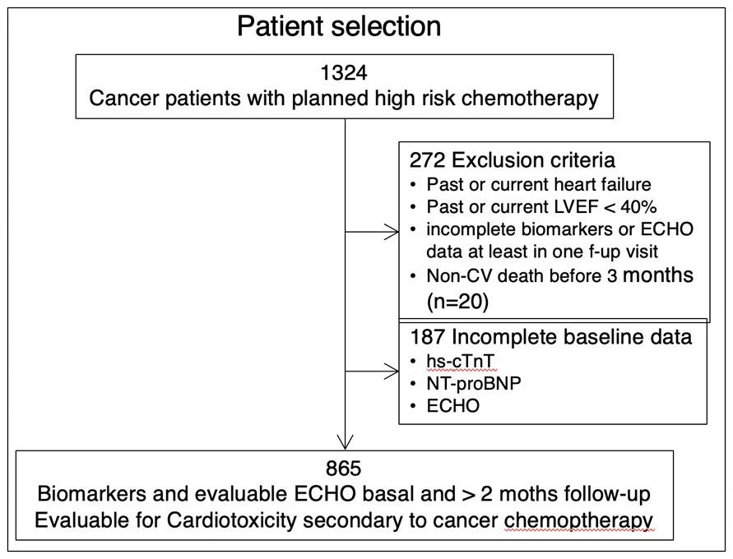
Figure legend. Patient selection diagram. Inclusion and exclusion criteria in the CARDIOTOX registry.

Figure 2. Progressive myocardial injury / left ventricular dysfunction and evidence-based treatment recommended in clinical practice guidelines.
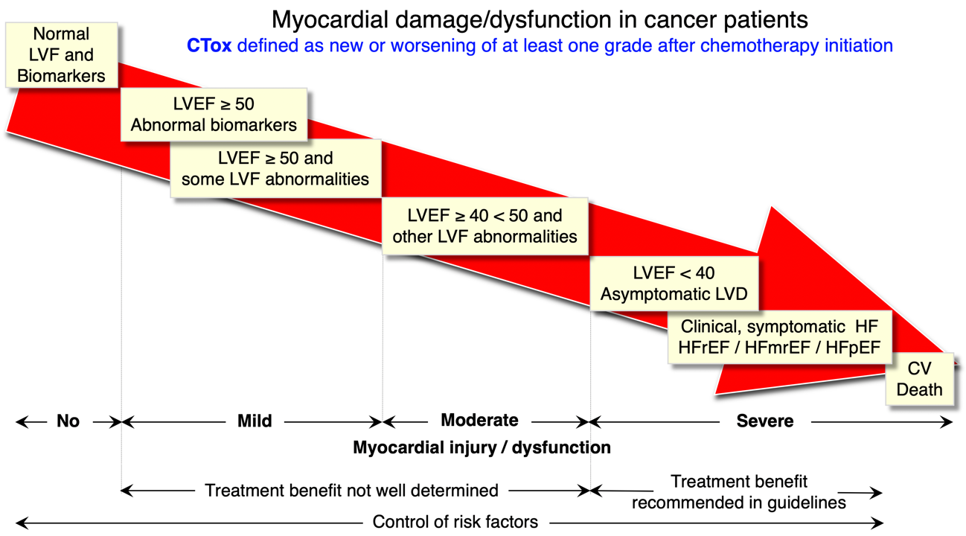

Figure legend: CTox: cardiotoxicity defined as new or worsening of myocardial damage/dysfunction: from normal to mild moderate or severe, mild to moderate or severe or moderate to severe. CV: cardiovascular; HF: heart failure; HFmrEF: heart failure with mid-range LVEF; HFpEF: heart failure with preserved LVEF; HFrEF: heart failure with reduced LVEF; LV: left ventricular; LVEF: left ventricular ejection fraction; LVF: left ventricular function.
Other LVEF abnormalities: increased LVESV, left atrial area >30cm2, 10% decrease of LVEF & LVEF<53%, average E/E’>14, global longitudinal strain > -18%, 15% relative reduction of global longitudinal strain.

Figure 3. Representative parameters of myocardial injury/ left ventricular dysfunction during follow-up.
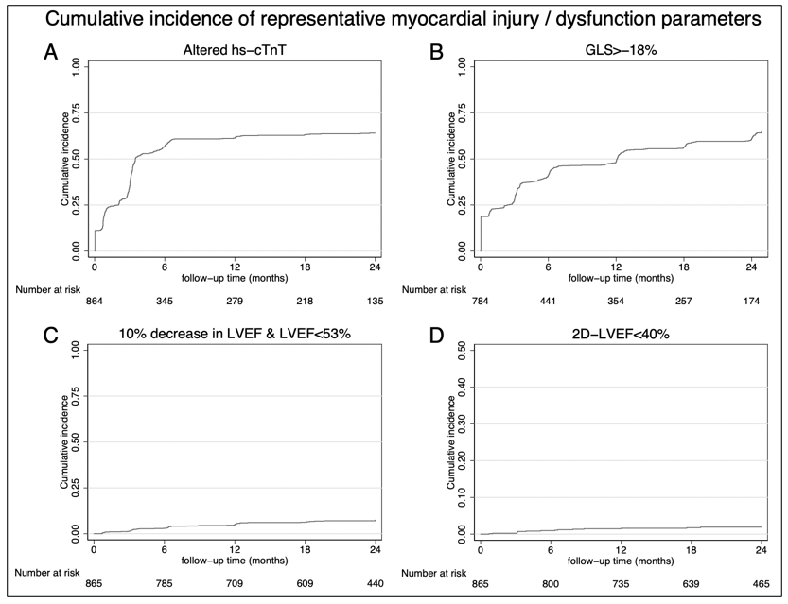

Figure 3 legend. Kaplan-Meier curves for high sensitivity troponins above normal levels (hsTnT), left ventricular ejection fraction (LVEF) < 40 %, LVEF < 53% with a decline ≥10 points, and global longitudinal strain (GLS) > -18 during follow-up.

Figure 4. Evolution of left ventricular damage/ dysfunction

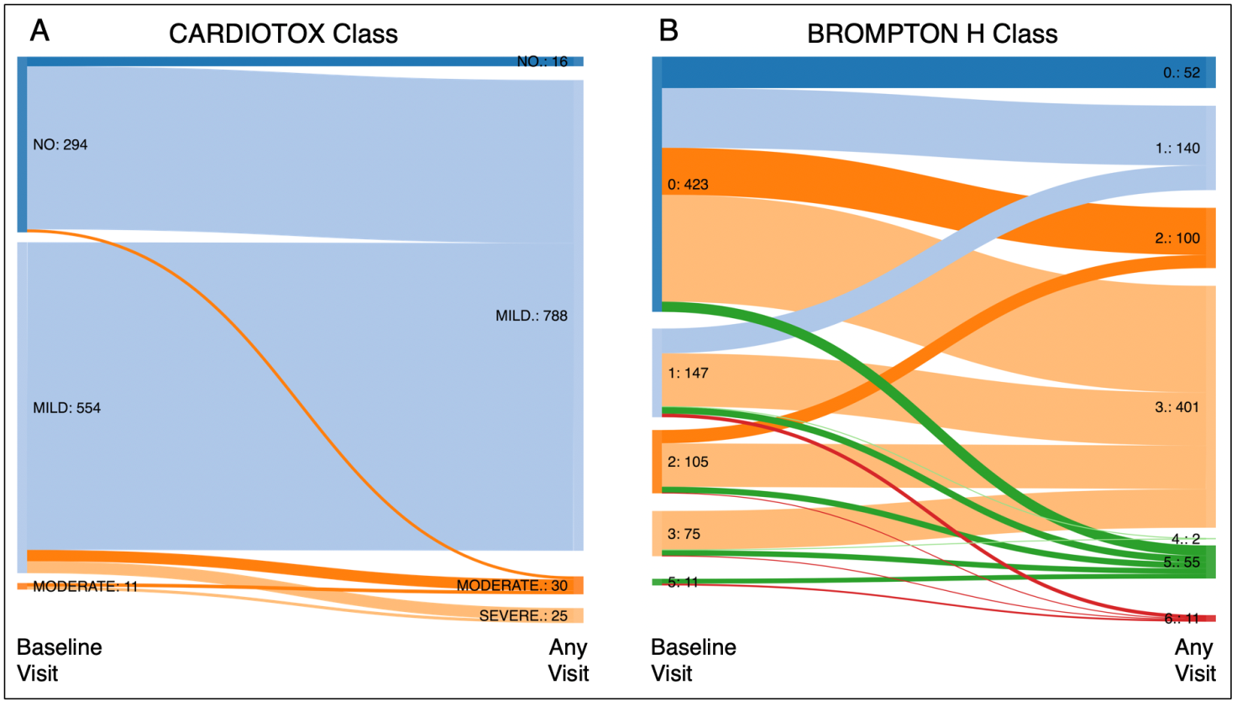

Figure 4 legend: Sankey curves illustrating worsening of myocardial damage /function using the CARDIOTX classification (No, mild, moderate and severe) and the 6 groups of the Royal Brompton hospital (15).

Figure 5. All-cause mortality in the different groups of CTox

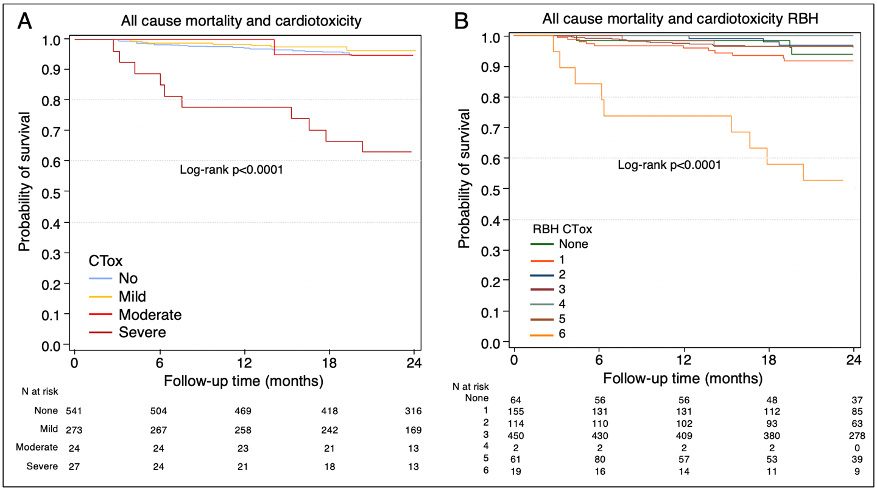

Figure 5 legend. Kaplan Meier curves for all-cause death in patients without and with different forms of cardiotoxicity in CARDIOTOX and Royal Brompton Hospital classifications.

Table 1. Baseline demographic characteristics in patients with/without CTox during follow-up.
 | All patients n=865 | Cardiotoxicity
 | All patients n=865 | No CTox  541 (62.5) | Mild  273 (31.6%) | Moderate  24 (2.8%) | Severe  27 (3.1%) | p value
Age, years, mean ± sd | 54.7 ±13.9 | 55.4 ± 14.6 | 52.4 ± 12.1 | 56.4 ± 12.4 | 61.8 ± 14 | 0.001
Men (row %) | 138 (16%) | 5 (13.2 %) | 143 (14.9 %) | 11 (28.9 %) | 15 (53.6%) | <0.001
Medical History
Cancer | 70 (8.5%) | 41 (58.6 %) | 18 (25.7 %) | 4 (5.7 %) | 7 (10 %) | 0.006
Metastasis | 10 (1.2 %) | 8 (80 %) | 1 (10 %) | 0 (0 %) | 1 (10 %) | 0.217
Chemotherapy | 42 (4.9 %) | 26 (61.9 %) | 9 (21.4 %) | 1 (2.4 %) | 6 (14.3 %) | 0.004
Radiotherapy | 21 (2.5 %) | 12 (57.1 %) | 4 (19 %) | 2 (9.5 %) | 3 (14.3 %) | 0.011
Smoking | 267 (32.5 %) | 163 (61 %) | 80 (30 %) | 10 (3.7 %) | 14 (5.2 %) | 0.083
Hypertension | 192 (23.8 %) | 138 (71.9 %) | 42 (21.9 %) | 7 (3.6 %) | 5 (2.6 %) | 0.002
Dyslipidaemia | 215 (26.6 %) | 141 (65.6 %) | 62 (28.8 %) | 5 (2.3 %) | 7 (3.3 %) | 0.524
Diabetes | 77 (9.6 %) | 55 (71.4 %) | 14 (18.2 %) | 3 (3.9 %) | 5 (6.5 %) | 0.011
Myocardial infarction | 11 (1.3 %) | 8 (72.7 %) | 0 (0 %) | 0 (0 %) | 3 (27.3 %) | 0.001
AF | 14 (1.6 %) | 9 (64.3 %) | 1 (7.1 %) | 2 (14.3 %) | 2 (14.3 %) | 0.004
Heart failure (HFrEF) | 0 (0 %) | 0 (0 %) | 0 (0 %) | 0 (0 %) | 0 (0 %)
Peripheral vascular disease | 6 (0.7 %) | 4 (66.7 %) | 1 (16.7 %) | 0 (0 %) | 1 (16.7 %) | 0.273
Previous cardiotoxicity | 4 (0.5 %) | 2 (50 %) | 1 (25 %) | 1 (25 %) | 0 (0 %) | 0.176
Cancer diagnosis
Breast Cancer | 568 (65.7 %) | 333 (58.6 %) | 218 (38.4 %) | 14 (2.5 %) | 3 (0.5 %) | <0.001
Non-Hodgkin's lymphoma | 133 (15.4 %) | 82 (61.7 %) | 30 (22.6 %) | 6 (4.5 %) | 15 (11.3 %) | <0.001
Hodgkin's lymphoma | 44 (5.1 %) | 31 (70.5 %) | 10 (22.7 %) | 1 (2.3 %) | 2 (4.5 %) | 0.46
Myeloblastic acute leukaemia | 31 (3.6 %) | 25 (80.6 %) | 1 (3.2 %) | 0 (0 %) | 5 (16.1 %) | <0.001
Colorectal | 17 (2 %) | 14 (82.4 %) | 1 (5.9 %) | 0 (0 %) | 2 (11.8 %) | 0.023
Lymphoblastic acute leukaemia | 8 (0.9 %) | 7 (87.5 %) | 1 (12.5 %) | 0 (0 %) | 0 (0 %) | 0.558
Other non-haematological | 75 (8.7 %) | 55 (73.3 %) | 16 (21.3 %) | 3 (4 %) | 1 (1.3 %) | 0.12
Other haematological | 10 (1.2 %) | 6 (60 %) | 3 (30 %) | 0 (0 %) | 1 (10 %) | 0.554
2 different cancer diagnosis | 22 (2.5 %) | 13 (59.1 %) | 7 (31.8 %) | 0 (0 %) | 2 (9.1 %) | 0.359
Myocardial damage markers at baseline
cTnI > 40 | 10 (1.5 %) | 9 (90 %) | 0 (0 %) | 0 (0 %) | 1 (10 %) | 0.019
hsTnT > 14 | 97 (13.3 %) | 92 (94.8 %) | 0 (0 %) | 3 (3.1 %) | 2 (2.1 %) | <0.001
NT-proBNP by age (>125 if age < 75; > 450 if age > 75y | 177 (23.6 %) | 157 (88.7 %) | 0 (0 %) | 10 (5.6 %) | 10 (5.6 %) | <0.001
LVEF 2D <50% | 9 (1 %) | 4 (44.4 %) | 0 (0 %) | 0 (0 %) | 5 (55.6 %) | <0.001
LVEF 2D ≥ 40 < 50 | 9 (1 %) | 4 (44.4 %) | 0 (0 %) | 0 (0 %) | 5 (55.6 %) | <0.001
LVEF 2D <40 | 0 (0 %) | 0 (0 %) | 0 (0 %) | 0 (0 %) | 0 (0 %)
LA area > 30 cm2 | 7 (0.9 %) | 3 (42.9 %) | 0 (0 %) | 2 (28.6 %) | 2 (28.6 %) | <0.001
LV mass index (g/m2) | 80.5 ± 22.5 | 82.55 ± 24 | 75.84 ± 19.6 | 78.13 ± 18.7 | 95.42 ± 19.4 | 0.0003
LV mass index by gender  Men ≥ 115 Women ≥ 95 | 88 (19.3 %) | 62 (70.5 %) | 19 (21.6 %) | 1 (1.1 %) | 6 (6.8 %) | 0.002
E/E´ ≥ 14 | 32 (4.1 %) | 31 (96.9 %) | 0 (0 %) | 1 (3.1 %) | 0 (0 %) | <0.001
GLS > -18% | 147 (24.3 %) | 129 (87.8 %) | 0 (0 %) | 9 (6.1 %) | 9 (6.1 %) | <0.001
2D LVESV>31 o 24 ml/m2 | 251 (31.7 %) | 234 (93.2 %) | 0 (0 %) | 9 (3.6 %) | 8 (3.2 %) | <0.001
LVEF | 64 ± 5.9 | 63.57 ± 5.7 | 65.79 ± 5.4 | 62.61 ± 6.7 | 57.29 ± 7.5 | <0.001
GLS | -19.5 ± 3.1 | -19.14 ± 3.2 | -20.87 ± 2 | -18.14 ± 3.4 | -17.59 ± 3.4 | <0.001
Table 1 legend: cTnI: cardiac troponin I; CTox: cardiotoxicity; GLS: global longitudinal strain; hsTnT: high sensitivity troponin T; LA: left atrium, LV: left ventricle; LVEF: left ventricular ejection fraction; LVESV: left ventricular end systolic volume; TKI: tyrosine kinase inhibitors;

Table 2: Medications in patients with and without CTox

 | All cases  865 | CTox
 | All cases  865 | No CTox  541 (62,5%) | Mild  273 (31.6%) | Moderate  24 (2,8%) | Severe  27 (3,1%) | p value
Cancer therapy
Anthracycline | 731 (84.5 %) | 441 (60.3 %) | 247 (33.8 %) | 20 (2.7 %) | 23 (3.1 %) | 0.011
Anti HER2 | 177 (20.5 %) | 100 (56.5 %) | 66 (37.3 %) | 10 (5.6 %) | 1 (0.6 %) | 0.002
Anthracycline & Anti-HER2 | 140 (16.2 %) | 76 (54.3 %) | 54 (38.6 %) | 9 (6.4 %) | 1 (0.7 %) | 0.002
TKI | 10 (1.2 %) | 5 (50 %) | 4 (40 %) | 1 (10 %) | 0 (0 %) | 0.296
Left breast radiotherapy | 236 (27.3 %) | 130 (55.1 %) | 98 (41.5 %) | 6 (2.5 %) | 2 (0.8 %) | <0.001
Mediastinal radiotherapy | 23 (2.7 %) | 14 (60.9 %) | 6 (26.1 %) | 2 (8.7 %) | 1 (4.3 %) | 0.215
Heart failure therapy at baseline
Betablokers | 45 (5.2 %) | 36 (80 %) | 6 (13.3 %) | 0 (0 %) | 4 (8.9 %) | 0.004
Aldosterone antagonist | 8 (0.9 %) | 4 (50 %) | 0 (0 %) | 1 (12.5 %) | 3 (37.5 %) | <0.001
ACE-i/ARBs | 140 (16.2 %) | 96 (68.6 %) | 30 (21.4 %) | 7 (5 %) | 7 (5 %) | 0.007
Ivabradine | 1 (0.1 %) | 1 (100 %) | 0 (0 %) | 0 (0 %) | 0 (0 %) | 1
Statins | 144 (16.6 %) | 98 (68.1 %) | 34 (23.6 %) | 3 (2.1 %) | 9 (6.3 %) | 0.021
Heart failure therapy during follow up
Betablokers | 125 (14.5 %) | 83 (66.4 %) | 12 (9.6 %) | 6 (4.8 %) | 24 (19.2 %) | <0.001
Aldosterone antagonist | 30 (3.5 %) | 10 (33.3 %) | 1 (3.3 %) | 4 (13.3 %) | 15 (50 %) | <0.001
ACE-i/ARBs | 215 (24.9 %) | 143 (66.5 %) | 35 (16.3 %) | 12 (5.6 %) | 25 (11.6 %) | <0.001
Ivabradine | 8 (0.9 %) | 4 (50 %) | 2 (25 %) | 1 (12.5 %) | 1 (12.5 %) | 0.12
Statins | 223 (25.8 %) | 148 (66.4 %) | 54 (24.2 %) | 6 (2.7 %) | 15 (6.7 %) | 0.001

Table 2 legend: ACE-I angiotensin converting enzyme inhibitors, ARBs: angiotensin receptor blockers; CTox: cardiotoxicity; HER2: Human epidermal growth factor receptor 2; TKI: tirosin-kinase inhibitors.
Table 3. Prevalence of different forms of myocardial damage / dysfunction and CTox through the follow-up

LV damage / injury | Basal  n (%; 95% CI) | Worst  n (%; 95% CI) | Fulfilled  CTox criteria  n (%; 95% CI)
No (Normal) | 296 (34.2%; 31.1 - 37.4%) | 16 (1.8%; 1.1 - 3.0%) | 541 (62%; 59.3 - 65.7%)
Mild | 558 (64.5%; 61.3 - 67.6%) | 792 (91,6%; 89.5-93.2%) | 273 (31.6%; 28.6 - 34.7%)
Moderate | 11 (1.3%; 0.7% - 2.3%) | 24 (2.8%; 1.9 - 4.1%) | 24 (2.8%; 1.9 - 4.1%)
Severe | - | 27 (3.1%; 2.2 - 4.5%)
Asymptomatic LVEF < 40% (2D or 3D) | - | 6 (0.7%; 0.3% - 1.5%)
Any heart failure | - | 21 (2.4 %; 1.5-3.7%)
HFrEF | - | 9 (1%; 0.5%-2%)
HFmrEF | - | 9 (1%; 0.5%-2%)
HFpEF | - | 3 (0.35%; 0.07%-1%)
Cardiovascular death | - | 4 (0.46%;0.17%-1.2%)
All cause death | - | 54 (6.2%; 4.8%-8%)
CTox hard endpoints | - | 63 (7.3%;5.7%-9.2%)

Table 3 legend: CV: cardiovascular; HFmrEF: heart failure with mid-range LVEF; HFpEF: heart failure with preserved LVEF; HFrEF: heart failure with reduced LVEF; LVEF: left ventricular ejection fraction.

APPENDIX
Appendix figure 1. Biomarkers and ventricular functional abnormalities though the follow-up
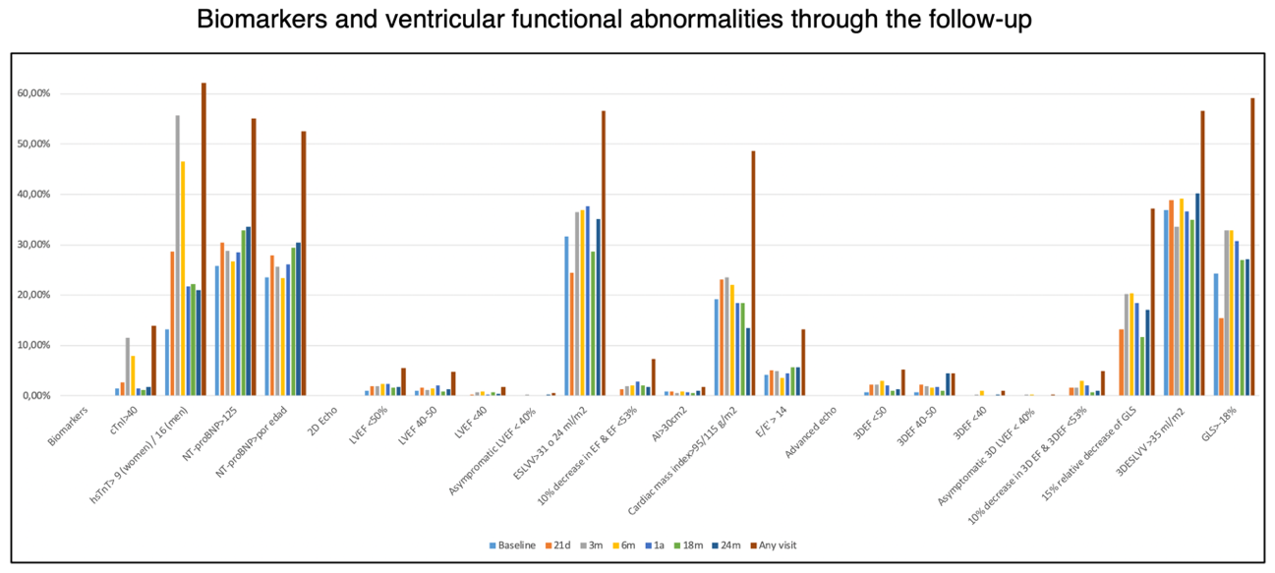

Appendix figure. 1 legend. Prevalence of abnormal biomarkers and ventricular function abnormalities at each visit during follow-up

Summarizing Illustration

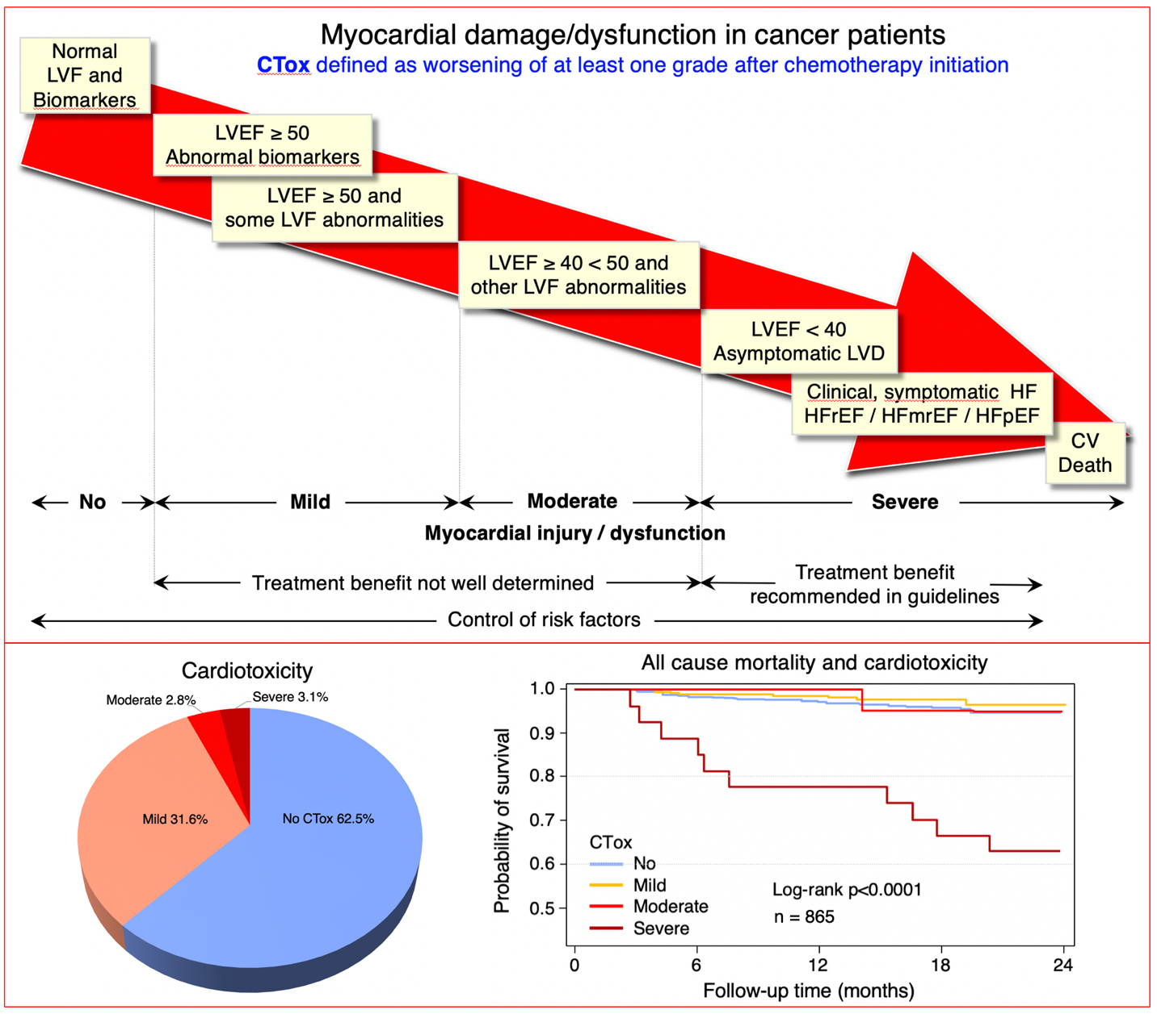

Appendix Table 1 Cancer chemotherapy considered as inclusion criteria for the registry

Alkylating agents: Bendamustine, busulfan, carmustine, cyclophosphamide, cisplatin, ifosfamide, mitomycin C, thiotepa

Antimicrotubule agents: Docetaxel, Paclitaxel
Vinca alkaloids: vinblastine, vincristine, vindesine, vinorelbine
Monoclonal Antibodies: Alemtuzumab, Bevacizumab, Catumaxomab, cetuximab, gemtuzumab, ipilimumab, ofatumumab, panitumumab, rituximab, trastuzumab
Antimetabolites: capecitabine, cytarabine, clofarabine, fluorouracil, gemcitabine
Anthracyclines: aclarubicin, doxorubicin (Adriamycin), daunorubicin, epirubicin, idarubicin, mitoxantrone, pirarubicin, valrubicin, zorubicin
Angiogenesis inhibitors: Lenalidomide
Interleukins: Aldesleukin
Small molecule tyrosine kinase inhibitors: Dasatinib, nilotinib, sorafenib, sunitinib, pazopanib, cabozantanib, axitinib, lapatinib, erlotinib, gefitinib, temsirolimus.
Other antineoplastic agents: anagrelide, bleomycin, bortezomib, estramustine, etoposide, irinotecan, mitotane, arsenic trioxide.

Appendix Table 2. Biomarkers, 2D ECHO and Advanced ECHO parameters at baseline and during follow-up
 | Baseline | 21d | 3m | 6m | 1a | 18m | 24m
Biomarkers
NT-proBNP (pg/mL) | 211.1±985 | 241.7±1146.6 | 179.9±489.3 | 158.7±463.1 | 154.3±347.7 | 150.1±276.6 | 166.2±320.2
cTnI (pg/mL) | 22.2±146.3 | 17.6±14.3 | 25.6±31.9 | 75.8±1282.1 | 16.7±8.5 | 17±22.8 | 21±95.3
hs-cTnT (pg/mL) | 6.5±13.5 | 8.1±6.4 | 12.9±10.1 | 16.6±134.4 | 7.3±4.8 | 7.6±6.4 | 7.4±6
ECHO
EDLVV index (mL/m2) | 61.3±24.7 | 57.6±24.6 | 62.2±25.4 | 62.5±24.5 | 62.3±24.3 | 57.1±24.5 | 61.4±25.6
ESLVV index (mL/m2) | 22.4±10.7 | 21.1±10.1 | 23.2±10.5 | 24.1±11.3 | 24.1±11.1 | 22.1±11.4 | 23.3±11.2
LVEF (%) | 64.1±5.9 | 63.4±6.1 | 62.5±6.1 | 61.9±6.1 | 61.9±5.9 | 62.3±5.9 | 62.6±5.9
LAA (cm2) | 17.1±4.3 | 17±4.3 | 17±4.2 | 17.1±4.3 | 17.2±4.2 | 16.6±4.3 | 16.9±4.4
Average E/E' | 7±4.3 | 8.2±3.1 | 7±4.2 | 7±4.8 | 7±4.3 | 7.9±3.7 | 8.2±5.5
Myocardial mass index (g/m2) | 80.5±22.5 | 83.2±23.5 | 84.3±27.9 | 83.4±24.2 | 80.7±22.3 | 80.2±23.9 | 76.7±22.9
3D EDLVV (mL/m2) | 87.2±28.2 | 92.3±30.7 | 86.8±28.9 | 88.7±27.8 | 87.9±28.7 | 89.8±29.6 | 90.7±28.1
3D ESLVV (mL/m2) | 32±13 | 34.4±15.2 | 33.3±13.3 | 34.4±13 | 33.2±12 | 33.2±12 | 35.1±13.2
3D LVEF (%) | 63.5±6.2 | 62.9±6.3 | 61.7±6.2 | 61.1±6.6 | 61.8±6.2 | 62.6±5.9 | 62.2±6.2
GLS (%) | -19.5±3.1 | -20.1±2.8 | -18.9±3.1 | -18.7±3.2 | -19±3.1 | -19.3±3.2 | -19.4±3

Appendix. List of CardioTox investigators

La Paz University Hospital. IdiPaz. UAM. Madrid
Executive Committee
José López Sendón (1) (Chairman)
Antonio Buño Soto(4)
Miguel Canales Albendea(5)
Enrique Espinosa (3)
Jaime Feliu Batlle(3)
Teresa López-Fernández (1)
Esteban López de Sá (1)
Mar Moreno Yangüela (1)
Elena Ramírez (2)
Olaia Rodríguez Fraga (4)
(1) Servicio de Cardiología
(2) Servicio de Farmacología Clínica
(3) Servicio de Oncología Médica
(4) Servicio de Análisis Clínicos
(5) Servicio de Hematología
(6) Fundación para la Investigación Biomédica del Hospital Universitario La Paz

Investigators
La Paz University Hospital. IdiPaz. UAM
Cardiology
Ainara Albaladejo
Guiomar Mediavilla
Carlos Álvarez-Ortega
Teresa López-Fernández
José López-Sendón
Mar Moreno Yangüela
Silvia Valbuena
Regina Dalmau
Almudena Castro
Esteban López de Sá
Juan Caro Codón
Oncology:
Pilar Zamora Auñon
Jaime Feliu Batlle
Enrique Espinosa
Beatriz Castelo
Andrés Redondo
Álvaro Pinto
HematoOncology
Miguel Canales Albendea
Pilar Gómez Prieto
Central Laboratory
Antonio Buño Soto
Patricia Chanca
Paloma Oliver
Olaia Rodríguez Fraga
Oncoradiotherapy
Isabel Rodríguez
Lara Miralles
Belén Belinchón
Aurea Manso
Rosa Moreiras
Pharmacy:
Gema Casado
Alicia Herrero

Hospital Universitario de Bellvitge, IDIBELL, L’Hospitalet de Llobregat, Barcelona
José González-Costello
Sonia Pernas Simón

Hospital Clínico Santiago de Compostela.
José Ramón González-Juanatey
Pilar Mazón Ramos
Amparo Martínez Monzonis
Rafael López López
Patricia Palacios Ozores
Milagros Pedreira Pérez
Belén Álvarez Álvarez

Hospital Lucus Augusti, Lugo
Begoña Campos Balea
Carlos González-Juanatey
Ana Testa Fernández
Silvia Varela Ferreiro

Hospital de Fuenlabrada, Madrid
José María Serrano Antolín
Juan Antonio Guerra Martínez
Luis Javier Morales García
Carlos Gutierrez Landaluce
Elena Moreno Merino
Nieves Estival Ortega

Hospital de Getafe, Madrid
Joaquin Alonso

Hospital General Universitario Gregoria Marañon
Francisco Fernández Avilés
Ana González-Mansilla
Pilar García Alfonso

Servicio de Cardiología. Hospital Infanta Sofía, Madrid
Rosalía Cadenas Chamorro
María Merino Salvador
Ignacio Plaza

Hospital San Juan. Alicante
Vicente Bertomeu
Juan Quiles

