Assessing the Impact of Autonomous Vessels on the Navigational Safety of Maritime Transport
Iulia Manole
Department of Civil and Environmental Engineering, Centre for Transport Studies, Imperial College London, United Kingdom. E-mail: iuliamanole97@gmail.com
Prof. Arnab Majumdar
Department of Civil and Environmental Engineering, Centre for Transport Studies, Imperial College London, United Kingdom. E-mail: a.majumdar@imperial.ac.uk

Autonomous vessels (AVs) are expected to commission and become operational within the next decade, in response to the declining supply of seafarers and increasing demand for seaborne trade. It is generally assumed that the introduction of autonomy would reduce the occurrence of human-related accidents on ships, but there is a lack of studies on the impact that autonomous vessels would have on the safety of maritime transportation. In this study, quantitative and qualitative tools are used to assess the impact of AVs on maritime transportation safety. Accident and incident data is analyzed to determine the influence of human errors. Then, it will be determined what proportion of these accidents would have been prevented had the vessels involved been unmanned. Thereafter, the frequency of each contributory factor is determined, along with any association between them and the occurrence of navigational human errors. The qualitative method comprises of interviews with industry professionals of different backgrounds, to explore the expected future impact of AVs and determine the main benefits and difficulties. It is predicted and verified by subject matter experts that autonomous vessels will have positive effects, creating less human dependent actions, therefore reducing accident frequency. Obstacles such as the lack of adequate legislation and regulations or possible cyberattacks are also discussed.

Keywords: Autonomous vessels, unmanned, maritime safety, data quality, thematic analysis.

1. Introduction
The concept of Autonomous Vessels (AVs) dates to 1973, when Schonknecht discussed the possibility that captains steer ships from the shore, with on-board computers (0). Then, it was sought to advance automation but not fully, due to shipping companies hiring low-cost crews, as well as high operational and maintenance costs of automation. European research groups began project MUNIN to develop an autonomous cargo vessel. Remotely controlled unmanned vessels may soon navigate around the seas and completely change the safety of ports (1).
The International Maritime Organization (IMO) started to work with the Maritime Safety Committee on a plan to consider the safety and environmental protection conditions that AV operations could have. The IMO defines autonomous vessels as Maritime Autonomous Surface Ships that navigate without human interaction. To facilitate the process of regulating such vessels, the IMO has determined four degrees of automation, but vessels can use more than one in a single journey (2):
- Degree 1: Vessel with automated processes and choice help. Crew is on board to operate and make decisions;
- Degree 2: Remotely controlled vessel, crew on board;
- Degree 3: A vessel that can only be controlled remotely and has no crew on board;
- Degree 4: Fully AV. The vessel’s working framework can make decisions and actions without human response.
AVs are expected to increase safety around seas and ports, since up to 96% of maritime accidents can be attributed to human errors (3). However, questions arise due to the uncertainty of the sector about their ability to: maintain safe navigation, detect hazards and compete with human capacity. This paper aims to determine potential safety implication of automation in shipping, by considering changes in risk assessment and hazard identification. A hybrid methodology is used to critically assess the impacts of AVs on maritime safety, along with challenges and changes that are expected to follow. Quantitative analysis of U.K.’s Marine Accident Investigation Branch (MAIB) accident investigation reports is used to determine the current factors that contribute to marine casualties. Then, thematic analysis of interviews with industry professionals will provide a realistic perspective on the expected positives and negatives of automation in the maritime industry. Therefore, this paper identifies important considerations regarding the implications of unintended consequences, challenges to automation, and a realistic description of what automation can and can not deliver in terms of reduced maritime incidents.

2. Literature Review
There are no fully operational ocean-going AVs in use, and there is little literature on their future impact on safety. The only exception is the autonomous spaceport droneship designed by SpaceX, a moving platform that facilitates landing of boosters at sea (00). A review of 47 documents published during the past decade indicates that the focus is on the technical aspect of autonomous operations and vessel design (5). For example, studies exist on the application of the automatic identification system (AIS) data on path guidance of autonomous catamaran ferry (6), the potential of remote pilotage operations (7) and the assessment of collision risk for autonomous surface ships (8). However, the changes in legal, organizational and social factors must also be considered, as they affect the safe and efficient development of autonomous shipping systems.
Research on the safety of autonomous systems is limited to hazard identification and analysis. A framework was proposed to identify factors influencing navigational risks by categorizing an AV’s voyage into operational phases. Risk influencing factors (RIFs) were determined through a literature review and subsequently grouped using an expert panel of subject matter experts. They determined that human related factors were the most prevalent, assuming that the AVs were controlled from shore. Thus, even with the removal of crews operating onboard a vessel, human errors will still exist albeit in another realm. RIFs were most frequent in open sea navigation, while the maneuvering and pilotage phases were determined to generally be more navigationally complex in nature. However, there is no mention if the duration of the phases was considered. (9)
Two papers have sought to evaluate the safety impact of deploying AVs by analyzing existing safety reports. The first one (10) proposed a safety assessment of unmanned vessels through a “what-if” analysis of existing maritime accident reports, based on the Human Factors Analysis and Classification System for Marine Accidents, originating from Reason’s Swiss Cheese theory. 100 maritime accidents were studied and it was assumed that unmanned ships operate autonomously only during ocean passage, while coastal navigation, pilotage and berthing are conducted by a shore operator. 52 were navigational accidents (grounding and collision). The remaining accidents were due to fire, flooding, or structural failure of the vessels, which can also occur on a poorly designed and maintained AV. Thus, greater emphasis should be placed on analyzing navigation-related accidents. Unmanned vessels were determined better in reducing the likelihood of accidents rather than reducing their severity, while the accidents were attributed to the lack of situational awareness of the bridge team and the inadequate maintenance or supervision of mechanisms. (10)
Similarly, the second paper (11) studied the potential decrease in human casualties and lost ships with the introduction of autonomy. They quantified the reduction of number of lives lost through the removal of crew from ships, then assessed the reduction in navigation-related accidents through the implementation of autonomous systems.
These studies can be expanded by assessing the impact of the implementation through the analysis of the proportion of navigation accidents that can be eliminated, since not all accidents of such nature are directly influenced by human errors. For example, collisions between ships can occur due to mechanical malfunction, e.g. the total loss of steerage control. Such failure modes may also occur on AVs. The common point of previous papers is that the studied accidents happened in a system operated by humans, which will be automated. This paper aims to determine how the implementation of the autonomous system could reduce the frequency of these accidents and detect new challenges.

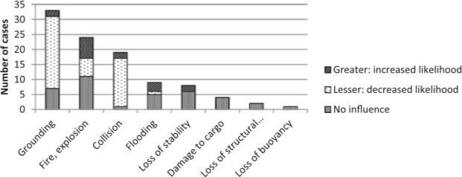

Fig. 1. Impact of automated framework on accident’s likelihood (12)

However, as AVs seek to eliminate certain risks, a new one appears and needs to be studied. Fig.1 shows the frequency of various types of accidents in relation to the type of ship. For grounding and collision, the number of accidents decreases considerably when changing the type of ship. The exception in this case comes with accidents caused by fire or explosions, in which it is fairly even. However, the increase in this type of accidents after introducing AVs might be due to the complexity of electrical installations and putting out fires in areas that are not prepared for it (12).
In conclusion, while the number of accidents can be expected to decrease significantly on AVs, once they occur, their consequences are significantly greater than at present because the absence of a crew will lead to a delay in any response. However, by eliminating the crews of the ships and reducing the staff members at the dock, the death toll will be reduced significantly since 95% of maritime deaths are caused by human errors (12). Various projects on autonomous shipping exist or are under development, such as the Maritime Unmanned Navigation Through Intelligence Network (MUNIN) and YARA Birkeland.

2.1. Projects
MUNIN was created by the European Commission (EC) in 2012 and ended in 2015, aiming to analyze the technical, legal and economic viability of the AV concept. They concluded that the introduction of AVs will reduce ship operations costs and gas emissions, having a positive environmental impact and bringing innovation. Most vessel losses are caused by collision and sinking, which may decrease by 10% due to smarter operational systems for avoiding collisions in ports during docking or undocking. Additionally, the main cause of maritime accidents is the human errors, which will gradually be reduced through automation, using smart consoles and no crew on board. The major concern in developing MUNIN was cyber-security, a new risk that appears with autonomation. Overall, AVs can generate savings of about US$ 7 million over 25 years compared to conventional bulk carrier (13).
Project Yara Birkeland arose from MUNIN and is the world's first emission-free electric container ship (14). It started operating in 2022 and will gradually operate without crew after two years. This will allow a reduction of 40,000 truck road trips between the Yara fertilizer plant to Brevik and Larvik ports in Norway, with implied emission reduction. This project aims to reduce NO₂ and CO₂ emissions by reducing road transport, and to improve air quality and safety (14). Initial tests of the model were successful, demonstrating both the concept and the technology (15).

3. Methods
Figure 2 summarizes the methodology of this paper to assess the impact of AVs on maritime transportation safety. Data is extracted from investigation reports and subsequently analyzed to determine the influence of human errors. The quality of the dataset is assessed, and a preliminary descriptive analysis is conducted, finding the frequency of each factor and any association between them and the occurrence of navigational human errors. The qualitative method comprises of semi-structured interviews with industry professionals of different backgrounds, to explore the expected future impact of AVs and determine the main benefits and difficulties. These are analyzed using thematic analysis.

Interview / Survey
Trend Analysis
Statistical Associations
Quantitative Analysis
Participant Selection

Thematic Analysis
Qualitative Analysis
Accident Data
Data Quality Assessment
Data Extraction
Data Selection

Fig. 2. Methodology
3.1. Accident data
3.1.1. Data selection
This paper uses MAIB accident data from investigation reports related to navigation errors caused by vessel crew. The accident type is limited to collision, contact/allision or grounding, as they normally follow navigational errors.

3.1.2. Data extraction
Since accident reports contain a wide variety of information, a process was derived to extract the necessary data. First, the factual information is reviewed to obtain details of the event, such as location, time and environmental conditions. Then, the narrative and analysis are reviewed to determine the influence human error and improvements AVs would make on preventing the accident. The immediate cause and other underlying contributory factors are found.
In the reports, only accidents resulting from human error that directly affected navigational decisions are considered. As such, mechanical malfunction such as the loss of control of the controllable pitch propeller (CPP), or loss of propulsion control are outside of the scope of the study. It is assumed that AVs are at least degree 3 and their sensemaking, decision making and execution of maneuvers is without error.

3.1.3. Data quality assessment
Data quality is checked using nine dimensions: accuracy, consistency, timeliness, accessibility, relevance, completeness, interpretability, credentials and detail of the narrative (19).

3.2. Quantitative analysis
Accident reports are classed according to their severity: less serious, serious and very serious marine casualty (20), while the “type of occurrence” is collision, contact, or grounding (21). The accidents are categorized based on whether human error was a critical factor. The technical and conceptual reasons for the accident are also described, along with the necessary improvements AVs may require to eliminate human error. When the pilot is onboard and the Master present, the Master is considered the officer of the watch (OOW) (22).
The categorical variables that were collected can be examined for associations and the relationship between the variables can be analyzed. This is calculated using Pearson’s chi-squared test, which compares the actual counts of events with the expected counts if the variables were independent. The test requires for less than 20% of the data fields to have expected frequencies below five (18). The null hypothesis is rejected with a level of confidence of 95%.

3.3. Qualitative analysis
A common issue in quantitative analysis is research subjectivity. To overcome this, qualitative research is also performed, following the framework in Fig. 4. After analyzing several AVs projects around Europe and reviewing accident data to understand the present situation, an interview questionnaire is designed to capture the effects AVs would have on maritime safety. The interviews were completed in 2021, transcribed and analyzed with the NVivo program, which categorizes answer topics in themes.
Using the framework in Fig. 4, the research can suffer from generalization due to the small sample size, which is a common issue in qualitative research. However, the participants have diverse backgrounds and professional experience, making the analysis more realistic.

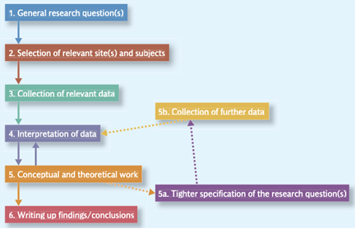

Fig. 4. Main steps of qualitative research (23)

Different data collection methods such as interviews, questionnaires, surveys, focus groups and observations have been considered. Individual interviews and questionnaires are used in this study, specifically self-completion questionnaires, which are considered an open-ended self-report measure as participants can answer them remotely and at any convenient time. One advantage of questionnaires compared to the structured individual interviews is the absence of interview effects, such as the ethnicity, gender or social background of the interviewer, that can affect the answers that people give (23). The self-completion questionnaire designed for the study has fewer open questions because closed questions are easier to answer, while the format is easy to follow and designed to reduce the risk of "respondent fatigue".
The questionnaire participants for this study were selected from Spain and Denmark (Table 1). They were acquired through snowball sampling, where the researcher makes connections with individuals with relevant experience, through whom other contacts are established (23).

Table 1. List of interviewed participants

ID | Experience | Country | Gender | Role
1 | 16 years | Spain | Male | Chief Engineer
2 | 6 years | Spain | Male | Chief Engineer
3 | 6 years | Spain | Male | Loading Master
4 | 43 years | Denmark | Male | Nautical Superintendent
5 | 12 years | Spain | Male | Harbor Pilot
6 | 2 years | Spain | Female | Naval architect and maritime engineer
3.4. Thematic analysis
Thematic analysis is used to distinguish themes within the questionnaire data (24). This offers flexibility when identifying patterns and themes in the study. The analysis is conducted based on (23), (25) and (26). Using NVivo, codes are created for assigning sentences from the participants, allowing for a better organization of the information. A code is a word or group of words used to describe the topic of various sentences from the participants. Different codes with similar meaning units are grouped to form a category, which in this case entail the main themes of the study. Figure 5 outlines the thematic analysis approach suggested by (25), how from a general answer or raw data, high levels of abstraction can be obtained.

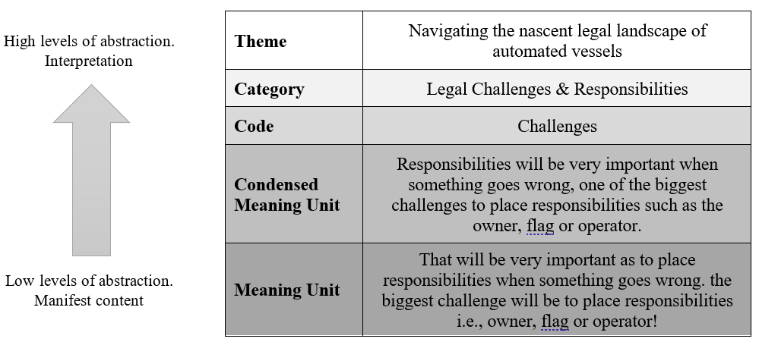
Fig. 5. Thematic qualitative analysis outline

4. Results
This section presents the results of the analysis of 74 maritime accidents at UK ports.

4.1. Accident data
4.1.1. Database
The information that has been extracted from the investigation reports has been categorized into different data fields (Table 2):

Table 2. Data fields extracted from accident reports.

General description
Serial number, Case title
Marine casualty information
Date, Time, Location, Accident severity, Casualty event, Place on board, Fatalities, Serious injuries, Minor injuries, Damage/ Environmental impact, Ship operation, Voyage, Persons onboard
Vessel details
Name, Flag, Vessel type, Construction, Age of vessel, Length overall, Displacement, Minimum safe manning, Authorized cargo
Voyage details
Type of voyage, Cargo information, Manning
Environmental conditions
Visibility, Wind, Sea state, Swell height, Weather, Light, Tidal stream
Human error analysis
Appointment of OOW, Years of nautical experience, Time with vessel involved, Presence of alcohol/drug, Fatigue, Human error (Navigational), Technical accident reason, Conceptual accident reason, Would autonomy help, Autonomous vessel improvements

4.1.2. Data quality assessment

Table 3. Data quality assessment results.

Dimension | Collision | Contact | Grounding
Accessibility | 71.35%
Completeness | 86.02% | 82.80% | 81.45%
Consistency | 95.46% | 96.17% | 96.17%
Relevance | 84.52%
Accuracy | High
Credentials | High
Interpretability | High
Timeliness | Unknown
Narrative | Detailed

All dimensions are above the 50% threshold (Table 3). The lower accessibility score was due to the lack of analytical data necessary for the study. For completeness, vessel details contained unknowns, which might be due to underreporting of certain data fields. The environmental conditions data were also incomplete, despite the good practice to maintain hourly and four-hourly logs. It could be because reporting such data is not mandatory unless it was thought to be a critical factor. All the investigation reports were highly detailed and consistent in the manner of reporting. The format of report, analysis and information included are similar across the accidents. However, the quantity of information may vary depending on the amount of evidence uncovered and accident severity.
Considering MAIB is a government branch and investigation reports are official documents published to highlight safety concerns and seek to improve safety, the investigation reports are assumed to be reliable and accurate. Overall, the data is deemed to be of high quality and suitable for further analysis in this paper.

4.2. Quantitative analysis
4.2.1. General details of the accidents
74 accidents between 2013 and 2020 have been reviewed: 28 collisions, 13 contacts and 33 groundings. There are 3 less serious, 53 serious and 18 very serious marine casualties. These resulted in 8 fatalities, 5 serious injuries and 36 minor injuries.
106 vessels were involved in these accidents: 37.7% cargo ships, 20.8% ferry, 16% fishing vessels and 17% smaller ships for recreational and operational activities. Most accidents occurred when the vessels were on passage (67%) or maneuvering while berthing or unberthing (21.7%). This result concurs with (9)’s identification of risk influencing factors, having found them most prevalent at the ocean passage phase. Even though maneuvering is navigationally more challenging, vessels spend most of their time on passage, explaining their higher frequency. This also makes it more likely for the crew to be susceptible to distraction and boredom, as they are less challenged during the process.
The highest accident rate was from 00:01 to 03:59, which is expected since humans tend to become increasingly tired towards twilight (27). As such, most companies have a policy for watchkeepers to have a minimum of six hours rest before their watch, but this is often not strictly enforced. Furthermore, vessels at sea and other objects are less conspicuous with the absence of daylight, hence visual assessment of collisions becomes less effective. It is common for watchkeepers to be disoriented by the array of lights displayed by vessels at night as it is not possible to visually assess how far vessels are. Of the ten accidents reported to be affected by fatigue, six occurred between 00:01 - 04:00 and four between 04:00 - 08:00, the conventional sleeping hours.

4.2.2. Accident reason
Of the 74 accidents, 57 were a result of human error, nine were not (poor design, instability, or malfunction of equipment) and eight were outside the scope of the study. Regarding the human-error-related accidents, the predominant contributing factor is the lack of situational awareness (64%). Besides error in execution of the passage, improper or insufficient passage planning represents 14% of accidents. The next most identified factor is inaction or insufficient action (11%). This is tied with the lack of situation awareness, as most OOWs are unaware that they are in a collision course or heading for shallow waters, which results in no action being taken or action taken too late.
The lack of situational awareness reflects the loss of position awareness, lack of identification of other vessels in collision course and shallow waters in the vicinity. It may happen due to: incorrect equipment set up (charts not used, radar not set for long-range scanning, or no additional lookout role delegated), distraction (using entertainment devices, or preoccupied with other operational duties), fatigue, alcohol or poor seamanship (bridge left unattended, navigating by eye, visual navigation in poor visibility, not using navigational aids or radar, ECDIS, GPS etc., over-reliance on AIS, not verifying course on chart or not accounting for weather/tidal stream).

4.2.3. Environmental conditions
Generally, poor environmental conditions were not a major contributary factor to accidents. Only 4% accidents occurred in poor visibility, being either serious or very serious marine casualties. This can be mitigated by RADAR equipment aboard ships, where most crews learn to navigate blind, without the aid of visual references and only through the use of radar, GPS and chart plotting. 44.6% accidents took place in light wind conditions and included most very serious casualties. Sea state, swell height, weather, light and tidal stream were not as widely reported as visibility and wind, even though it is generally required by watchkeepers to record these at a 4-hour frequency.

4.2.4. Human performance and experience of OOW
13.5% accidents reported that fatigue was a contributory factor, while 8.1% cited alcohol or drug use. These resulted in serious or very serious casualties. During the accidents, 38 of the OOWs at the time were the Master of the vessel, which makes up 35.8% of the vessels involved. The second highest identity is the skipper (21 for 19.8% of the vessels), who is also the highest appointed, and typically most experienced personnel on smaller craft. Following are less experienced appointments such as the Second Officer and Chief Officer. It is also observed that more than half of the vessels involved in very serious marine casualties involved the Skipper. This could be because most skippers’ responsibilities also include fishing and other high intensity work, and they do not receive the same level of navigational training as merchant vessels. The breakdown of accident frequencies can be seen in Fig. 6.

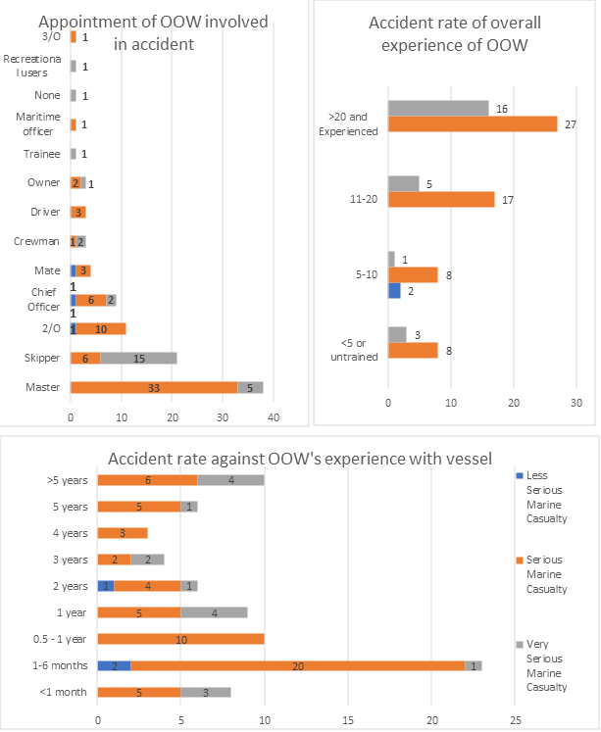

Fig. 6. Appointment and level of experience of OOW by number of accidents and accident rates.

In line with this analysis, the majority of the OOWs were individuals with more sea time even though it would be intuitive to expect the less experienced mariner to contribute the most to accidents. In this instance, 40.6% of the accidents involved OOWs working at sea for over 20 years. On the other hand, less experienced individuals of less than five years and untrained members form only 10.3% of the group. This is in concurrence with the finding that many of the OOWs were Masters or Skippers, who are the most experienced on the vessel and take on the largest responsibilities.
The highest proportion of OOWs have only had experience with the vessel, or the class of vessel, for less than a year. As presented in Fig. 6, the number of accidents when the OOW has only been on for less than 1 month, between 1 to 6 months, and between half a year and a year, is 8, 23 and 10 respectively. However, an increase in experience does not result in lower frequencies, and the shorter time period does not reflect a lack of navigational competence in the OOW.

4.3. Statistical associations
There was a significant relationship between fatigue and the time of occurrence. Other variable relationships were insignificant or inconclusive due to insufficient data. It was also found that shorter, lighter vessels were more likely to have been involved in very serious marine casualties, involving total loss of ship, loss of life or severe pollution. This is expected, as smaller ships are more vulnerable to capsizing and damage, especially upon impact with larger vessels.

4.4. Improvements of AVs
Accidents affected by human error could have been avoided if it the vessels had been operated with autonomy. This can be achieved through the artificial intelligence (AI) onboard AVs. Firstly, to counter the lack of situational awareness, all information from the vessel’s sensor suite would be constantly monitored and assessed by the AI for real-time sense-making of traffic conditions and safe water. For example, the AI can visually identify surrounding vessels through electro-optical or infrared systems and assess their relative course and speed through changes in the relative bearing and recognize any vessels on a collision course. This information would also be cross-checked with radar and AIS information to gather a complete picture. The AI can also conduct position checks through GPS and visual fixes along with the planned track and available safe water. Secondly, AI could avoid collisions depending on the traffic condition, which is automatically monitored by the system. Through the radar and automatic radar plotting aid (ARPA) outputs, it can adjust the vessel’s heading until it can pass another vessel with a satisfactory lateral distance, which can be computed through ‘Closest Point of Approach’ or ARPA. It can also ensure that it is in safe waters through real-time adjustments upon position checks.
The sensor equipment already exists on most operational vessels, but the OOW may not use them due to distraction, fatigue, stress, and unfamiliarity. The benefit of the AI over humans is that the computer has a higher capacity and is less likely to be overloaded. Even if offshore operators of AVs mistakenly direct the vessels due to inexperience, fatigue or alcohol, the onboard AI can be configured to automatically take over control and redirect the vessel to a safer path. This is similar to self-driving cars with automatic collision avoidance.
11 of the accidents can only be avoided with specific configurations on the AVs, and they serve as improvements that would be necessary. Firstly, the chart database on vessels must be up to date, following chart revisions and Notice to Mariners updates. This would highlight any unsafe waters from recent shipwrecks, ongoing construction, and other sea hazards. Secondly, the AI should be able to plan tracks that are tailored to the specific vessel characteristics, such as its draught and turning angles. This allows the vessel to know exactly the depth required for safe water, areas of dangerously shallow water, and thus the flexibility for vessels to deviate from their planned tracks. Lastly, dangerous maneuvers such as high-speed turns in the presence of other vessels and shore platforms in close proximity can be prevented.

4.5. Qualitative
When AVs start navigating around the world, many interests may be affected, especially for insurers. The results are based on the encounters, remarks and feelings of six professionals. Table 5 presents the most insightful themes that have been identified and their discussion, linked to findings from the literature and quantitative analysis, to provide a full image of the effects AVs are expected to have on maritime safety.

Table 5. Qualitative analysis discussion

Quotes | Discussion
Navigating the nascent legal landscape of automated vessels
‘Situations of human errors, we can know who is responsible, but in AVs who will be responsible if there is a machine error?’  ‘Who will be responsible in case of an accident when no one is onboard? The software engineers? If no one is on board besides pilot – who is responsible and in charge? That will be very important as to place responsibilities when something goes wrong.’  ‘International regulations will have to be developed together with new technologies. Achieve a global agreement over the world and all the necessary changes in laws for responsibilities.’  ‘To develop a new regulatory framework for AVs. For example, SOLAS needs to be expanded to allow AVs (right now, it says that someone physically onboard is needed for a ship to operate, which does not allow AVs to be a reality).’ | The dependence on the autonomous system will consequently lead to a gain in terms of importance in the insurance policies. Nowadays, the most common error is the human error, but in the future, it will be a technical error so the insurance will need to change too.  From the point of view of regulation of responsibility in automation, AVs have common aspects with autonomous cars. In a hypothetical accident between self-driving cars and pedestrians or drivers, the car factories argue that the responsibility lies only with the company that designed the software, so long and complex courts are ahead to discuss responsibility of the accidents. The list of laws that apply will vary depending on different factors such as the place of the accident, the type of accident, the nationality of the ship, etc.  Implementing AVs will cause a before and after in which the consideration of this aspect must be changed, since at this time the limitation of liability goes hand in hand with human fault. In the future, the use of smart devices will increase, so the responsibility is more likely to be due to technical failures. The new considerations will include responsibility for errors made by operators on land, in a similar way to the faults of the ship's crew members that occur nowadays in the conventional vessels. However, in relation to failures by technical means, there will be new laws and conventions that will link to software errors, data loss, system break, etc. In some cases, human intervention can solve different errors and overcome many technical problems, but in cases where the human cannot do anything (as in the case of a loss of communication), the distribution of responsibility will become a problem and the IMO will have an important role in this new area.
Automated vessels, removing human error from the shipping environment
‘With AVs can estimate a great part of future situations based on previous data, technology always offers solutions, improves people’s lives and more efficiency in process engineering.’  ‘An efficient way to eliminate all this common error human factors is to have complete automation of the vessels. Unmanned vessels will reduce human error, which is the most common cause of accidents, so we will improve the safety at ports.’ | During the last two decades, the human error has been present in the majority of the maritime accidents, approximately 60-70% of maritime accidents the human has intervened. Whether it is due to poor management of the on-board systems, poor decision-making or incorrect action, distractions, poor maintenance, incorrect stowage, or any other cause, it is a problem that is present every day today and is a risk to life and safety at sea (28).  These quotes emphasize on the findings from studies carried out in recent years about maritime accidents and their causes, which found that more than 60% of maritime incidents are due to human errors such as fatigue, errors of judgment or personal decision, negligence, or inadequate training (29). It is reasonable to assume that AVs would reduce the human-error-related accidents, eliminating risks faced by offshore crews that can end in injury or death.
Using Artificial Intelligence to optimize navigation, decision making and planning
‘Situations where the ability of a worker with his/her intuition after all the experience save the ship only will be possible with a good artificial intelligence a lot of time and a big dataset.’  ‘Reducing human error due to artificial intelligence.’  ‘The algorithm will be frequently updated through new training data that is continuously collected navigation based on Artificial Intelligence technology and all the decisions are programmed into the software according to the COLREG regulation’ | An autonomous surface vessel can navigate without human intervention, being controlled by AI programs that solve any problems arising during navigation, through algorithms. AI would connect to a network with several devices and use data about the weather, sea and dangerous obstacles to make a shorter route and therefore save on consumption (30).  The technology used is based on machine learning, where it creates a self-adaptive and predictive management system on the ship behavior. It manages monitoring and controls a large part of the ship's systems in real time, carrying out tasks quickly and efficiently. The system also informs the captain of recommendations on stabilizers, speed and route planning (31). This facilitates decision-making during navigation and in port operations, reducing the frequency of human errors.
Difficulties & controversies in AV operations
‘Communications between crew and machines and could be a big problem, especially at the beginning with the first levels of autonomy’  ‘I can see cargo vessels without crew, but automated operations should always be supervised by the crew. The crew will be reduced to a minimum but if there aren´t changes in the vessel the reduction of crew will not be as much as we think.’  ‘A lot of things that can be done at port with land crew but the time at port will be increased and the vessel will be done with fewer journeys, due to that reason the maintenance (in the engine room and deck) are made in sailing time.’  ‘I do not see it as feasible, since you will always need a crew for maintenance of the ship, this is affected by weather conditions, machinery wear and in the best of cases the crew would be reduced even more.’  ‘Job losses, economic and social impact.’  ‘The possibility of remote-control failure and cybersecurity are the main issues that need to be solved in order to be complete safe vessels. Very special attention should be taken about Cybersecurity as we have to be aware of hackers’ attacks.’  ‘Adapt to possible problems created by automation of industries like the cyber-attacks. With AVs, one of the main goals is to reduce human error but the company has to empathize Cybersecurity aspects.’ | AVs could improve safety by diminishing human error in the long term. However, during the transition phase, these vessels will work closely with conventional vessels. The way these will interact can create great difficulties when it comes to navigation in the event of a potential collision scenario. Another problem is the transmission of data between the ship and the control center, increasing the possibilities of saturation due to the high amount of image or video data and the large information flow through the sensors on board.  Another great uncertainty comes with the change in the way of working and in the preparation of these workers. The passage to land should be done gradually, and Lloyd's Register define the steps to be taken before completing full automation between on-board decision making, shared decision making with the ground, reduction of crews and full automation.  One of the biggest disadvantages that come with automation is the drastic reduction of workers, since a small team of maritime workers and engineers will be able to manage and coordinate several vessels. Although the work will be diversified in many aspects and the people who work on the ship will come from external companies, it has been argued by the interviewees that the generation of indirect employment will not supply the decrease in the demand for personnel, and although the companies allege that the number of officers decreases alarmingly, the reality for active mariners would be very uncertain.  Cyberattacks have become a growing danger in shipping, where programmers/hackers comprise frameworks like AIS, to alter the GPS signal. Due to the increased reliance of an AV on innovation, network safety turns into a significantly more major issue that organizations should address. Onboard controls and data can be undermined and powerless against computer-based at-tacks, as self-governing vessels require a steady relationship for checking and control (32).
Next steps in the short-term future of AVs
‘In the next 10 years we will see big cargo vessels with no crew. The crew is one of the most expensive costs they have.’  ‘We will see it increase year by year until it will become a reality. Of course, right now, we are in the design and testing phase and this implies testing with small-medium ships.’  ‘When a good foundation is created in safety regulations and the study of the behavior of AVs in the face of adversity.’ | Crew expenses are typically around 20-30% of the total expense of a cargo ship, including salaries, diet, insurance, contract, provisions and other essential components. AVs can reduce or eliminate these costs, making an incentive for shipping companies seeking for cost decrease in an inexorably aggressive market.  Some countries and organizations are already involved in the study and analysis of the implementation of AVs. The European Union allocated 3.5 million Euros to finance the MUNIN project, to investigate the costs and benefits of unmanned vessels. Moreover, Oskar Levanter, vice president of innovation at Rolls Royce, said that the technological trend is towards the automation of processes. He affirms that technology is at an appropriate level to revolutionize the maritime industry society.

Most participants brought up similar advantages of automation, the most recurring being the increased safety. However, cost reduction and efficiency improvement were also mentioned by the interviewees. Automation will involve a series of changes in the human behavior of a ship's crew. The automation of a ship does not mean that the human element no longer exists since, in a direct or indirect way, it will always be present (33). Although some types of jobs are eliminated, new ones will be created as has happened in the automation of other sectors.
On the other hand, legislation uncertainty and cyberattacks were the most recurring difficulties and controversies mentioned by the participants. At the moment, there is no adequate legislation, so companies interested in developing this technology do not have clear instructions, and the development of new laws related to AVs is a slow process. Interim guidelines could be developed in the next few years according to the results from MUNIN and YARA Birkeland projects, and others. Once the authorities and organizations related to the maritime sector have a clear idea of the new autonomous regulations, DNV GL suggests that a new Autonomous Ship Code should be developed, commanded by SOLAS (34).

5. Conclusion
This paper presents a preliminary analysis of how AVs may impact maritime safety in the future, based upon a hybrid methodology of quantitative and qualitative analysis. The former involved the analysis of over 70 maritime accident reports sourced from the MAIB. This revealed that 77% of the accidents studied could be prevented with the introduction of autonomy, and thus the elimination of human errors that influenced decisions and behavior in navigation. However, 12% of the navigation accidents would not be prevented, being caused by mechanical malfunctions. The most frequently identified human errors were the lack of situational awareness, insufficient action, and improper passage planning. To eliminate human errors, the AVs must mitigate them by design, through a wide array of sensor equipment such as electro optics and radar, and properly designed AI. For this to happen, deep learning is crucial to ensure adequate depth of knowledge for robust and resilient decision making in AI systems. Programmers will also have to look upon existing seamanship practices and rules to design the vessel’s behavior.
The qualitative analysis provided further, holistic insights on the impacts of AVs. Most participants highlighted similar advantages of automation, the most recurring being the increased safety. Cost reduction and efficiency improvement were also mentioned. However, new challenges and controversies arise, the lack of adequate legislation and regulations or possible cyberattacks can be some obstacles in the maritime environment. In the short run, shipping crews should focus on upholding a strong safety culture and maintain currency in their navigational skills through frequent and targeted trainings. It may be impossible to eliminate human error, since it may exist in other forms in the process of maritime transport, such as in the design, construction, and remote operation of vessels. It was assumed that AVs are perfectly designed, and do not run the risk of compromise of cyber-security attacks.
New threats must be included in the data fields of MAIB, such as cyberattacks, distinguishing between untargeted and targeted attacks (35). To improve future data quality assessment and overcome the challenges, a new data field related to the sensor’s connectivity must be added to the reporting scheme as a text category to provide detailed descriptions of the sensor’s performance. Due to ship digitization, many sensors will be operating during navigation and, under bad environmental conditions, some can lose communication and connectivity with the software or, due to computational issues, sensors can stop working.
This paper serves as an introduction and require expansion upon availability of data on the real-world usability of autonomous technology. In the long term, with the increased availability of data on the real-world effectiveness and usability of AVs, problems that arise in autonomy and its design can be solved. The nature of the accidents for unmanned vessels may be different compared to conventional shipping, where there might be more concern for economic repercussions with the removal of manned crewing. As such, it would be necessary for accident investigation to change and adapt to the nature of autonomous shipping accidents. This study can be further expanded upon with accidents not involving fatalities and ship loss, since these do not fully reflect the safety of ships. A more complete analysis can subsequently be expanded to assess the economic tradeoffs of implementing AVs.

References

(00) https://spacexfleet.com/fleet?fbclid=IwAR1pxPFgioAsbcv9J46ZPCyaZno8rg0nKKc-3MO-1KNCqSnskMWF2NqqcQE
(0) SCHONKNECHT, ROLF (ET AL). 1983. Ships and Shipping of Tomorrow. Macgregor Publiations, Limited. Hounslow, England. ISBN 13 9780906536018

